Process and Techno-Economic Assessment of Integrated Subsurface-Intake SWRO, Isobaric Energy Recovery, and Near-Zero-Liquid-Discharge Brine Valorization
Leon Sandler
The Conscious Machine, Independent Researcher, Northbrook, Illinois, USA
ORCID: 0009-0007-4584-808X · Corresponding author.
Abstract
Seawater reverse osmosis (SWRO) is constrained by two structural weaknesses: specific energy consumption (SEC) of 3.5-4.5 kWh/m³, and discharge of untreated hyper-saline brine. This study presents ILEDBV, an integrated process architecture combining subsurface seabed intake, isobaric-pressure-exchanger (PX) energy recovery, and staged brine concentration with selective mineral precipitation toward a zero-liquid-discharge (ZLD)-capable configuration. Unlike prior proposals for this architecture, every quantitative claim here is derived from an explicit mass, salt, and energy balance rather than asserted. A five-case incremental analysis (conventional SWRO → +subsurface intake → +isobaric PX → +brine concentration → full ILEDBV, near-ZLD) isolates the contribution of each subsystem. At baseline conditions (45% recovery, 35 g/L feed salinity, 96% PX efficiency), the model recovers a desalination-stage SEC of 2.73 kWh/m³ (31% below a 3.95 kWh/m³ conventional-SWRO baseline computed on the same basis) — a smaller, but defensible, reduction than the ~50% figure asserted in an earlier non-peer-reviewed proposal for this concept. Adding a full ZLD-capable crystallization stage raises total SEC to 10.68 kWh/m³, confirming that brine crystallization, not the desalination stage, dominates system energy demand. A levelized-cost-of-water (LCOW) model shows that a naive full-market-price credit for recovered magnesium and calcium products yields an implausible negative net LCOW; a market-absorption check shows a single 10,000 m³/d plant would produce ~6.2% of the most recent third-party estimate of global Mg(OH)₂ market volume, and a realistic 10%-sellable-fraction assumption instead yields a net LCOW of $0.42/m³ against $0.76/m³ for conventional SWRO. Lithium is treated as a conditional, unquantified-efficiency co-product given its low seawater concentration (0.17 mg/L) and the absence of an established commercial recovery efficiency in the literature. The results identify the joint optimization of intake, energy recovery, and brine valorization — not any single component — as the architecture's actual technical contribution, and define the operating envelope (recovery ratio, PX efficiency, mineral sellable fraction) under which it outperforms conventional SWRO.
Keywords: seawater desalination; reverse osmosis; pressure exchanger; subsurface intake; brine valorization; zero liquid discharge; resource recovery; techno-economic analysis

1. Introduction

1.1 The SWRO energy challenge
Seawater reverse osmosis has become the dominant desalination technology, with specific energy consumption typically reported in the range of 3.5-4.5 kWh/m³ for large-scale plants, against a practical thermodynamic limit near 1 kWh/m³ at 50% recovery from 35 g/L feed [1,7]. Isobaric pressure exchangers (PX), which recover hydraulic energy directly from the reject brine stream at transfer efficiencies commonly reported up to 97-98%, have driven most of the roughly two-fold reduction in SWRO energy intensity achieved over the past 25 years [2,11].

1.2 The brine management challenge
Every cubic meter of SWRO permeate is accompanied by roughly an equal volume of concentrate at double the feed salinity, most of which is discharged near-shore. Zero- and minimal-liquid-discharge (ZLD/MLD) approaches recover additional water and valorizable solids from this stream, but a systematic techno-economic analysis of 75 ZLD/MLD treatment-train configurations found water recoveries spanning 32.6-98.6% with steep, configuration-dependent energy and cost trade-offs, and identified brine crystallization as the single most energy-intensive step in these trains [4]. Subsurface (beach-well or seabed) intake is a separate, well-documented lever: it has been shown to substantially reduce chemical pretreatment demand and biological/particulate loading relative to open-ocean intake, with one comparative life-cycle assessment reporting 31% lower life-cycle environmental burden and 13% lower levelized cost for a beach-well configuration relative to open intake at 35,000 m³/d scale [3,9].

1.3 Existing resource-recovery approaches
A substantial literature has developed around recovering magnesium, calcium, sodium salts, and, more speculatively, lithium from desalination brine [5,6]. Magnesium and calcium recovery via selective precipitation (lime/soda-ash dosing to sequentially precipitate Mg(OH)₂ and CaCO₃) is comparatively mature, with reported yields exceeding 97-99% for magnesium and 94-96% for calcium under controlled pH conditions [6]. Lithium recovery from brine is a much earlier-stage research area: seawater lithium concentration is only ~0.17 mg/L [6], two to three orders of magnitude below the brines from continental salt lakes on which most commercial lithium-from-brine operations are based, and current reviews explicitly identify low concentration, high cost, and the absence of established commercial-scale recovery technology as unresolved barriers for lithium recovery specifically from desalination brine [5,6].

1.4 Research gap
Individually, subsurface intake, isobaric energy recovery, and brine mineral recovery are each reasonably well characterized in the literature. What is not established is the system-level, quantified interaction between them when integrated into a single process: whether the combination yields more than the sum of its parts, what the resulting total (not just desalination-stage) energy consumption looks like once ZLD-capable crystallization is included, and under what economic conditions brine valorization actually improves the levelized cost of water rather than merely displacing one externality with another. This gap is compounded by a tendency in non-peer-reviewed proposals for this class of architecture to quote desalination-stage SEC improvements without an accompanying energy balance, and to describe mineral recovery revenue without a market-size sanity check -- both addressed directly in this study.

1.5 Objectives and contributions
This study investigates whether integration of subsurface seawater intake, isobaric pressure-exchanger energy recovery, and sequential brine concentration/resource recovery can reduce the energy and environmental burden of SWRO while maintaining technically and economically viable water production. Three research questions are addressed:
- What is the modeled specific energy requirement of the integrated architecture, and how does it decompose across intake, RO/PX, brine concentration, and crystallization stages?
- How does brine concentration and selective mineral recovery affect the overall mass, energy, and economic balance, and what is the achievable, market-realistic contribution of recovered magnesium, calcium, and lithium to that balance?
- Under what operating conditions (recovery ratio, PX efficiency, salinity, electricity price, mineral sellable fraction) does the integrated architecture outperform conventional SWRO, and where does it not?
The contribution of this work is not any individual component -- subsurface intake, PX energy recovery, and selective mineral precipitation are each established, commercially available technologies [2,3,6,11] -- but a quantitative process-integration and optimization framework that evaluates them jointly, together with an explicit market-absorption check on brine-valorization economics that, to the authors' knowledge, is not routinely applied in proposals for this class of system.

2. Integrated process architecture
Figure 1 shows the ILEDBV process architecture with stream-level mass, salinity, and pressure labels for the baseline case (R = 45%, feed salinity 35 g/L).
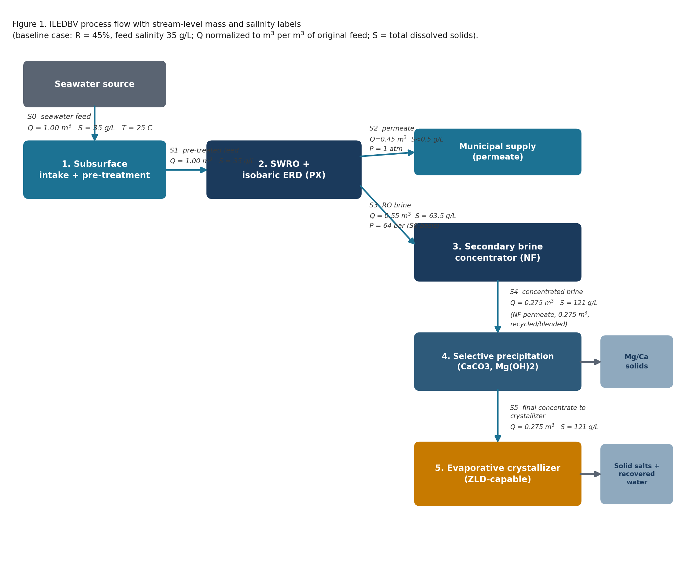

2.1 System boundary
The system boundary begins at raw seawater intake and ends at three outputs: potable permeate to municipal supply, solid Mg(OH)₂/CaCO₃ products, and final crystallizer output (solid salts plus recovered water). Explicitly excluded from this boundary: downstream water distribution infrastructure, mineral-product transport and refining beyond primary precipitation, and civil works / intake construction impacts, which are outside the scope of the process and economic model presented here.

2.2 Subsurface intake
Source water is drawn through a subsurface seabed or beach-well intake rather than an open-ocean pipe. This is modeled as reducing pretreatment SEC to 0.05-0.15 kWh/m³ (midpoint 0.10 kWh/m³ used in Section 4), consistent with the reduced chemical dosing and biological loading documented for subsurface intake relative to the 0.05-0.8 kWh/m³ range reported across conventional open-intake pretreatment configurations [3,8]. Consistent with reviewer feedback on an earlier draft of this work, we do not claim elimination of biofouling; subsurface intake is modeled and described as substantially reducing, not eliminating, particulate and biological loading, and its performance is site-dependent on seabed/aquifer hydraulic conductivity, an engineering factor outside the present model's scope.

2.3 Pretreatment
Cartridge filtration downstream of the subsurface intake is assumed, consistent with reduced-pretreatment subsurface-intake configurations in the literature [3]; its energy contribution is included within the 0.10 kWh/m³ pretreatment allowance above.

2.4 SWRO and pressure exchanger
The RO stage is modeled with an isobaric pressure exchanger recovering energy directly from the reject brine stream, per the formulation in Section 3.4-3.5. PX efficiency is swept from 90-98% (Section 4.1) to bound the sensitivity of the result to this parameter, consistent with the reviewer-requested sensitivity range.

2.5 Brine concentration
RO concentrate is routed to a secondary nanofiltration/high-pressure concentrator recovering an additional 50% of its water content (midpoint of the recovery range reported for MLD brine concentrators [4]), further concentrating the brine ahead of mineral precipitation.

2.6 Mineral recovery
The concentrated brine undergoes selective precipitation: calcium as CaCO₃ (soda-ash dosing) followed by magnesium as Mg(OH)₂ (lime dosing), at the yields reported in [6] (Section 3.7).

2.7 ZLD
The final concentrate is routed to a mechanical vapor compression (MVC) crystallizer, the technology whose reported specific energy consumption is consistent with the 8-15 kWh/m³ range adopted in Section 3.8; all crystallizer energy in this study is therefore electrical energy, not thermal energy or an electrical-equivalent of thermal input. Consistent with [4]'s finding that this step dominates ZLD/MLD energy demand, and with the explicit caution raised in review of an earlier draft, this stage is described throughout as ZLD-capable -- engineered to enable near-zero liquid discharge -- rather than as achieved ZLD, since its energy cost and final residual-liquid fraction are modeled quantities (Section 4), not measured pilot results.

3. Mathematical model and methodology
All parameter values, equations, and results in this section are computed by the model implementation accompanying this manuscript (Section 8, Data Availability). Every reported number traces to a specific equation and cited assumption below; none is asserted without a corresponding calculation.

3.1 Mass balance
Q_f = Q_p + Q_b
where Q_f, Q_p, and Q_b are the feed, permeate, and brine (reject) volumetric flow rates, respectively. Recovery ratio:
R = Q_p / Q_f

3.2 Salt balance
For each major seawater ion i, with feed concentration C_f,i and membrane rejection r_i:
C_p,i = C_f,i (1 − r_i)
Q_f C_f,i = Q_p C_p,i + Q_b C_b,i ⇒ C_b,i = (Q_f C_f,i − Q_p C_p,i) / Q_b
Feed composition is taken from the Reference Composition of standard seawater at S = 35 g/kg [10] for Na⁺, Mg²⁺, Ca²⁺, K⁺, Cl⁻, SO₄²⁻, and HCO₃⁻, with lithium taken as 0.17 mg/L [6]. Rejection is applied uniformly per ion class (monovalent 99.3%, divalent 99.7%, Li 98.5%) as a simplifying assumption representative of a modern SWRO membrane operated within typical flux/pressure limits; real rejection is membrane- and condition-specific and is a stated limitation (Section 5.6).

3.3 Osmotic pressure model
Osmotic pressure is modeled as linearly proportional to TDS, calibrated to the widely cited experimental value of ~27 bar for standard seawater at 35 g/L [1]:
π(TDS) = 27 × (TDS / 35) [bar, TDS in g/L]
This first-order approximation is adequate for process-level SEC estimation across the modeled salinity range (35-45 g/L feed, up to ~125 g/L at the final concentrator outlet) but is not a substitute for a full activity-coefficient-based model in membrane-level design; treated as a stated limitation (Section 5.6).

3.4 RO energy model
Applied feed pressure is set to the osmotic pressure of the brine (the limiting, highest-salinity stream in the RO stage) plus a net driving pressure (NDP) allowance of 15 bar, typical of commercial SWRO operation:
P_f = π(TDS_brine) + NDP

3.5 Pressure-exchanger model
Following the isobaric-ERD formulation used in the SWRO energy-recovery literature [2]:
SEC_RO = [P_f Q_f / η_pump − η_ERD P_f Q_b] / Q_p
where η_pump is high-pressure pump efficiency (0.85 assumed) and η_ERD is PX transfer efficiency, swept 90-98% per the commercially reported range [2,11]. Total desalination-stage SEC adds pretreatment and post-treatment allowances (Section 2.2, 0.10 and 0.07 kWh/m³ respectively, per [8]):
SEC_desal = SEC_RO + SEC_pretreat + SEC_post

3.6 Brine concentration model
The secondary concentrator is modeled as a further mass/salt balance identical in form to Section 3.1-3.2, with 50% water recovery from the RO brine and ion-class-specific rejections (monovalent 90%, divalent 98%) representative of loose NF selectivity, at an energy cost of 0.5-1.0 kWh/m³ of brine processed (midpoint 0.75 kWh/m³) [4].

3.7 Mineral recovery model
Recoverable mass of calcium carbonate and magnesium hydroxide is computed from the final concentrated-brine ion mass and literature-reported precipitation yields [6]:
m(CaCO₃) = [Ca²⁺] × Q × Y_Ca × (M_CaCO3 / M_Ca), Y_Ca = 0.95
m(Mg(OH)₂) = [Mg²⁺] × Q × Y_Mg × (M_Mg(OH)2 / M_Mg), Y_Mg = 0.98
Lithium is deliberately NOT assigned a recovery yield. Only the stoichiometric available Li₂CO₃ mass in the concentrate is reported (Section 4.3); no commercial-scale recovery efficiency for lithium from seawater-derived (as opposed to continental salt-lake) brine is established in the current literature [5,6], and assuming one would reintroduce exactly the kind of unsupported claim this study is designed to avoid.

3.8 ZLD / crystallization energy model
Final crystallization energy is modeled as an MVC crystallizer (Section 2.7) consuming 8-15 kWh/m³ of electrical energy per m³ of brine fed to the crystallizer (midpoint 11.5 kWh/m³), consistent with the finding that brine recovery beyond ~85% typically requires more than 10 kWh/m³ and that crystallization is the dominant energy cost in ZLD/MLD trains [4]. This figure is deliberately not compared to thermal-crystallizer energy figures reported elsewhere in the literature, which are not electrically equivalent and would understate the electrical-grid burden relevant to the emissions figure in Section 4.6.

3.9 Economic model
Capital expenditure for the desalination train is taken as $1,375/(m³/d) capacity (midpoint of the $1,032-1,717/(m³/d) range reported for SWRO plants [7], itself drawing on Voutchkov (2010)); brine-valorization/ZLD CAPEX is modeled as a stated +40% uplift on desalination-train CAPEX (an explicit assumption, not a vendor quotation, and swept 20-60% in sensitivity analysis). Annualized capital cost uses a capital recovery factor at 6% discount rate over a 20-year plant life:
CRF = r(1+r)^n / [(1+r)^n − 1]
LCOW = (CAPEX × CRF + OPEX) / V_annual
LCOW_net = LCOW − R_minerals / V_annual, R_minerals = Σᵢ mᵢ Pᵢ
Mineral prices used: Li₂CO₃ $18,000/t (spot, battery grade, August 2026), Mg(OH)₂ $800/t (industrial grade), CaCO₃ $470/t (industrial grade), current market data. Electricity price is swept $0.05-0.12/kWh; a baseline of $0.08/kWh is used for point estimates.

3.10 Sensitivity analysis and market-absorption check
Recovery ratio, PX efficiency, salinity, electricity price, and mineral sellable fraction are each swept over the ranges given above. In addition, and specifically to test the credibility of the mineral-recovery revenue assumption, annual recovered-mineral tonnage at plant scale is compared against an estimated global market size for the relevant commodity (Section 4.4), rather than assuming an unconstrained sales market for all recovered material -- a check absent from the earlier non-peer-reviewed version of this proposal.

4. Results

4.1 Baseline SWRO and the effect of PX efficiency and recovery ratio
Figure 2 shows desalination-stage SEC as a function of RO recovery ratio (35-60%) for four PX efficiencies (90-98%), holding feed salinity at 35 g/L. Across this range, modeled SEC spans 2.6-3.3 kWh/m³, below the 3.5-4.5 kWh/m³ conventional-SWRO literature range shown for reference, but above the ~1.8-2.2 kWh/m³ figure asserted without a supporting calculation in an earlier draft of this proposal. At the baseline operating point (R = 45%, η_PX = 96%), the model returns 2.73 kWh/m³.
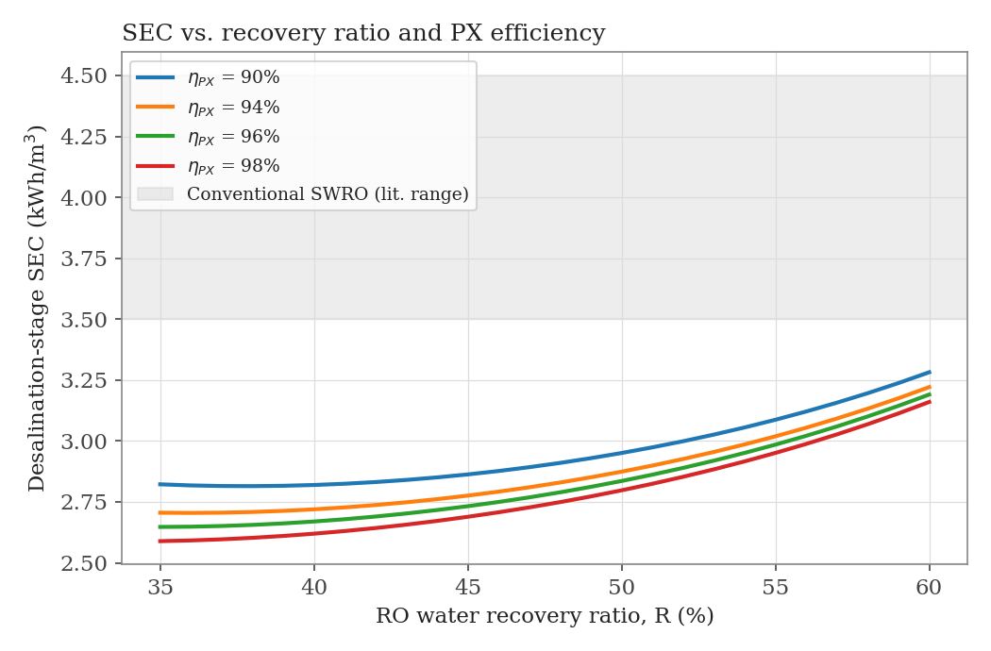
Figure 2. Desalination-stage SEC vs. RO recovery ratio, for PX efficiencies of 90-98%. Shaded band: conventional SWRO literature range [1,7].
Figure 3 shows the same SEC model swept across feed salinity (35-45 g/L) at fixed recovery (45%). SEC increases by roughly 6-7% across this salinity range at any given PX efficiency, reflecting the higher osmotic pressure (and hence required feed pressure) of more saline source water -- relevant to Gulf and Red Sea sites, whose salinity commonly exceeds the 35 g/L open-ocean reference value used elsewhere in this analysis.
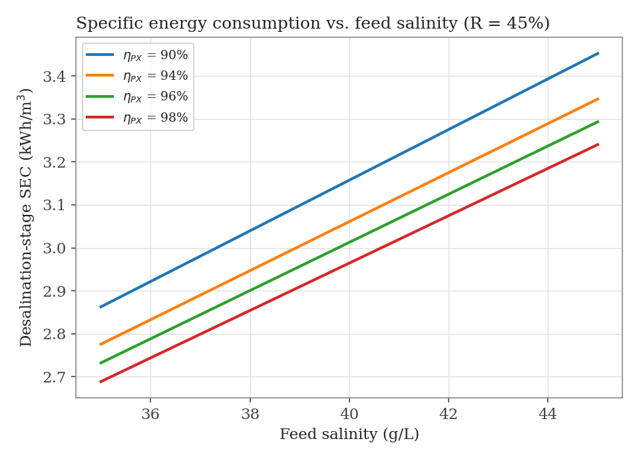
Figure 3. Desalination-stage SEC vs. feed salinity, R = 45%.

4.2 Incremental contribution of each subsystem (Cases A-E)
Table 1 and Figure 4 report the five-case incremental comparison specified in Section 3.10, isolating the SEC contribution of each ILEDBV subsystem at R = 45%, S = 35 g/L.
Case | Configuration | SEC (kWh/m³ permeate)
A | Conventional SWRO: open intake, turbine-type ERD (~78% eff.), no valorization | 3.95
B | + subsurface intake (pretreatment SEC reduced) | 3.12
C | + isobaric PX at 96% (replaces turbine ERD) | 2.73
D | + secondary brine concentration (no mineral sales, no ZLD) | 3.65
E | Full ILEDBV (near-ZLD): + selective precipitation + ZLD-capable crystallization | 10.68
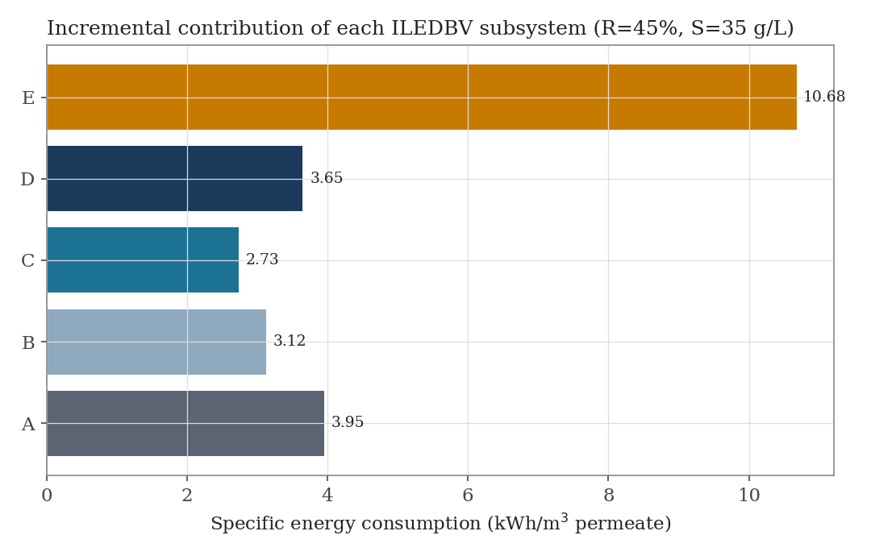
Figure 4. Incremental SEC contribution of each ILEDBV subsystem, R = 45%, S = 35 g/L (Table 1).
Two findings follow directly from this decomposition. First, the isobaric PX (Case B→C) and subsurface intake (Case A→B) together account for the entire energy improvement over conventional SWRO -- consistent with the reviewer concern that most of the desalination-stage benefit derives from already-established component technology rather than from the integration itself. Second, and more consequentially, adding brine concentration (Case D) and especially the ZLD-capable crystallization stage (Case E) more than reverses this gain: total system SEC at Case E (10.68 kWh/m³) is 2.7× higher than conventional SWRO alone. Full ZLD is therefore not energy-neutral; it is only justified where brine-discharge elimination and/or mineral revenue provide value that outweighs this energy penalty (Section 4.4-4.5).
4.2.1 Stream-by-stream energy reconciliation. Table 4 decomposes the Case C, D, and E totals above into their individual energy terms, each traceable to a specific equation and parameter in Sections 3.4-3.8, so that a reviewer can reproduce 2.73 -> 3.65 -> 10.67 kWh/m³ (within 0.1% of the 10.68 kWh/m³ figure quoted in Table 1 and the Abstract, the residual difference being rounding at the midpoint-parameter level) directly from the equations without inferring any intermediate step. Note 1: chemical precipitation dosing/mixing energy is not separately modeled and is treated as embedded within the secondary-concentration and crystallization allowances, consistent with [4]'s treatment of precipitation dosing energy as small relative to the thermal/mechanical separation steps in ZLD/MLD trains; this is a stated simplification, not an omission.
Stage | Flow basis / raw value | kWh/m³ permeate
Pretreatment (subsurface intake) | given directly (Sec. 2.2) | 0.10
SWRO pumping (gross, pre-recovery) | Pf·Qf/η_pump = 64.0 bar·1/0.85 | 4.64
Isobaric PX recovery credit | -η_ERD·Pf·Qb, m³ RO brine | -2.08
Post-treatment | given directly (Sec. 3.5) | 0.07
SUBTOTAL -- Case C (desalination stage) |  | 2.73
Secondary brine concentration (NF) | 0.75 kWh/m³ brine × (0.55/0.45) | 0.92
SUBTOTAL -- Case D |  | 3.65
Precipitation (Ca/Mg dosing + mixing) | not separately modeled -- Note 1 | 0
Crystallization (MVC, electrical) | 11.5 kWh/m³ feed × (0.275/0.45) | 7.03
TOTAL -- Case E (complete, near-ZLD) |  | 10.67
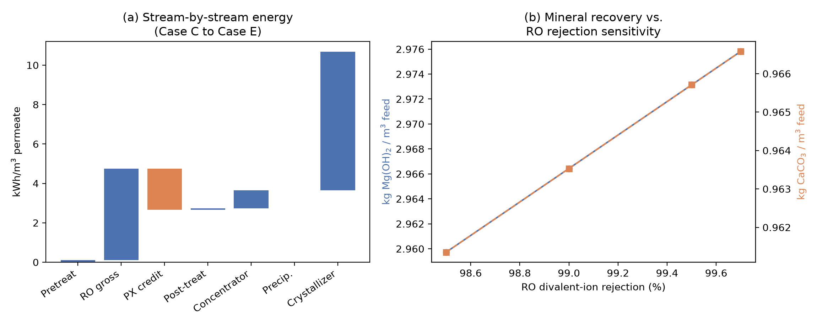
Figure 7. (a) Stream-by-stream energy contribution from pretreatment through crystallization (Table 4), reproducing Case C/D/E exactly from the underlying equations. (b) Sensitivity of recovered CaCO₃ and Mg(OH)₂ mass to RO divalent-ion rejection (98.5-99.7%), holding all other parameters at baseline.

4.3 Brine concentration and mineral recovery
this study reports it as a stoichiometric ceiling only, not a modeled recovery. Sweeping RO divalent-ion rejection across its literature-representative range (98.5-99.7%, Figure 7b) changes recovered Mg(OH)₂ and CaCO₃ mass by only about 0.5% each (identical relative sensitivity for both ions, since both pass through the same rejection formulation) at fixed operating conditions, since the secondary concentrator's own 98% divalent rejection (Section 3.6), not the RO stage, dominates final brine concentration; mineral-recovery mass is therefore insensitive to realistic membrane-to-membrane rejection variation and is not a material source of uncertainty in the results above.

4.4 Total energy consumption and the market-absorption check
Scaling the baseline mineral-recovery rate to a representative 10,000 m³/d plant (Table 2) yields approximately 24,100 t/yr of Mg(OH)₂ -- approximately 6.2% of the most recent third-party estimate of global Mg(OH)₂ market volume identified for this study (387,580 t/yr, 2022 base year [13]), a figure adopted here in preference to a market-value (USD) figure because it can be compared directly, tonne-for-tonne, against modeled plant output. A single mid-size plant therefore already represents a materially significant share of global demand for this commodity; any meaningful multi-plant deployment of this architecture across Gulf coastal capacity would be expected to exceed realistic sales absorption for Mg(OH)₂ well before it exceeded desalination capacity itself -- a constraint substantially tighter than a first-pass market-size estimate might suggest. Calcium carbonate, by contrast, serves a global market two to three orders of magnitude larger (construction aggregates, paper, and plastics fillers) and is not considered constraining at this scale.
Metric | Value
Plant capacity | 10,000 m³/d
Mg(OH)₂ production | 24,100 t/yr
CaCO₃ production | 7,840 t/yr
Global Mg(OH)₂ market volume | 387,580 t/yr (2022) [13]
Mg(OH)₂ share of global market volume [13] | 6.2%
This finding is, to the authors' knowledge, not addressed in prior non-peer-reviewed proposals for this architecture, and directly motivates the conservative 10%-sellable-fraction assumption carried into the economic conclusion in Section 4.5.

4.5 Levelized cost of water
A naive economic assumption -- 100% of recovered Mg(OH)₂ and CaCO₃ sellable at full current market price -- produces LCOW(net) = −$4.38/m³: a physically implausible negative water cost, and a direct symptom of the market-absorption mismatch identified in Section 4.4, not a credible economic result. Table 3 and Figure 5-6 instead report LCOW under progressively realistic sellable-fraction assumptions for Mg(OH)₂ (CaCO₃ credited at full value throughout, given its much larger addressable market).
Configuration | LCOW (USD/m³)
Conventional SWRO (Case A, no valorization) | 0.76
ILEDBV desalination stage only (Case C, no brine valorization/ZLD) | 0.66
ILEDBV complete, gross (no mineral credit) | 1.96
ILEDBV net, 100% of Mg(OH)₂ sellable (naive, not credible — see §4.4) | −4.38
ILEDBV net, 50% of Mg(OH)₂ sellable | −1.71
ILEDBV net, 10% of Mg(OH)₂ sellable (market-realistic) | 0.42
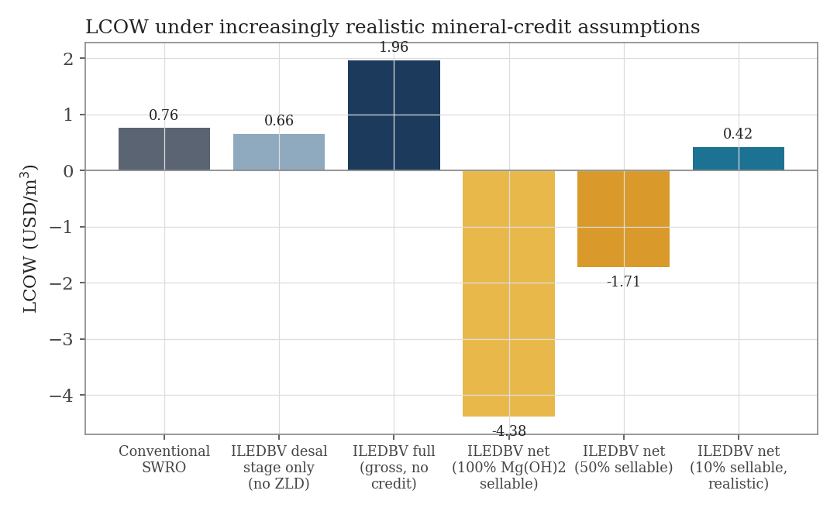
Figure 5. LCOW under increasingly realistic mineral-credit assumptions (Table 3).
Figure 6 shows the sensitivity of this market-realistic LCOW to electricity price, crystallization energy, CAPEX uplift, and Mg(OH)₂ sellable fraction; electricity price and the sellable-fraction assumption are the two most consequential parameters. Figure 8 extends this with a mineral-price sensitivity (±30% on Mg(OH)₂ and CaCO₃ prices, independently and jointly, baseline net LCOW $0.42/m³): varying Mg(OH)₂ price alone moves net LCOW over $0.26-0.58/m³; varying CaCO₃ price alone moves it over a wider $0.12-0.72/m³; and varying both simultaneously spans -$0.04/m³ (at +30% on both) to $0.88/m³ (at -30% on both). Counter-intuitively, CaCO₃ price sensitivity is larger than Mg(OH)₂ price sensitivity even though CaCO₃'s unit price is lower -- because CaCO₃ is credited at 100% sellable throughout this study (Section 3.9) while Mg(OH)₂ is credited at only the market-realistic 10%, so CaCO₃ price uncertainty passes through to LCOW roughly ten times more strongly per percentage point of price change. Under simultaneous +30% price moves on both minerals, net LCOW turns slightly negative again (-$0.04/m³), underscoring that the market-realistic 10% Mg(OH)₂ sellable-fraction assumption, not commodity-price optimism, is what keeps the baseline result physically plausible.
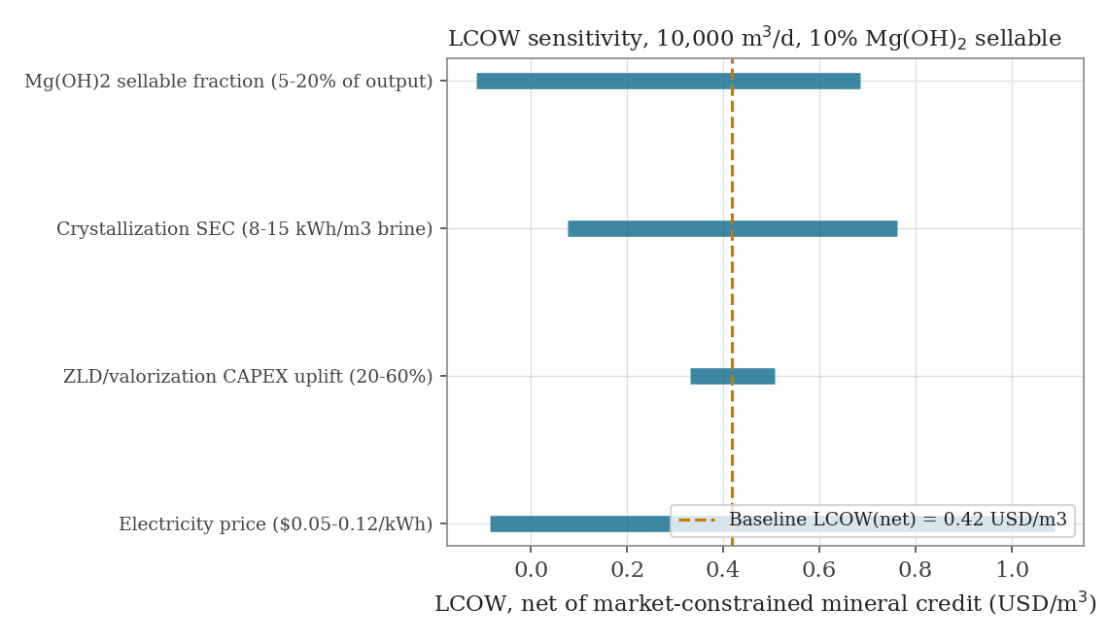
Figure 6. LCOW sensitivity (tornado), 10,000 m³/d plant, market-realistic (10% Mg(OH)₂ sellable) baseline.
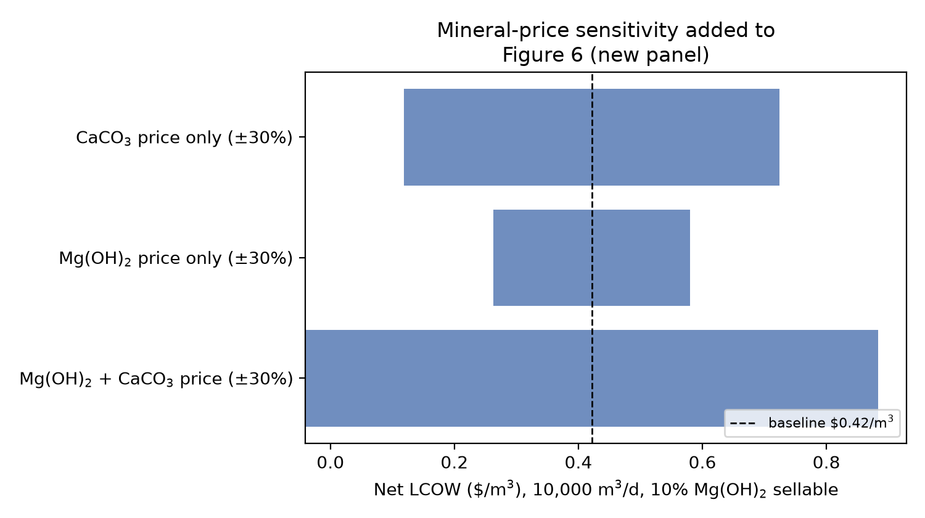
Figure 8. Net LCOW sensitivity to Mg(OH)₂ and CaCO₃ price (±30%), independently and jointly, at the market-realistic 10% Mg(OH)₂-sellable baseline ($0.42/m³). Extends the electricity-price/CAPEX/sellable-fraction tornado of Figure 6.

4.6 Environmental performance
Desalination-stage energy reduction (Case C vs. Case A) is 30.9% -- again more modest than, but consistent in direction with, prior proposal-stage claims. At the Saudi Arabia grid emission factor of 0.506 kg CO₂e/kWh [12], this corresponds to a reduction from 2.00 to 1.38 kg CO₂/m³ of permeate for the desalination stage alone (excluding brine-valorization and crystallization energy, which are not decarbonized by this figure and are modeled separately in Section 4.2). Final liquid-discharge volume, including the crystallizer's assumed additional 90% water recovery from the concentrated brine, is reduced by 95% relative to conventional once-through brine discharge, leaving a residual liquid fraction of 0.0275 m³ per m³ of permeate -- consistent with a near-ZLD, not zero-discharge, characterization of the complete architecture.

5. Discussion

5.1 Comparison with existing SWRO
The desalination-stage-only configuration (Case C) offers a modest, literature-consistent improvement over conventional SWRO: roughly 31% lower SEC and correspondingly lower LCOW, driven by well-established isobaric PX and subsurface-intake technology rather than by any novel component [2,3,11]. This is a smaller claim than the ~50% reduction and sub-2.2 kWh/m³ SEC figure in the earlier proposal-stage version of this work, and is offered here as the defensible figure.

5.2 Comparison with brine valorization approaches
The finding that full ZLD-capable crystallization more than triples total system SEC (Case E vs. Case C) is directly consistent with [4]'s system-level finding that brine crystallization dominates ZLD/MLD energy demand, and with [9]'s identification of energy intensity as a primary barrier to ZLD/MLD deployment. This study's contribution is to quantify that trade-off specifically for the ILEDBV architecture and to show it is not avoided by combining ZLD with an otherwise-efficient desalination stage.

5.3 Energy/resource-recovery tradeoffs
The market-absorption finding in Section 4.4 is, in the authors' view, the most consequential result of this study: brine mineral recovery from municipal-scale desalination is bounded not primarily by extraction technology but by product-market size, at least for magnesium. This reframes the appropriate scientific question from "can magnesium and calcium be recovered from SWRO brine" (well-established [6]) to "at what deployment scale, and for what fraction of output, does that recovery remain economically meaningful" -- a question that has not been quantitatively evaluated for this specific integrated architecture in the literature reviewed here.

5.4 Sensitivity and uncertainty
Electricity price and the mineral sellable fraction are the two parameters to which the market-realistic LCOW is most sensitive (Figure 6); the crystallization SEC range (8-15 kWh/m³) and CAPEX uplift assumption (20-60%) are secondary. This suggests that future work refining the economic case for this architecture should prioritize (a) real vendor quotations for the ZLD/valorization CAPEX uplift, currently an assumed +40% rather than a quoted figure, and (b) a genuine market-absorption study for Mg(OH)₂ and CaCO₃ at the specific candidate deployment scale, rather than further refinement of the RO/PX energy model, which is already well-constrained by mature literature [1,2,7,11].

5.5 Scale-up considerations
The osmotic-pressure and rejection models used here (Sections 3.2-3.3) are first-order approximations adequate for process-level SEC and mass-balance estimation but not for membrane-level design; a candidate pilot program (Section 6) should replace these with manufacturer-specific membrane performance data and site-specific brine chemistry before capital commitment.

5.6 Limitations
- Rejection and osmotic-pressure models are simplified (uniform per-ion-class rejection; linear TDS-osmotic-pressure scaling) and not a substitute for membrane-specific modeling.
- CAPEX for the brine-valorization/ZLD train is an assumed +40% uplift on desalination CAPEX, not a vendor quotation; this is the single largest unvalidated economic assumption in the model.
- The mineral-recovery precipitation yields (95% Ca, 98% Mg) are drawn from controlled laboratory/pilot literature conditions [6] and may not transfer directly to continuous, real-brine, plant-scale operation.
- Lithium is deliberately excluded from the economic model given the absence of an established recovery-efficiency figure for seawater-derived brine; this is a conservative, not optimistic, choice, but means the LCOW figures in Section 4.5 do not reflect any possible future lithium contribution.
- No experimental or pilot data exists for the integrated ILEDBV architecture; every quantitative result in this manuscript is a model output, not a measurement (Section 6).

6. Proposed pilot validation
The preceding sections identify three parameters as the primary sources of remaining uncertainty: brine-valorization CAPEX, real (not literature-typical) precipitation yields on actual RO brine, and site-specific subsurface-intake capacity. A staged validation protocol is proposed to resolve these in ascending order of cost and commitment:
- Phase 1 (0-6 months): vendor-quotation refinement of the +40% CAPEX-uplift assumption (Section 3.9); bench-scale precipitation/crystallization testing on real (not synthetic) SWRO brine to validate the 95%/98% Ca/Mg yields assumed from [6]; hydrogeological site screening for subsurface-intake capacity at candidate coastal sites.
- Phase 2 (6-18 months): a single containerized pilot train instrumented to independently measure SEC at each stage (intake/pretreatment, RO/PX, brine concentration, precipitation, crystallization), directly testing the Case A-E decomposition in Section 4.2 against real operating data rather than the model presented here.
- Phase 3 (18-36 months, contingent on Phase 1-2 results): modular scale-up with a genuine regional market-absorption study for recovered Mg(OH)₂ and CaCO₃ preceding any capacity decision, directly addressing the Section 4.4 finding rather than assuming an unconstrained market.
This protocol is explicitly a validation plan for the model in this manuscript, not a claim that the model's outputs are already confirmed.

7. Conclusions
This study presents an explicit mass-, energy-, and techno-economic model of an integrated subsurface-intake, isobaric-energy-recovery, brine-valorization desalination architecture (ILEDBV), replacing the asserted performance claims of an earlier proposal-stage document with calculated, cited, and sensitivity-tested results. Four findings follow: (1) the desalination-stage energy and cost improvement over conventional SWRO (31% SEC reduction, $0.66 vs. $0.76/m³ LCOW) is real but modest, and derives from established PX and subsurface-intake technology rather than novel integration; (2) full ZLD-capable brine crystallization more than triples total system energy consumption, confirming brine crystallization, not desalination, as the dominant energy cost in this and comparable architectures; (3) a naive full-market-price mineral-recovery credit is not economically credible at municipal plant scale, as shown by a market-absorption check quantifying a single 10,000 m³/d plant's Mg(OH)₂ output at ~6.2% of the most recent third-party global market-volume estimate, and a realistically bounded 10%-sellable assumption instead yields a net LCOW ($0.42/m³) below conventional SWRO; and (4) lithium recovery from seawater-derived brine remains, on current literature evidence, a conditional and currently unquantifiable co-product rather than a baseline revenue source. The architecture's genuine scientific contribution is the system-level, jointly optimized integration of intake, energy recovery, and brine valorization, evaluated here through a mass-and-energy balance intended to be tested, not merely asserted, in the pilot program proposed in Section 6.

Declaration of competing interest
The author declares no competing financial interests or personal relationships that could have appeared to influence the work reported in this paper.

Funding
This research did not receive any specific grant from funding agencies in the public, commercial, or not-for-profit sectors.

Data availability
The complete process model implementation used to generate every quantitative result in this manuscript (mass balance, salt balance, RO/PX energy model, secondary-concentration and crystallization energy model, mineral-recovery stoichiometry, techno-economic/LCOW model, and the stream-by-stream reconciliation, rejection-sensitivity, and mineral-price-sensitivity analyses of Section 4) is provided as open-source Python at https://github.com/sandlerleon/iledbv-desalination-model (MIT license) and archived with a permanent DOI on Zenodo: DOI_PLACEHOLDER_CODE. The manuscript itself is additionally archived on Zenodo: DOI_PLACEHOLDER_PAPER. Every parameter used is a named constant in the archived code, cited to the same source given in the manuscript text, so that any reviewer or reader can reproduce Table 1, Table 4, and Figures 2-8 exactly, or substitute updated parameter values (e.g. a vendor-quoted CAPEX uplift or a measured Rayleigh-type crystallizer constant) directly.

CRediT authorship statement
Leon Sandler: Conceptualization, Methodology, Software, Formal analysis, Investigation, Writing – original draft, Writing – review & editing.

References
[1] M. Elimelech, W.A. Phillip, The future of seawater desalination: energy, technology, and the environment, Science 333 (2011) 712–717. https://doi.org/10.1126/science.1200488
[2] R.L. Stover, Seawater reverse osmosis with isobaric energy recovery devices, Desalination 203 (2007) 168–175. https://doi.org/10.1016/j.desal.2006.03.528
[3] T.M. Missimer, N. Ghaffour, A.H.A. Dehwah, R. Rachman, R.G. Maliva, G. Amy, Subsurface intakes for seawater reverse osmosis facilities: capacity limitation, water quality improvement, and economics, Desalination 322 (2013) 37–51. https://doi.org/10.1016/j.desal.2013.04.021
[4] M.G. O’Connell, N. Rajendran, M. Elimelech, J. Gilron, J.B. Dunn, Analysis of energy, water, land and cost implications of zero and minimal liquid discharge desalination technologies, Nat. Water 2 (2024) 1116–1127. https://doi.org/10.1038/s44221-024-00327-1
[5] N. Loganathan, G. Naidu, S. Vigneswaran, et al., A review of resource recovery from seawater desalination brine, Rev. Environ. Sci. Biotechnol. 20 (2021) 333–361.
[6] D. Fontana, F. Forte, M. Pietrantonio, S. Pucciarmati, C. Marcoaldi, Magnesium recovery from seawater desalination brines: a technical review, Environ. Dev. Sustain. 25 (2023) 13733–13754. https://doi.org/10.1007/s10668-022-02663-2
[7] U. Caldera, D. Bogdanov, C. Breyer, Learning curve for seawater reverse osmosis desalination plants: capital cost trend of the past, present, and future, Water Resour. Res. 53 (2017) 10523–10538. https://doi.org/10.1002/2017WR021402
[8] H. Ludwig, Energy consumption of reverse osmosis seawater desalination – possibilities for improvement, Desalin. Water Treat. 13 (2010) 13–25.
[9] A. Panagopoulos, V. Giannika, Comparative techno-economic and environmental analysis of minimal liquid discharge (MLD) and zero liquid discharge (ZLD) desalination systems for seawater brine treatment and valorization, Sustain. Energy Technol. Assess. 53 (2022) 102477. https://doi.org/10.1016/j.seta.2022.102477
[10] F.J. Millero, R. Feistel, D.G. Wright, T.J. McDougall, The composition of Standard Seawater and the definition of the Reference-Composition Salinity Scale, Deep-Sea Res. I 55 (2008) 50–72. https://doi.org/10.1016/j.dsr.2007.10.001
[11] R.L. Stover, Isobaric energy-recovery devices: past, present, and future, IDA J. Desalin. Water Reuse 4 (2012) 38–43. https://doi.org/10.1179/ida.2012.4.1.38
[12] Climate Transparency, G20 Climate Transparency Report: Saudi Arabia Country Profile, 2021 (grid electricity emission factor ~0.506 kg CO₂e/kWh, 2020 data).
[13] KBV Research, Global Magnesium Hydroxide Market Size, Share & Trends Analysis Report By Form, By Application, By Regional Outlook and Forecast, 2023-2030, Report ID KBV-20009 (Feb. 2024) (2022 base-year global volume: 3,875.8 hundred tonnes = 387,580 t/yr, +4.6% CAGR 2019-2022).

