Consistency Testing of an Integrated SWRO–Brine Valorization Architecture: Alkalinity as the Binding Constraint
Leon Sandler
Independent Researcher, Northbrook, Illinois, USA
ORCID: https://orcid.org/0009-0007-4584-808X
Corresponding author: sandler.leon@gmail.com

Abstract
Integrated seawater reverse osmosis (SWRO) with brine valorization is widely proposed as a route to lower energy and near-zero liquid discharge, but such architectures are rarely tested against the physical bounds their stages must obey. Here a consistency-testing framework is applied to an architecture combining subsurface intake, isobaric energy recovery, membrane brine concentration, selective Ca/Mg precipitation and mechanical-vapor-compression crystallization. Each subsystem is checked against a thermodynamic or stoichiometric constraint rather than an assumed value. The concentrator duty commonly assumed in this class of study, 0.5-1.0 kWh m−3 of brine, lies at or below the least work of separation for that feed, 0.94 kWh m−3. A bounded estimate from that minimum and a 25-55% second-law efficiency gives 1.7-3.8 kWh m−3, raising the modeled total specific energy consumption to a median of 13.1 kWh m−3. Magnesium recovery is limited by alkalinity rather than by magnesium. The base required carries 10.0 kg CO₂ per cubic meter of permeate in embodied carbon, roughly double the plant's grid emissions, or 27 kWh m−3 if generated electrochemically. Lime dosing releases 5.3 times more calcium than the carbonate step removes, so the train does not close. Costing those reagents explicitly is decisive: at $1.70 m−3 they exceed the $1.25 m−3 mineral credit, and Monte Carlo propagation (300,000 samples) gives a net levelized cost of $2.20 m−3 against $0.76 m−3 for conventional SWRO. Closing the calcium balance costs $0.44 m−3; above $0.069 kWh−1 no on-site base can close the loop, because the reversible limit of water dissociation binds.
Keywords
seawater desalination; reverse osmosis; brine valorization; alkalinity; consistency testing; technoeconomic analysis
1. Introduction
Seawater reverse osmosis (SWRO) supplies a growing share of municipal water in arid coastal regions, and its energy performance has improved to the point where further gains at the membrane stage are incremental. Specific energy consumption (SEC) in well-designed modern plants equipped with isobaric energy recovery falls in the range of 2.5–3.5 kWh m⁻³, and a recent audited measurement on an operating 2,500 m³ d⁻¹ plant revealed a value of 1.794 kWh m⁻³ under a low-flux design with new membranes [16]; a survey across operating plants placed the practical distribution firmly in that band [24]. The thermodynamic floor for seawater at typical recovery is still lower [18]. These figures matter for how any new architecture should be assessed: the headroom between a modern plant and the thermodynamic limit is now small enough that claims of large energy savings at the desalination stage should be treated sceptically, and a proposed architecture is better judged on what it does with the concentrate than on what it saves at the membrane.
That concentrate is the unresolved problem. Every cubic meter of permeate is accompanied by a roughly equal volume of brine at approximately twice the feed salinity, and its disposal is increasingly constrained. Two responses have developed in parallel. The first treats the brine as a waste to be minimized through minimal-liquid-discharge (MLD) and zero-liquid-discharge (ZLD) configurations; module-scale modeling of enhanced-RO pathways shows how far membrane processes can carry the concentration duty before a thermal step becomes unavoidable [2], and a comparative technoeconomic assessment of the MLD against the full ZLD shows that the cost penalty rises steeply over the final increments of water recovery [15]. The second treats the brine as an ore, recovering calcium, magnesium and, in some proposals, lithium as saleable coproducts. The two responses are complementary in principle and are seldom combined in practice.
Within the desalination stage itself, the two technologies are mature enough that their behavior is well characterized. Isobaric pressure-exchanger energy recovery is standard practice, with device efficiencies above 95% and a design literature going back two decades [11,23]; it is the single change most responsible for the SEC figures quoted above, and it leaves little further recovery. Subsurface intake through beach wells or seabed galleries is less universally applicable but well studied: Comparative assessments against open intakes report lower pretreatment demand, reduced chemical dosing and lower entrainment impact [21], and operating-cost comparisons reach similar conclusions where the hydrogeology permits [7], and numerical modeling has clarified the conditions under which a beach well can sustain design yield without clogging [1]. The limitation is site dependence rather than process performance, which is the reason subsurface intake is a design choice rather than a general recommendation.
The brine concentration step is where the literature is least settled and where the greatest discrepancy is found in the present study. Osmotically assisted and high-pressure membrane configurations extend the membrane concentration well beyond conventional SWRO brine salinity [3], but the energy demand sharply increases because the osmotic pressure to be overcome rises with it. Panagopoulos compared minimum and actual energy consumption across brine-treatment technologies and reported that the gap between the two is both large and frequently unacknowledged [14]. That comparison is the appropriate reference point for any assumed concentrator energy, and as Section 4.5 shows, values in common use in integrated-architecture studies—including the value adopted in the first version of this work—fall below the least work of separation for the feed concerned (0.94 kWh m⁻³), which no process can do.
With respect to the final concentration and crystallization, mechanical vapor compression (MVC) remains the reference technology, and a technoeconomic analysis of the MVC in near-ZLD service establishes both its energy intensity and the conditions under which it dominates the plant operating cost [20]. Three alternatives are under active development and deserve explicit comparison rather than omission. Membrane distillation crystallization has been demonstrated on hypersaline feeds with seeding to control scaling [8,19]; eutectic freeze crystallization offers a route to separate salts and water at lower theoretical energy and has been applied specifically to RO brine [13]; and solar-driven interfacial evaporation has advanced rapidly, with architectures now able to sustain evaporation from high-salinity brine while harvesting crystallized salt autonomously rather than fouling [4,5,6]. The latter substitutes land area and capital for electricity, which materially changes the carbon comparison and is taken up in Section 4.7.
Mineral recovery from concentrated brine is the component with the widest spread between laboratory results and process claims. The sequential precipitation of calcium and magnesium is well established chemically, and recent work has quantified how the background sodium chloride affects yield, purity, particle morphology and carbonate polymorph, all of which determine whether a recovered solid meets any industrial specification [9]. Product-quality-directed studies have produced high-purity magnesium sulfate and vaterite-type calcium carbonate from seawater and brine feeds [17], establishing that a specification-grade product is attainable but not that it is attainable as a byproduct of a plant optimized for water. Mineral carbonation has been proposed as the route to selective recovery [10], and magnesium recovery via CO₂ mineralization has been demonstrated when carbon dioxide supplies carbonate [25]. This last result is directly relevant to the present architecture: it indicates that the carbonate source and the alkalinity source are design variables rather than fixed reagents, which is the observation Section 4.7 develops.
Integration of these components has been attempted only in part. Energy recovery and subsurface intake are routinely combined because neither constrains the other. Brine concentration has been coupled to crystallization in MLD and ZLD studies [2,15]. Mineral recovery has been studied on brine streams in isolation from the plants that produce them [9,10,17]. An end-to-end assessment in which the intake, energy-recovery configuration, concentration, precipitation chemistry and crystallization load are solved on a single mass, salt, energy and carbon balance has not been reported—nor one in which, critically, each stage is then tested against the physical bound it must respect. This absence matters because the components interact: the concentrator sets the crystallizer feed salinity, the precipitation chemistry returns ions to the stream the concentrator has just stripped, and the reagents that drive the precipitation carry an embodied carbon burden that no stage-level analysis sees.
This study addresses that gap for one representative architecture, referred to here as ILEDBV (Integrated Low-Energy Desalination with Brine Valorization), which combines subsurface intake, isobaric pressure-exchanger energy recovery, membrane brine concentration, selective Ca/Mg precipitation and MVC crystallization. Figure 1 is the author’s conceptual integration of these five published component technologies rather than a description of an existing installation, and is presented as such. The objective is not to advocate the architecture but to test it: each subsystem claim is checked against a thermodynamic or stoichiometric constraint rather than carried as an assumed value, and a claim is allowed to fail. Three questions are posed. What is the modeled specific energy requirement once each stage is held to its physical bound, and how does it decompose? What governs the recovery of minerals from the brine, given that the reagents required to precipitate them are themselves products of energy-intensive processes? And under what combination of capital cost, electricity price and realizable mineral value, propagated probabilistically rather than varied one factor at a time, does the integrated architecture outperform conventional SWRO? The answers are, respectively, that the energy advantage does not survive a modern comparator, that mineral recovery is limited by alkalinity rather than by mineral inventory at a cost of 10.0 kg CO₂ per cubic meter of permeate, and that the economic case does not close: the modeled net levelized cost is $2.20 m⁻³ against $0.76 m⁻³ for conventional SWRO, and only 0.09% of the sampled configurations fall below the comparator.
2. Integrated process architecture
The architecture examined here, referred to as ILEDBV (Integrated Low-Energy Desalination with Brine Valorization), is shown in Fig. 1 with stream-level mass, salinity and pressure labels for the baseline case (R = 45%, feed salinity 35 g/L). Figure 1 is the author’s conceptual integration of five separately published component technologies rather than a description of an existing installation.
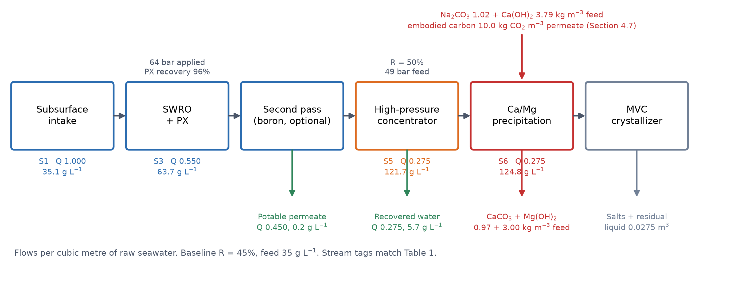
Fig. 1. Process flow diagram of the ILEDBV architecture. Flows and salinities are per cubic meter of raw seawater at the baseline case (R = 45%, feed 35 g L⁻¹), and the stream tags match Table 1. The diagram is the author's conceptual integration of five separately published component technologies rather than a description of an existing installation.
2.1 System boundary
The boundary begins at raw seawater intake and ends at three outputs: potable permeate to municipal supply, solid Mg(OH)₂ and CaCO₃ products, and final crystallizer output. Water distribution, mineral transport and refinement beyond primary precipitation, and civil works are excluded. This analysis adds one term inside the boundary that the first version of this work omitted: the embodied carbon and purchase cost of the precipitation reagents, which Section 4.7 shows to dominate both the carbon and the economic account.
2.2 Subsurface intake
Source water is drawn through a subsurface seabed or beach-well intake rather than an open-ocean pipe, reducing particulate and biological loading and hence pretreatment demand [21,7,1]. The pretreatment energy is swept across the full 0.05–0.80 kWh m⁻³ range reported for intake configurations rather than fixed at a midpoint. The intake is not claimed to eliminate biofouling, and its performance is site dependent on the seabed and aquifer hydraulic conductivity. A subsurface intake also removes the need for the vortex or hydrocyclone preseparation sometimes proposed ahead of the SWRO: the seabed performs that duty, which is part of the rationale for choosing it.
2.3 SWRO, pressure exchanger, and product-water quality
The RO stage is modeled with an isobaric pressure exchanger that recovers energy from the reject brine (Eqs. (6) and (7)), with the PX efficiency swept 90–98% [23,11]. Reviewer comment on the original prompted an explicit treatment of product-water quality. At 45% recovery, the modeled first-pass permeate is approximately 250 mg L−1 TDS and 140 mg L−1 chloride, both of which are comfortably within the potable limits. Boron is the parameter that determines whether a second pass is needed because boric acid is largely unionized at seawater pH and is therefore poorly rejected.
Boron rejection is not a single number: it decreases as elements age and increases with temperature and pH. Across seawater boron concentrations of 4.6–5.5 mg L⁻¹ and a single-pass rejection of 72–88%, which spans new elements in cool water to end-of-life elements at 32 °C, the first-pass permeate boron concentration is 0.55–1.54 mg L⁻¹. That range complies with the WHO guidelines of 2.4 mg L⁻¹ in every case and with the EU directive limit of 1.5 mg L⁻¹ in all but the most severe case, but it straddles the 1.0 mg L⁻¹ figure often written into municipal supply contracts and exceeds a 0.5 mg L⁻¹ irrigation specification in every case.
The requirement for a second pass is therefore conditional rather than absolute, and we state it as such: it is not required to meet the WHO guidelines; it is required at end-of-life conditions against a 1.0 mg L⁻¹ contract specification, and it is required in all cases where the product serves the irrigation of boron-sensitive crops. When fitted, a partial second pass at elevated pH treating 35–100% of the permeate adds 0.16–0.46 kWh m⁻³ and brings boron to 0.03–0.15 mg L⁻¹ from the worst first-pass case, which satisfies every specification considered. The energy comparison in Section 5.1 is reported both with and without it so that the conclusion does not depend on which specification a given project faces.
A gravity-fed second pass, drawn on an elevated cistern rather than a booster pump, was considered and rejected on hydraulic grounds. A 12 bar feed requires 122 m of static head; no coastal municipal site offers it, and the structure required would cost more than the pump it replaces.
2.4 Brine concentration
The RO concentrate is routed to a high-pressure, low-salt-rejection membrane stage, recovering an additional 50% of its water. The original described this stage as nanofiltration. That label is withdrawn: at the rejections assumed (90% monovalent, 98% divalent) and the pressures implied by the feed osmotic pressure, the stage is a high-pressure RO stage. A genuine NF, which would reject perhaps 30% of the monovalent salt, would give a crystallizer feed of 91.3 g L⁻¹ rather than 124.8 g L⁻¹ and a materially different downstream duty.
2.5 Mineral recovery and crystallization
The concentrated brine undergoes selective precipitation, with calcium as CaCO₃ by soda-ash dosing followed by magnesium as Mg(OH)₂ by lime dosing, with the design basis given in Table 4. The residue is routed to a mechanical vapor compression crystallizer, which consumes 8–15 kWh m⁻³ of electrical energy per cubic meter of crystallizer feed [20]. The stage is described throughout as ZLD-capable, by which we mean only that the configuration contains no designed liquid discharge stream, not that zero discharge has been demonstrated. The residual liquid fraction is a modeled quantity without pilot validation, and real leakage, blowdown and operational upsets would raise it. No claim of achieved zero liquid discharge is made anywhere in this work.
3. Mathematical model
Symbols are defined in the Nomenclature. The solution procedure is sequential: Eqs. (1)–(3) close the water and per-ion salt balance for each membrane stage in turn; Eqs. (4)–(5) give the osmotic pressure of each stream; Eqs. (6)–(7) give the RO stage energy; Eqs. (8)–(9) bound the concentrator energy; Eqs. (10)–(12) give the mineral masses and the alkalinity they require; and Eq. (13) gives the levelized cost. No stage is solved before its feed is known; thus, the procedure requires no iteration. The stage water balance and the per-ion permeate and salt balances are, for each membrane stage:
$Q_{\text{p}}\text{ = }R Q_{\text{f}}\text{, }Q_{\text{b}}\text{ = }Q_{\text{f}}\text{ − }Q_{\text{p}}$ (1)
$C_{\text{p,}i}\text{ = }C_{\text{f,}i} \left(\text{1}\text{ − }r_{i}\right)$ (2)
$C_{\text{b,}i}\text{ = }\frac{Q_{\text{f}} C_{\text{f,}i}\text{ − }Q_{\text{p}} C_{\text{p,}i}}{Q_{\text{b}}}$ (3)
Here Q is volumetric flow, C is concentration and r is membrane rejection; the subscripts f, p and b denote the feed, permeate and concentrate of a stage and the index i runs over the ions of Table 1. The osmotic pressure of a stream is taken from a linear model calibrated at seawater salinity, Eq. (4), and from its osmotic-coefficient-corrected form, Eq. (5):
$π\text{ = }\text{27} \frac{\text{TDS}}{\text{35}}$ (4)
$π\text{ = }φ\left(S\right)\text{ × }\text{27} \frac{\text{TDS}}{\text{35}}$ (5)
The applied feed pressure, which includes an allowance for concentration polarization, and the specific energy of the RO stage with isobaric energy recovery are:
$P_{\text{f}}\text{ = }β π_{\text{b}}\text{ + }\text{NDP}$ (6)
${\text{SEC}}_{\text{RO}}\text{ = }\frac{\frac{P_{\text{f}} Q_{\text{f}}}{η_{\text{pump}}}\text{ − }η_{\text{PX}} P_{\text{f}} Q_{\text{b}}}{Q_{\text{p}}}$ (7)
The reversible minimum work of separation for a stage, expressed per cubic meter of feed to that stage, and the actual stage energy obtained from it, are:
$w_{\text{min}}\text{ = }π_{\text{f}} \text{ln}\left[\frac{\text{1}}{\text{1}\text{ − }R}\right]$ (8)
${\text{SEC}}_{\text{stage}}\text{ = }\frac{w_{\text{min}}}{η_{\text{II}}}$ (9)
The masses of the two precipitation products and the alkalinity their recovery requires are:
$m_{\text{CaCO₃}}\text{ = }C_{\text{Ca}} Q_{\text{c}} Y_{\text{Ca}} \frac{M_{\text{CaCO₃}}}{M_{\text{Ca}}}$ (10)
$m_{\text{Mg(OH)₂}}\text{ = }C_{\text{Mg}} Q_{\text{c}} Y_{\text{Mg}} \frac{M_{\text{Mg(OH)₂}}}{M_{\text{Mg}}}$ (11)
$n_{\text{base}}\text{ = }\text{2}n_{\text{Mg}}\text{ + }\text{2}n_{\text{Ca}}$ (12)
The levelized cost of water, net of the mineral credit, is:
$\text{LCOW}\text{ = }\frac{\text{CAPEX}\text{ × }\text{CRF}\text{ + }\text{OPEX}}{V_{\text{annual}}}\text{ − }\frac{R_{\text{minerals}}}{V_{\text{annual}}}$ (13)
Equation (8) is obtained as follows. Removing a differential volume dx of pure water from the unit feed volume leaves the retained salt in a smaller volume, so the concentrate osmotic pressure increases as π(x) = π_{f}/(1 − x) under the van’t Hoff proportionality and complete salt retention. The reversible work is the integral of that rising pressure over the extracted volume, and integrating from 0 to the stage recovery R gives Eq. (8). Three assumptions are embedded and are stated rather than left implicit: complete salt rejection, an infinitely staged or continuously counterbalanced process so that the applied pressure never exceeds the local osmotic pressure, and negligible concentration polarization. Each makes the bound looser, so a real stage must exceed it. The result is expressed per cubic meter of FEED to the stage, which for the brine concentrator is per cubic meter of brine processed—the same basis on which the original energy assumption was quoted, so the two are directly comparable.
Because φ(S) in Eq. (5) is carried as a bounded sensitivity rather than a locked correlation, the specific energy figures reported here are model estimates rather than final values. Section 4.5 shows the residual uncertainty from this source to be under 2% of the total SEC, an order of magnitude smaller than the concentrator correction, so it does not affect any conclusions drawn; however, the distinction is stated so that the numbers are not quoted onward as settled.
This is a reversible benchmark, not a membrane-process energy model. It bounds what any configuration can achieve; it does not predict what a particular element, array or staging arrangement will consume. Second-law efficiency, Eq. (9), carries that distinction explicitly.
The osmotic coefficient of seawater is not constant: it passes through a minimum near seawater salinity and increases as the solution concentrates, so a correlation anchored at 35 g L⁻¹ underpredicts at brine salinities. Published seawater property correlations covering this range are available [22,12] and are the appropriate basis for φ(S) in Eq. (5). Section 4.5 reports how much the correction actually matters.
Equations (5), (8), (9) and (12) were introduced in the preceding revision. Equation (8) is the reversible bound against which the concentrator assumption is tested in Section 4.5; Eq. (12) is the alkalinity balance on which Section 4.7 rests.
4. Results
4.1 Stream table and process composition
Stream | Q | TDS | Na⁺ | Mg²⁺ | Ca²⁺ | K⁺ | Cl⁻ | SO₄²⁻ | HCO₃⁻ | Br⁻
S1 raw seawater | 1.000 | 35.1 | 10.781 | 1.284 | 0.412 | 0.399 | 19.353 | 2.712 | 0.126 | 0.067
S2 RO permeate | 0.450 | 0.2 | 0.075 | 0.004 | 0.001 | 0.003 | 0.136 | 0.008 | 0.001 | 0.001
S3 RO brine | 0.550 | 63.7 | 19.540 | 2.331 | 0.748 | 0.723 | 35.076 | 4.924 | 0.228 | 0.122
S4 concentrator permeate | 0.275 | 5.7 | 1.954 | 0.047 | 0.015 | 0.072 | 3.508 | 0.099 | 0.023 | 0.012
S5 concentrator concentrate | 0.275 | 121.7 | 37.126 | 4.616 | 1.481 | 1.374 | 66.645 | 9.750 | 0.434 | 0.232
S6 crystallizer feed | 0.275 | 124.8 | 38.740 | 0.092 | 7.534 | 1.374 | 66.645 | 9.750 | 0.434 | 0.232
Table 1. Ion-by-ion stream table, g L⁻¹, per cubic meter of raw seawater. S6 is the crystallizer feed.
Two features of Table 1, shown graphically in Fig. 2, were not visible in the original analysis. The calcium concentration increases from 1.48 to 7.53 g L⁻¹ across the precipitation train rather than decreasing, because lime dosing returns one calcium ion per magnesium precipitated. Total dissolved solids also increase, from 121.7 to 124.8 g L⁻¹, because the dissolved reagents added exceed the solids removed. Selective precipitation is therefore justified by the value of its products and not by any reduction in crystallizer duty, which slightly increases. This finding is important because it contradicts a common intuition about brine mineral recovery: extracting solids from the stream does not decrease the thermal load downstream when the reagents that extract them add more dissolved mass than the solids remove. Any assessment that credits precipitation with a reduced crystallizer duty should check this balance for its own reagent set.
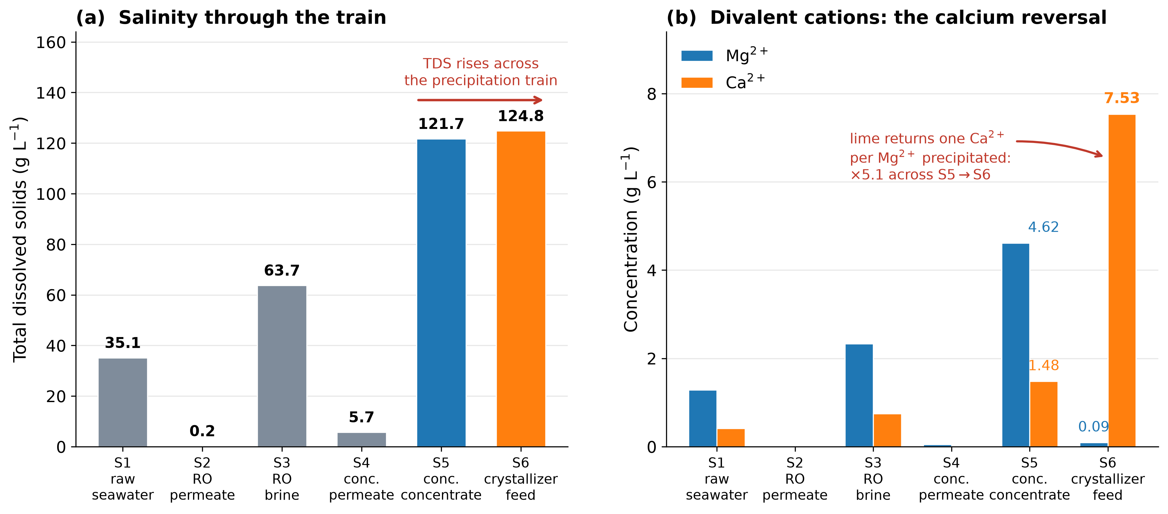
Fig. 2. Stream composition through the process train, plotted from Table 1. (a) Total dissolved solids at each stream; TDS rises from 121.7 to 124.8 g L⁻¹ across the precipitation step, because the dissolved reagents added exceed the solids removed. (b) Magnesium and calcium; magnesium falls from 4.62 to 0.09 g L⁻¹ while calcium rises from 1.48 to 7.53 g L⁻¹, because lime returns one calcium ion per magnesium precipitated.
4.2 Incremental contribution of each subsystem
The five-case decomposition isolates each subsystem’s contribution to specific energy consumption. Case A is a conventional turbine-ERD baseline, Case B substitutes the isobaric pressure exchanger, Case C adds the subsurface intake, Case D adds the brine concentration, and Case E adds crystallization. Table 2 reports the decomposition with the concentrator held to the bounded range of Section 4.5 rather than to the literature midpoint used in the original.
Concentrator basis | kWh m⁻³ brine | Case C | Case D | Case E
original assumption, 0.75 | 0.75 | 2.73 | 3.65 | 10.67
55% second-law efficiency | 1.72 | 2.73 | 4.83 | 11.85
Monte Carlo median | 2.36 | 2.73 | 5.61 | 12.64
25% second-law efficiency | 3.77 | 2.73 | 7.34 | 14.37
Table 2. Stage decomposition, kWh per cubic meter of permeate. Case C is the desalination stage, Case D adds brine concentration, and Case E adds crystallization. The original reported Case E as 10.68 kWh m⁻³.
Crystallization remains the dominant single term in every case, but the concentrator correction moves Case E from the 10.68 kWh m⁻³ originally reported to a modeled 11.85–14.37 kWh m⁻³ (Fig. 3). As elsewhere in this paper, that range is a bounded model estimate rather than a measured or predicted plant value.
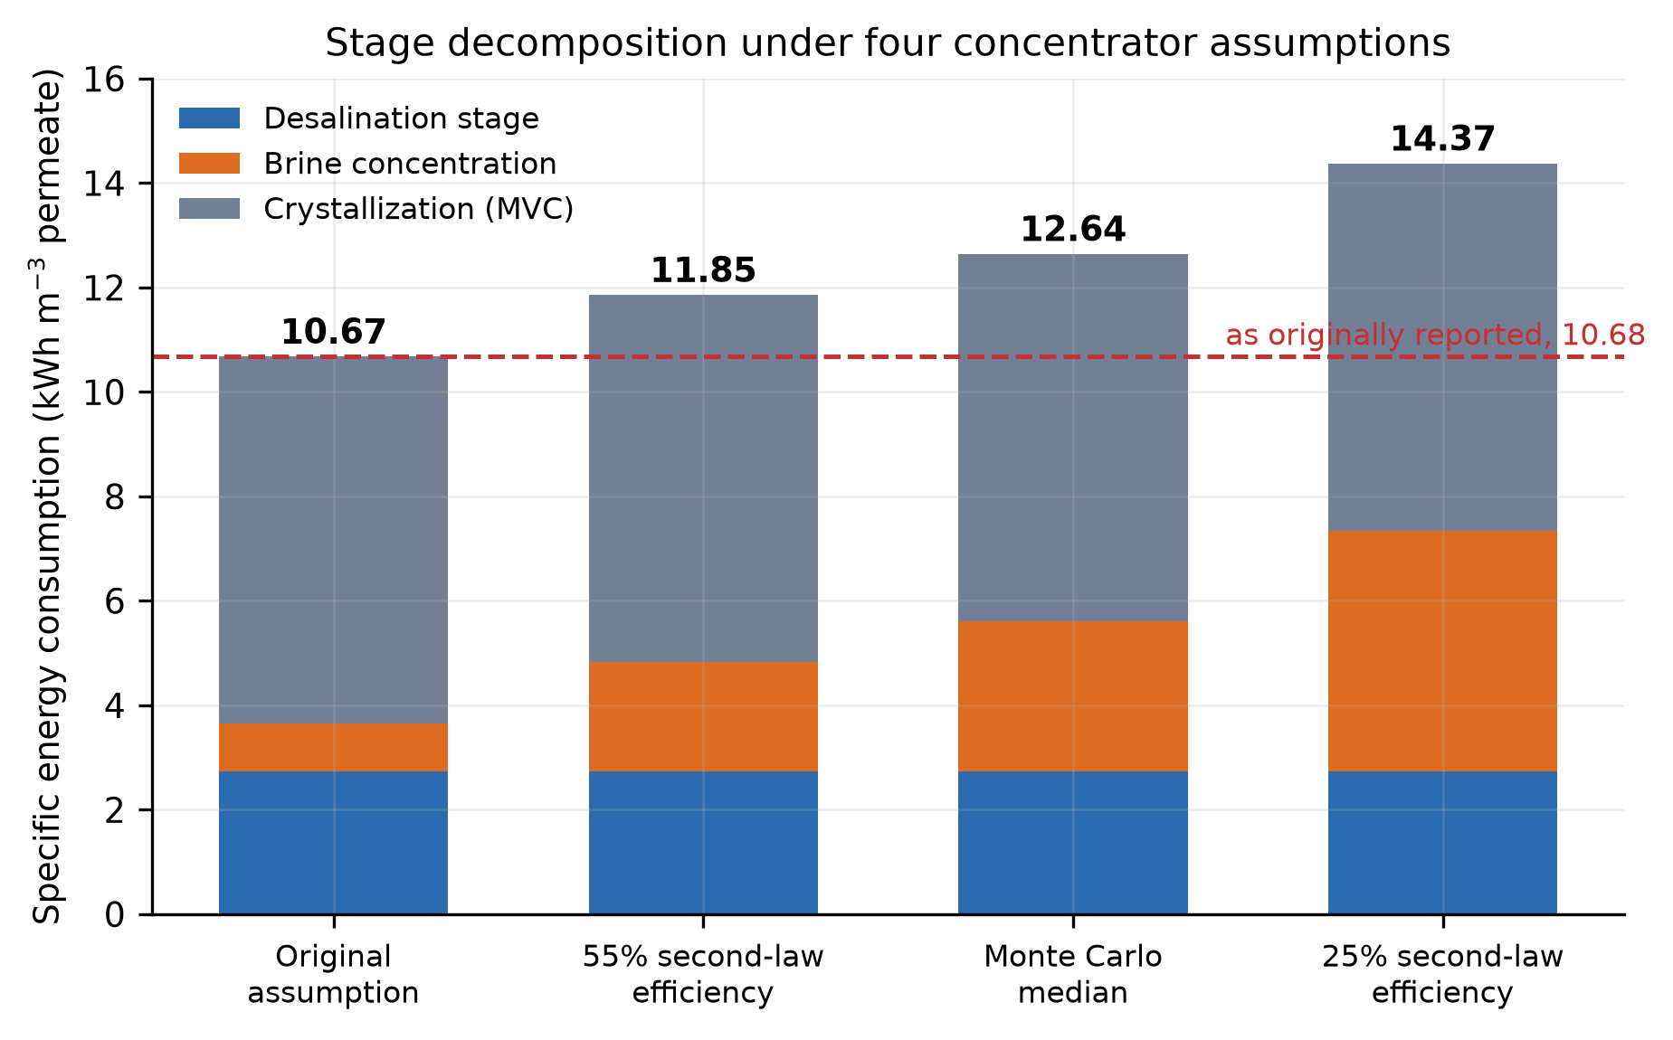
Fig. 3. Stage decomposition of specific energy consumption under four concentrator assumptions, in kWh per cubic meter of permeate. The dashed line is the total of 10.68 kWh m⁻³ reported in the original version. Every value is a bounded model estimate rather than a measured plant value.
4.3 Market absorption
The original included a market absorption check to test whether the recovered tonnage could in fact be sold, and that check stands: a 10,000 m³ d⁻¹ plant would produce a material fraction of the addressable Mg(OH)₂ market, so a sellable fraction well below unity is the realistic assumption rather than a conservative one. The revision extends the same reasoning to calcium carbonate, which the original credited at 100% of the market price. Recovered carbonate competes against a large, low-margin commodity whose specification depends on purity, particle size and brightness, none of which is controlled by a process optimized for water. A sellable fraction of 50–70% is used here, sampled rather than fixed, and transport and refining beyond primary precipitation remain outside the boundary and therefore uncredited.
4.4 Environmental performance
The original environmental assessment considered carbon dioxide from grid electricity only. On the corrected energy basis, the term is approximately 5.2 kg CO₂ per cubic meter of permeate at a grid intensity of 0.4 kg kWh⁻¹. Section 4.7 shows that it is the smaller half of the account: reagent-embodied carbon adds 10.0 kg m⁻³, and the carbonate product fixes only 0.94 kg m⁻³, yielding a net median of 14.3 kg CO₂ per cubic meter (90% interval 10.7–18.2). No sampled configuration is carbon negative. Replacing MVC crystallization with solar interfacial evaporation [4,5,6] would remove most of the electricity term but none of the reagent term, and would substitute land area for energy.
Two environmental risks specific to intake are noted rather than modeled. Subsurface intakes are subject to progressive clogging of the seabed or aquifer interface, and sustained abstraction near the coast carries a risk of saline intrusion into adjacent fresh groundwater. Both are strongly site dependent and require hydrogeological assessment at any candidate location.
4.5 Consistency test 1: Concentration against the least work of separation
Integrating the rising concentrate osmotic pressure over the extracted volume gives Eq. (8). At the modeled RO brine (49 bar) and 50% concentrator recovery this evaluates to 0.944 kWh per cubic meter of brine processed. Any real stage must exceed it. The 0.5–1.0 kWh m−3 range adopted in the original version of this work, and in comparable published assessments, spans 0.53 to 1.06 times this minimum: the midpoint is thermodynamically inadmissible, and the upper bound would require a second-law efficiency of 94%. Dividing the reversible minimum by the 25–55% second-law efficiency range characteristic of high-pressure membrane stages gives a bounded estimate of 1.72–3.77 kWh m−3 (Fig. 4). We describe this as a bounded estimate rather than an attainable or demonstrated value: it is derived from a thermodynamic bound and an assumed efficiency range, not from measurement of a stage operating on this feed. All the results below use that range.
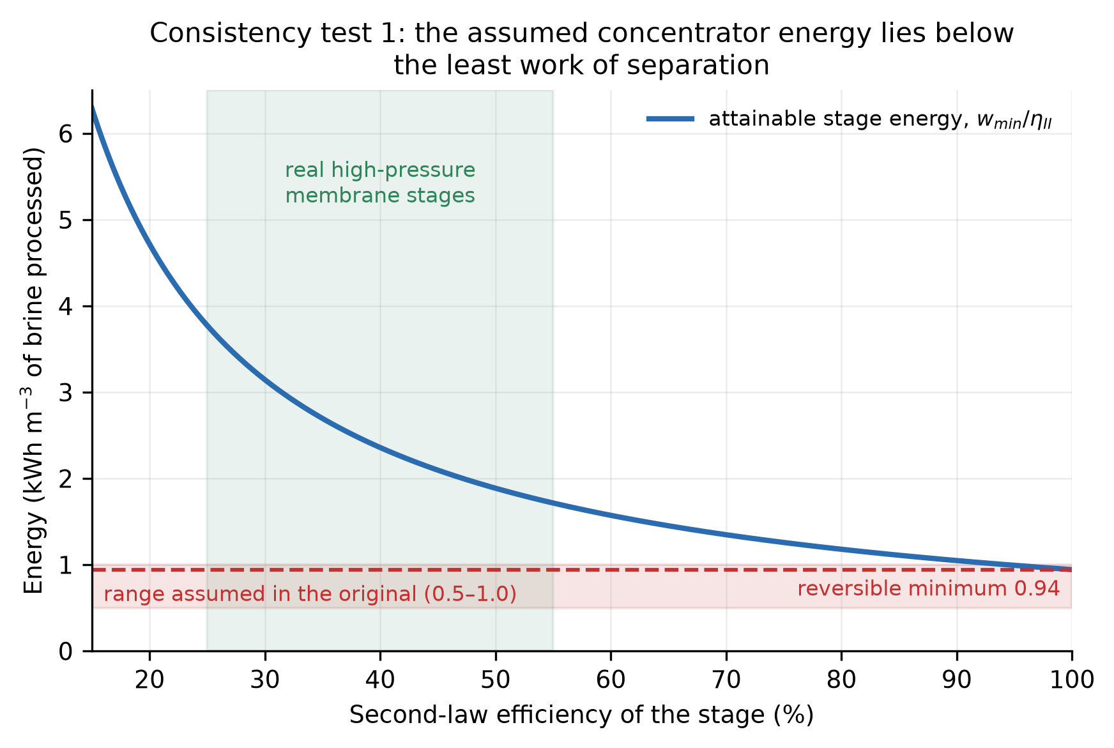
Fig. 4. Consistency test 1. Attainable brine-concentrator energy, w_{min}/η_{II,} against the second-law efficiency of the stage. The reversible minimum for the modeled feed is 0.94 kWh per cubic meter of brine processed; the 0.5-1.0 kWh m⁻³ range assumed in the original lies at or below it, and its upper bound would require a second-law efficiency of 94%.
Reviewer comment on the original asked that the deviation of the linear osmotic model at brine salinity be quantified rather than acknowledged. Applying an increase in the osmotic coefficient of 8–24% between 35 and 120 g L⁻¹ increases the concentrator feed osmotic pressure from 49.0 to 50.3–52.9 bar and the stage energy from 2.36 to 2.42–2.55 kWh m⁻³ of brine, moving the total specific energy consumption from 12.64 to 12.87 kWh m⁻³, evaluated deterministically at the median concentrator duty rather than as a distribution median. The effect is therefore real but second-order, under 2% of the total SEC, and an order of magnitude smaller than the concentrator correction above. It is reported here as a bounded sensitivity; locking it to a point value requires implementing the published correlation [22,12], which the deposited code is structured to accept.
4.6 Consistency test 2: The ceiling on boundary-layer management
Concentration polarization increases the wall concentration to β times the bulk, so eliminating it entirely saves exactly (β - 1) π_{bulk} and no more. At an aggressive β of 1.20, this ceiling is 0.39 kWh m⁻³, or 13.3% of the desalination-stage SEC. Any rotating-element or centrifugal scheme must therefore consume less than 0.39 kWh m⁻³ of net shaft power, after seal and bearing losses, to be worth adopting. We offer this as a screening test rather than a recommendation.
4.7 Consistency test 3: alkalinity, carbon and calcium closure
Precipitating Mg(OH)₂ requires two equivalents of base per mole of product; however, the base is supplied (Eq. (12)). Table 3 and Fig. 5 show four routes on a common basis of one cubic meter of permeate.
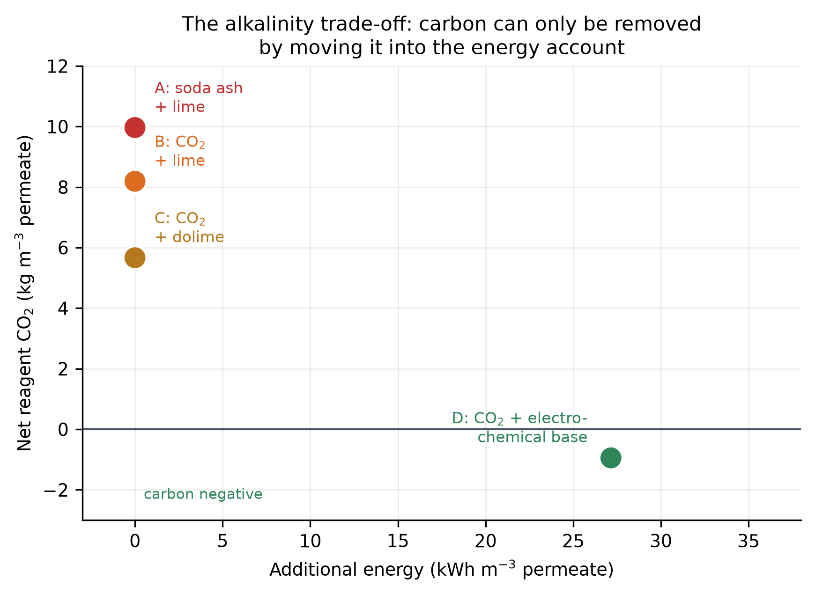
Fig. 5. Consistency test 3. Net reagent carbon against additional energy demand for the four alkalinity routes of Table 3, per cubic meter of permeate. The reagent carbon burden can be removed only by moving it into the energy account.
Alkalinity route | Reagent CO₂ (kg/m³) | Ca released/removed | Mg imported (kg/m³) | Extra energy (kWh/m³)
A: soda ash + lime (as written) | 9.97 | 5.3 × | 0.00 | 0.0
B: dosed CO₂ + lime | 8.19 | 6.3 × | 0.00 | 0.0
C: dosed CO₂ + dolime | 5.67 | 3.7 × | 3.33 | 0.0
D: dosed CO₂ + electrochemical base | −0.94 | 0.0 × | 0.00 | 27.1
Table 3. Alkalinity routes per cubic meter of permeate. Embodied-carbon factors are swept in the Monte Carlo method rather than treated as point values.
The calcium closure can be read directly from Table 1 and follows from Eq. (12). Writing concentrations per cubic meter of concentrate, the carbonate step removes Y_{Ca} × C_{Ca} = 1.407 g L⁻¹, whereas the lime step, supplying the two equivalents of base that Eq. (12) requires, releases one calcium ion per magnesium precipitated and therefore adds 7.460 g L⁻¹. The calcium reported to the crystallizer is therefore 1.481 − 1.407 + 7.460 = 7.534 g L⁻¹, which is exactly the S6 value in Table 1. Because seawater holds approximately three times more magnesium than calcium on a molar basis, the added term always exceeds the removed term, and the balance cannot be closed by any choice of precipitation yield.
The route as specified involves 9.97 kg of CO₂ per cubic meter of permeate in reagent-embodied carbon against 0.94 kg fixed in the carbonate product and approximately double the plant’s grid emissions. An environmental assessment restricted to electricity accounts for approximately one-third of the total. Therefore, the calcium balance does not close: the lime step returns 5.3 times more calcium than the carbonate step removed, and that calcium reports to the crystallizer rather than to a product. Calcined dolomite reduces the imbalance to 3.7 times at the cost of importing 3.33 kg of the magnesium product per cubic meter, which weakens the recovery claim even as it improves the balance. The carbon burden can be removed only by moving it into the energy account: an electrochemical base makes the reagent term slightly negative at −0.94 kg CO₂ per cubic meter but adds 27 kWh m⁻³.
The embodied-carbon factors for soda ash and lime are taken from life-cycle inventory ranges rather than from a single primary measurement and are swept rather than fixed. The conclusion does not depend on where in those ranges the true values lie: at the combination most favorable to the process, the lowest reagent factor with the cleanest grid—reagent carbon—is 7.6 kg CO₂ m⁻³ against 2.0 kg m⁻³ from electricity, and at every other combination tested, the margin is wider. The reagent term is dominant across the full plausible range.
4.8 Precipitation design basis
Parameter | Value | Basis
Carbonate reagent | Na₂CO₃, 1.023 kg per m³ feed | 1.0 mol per mol Ca, 10% excess
Alkalinity reagent | Ca(OH)₂, 3.792 kg per m³ feed | 1.0 mol per mol Mg, 10% excess
CaCO₃ recovered | 0.966 kg per m³ feed | 95% yield
Mg(OH)₂ recovered | 2.985 kg per m³ feed | 98% yield
Residence time | 30 min carbonate, 45 min hydroxide | seawater practice
Reactor volume per 1000 m³/d feed | 5.7 and 8.6 m³ | residence time × concentrate flow
Solid‒liquid separation | gravity thickener followed by filter press | assumed
Cake solids | CaCO₃ 65%, Mg(OH)₂ 45% | Mg(OH)₂ dewaters poorly
Product purity | set by the NaCl background | see [9,17]
Table 4. Precipitation design basis.
4.9 Operating cost and uncertainty propagation
Item | $ per m³ permeate
Electricity | 1.049
Precipitation reagents | 1.580
Pretreatment and CIP chemicals | 0.030
Membrane replacement (RO + concentrator) | 0.040
Cartridge filters and consumables | 0.010
Labor | 0.045
Maintenance and spares (2% CAPEX/yr) | 0.055
Insurance and overhead | 0.020
Solids handling and product logistics | 0.035
TOTAL OPEX | 2.864
Table 5. OPEX breakdown at $0.08 kWh⁻¹ and the median modeled SEC.
Cost element | Conventional SWRO ($0.76 m⁻³) | ILEDBV
Intake and pretreatment | yes | yes
High-pressure pumping and RO | yes | yes
Energy recovery device | turbine ERD | isobaric PX
Posttreatment | yes | yes
Boron-compliant second pass | yes | yes (added in revision)
Brine outfall/discharge | yes | not applicable (no outfall)
Brine concentration | no | yes
Precipitation and solids handling | no | yes
Crystallization | no | yes
Mineral revenue credit | no | yes
Table 6. Cost boundary comparison. The two levelized costs compared in the original did not cover the same scope; comparisons in this paper are made element by element on this table.
The parameters the consistency tests identify as governing were propagated by Monte Carlo with 300,000 samples (seed 20260919), sampling concentrator second-law efficiency, crystallizer energy, intake energy, electricity and reagent prices, CAPEX uplift, sellable fractions and prices for both minerals, reagent embodied carbon and grid carbon intensity. Every parameter is sampled from an independent uniform distribution over the interval given in Table 7, the mineral price multiplier being drawn separately for each of the two products, so that the thirteen rows of that table correspond to fourteen independently sampled quantities; uniform sampling is used deliberately, since for most of these quantities, the literature supports a plausible range but not a shape. The results are summarized in Table 8 and Fig. 6.
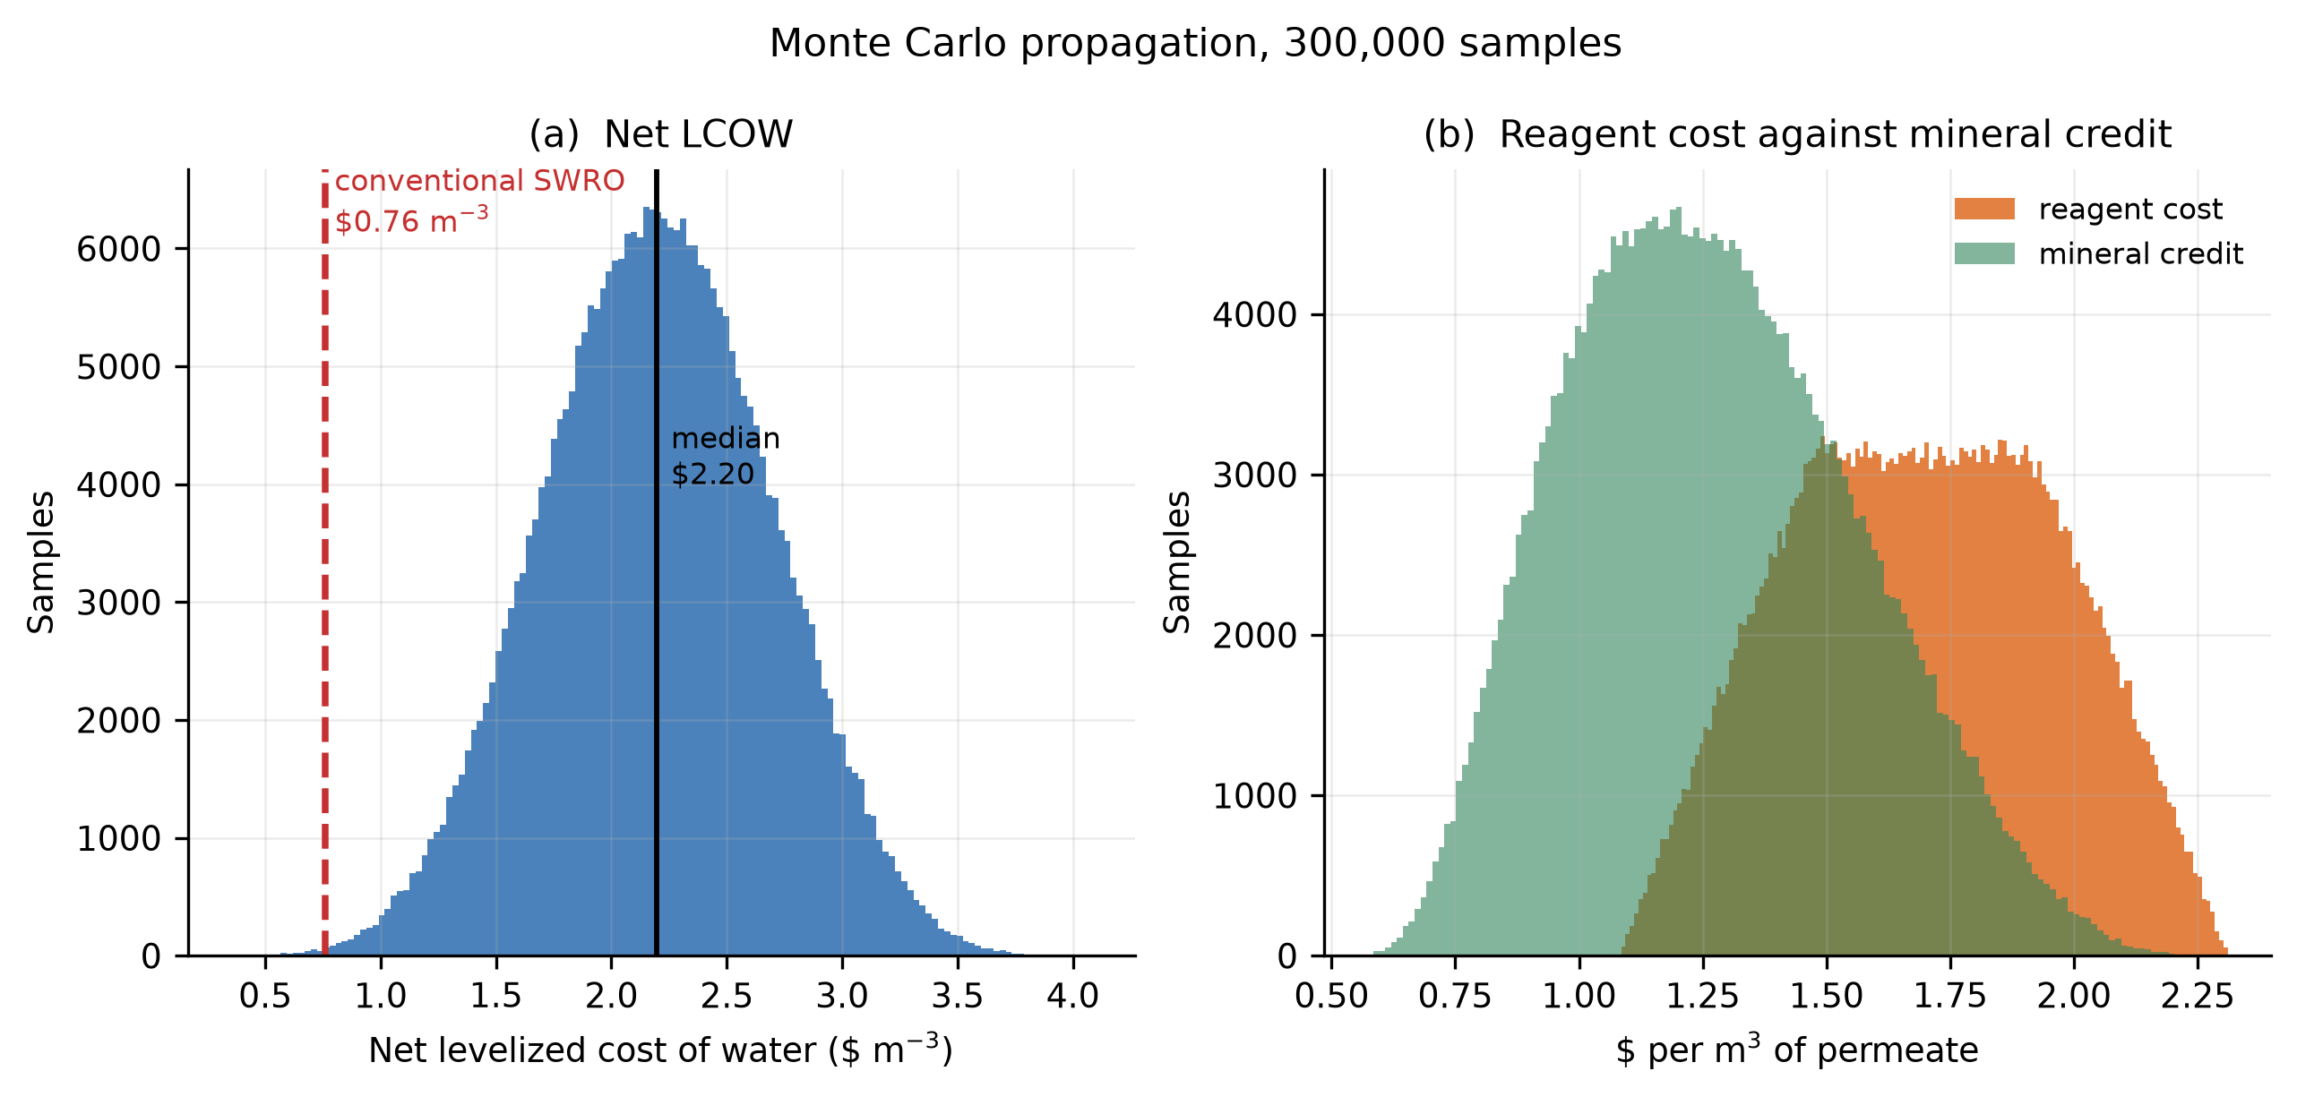
Fig. 6. Monte Carlo propagation over fourteen uncertain parameters, 300,000 samples, seed 20260919. (a) Distribution of net levelized cost of water against the conventional SWRO comparator. (b) Reagent cost and realizable mineral credit on a common axis.
Sampled parameter | Lower | Upper | Unit | Basis
Concentrator second-law efficiency | 0.25 | 0.55 | - | range for high-pressure membrane stages
Crystallizer energy | 8 | 15 | kWh m⁻³ feed | MVC literature [20]
Intake and pretreatment energy | 0.05 | 0.80 | kWh m⁻³ | full reported intake range
Electricity price | 0.05 | 0.12 | $ kWh⁻¹ | industrial tariff range
Soda ash price | 0.18 | 0.35 | $ kg⁻¹ | bulk industrial
Hydrated lime price | 0.08 | 0.18 | $ kg⁻¹ | bulk industrial
CAPEX uplift for valorization | 0.20 | 0.60 | - | assumption, per reviewer request
CaCO₃ sellable fraction | 0.50 | 0.70 | - | purity and market constraints
Mg(OH)₂ sellable fraction | 0.05 | 0.20 | - | market-absorption check, Section 4.3
Mineral price multiplier | 0.70 | 1.30 | - | applied separately to each product
Soda ash embodied carbon | 0.80 | 1.30 | kg CO₂ kg⁻¹ | LCA inventory range
Lime embodied carbon | 0.90 | 1.50 | kg CO₂ kg⁻¹ | calcination plus fuel
Grid carbon intensity | 0.15 | 0.65 | kg CO₂ kWh⁻¹ | spans low-carbon to coal grids
Table 7. Monte Carlo sampling ranges. All distributions are uniform and independent; the seed is recorded so that the draw is reproducible.
Quantity | Median | 5th percentile | 95th percentile | Unit
Concentrator energy | 2.358 | 1.763 | 3.558 | kWh m⁻³ brine
Total SEC | 13.11 | 10.798 | 15.482 | kWh m⁻³ permeate
Reagent OPEX | 1.697 | 1.264 | 2.131 | $ m⁻³
Total OPEX | 3.04 | 2.4 | 3.715 | $ m⁻³
Gross LCOW | 3.462 | 2.82 | 4.14 | $ m⁻³
Mineral credit | 1.252 | 0.834 | 1.779 | $ m⁻³
Net LCOW | 2.198 | 1.383 | 3.01 | $ m⁻³
Net CO₂ | 14.324 | 10.691 | 18.228 | kg m⁻³ permeate
Table 8. Monte Carlo results, 300,000 samples.
The earlier version of this analysis treated nonenergy operating cost as a share of energy cost, which concealed the dominant term. Costed explicitly (Table 5), the precipitation reagents come to a median of $1.70 per cubic meter of permeate against a median realizable mineral credit of $1.25 (Fig. 7). The soda ash and lime required to precipitate the two products cost more than the products are worth. Of the 300,000 sampled combinations of prices, sellable fractions and capital assumptions, 271 (0.09%) produced a net cost below the conventional comparator, the most favorable reaching $0.35 m−3. The architecture is therefore not categorically more expensive; it is competitive only in a small corner of the sampled space, which Section 4.11 locates. No sampled configuration is carbon negative; Figure 8 separates the carbon account into its electricity and reagent terms across the range of grid intensity. The comparator itself requires definition: the $0.76 m−3 figure is a levelized cost for a conventional SWRO plant covering intake, pretreatment, high-pressure pumping with energy recovery, posttreatment, brine outfall, membrane replacement, labor, maintenance and annualized capital at the same 6% discount rate and 20-year life used here. It excludes distribution and excludes any valorization train. Table 6 shows the two boundaries side by side, and the comparison in this paper is made on that table rather than between headline figures.
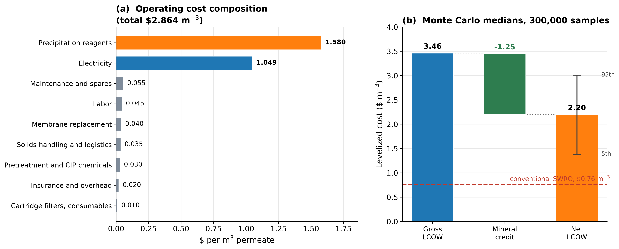
Fig. 7. Cost structure. (a) Operating-cost composition from Table 5, evaluated at $0.08 kWh⁻¹ and the median modeled SEC; the precipitation reagents, not electricity, are the largest single line. (b) Monte Carlo medians from Table 8: gross levelized cost, mineral credit and net levelized cost, with the 5th-95th percentile interval on the net value and the conventional SWRO comparator.
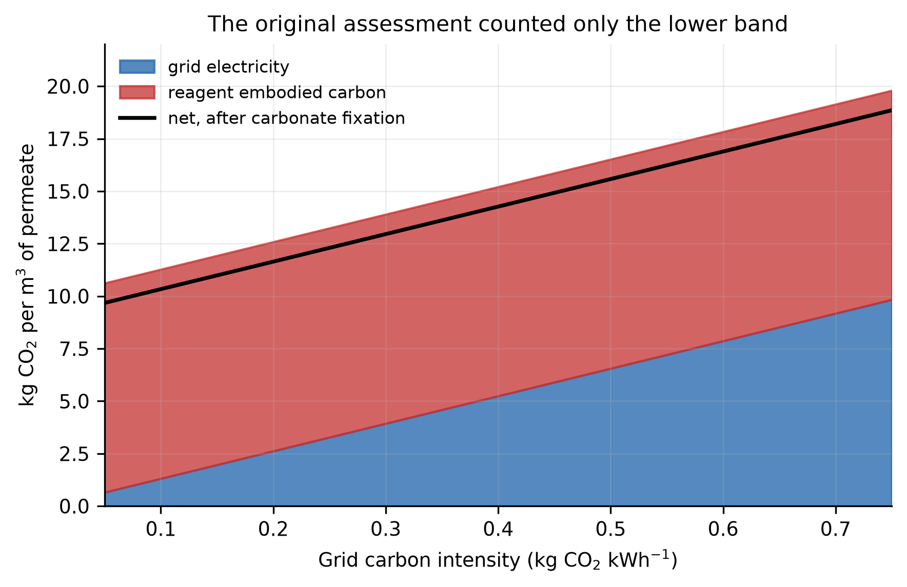
Fig. 8. Carbon account per cubic meter of permeate against grid carbon intensity, separated into grid electricity and reagent embodied carbon, with the net value after carbonate fixation. The original assessment counted only the electricity band.
4.10 Which correction reverses the conclusion
The revision reverses the original economic conclusion, but the original conclusion contains two independent errors, and the analysis thus far does not say which is responsible. Each correction is turned on in sequence, with every other parameter at its median, to separate them (Table 9, Fig. 9A).
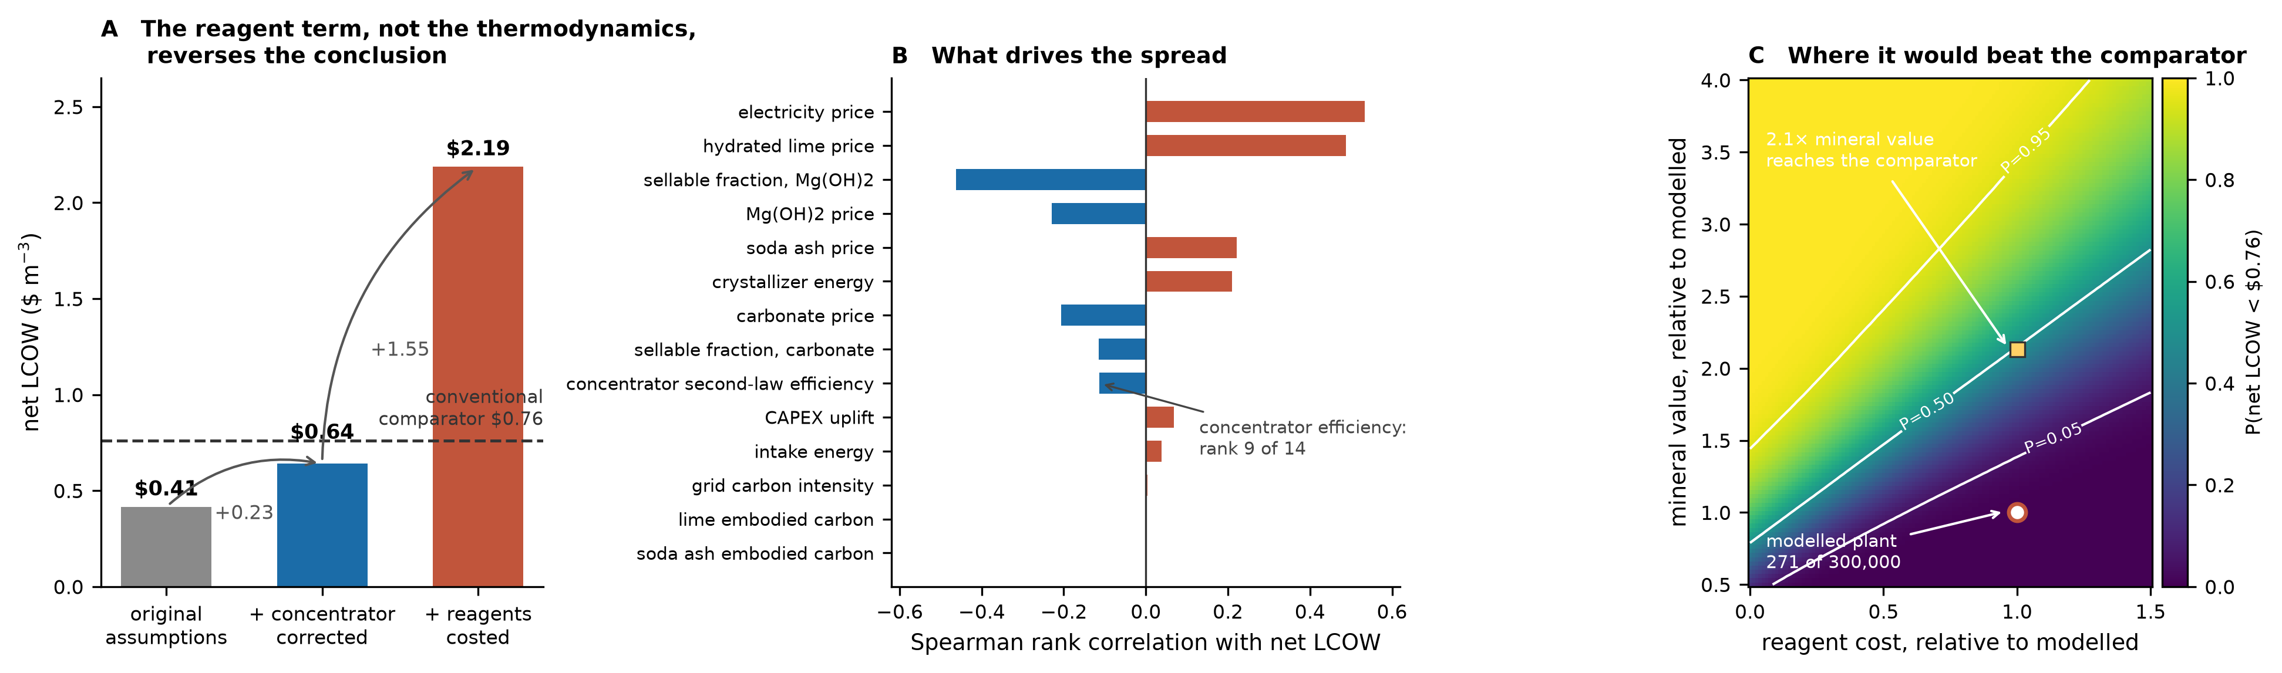
Fig. 9. Attribution of the economic reversal. (A) Ablation of the two corrections, each turned on in sequence with all other parameters at their median. (B) Spearman rank correlation of each sampled parameter with net LCOW. (C) Probability that net LCOW falls below the comparator over the plane of reagent cost and mineral value, both relative to the values modeled here.
Configuration | SEC (kWh m⁻³) | Net LCOW ($ m⁻³) | Change ($ m⁻³)
Original assumptions | 11.00 | 0.41 | -
Concentrator corrected to the thermodynamic bound | 12.96 | 0.64 | +0.23
Reagents costed explicitly | 12.96 | 2.19 | +1.55
Table 9. Ablation of the two corrections. Each row adds one correction to the row above, and all the other parameters are held at their median. The conventional comparator is $0.76 m⁻³.
This result is not what this paper’s emphasis implies. Correcting the concentrator to the thermodynamic bound increases the modeled cost by $0.23 m⁻³ and leaves the architecture at $0.64 m⁻³, which is still below the $0.76 m⁻³ comparator. What reverses the conclusion is costing the precipitation reagents explicitly, worth $1.55 m⁻³, or 6.8 times the thermodynamic correction. Consistency test 1 establishes that the original concentrator specification was thermodynamically inadmissible, which is a statement about physical possibility and stands on its own merits; however, the economic reversal is carried almost entirely by consistency test 3. Alkalinity, not thermodynamics, is what makes this architecture uncompetitive, and the title of this paper should be read accordingly.
4.11 Parameter attribution and the admissibility domain
Two questions follow: which sampled parameter governs the spread in net cost, and whether any region of the parameter space is competitive. Table 10 ranks the sampled parameters by Spearman rank correlation with net LCOW, together with the swing each commands between the lowest and highest deciles of its own range (Fig. 9B). Rank correlation is used because the cost model is not linear in every input.
Parameter | Spearman ρ | Swing ($ m⁻³)
electricity price | +0.534 | 0.822
hydrated lime price | +0.488 | 0.759
sellable fraction, Mg(OH)₂ | −0.463 | 0.725
Mg(OH)₂ price | −0.229 | 0.364
soda ash price | +0.222 | 0.348
crystallizer energy | +0.210 | 0.333
carbonate price | −0.207 | 0.326
sellable fraction, carbonate | −0.115 | 0.183
Table 10. The eight parameters most strongly associated with net LCOW, of the fourteen sampled.
Two of the three leading parameters, hydrated lime price and the sellable fraction of Mg(OH)₂, belong to the alkalinity chain, which is the conclusion the ablation reaches by a different route. The concentrator second-law efficiency, the quantity this paper analyzes most closely, ranks ninth of those fourteen with ρ = −0.114. That is not a contradiction. The thermodynamic argument determines whether the original specification was admissible at all, a question no cost sensitivity can answer, while contributing little to the cost spread once a physically admissible range is imposed. Sensitivity and admissibility are different questions and are reported here separately.
The probability that net LCOW falls below the comparator over the plane of reagent cost and mineral value, both relative to the values modeled here, is shown in Fig. 9C. The modeled operating point lies deep in the inadmissible region. Reaching the comparator at present reagent prices requires the recovered minerals to be worth 2.1 times the value assumed here; were the reagent requirement eliminated entirely, 0.8 times would suffice. These are the two available levers, and their magnitudes are the specification any future version of this architecture would have to meet. Neither is reached by improving the concentrator.
4.12 Unbinding the constraint: electrochemical alkalinity supply
Sections 4.10 and 4.11 establish that the alkalinity requirement, not the concentrator, is what makes this architecture uncompetitive. That is a statement about how the base is supplied, not about the architecture as such. The stoichiometry is fixed—two equivalents per mole of Mg(OH)₂ however the base arrives—but the supply route is a design choice, and Section 4.7 evaluated four of them. Route D, in which base is generated electrochemically on site and captured CO₂ is dosed as the carbonate source, changes the binding constraint rather than relaxing it.
Three consequences follow, and they are of different types. Stoichiometrically, no lime is added; thus, no calcium is released, and the closure ratio decreases from 5.33 to 0.00, indicating that the calcium balance is exactly closed. In terms of carbon, the only reagent is captured CO₂, which ends up bound in the carbonate product; thus, reagent carbon becomes −0.94 kg CO₂ per cubic meter against +9.97 for the purchased-alkali route. Economically, the reagent bill of $1.70 m⁻³ is replaced by 27.1 kWh m⁻³ of electrochemical demand, increasing the modeled total specific energy consumption from 13.1 to 40.3 kWh m⁻³.
That substitution converts a commodity price into an energy price, and the two do not behave alike. Solving for the electricity price at which the two routes cost the same gives $0.061 kWh⁻¹; below it, an electrochemical supply is less expensive. Solving for the price at which route D reaches the conventional comparator gives $0.033 kWh⁻¹ (Fig. 10A). The purchased-alkali route has no such crossing: at zero electricity cost, it still sits at $1.10 m⁻³, which is $0.34 above the comparator, because the gap is reagents, capital and fixed operating cost net of the mineral credit rather than energy. No electricity price rescues route A; route D competes below a price that several desalination regions already contract.
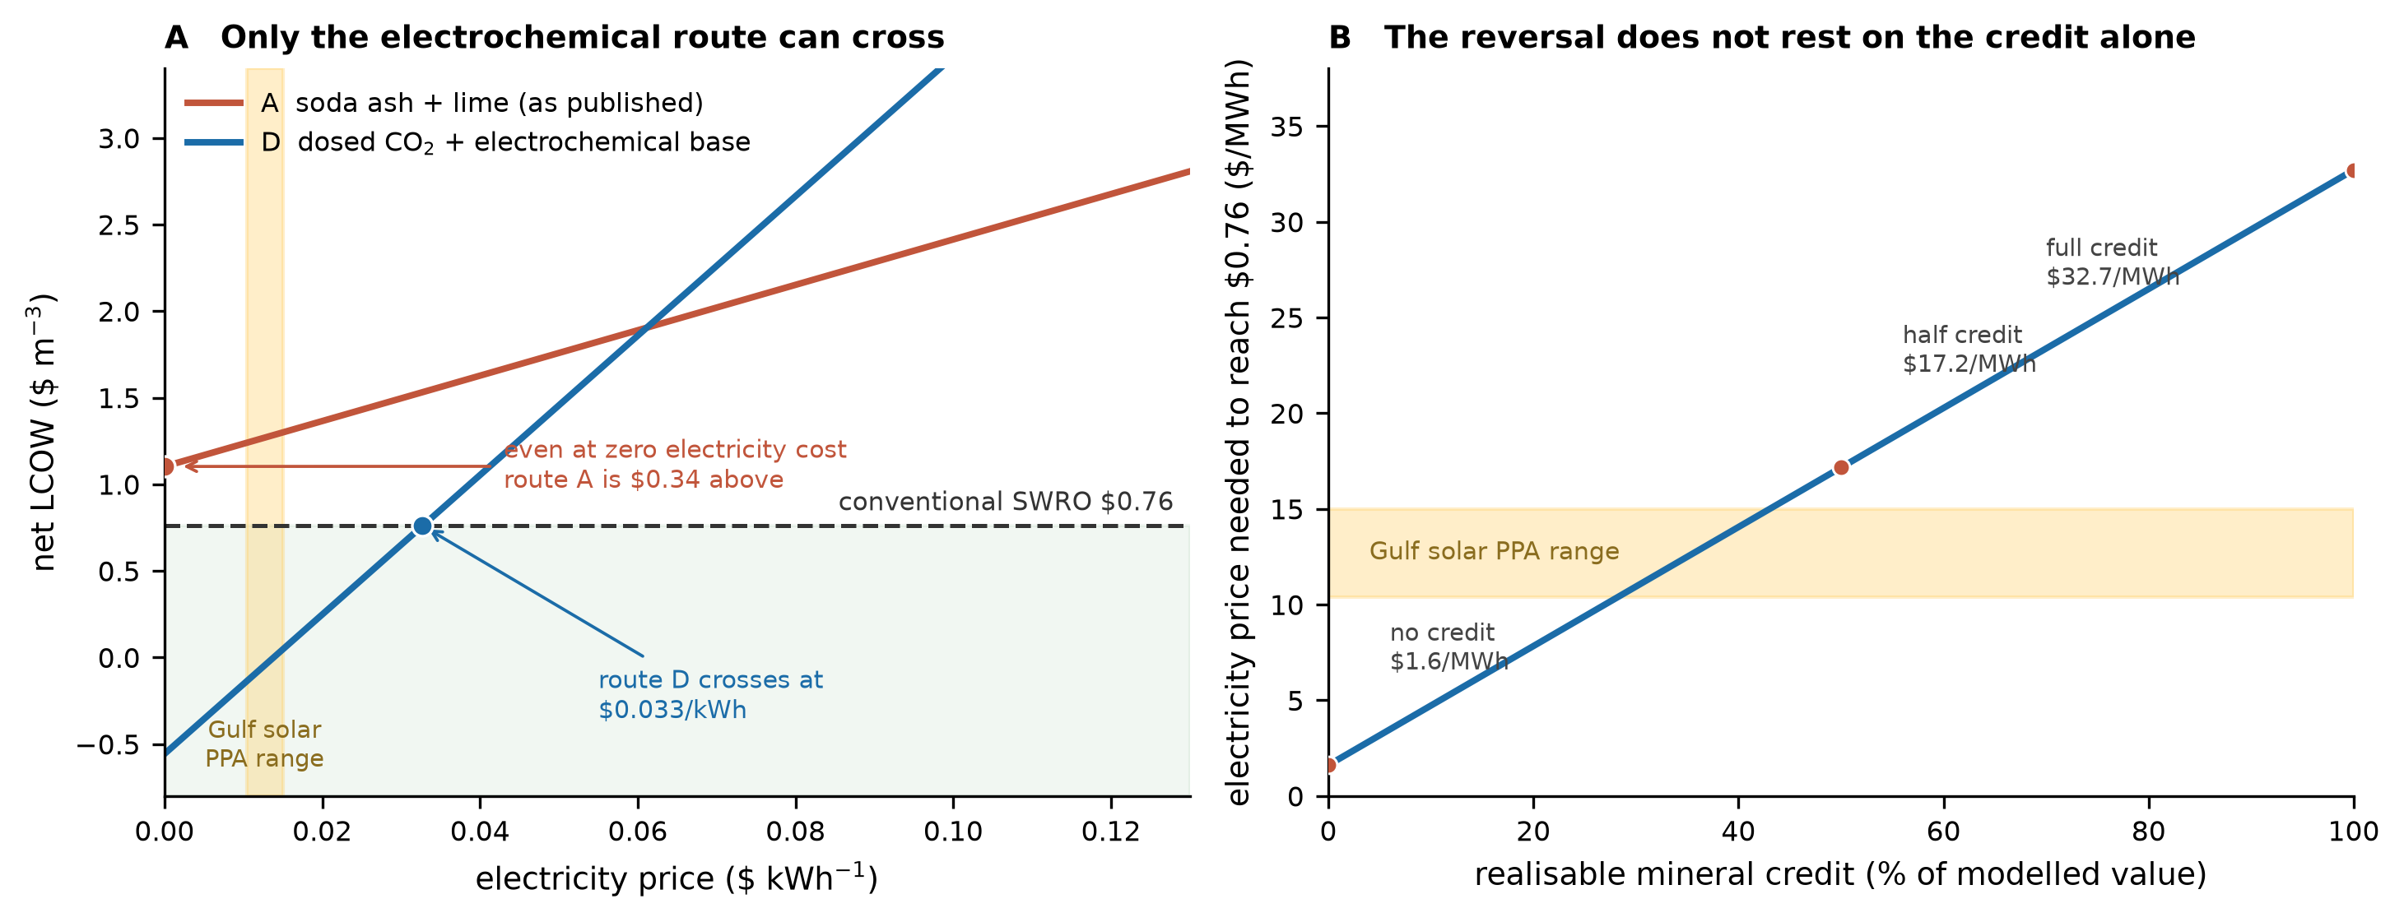
Fig. 10. Unbinding the alkalinity constraint. (A) Net levelized cost against electricity price for the purchased-alkali route A and the electrochemical route D; only route D crosses the conventional comparator. (B) Electricity price at which route D reaches the comparator, as a function of the realizable mineral credit.
The conclusion does not rest on the mineral credit. Recomputing the crossing at reduced credit gives $0.0172 kWh⁻¹ at half the modeled value and $0.0016 kWh⁻¹ with no mineral revenue at all (Fig. 10B); the credit changes where the line sits, not whether it exists.
Two conditions bound the result, and both are stated rather than assumed. The electricity must be cheap, which is the crossing above, and it must also be clean for a separate reason. Drawing 40.3 kWh m⁻³ from a grid at 0.55 kg CO₂ kWh⁻¹ yields +21.2 kg CO₂ m⁻³, which is worse than that of the purchased-alkali route at +16.2. With respect to the solar-dominated supply at 0.05 kg CO₂ kWh⁻¹, the same pattern is +1.07 kg m⁻³, against +9.68 for the purchased-alkali route on the same supply. Route D is therefore a proposition about dedicated low-carbon generation rather than about grid connection, and in a region with expensive or carbon-intensive power, it is worse than conventional SWRO on both axes.
Finally, one cost is absent from all the above. An electrochemical unit generating approximately 11 kg of base per cubic meter of permeate is an industrial installation with a capital cost that this model has no basis to estimate, and the chlorine coproduced by a chlor-alkali route is neither costed as a liability nor credited as a product. The figures in this section are therefore an upper bound on route D’s performance, and obtaining a vendor quotation is the first thing a serious evaluation of it would do.
4.13 Alkalinity and calcium as one design problem
Sections 4.7 and 4.12 evaluated alkalinity routes one at a time and reported the calcium balance of each as a consequence of the route. The two are coupled. Every mole of hydroxide supplied as Ca(OH)₂ imports half a mole of calcium, and the cheapest base per mole is also the one that imports it. This section therefore treats base supply, carbonate supply and calcium removal as a single linear program per cubic meter of permeate, Eq. (14), and asks two questions: what it costs to close the calcium balance, and what an on-site base source would have to achieve for the closed loop to reach the conventional comparator.
$\text{min} C_{\text{alk}}\text{ + }C_{\text{energy}}\text{ + }C_{\text{disposal}}\text{ − }C_{\text{products}}$ (14)
subject to
$x_{\text{L}}\text{ + }x_{\text{N}}\text{ + }x_{\text{E}}\text{ − }\text{2}d\text{ ≥ }\text{2}n_{\text{Mg}}$
$s\text{ + }d\text{ = }n_{\text{Ca}}$
$\frac{x_{\text{L}}}{\text{2}}\text{ − }n_{\text{Ca}}\text{ − }g\text{ ≤ }{\text{ΔCa}}_{\text{max}}$
$g\text{ ≤ }f_{\text{gyp}} n_{\text{SO₄}}$
$\text{SEC}\text{ ≤ }{\text{SEC}}_{\text{target}}$
$\text{CO₂}\text{ ≤ }{\text{CO₂}}_{\text{target}}$
Hydroxide may be supplied as Ca(OH)₂ (x_{L}), as purchased NaOH (x_{N}) or by on-site electrochemical generation (x_{E}); carbonate for the calcium step as Na₂CO₃ (s) or as dosed captured CO₂ (d), which requires two further equivalents of base per mole. A third calcium sink is added that the original sequence did not use: after the hydroxide step, the calcium-rich stream is brought to gypsum saturation so that the imported calcium leaves as CaSO₄·2H₂O (g) instead of reporting to the crystallizer. Its capacity is fixed by the sulfate the feed brings, 2.712 g kg⁻¹ at S = 35 [26], or 64.3 mol per cubic meter of permeate; the fraction recoverable against the residual solubility of gypsum in concentrated NaCl brine is not modeled and is carried as f_{gyp} = 0.70, swept from 0.5 to 0.9. The disposal term is left at zero and the calcium balance is imposed as the constraint ΔCa ≤ 0 instead, so that its shadow price reports what closure costs. Soda ash and lime prices are the midpoints of the ranges in Table 7, and their embodied carbon is taken at the point values behind Table 3; captured CO₂ is taken at $40 t⁻¹, the basis of route D's reagent cost in Section 4.12; purchased NaOH is taken at $0.45 kg⁻¹, swept from $0.30 to $0.70, with 1.9 kg CO₂ kg⁻¹ embodied. The on-site source is characterized by a single number, its yield in moles of OH⁻ per kWh, which places chlor-alkali, bipolar-membrane and other electrochemical routes on one axis regardless of chemistry. As in Section 4.12, the capital cost of the electrochemical unit and the value or liability of its acid or chlorine coproduct are excluded, so every on-site result below is a lower bound on cost.
Per mole of base, the three sources order differently in money and in carbon (Fig. 11A). Lime costs $4.82 per kmol of OH− and carries 33.6 kg CO₂; purchased NaOH costs $18.00 and carries 76 kg CO₂; the on-site source at the chlor-alkali basis of Section 4.12, 10 mol kWh−1, costs $8.00 at $0.08 kWh−1 and $1.50 at $0.015 kWh−1. On-site base undercuts lime once its yield exceeds 16.6 mol kWh−1 at $0.08 kWh−1, or 10.4 mol kWh−1 at $0.05. Purchased NaOH removes the calcium import but never enters an optimum: across its whole price range it costs more per mole than lime and more than 10 mol kWh−1 on-site base at any electricity price below $0.12 kWh−1, and it carries the most embodied carbon of the three.
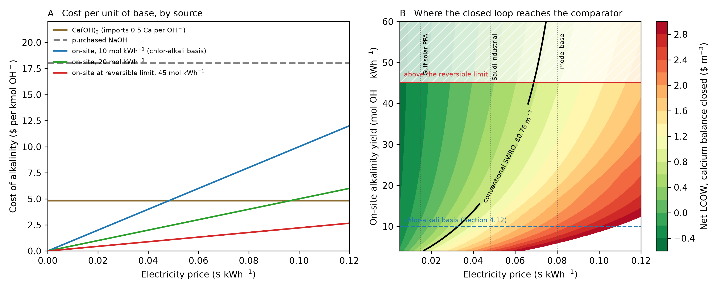
Fig. 11. Alkalinity and calcium treated as one design problem, Eq. (14). (A) Cost per kmol of hydroxide by source against electricity price, with the reversible limit of water dissociation at 45 mol OH⁻ kWh⁻¹. (B) Net levelized cost of the calcium-closed optimum over electricity price and on-site alkalinity yield, with the heavy contour at the $0.76 m⁻³ conventional comparator.
Architecture | ΔCa (mol m⁻³) | Ca imported / removed | Reagents ($ m⁻³) | Extra kWh m⁻³ | Net LCOW ($ m⁻³), $0.08 / $0.015 | CO₂ (kg m⁻³), 0.55 / 0.05 grid
Na₂CO₃ + Ca(OH)₂, as written | +92.9 | 5.33 | 1.70 | 0.0 | 2.16 / 1.30 | 16.2 / 9.7
Na₂CO₃ + purchased NaOH | −21.4 | 0.00 | 4.72 | 0.0 | 5.17 / 4.32 | 25.9 / 19.4
Na₂CO₃ + on-site NaOH | −21.4 | 0.00 | 0.60 | 22.9 | 2.88 / 0.55 | 21.1 / 3.1
Dosed CO₂ + on-site NaOH (route D) | −21.4 | 0.00 | 0.04 | 27.1 | 2.66 / 0.05 | 21.2 / 1.1
As written, then gypsum removal | +47.9 | 1.72 | 1.70 | 0.0 | 2.16 / 1.30 | 16.2 / 9.7
Lime/NaOH blend + gypsum, ΔCa = 0 | 0.0 | 1.00 | 2.96 | 0.0 | 3.42 / 2.57 | 20.3 / 13.7
Table 11. Candidate architectures per cubic meter of permeate. ΔCa is calcium imported minus calcium removed; negative values mean the train removes more than it adds. On-site base at 10 mol OH⁻ kWh⁻¹; gypsum at f_{gyp} = 0.70. Carbon counts CO₂ fixed in the carbonate product once.
Table 11 separates what a change of sequence can do from what a change of base supply can do. Adding the gypsum step to the train as written roughly halves the imbalance, from +92.9 to +47.9 mol m⁻³, and the import-to-removal ratio from 5.33 to 1.72, at no reagent cost; however, it cannot close the balance. Seawater carries 64 mol of sulfate against 114 mol of magnesium per cubic meter of permeate, so even complete gypsum recovery could absorb only 56% of the calcium that lime imports. Closing the balance with purchased reagents alone, by blending in NaOH until ΔCa = 0, raises the net cost from $2.16 to $3.42 m⁻³ at the base case, which is worse than the train as written. Calcium closure is not available cheaply from reagents; it has to be bought with energy.
Solving Eq. (14) gives the cost of closure directly (Table 12). At the model base case, $0.08 kWh⁻¹ on the Saudi grid mix, the unconstrained optimum is not the route as written: dosed CO₂ displaces soda ash as the carbonate source, because captured CO₂ plus its two equivalents of lime costs less per mole than Na₂CO₃, and all the base comes from lime. That lowers the net cost to $1.80 m⁻³ but raises the calcium import to +114 mol m⁻³. Imposing ΔCa ≤ 0 moves 51% of the base to the on-site source, uses the full gypsum sink (7.75 kg m⁻³), and raises the net cost to $2.24 m⁻³: closing the calcium balance costs $0.44 per cubic meter of permeate. Without the gypsum step the on-site share rises to 84% and closure costs $0.73. The closure cost falls from $0.52 to $0.36 as f_{gyp} rises from 0.5 to 0.9 and does not depend on the NaOH price, which never enters the solution. On Gulf solar power at $0.015 kWh⁻¹ the optimum is route D itself, the calcium balance closes without being imposed, and closure costs nothing.
Case | Base: lime / NaOH / on-site | Carbonate | Gypsum (kg m⁻³) | Extra kWh m⁻³ | Net LCOW ($ m⁻³) | CO₂ (kg m⁻³) | ΔCa (mol m⁻³)
$0.08, Saudi mix: unconstrained | 100% / 0% / 0% | dosed CO₂ | 0.00 | 0.0 | 1.80 | 15.4 | +114.3
$0.08, Saudi mix: ΔCa ≤ 0 | 49% / 0% / 51% | dosed CO₂ | 7.75 | 13.9 | 2.24 | 18.4 | 0.0
$0.08, Saudi mix: ΔCa ≤ 0, no gypsum | 16% / 0% / 84% | dosed CO₂ | 0.00 | 22.9 | 2.53 | 20.3 | 0.0
$0.015, solar: ΔCa ≤ 0 | 0% / 0% / 100% | dosed CO₂ | 0.00 | 27.1 | 0.05 | 1.1 | −21.4
Table 12. Optima of Eq. (14) at 10 mol OH⁻ kWh⁻¹. The difference between the first two rows, $0.44 m⁻³, is the cost of closing the calcium balance at the base case.
The second question has a sharper answer (Fig. 11B). For the calcium-closed loop to reach the $0.76 m⁻³ comparator, the on-site source must deliver at least 3.6 mol OH⁻ per kWh at $0.015 kWh⁻¹, 8.8 at $0.03, 18.9 at $0.048 and 82 at $0.08. The last figure is not attainable by any electrochemical route. Splitting water into H+ and OH⁻ across a bipolar junction requires at least (RT/F) ln 10 × ΔpH, 0.828 V for a gradient from pH 0 to 14, which caps the yield at 45.1 mol OH⁻ kWh⁻¹, or 0.555 kWh per kg of NaOH equivalent; chlor-alkali electrolysis, which also evolves gas at both electrodes, sits well below that cap. Above $0.069 kWh⁻¹, therefore, no base source however efficient closes the loop against the comparator: at that price the plant's other 13.1 kWh m⁻³ already cost $0.90 m⁻³, leaving too little of the margin to pay even for reversibly generated base. At the chlor-alkali basis the ceiling is $0.0327 kWh⁻¹, which reproduces the route-D crossing of Section 4.12 by an independent calculation, and doubling the yield to 20 mol kWh⁻¹ lifts it only to $0.0494.
Carbon pulls the other way on a carbon-intensive grid. On-site base at 10 mol kWh⁻¹ on the Saudi mix carries 55 kg CO₂ per kmol of OH⁻, against 33.6 for lime, so the calcium-closed optimum at the base case emits 18.4 kg CO₂ m⁻³ against 15.4 for the unconstrained one; minimizing carbon instead of cost under the same closure constraint selects the same mix. Calcium closure and a carbon target are compatible only where the electricity is itself low in carbon, which is the same condition that makes it cheap enough to close the cost gap. Taken together, the coupled problem gives the architecture question a quantitative answer: the loop closes, in calcium and in cost, only with calcium-free base generated at better than about 19 mol OH⁻ per kWh from electricity at or below the $0.048 kWh⁻¹ industrial tariff, and at lower yields on cheaper power, with a gypsum sink absorbing whatever calcium the cheaper lime share still imports.
5. Discussion
5.1 Comparison with conventional SWRO
The energy claim made in the original version of this work does not survive. Modern SWRO plants with isobaric recovery operate at 2.5–3.5 kWh m⁻³, and an audited measurement on an operating plant reports 1.794 kWh m⁻³ [16,24]. Adding the boron-compliant second pass that a municipal plant requires brings the desalination stage of this architecture to a modeled 2.89–3.19 kWh m⁻³, within that band rather than below it. The architecture should not be presented as an energy-reduction technology.
5.2 Comparison with the brine-valorization literature
Assessments of mineral recovery from desalinated brine typically report favorable economic results [10,17,25]. The present analysis suggests those results are sensitive to whether the alkalinity is costed. Where the reagent demand implied by Eq. (12) is priced at bulk industrial rates, it exceeds the value of the recovered minerals at any sellable fraction and price combination sampled here. This may help explain why a process repeatedly reported as attractive has not been commercialized at scale.
5.3 Alternative crystallization pathways
Mechanical vapor compression dominates the energy account, and three alternatives merit consideration. Membrane distillation crystallization has been demonstrated on hypersaline feeds with seeding to control scaling [8,19]; eutectic freeze crystallization offers a lower theoretical energy route and has been applied to RO brine [13], and solar-driven interfacial evaporation now sustains evaporation from high-salinity brine with autonomous salt harvesting [4,5,6]. The latter substitutes land area and capital for electricity. Since grid electricity is only approximately one-third of this architecture’s carbon account, eliminating it would not by itself make the process carbon neutral: the reagent term would remain.
5.4 Toward a closed valorization loop
Section 4.13 turns the negative result of Sections 4.7-4.12 into a design target, and the target defines the next stage of this work more precisely than the original question did. The question is no longer whether this architecture works but what an alkalinity pathway must achieve for desalination and brine valorization to close together, and it can be pursued computationally before any laboratory work, by adding candidate pathways to Eq. (14). A single reagent price is the wrong basis for comparing them. Each should be scored on three quantities at once, net cost per cubic meter of permeate, embodied and operational carbon per cubic meter, and moles of alkalinity delivered per kWh, together with the calcium it adds or removes; Figure 11 and Table 11 report the existing routes on that basis.
Five directions follow from the analysis, and each carries a specific test. First, electrochemical base, including bipolar-membrane electrodialysis of the brine itself, avoids both purchased reagent and calcium import; the target is the yield and price combination of Fig. 11B, and the hard constraint is the acid stream it coproduces, which must have a sink. Neutralizing that acid with limestone would reimport exactly the calcium the route was chosen to avoid. Second, CO₂-assisted pathways already win the carbonate step whenever captured CO₂ is cheap and low in carbon, but they raise the base demand by two equivalents per mole of calcium, about 19% at this composition. Third, alkaline industrial residues could replace purchased base, but most are calcium-bearing and would reproduce the lime problem unless they are magnesium-rich; their purity, leaching behavior and regulatory status would also have to be established. Fourth, alkalinity regeneration, in which base is recovered within the process rather than consumed once, is the most promising systems-level direction and the least developed; the most direct version would generate base electrochemically from the NaCl product stream, closing the loop internally. Fifth, the precipitation sequence should be optimized as a whole rather than stage by stage. The gypsum step of Section 4.13 is one instance: moving calcium removal after the hydroxide step changes what the calcium import costs, and the order of carbonate, magnesium, sulfate and calcium removal determines what each later step has available [10,25].
5.5 Limitations
The osmotic coefficient correction in Eq. (5) is carried as a swept parameter rather than a fitted correlation. Locking it requires implementing the seawater property correlations of [22] and [12] over the full 35–125 g kg−1 range of this process and resolving the concentrator duty; the deposited code is structured to accept that substitution. Until that is done, every specific-energy figure reported here is a bounded model estimate rather than a final quantitative prediction and should be cited as such. Section 4.5 bounds the residual uncertainty from this source at under 2% of the total SEC, so no conclusion in this paper turns on it. The brine concentrator is modeled thermodynamically rather than hydraulically: no membrane element is selected and no design flux, operating pressure or recovery schedule is specified, so the analysis bounds what the stage must consume without establishing that an element can deliver the modeled separation at a practical flux, and fouling and scaling on a concentrate at this salinity are not represented. Whether a commercially available element meets the assumed rejections at an achievable pressure is a question the energy bound of Section 4.5 does not answer. The embodied-carbon factors for soda ash and lime are indicative and are swept rather than fixed. Precipitation yields are taken from the literature and not measured here, and product purity is not modeled: purity is set by coprecipitation and occlusion of the sodium chloride background [9], which determines whether the solids meet any industrial specification and therefore whether the sellable fractions assumed here are attainable at all. The residual liquid fraction is modeled, not validated. Subsurface intake performance is site dependent, and the risks of aquifer clogging and seawater intrusion are not modeled. The coupled program of Section 4.13 is linear and deliberately coarse: it does not represent precipitation kinetics, coprecipitation between steps or the residual solubility of gypsum in concentrated brine, which is carried as the swept fraction fgyp; it excludes the capital cost of any electrochemical unit and the disposition of its acid or chlorine coproduct; and the reversible limit it uses is a thermodynamic bound, not an achievable operating point. Lithium recovery is excluded from the baseline: at the corrected economics the net cost gap to the comparator is about $1.44 m−3, and no lithium credit is assumed against it.
5.6 Proposed validation
Three measurements would settle the questions this analysis raises, and none requires the full architecture to be built. First, the second-law efficiency of a high-pressure concentrator operating on real SWRO brine at 60–65 g L−1, which fixes the energy term the original assumed. That test should also characterize a candidate element directly: water flux, ion-specific rejection, the operating pressure required, the recovery achievable, and the sensitivity of each to concentration polarization, scaling and fouling. Second, the reagent demand and product purity of sequential Ca/Mg precipitation from that concentrate at the pilot scale, which fixes both the alkalinity cost and the sellable fraction. The recovered solids should be characterized for purity, moisture, particle size and brightness and judged against a stated industrial specification, so that the sellable fractions assumed here are replaced by demonstrated grades. Third, the calcium balance across the precipitation train, which Table 1 predicts does not close. Each is a bench or skid-scale measurement, and each independently tests one of the three consistency tests reported here. Measured values would then replace the assumed parameters in the deposited model, which would report whether a practically achievable membrane configuration and a commercially acceptable recovery process still satisfy those tests.
6. Conclusions
In this study, three consistency tests are applied to an integrated SWRO and brine-valorization architecture, and the outcome of each is reported, including where the architecture fails.
The energy claim does not survive a modern comparator. Against plants operating at 2.5–3.5 kWh m⁻³, the desalination stage offers no material advantage once a boron-compliant second pass is included, and the corrected concentrator increases the modeled total specific energy consumption to a median of 13.1 kWh m⁻³. That figure, and every specific-energy figure in this paper, is a bounded model estimate rather than a measured or predicted plant value, for the reasons set out in Sections 3 and 5.5.
The valorization case, as configured, does not close, and the binding constraint is alkalinity in both currencies. In terms of money, soda ash and lime cost a median of $1.70 per cubic meter of permeate against a realizable mineral credit of $1.25. In terms of carbon, calcination costs 10.0 kg of CO₂ per cubic meter compared with 0.94 kg fixed in the carbonate product, whereas the electrochemical base costs 27 kWh m⁻³. Published assessments generally count neither.
One modeled route removes that constraint, and quantifying the conditions under which it does so is the practical value of this analysis. When the base is generated electrochemically on site, with captured CO₂ as the carbonate source, the calcium balance is exactly closed, reagent carbon is made net negative at −0.94 kg CO₂ m⁻³, and the reagent bill is replaced with 27.1 kWh m⁻³ of electrochemical demand. Because it substitutes a commodity price for an energy price, it has a crossing the purchased-alkali route does not: route D reaches the conventional comparator below $0.033 kWh⁻¹, whereas route A remains $0.34 m⁻³ above it even at zero electricity cost. The result is conditional in two ways that should be stated alongside it. The electricity must also be low carbon, since the same demand drawn at grid intensity is worse than the route it replaces, and the capital cost of the electrochemical unit, together with the disposition of its chlorine coproduct, is not modeled here and would have to be quoted before the figure could be relied on. Subject to those, brine valorization appears to be an energy-price problem rather than a stoichiometric impossibility, which is a materially different conclusion from the one this architecture started with.
Treated as one design problem, alkalinity supply and calcium closure give the architecture question a quantitative answer. Closing the calcium balance costs $0.44 per cubic meter at the base case even with gypsum as a calcium sink, and $0.73 without it, and it cannot be bought cheaply with purchased reagents. With on-site base, the closed loop reaches the comparator only if the base is generated at better than about 19 mol OH⁻ per kWh from electricity at or below the $0.048 kWh⁻¹ industrial tariff, and above $0.069 kWh⁻¹ it cannot reach it at all, because the reversible limit of water dissociation, 45 mol OH⁻ per kWh, binds first. The next stage of this work is therefore to score candidate alkalinity pathways on cost, carbon, yield per kWh and calcium together, as Section 5.4 sets out. This paper does not report a working valorization process; it identifies the conditions such a process would have to meet and quantifies how far the architecture examined here is from them.
Nomenclature
Symbol | Definition | Unit
C_{f,i}/C_{p,i}/C_{b,i} | feed, permeate, concentrate concentration of ion i | g L⁻¹
r_{i} | membrane rejection of ion i | -
R | water recovery ratio of a membrane stage | -
Q_{f}/Q_{p}/Q_{b} | feed, permeate, concentrate flow | m³ m⁻³ feed
π | osmotic pressure | bar
φ(S) | osmotic coefficient at salinity S | -
P_{f} | applied feed pressure | bar
NDP | net driving pressure allowance | bar
β | concentration-polarization factor, C_{wall}/C_{bulk} | -
η_{pump}/η_{PX}/η_{II} | pump, pressure-exchanger, second-law efficiency | -
w_{min} | least work of separation | kWh m⁻³
SEC | specific energy consumption | kWh m⁻³ permeate
LCOW | levelized cost of water | $ m⁻³
CRF | capital recovery factor | yr⁻¹
Y_{Ca}/Y_{Mg} | precipitation yield of calcium and magnesium | -
n_{base} | alkalinity demand | equivalents
x_{L,} x_{N,} x_{E} | OH⁻ supplied as Ca(OH)₂, purchased NaOH, on-site base | kmol m⁻³
s, d | carbonate supplied as Na₂CO₃, as dosed CO₂ | kmol m⁻³
g | calcium removed as gypsum | kmol m⁻³
f_{gyp} | fraction of feed sulfate recoverable as gypsum | -
ΔCa | calcium imported minus calcium removed | kmol m⁻³

Data availability
The model implementation, the parameter set, the random seed, and the scripts that generate every table and figure are openly available at https://github.com/sandlerleon/iledbv-desalination-model, release tag v2.3.0. An archived snapshot of that release is deposited at https://doi.org/10.5281/zenodo.22178234; this manuscript and the point-by-point response to reviewers are deposited at https://doi.org/10.5281/zenodo.22178232. Both are concept DOIs and resolve to the current version of each deposit. The revised version was produced with Python 3.11.9 and NumPy 2.4.6. Running iledbv_revision_v2.py, design_and_costing.py, boron_recalc.py, reversal_analysis.py and alkalinity_calcium_design.py regenerates the JSON files from which every number in this paper is taken; audit_manuscript.py rechecks the built document against them. Figures 2 and 7 were added in the present revision and are plotted directly from Tables 1, 5 and 8 by a separate plotting script supplied with this submission for deposit alongside the model code; they introduce no new model output, and no number in this paper changed in this revision. No experimental data were generated.
Declaration of competing interest
The author declares that there are no competing financial or nonfinancial interests.
Funding
This research received no specific grant from funding agencies in the public, commercial, or not-for-profit sectors.
CRediT authorship contribution statement
Leon Sandler: Conceptualization, Methodology, Software, Formal analysis, Investigation, Data curation, Writing – original draft, Writing – review & editing, Visualization.
Declaration of generative AI and AI-assisted technologies in the writing process
During the preparation of this work the author used Claude (Anthropic) as a drafting and analysis aid. The author reviewed and edited all content, verified every cited reference against Crossref, carried out and checked all modeling and numerical work, and takes full responsibility for the content of the publication. No AI tool is listed as an author, and none was used to generate or alter data.
References
[1] O. Alagha, O. Abuhajar, Numerical Modeling of Beach Well Intake as Pre-Treatment for a Desalination Plant, Water 12 (2020) 2420. https://doi.org/10.3390/w12092420
[2] A.A. Atia, N.Y. Yip, V. Fthenakis, Pathways for minimal and zero liquid discharge with enhanced reverse osmosis technologies: Module-scale modeling and techno-economic assessment, Desalination 509 (2021) 115069. https://doi.org/10.1016/j.desal.2021.115069
[3] T.V. Bartholomew, L. Mey, J.T. Arena, N.S. Siefert, M.S. Mauter, Osmotically assisted reverse osmosis for high salinity brine treatment, Desalination 421 (2017) 3-11. https://doi.org/10.1016/j.desal.2017.04.012
[4] M. Ding, Z. Duan, L. Zhang, H. Wu, H. Xu, C. Liu, et al., Spatial Decoupling of Water Evaporation and Salt Crystallization via a 3D Discrete Wettability Patterned Architecture, Advanced Functional Materials 36 (2026) e76165. https://doi.org/10.1002/adfm.76165
[5] M. Ding, Z. Duan, D. Zhao, C. Liu, C. Li, Tree‐Inspired 3D Biomimetic Evaporator for Efficient Solar Desalination and Automated Salt Collection with Zero Liquid Discharge, Advanced Functional Materials 36 (2025) e12220. https://doi.org/10.1002/adfm.202512220
[6] M. Ding, Z. Duan, L. Zhang, C.Y. Liu, C. Li, J. Zhang, Modular gradient-porous evaporator for efficient solar desalination and autonomous salt harvesting from high-salinity brine, Water Research 290 (2026) 125053. https://doi.org/10.1016/j.watres.2025.125053
[7] S.M.H. Fayaz, R. Mafigholami, F. Razavian, K. Ghasemipanah, Technical and economical comparison study between operation costs of beach well intake and open intake for seawater reverse osmosis desalination in the Persian Gulf, Desalination and Water Treatment 178 (2020) 74-82. https://doi.org/10.5004/dwt.2020.24953
[8] S. Flatscher, F. Hell, M.W. Hlawitschka, J. Lahnsteiner, Seeded membrane distillation crystallization for hypersaline brine treatment, Water Reuse 14 (2024) 16-29. https://doi.org/10.2166/wrd.2024.086
[9] N.A. Kasimu, J. Gu, Effect of sodium chloride on yield, purity, morphology and polymorphs of calcium or magnesium carbonate sequentially precipitated from brine solution, Desalination 578 (2024) 117443. https://doi.org/10.1016/j.desal.2024.117443
[10] N. Mahmud, M.H. El-Naas, Selective recovery of calcium and magnesium from desalination brine through mineral carbonation and alkaline precipitation, Next Sustainability 8 (2026) 100388. https://doi.org/10.1016/j.nxsust.2026.100388
[11] G. Migliorini, E. Luzzo, Seawater reverse osmosis plant using the pressure exchanger for energy recovery: a calculation model, Desalination 165 (2004) 289-298. https://doi.org/10.1016/j.desal.2004.06.034
[12] K.G. Nayar, M.H. Sharqawy, L.D. Banchik, J.H. Lienhard V, Thermophysical properties of seawater: A review and new correlations that include pressure dependence, Desalination 390 (2016) 1-24. https://doi.org/10.1016/j.desal.2016.02.024
[13] A. Nemmour, H. Zhang, K.E. Kadi, I. Janajreh, Salt recovery from a reverse osmosis brine by eutectic freeze crystallization method for waste brine management, Environmental Science and Pollution Research 33 (2025) 1930-1940. https://doi.org/10.1007/s11356-025-36553-7
[14] A. Panagopoulos, A comparative study on minimum and actual energy consumption for the treatment of desalination brine, Energy 212 (2020) 118733. https://doi.org/10.1016/j.energy.2020.118733
[15] A. Panagopoulos, V. Giannika, Comparative techno-economic and environmental analysis of minimal liquid discharge (MLD) and zero liquid discharge (ZLD) desalination systems for seawater brine treatment and valorization, Sustainable Energy Technologies and Assessments 53 (2022) 102477. https://doi.org/10.1016/j.seta.2022.102477
[16] B. Peñate-Suarez, J.A.d.l. Fuente-Bencomo, G. Melián-Monroy, S.Y. Arenas Urrea, R. González-Almenara, L. García-Rodríguez, The worldwide lowest specific energy consumption measured in a seawater desalination plant – Real integration and opportunities of improvement, Energy Conversion and Management: X 30 (2026) 101682. https://doi.org/10.1016/j.ecmx.2026.101682
[17] R.K. Puthanveettil, S. Kim, M.J. Kim, Utilizing seawater and brine to simultaneously produce high-purity magnesium sulfate and vaterite-type calcium carbonate, Desalination 578 (2024) 117436. https://doi.org/10.1016/j.desal.2024.117436
[18] H. Qian, Z. Zhou, L. Zhang, F. Wu, Q. Zhang, Z. Zhang, Thermodynamic analysis on the theoretical energy consumption of seawater desalination, Desalination 320 (2013) 73-79. https://doi.org/10.1016/j.desal.2013.04.006
[19] C. Quist-Jensen, F. Macedonio, E. Drioli, Membrane crystallization for salts recovery from brine—an experimental and theoretical analysis, Desalination and Water Treatment 57 (2016) 7593-7603. https://doi.org/10.1080/19443994.2015.1030110
[20] A. RANDON, S. RECH, A. LAZZARETTO, Brine Management: Techno-economic Analysis of a Mechanical Vapor Compression Energy System for a Near-Zero Liquid Discharge Application, International Journal of Thermodynamics 23 (2020) 128-137. https://doi.org/10.5541/ijot.673573
[21] M.P. Shahabi, A. McHugh, G. Ho, Environmental and economic assessment of beach well intake versus open intake for seawater reverse osmosis desalination, Desalination 357 (2015) 259-266. https://doi.org/10.1016/j.desal.2014.12.003
[22] M.H. Sharqawy, J.H. Lienhard, S.M. Zubair, Thermophysical properties of seawater: a review of existing correlations and data, Desalination and Water Treatment 16 (2010) 354-380. https://doi.org/10.5004/dwt.2010.1079
[23] R.L. Stover, Seawater reverse osmosis with isobaric energy recovery devices, Desalination 203 (2007) 168-175. https://doi.org/10.1016/j.desal.2006.03.528
[24] C. Wang, L. Wang, L. Dong, H.K. Shon, J. Kim, Specific energy consumption of seawater reverse osmosis desalination plants using machine learning, Desalination 602 (2025) 118654. https://doi.org/10.1016/j.desal.2025.118654
[25] D. Zhang, Y. Li, J. Cao, Efficient magnesium recovery from seawater desalination brine via CO₂ mineralization to synthesize hydromagnesite for uranium extraction, Desalination 559 (2023) 116629. https://doi.org/10.1016/j.desal.2023.116629
[26] F.J. Millero, R. Feistel, D.G. Wright, T.J. McDougall, The composition of Standard Seawater and the definition of the Reference-Composition Salinity Scale, Deep Sea Research Part I: Oceanographic Research Papers 55 (2008) 50-72. https://doi.org/10.1016/j.dsr.2007.10.001

