Laser-Assisted Nuclear Thermal Propulsion for Cislunar Logistics: A Monte Carlo Power-Closure Assessment
Leon Sandler
Independent Researcher, Northbrook, Illinois, USA
ORCID: https://orcid.org/0009-0007-4584-808X
Corresponding author: sandler.leon@gmail.com

Highlights
• Reaching 1300-1500 s needs laser power of 2.2-3.6 times the reactor power
• A 1-50 MW laser on a 100-500 MWt reactor gives at most 1,000 s
• Median IMLEO is 1.7 times that of conventional NTP; 0% of draws reach -40%
• Beam capture collapses beyond a few 10^4 km, ruling out relay beaming
• Laser nodes outweigh the tug and a single laser fault erodes the benefit
Abstract
Laser-assisted nuclear thermal propulsion (LANTP) proposes to lift the specific impulse of a nuclear thermal tug by adding orbital laser power to the hydrogen, for logistics between low Earth orbit and low lunar orbit. We test the claims of such a concept (specific impulse 1300–1500 s, thrust 50–120 kN, a laser of 1–50 MW on a 100–500 MWt reactor, 40% lower initial mass in low Earth orbit, IMLEO) with a coupled model: hydrogen dissociation thermodynamics validated against Cantera, a power chain from wall plug to propellant, Gaussian-beam capture with pointing jitter, finite burns with occultation and link dropouts, a mass model of the tug and its laser nodes, and a Monte Carlo analysis over assumed ranges. A reactor-limited core gives 860 s; reaching 1300–1500 s needs useful laser power of 2.2–3.6 times the reactor power, so a 1–50 MW laser reaches at most 1,000 s, and thrusts of 50–120 kN need emitted laser power of 0.7–1.6 GW at 1400 s. Median IMLEO is 1.7 times that of conventional nuclear thermal propulsion (5th–95th percentile 1.0–3.7), none of the draws reaches the claimed 40% reduction, and receiver specific mass dominates (rank correlation 0.79). The laser nodes outweigh the tug by orders of magnitude, a single laser fault raises the median IMLEO ratio to 2.3, and a 1.4 GW beam falls short of deflecting a 40–90 m asteroid by more than two orders of magnitude. All inputs are assumed; the study gives falsification boundaries, not a design.
Keywords: Laser-assisted nuclear thermal propulsion; cislunar logistics; power closure; Monte Carlo; beam capture; hydrogen dissociation
1. Introduction
Nuclear thermal propulsion (NTP) heats hydrogen in a reactor core and expands it through a nozzle. Its specific impulse, about twice that of the best chemical engines, is limited by the temperature the core can withstand, which for the carbide fuels of the NERVA lineage is below about 3000 K [1,2]. NTP has been studied for lunar transportation [3], where its high thrust at moderate specific impulse suits short transfers. Beaming laser power to a vehicle has a long history in launch and space propulsion [4–6], and orbital power beaming systems for cislunar space are under study [7]. Laser-assisted nuclear thermal propulsion (LANTP) combines the two: the reactor heats the hydrogen to the core limit and a beam from orbital laser nodes adds power in the chamber, so that a higher chamber temperature, hydrogen dissociation and a higher specific impulse become available without raising the core temperature.
A concept of this kind has been described with the following claims: a specific impulse of 1300–1500 s at a chamber temperature of about 4500 K, a thrust of 50–120 kN, a laser of the "multi-megawatt" class (1–50 MW) on a reactor of 100–500 MWt, and a 40% lower initial mass in low Earth orbit (IMLEO) than conventional NTP for the same cislunar mission. These claims are quantitative and can be tested. Whether they hold depends on the interaction of four things that a single-discipline analysis separates: the thermodynamics of dissociating hydrogen, the power chain from the electrical supply to the propellant, the optical link between a laser node and a moving vehicle, and the mass of the receiver and of the laser infrastructure. The central question of this paper is therefore under what coupled conditions laser assistance gives a meaningful advantage over conventional NTP, and under which parameter combinations it is inferior.
Three hypotheses are tested. H1: the claimed specific impulse and thrust require a laser power that is far above the claimed class. H2: the IMLEO of the laser-assisted tug exceeds that of conventional NTP over most of the assumed parameter space, because of the receiver and the finite duration of the beam link, so that the claimed 40% reduction is not reached. H3: a break-even region exists only for small receiver specific mass and low laser fraction, and it is lost when the laser infrastructure, a single laser fault or the constraint of the link are included. The paper makes four contributions: a coupled feasibility boundary of the thermochemical, optical and mass models; an infrastructure-aware comparison that amortizes the laser nodes over a number of missions; a reliability-aware evaluation with the propellant reserve for laser outages; and a set of explicit, falsifiable conditions (Section 7).
2. System architecture
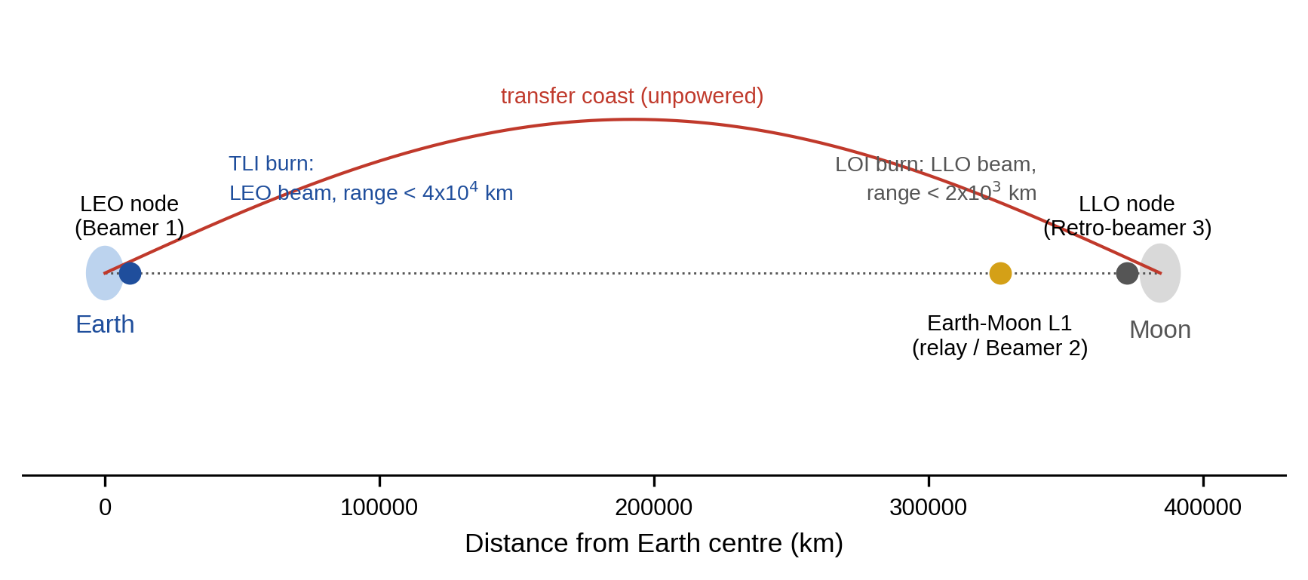
Fig. 1. Architecture of the laser-assisted transfer between low Earth orbit and low lunar orbit: laser nodes in low Earth orbit (Beamer 1) and low lunar orbit (retro-beamer 3), an Earth–Moon L1 relay for tracking and communication, and a bimodal tug that carries a reactor and a beam receiver (schematic, not to scale).
The vehicle is a bimodal tug: a reactor of thermal power P_{R} heats hydrogen, stored cryogenically at about 20 K and preheated to T_{in} = 100 K, to the core outlet temperature limit T_{core} (assumed 2600–2900 K); a beam receiver adds a useful laser power P_{use}=ρP_{R} to the same flow, so that the chamber enthalpy is h_{c}=h_{core}+ρ(h_{core}−h_{in}). The mass flow ṁ=P_{R}/(h_{core}−h_{in}) is set by the reactor alone. The reactor-only case, ρ=0, is the conventional NTP reference. The laser nodes are a node in low Earth orbit that beams during trans-lunar injection (TLI), a node in low lunar orbit that beams (as a retro-beamer) during lunar orbit insertion (LOI), and a relay at the Earth–Moon L1 point used for tracking and data, not for power (Fig. 1). The mission delivers a payload of 20 t from a 400 km circular orbit to a 100 km circular lunar orbit in a transfer of 2.0 days; the tug is expended in the main comparison, and a round trip with a propulsive return is examined as a sensitivity (Section 6.8).
3. Thermochemical and nozzle model
Hydrogen at the chamber conditions is treated as an equilibrium mixture of H₂ and H with the dissociation degree α given by K_{p}=4α²p/(1−α²). The equilibrium constant follows from the partition functions of the two species, with a rigid rotor and harmonic oscillator for H₂ (rotational temperature 87.55 K, vibrational temperature 6332 K), a doublet ground state of the atom and the dissociation energy 4.4781 eV from the vibrational ground state [8]. The enthalpy per kg is h=[(1−α)h_{H2}(T)+α(5RT+D₀)]/M_{H2} and the entropy of the mixture is built from the same partition functions. The chamber temperature follows from the enthalpy balance of Section 2 at the chamber pressure p_{c} (assumed 2–7 MPa; 3 MPa nominal).
The exhaust velocity of an expansion to p_{e}=10⁻⁴p_{c} with nozzle efficiency η_{n} (0.92–0.96) is computed in three ways. In the frozen expansion the composition of the chamber is kept and the temperature follows from the isentropic condition; the dissociation energy is lost. In the partial expansion a fraction φ (0–0.5) of the dissociation energy is recovered by recombination in the nozzle. In the shifting-equilibrium expansion the mixture is in chemical equilibrium throughout, which gives an upper bound. The ideal-gas formula I_{sp}=g₀⁻¹{[2γ/(γ−1)](RT_{c}/M)[1−(p_{e}/p_{c})^{(γ−1)/γ}]}^{1/2} with M = 2.016 g/mol and γ of 1.3 or 1.4, which does not include dissociation, is shown for comparison. The implementation was validated against Cantera [9] with NASA polynomial data (equilibrium composition, and isentropic expansions with frozen and equilibrium composition; Table 1) and against an independent numerical minimization of the Gibbs energy, and compared in method with the NASA chemical-equilibrium program [10].
4. Optical and power model
Four powers are distinguished. The useful thermal power delivered to the propellant is P_{use}=ρP_{R}. The power absorbed by the receiver is P_{abs}=P_{use}/η_{coup}, with a coupling efficiency η_{coup} (0.80–0.95) that accounts for re-radiation and conduction losses of a receiver at the chamber temperature; the difference is waste heat on the vehicle. The power received at the aperture is P_{rec}=P_{abs}/η_{abs} with an absorption efficiency η_{abs} (0.90–0.99). The emitted power is P_{emit}=P_{rec}/(η_{opt}η_{cap}) with transmitter optics efficiency η_{opt} = 0.9 and the captured fraction η_{cap} of the link. The electrical power drawn by the laser is P_{elec}=P_{emit}/η_{wp} with a wall-plug efficiency η_{wp} (0.3–0.5), and the difference is waste heat at the node.
The link is a Gaussian beam. The transmitter aperture D_{t} (10 m unless stated) gives a waist w₀=0.45D_{t} and the beam is assumed to be refocused on the receiver at every range, an optimistic assumption, so that the spot radius is w=M²λR/(πw₀) at range R, with wavelength λ = 1.07 µm and beam quality M² (1.1–1.6) [11]. Pointing jitter σ_{θ} (0.05–0.3 µrad rms per axis) is added to the spot size in quadrature, w_{eff}²=w²+4(σ_{θ}R)², and a receiver of radius r_{R} = 3 m captures η_{cap}=1−exp (−2r_{R}²/w_{eff}²). The beam is lost when the line of sight between the node and the vehicle passes through the Earth (with a 100 km atmospheric margin) or the Moon (20 km margin), and Poisson dropouts (0.01–0.5 per hour), each followed by a re-acquisition time of 10–120 s, interrupt it. The captured fraction, the occultation and the dropouts are evaluated along the simulated trajectory.
5. Mission, mass and uncertainty model
5.1 Transfer geometry and finite burns
The transfer is a coplanar patched-conic transfer from a 400 km circular orbit to a 100 km circular lunar orbit. The perigee speed is solved for the time of flight (2 days nominal, 1.6–4.5 days studied), which gives an impulsive Δv_{TLI} of 3.19 km/s and Δv_{LOI} of 1.28 km/s at 2 days [12]. The burns are integrated as finite burns in the central body's two-body field with thrust along the velocity: TLI is a prograde burn from the circular orbit until the orbital energy of the transfer orbit is reached; LOI is a retrograde burn centered on periselene until the orbit is circular. The thrust is F=ṁ g₀I_{sp}(t) with I_{sp} interpolated from a table of specific impulse against the laser power received, which changes with the captured fraction, so that gravity losses, the growth of the node–vehicle range, occultation and dropouts all enter the propellant used. The laser node is on a circular orbit 1000 km ahead of the vehicle at the start of each burn.
5.2 Mass model and comparison with conventional NTP
The initial mass M satisfies M=m_{pl}+m_{fix}+(1+f_{t})(1+f_{r})m_{burned}(M), where m_{pl} = 20 t is the payload, m_{fix}=m_{eng}+m_{rec}+m_{misc}, m_{eng}=F/(g₀ T/W) with an engine thrust-to-weight T/W of 3–8, m_{rec}=μ_{rec}P_{abs} with a receiver specific mass μ_{rec} of 15–80 kg per MW absorbed (assumed), m_{misc} = 3.0 t of structure and avionics, f_{t} is the tank mass fraction (0.12–0.25), and f_{r} = 0.05 a residual and boil-off allowance. m_{burned}(M) is the propellant used by the simulated burns for the initial mass M, and the equation is solved for the smallest M that closes. The conventional NTP reference uses the same reactor, payload, trajectory, margins and burn simulation with ρ=0 and no receiver. The IMLEO ratio is M_{LANTP}/M_{NTP}; the claimed 40% reduction corresponds to 0.6.
5.3 Laser infrastructure
Each laser node is sized for the emitted power P_{emit} at the start of the burn and the energy E_{emit}=P_{emit}t_{on} of the burns it serves (TLI for the node in low Earth orbit, LOI for the node in low lunar orbit). The electrical supply is a battery buffer of mass E_{emit}/(η_{wp}e_{s}) with specific energy e_{s} of 150–500 Wh/kg, a waste-heat buffer of mass E_{emit}(1/η_{wp}−1)/c_{s} with a heat capacity c_{s} of 0.5–3 MJ/kg, the laser and its optics at 100–1000 kg per MW emitted, an aperture of 10–30 kg/m², and a solar array that recharges the buffer between missions (6 missions per year). Buffering the burn energy rather than supplying the peak power directly is the lighter choice for a duty cycle of hours per mission; the result is therefore a lower bound on the node mass. The infrastructure is amortized over 90 missions (15 years). A mass of 2.0 t is added for the relay.
5.4 Contingency policies
Three policies are compared for the tank loading. In the nominal policy the vehicle carries the propellant for laser-assisted burns. In the single-fault policy it carries the propellant to complete TLI on the reactor alone, so that a laser outage before TLI does not strand the vehicle. In the full-fallback policy it carries the propellant for a reactor-only mission with the LANTP hardware. The propellant to complete TLI after a loss of the laser at a time t_{out} is also computed for the nominal vehicle.
5.5 Uncertainty analysis
The uncertain parameters of Table 2 are sampled independently (uniform or log-uniform between the limits, assumed) with 1,500 independent random draws; the laser power fraction is that required to reach a chamber temperature of 4500 K at the sampled chamber pressure and core temperature. The distributions of the specific impulse and of the IMLEO ratio are reported with their 5th, 50th and 95th percentiles, the influence of the inputs by Spearman rank correlation with the IMLEO ratio, and the convergence by the median against the number of draws with a bootstrap interval. Break-even surfaces are computed on grids of receiver specific mass, laser power fraction, payload and transfer time for the nominal vehicle, and the infrastructure-inclusive ratio (M_{LANTP}+M_{inf}/N)/M_{NTP} gives the number of missions N* at which the nodes are amortized. All inputs are assumed ranges, not measurements; the results are conditional on them.
Parameter | Unit | Low | High | Distribution | Nominal
Reactor thermal power | MW | 100 | 500 | uniform | 500
Core outlet temperature limit | K | 2,600 | 2,900 | uniform | 2,800
Chamber pressure | MPa | 2.00 | 7.00 | log-uniform | 3.00
Nozzle recombination fraction φ | – | 0.00 | 0.50 | uniform | 0.30
Nozzle efficiency | – | 0.92 | 0.96 | uniform | 0.94
Receiver specific mass | kg/MW absorbed | 15 | 80 | log-uniform | 25
Engine thrust-to-weight | – | 3.00 | 8.00 | uniform | 5.00
Tank mass fraction | – | 0.12 | 0.25 | uniform | 0.18
Pointing jitter (rms per axis) | µrad | 0.05 | 0.30 | log-uniform | 0.05
Beam quality M² | – | 1.10 | 1.60 | uniform | 1.20
Link dropout rate | per hour | 0.01 | 0.50 | log-uniform | 0.05
Re-acquisition time | s | 10 | 120 | uniform | 30
Coupling efficiency | – | 0.80 | 0.95 | uniform | 0.90
Absorption efficiency | – | 0.90 | 0.99 | uniform | 0.95
Laser wall-plug efficiency | – | 0.30 | 0.50 | uniform | 0.40
Energy buffer specific energy | Wh/kg | 150 | 500 | log-uniform | 250
Waste-heat buffer capacity | MJ/kg | 0.50 | 3.00 | log-uniform | 1.50
Laser and optics specific mass | kg/MW emitted | 100 | 1,000 | log-uniform | 300
Aperture areal density | kg/m² | 10 | 30 | uniform | 15
Table 2. Uncertain parameters of the Monte Carlo analysis (assumed ranges) and the nominal values used for the break-even grids.
6. Results
All results are conditional on the assumed ranges of Table 2. Probabilities and percentiles describe the assumed uncertainty, not field statistics. Unless stated, the mission is a one-way delivery of 20 t at a transfer time of 2 days.
6.1 Hydrogen thermochemistry and validation
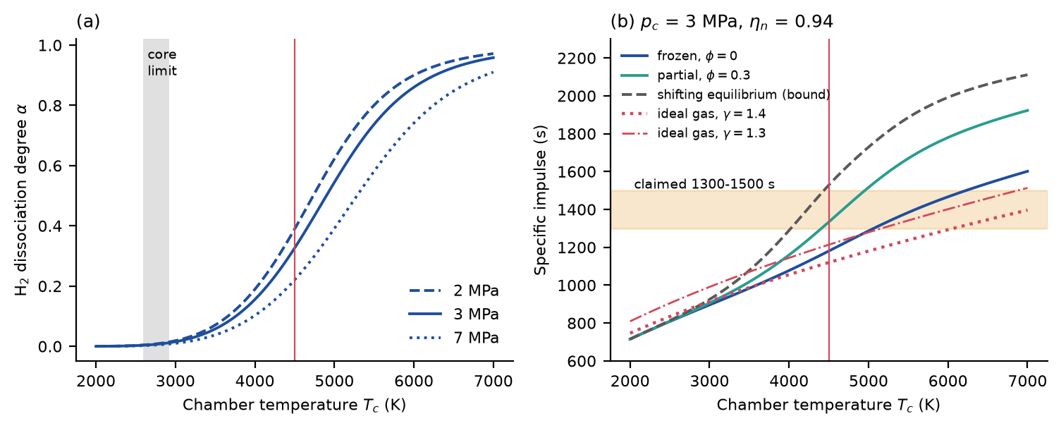
Fig. 2. (a) Equilibrium dissociation degree of hydrogen against chamber temperature at three pressures. (b) Specific impulse for frozen flow, partial recombination, the shifting-equilibrium bound and the ideal-gas formula without dissociation (vertical line: 4500 K; band: claimed 1300–1500 s).
The dissociation degree at 3 MPa is 0.33 at 4500 K and the core limit of 2600–2900 K lies below the onset of dissociation (Fig. 2a). The specific impulse at 4500 K and 3 MPa is 1,180 s for frozen flow, 1,334 s for recombination of 30% of the dissociation energy and 1,529 s for the shifting-equilibrium bound; the ideal-gas formula, which neglects dissociation, gives 1,120 s (γ = 1.4) and 1,214 s (γ = 1.3). The claimed 1300–1500 s at 4500 K is therefore reached only if a substantial part of the dissociation energy is recovered in the nozzle, which is a property of the nozzle kinetics that no assumption of this paper fixes; at the core limit the specific impulse is 858 s. Against Cantera the dissociation degree of this model is higher by 4% to 8%, the frozen specific impulse lower by 0.8% to 1.6% and the shifting-equilibrium bound within −0.6% to 0.9% (Table 1); the difference in the dissociation degree is that of a rigid-rotor, harmonic-oscillator model without anharmonicity and is not corrected. The minimization of the Gibbs energy agrees with the analytic equilibrium to 1e-08 in the dissociation degree, which verifies the equilibrium solver but is not an independent test of the thermodynamic data.
Quantity | Condition | Reference | This model | Difference
Dissociation degree α | 2800 K, 3 MPa | 0.0075 | 0.0079 | 5.1%
Dissociation degree α | 3000 K, 0.1 MPa | 0.0793 | 0.0836 | 5.5%
Dissociation degree α | 3500 K, 3 MPa | 0.0542 | 0.0577 | 6.5%
Dissociation degree α | 4000 K, 0.1 MPa | 0.6260 | 0.6534 | 4.4%
Dissociation degree α | 4500 K, 3 MPa | 0.3028 | 0.3264 | 7.8%
Isp, frozen (s) | 3500 K, 3 MPa | 1,062 | 1,046 | −1.5%
Isp, frozen (s) | 4500 K, 3 MPa | 1,272 | 1,256 | −1.3%
Isp, frozen (s) | 5500 K, 3 MPa | 1,485 | 1,472 | −0.8%
Isp, frozen (s) | 4500 K, 7 MPa | 1,255 | 1,235 | −1.6%
Isp, shifting (s) | 3500 K, 3 MPa | 1,155 | 1,147 | −0.6%
Isp, shifting (s) | 4500 K, 3 MPa | 1,612 | 1,626 | 0.9%
Isp, shifting (s) | 5500 K, 3 MPa | 1,988 | 2,006 | 0.9%
Isp, shifting (s) | 4500 K, 7 MPa | 1,509 | 1,516 | 0.4%
Table 1. Validation of the hydrogen model against Cantera 3.2.0 (h2o2.yaml) (equilibrium and isentropic expansion to p_{e}=10⁻⁴p_{c}, nozzle efficiency 1).
6.2 Power closure: the laser fraction required
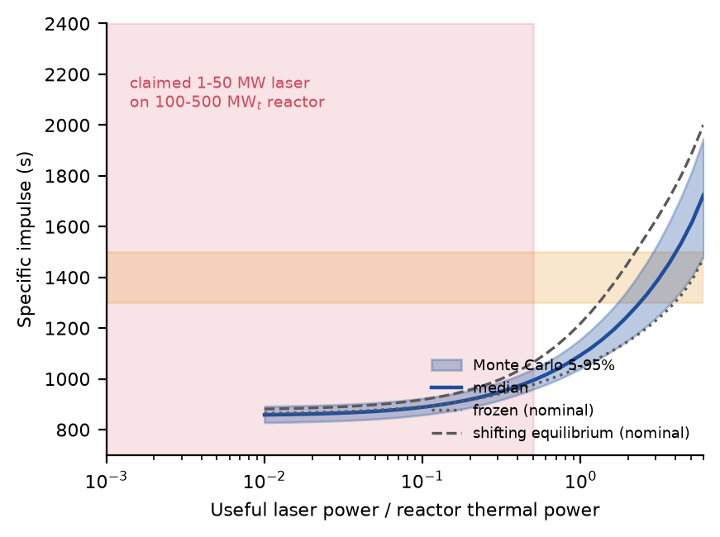
Fig. 3. Specific impulse against the useful laser power as a fraction of the reactor power: Monte Carlo median and 5–95% band, the frozen and shifting-equilibrium bounds for the nominal parameters, the claimed laser class (shaded) and the claimed specific impulse (band).
With the reactor alone the specific impulse is 858 s (5th–95th percentile 828–892 s). Reaching 1300, 1400 and 1500 s at the median of the parameters requires a useful laser power of 2.2, 2.9 and 3.6 times the reactor power (Fig. 3); with 4500 K as the design point the fraction is 2.4. A laser of 1–50 MW on a reactor of 100–500 MWt corresponds to a fraction between 0.002 and 0.50, and the specific impulse at those two ends is 867 and 1,008 s. The claimed performance is therefore inconsistent with the claimed laser power: the most favorable end of the claim (50 MW on 100 MWt) is short by a factor of 4, and the other end by a factor of more than 1,100 (H1). The reason is the enthalpy balance: heating hydrogen from the core limit to 4500 K, including dissociation, needs about 2.4 times the enthalpy that the reactor delivers between the tank and the core outlet.
6.3 Emitted laser power at the claimed thrust
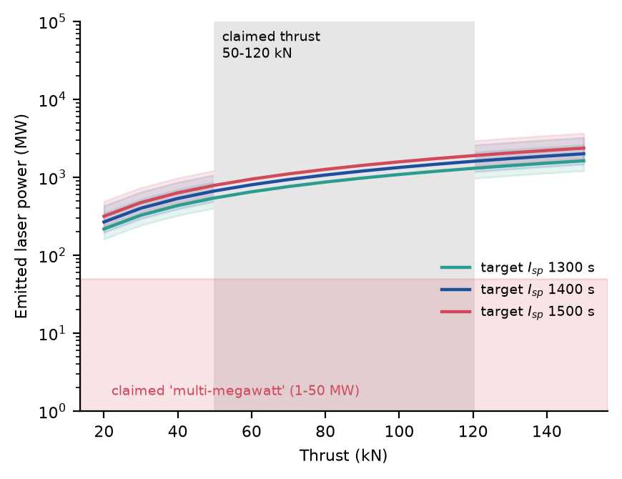
Fig. 4. Emitted laser power required for a given thrust and specific impulse (median and 5–95% band over the parameters), against the claimed thrust (band) and the claimed laser class (shaded).
For a thrust of 50 kN at 1400 s the emitted laser power is 668 MW (5th–95th percentile 490–1,079 MW), and for 120 kN 1,603 MW (1,175–2,589 MW) (Fig. 4), against the claimed 1–50 MW. These are emitted powers at the start of the burn, where the beam is captured almost completely; they include the receiver, optics and coupling efficiencies of Section 4 and need an electrical power of 1.7–4.0 GW at the median wall-plug efficiency. Table 3 gives the power chain for the nominal vehicle: a useful power of 1.19 GW on the propellant needs 1.55 GW of emitted power and 3.87 GW of electrical power, and rejects 2.32 GW of waste heat at the node and 0.13 GW at the receiver.
Quantity | Value
Reactor thermal power P_{R} | 500 MW
Useful thermal power on the propellant P_{use}=ρP_{R} (ρ = 2.38) | 1,192 MW
Absorbed by the receiver P_{abs} (coupling 0.90) | 1,324 MW
Received at the aperture P_{rec} (absorption 0.95) | 1,394 MW
Emitted by the node P_{emit} (optics 0.9, capture at 1000 km) | 1,549 MW
Electrical power P_{elec} (wall plug 0.4) | 3,872 MW
Waste heat at the laser node | 2,323 MW
Waste heat at the receiver | 132 MW
Thrust (reactor only: 97 kN) | 149 kN
Specific impulse (reactor only: 867 s) | 1,334 s
Table 3. Power chain of the nominal vehicle at a chamber temperature of 4500 K.
6.4 Beam link
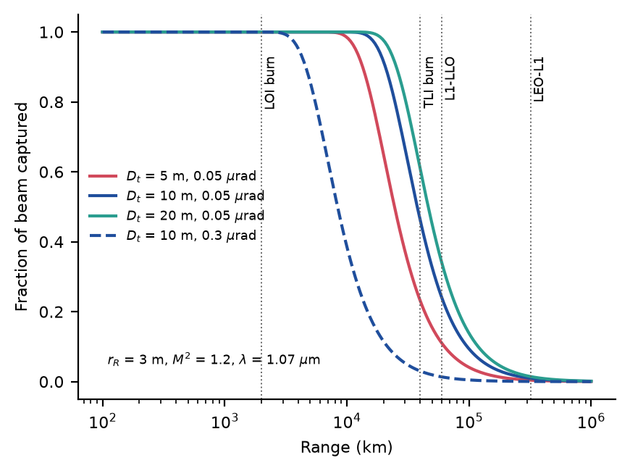
Fig. 5. Fraction of the emitted beam captured by a 3 m receiver against range, for three apertures at 0.05 µrad pointing jitter and one at 0.3 µrad (refocused beam, M² = 1.2, λ = 1.07 µm); vertical lines mark the ranges of the burns and of the relay links.
With a 10 m aperture and 0.05 µrad of jitter the captured fraction is 1.00 at 1000 km (the start of LOI), 0.69 at 29,000 km (the end of TLI), 0.24 over the 60,000 km between the L1 relay and the lunar node and 0.010 over the 320,000 km between the Earth node and L1 (Fig. 5). Even a 100 m aperture captures 0.39 at 60,000 km and 0.017 at 320,000 km, because the pointing jitter, not diffraction, then limits the spot; the receiver radius needed for half of the beam at 60,000 km is 4.8 m with a 10 m aperture. Beaming across the relay legs is therefore excluded and the laser must act while the vehicle is within a few 10⁴ km of its node, the ranges drawn in Fig. 1. Tolerating a jitter of 0.3 µrad shortens the range at which half of the beam is captured with the 10 m aperture to about 8,400 km (Supplementary Information).
6.5 Finite burns, occultation and link losses
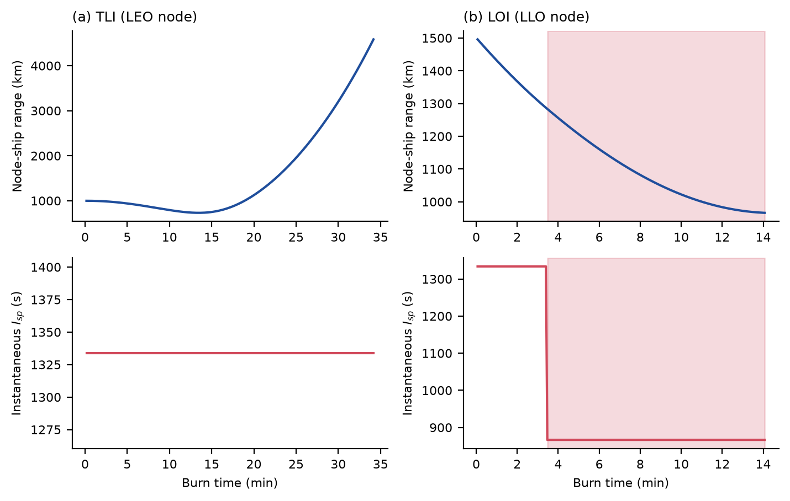
Fig. 6. Burn timelines of the nominal vehicle: node–vehicle range and instantaneous specific impulse during (a) TLI and (b) LOI; shaded: line of sight blocked by the Earth or the Moon.
The nominal LANTP tug (initial mass 100 t, thrust 149 kN) burns for 34 min during TLI and 14 min during LOI, against 25 and 7 min for the reactor-only tug of 53 t (Fig. 6). In the nominal case the TLI burn ends within 4,600 km of the node, so that the beam is captured completely and the specific impulse stays at the design value; during LOI the Moon blocks the line of sight 3.5 min after the start of the burn, and the specific impulse falls to the reactor-only value for the rest of the burn. Over the Monte Carlo draws the lower power of the weaker links and the gravity losses of the longer burns lower the delivered impulse. The effective specific impulse of the TLI burn, defined by the impulsive Δv and the propellant used and so including gravity losses, has a median of 1,023 s (5th–95th percentile 673–1,253 s) over the Monte Carlo draws, well below the design value of 1,291 s (Fig. 7b).
6.6 Monte Carlo analysis of the initial mass
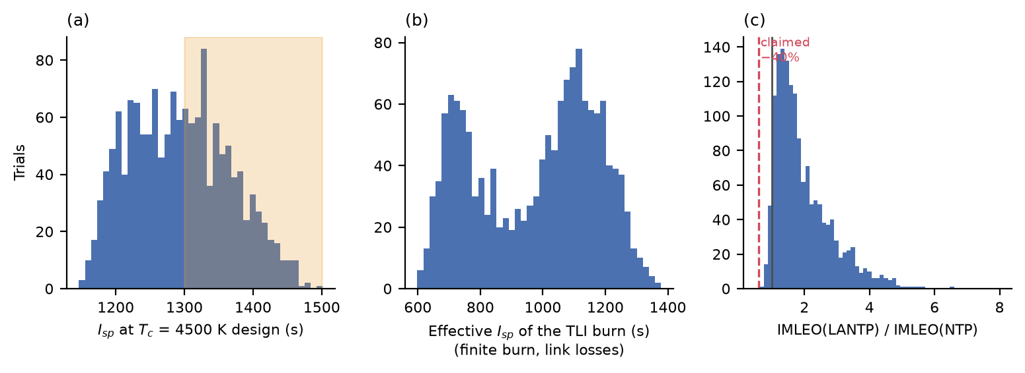
Fig. 7. Monte Carlo distributions (1,500 draws): (a) specific impulse at the 4500 K design point, with the claimed band; (b) effective specific impulse of the TLI burn including gravity losses and link losses; (c) IMLEO of the laser-assisted tug divided by that of conventional NTP, with the claimed 40% reduction.
The design-point specific impulse has a median of 1,291 s (5th–95th percentile 1,186–1,418 s), and 46% of the draws lie in the claimed band of 1300–1500 s (Fig. 7a). The IMLEO ratio has a median of 1.69 (5th–95th percentile 1.02–3.70); 4.0% of the draws are below 1 and 0.0% reach the claimed ratio of 0.6 (Fig. 7c) (H2). The receiver is the main cause: the median receiver mass is 26.1 t (5th–95th percentile 8.3–73.6 t) against a reactor-only tug of about 55 t. The rank correlation of the IMLEO ratio with the receiver specific mass is 0.79, with the reactor power 0.56, with the nozzle recombination fraction −0.08 and with the chamber pressure −0.14 (Fig. 10); the link parameters (jitter, beam quality, dropouts) matter much less than the receiver. The 95% bootstrap interval of the median ratio at 1,500 draws is 1.66–1.73 (Fig. 11b).
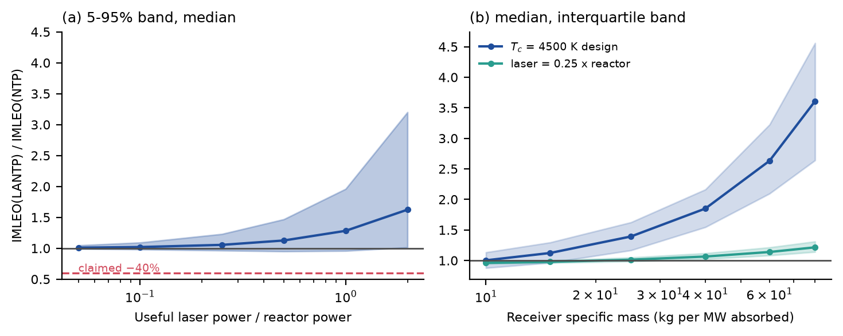
Fig. 8. IMLEO ratio of the laser-assisted tug to conventional NTP against (a) the useful laser power fraction (5–95% band and median) and (b) the receiver specific mass, for the 4500 K design point and for a fixed laser fraction of 0.25.
The ratio rises with the laser fraction (Fig. 8a): its median is 1.02 at a fraction of 0.1, 1.13 at 0.5 and 1.62 at 2, and the lower end of the 5–95% band is 0.96 at a fraction of 0.25. At a fixed fraction of 0.25 the median ratio is 0.96 for a receiver of 10 kg/MW and 1.22 for 80 kg/MW; for the 4500 K design it is 1.00 and 3.61 (Fig. 8b). In no case does the 5th percentile fall below 0.88.
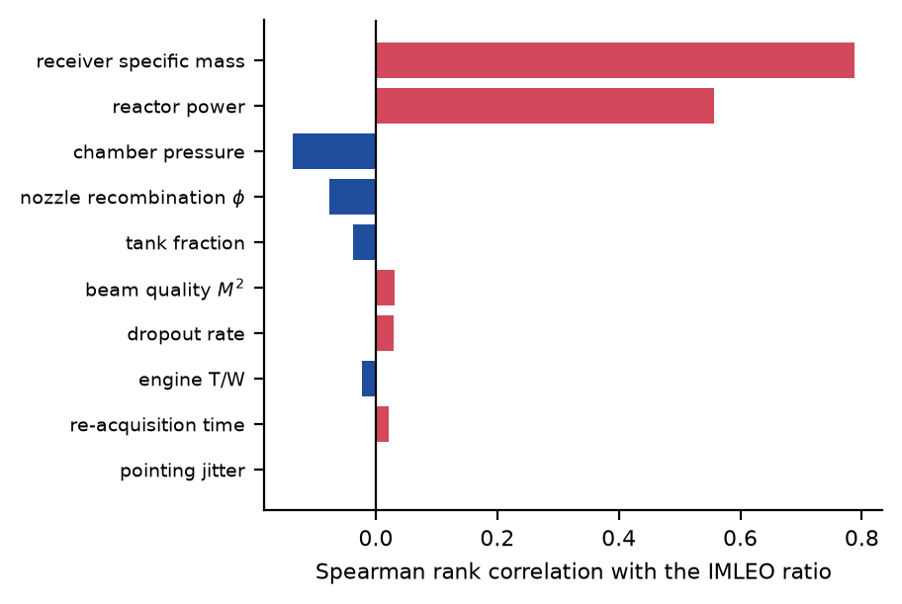
Fig. 10. Spearman rank correlation of the IMLEO ratio with the uncertain parameters.
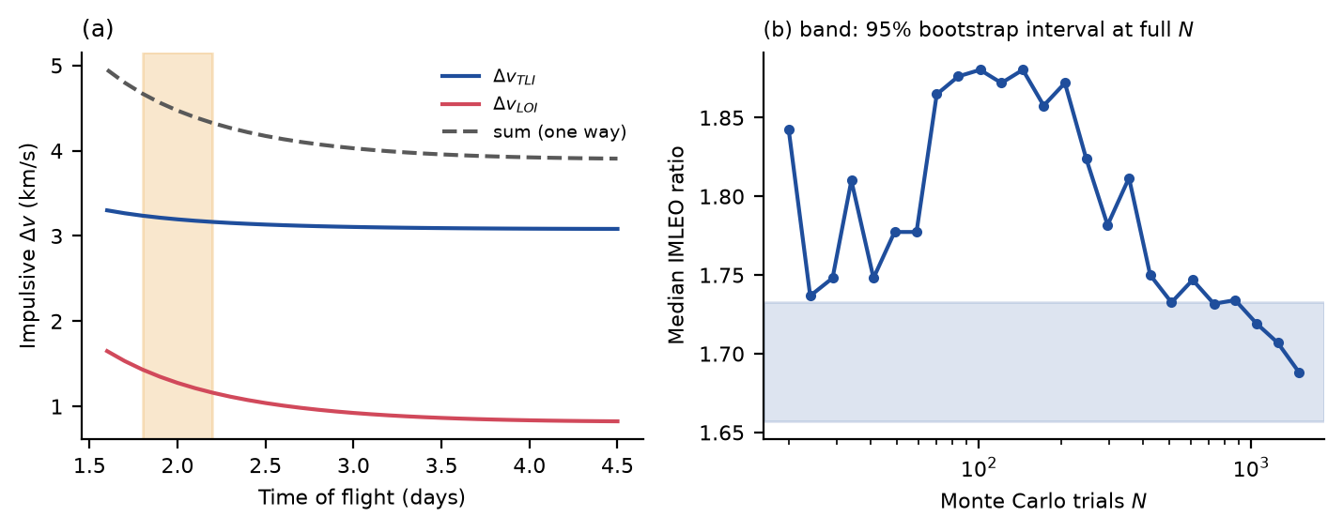
Fig. 11. (a) Impulsive Δv of TLI and LOI against the time of flight (band: the 1.8–2.2 day transfer of the nominal case). (b) Convergence of the median IMLEO ratio with the number of Monte Carlo draws; the band is the 95% bootstrap interval of the median at the full number of draws.
6.7 Break-even surfaces and amortization of the laser nodes
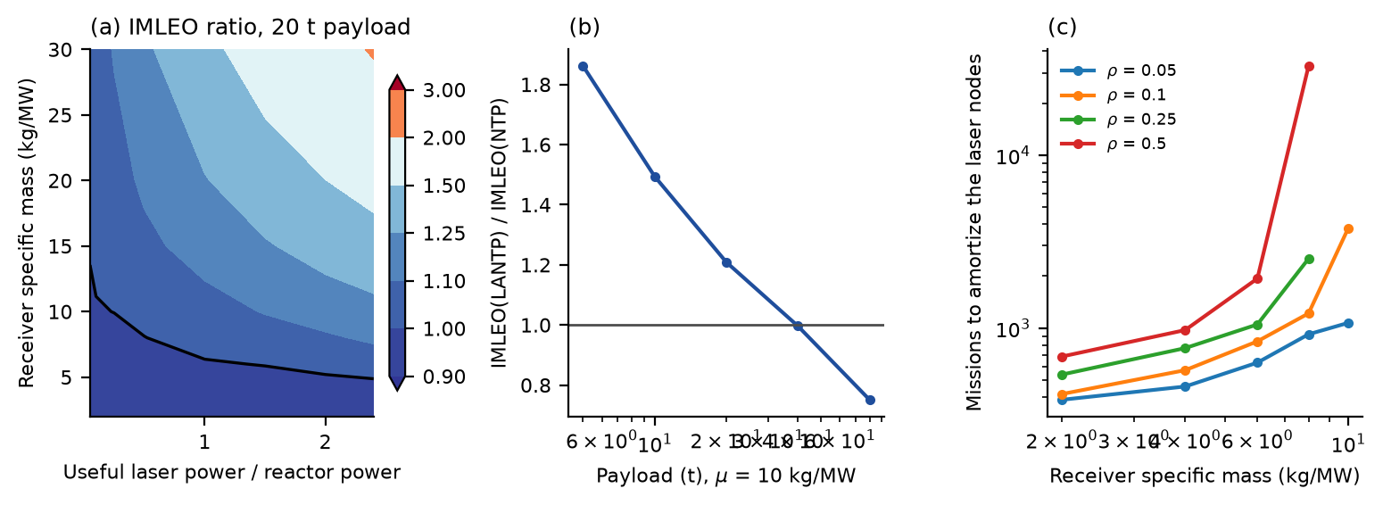
Fig. 9. Break-even analysis for the nominal vehicle: (a) IMLEO ratio on a grid of receiver specific mass and useful laser power fraction (black line: ratio 1); (b) ratio against payload at a receiver of 10 kg/MW; (c) number of missions over which the laser nodes must be amortized for the spacecraft saving to equal the node mass (missing points: no saving).
On the grid of receiver specific mass and laser fraction (Fig. 9a) the IMLEO ratio is below 1 only in a small corner: its minimum is 0.90, at the smallest receiver (2 kg/MW) and a laser fraction of 2.00; at a fraction of 0.25 the ratio crosses 1 at a receiver of about 10 kg/MW. The best case saves 10% of the IMLEO, not 40%. At the 4500 K design (fraction 2.4) the ratio is 0.91 at 2 kg/MW and 2.03 at 30 kg/MW. The advantage grows with the payload because the fixed receiver is shared by more cargo: the ratio falls below 1 at a payload of about 40 t (Fig. 9b); the transfer time changes the ratio by less than 3% between 1.8 and 4.5 days. With the conventional tug allowed the best reactor of a scan from 250 to 2000 MWt, its initial mass is 98 t for 40 t of payload and 192 t for 80 t, so that the laser-assisted tug at 10 kg/MW has a ratio of 1.02 and 0.91 against the best conventional tug, not 1.00 and 0.79 against the 500 MWt reference. The laser nodes of Section 6.8 weigh 17,888 t for the nominal vehicle, so the smallest number of missions that amortizes them on the grid is 385, against an assumed lifetime of 90 missions, and for most of the grid they are never amortized (Fig. 9c).
6.8 Laser infrastructure and the round trip
Item | Value
Emitted power P_{emit} | 1.55 GW
Electrical power at the node | 3.87 GW
Energy emitted per burn (LEO node, TLI) | 0.88 GWh
Battery buffer (LEO node) | 8,819 t
Waste-heat buffer (LEO node) | 3,175 t
Laser and optics (LEO node) | 465 t
Aperture and recharge array (LEO node) | 17.9 t
Both nodes and relay | 17,888 t
Per mission over 90 missions | 199 t
Tug, LANTP / conventional NTP | 100 t / 53 t
Table 5. Laser infrastructure of the nominal vehicle (lower bound: energy buffered, not supplied at peak power).
The nominal laser node would need to emit 1.5 GW for 34 min and so to store 2.2 GWh of electrical energy and to buffer 5 TJ of waste heat per burn (Table 5). The two nodes and the relay weigh 17,888 t (median over the draws 19,790 t, 5th–95th percentile 8,282–54,805 t), against a tug of 100 t; per mission, over 90 missions, the infrastructure adds 199 t to the IMLEO, so that the infrastructure-inclusive IMLEO ratio has a median of 5.6 (5th–95th percentile 2.8–14.7). Supplying the peak power from solar arrays or a reactor instead of buffering the energy would be far heavier. The comparison with conventional NTP is thus unfavorable even before the link is considered. A round trip with propulsive return (four burns, the tug reused, same 500 MWt reactor) gives an IMLEO ratio of 1.28 (76 t against 59 t) for a 10 t payload at 10 kg/MW and 2.36 (140 t against 59 t) at 25 kg/MW; for 20 t the reactor-only tug does not close (its thrust is too low for the multi-hour burns of a heavy vehicle) while the laser-assisted tug does (97 t versus no closure at 10 kg/MW), and for 40 t the ratio is 0.18 (149 t against 820 t) at 10 kg/MW and 0.93 (761 t against 820 t) at 25 kg/MW. The advantage at large payloads is a thrust advantage at a fixed reactor and not a specific-impulse advantage, and it is reduced when the conventional tug is allowed a larger reactor (Section 6.7).
6.9 Laser outage and contingency
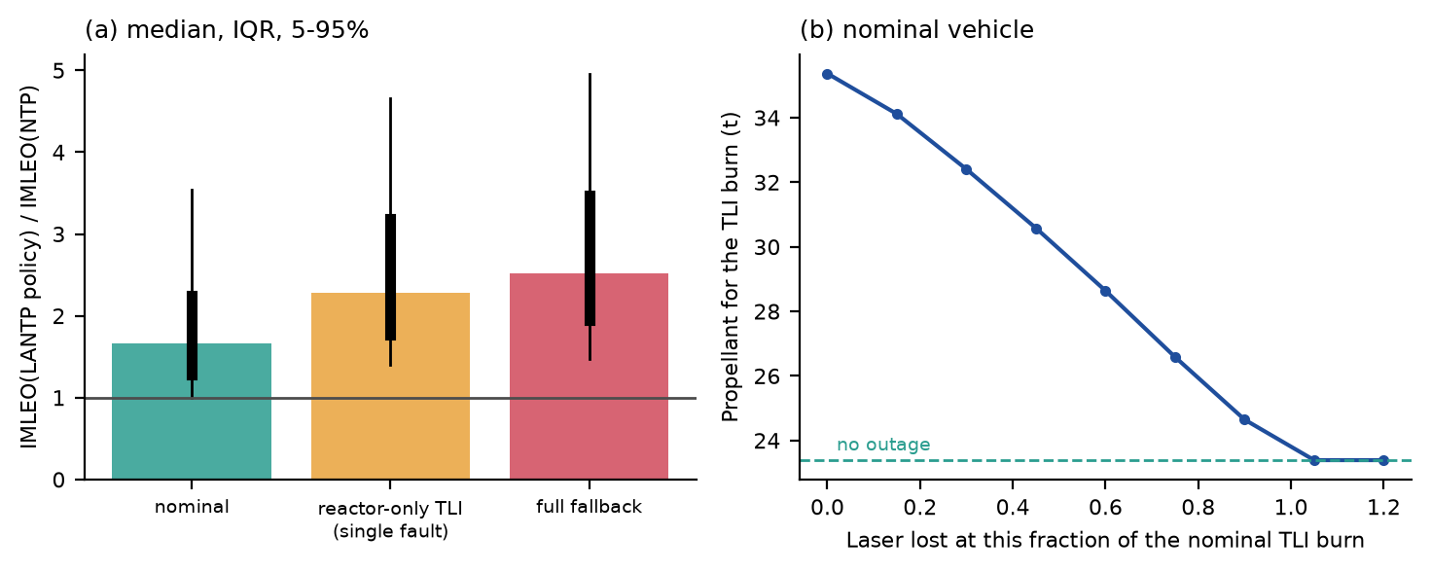
Fig. 12. (a) IMLEO ratio for three tank-loading policies (bar: median; thick line: interquartile range; thin line: 5–95%). (b) Propellant to complete TLI after a loss of the laser at a given fraction of the nominal burn, for the nominal vehicle.
A laser outage does not strand the vehicle, because the reactor continues the burn, but it costs propellant: the TLI burn of the nominal vehicle uses 23.4 t with the laser throughout and 35.4 t if the laser is lost at the start (Fig. 12b). Carrying the propellant to complete TLI on the reactor alone (single-fault tolerance) raises the median IMLEO ratio from 1.66 to 2.28, and carrying the propellant for a reactor-only mission with the LANTP hardware gives 2.52 (Table 6); since the receiver mass stays, the full-fallback ratio is above 1 in more than 95% of the draws. A conventional NTP tug has no such fault. Whether the reserve is worth carrying depends on the probability of an outage, which no data support here; the reserve is the cost of the dependence on the beam.
Policy | Median ratio | 5–95% | Median mass (t)
nominal (laser on both burns) | 1.66 | 0.99–3.54 | 93
laser lost before TLI, reactor-only TLI (single fault) | 2.28 | 1.40–4.66 | 128
reactor-only mission with the LANTP hardware (full fallback) | 2.52 | 1.47–4.95 | 140
Table 6. Tank-loading policies: median IMLEO ratio to conventional NTP, 5–95% range, and median initial mass (500 draws).
7. Falsifiable conditions
The results of Section 6 can be stated as conditions that the concept must satisfy, each with the value this model gives (Table 4). They are conditional on the assumed ranges, and each is falsified by a single measurement or analysis that contradicts it. They also state where LANTP is inferior to conventional NTP: for a receiver specific mass above a few kg/MW at the laser fractions of the claim, for small payloads, for a link that is interrupted, and for any case in which the laser nodes are counted.
Claim | Condition | This model
Specific impulse 1300–1500 s | Useful laser power ≥ 2.2–3.6 × reactor power, and recovery of the dissociation energy in the nozzle | A 1–50 MW laser on 100–500 MWt gives ≤ 1,000 s
Thrust 50–120 kN at 1400 s | Emitted laser power 0.7–1.6 GW (median) | Short of the 1–50 MW class by a factor of 13–1,600
Chamber temperature about 4500 K | A heating and containment concept that withstands a temperature above the highest reported melting temperatures of refractory solids (Table 7) | Not demonstrated
Beam capture | Captured fraction ≥ 0.5 only within 37,800 km for a 10 m aperture, 0.05 µrad and a 3 m receiver; 8,400 km at 0.3 µrad | Relay beaming over 6×10⁴ km captures ≤ 39%
IMLEO 40% below conventional NTP | Ratio ≤ 0.6 | Median 1.69; 0% of draws at or below 0.6; best grid point 0.90
Net benefit with infrastructure | Spacecraft saving × missions ≥ node mass | Median infrastructure-inclusive ratio 5.6; nodes 17,888 t
Continued mission after a laser fault | Reserve propellant for reactor-only TLI | Median ratio 2.28 with the reserve
Table 4. Falsifiable conditions of the concept and the values of this model (all conditional on the assumed ranges).
Item | Temperature (K)
Reactor core limit used | 2600–2900 (2800 nominal)
Tungsten, melting | 3695
Graphite, sublimation at 1 atm | about 3900
TaC–HfC system, highest melting temperature reported [13] | about 4000
Design chamber temperature of the claim | 4500
Table 7. Temperatures (K) relevant to the 4500 K chamber (handbook values for the first three solids are quoted from memory of standard tables and should be verified).
8. Extension: directed-energy deflection of an asteroid
A beam of the power that LANTP would need could in principle also be used to deflect an asteroid [14]. A simple model tests this for the infrastructure above: the beam of 1.4 GW from a 10 m aperture reaches the asteroid at a range of 3×10⁴–3×10⁵ km, the spot size follows from the same optical model, the momentum coupling saturates at 30–300 µN/W with a half-saturation intensity of 10⁸–10¹⁰ W/m², and the irradiation lasts half of a lead time of 1–10 days; the displacement achieved at the Earth is divided by the required miss of one Earth radius. The median ratio is 2×10⁻³ for a 40 m asteroid and 3×10⁻⁴ for a 90 m asteroid (95th percentile 3×10⁻¹ and 3×10⁻²) (Fig. 13a), and the largest diameter that is deflected is less than 1 m at 1.4 GW and 36 m at 30 GW with a 10 m aperture (Fig. 13b). Even 30 GW deflects only asteroids up to about 44 m with a 100 m aperture, below the 40–90 m class for most of it. The conclusion rests on the assumed coupling and lead time and is a limitation of the concept rather than a result of the transport analysis.
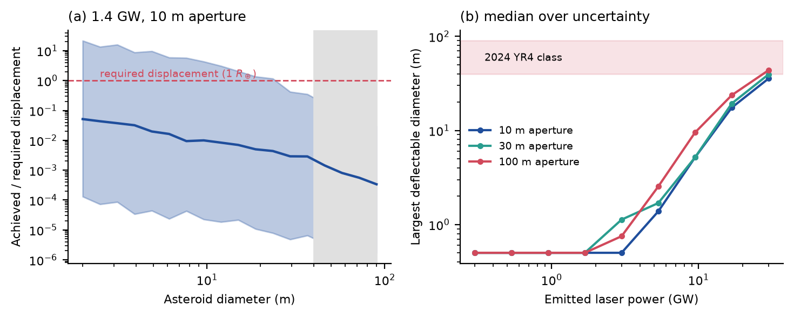
Fig. 13. (a) Achieved over required displacement against asteroid diameter for 1.4 GW and a 10 m aperture (median and 5–95% band; shaded: 40–90 m class). (b) Largest diameter that is deflected against the emitted power for three apertures.
9. Discussion
The three hypotheses are supported by the model under the assumed ranges. H1: the claimed specific impulse needs a useful laser power of 2.2–3.6 times the reactor power and the claimed thrust needs gigawatts of emitted laser power, not megawatts. H2: the median IMLEO is 1.7 times that of conventional NTP and no draw reaches the claimed 40% reduction. H3: a break-even region exists (ratio down to 0.90) only for the smallest receivers and low laser fractions, and it is lost when the infrastructure, the link or a laser fault is included. These conclusions are about the claims examined; they are not a general statement that laser power cannot assist nuclear thermal propulsion, and they depend on the receiver specific mass, which is the least certain input and the dominant one.
9.1 Novelty and relation to earlier work
Laser-heated hydrogen rockets were analyzed for launch and orbit transfer decades ago [4–6], and nuclear thermal tugs have been studied for the Moon [3]. The contribution here is the coupling: the same model carries the thermodynamics of dissociating hydrogen, the power chain, the link along a finite burn, the mass of the receiver and of the laser nodes, and the policy for a laser outage, so that the feasibility boundary is stated in terms of quantities a designer can measure (laser fraction, receiver specific mass, captured fraction, number of missions). An infrastructure-aware view, in which the nodes are amortized over repeated shuttle missions, and a reliability-aware view, in which the vehicle must complete the transfer after a laser fault, are not part of the earlier analyses cited here, to the extent that these were found; a complete literature search was not made.
9.2 What would change the conclusion
The model identifies the levers. A receiver of a few kg/MW, a payload of several tens of tonnes, an infrastructure that already exists for another purpose (so that its mass is not charged to the transfers), a beam that is held for the whole burn by a node that stays close to the vehicle, and a nozzle that recovers most of the dissociation energy would together reduce the IMLEO. At 10 kg/MW the ratio falls below 1 for a payload above 40 t against the 500 MWt reference tug (and above about 48 t against the best conventional tug), and with the nodes as an existing asset the break-even receiver mass at a laser fraction of 0.25 is about 10 kg/MW. None of these conditions is demonstrated; each is a measurable target.
9.3 Limitations
(i) All design inputs (efficiencies, specific masses, link parameters, coupling coefficients) are assumed ranges; the ranges are not measurements and the results are conditional on them. (ii) The thermodynamic model is a rigid-rotor, harmonic-oscillator model that overestimates the dissociation degree by 4–8% against Cantera; the nozzle is described by an expansion ratio, an efficiency and a recombination fraction, not by kinetics, and the heat transfer, wall temperature and radiation of a chamber at 4500 K are not modeled. (iii) The link assumes refocusing at every range, an ideal Gaussian beam and independent dropouts; atmospheric effects are absent and beam safety, acquisition and tracking are represented only by the re-acquisition time. (iv) The trajectory is coplanar with patched conics and thrust along the velocity, and the node is on a circular orbit near the vehicle. (v) The mass model is of design level, the infrastructure is a lower bound, and costs and the lifecycle are not modeled beyond the number of missions. (vi) The performance claims tested are those of the concept description; no source of that description is cited here and the tested values should be checked against it. (vii) The literature cited was checked for existence and bibliographic data, not read in full for each statement.
10. Conclusions
Within the assumed ranges, a laser of the claimed class cannot lift a nuclear thermal tug to the claimed performance: a useful laser power of 2.2–3.6 times the reactor power is needed for 1300–1500 s and gigawatts of emitted power for 50–120 kN. The beam can only act within a few 10⁴ km of a node, the receiver dominates the mass, and the median IMLEO is 1.7 times that of conventional NTP (5th–95th percentile 1.0–3.7), with no draw at the claimed 0.6. The laser nodes weigh 17,888 t for the nominal vehicle and a single laser fault costs propellant. A narrow break-even region (ratio down to 0.90) exists for small receivers and low laser fractions. The falsifiable conditions of Table 4 define what a demonstration would have to show: a receiver specific mass of a few kg/MW, a captured fraction above 0.5 over the whole burn, a heating concept for 4500 K, a nozzle that recovers the dissociation energy, and an amortization of the nodes over many missions.
Declaration of competing interest
The author declares no competing interests.
Funding
This research did not receive any specific grant from funding agencies in the public, commercial, or not-for-profit sectors.
CRediT authorship contribution statement
Leon Sandler: Conceptualization, Methodology, Software, Validation, Formal analysis, Investigation, Visualization, Writing – original draft, Writing – review and editing.
Data availability
The simulation code, the data behind every figure and table, the automated tests and the manuscript sources (version 1.0.0) are archived at https://doi.org/10.5281/zenodo.24048703 (software, all versions) and https://doi.org/10.5281/zenodo.24048701 (manuscript, all versions), and are available at https://github.com/sandlerleon/lantp-cislunar-mc. The study uses no experimental data.
Declaration of generative AI and AI-assisted technologies in the writing process
During the preparation of this work the author used Claude (Anthropic) to assist with drafting text, writing and testing simulation code and generating figures from that code. After using this tool, the author reviewed and edited the content as needed and takes full responsibility for the content of the publication.
References
[1] H. Ludewig, An integrated analysis of a NERVA based nuclear thermal propulsion system, AIP Conference Proceedings 813 (2006) 870–878. https://doi.org/10.1063/1.2169269
[2] A.L. Qualls, E. Hancock, Recapturing NERVA-derived fuels for nuclear thermal propulsion, in: 47th AIAA/ASME/SAE/ASEE Joint Propulsion Conference & Exhibit, AIAA (2011). https://doi.org/10.2514/6.2011-5847
[3] C. Reynolds, J. Horton, C. Joyner, T. Kokan, D. Levack, Applications of nuclear thermal propulsion to lunar architectures, in: AIAA Propulsion and Energy 2019 Forum, AIAA (2019). https://doi.org/10.2514/6.2019-4032
[4] M.A. Minovitch, Reactorless nuclear propulsion – the laser rocket, in: 8th Joint Propulsion Specialist Conference, AIAA (1972). https://doi.org/10.2514/6.1972-1095
[5] J.T. Kare, Laser-powered heat exchanger rocket for ground-to-orbit launch, Journal of Propulsion and Power 11 (1995) 535–543. https://doi.org/10.2514/3.23875
[6] A. Mertogul, D. Zerkle, H. Krier, J. Mazumdar, Continuous wave laser sustained hydrogen plasmas for thermal rocket propulsion, in: 21st International Electric Propulsion Conference, AIAA (1990). https://doi.org/10.2514/6.1990-2637
[7] L. Carrio, T. Cichan, Cislunar orbital power beaming system design concepts, in: IAF Space Power Symposium, International Astronautical Federation (2025) 160–171. https://doi.org/10.52202/083089-0016
[8] G. Herzberg, A. Monfils, The dissociation energies of the H2, HD, and D2 molecules, Journal of Molecular Spectroscopy 5 (1961) 482–498. https://doi.org/10.1016/0022-2852(61)90111-4
[9] D.G. Goodwin, H.K. Moffat, I. Schoegl, R.L. Speth, B.W. Weber, Cantera: an object-oriented software toolkit for chemical kinetics, thermodynamics, and transport processes, version 3.2.0, https://www.cantera.org
[10] S. Gordon, B.J. McBride, Computer program for calculation of complex chemical equilibrium compositions and applications, I. Analysis, NASA Reference Publication 1311, NASA Lewis Research Center, Cleveland (1994).
[11] A.E. Siegman, Lasers, University Science Books, Mill Valley (1986).
[12] R.R. Bate, D.D. Mueller, J.E. White, Fundamentals of Astrodynamics, Dover, New York (1971).
[13] O. Cedillos-Barraza, D. Manara, K. Boboridis, T. Watkins, S. Grasso, D.D. Jayaseelan, R.J.M. Konings, M.J. Reece, W.E. Lee, Investigating the highest melting temperature materials: a laser melting study of the TaC-HfC system, Scientific Reports 6 (2016) 37962. https://doi.org/10.1038/srep37962
[14] P. Lubin, G. Hughes, Directed energy for planetary defense, in: Handbook of Cosmic Hazards and Planetary Defense, Springer, Cham (2015) 941–991. https://doi.org/10.1007/978-3-319-03952-7_77

