Laser-Assisted Nuclear Thermal Propulsion for Cislunar Logistics: A Monte Carlo Power-Closure Assessment
Leon Sandler
Independent Researcher, Northbrook, Illinois, USA
ORCID: https://orcid.org/0009-0007-4584-808X
Corresponding author: sandler.leon@gmail.com

Abstract
Laser-assisted nuclear thermal propulsion (LANTP) would raise the specific impulse of a nuclear thermal tug by adding orbital laser power to the hydrogen. We take performance targets of this kind (specific impulse 1300–1500 s, thrust 50–120 kN, a 1–50 MW laser on a 100–500 MWt reactor, and an initial mass in low Earth orbit, IMLEO, 40% below that of conventional nuclear thermal propulsion, NTP) as hypothetical design targets and test them for Earth–Moon logistics with a coupled model: hydrogen thermochemistry checked against Cantera, a power chain from the wall plug to the propellant, Gaussian-beam capture, finite burns with occultation and link dropouts, tug and laser-node masses, and Monte Carlo and Sobol analyses over assumed ranges. Reaching 1300–1500 s requires a useful laser power of 2.2–3.6 times the reactor power, so a 1–50 MW laser gives at most 1,000 s, and 50–120 kN needs 0.7–1.6 GW of emitted power. Against a conventional tug whose reactor is sized for the payload, the laser-assisted tug has a median IMLEO ratio of 1.44 (5th–95th percentile 1.13–1.94); 0% of the draws are below 1 and none reaches 0.6. Receiver specific mass accounts for 70% of the variance. A technology-threshold map shows that a mass benefit needs a receiver below approximately 11 kg per MW absorbed. The laser nodes (about 18 kt) and the propellant reserve for a single laser fault eliminate this benefit. Results are conditional on the assumed ranges.
Keywords: Laser-assisted nuclear thermal propulsion; Cislunar logistics; Beamed energy; Power closure; Monte Carlo simulation; Sobol sensitivity analysis
1. Introduction
Nuclear thermal propulsion (NTP) heats hydrogen in a reactor core and expands it through a nozzle. Its specific impulse, approximately twice that of the best chemical engines, is limited by the temperature the core can withstand, which for the carbide fuels of the NERVA lineage is less than approximately 3000 K [1,2]. NTP has been proposed for human missions [3] and studied for cislunar transportation, where its high thrust at moderate specific impulse suits short transfers [4–7]. Laser-assisted nuclear thermal propulsion (LANTP) adds a second energy source: orbital laser nodes beam power to a receiver on the tug, so that the hydrogen can be heated beyond the core limit, dissociate and give a higher specific impulse without raising the core temperature.
Laser propulsion has a long history. Kantrowitz proposed laser propulsion to Earth orbit [8], Minovitch described a “laser rocket” [9], Kare proposed a laser-powered heat-exchanger rocket for launch [10], and Mead gave a perspective on beamed-energy propulsion [11]. Laser-sustained plasma thrusters were evaluated theoretically [12] and tested with a 10 kW laser [13], continuous-wave laser-sustained hydrogen plasmas were studied for thermal rocket propulsion [14], a simplified thrust model exists for porous-heat-exchanger laser rockets [15], and a recent study examines the feasibility of laser thermal beamed-energy propulsion [16]. Power beaming has been considered for lunar exploration [17] and in orbital systems for cislunar space [18]. To the extent that the author could determine from titles and abstracts, these works treat the laser-heated thruster, the beam link or the mission separately; none was found that combines the thermochemistry of dissociating hydrogen, the receiver and laser-node masses, the finite-burn link and the comparison with an optimally sized NTP tug in one model.
Concepts of LANTP are described with performance targets such as a specific impulse of 1300–1500 s at a chamber temperature of approximately 4500 K, a thrust of 50–120 kN, a laser of the "multi-megawatt" class (1–50 MW) on a reactor of 100–500 MWt, and an initial mass in low Earth orbit (IMLEO) 40% below that of conventional NTP for the same cislunar mission. These targets come from a concept description that is not available in the open literature; they are therefore treated here as hypothetical design targets, not as published results, and the conclusions are about the targets and not about any particular author. The central question is under what coupled conditions laser assistance provides a meaningful advantage over conventional NTP, and under which parameter combinations it is inferior.
Three hypotheses are tested. H1: the targets for specific impulse and thrust require a laser power far above the targeted class. H2: the IMLEO of the laser-assisted tug exceeds that of a conventional tug whose reactor is sized for the payload over most of the assumed parameter space, so that the 40% reduction is not reached. H3: a mass benefit exists only below a receiver specific mass that depends on the laser power, and it is lost when the laser infrastructure or a single laser fault is included. The paper makes four contributions: a coupled feasibility boundary of the thermochemical, optical and mass models with a technology-threshold map; a comparison against an optimized conventional benchmark with global (variance-based) sensitivity analysis; an infrastructure-aware and reliability-aware evaluation; and a set of falsifiable conditions (Section 7).
2. System architecture
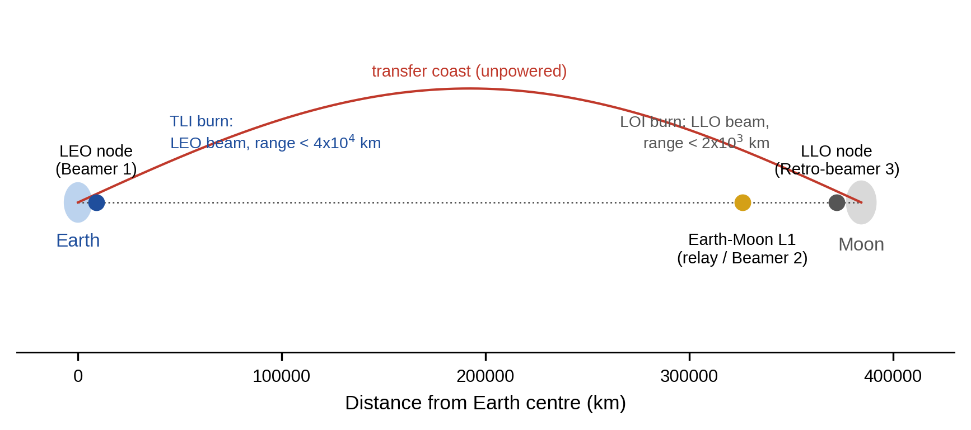
Fig. 1. Architecture of the laser-assisted transfer between low Earth orbit and low lunar orbit: laser nodes in low Earth orbit (Beamer 1) and low lunar orbit (retro-beamer 3), an Earth–Moon L1 relay for tracking and communication, and a bimodal tug that carries a reactor and a beam receiver (schematic, not to scale).
The vehicle is a bimodal tug: a reactor of thermal power P_{R} heats hydrogen, stored cryogenically at approximately 20 K and preheated to T_{in} = 100 K, to the core outlet temperature limit T_{core} (assumed 2600–2900 K); a beam receiver adds a useful laser power P_{use}=ρP_{R} to the same flow, so that the chamber enthalpy is h_{c}=h_{core}+ρ(h_{core}−h_{in}). The mass flow ṁ=P_{R}/(h_{core}−h_{in}) is set by the reactor alone. The reactor-only case, ρ=0, is the conventional NTP reference. The laser nodes are a node in low Earth orbit that beams during translunar injection (TLI), a node in low lunar orbit that beams (as a retro-beamer) during lunar orbit insertion (LOI), and a relay at the Earth–Moon L1 point used for tracking and data, not for power (Fig. 1). The mission delivers a payload of 20 t from a 400 km circular orbit to a 100 km circular lunar orbit in a transfer of 2.0 days; the tug is expended in the main comparison, and a round trip with a propulsive return is examined as a sensitivity (Section 6.9).
Orbital geometry of the nodes. Each node is on a circular orbit of the same radius as the circular orbit in which the burn starts (400 km altitude for the node in low Earth orbit, 100 km altitude for the node in low lunar orbit), in the orbital plane of the transfer, and is phased so that it is 1,000 km ahead of the vehicle along the orbit at the start of the burn. The node therefore moves on its own circular orbit during the burn while the vehicle departs along (TLI) or arrives on (LOI) the transfer orbit, and the node–vehicle range and the line of sight follow from the two trajectories. The model assumes that the node can be phased to this initial separation, for example by waiting in the departure orbit, and that its orbit is maintained; the sensitivity of the results to the phasing is examined in Section 6.5.
3. Thermochemical and nozzle model
Hydrogen at the chamber conditions is treated as an equilibrium mixture of H₂ and H with the dissociation degree α given by K_{p}=4α²p/(1−α²). The equilibrium constant follows from the partition functions of the two species, with a rigid rotor and harmonic oscillator for H₂ (rotational temperature 87.55 K, vibrational temperature 6332 K), a doublet ground state of the atom and the dissociation energy 4.4781 eV from the vibrational ground state [19]. The enthalpy per kg is h=[(1−α)h_{H2}(T)+α(5RT+D₀)]/M_{H2} and the entropy of the mixture is built from the same partition functions. The chamber temperature follows from the enthalpy balance of Section 2 at the chamber pressure p_{c} (assumed 2–7 MPa; 3 MPa nominal).
The exhaust velocity of an expansion to p_{e}=10⁻⁴p_{c} with nozzle efficiency η_{n} (0.92–0.96 in the analysis; 1 in the validation against Cantera, which has no nozzle loss) is computed in three ways. In the frozen expansion the composition of the chamber is kept and the temperature follows from the isentropic condition; the dissociation energy is lost. In the partial expansion a fraction φ (0–0.5) of the dissociation energy is recovered by recombination in the nozzle. In the shifting-equilibrium expansion the mixture is in chemical equilibrium throughout, which gives an upper bound. The ideal-gas formula I_{sp}=g₀⁻¹{[2γ/(γ−1)](RT_{c}/M)[1−(p_{e}/p_{c})^{(γ−1)/γ}]}^{1/2} with M = 2.016 g/mol and γ of 1.3 or 1.4, which does not include dissociation, is shown for comparison. The implementation was validated against Cantera [20] with NASA polynomial data (equilibrium composition, and isentropic expansions with frozen and equilibrium composition) at identical temperature, pressure, expansion ratio and nozzle efficiency (Table 1), and against an independent numerical minimization of the Gibbs energy; the method is of the kind of the NASA chemical-equilibrium program [21].
4. Optical, receiver and power model
4.1 Power chain and beam link
Four powers are distinguished. The useful thermal power delivered to the propellant is P_{use}=ρP_{R}. The power absorbed by the receiver is P_{abs}=P_{use}/η_{coup}, with a coupling efficiency η_{coup} (0.80–0.95) that accounts for reradiation and conduction losses of a receiver at the chamber temperature; the difference is waste heat on the vehicle. The power received at the aperture is P_{rec}=P_{abs}/η_{abs} with an absorption efficiency η_{abs} (0.90–0.99). The emitted power is P_{emit}=P_{rec}/(η_{opt}η_{cap}) with transmitter optics efficiency η_{opt} = 0.9 and the captured fraction η_{cap} of the link. The electrical power drawn by the laser is P_{elec}=P_{emit}/η_{wp} with a wall-plug efficiency η_{wp} (0.3–0.5), and the difference is waste heat at the node.
The link is a Gaussian beam. The transmitter aperture D_{t} (10 m unless stated) gives a waist w₀=0.45D_{t} and the beam is assumed to be refocused on the receiver at every range, an optimistic assumption, so that the spot radius is w=M²λR/(πw₀) at range R, with wavelength λ = 1.07 µm and beam quality M² (1.1–1.6) [22]. Pointing jitter σ_{θ} (0.05–0.3 µrad rms per axis) is added to the spot size in quadrature, w_{eff}²=w²+4(σ_{θ}R)², and a receiver of radius r_{R} = 3 m captures η_{cap}=1−exp (−2r_{R}²/w_{eff}²). The beam is lost when the line of sight between the node and the vehicle passes through the Earth (with a 100 km atmospheric margin) or the Moon (20 km margin), and Poisson dropouts (0.01–0.5 per hour), each followed by a reacquisition time of 10–120 s, interrupt it. The captured fraction, the occultation and the dropouts are evaluated along the simulated trajectory.
4.2 Scope of the receiver mass and the heating of the hydrogen
The receiver specific mass μ_{rec} (15–80 kg per MW absorbed, assumed) is defined here as the mass of everything on the vehicle that converts the received beam into hydrogen enthalpy: the receiving optics and window, the absorber or the plasma chamber, the thermal protection and cooling that keep the structure below its limits, the structure and mounting, and the receiver's own thermal management and pointing; it excludes the reactor, its shield, the nozzle and the tanks. The range is an assumption; no flight or ground receiver of this power exists to calibrate it, and it is the most important input of the analysis (Section 6.7).
A chamber temperature of 4500 K is above the highest melting temperature measured for any compound, 4232 ± 84 K for HfC_{0.98} [23], and graphite, which melts only at pressures of the order of 10–100 MPa near 4800 K [24], would sublime at the 3 MPa of the nominal chamber (Table 7). A solid chamber wall at the gas temperature is therefore excluded, and the hydrogen must be heated without contact with a wall at that temperature, for example in a laser-sustained plasma, which has been studied for hydrogen and tested at 10 kW [13,14]. The model does not contain a model of such a heating zone; it takes the chamber temperature as a design target and represents the losses of a noncontact heating zone through the coupling efficiency η_{coup}. The following calculation is an illustrative bound and not evidence that the receiver is feasible. A surface radiating as a blackbody at 4500 K emits 23.3 MW/m², so the 10% loss budget of the nominal vehicle (132 MW of waste heat at the receiver) would be used up by an optically thick hot zone of approximately 5.7 m² of radiating surface. This only indicates the size of a heating zone that would be compatible with the assumed coupling efficiency of 0.8–0.95; it does not show that such a coupling can be achieved. The emissivity of the hot hydrogen and of a plasma, the stability of a laser-sustained plasma at 3 MPa, the absorption of the beam in the gas, the residence time of the gas at the flow rate of the tug (11.4 kg/s of hydrogen) and the cooling of the window and of the surrounding structure are not validated here. They are the unvalidated physics behind η_{coup} and μ_{rec} and would have to be established by experiment.
5. Mission, mass and uncertainty model
5.1 Transfer geometry and finite burns
The transfer is a coplanar patched-conic transfer from a 400 km circular orbit to a 100 km circular lunar orbit. The perigee speed is solved for the time of flight (2 days nominal, 1.6–4.5 days studied), which gives an impulsive Δv_{TLI} of 3.19 km/s and Δv_{LOI} of 1.28 km/s at 2 days [25]. The burns are integrated as finite burns in the central body's two-body field with thrust along the velocity: TLI is a prograde burn from the circular orbit until the orbital energy of the transfer orbit is reached; LOI is a retrograde burn centered on periselene until the orbit is circular. The thrust is F=ṁ g₀I_{sp}(t) with I_{sp} interpolated from a table of specific impulse against the laser power received, which changes with the captured fraction, so that gravity losses, the growth of the node–vehicle range, occultation and dropouts all enter the propellant used. A second, independent integration of the finite burns (Section 6.11) checks the integrator.
5.2 Mass model and benchmark
The initial mass M satisfies M=m_{pl}+m_{fix}+(1+f_{t})(1+f_{r})m_{burned}(M), where m_{pl} = 20 t is the payload, m_{fix}=m_{eng}+m_{rec}+m_{misc}, m_{eng}=F/(g₀ T/W) with an engine thrust-to-weight T/W of 3–8, m_{rec}=μ_{rec}P_{abs}, m_{misc} = 3.0 t of structure and avionics, f_{t} is the tank mass fraction (0.12–0.25), and f_{r} = 0.05 a residual and boil-off allowance. m_{burned}(M) is the propellant used by the simulated burns for the initial mass M, and the equation is solved for the smallest M that closes. The engine system (reactor, shield, nozzle and turbopump) is assumed to have a mass proportional to its thrust at every reactor size, that is a constant thrust-to-weight ratio; this ignores the fixed overheads of a shield and a pressure vessel that favor larger reactors and the heavier structure of very large cores that favors smaller ones, and Section 6.6 tests the effect of a size-dependent scaling. The primary benchmark is a conventional NTP tug whose reactor power is chosen to minimize its own initial mass for the same payload, trajectory, margins and burn simulation, compared with the laser-assisted tug whose reactor power is likewise chosen to minimize its mass. Two design spaces are therefore distinguished. The sampling space of the Monte Carlo analysis is that of Table 2, in which the reactor power is 100–500 MWt (the concept's range) and is used for the secondary comparison at equal reactor power. In the optimized benchmark the reactor power of each tug is a decision variable, scanned over 25, 50, 100, 250, 500, 750, 1,000, 1,500, and 2,000 MWt, while all other parameters are drawn from Table 2; the scan extends beyond 100–500 MWt and relies on the assumed engine scaling outside the range of the concept. The IMLEO ratio is M_{LANTP}/M_{NTP}; the targeted 40% reduction corresponds to 0.6.
5.3 Laser infrastructure
Each laser node is sized for the emitted power P_{emit} at the start of the burn and the energy of the burns it serves (TLI for the node in low Earth orbit, LOI for the node in low lunar orbit). Three energies are distinguished: the emitted optical energy E_{emit}=P_{emit}t_{on}, the electrical energy E_{el}=E_{emit}/η_{wp} drawn from the buffer, and the waste heat E_{w}=E_{el}−E_{emit} to be absorbed. The electrical supply is a battery buffer of mass E_{el}/e_{s} with specific energy e_{s} of 150–500 Wh/kg, the waste-heat buffer has mass E_{w}/c_{s} with a heat capacity c_{s} of 0.5–3 MJ/kg, the laser and its optics weigh 100–1000 kg per MW emitted, the aperture 10–30 kg/m², and a solar array recharges the buffer between missions (6 missions per year, efficiency 0.9). The laser is assumed to be on for the whole burn (conservative). Buffering the burn energy rather than supplying the peak power directly is the lighter choice for a duty cycle of hours per mission; the result is a lower bound on the node mass. The infrastructure (two nodes and a relay of 2.0 t) is amortized over 90 missions (15 years).
5.4 Contingency policies
Three policies are compared for the tank loading. In the nominal policy the vehicle carries the propellant for laser-assisted burns. In the single-fault policy it carries the propellant to complete TLI on the reactor alone, so that a laser outage before TLI does not strand the vehicle. In the full-fallback policy it carries the propellant for a reactor-only mission with the LANTP hardware. The propellant to complete TLI after a loss of the laser at a time t_{out} is also computed for the nominal vehicle.
5.5 Uncertainty, sensitivity and verification
The uncertain parameters of Table 2 are sampled independently (uniform or log-uniform between the limits, assumed): 1,500 draws for the fixed-reactor analysis and 500 draws for the optimized benchmark. The distributions are reported with their 5th, 50th and 95th percentiles. The influence of the inputs is measured by Spearman rank correlation and by variance-based Sobol indices of the IMLEO ratio (scrambled Sobol quasi-random sequence with a base sample of 2,048, first-order index with the Saltelli estimator and total index with the Jansen estimator, bootstrap 95% intervals for both, 32,768 model evaluations, 14 parameters), which include nonlinear interactions. A technology-threshold map gives the IMLEO ratio on a grid of useful laser power and receiver specific mass for the nominal vehicle, and the infrastructure-inclusive ratio (M_{LANTP}+M_{inf}/N)/M_{NTP} gives the number of missions N* at which the nodes are amortized. Verification consists of the validation of the thermochemistry (Section 6.1), an independent adaptive integration of the finite burns and a rocket-equation limiting case (Section 6.11), the closure residual of the mass equation, and automated tests. All inputs are assumed ranges, not measurements; the results are conditional on them.
5.6 Software and use of AI tools
The model is written in Python (numpy, scipy, matplotlib; Cantera for the validation) and archived with its results and tests (data availability). A generative AI tool (Claude, Anthropic) was used to assist with drafting the text, writing and testing the code and generating the figures from the code; the author reviewed and edited the output, checked the calculations against independent solvers and the closed-form limits, and takes full responsibility for the content.
Parameter | Unit | Low | High | Distribution | Nominal
Reactor thermal power | MW | 100 | 500 | uniform | 500
Core outlet temperature limit | K | 2,600 | 2,900 | uniform | 2,800
Chamber pressure | MPa | 2.00 | 7.00 | log-uniform | 3.00
Nozzle recombination fraction φ | – | 0.00 | 0.50 | uniform | 0.30
Nozzle efficiency | – | 0.92 | 0.96 | uniform | 0.94
Receiver specific mass | kg/MW absorbed | 15 | 80 | log-uniform | 25
Engine thrust-to-weight | – | 3.00 | 8.00 | uniform | 5.00
Tank mass fraction | – | 0.12 | 0.25 | uniform | 0.18
Pointing jitter (rms per axis) | µrad | 0.05 | 0.30 | log-uniform | 0.05
Beam quality M² | – | 1.10 | 1.60 | uniform | 1.20
Link dropout rate | per hour | 0.01 | 0.50 | log-uniform | 0.05
Reacquisition time | s | 10 | 120 | uniform | 30
Coupling efficiency | – | 0.80 | 0.95 | uniform | 0.90
Absorption efficiency | – | 0.90 | 0.99 | uniform | 0.95
Laser wall-plug efficiency | – | 0.30 | 0.50 | uniform | 0.40
Energy buffer specific energy | Wh/kg | 150 | 500 | log-uniform | 250
Waste-heat buffer capacity | MJ/kg | 0.50 | 3.00 | log-uniform | 1.50
Laser and optics specific mass | kg/MW emitted | 100 | 1,000 | log-uniform | 300
Aperture areal density | kg/m² | 10 | 30 | uniform | 15
Table 2. Uncertain parameters of the Monte Carlo analysis (assumed ranges) and the nominal values used for the break-even grids.
6. Results
All results are conditional on the assumed ranges of Table 2. Probabilities and percentiles describe the assumed uncertainty, not field statistics. Unless stated, the mission is a one-way delivery of 20 t at a transfer time of 2 days.
6.1 Hydrogen thermochemistry and validation
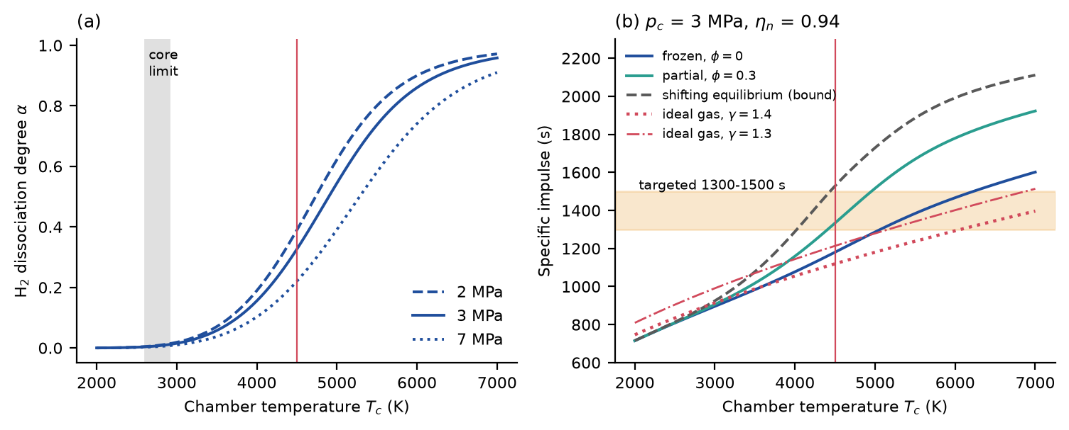
Fig. 2. (a) Equilibrium dissociation degree of hydrogen against chamber temperature at three pressures. (b) Specific impulse for frozen flow, partial recombination, the shifting-equilibrium bound and the ideal-gas formula without dissociation, for η_{n} = 0.94 (vertical line: 4500 K; band: targeted 1300–1500 s).
The dissociation degree at 3 MPa is 0.33 at 4500 K and the core limit of 2600–2900 K lies below the onset of dissociation (Fig. 2a). Table 1 compares the model with Cantera at identical conditions: the same temperature, pressure, expansion ratio (p_{e}=10⁻⁴p_{c}) and, for the specific impulse, the same nozzle efficiency, first 1 (the isentropic limit, which Cantera computes) and then 0.94 (the value used in Fig. 2b and in the rest of the paper, obtained by multiplying the exhaust velocity). At 4500 K and 3 MPa the frozen specific impulse is 1,272 s for Cantera and 1,256 s for this model at an efficiency of 1, and 1,196 and 1,180 s at 0.94; the shifting-equilibrium bound is 1,612 and 1,626 s at 1, and 1,515 and 1,529 s at 0.94. The values of Fig. 2b and of the text (1,180 s frozen, 1,529 s shifting) are thus the efficiency-0.94 values of the same calculation. Recombination of 30% of the dissociation energy (Fig. 2b) has no Cantera counterpart and gives 1,334 s; the ideal-gas formula, which neglects dissociation, gives 1,120 s (γ = 1.4) and 1,214 s (γ = 1.3). Over the validation cases the dissociation degree of this model is higher than that of Cantera by 4% to 8%, the frozen specific impulse lower by 0.8% to 1.6% and the shifting-equilibrium bound within −0.6% to 0.9%; the difference in the dissociation degree is that of a rigid-rotor, harmonic-oscillator model without anharmonicity and is not corrected. The targeted 1300–1500 s at 4500 K is reached only if a substantial part of the dissociation energy is recovered in the nozzle, which depends on nozzle kinetics that this model does not resolve; at the core limit the specific impulse is 858 s. The minimization of the Gibbs energy agrees with the analytic equilibrium to 1e-08 in the dissociation degree, which verifies the equilibrium solver but not the thermodynamic data.
Quantity | Condition | Reference | This model | Difference | This model, η_{n} = 0.94
α | 2800 K, 3 MPa | 0.0075 | 0.0079 | 5.1% | –
α | 3000 K, 0.1 MPa | 0.0793 | 0.0836 | 5.5% | –
α | 3500 K, 3 MPa | 0.0542 | 0.0577 | 6.5% | –
α | 4000 K, 0.1 MPa | 0.6260 | 0.6534 | 4.4% | –
α | 4500 K, 3 MPa | 0.3028 | 0.3264 | 7.8% | –
Isp frozen (s) | 3500 K, 3 MPa | 1,062 | 1,046 | −1.5% | 984
Isp frozen (s) | 4500 K, 3 MPa | 1,272 | 1,256 | −1.3% | 1,180
Isp frozen (s) | 5500 K, 3 MPa | 1,485 | 1,472 | −0.8% | 1,384
Isp frozen (s) | 4500 K, 7 MPa | 1,255 | 1,235 | −1.6% | 1,161
Isp shifting (s) | 3500 K, 3 MPa | 1,155 | 1,147 | −0.6% | 1,078
Isp shifting (s) | 4500 K, 3 MPa | 1,612 | 1,626 | 0.9% | 1,529
Isp shifting (s) | 5500 K, 3 MPa | 1,988 | 2,006 | 0.9% | 1,886
Isp shifting (s) | 4500 K, 7 MPa | 1,509 | 1,516 | 0.4% | 1,425
Table 1. Validation of the hydrogen model against Cantera 3.2.0 (h2o2.yaml) at identical conditions (equilibrium and isentropic expansion to p_{e}=10⁻⁴p_{c}). The specific-impulse columns for η_{n} = 1 compare the two solvers; the last column is the value of this model at the nozzle efficiency of 0.94 used in the paper (the Cantera value at 0.94 is 0.94 times the reference).
6.2 Power closure: the laser fraction required
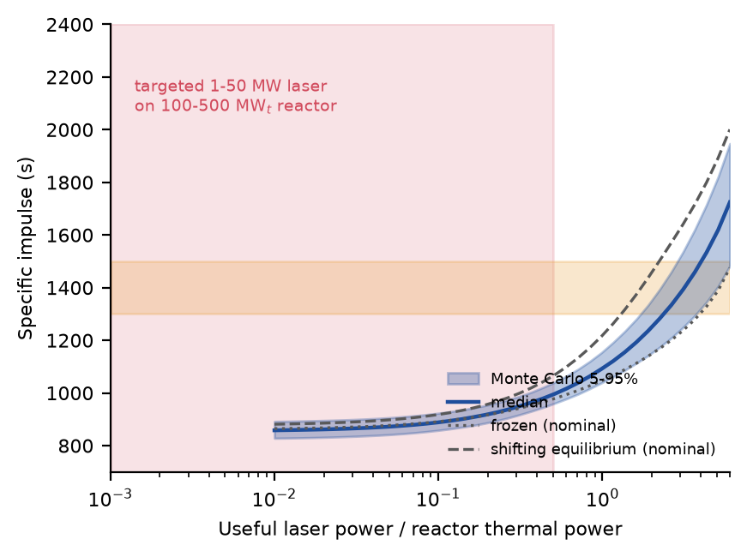
Fig. 3. Specific impulse against the useful laser power as a fraction of the reactor power: Monte Carlo median and 5–95% band, the frozen and shifting-equilibrium bounds for the nominal parameters, the targeted laser class (shaded) and the targeted specific impulse (band).
With the reactor alone the specific impulse is 858 s (5th–95th percentile 828–892 s). Reaching 1300, 1400 and 1500 s at the median of the parameters requires a useful laser power of 2.2, 2.9 and 3.6 times the reactor power (Fig. 3); with 4500 K as the design point the fraction is 2.4. A laser of 1–50 MW on a reactor of 100–500 MWt corresponds to a fraction between 0.002 and 0.50, and the specific impulse at those two ends is 867 and 1,008 s. The targeted performance is therefore inconsistent with the targeted laser power: the most favorable end of the combination (50 MW on 100 MWt) is short by a factor of 4, and the other end by a factor of more than 1,100 (H1). The reason is the enthalpy balance: heating hydrogen from the core limit to 4500 K, including dissociation, needs about 2.4 times the enthalpy that the reactor delivers between the tank and the core outlet.
6.3 Emitted laser power at the targeted thrust
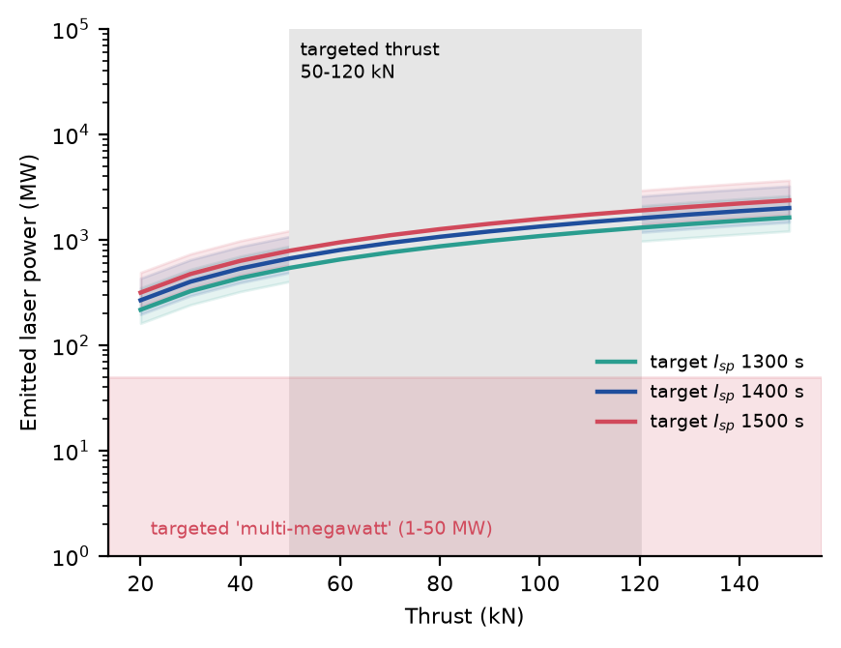
Fig. 4. Emitted laser power required for a given thrust and specific impulse (median and 5–95% band over the parameters), against the targeted thrust (band) and the targeted laser class (shaded).
For a thrust of 50 kN at 1400 s the emitted laser power is 668 MW (5th–95th percentile 490–1,079 MW), and for 120 kN 1,603 MW (1,175–2,589 MW) (Fig. 4), against the targeted 1–50 MW. These are emitted powers at the start of the burn, where the beam is captured almost completely; they include the receiver, optics and coupling efficiencies of Section 4 and need an electrical power of 1.7–4.0 GW at the median wall-plug efficiency. Table 3 gives the power chain for the nominal vehicle: a useful power of 1.19 GW on the propellant needs 1.55 GW of emitted power and 3.87 GW of electrical power, and rejects 2.32 GW of waste heat at the node and 0.13 GW at the receiver.
Quantity | Value
Reactor thermal power P_{R} | 500 MW
Useful thermal power on the propellant P_{use}=ρP_{R} (ρ = 2.38) | 1,192 MW
Absorbed by the receiver P_{abs} (coupling 0.90) | 1,324 MW
Received at the aperture P_{rec} (absorption 0.95) | 1,394 MW
Emitted by the node P_{emit} (optics 0.9, capture at 1000 km) | 1,549 MW
Electrical power P_{elec} (wall plug 0.4) | 3,872 MW
Waste heat at the laser node | 2,323 MW
Waste heat at the receiver | 132 MW
Thrust (reactor only: 97 kN) | 149 kN
Specific impulse (reactor only: 867 s) | 1,334 s
Table 3. Power chain of the nominal vehicle at a chamber temperature of 4500 K.
6.4 Beam link
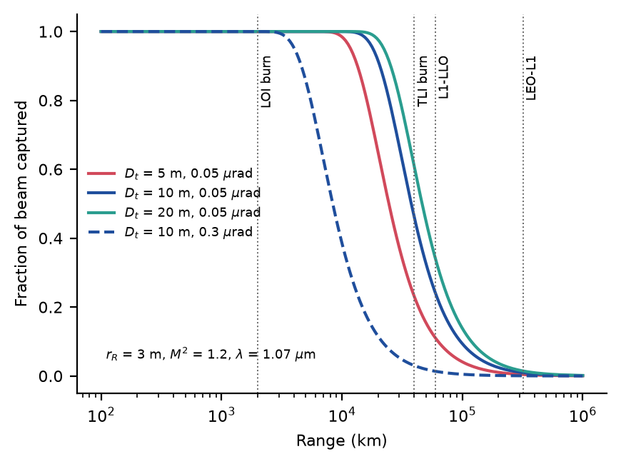
Fig. 5. Fraction of the emitted beam captured by a 3 m receiver against range, for three apertures at 0.05 µrad pointing jitter and one at 0.3 µrad (refocused beam, M² = 1.2, λ = 1.07 µm); vertical lines mark the ranges of the burns and of the relay links.
With a 10 m aperture and 0.05 µrad of jitter the captured fraction is 1.00 at 1000 km (the start of LOI), 0.69 at 29,000 km, 0.24 over the 60,000 km between the L1 relay and the lunar node and 0.010 over the 320,000 km between the Earth node and L1 (Fig. 5). Even a 100 m aperture captures 0.39 at 60,000 km and 0.017 at 320,000 km, because the pointing jitter, not diffraction, then limits the spot; the receiver radius needed for half of the beam at 60,000 km is 4.8 m with a 10 m aperture. Beaming across the relay legs is therefore excluded and the laser must act while the vehicle is within a few 10⁴ km of its node, the ranges drawn in Fig. 1. Tolerating a jitter of 0.3 µrad shortens the range at which half of the beam is captured with the 10 m aperture to approximately 8,400 km (Table S4).
6.5 Finite burns, occultation, link losses and node phasing
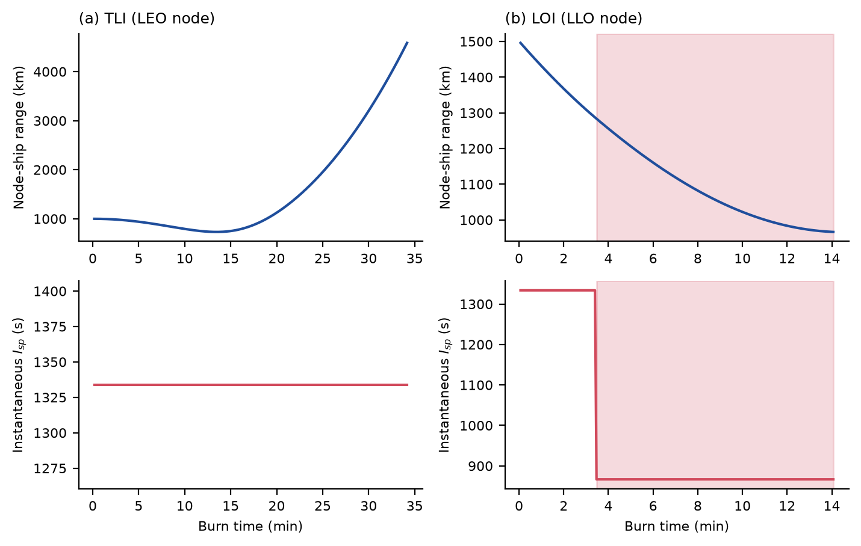
Fig. 6. Burn timelines of the nominal vehicle: node–vehicle range and instantaneous specific impulse during (a) TLI and (b) LOI; shaded: line of sight blocked by the Earth or the Moon.
The nominal LANTP tug (initial mass 100 t, thrust 149 kN) burns for 34 min during TLI and 14 min during LOI, against 25 and 7 min for the reactor-only tug of 53 t (Fig. 6). In the nominal case the TLI burn ends within 4,600 km of the node, so that the beam is captured completely and the specific impulse remains at the design value; during LOI the Moon blocks the line of sight 3.5 min after the start of the burn, and the specific impulse decreases to the reactor-only value for the rest of the burn. Over the Monte Carlo draws the lower power of the weaker links and the gravity losses of the longer burns lower the delivered impulse: the effective specific impulse of the TLI burn, defined by the impulsive Δv and the propellant used and so including gravity losses, has a median of 1,023 s (5th–95th percentile 673–1,253 s), well below the design value of 1,291 s (Fig. 8b). The result depends on the phasing of the node. With the node 500 km, 1000 km and 3000 km ahead of the vehicle at the start of the burn the IMLEO ratio at equal reactor power is 1.81, 1.90 and 1.95; with the node 10,000 km ahead the vehicle is occulted by the Earth during the burn, the specific impulse decreases to the reactor-only value and the ratio is 2.43 (2.67 at 20,000 km). The benefit therefore requires a node that stays near the vehicle throughout the burn.
6.6 Monte Carlo analysis of the initial mass
Primary benchmark. With the reactor power of each tug chosen to minimize its own initial mass for the same payload (500 draws; reactor power scanned over 25, 50, 100, 250, 500, 750, 1,000, 1,500, and 2,000 MWt), the laser-assisted tug has an IMLEO ratio with a median of 1.44 (5th–95th percentile 1.13–1.94); 0% of the draws are below 1 and 0% reach the targeted ratio of 0.6 (H2) (Fig. 7a). The optimal reactor power of the conventional tug has a median of 500 MWt (the same in at least 90% of the draws), that of the laser-assisted tug 100 MWt (5th–95th percentile 100–250), because every megawatt of reactor power carries a receiver with it (Fig. 7b). Against the same best conventional tug, the laser-assisted tug at the reactor power of the draw (100–500 MWt) has a median ratio of 1.74 (1.14–3.97).
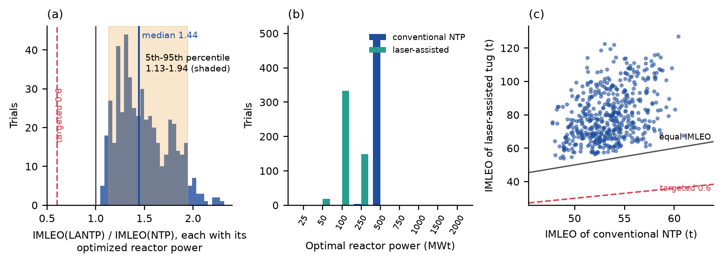
Fig. 7. Primary benchmark, both tugs with the reactor power that minimizes their own initial mass (500 draws): (a) distribution of the IMLEO ratio with its median and 5th–95th percentile range, the ratio of 1 and the targeted 0.6; (b) optimal reactor power of the conventional and of the laser-assisted tug; (c) initial mass of the laser-assisted tug against that of conventional NTP, with the lines of equal mass and of the targeted 40% reduction.
Scaling of the engine mass with reactor power. Because the optimum depends on how the engine system weighs at different sizes, the benchmark was repeated (150 draws) with the engine mass scaling as P_{R}^{x} at constant thrust, relative to its value at 500 MWt: for x = 0.7 (larger reactors lighter per unit of thrust) the median ratio is 1.51 (5th–95th percentile 1.18–1.95), for x = 1 (the baseline) 1.49 and for x = 1.3 (larger reactors heavier per unit of thrust) 1.48 (1.14–1.93). In all three cases the median optimal reactor power is 500 MWt for the conventional tug and 100 MWt for the laser-assisted tug, and no draw has a ratio below 1. The ratio changes by less than 0.04 (medians) between the three scalings, and the optimal reactor power of each tug is unchanged or almost unchanged (95th percentile of the conventional tug 750 MWt at x = 0.7): the benchmark is therefore not an artifact of the constant thrust-to-weight assumption within the range tested. The draws differ from the 500 of the main benchmark, so the baseline median differs slightly from the value above. The optimum of the laser-assisted tug remains far below that of the conventional tug because of the receiver mass it carries with every megawatt (Table S23).
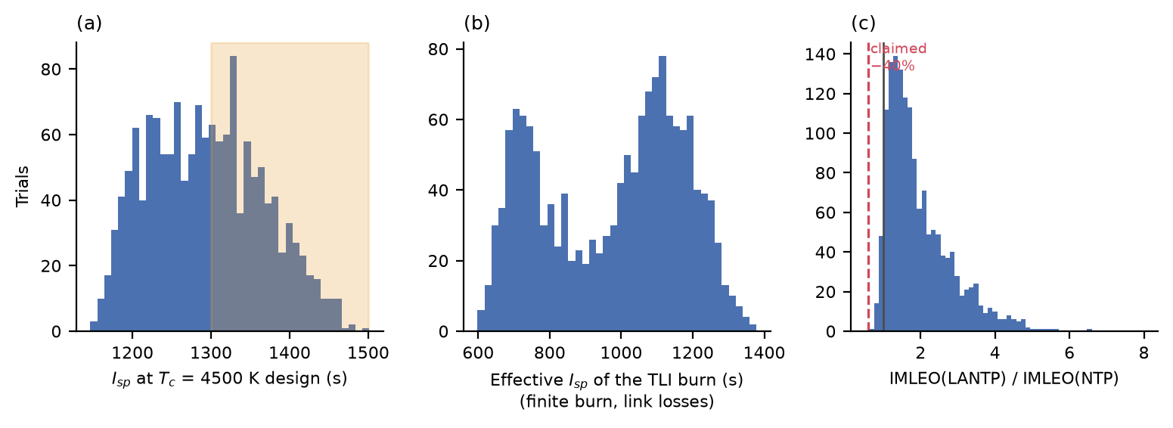
Fig. 8. Monte Carlo distributions at equal reactor power (1,500 draws): (a) specific impulse at the 4500 K design point, with the targeted band; (b) effective specific impulse of the TLI burn including gravity losses and link losses; (c) IMLEO of the laser-assisted tug divided by that of conventional NTP, with the targeted 40% reduction.
Secondary comparison at equal reactor power. The design-point specific impulse has a median of 1,291 s (5th–95th percentile 1,186–1,418 s), and 46% of the draws lie in the targeted band of 1300–1500 s (Fig. 8a). The IMLEO ratio at equal reactor power has a median of 1.69 (5th–95th percentile 1.02–3.70); 4.0% of the draws are below 1 and 0.0% reach 0.6 (Fig. 8c). The receiver is the main cause: the median receiver mass is 26.1 t (5th–95th percentile 8.3–73.6 t) against a reactor-only tug of approximately 55 t. The 95% bootstrap interval of the median ratio at 1,500 draws is 1.66–1.73 (Fig. 12b).
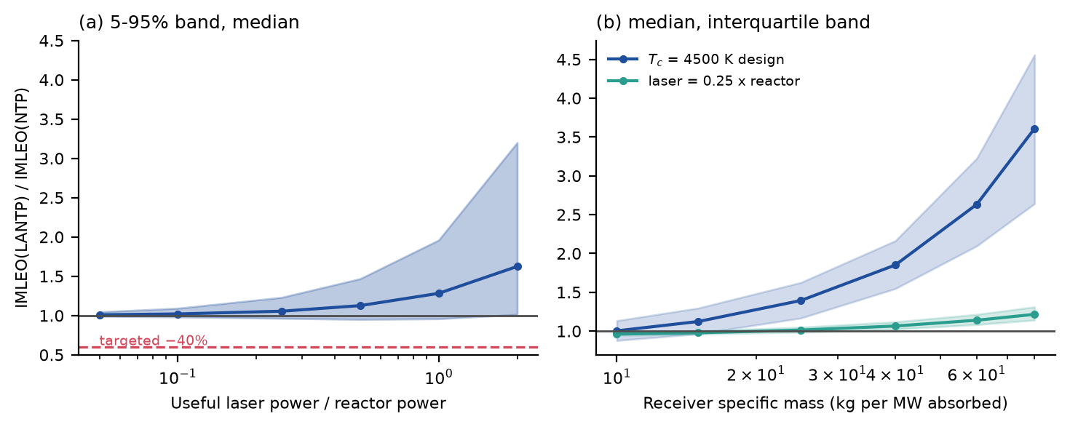
Fig. 9. IMLEO ratio of the laser-assisted tug to conventional NTP (reactor power of the draw) against (a) the useful laser power fraction (5–95% band and median) and (b) the receiver specific mass, for the 4500 K design point and for a fixed laser fraction of 0.25.
The ratio increases with the laser fraction (Fig. 9a): its median is 1.02 at a fraction of 0.1, 1.13 at 0.5 and 1.62 at 2, and the lower end of the 5–95% band is 0.96 at a fraction of 0.25. At a fixed fraction of 0.25 the median ratio is 0.96 for a receiver of 10 kg/MW and 1.22 for 80 kg/MW; for the 4500 K design it is 1.00 and 3.61 (Fig. 9b).
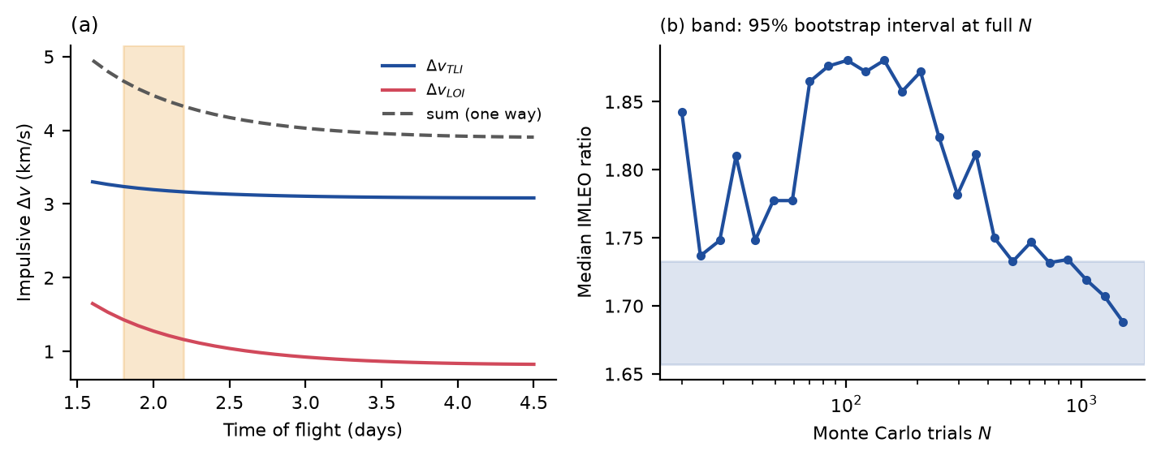
Fig. 12. (a) Impulsive Δv of TLI and LOI against the time of flight (band: the 1.8–2.2 day transfer of the nominal case). (b) Convergence of the median IMLEO ratio at equal reactor power with the number of Monte Carlo draws; the band is the 95% bootstrap interval of the median at the full number of draws.
6.7 Global sensitivity analysis
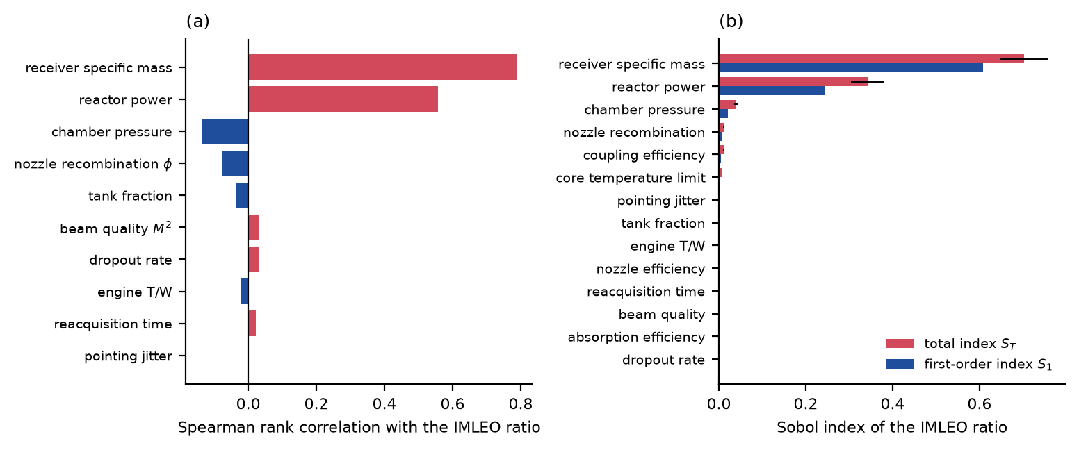
Fig. 11. Sensitivity of the IMLEO ratio at equal reactor power: (a) Spearman rank correlation with the uncertain parameters (Monte Carlo draws); (b) Sobol first-order and total indices (scrambled Sobol sequence; bars: 95% bootstrap interval of the total index).
The rank correlation of the IMLEO ratio with the receiver specific mass is 0.79, with the reactor power 0.56, with the chamber pressure −0.14 and with the nozzle recombination fraction −0.08 (Fig. 11a). The Sobol indices (base sample 2,048, 32,768 evaluations, 14 parameters; Fig. 11b) show that the receiver specific mass has a total index of 0.70 (95% bootstrap interval 0.65–0.76) and a first-order index of 0.61 (0.46–0.76), and the reactor power a total index of 0.34 (0.30–0.38) and a first-order index of 0.24 (0.16–0.34); the sum of the first-order indices is 0.90, so that 10% of the variance comes from interactions. The interaction between receiver mass and reactor power is expected: the receiver mass is the product of the specific mass and the absorbed power, which is proportional to the reactor power at the 4500 K design. The total index is not smaller than the first-order index for any parameter beyond the estimation error (largest excess of the first-order index: 0.001), as required by the definition of the indices. The first-order intervals are wide because the ratio has a heavy upper tail, which makes the first-order estimator noisy, and a smaller sample or ordinary random sampling can produce a first-order estimate above the total one by chance; the quasi-random sequence and the sample used here avoid this. The indices of the receiver and of the reactor are stable from a base sample of 512 (Table S24), and for the logarithm of the ratio, which has a lighter tail, they are 0.64 and 0.66 (receiver: first-order and total) and 0.30 and 0.32 (reactor). All link parameters (jitter, beam quality, dropouts, reacquisition time) have total indices of 0.01 or less, and the efficiencies of the receiver (coupling, absorption) 0.01 at most. The conclusions are therefore about the receiver and the reactor, not about the link, once the beam is held (Section 6.5).
6.8 Break-even surfaces and technology-threshold map
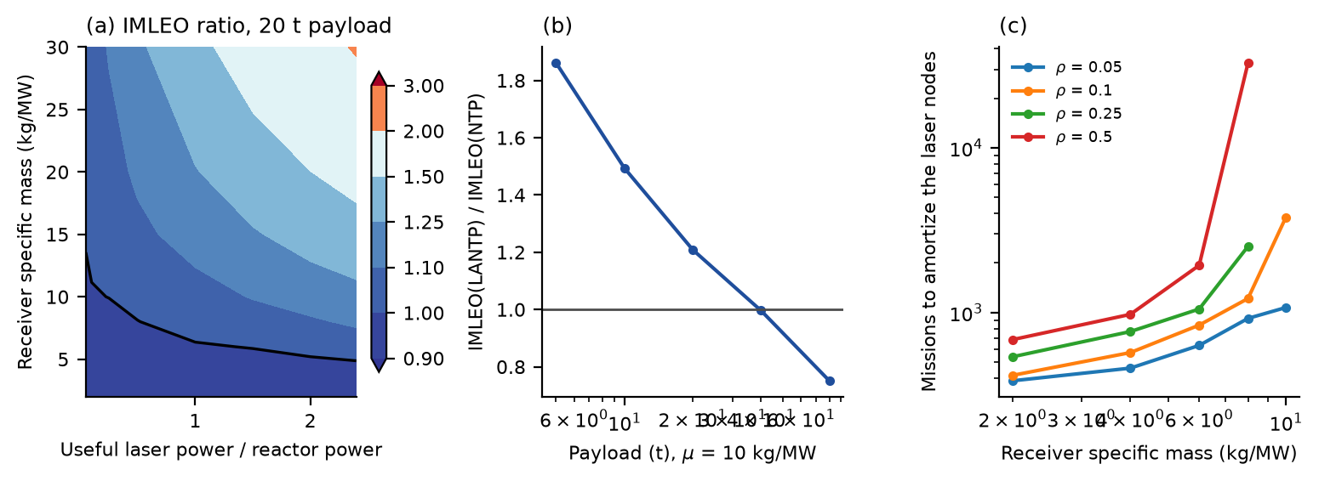
Fig. 10. Break-even analysis for the nominal vehicle (reactor 500 MWt): (a) IMLEO ratio on a grid of receiver specific mass and useful laser power fraction (black line: ratio 1); (b) ratio against payload at a receiver of 10 kg/MW; (c) number of missions over which the laser nodes must be amortized for the spacecraft saving to equal the node mass (missing points: no saving).
On the grid of receiver specific mass and laser fraction (Fig. 10a) the IMLEO ratio at the nominal 500 MWt is below 1 only in a small corner: its minimum is 0.90, at the smallest receiver (2 kg/MW) and a laser fraction of 2.00; at a fraction of 0.25 the ratio crosses 1 at a receiver of approximately 10 kg/MW. The best case saves 10% of the IMLEO, not 40%. The advantage grows with the payload because the fixed receiver is shared by more cargo: against the 500 MWt reference tug the ratio at 10 kg/MW falls below 1 at a payload of approximately 40 t (Fig. 10b); against the best conventional tug (reactor scan from 250 to 2000 MWt) the ratio is 1.02 for 40 t of payload and 0.91 for 80 t (the best conventional tug weighs 98 t and 192 t), not 1.00 and 0.79 against the 500 MWt reference. The transfer time changes the ratio by less than 3% between 1.8 and 4.5 days. The laser nodes of Section 6.9 weigh 17,888 t for the nominal vehicle, so the smallest number of missions that amortizes them on the grid is 385, against an assumed lifetime of 90 missions, and for most of the grid they are never amortized (Fig. 10c).
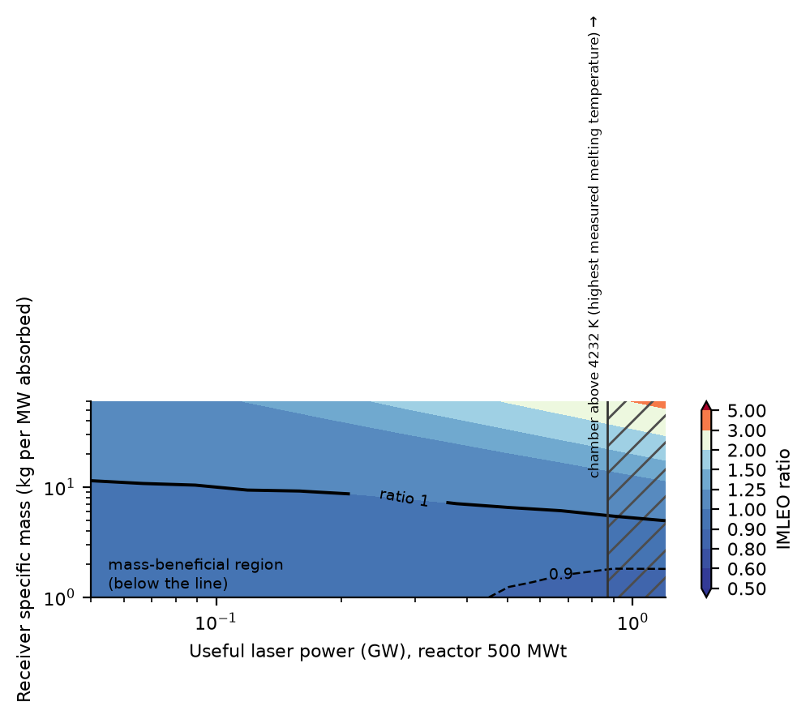
Fig. 14. Technology-threshold map of the nominal vehicle: IMLEO ratio against the useful laser power and the receiver specific mass (reactor 500 MWt). A mass benefit exists below the solid line (ratio 1) and a 10% benefit below the dashed line; the hatched region has a chamber temperature above the highest measured melting temperature of any compound.
Fig. 14 condenses the result into a threshold: for a useful laser power of 0.05 GW the receiver must weigh less than 11 kg per MW absorbed for the mass benefit to exist at all, and less than 5 kg/MW at 1.2 GW; a 10% benefit needs less than 1.8 kg/MW at 1.2 GW and is not reached below 0.50 GW within the range of receiver masses studied (down to 1 kg/MW). No point of the map reaches the targeted 0.6. The power at which the chamber temperature reaches the highest measured melting temperature of any compound, 4232 K [23], is 0.87 GW; the laser powers beyond it require a heating concept that does not rely on a solid wall (Section 4.2). The map is for the nominal reactor, laser-link and mass parameters and the 20 t payload.
6.9 Laser infrastructure and the round trip
Item | Value
Emitted power P_{emit} | 1.55 GW
Electrical power at the node P_{elec} | 3.87 GW
Burn time with the laser on (TLI) | 34 min
Optical energy emitted E_{emit} (LEO node, TLI) | 0.88 GWh
Electrical energy drawn from the buffer E_{el}=E_{emit}/η_{wp} | 2.20 GWh
Waste heat to be absorbed E_{w}=E_{el}−E_{emit} | 1.32 GWh = 4.8 TJ
Battery buffer E_{el}/e_{s} (250 Wh/kg) | 8,819 t
Waste-heat buffer E_{w}/c_{s} (1.5 MJ/kg) | 3,175 t
Laser and optics (300 kg/MW emitted) | 465 t
Aperture and recharge array | 17.9 t
Node in low Earth orbit | 12,476 t
Both nodes and relay | 17,888 t
Per mission over 90 missions | 199 t
Tug, LANTP / conventional NTP (same reactor) | 100 t / 53 t
Table 5. Laser infrastructure of the nominal vehicle: the quantities are the optical energy emitted, the electrical energy drawn from the buffer and the waste heat, each with its own mass (lower bound: energy buffered, not supplied at peak power).
The nominal laser node would emit 1.5 GW for 34 min, that is 0.88 GWh of optical energy; at the wall-plug efficiency of 0.4 this is 2.20 GWh of electrical energy to be stored and 1.32 GWh (4.8 TJ) of waste heat to be buffered per burn (Table 5). The two nodes and the relay weigh 17,888 t (median over the draws 19,790 t, 5th–95th percentile 8,282–54,805 t), against a tug of 100 t; per mission, over 90 missions, the infrastructure adds 199 t to the IMLEO, so that the infrastructure-inclusive IMLEO ratio at equal reactor power has a median of 5.6 (5th–95th percentile 2.8–14.7). Supplying the peak power from solar arrays or a reactor instead of buffering the energy would be far heavier. The comparison with conventional NTP is thus unfavorable even before the link is considered. A round trip with propulsive return (four burns, the tug reused, same 500 MWt reactor) gives an IMLEO ratio of 1.28 (76 t against 59 t) for a 10 t payload at 10 kg/MW and 2.36 (140 t against 59 t) at 25 kg/MW. For 20 t and for 40 t the reactor-only tug does not close, because its thrust is too low for the multihour burns of a heavy vehicle, while the laser-assisted tug closes at an initial mass of 97 t for 20 t and of 149 t for 40 t at 10 kg/MW (25 kg/MW: 164 t and no closure). The advantage at large payloads at a fixed reactor is a thrust advantage and not a specific-impulse advantage, and it is reduced when the conventional tug is allowed a larger reactor (Section 6.8).
6.10 Laser outage and contingency
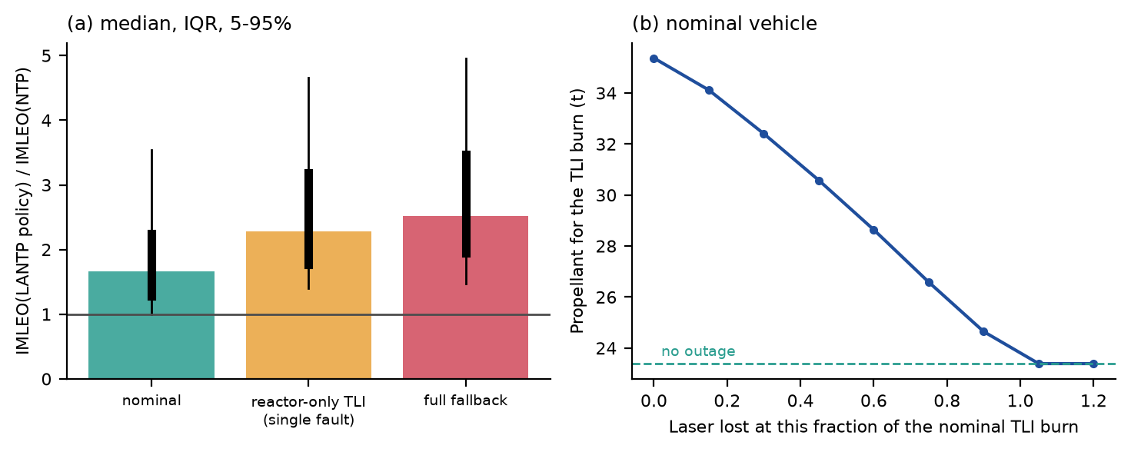
Fig. 13. (a) IMLEO ratio for three tank-loading policies (bar: median; thick line: interquartile range; thin line: 5–95%). (b) Propellant to complete TLI after a loss of the laser at a given fraction of the nominal burn, for the nominal vehicle.
A laser outage does not strand the vehicle, because the reactor continues the burn, but it costs propellant: the TLI burn of the nominal vehicle uses 23.4 t with the laser throughout and 35.4 t if the laser is lost at the start (Fig. 13b). Carrying the propellant to complete TLI on the reactor alone (single-fault tolerance) increases the median IMLEO ratio from 1.66 to 2.28, and carrying the propellant for a reactor-only mission with the LANTP hardware gives 2.52 (Table 6); since the receiver mass stays, the full-fallback ratio is above 1 in more than 95% of the draws. A conventional NTP tug has no such fault. Whether the reserve is worth carrying depends on the probability of an outage, which no data support here; the reserve is the cost of the dependence on the beam.
Policy | Median ratio | 5–95% | Median mass (t)
nominal (laser on both burns) | 1.66 | 0.99–3.54 | 93
laser lost before TLI, reactor-only TLI (single fault) | 2.28 | 1.40–4.66 | 128
reactor-only mission with the LANTP hardware (full fallback) | 2.52 | 1.47–4.95 | 140
Table 6. Tank-loading policies: median IMLEO ratio to conventional NTP (same reactor), 5–95% range, and median initial mass (500 draws).
6.11 Independent verification
The finite burns of the mission model (fixed-step fourth-order integration) were compared with an independent adaptive eighth-order integration (DOP853, relative tolerance 10⁻¹¹) of the same equations for TLI and for the departure burn from low lunar orbit at initial masses of 40, 80 and 160 t, with constant specific impulse (Table S19). The propellant used differs by at most 0.29% and the burn times by at most 7 s, which is the step of the fixed-step integrator. This comparison verifies the numerical accuracy of the integration of the equations of motion; because both integrators solve the same equations, it does not verify the physical validity of the trajectory model or of the mass model. A limiting-case check addresses the bookkeeping: near-impulsive burns of the mission model (thrust 40 times the nominal) use the propellant of the rocket equation for the impulsive velocity change of the same transfer within 0.25% (Table S19). The mass equation closes with a residual below 1% of the initial mass in every draw, and the thermochemistry has been checked against Cantera (Section 6.1). A second, independent implementation of the whole mission and mass model was not made, and the conclusions about the receiver, the infrastructure and the contingency policies rest on one implementation of those parts.
7. Falsifiable conditions
The results of Section 6 can be stated as conditions that a laser-assisted tug must satisfy, each with the value this model gives (Table 4). They are conditional on the assumed ranges, and each is falsified by a single measurement or analysis that contradicts it. They also state where LANTP is inferior to conventional NTP: for a receiver specific mass above the threshold of Fig. 14, for payloads below several tens of tonnes, for a link that is interrupted or a node that is not held near the vehicle, and for any case in which the laser nodes are counted.
Design target | Condition | This model
Specific impulse 1300–1500 s | Useful laser power ≥ 2.2–3.6 × reactor power, and recovery of the dissociation energy in the nozzle | A 1–50 MW laser on 100–500 MWt gives ≤ 1,000 s
Thrust 50–120 kN at 1400 s | Emitted laser power 0.7–1.6 GW (median) | Short of the 1–50 MW class by a factor of 13–1,600
Chamber temperature about 4500 K | A heating and containment concept for a temperature above the highest measured melting temperature of a compound, 4232 ± 84 K (Table 7) | Not demonstrated; not modeled
Beam capture | Captured fraction ≥ 0.5 only within 37,800 km for a 10 m aperture, 0.05 µrad and a 3 m receiver; 8,400 km at 0.3 µrad | Relay beaming over 6×10⁴ km captures ≤ 39%
IMLEO 40% below conventional NTP | Ratio ≤ 0.6 against a conventional tug with an optimized reactor | Median 1.44; 0% of draws below 1, 0% at or below 0.6; best point of the map 0.86
Receiver specific mass | Below the threshold of the map (Fig. 14) | ≤ 11 kg/MW at 0.05 GW, ≤ 5 kg/MW at 1.2 GW for any mass benefit
Net benefit with infrastructure | Spacecraft saving × missions ≥ node mass | Median infrastructure-inclusive ratio 5.6; nodes 17,888 t
Continued mission after a laser fault | Reserve propellant for reactor-only TLI | Median ratio 2.28 with the reserve (1.66 without)
Table 4. Falsifiable conditions of a laser-assisted tug and the values of this model (all conditional on the assumed ranges).
Item | Temperature (K) | Source
Reactor core outlet limit used in the model | 2600–2900 (2800 nominal) | this paper
Highest measured melting temperature of a compound, HfC_{0.98} | 4232 ± 84 | [23]
TaC–HfC system, range of measured melting temperatures | 4041–4232 | [23]
Graphite: melts only at 10–100 MPa | 4800 ± 100 | [24]
Design chamber temperature of the targets | 4500 | targets
Table 7. Temperatures (K) relevant to the 4500 K chamber. The melting temperatures are measured values from the cited studies as reported in their abstracts; graphite sublimes below the melting pressure.
8. Discussion
The three hypotheses are supported by the model under the assumed ranges. H1: the targeted specific impulse needs a useful laser power of 2.2–3.6 times the reactor power and the targeted thrust needs gigawatts of emitted laser power, not megawatts. H2: against a conventional tug with an optimized reactor the median IMLEO ratio is 1.44 and no draw reaches the targeted 0.6. H3: a mass benefit exists only below a receiver specific mass of 5 to 11 kg/MW (depending on the laser power) and then amounts to at most 14% in the nominal case; it is lost when the infrastructure, a node that is not held near the vehicle or a laser fault is included. These conclusions are about the targets examined; they are not a general statement that laser power cannot assist nuclear thermal propulsion, and they depend on the receiver specific mass, which is the least certain input and the dominant one (Section 6.7).
8.1 Relation to earlier work
Laser-heated hydrogen rockets, laser-sustained plasma thrusters and laser heat-exchanger rockets were analyzed and tested decades ago [8–10,12–14], and recent work continues on the thrust performance of laser heat-exchanger rockets and on the feasibility of laser thermal beamed-energy propulsion [15,16]. Nuclear thermal tugs have been studied for cislunar transportation and compared with chemical propulsion [4–7]. The contribution here is the coupling and the benchmark: the same model carries the thermodynamics of dissociating hydrogen, the power chain, the link along a finite burn, the mass of the receiver and of the laser nodes, and the policy for a laser outage, and compares the result with a conventional tug whose reactor is sized for the payload, so that the feasibility boundary is stated in quantities a designer can measure (laser power, receiver specific mass, captured fraction, number of missions). The literature was surveyed through bibliographic records, titles and abstracts; the full texts of the conference papers were not available to the author, so the comparison with earlier work is limited to what those records show.
8.2 What would change the conclusion
The map identifies the levers. A receiver of a few kg/MW, a payload of several tens of tonnes, an infrastructure that already exists for another purpose (so that its mass is not charged to the transfers), a beam that is held for the whole burn by a node that stays close to the vehicle, and a nozzle that recovers most of the dissociation energy would together reduce the IMLEO. At 10 kg/MW the ratio against the 500 MWt reference tug falls below 1 for a payload above 40 t, but against the best conventional tug only above about 48 t; with the nodes as an existing asset the break-even receiver mass at a laser fraction of 0.25 is approximately 10 kg/MW. None of these conditions is demonstrated; each is a measurable target.
8.3 Limitations
(i) All design inputs (efficiencies, specific masses, link parameters, and coupling coefficients) are assumed ranges; they are not measurements and the results are conditional on them. (ii) The receiver specific mass is an assumed lumped parameter; the heating of the hydrogen to 4500 K without a solid wall at that temperature is not modeled, and the chamber temperature is a design target (Section 4.2). (iii) The thermodynamic model is a rigid-rotor, harmonic-oscillator model that overestimates the dissociation degree by 4–8% against Cantera; the nozzle is described by an expansion ratio, an efficiency and a recombination fraction, not by kinetics. (iv) The link assumes refocusing at every range, an ideal Gaussian beam and independent dropouts; atmospheric effects are absent and beam safety, acquisition and tracking are represented only by the reacquisition time. (v) The trajectory is coplanar with patched conics and thrust along the velocity, and the node is on a circular orbit phased near the vehicle; the result depends on that phasing (Section 6.5). (vi) The mass model is of design level, the infrastructure is a lower bound, and costs and the lifecycle are not modeled beyond the number of missions. (vii) The thermochemistry and the finite-burn integrator were verified independently, but the mission and mass model has a single implementation. (viii) The performance targets tested come from a concept description that is not in the open literature; they are treated as hypothetical design targets. (ix) The literature survey is limited to the bibliographic records, titles and abstracts available to the author.
9. Conclusions
Within the assumed ranges, a laser of the targeted class cannot lift a nuclear thermal tug to the targeted performance: a useful laser power of 2.2–3.6 times the reactor power is needed for 1300–1500 s and gigawatts of emitted power for 50–120 kN. The beam can only act within a few 10⁴ km of a node that is held near the vehicle, and the receiver and the reactor dominate the mass (Sobol total indices 0.70 and 0.34). Against a conventional tug with an optimized reactor the median IMLEO ratio is 1.44 (5th–95th percentile 1.13–1.94), with no draw at the targeted 0.6; the technology-threshold map shows that a mass benefit needs a receiver of less than approximately 11 kg per MW absorbed and is at most 14%. The laser nodes weigh 18 kt for the nominal vehicle and a single laser fault costs propellant, which increases the median ratio at equal reactor power from 1.7 to 2.3. The falsifiable conditions of Table 4 define what a demonstration would have to show: a receiver specific mass of a few kg/MW, a captured fraction above 0.5 over the whole burn, a heating concept for 4500 K that does not rely on a solid wall, a nozzle that recovers the dissociation energy, and an amortization of the nodes over many missions.
Declarations
Funding: This research did not receive any specific grant from funding agencies in the public, commercial, or not-for-profit sectors.
Competing interests: The author declares no competing interests.
Author contributions: Leon Sandler is the sole author: conceptualization, methodology, software, validation, formal analysis, investigation, visualization, writing – original draft, writing – review and editing.
Data and code availability: The simulation code, the data behind every figure and table, the automated tests and the manuscript sources (version 1.2.1) are archived at https://doi.org/10.5281/zenodo.24048703 (software, all versions) and https://doi.org/10.5281/zenodo.24048701 (manuscript, all versions), and are available at https://github.com/sandlerleon/lantp-cislunar-mc. The study uses no experimental data.
Use of AI tools: see Section 5.6. A generative AI tool (Claude, Anthropic) assisted with drafting text, writing and testing simulation code and generating figures from that code; the author reviewed and edited the content and takes full responsibility for it.
Ethics approval and consent: not applicable.
References
[1] H. Ludewig, An integrated analysis of a NERVA based nuclear thermal propulsion system, AIP Conference Proceedings 813 (2006) 870–878. https://doi.org/10.1063/1.2169269
[2] A.L. Qualls, E. Hancock, Recapturing NERVA-derived fuels for nuclear thermal propulsion, in: 47th AIAA/ASME/SAE/ASEE Joint Propulsion Conference & Exhibit, AIAA (2011). https://doi.org/10.2514/6.2011-5847
[3] S.K. Borowski, D.R. McCurdy, T.W. Packard, Nuclear thermal propulsion (NTP): a proven growth technology for human NEO/Mars exploration missions, in: 2012 IEEE Aerospace Conference, IEEE (2012) 1–20. https://doi.org/10.1109/aero.2012.6187301
[4] C. Reynolds, J. Horton, C. Joyner, T. Kokan, D. Levack, Applications of nuclear thermal propulsion to lunar architectures, in: AIAA Propulsion and Energy 2019 Forum, AIAA (2019). https://doi.org/10.2514/6.2019-4032
[5] C. Reynolds, C. Joyner, T. Kokan, D. Levack, Nuclear thermal propulsion vs. LOX/LH2 chemical propulsion for cislunar architectures, in: Nuclear and Emerging Technologies for Space (NETS 2023), American Nuclear Society (2023) 474–479. https://doi.org/10.13182/nets23-41903
[6] S. Kumar, L. Thomas, J. Cassibry, Application of nuclear thermal propulsion for sustainable cislunar exploration, Acta Astronautica 228 (2025) 435–441. https://doi.org/10.1016/j.actaastro.2024.11.045
[7] E. Payton, C. Merrill, M. Peck, D. Savransky, Optimal cislunar trajectories with continuous, high-thrust nuclear-thermal propulsion, in: AIAA SCITECH 2025 Forum, AIAA (2025). https://doi.org/10.2514/6.2025-0087
[8] A. Kantrowitz, Laser propulsion to Earth orbit, in: Space Manufacturing Facilities, AIAA (1975). https://doi.org/10.2514/6.1975-2009
[9] M.A. Minovitch, Reactorless nuclear propulsion – the laser rocket, in: 8th Joint Propulsion Specialist Conference, AIAA (1972). https://doi.org/10.2514/6.1972-1095
[10] J.T. Kare, Laser-powered heat exchanger rocket for ground-to-orbit launch, Journal of Propulsion and Power 11 (1995) 535–543. https://doi.org/10.2514/3.23875
[11] F.B. Mead Jr., Beamed energy (laser) propulsion (a perspective), Defense Technical Information Center (2000). https://doi.org/10.21236/ada409833
[12] S.-M. Jeng, D.R. Keefer, A theoretical evaluation of laser-sustained plasma thruster performance, in: 23rd Joint Propulsion Conference, AIAA (1987). https://doi.org/10.2514/6.1987-2166
[13] J. Black, H. Krier, D. Zerkle, R. Glumb, Characterization of laser-sustained plasma behavior during 10 kW laser thruster tests, in: 23rd Plasmadynamics and Lasers Conference, AIAA (1992). https://doi.org/10.2514/6.1992-3022
[14] A. Mertogul, D. Zerkle, H. Krier, J. Mazumdar, Continuous wave laser sustained hydrogen plasmas for thermal rocket propulsion, in: 21st International Electric Propulsion Conference, AIAA (1990). https://doi.org/10.2514/6.1990-2637
[15] K. Mori, H. Itoh, A simplified model for the thrust performance of porous heat exchanger (PHX) laser rocket propulsion, in: AIAA Propulsion and Energy 2019 Forum, AIAA (2019). https://doi.org/10.2514/6.2019-3802
[16] H. McDonald, K. Chen, Laser thermal beamed energy propulsion feasibility study, in: AIAA SCITECH 2024 Forum, AIAA (2024). https://doi.org/10.2514/6.2024-1810
[17] G.A. Landis, Laser power beaming for lunar polar exploration, in: AIAA Propulsion and Energy 2020 Forum, AIAA (2020). https://doi.org/10.2514/6.2020-3538
[18] L. Carrio, T. Cichan, Cislunar orbital power beaming system design concepts, in: IAF Space Power Symposium, International Astronautical Federation (2025) 160–171. https://doi.org/10.52202/083089-0016
[19] G. Herzberg, A. Monfils, The dissociation energies of the H2, HD, and D2 molecules, Journal of Molecular Spectroscopy 5 (1961) 482–498. https://doi.org/10.1016/0022-2852(61)90111-4
[20] D.G. Goodwin, H.K. Moffat, I. Schoegl, R.L. Speth, B.W. Weber, Cantera: an object-oriented software toolkit for chemical kinetics, thermodynamics, and transport processes, version 3.2.0, https://www.cantera.org
[21] S. Gordon, B.J. McBride, Computer program for calculation of complex chemical equilibrium compositions and applications, I. Analysis, NASA Reference Publication 1311, NASA Lewis Research Center, Cleveland (1994).
[22] A.E. Siegman, Lasers, University Science Books, Mill Valley (1986).
[23] O. Cedillos-Barraza, D. Manara, K. Boboridis, T. Watkins, S. Grasso, D.D. Jayaseelan, R.J.M. Konings, M.J. Reece, W.E. Lee, Investigating the highest melting temperature materials: a laser melting study of the TaC-HfC system, Scientific Reports 6 (2016) 37962. https://doi.org/10.1038/srep37962
[24] A.I. Savvatimskiy, Measurements of the melting point of graphite and the properties of liquid carbon (a review for 1963–2003), Carbon 43 (2005) 1115–1142. https://doi.org/10.1016/j.carbon.2004.12.027
[25] R.R. Bate, D.D. Mueller, J.E. White, Fundamentals of Astrodynamics, Dover, New York (1971).
[26] P. Lubin, G. Hughes, Directed energy for planetary defense, in: Handbook of Cosmic Hazards and Planetary Defense, Springer, Cham (2015) 941–991. https://doi.org/10.1007/978-3-319-03952-7_77

