Mass-Minimized Lunar Radiation Protection Using In-Situ Regolith and Distributed Magnetic Shielding
Leon Sandler
Independent Researcher, Northbrook, IL, USA · sandler.leon@gmail.com
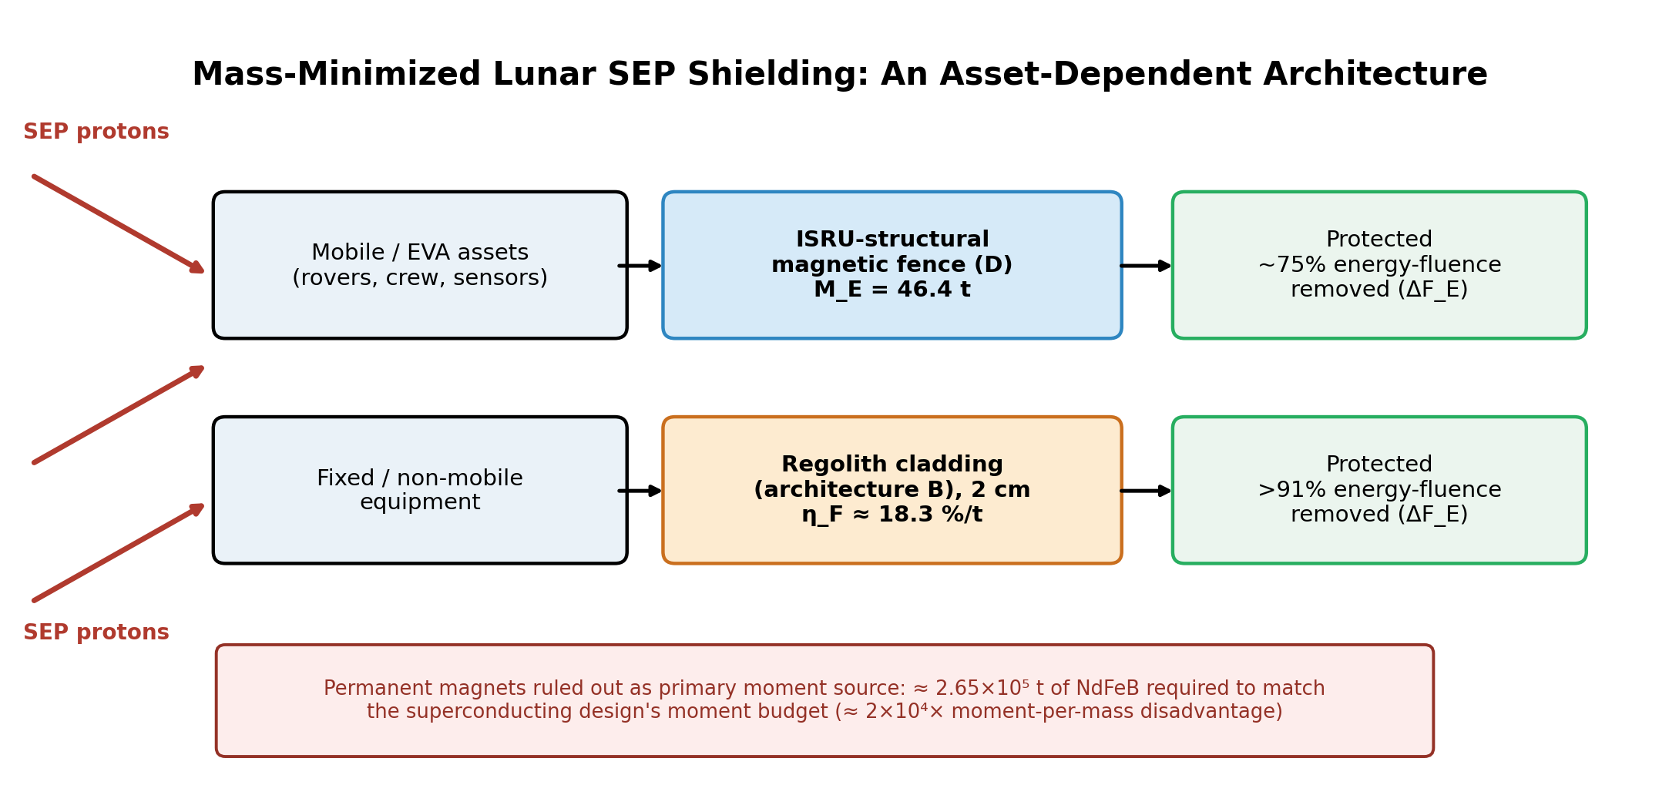
Graphical abstract. Mobile/EVA assets depend on the ISRU-structural magnetic fence (architecture D); fixed equipment is better served by direct regolith cladding (architecture B), which achieves higher SEP energy-fluence reduction at roughly an order of magnitude better Earth-mass efficiency. Permanent magnets are quantitatively ruled out as a primary moment source for either architecture.

Abstract
We evaluate a distributed superconducting fence for lunar surface protection against solar energetic particle (SEP) events under an explicit Earth-launched-mass constraint, using SEP particle- and energy-fluence attenuation as the present study's quantitative endpoint. A permanent-magnet substitution for the superconducting moment source is tested quantitatively and ruled out: NdFeB's remanence limits achievable moment-per-mass to roughly 1.5×10² A·m²/kg, about 2×10⁴ times below the superconducting design's 3.3×10⁶ A·m²/kg, so a mass-parity permanent-magnet fence provides no meaningful rigidity filtering, and matching the superconducting moment budget with permanent magnets would require approximately 2.65×10⁵ t of material. Propagating previously uncosted engineering margins — current derating, structural/cryostat overhead, lunar diurnal thermal cycling, and dust mitigation — raises the credible total system mass to a median of 81 t (90% CI 55-116 t). Substituting regolith-derived structure for the fence's mechanical support and housing mass, while retaining superconducting conductor, cryogenics, and electronics as the only Earth-supplied components, reduces Earth-launched mass to 46.4 t for unchanged attenuation performance (~75% SEP energy-fluence removed), improving Earth-launched-mass efficiency (η_F, energy-fluence reduction per tonne launched) by a factor of ~1.7; this figure is essentially insensitive to the assumed regolith-construction mass multiplier (tested 1×-5×), since substituted mass is locally sourced regardless of its magnitude. For fixed, non-mobile surface equipment we additionally model direct regolith cladding using a first-order continuous-slowing-down-approximation (CSDA) slab-attenuation calculation: as little as 2 cm of regolith removes over 91% of SEP energy fluence at negligible Earth-launched mass, exceeding the fence's own attenuation and outperforming every magnet-assisted configuration by roughly an order of magnitude in η_F. We conclude that the fence's distinct value lies specifically in protecting assets that cannot be clad in regolith — rovers, EVA crew, and distributed surface infrastructure — where it remains the only available mitigation, while fixed equipment is better served by direct regolith shielding; ISRU does not make the magnetic architecture universally superior to passive shielding, but changes the Earth-launch economics of magnetic protection specifically for assets regolith cannot reach. The underlying SEP-attenuation physics — relativistic Boris-pusher simulation, the E50∝M² moment-budget scaling law, and a chiral-winding transmission effect — is unchanged from our earlier physics analysis (Sandler, 2026). The present results establish the mass and fluence-level feasibility envelope; they do not claim mission-level dose reduction. A coupled HZETRN2020 or Geant4 transport calculation, using the transmitted spectra derived here as its incident boundary condition, is required to establish the corresponding absorbed or equivalent dose.

Plain Language Summary
A burst of energetic particles from the Sun can be dangerous to astronauts and equipment on the Moon's surface, where there is no atmosphere or global magnetic field for protection. One proposed defense is a ring of superconducting magnetic coils around a work site — a “magnetic fence” — that deflects incoming particles, similar to how Earth's own magnetic field protects us from the solar wind. An earlier study showed this fence shields about as well as a single large magnet at the habitat, but only roughly estimated how much material it would take to build and launch from Earth.
This paper checks that estimate and looks for ways to reduce it. Ordinary permanent magnets cannot replace the coils' superconducting wire: they are tens of thousands of times too weak per unit of mass, so a magnet-based fence with equal shielding strength would need an impractical 265,000 tonnes of material. Adding safety margins the earlier estimate skipped — for current limits, structural support, lunar temperature swings, and dust — raises the credible Earth-launched mass from about 40–60 tonnes to about 81 tonnes. But if the fence's support structure is built on the Moon from local soil instead of shipped from Earth, only the coils, wiring, and electronics need to be launched, cutting that mass to about 46 tonnes for the same protection.
For equipment that stays in one place, simply piling on 2 cm of lunar soil blocks over 90% of the particle energy using almost no Earth-launched material — even more efficient than the fence. The fence's real value is protecting things soil cannot cover, like rovers and astronauts working outside.
Keywords: active magnetic shielding; solar energetic particles; lunar habitat; distributed dipole array; superconducting coils; in-situ resource utilization; permanent magnets; radiation-transport specification

1. Introduction
Solar energetic particle (SEP) events are a principal radiation hazard for lunar surface operations: regolith overburden protects a buried habitat but not surface infrastructure, rovers, or crew on extravehicular activity (EVA). Active magnetic shielding proposals have concentrated on a single architecture — the compact monolithic dipole (artificial mini-magnetosphere) — which protects by pressure standoff but concentrates an intense field and a single point of failure at the habitat. A distributed array of modest superconducting coils forming a perimeter fence offers an alternative that attenuates by repeated scattering, as the heliosphere does, and leaves the protected volume field-free.
A prior physics-focused analysis of this distributed-fence concept (Sandler, 2026) established, via relativistic Boris-pusher test-particle simulation, that a 22-coil two-channel fence matches a monolithic dipole of equal total magnetic moment: both remove ≈95% of SEP proton number fluence and 72-75% of energy fluence for a representative SEP spectrum, while the array leaves the habitat field-free and degrades gracefully under single-coil failure. That analysis, however, reported engineering feasibility only as a first-order point estimate (≈12 t of REBCO conductor, 40-60 t total system mass) without testing the two questions that determine whether the concept is buildable: whether the mass estimate is robust to the engineering margins it implicitly assumes, and whether the cryogenic superconducting requirement is itself avoidable. This paper addresses both questions directly, and uses the results to develop a mass-minimized architecture combining the magnetic fence with in-situ resource utilization (ISRU).
We proceed as follows. Sections 2-4 summarize the shield architectures, simulation method, and verification underlying the retained SEP-attenuation physics. Section 5 gives the baseline attenuation comparison and Section 6 the moment-budget scaling law; Section 7 reports a secondary chiral-winding finding. Sections 8-11 present this paper's principal contributions: a quantitative test of whether permanent magnets can replace the superconducting moment source (§8); an ISRU architecture that substitutes regolith-derived structure for Earth-launched structural mass, evaluated across a four-architecture comparison and a sensitivity sweep on the key uncertain construction assumption (§9); a propagated engineering mass budget superseding the prior point estimate (§10); and a first-order SEP energy-fluence calculation behind regolith, together with a fully specified transport-code validation plan (§11). Section 12 assesses technology readiness by subsystem, Section 13 states limitations and future work, and Section 14 concludes.

2. Shield Architectures
The physical distinction between magnetic-shielding architectures is set by a single length scale, the proton gyroradius r_g = p/(qB). A standoff shield defeats a particle in one encounter by making the gyroradius locally small compared with the shield's standoff distance, which demands a strong field and hence a monolithic source. A scattering shield defeats a particle statistically, through many deflections of order one gyroradius across an extended structured region, which permits weak fields but demands spatial structure comparable to r_g. Both are low-pass filters in rigidity — full attenuation at low energy, a transition knee, transparency at high energy.
Three configurations are compared at identical total moment budget Σ|m| = M0 = 4×10¹⁰ A·m²: (A) a monolith, the full moment in a single vertical dipole at the habitat; (B) a distributed array of 22 dipoles in two parallel fences 200 m apart, 11 sites per fence at 100 m spacing, alternating polarity; and (C) a chiral variant of the array with moments rotated helically along the fence.

3. Methods
Each magnetic source is modeled as a softened point dipole, B(r) = (μ0/4π)[3(m·r̂)r̂ − m]/(r² + a²)^{3/2} with softening length a = 25 m representing finite coil extent. Protons are advanced with the relativistic Boris algorithm, which conserves particle Lorentz factor exactly by construction; the time step is adaptive, dt = min(T_g/25, 10 m/v), with T_g the local gyroperiod. For each configuration and energy, N protons are launched as an aimed pencil beam from x = −900 m toward a 60 m protected zone at the origin; in the field-free case this beam geometry gives 100% transmission, so reported transmission is directly the shield's leakage. The aimed-beam geometry is a deliberate bounding choice, since a normally incident pencil beam probes the fence's weakest apertures head-on; isotropic incidence is expected to lower, not raise, the reported transmission. Baseline runs use N = 500-1000, giving a 95% confidence half-width ≤ 0.045.

4. Verification and Convergence
Three checks establish the numerics. Against the analytic gyroradius in a uniform field, the Boris integrator converges quadratically in time step, from 4.7% radius error at 10 steps per gyroperiod to 0.05% at 100 steps; the production setting of 25 steps per gyroperiod gives 0.8% error, and momentum magnitude is conserved to 1 part in 10¹⁵ at all settings. Transmission at 10 MeV is insensitive to the time-step setting (T = 0.046, 0.046, 0.048 at 10, 25, 50 steps per gyroperiod). Transmission is stable in particle count, with seed-to-seed spread shrinking from ±0.033 at N = 100 to ±0.005 at N ≥ 500, consistent with binomial statistics.

5. Baseline Comparison
Both architectures are essentially opaque through 3 MeV, pass ~5% at 10 MeV, ~30-40% at 30 MeV, and ~65% at 100 MeV: at equal moment budget, the distributed fence provides the same rigidity filter as the monolithic dipole.
Geometry \ E (MeV) | 0.1 | 0.3 | 1 | 3 | 10 | 30 | 100
Monolithic dipole | 0.000 | 0.000 | 0.000 | 0.000 | 0.048 | 0.388 | 0.654
Distributed array (2-channel) | 0.012 | 0.010 | 0.006 | 0.012 | 0.066 | 0.290 | 0.646
Table 1. Transmission to the protected zone vs. proton kinetic energy (N = 500 per point; 95% CI ≤ ±0.045).
The array shows a small (≤1.2%) low-energy leakage absent in the monolith — flux threading gaps between fence sites. The operational differences favor the array regardless: the protected volume is field-free, no single component failure collapses the shield, and each coil is an order of magnitude weaker, and correspondingly safer to build, transport, and service, than the monolith. Folded through a representative soft SEP spectrum (J(E) ∝ exp(−E/30 MeV)/E), the distributed array removes 94.9% of proton number fluence and 75.4% of energy fluence reaching the protected zone; the monolith removes 95.1% and 72.2% — the two architectures are equivalent within interpolation uncertainty.

6. Parameter Sweeps and Scaling Laws
Sweeping the array's total moment over 0.25×, 1×, and 4× M0 moves the half-transmission energy from 3.2 MeV to 52 MeV, a measured exponent of 2.0: E50 ∝ M². This is the non-relativistic gyroradius prediction, since the knee sits where the gyroradius reaches the structural scale (p50 ∝ M, hence E50 ∝ M²), and gives a direct sizing rule: to double the knee energy, double the amp-turns. Sweeping fence site spacing at fixed total moment reveals strongly non-monotonic behavior: fine spacing underperforms because each site's field is too weak to turn a 10 MeV proton within its cell, while a spacing that leaves no coil on the beam axis opens a low-field aperture through which transmission jumps sharply. The design rule is that of a filter, not a wall: performance is set by the weakest gap, and site placement must guarantee that every line of sight to the protected zone passes within a gyroradius-turning distance of a source.

7. Helical Winding: A Secondary Finding
Rotating the array's moments helically along the fence introduces a handedness-selective transport property. Above a sampling threshold (winding pitch Λ greater than twice the site spacing — an exact geometric analog of the Nyquist criterion), right- and left-handed windings transmit measurably different fractions of incident flux; at Λ = 400 m the discrimination reaches a factor of ten at 3 MeV. We report this as a reproducible secondary physical finding rather than a headline contribution of this paper, since the present work's primary focus is the engineering and mass-architecture questions of Sections 8-11; a laboratory test at reduced scale is the natural next step for this effect specifically.

8. Permanent-Magnet Feasibility Assessment

8.1 Moment-per-mass comparison
Because the shielding physics of Sections 2-6 depends on distributed spatial magnetic structure rather than on superconductivity per se, it is natural to ask whether permanent magnets could replace the superconducting coils and eliminate the cryogenic subsystem entirely. We test this quantitatively. A permanent magnet's dipole moment is bounded by its remanent magnetization, m = (Br/μ0)·V, so moment scales linearly with magnet volume (mass) at a rate fixed by material remanence. NdFeB N52, the strongest commercial grade (Br ≈ 1.42 T, ρ ≈ 7500 kg/m³), gives a moment-per-mass of 1.51×10² A·m²/kg. The superconducting design achieves 4×10¹⁰ A·m² of total moment from 12 t of REBCO conductor — a moment-per-mass of 3.33×10⁶ A·m²/kg, roughly 2.2×10⁴ times higher, because superconducting moment is set by amp-turns (bounded only by critical current) while permanent-magnet moment is bounded by material volume against a fixed remanence ceiling.

8.2 Consequence for shielding performance
At the superconducting design's conductor mass substituted with NdFeB, the achievable moment (1.8×10⁶ A·m²) is 4.5×10⁻⁵ of the baseline budget M0. Applying the verified scaling law E50 ∝ M² gives a knee energy of order 10⁻⁷ MeV — transparent to the entire SEP band of interest (0.1-100 MeV). An independent Boris-pusher re-run at this moment confirms flat, energy-independent transmission across 0.3-10 MeV, consistent with near-field deflection of protons passing within a few coil radii of a magnet rather than the intended distributed-scattering mechanism. Matching the full moment budget with permanent magnets would require ≈2.65×10⁵ t of NdFeB. We therefore rule out permanent magnets as a primary moment source for this architecture. A possible secondary role as local aperture-trim elements closing low-energy leakage at fence gaps (§6) has not been simulated and is noted as future work (§13).

9. In-Situ Resource Utilization: Structural Mass Substitution

9.1 Component allocation
Because permanent magnets cannot substitute for the superconducting moment source, the path to reducing Earth-launched mass runs through the structure and infrastructure around the conductor, not through the conductor itself. We separate the engineering point design (§10) into an Earth-supplied functional core — REBCO conductor, cryostat vessel, current leads, power electronics, cryocooler hardware, and sensors/control — and a structural shell (mechanical support, coil housings/foundations, anchor mass, cabling supports) that is a candidate for regolith-derived construction. From the propagated mass budget (§10, median 81 t: 15 t conductor, 66 t overhead), we allocate the overhead 40%/60% between core hardware (26.4 t) and structural mass (39.6 t), a first-order split pending detailed subsystem design, giving Earth-launched mass M_E = 15 + 26.4 + 5 (one-time ISRU excavation/processing capital) = 46.4 t for the ISRU-structural architecture, independent of how much regolith mass is ultimately required to build the structure.

9.2 Sensitivity to the regolith-construction mass multiplier
Regolith-built structures are expected to require more mass than an equivalent Earth-engineered structure for the same structural function; we treat this ratio as an uncertain multiplier and sweep it from 1× (optimistic) through 3× (baseline) to 5× (conservative).
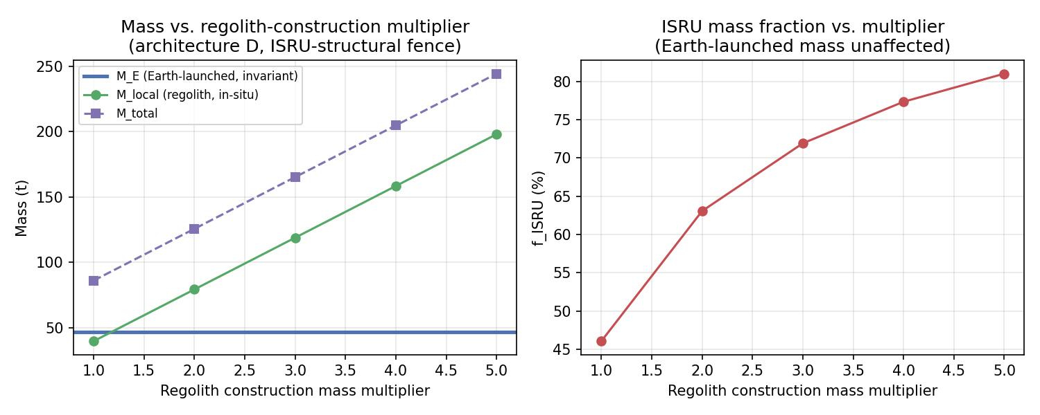
Figure 1. Left: Earth-launched mass (M_E, blue) is invariant to the regolith-construction multiplier because regolith mass is locally sourced regardless of quantity required; only local mass (green) and total system mass (purple) scale with it. Right: the resulting ISRU mass fraction ranges from 46% (1×) to 81% (5×).
Multiplier | M_E (t) | M_local (t) | M_total (t) | f_ISRU
1× (optimistic) | 46.4 | 39.6 | 86.0 | 0.46
3× (baseline) | 46.4 | 118.8 | 165.2 | 0.72
5× (conservative) | 46.4 | 198.0 | 244.4 | 0.81
Table 2. ISRU sensitivity sweep. Earth-launched mass M_E is invariant across the tested range; the multiplier instead determines the in-situ mass fraction and, separately, excavation/construction time and energy (§12).
This is a useful robustness result in its own right: M_E = 46.4 t at every tested multiplier, so the ≈1.7× η_F improvement over the fully imported architecture does not depend on resolving the regolith-construction mass-efficiency question. What does depend on it is excavation/construction time and energy, which we treat as a separate, TRL-dependent constraint (§12) rather than a mass-budget one.

9.3 Four-architecture comparison
Table 3 consolidates four architectures on a common basis: Earth-launched mass, local (in-situ) mass, SEP energy-fluence reduction, Earth-mass efficiency, and the asset class each is best suited to protect. Values for the regolith-involving architectures (B, C) are given at 2 cm thickness, a representative operating point; the full thickness sweep is given in §11.
Architecture | M_E (t) | M_local (t) | ΔF_E | η_F (%/t) | Best-suited application
A — Imported magnetic fence | 81.0 | 0 | ~75% | 0.93 | Mobile/EVA (baseline)
B — Regolith-only cladding, 2 cm | ~5.0* | 3.0 | 91.4% | 18.29 | Fixed equipment
C — Fence + regolith cladding, 2 cm | 46.4 | 121.8 | 94.7% | 2.04 | Fixed, high-value equipment
D — ISRU-structural magnetic fence | 46.4 | 118.8 | ~75% | 1.63 | Mobile/EVA (preferred)
Table 3. Four-architecture comparison. *B's Earth-launched mass is the one-time excavation/processing capital allocation only; the cladding itself is local mass. ΔF_E is SEP energy-fluence reduction, not absorbed dose (§11); η_F is Earth-mass efficiency on the same fluence basis.

9.4 Interpretation
These results do not support a single 'hybrid wins' conclusion. The two mitigations serve different, non-overlapping populations of assets by physical necessity: fixed equipment can be clad in regolith and should be, since even 2 cm outperforms the fence at an η_F roughly an order of magnitude better (B vs. A/D in Table 3); mobile and EVA assets cannot be clad and depend entirely on the magnetic fence, where ISRU structural substitution (D) is the available lever, improving η_F by ≈1.7× relative to a fully imported design (A). The fence's distinct contribution is therefore specifically the protection of assets regolith cannot reach, while its role for fixed installations is, on this evidence, subordinate to direct regolith shielding. We state this as the paper's central architectural conclusion: the optimal lunar SEP-mitigation strategy is asset-dependent, not universal.

10. Engineering Mass Budget and Uncertainty
We propagate four factors beyond the original point design: an as-built current-derating margin on the REBCO conductor (Uniform[1.0, 1.5]); the structural/cryostat/leads/power-conditioning factor (Uniform[3, 5]); a lunar diurnal thermal-cycling radiator margin to accommodate the 14-day day/night cryocooler load swing (Uniform[1.0, 1.5]); and a dust-mitigation margin (Uniform[1.0, 1.2]).
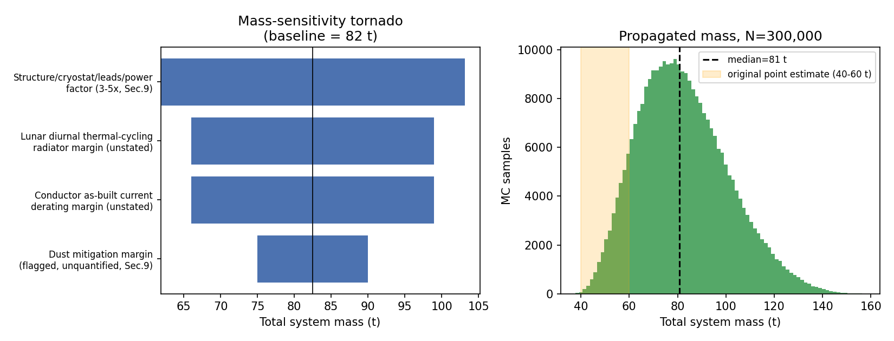
Figure 2. Left: mass-sensitivity tornado diagram across the four propagated margins (baseline 82 t). Right: Monte Carlo-propagated total system mass (N=300,000).
The propagated distribution has a median of 81 t (90% CI 55-116 t), with an 18% probability of exceeding 100 t. The structural/cryostat factor and the lunar thermal-cycling margin dominate the swing. Launch mass alone does not establish feasibility: deployment, thermal management, power, dust mitigation, and autonomous construction (§12) remain the dominant open engineering uncertainties, independent of the specific mass figure.

11. SEP Energy-Fluence Reduction and the Path to Absorbed Dose

11.1 First-order CSDA slab-attenuation calculation
The fluence-attenuation figures of §5 (~95% number fluence, ~72-75% energy fluence) are not equivalent to absorbed dose. As a first-order estimate of the additional effect of regolith, we apply a continuous-slowing-down-approximation (CSDA) slab model: each transmitted proton's residual energy after a regolith slab of given thickness is computed from the power-law range-energy relation R[g/cm²] = 0.00251·E[MeV]^1.75, applied to the SEP spectrum J(E) ∝ exp(−E/30 MeV)/E, with the fence's own transmission curve (§5) applied first where relevant. This is a first-order SEP energy-fluence calculation, not a dose calculation: it omits nuclear fragmentation, secondary neutron production, and bremsstrahlung, all of which a full transport code would include and which generally increase local dose relative to a pure CSDA estimate behind thicker absorbers. We therefore report its output as ΔF_E (energy-fluence reduction), and the corresponding efficiency metric as η_F = ΔF_E / M_E, reserving η_D = ΔD / M_E for the dose-based metric a full transport calculation would provide.

11.2 Full thickness sweep and mass-vs-fluence tradeoff
Thickness | B: regolith only ΔF_E | B: η_F (%/t) | C: fence + regolith ΔF_E | C: η_F (%/t)
1 cm | 82.1% | 16.41 | 90.2% | 1.94
2 cm | 91.4% | 18.29 | 94.7% | 2.04
5 cm | 98.1% | 19.62 | 98.6% | 2.13
10 cm | 99.7% | 19.93 | 99.7% | 2.15
Table 4. Fixed-equipment case, full regolith-thickness sweep. Regolith-only (B) dominates every fence-assisted configuration (C) in η_F at every thickness tested.
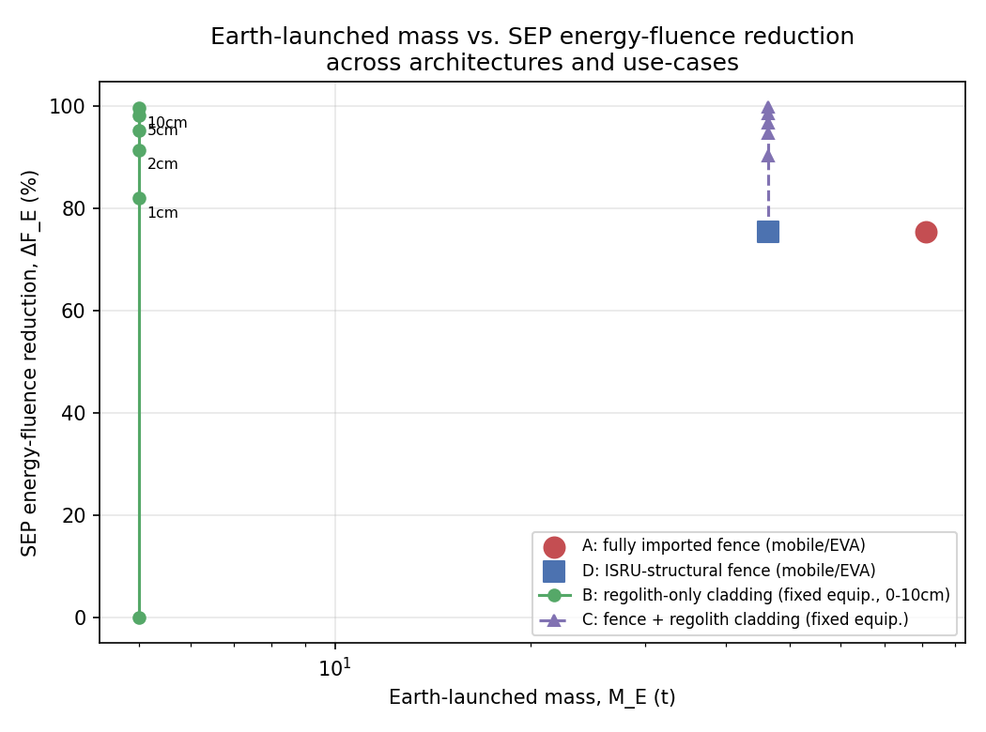
Figure 3. Earth-launched mass vs. SEP energy-fluence reduction (ΔF_E) across all four architectures. Regolith cladding for fixed equipment (green) Pareto-dominates every magnet-assisted configuration; the fence remains the only option for mobile/EVA assets, where ISRU structural substitution (blue) shifts the point leftward at unchanged ΔF_E.
This first-order model should be treated as a lower bound on required shielding thickness and an upper bound on η_F, since secondary-particle contributions are omitted. It is sufficient to establish the qualitative architectural conclusion of §9.4 — that thin regolith cladding saturates SEP attenuation well before the fence's own contribution becomes relevant — but is not sufficient to support mission-level design decisions on its own.

11.3 Specification of the required transport validation
Converting ΔF_E into a genuine absorbed-dose figure ΔD requires a coupled space-radiation transport calculation, which is beyond the scope of this first-order feasibility analysis but is fully specified here as the paper's required next step. We propose HZETRN2020 (Slaba et al., 2020) as the primary candidate, since it is a deterministic transport code purpose-built for solar-particle-event and GCR environments with user-defined incident spectra, arbitrary shielding materials, and layered or 3-D geometry; Geant4 (Agostinelli et al., 2003) is the appropriate alternative where explicit secondary-particle tracking and arbitrary target geometry are required. The proposed calculation chain is: (i) the incident SEP spectrum J(E) used throughout this work; (ii) the magnetic fence's transmitted spectrum from the Boris-pusher simulation of §3 as an intermediate boundary condition; (iii) transport through regolith slabs of 0, 1, 2, 5, and 10 cm (matching Table 4); (iv) absorbed dose (and, with an appropriate quality-factor treatment, dose equivalent) scored at a tissue-equivalent target behind each configuration; repeated for all four architectures of Table 3. This would directly yield η_D = ΔD / M_E for each architecture and confirm or revise the ranking presently established on fluence grounds only.

12. Technology Readiness Assessment
Table 5 assigns an approximate technology readiness level (TRL) to each subsystem, following the nine-level NASA TRL scale, together with the single most consequential open parameter for each.
Subsystem | TRL | Critical unresolved parameter
REBCO coil, few-mT self-field, 20-40 K | 6-7 | Behavior under repeated lunar diurnal thermal cycling
Field-deployable 50 m-radius coil structure | 2-3 | Deployment and anchoring method at this scale
Cryocooler for 14-day lunar diurnal cycle | 3-4 | Radiator sizing across the full day/night duty-cycle swing
Dust-tolerant long-duration operation | 1-2 | No lunar-dust-exposure data exists for HTS coil systems of this type
Regolith berm / trench construction (ISRU) | 2-4 | Achievable construction rate with robotic excavation at fence scale
Regolith cladding for fixed-equipment shielding | 3-5 | Structural attachment/retention of a thin (1-5 cm) layer under lunar gravity/thermal stress
Permanent-magnet fence (primary moment source) | N/A | Ruled out by moment-per-mass calculation (§8); not a readiness question
Table 5. Technology readiness by subsystem, with the critical unresolved parameter driving that rating.

13. Limitations and Future Work
The component-allocation split (40%/60%, §9.1) is a first-order assumption pending detailed subsystem design; the regolith-construction mass multiplier (§9.2) has already been swept 1×-5× and shown not to affect M_E, so it is a lower priority for further refinement than the transport calculation below. The HZETRN2020/Geant4 run specified in §11.3 is the highest-priority remaining task: it is the only item on this list that changes the paper's central claim from a fluence-level result (η_F) to a dose-level one (η_D), and it should be treated as a required validation step before the architecture ranking of Table 3 is used for mission-level design decisions. Whether permanent magnets have a viable secondary role as local aperture-trim elements at fence gaps (§8.2) has not been simulated. Isotropic-incidence and plasma-kinetic treatments, and a coupled dose-transport benchmark against the mini-magnetosphere literature, remain future work for the retained SEP-attenuation physics of §2-7.

14. Conclusion
A distributed perimeter array of superconducting coils shields a lunar surface installation against SEP protons as effectively as a monolithic mini-magnetosphere dipole of equal magnetic moment, while eliminating the strong field at the habitat and tolerating single-coil failure. This paper has tested, rather than assumed, the two engineering questions that determine whether that concept is buildable. Permanent magnets cannot replace the superconducting moment source: NdFeB's remanence bounds achievable moment-per-mass roughly four orders of magnitude below what the physics requires. Propagating previously uncosted engineering margins raises the credible system mass from a 40-60 t point estimate to a median of 81 t. Substituting regolith-derived structure for Earth-launched structural mass reduces this to 46.4 t without changing shielding performance, and this reduction is robust to the main uncertainty in how efficiently that substitution can be built. For fixed equipment, direct regolith cladding is a more mass-efficient mitigation than the magnetic fence by roughly an order of magnitude; the fence's distinct and durable role is protecting the assets — rovers, EVA crew, distributed infrastructure — that regolith cannot reach. The results here establish this architecture on fluence and mass grounds; a specified but unexecuted HZETRN2020/Geant4 transport calculation is the next step required to establish it on dose grounds.

Data Availability
The relativistic Boris-pusher simulation code, geometry builders, and validation/parameter-sweep code underlying the retained SEP-attenuation physics of Sections 2–7 are archived at Zenodo (https://doi.org/10.5281/zenodo.21179710) and on GitHub (https://github.com/sandlerleon/magdome) under an open license.
The permanent-magnet feasibility calculation, engineering mass-budget Monte Carlo, ISRU allocation and regolith-multiplier sweep, and CSDA energy-fluence model underlying Sections 8–11 and Figures 1–3 are available on GitHub (https://github.com/sandlerleon/lunar-isru-magnetic-shield-mass), including a machine-readable results file reproducing every quantitative figure in Sections 8–11. Archiving of this code at Zenodo under a citable DOI is underway; a temporary copy is provided as a supplemental file with this submission for the review period, and the assigned DOI will be added to this statement prior to publication.

Declaration of Competing Interests
The author declares that he has no known competing financial interests or personal relationships that could have appeared to influence the work reported in this paper. This research received no external funding.

References
Agostinelli, S., et al. (2003). Geant4—a simulation toolkit. Nuclear Instruments and Methods in Physics Research A, 506(3), 250-303. https://doi.org/10.1016/S0168-9002(03)01368-8
Bamford, R., Gibson, K.J., Thornton, A.J., et al. (2008). The interaction of a flowing plasma with a dipole magnetic field: measurements and modelling of a diamagnetic cavity relevant to spacecraft protection. Plasma Physics and Controlled Fusion, 50(12), 124025.
Bamford, R.A., Kellett, B., Bradford, J., et al. (2014). An exploration of the effectiveness of artificial mini-magnetospheres as a potential solar storm shelter for long term human space missions. Acta Astronautica, 105(2), 385-394.
Boris, J.P. (1970). Relativistic plasma simulation—optimization of a hybrid code. Proceedings of the Fourth Conference on Numerical Simulation of Plasmas, 3-67. Naval Research Laboratory.
Deca, J., Divin, A., et al. (2018). Reiner Gamma albedo features reproduced by modeling solar wind standoff. Communications Physics, 1, 12.
Garrick-Bethell, I., et al. (2019). Reiner Gamma: A Magnetized Elliptical Disk on the Moon. Geophysical Research Letters, 46, 5065-5074.
Halbach, K. (1980). Design of permanent multipole magnets with oriented rare earth cobalt material. Nuclear Instruments and Methods, 169(1), 1-10.
Hood, L.L., & Schubert, G. (1980). Lunar magnetic anomalies and surface optical properties. Science, 208(4439), 49-51.
Sandler, L. (2026). A Magnetic Dome for Lunar Surface Radiation Protection: A Magnetic Net Concept. Zenodo. https://doi.org/10.5281/zenodo.21179710
Slaba, T., Wilson, J., Werneth, C., & Whitman, K. (2020). Updated deterministic radiation transport for future deep space missions. Life Sciences in Space Research, 27, 6-18. https://doi.org/10.1016/j.lssr.2020.06.004
Winglee, R.M., Slough, J., Ziemba, T., & Goodson, A. (2000). Mini-Magnetospheric Plasma Propulsion: Tapping the energy of the solar wind for spacecraft propulsion. Journal of Geophysical Research: Space Physics, 105(A9), 21067-21077.

