Endocrine State and Soluble Proteoforms as Convergent Regulators of Synaptic Plasticity: Implications for Menopause and Early Neurodegeneration
Leon Sandler
Independent Researcher • sandler.leon@gmail.com • Northbrook, Illinois, USA

Highlights
• Synthesizes the menopause/neuroendocrine and Aβ/tau synaptotoxicity literatures around a shared synaptic mechanism.
• Proposes that endocrine state and soluble proteoform burden may jointly regulate synaptic metaplasticity.
• Explicitly distinguishes mood symptoms, cognitive complaints, and Alzheimer's pathophysiology as separate entities.
• Presents five competing explanatory models and a full falsifiable research agenda.
• Evaluates peripheral, non-BBB-penetrating proteoform clearance as one, not the sole, downstream implication.

Ethical Statement
This paper is a theoretical/conceptual review synthesizing existing literature. It does not report new clinical or preclinical data, does not propose or endorse any unproven treatment, and nothing in it should be read as clinical guidance for menopausal mood symptoms, cognitive complaints, or Alzheimer's disease. Systemic hormone therapy, neurosteroid GABA-A modulators, and peripheral anti-amyloid immunotherapy each carry distinct, well-documented risks and an evolving, sometimes contradictory evidence base (Section 3.3) that is outside the scope of this review and must be independently evaluated by qualified clinicians for any individual patient. This framework identifies a proposed experimental interaction that could eventually motivate biomarker-stratified mechanistic studies; it does not establish, and should not be read as establishing, an indication for anti-amyloid therapy, hormone therapy, or any other intervention in perimenopausal mood or cognitive symptoms. This paper's contribution is to motivate hypothesis-driven mechanistic research.

Abstract
Long-term depression (LTD), a normal activity-dependent form of synaptic weakening, and clinical depression/cognitive decline are studied in almost entirely separate literatures, connected only by overlapping terminology. This review synthesizes evidence from two such literatures — neuroendocrinology of the menopause transition and molecular synaptotoxicity of soluble amyloid-β (Aβ) oligomers — to ask whether they converge on a shared synaptic mechanism. We first review the receptor-level evidence that estrogen (17β-estradiol) and the neurosteroid allopregnanolone regulate hippocampal excitatory-inhibitory balance through ERβ, GPER1, and GABA-A δ-subunit-containing receptors, emphasizing that these effects are not uniformly "anti-LTD": GPER1, notably, mediates its own distinct form of hippocampal LTD. We then review the well-established evidence that soluble, pre-plaque Aβ oligomers facilitate NMDA-receptor- and mGluR1-dependent hippocampal LTD via convergent calcineurin/AKAP150 spine-elimination signaling, independent of amyloid plaque. We situate both literatures within Bienenstock-Cooper-Munro (BCM) metaplasticity theory, in which a sliding modification threshold — rather than a fixed switch — governs whether a given synaptic input produces potentiation or depression, offering a formal vocabulary for how two independent biological inputs (endocrine state, proteoform burden) could shift the same threshold.
We synthesize this evidence into a specific, falsifiable hypothesis: that declining estrogen/allopregnanolone tone and rising soluble proteoform burden act on convergent postsynaptic machinery to jointly lower the threshold for pathologically facilitated synaptic weakening in hippocampal and limbic circuits. We explicitly distinguish this synaptic-level claim from the clinically distinct phenomena of perimenopausal mood symptoms, subjective cognitive complaints, objective mild cognitive impairment, and diagnosed Alzheimer's disease, cautioning against collapsing these entities. We review competing and complementary explanatory models, including the possibility that both endocrine decline and proteinopathy are downstream consequences of a shared upstream process (aging, neuroinflammation, or vascular dysfunction) rather than directly interacting. We present a structured, falsifiable research agenda — not a treatment proposal — specifying the experiments needed to confirm, partially confirm, or refute the proposed convergence, and only secondarily note that, if confirmed, this convergence would motivate evaluating combined endocrine and peripheral proteoform-targeting strategies as one among several possible downstream translational directions. We do not claim the central convergence hypothesis is established; the review's contribution is to make an underexplored cross-disciplinary link explicit, evidence-weighted, and testable.
Keywords: long-term depression, synaptic metaplasticity, BCM theory, estrogen, allopregnanolone, GABA-A receptor, amyloid-beta oligomers, perimenopausal depression, peripheral sink hypothesis, NMDA receptor, GPER1, hippocampus, sex differences, Alzheimer's disease, neuroendocrinology

1. Introduction

1.1 The Dual-Scale Paradox of LTD
Long-term depression (LTD) is, at the cellular level, a well-characterized, activity-dependent weakening of synaptic strength mediated chiefly by NMDA-receptor- and metabotropic glutamate receptor (mGluR)-dependent AMPA receptor internalization [1,2]. It is a normal, physiological, and necessary component of synaptic plasticity, essential for memory refinement and circuit pruning; it is not itself a pathological process. Separately, and largely in a different literature, hippocampal and limbic structural and functional deficits — reduced dendritic complexity, spine loss, blunted neurogenesis — are reproducibly associated with major depressive disorder (MDD) and with depressive symptoms emerging during the perimenopausal transition [3–5]. Throughout this review we deliberately avoid the phrase "pathological LTD," which risks implying that a normal physiological mechanism is intrinsically disease-causing. We instead use pathologically facilitated LTD, proteoform-facilitated synaptic weakening, or net LTD bias to denote a shift in the balance of a normal mechanism toward excessive or context-inappropriate synaptic depression — terminology we carry consistently through the remainder of the review.

1.2 Two Literatures, One Possible Point of Convergence
Two bodies of evidence motivate this review's central question. First, soluble Aβ oligomers — dimers and trimers, not monomers, and at concentrations well below those required for amyloid plaque formation — facilitate hippocampal LTD and cause reversible dendritic spine loss in an NMDA-receptor-dependent manner, independent of any plaque pathology [6–10]. Second, the perimenopausal decline and fluctuation of ovarian and adrenal-derived neurosteroids independently destabilizes overlapping synaptic populations: estrogen modulates hippocampal dendritic spine density and glutamatergic transmission via ERα, ERβ, and the membrane receptor GPER1 [11–17], while declining allopregnanolone reduces tonic inhibitory tone via δ-subunit-containing GABA-A receptors, an effect directly implicated in postpartum depression and targeted by the FDA-approved neurosteroid analogs brexanolone and zuranolone [18–23]. The menopause transition is associated with a two-to-four-fold increase in the risk of clinically significant depressive symptoms [5,24,25], and has separately been proposed as a period of heightened vulnerability to the earliest stages of Alzheimer's-type neurodegeneration, a proposal made more plausible by well-established sex differences in Alzheimer's disease risk and APOE4 genotype effects (Section 3.4) [26–31].
This review asks whether these two literatures describe a shared underlying vulnerability at the level of synaptic plasticity regulation, rather than assuming they do. We organize the review around five evidence domains — synaptic metaplasticity theory (Section 2), endocrine regulation of plasticity (Section 3), soluble proteoform synaptotoxicity (Section 4), the proposed point of convergence and competing explanatory models (Section 5), and clinical entity boundaries and translational implications (Sections 6–8) — before presenting a structured falsifiability and research agenda (Section 9).

2. Synaptic Metaplasticity: A Formal Framework for Threshold Shifting
The Bienenstock-Cooper-Munro (BCM) theory of synaptic plasticity provides a formal, decades-old framework directly relevant to this review's central question [32]. BCM theory posits a modification threshold, θM, that determines whether a given level of postsynaptic activity produces potentiation (above θM) or depression (below θM), and critically, that θM itself slides as a function of the recent history of postsynaptic activity — a process termed metaplasticity, or "the plasticity of plasticity" [32–34]. BCM-like sliding-threshold behavior has been experimentally confirmed in the hippocampus, including in awake, freely moving animals, and is NMDA-receptor-dependent [33,35]. This framework matters for the present synthesis because it reframes the central question away from "does X cause LTD" toward "does X shift the threshold at which a given synaptic input produces LTD versus LTP" — precisely the kind of joint, threshold-level effect that two independent biological inputs (endocrine state and proteoform burden) could plausibly produce without either being sufficient alone. We adopt this threshold-shift framing for the remainder of the review, and it is reflected in our preferred terminology, net LTD bias (Section 1.1), which is intended as an informal restatement of a threshold shift in θM rather than a new construct.

3. Endocrine Regulation of Synaptic Plasticity Networks

3.1 Estrogen and Hippocampal Synaptic Plasticity: A Bidirectional, Receptor-Specific Picture
17β-estradiol modulates hippocampal excitatory synapses through at least three receptor systems with partially distinct, and notably not uniformly pro-LTP, effects (Figure 2). ERβ activation increases PSD-95, synaptophysin, and GluR1 expression, enhances long-term potentiation, and increases dendritic branching and mushroom-spine density in an ERβ-dependent manner [11]. GPER1 activation acutely potentiates glutamatergic transmission and increases dendritic spine density [12–14,16], and is required for a specific, mGluR-dependent form of hippocampal LTD at Schaffer-collateral-CA1 synapses distinct from NMDA-receptor-dependent LTD [16] — meaning GPER1 signaling is not uniformly "anti-LTD" and its net effect on plasticity is pathway- and context-dependent. E2 additionally reduces GABAergic inhibitory tone via GPER1/ERK signaling in some circuits, which can paradoxically increase net excitability and spine density through disinhibition [12,17]. We flag this complexity because a simplified "estrogen = anti-LTD" narrative would overstate current evidence; the defensible claim, developed in Section 5, is that estrogen loss removes a specific, receptor-dependent stabilizing input to synaptic populations also targeted by proteoform-driven LTD (Section 4), not that estrogen uniformly opposes LTD through a single pathway.

3.2 Neurosteroids and GABA-A Receptor Plasticity
Allopregnanolone, a progesterone-derived neurosteroid, is a potent positive allosteric modulator of δ-subunit-containing extrasynaptic GABA-A receptors, which mediate tonic (rather than phasic) inhibitory current [18–20]. Allopregnanolone levels fall sharply after childbirth and fluctuate over the menopause transition in parallel with progesterone [19,21]; the resulting reduction in tonic inhibition is directly implicated in postpartum depression, and synthetic analogs restoring GABA-A δ-subunit tone (brexanolone, zuranolone) produce rapid antidepressant effects in postpartum depression [18,20,22]. A separate pilot study of the related neurosteroid analog ganaxolone in postmenopausal women with persistent depression despite antidepressant treatment reported symptomatic improvement, suggesting this mechanism may extend beyond the immediate postpartum period, though this evidence remains preliminary [23]. Because δ-subunit-containing GABA-A receptors are also expressed in the hippocampal dentate gyrus and modulate network excitability relevant to LTD/LTP threshold regulation [20], allopregnanolone decline is mechanistically positioned to shift the same circuits toward reduced inhibitory restraint on excitatory synaptic weakening, independent of its well-established mood effects.

3.3 Menopause as a State of Synaptic Metaplasticity, Not Simple Hormone Deficiency
A critical distinction, underemphasized in earlier framings of this topic, is between absolute hormone deficiency and hormonal variability/fluctuation. The perimenopausal transition is characterized less by a simple monotonic decline than by increasingly erratic estradiol fluctuation superimposed on a declining trend, and it is this fluctuation — rather than the eventual low postmenopausal steady state — that some evidence links most directly to depressive symptom onset [24,36]. This distinction matters for the present synthesis: a metaplasticity framework (Section 2) predicts that a rapidly shifting modification threshold, driven by hormonal instability rather than steady-state deficiency, could itself be destabilizing to a degree that a stable, lower estrogen state might not be — a hypothesis distinct from, and not addressed by, a simple "low estrogen is bad" model.
This distinction is reinforced by clinical trial data on hormone therapy and cognition, which are considerably more mixed than a straightforward neuroprotection narrative would predict, and which we review here in the interest of balance rather than selectively citing supportive findings. The Kronos Early Estrogen Prevention Study (KEEPS-Cog) found no adverse or beneficial cognitive effects of transdermal estradiol over four years in recently postmenopausal women, a null result sustained in 14-year follow-up [37,38]. The Early versus Late Intervention Trial with Estradiol (ELITE) found no difference in cognitive outcomes regardless of whether estradiol was initiated early or late relative to menopause, contrary to the "critical window" hypothesis it was designed to test [39,40]. A large meta-analysis of over 30 randomized controlled trials similarly found no overall cognitive effect of menopausal hormone therapy, with a possible exception in women with surgical menopause [41]. By contrast, the Women's Health Initiative Memory Study (WHIMS) found increased all-cause dementia risk with combined estrogen-progestogen therapy specifically in women over 60 initiating treatment more than a decade after menopause [42,43], a finding sometimes invoked to support a "critical window" model even though ELITE's direct test of that model was null. A 2025 systematic review and meta-analysis concluded that menopausal hormone therapy shows no clear evidence of either increasing or decreasing dementia risk overall [44]. We present this literature at length because it substantially complicates — without invalidating — the endocrine-restoration component of the synthesis in Section 5; any translational extension of this review's hypothesis must contend with this null-to-mixed trial record rather than treating hormone therapy as a validated neuroprotective intervention.

3.4 Sex Differences in Alzheimer's Disease Risk as Independent Motivation
Independent of any causal role for the menopause transition specifically, Alzheimer's disease shows well-established sex differences that motivate examining female-specific biology as a research priority in its own right. Women bear a disproportionate share of Alzheimer's disease cases, and the APOE4 allele confers a larger risk increase in women than in men, with one meta-analysis of 27 studies (n≈58,000) reporting a fourfold increased risk in female APOE4 carriers at ages 65-75 [26,27]. Female APOE4 carriers also show higher CSF total tau and, in some cohorts, faster clinical progression from mild cognitive impairment to Alzheimer's disease than male carriers [26,28]. Proposed mechanisms include sex-dependent APOE4 effects on microglial plaque coverage [29], testosterone-mediated modulation of APOE4 effects [30], and broader factors including differential cognitive reserve and comorbidity patterns [26,31]. These sex differences establish that female-specific neurobiology is independently relevant to Alzheimer's disease risk, providing motivation for the present synthesis that does not depend on the specific menopause-LTD hypothesis being correct.

3.5 HPA-Axis Interactions: A More Cautious Picture Than Often Assumed
A frequently proposed mechanism links perimenopausal neurosteroid decline to HPA-axis dysregulation via impaired GABAergic restraint on corticotropin-releasing hormone neurons, predicting elevated cortisol and glucocorticoid-mediated hippocampal atrophy [45,46]. The direct evidence for this chain is mixed: some longitudinal cohorts report rising cortisol across the late menopause transition [45], but controlled Dex/CRH studies comparing women with and without perimenopausal depression have found essentially normal HPA-axis reactivity, leading some investigators to conclude perimenopausal depression may be mechanistically distinct from HPA-axis-driven non-reproductive depression [47,48]. We treat the HPA-axis/glucocorticoid pathway as a plausible but currently unconfirmed contributor, not a load-bearing component of the central hypothesis.

4. Soluble Proteoforms as an Independent Driver of Facilitated LTD

4.1 Aβ Oligomers Facilitate NMDA-Receptor-Dependent LTD Independent of Plaque
Physiological (picomolar) concentrations of naturally secreted Aβ dimers and trimers — not monomers — induce progressive, reversible loss of hippocampal dendritic spines and functional synapses in an NMDA-receptor-dependent manner, with no requirement for plaque formation [6,7]. Mechanistically, soluble Aβ oligomers facilitate hippocampal LTD by disrupting neuronal glutamate uptake, increasing extracellular glutamate and driving excessive activation of extrasynaptic GluN2B-containing NMDA receptors [8,9]. A 2024 study extended this mechanism, showing that Aβ oligomers acutely engage AKAP150-anchored calcineurin signaling via mGluR1 activation, dephosphorylating NMDA receptor GluN2B subunits and requiring local postsynaptic AKAP-calcineurin-LTD signaling for Aβ-mediated impairment of NMDA-receptor calcium influx, LTP inhibition, and dendritic spine loss, in knock-in mice of both sexes [10]. A related study identified Ca2+-permeable AMPA receptors and AKAP-calcineurin-NFAT-Mdm2 signaling as an additional, partially distinct route to Aβ-induced spine elimination [49]. This body of work establishes that soluble oligomeric proteoforms act on the same convergent glutamatergic/calcineurin machinery implicated in endocrine-modulated plasticity (Section 3), providing this review's mechanistic point of convergence (Figure 3).

4.2 Tau: A Secondary, More Provisional Proteoform Example
Following the reviewer guidance that motivated this revision, we treat Aβ oligomers as the primary proteoform example throughout this review, given the comparative depth and mechanistic specificity of the Aβ-LTD literature (Section 4.1), and treat tau as a secondary, more provisional parallel. Tau pathology interacts with overlapping glutamatergic signaling and combined Aβ/tau burden is associated with more severe synaptic and cognitive deficits than either alone in animal models, but tau's LTD-facilitating mechanisms are considerably less completely characterized at the receptor-signaling level than those reviewed for Aβ in Section 4.1, and any extension of this review's hypothesis to tau should be treated as a distinct, less-validated claim rather than an equivalent one.

5. Proposed Point of Convergence and Competing Explanatory Models

5.1 The Central Hypothesis, Reframed Around Metaplasticity Rather Than Treatment
Sections 3 and 4 establish, independently, that (i) declining and fluctuating estrogen/allopregnanolone destabilizes hippocampal excitatory-inhibitory balance through several receptor-specific mechanisms, and (ii) soluble Aβ oligomers facilitate NMDA-receptor- and mGluR1-dependent LTD through convergent calcineurin/AKAP150 signaling. Framed through BCM metaplasticity theory (Section 2), we propose that both processes act as inputs to the same sliding modification threshold in hippocampal and limbic circuits, such that endocrine state changes the threshold at which a given proteoform burden produces synaptic weakening, and vice versa (Figure 1). We state this as a hypothesis about synaptic metaplasticity, not as a treatment proposal: the central scientific question this review poses is does endocrine state alter susceptibility to proteoform-driven synaptic metaplasticity, and any therapeutic implication (Section 7) is downstream of, and secondary to, that question.

5.2 Competing and Alternative Explanatory Models
A convergence hypothesis should be evaluated against plausible alternatives. We enumerate five models, only the last of which corresponds to this review's central hypothesis:
Model 1 (Independent parallel pathways): endocrine decline independently affects mood circuitry while Aβ independently affects memory circuitry, with no meaningful interaction; apparent co-occurrence reflects shared risk periods (aging, midlife) rather than mechanistic convergence.
Model 2 (Endocrine state gates proteoform vulnerability): endocrine decline alters the threshold at which a given proteoform burden produces synaptic dysfunction, without proteoforms substantially affecting endocrine signaling (a one-directional version of this review's hypothesis).
Model 3 (Proteoforms alter endocrine/neurosteroid signaling): soluble oligomers could, in principle, disrupt neurosteroidogenesis or receptor expression/trafficking (ERβ, GPER1, GABA-A δ-subunit), producing an endocrine-like phenotype as a consequence of proteinopathy rather than a cause of increased vulnerability to it; we are not aware of direct evidence for this direction and flag it as a plausible but untested alternative.
Model 4 (Shared upstream driver): both endocrine decline and proteoform accumulation could be downstream consequences of a third process — chronological/biological aging, neuroinflammation, cerebrovascular dysfunction, or metabolic decline — with no direct causal link between the two, such that intervening on either alone (or together) would not be expected to outperform addressing the shared upstream driver.
Model 5 (Bidirectional convergence, this review's central hypothesis): endocrine state and proteoform burden jointly and reciprocally shift the same synaptic metaplasticity threshold, as formalized in Section 5.1.
These models are not mutually exclusive, and elements of Models 1, 3, and 4 could hold alongside a partial version of Model 5. Section 9's research agenda is designed to distinguish among them empirically rather than assume Model 5 by default.

5.3 Evidence-Weighted Synthesis Table
Table 1 separates what is independently established in each literature from what this review hypothesizes about their joint effect, and specifies the experimental system and remaining uncertainty for each claim.
Claim | Evidence / experimental system | Status | Remaining uncertainty
Soluble Aβ oligomers facilitate NMDA-R/mGluR1-dependent hippocampal LTD, independent of plaque | Ex vivo hippocampal slices, primary neuron culture, AKAP150 knock-in mice [6-10,49] | Established | Human in vivo relevance at physiological concentrations
ERβ/GPER1 signaling modulates hippocampal spine density and plasticity | Electrophysiology, receptor knockout mice, ex vivo morphology [11-17] | Established | Translation from acute slice effects to chronic in vivo state
GPER1 effects on plasticity are uniformly anti-LTD/pro-LTP | Direct electrophysiological evidence of GPER1-dependent mGluR-LTD [16] | Refuted as stated; context-dependent | Which conditions favor GPER1's pro-LTP vs. pro-LTD action
Allopregnanolone decline reduces tonic GABAergic inhibition via GABA-A δ-subunit receptors | Postpartum depression cohorts, brexanolone/zuranolone RCTs [18-23] | Established | Generalization from postpartum to perimenopausal population
Perimenopausal transition increases depression risk | Epidemiological cohorts, meta-analyses [5,24,25] | Established | Whether fluctuation or deficiency is the operative variable (Section 3.3)
Systemic hormone therapy protects cognition/reduces dementia risk | Multiple RCTs (KEEPS, ELITE, WHI) and meta-analyses, largely null-to-mixed [37-44] | Contested / largely null in RCTs | Whether any subgroup (surgical menopause, APOE4 status, timing) benefits
Sex differences and APOE4 interact to elevate female Alzheimer's risk | Large cohort meta-analyses, mouse models [26-30] | Established | Precise mechanism linking APOE4-sex interaction to endocrine transition
Perimenopausal HPA-axis dysregulation mediates depression risk increase | Mixed: some cohorts show cortisol rise; controlled Dex/CRH studies show normal reactivity [45-48] | Contested | Whether HPA-axis involvement is present in a subgroup
Endocrine state and proteoform burden act on convergent synaptic machinery (same threshold, BCM framework) | Structural/mechanistic overlap (NMDA-R/glutamatergic signaling in shared circuits); no combined study | Structurally plausible / Proposed | No direct experimental test exists (Section 9 addresses this gap)
Endocrine state and proteoform burden are reciprocally interacting (Model 5, Section 5.2) rather than independent (Model 1) or upstream-driven (Model 4) | No direct experimental test identified | Hypothesized (this review's central claim) | Requires the full research agenda in Section 9 to adjudicate among Models 1-5
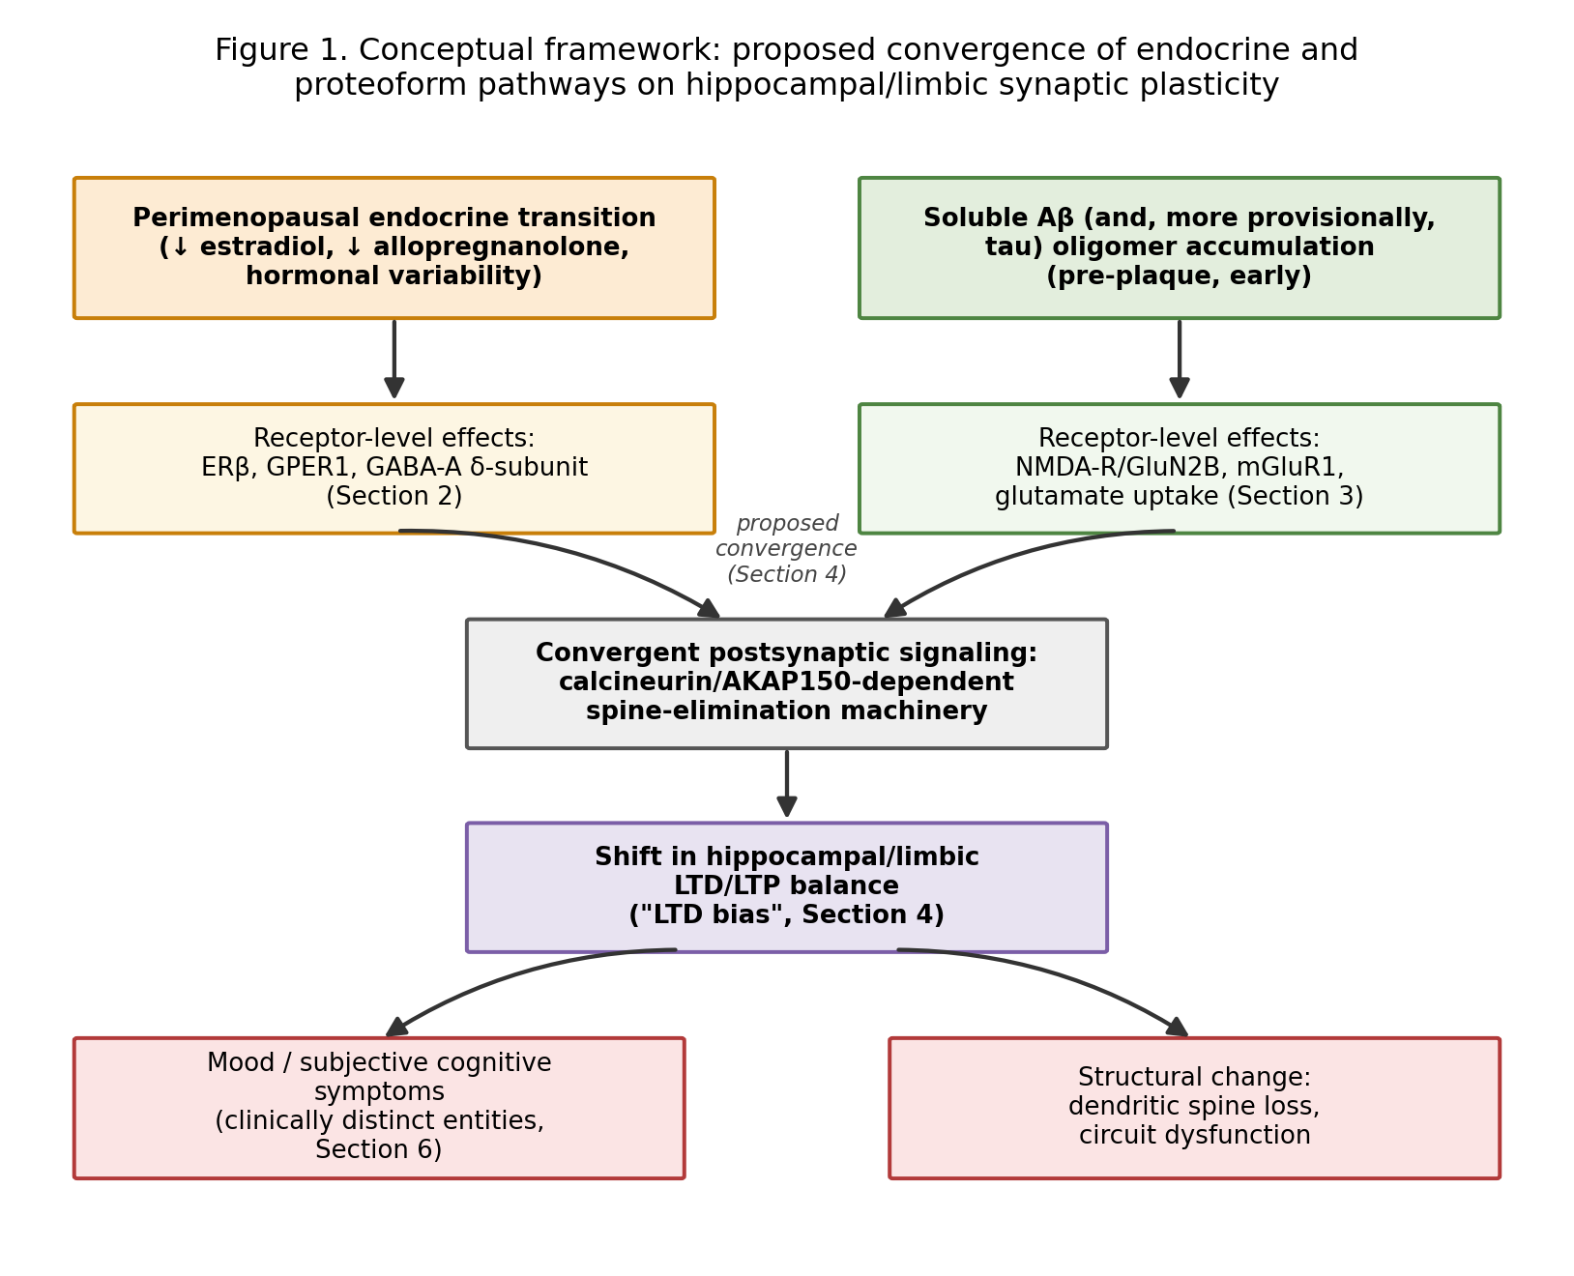
Figure 1. Conceptual framework: proposed convergence of endocrine and proteoform pathways on hippocampal/limbic synaptic plasticity, culminating in clinically distinct downstream phenomena (Section 6).
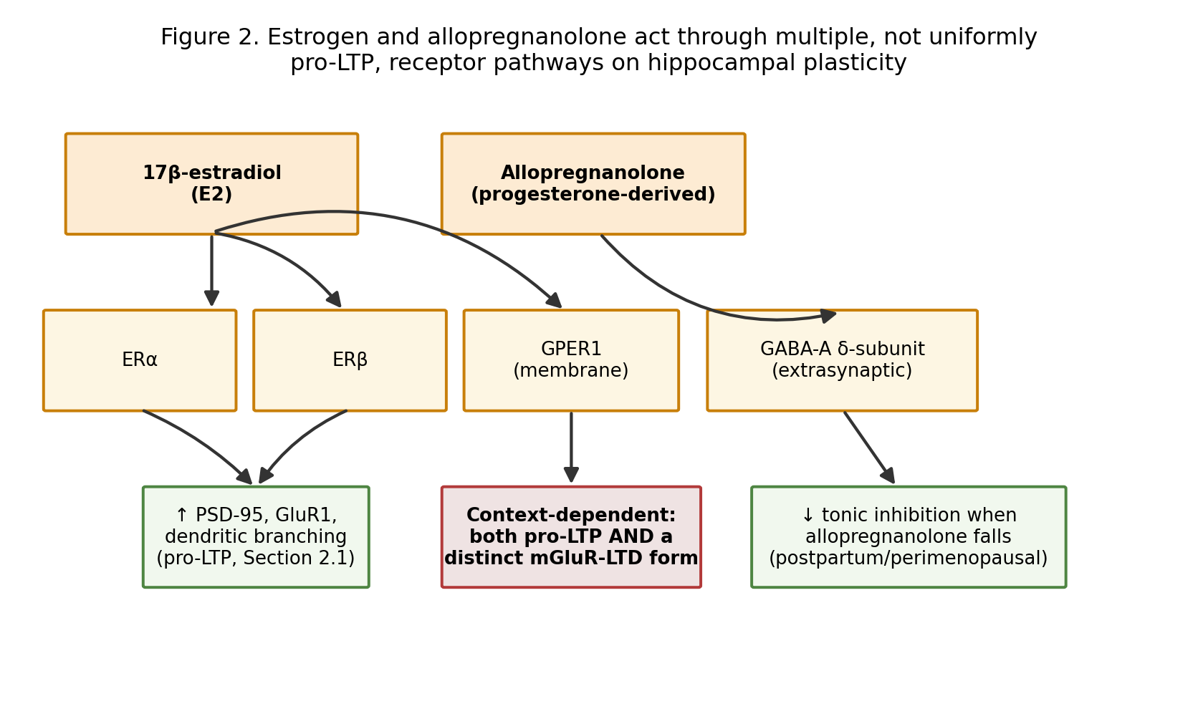
Figure 2. Estrogen and allopregnanolone act through multiple, not uniformly pro-LTP, receptor pathways on hippocampal plasticity.
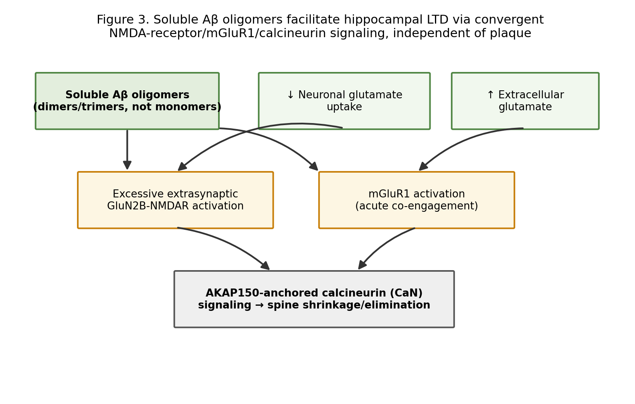
Figure 3. Soluble Aβ oligomers facilitate hippocampal LTD via convergent NMDA-receptor/mGluR1/calcineurin signaling, independent of plaque.

6. Distinguishing Clinical Entities: Mood, Cognition, and Neurodegeneration Are Not Equivalent
A synaptic-mechanism review of this kind risks collapsing clinically distinct entities into a single narrative arc ("menopausal mood symptoms lead to Alzheimer's disease"), which the evidence does not support and which this review explicitly rejects. We distinguish five levels that should not be conflated: (i) perimenopausal mood symptoms (depressive symptoms or diagnosed depression arising during the menopause transition, Section 3.3), which are common, generally not progressive, and typically respond to standard psychiatric treatment; (ii) subjective cognitive complaints, which are frequently reported during perimenopause and do not reliably predict objective impairment; (iii) objective mild cognitive impairment, a distinct clinical diagnosis with its own risk factors and only partial overlap with mood symptoms; (iv) Alzheimer's disease pathophysiology (amyloid and tau accumulation as measured by biomarkers or PET), which can be present without any clinical symptoms for years; and (v) clinical Alzheimer's disease, the eventual dementia syndrome. The mechanistic overlap proposed in Section 5 concerns shared synaptic vulnerability at the level of (iv) and its earliest interactions with circuits also implicated in (i)-(iii); it does not imply that perimenopausal depression is an early stage of Alzheimer's disease, that most women with perimenopausal mood symptoms have elevated proteoform burden, or that treating one entity is expected to treat another. Any research or communication building on this review should maintain these distinctions explicitly.

7. Translational Implications: A Downstream, Not Central, Consideration

7.1 Existing Single-Target Approaches
Current approaches to each clinical entity in Section 6 are largely developed in isolation. Perimenopausal depression is treated with SSRIs/SNRIs, hormone therapy, or neurosteroid GABA-A modulators (Section 3.2-3.3). Alzheimer's disease, once diagnosed, is treated with anti-amyloid monoclonal antibodies (lecanemab, donanemab) that require CNS engagement and carry amyloid-related imaging abnormality (ARIA) risk linked mechanistically to direct antibody engagement of vascular and parenchymal amyloid [50,51]. No existing approach is designed around the convergence hypothesis in Section 5.

7.2 A Peripheral, Non-CNS-Penetrating Proteoform-Clearance Component, Considered Cautiously
If Section 5's convergence hypothesis were confirmed, one — not the only — downstream translational direction would be evaluating whether addressing soluble proteoform burden through a peripherally restricted mechanism, rather than a directly CNS-penetrant one, could reduce the ARIA-type risk profile associated with existing anti-amyloid therapy while still addressing one arm of the proposed convergent pathway. A peripherally restricted mechanism — in which circulating antibodies sequester soluble Aβ in blood, establishing a concentration gradient that draws oligomeric species out of the CNS via efflux transporters without requiring antibody entry into the brain — has experimental precedent independent of the present hypothesis [52,53], though the mechanism remains actively contested: it depends on intact efflux transport (e.g., LRP1) [52,54], its evidence base concerns Aβ clearance broadly rather than the specific synaptotoxic oligomer species implicated in Section 4.1, and it does not resolve whether lowering plasma Aβ concentration necessarily lowers the CNS oligomer pool most relevant to LTD facilitation. Any implementation via active immunization would additionally inherit the safety architecture required to avoid the T-cell-mediated meningoencephalitis signal associated with the first-generation AN1792 vaccine [55,56], and would require epitope-restricted design of the kind validated in later-generation candidates [57]. We present this as an illustrative example of a downstream research direction, not a validated or proposed treatment, and we emphasize per Section 6 that it would not be indicated for perimenopausal mood symptoms in the absence of independently confirmed proteoform burden.

7.3 Explicit Clinical-Translational Boundary
To state plainly what Sections 6-7 imply: this review does not support, and should not be cited in support of, treating women with perimenopausal depression with anti-amyloid therapy, hormone therapy specifically for cognitive protection (given Section 3.3's largely null RCT record), or any other intervention on the basis of the convergence hypothesis alone. The proposed framework identifies an experimental interaction that could eventually motivate biomarker-stratified mechanistic studies in appropriately selected, consenting research populations; it does not establish a clinical indication for any therapy in any population.

8. Limitations
This is a conceptual synthesis, and its central claim — that endocrine state and proteoform burden interact at the level of synaptic metaplasticity — has not been directly tested in any single experimental system to our knowledge (Table 1, final two rows). The estrogen-plasticity literature is more heterogeneous than a simple "estrogen opposes LTD" narrative suggests (Section 3.1), and the hormone therapy-cognition RCT literature is substantially null-to-mixed (Section 3.3), which should temper any translational inference. The HPA-axis link, though frequently proposed, has mixed direct empirical support. Tau is treated throughout as a secondary, more provisional proteoform example than Aβ (Section 4.2). The peripheral-sink component discussed as one possible downstream direction (Section 7.2) inherits substantial, separately documented uncertainty regarding mechanism, generalizability, and safety, which we do not re-derive in full here. Finally, this review's synthesis spans multiple large, independently mature literatures (menopause neuroscience, GABA-A/neurosteroid pharmacology, Aβ synaptotoxicity, BCM metaplasticity theory, sex differences in Alzheimer's disease); while we have aimed for balanced coverage of each domain sufficient to motivate the central hypothesis, a reader seeking exhaustive coverage of any single domain should consult the dedicated reviews we cite within each section.

9. Falsifiable Research Agenda
Table 2 restates the core experimental predictions from a prior draft of this synthesis as a structured research agenda, specifying for each question the model system, intervention, measurement, predicted outcome under the central hypothesis (Model 5), and how the result would be interpreted relative to the competing models in Section 5.2.
Question | Model / Intervention | Measurement | Predicted outcome (Model 5) | Interpretation if not observed
Do endocrine state and oligomer burden interact (additively/synergistically) on LTD induction? | Ovariectomized vs. sham mice ± acute soluble Aβ oligomer infusion | Hippocampal LTD magnitude (field EPSP slope depression) | LTD magnitude in OVX+oligomer exceeds the sum of single-factor effects | Equal to sum: additive, not synergistic (still consistent with Model 5, weaker form). No greater than larger single effect: supports Model 1 (independent pathways) for this readout
Is the interaction receptor-specific as proposed (ERβ, GABA-A δ-subunit)? | OVX mice + oligomer, ± ERβ-selective agonist or zuranolone-class GABA-A δ-PAM | LTD magnitude, spine density (Golgi/2-photon imaging) | Partial normalization of LTD/spine loss by either agonist | No normalization: falsifies the specific receptor pathways proposed, even if a general endocrine-oligomer interaction holds via another route
Does GPER1 activation help or worsen oligomer-facilitated LTD, given its distinct LTD-promoting role (Section 3.1)? | OVX mice + oligomer + GPER1 agonist (G1) | LTD magnitude | Direction not assumed; test is diagnostic, not confirmatory | If GPER1 agonism worsens LTD, the simplified "estrogen restoration helps" framing must be replaced with a pathway-specific model (Section 3.1)
Does peripheral, non-CNS-penetrating oligomer clearance reduce LTD/spine loss in oligomer-exposed, ovariectomized animals? | OVX mice + oligomer ± peripheral sequestration (as in Section 7.2) | LTD magnitude, spine density, peripheral vs. CNS oligomer concentration | Reduced LTD/spine loss with clearance | No effect: the peripheral-sink logic (Section 7.2) does not extend to this synaptotoxic oligomer species/context
Does combined endocrine restoration + peripheral clearance outperform either alone? | Four-arm design: vehicle / endocrine only / clearance only / combined | LTD magnitude; if extended, mood/cognition-relevant behavioral measures | Combined arm shows greatest normalization | No combined advantage over the better single arm: falsifies the additivity/synergy claim even if each single-target effect independently replicates
Are endocrine decline and proteoform burden consequences of a shared upstream driver (Model 4) rather than directly interacting? | Aged (not ovariectomized) mice with independently manipulated inflammatory/vascular status | LTD magnitude, correlation structure between endocrine markers, oligomer burden, and inflammatory/vascular markers | Direct endocrine-oligomer interaction persists after controlling for shared aging/inflammatory covariates | If the interaction disappears after controlling for a shared covariate, Model 4 is favored over Model 5
Additional falsification conditions, stated for completeness: (i) if oligomer-facilitated LTD magnitude is statistically indistinguishable between ovariectomized and sham animals at matched oligomer exposure, the proposed endocrine-oligomer convergence does not hold; (ii) if combined intervention produces no greater normalization than the better single intervention, additivity/synergy is falsified even if single-target effects replicate independently; (iii) given GPER1's documented dual role, if GPER1 agonism increases rather than decreases oligomer-facilitated LTD, the receptor-specific model must be revised accordingly rather than treating "estrogen" as a single lever.

10. Conclusion
We have synthesized two literatures usually studied separately — neuroendocrine regulation of hippocampal plasticity across the menopause transition, and soluble Aβ oligomer-driven synaptotoxicity in early neurodegeneration — around a shared formal question, posed in the language of BCM metaplasticity theory: does endocrine state alter susceptibility to proteoform-driven synaptic metaplasticity? We have deliberately reframed this review's central contribution around that mechanistic question rather than around any proposed treatment, distinguished the clinically separate phenomena of mood symptoms, cognitive complaints, and Alzheimer's pathophysiology, weighed the central convergence hypothesis against four plausible alternative models, and presented a structured, falsifiable research agenda capable of confirming, partially confirming, or refuting the proposed convergence. If confirmed, this synthesis would motivate mechanistic, biomarker-stratified research into combined endocrine and peripheral proteoform-targeting strategies as one of several possible downstream directions — not a therapeutic recommendation. If falsified, particularly via the shared-upstream-driver or no-interaction criteria in Section 9, the exercise will still have clarified which receptor-specific mechanisms are, and are not, shared between neuroendocrinology and neurodegeneration research, a clarification we regard as valuable independent of which model proves correct.

References
[1] Malenka, R.C., & Bear, M.F. (2004). LTP and LTD: an embarrassment of riches. Neuron, 44(1), 5–21.
[2] Collingridge, G.L., Peineau, S., Howland, J.G., & Wang, Y.T. (2010). Long-term depression in the CNS. Nature Reviews Neuroscience, 11(7), 459–473.
[3] Duman, R.S., & Aghajanian, G.K. (2012). Synaptic dysfunction in depression: potential therapeutic targets. Science, 338(6103), 68–72.
[4] McEwen, B.S. (2005). Glucocorticoids, depression, and mood disorders: structural remodeling in the brain. Metabolism, 54(5 Suppl 1), 20–23.
[5] de Kruif, M., Spijker, A.T., & Molendijk, M.L. (2016). Depression during the perimenopause: a meta-analysis. Journal of Affective Disorders, 206, 174–180.
[6] Shankar, G.M., Bloodgood, B.L., Townsend, M., Walsh, D.M., Selkoe, D.J., & Sabatini, B.L. (2007). Natural oligomers of the Alzheimer amyloid-β protein induce reversible synapse loss by modulating an NMDA-type glutamate receptor-dependent signaling pathway. Journal of Neuroscience, 27(11), 2866–2875.
[7] Shankar, G.M., et al. (2008). Amyloid-β protein dimers isolated directly from Alzheimer's brains impair synaptic plasticity and memory. Nature Medicine, 14, 837–842.
[8] Li, S., Hong, S., Shepardson, N.E., Walsh, D.M., Shankar, G.M., & Selkoe, D.J. (2009). Soluble oligomers of amyloid β protein facilitate hippocampal long-term depression by disrupting neuronal glutamate uptake. Neuron, 62(6), 788–801.
[9] Hu, N.W., Klyubin, I., Anwyl, R., & Rowan, M.J. (2009). GluN2B subunit-containing NMDA receptor antagonists prevent Aβ-mediated synaptic plasticity disruption in vivo. PNAS, 106(48), 20504–20509.
[10] Prikhodko, O., Freund, R.K., Sullivan, E., Kennedy, M.J., & Dell'Acqua, M.L. (2024). Amyloid-β causes NMDA receptor dysfunction and dendritic spine loss through mGluR1 and AKAP150-anchored calcineurin signaling. Journal of Neuroscience, 44(37), e0675242024.
[11] Liu, F., Day, M., Muniz, L.C., et al. (2008). Activation of estrogen receptor-beta regulates hippocampal synaptic plasticity and improves memory. Nature Neuroscience, 11(3), 334–343.
[12] Oberlander, J.G., & Woolley, C.S. (2016). 17β-estradiol acutely potentiates glutamatergic synaptic transmission in the hippocampus through distinct mechanisms in males and females. Journal of Neuroscience, 36(9), 2677–2690.
[13] Briz, V., Liu, Y., Zhu, G., Bi, X., & Baudry, M. (2015). A novel form of synaptic plasticity in field CA3 of hippocampus requires GPER1 activation and BDNF release. Journal of Cell Biology, 210(7), 1225–1237.
[14] Kumar, A., et al. G protein-coupled estrogen receptor: rapid effects on hippocampal-dependent spatial memory and synaptic plasticity. Frontiers in Neuroscience (review), PMC7298106.
[15] Srivastava, D.P., Woolfrey, K.M., Jones, K.A., et al. (2010). Rapid modulation of synaptogenesis and spinogenesis by 17β-estradiol in primary cortical neurons. PMC4396386.
[16] Gross, K.S., Alderman, Z., Merrill, D., et al. G-protein coupled estrogen receptor (GPER1) activation promotes synaptic insertion of AMPA receptors and induction of chemical LTP at hippocampal temporoammonic-CA1 synapses. PMC9883958.
[17] Tabatadze, N., et al. (2024). 17β-estradiol reduces inhibitory synaptic currents in entorhinal cortex neurons through GPER1 activation of extracellular signal-regulated kinase. Hippocampus.
[18] Maguire, J. (2021). Targeting GABA receptors to treat postpartum depression. In: Novel Molecular Targets for Mood Disorders and Psychosis, NCBI Bookshelf, NBK575003.
[19] Deligiannidis, K.M., Kroll-Desrosiers, A.R., Mo, S., Nguyen, H.P., Svenson, A., Jaitly, N., Hall, J.E., Barton, B.A., Rothschild, A.J., & Shaffer, S.A. (2016). Peripartum neuroactive steroid and γ-aminobutyric acid profiles in women at-risk for postpartum depression. Psychoneuroendocrinology, 70, 98–107.
[20] Carver, C.M., & Reddy, D.S. (2014). Neurosteroid structure-activity relationships for functional activation of extrasynaptic δGABA(A) receptors. Journal of Pharmacology and Experimental Therapeutics, 348(1), 172–183.
[21] Wilson, C.A., et al. (2025). Brexanolone, zuranolone and related neurosteroid GABA-A receptor positive allosteric modulators for postnatal depression. Cochrane Database of Systematic Reviews.
[22] Kanes, S.J., Colquhoun, H., Doherty, J., et al. (2017). Open-label, proof-of-concept study of brexanolone in the treatment of severe postpartum depression. Human Psychopharmacology, 32(2), e2576.
[23] Dichtel, L.E., Nyer, M., Dording, C., Fisher, L.B., Cusin, C., Shapero, B.G., et al. (2020). Effects of open-label, adjunctive ganaxolone on persistent depression despite adequate antidepressant treatment in postmenopausal women: a pilot study. Journal of Clinical Psychiatry, 81, 19m12887.
[24] Gordon, J.L., et al. (2019). Estradiol fluctuation, sensitivity to stress, and depressive symptoms in the menopause transition: a pilot study. Frontiers in Psychology, 10, 1319.
[25] The Menopause Transition: Estrogen Variability, Stress Reactivity and Mood. Protocol document, ClinicalTrials.gov NCT03003949.
[26] Fisher, D.W., Bennett, D.A., & Dong, H. (2018/2023 update). Sex and gender differences in Alzheimer's disease risk. Frontiers in Global Women's Health / PMC10796575.
[27] Neu, S.C., et al. (2017). Apolipoprotein E genotype and sex risk factors for Alzheimer disease: a meta-analysis. JAMA Neurology, 74(10), 1178–1189.
[28] Altmann, A., Tian, L., Henderson, V.W., Greicius, M.D., & Alzheimer's Disease Neuroimaging Initiative Investigators. (2014). Sex modifies the APOE-related risk of developing Alzheimer disease. Annals of Neurology, 75(4), 563–573.
[29] Sex-dependent effect of APOE on Alzheimer's disease and other age-related neurodegenerative disorders. (2020). Disease Models & Mechanisms, 13(8), dmm045211.
[30] Shi, Z., Wu, L., & Zhang, C. (2025). Testosterone as a mediator of APOE4-linked sex differences in Alzheimer's disease. [Review].
[31] Mosconi, L., Berti, V., Guyara-Quinn, C., et al. (2017). Perimenopause and emergence of an Alzheimer's bioenergetic phenotype in brain and periphery. PLoS ONE, 12(10), e0185926.
[32] Bienenstock, E.L., Cooper, L.N., & Munro, P.W. (1982). Theory for the development of neuron selectivity: orientation specificity and binocular interaction in visual cortex. Journal of Neuroscience, 2(1), 32–48.
[33] Abraham, W.C. (2008). Metaplasticity: tuning synapses and networks for plasticity. Nature Reviews Neuroscience, 9(5), 387.
[34] Cooper, L.N., & Bear, M.F. (2012). The BCM theory of synapse modification at 30: interaction of theory with experiment. Nature Reviews Neuroscience, 13(11), 798–810.
[35] Abraham, W.C., Mason-Parker, S.E., Bear, M.F., Webb, S., & Tate, W.P. (2001). Heterosynaptic metaplasticity in the hippocampus in vivo: a BCM-like modifiable threshold for LTP. Proceedings of the National Academy of Sciences USA, 98(19), 10924–10929.
[36] Freeman, E.W. (2010/2015). Associations of hormones and menopausal status with depressed mood in women with no history of depression. Archives of General Psychiatry / related cohort publications.
[37] Gleason, C.E., Dowling, N.M., Wharton, W., et al. (2015). Effects of hormone therapy on cognition and mood in recently postmenopausal women: findings from the randomized, controlled KEEPS-Cognitive and Affective Study. PLoS Medicine, 12(6), e1001833.
[38] Gleason, C.E., Dowling, N.M., Kara, F., et al. (2024). Long-term cognitive effects of menopausal hormone therapy: findings from the KEEPS Continuation Study. PLoS Medicine, 21(11), e1004435.
[39] Hodis, H.N., Mack, W.J., Shoupe, D., Azen, S., Stanczyk, F., & Hwang-Levine, J. (2014/2015). Methods and baseline cardiovascular data from the Early versus Late Intervention Trial with Estradiol testing the menopausal hormone timing hypothesis. Menopause, 22(4), 391–401.
[40] Henderson, V.W., et al. (2016). Cognitive effects of estradiol after menopause: a randomized trial of the timing hypothesis. Neurology, 87(7), 699–708.
[41] Andy, C., Nerattini, M., Jett, S., et al. (2024). Systematic review and meta-analysis of the effects of menopause hormone therapy on cognition. Frontiers in Endocrinology, 15, 1350318.
[42] Shumaker, S.A., et al. (2003). Estrogen plus progestin and the incidence of dementia and mild cognitive impairment in postmenopausal women: the Women's Health Initiative Memory Study. JAMA, 289(20), 2651–2662.
[43] Espeland, M.A., Shumaker, S.A., Leng, I., Manson, J.E., Brown, C.M., LeBlanc, E.S., et al. (2013). Long-term effects on cognitive function of postmenopausal hormone therapy prescribed to women aged 50 to 55 years. JAMA Internal Medicine, 173(15), 1429–1436.
[44] Menopause hormone therapy and risk of mild cognitive impairment or dementia: a systematic review and meta-analysis. (2025). The Lancet Healthy Longevity.
[45] Woods, N.F., Carr, M.C., Tao, E.Y., Taylor, H.J., & Mitchell, E.S. (2006). Cortisol levels during the menopausal transition and early postmenopause: observations from the Seattle Midlife Women's Health Study. Menopause, 13(2), 212–221.
[46] Gordon, J.L., Girdler, S.S., Meltzer-Brody, S.E., et al. (2015). Ovarian hormone fluctuation, neurosteroids, and HPA axis dysregulation in perimenopausal depression: a novel heuristic model. American Journal of Psychiatry, 172(3), 227–236.
[47] Schmidt, P.J., et al. Cortisol and ACTH response to Dex/CRH testing in women with and without perimenopausal depression. Journal of Clinical Endocrinology & Metabolism, 106(10), 3007.
[48] Gordon, J.L., et al. (2019). Estradiol fluctuation, sensitivity to stress, and depressive symptoms in the menopause transition: a pilot study. Frontiers in Psychology, 10, 1319. [see also ref. 24]
[49] Martinez, T.P., Larsen, M.E., Sullivan, E., Woolfrey, K.M., & Dell'Acqua, M.L. (2024). Amyloid-β-induced dendritic spine elimination requires Ca2+-permeable AMPA receptors, AKAP-Calcineurin-NFAT signaling, and the NFAT target gene Mdm2. eNeuro, 11, ENEURO.0175-23.2024.
[50] van Dyck, C.H., et al. (2023). Lecanemab in early Alzheimer's disease. New England Journal of Medicine, 388, 9–21.
[51] Sims, J.R., et al. (2023). Donanemab in early symptomatic Alzheimer's disease: the TRAILBLAZER-ALZ 2 randomized clinical trial. JAMA, 330(6), 512–527.
[52] DeMattos, R.B., et al. (2001). Peripheral anti-Aβ antibody alters CNS and plasma Aβ clearance and decreases brain Aβ burden in a mouse model of Alzheimer's disease. PNAS, 98(15), 8850–8855.
[53] Vasilevko, V., Xu, F., Previti, M.L., Van Nostrand, W.E., & Cribbs, D.H. (2007). Experimental investigation of antibody-mediated clearance mechanisms of amyloid-β in CNS of Tg-SwDI transgenic mice. Journal of Neuroscience, 27(49), 13376–13383.
[54] Deane, R., Bell, R.D., Sagare, A., & Zlokovic, B.V. (2009). Clearance of amyloid-β peptide across the blood-brain barrier: implication for therapies in Alzheimer's disease. CNS & Neurological Disorders - Drug Targets, 8(1), 16–30; Yamada, K., Hashimoto, T., Yabuki, C., Nagae, Y., Tachikawa, M., Strickland, D.K., Liu, Q., Bu, G., Basak, J.M., Holtzman, D.M., Ohtsuki, S., Terasaki, T., & Iwatsubo, T. (2008). The low-density lipoprotein receptor-related protein 1 mediates uptake of amyloid β peptides in an in vitro model of the blood-brain barrier cells. Journal of Biological Chemistry, 283(50), 34554–34562.
[55] Orgogozo, J.M., et al. (2003). Subacute meningoencephalitis in a subset of patients with AD after Aβ42 immunization. Neurology, 61(1), 46–54.
[56] Nicoll, J.A.R., et al. (2003). Neuropathology of human Alzheimer disease after immunization with amyloid-β peptide: a case report. Nature Medicine, 9, 448–452.
[57] Yu, H.J., et al. (2023). Safety, tolerability, immunogenicity, and efficacy of UB-311 in participants with mild Alzheimer's disease. eBioMedicine, 94, 104665.

Declaration of AI Assistance
During the preparation of this work, the author used Claude (Anthropic; Opus/Sonnet models) to assist with literature synthesis, drafting, and generation of the conceptual figures (Figures 1-3), for which the underlying Python/Matplotlib scripts are archived alongside this manuscript (see Data and Code Availability). After using this tool, the author reviewed and edited the content as needed and takes full responsibility for the content of the publication. No AI tool is listed as an author, consistent with Elsevier's policy on the use of generative AI and AI-assisted technologies in scientific writing.

Data and Code Availability
The conceptual-framework figures (Figures 1-3) and the structured evidence tables (Tables 1-2) are provided as open-source Python (Matplotlib/pandas) at {GITHUB_URL} (MIT license) and archived with a permanent DOI on Zenodo: {CODE_DOI_URL}. The manuscript itself is additionally archived on Zenodo: {PAPER_DOI_URL}. This is a conceptual/theoretical review; no new clinical or preclinical data were generated.

