A fail-safe permissive interlock against aircraft misfuelling: system concept, barrier-degradation model and Monte Carlo risk assessment
L. Sandler
Independent Researcher (The Conscious Machine), Northbrook, Illinois, United States
ORCID 0009-0007-4584-808X · leonsandler@alumni.swinburne.edu

ABSTRACT
Delivering the wrong fuel to an aircraft remains a recurrent ground-operations hazard whose usual defences – placards, filler-port restrictors and checklists – are passive or administrative and are repeatedly defeated on the ramp. This paper develops and assesses a fail-safe permissive interlock for refuelling vehicles: a durable code at each fuel port is read at the vehicle, an edge controller compares the aircraft’s registered fuel requirement with the vehicle’s declared product, and a start permissive is issued only on a verified match, without altering the existing deadman or emergency shut-off. A closed-form event hazard, a mean-field model of barrier compromise through bypass and habitual override, and a fleet Monte Carlo (5,000 replicates, with parameter and stochastic uncertainty separated) compare four barrier configurations; a virtual fault-injection campaign tests the controller logic. Under assumed, ideation-stage parameters the interlock as first conceived lowers the nominal misfuelling hazard by approximately 83% but not to zero: most of the residual is product that differs from the vehicle’s records. In 20-vehicle fleets a transient tag-fouling episode drives 19.7% of replicates into a bypassed state; slow restoration and peer feedback together cause this, and tamper analytics removes it. The conclusions survive alternative dependence structures and prior families. All results are model-conditional; no hardware has been built. A seeded-drill protocol for verification is proposed.

NOMENCLATURE
Symbol | Meaning
S, W | Daily crew-stress and tag-fouling/weather indices, in [0, 1]
λ(S) | Probability per fuelling that a wrong-product delivery is attempted
m(S) | Miss probability of the administrative (checklist/placard) check
p_{u} | Probability that the aircraft tag cannot be read after retries
π | Probability that the interlock permits a true mismatch
p_{L}, m_{L} | Depot-loading error probability; administrative miss for it
δ | Detection probability of the optional inline product sensor
β_{cc} | Beta-factor: probability that both barriers fail from a shared cause
I, c | Compromised fraction of vehicles; compromise state of one vehicle (0/1)
ρ | Control group, restoration rate over compromise rate (equation 6)
T_{d} | Mean time to detect and restore a compromised vehicle
PMFE | Misfuelling events per million fuellings
PFD | Probability of failure on demand
DU, DD | Dangerous undetected / dangerous detected failure

1.0 INTRODUCTION
Delivering the wrong fuel to an aircraft is easy to commit and, once the caps are closed, difficult to detect. The United States National Transportation Safety Board (NTSB) investigated misfuelling accidents in the early 1980s and recommended physical filler-port restrictors as a means of preventing them⁽¹⁾. Misfuelling has nevertheless continued. A 2016 NTSB safety alert for line personnel notes that non-standard nozzles can be made to fit small avgas ports, that supplemental-type-certificate (STC) engine conversions change an aircraft’s fuel requirement without changing its appearance, and that line staff must identify aircraft by registration rather than by type⁽²⁾. In a 2014 air-ambulance accident, a Cessna 421C was fuelled with Jet A through a small nozzle that fitted the avgas filler port, with four fatalities⁽³⁾. The Transportation Safety Board of Canada (TSB) report on a 2015 PA-31-350 accident at Thompson, Manitoba, found that a flared Jet-A1 spout had been replaced by one that would fit the aircraft’s smaller filler openings; the same report records 21 jet-for-avgas misfuellings in Canada since 1980, which produced eight crashes and eleven forced landings⁽⁴⁾.
The common thread is that the defences are passive or administrative, and that people defeat them: a nozzle is swapped, a placard goes unread, a truck is mistaken for another. Reason’s account of active failures and latent conditions^{(5,6)} predicts this, and implies that a barrier is only as strong as the likelihood that it remains in place and in use. This paper examines an active, fail-safe barrier – a permissive interlock that withholds the start of fuel flow unless the aircraft’s registered requirement and the vehicle’s product agree – and asks three questions that proposals of this kind rarely answer quantitatively. How much residual risk remains, and where does it sit? How does the barrier itself degrade through bypass and habitual override when it causes nuisance delays? And how can a pilot demonstrate benefit when the hazard occurs a few times per million operations?
The principal contribution is the second: a quantitative demonstration that a safety barrier can initially reduce risk and then lose its effectiveness because operators bypass it after nuisance failures, together with an assessment of how robust that behaviour is to the modelling assumptions. Supporting contributions are (i) an architecture whose start and continuous-flow permissions are separated and which cannot impair the existing emergency shut-off (Section 3); (ii) a safety-assurance analysis with a fault tree and failure-mode table distinguishing dangerous from nuisance failures (Section 4); (iii) a three-level probabilistic framework, implemented in the style of the author’s MyUncle framework⁽⁷⁾, with explicit treatment of dependence (Sections 5 and 6); (iv) a virtual fault-injection campaign on the controller logic (Sections 6 and 7); and (v) a verification method based on seeded drills (Section 8). All quantitative results rest on assumed parameters appropriate to technology-readiness level (TRL) 1–3. No prototype has been built or tested, and the results are model-conditional estimates, not demonstrated safety performance.

2.0 EXISTING BARRIERS AND THE GAP
Industry standards such as the Joint Inspection Group’s JIG 1 for into-plane fuelling⁽⁸⁾ and NFPA 407 for aircraft fuel servicing⁽⁹⁾ address quality control, bonding, equipment and operating procedure; they rely on trained personnel to select the right product for the right aircraft. Physical measures – filler-port restrictors, distinct nozzle geometries, decals – are effective where fitted and not defeated, but are specific to fuel pairs and can be defeated by adaptors, as the accidents above show. What is absent is an aircraft-specific, vehicle-side barrier that does not depend on the operator’s recognition of the aircraft. Loading racks already use permissive logic for grounding and overfill; the concept here extends the idea to the point of delivery. The gap this paper addresses is therefore twofold: the barrier itself, and a quantitative understanding of how such a barrier fails in service.

3.0 INTERLOCK ARCHITECTURE
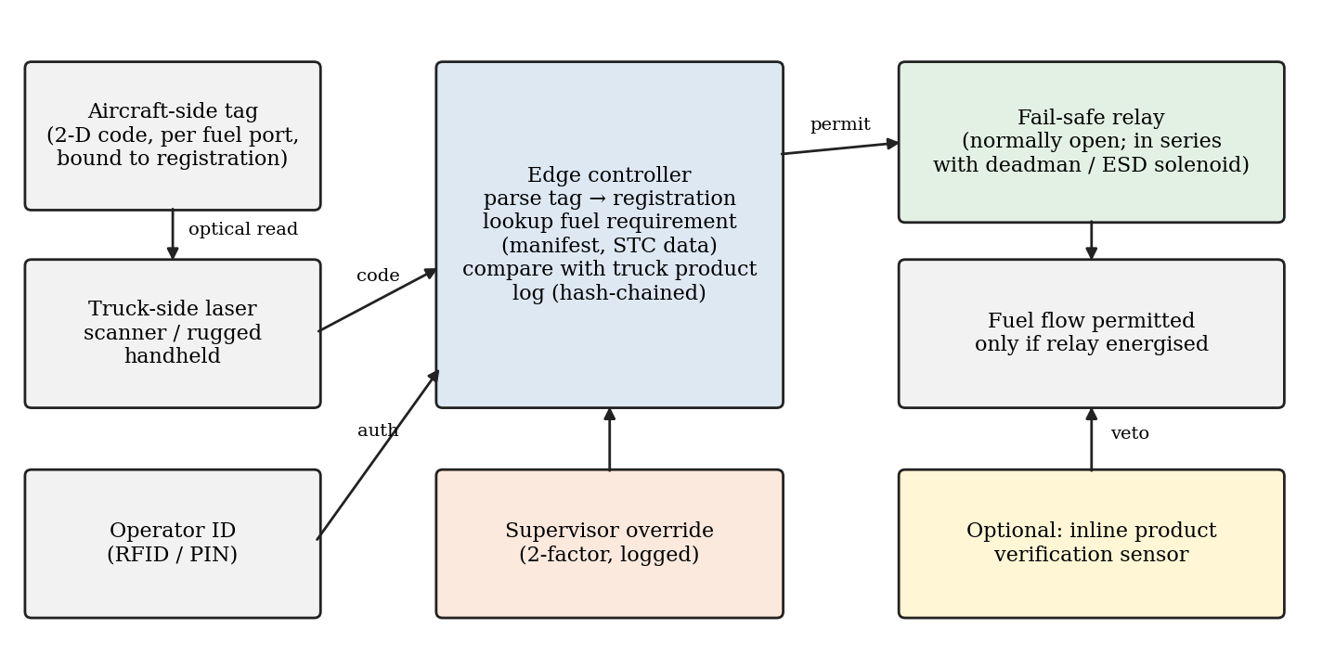
Fig. 1. Architecture of the permissive interlock. Solid arrows show the normal permit path; the supervisor override and the optional product sensor act on the edge controller and the flow path respectively.

3.1 Hardware and identity verification
Aircraft-side tag. A ceramic- or metal-backed two-dimensional code is fixed beside each fuel port, resistant to fuel, hydraulic fluid, ultraviolet exposure and pressure washing. The code carries only an identifier bound to the aircraft registration; the fuel requirement is looked up, so that a re-engining or re-registration is corrected in one record. Vehicle-side reader. A laser scanner at the hose reel, or in a handheld terminal, reads the tag. Control gatekeeper. A micro-controller drives a failsafe industrial relay that forms part of the start permissive of the deadman circuit (Section 3.2). Requirement records. The look-up returns a set of acceptable product classes rather than a single grade – for example Jet A or Jet A-1 (including approved blends that are certified as drop-in), or a specific avgas grade – and a record age. Records for aircraft with engine conversions carry a mandatory flag that forces a second-source cross-check.

3.2 Separating start permission from continuous-flow permission
Treating every controller fault the same way would either risk a surge by stopping flow abruptly or ignore a real hazard once flow had begun. The architecture therefore distinguishes four classes of fault (Table 1) and four roles for the circuits involved.
Start permissive. The relay contact is in series with the deadman’s start path, in the manner of a motor-starter: once the controller has verified the delivery, the contact closes and a hard-wired seal-in through the existing deadman holds the circuit while the operator keeps the deadman engaged. Loss of controller power therefore cannot interrupt a delivery already in progress, but it does prevent any new start. Continuous-flow permission. Remains with the existing deadman and emergency shut-off (ESD); the interlock adds no new authority to hold flow. Independent ESD. The ESD and deadman release paths are not routed through the controller. Because the interlock contact is in series with the pre-existing circuit, a relay that welds closed can only remove the interlock’s own protection; it cannot prevent the original circuit from opening, so the added element can add trips but cannot defeat one. Controlled shutdown. The only conditions that stop flow already in progress are those that indicate the delivery may be wrong – a product-sensor veto or the revocation of the aircraft record – and these command a ramped closure of a valve (where fitted) rather than an abrupt break in the circuit.
Table 1. Fault classes and required interlock response.
Class | Examples | Response
A – start inhibit | Tag invalid; record missing or stale; product mismatch; operator not authenticated; heartbeat or self-test failure; relay-feedback mismatch | Relay remains open; no start; alert; override only for an invalid tag
B – controlled shutdown | Product-sensor veto during flow; aircraft record revoked during flow | Alarm; ramped valve closure over a defined minimum time; latched fault; supervisor investigation
C – alarm and complete | Controller, communications or power fault during flow | Seal-in persists under the deadman; alarm; next start inhibited until reset and self-test
D – independent ESD | Deadman release; emergency shut-off trip | Not routed through the controller; always effective
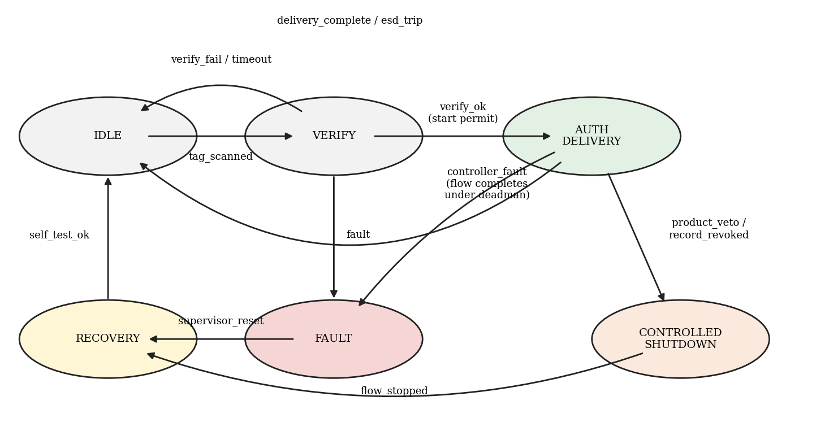
Fig. 2. Controller state-transition diagram. The start permissive is energised only in AUTH_DELIVERY, which is reachable only through VERIFY; the independent ESD is outside the diagram.
The state machine (Fig. 2; 14 defined transitions over 6 states) is implemented and tested: the relay output is energised in exactly one state, that state cannot be reached from any other state without passing through VERIFY, undefined events are ignored without changing state, and a fault during delivery sends the controller to FAULT, from which only a supervisor reset and a passed self-test return it to IDLE.
Consequences of valve closure under flow. If a Class B event does require flow to stop, the closure rate must limit the pressure transient. The Joukowsky relation ΔP = ρav gives the instantaneous surge for a sudden stop, and closures slower than 2L/a reduce it approximately in proportion to that time⁽¹²⁾. For an illustrative delivery of 2,000 L min⁻¹ through a 75 mm hose at a velocity of 7.5 m s⁻¹, density 800 kg m⁻³, an assumed hose wave speed of 400 m s⁻¹ and a 15 m length, an instantaneous stop would give approximately 2.4 MPa, whereas a controlled closure over 5 s would give approximately 36 kPa. These numbers are illustrative; the wave speed and hose rating must be taken from the actual installation, and the minimum closure time is a design parameter of the safety case.

3.3 Data and audit trail
Every scan, permit, block and override is time-stamped, position-tagged and appended to a hash-chained log. Beyond compliance, the log has a safety function that Section 7 quantifies: comparing relay-state telemetry with scan records allows a bypass (for example a jumper across the relay) to be detected within days rather than at a periodic audit.

4.0 SAFETY ASSURANCE AND INTEGRATION CONSTRAINTS

4.1 Fault tree and failure modes
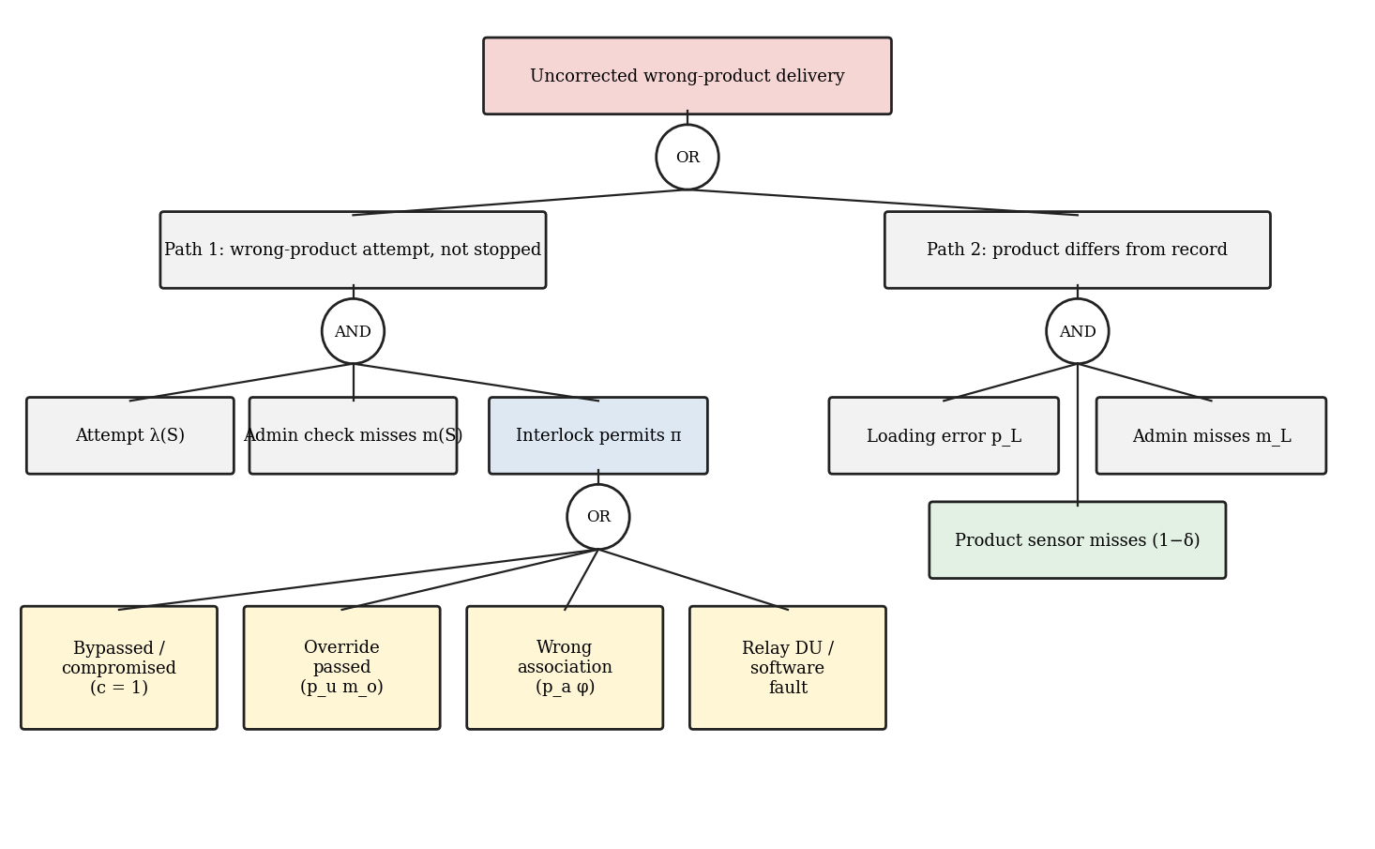
Fig. 3. Fault tree for an uncorrected wrong-product delivery. Path 1 requires an attempted mismatch, an administrative miss and an interlock that permits; path 2 is a product that differs from its record and passes both the administrative and the sensor checks.
Table 2 classifies the failure and circumvention modes that the quantitative model carries forward, distinguishing dangerous undetected failures from dangerous detected failures and from nuisance outcomes. The deliberate-defeat mode follows the pattern described as normalisation of deviance⁽¹³⁾: nuisance interruptions create pressure to work around the device, and each workaround makes the next more acceptable.
Table 2. Failure-modes-and-effects summary.
Mode | Mechanism | Class | Effect | Mitigation / model term
Tag unreadable | Fouling, ice, abrasion, glare | Nuisance | Block; override path | Dual tags; p_{u}, m_{o}
Wrong association | Adjacent aircraft; stale record after conversion | DU | Permit against wrong requirement | Stand/GPS check; registry cross-check; p_{a}
Relay welded closed | Contact welding | DU (DD with feedback) | Permit regardless of logic | Mirror-contact feedback; 1oo2; PFD
Controller software fault | Stuck permit; comparison error | DU | Permit regardless of data | Diverse second check; p_{sw}
Relay fails open / power loss | Transient, reset | Nuisance (safe) | No start; flow in progress sealed in | Fail-safe by design
Product not as declared | Depot loading or labelling error; contamination | DU | Records-based check cannot see it | Inline sensor (δ); p_{L}
Product sensor fault | Drift, fouling, false veto | DU / nuisance | Missed mismatch or false stop | Calibration, self-test; δ, p_{sens,false}
Bypass / habitual override | Jumper, shared PIN, rubber-stamping | DU (latent) | Interlock inactive | Tamper analytics; compromise state I
Data-link loss | No coverage on ramp | Nuisance | Cache used; age limit | Stale-record limit
Credential misuse | Spoofed tags, shared credentials | DU | Unauthorised override | Two-factor, single-use tokens (Section 7.5)

4.2 Aviation ground-fuelling safety assurance and integration constraints
The following constraints must be addressed in a safety case before any operational use. This paper does not claim compliance with, or certification against, any of the standards named; the analysis shows only where the architecture must be shown to meet them.
Isolation from deadman and ESD. The interlock must be demonstrably unable to disable or delay the existing emergency shut-off. The architecture in Section 3.2 relies on series insertion in the start path and on an ESD path that bypasses the controller; the safety case must show this by circuit analysis and test on each vehicle type, including the effect of a welded contact and of loss of the interlock supply.
Hazardous-area equipment and ignition-source control. Equipment on or near the vehicle must be suitable for the zone in which it operates, under the applicable explosive-atmosphere requirements⁽¹¹⁾; a laser scanner, relay, radio and any sensor are potential ignition sources unless suitably protected, and the sensor’s wetted parts must be compatible with the fuels. Aircraft fuel servicing practice⁽⁹⁾ governs bonding and operating procedure and must not be compromised by the added equipment.
Vehicle-to-aircraft association. Reading the wrong tag is the principal way a correct-looking permit can be wrong. Mitigations include a short reader range, display of the registration and type for operator read-back, a check of the vehicle’s GPS position against the manifest stand, and a limited time between scan and flow start. The residual is carried in the model as p_{a}.
Fuel-grade identification. The requirement record must represent Jet A, Jet A-1, avgas grades and approved alternative fuels (for example certified drop-in sustainable-aviation-fuel blends and any unleaded avgas grades authorised for the aircraft) as classes with explicit compatibility, rather than as a binary jet/avgas flag, and must handle aircraft approved for more than one grade.
Configuration management after conversions. A fuel requirement can change when an engine or fuel system is converted under an STC without any change to the filler opening⁽²⁾. The record must therefore be keyed to registration, versioned, tied to the modification status, and reviewed whenever an aircraft is converted or re-registered; stale records must be rejected by an age limit.
Product verification sensor. An inline sensor addresses the largest residual in Section 7, but introduces its own failure modes: drift, fouling, limited discrimination between similar products, false vetoes, and a requirement for periodic calibration and function test. Its detection probability δ is carried as an uncertain parameter and swept in Section 7.2; the sensor does not replace sampling and quality control.
Manual override governance, emergency procedures and recovery. Override is allowed only for an invalid tag, requires a single-use token and an independent supervisor factor, is always logged, and triggers a review if its frequency exceeds a threshold. Emergency procedures must not depend on the interlock, and recovery after a Class B or C event requires supervisor action and a passed self-test before the next start.

5.0 PROBABILISTIC FRAMEWORK
Following the structure of MyUncle⁽⁷⁾ – analytics, a mean-field reduction and stochastic simulation that cross-check one another – the model has three levels. Time is measured in fuellings for the event hazard and in days for the fleet dynamics.

5.1 Level A: event tree and closed-form hazard
Consider one fuelling at crew-stress S and tag-fouling index W. The initiating event is an attempt to deliver the wrong product, with probability
λ(S) = λ₀ [ 1 + β_{s} S^{h} / ( K^{h} + S^{h} ) ] (1)
Two barriers act on it. The administrative check (placard comparison, checklist) fails with probability m(S) = m₀(1 + gS), a form consistent with the rising error probabilities that the human-reliability literature associates with stress^{(14,15)}. The interlock permits the mismatch with probability
π = min{ 1, p_{u} m_{o} + (1 − p_{u}) p_{a}φ + PFD + p_{sw} } (2)
whose terms are the branches of the interlock sub-tree: a mismatch passing the override path, a wrong association that looks compatible (φ = 0.6), a dangerous relay failure with PFD = λ_{DU}T_{p}/2 for proof-test interval T_{p}⁽¹⁶⁾, and a controller software fault. The event tree then has a single branch ending in an uncorrected delivery, in which both barriers fail. Its probability is P(M ∩ Π | attempt), where M and Π are the events “administrative check misses” and “interlock permits”.
Why the beta-factor form. The joint probability of two events with given marginals is bounded: independence gives mπ; no dependence structure can exceed the Fréchet–Hoeffding upper bound min(m, π)⁽¹⁷⁾. The model interpolates between these limits by supposing that, given an attempt, a shared cause (for example a single distraction or a rushed turnaround) occurs with probability β_{cc}. Under a shared cause the two failures are perfectly nested, so the joint probability is the smaller marginal; otherwise the barriers fail independently:
P(M ∩ Π | attempt) = β_{cc} min(m, π) + (1 − β_{cc}) mπ (3)
Thus β_{cc} = 0 is independence and β_{cc} = 1 is the worst case over all positive dependence between the barriers; the nominal value 0.05 is an assumption, and Section 7.2 reports the hazard reduction over the whole range 0–1. An additional behavioural dependence, complacency, in which the administrative check is performed less carefully because an interlock exists, is represented by a multiplier on m. Adding a depot-loading error that no records-based check can detect, the per-event hazard of a vehicle in compromise state c ∈ ^{(0,1)} is
h = λ [ β_{cc} min(π_{c}, m) + (1 − β_{cc}) π_{c} m ] + p_{L} m_{L} [ 1 − δ(1 − c) ] (4)
with π_{c} = 1 when c = 1. A compromised interlock reverts the vehicle to administrative checks and never makes it worse than the baseline; this property is tested in the code.

5.2 Level B: mean-field barrier compromise
Nuisance blocks occur at rate p_{nuis} = p_{u} + p_{false} (plus a sensor false-veto term when a sensor is fitted) per fuelling. Each induces a permanent defeat with probability ν, and defeat is more likely when peers have bypassed the device. With I the compromised fraction and a detection-and-restoration rate R = 1/T_{d}, the mean-field equation has the form of the MyUncle maintenance equation⁽⁷⁾:
dI/dτ = μ(I)(1 − I) − ρI, μ(I) = 1 + β_{c} I^{h} / ( K^{h} + I^{h} ) (5)
ρ = R / λ_{eff}, λ_{eff} = ν n_{e} p_{nuis} (6)
where n_{e} is fuellings per vehicle-day. Without feedback the steady state is I* = 1/(1 + ρ). With peer feedback of sufficient strength a bistable window appears; for the MyUncle default values (β_{c} = 20, h = 6, K = 0.5) it spans 3.9 < ρ < 11.3. Inside the window a fleet that starts compliant remains compliant until a disturbance carries it past a saddle-node threshold, after which it remains bypassed even when the disturbance ends. These feedback values are borrowed, not estimated from operational data; Section 7.3 tests how much of the conclusion depends on them.

5.3 Level C: fleet Monte Carlo
Each replicate draws one parameter set from log-normal priors (Table 3), simulates one year of daily operations for N vehicles with Poisson fuelling counts, Beta-distributed daily stress and a seasonal tag-fouling index, updates compromise states (new defeats from nuisance blocks amplified by μ(I); restoration at rate 1/T_{d}), and accumulates the expected hazard of equation (4) over every event (Rao–Blackwellisation), because direct Bernoulli sampling of events with probabilities of order 10⁻⁶ would need billions of events. Four configurations are compared: S0, administrative checks only; S1, the interlock as originally conceived with a 90-day audit; S2, S1 with automated tamper analytics (T_{d} = 7 d); S3, S2 plus redundant tags, a 1oo2 relay and an inline product sensor (δ = 0.95).
Table 3. Uncertain parameters (log-normal; median and geometric-SD factor) and principal fixed values. All are assumptions for an ideation-stage concept.
Parameter | Median | GSD | Comment
λ₀ attempt probability | 1×10⁻⁴ | ×3 | per fuelling, unstressed
m₀ administrative miss | 0.01 | ×2.5 | increases with stress, g = 4
m_{o} override miss | 0.02 | ×2.5 | supervisor verification
p_{a} association error | 5×10⁻⁴ | ×3 | φ = 0.6 passes as compatible
p_{u} = p_{u0} + p_{u1}W | 0.003 + 0.03W | ×2 each | dual tags: β = 0.1 common cause
λ_{DU} relay | 2×10⁻⁷ h⁻¹ | ×3 | T_{p} = 8760 h; 1oo2 β = 0.1
p_{sw} software fault | 1×10⁻⁵ | ×3 | per demand
β_{cc} common cause | 0.05 | ×2 | swept 0–1 in Section 7.2
ν defeat per nuisance | 2×10⁻³ | ×3 | peer amplification via μ(I)
p_{L} loading error | 2×10⁻⁶ | ×3 | m_{L} = 0.3
T_{d} detect/restore | 90 d (S1); 7 d (S2, S3) | ×1.5 | audit vs analytics
p_{false} | 0.005 | ×2 | late aircraft swap etc.
Fixed | — | — | n_{e} = 20 fuellings/vehicle-day; sensor false veto 0.002; complacency 1

6.0 SIMULATION METHODOLOGY

6.1 Replicates, uncertainty separation and scenarios
Every ensemble uses 1,000 parameter sets, each simulated for 5 independent fleet-years, yielding 5,000 replicates. Parameter uncertainty (epistemic) and fleet-to-fleet variability at fixed parameters (aleatory) are separated by a one-way variance decomposition of log₁₀ PMFE; the share attributable to parameter uncertainty is reported in Section 7.4. Parameter draws depend only on the seed and are common across configurations, so comparisons between configurations are paired. Table 4 defines each scenario; a fleet is said to have collapsed if the year-mean fraction of compromised vehicles exceeds 0.5. The regional-fleet ensemble uses 2,000 replicates, and the shock ensembles 5,000.

6.2 Validation, seeds and software
A crude event-by-event Bernoulli simulator, run at deliberately inflated error rates in a frozen environment (4×10⁶ events per configuration), reproduces the closed-form hazard of equation (4) within sampling error: standardised differences -0.39, -1.14 and 0.21 for S0, S1 and S3. The test suite (11 tests) also checks the fail-safe truth table, the state machine, configuration ordering, the linear limit I* = 1/(1 + ρ), and the monotonic effect of faster detection. All results are regenerated with one command from the master seed 7; the run used Python 3.12.3, NumPy 2.4.4, SciPy 1.17.1 and Matplotlib 3.10.8.

6.3 Robustness experiments
Four further experiments respond to the principal modelling choices. (i) Dependence: β_{cc} from 0 to 1 and a complacency multiplier of 1, 3 and 10, evaluated at nominal parameters. (ii) Sensor: δ from 0 to 0.99. (iii) Priors: the baseline log-normal priors, priors with the log-scale spread widened by a factor 1.5, and bounded log-uniform priors with the same variance. (iv) Feedback and restoration: a grid over β_{c}, the exponent h and T_{d}, mapping both the width of the mean-field bistable window and the Monte Carlo collapse probability under the shock scenario, followed by an attribution run that switches feedback and slow restoration off separately.

6.4 Virtual fault-injection campaign
A model of the controller logic is subjected to injected faults in nine categories: wrong requirement in a record, stale record, loss of communications, scan of the wrong aircraft, sensor misclassification, welded relay, a stuck-permit software fault, power interruption, and attempted unauthorised override (token only, second factor only, replayed or expired token). Each injected scenario is one in which a true mismatch is present, so that any permit is unsafe. Each category is sampled 20,000 times, with defences switched on and off one at a time. The output is the proportion of injected dangerous scenarios that yield an unsafe permit. It is a software-level test of the logic and of its assumed detector efficacies, not a hardware test and not a measurement of those efficacies.
Table 4. Scenario definitions and collapse probabilities (collapse: year-mean compromised fraction > 0.5; Wilson 95% intervals).
Scenario | Vehicles | Duration | Replicates | S1 | S2 | S3
Pilot, no shock | 5 | 365 d | 5,000 | 13.8% (12.9–14.8) | 0.0% (0.0–0.1) | 0.0% (0.0–0.1)
Regional, no shock | 60 | 365 d | 2,000 | 16.1% (14.6–17.8) | 0.1% (0.0–0.4) | 0.0% (0.0–0.2)
Shock: 60 d, ×4 tag-unreadable, from day 120 | 20 | 365 d | 5,000 | 19.7% (18.6–20.8) | 0.1% (0.1–0.3) | 0.0% (0.0–0.1)

7.0 RESULTS

7.1 Residual hazard
At nominal parameters and mean environment the closed-form hazard is 3.58 (S0), 0.62 (S1, S2) and 0.035 (S3) events per 10⁶ fuellings: reductions of 83% and 99%. These are model-conditional estimates, not demonstrated safety performance. Table 5 shows where the residual lies: 97% of S1’s hazard arises from product that is not what the records say it is, a path that scan-and-compare logic cannot address and that an inline sensor decreases approximately twenty-fold.
Table 5. Nominal residual hazard by path (events per 10⁶ fuellings).
Path | S0 | S1 | S2 | S3
Wrong-product attempt, administrative miss only | 2.98 | — | — | —
Passes interlock via override | — | 0.0057 | 0.0057 | 0.0006
Passes via wrong association | — | 0.0029 | 0.0029 | 0.0029
Passes via relay/software fault | — | 0.0087 | 0.0087 | 0.0010
Depot-loading error (invisible to records) | 0.600 | 0.600 | 0.600 | 0.030
Total | 3.58 | 0.62 | 0.62 | 0.035

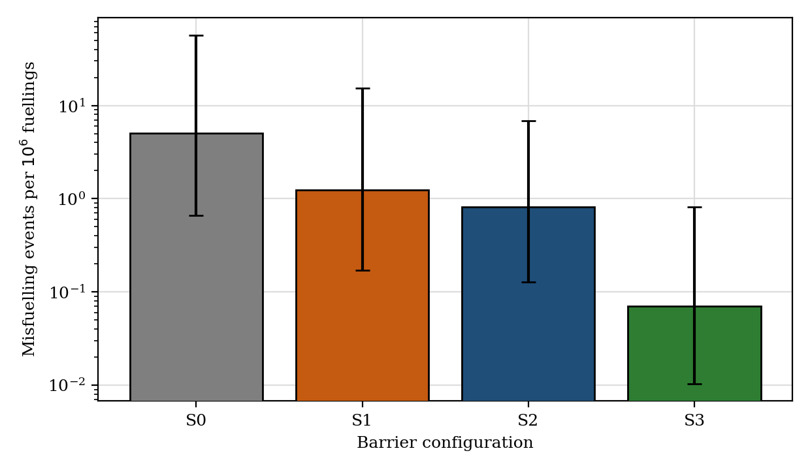
Fig. 4. Misfuelling events per 10⁶ fuellings for the four barrier configurations in a 5-vehicle fleet (median and 95% interval over 5,000 replicates, including parameter uncertainty; logarithmic axis).
With parameter uncertainty and the full dynamics (Fig. 4) the five-vehicle medians are 5.02 (0.67–56.8), 1.25 (0.17–15.3), 0.82 (0.13–6.80) and 0.071 (0.010–0.81) PMFE for S0–S3. The paired median relative risk reduction against S0 is 69% for S1 (95% interval 8–98%), 81% for S2 and 98.4% for S3 (93.7–99.8%). The S1 figure is lower than the nominal 83% because the ensemble includes bypassed vehicles, seasonal fouling and parameter uncertainty; S1 has a heavy upper tail (mean 2.87 against median 1.25 PMFE). For 60 vehicles (approximately 4.4×10⁵ fuellings per year) the median expected events per year are 2.06, 0.60, 0.37 and 0.035 for S0–S3; absolute values scale with the assumed λ₀ and should be read as relative, not predictive.

7.2 Dependence and sensor sensitivity
Across β_{cc} from 0 to 1 and a complacency multiplier of 1 to 10 (Fig. 5), the nominal hazard reduction of S1 remains between 76% and 83%, and that of S3 between 97.4% and 99.1%. The lower end of each range is the fully dependent case, which by the Fréchet–Hoeffding bound is the worst case for any positive dependence between the barriers; the claimed improvement therefore survives the extremes, although its magnitude falls with dependence. Complacency matters little because the interlock’s pass probability π is already far below the administrative miss m, so the interlock, not the check, controls the joint probability.
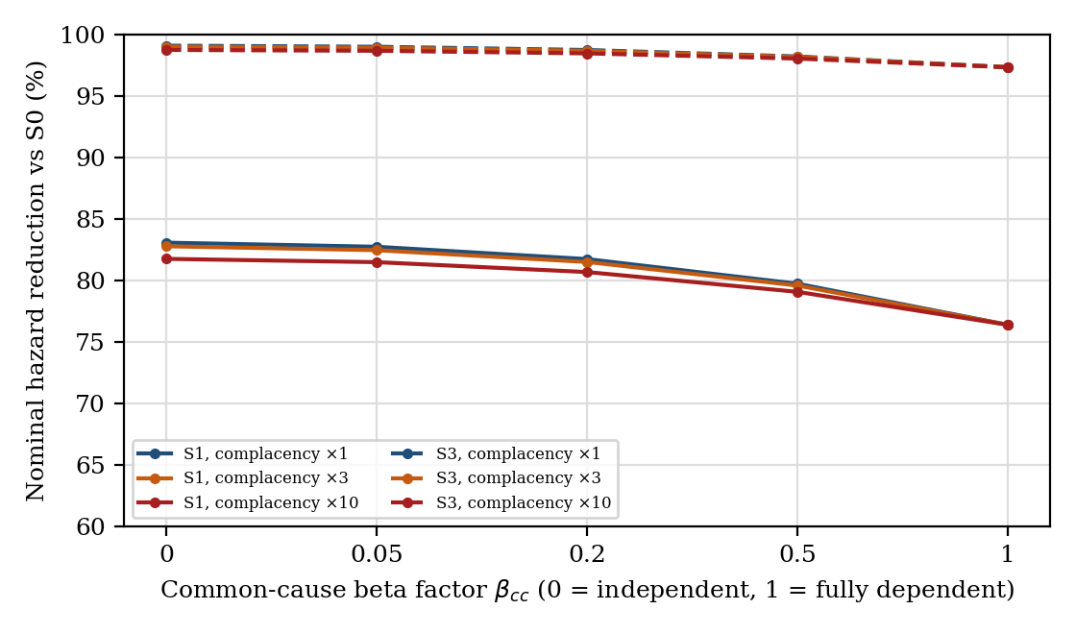
Fig. 5. Nominal hazard reduction relative to S0 against the common-cause beta factor, for complacency multipliers of 1, 3 and 10 (S1 solid, S3 dashed).
The product sensor drives S3’s advantage over S1. With the sensor absent (δ = 0) S3 reduces the nominal hazard by 83.1%; with δ = 0.5, 0.8, 0.9, 0.95 and 0.99 the reduction is 91.5, 96.5, 98.2, 99.0 and 99.7%. Even a modest sensor removes much of the loading-error residual, but a false-veto probability of 0.002 increases the nuisance rate by that amount and must be weighed against the operational burden (Section 7.6).

7.3 Barrier compromise, hysteresis and robustness of the bistability result
The nominal control group is ρ = 15.0 for S1, only 1.3 times the upper edge of the default bistable window, whereas S2 and S3 sit at ρ = 193 and 419 (Fig. 6).
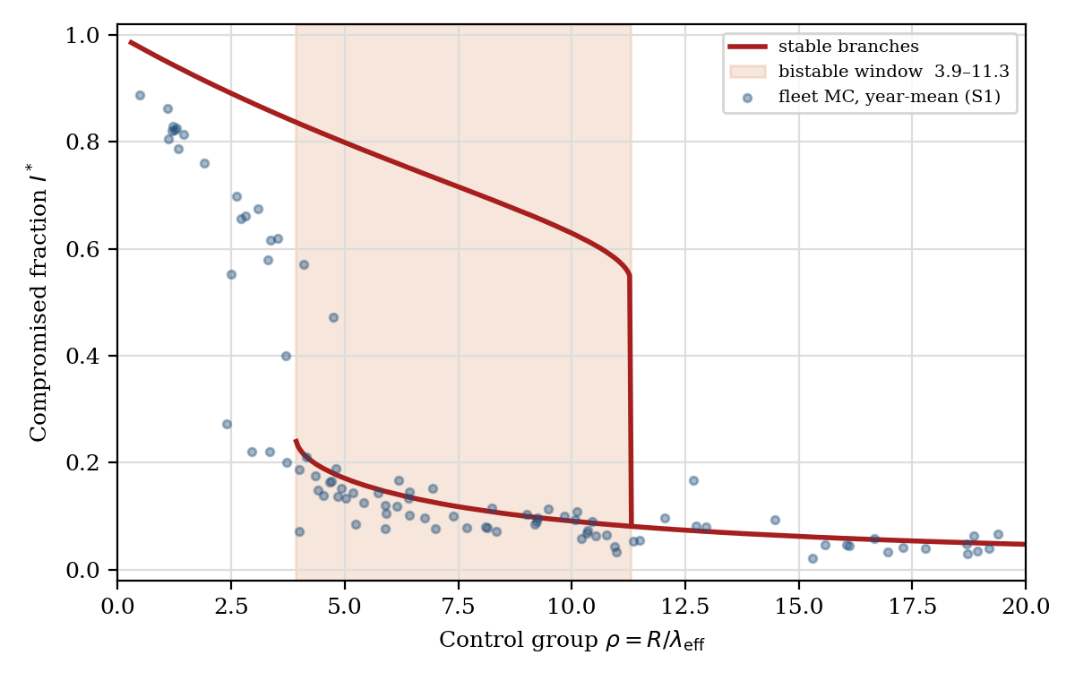
Fig. 6. Steady compromised fraction I* against ρ from the mean-field equation (5) with the default feedback parameters, bistable window shaded; points are year-mean compromised fractions from 60-vehicle Monte Carlo runs for S1.
Shock response. A 60-day shock multiplying the tag-unreadable probability by four was imposed on 20-vehicle fleets (Fig. 7). Under S1, 19.7% (18.6–20.8) of 5,000 replicates collapsed; under S2 0.1% (0.1–0.3) and under S3 0.0% (0.0–0.1). A pilot in benign conditions would therefore overstate the long-run integrity of S1.
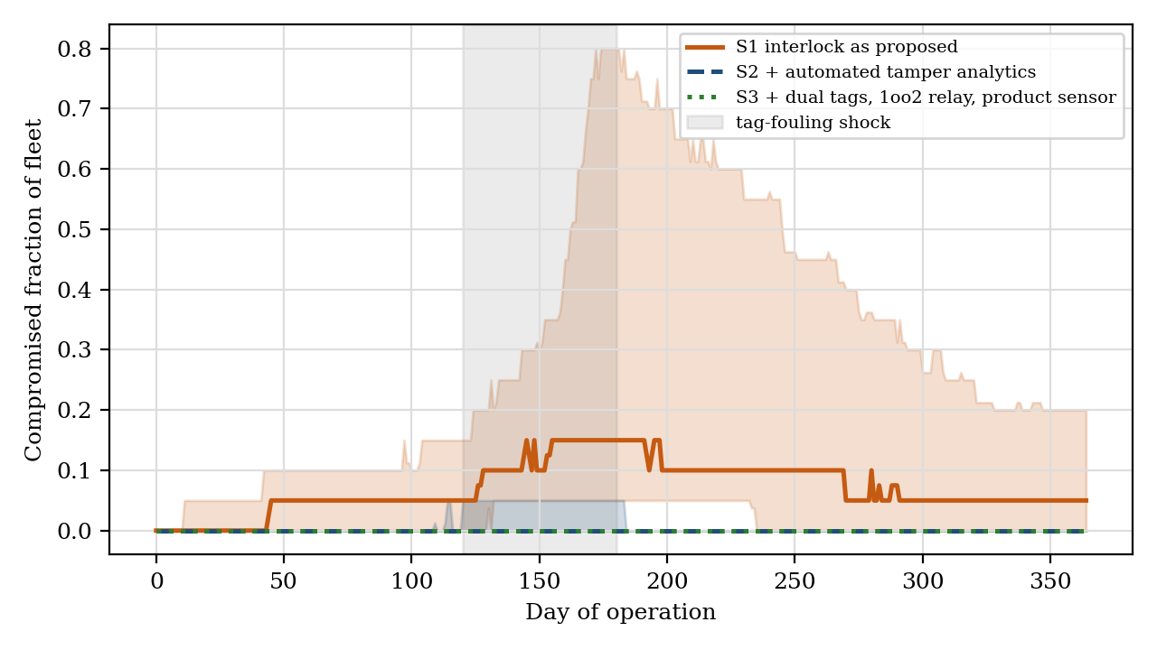
Fig. 7. Compromised fraction of a 20-vehicle fleet through the tag-fouling shock (median and inter-quartile range; 200 of the 5,000 replicates per configuration are plotted).
Is the collapse an artefact of the borrowed parameters? Part of it is, and the experiments say how much. The width of the mean-field bistable window depends strongly on the feedback (Fig. 8, left): in the grid explored (β_{c} from 2 to 40, h from 1 to 10) bistability occurs in 67% of the cells, never for h = 1, and for h = 6 requires β_{c} of at least 4. Bistability therefore requires cooperative, threshold-like peer feedback; with weak or graded feedback the compromised fraction responds smoothly and there is no hysteresis. The Monte Carlo collapse probability under shock (Fig. 8, right) increases with feedback strength and, much more steeply, with the restoration time T_{d}; the dashed curve marks where ρ equals the upper edge of the bistable window for each β_{c}.
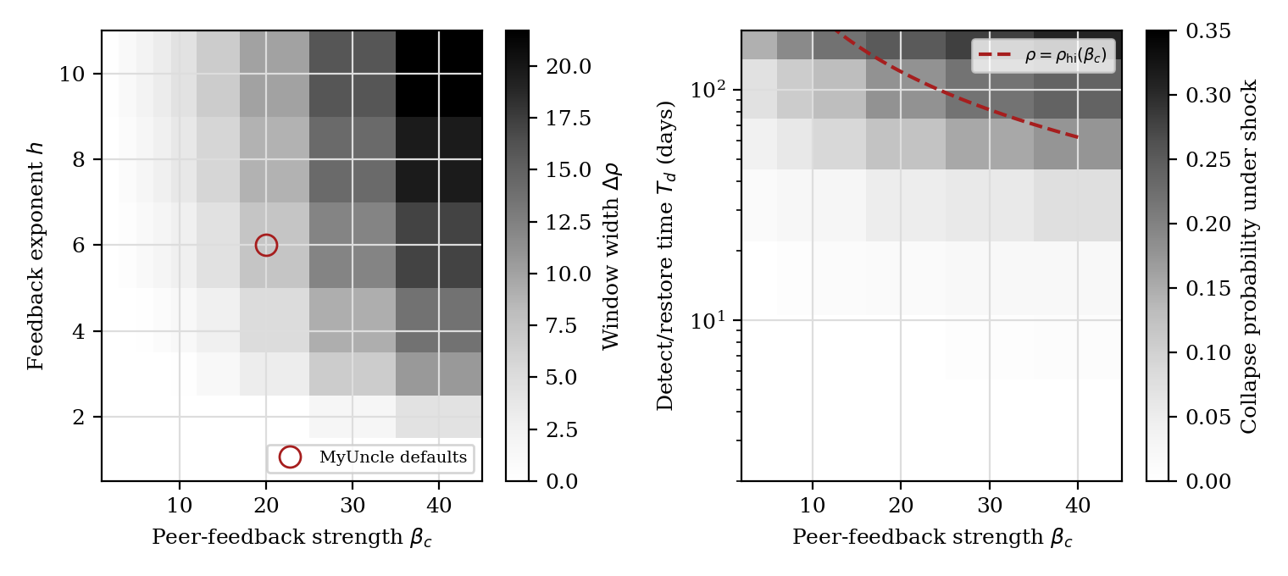
Fig. 8. Left: width of the mean-field bistable window over feedback strength β_{c} and exponent h (K = 0.5). Right: Monte Carlo collapse probability for 20-vehicle S1 fleets under the shock, over β_{c} and restoration time T_{d}, with the curve ρ = ρ_{hi}(β_{c}).
The attribution runs (shock scenario, 20 vehicles, 5,000 replicates each) show that the collapse in S1 depends on both ingredients: S1 as specified gives 19.7% (18.6–20.8); removing peer feedback (β_{c} = 0) reduces it to 1.9% (1.5–2.3); shortening restoration to 7 days with feedback retained gives 0.1% (0.1–0.3); removing both gives 0.0% (0.0–0.1). The robust conclusion is therefore that fast detection of bypass prevents collapse across the whole explored parameter range, whereas the severity of collapse without it is set by feedback parameters that have not been measured.

7.4 Convergence, uncertainty separation and prior robustness
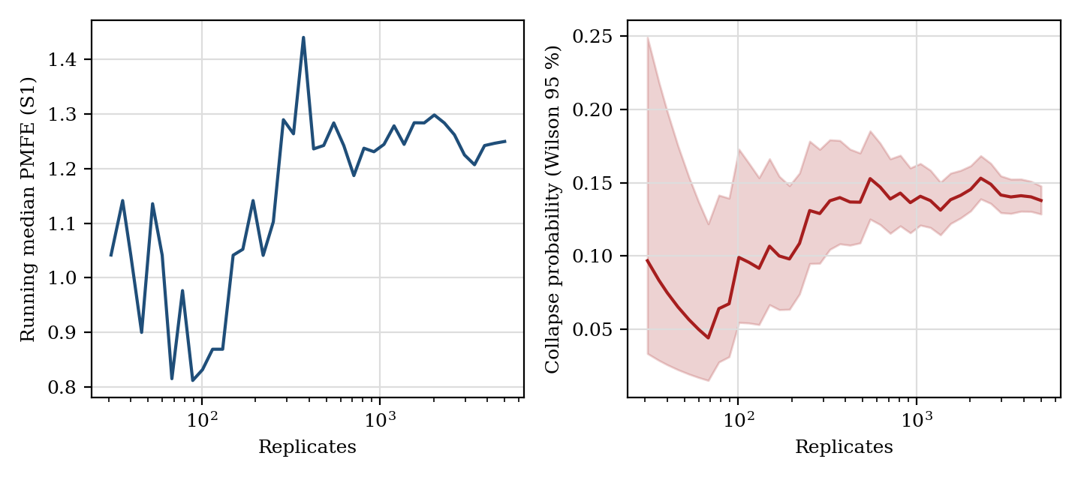
Fig. 9. Convergence of the S1 running median PMFE (left) and of the collapse probability with Wilson 95% intervals (right) over the 5,000 pilot-fleet replicates.
The running median and collapse probability stabilise after approximately 10³ replicates (Fig. 9); at 5,000 replicates the Wilson interval for S1’s collapse probability in the pilot scenario is 12.9–14.8% (Table 4). Parameter uncertainty accounts for 87–100% of the variance of log₁₀ PMFE; fleet-to-fleet variability at fixed parameters is a minor contributor, so the width of the intervals in Fig. 4 is dominated by what is not known about the inputs and can be reduced only by data. Table 6 shows that the conclusions are not an artefact of the log-normal prior family.
Table 6. Prior robustness (2,500 replicates each; paired median relative risk reduction against S0, and S1 collapse probability in the pilot scenario).
Prior family | S1 reduction | S3 reduction | S1 collapse
lognormal (baseline) | 71% (5–98) | 98.4% (94.1–99.8) | 12.7%
wider priors (GSD^1.5) | 56% (1–99) | 97.5% (81.5–99.9) | 22.5%
log-uniform, same SD | 69% (6–98) | 98.4% (94.3–99.8) | 13.2%

7.5 Fault-injection results
Table 7 gives the proportion of injected dangerous scenarios that yield an unsafe permit. With all defences off, 88.9% of the pooled scenarios yield an unsafe permit; with the full controller, 4.5%. The structural categories – stale record, communications loss, unauthorised override and power interruption – give zero unsafe permits with the defences present and are fully unsafe or partly unsafe when the relevant defence is removed, so each defence is necessary for its category. The remaining residual lies in categories whose outcome depends on a detector that is itself imperfect: a wrong requirement in the record (20.1%, set by the assumed efficacy of the second-source cross-check), a wrong aircraft scan (9.9%), sensor misclassification, a stuck-permit software fault and a welded relay. For these categories the campaign propagates assumed efficacies rather than measuring them; it shows that no single defence removal is benign and where the residual sits, and it does not replace hardware testing or certification.
Table 7. Virtual fault-injection results: proportion of injected dangerous scenarios that yield an unsafe permit (20,000 per category; Wilson 95% intervals).
Category (injected) | Defence | All defences off | Full controller | Defence removed
Wrong requirement in record | registry xcheck | 100.0% | 20.1% (19.6–20.7) | 100.0%
Stale record | stale limit | 100.0% | 0.0% (0.0–0.0) | 100.0%
Communications loss (cache) | stale limit | 100.0% | 0.0% (0.0–0.0) | 100.0%
Wrong aircraft scanned | stand check | 100.0% | 9.9% (9.5–10.3) | 100.0%
Sensor misclassification | sensor | 100.0% | 4.7% (4.4–5.0) | 100.0%
Relay welded closed | relay feedback | 100.0% | 1.0% (0.9–1.1) | 100.0%
Stuck-permit software fault | diverse check | 100.0% | 4.8% (4.6–5.2) | 100.0%
Power interruption | (fail-safe) | 0.0% | 0.0% (0.0–0.0) | 0.0%
Unauthorised override | two factor | 100.0% | 0.0% (0.0–0.0) | 49.7%
All categories pooled |  | 88.9% | 4.5% (4.4–4.6) | —

7.6 Sensitivity and operational burden
Partial rank correlation (Fig. 10) identifies the depot-loading error probability as the dominant driver of S1’s misfuelling rate (PRCC 0.74), followed by the attempt probability (0.48), the defeat propensity ν (0.50), the administrative miss (0.42) and the tag-fouling slope (0.25)^{(18,19)}. Relay failure rate and software fault probability matter comparatively little at the assumed levels, which argues for effort on data integrity and tamper detection before relay redundancy. Operationally (Fig. 11), S1 and S2 block 2.1% of fuellings for tag or data reasons (95% interval 0.9–5.8%), adding a mean of 2.1 s per fuelling and delaying 0.23% of fuellings by more than five minutes; dual tags in S3 reduce the figures to 0.9% and 0.9 s even with the sensor’s false-veto allowance.
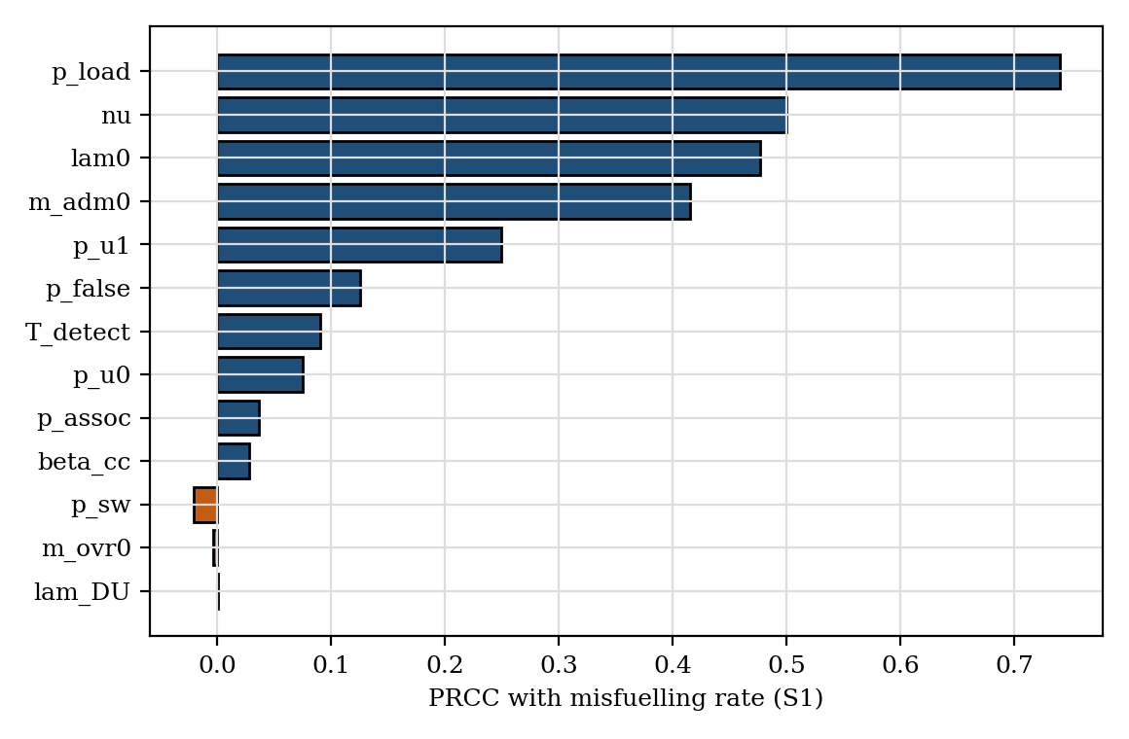
Fig. 10. Partial rank correlation coefficients between uncertain inputs and the misfuelling rate of configuration S1.
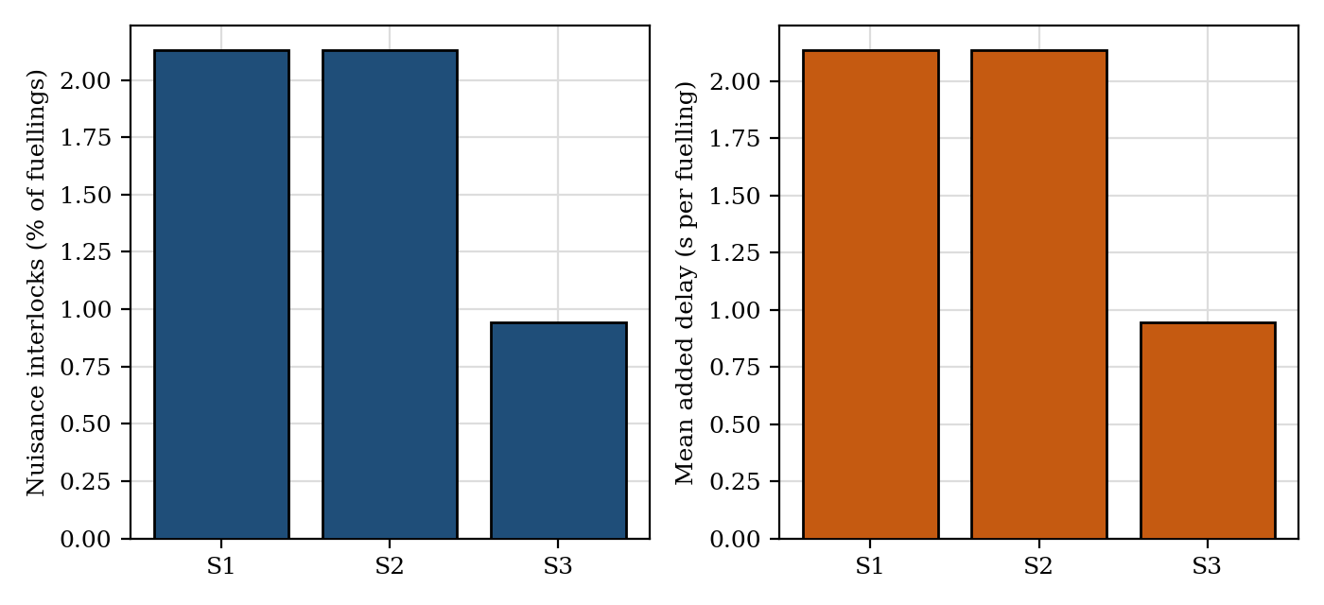
Fig. 11. Operational burden: fraction of fuellings blocked (left) and mean added delay per fuelling (right), median over replicates.

8.0 OPERATIONAL VERIFICATION
The concept envisaged a twelve-month programme: engineering and bench integration, installation on five vehicles and one fixed dispenser with a local contractor, data review, then wider rollout. The model shows why this must be framed as a verification programme. With the nominal attempt probability a five-vehicle pilot of 120 days (approximately 12,000 fuellings) expects 1.7 real wrong-product attempts and has a probability 0.81 of seeing at least one (Fig. 12, left); a real misfuelling will almost certainly not occur, so hazard reduction cannot be shown directly.
Three measures are proposed instead. First, seeded-mismatch drills: supervised presentation of incompatible product–aircraft pairs. If all n drills are blocked, the one-sided 95% upper bound on the pass probability is 1 − 0.05^{1/n} ≈ 3/n, so 299 consecutive successes support a claim of at most 1% and 2995 support 0.1% (Fig. 12, right). Drills measure the detection chain, not behaviour under pressure, and should be interleaved with unannounced drills. Second, leading indicators: nuisance-block rate, override count and latency, tag-read success by weather, and the divergence between relay-state telemetry and scan records, the observable signature of bypass. Third, stress exposure: the pilot should include a fouling or icing period, or an induced equivalent, because Section 7.3 shows that compromise is triggered by transients. The fault-injection campaign of Section 7.5 should be re-run on the real controller software as hardware-in-the-loop tests, with the assumed detector efficacies replaced by measured ones.
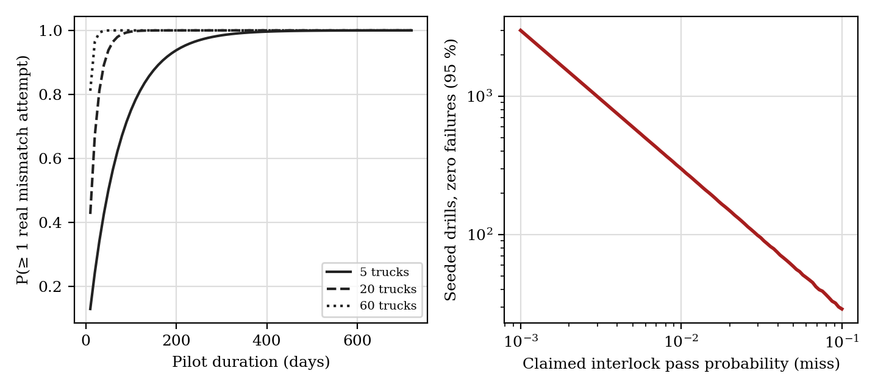
Fig. 12. Left: probability that a pilot observes at least one real wrong-product attempt, by duration and fleet size. Right: seeded drills with zero failures needed to demonstrate a given miss probability at 95% confidence.

9.0 ECONOMICS
An unsafe delivery – a wrong product reaching an aircraft – is not the same as an accident or a hull loss. Writing E for fuellings per vehicle-year, Δh for the hazard reduction per fuelling, C_{a} for annualised cost per vehicle and κ for the probability that an unsafe delivery becomes an accident, the interlock is justified when Δh·E·C_{unsafe} > C_{a}, equivalently Δh·E·κ·C_{acc} > C_{a}. The break-even consequence cost per unsafe delivery is C* = C_{a}/(Δh·E), and per accident C*/κ. The TSB record of 21 jet-for-avgas deliveries, of which only two were detected before departure and 19 ended in a crash or forced landing⁽⁴⁾, suggests κ close to one for that particular mismatch, but κ may be much lower for other product errors, so it is treated as a free parameter.
Annualised cost uses the concept’s indicative figures (the author’s unvalidated estimates): hardware US$1,200–1,800 per vehicle for S1 over seven years, plus 10% of hardware cost per year for installation and maintenance, US$50–100 per vehicle-month for connectivity and hosting, and a one-time software effort of US$35,000–45,000 amortised over the fleet and five years. For S3 the hardware cost (US$5,000–12,000 per vehicle, mostly the inline sensor) is an assumption, and US$150 per vehicle-year is added for calibration. At nominal values and 60 vehicles, C_{a} is US$1398 (S1) and US$3126 (S3) per vehicle-year, and US$2864 and US$4593 for a five-vehicle pilot.
Table 8. Break-even consequence cost per unsafe delivery, C* (US$ thousand), for a 60-vehicle fleet, one input varied at a time from the nominal case (E = 7,300 fuellings per vehicle-year, f = 1, nominal costs).
Input varied | S1 | S3
Nominal | 65 | 121
Fuellings per vehicle-year 3,650 | 129 | 242
Fuellings per vehicle-year 14,600 | 32 | 60
Hardware 1,200 (S1) / 5,000 (S3) | 61 | 93
Hardware 1,800 (S1) / 12,000 (S3) | 68 | 158
Hosting US$50 / month, software US$35 k | 50 | 109
Hosting US$100 / month, software US$45 k | 79 | 133
Error propensity f = 0.3 (unsafe-delivery probability ×0.3) | 216 | 403
Error propensity f = 3 (×3) | 22 | 40
Nominal, per accident with κ = 0.5 | 129 | 242
Nominal, per accident with κ = 0.1 | 647 | 1208

Rather than a single threshold, Fig. 13 shows the break-even frontier over error propensity and exposure: the interlock pays for itself wherever the consequence cost per unsafe delivery exceeds the contour value. At nominal values this is approximately US$65 000 for S1 and US$121 000 for S3, well below the cost of a hull loss, but the value moves by an order of magnitude over the plausible range of f and E (Table 8), and it inherits the unvalidated calibration of λ₀ and p_{L}. The incremental case for S3 over S1 is weaker: its added cost is justified only where the consequence cost per unsafe delivery exceeds approximately US$406 000 at nominal exposure. The economic analysis should therefore be read as showing where the decision is sensitive, not as a business case.
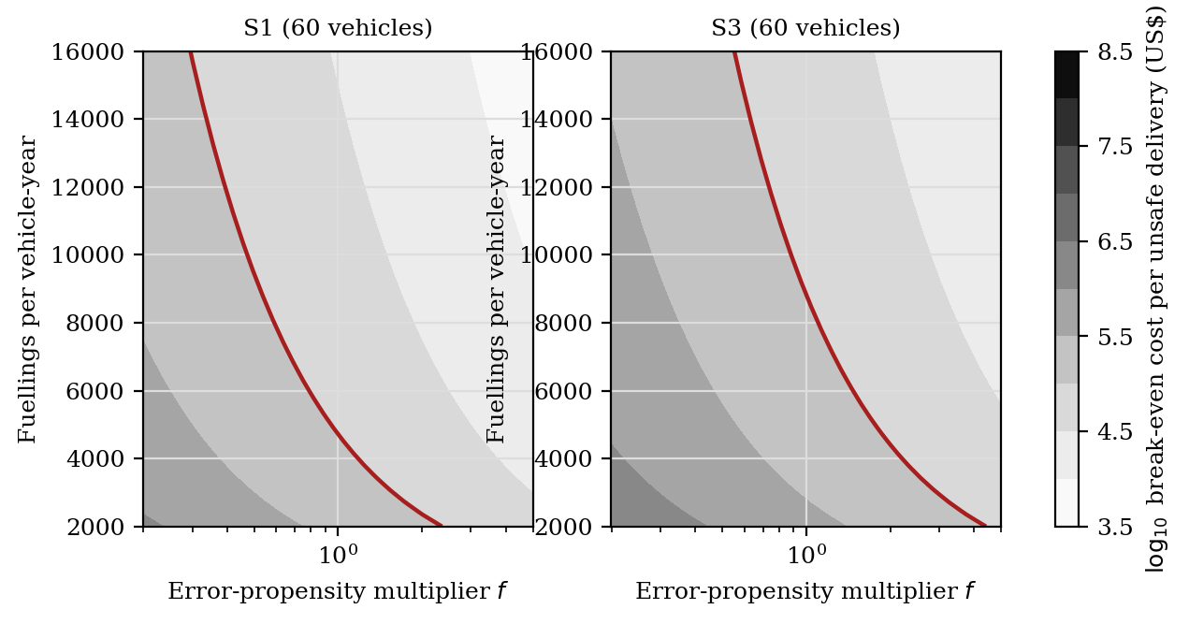
Fig. 13. Break-even consequence cost per unsafe delivery (log₁₀ US$) over the error-propensity multiplier f (applied to λ₀ and p_{L}) and fuellings per vehicle-year, for S1 and S3 in a 60-vehicle fleet. The red contour is US$10⁵.

10.0 DISCUSSION AND LIMITATIONS
The headline claim must be tempered. A permissive interlock does not eliminate misfuelling: it converts a single-barrier human process into a layered defence whose residual risk is dominated by what the barrier cannot observe (the true contents of the tank) and by what people do to it (bypass). The most useful design conclusions concern product verification at the point of delivery, data integrity in the aircraft records, and making tampering visible quickly, rather than the scanner or the relay.
Model-conditional results. No field data underlie the priors, and no hardware has been built or tested. Absolute event rates scale with the assumed attempt probability; the relative comparisons depend on the independence structure, on the Hill form and strength of the peer feedback, and on a constant nuisance-to-defeat conversion. The robustness experiments bound several of these – the dependence structure (Section 7.2), the prior family (Section 7.4) and the feedback parameters (Section 7.3) – but cannot replace measurement, which is the purpose of the pilot’s leading indicators. The fault-injection campaign tests logic, not hardware, and not the detector efficacies it assumes.
Scope and generalisability. The model addresses product mismatch only; over-fuelling, water and particulate contamination, hose misconnection and fuel-quantity errors are not covered. The interlock cannot prevent an operator from fuelling an aircraft other than the one scanned; the association term and the stand check only partly represent this. Visiting aircraft without tags need a policy decision, since blocking them may be operationally unacceptable while permitting them reintroduces the hazard. The barrier-degradation framework itself – a protective device whose use erodes through nuisance and peer behaviour, and which is restored by detection – applies to other ground-operations interlocks and is the portion most likely to generalise.
Certification and safety assurance. The quantitative analysis does not constitute a safety case. A safety case must establish the claimed integrity level under IEC 61508⁽¹⁰⁾, the hazardous-area suitability of every item⁽¹¹⁾, the behaviour on loss of power and under electrical transients on the vehicle, cybersecurity of the tags, records and credentials, and the human-factors implications of the override process.

11.0 CONCLUSIONS
Under the assumed parameters, a fail-safe, registration-keyed permissive interlock reduces the nominal wrong-product hazard by approximately 83% as first conceived and by approximately 99% with redundant tags, tamper analytics and an inline product sensor. These are model-conditional estimates. The reduction is finite, because most of the residual lies in product that differs from the vehicle’s records, and it is fragile in the sense that the barrier itself can degrade: after a transient fouling episode 19.7% of simulated 20-vehicle fleets with a 90-day audit collapse into a bypassed state, whereas fast detection of bypass removes the effect across the explored parameter range. The existence of hysteresis depends on threshold-like peer feedback that has not been measured, so the strength of the result is in the role of restoration time rather than in the feedback values. A pilot cannot observe the hazard directly; seeded drills, leading indicators and a deliberate stress period are proposed instead, and the logic-level fault-injection campaign should be repeated on the real controller. The next step is to replace the assumed priors by observed rates from an operational pilot.

DECLARATIONS
Data and code availability. The simulation (interlock_mc.py), test suite, scripts and results file are openly available at https://github.com/sandlerleon/misfuelling-interlock-mc and are archived at Zenodo, doi:10.5281/zenodo.23861809 (software, all versions); this manuscript is archived as a preprint at doi:10.5281/zenodo.23861807 (all versions). All numerical results and figures are regenerated from the master seed by one command; software versions are recorded in the results file. The MyUncle framework on which the structure is modelled is archived at doi:10.5281/zenodo.21223570⁽⁷⁾.
Competing interests. The author declares no competing interests.
Funding. This research received no specific funding.
Provenance. An earlier, non-peer-reviewed, ideation-stage description of the interlock concept was submitted to an open-innovation challenge (ID 144204). The present paper adds the safety-assurance analysis, the probabilistic framework, the simulation code and all results.
Use of generative AI. A generative AI assistant (Claude, Anthropic) was used to help develop the simulation code and tests, to run the analyses, and to draft and revise the manuscript text and figures. The author specified the research questions, reviewed and edited all content, checked the outputs, and takes full responsibility for the work.

REFERENCES
(1) NATIONAL TRANSPORTATION SAFETY BOARD. Safety recommendation A-86-135 (aircraft misfuelling; fuel filler port restrictors), 1986, Washington DC, USA.
(2) NATIONAL TRANSPORTATION SAFETY BOARD. Safety Alert SA-051: Line personnel – fueling matters; prevent misfueling through standardized procedures for every aircraft, March 2016, Washington DC, USA.
(3) NATIONAL TRANSPORTATION SAFETY BOARD. Preliminary report on the Cessna 421C (N51RX) accident at Las Cruces, New Mexico, 27 August 2014, 2014, Washington DC, USA.
(4) TRANSPORTATION SAFETY BOARD OF CANADA. Aviation Investigation Report A15C0134: Incorrect fuel type and forced landing, Keystone Air Service Ltd., Piper PA-31-350, C-FXLO, Thompson, Manitoba, 15 September 2015, 2016, Gatineau, Canada (published 6 September 2016).
(5) REASON, J. Human Error, 1990, Cambridge University Press, Cambridge, UK.
(6) REASON, J. Human error: models and management, BMJ, 2000, 320, (7237), pp 768–770.
(7) SANDLER, L. MyUncle: a compact maintenance-lattice framework for order-persistence simulations across disciplines (v1.0.0), 2026, Zenodo, doi:10.5281/zenodo.21223570.
(8) JOINT INSPECTION GROUP. JIG 1: Aviation fuel quality control and operating standards for into-plane fuelling services, Issue 13, September 2021, London, UK.
(9) NATIONAL FIRE PROTECTION ASSOCIATION. NFPA 407: Standard for aircraft fuel servicing, 2022 edition, Quincy, USA.
(10) INTERNATIONAL ELECTROTECHNICAL COMMISSION. IEC 61508: Functional safety of electrical/electronic/programmable electronic safety-related systems, 2nd ed, 2010, Geneva, Switzerland.
(11) INTERNATIONAL ELECTROTECHNICAL COMMISSION. IEC 60079 series: Explosive atmospheres, Geneva, Switzerland; and EUROPEAN PARLIAMENT AND COUNCIL. Directive 2014/34/EU on equipment and protective systems intended for use in potentially explosive atmospheres, 2014.
(12) WYLIE, E.B. and STREETER, V.L. Fluid Transients in Systems, 1993, Prentice Hall, Englewood Cliffs, USA.
(13) VAUGHAN, D. The Challenger Launch Decision: Risky Technology, Culture, and Deviance at NASA, 1996, University of Chicago Press, Chicago, USA.
(14) SWAIN, A.D. and GUTTMANN, H.E. Handbook of Human Reliability Analysis with Emphasis on Nuclear Power Plant Applications, NUREG/CR-1278, 1983, US Nuclear Regulatory Commission, Washington DC, USA.
(15) KIRWAN, B. A Guide to Practical Human Reliability Assessment, 1994, Taylor & Francis, London, UK.
(16) RAUSAND, M. and HØYLAND, A. System Reliability Theory: Models, Statistical Methods, and Applications, 2nd ed, 2004, Wiley, Hoboken, USA.
(17) NELSEN, R.B. An Introduction to Copulas, 2nd ed, 2006, Springer, New York, USA.
(18) MARINO, S., HOGUE, I.B., RAY, C.J. and KIRSCHNER, D.E. A methodology for performing global uncertainty and sensitivity analysis in systems biology, J Theor Biol, 2008, 254, (1), pp 178–196.
(19) SALTELLI, A., RATTO, M., ANDRES, T., CAMPOLONGO, F., CARIBONI, J., GATELLI, D., SAISANA, M. and TARANTOLA, S. Global Sensitivity Analysis: The Primer, 2008, Wiley, Chichester, UK.
(20) WILSON, E.B. Probable inference, the law of succession, and statistical inference, J Am Stat Assoc, 1927, 22, (158), pp 209–212.

