Targeting Neuroimmune Interfaces in Depression with Engineered Autologous Immune Cells: A Falsifiable Preclinical Framework
Leon Sandler
Independent Researcher, Northbrook, IL, USA • sandler.leon@gmail.com
Highlights
- Proposes engineered autologous immune cells as an immunotherapy design paradigm directed at CNS border interfaces rather than at the brain parenchyma.
- Places the meningeal–dural sinus and choroid–plexus compartments, not the parenchymal blood–brain barrier, at the mechanistic center of the framework.
- Specifies the receptor–ligand cascades (IL-10R/STAT3 and TGF-βR/SMAD2/3) through which a locally delivered payload acts on border-associated macrophages and microglia.
- Replaces an unsupported claim of a shared signature across four depression phenotypes with a testable claim about partially overlapping immune states in biologically defined subgroups.
- Defines a preclinical program in which immune mechanism is primary and behavior secondary, with eight falsification criteria, including criteria under which immune-state matching would increase rather than reduce risk.
Ethical Statement
This is a conceptual hypothesis paper. No experimental data, engineered construct, or human intervention is reported, and the approach described has not been tested in any organism. Nothing here constitutes a therapeutic recommendation. Depression is associated with a serious risk of self-harm, and nothing in this paper should delay or substitute for established care. Any future translational development would require extensive preclinical safety, ethical, and regulatory evaluation, as discussed in Section 8.
Abstract
Peripheral immune dysregulation is an established feature of a biologically identifiable subset of depression, yet immunological interventions in psychiatry remain confined to systemic anticytokine pharmacology, which is distributed indiscriminately and has produced benefits only in biomarker-selected patients. We propose a different design paradigm: engineered autologous immune cells directed not at the brain parenchyma but at the CNS border compartments — the meningeal and dural sinus spaces and the choroid plexus — where endogenous immune cells are already known to modulate mood-relevant and cognition-relevant circuits without crossing the parenchymal blood–brain barrier. We set out the immunological mechanism such a framework requires: the cellular targets at each interface (border-associated macrophages, meningeal T-cell populations, choroid-plexus epithelium), the receptor–ligand cascades through which a locally secreted payload would act (IL-10R→JAK1/TYK2→STAT3 suppression of NF-κB-driven transcription; TGF-βR→SMAD2/3 maintenance of the microglial homeostatic signature), and the synthetic-biology controls (inducible expression, safety switches) that locality and dose control would demand. We treat four depression-associated phenotypes—postpartum, chronic treatment-resistant, postdeployment, and perimenopausal—not as sharing one common signature, a claim no cross-phenotype study supports, but as test cases for whether partially overlapping immune states can be identified and manipulated. We present a mechanistic evidence chain with explicit evidence status for each link, a tiered payload architecture separating established from exploratory engineering targets, and a preclinical program in which trafficking and immune-state end points are primary and behavioral end points secondary. Eight falsification criteria are specified, including conditions under which immune-state matching would be shown to increase immunological risk.
Keywords
neuroimmunology; meningeal immunity; choroid plexus; border-associated macrophages; engineered cell therapy; regulatory T cells; IL-10; TGF-β; depression; neuroinflammation; CAR-T; immune-state matching
1. Introduction
1.1 An immune engineering problem posed by a psychiatric phenotype
The hypothesis that immune signaling contributes causally to depressive phenotypes is no longer controversial. Peripheral inflammatory markers are elevated in a substantial minority of patients with major depressive disorder [1,2], and experimentally administered inflammatory cytokines reliably induce depressive-like states in humans and animals [3,4], and positron emission tomography has been used to demonstrate microglial activation in patients with depression [5]. What has not followed is a correspondingly sophisticated intervention. Systemic anticytokine biologics borrowed from rheumatology, which are distributed indiscriminately and suppress immunity body wide, have shown benefits only when patients are preselected on inflammatory biomarkers—most clearly in the C-reactive-protein-stratified infliximab trial, where the unstratified result was null and the high-CRP subgroup improved [6]. The field's own reviews now frame this explicitly as a precision-medicine problem — identifying which patients have an immune phenotype worth targeting — rather than as a search for a universal anti-inflammatory antidepressant [7].
This paper asks an engineering question rather than a psychiatric one: if the relevant immune signaling is regionally organized and the therapeutically relevant compartment is a specific immunological niche, what would it take to develop a cell-based intervention that acts there rather than everywhere? The answer we developed borrows its manufacturing paradigm from chimeric antigen receptor (CAR) T-cell therapy and its mechanistic target from the past decade of border-immunology research, and it treats the psychiatric phenotype as downstream of a primary immunological question.
1.2 Why the CNS borders rather than the parenchyma
A naive version of an immune-cell intervention for depression would engineer cells to produce a monoamine — dopamine, for example — on the assumption that peripheral production could raise central tone. This does not work, and the reason is instructive. Dopamine does not cross the blood–brain barrier in physiologically meaningful quantities, which is why Parkinson's disease is treated with the precursor L-DOPA rather than with dopamine itself; peripheral catecholamine production, including the genuine but small quantities that immune cells themselves synthesize [8–10], has no established route to central dopaminergic circuits. Any credible immune cell intervention must therefore act through immune signaling, not neurotransmitter delivery.
The productive consequence of that constraint is that it points to the CNS borders. The dura, leptomeninges, dural venous sinuses, perivascular spaces, and choroid plexus host resident and trafficking immune populations that are anatomically outside the parenchymal barrier yet are functionally coupled to the brain [11–16]. Cytokines produced by cells in these compartments have demonstrable, circuit-specific behavioral consequences in mice: meningeal T-cell-derived interferon-γ is required for normal social behavior through effects on cortical inhibitory circuits [17], meningeal interleukin-4 supports learning and memory [18], and interleukin-17 from meningeal γδ T cells modulates anxiety-like behavior [19]. These findings demonstrate that an interface-to-circuit link exists. The present framework asks whether it can be engineered.
1.3 Scope and approach
This is a hypothesis paper. No construct has been constructed, and no animal or human studies have been performed. Its contribution is (i) to specify, at the receptor and pathway level, the immunological mechanism an interface-directed engineered-cell intervention would require (Section 2); (ii) to set out the evidence base and its limits with explicit evidence status for each link in the chain (Sections 3–4); (iii) to define what immune-state matching means as a testable proposition rather than an aspiration (Section 5); and (iv) to specify a preclinical program, with controls and falsification criteria, capable of refuting it (Section 7). We restrict the primary hypothesis to immune-state modulation, for which the supporting biology is strongest, and treat engineered dopaminergic signaling as a separate, substantially less validated extension that should not be assumed to succeed or fail on the same evidence.
2. Neuroimmune Mechanism and Safety Architecture
This section is the center of the paper. The question an immunology reviewer will ask is not whether engineered cells could improve a behavioral score but what specifically happens to the immune system at a defined anatomical interface, through which receptors, on which cell populations, with what local versus systemic consequences. Every subsequent section is organized around the steps described here.
2.1 The border compartments as the proposed site of action
The CNS is not immunologically isolated; it is immunologically compartmentalized. The dural sinuses function as a neuroimmune hub where antigen-presenting cells and lymphocytes sample cerebrospinal fluid-derived material [13]. Meningeal lymphatic vessels drain macromolecules and immune cells from the CSF to deep cervical lymph nodes [11,12,20]. Skull and vertebral bone marrow supplies myeloid cells to the meninges through direct osseous channels, a route anatomically distinct from the peripheral circulation [14,21]. Single-cell atlases have resolved the resident populations of these niches—border-associated macrophages of the dura, subdural meninges, and perivascular space—each with ontogeny and transcriptional signatures distinct from those of parenchymal microglia [15,22–25], including a resident meningeal B-cell compartment supported by a local lymphopoietic niche [24,25]. Anatomical work has continued to revise this picture recently, identifying an additional mesothelial membrane subdividing the subarachnoid space [26] and direct channels connecting the dura to the brain [27]. In parallel, the choroid plexus operates as a regulatory gateway whose epithelial trafficking signals and cytokine output change with age and inflammatory state and influence hippocampal function [28–31].
The design consequence is that a cell delivered into the circulation does not need to cross the parenchymal blood–brain barrier to reach a compartment from which CNS-relevant signaling occurs. This is the single structural reason the present framework is worth considering.
2.2 The proposed payload–receptor cascades
Specifying the intended signaling is necessary for the hypothesis to be evaluable. Two cascades form the Tier 1 proposal (Section 5.3).
Interleukin-10. IL-10 secreted locally can engage the IL-10RA/IL-10RB heterodimeric receptor expressed on border-associated macrophages and microglia, activating JAK1/TYK2 and phosphorylating STAT3, which induces SOCS3 and transcriptionally suppresses the NF-κB-driven production of TNF, IL-1β, and IL-6 [32,33]. The intended effect is a reduction in local pro-inflammatory tone at the interface, not systemic immunosuppression — the distinction on which the entire safety argument rests.
Transforming growth factor-β. TGF-β1 engages TGFβRII/TGFβRI (ALK5) and signals through SMAD2/3. TGF-β is required for the establishment and maintenance of the microglial homeostatic transcriptional signature [34,35]; therefore, the intended effect involves not only the suppression of inflammatory output but also the active support of a homeostatic microglial state.
The contrasting case is instructive. Interferon-γ acts through IFNγR1/2 and JAK1/JAK2–STAT1 on meningeal T cells and downstream circuits and is the best-characterized example of an interface cytokine with a demonstrated, circuit-specific behavioral consequence [17]. It establishes that coupling exists; it is not proposed as a payload because its behavioral effect is directionally inappropriate here and its inflammatory profile is the opposite of the intended one.
The rationale for cell-based rather than pharmacological delivery follows directly from these cascades. Systemic administration of recombinant IL-10 has unfavorable pharmacokinetics, requires sustained high doses to reach tissue concentrations, and produces dose-limiting systemic immunosuppression; a cell that localizes to a niche and secretes continuously at low output is a fundamentally different pharmacological object. Whether that difference is sufficient is an empirical question, and Section 7.2 specifies a systemic-cytokine comparator arm precisely to test it.
2.3 Locality and dose control as engineering requirements
Constitutive, unregulated cytokine secretion at a CNS interface would be unacceptable. The framework therefore treats three synthetic-biology components as nonnegotiable design elements rather than refinements: inducible or inflammation-responsive promoters such that payload output tracks the local inflammatory state rather than running continuously; a pharmacologically activated safety switch such as inducible caspase-9, permitting rapid ablation of the infused population; and demonstrated dose proportionality between construct expression and local cytokine concentration. None of these are speculative technologies; all are in clinical or late preclinical use in the cell therapy field [36–38].
2.4 Immune-cell dopaminergic signaling: a Tier 3 module, not a delivery route
Peripheral immune cells possess genuine catecholaminergic machinery. Human regulatory T cells express tyrosine hydroxylase and contain endogenous catecholamines that subserve in an autocrine/paracrine inhibitory loop [8]; T follicular helper cells release dopamine within germinal centers, accelerating its delivery to B cells [10]; immune cells across lineages express D1- through D5-family receptors and alter activation and cytokine output in response [9,39]. This is immunoregulation, not neurotransmission at a distance. We include engineered modulation of this axis as an exploratory third tier because it is a mechanistically plausible way to tune local immune-cell behavior at a niche, and we explicitly flag that it has the weakest supporting evidence in the framework and is the component most likely to be falsified.
2.5 How this framework could cause harm
Enumerating the mechanisms by which the proposal could produce injury is, in our view, a required part of the proposal, and each item below is designated a mandatory preclinical toxicology endpoint in Section 7, not a hypothetical aside.
- Immune effector cell-associated neurotoxicity. CAR-T-cell therapy produces a neurotoxicity syndrome mechanistically associated with endothelial activation and blood–brain barrier disruption [40,41]. A platform that deliberately positions engineered cells at CNS borders cannot treat this as an unrelated precedent; it is the closest available human safety signal.
- Cytokine release syndrome. Systemic cytokine release following engineered-cell infusion is well characterized and graded [42]. An immunoregulatory payload does not exclude this, since the infusion and expansion phases are shared.
- Loss of protective immune surveillance. Sustained suppression of inflammatory tone at CNS borders could impair immune surveillance in those compartments, with infection risk analogous in kind, although not in mechanism, to that seen with therapies that block leukocyte entry into the CNS.
- Persistence and irreversibility. A population that engrafts durably at an interface may be difficult to remove; this is the direct justification for the safety-switching requirement in Section 2.3.
- The off-target genomic consequences of editing include large deletions and rearrangements at the target locus [43,44].
3. Evidence base
3.1 Immune states associated with depression
Rather than reviewing four clinical literatures separately, we summarize the common structure. In terms of phenotypes, reproducible findings include elevated circulating IL-6, TNF, and CRP levels in a subset of patients [1,2]; an association between this elevation and poor response to monoaminergic antidepressants [6,45]; evidence of microglial activation on neuroimaging [5]; and, in animal models, a demonstrated causal role for the peripheral immune state in determining susceptibility to stress, including IL-6-dependent susceptibility to social defeat [49] and stress-induced loss of endothelial claudin-5 with consequent barrier permeability [50]. The latter is important for the present framework because it establishes that the peripheral immune state affects the physical and signaling properties of the neurovascular and border compartments themselves.
Two features of the recent literature matter specifically for the present proposal. First, the relationship is now understood as bidirectional rather than unidirectional, with inflammatory signaling and depressive states each capable of driving the other [46]. Second, and more importantly here, the field has moved away from treating inflammation in depression as a single continuum and toward resolving it into discrete, peripherally measurable subgroups—immune-cell-stratified subgroups of inflamed depression [47] and a separable immunometabolic subtype [48]. That shift is what makes the present framework tractable at all: an intervention matched to an immune state presupposes that reproducible immune states exist and can be assigned from peripheral measurement, which is precisely what this work is beginning to establish.
3.2 Comparative evidence across four depression-associated phenotypes
Table 1 compares the four phenotypes on immune evidence rather than giving each a separate narrative section. The purpose is to show that the immune associations are real in each case and that they are not obviously the same association.
Phenotype | Representative immune evidence | Candidate immune state | Evidence strength | Principal uncertainty
Postpartum | Perinatal inflammatory shift; altered regulatory T-cell dynamics [51,52] | Transient inflammatory rebound following steroid withdrawal | Moderate | Causality versus coincidence with hormone withdrawal
Chronic/treatment-resistant | Elevated IL-6, TNF, CRP; CRP-stratified infliximab response [1,2,6] | Persistent low-grade inflammatory state | Moderate–strong | Present in a subset only; substantial heterogeneity
Postdeployment (PTSD-enriched) | Meta-analytic elevation of IL-6 and CRP; prospective predeployment CRP predicts risk [53–55] | Trauma-associated inflammatory state | Moderate | Not a formal diagnostic entity; diagnostic heterogeneity
Perimenopausal | Loss of estrogen-dependent anti-inflammatory tone; sex differences in immune regulation [56,57] | Withdrawal of an endogenous immunoregulatory input | Emerging | Least direct evidence tying this to depressive phenotype specifically

The honest reading of Table 1 is that four separate immune associations exist and that their identity has not been tested. Section 5.1 states the hypothesis accordingly.
3.3 What engineered autologous cell therapy establishes and what it does not
CAR-T-cell therapy is the engineering precedent of the framework and its principal source of safety information, but the inference it licenses is narrow. Table 2 separates the two.
CAR-T establishes | CAR-T does not establish
Ex vivo genetic engineering of autologous immune cells is feasible at clinical scale and under regulatory approval [36,58,59] | That engineered cells traffic to meningeal or choroid-plexus compartments
Per-patient manufacture is achievable within disease-relevant timelines | That immune modulation at CNS borders is safe
Engineered cells expand, persist, and retain function in vivo | That persistence appropriate for oncology is appropriate for a nonmalignant indication
Engineered cells can be directed against a defined molecular target | That a cytotoxic-effector paradigm transfers to an immunoregulatory objective — the intended immunology here is the opposite
Gene-edited (CRISPR) T cells have been administered to humans [60] | That cytokine output can be tuned, localized, and reversed to the degree this framework requires

A closer precedent is regulatory T-cell therapy, where the therapeutic objective is immunoregulatory rather than cytotoxic, engineered antigen-specific Treg constructs are in development, and tissue-directed homing is an explicit design goal [61–63]. The recent application of CD19-directed CAR-T cells to autoimmune disease further demonstrates that engineered cell therapy can be deployed outside of oncology with durable immunological effects [64,65], and the general case for engineered T cells as a platform technology beyond cancer—as a living, self-amplifying drug applicable to nonmalignant indications—is now argued explicitly in the field [66].
4. Mechanistic Evidence Chain with Explicit Evidence Status
Table 3 decomposes the proposal into sequential claims and assigns each an explicit status — Demonstrated, Supported, Contested, or Proposed — rather than folding evidence quality into a single judgment about the hypothesis as a whole. The intent is to let a reader locate the weakest links immediately.
# | Claim | Evidence | Status
1 | Peripheral inflammatory markers are elevated in a subset of depression | Meta-analyses [1,2] | Demonstrated
2 | Peripheral inflammatory signaling can causally produce depressive-like states | Interferon-α therapy; cytokine challenge; sickness behavior [3,4] | Demonstrated
3 | Anti-inflammatory treatment benefits biomarker-selected patients only | CRP-stratified infliximab RCT [6] | Supported (limited replication)
4 | Immune populations reside at meningeal, dural sinus, and choroid-plexus interfaces | Single-cell atlases; anatomical studies [13,15,22,23,28–31] | Demonstrated
5 | Cytokines produced at CNS borders modulate specific behaviors | Meningeal IFN-γ/social behavior; IL-4/cognition; γδ-T IL-17/anxiety [17–19] | Demonstrated (mouse)
6 | Peripheral immune state alters border/barrier properties and stress susceptibility | IL-6-dependent defeat susceptibility; stress-induced Claudin-5 loss [49,50] | Demonstrated (mouse)
7 | Autologous immune cells can be gene-edited ex vivo and safely reinfused | CAR-T and CRISPR T-cell clinical experience [36,58–60] | Demonstrated (oncology)
8 | Engineered cells can be directed to a defined nontumour tissue compartment | Engineered Treg homing literature; early and indication-specific [61–63] | Contested/early
9 | Engineered autologous cells traffic to meningeal or choroid-plexus interfaces | No direct data | Proposed
10 | Interface-localized payload shifts local immune state without systemic immunosuppression | No direct data | Proposed
11 | That local shift produces a measurable CNS and behavioral consequence | No direct data | Proposed
12 | Immune-state-matched payload outperforms a generic payload | No direct data | Proposed

Rows 9–12 are the weakest links and are, accordingly, the primary targets of the preclinical program in Section 7. Row 8 is the pivotal contested step: if engineered cells cannot be reliably directed to a chosen nontumour niche, the framework fails at the first experimentally tractable point and that failure would be informative well beyond this application.
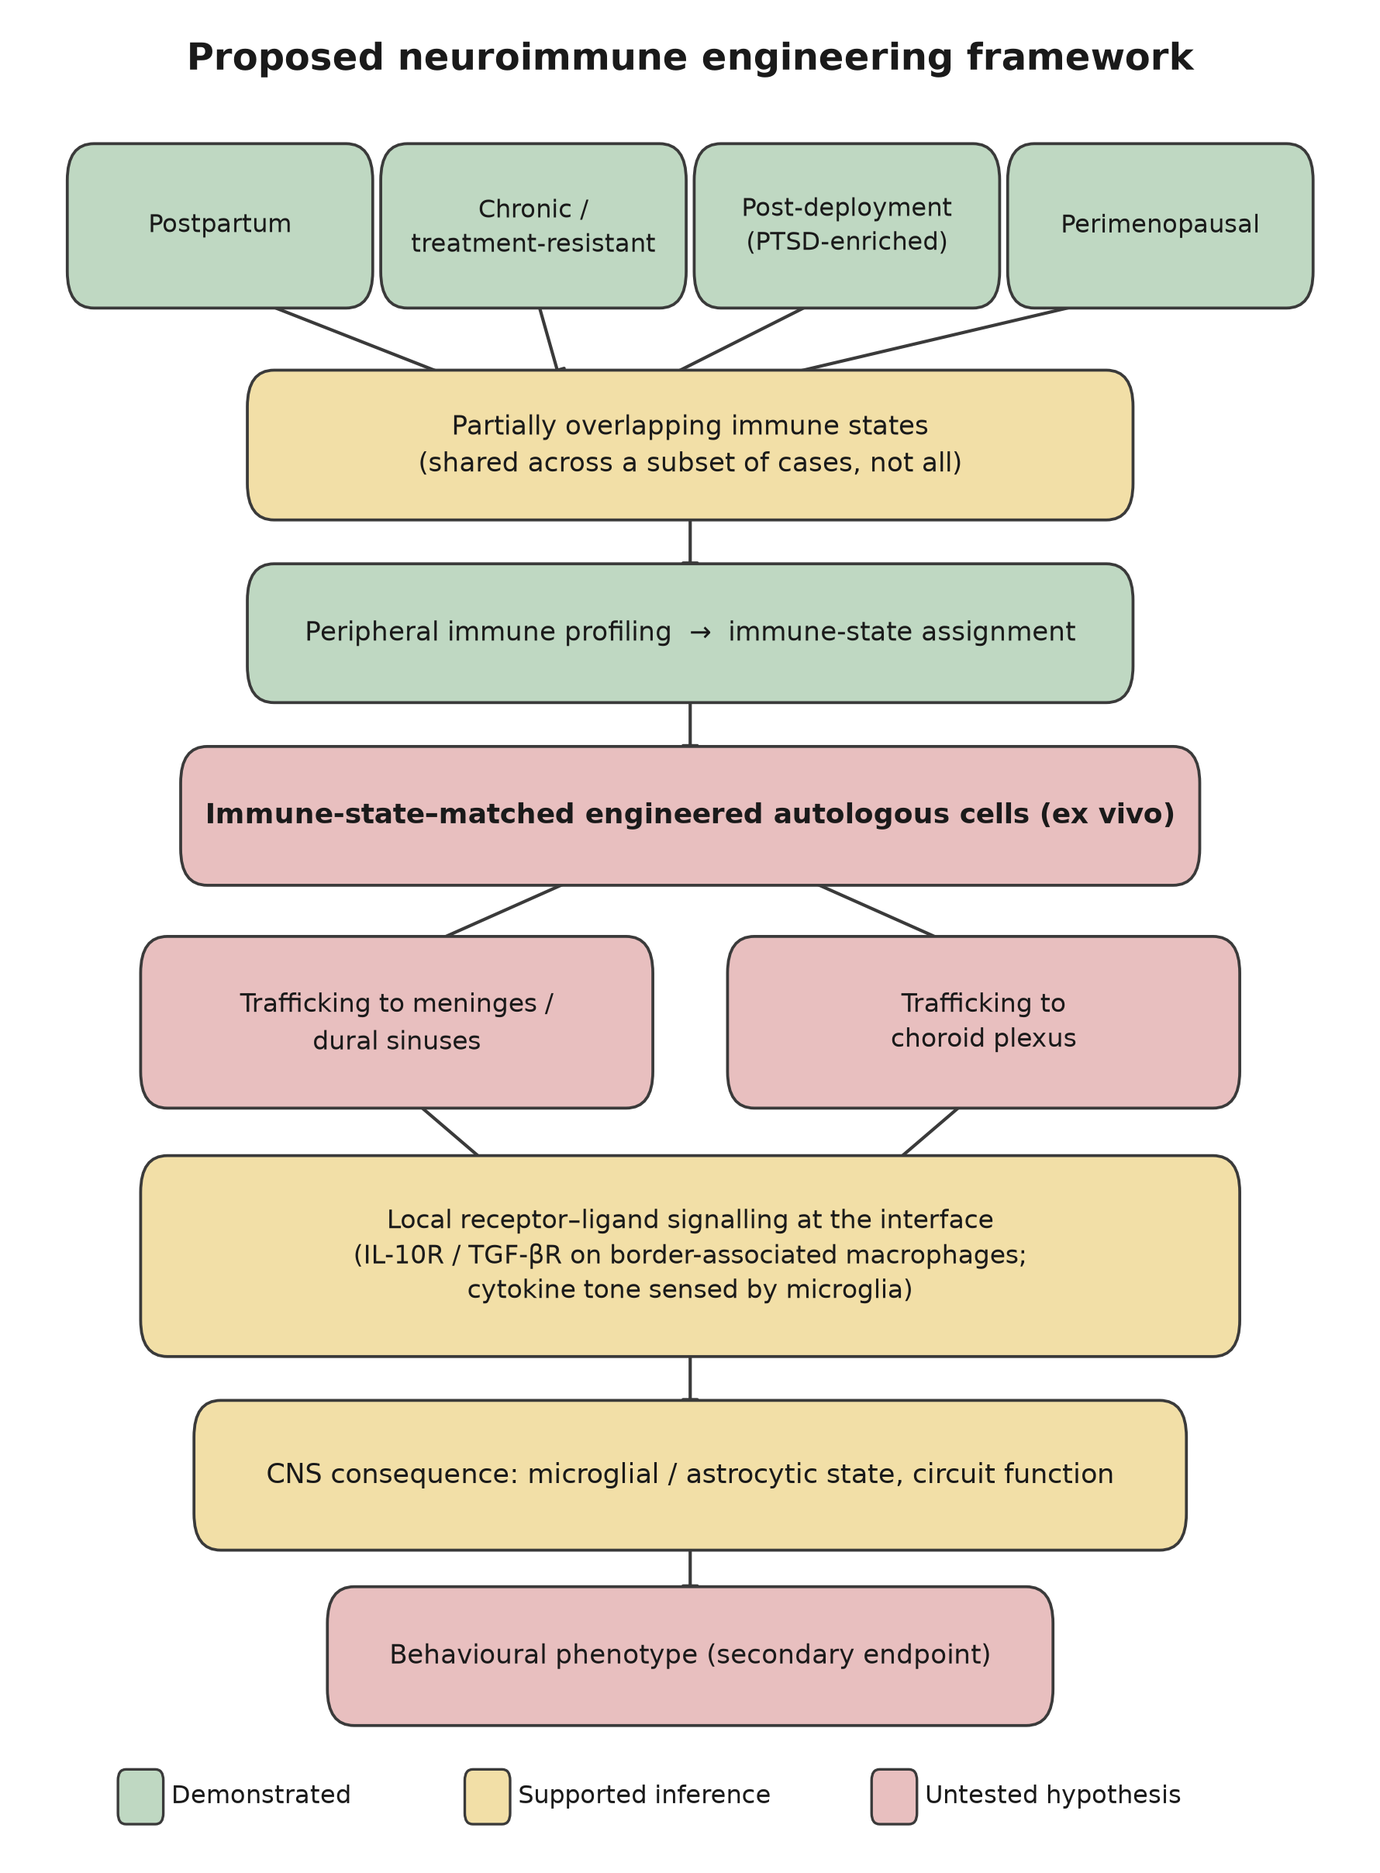
Figure 1. Proposed neuroimmune engineering framework. Steps are color-coded by evidence status, not by confidence in the overall hypothesis. Endogenous immune cell residence and signaling at CNS borders are demonstrated; engineered-cell trafficking to those borders and every step downstream of it are untested. The behavioral phenotype appears last and is treated as a secondary endpoint throughout (Section 7.1).
5. Proposed Framework: Immune-State–Matched Engineering
5.1 Central hypothesis
We do not claim that postpartum, chronic, postdeployment, and perimenopausal depression share a common immune signature. No cross-phenotype study has tested that, and Table 1 shows four separate associations of differing strength. The hypothesis is narrower and testable:
Biologically defined subgroups within clinically heterogeneous depression-associated states occupy partially overlapping immune states; those states can be identified by peripheral profiling, and animals occupying them respond preferentially to engineered immune cell intervention directed at CNS border compartments relative both to animals not occupying them and to intervention with a generic payload.
In this way, the four phenotypes function as test cases for a question about immune-state identification and manipulation rather than as four conditions asserted to share a mechanism. The claim is falsifiable at each conjunct.
5.2 What “immune-state–matched” means and what it does not
We deliberately avoid the term “personalized therapy”. No algorithm currently links a patient immune profile to an engineering construct with a predictable response, and asserting one would overstate the field. Immune-state matching denotes something weaker and testable: assignment of an animal, and eventually a patient, to one of a small number of empirically derived immune states and selection of payload according to that assignment.
Genuine personalization would require five prerequisites in sequence, none yet satisfied: (i) reproducible, discretely identifiable immune states across the relevant populations; (ii) biomarkers that assign individuals to those states reliably; (iii) evidence that state membership is causally related to phenotype rather than incidental; (iv) demonstration that response to immune manipulation differs by state; and (v) characterized safety boundaries for each state–payload combination. Section 7 addresses prerequisites (i), (iii), and (iv) in animals; (ii) and (v) would require dedicated programs of their own.
5.3 Tiered payload architecture
The candidate payloads differ substantially in the strength of their supporting biology, and presenting them as equivalent options would misrepresent the evidence. We therefore tier them explicitly and propose that Tier 1 alone constitutes the primary hypothesis.
Tier 1 — established biological rationale. Anti-inflammatory payloads (IL-10 and TGF-β) act through the cascades described in Section 2.2. The receptor biology is characterized, the target cell populations are defined, and the intended direction of effect is supported by the inflammation–depression literature.
Tier 2 — plausible, requiring validation. Controlled modulation of local immune signaling at the interface beyond simple cytokine suppression, including chemokine-mediated recruitment changes and engineered support of the microglial homeostatic signature.
Tier 3—exploratory. Engineered immune-cell dopaminergic signaling (Section 2.4) and neurotrophic payloads. These carry the weakest evidence, are separately falsifiable, and should not be permitted to carry the framework's credibility.
6. Competing Explanatory Models
Model 1 — Independent immune associations. The four phenotypes have genuinely distinct immune profiles, and the apparent commonality reflects nonspecific stress-associated inflammation. Immune-state matching would then have no cross-phenotype validity, although a within-phenotype intervention might still work.
Model 2 — Inflammation as a downstream marker. Inflammatory elevation is a consequence of the same upstream stress physiology that produces a depressive phenotype, and correcting it does not alter mood-related outcomes.
Model 3 — Peripheral-only effect. Immune correction improves peripherally mediated sickness-behavior components without engaging the circuits underlying the core phenotype, producing partial and potentially misleading improvements in composite measures.
Model 4—Interface-mediated causal contribution (this paper's hypothesis). The immune state at CNS borders causally contributes to circuit function, and engineered modulation produces effects that are not attributable to peripheral immune changes alone. Section 7.3 describes the experiment that distinguishes Model 4 from Model 3 directly.
These are not mutually exclusive. Elements of Models 1–3 may hold alongside a partial version of Model 4.
7. Preclinical Experimental Framework
All the work described here is in mice. No human or clinical study is proposed, and none should be inferred.
7.1 Endpoint hierarchy
The framework's claims are immunological, and its endpoints are ordered accordingly. Behavioral measures are informative only once the immunological chain has been demonstrated and are not permitted to carry the mechanistic argument. We note specifically that forced-swim immobility is a contested index of a depressive state [67] and is therefore excluded as a primary endpoint.
- Primary (engineered-cell and immune): infused-cell persistence, viability, phenotype, and differentiation state; quantified trafficking across blood, spleen, deep cervical lymph nodes, dura and dural sinuses, choroid plexus, CSF, and parenchyma; in situ payload output; local cytokine and chemokine profile; immune composition at the interface, including border-associated macrophage subsets, T-cell subsets, and regulatory T-cell frequency.
- Secondary (CNS): microglial morphological and transcriptional state; astrocytic reactivity; barrier integrity markers, including Claudin-5; and circuit and synaptic readouts appropriate for the model.
- Tertiary (behavioral): sucrose preference and social interaction as the principal measures; model-specific additions such as fear-extinction retention where relevant.
- Safety (mandatory, per Section 2.5): systemic cytokine panel; neurological scoring; weight and general condition; infection challenge in a subset; histopathology of border compartments; off-target editing assessment.
7.2 Control architecture
Because almost any cell infusion produces some immunological effects, the control structure carries most of the inferential weight. Each arm isolates one interpretive alternative.
Arm | Controls for
Vehicle | Handling, infusion procedure
Unmodified autologous cells | Effects of cell infusion and expansion per se
Engineered cells, payload-null construct | Effects of the engineering and transduction process itself
Engineered cells, generic payload | Whether immune-state matching adds anything beyond a fixed payload
Engineered cells, immune-state–matched payload | Test arm
Trafficking-deficient engineered cells, matched payload | Whether interface localization is necessary (Section 7.3)
Systemic recombinant cytokine, output-matched | Whether cell-based delivery is necessary at all
High- versus low-inflammatory stratification within each model | Whether response depends on immune state, as hypothesized
Pharmacological comparator (SSRI or ketamine) | Effect size context against established agents

7.3 Necessity test
The framework's central mechanistic claim is not that engineered cells help but that they help because they act at CNS border interfaces. Demonstrating trafficking is necessary but not sufficient, since cells might traffic and yet exert their effects peripherally. The decisive comparison is therefore against a trafficking-deficient engineered arm matched for systemic payload output — achievable by disrupting the integrin or chemokine–receptor program required for border entry while leaving the payload cassette intact. If the effect survives loss of localization, the mechanism is peripheral, and the interface claim is false, regardless of the behavioral outcome. We regard this as the single most important experiment in the program.
7.4 Models and phenotype mapping
Model | Phenotype represented | Expected immune state | Model-specific primary endpoint | Principal confound
Hormone-withdrawal postpartum model | Postpartum | Transient postwithdrawal inflammatory rebound | Interface immune composition across the withdrawal window | Hormonal effects on immune readouts directly
Chronic social defeat | Chronic/treatment-resistant | IL-6-associated susceptibility phenotype [49] | Trafficking and interface cytokine profile in susceptible versus resilient animals | Preexisting susceptibility differences
Single prolonged stress | Postdeployment (PTSD-enriched) | Trauma-associated inflammatory state | Interface immune state plus fear-extinction retention | Model captures fear learning better than mood
Ovariectomized aged mice | Perimenopausal | Loss of estrogen-dependent immunoregulatory tone | Interface immune state; barrier integrity markers | Aging effects confounded with hormone loss

A cross-model analysis is the point of running all four: whether animals assigned to the same empirically derived immune state respond similarly regardless of the model that produced that state. A positive result there, and only there, would support the overlapping-states claim in Section 5.1.
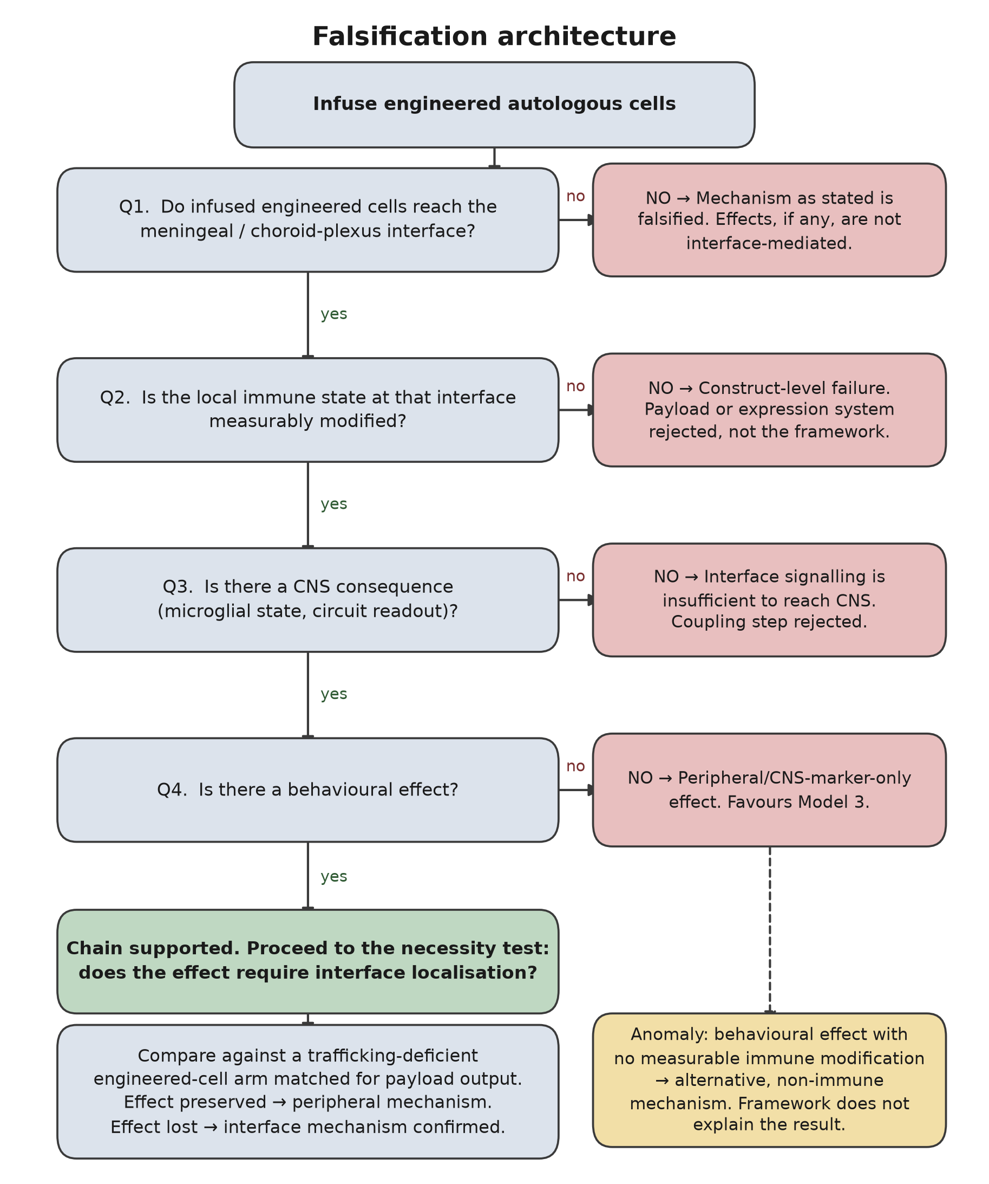
Figure 2. Falsification architecture. Each negative answer falsifies a specific, named link rather than the hypothesis as an undifferentiated whole, and the terminal branch is the necessity test of Section 7.3. The dashed path marks the anomalous outcome — behavioral change without immune modification — which the framework does not explain and which would indicate a nonimmune mechanism.
7.5 Falsification criteria
- F1. Infused cells are not detected in the meningeal or choroid-plexus compartments above the control: the mechanism as stated is falsified, irrespective of any behavioral findings.
- F2. Cells traffic but the local immune state is unchanged: construct-level failure of payload or expression system; the framework is not thereby refuted, but the specific construct is.
- F3. Local immune state changes with no CNS consequence: the interface-to-CNS coupling step is rejected.
- F4. CNS consequences with no behavioral effect: favors Model 3 (peripheral/marker-only).
- F5. The effect is preserved in the trafficking-deficient arm: the interface claim is false, and the mechanism is peripheral (Section 7.3).
- F6. Behavioral effect with no measurable immune modification anywhere: an alternative, nonimmune mechanism is operating, and the framework does not explain the results.
- F7. Matched payload does not outperform generic payload in state-stratified animals: the immune-state-matching claim specifically is falsified, even if the general intervention works.
- F8. Matched payload produces more frequent or more severe adverse immune events than a generic payload—cytokine release, CNS inflammatory infiltration, or infection susceptibility: matching increases rather than reduces risk, and the framework should be abandoned on safety grounds even if an efficacy signal is present.
8. Safety, Limitations, and Translational Barriers
The safety mechanisms enumerated in Section 2.5 are design constraints rather than afterthoughts, and each maps to a mandatory endpoint in Section 7.1. Beyond them, the regulatory distance is substantial: the murine work proposed here requires institutional animal care and use approval, and any hypothetical human application would require a separate investigational pathway that this paper neither proposes nor anticipates. The psychiatric indication adds a specific obligation, since depression is associated with elevated suicide risk, and a vulnerable population is unusually susceptible to premature therapeutic optimism.
The scientific limitations are as follows. The framework is conceptual, and no construct exists. The causal direction of the inflammation–depression association remains unresolved for most phenotypes, and Model 2 cannot currently be excluded. Postdeployment depression is not a formal diagnostic entity and is treated throughout as a heterogeneous, PTSD-enriched population. The four murine models are standard but imperfect proxies, and none reproduce a human depressive episode [68]. Border-immunology findings linking interface cytokines to behavior are, at present, almost entirely murine, and their human applicability is assumed rather than established. Tier 3 payloads rest on the weakest evidence in the paper. Finally, the framework's most distinctive claim — that immune-state matching adds value over a fixed payload — is also its least supported, which is why criteria F7 and F8 are stated explicitly.
9. Conclusions
Immunology has supplied psychiatry with an increasingly detailed description of inflammation-associated depression and, thus far, with interventions borrowed unmodified from other indications. We have argued that the more interesting opportunity is architectural: the CNS border compartments are anatomically accessible to circulating cells, are populated by immune cells whose cytokine output has demonstrated circuit-specific behavioral consequences in mice and are therefore a plausible target for an engineered cell platform of the kind oncology has already made routine. We have specified the receptor-level mechanism that such a platform would require, separated what its engineering precedent does and does not establish, tiered its payloads by evidence strength, restated its central claim as a testable proposition about overlapping immune states rather than an assertion of shared etiology, and defined the controls and the eight criteria by which it should be rejected. The value of the framework does not depend on its being correct: the trafficking and necessity experiments in Section 7 would establish whether engineered cells can be directed to CNS borders at all, which is a question of considerably broader neuroimmunological interest than its application here.
Declaration of Generative AI Use
During the preparation of this work, the author used Claude (Anthropic) to assist with literature synthesis, mechanistic framing, and drafting. The author reviewed and edited all the content, verified the cited literature, and takes full responsibility for the content of the publication. No AI tool is listed as an author.
Data Availability Statement
No new data were generated or analyzed in this conceptual work. The code generating Figures 1 and 2, together with the reference-verification script used to audit the bibliography against Crossref, is openly available at https://github.com/sandlerleon/neuroimmune-interfaces-depression (MIT license) and archived with a permanent DOI on Zenodo: https://doi.org/10.5281/zenodo.22730127. The manuscript is additionally archived as a preprint on Zenodo: https://doi.org/10.5281/zenodo.22730125.
Conflict of Interest
The author declares that there are no competing financial or personal interests. This work received no external funding.
References
[1] Osimo EF, Pillinger T, Rodriguez IM, Khandaker GM, Pariante CM, Howes OD. Inflammatory markers in depression: a meta-analysis of mean differences and variability in 5,166 patients and 5,083 controls. Brain Behav Immun. 2020;87:901–909.
[2] Köhler CA, Freitas TH, Maes M, et al. Peripheral cytokine and chemokine alterations in depression: a meta-analysis of 82 studies. Acta Psychiatr Scand. 2017;135(5):373–387.
[3] Dantzer R, O'Connor JC, Freund GG, Johnson RW, Kelley KW. From inflammation to sickness and depression: when the immune system subjugates the brain. Nat Rev Neurosci. 2008;9(1):46–56.
[4] Capuron L, Miller AH. Immune system to brain signaling: neuropsychopharmacological implications. Pharmacol Ther. 2011;130(2):226–238.
[5] Setiawan E, Wilson AA, Mizrahi R, et al. Role of translocator protein density, a marker of neuroinflammation, in the brain during major depressive episodes. JAMA Psychiatry. 2015;72(3):268–275.
[6] Raison CL, Rutherford RE, Woolwine BJ, et al. A randomized controlled trial of the tumor necrosis factor antagonist infliximab for treatment-resistant depression. JAMA Psychiatry. 2013;70(1):31–41.
[7] Drevets WC, Wittenberg GM, Bullmore ET, Manji HK. Immune targets for therapeutic development in depression: towards precision medicine. Nat Rev Drug Discov. 2022;21(3):224–244.
[8] Cosentino M, Fietta AM, Ferrari M, et al. Human CD4+CD25+ regulatory T cells selectively express tyrosine hydroxylase and contain endogenous catecholamines subserving an autocrine/paracrine inhibitory functional loop. Blood. 2007;109(2):632–642.
[9] Levite M. Dopamine and T cells: dopamine receptors and potent effects on T cells, dopamine production in T cells, and abnormalities in the dopaminergic system in T cells in autoimmune, neurological and psychiatric diseases. Acta Physiol (Oxf). 2016;216(1):42–89.
[10] Papa I, Saliba D, Ponzoni M, et al. Tᶠʜ-derived dopamine accelerates productive synapses in germinal centres. Nature. 2017;547(7663):318–323.
[11] Louveau A, Smirnov I, Keyes TJ, et al. Structural and functional features of central nervous system lymphatic vessels. Nature. 2015;523(7560):337–341.
[12] Aspelund A, Antila S, Proulx ST, et al. A dural lymphatic vascular system that drains brain interstitial fluid and macromolecules. J Exp Med. 2015;212(7):991–999.
[13] Rustenhoven J, Drieu A, Mamuladze T, et al. Functional characterization of the dural sinuses as a neuroimmune interface. Cell. 2021;184(4):1000–1016.
[14] Cugurra A, Mamuladze T, Rustenhoven J, et al. Skull and vertebral bone marrow are myeloid cell reservoirs for the meninges and CNS parenchyma. Science. 2021;373(6553):eabf7844.
[15] Alves de Lima K, Rustenhoven J, Kipnis J. Meningeal immunity and its function in maintenance of the central nervous system in health and disease. Annu Rev Immunol. 2020;38:597–620.
[16] Rustenhoven J, Kipnis J. Brain borders at the central stage of neuroimmunology. Nature. 2022;612(7940):417–429.
[17] Filiano AJ, Xu Y, Tustison NJ, et al. Unexpected role of interferon-γ in regulating neuronal connectivity and social behaviour. Nature. 2016;535(7612):425–429.
[18] Derecki NC, Cardani AN, Yang CH, et al. Regulation of learning and memory by meningeal immunity: a key role for IL-4. J Exp Med. 2010;207(5):1067–1080.
[19] Alves de Lima K, Rustenhoven J, Da Mesquita S, et al. Meningeal γδ T cells regulate anxiety-like behavior via IL-17a signaling in neurons. Nat Immunol. 2020;21(11):1421–1429.
[20] Da Mesquita S, Louveau A, Vaccari A, et al. Functional aspects of meningeal lymphatics in ageing and Alzheimer's disease. Nature. 2018;560(7717):185–191.
[21] Herisson F, Frodermann V, Courties G, et al. Direct vascular channels connect skull bone marrow and the brain surface enabling myeloid cell migration. Nat Neurosci. 2018;21(9):1209–1217.
[22] Van Hove H, Martens L, Scheyltjens I, et al. A single-cell atlas of mouse brain macrophages reveals unique transcriptional identities shaped by ontogeny and tissue environment. Nat Neurosci. 2019;22(6):1021–1035.
[23] Mrdjen D, Pavlovic A, Hartmann FJ, et al. High-dimensional single-cell mapping of central nervous system immune cells reveals distinct myeloid subsets in health, aging, and disease. Immunity. 2018;48(2):380–395.
[24] Brioschi S, Wang WL, Peng V, et al. Heterogeneity of meningeal B cells reveals a lymphopoietic niche at the CNS borders. Science. 2021;373(6553):eabf9277.
[25] Schafflick D, Wolbert J, Heming M, et al. Single-cell profiling of CNS border compartment leukocytes reveals that B cells and their progenitors reside in non-diseased meninges. Nat Neurosci. 2021;24(9):1225–1234.
[26] Møllgård K, Beinlich FRM, Kusk P, et al. A mesothelium divides the subarachnoid space into functional compartments. Science. 2023;379(6627):84–88.
[27] Smyth LCD, Xu D, Okar SV, et al. Identification of direct connections between the dura and the brain. Nature. 2024;627(8002):165–173.
[28] Baruch K, Deczkowska A, David E, et al. Aging-induced type I interferon response at the choroid plexus negatively affects brain function. Science. 2014;346(6205):89–93.
[29] Kunis G, Baruch K, Rosenzweig N, et al. IFN-γ-dependent activation of the brain's choroid plexus for CNS immune surveillance and repair. Brain. 2013;136(Pt 11):3427–3440.
[30] Schwartz M, Baruch K. The resolution of neuroinflammation in neurodegeneration: leukocyte recruitment via the choroid plexus. EMBO J. 2014;33(1):7–20.
[31] Dani N, Herbst RH, McCabe C, et al. A cellular and spatial map of the choroid plexus across brain ventricles and ages. Cell. 2021;184(11):3056–3074.
[32] Saraiva M, O'Garra A. The regulation of IL-10 production by immune cells. Nat Rev Immunol. 2010;10(3):170–181.
[33] Ouyang W, O'Garra A. IL-10 family cytokines IL-10 and IL-22: from basic science to clinical translation. Immunity. 2019;50(4):871–891.
[34] Butovsky O, Jedrychowski MP, Moore CS, et al. Identification of a unique TGF-β-dependent molecular and functional signature in microglia. Nat Neurosci. 2014;17(1):131–143.
[35] Butovsky O, Weiner HL. Microglial signatures and their role in health and disease. Nat Rev Neurosci. 2018;19(10):622–635.
[36] June CH, Sadelain M. Chimeric antigen receptor therapy. N Engl J Med. 2018;379(1):64–73.
[37] Di Stasi A, Tey SK, Dotti G, et al. Inducible apoptosis as a safety switch for adoptive cell therapy. N Engl J Med. 2011;365(18):1673–1683.
[38] Roybal KT, Lim WA. Synthetic immunology: hacking immune cells to expand their therapeutic capabilities. Annu Rev Immunol. 2017;35:229–253.
[39] Matt SM, Gaskill PJ. Where is dopamine and how do immune cells see it? Dopamine-mediated immune cell function in health and disease. J Neuroimmune Pharmacol. 2020;15(1):114–164.
[40] Gust J, Hay KA, Hanafi LA, et al. Endothelial activation and blood–brain barrier disruption in neurotoxicity after adoptive immunotherapy with CD19 CAR-T cells. Cancer Discov. 2017;7(12):1404–1419.
[41] Santomasso BD, Park JH, Salloum D, et al. Clinical and biological correlates of neurotoxicity associated with CAR T-cell therapy in patients with B-cell acute lymphoblastic leukemia. Cancer Discov. 2018;8(8):958–971.
[42] Lee DW, Santomasso BD, Locke FL, et al. ASTCT consensus grading for cytokine release syndrome and neurologic toxicity associated with immune effector cells. Biol Blood Marrow Transplant. 2019;25(4):625–638.
[43] Kosicki M, Tomberg K, Bradley A. Repair of double-strand breaks induced by CRISPR–Cas9 leads to large deletions and complex rearrangements. Nat Biotechnol. 2018;36(8):765–771.
[44] Anzalone AV, Koblan LW, Liu DR. Genome editing with CRISPR–Cas nucleases, base editors, transposases and prime editors. Nat Biotechnol. 2020;38(7):824–844.
[45] Miller AH, Raison CL. The role of inflammation in depression: from evolutionary imperative to modern treatment target. Nat Rev Immunol. 2016;16(1):22–34.
[46] Beurel E, Toups M, Nemeroff CB. The bidirectional relationship of depression and inflammation: double trouble. Neuron. 2020;107(2):234–256.
[47] Lynall ME, Turner L, Bhatti J, et al. Peripheral blood cell-stratified subgroups of inflamed depression. Biol Psychiatry. 2020;88(2):185–196.
[48] Milaneschi Y, Lamers F, Berk M, Penninx BWJH. Depression heterogeneity and its biological underpinnings: toward immunometabolic depression. Biol Psychiatry. 2020;88(5):369–380.
[49] Hodes GE, Pfau ML, Leboeuf M, et al. Individual differences in the peripheral immune system promote resilience versus susceptibility to social stress. Proc Natl Acad Sci USA. 2014;111(45):16136–16141.
[50] Menard C, Pfau ML, Hodes GE, et al. Social stress induces neurovascular pathology promoting depression. Nat Neurosci. 2017;20(12):1752–1760.
[51] Osborne LM, Monk C. Perinatal depression — the fourth inflammatory morbidity of pregnancy? Theory and literature review. Psychoneuroendocrinology. 2013;38(10):1929–1952.
[52] Sherer ML, Posillico CK, Schwarz JM. The psychoneuroimmunology of pregnancy. Front Neuroendocrinol. 2018;51:25–35.
[53] Passos IC, Vasconcelos-Moreno MP, Costa LG, et al. Inflammatory markers in post-traumatic stress disorder: a systematic review, meta-analysis, and meta-regression. Lancet Psychiatry. 2015;2(11):1002–1012.
[54] Michopoulos V, Powers A, Gillespie CF, Ressler KJ, Jovanovic T. Inflammation in fear- and anxiety-based disorders: PTSD, GAD, and beyond. Neuropsychopharmacology. 2017;42(1):254–270.
[55] Eraly SA, Nievergelt CM, Maihofer AX, et al. Assessment of plasma C-reactive protein as a biomarker of posttraumatic stress disorder risk. JAMA Psychiatry. 2014;71(4):423–431.
[56] Straub RH. The complex role of estrogens in inflammation. Endocr Rev. 2007;28(5):521–574.
[57] Klein SL, Flanagan KL. Sex differences in immune responses. Nat Rev Immunol. 2016;16(10):626–638.
[58] Maude SL, Laetsch TW, Buechner J, et al. Tisagenlecleucel in children and young adults with B-cell lymphoblastic leukemia. N Engl J Med. 2018;378(5):439–448.
[59] Neelapu SS, Locke FL, Bartlett NL, et al. Axicabtagene ciloleucel CAR T-cell therapy in refractory large B-cell lymphoma. N Engl J Med. 2017;377(26):2531–2544.
[60] Stadtmauer EA, Fraietta JA, Davis MM, et al. CRISPR-engineered T cells in patients with refractory cancer. Science. 2020;367(6481):eaba7365.
[61] Raffin C, Vo LT, Bluestone JA. Treg cell-based therapies: challenges and perspectives. Nat Rev Immunol. 2020;20(3):158–172.
[62] Ferreira LMR, Muller YD, Bluestone JA, Tang Q. Next-generation regulatory T cell therapy. Nat Rev Drug Discov. 2019;18(10):749–769.
[63] Zhang Q, Lu W, Liang CL, et al. Chimeric antigen receptor (CAR) Treg: a promising approach to inducing immunological tolerance. Front Immunol. 2018;9:2359.
[64] Mougiakakos D, Krönke G, Völkl S, et al. CD19-targeted CAR T cells in refractory systemic lupus erythematosus. N Engl J Med. 2021;385(6):567–569.
[65] Müller F, Taubmann J, Bucci L, et al. CD19 CAR T-cell therapy in autoimmune disease — a case series with follow-up. N Engl J Med. 2024;390(8):687–700.
[66] Baker DJ, Arany Z, Baur JA, Epstein JA, June CH. CAR T therapy beyond cancer: the evolution of a living drug. Nature. 2023;619(7971):707–715.
[67] Molendijk ML, de Kloet ER. Immobility in the forced swim test is adaptive and does not reflect depression. Psychoneuroendocrinology. 2015;62:389–391.
[68] Nestler EJ, Hyman SE. Animal models of neuropsychiatric disorders. Nat Neurosci. 2010;13(10):1161–1169.

