Landfill methane recovery and use under deep uncertainty: a satellite-constrained Monte Carlo decision model for the Norte III landfill, Buenos Aires
Leon Sandler
Independent Researcher, Northbrook, Illinois, USA
ORCID: https://orcid.org/0009-0007-4584-808X
Corresponding author: sandler.leon@gmail.com

Highlights
• Satellite-constrained methane balance of a megasite, calibrated in two periods
• Collection efficiency is inferred at about 14%, not measured; 3 error models agree
• No integrated intervention has a positive median NPV without carbon credits
• Added engines on surplus gas pay; biomethane needs about US$14 per MMBtu
• Cover helps only if captured share of blocked gas exceeds an analytic threshold
Abstract
Very large landfills are major methane sources, but site decisions rarely combine operator-reported capture, independent emission estimates and the economics of competing gas uses. We built a Latin-hypercube Monte Carlo decision model (300,000 draws, 78 inputs) of landfill-gas generation, collection, surface emission and oxidation, selective covers, biomethane upgrading, additional power generation and photovoltaics, and applied it to the Norte III landfill in Buenos Aires. A bottom-up generation prior is constrained by satellite emission estimates at their own observation date (2022, with the capture of that period) and carried forward to the 2025–26 decision period; three observation-error models are compared. The inferred collection efficiency is 0.13 (0.09 to 0.19) in 2022 and 0.14 (0.10 to 0.21) in 2025–26 (median, 90% interval), a model output conditional on the priors, not a measurement. Methane, carbon and energy balances close for every scenario. Under the assumed no-credit conditions, none of the eight integrated intervention scenarios has a positive median incremental net present value; wellfield optimisation with a selective cover abates methane at a median US$3.6 per tCO₂e. Additional engines on surplus gas, reported separately, have positive value in 99% of draws at merchant tariffs, whereas biomethane needs a bio-GNC plant-gate price of US$0.46 per Nm³ (about US$14 per MMBtu) to break even. A cover reduces net emissions only when the captured share of blocked gas exceeds an analytic break-even (median 0.14). Conclusions are unchanged under correlated inputs, alternative priors, time-varying generation and dated Argentine price, tax and financing benchmarks.
Keywords
Landfill gas; Methane mitigation; Satellite constraint; Biomethane; Monte Carlo decision analysis; Techno-economic analysis; Argentina
1. Introduction
Landfills are among the largest anthropogenic sources of methane, and airborne and satellite surveys have shown that a small number of very large sites contribute a disproportionate share of urban emissions (Duren et al., 2019; Maasakkers et al., 2022; Schuit et al., 2023; Cusworth et al., 2024). Inventories derived from first-order decay models and assumed collection efficiencies can differ substantially from measurement-based estimates (Stuart et al., 2026), and collection efficiency itself is poorly constrained in the literature (Spokas et al., 2006; Giordano et al., 2024; Saul et al., 2026). The Norte III landfill in Greater Buenos Aires is one of the large sites identified from space. Its operator reports a large and growing capture system with on-site power generation (CEAMSE, 2026; Canal 26, 2026), while satellite observations place surface emissions at tens of tonnes of methane per hour (Maasakkers et al., 2022; Bloomberg News, 2022). Both statements can hold only if most of the methane generated is not collected, and a decision model for the site must respect that tension.
Mitigation options are numerous: wellfield tuning and leak repair, engineered covers, new uses of recovered gas (additional engines, compressed bio-GNC for vehicles, pipeline biomethane), on-site solar generation and gas buffering. Techno-economic studies usually evaluate such options one at a time, with point estimates (Ghafoori et al., 2022; Agostini et al., 2024). Three gaps follow. First, the climate benefit of a measure is rarely tied to a mass balance in which blocked or captured gas can reappear elsewhere. Second, uncertainty in prices, exchange rates, taxes and financing is usually represented by a few scenarios rather than propagated, and site-relevant prices are seldom dated. Third, the site's emission estimate is rarely confronted with independent top-down data, so the climate value of added capture is uncertain in a way that is not reported.
This paper contributes a satellite-constrained decision model for a single landfill. To our knowledge, no earlier study of a landfill combines (i) a site methane balance constrained by satellite emission estimates at their own observation date, with explicit alternative observation-error models, (ii) a stochastic comparison of the competing uses of recovered gas in which every scenario closes methane, carbon and energy balances, and (iii) closed-form break-evens for selective covers (the minimum captured share of blocked gas) and for photovoltaic coatings (the minimum efficiency), verified against the simulation. Economic inputs are anchored to dated Argentine benchmarks, and the results are tested against correlated inputs, alternative priors, structural alternatives and time-varying generation.
The study is a screening analysis. It uses no site measurements beyond published operator and satellite figures, it treats prices and unit costs as distributions conditioned on dated benchmarks, and it makes no claim about what the operator will do. Its purpose is to show which decisions are robust to the stated uncertainty, which are not, and which measurements would resolve them.
2. Case study, reported data and benchmarks
2.1 Operator data and top-down estimates
Norte III receives roughly 18,000 t of municipal solid waste per day (CEAMSE, 2026). CEAMSE reports captured biogas of 13,800 m³ h⁻¹ in 2025, rising to 16,000 m³ h⁻¹ in April 2026 (Canal 26, 2026), against a maximum captured flow of 13,100 Nm³ h⁻¹ in 2013 (Rosso, 2016). Biogas-fired power plants have operated on site since 2012 (Canal 26, 2026); the operator statement summarised in the project white paper (Sandler, 2026) gives 23 MW installed in 2020 and an expansion to 33 MW planned for 2026. Gas not used by the engines is flared. These are operator statements: they are not measured fugitive emissions, they do not state the methane fraction, and they do not establish that any gas is uncommitted.
Top-down estimates come from satellites. Maasakkers et al. (2022) combined TROPOMI and GHGSat observations and reported emissions of 3 to 29 t CH₄ h⁻¹ from strongly emitting landfills in four cities, with the Buenos Aires site near 28 t h⁻¹ (SRON, 2022); a GHGSat observation in September 2022 implied 18 to 38 t h⁻¹ (Bloomberg News, 2022). These estimates refer to 2019–2022. Capture has since increased, and comparing them with a 2025–26 capture rate, as the first version of this analysis did, mixes periods. CEAMSE disputes the characterisation of the site (Canal 26, 2026). The satellite estimates are therefore used as a constraint at their own date, with an explicit observation-error model, not as ground truth (Section 3.2).
2.2 Dated Argentine economic benchmarks
Table 2 lists the market and regulatory benchmarks to which the economic priors are anchored, with their dates. Gas values distinguish the wellhead (PIST) price that a pipeline injector would receive, the delivered cost of gas to compressed natural gas (GNC) stations in the Buenos Aires metropolitan area and the retail GNC price; a bio-GNC plant supplying an anchor fleet would sell between the second and the third, net of compression and station costs. Electricity values distinguish the merchant (wholesale) value of energy from the long-term contract tariffs that the RenovAr programme awarded to landfill-gas projects. Peso values are converted at an assumed 1,400 ± 100 ARS per USD (late 2025) and should be re-dated before use. Capital goods carry import duties that Decree 513/2025 reduced to 12.6% for many items, against the 20% Mercosur common external tariff (Marval O'Farrell Mairal, 2025); the imported share, duty and logistics define the capital premium, Eq. (9). Country risk enters through the real discount rate, and corporate income tax, the debt share and credit eligibility are treated in the robustness analysis (Section 4.8).
Item | Benchmark | Date | Source | Prior used
Wellhead (PIST) gas price, AMBA distributors | US$2.94–2.98 per MMBtu | Dec 2025 | (Estudio O'Farrell, 2025) | p_pipe tri(0.07, 0.10, 0.16) US$ per Nm³
Gas delivered to AMBA GNC stations (pre-VAT) | ARS 221.63 per m³ (≈ US$0.16) | Nov 2025 | (Surtidores, 2025) | p_gnc tri(0.13, 0.19, 0.40) US$ per Nm³
Retail GNC price, AMBA | ARS 500–570 per m³ (≈ US$0.36–0.41) | Jul 2025 | (La Nación, 2025) | upper end of p_gnc
Wholesale electricity: marginal and priority-market cost | US$69 and 64 per MWh | 2024 | (MEGSA, 2025) | p_el tri(60, 75, 95) US$ per MWh (merchant)
Monomic wholesale electricity price | ARS 121,100 per MWh (≈ US$87) | Aug 2025 | (UDEA, 2025) | c_el tri(70, 95, 130) (purchase incl. network)
RenovAr landfill-gas contract awards | US$128–130 per MWh | 2017 | (Energías Renovables, 2017; Renewable Energy Magazine, 2017) | p_el,k tri(110, 125, 135) (contract variant)
Import duty on capital goods | 12.6% (Decree 513/2025); 20% CET | Jul 2025 | (Marval O'Farrell Mairal, 2025) | duty tri(0, 0.126, 0.20)
Country risk (EMBI spread) | 561 to >1,200 bp; 569 bp on 17 Dec | 2025 | (USAL, 2025) | r tri(0.08, 0.12, 0.18) real
Corporate income tax, top bracket | 35% | 2021 law | (Argentina, 2021) | after-tax variant
Landfill-gas carbon credits; voluntary-market average | ≈US$9.5 and 5.5 per tCO₂e | 2025 | (MSCI, 2025) | cp tri(2, 6, 12), eligibility uni(0.2, 0.8)
Table 2. Dated Argentine benchmarks and the priors anchored to them (US$ conversions at 1,400 ARS per USD, an assumption).
3. Methods
3.1 Methane balance in two periods
Gas quantities are in Nm³ CH₄ h⁻¹ unless stated. Generation around the observation date, G₂₂, is bottom-up, from waste acceptance A (t d⁻¹), methane potential L₀ (Nm³ CH₄ t⁻¹) and an effective fraction f_{ss} of steady-state generation that absorbs landfill age, decay rate and lag; the prior is deliberately wide (L₀ from 50 to 170, f_{ss} from 0.30 to 0.95; Appendix A):
$G_{22}=\frac{365 A L_{0} f_{ss}}{8760}, G=g_{t} G_{22}$ (1)
where g_{t} (0.95 to 1.15) carries generation forward to the 2025–26 decision period. Collected methane is the reported biogas flow times the methane fraction, separately for the historical period (Q₂₂, 12,000 to 14,000 Nm³ h⁻¹, between the 2013 peak and the 2025 value) and the decision period (Q, 13,000 to 16,500 Nm³ h⁻¹). The collection efficiency of each period is an inferred quantity, η= C/G, and draws above 0.95 are rejected as inconsistent. Surface emission after oxidation in the cover soil, a fraction ox (Chanton et al., 2009), is
$E=(G−C)(1−ox)$ (2)
evaluated with G₂₂ and C₂₂ at the observation date and with G and C for the decision period. Existing engines consume P_{el} CF/(η_{el} LHV), with LHV = 9.94 kWh Nm⁻³; the surplus beyond the engines, S, is flared. Methane is converted with 0.717 kg Nm⁻³ and to CO₂-equivalent with the AR6 values for non-fossil methane, 27.0 (GWP100) and 79.7 (GWP20) (Forster et al., 2021; Balcombe et al., 2018).
3.2 Satellite constraint and observation-error models
The satellite information enters as a likelihood on the modelled emission at the observation date, E₂₂ (t h⁻¹). Three observation-error models are compared: a uniform window over the reported range (18 to 38 t h⁻¹; I is the indicator function), a Gaussian centred on the peer-reviewed estimate (28 ± 6 t h⁻¹), and a lognormal with the same median and σ_{ln} = 0.35, the base case because emission-rate retrievals have multiplicative errors (Schuit et al., 2023):
$L_{\text{win}}=\text{I}(18≤E_{22}≤38), L_{\text{G}}=e^{−\frac{(E_{22}−28)^{2}}{2·6^{2}}}, L_{\text{LN}}=e^{−\frac{(\text{ln}E_{22}−\text{ln}28)^{2}}{2·0.35^{2}}}$ (3)
Posterior samples are drawn by importance resampling of the prior draws with weights w_{i} ∝L(E_{22,i}) (Beaumont et al., 2002); the effective sample size is
$\text{ESS}=\frac{(∑_{i}w_{i})^{2}}{∑_{i}w_{i}^{2}}$ (4)
which is 224,817 (lognormal), 186,963 (Gaussian) and 182,249 (window) of 300,000 draws. The window model is equivalent to approximate Bayesian rejection. Every collection efficiency reported below is an inference conditional on the generation prior and the error model; none is a measurement.
3.3 Interventions, selective covers and the cover break-even
Eight scenarios follow the structure of the project white paper (Table 1). Wellfield optimisation (S1) raises the collection efficiency by an absolute increment Δη₁; the added gas is flared unless a later scenario uses it. A selective cover (S2, S3) acts on the fraction f_{hot} of surface flux passing through the covered area. With M_{c} the methane arriving at the cover, the barrier blocks b = εM_{c}; a share s_{c} of the blocked gas is captured by the extraction system and the rest is redirected to uncovered surface with oxidation ρ ox, while oxidation under the cover falls to ox_{cov} = ox(1−δε). The emission after the cover and the net methane avoided are
$E_{1}=(E_{s}−M_{c})(1−ox)+(M_{c}−b)(1−ox_{cov})+(1−s_{c}) b (1−ρ ox)$ (5)
$ΔE=E_{s}(1−ox)−E_{1}−s_{c} b (1−d_{f})$ (6)
where E_{s} is the methane reaching the surface after S1 and d_{f} the destruction efficiency of the flare or engine. Because ΔE is linear in s_{c}, the cover reduces net emissions if and only if
$s_{c}>s_{c}^{*}=−\frac{A_{0}}{A_{1}}, A_{0}=M_{c}(1−ox)−(M_{c}−b)(1−ox_{cov})−b(1−ρ ox), A_{1}=b(1−ρ ox)−b(1−d_{f})$ (7)
This is the quantitative form of the concern that sealing one area may only redirect leakage. Two structural alternatives are tested: redirected gas that is not oxidised (ρ = 0) and complete loss of oxidation under the cover (δ = 1).
Scenario | Incremental change | Counterfactual
S0 | Documented recovery, power generation and flaring | Reference
S1 | Wellfield optimisation and leak detection | S0
S2 | S1 + conventional engineered cover on hot-spot area | S1
S3 | S1 + selective experimental coating | S1
S4 | S2 + conventional photovoltaics on the covered area | S2
S5 | S2 + experimental PV paint on the covered area | S4 at equal area
S6 | S2 + gas buffer + biomethane upgrading (surplus + captured gas) | Flaring
S6b | S1 + gas buffer + biomethane upgrading, no cover | Flaring
S7 | S6 + PV-assisted upgrader + adaptive control | S6
PW | Additional gas engines on the existing surplus (power alternative) | Flaring
Table 1. Scenario definitions. S1–S7 are the integrated interventions; PW is reported separately as the alternative use of the surplus gas.
3.4 Uses of recovered gas and their climate accounts
Three biomethane routes are priced: bio-GNC to an anchor fleet with a demand cap, pipeline injection with a spur and metering station, and a hybrid; the best route is chosen per draw. Electricity for upgrading (0.20 to 0.40 kWh per Nm³ raw gas) is common to all routes, and compression is route-specific: 0.25 kWh per Nm³ of product for GNC dispensing and 0.10 kWh per Nm³ for pipeline injection (Angelidaki et al., 2018). On the GNC-only route, product in excess of the anchor demand is flared, and its slip is counted. Plant fugitive methane is removed from the product stream before sale and counted as an emission (Bakkaloglu et al., 2022). Relative to flaring the same gas, the climate account of upgrading is
$Δ\text{C}{\text{O}}_{\text{2}}\text{e}=EF_{NG} E_{\text{exp}}−\text{GWP} Δm_{\text{C}{\text{H}}_{4}}−EF_{\text{grid}} W_{\text{el}}$ (8)
with E_{exp} the energy of biomethane exported (displacing natural gas at 0.202 tCO₂ per MWh), Δm_{CH4} the change in methane emitted (buffer and plant leakage, tail-gas slip and flaring of unsold product, minus the flare slip avoided) and W_{el} the grid electricity used. The power alternative (PW) installs additional gas engines on the same surplus (Bove and Lunghi, 2006); its climate account is the grid electricity displaced. Gas already consumed by existing engines is never counted as feedstock. The first version of the model applied the GNC compression energy to every route, did not count unsold product or plant fugitive methane, and had no climate account for the power alternative; all four are corrected here.
3.5 Economics
Cash flows are in real US dollars over 20 years. The net present value is
$\text{NPV}=−κ \text{CAPEX}+AF(r) (m_{p}R−O), AF(r)=\frac{1−(1+r)^{−20}}{r}, κ=1+f_{\text{imp}} (d+l)$ (9)
where κ is the capital premium built from the imported share f_{imp}, the import duty d and logistics and exchange costs l, m_{p} a lognormal realised-price multiplier (mean 1, σ = 0.25) for tariff and exchange-rate risk, and r the real discount rate (8 to 18%, mode 12%, consistent with the 2025 country-risk spread). Replacement of short-lived assets (coatings, paint) is discounted explicitly. For photovoltaics on the covered area, setting the levelised cost of the paint equal to that of conventional PV gives the break-even efficiency
$η^{*}=\frac{c_{pt} κ [CRF(r,L_{pt})+o_{pt}]}{LCOE_{\text{conv}} H_{poa} PR}$ (10)
Carbon-credit revenue is zero in the base case. The levelised abatement cost is −NPV/(AF·ΔCO₂e) and equals the credit price at which a scenario breaks even. Variants (Section 4.8) add corporate tax at 35% with straight-line depreciation over 10 years (Argentina, 2021), a weighted average cost of capital built from debt and equity costs, contracted rather than merchant electricity, and expected credit revenue with an eligibility probability.
3.6 Monte Carlo design, balances and automated tests
Inputs (Appendix A) are sampled by Latin hypercube (McKay et al., 1979) with triangular, uniform or lognormal marginals and are tagged as operator-reported [R], literature or standard value [L], dated benchmark [B] or assumed [A]. Sensitivity is reported as Spearman rank correlation (Saltelli et al., 2008). For every scenario the model closes three balances: methane (generated = emitted + oxidised + destroyed + exported), carbon (the same flows in tonnes of carbon, with biogenic CO₂ from oxidation and combustion) and energy (offered = exported + flared + lost, with electricity imported tracked separately). The climate benefit of each scenario is computed both from the incremental formulas and from the balances, and the two must agree. 51 automated tests must pass before results are produced (Appendix B): unit conversions; closure of the cover, upgrader and scenario balances; agreement of the balance-based and incremental climate benefits; limiting cases (a barrier that blocks nothing avoids nothing; unchanged oxidation gives s_{c} b(d_{f}−ox); zero gas prices make upgrading unprofitable); a hand-calculated upgrading case; an independent cash-flow benchmark of the annuity NPV; the analytic first-order-decay limits; LCOE parity at η*; and a standard error of P(NPV > 0) below 0.01.
3.7 Robustness design
Beyond the three observation-error models, the analysis is repeated (120,000 draws each) with rank correlations induced by the Iman–Conover method (Iman and Conover, 1982) between gas and electricity prices, between the prices and the costs that move with them, among capital costs, between the realised-price multiplier and logistics, and between L₀ and f_{ss}; with uniform instead of triangular marginals; with every prior widened by 50%; with the two structural cover alternatives; with contracted electricity; with a WACC; over a sweep of discount rates; and with expected credit revenue. Temporal variability is tested by replacing constant gas supply with a first-order-decay trajectory (IPCC, 2006),
$\frac{G(t)}{G(0)}=\frac{1−e^{−k(a+t)}}{1−e^{−ka}} (t<t_{c}), \frac{G(t)}{G(0)}=\frac{1−e^{−k(a+t_{c})}}{1−e^{−ka}} e^{−k(t−t_{c})} (t≥t_{c})$ (11)
with decay rate k (0.05 to 0.15 yr⁻¹), years of deposition a and years to closure t_{c}, and annual cash flows replacing the annuity for the uses of surplus gas.
4. Results
4.1 Calibration and the inferred collection efficiency
Reported flows imply that the existing engines consume 5,861 (4,931 to 6,878) Nm³ CH₄ h⁻¹ of a collected 7,319 (6,390 to 8,291) (median, 90% interval), leaving a surplus of 1,452 (87 to 2,808) Nm³ CH₄ h⁻¹. The surplus is positive in 96% of draws and exceeds 500 Nm³ h⁻¹ in 87%, but it depends strongly on engine capacity: the median is 2,232 Nm³ h⁻¹ for installed power of 25 MW or less and 633 Nm³ h⁻¹ once the expansion to about 33 MW is complete (Fig. 1d).
The prior gives generation around 2022 of 43,527 (24,087 to 72,266) Nm³ CH₄ h⁻¹ and a modelled 2022 emission of 22 (10 to 39) t h⁻¹. The satellite constraint shifts generation to 49,642 (34,300 to 70,876) Nm³ h⁻¹ and the emission at the observation date to 25 (16 to 38) t h⁻¹, and the three error models give nearly the same posterior (Fig. 1a,b): the inferred 2022 collection efficiency is 0.13 (0.09 to 0.19) (lognormal), 0.13 (0.10 to 0.18) (Gaussian) and 0.13 (0.09 to 0.17) (window). Carried forward with the 2025–26 capture, the efficiency is 0.14 (0.10 to 0.21) and the surface emission 26 (17 to 40) t h⁻¹ (Fig. 1c). The collection efficiency of the first version, 0.18, compared a 2025–26 capture with 2019–22 satellite data and is superseded; it was never a measurement. One percentage point of collection efficiency corresponds to 3.3 (2.2 to 4.7) kt CH₄ yr⁻¹ (about 88 kt CO₂e at GWP100), and the total baseline emission including slip from collected gas is 232 (148 to 349) kt CH₄ yr⁻¹, about 6.3 Mt CO₂e yr⁻¹.
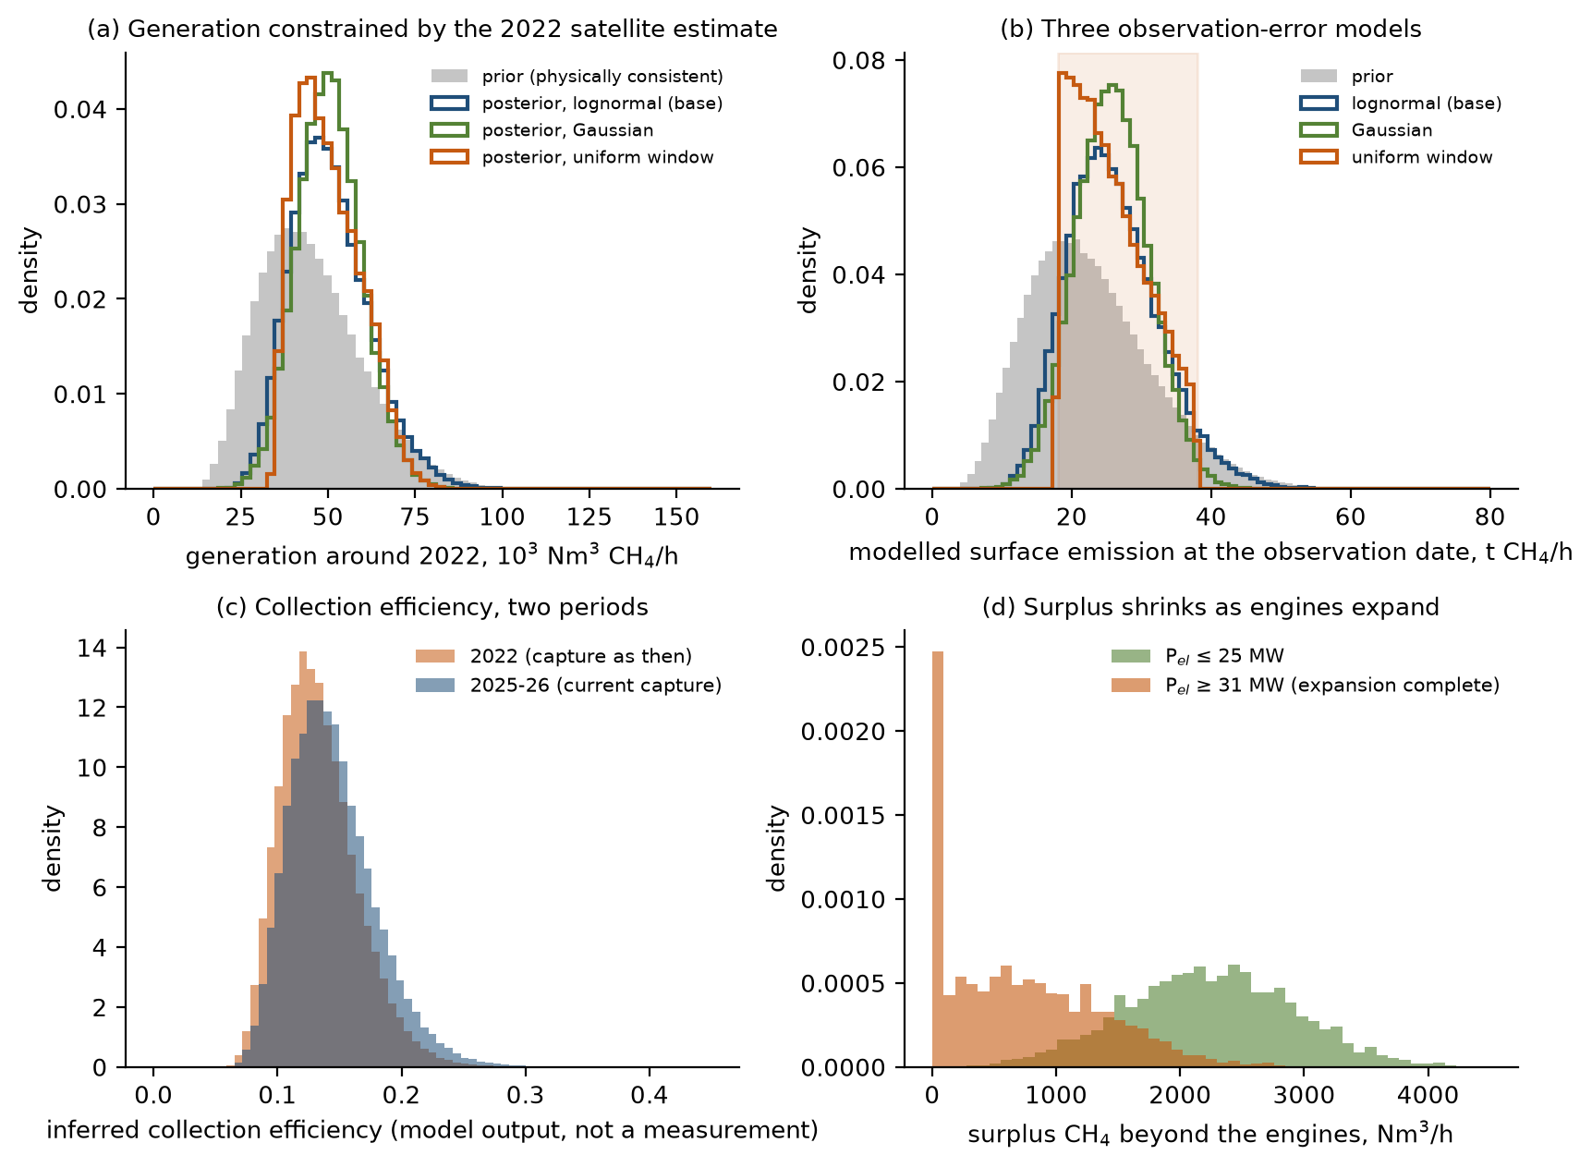
Fig. 1. Calibration. (a) Generation around 2022: prior and the posteriors of the three observation-error models. (b) Modelled surface emission at the observation date with the satellite range shaded. (c) Inferred collection efficiency in 2022 and 2025–26 (lognormal posterior; a model output, not a measurement). (d) Surplus methane beyond the existing engines by installed capacity.
4.2 Wellfield optimisation and selective covers
S1 avoids a median 176 (52 to 380) kt CO₂e yr⁻¹ at a net present cost of 5.9 MUSD, a levelised abatement cost of US$4.6 per tCO₂e. A conventional cover reduces net methane emissions in 92% of draws and an experimental coating in 91% (Fig. 2a); the net effect of the cover alone is 8.1 (−1.1 to 25.3) kt CH₄ yr⁻¹ for the conventional cover. Net avoided methane is 64% of the gross added capture (median), so gross capture overstates the benefit by about a third. The break-even captured share s_{c}* has a median of 0.14 (0.04 to 0.30); the cover increases emissions in exactly the 7.5% of draws in which s_{c} falls below its own s_{c}*, and the analytic boundary tracks the simulated sign change (Fig. 2b). The cover's effect is controlled by s_{c} (Spearman ρ = 0.74), then by f_{hot}, ox and ε. Under the structural alternatives the probability of net benefit falls to 81% (redirected gas not oxidised) and 88% (all oxidation lost under the cover).
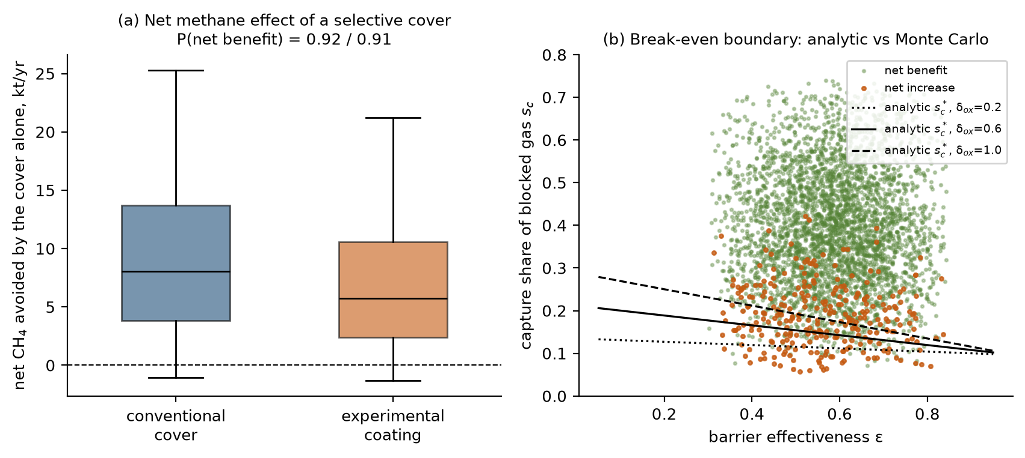
Fig. 2. Selective cover. (a) Net methane avoided by the cover alone (boxes P25–P75, whiskers P5–P95). (b) Simulated net benefit or increase against barrier effectiveness and captured share, with the analytic break-even s_{c}* for three values of the oxidation-loss parameter.
4.3 Scenario economics without credits
None of the eight integrated intervention scenarios has a positive median incremental NPV under the assumed no-credit conditions (Fig. 3a; Table 3). The probability of a positive NPV is at most 0.014 (S6b). Measures do not add: S6, which upgrades the gas captured by the cover, has a lower median NPV than S6b, which upgrades without a cover (−19.4 against −14.7 MUSD), because the cover costs more than the extra gas is worth, and S7 avoids the most methane (512 kt CO₂e yr⁻¹) at the largest cost. Corporate tax with depreciation shields reduces the losses but does not change any sign (Table 3, after-tax column).
The power alternative is reported separately because it is not an emission-reduction intervention but a competing use of gas that is already collected. Additional engines on the existing surplus have a positive NPV in 98.5% of the draws with surplus gas at merchant tariffs (median 6.3 (0.7 to 16.4) MUSD) and in 100.0% with a RenovAr-type contract (median 14.9 (3.5 to 30.9) MUSD; Fig. 3b). Their climate benefit, from displaced grid electricity, is 8.9 (0.6 to 10.8) kt CO₂e yr⁻¹, an order of magnitude smaller than that of the capture measures.
Scenario | NPV | P(NPV>0) | After tax | Avoided (kt CO₂e/yr) | Abatement | P(>0), US$25
S1 | −5.9 (−8.9 to −3.6) | 0.000 | −4.2 | 176 (52 to 380) | 4.6 | 0.98
S2 | −10.6 (−17.6 to −6.6) | 0.000 | −7.8 | 409 (109 to 931) | 3.6 | 0.97
S3 | −17.7 (−39.0 to −9.4) | 0.000 | −13.0 | 348 (93 to 820) | 7.2 | 0.93
S4 | −17.5 (−36.3 to −8.9) | 0.001 | −14.7 | 415 (115 to 939) | 6.0 | 0.95
S5 | −23.0 (−69.0 to −8.1) | 0.002 | −17.7 | 413 (113 to 937) | 8.0 | 0.89
S6 | −19.4 (−29.1 to −8.7) | 0.005 | −15.3 | 418 (119 to 941) | 6.2 | 0.95
S6b | −14.7 (−22.2 to −4.5) | 0.014 | −11.6 | 186 (60 to 389) | 10.5 | 0.89
S7 | −21.5 (−31.1 to −10.7) | 0.002 | −17.0 | 512 (192 to 1,061) | 5.6 | 0.98
PW | 6.1 (0.0 to 16.3) | 0.946 | 3.1 | 9 (1 to 11) | (profit) | 0.96
Table 3. Scenario results, lognormal posterior (median, P5 to P95). NPV incremental to S0 in MUSD with no credit revenue; after-tax median with 35% tax and 10-year depreciation; avoided emissions at GWP100; abatement cost in US$ per tCO₂e; last column P(NPV > 0) with a US$25 credit. PW: additional engines on the existing surplus.
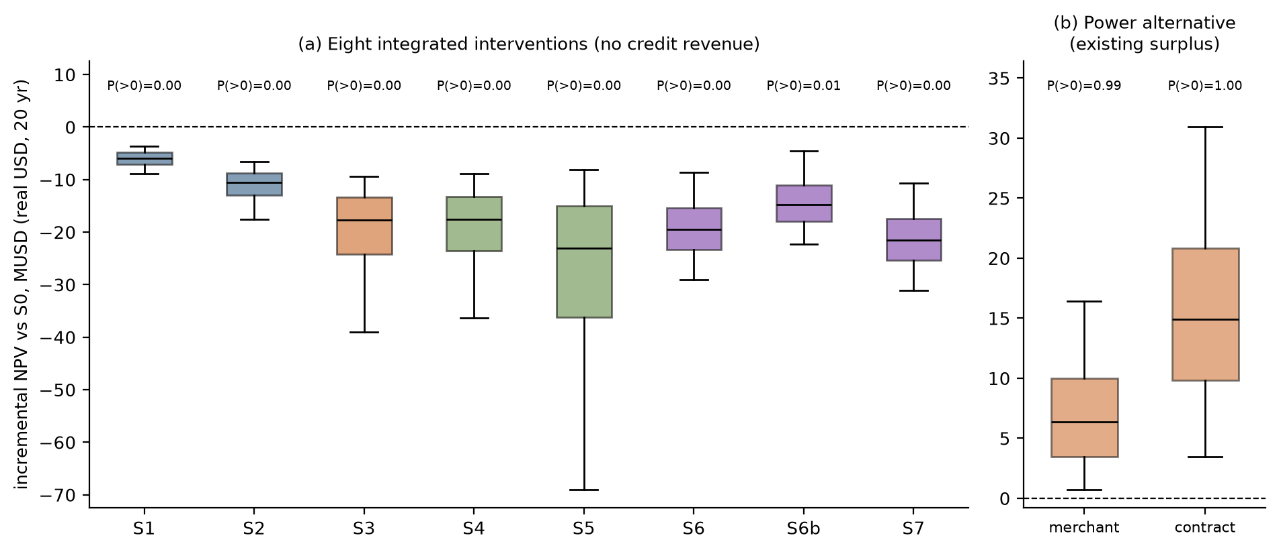
Fig. 3. (a) Incremental NPV of the eight integrated interventions, lognormal posterior, no credit revenue (boxes P25–P75, whiskers P5–P95). (b) NPV of additional engines on the existing surplus at merchant and contracted tariffs.
4.4 Biomethane against additional power
For the surplus beyond the existing engines, biomethane has a positive NPV in 5.4% of draws (median −9.8 (−16.3 to 0.3) MUSD) and beats additional engines in 0.02%. Where it is built, bio-GNC to an anchor customer is the preferred route in 99.9% of draws, because the pipeline price anchored to the PIST benchmark is low relative to the cost of a spur. The break-even realised bio-GNC plant-gate price is US$0.46 (0.26 to 1.42) per Nm³ (about US$14 per MMBtu) against a prior of 0.13 to 0.40; pipeline injection would need US$0.60 per Nm³ (US$18 per MMBtu), about six times the PIST price. To match additional engines, bio-GNC would need US$0.61 per Nm³. Sizing does not rescue upgrading: with only the existing surplus as feedstock, the probability of a positive NPV peaks at 0.05 at 2,000 Nm³ h⁻¹ of raw gas (Fig. 4b). The climate accounts of the two uses are similar: upgrading avoids more CO₂e than power in 54% of draws, by a median of only 199 t yr⁻¹. A gas buffer lowers NPV in 99.97% of draws (median −1.18 MUSD).
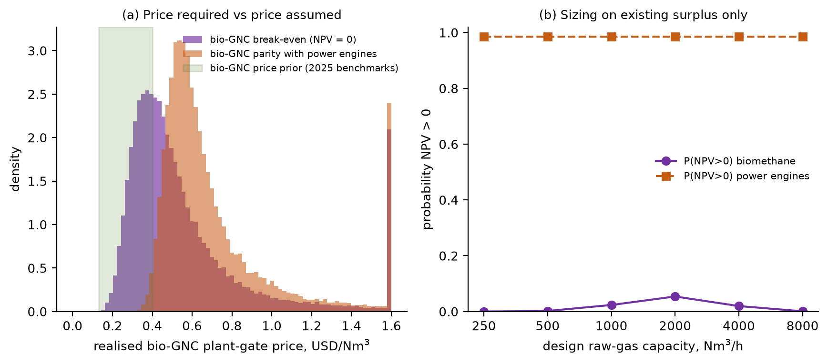
Fig. 4. (a) Bio-GNC plant-gate price required for NPV = 0 and for parity with additional engines, against the prior (values above US$1.6 per Nm³ pooled). (b) Probability of positive NPV against design capacity, existing surplus only.
4.5 Photovoltaic coating against conventional photovoltaics
On the covered area, conventional PV has a positive NPV in 4.0% of draws and a median LCOE of US$119 (84 to 169) per MWh, above the merchant value of electricity because of the landfill foundation premium, the capital premium and the discount rate. The paint, with deliberately wide priors (efficiency 2 to 10%, installed cost US$5 to 150 m⁻², life 2 to 20 years), has a median LCOE of US$211 (60 to 605) per MWh and is cheaper in 23% of draws. The break-even efficiency η*, Eq. (10), has a median of 9.7% (2.9% to 24.9%) and exceeds 10% in 48% of draws (Fig. 5a). The 23% figure is a property of unvalidated priors; the transferable result is the η* surface.
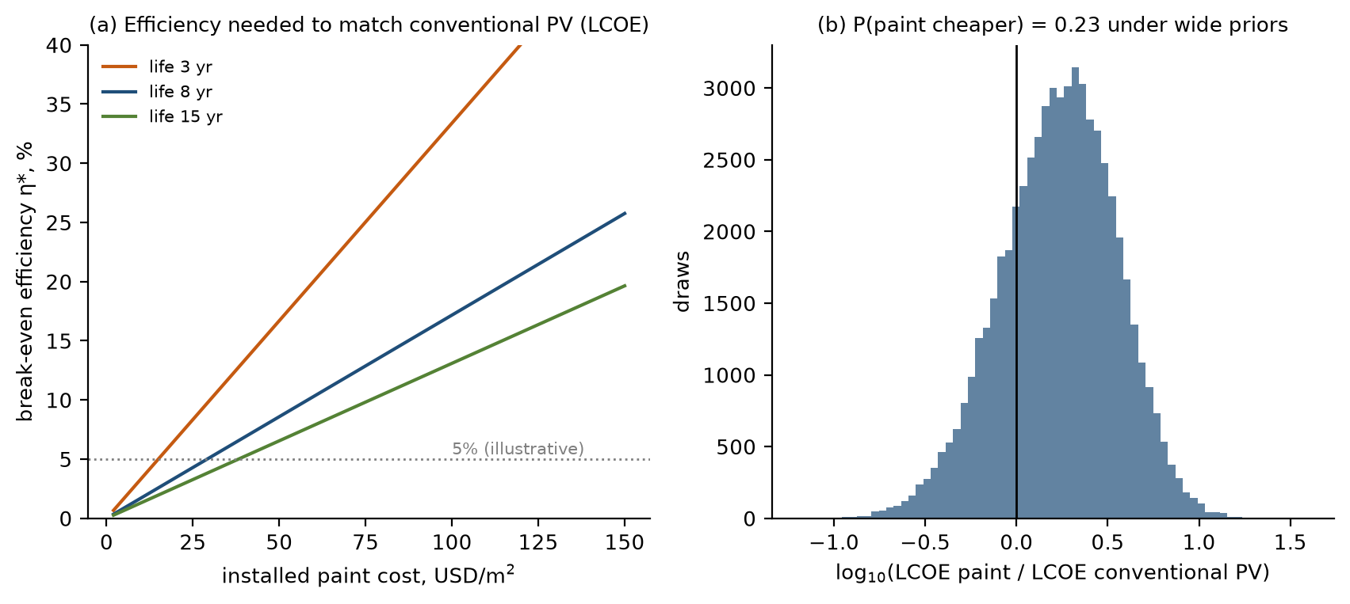
Fig. 5. (a) Break-even efficiency of PV paint for LCOE parity with conventional PV against installed cost, for three lifetimes (other inputs at posterior medians). (b) Distribution of the LCOE ratio.
4.6 Abatement cost
Median levelised abatement costs are low in absolute terms: US$3.6 (S2), 4.6 (S1), 5.6 (S7) and 10.5 (S6b) per tCO₂e at GWP100 (Fig. 6). At GWP20 the avoided CO₂e is 2.95 times larger and the cost correspondingly lower; the median avoided in S2 becomes 1,206 kt CO₂e yr⁻¹.
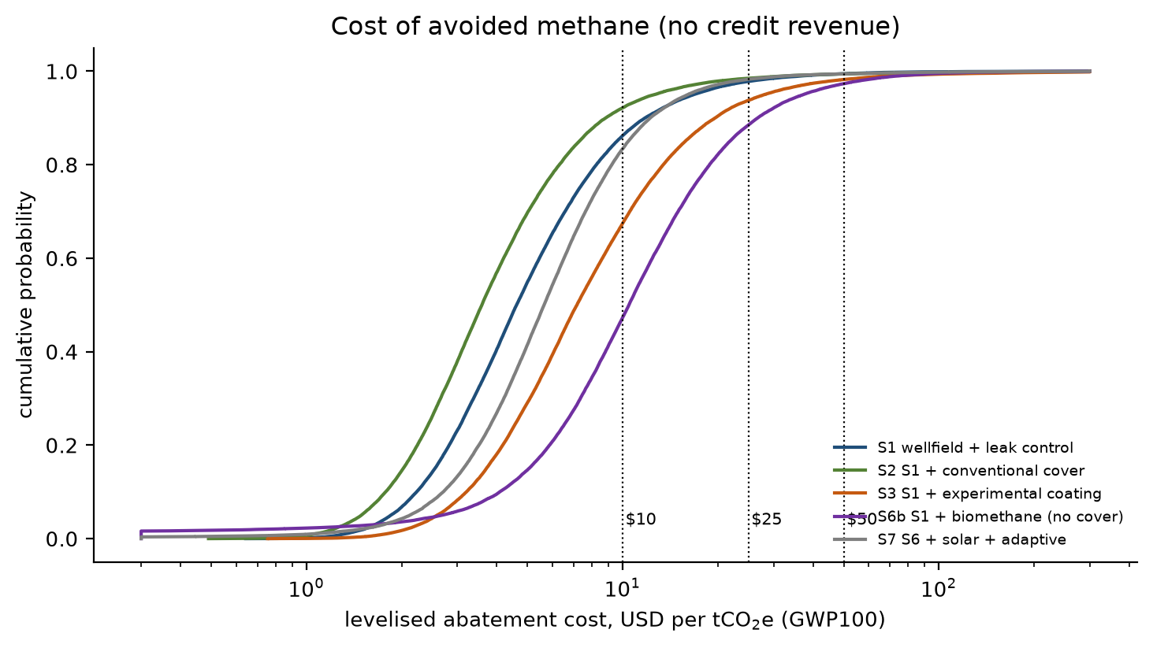
Fig. 6. Cumulative distribution of levelised abatement cost (GWP100, no credit revenue); dotted lines mark credit prices of US$10, 25 and 50 per tCO₂e.
4.7 Sensitivity
The NPV of upgrading without a cover (S6b) is controlled by price and capital: the realised-price multiplier (ρ = 0.52), the bio-GNC price (0.52) and the upgrader capital cost (−0.38); gas-side inputs rank lower (Fig. 7a). The value of additional engines depends on the same price multiplier (0.64), then on the methane fraction, the discount rate and the installed engine capacity (Fig. 7b). Tariff and exchange-rate risk, not gas chemistry, is the dominant uncertainty for monetising recovered gas.
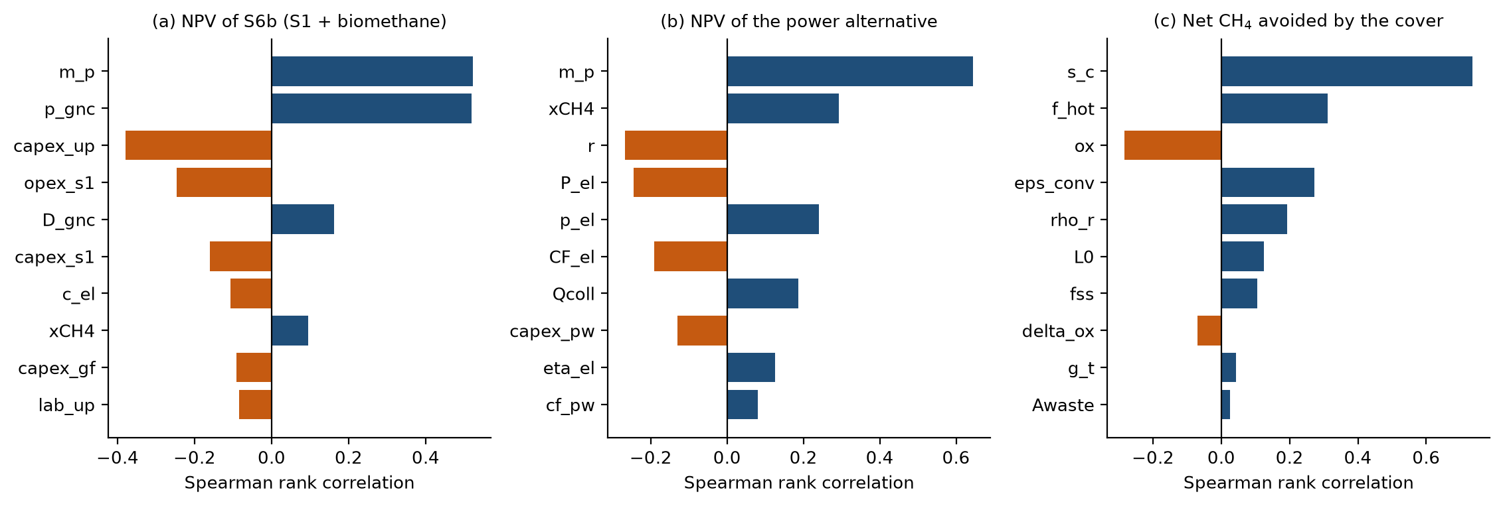
Fig. 7. Spearman rank correlations, lognormal posterior: (a) NPV of S6b; (b) NPV of the power alternative; (c) net methane avoided by the conventional cover. Top ten inputs.
4.8 Credits, tax, financing and the discount rate
Because the abatement costs are low, a credit near US$5 to 10 per tCO₂e would make the capture measures viable if the added capture were eligible: at US$25 the probability of a positive NPV is 0.98 for S1 and 0.97 for S2 (Fig. 8a). At the 2025 market range, with an eligibility probability between 0.2 and 0.8, the expected credit revenue raises P(NPV > 0) only to 0.33 (S1) and 0.38 (S2). The discount rate does not change any conclusion between 6 and 20% real (Fig. 8b): S1 and S2 remain negative at every rate, S6b reaches at most 0.049, and the power alternative stays above 0.90. A WACC built from equity and debt costs gives a median S6b NPV of −14.6 MUSD against −14.7 in the base case. CEAMSE reports that it began certifying carbon credits linked to biogas management in 2025 (Canal 26, 2026); whether the added capture modelled here would be additional, verifiable and saleable is outside this study.
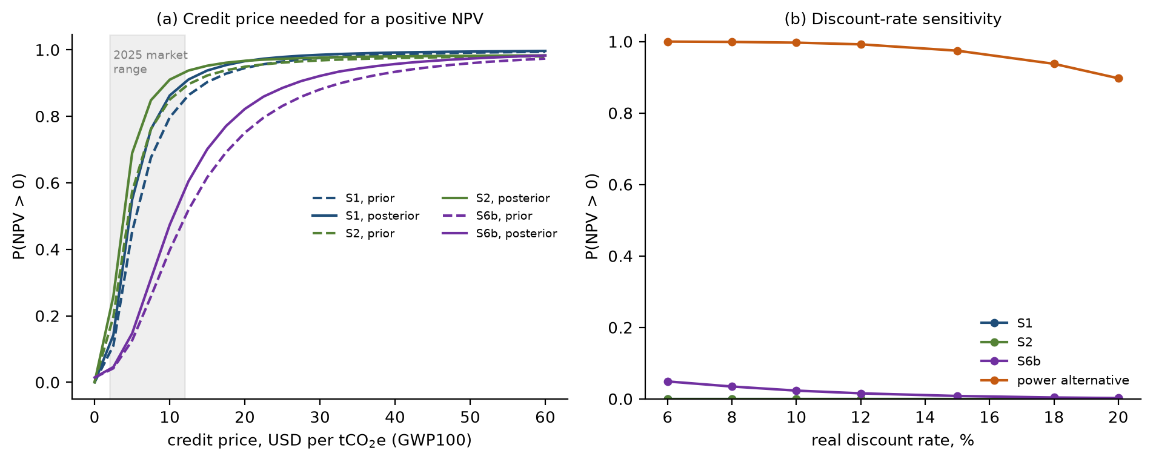
Fig. 8. (a) Probability of positive NPV against credit price for S1, S2 and S6b, prior (dashed) and lognormal posterior (solid), with the 2025 market range shaded. (b) Probability of positive NPV against the real discount rate.
4.9 Robustness
Table 4 and Fig. 9 repeat the headline quantities under every variant. The decision-relevant conclusions do not change: no integrated scenario has a positive median NPV in any variant, additional engines on the surplus remain profitable in 92% to 100% of draws, upgrading beats them in under 1% of draws, and the cover's net benefit stays between 81% and 92%. The climate case moves with the generation prior and the emission estimate: without the satellite constraint S2 avoids 338 kt CO₂e yr⁻¹ instead of 405, and widening every prior by 50% raises it to 484. Correlated inputs change no headline quantity by more than a few per cent. With a first-order-decay supply trajectory, the median NPV of additional engines falls from 6.5 to 4.2 MUSD and remains positive in 93% of draws, while upgrading falls from −9.7 to −10.7 MUSD.
Variant | η 2022 | η 2025–26 | S2 avoided | P(cover) | S6b NPV | P(PW>0) | p* | Abatement S2 | Any > 0
likelihood: lognormal | 0.130 | 0.140 | 405 | 0.92 | −14.7 | 0.99 | 0.46 | 3.7 | no
likelihood: Gaussian | 0.129 | 0.139 | 410 | 0.92 | −14.7 | 0.99 | 0.46 | 3.6 | no
likelihood: uniform window | 0.132 | 0.142 | 407 | 0.92 | −14.7 | 0.99 | 0.46 | 3.6 | no
prior only (no satellite constraint) | 0.149 | 0.160 | 338 | 0.92 | −14.7 | 0.99 | 0.46 | 4.4 | no
correlated inputs (Iman-Conover) | 0.134 | 0.144 | 402 | 0.92 | −14.7 | 0.98 | 0.46 | 3.7 | no
uniform marginals | 0.120 | 0.130 | 439 | 0.83 | −15.9 | 0.97 | 0.52 | 3.9 | no
priors widened by 50% | 0.122 | 0.132 | 484 | 0.90 | −16.4 | 0.92 | 0.51 | 3.4 | no
cover: redirected gas unoxidised | 0.130 | 0.140 | 340 | 0.81 | −14.7 | 0.99 | 0.46 | 4.4 | no
cover: all oxidation lost under cover | 0.130 | 0.140 | 373 | 0.88 | −14.7 | 0.99 | 0.46 | 4.0 | no
contracted electricity tariff (RenovAr-type) | 0.130 | 0.140 | 405 | 0.92 | −14.7 | 1.00 | 0.46 | 3.7 | no
WACC from equity, debt and tax | 0.130 | 0.140 | 405 | 0.92 | −14.6 | 0.98 | 0.47 | 3.7 | no
Table 4. Robustness of the headline quantities (medians unless stated). η: inferred collection efficiency; S2 avoided in kt CO₂e yr⁻¹; P(cover): probability that the cover reduces net emissions; S6b NPV in MUSD; P(PW > 0): probability that additional engines have positive NPV; p*: bio-GNC break-even price in US$ per Nm³; abatement cost of S2 in US$ per tCO₂e; last column: does any integrated scenario have a positive median NPV?
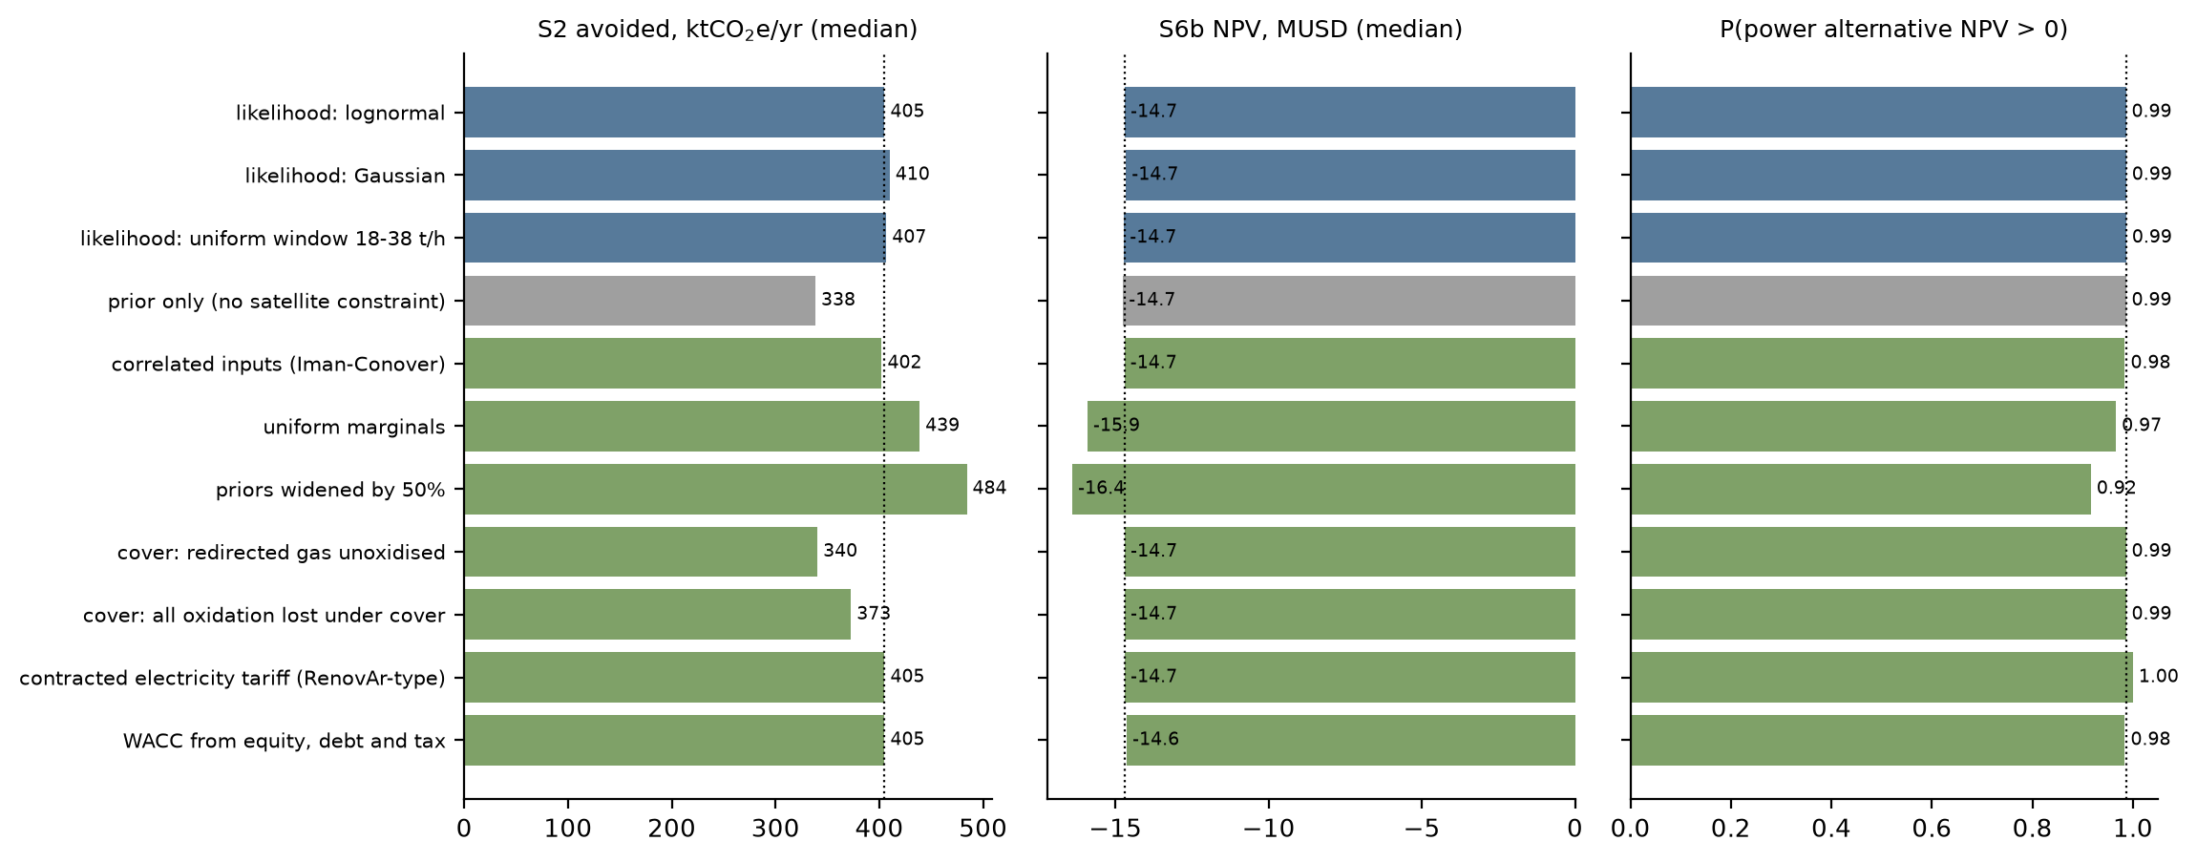
Fig. 9. Headline quantities under the observation-error models (blue), without the satellite constraint (grey) and under the other robustness variants (green); the dotted line marks the base case.
4.10 Physical consistency: methane, carbon and energy balances
In every scenario the methane, carbon and energy balances close to round-off (relative residuals below 10⁻⁹), and the climate benefit computed from the balances equals the incremental benefit to within 10⁻⁸ (Appendix B). Fig. 10a shows the fate of the generated methane for a median draw: in the reference case 232 kt CH₄ yr⁻¹ is emitted, 48 kt is oxidised in the cover soil and 45 kt is destroyed in engines and flares. The measures shift methane from the first category to the third; upgrading exports 5.0 kt CH₄ yr⁻¹ as biomethane and adds a fossil-CO₂ credit (displaced natural gas minus grid electricity used) that is small against the methane term (Fig. 10b).
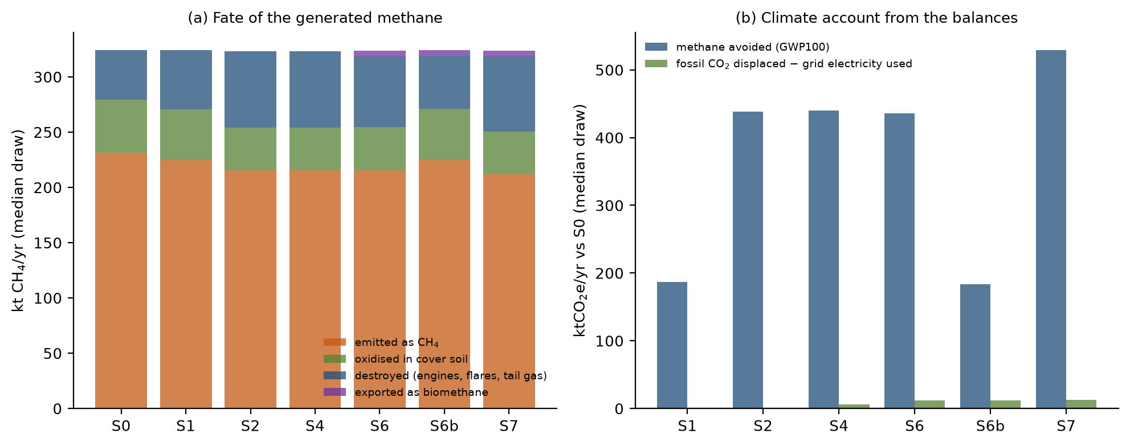
Fig. 10. (a) Fate of the generated methane by scenario (median draw). (b) Climate account from the balances: methane avoided (GWP100) and fossil CO₂ displaced net of grid electricity used, relative to S0.
4.11 Scorecard for the research hypotheses
Hypothesis | Result
H1: cover plus pressure-managed extraction lowers total emissions | Supported conditionally: net reduction in 92% of draws if s_{c} > s_{c}* (median 0.14); net benefit is 64% of gross capture.
H2: PV coatings beat conventional PV only above measurable thresholds | Paint cheaper in 23% of draws under wide, unvalidated priors; break-even efficiency 9.7% at median inputs.
H3: biomethane from surplus gas has higher risk-adjusted NPV than alternatives | Not supported: beats additional engines in 0.02% of draws; break-even US$0.46 per Nm³ (US$14 per MMBtu).
H4: buffering offsets its leakage, energy and capital costs | Not supported: positive in 0.03% of draws; median ΔNPV −1.18 MUSD.
H5: the integrated configuration has lower lifecycle CO₂e per tonne of waste | Supported but small: S7 lower in 99.6% of draws; median reduction 8.3%, from 1.04 to 0.95 tCO₂e per tonne.
Table 5. Outcome of the five hypotheses of the project white paper (lognormal posterior).
5. Discussion
5.1 What the model says about priorities
The largest finding concerns scale. Collected methane is about 5.2 t h⁻¹, whereas the satellite-constrained generation is about 37 t h⁻¹, so most generated methane is not collected. The measures that change the balance are those that raise collection efficiency, at about 3.3 kt CH₄ yr⁻¹ per percentage point; coatings, PV and buffers act on the margin. The integrated package S7 lowers per-tonne emissions by a median 8%. This conclusion follows from the reported capture and the satellite constraint and does not depend on the economic priors. Because measured collection efficiencies at active sites span a wide range (Spokas et al., 2006; Giordano et al., 2024; Saul et al., 2026), a site flux campaign is the measurement with the largest value of information.
5.2 Decisions that are robust, and decisions that are not
Robust under the stated priors and every variant: no integrated measure pays without credit revenue; abatement is cheap per tonne; a cover needs a minimum captured share to help; a buffer does not pay; additional engines on genuinely uncommitted surplus gas are profitable at merchant and contracted tariffs. Not robust: the existence of surplus gas once the engine expansion is complete; the ranking of the capture measures by abatement cost, which depends on the emission estimate; and the comparison of paint with PV, which depends on three unvalidated numbers. The break-even prices, s_{c}* and η* are the portable outputs: a reader with a dated quotation or a measured captured share can read the decision from them. We recommend that no capital be committed to coatings, buffers or upgrading before three measurements are in hand: a calibrated site flux survey to fix the collection efficiency, hourly gas flow and engine dispatch records to fix the true surplus, and a firm offtake or tariff quotation.
5.3 Limitations
The model is a lumped-parameter screening tool. It has no spatial gas-flow solution, so the hot-spot fraction, barrier effectiveness and captured share are parameters, not predictions; a pressure-resolved porous-media model is the next step for the cover question. The satellite constraint rests on a few retrievals from 2019–22 with wind and retrieval uncertainty, and the three error models span but do not exhaust the possibilities; repeated observations of the site after the capture increase would sharpen the inference most. The generation prior is an assumption, as is the growth factor that carries it to 2025–26. Operator figures were taken as reported, and the 23 MW and 33 MW capacities come from the white paper's summary of the operator statement. Prices are anchored to the benchmarks of Table 2, but peso conversions and the plant-gate price a bio-GNC buyer would actually pay are assumptions. The PV-paint concept derives from the author's unpublished competition submission, and no experimental data exist for it; treating its performance as a prior asks what it would need to achieve, not what it will achieve.
5.4 What would falsify these conclusions
Conclusion | Fails if
Covers reduce net methane | The captured share of blocked gas falls below s_{c}* (median 0.14), for example when extraction headroom or header capacity is limiting.
Biomethane loses to power | A firm bio-GNC price above about US$0.61 per Nm³, or electricity worth less than the engines' break-even (median US$39 per MWh), or no engine capacity can be added.
Surplus gas exists | The 33 MW expansion is commissioned (surplus positive in 80% of those draws, median 633 Nm³ CH₄ h⁻¹).
Collection efficiency near 0.14 | A calibrated flux survey after the 2025–26 capture increase finds a surface emission outside about 17 to 40 t h⁻¹.
PV paint is unlikely to beat PV | Validated efficiency exceeds η* for its measured cost and life (Fig. 5a).
Table 6. Conditions under which each conclusion fails.
6. Conclusions
1. A methane balance constrained by satellite estimates at their own observation date implies a collection efficiency of about 0.13 in 2022 and 0.14 in 2025–26 at Norte III; these are inferences conditional on a wide generation prior and agree across three observation-error models. The leading mitigation lever is collection efficiency, worth about 3.3 kt CH₄ yr⁻¹ per percentage point.
2. None of the eight integrated intervention scenarios has a positive median incremental NPV under the assumed no-credit conditions, although the median abatement costs are US$3.6 to 10.5 per tCO₂e; credit eligibility, not engineering feasibility, decides bankability.
3. Additional engines on uncommitted surplus gas, the competing use reported separately, are profitable in 99% of draws at merchant tariffs; biomethane would need about US$0.46 per Nm³ (US$14 per MMBtu) to break even.
4. A selective cover helps only when the captured share of the gas it blocks exceeds a closed-form threshold (median 0.14); gross capture overstates the net benefit by about a third.
5. Every scenario closes its methane, carbon and energy balances, and the conclusions survive correlated inputs, alternative priors, structural cover alternatives, dated tax and financing assumptions and time-varying gas supply.
Declarations
CRediT authorship contribution statement. Leon Sandler: Conceptualization, Methodology, Software, Formal analysis, Investigation, Writing – original draft, Writing – review and editing.
Declaration of generative AI and AI-assisted technologies in the writing process. During the preparation of this work the author used Claude (Anthropic) to assist with source gathering, code development, drafting and editing. The author reviewed and edited the content as needed and takes full responsibility for the content of the publication.
Funding. This research received no external funding.
Declaration of competing interest. The author declares no known competing financial interests or personal relationships that could have influenced the work reported in this paper. The PV-coating concept examined in Section 4.5 originates from the author's own unpublished competition submission.
Data and code availability. The model (NorteIII_MC.py), the automated tests, the figure and export code (NorteIII_figs.py), the parameter table and all results are available at https://github.com/sandlerleon/norte3-landfill-methane-decision and archived at https://doi.org/10.5281/zenodo.23823891 (software, version 2.0.0); this manuscript is archived at https://doi.org/10.5281/zenodo.23823886. One command regenerates every number, table and figure.
References
Agostini, A., Buffi, M., Hurtig, O., Carbone, C., Zanoni, F., Monteleone, G., 2024. Techno-economic evaluation of GHG emissions mitigation of biomethane upgrading technologies. Journal of Environmental Management 364, 121459. https://doi.org/10.1016/j.jenvman.2024.121459
Angelidaki, I., Treu, L., Tsapekos, P., Luo, G., Campanaro, S., Wenzel, H., Kougias, P.G., 2018. Biogas upgrading and utilization: current status and perspectives. Biotechnology Advances 36, 452–466. https://doi.org/10.1016/j.biotechadv.2018.01.011
Argentina, 2021. Ley 27.630, Impuesto a las Ganancias: modificación de alícuotas para sociedades. Boletín Oficial de la República Argentina, 16 June 2021.
Bakkaloglu, S., Cooper, J., Hawkes, A., 2022. Methane emissions along biomethane and biogas supply chains are underestimated. One Earth 5, 724–736. https://doi.org/10.1016/j.oneear.2022.05.012
Balcombe, P., Speirs, J.F., Brandon, N.P., Hawkes, A.D., 2018. Methane emissions: choosing the right climate metric and time horizon. Environmental Science: Processes & Impacts 20, 1323–1339. https://doi.org/10.1039/C8EM00414E
Beaumont, M.A., Zhang, W., Balding, D.J., 2002. Approximate Bayesian computation in population genetics. Genetics 162, 2025–2035. https://doi.org/10.1093/genetics/162.4.2025
Bloomberg News, 2022. Mountains of waste overwhelm Buenos Aires effort to curb methane. 1 December 2022. https://www.bnnbloomberg.ca/mountains-of-waste-overwhelm-buenos-aires-effort-to-curb-methane-1.1853619
Bove, R., Lunghi, P., 2006. Electric power generation from landfill gas using traditional and innovative technologies. Energy Conversion and Management 47, 1391–1401. https://doi.org/10.1016/j.enconman.2005.08.017
CEAMSE, 2026. Información inexacta con respecto a la emisión de metano del Complejo Ambiental Norte III. https://www.ceamse.gov.ar/informacion-inexacta-con-respecto-a-la-emision-de-metano-del-complejo-ambiental-norte-iii/
Canal 26, 2026. Tras aparecer como el más contaminante del mundo, el CEAMSE respondió y aseguró que cumple con los estándares ambientales. 18 May 2026. https://www.canal26.com/planeta/2026/05/18/tras-aparecer-como-el-mas-contaminante-del-mundo-el-ceamse-respondio-y-aseguro-que-cumple-con-los-estandares-ambientales/
Chanton, J.P., Powelson, D.K., Green, R.B., 2009. Methane oxidation in landfill cover soils, is a 10% default value reasonable? Journal of Environmental Quality 38, 654–663. https://doi.org/10.2134/jeq2008.0221
Cusworth, D.H., Duren, R.M., Ayasse, A.K., Jiorle, R., Howell, K., Aubrey, A., Green, R.O., et al., 2024. Quantifying methane emissions from United States landfills. Science 383, 1499–1504. https://doi.org/10.1126/science.adi7735
Duren, R.M., Thorpe, A.K., Foster, K.T., Rafiq, T., Hopkins, F.M., Yadav, V., Bue, B.D., et al., 2019. California's methane super-emitters. Nature 575, 180–184. https://doi.org/10.1038/s41586-019-1720-3
Energías Renovables, 2017. Argentina adjudica 1.408 megavatios renovables a un precio un 25% menor que el año pasado. 5 December 2017. https://www.energias-renovables.com/panorama/argentina-adjudica-1-408-megavatios-renovables-a-20171205
Forster, P., Storelvmo, T., Armour, K., et al., 2021. The Earth's energy budget, climate feedbacks, and climate sensitivity, in: Climate Change 2021: The Physical Science Basis. Cambridge University Press, pp. 923–1054. https://doi.org/10.1017/9781009157896.009
Ghafoori, M.S., Loubar, K., Marin-Gallego, M., Tazerout, M., 2022. Techno-economic and sensitivity analysis of biomethane production via landfill biogas upgrading and power-to-gas technology. Energy 239, 122086. https://doi.org/10.1016/j.energy.2021.122086
Giordano, C.R., Van Brunt, M.E., Halevi, S.J., Castaldi, M.J., Orlovits, Z., Illes, Z., 2024. Landfill gas collection efficiency: categorization of data from existing in-situ measurements. Waste Management 175, 83–91. https://doi.org/10.1016/j.wasman.2023.12.042
IPCC, 2006. 2006 IPCC Guidelines for National Greenhouse Gas Inventories, Volume 5: Waste, Chapter 3: Solid Waste Disposal. IGES, Hayama, Japan.
Iman, R.L., Conover, W.J., 1982. A distribution-free approach to inducing rank correlation among input variables. Communications in Statistics – Simulation and Computation 11, 311–334. https://doi.org/10.1080/03610918208812265
La Nación, 2025. Por qué no hay GNC en algunas estaciones de servicio de la Argentina. 3 July 2025. https://www.lanacion.com.ar/economia/por-que-no-hay-gnc-en-algunas-estaciones-de-servicio-de-la-argentina-nid03072025-2/
MEGSA (Mercado Electrónico de Gas S.A.), 2025. Reforma del sector eléctrico: precios y costos del mercado mayorista (CAMMESA data). April 2025. https://www.megsa.ar/api/d/uVn
MSCI, 2025. The first Core Carbon Principles-qualifying projects: the VCM steps on the gas (blog post). https://www.msci.com/www/blog-posts/the-first-core-carbon/04528494831
Maasakkers, J.D., Varon, D.J., Elfarsdóttir, A., McKeever, J., Jervis, D., Mahapatra, G., Pandey, S., et al., 2022. Using satellites to uncover large methane emissions from landfills. Science Advances 8, eabn9683. https://doi.org/10.1126/sciadv.abn9683
Marval O'Farrell Mairal, 2025. Reducción en derechos de importación y exportación (Decreto 513/2025). July 2025. https://www.marval.com/Publicacion/reduccion-en-derechos-de-importacion-y-exportacion-17286
McKay, M.D., Beckman, R.J., Conover, W.J., 1979. A comparison of three methods for selecting values of input variables in the analysis of output from a computer code. Technometrics 21, 239–245. https://doi.org/10.1080/00401706.1979.10489755
Estudio O'Farrell, 2025. Precios PIST del gas natural, Resolución SE 487/2025. 12 December 2025. https://www.estudio-ofarrell.com/?p=24430
Renewable Energy Magazine, 2017. Argentina subasta 1.200 megavatios de nueva potencia renovable. 22 August 2017. https://www.renewableenergymagazine.com/panorama/argentina-subasta-1-200-megavatios-de-nueva-20170822
Rosso, M.E., 2016. Power generation from biogas utilization at landfill sites: Norte III Final Disposal Environmental Complex, Metropolitan Area of Buenos Aires. Global Methane Forum, Washington, DC, March 2016.
SRON Netherlands Institute for Space Research, 2022. Methane satellites find landfills with the same climate impact as several hundred thousand cars. Press release, 10 August 2022. https://www.sron.nl/en/?p=9721
Saltelli, A., Ratto, M., Andres, T., Campolongo, F., Cariboni, J., Gatelli, D., Saisana, M., Tarantola, S., 2008. Global Sensitivity Analysis: The Primer. Wiley, Chichester.
Sandler, L., 2026. Solar-assisted landfill methane recovery and biomethane valorization: a research white paper. Unpublished, 17 October 2026.
Saul, C.J., Imhoff, P.T., Wang, Y., Barlaz, M.A., 2026. Critical analysis of literature on landfill gas collection efficiency and its application to emissions estimates. Waste Management 213, 115353. https://doi.org/10.1016/j.wasman.2026.115353
Schuit, B.J., Maasakkers, J.D., Bijl, P., Mahapatra, G., van den Berg, A.W., Pandey, S., Lorente, A., et al., 2023. Automated detection and monitoring of methane super-emitters using satellite data. Atmospheric Chemistry and Physics 23, 9071–9098. https://doi.org/10.5194/acp-23-9071-2023
Spokas, K., Bogner, J., Chanton, J.P., Morcet, M., Aran, C., Graff, C., Moreau-Le Golvan, Y., Hebe, I., 2006. Methane mass balance at three landfill sites: what is the efficiency of capture by gas collection systems? Waste Management 26, 516–525. https://doi.org/10.1016/j.wasman.2005.07.021
Stuart, J., Bourlon, E., Martino, R., Coyle, L., Fraser, S., Laurin, E., Vogel, F., et al., 2026. Canada's landfill methane inventories: the challenge of accurate modeled and measurement-based emissions. Elementa: Science of the Anthropocene 14, 00115. https://doi.org/10.1525/elementa.2025.00115
Surtidores, 2025. Ajuste en el gas natural: cómo impacta el nuevo precio en el valor del GNC en las estaciones. 3 November 2025. https://surtidores.com.ar/ajuste-en-el-gas-natural-como-impacta-el-nuevo-precio-en-el-valor-del-gnc-en-las-estaciones/
UDEA (Unión de Usuarios de Energía de Argentina), 2025. Informe sectorial, agosto 2025. https://www.udea.org.ar/newsroom/archivosinformes/Informe%20Sectorial%20Agosto%202025.pdf
Universidad del Salvador, Facultad de Ciencias Económicas, 2025. Informe económico mensual (IEM), diciembre 2025. https://www.usal.edu.ar/fceye/wp-content/uploads/sites/6/2025/12/IEM-Diciembre-2025-1.pdf
Appendix A. Input distributions
Table A1 lists the sampled inputs. Distributions are triangular (minimum, mode, maximum), uniform (minimum, maximum) or lognormal (σ, mean 1). Tags: R, operator-reported or published programme value; L, literature or standard value; B, dated market or regulatory benchmark (Table 2); A, assumed by the author and requiring a site-specific or dated quotation before use in a decision. Inputs marked * enter only the robustness variants.
Input | Description | Distribution | Tag
Qcoll22 | collected biogas around 2022 (satellite period), Nm3/h; 13,100 peak in 2013, 13,800 in 2025 | tri(12,000, 13,100, 14,000) | A
Awaste | waste to Norte III, t/day (~18,000 reported) | tri(14,000, 16,500, 19,000) | R
L0 | CH4 generation potential, Nm3 CH4 per t waste (inventory 100, CAA 170) | tri(50, 100, 170) | L
fss | fraction of steady-state generation reached (age/decay/lag) | tri(0.3, 0.6, 0.95) | A
xCH4 | CH4 fraction of landfill gas | tri(0.42, 0.5, 0.57) | A
ox | cover methane oxidation fraction | tri(0.05, 0.15, 0.35) | L
g_t | generation 2025-26 relative to 2022 | tri(0.95, 1.05, 1.15) | A
Qcoll | collected biogas 2025-26, Nm3/h (13,800 in 2025; 16,000 Apr 2026) | tri(13,000, 14,800, 16,500) | R
P_el | installed biogas power, MW (23 in 2020; 33 planned 2026) | tri(23, 28, 33) | R
CF_el | engine capacity factor | tri(0.7, 0.85, 0.93) | A
eta_el | engine electrical efficiency | tri(0.36, 0.4, 0.43) | L
d_f | flare/engine CH4 destruction efficiency | tri(0.95, 0.98, 0.995) | L
dEta1 | S1 absolute gain in collection efficiency (of generation) | tri(0, 0.02, 0.06) | A
capex_s1 | S1 capex, MUSD | tri(0.5, 1.5, 4) | A
opex_s1 | S1 opex, MUSD/yr | tri(0.15, 0.4, 1) | A
f_hot | flux fraction passing covered area | tri(0.1, 0.25, 0.5) | A
h_e | hot-spot flux enrichment over mean | tri(1.5, 3, 6) | A
A_act | actively emitting area, ha | tri(100, 200, 400) | A
eps_conv | conventional cover: fraction of arriving CH4 blocked | tri(0.3, 0.6, 0.85) | A
eps_coat | experimental coating: fraction blocked | tri(0.1, 0.45, 0.85) | A
s_c | share of blocked CH4 captured by extraction | tri(0.05, 0.35, 0.75) | A
delta_ox | fractional loss of oxidation under cover | tri(0.2, 0.6, 1) | A
rho_r | oxidation of redirected gas relative to ox | uni(0, 1) | A
c_conv | conventional cover cost, kUSD/ha | tri(80, 150, 300) | A
c_coat | experimental coating cost, kUSD/ha | tri(100, 250, 700) | A
om_cov | cover O&M, fraction of capex per yr | tri(0.015, 0.03, 0.05) | A
life_conv | conventional cover life, yr | tri(15, 25, 30) | A
life_coat | coating life, yr | tri(4, 8, 15) | A
r | real USD discount rate (EMBI 2025: 561 to >1,200 bps; 569 bps Dec 2025) | tri(0.08, 0.12, 0.18) | B
f_imp | imported share of equipment capex | tri(0.5, 0.7, 0.9) | A
duty | import duty on capital goods (0% BK regime; 12.6% Decree 513/2025; 20% Mercosur CET) | tri(0, 0.126, 0.2) | B
logist | freight, logistics and FX cost on imports, fraction | tri(0.03, 0.08, 0.15) | A
m_p | realised-price multiplier (tariff/FX risk), mean 1 | logn(0.25) | A
avail_firm | fraction of surplus gas contractually firm | tri(0.6, 0.85, 1) | A
uptime | plant availability | tri(0.8, 0.9, 0.95) | A
rec | CH4 recovery in upgrading | tri(0.9, 0.95, 0.985) | L
tail_ox | fraction of tail-gas CH4 slip oxidised | uni(0, 0.95) | A
fug_plant | plant fugitive CH4, fraction of CH4 in | tri(0.002, 0.006, 0.012) | L
capex_up | upgrader capex, USD per Nm3/h raw capacity | tri(1,800, 3,000, 5,000) | A
e_up | upgrading electricity, kWh/Nm3 raw | tri(0.2, 0.28, 0.4) | L
c_el | electricity purchase cost, USD/MWh (wholesale monomic ~87-91 USD/MWh 2024-25 plus network) | tri(70, 95, 130) | B
om_up | upgrader O&M, fraction of capex per yr | tri(0.03, 0.04, 0.06) | A
lab_up | labour/other, MUSD/yr | tri(0.15, 0.25, 0.45) | A
capex_gv | GNC compression capex, USD per Nm3/h product | tri(400, 800, 1,500) | A
capex_gf | GNC fixed capex, MUSD | tri(0.3, 0.8, 2) | A
p_gnc | bio-GNC net plant-gate price, USD/Nm3 (delivered station gas ~0.15, retail ~0.40-0.45, 2025) | tri(0.13, 0.19, 0.4) | B
p_pipe | pipeline net plant-gate price, USD/Nm3 (PIST 2.94-2.98 USD/MMBtu, Dec 2025) | tri(0.07, 0.1, 0.16) | B
D_gnc | bio-GNC anchor demand, Nm3/h | tri(300, 1,000, 3,000) | A
dist_km | distance to injection point, km | tri(2, 8, 20) | A
c_km | pipeline spur cost, MUSD/km | tri(0.3, 0.6, 1.2) | A
c_inj | injection/metering station, MUSD | tri(0.5, 1, 2) | A
capex_pw | gas-engine power capex, USD/kW (RenovAr landfill-gas ref 1.3 MUSD/MW) | tri(1,100, 1,300, 1,700) | R
p_el | electricity sale price, merchant/MAT, USD/MWh (marginal cost 69, monomic ~87-91, 2024-25) | tri(60, 75, 95) | B
p_el_k* | electricity sale price, RenovAr-type contract, USD/MWh (landfill-gas awards 128-130, 2017) | tri(110, 125, 135) | B
cf_pw | new engines capacity factor | tri(0.8, 0.88, 0.93) | A
eta_pw | new engines electrical efficiency | tri(0.36, 0.4, 0.43) | L
om_pw | engine O&M, fraction of capex per yr | tri(0.03, 0.045, 0.07) | A
var_loss | flow-variability loss without buffer | uni(0.05, 0.25) | A
zeta | fraction of variability loss removed by buffer | uni(0.5, 0.9) | A
capex_buf | buffer capex, MUSD | tri(0.3, 0.8, 2) | A
leak_buf | buffer CH4 leakage, fraction of throughput | tri(0.002, 0.005, 0.01) | A
f_pv | share of upgrader electricity from on-site PV | uni(0.1, 0.5) | A
dEta_ad | adaptive-control gain in collection efficiency | tri(0, 0.01, 0.03) | A
capex_ad | adaptive control capex, MUSD | tri(0.2, 0.5, 1.2) | A
opex_ad | adaptive control opex, MUSD/yr | tri(0.05, 0.1, 0.25) | A
kwp_ha | conventional PV, kWp per ha | tri(500, 700, 900) | A
capex_pv | PV capex, USD/kW (RenovAr ref 850) | tri(550, 750, 1,100) | R
prem_pv | landfill foundation premium for PV | tri(1.1, 1.3, 1.6) | A
yield_pv | PV yield, kWh/kWp/yr | tri(1,350, 1,500, 1,650) | A
om_pv | PV O&M, fraction of capex per yr | tri(0.01, 0.015, 0.025) | A
life_pv | PV life, yr | tri(20, 25, 30) | A
p_pv | PV electricity value, merchant, USD/MWh (2024-25 wholesale cost) | tri(55, 70, 90) | B
eta_pt | PV-paint module efficiency (unvalidated) | tri(0.02, 0.05, 0.1) | A
c_pt | PV-paint installed cost, USD/m2 (unvalidated; wide on purpose) | tri(5, 30, 150) | A
life_pt | PV-paint life, yr (unvalidated; wide on purpose) | tri(2, 6, 20) | A
pr_pt | PV-paint performance ratio | tri(0.65, 0.78, 0.85) | A
om_pt | PV-paint O&M, fraction of capex per yr | tri(0.01, 0.02, 0.04) | A
H_poa | plane-of-array irradiation, kWh/m2/yr | tri(1,550, 1,650, 1,750) | A
ef_grid | grid emission factor, tCO2/MWh | tri(0.28, 0.31, 0.36) | A
cp* | carbon-credit price if eligible, USD/tCO2e (VCM ~5.5, landfill gas ~9.5 USD, 2025) | tri(2, 6, 12) | B
p_elig* | probability that added capture is eligible for credits | uni(0.2, 0.8) | A
dv* | debt share of financing | tri(0, 0.4, 0.6) | A
r_e* | real cost of equity | tri(0.12, 0.16, 0.22) | A
r_d* | real cost of debt | tri(0.07, 0.09, 0.12) | A
k_dec* | first-order decay rate, 1/yr (IPCC 2006, temperate wet MSW) | tri(0.05, 0.09, 0.15) | L
age* | years of deposition before 2026 | tri(20, 28, 32) | A
t_close* | years until deposition stops, from 2026 | tri(3, 8, 15) | A
Table A1. Input distributions.
Appendix B. Balances and automated tests
Scenario | Emitted | Oxidised | Destroyed | Exported | Biogenic C | Exported energy | Electricity | Total CO₂e
S0 | 231.5 | 47.7 | 44.8 | 0.0 | 69.2 | 0.0 | 0.0 | 6.25
S1 | 224.6 | 46.2 | 53.2 | 0.0 | 74.5 | 0.0 | 0.0 | 6.06
S2 | 215.3 | 39.1 | 68.9 | 0.0 | 82.0 | 0.0 | 0.0 | 5.81
S4 | 215.3 | 39.1 | 68.9 | 0.0 | 82.0 | 0.0 | 0.0 | 5.81
S6 | 215.4 | 39.1 | 64.0 | 5.0 | 78.3 | 69.4 | 6.3 | 5.80
S6b | 224.7 | 46.2 | 48.2 | 5.0 | 70.9 | 69.2 | 6.2 | 6.06
S7 | 211.9 | 38.3 | 68.3 | 5.0 | 80.9 | 69.4 | 4.3 | 5.71
Table B1. Scenario balances for the median draw: methane emitted, oxidised, destroyed and exported (kt CH₄ yr⁻¹); biogenic carbon released as CO₂ (kt C yr⁻¹); biomethane energy exported and grid electricity used (GWh yr⁻¹); total emissions (Mt CO₂e yr⁻¹, GWP100). Residuals of all balances are below 10⁻⁹ of generation.
The automated test suite (python NorteIII_MC.py --test) contains 51 checks, all of which pass: unit conversions (methane mass, carbon content, annuity and capital recovery factors); Latin-hypercube moments and the induced rank correlation; the white paper's screening arithmetic; closure of the cover balance; the analytic break-even s_{c}*; two limiting cases of the cover; methane and carbon closure of seven scenario balances; methane and energy closure of four upgrader accounts; equality of balance-based and incremental climate benefits for four scenarios; a hand-calculated upgrading case; an explicit cash-flow benchmark of the annuity NPV; unprofitability at zero gas prices; LCOE parity at η*; the calibration window; physical consistency of the posterior; determinism; the steady-state limit of the time-resolved NPV and the analytic slow-decay limit of the first-order-decay model; and the Monte Carlo standard error.
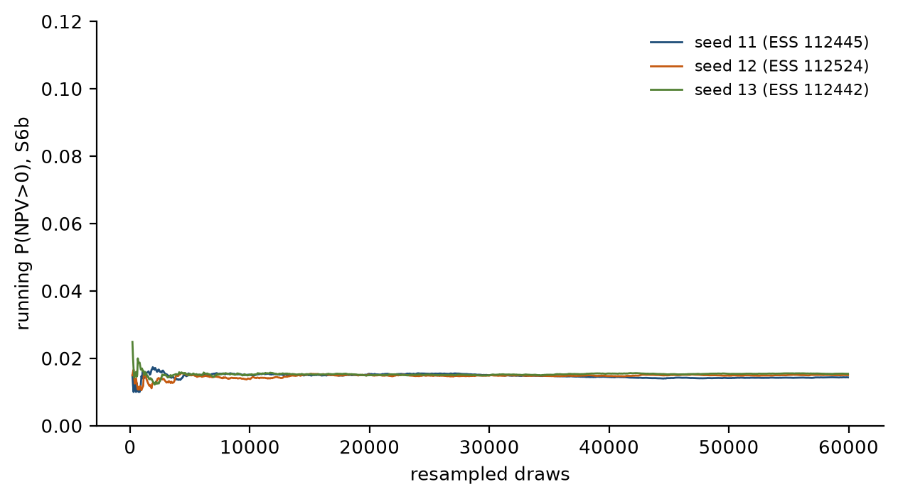
Fig. B1. Running probability of positive NPV for S6b across three independent seeds (resampled lognormal posterior; ESS in the legend).

