Landfill methane recovery and use under deep uncertainty: a satellite-constrained Monte Carlo decision model for the Norte III landfill, Buenos Aires
Leon Sandler
Independent Researcher, Northbrook, Illinois, USA
ORCID: https://orcid.org/0009-0007-4584-808X
Corresponding author: leon.sandler@alumni.swinburne.edu

Highlights
• Satellite-constrained methane balance of a megasite, calibrated in two periods
• Capture efficiency of 0.14 to 0.24 is conditional on the data, not measured
• No integrated intervention has a positive median NPV without carbon credits
• Added engines pay only where surplus gas exists; biomethane needs US$14 per MMBtu
• Cover helps only if captured share of blocked gas exceeds an analytic threshold
Abstract
Very large landfills are major methane sources, but site decisions rarely join operator-reported capture, independent emission estimates and the economics of competing gas uses. We built a Latin-hypercube Monte Carlo decision model (300,000 draws, 78 inputs) of landfill-gas generation, collection, surface emission, oxidation, selective covers, biomethane upgrading, additional power generation and photovoltaics, and applied it to the Norte III landfill in Buenos Aires. A bottom-up generation prior is constrained by satellite emission estimates at their own date (2022) and carried to 2025–26. The inferred collection efficiency, 0.13 (0.09 to 0.19) in 2022 and 0.14 (0.10 to 0.21) in 2025–26 (median, 90% interval), follows from the emission, oxidation and reported capture, is conditional on the data and not a measurement, and increases to 0.24 (0.15 to 0.37) with an independent 2025 observation that the model overpredicts by a factor of 3.5. Under no-credit conditions none of eight integrated scenarios has a positive median net present value; wellfield optimization with a selective cover abates methane at a median US$3.6 per tCO₂e. Additional engines are profitable in 99% of draws that have surplus gas, but in 69% of all operating states after the planned expansion; biomethane needs US$0.46 per Nm³ (US$14 per MMBtu). A cover helps only if the captured share of blocked gas exceeds an analytic break-even (median 0.14). Conclusions hold under alternative generation histories, satellite scaling and dated Argentine benchmarks.
Keywords
Landfill gas; Methane mitigation; Satellite constraint; Biomethane; Monte Carlo decision analysis; Techno-economic analysis
1. Introduction
Landfills are among the largest anthropogenic sources of methane, and airborne and satellite surveys have shown that a small number of very large sites contribute a disproportionate share of urban emissions (Cusworth et al., 2024; Duren et al., 2019; Maasakkers et al., 2022; Schuit et al., 2023). Inventories derived from first-order decay models and assumed collection efficiencies can differ substantially from measurement-based estimates (Stuart et al., 2026), and at facility scale satellite estimates often do not correlate with reported or modeled values (Dogniaux et al., 2025). Collection efficiency itself is poorly constrained in the literature (Giordano et al., 2024; Saul et al., 2026; Spokas et al., 2006). The Norte III landfill in Greater Buenos Aires is one of the large sites identified from space. Its operator reports a large and growing capture system with on-site power generation (CEAMSE, 2026; Canal 26, 2026), while satellite observations place surface emissions at tens of tonnes of methane per hour (Bloomberg News, 2022; Maasakkers et al., 2022). Both statements can hold only if most of the methane generated is not collected, and a decision model for the site must respect that tension.
Mitigation options are numerous: wellfield tuning and leak repair, engineered covers, new uses of recovered gas (additional engines, compressed bio-GNC for vehicles, pipeline biomethane), on-site solar generation and gas buffering. Techno-economic studies usually evaluate such options one at a time, with point estimates and a fixed gas supply (Agostini et al., 2024; Ghafoori et al., 2022), whereas the measurement literature quantifies emissions or collection efficiency without evaluating the decisions that follow from them (Cusworth et al., 2024; Giordano et al., 2024; Maasakkers et al., 2022). Neither can answer how a decision-maker should choose between more capture and better use of the gas already collected when the site's emission is known only through uncertain remote sensing: the climate benefit of a measure is rarely tied to a mass balance in which blocked or captured gas can reappear elsewhere; uncertainty in prices, exchange rates, taxes and financing is usually represented by a few scenarios rather than propagated; and the existence of surplus gas for any new use is assumed, not tested.
This paper therefore asks one question: under which observable physical and economic conditions does additional methane capture outperform alternative uses of already collected landfill gas? We answer it for a single landfill with a satellite-constrained decision model that (i) infers the collection efficiency from the satellite emission, the oxidation and the reported capture, and states what that inference does and does not identify (Section 4.2) and how it compares with an independent 2025 observation (Section 4.3); (ii) closes methane, carbon and energy balances for every scenario, so that blocked or redirected gas is never lost from the account; (iii) separates the probability that additional engines are profitable given that surplus gas exists from the probability across all operating states (Section 4.6); (iv) reports the climate account of each use under alternative counterfactuals (Section 4.7); and (v) derives closed-form break-evens for selective covers (the minimum captured share of blocked gas) and for photovoltaic coatings (the minimum efficiency), verified against the simulation. Economic inputs are anchored to dated Argentine benchmarks.
The study is a screening analysis. It uses no site measurements beyond published operator and satellite figures, it treats prices and unit costs as distributions conditioned on dated benchmarks, and it makes no claim about what the operator will do or about the accuracy of the operator's reported figures. Its purpose is to show which decisions are robust to the stated uncertainty, which are not, and which measurements would resolve them.
2. Case study, reported data and benchmarks
2.1 Operator data and top-down estimates
Norte III receives roughly 18,000 t of municipal solid waste per day (CEAMSE, 2026). CEAMSE reports captured biogas of 13,800 m³ h⁻¹ in 2025, increasing to 16,000 m³ h⁻¹ in April 2026 (Canal 26, 2026), against a maximum captured flow of 13,100 Nm³ h⁻¹ in 2013 (Rosso, 2016). Biogas-fired power plants have operated on site since 2012 (Canal 26, 2026); the operator statement summarized in the project white paper (Sandler, 2026) gives 23 MW installed in 2020 and an expansion to 33 MW planned for 2026. Gas not used by the engines is flared. These are operator statements: they are not measured fugitive emissions, they do not state the methane fraction, and they do not establish that any gas is uncommitted.
Top-down estimates come from satellites. Maasakkers et al. (2022) combined TROPOMI hot-spot detection with high-resolution GHGSat target-mode observations and reported emissions of 3 to 29 t CH₄ h⁻¹ from strongly emitting landfills in four cities, with the Buenos Aires site near 28 t h⁻¹ (SRON, 2022); a GHGSat observation in September 2022 implied 18 to 38 t h⁻¹ (Bloomberg News, 2022). These estimates refer to 2019–2022 and are retrievals at the time of observation, not annual facility means. Capture has since increased, and comparing them with a 2025–26 capture rate, as the first version of this analysis did, mixes periods. CEAMSE disputes the characterization of the site (Canal 26, 2026). The satellite estimates are therefore used as a constraint at their own date, with an explicit observation-error model, not as ground truth (Section 3.2). One later observation is independent of the calibration: Carbon Mapper retrievals from Tanager-1 and EMIT for 2025, summarized by the UCLA STOP Methane project as an average of overpass emission rates of 7.6 t CH₄ h⁻¹ for the Greater Buenos Aires landfill operated by CEAMSE (UCLA STOP Methane Project, 2026). The operator replies that the ranking rests on point satellite measurements under particular atmospheric conditions, which limit their representativeness (Canal 26, 2026). The observation is used here as an independent check, with its own error model (Sections 3.8 and 4.3).
2.2 Dated Argentine economic benchmarks
Supplementary Table S5 lists the market and regulatory benchmarks to which the economic priors are anchored, with their dates. Gas values distinguish the wellhead (PIST) price that a pipeline injector would receive, the delivered cost of gas to compressed natural gas (GNC) stations in the Buenos Aires metropolitan area and the retail GNC price; a bio-GNC plant supplying an anchor fleet would sell between the second and the third, net of compression and station costs. Electricity values distinguish the merchant (wholesale) value of energy from the long-term contract tariffs that the RenovAr programme awarded to landfill-gas projects. Peso values are converted at an assumed 1,400 ± 100 ARS per USD (late 2025) and should be re-dated before use. Capital goods carry import duties that Decree 513/2025 reduced to 12.6% for many items, against the 20% Mercosur common external tariff (Marval O'Farrell Mairal, 2025); the imported share, duty and logistics define the capital premium, Eq. (9). Country risk enters through the real discount rate, and corporate income tax, the debt share and credit eligibility are treated in the robustness analysis (Section 4.11).
3. Methods
3.1 Methane balance in two periods
Gas quantities are in Nm³ CH₄ h⁻¹ unless stated. Generation around the observation date, G₂₂, is bottom-up, from waste acceptance A (t d⁻¹), methane potential L₀ (Nm³ CH₄ t⁻¹) and an effective fraction f_{ss} of steady-state generation that absorbs landfill age, decay rate and lag; the prior is deliberately wide (L₀ from 50 to 170, f_{ss} from 0.30 to 0.95; Supplementary Table S2):
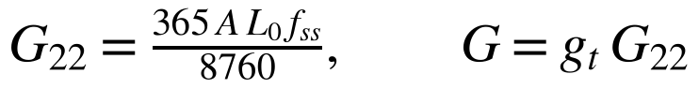 (1)
where g_{t} (0.95 to 1.15) carries generation forward to the 2025–26 decision period. Collected methane is the reported biogas flow times the methane fraction, separately for the historical period (Q₂₂, 12,000 to 14,000 Nm³ h⁻¹, between the 2013 peak and the 2025 value) and the decision period (Q, 13,000 to 16,500 Nm³ h⁻¹). The collection efficiency of each period is an inferred quantity, η= C/G, and draws above 0.95 are rejected as inconsistent. Surface emission after oxidation in the cover soil, a fraction ox (Chanton et al., 2009), is
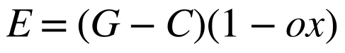 (2)
evaluated with G₂₂ and C₂₂ at the observation date and with G and C for the decision period. Existing engines consume P_{el} CF/(η_{el} LHV), with LHV = 9.94 kWh Nm⁻³; the surplus beyond the engines, S, is flared. Methane is converted with 0.717 kg Nm⁻³ and to CO₂-equivalent with the AR6 values for non-fossil methane, 27.0 (GWP100) and 79.7 (GWP20) (Balcombe et al., 2018; Forster et al., 2021).
3.2 Satellite constraint and observation-error models
The satellite information enters as a likelihood on the modeled emission at the observation date, E₂₂ (t h⁻¹). Three observation-error models are compared: a uniform window over the reported range (18 to 38 t h⁻¹; I is the indicator function), a Gaussian centered on the peer-reviewed estimate (28 ± 6 t h⁻¹), and a lognormal with the same median and σ_{ln} = 0.35, the base case because emission-rate retrievals have multiplicative errors (Schuit et al., 2023):
(3)
Posterior samples are drawn by importance resampling of the prior draws with weights w_{i} ∝L(E_{22,i}) (Beaumont et al., 2002); the effective sample size is
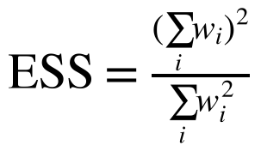 (4)
which is 224,817 (lognormal), 186,963 (Gaussian) and 182,249 (window) of 300,000 draws. The window model is equivalent to approximate Bayesian rejection. Every collection efficiency reported below is an inference conditional on the generation prior and the error model; none is a measurement.
3.3 Interventions, selective covers and the cover break-even
Eight scenarios follow the structure of the project white paper (Table 1). Wellfield optimization (S1) increases the collection efficiency by an absolute increment Δη₁; the added gas is flared unless a later scenario uses it. A selective cover (S2, S3) acts on the fraction f_{hot} of surface flux passing through the covered area. With M_{c} the methane arriving at the cover, the barrier blocks b = εM_{c}; a share s_{c} of the blocked gas is captured by the extraction system and the rest is redirected to uncovered surface with oxidation ρ ox, while oxidation under the cover decreases to ox_{cov} = ox(1−δε). The emission after the cover and the net methane avoided are
(5)
(6)
where E_{s} is the methane reaching the surface after S1 and d_{f} the destruction efficiency of the flare or engine. Because ΔE is linear in s_{c}, the cover reduces net emissions if and only if
(7)
This is the quantitative form of the concern that sealing one area may only redirect leakage. Two structural alternatives are tested: redirected gas that is not oxidized (ρ = 0) and complete loss of oxidation under the cover (δ = 1).
Scenario | Incremental change | Counterfactual
S0 | Documented recovery, power generation and flaring | Reference
S1 | Wellfield optimization and leak detection | S0
S2 | S1 + conventional engineered cover on hot-spot area | S1
S3 | S1 + selective experimental coating | S1
S4 | S2 + conventional photovoltaics on the covered area | S2
S5 | S2 + experimental PV paint on the covered area | S4 at equal area
S6 | S2 + gas buffer + biomethane upgrading (surplus + captured gas) | Flaring
S6b | S1 + gas buffer + biomethane upgrading, no cover | Flaring
S7 | S6 + PV-assisted upgrader + adaptive control | S6
PW | Additional gas engines on the existing surplus (power alternative) | Flaring
Table 1. Scenario definitions. S1–S7 are the integrated interventions; PW is reported separately as the alternative use of the surplus gas.
3.4 Uses of recovered gas and their climate accounts
Three biomethane routes are priced: bio-GNC to an anchor fleet with a demand cap, pipeline injection with a spur and metering station, and a hybrid; the best route is chosen per draw. Electricity for upgrading (0.20 to 0.40 kWh per Nm³ raw gas) is common to all routes, and compression is route-specific: 0.25 kWh per Nm³ of product for GNC dispensing and 0.10 kWh per Nm³ for pipeline injection (Angelidaki et al., 2018). On the GNC-only route, product in excess of the anchor demand is flared, and its slip is counted. Plant fugitive methane is removed from the product stream before sale and counted as an emission (Bakkaloglu et al., 2022). Relative to flaring the same gas, the climate account of upgrading is
(8)
with E_{exp} the energy of biomethane exported (displacing natural gas at 0.202 tCO₂ per MWh), Δm_{CH4} the change in methane emitted (buffer and plant leakage, tail-gas slip and flaring of unsold product, minus the flare slip avoided) and W_{el} the grid electricity used. The power alternative (PW) installs additional gas engines on the same surplus (Bove and Lunghi, 2006); its climate account is the grid electricity displaced. Gas already consumed by existing engines is never counted as feedstock. The first version of the model applied the GNC compression energy to every route, did not count unsold product or plant fugitive methane, and had no climate account for the power alternative; all four are corrected here.
3.5 Economics
Cash flows are in real US dollars over 20 years. The net present value is
(9)
where κ is the capital premium built from the imported share f_{imp}, the import duty d and logistics and exchange costs l, m_{p} a lognormal realized-price multiplier (mean 1, σ = 0.25) for tariff and exchange-rate risk, and r the real discount rate (8 to 18%, mode 12%, consistent with the 2025 country-risk spread). Replacement of short-lived assets (coatings, paint) is discounted explicitly. For photovoltaics on the covered area, setting the levelised cost of the paint equal to that of conventional PV gives the break-even efficiency η* = c_{pt} κ [CRF(r,L_{pt})+o_{pt}]/(LCOE_{conv} H_{poa} PR) (Supplementary Section S2). Carbon-credit revenue is zero in the base case. The levelised abatement cost is −NPV/(AF·ΔCO₂e) and equals the credit price at which a scenario breaks even. Variants (Section 4.11) add corporate tax at 35% with straight-line depreciation over 10 years (Argentina, 2021), a weighted average cost of capital built from debt and equity costs, contracted rather than merchant electricity, and expected credit revenue with an eligibility probability.
3.6 Monte Carlo design, balances and automated tests
Inputs (Supplementary Table S2) are sampled by Latin hypercube (McKay et al., 1979) with triangular, uniform or lognormal marginals and are tagged as operator-reported [R], literature or standard value [L], dated benchmark [B] or assumed [A]. Sensitivity is reported as Spearman rank correlation (Saltelli et al., 2008). For every scenario the model closes three balances: methane (generated = emitted + oxidized + destroyed + exported), carbon (the same flows in tonnes of carbon, with biogenic CO₂ from oxidation and combustion) and energy (offered = exported + flared + lost, with electricity imported tracked separately). The climate benefit of each scenario is computed both from the incremental formulas and from the balances, and the two must agree. Before results are produced, 59 automated tests must pass (Supplementary Section S4): unit conversions; closure of the cover, upgrader and scenario balances; agreement of the balance-based and incremental climate benefits; limiting cases; a hand-calculated upgrading case; an independent cash-flow benchmark of the annuity NPV; the analytic first-order-decay limits; LCOE parity at η*; the closed-form identity of the collection efficiency (Section 3.8); the limiting cases of the engine counterfactuals and of the climate variants; and a standard error of P(NPV > 0) below 0.01. The tests verify internal consistency; they do not validate the model against site data, which Section 4.3 addresses separately.
3.7 Robustness design
Beyond the three observation-error models, the analysis is repeated (120,000 draws each) with rank correlations induced by the Iman–Conover method (Iman and Conover, 1982) among prices, among costs and between L₀ and f_{ss}; with uniform marginals; with every prior widened by 50%; with the two structural cover alternatives; with contracted electricity; with a WACC; over a sweep of discount rates; and with expected credit revenue. Temporal variability is tested by replacing constant gas supply with a first-order-decay trajectory (IPCC, 2006),
(11)
with decay rate k (0.05 to 0.15 yr⁻¹), years of deposition a and years to closure t_{c}, and annual cash flows replacing the annuity for the uses of surplus gas.
3.8 Identifiability, representativeness and independent check of the satellite constraint
Because the satellite constrains the surface emission, the collection efficiency of the observation period follows from Eqs. (1) and (2) as
(12)
with ρ_{m} = 0.717 × 10⁻³ t Nm⁻³. The efficiency depends on the emission, the oxidation fraction and the reported capture, and on no generation parameter; A, L₀ and f_{ss} matter only through the emission they imply, which the likelihood tests. We quantify this identifiability in four ways: the share of the variance of the log-odds carried by each term of Eq. (12); the prior-to-posterior contraction of each input; the posterior under five alternative generation histories (an inventory-anchored prior, a high and a low generation prior, a first-order-decay history in which f_{ss} follows from k, the age of the site and the growth of deposition, and a widened prior on the historical capture, 8,000 to 18,000 Nm³ h⁻¹), compared by their mean likelihood (evidence) relative to the base prior; and the effect of the observation model.
Representativeness is tested by scaling the satellite median by 0.25 to 2 (a snapshot that caught an episodic high, a survey biased to detections, or a site-wide emission above or below the retrieved plume) and by widening σ_{ln} to 0.5, 0.7 and 1.0 for wind, temporal-sampling and retrieval uncertainty. As an independent check, the 2025 observation of 7.6 t h⁻¹ (UCLA STOP Methane Project, 2026) is treated as a lognormal likelihood on the 2025–26 surface emission with σ_{ln} = 0.5 (an assumption: the source reports no uncertainty). The model calibrated on 2019–22 data alone predicts this emission, and the discrepancy is reported as the ratio of observed to predicted median and as the probability that the predictive distribution lies at or below the observation. The observations are then combined, with their stated errors and with both errors inflated to 0.7, and the generation growth g_{t} that would reconcile them is computed.
3.9 Engine counterfactuals and climate-accounting variants
The profitability of additional engines is evaluated in nine operating states built on the same posterior draws: installed capacity (23 MW), the prior range of engine capacity, and the planned 33 MW, each with constant gas supply; the 33 MW case with first-order decline of the gas supply; reduced availability of the new engines (25% downtime); curtailment of 20% of the output; a low merchant tariff (US$45 per MWh); a contracted tariff; and a combined stress case. For each state we report the probability that surplus gas exists, the probability of a positive NPV given that it exists, and the probability across all draws (a draw without surplus gas counts as no profitable deployment).
The climate account of the added engines and of biomethane is repeated with four changes, each a sensitivity and not a prediction (tag A): engine methane slip of 1 to 6% of the methane burned (the base model uses the flare and engine destruction efficiency, 0.5 to 5% slip); a marginal rather than average grid emission factor (0.35 to 0.65 tCO₂ per MWh, mode 0.45); a poorer counterfactual in which the surplus is flared with a destruction efficiency of 0.80 to 0.98 (flare uptime and combustion efficiency); and partial displacement of fossil natural gas by biomethane (fraction 0.3 to 1.0). The slip at which the climate benefit of the engines is exhausted follows from the balance and is reported.
4. Results
4.1 Calibration and the inferred collection efficiency
Reported flows imply that the existing engines consume 5,861 (4,931 to 6,878) Nm³ CH₄ h⁻¹ of a collected 7,319 (6,390 to 8,291) (median, 90% interval), leaving a surplus of 1,452 (87 to 2,808) Nm³ CH₄ h⁻¹. The surplus is positive in 96% of draws and exceeds 500 Nm³ h⁻¹ in 87%, but it depends strongly on engine capacity: the median is 2,232 Nm³ h⁻¹ for installed power of 25 MW or less and 633 Nm³ h⁻¹ once the expansion to approximately 33 MW is complete (Fig. 1d).
The prior gives generation around 2022 of 43,527 (24,087 to 72,266) Nm³ CH₄ h⁻¹ and a modeled 2022 emission of 22 (10 to 39) t h⁻¹. The satellite constraint shifts generation to 49,642 (34,300 to 70,876) Nm³ h⁻¹ and the emission at the observation date to 25 (16 to 38) t h⁻¹, and the three error models give nearly the same posterior (Fig. 1a,b): the inferred 2022 collection efficiency is 0.13 (0.09 to 0.19) (lognormal), 0.13 (0.10 to 0.18) (Gaussian) and 0.13 (0.09 to 0.17) (window). Carried forward with the 2025–26 capture, the efficiency is 0.14 (0.10 to 0.21) and the surface emission 26 (17 to 40) t h⁻¹ (Fig. 1c). The collection efficiency of the first version, 0.18, compared a 2025–26 capture with 2019–22 satellite data and is superseded; it was never a measurement. One percentage point of collection efficiency corresponds to 3.3 (2.2 to 4.7) kt CH₄ yr⁻¹ (approximately 88 kt CO₂e at GWP100), and the total baseline emission including slip from collected gas is 232 (148 to 349) kt CH₄ yr⁻¹, approximately 6.3 Mt CO₂e yr⁻¹.
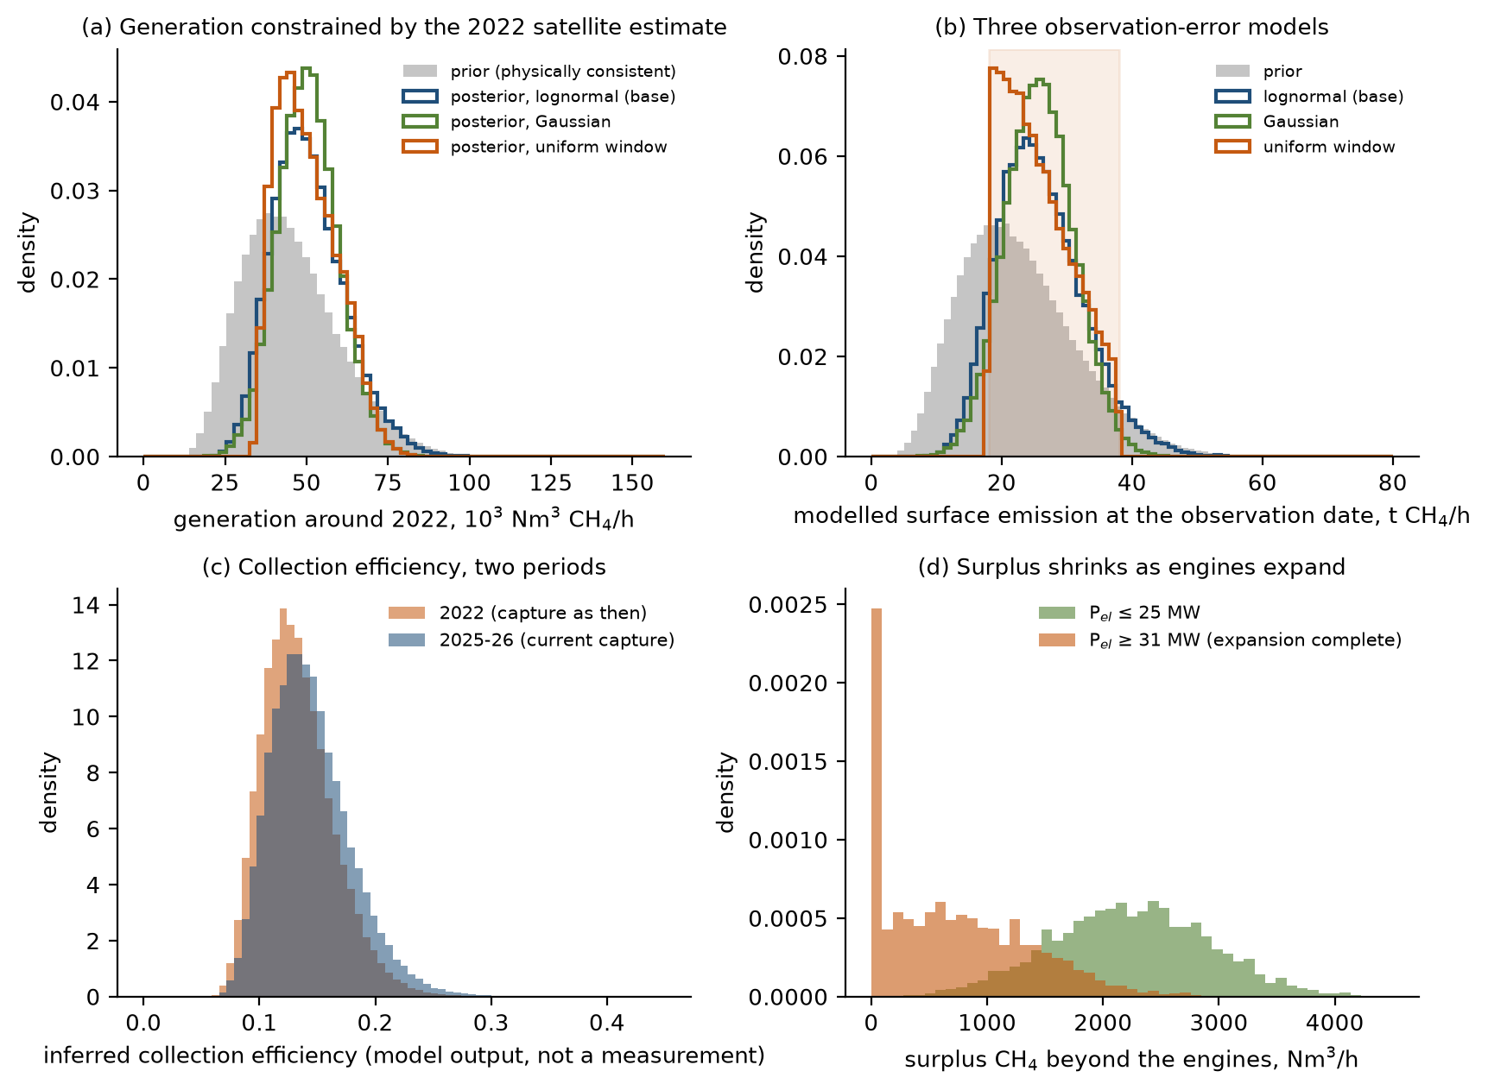
Fig. 1. Calibration. (a) Generation around 2022: prior and the posteriors of the three observation-error models. (b) Modeled surface emission at the observation date with the satellite range shaded. (c) Inferred collection efficiency in 2022 and 2025–26 (lognormal posterior; a model output, not a measurement). (d) Surplus methane beyond the existing engines by installed capacity.
4.2 Identifiability and representativeness of the satellite-constrained collection efficiency
The collection efficiency of Eq. (12) is determined by the emission, the oxidation fraction and the reported capture; the identity holds to 1e-16 in the sampled draws. In the lognormal posterior the log-odds of capture has a standard deviation of 0.27, of which 89% is carried by the emission, 7% by the reported capture and 3.9% by oxidation (Supplementary Table S1). The generation parameters are weakly identified individually: the satellite constraint contracts the interquartile range of L₀ by 13% and of f_{ss} by 13%, and leaves waste acceptance (A), the methane fraction and the historical capture essentially unchanged (contractions of 1%, 0% and 0%), whereas their product, the generation, contracts by 26%. Generation and efficiency are strongly dependent in the posterior (correlation of ln G₂₂ with η₂₂: −0.94), because efficiency is the capture divided by generation (Fig. 2a). The bottom-up prior already implies an efficiency of 0.15 (0.09–0.27) before any satellite information is used (prior median and 90% interval), so the satellite estimate narrows an inference that the generation prior and the reported capture already make, rather than creating it.
The conclusion does not depend on the generation history (Supplementary Table S6). Under the five alternatives the median 2022 efficiency ranges from 0.07 (high generation) to 0.24 (low generation) and the 2025–26 efficiency from 0.08 to 0.25. The alternatives are not equally compatible with the satellite estimate: relative to the base prior the evidence is 1.06 for the inventory-anchored prior, 1.25 for the first-order-decay history, 0.39 for high generation and 0.02 for low generation, which the 18 to 38 t h⁻¹ range disfavors by a factor of approximately 49. Widening the historical-capture prior widens the 2022 interval to 0.13 (0.07–0.21) but moves the median by less than 0.01. Across the generation histories the 2025–26 efficiency does not exceed 0.25, and the conclusions on covers, engines and biomethane do not change (Supplementary Table S6, last columns).
Representativeness is the larger uncertainty. The 2019–22 estimates are retrievals at the time of observation, not annual facility means, and wind, temporal sampling, detection thresholds and intermittent high-emission events can bias them in either direction, although airborne surveys find that large landfill emissions often persist across repeated visits (Cusworth et al., 2024). Scaling the satellite median by 0.25 to 2 moves the 2025–26 efficiency from 0.11 to 0.28 (medians), and widening σ_{ln} from 0.35 to 1.0 leaves the median at 0.15 but widens the interval to 0.15 (0.09–0.27). For the efficiency to reach 0.5, the surface emission would have to be approximately 4.3 t h⁻¹, a factor of 6 below the satellite median, and for 0.3 approximately 10 t h⁻¹. None of these changes the sign of any scenario's median NPV, and the probability that a cover reduces net emissions remains between 89% and 95% (Supplementary Table S6). The inferred efficiency of approximately 0.14 is therefore conditional on the model structure and on the satellite estimate; it is not evidence that the operator's reported capture is wrong.
Measured collection efficiencies are not directly comparable between sites. Field studies find that the default efficiencies of inventories tend to overstate capture (Giordano et al., 2024; Spokas et al., 2006), and reviews caution against transferring efficiencies between sites with different covers, ages and wellfield operation (Saul et al., 2026). An efficiency of 0.14 at a very large, young-cover site with a rapidly growing capture system is therefore not implausible in kind, but it lies far outside the efficiencies commonly assumed, and no published value is used as a prior for Norte III.
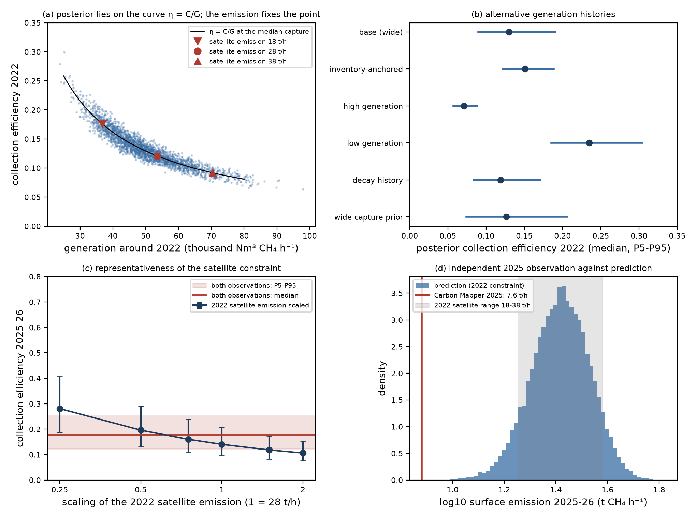
Fig. 2. Identifiability and independent check. (a) Posterior draws of generation and 2022 efficiency lie on the curve η = C/G; the satellite emission fixes the position along it. (b) Posterior 2022 efficiency under alternative generation histories (median, P5–P95). (c) 2025–26 efficiency against the scaling of the 2022 satellite emission, and with both observations. (d) Predicted 2025–26 surface emission against the independent 2025 observation (red line) and the 2022 satellite range.
4.3 External validation and model discrepancy
The automated tests establish internal consistency, not agreement with site behavior. One observation exists that is independent of the calibration and of the reported flows: the Carbon Mapper average of 7.6 t CH₄ h⁻¹ for 2025 (UCLA STOP Methane Project, 2026). The model calibrated on 2019–22 data alone predicts a 2025–26 surface emission of 26.3 (16.8 to 39.7) t h⁻¹ (median and 90% interval; Fig. 2d). The observed value is 29% of the predicted median; the predictive distribution lies at or below it in 0.0% of draws (1.5% when the lognormal error of the observation is included), a log-discrepancy of −2.2 standard deviations. The model therefore overpredicts the 2025 emission, and the discrepancy is not inside the stated interval.
Three explanations are possible and cannot be separated with the data at hand. First, the emission fell: reaching 2025's value from the 2022 estimate requires generation to fall to 37% of its 2022 value within approximately three years (the prior of g_{t} is 0.95 to 1.15) while about 18,000 t d⁻¹ continue to arrive, which is not credible for generation alone, although an emission reduction from interventions that are not in the model's baseline, such as new covers or leak repair since 2022, cannot be excluded. Second, the two data sets differ in instrument, retrieval algorithm, overpass time and averaging convention, and neither is a facility-wide annual mean; facility-scale agreement across methods is poor in general (Dogniaux et al., 2025). Third, the model's structure or priors may be wrong, for example the oxidation fraction or the assumption that the reported flows are complete. When both observations are used with their stated errors, the posterior surface emission is 19.3 (12.9–28.5) t h⁻¹ in 2022 and 19.8 (13.0–29.4) t h⁻¹ in 2025–26, and the efficiency in 2025–26 is 0.18 (0.12–0.25); the 2025 observation alone is 0.24 (0.15–0.37), and inflating both errors to 0.7 yields 0.18 (0.12–0.29). The base-case efficiency of 0.14 is therefore the lower end of a range of approximately 0.14 to 0.24 that the two satellite data sets jointly support, and in every case most of the generated methane is not collected (P95 0.37). Decisions are unchanged across the range: the probability that a cover reduces net emissions is 90% to 91%, the probability that additional engines are profitable given surplus gas is 99%, and no integrated scenario has a positive median NPV (Supplementary Table S6).
We conclude that the model is externally unvalidated at facility scale. Only one independent observation is available to us, it is a secondary summary without an uncertainty, and a second independent facility-scale data set does not exist in the sources we could access. Section 5.2 gives a field-measurement protocol that would convert this check into a validation.
4.4 Wellfield optimization and selective covers
S1 avoids a median 176 (52 to 380) kt CO₂e yr⁻¹ at a net present cost of 5.9 MUSD, a levelised abatement cost of US$4.6 per tCO₂e. A conventional cover reduces net methane emissions in 92% of draws and an experimental coating in 91% (Fig. 3a); the net effect of the cover alone is 8.1 (−1.1 to 25.3) kt CH₄ yr⁻¹ for the conventional cover. Net avoided methane is 64% of the gross added capture (median), so gross capture overstates the benefit by about a third. The break-even captured share s_{c}* has a median of 0.14 (0.04 to 0.30); the cover increases emissions in exactly the 7.5% of draws in which s_{c} falls below its own s_{c}*, and the analytic boundary tracks the simulated sign change (Fig. 3b). The cover's effect is controlled by s_{c} (Spearman ρ = 0.74), then by f_{hot}, ox and ε. Under the structural alternatives the probability of net benefit decreases to 81% (redirected gas not oxidized) and 88% (all oxidation lost under the cover).
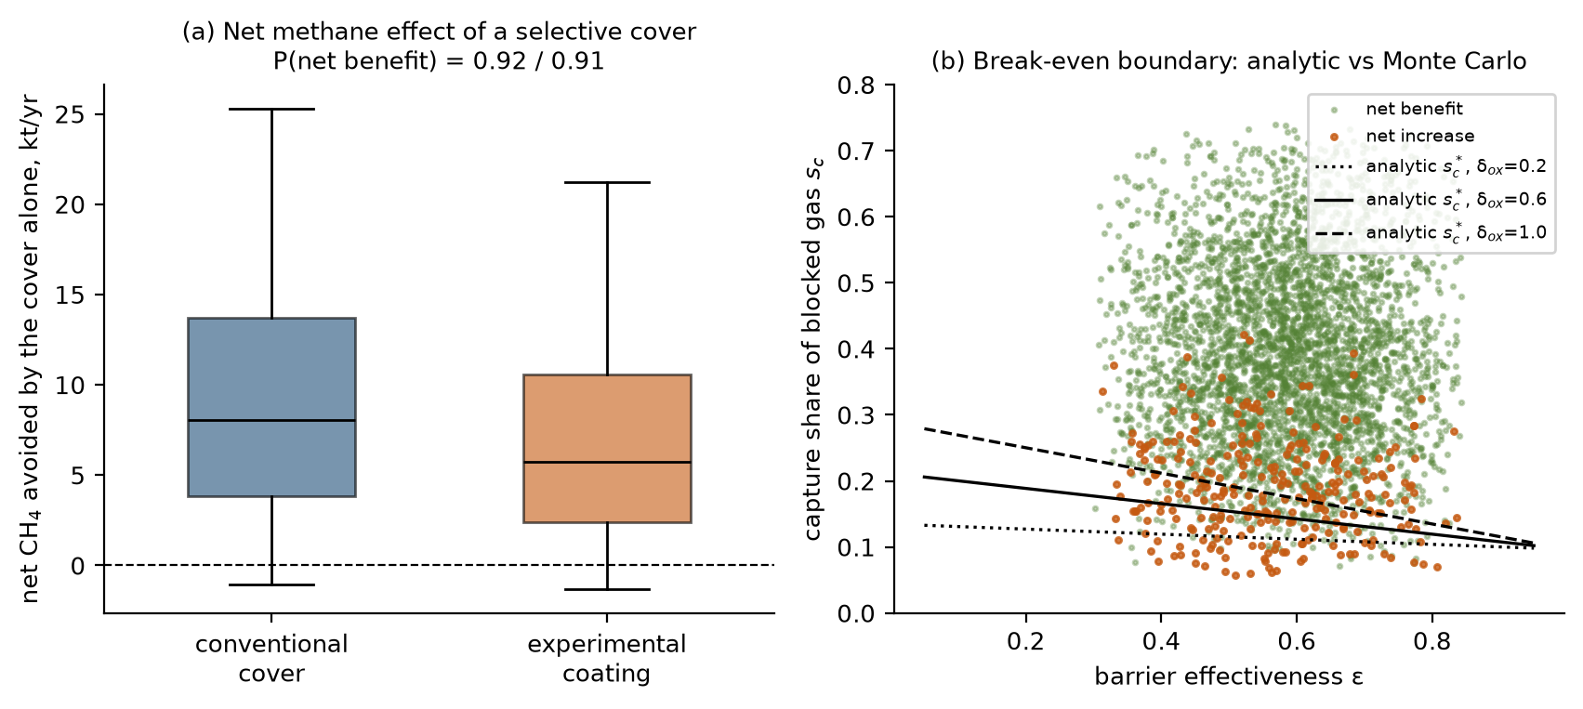
Fig. 3. Selective cover. (a) Net methane avoided by the cover alone, for the conventional cover (blue) and the experimental coating (orange); boxes P25–P75, line the median, whiskers P5–P95; the dashed line marks zero, and the figures above the panel are the probabilities that the net effect is a benefit. (b) Simulated net benefit (green) or net increase (orange) against barrier effectiveness ε and captured share s_{c} of the blocked gas, with the analytic break-even s_{c}* for three values of the oxidation-loss parameter δ_{ox} (dotted 0.2, solid 0.6, dashed 1.0).
4.5 Scenario economics without credits
None of the eight integrated intervention scenarios has a positive median incremental NPV under the assumed no-credit conditions (Fig. 4a; Table 2). The probability of a positive NPV is at most 0.014 (S6b). Measures do not add: S6, which upgrades the gas captured by the cover, has a lower median NPV than S6b, which upgrades without a cover (−19.4 against −14.7 MUSD), because the cover costs more than the extra gas is worth, and S7 avoids the most methane (512 kt CO₂e yr⁻¹) at the largest cost. Corporate tax with depreciation shields reduces the losses but does not change any sign (Table 2, after-tax column).
Scenario | NPV | P(NPV>0) | After tax | Avoided (kt CO₂e/yr) | Abatement | P(>0), US$25
S1 | −5.9 (−8.9 to −3.6) | 0.000 | −4.2 | 176 (52 to 380) | 4.6 | 0.98
S2 | −10.6 (−17.6 to −6.6) | 0.000 | −7.8 | 409 (109 to 931) | 3.6 | 0.97
S3 | −17.7 (−39.0 to −9.4) | 0.000 | −13.0 | 348 (93 to 820) | 7.2 | 0.93
S4 | −17.5 (−36.3 to −8.9) | 0.001 | −14.7 | 415 (115 to 939) | 6.0 | 0.95
S5 | −23.0 (−69.0 to −8.1) | 0.002 | −17.7 | 413 (113 to 937) | 8.0 | 0.89
S6 | −19.4 (−29.1 to −8.7) | 0.005 | −15.3 | 418 (119 to 941) | 6.2 | 0.95
S6b | −14.7 (−22.2 to −4.5) | 0.014 | −11.6 | 186 (60 to 389) | 10.5 | 0.89
S7 | −21.5 (−31.1 to −10.7) | 0.002 | −17.0 | 512 (192 to 1,061) | 5.6 | 0.98
PW | 6.1 (0.0 to 16.3) | 0.946 | 3.1 | 9 (1 to 11) | (profit) | 0.96
Table 2. Scenario results, lognormal posterior (median, P5 to P95). NPV incremental to S0 in MUSD with no credit revenue; after-tax median with 35% tax and 10-year depreciation; avoided emissions at GWP100; abatement cost in US$ per tCO₂e; last column P(NPV > 0) with a US$25 credit. PW: additional engines on the existing surplus (draws with surplus gas).
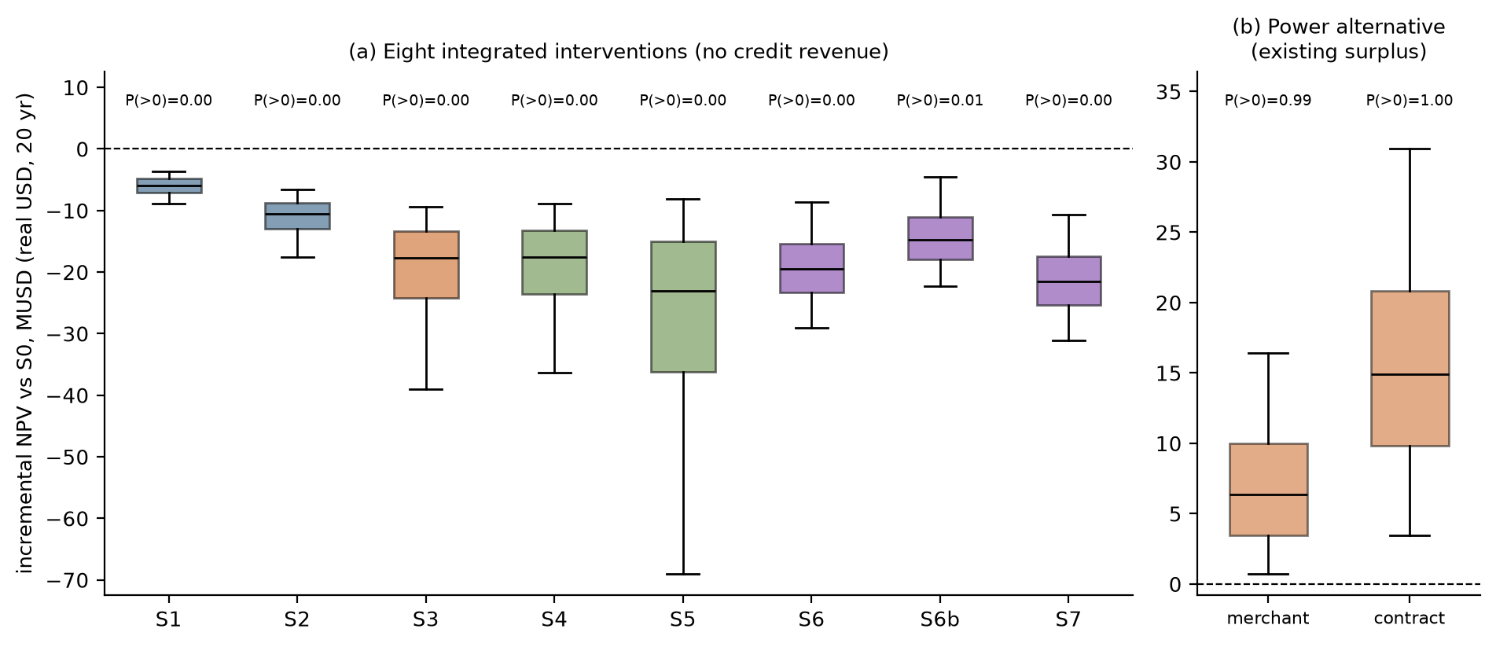
Fig. 4. Net present value (NPV). (a) Incremental NPV of the eight integrated interventions S1–S7 (defined in Table 1), lognormal posterior, no credit revenue, in millions of real US dollars over 20 years; boxes P25–P75, line the median, whiskers P5–P95; the dashed line marks zero, colors group similar measures, and P(>0) is the probability of a positive NPV. (b) NPV of additional engines on the existing surplus at merchant and contracted tariffs.
4.6 Additional engines and biomethane: counterfactuals for the surplus gas
The power alternative is reported separately because it is not an emission-reduction intervention but a competing use of gas that is already collected. Additional engines on the existing surplus have a positive NPV in 98.5% of the draws with surplus gas at merchant tariffs (median 6.3 (0.7 to 16.4) MUSD) and in 100.0% with a RenovAr-type contract (median 14.9 (3.5 to 30.9) MUSD; Fig. 4b). That probability is conditional on surplus gas existing and says nothing about whether it will exist (Table 3). At the installed 23 MW the surplus exists in 100% of draws and engines are profitable in 99% of all draws; with the prior range of capacity (23 to 33 MW) the figures are 96% and 95%; after the planned expansion to 33 MW surplus gas exists in only 70% of draws (median 690 Nm³ CH₄ h⁻¹ where it exists) and a profitable deployment in 69%. Declining gas supply lowers the probability given surplus to 95%; 25% downtime of the new engines to 90%; a US$45 per MWh tariff to 69%; a contracted tariff increases it to 100%. Combining a 33 MW fleet, declining supply, downtime, curtailment and the low tariff leaves a profitable deployment in 13% of draws (19% of those with surplus). The finding that engines are profitable on genuinely uncommitted gas is robust; whether genuinely uncommitted gas will remain after the expansion is not.
Operating state | P(surplus) | P(NPV>0 | surplus) | P(NPV>0, all) | Median NPV
installed capacity: 23 MW, constant gas supply | 1.00 | 0.99 | 0.99 | 7.7
prior range 23-33 MW, constant gas supply (base) | 0.96 | 0.99 | 0.95 | 6.3
planned expansion: 33 MW, constant gas supply | 0.70 | 0.99 | 0.69 | 3.5
33 MW, gas supply declining (first-order decay) | 0.70 | 0.95 | 0.66 | 3.0
base, new engines 25% less available (downtime) | 0.96 | 0.90 | 0.86 | 3.0
base, 20% of the output curtailed | 0.96 | 0.93 | 0.89 | 3.6
base, low tariff (US$45 per MWh) | 0.96 | 0.69 | 0.66 | 0.9
base, contracted tariff (RenovAr-type) | 0.96 | 1.00 | 0.96 | 14.9
stress: 33 MW, decline, 25% downtime, 20% curtailment, US$45 | 0.70 | 0.19 | 0.13 | −1.3
Table 3. Additional engines on the surplus gas under nine operating states (40,000 posterior draws each). P(surplus): probability that surplus gas exists; P(NPV>0 | surplus): probability of a positive NPV given that it exists; P(NPV>0, all): probability across all draws, counting a draw without surplus gas as no profitable deployment; median NPV in MUSD given surplus.
For the surplus beyond the existing engines, biomethane has a positive NPV in 5.4% of draws (median −9.8 (−16.3 to 0.3) MUSD) and beats additional engines in 0.02%. Where it is built, bio-GNC to an anchor customer is the preferred route in 99.9% of draws, because the pipeline price anchored to the PIST benchmark is low relative to the cost of a spur. The break-even realized bio-GNC plant-gate price is US$0.46 (0.26 to 1.42) per Nm³ (approximately US$14 per MMBtu) against a prior of 0.13 to 0.40; pipeline injection would need US$0.60 per Nm³ (US$18 per MMBtu), approximately six times the PIST price. To match additional engines, bio-GNC would need US$0.61 per Nm³. Sizing does not rescue upgrading: with only the existing surplus as feedstock, the probability of a positive NPV peaks at 0.05 at 2,000 Nm³ h⁻¹ of raw gas (Supplementary Fig. S4b). A gas buffer lowers NPV in 99.97% of draws (median −1.18 MUSD).
4.7 Climate accounting of the uses of recovered gas
A project can have a positive NPV and a small climate benefit, and the base account of Table 2 makes two simplifying choices that Supplementary Table S7 tests. For additional engines the base account credits only the displaced grid electricity at the average emission factor and treats the engines like the flare they replace; the median benefit is 9.0 kt CO₂e yr⁻¹, 2.2% of that of the cover (S2). The benefit is exhausted only if the engines slip more than 8.9% of the methane they burn (median break-even slip, P5 to P95: 7.4% to 10.7%), well above the 1 to 6% range tested, and a marginal grid factor increases it to 13.2 kt. If the surplus is not reliably flared (destruction efficiency 0.80 to 0.98), the benefit of burning it rises to 16.9 kt; with slip, marginal factor and poor flaring together it is 20.4 kt. For biomethane the benefit depends mainly on whether it displaces fossil gas: with displacement between 0.3 and 1.0 the median decreases from 8.0 to 3.8 kt CO₂e yr⁻¹ and the benefit is positive in 88% of draws instead of 99%. Financial and climate rankings differ: additional engines have the highest NPV of the uses of surplus gas and a benefit of a few percent of that of the capture measures, whereas S2 has the largest benefit and a negative NPV.
Credits add a further layer that this model does not resolve. Only the capture that is additional to what the operator is already required or committed to do could earn credits, and the engines' displaced grid electricity could be claimed under an electricity-certificate scheme as well as in a methane-credit project; the eligibility probability of 0.2 to 0.8 used in Section 4.11 is a placeholder for these tests, not an estimate of them.
4.8 Photovoltaics and the coating
The comparison of a conventional photovoltaic array with the experimental coating on the covered area is given in Supplementary Section S2 (Fig. S2), because the coating's performance priors are unvalidated. Conventional PV has a positive NPV in 4.0% of draws, with a median LCOE of US$119 (84 to 169) per MWh, above the merchant value of electricity because of the landfill foundation premium, the capital premium and the discount rate. The coating is cheaper in 23% of draws under deliberately wide priors, a property of those priors; the transferable result is the break-even efficiency η*, with a median of 9.7%, exceeding 10% in 48% of draws. Until that efficiency is demonstrated, the area is better used for the capture that Sections 4.4 and 4.5 evaluate.
4.9 Abatement cost
Median levelised abatement costs are low in absolute terms: US$3.6 (S2), 4.6 (S1), 5.6 (S7) and 10.5 (S6b) per tCO₂e at GWP100 (Supplementary Fig. S5). At GWP20 the avoided CO₂e is 2.95 times larger and the cost correspondingly lower; the median avoided in S2 becomes 1,206 kt CO₂e yr⁻¹.
4.10 Sensitivity
The NPV of upgrading without a cover (S6b) is controlled by price and capital: the realized-price multiplier (ρ = 0.52), the bio-GNC price (0.52) and the upgrader capital cost (−0.38); gas-side inputs rank lower (Supplementary Fig. S6a). The value of additional engines depends on the same price multiplier (0.64), then on the methane fraction, the discount rate and the installed engine capacity (Supplementary Fig. S6b). Tariff and exchange-rate risk, not gas chemistry, is the dominant uncertainty for monetizing recovered gas.
4.11 Credits, tax, financing and the discount rate
Because the abatement costs are low, a credit near US$5 to 10 per tCO₂e would make the capture measures viable if the added capture were eligible: at US$25 the probability of a positive NPV is 0.98 for S1 and 0.97 for S2 (Supplementary Fig. S7a). At the 2025 market range, with an eligibility probability between 0.2 and 0.8, the expected credit revenue increases P(NPV > 0) only to 0.33 (S1) and 0.38 (S2). The discount rate does not change any conclusion between 6 and 20% real (Supplementary Fig. S7b): S1 and S2 remain negative at every rate, S6b reaches at most 0.049, and the power alternative remains above 0.90. A WACC built from equity and debt costs gives a median S6b NPV of −14.6 MUSD against −14.7 in the base case. CEAMSE reports that it began certifying carbon credits linked to biogas management in 2025 (Canal 26, 2026); whether the added capture modeled here would be additional, verifiable and saleable is outside this study.
4.12 Robustness
Supplementary Table S8 and Supplementary Fig. S8 repeat the headline quantities under every variant. The decision-relevant conclusions do not change: no integrated scenario has a positive median NPV in any variant, additional engines on the surplus remain profitable in 92% to 100% of draws with surplus, upgrading beats them in under 1% of draws, and the cover's net benefit remains between 81% and 92%. The climate case moves with the generation prior and the emission estimate: without the satellite constraint S2 avoids 338 kt CO₂e yr⁻¹ instead of 405, and widening every prior by 50% increases it to 484. Correlated inputs change no headline quantity by more than a few percent. With a first-order-decay supply trajectory, the median NPV of additional engines decreases from 6.5 to 4.2 MUSD and remains positive in 93% of draws, while upgrading decreases from −9.7 to −10.7 MUSD.
5. Discussion
5.1 What the model says about priorities
The largest finding concerns scale. Collected methane is approximately 5.2 t h⁻¹, whereas the satellite-constrained generation is approximately 37 t h⁻¹, so most generated methane is not collected. The measures that change the balance are those that increase collection efficiency, at approximately 3.3 kt CH₄ yr⁻¹ per percentage point; coatings, PV and buffers act on the margin. The integrated package S7 lowers per-tonne emissions by a median 8%. This conclusion follows from the reported capture and the satellite constraint and does not depend on the economic priors, but its size depends on which satellite estimate is trusted (Sections 4.2 and 4.3). Because measured collection efficiencies at active sites span a wide range (Giordano et al., 2024; Saul et al., 2026; Spokas et al., 2006), a site flux campaign is the measurement with the largest value of information.
5.2 Decisions that are robust, and decisions that are not
Robust under the stated priors and every variant: no integrated measure pays without credit revenue; abatement is cheap per tonne; a cover needs a minimum captured share to help; a buffer does not pay; additional engines on genuinely uncommitted surplus gas are profitable at merchant and contracted tariffs. Not robust: the existence of surplus gas once the engine expansion is complete; the profitability of the engines under a low tariff, downtime and a declining supply; the ranking of the capture measures by abatement cost, which depends on the emission estimate; and the comparison of paint with PV, which depends on three unvalidated numbers. The break-even prices, s_{c}* and η* are the portable outputs, readable against a dated quotation or a measured captured share. We recommend that no capital be committed to coatings, buffers or upgrading before three measurements are in hand: a calibrated site flux survey to fix the collection efficiency, hourly gas flow and engine dispatch records to fix the true surplus, and a firm offtake or tariff quotation.
A field protocol would turn the check of Section 4.3 into a validation. (i) Facility-wide emission measurements across seasons with an independent method, for example tracer-gas dispersion or airborne mass balance, reported with wind and sampling uncertainty. (ii) A time series of satellite retrievals from more than one instrument with a common wind product, so that the 2019–22 and 2025 values can be compared on equal terms. (iii) Hourly biogas flow, methane fraction and engine dispatch, which fix C and the surplus directly. (iv) Pre-registration of the model's predictive interval for the surface emission (26 (17 to 40) t h⁻¹, Section 4.1) before the measurements are made, and its comparison with them afterwards. The operator reports that it now uses drones with the Sniffer method to measure fugitive emissions (Canal 26, 2026); publication of those data would serve (i) and (iv).
5.3 Limitations
The model is a lumped-parameter screening tool. It has no spatial gas-flow solution, so the hot-spot fraction, barrier effectiveness and captured share are parameters, not predictions; a pressure-resolved porous-media model is the next step for the cover question. The satellite constraint rests on a few retrievals from 2019–22 with wind and retrieval uncertainty, and the three error models span but do not exhaust the possibilities. The efficiency is determined by the emission, the oxidation fraction and the reported capture alone, so an error in any of them passes directly into it; the generation prior only restricts the draws. The model overpredicts the one independent 2025 observation by a factor of approximately 3.5 and is externally unvalidated at facility scale (Section 4.3). The generation prior and the growth factor that carries it to 2025–26 are assumptions. Operator figures were taken as reported, and the 23 MW and 33 MW capacities come from the white paper's summary of the operator statement. Prices are anchored to the benchmarks of Supplementary Table S5, but peso conversions and the plant-gate price a bio-GNC buyer would actually pay are assumptions. The engine slip, marginal grid factor, flare counterfactual and displacement ranges of Section 4.7 are assumptions, and credit additionality is not modeled. The PV-paint concept derives from the author's unpublished competition submission, and no experimental data exist for it; treating its performance as a prior asks what it would need to achieve, not what it will achieve.
5.4 What would falsify these conclusions
Conclusion | Fails if
Covers reduce net methane | The captured share of blocked gas falls below s_{c}* (median 0.14), for example when extraction headroom or header capacity is limiting.
Biomethane loses to power | A firm bio-GNC price above approximately US$0.61 per Nm³, or electricity worth less than the engines' break-even (median US$39 per MWh), or no engine capacity can be added.
Surplus gas exists | The 33 MW expansion is commissioned (surplus positive in 80% of those draws, median 633 Nm³ CH₄ h⁻¹), or hourly records show all collected gas committed.
Collection efficiency near 0.14 to 0.24 | A calibrated flux survey after the 2025–26 capture increase finds a surface emission outside about 7 to 40 t h⁻¹, or capture measured against generation inferred from deposition exceeds 0.5.
PV paint is unlikely to beat PV | Validated efficiency exceeds η* for its measured cost and life (Fig. S2a).
Table 4. Conditions under which each conclusion fails.
6. Conclusions
1. A methane balance constrained by satellite estimates at their own observation date implies a collection efficiency of approximately 0.13 in 2022 and 0.14 in 2025–26 at Norte III, increasing to 0.24 when an independent 2025 observation is added. The efficiency is determined by the emission, the oxidation fraction and the reported capture, not by the generation prior; it is conditional on the data and the model and is not a measurement. The leading mitigation lever is collection efficiency, worth approximately 3.3 kt CH₄ yr⁻¹ per percentage point.
2. The model overpredicts the one independent 2025 emission observation by a factor of approximately 3.5 and is externally unvalidated at facility scale; a field-measurement protocol is proposed to resolve this.
3. None of the eight integrated intervention scenarios has a positive median incremental NPV under the assumed no-credit conditions, although the median abatement costs are US$3.6 to 10.5 per tCO₂e; credit eligibility, not engineering feasibility, decides bankability.
4. Additional engines on uncommitted surplus gas are profitable in 99% of draws that have surplus gas at merchant tariffs, but in 69% of all operating states once the 33 MW expansion is complete, and their climate benefit is a few percent of that of the capture measures; biomethane would need approximately US$0.46 per Nm³ (US$14 per MMBtu) to break even.
5. A selective cover helps only when the captured share of the gas it blocks exceeds a closed-form threshold (median 0.14); gross capture overstates the net benefit by approximately one-third.
6. Every scenario closes its methane, carbon and energy balances, and the decision conclusions survive alternative generation histories, satellite scaling and error, correlated inputs, structural cover alternatives, tax and financing assumptions and climate-accounting choices.
Declarations
CRediT authorship contribution statement. Leon Sandler: Conceptualization, Methodology, Software, Formal analysis, Investigation, Writing – original draft, Writing – review and editing.
Declaration of generative AI and AI-assisted technologies in the writing process. During the preparation of this work the author used Claude (Anthropic) to assist with source gathering, code development, drafting and editing. The author reviewed and edited the content as needed and takes full responsibility for the content of the publication.
Funding. This research received no external funding.
Declaration of competing interest. The author declares no known competing financial interests or personal relationships that could have influenced the work reported in this paper. The PV-coating concept examined in Section 4.8 originates from the author's own unpublished competition submission.
Data and code availability. The model (NorteIII_MC.py), the identifiability and counterfactual analyses (NorteIII_review.py), the automated tests, the figure and export code (NorteIII_figs.py), the parameter table and all results are available at https://github.com/sandlerleon/norte3-landfill-methane-decision and archived at https://doi.org/10.5281/zenodo.23823890 (software, all versions; this manuscript describes version 2.1.2); this manuscript and its Supplementary Information are archived at https://doi.org/10.5281/zenodo.23823885 (all versions). One command regenerates every number, table and figure.
References
Agostini, A., Buffi, M., Hurtig, O., Carbone, C., Zanoni, F., Monteleone, G., 2024. Techno-economic evaluation of GHG emissions mitigation of biomethane upgrading technologies. Journal of Environmental Management 364, 121459. https://doi.org/10.1016/j.jenvman.2024.121459
Angelidaki, I., Treu, L., Tsapekos, P., Luo, G., Campanaro, S., Wenzel, H., Kougias, P.G., 2018. Biogas upgrading and utilization: current status and perspectives. Biotechnology Advances 36, 452–466. https://doi.org/10.1016/j.biotechadv.2018.01.011
Argentina, 2021. Ley 27.630, Impuesto a las Ganancias: modificación de alícuotas para sociedades. Boletín Oficial de la República Argentina, 16 June 2021.
Bakkaloglu, S., Cooper, J., Hawkes, A., 2022. Methane emissions along biomethane and biogas supply chains are underestimated. One Earth 5, 724–736. https://doi.org/10.1016/j.oneear.2022.05.012
Balcombe, P., Speirs, J.F., Brandon, N.P., Hawkes, A.D., 2018. Methane emissions: choosing the right climate metric and time horizon. Environmental Science: Processes & Impacts 20, 1323–1339. https://doi.org/10.1039/C8EM00414E
Beaumont, M.A., Zhang, W., Balding, D.J., 2002. Approximate Bayesian computation in population genetics. Genetics 162, 2025–2035. https://doi.org/10.1093/genetics/162.4.2025
Bloomberg News, 2022. Mountains of waste overwhelm Buenos Aires effort to curb methane. 1 December 2022. https://www.bnnbloomberg.ca/mountains-of-waste-overwhelm-buenos-aires-effort-to-curb-methane-1.1853619 (accessed 4 November 2026)
Bove, R., Lunghi, P., 2006. Electric power generation from landfill gas using traditional and innovative technologies. Energy Conversion and Management 47, 1391–1401. https://doi.org/10.1016/j.enconman.2005.08.017
CEAMSE, 2026. Información inexacta con respecto a la emisión de metano del Complejo Ambiental Norte III. https://www.ceamse.gov.ar/informacion-inexacta-con-respecto-a-la-emision-de-metano-del-complejo-ambiental-norte-iii/ (accessed 4 November 2026)
Canal 26, 2026. Tras aparecer como el más contaminante del mundo, el CEAMSE respondió y aseguró que cumple con los estándares ambientales. 18 May 2026. https://www.canal26.com/planeta/2026/05/18/tras-aparecer-como-el-mas-contaminante-del-mundo-el-ceamse-respondio-y-aseguro-que-cumple-con-los-estandares-ambientales/ (accessed 4 November 2026)
Chanton, J.P., Powelson, D.K., Green, R.B., 2009. Methane oxidation in landfill cover soils, is a 10% default value reasonable? Journal of Environmental Quality 38, 654–663. https://doi.org/10.2134/jeq2008.0221
Cusworth, D.H., Duren, R.M., Ayasse, A.K., Jiorle, R., Howell, K., Aubrey, A., Green, R.O., et al., 2024. Quantifying methane emissions from United States landfills. Science 383, 1499–1504. https://doi.org/10.1126/science.adi7735
Dogniaux, M., Maasakkers, J.D., Girard, M., Jervis, D., McKeever, J., Schuit, B.J., Sharma, S., Lopez-Noreña, A., Varon, D.J., Aben, I., 2025. Global satellite survey reveals uncertainty in landfill methane emissions. Nature 647, 397–402. https://doi.org/10.1038/s41586-025-09683-8
Duren, R.M., Thorpe, A.K., Foster, K.T., Rafiq, T., Hopkins, F.M., Yadav, V., Bue, B.D., et al., 2019. California's methane super-emitters. Nature 575, 180–184. https://doi.org/10.1038/s41586-019-1720-3
Energías Renovables, 2017. Argentina adjudica 1.408 megavatios renovables a un precio un 25% menor que el año pasado. 5 December 2017. https://www.energias-renovables.com/panorama/argentina-adjudica-1-408-megavatios-renovables-a-20171205 (accessed 4 November 2026)
Forster, P., Storelvmo, T., Armour, K., et al., 2021. The Earth's energy budget, climate feedbacks, and climate sensitivity, in: Climate Change 2021: The Physical Science Basis. Cambridge University Press, pp. 923–1054. https://doi.org/10.1017/9781009157896.009
Ghafoori, M.S., Loubar, K., Marin-Gallego, M., Tazerout, M., 2022. Techno-economic and sensitivity analysis of biomethane production via landfill biogas upgrading and power-to-gas technology. Energy 239, 122086. https://doi.org/10.1016/j.energy.2021.122086
Giordano, C.R., Van Brunt, M.E., Halevi, S.J., Castaldi, M.J., Orlovits, Z., Illes, Z., 2024. Landfill gas collection efficiency: categorization of data from existing in-situ measurements. Waste Management 175, 83–91. https://doi.org/10.1016/j.wasman.2023.12.042
IPCC, 2006. 2006 IPCC guidelines for national greenhouse gas inventories, volume 5: waste, chapter 3: solid waste disposal. IGES, Hayama, Japan. https://www.ipcc-nggip.iges.or.jp/public/2006gl/vol5.html (accessed 4 November 2026)
Iman, R.L., Conover, W.J., 1982. A distribution-free approach to inducing rank correlation among input variables. Communications in Statistics – Simulation and Computation 11, 311–334. https://doi.org/10.1080/03610918208812265
La Nación, 2025. Por qué no hay GNC en algunas estaciones de servicio de la Argentina. 3 July 2025. https://www.lanacion.com.ar/economia/por-que-no-hay-gnc-en-algunas-estaciones-de-servicio-de-la-argentina-nid03072025-2/ (accessed 4 November 2026)
MEGSA (Mercado Electrónico de Gas S.A.), 2025. Reforma del sector eléctrico: precios y costos del mercado mayorista (CAMMESA data). April 2025. https://www.megsa.ar/api/d/uVn (accessed 4 November 2026)
MSCI, 2025. The first Core Carbon Principles-qualifying projects: the VCM steps on the gas (blog post). https://www.msci.com/www/blog-posts/the-first-core-carbon/04528494831 (accessed 4 November 2026)
Maasakkers, J.D., Varon, D.J., Elfarsdóttir, A., McKeever, J., Jervis, D., Mahapatra, G., Pandey, S., et al., 2022. Using satellites to uncover large methane emissions from landfills. Science Advances 8, eabn9683. https://doi.org/10.1126/sciadv.abn9683
Marval O'Farrell Mairal, 2025. Reducción en derechos de importación y exportación (Decreto 513/2025). July 2025. https://www.marval.com/Publicacion/reduccion-en-derechos-de-importacion-y-exportacion-17286 (accessed 4 November 2026)
McKay, M.D., Beckman, R.J., Conover, W.J., 1979. A comparison of three methods for selecting values of input variables in the analysis of output from a computer code. Technometrics 21, 239–245. https://doi.org/10.1080/00401706.1979.10489755
Estudio O'Farrell, 2025. Precios PIST del gas natural, Resolución SE 487/2025. 12 December 2025. https://www.estudio-ofarrell.com/?p=24430 (accessed 4 November 2026)
Renewable Energy Magazine, 2017. Argentina subasta 1.200 megavatios de nueva potencia renovable. 22 August 2017. https://www.renewableenergymagazine.com/panorama/argentina-subasta-1-200-megavatios-de-nueva-20170822 (accessed 4 November 2026)
Rosso, M.E., 2016. Power generation from biogas utilization at landfill sites: Norte III final disposal environmental complex, metropolitan area of Buenos Aires. Global Methane Forum, Washington, DC, March 2016.
SRON Netherlands Institute for Space Research, 2022. Methane satellites find landfills with the same climate impact as several hundred thousand cars. Press release, 10 August 2022. https://www.sron.nl/en/?p=9721 (accessed 4 November 2026)
UCLA Emmett Institute STOP Methane Project, 2026. Spotlight on the top 25 methane plumes in 2025: landfills (Carbon Mapper data from Tanager-1 and EMIT, 1 January to 31 December 2025, retrieved 7 April 2026). 20 April 2026. https://law.ucla.edu/news/spotlight-top-25-methane-plumes-2025-landfills (accessed 4 November 2026)
Saltelli, A., Ratto, M., Andres, T., Campolongo, F., Cariboni, J., Gatelli, D., Saisana, M., Tarantola, S., 2008. Global sensitivity analysis: the primer. Wiley, Chichester. https://doi.org/10.1002/9780470725184
Sandler, L., 2026. Solar-assisted landfill methane recovery and biomethane valorization: a research white paper. Unpublished, 17 October 2026.
Saul, C.J., Imhoff, P.T., Wang, Y., Barlaz, M.A., 2026. Critical analysis of literature on landfill gas collection efficiency and its application to emissions estimates. Waste Management 213, 115353. https://doi.org/10.1016/j.wasman.2026.115353
Schuit, B.J., Maasakkers, J.D., Bijl, P., Mahapatra, G., van den Berg, A.W., Pandey, S., Lorente, A., et al., 2023. Automated detection and monitoring of methane super-emitters using satellite data. Atmospheric Chemistry and Physics 23, 9071–9098. https://doi.org/10.5194/acp-23-9071-2023
Spokas, K., Bogner, J., Chanton, J.P., Morcet, M., Aran, C., Graff, C., Moreau-Le Golvan, Y., Hebe, I., 2006. Methane mass balance at three landfill sites: what is the efficiency of capture by gas collection systems? Waste Management 26, 516–525. https://doi.org/10.1016/j.wasman.2005.07.021
Stuart, J., Bourlon, E., Martino, R., Coyle, L., Fraser, S., Laurin, E., Vogel, F., et al., 2026. Canada's landfill methane inventories: the challenge of accurate modeled and measurement-based emissions. Elementa: Science of the Anthropocene 14, 00115. https://doi.org/10.1525/elementa.2025.00115
Surtidores, 2025. Ajuste en el gas natural: cómo impacta el nuevo precio en el valor del GNC en las estaciones. 3 November 2025. https://surtidores.com.ar/ajuste-en-el-gas-natural-como-impacta-el-nuevo-precio-en-el-valor-del-gnc-en-las-estaciones/ (accessed 4 November 2026)
UDEA (Unión de Usuarios de Energía de Argentina), 2025. Informe sectorial, agosto 2025. https://www.udea.org.ar/newsroom/archivosinformes/Informe%20Sectorial%20Agosto%202025.pdf (accessed 4 November 2026)
Universidad del Salvador, Facultad de Ciencias Económicas, 2025. Informe económico mensual (IEM), diciembre 2025. https://www.usal.edu.ar/fceye/wp-content/uploads/sites/6/2025/12/IEM-Diciembre-2025-1.pdf (accessed 4 November 2026)

