Supplementary Information
for: Landfill methane recovery and use under deep uncertainty: a satellite-constrained Monte Carlo decision model for the Norte III landfill, Buenos Aires
Leon Sandler

S1. Identifiability: variance shares, contraction and dependence
Eq. (12) of the manuscript gives the 2022 collection efficiency from the satellite emission, the oxidation fraction and the reported capture. It holds to 1e-16 in the sampled draws. Because the log-odds of capture is a sum of three terms, its variance divides into shares: in the prior (draws consistent with η ≤ 0.95) the emission carries 97% of the variance of ln[(1−η)/η] (standard deviation 0.41), the reported capture 3.4% and oxidation −0.0%; in the lognormal posterior the shares are 89%, 7% and 3.9% (standard deviation 0.27). Table S1 gives the prior-to-posterior contraction of the inputs that enter generation; contraction is 1 − IQR(posterior)/IQR(prior), and KS is the Kolmogorov–Smirnov distance between the two marginals.
Input | Prior, median (P5–P95) | Posterior, median (P5–P95) | Contraction | KS
Waste acceptance A (t/d) | 16,500 (14,791–18,209) | 16,561 (14,862–18,243) | 1% | 0.026
Methane potential L0 (Nm³ CH₄/t) | 105 (67–150) | 113 (79–151) | 13% | 0.138
Steady-state fraction f_ss | 0.61 (0.40–0.84) | 0.65 (0.46–0.85) | 13% | 0.130
Methane fraction | 0.50 (0.44–0.55) | 0.50 (0.44–0.55) | −0% | 0.010
Oxidation fraction | 0.18 (0.09–0.30) | 0.17 (0.09–0.29) | 4% | 0.033
Collected biogas 2022 (Nm³/h) | 13,049 (12,332–13,700) | 13,047 (12,329–13,702) | −1% | 0.006
Generation G22 (Nm³ CH₄/h) | 43,527 (24,087–72,266) | 49,642 (34,300–70,876) | 26% | 0.238
Efficiency η 2022 | 0.15 (0.09–0.27) | 0.13 (0.09–0.19) | 43% | 0.231
Table S1. Prior-to-posterior contraction (prior: draws consistent with η ≤ 0.95; posterior: lognormal).
Posterior correlations (Pearson, of logarithms for the generation terms) are: ln L0 with ln f_ss −0.33 (prior 0.00), ln G22 with η22 −0.94, ln E22 with η22 −0.92, ln L0 with η22 −0.55 and ln f_ss with η22 −0.50. The negative correlation between L0 and f_ss is the ridge along which generation is constant; the satellite constraint selects the ridge, not a point on it.
S2. Photovoltaic coating against conventional photovoltaics
On the covered area, conventional PV has a positive NPV in 4.0% of draws and a median LCOE of US$119 (84 to 169) per MWh, above the merchant value of electricity because of the landfill foundation premium, the capital premium and the discount rate. The paint, with deliberately wide priors (efficiency 2 to 10%, installed cost US$5 to 150 per m², life 2 to 20 years), has a median LCOE of US$211 (60 to 605) per MWh and is cheaper in 23% of draws. Setting the levelised cost of the paint equal to that of conventional PV gives the break-even efficiency
$η^{*}=\frac{c_{pt} κ [CRF(r,L_{pt})+o_{pt}]}{LCOE_{\text{conv}} H_{poa} PR}$ (S1)
which has a median of 9.7% (2.9% to 24.9%) and exceeds 10% in 48% of draws (Fig. S2a). The 23% figure is a property of unvalidated priors; the transferable result is the η* surface. Verified against the simulation: setting the paint efficiency to η* gives LCOE parity to numerical precision (automated test).
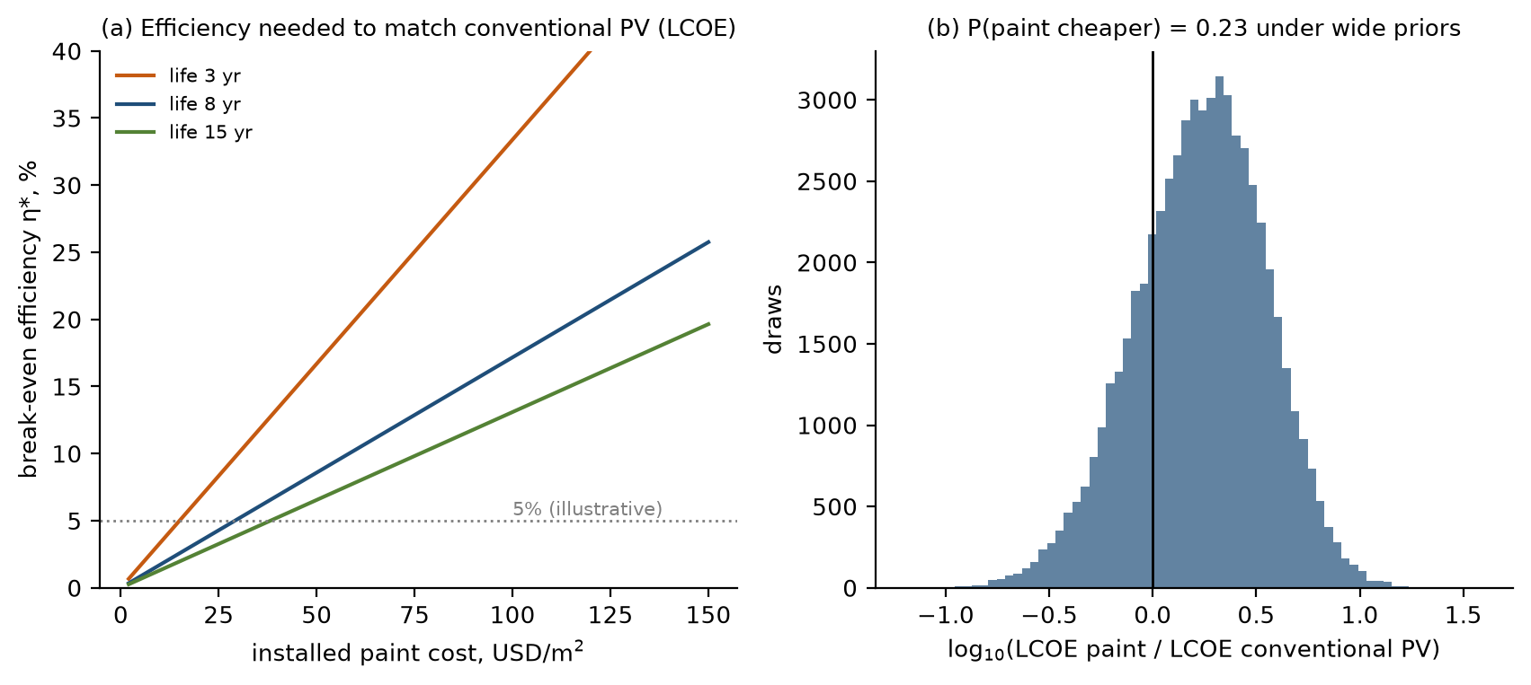
Fig. S2. (a) Break-even efficiency of PV paint for LCOE parity with conventional PV against installed cost, for three lifetimes (other inputs at posterior medians). (b) Distribution of the LCOE ratio.
S3. Input distributions
Table S2 lists the sampled inputs. Distributions are triangular (minimum, mode, maximum), uniform (minimum, maximum) or lognormal (σ, mean 1). Tags: R, operator-reported or published programme value; L, literature or standard value; B, dated market or regulatory benchmark (Table S5); A, assumed by the author and requiring a site-specific or dated quotation before use in a decision. Inputs marked * enter only the robustness variants. The sensitivities of Sections 3.8 and 3.9 of the manuscript (alternative generation priors, satellite scaling, engine slip 1 to 6%, marginal grid factor 0.35 to 0.65 with mode 0.45, counterfactual flare destruction 0.80 to 0.98, displacement 0.3 to 1.0) are tag A and are defined in NorteIII_review.py.
Input | Description | Distribution | Tag
Qcoll22 | collected biogas around 2022 (satellite period), Nm3/h; 13,100 peak in 2013, 13,800 in 2025 | tri(12,000, 13,100, 14,000) | A
Awaste | waste to Norte III, t/day (~18,000 reported) | tri(14,000, 16,500, 19,000) | R
L0 | CH4 generation potential, Nm3 CH4 per t waste (inventory 100, CAA 170) | tri(50, 100, 170) | L
fss | fraction of steady-state generation reached (age/decay/lag) | tri(0.3, 0.6, 0.95) | A
xCH4 | CH4 fraction of landfill gas | tri(0.42, 0.5, 0.57) | A
ox | cover methane oxidation fraction | tri(0.05, 0.15, 0.35) | L
g_t | generation 2025-26 relative to 2022 | tri(0.95, 1.05, 1.15) | A
Qcoll | collected biogas 2025-26, Nm3/h (13,800 in 2025; 16,000 Apr 2026) | tri(13,000, 14,800, 16,500) | R
P_el | installed biogas power, MW (23 in 2020; 33 planned 2026) | tri(23, 28, 33) | R
CF_el | engine capacity factor | tri(0.7, 0.85, 0.93) | A
eta_el | engine electrical efficiency | tri(0.36, 0.4, 0.43) | L
d_f | flare/engine CH4 destruction efficiency | tri(0.95, 0.98, 0.995) | L
dEta1 | S1 absolute gain in collection efficiency (of generation) | tri(0, 0.02, 0.06) | A
capex_s1 | S1 capex, MUSD | tri(0.5, 1.5, 4) | A
opex_s1 | S1 opex, MUSD/yr | tri(0.15, 0.4, 1) | A
f_hot | flux fraction passing covered area | tri(0.1, 0.25, 0.5) | A
h_e | hot-spot flux enrichment over mean | tri(1.5, 3, 6) | A
A_act | actively emitting area, ha | tri(100, 200, 400) | A
eps_conv | conventional cover: fraction of arriving CH4 blocked | tri(0.3, 0.6, 0.85) | A
eps_coat | experimental coating: fraction blocked | tri(0.1, 0.45, 0.85) | A
s_c | share of blocked CH4 captured by extraction | tri(0.05, 0.35, 0.75) | A
delta_ox | fractional loss of oxidation under cover | tri(0.2, 0.6, 1) | A
rho_r | oxidation of redirected gas relative to ox | uni(0, 1) | A
c_conv | conventional cover cost, kUSD/ha | tri(80, 150, 300) | A
c_coat | experimental coating cost, kUSD/ha | tri(100, 250, 700) | A
om_cov | cover O&M, fraction of capex per yr | tri(0.015, 0.03, 0.05) | A
life_conv | conventional cover life, yr | tri(15, 25, 30) | A
life_coat | coating life, yr | tri(4, 8, 15) | A
r | real USD discount rate (EMBI 2025: 561 to >1,200 bps; 569 bps Dec 2025) | tri(0.08, 0.12, 0.18) | B
f_imp | imported share of equipment capex | tri(0.5, 0.7, 0.9) | A
duty | import duty on capital goods (0% BK regime; 12.6% Decree 513/2025; 20% Mercosur CET) | tri(0, 0.126, 0.2) | B
logist | freight, logistics and FX cost on imports, fraction | tri(0.03, 0.08, 0.15) | A
m_p | realised-price multiplier (tariff/FX risk), mean 1 | logn(0.25) | A
avail_firm | fraction of surplus gas contractually firm | tri(0.6, 0.85, 1) | A
uptime | plant availability | tri(0.8, 0.9, 0.95) | A
rec | CH4 recovery in upgrading | tri(0.9, 0.95, 0.985) | L
tail_ox | fraction of tail-gas CH4 slip oxidised | uni(0, 0.95) | A
fug_plant | plant fugitive CH4, fraction of CH4 in | tri(0.002, 0.006, 0.012) | L
capex_up | upgrader capex, USD per Nm3/h raw capacity | tri(1,800, 3,000, 5,000) | A
e_up | upgrading electricity, kWh/Nm3 raw | tri(0.2, 0.28, 0.4) | L
c_el | electricity purchase cost, USD/MWh (wholesale monomic ~87-91 USD/MWh 2024-25 plus network) | tri(70, 95, 130) | B
om_up | upgrader O&M, fraction of capex per yr | tri(0.03, 0.04, 0.06) | A
lab_up | labour/other, MUSD/yr | tri(0.15, 0.25, 0.45) | A
capex_gv | GNC compression capex, USD per Nm3/h product | tri(400, 800, 1,500) | A
capex_gf | GNC fixed capex, MUSD | tri(0.3, 0.8, 2) | A
p_gnc | bio-GNC net plant-gate price, USD/Nm3 (delivered station gas ~0.15, retail ~0.40-0.45, 2025) | tri(0.13, 0.19, 0.4) | B
p_pipe | pipeline net plant-gate price, USD/Nm3 (PIST 2.94-2.98 USD/MMBtu, Dec 2025) | tri(0.07, 0.1, 0.16) | B
D_gnc | bio-GNC anchor demand, Nm3/h | tri(300, 1,000, 3,000) | A
dist_km | distance to injection point, km | tri(2, 8, 20) | A
c_km | pipeline spur cost, MUSD/km | tri(0.3, 0.6, 1.2) | A
c_inj | injection/metering station, MUSD | tri(0.5, 1, 2) | A
capex_pw | gas-engine power capex, USD/kW (RenovAr landfill-gas ref 1.3 MUSD/MW) | tri(1,100, 1,300, 1,700) | R
p_el | electricity sale price, merchant/MAT, USD/MWh (marginal cost 69, monomic ~87-91, 2024-25) | tri(60, 75, 95) | B
p_el_k* | electricity sale price, RenovAr-type contract, USD/MWh (landfill-gas awards 128-130, 2017) | tri(110, 125, 135) | B
cf_pw | new engines capacity factor | tri(0.8, 0.88, 0.93) | A
eta_pw | new engines electrical efficiency | tri(0.36, 0.4, 0.43) | L
om_pw | engine O&M, fraction of capex per yr | tri(0.03, 0.045, 0.07) | A
var_loss | flow-variability loss without buffer | uni(0.05, 0.25) | A
zeta | fraction of variability loss removed by buffer | uni(0.5, 0.9) | A
capex_buf | buffer capex, MUSD | tri(0.3, 0.8, 2) | A
leak_buf | buffer CH4 leakage, fraction of throughput | tri(0.002, 0.005, 0.01) | A
f_pv | share of upgrader electricity from on-site PV | uni(0.1, 0.5) | A
dEta_ad | adaptive-control gain in collection efficiency | tri(0, 0.01, 0.03) | A
capex_ad | adaptive control capex, MUSD | tri(0.2, 0.5, 1.2) | A
opex_ad | adaptive control opex, MUSD/yr | tri(0.05, 0.1, 0.25) | A
kwp_ha | conventional PV, kWp per ha | tri(500, 700, 900) | A
capex_pv | PV capex, USD/kW (RenovAr ref 850) | tri(550, 750, 1,100) | R
prem_pv | landfill foundation premium for PV | tri(1.1, 1.3, 1.6) | A
yield_pv | PV yield, kWh/kWp/yr | tri(1,350, 1,500, 1,650) | A
om_pv | PV O&M, fraction of capex per yr | tri(0.01, 0.015, 0.025) | A
life_pv | PV life, yr | tri(20, 25, 30) | A
p_pv | PV electricity value, merchant, USD/MWh (2024-25 wholesale cost) | tri(55, 70, 90) | B
eta_pt | PV-paint module efficiency (unvalidated) | tri(0.02, 0.05, 0.1) | A
c_pt | PV-paint installed cost, USD/m2 (unvalidated; wide on purpose) | tri(5, 30, 150) | A
life_pt | PV-paint life, yr (unvalidated; wide on purpose) | tri(2, 6, 20) | A
pr_pt | PV-paint performance ratio | tri(0.65, 0.78, 0.85) | A
om_pt | PV-paint O&M, fraction of capex per yr | tri(0.01, 0.02, 0.04) | A
H_poa | plane-of-array irradiation, kWh/m2/yr | tri(1,550, 1,650, 1,750) | A
ef_grid | grid emission factor, tCO2/MWh | tri(0.28, 0.31, 0.36) | A
cp* | carbon-credit price if eligible, USD/tCO2e (VCM ~5.5, landfill gas ~9.5 USD, 2025) | tri(2, 6, 12) | B
p_elig* | probability that added capture is eligible for credits | uni(0.2, 0.8) | A
dv* | debt share of financing | tri(0, 0.4, 0.6) | A
r_e* | real cost of equity | tri(0.12, 0.16, 0.22) | A
r_d* | real cost of debt | tri(0.07, 0.09, 0.12) | A
k_dec* | first-order decay rate, 1/yr (IPCC 2006, temperate wet MSW) | tri(0.05, 0.09, 0.15) | L
age* | years of deposition before 2026 | tri(20, 28, 32) | A
t_close* | years until deposition stops, from 2026 | tri(3, 8, 15) | A
Table S2. Input distributions.
S4. Balances and automated tests
Scenario | Emitted | Oxidised | Destroyed | Exported | Biogenic C | Exported energy | Electricity | Total CO₂e
S0 | 231.5 | 47.7 | 44.8 | 0.0 | 69.2 | 0.0 | 0.0 | 6.25
S1 | 224.6 | 46.2 | 53.2 | 0.0 | 74.5 | 0.0 | 0.0 | 6.06
S2 | 215.3 | 39.1 | 68.9 | 0.0 | 82.0 | 0.0 | 0.0 | 5.81
S4 | 215.3 | 39.1 | 68.9 | 0.0 | 82.0 | 0.0 | 0.0 | 5.81
S6 | 215.4 | 39.1 | 64.0 | 5.0 | 78.3 | 69.4 | 6.3 | 5.80
S6b | 224.7 | 46.2 | 48.2 | 5.0 | 70.9 | 69.2 | 6.2 | 6.06
S7 | 211.9 | 38.3 | 68.3 | 5.0 | 80.9 | 69.4 | 4.3 | 5.71
Table S3. Scenario balances for the median draw: methane emitted, oxidized, destroyed and exported (kt CH₄ yr⁻¹); biogenic carbon released as CO₂ (kt C yr⁻¹); biomethane energy exported and grid electricity used (GWh yr⁻¹); total emissions (Mt CO₂e yr⁻¹, GWP100). Residuals of all balances are below 10⁻⁹ of generation.
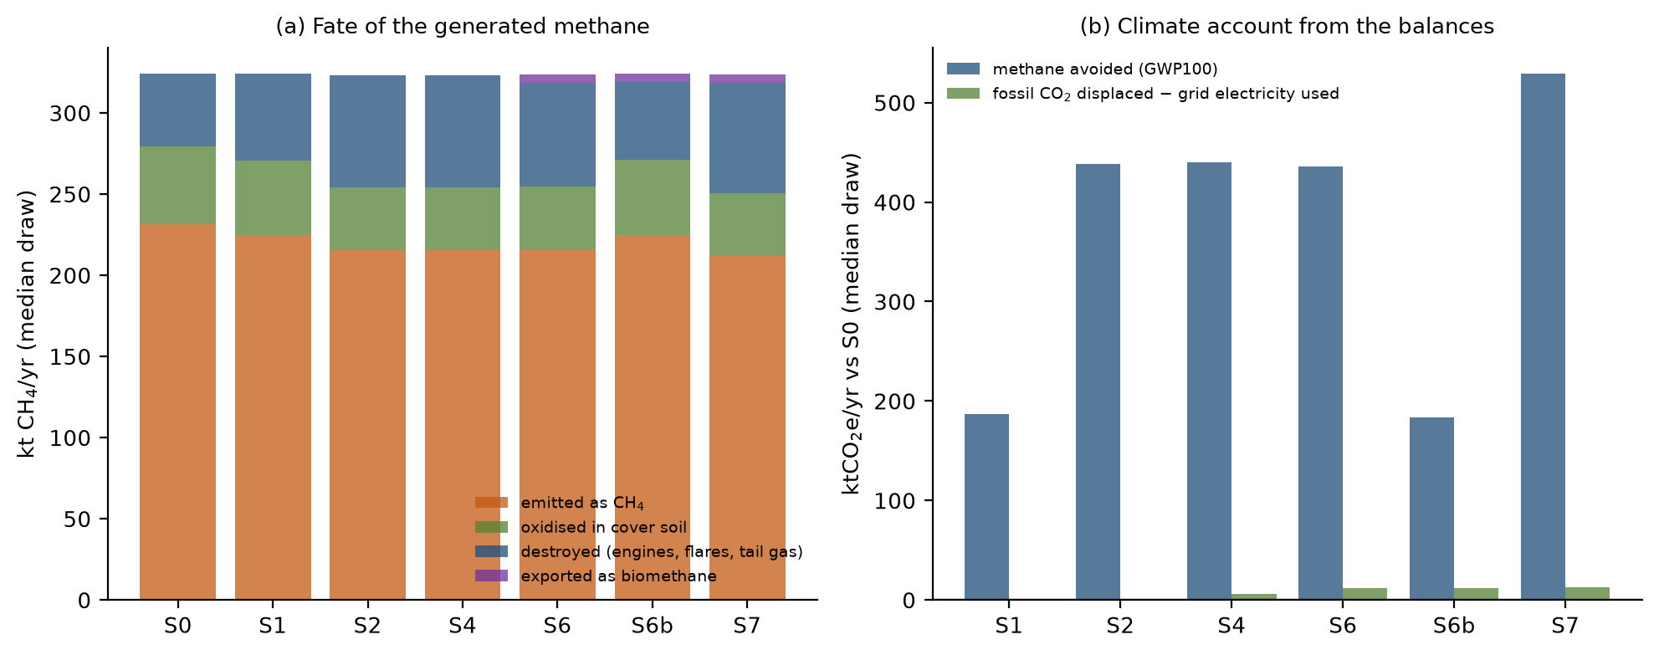
Fig. S3. (a) Fate of the generated methane by scenario (median draw). (b) Climate account from the balances: methane avoided (GWP100) and fossil CO₂ displaced net of grid electricity used, relative to S0.
The automated test suite (python NorteIII_MC.py --test) contains 59 checks, all of which pass: unit conversions (methane mass, carbon content, annuity and capital recovery factors); Latin-hypercube moments and the induced rank correlation; the white paper's screening arithmetic; closure of the cover balance; the analytic break-even s_{c}*; two limiting cases of the cover; methane and carbon closure of seven scenario balances; methane and energy closure of four upgrader accounts; equality of balance-based and incremental climate benefits for four scenarios; a hand-calculated upgrading case; an explicit cash-flow benchmark of the annuity NPV; unprofitability at zero gas prices; LCOE parity at η*; the calibration window; physical consistency of the posterior; determinism; the steady-state limit of the time-resolved NPV and the analytic slow-decay limit of the first-order-decay model; the closed-form identity of the collection efficiency and the additive identity of its log-odds; the uninformative limit of the observation model; the reproduction of the annuity NPV by the engine counterfactual in the constant-supply and fast-decay limits; the capital-and-O&M floor under full curtailment; the zero of the engines' climate benefit at the break-even slip; the consistency of the conditional and unconditional probabilities; and the Monte Carlo standard error.
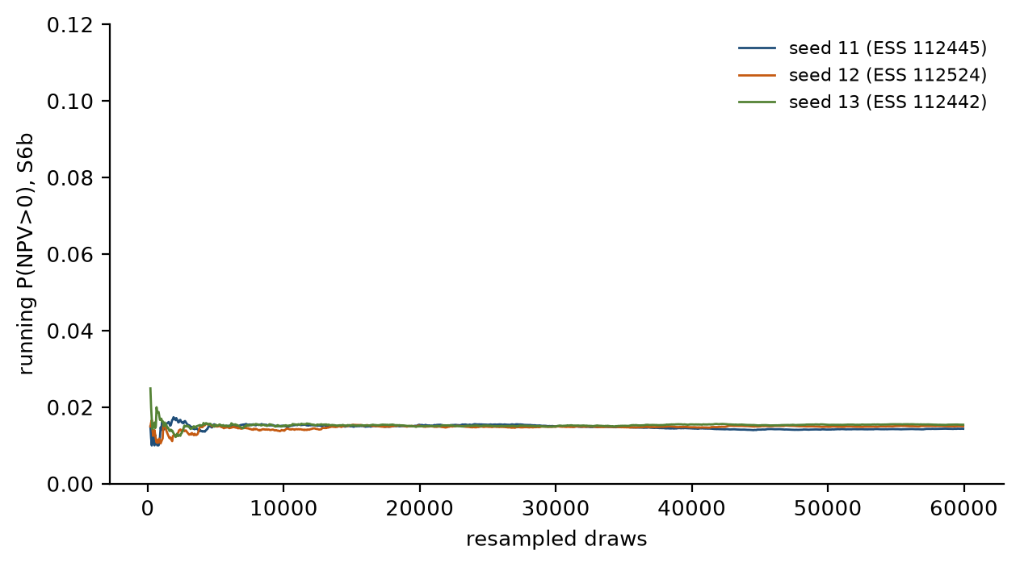
Fig. S1. Running probability of positive NPV for S6b across three independent seeds (resampled lognormal posterior; ESS in the legend).
Balances and climate account. In every scenario the methane, carbon and energy balances close to round-off (relative residuals below 10⁻⁹), and the climate benefit computed from the balances equals the incremental benefit to within 10⁻⁸. For a median draw in the reference case 232 kt CH₄ yr⁻¹ is emitted, 48 kt is oxidized in the cover soil and 45 kt is destroyed in engines and flares; the measures shift methane from the first category to the third, and upgrading exports 5.0 kt CH₄ yr⁻¹ as biomethane (Table S3 and Fig. S3). The fossil-CO₂ credit of upgrading (displaced natural gas minus grid electricity used) is small against the methane term.
S5. Scorecard for the research hypotheses
Hypothesis | Result
H1: cover plus pressure-managed extraction lowers total emissions | Supported conditionally: net reduction in 92% of draws if s_{c} > s_{c}* (median 0.14); net benefit is 64% of gross capture.
H2: PV coatings beat conventional PV only above measurable thresholds | Paint cheaper in 23% of draws under wide, unvalidated priors; break-even efficiency 9.7% at median inputs.
H3: biomethane from surplus gas has higher risk-adjusted NPV than alternatives | Not supported: beats additional engines in 0.02% of draws; break-even US$0.46 per Nm³ (US$14 per MMBtu).
H4: buffering offsets its leakage, energy and capital costs | Not supported: positive in 0.03% of draws; median ΔNPV −1.18 MUSD.
H5: the integrated configuration has lower lifecycle CO₂e per tonne of waste | Supported but small: S7 lower in 99.6% of draws; median reduction 8.3%, from 1.04 to 0.95 tCO₂e per tonne.
Table S4. Outcome of the five hypotheses of the project white paper (lognormal posterior).
S6. Further tables and figures of the main analysis
These tables and figures were part of the main text of the first submission and moved here to keep the main text within eight tables and figures. They are cited from the main text as Supplementary Tables S5 to S8 and Supplementary Figs. S4 to S8.
Item | Benchmark | Date | Source | Prior used
Wellhead (PIST) gas price, AMBA distributors | US$2.94–2.98 per MMBtu | Dec 2025 | (Estudio O'Farrell, 2025) | p_pipe tri(0.07, 0.10, 0.16) US$ per Nm³
Gas delivered to AMBA GNC stations (pre-VAT) | ARS 221.63 per m³ (≈ US$0.16) | Nov 2025 | (Surtidores, 2025) | p_gnc tri(0.13, 0.19, 0.40) US$ per Nm³
Retail GNC price, AMBA | ARS 500–570 per m³ (≈ US$0.36–0.41) | Jul 2025 | (La Nación, 2025) | upper end of p_gnc
Wholesale electricity: marginal and priority-market cost | US$69 and 64 per MWh | 2024 | (MEGSA, 2025) | p_el tri(60, 75, 95) US$ per MWh (merchant)
Monomic wholesale electricity price | ARS 121,100 per MWh (≈ US$87) | Aug 2025 | (UDEA, 2025) | c_el tri(70, 95, 130) (purchase incl. network)
RenovAr landfill-gas contract awards | US$128–130 per MWh | 2017 | (Energías Renovables, 2017; Renewable Energy Magazine, 2017) | p_el,k tri(110, 125, 135) (contract variant)
Import duty on capital goods | 12.6% (Decree 513/2025); 20% CET | Jul 2025 | (Marval O'Farrell Mairal, 2025) | duty tri(0, 0.126, 0.20)
Country risk (EMBI spread) | 561 to >1,200 bp; 569 bp on 17 Dec | 2025 | (USAL, 2025) | r tri(0.08, 0.12, 0.18) real
Corporate income tax, top bracket | 35% | 2021 law | (Argentina, 2021) | after-tax variant
Landfill-gas carbon credits; voluntary-market average | ≈US$9.5 and 5.5 per tCO₂e | 2025 | (MSCI, 2025) | cp tri(2, 6, 12), eligibility uni(0.2, 0.8)
Table S5. Dated Argentine benchmarks and the priors anchored to them (US$ conversions at 1,400 ARS per USD, an assumption).
Variant | η 2022 | η 2025–26 | Evidence | P(cover) | P(PW>0) | S6b NPV | Any > 0
Base generation prior | 0.13 (0.09–0.19) | 0.14 (0.10–0.21) | 1.00 | 0.92 | 0.99 | −14.7 | no
Inventory-anchored generation | 0.15 (0.12–0.19) | 0.16 (0.13–0.21) | 1.06 | 0.93 | 0.99 | −14.8 | no
High generation | 0.07 (0.06–0.09) | 0.08 (0.06–0.10) | 0.39 | 0.89 | 0.99 | −14.6 | no
Low generation | 0.24 (0.19–0.30) | 0.25 (0.20–0.33) | 0.02 | 0.95 | 0.99 | −15.0 | no
First-order-decay history | 0.12 (0.08–0.17) | 0.13 (0.09–0.19) | 1.25 | 0.92 | 0.99 | −14.7 | no
Wide historical-capture prior | 0.13 (0.07–0.21) | 0.14 (0.10–0.21) | 1.00 | 0.92 | 0.99 | −14.7 | no
Satellite emission × 0.25 | 0.26 (0.18–0.37) | 0.28 (0.19–0.41) | – | 0.90 | 0.99 | −14.9 | no
Satellite emission × 0.50 | 0.18 (0.12–0.27) | 0.20 (0.13–0.29) | – | 0.91 | 0.99 | −14.8 | no
Satellite emission × 0.75 | 0.15 (0.10–0.22) | 0.16 (0.11–0.24) | – | 0.92 | 0.98 | −14.7 | no
Satellite emission × 1.00 | 0.13 (0.09–0.19) | 0.14 (0.10–0.21) | – | 0.93 | 0.98 | −14.7 | no
Satellite emission × 1.50 | 0.11 (0.08–0.16) | 0.12 (0.08–0.17) | – | 0.93 | 0.99 | −14.6 | no
Satellite emission × 2.00 | 0.10 (0.07–0.14) | 0.11 (0.08–0.15) | – | 0.94 | 0.99 | −14.7 | no
Observation error σ = 0.50 | 0.13 (0.09–0.21) | 0.15 (0.09–0.23) | – | 0.92 | 0.99 | −14.7 | no
Observation error σ = 0.70 | 0.14 (0.09–0.23) | 0.15 (0.09–0.25) | – | 0.92 | 0.99 | −14.7 | no
Observation error σ = 1.00 | 0.14 (0.09–0.25) | 0.15 (0.09–0.27) | – | 0.92 | 0.98 | −14.7 | no
2025 observation alone | 0.22 (0.13–0.34) | 0.24 (0.15–0.37) | – | 0.90 | 0.99 | −14.8 | no
2022 and 2025 observations | 0.16 (0.11–0.23) | 0.18 (0.12–0.25) | – | 0.91 | 0.99 | −14.7 | no
Both, errors inflated to 0.7 | 0.17 (0.11–0.27) | 0.18 (0.12–0.29) | – | 0.91 | 0.99 | −14.8 | no
Table S6. Identifiability and representativeness: collection efficiency (median, P5–P95) and decision-relevant quantities under alternative generation histories, scaling and error of the satellite emission, and the independent 2025 observation. Evidence: mean likelihood of the 2022 satellite estimate under each generation prior, relative to the base prior (not defined for the other rows). P(cover): probability that the conventional cover reduces net emissions; P(PW > 0): probability that additional engines have a positive NPV given surplus gas; S6b NPV in MUSD; last column: does any integrated scenario have a positive median NPV?
Account | Benefit (kt CO₂e/yr) | P(benefit > 0)
Added engines: base (average grid factor, engines as flare) | 9.0 (2.3–10.9) | 1.00
Added engines: pessimistic engine slip (1-6%) | 7.2 (1.8–11.6) | 1.00
Added engines: marginal grid factor | 13.2 (3.5–18.0) | 1.00
Added engines: poor counterfactual flare (efficiency 0.80-0.98) | 16.9 (4.4–29.8) | 1.00
Added engines: slip + marginal factor + poor flare | 20.4 (5.4–34.1) | 1.00
Biomethane (S6b gas): base (full displacement, average grid factor) | 8.0 (1.2–14.4) | 0.99
Biomethane (S6b gas): partial displacement of fossil gas (0.3-1.0) | 3.8 (−1.8–10.4) | 0.88
Biomethane (S6b gas): marginal grid factor for upgrader electricity | 7.1 (0.7–13.3) | 0.98
Biomethane (S6b gas): poor counterfactual flare (efficiency 0.80-0.98) | 23.6 (5.1–57.0) | 1.00
Biomethane (S6b gas): all three | 18.4 (2.7–51.4) | 1.00
Table S7. Climate benefit (GWP100) of additional engines and of biomethane on the existing surplus under alternative accounting choices, in kt CO₂e per year relative to flaring the same gas (median and P5–P95, draws with surplus gas); sensitivities of tag A, not predictions.
Variant | η 2022 | η 2025–26 | S2 avoided | P(cover) | S6b NPV | P(PW>0) | p* | Abatement S2 | Any > 0
likelihood: lognormal | 0.130 | 0.140 | 405 | 0.92 | −14.7 | 0.99 | 0.46 | 3.7 | no
likelihood: Gaussian | 0.129 | 0.139 | 410 | 0.92 | −14.7 | 0.99 | 0.46 | 3.6 | no
likelihood: uniform window | 0.132 | 0.142 | 407 | 0.92 | −14.7 | 0.99 | 0.46 | 3.6 | no
prior only (no satellite constraint) | 0.149 | 0.160 | 338 | 0.92 | −14.7 | 0.99 | 0.46 | 4.4 | no
correlated inputs (Iman-Conover) | 0.134 | 0.144 | 402 | 0.92 | −14.7 | 0.98 | 0.46 | 3.7 | no
uniform marginals | 0.120 | 0.130 | 439 | 0.83 | −15.9 | 0.97 | 0.52 | 3.9 | no
priors widened by 50% | 0.122 | 0.132 | 484 | 0.90 | −16.4 | 0.92 | 0.51 | 3.4 | no
cover: redirected gas unoxidised | 0.130 | 0.140 | 340 | 0.81 | −14.7 | 0.99 | 0.46 | 4.4 | no
cover: all oxidation lost under cover | 0.130 | 0.140 | 373 | 0.88 | −14.7 | 0.99 | 0.46 | 4.0 | no
contracted electricity tariff (RenovAr-type) | 0.130 | 0.140 | 405 | 0.92 | −14.7 | 1.00 | 0.46 | 3.7 | no
WACC from equity, debt and tax | 0.130 | 0.140 | 405 | 0.92 | −14.6 | 0.98 | 0.47 | 3.7 | no
Table S8. Robustness of the headline quantities (medians unless stated). η: inferred collection efficiency; S2 avoided in kt CO₂e yr⁻¹; P(cover): probability that the cover reduces net emissions; S6b NPV in MUSD; P(PW > 0): probability that additional engines have positive NPV given surplus gas; p*: bio-GNC break-even price in US$ per Nm³; abatement cost of S2 in US$ per tCO₂e; last column: does any integrated scenario have a positive median NPV?
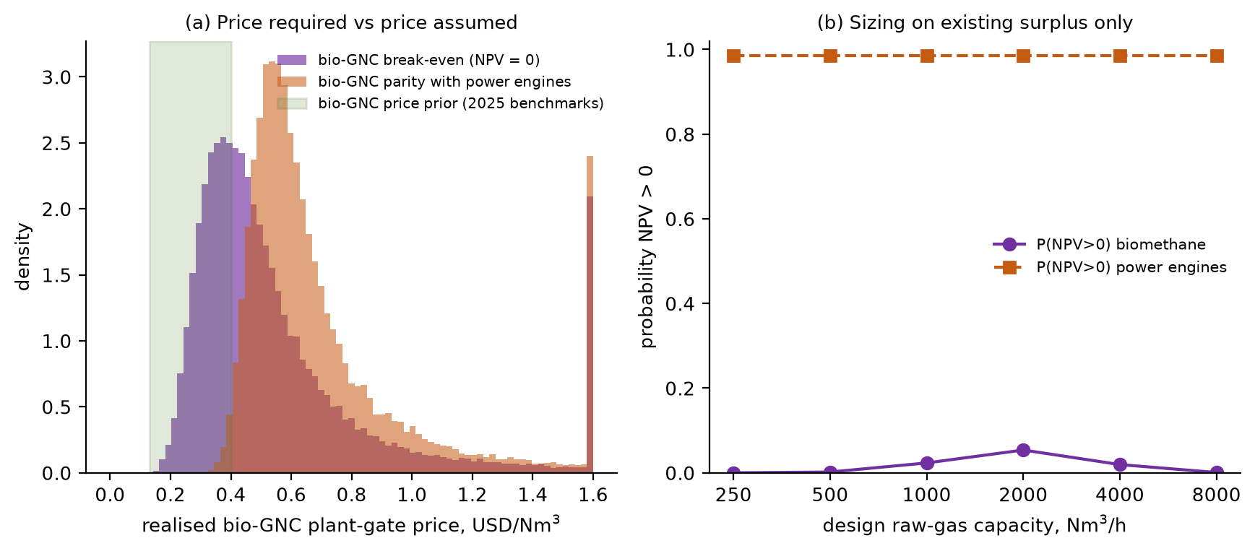
Fig. S4. (a) Bio-GNC plant-gate price required for NPV = 0 and for parity with additional engines, against the prior (values above US$1.6 per Nm³ pooled). (b) Probability of positive NPV against design capacity, existing surplus only.
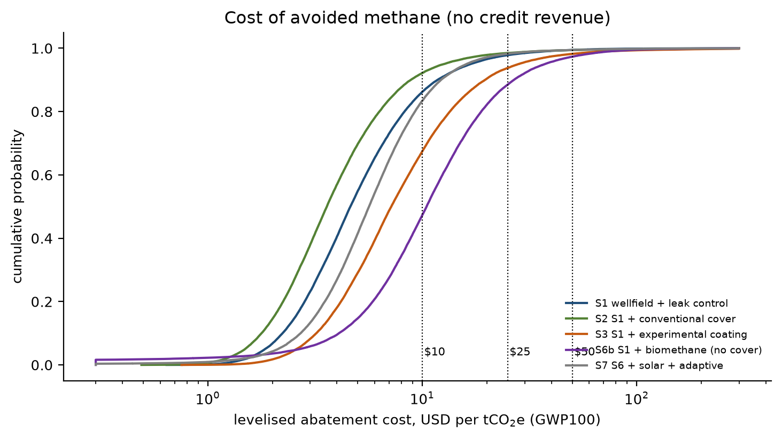
Fig. S5. Cumulative distribution of levelised abatement cost (GWP100, no credit revenue); dotted lines mark credit prices of US$10, 25 and 50 per tCO₂e.
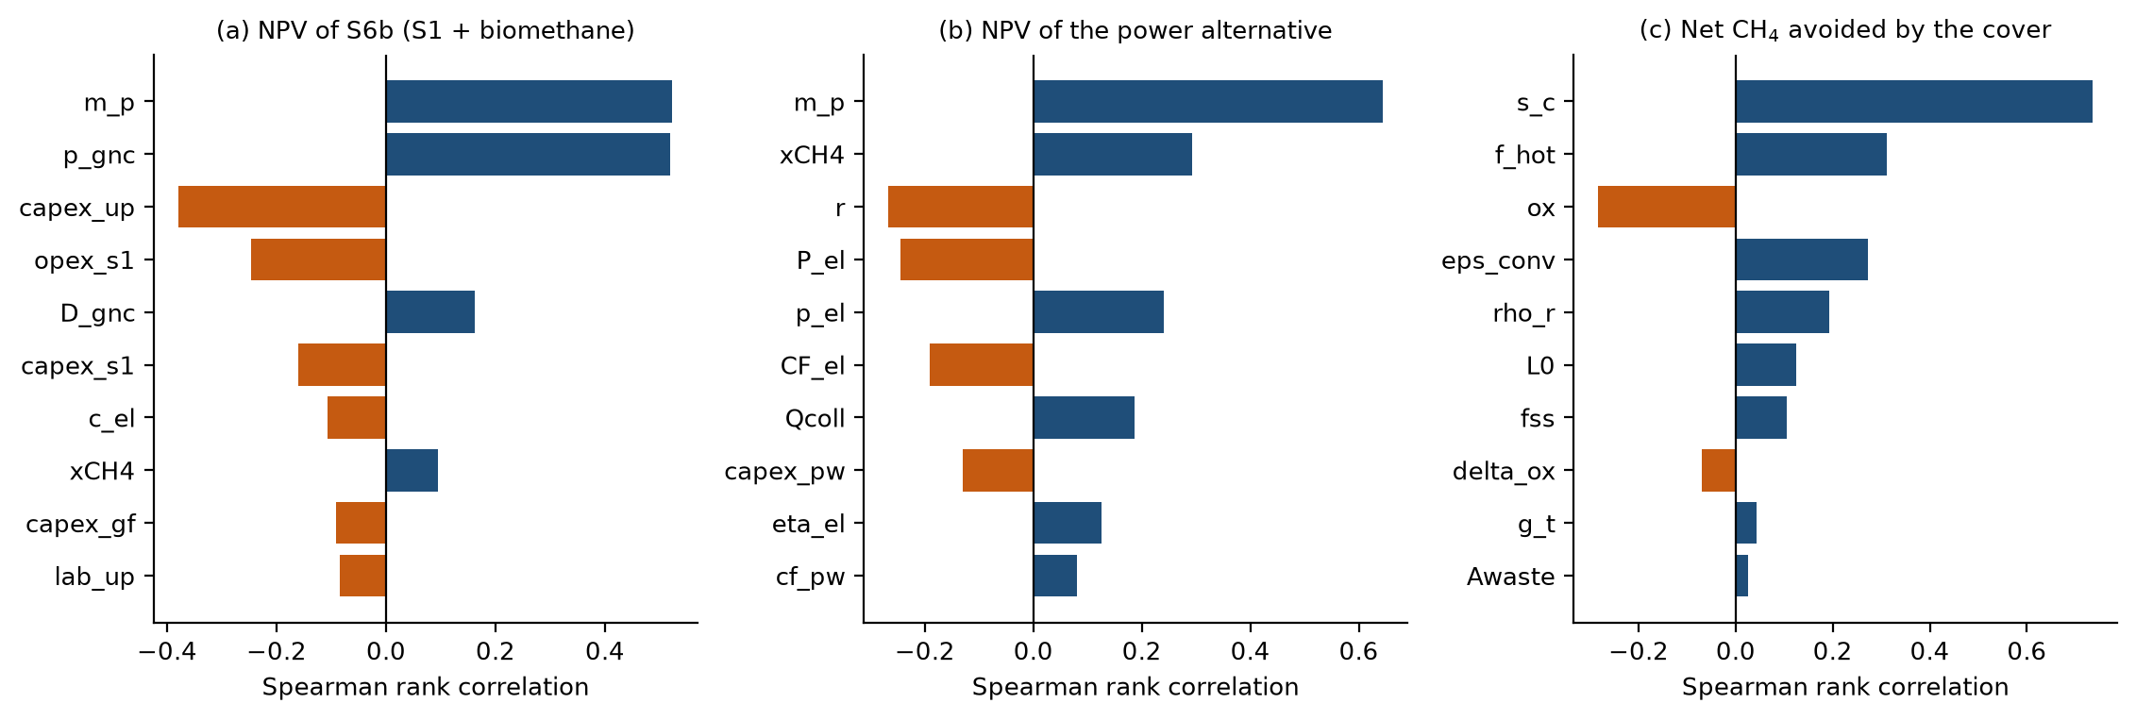
Fig. S6. Spearman rank correlations, lognormal posterior: (a) NPV of S6b; (b) NPV of the power alternative; (c) net methane avoided by the conventional cover. Top ten inputs.
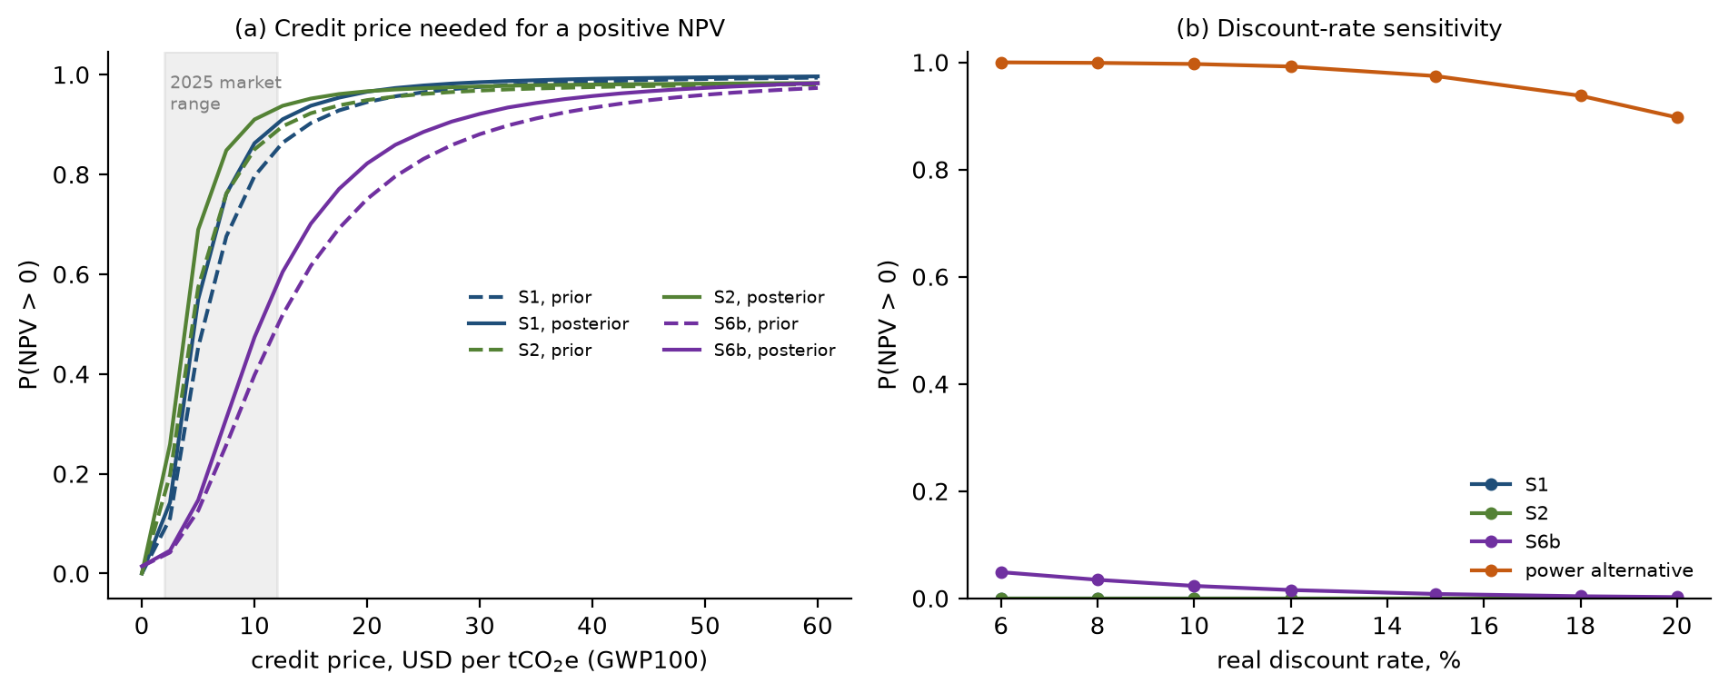
Fig. S7. (a) Probability of positive NPV against credit price for S1, S2 and S6b, prior (dashed) and lognormal posterior (solid), with the 2025 market range shaded. (b) Probability of positive NPV against the real discount rate.
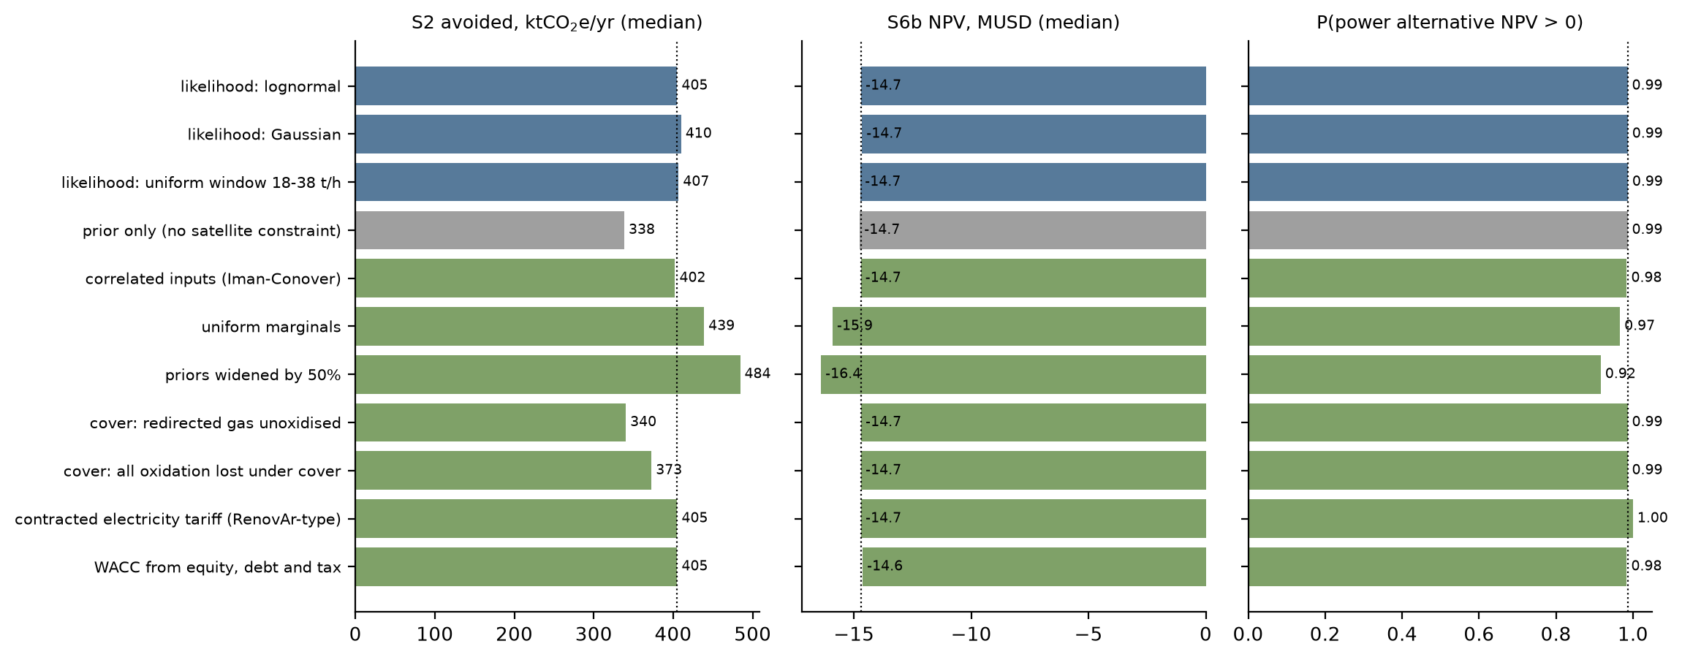
Fig. S8. Headline quantities under the observation-error models (blue), without the satellite constraint (grey) and under the other robustness variants (green); the dotted line marks the base case.

