Repair Fidelity as a Control Parameter Linking Cancer Resistance and Longevity
A bistable order–repair hypothesis inspired by the bowhead whale
Leon Sandler
Independent Researcher, Northbrook, Illinois, United States
ORCID: 0009-0007-4584-808X
Correspondence: sandler.leon@gmail.com
Summary
We propose that DNA repair fidelity is not merely a determinant of mutation rate but also a control parameter governing whether multicellular tissue remains in a stable cooperative state. The bowhead whale motivates the idea that it resists cancer not by adding tumor-suppressor barriers but by repairing damage more accurately. We formalize this with a bistable order–repair model in which tissue integrity is sustained by self-amplifying repair and eroded by stress. Increased repair fidelity increases the stress threshold at which tissue collapses, and we show that this shift is exact and independent of every shape parameter when repair is scaled uniformly. How repair enhancement is implemented changes the magnitude and can abolish the threshold entirely. The framework predicts that cancer resistance and age-associated decline should move together under a single repair intervention — a coupling that distinguishes this hypothesis from conventional mutation rate accounts.
Keywords: DNA repair fidelity; Peto's paradox; bistability; tissue homeostasis; cancer resistance; aging; bowhead whale; CIRBP
A whale reveals a gap in the standard cancer-defense model
Compared with small, short-lived animals, large, long-lived animals accumulate more cell divisions and therefore more opportunities for oncogenic mutation. That they do not suffer correspondingly more cancer is Peto's paradox (Caulin & Maley 2011). This paradox is usually discussed as though it had one answer. It has at least two, and the difference between them is the starting point of this paper.
Elephants multiply the barriers that a damaged cell must cross. They carry dozens of extra copies of the tumor suppressor gene TP53 and mount a more aggressive apoptotic response to DNA damage than human cells do (Abegglen et al. 2015). The naked mole rat interposes a different barrier again, secreting high-molecular-mass hyaluronan that suppresses contact-independent growth (Tian et al. 2013). In each case, the logic is the same: damage occurs, is detected, and the affected cell is removed or arrested.
At more than 200 years, the bowhead whale (Balaena mysticetus), the longest-lived mammal known, does something different and does it at a body mass above 80,000 kg. Compared with human fibroblasts, its fibroblasts require fewer oncogenic hits to transform in vitro, so the whale is not harder to transform at the single-cell level. Its cells instead have enhanced double-strand-break repair capacity and fidelity and lower mutation rates, which are associated with unusually high constitutive expression of the cold-inducible RNA-binding protein CIRBP. Transferring bowhead CIRBP into human cells increases both nonhomologous end-joining and homologous recombination efficiency, and CIRBP overexpression extends lifespan and radiation resistance in Drosophila (Firsanov et al. 2025).
Where elephants make damaged cells easier to remove, bowheads appear to make damage less likely to persist. Both strategies are effective; only one of them has a developed theoretical account (Seluanov et al. 2018).
The bowhead does not resolve Peto's paradox by eliminating damaged cells more aggressively. It resolves it by not accumulating the damage.
Elimination and restoration have different system-level costs
The elimination strategy has a cost that is easy to overlook because it is paid slowly. Removing or permanently arresting damaged cells is itself a driver of tissue aging when it happens at scale: a tissue that continually discards damaged cells must regenerate them, drawing on a finite progenitor pool, or accept a shrinking and less functional one. Senescent cells that are arrested rather than cleared accumulate and actively degrade the surrounding tissue (van Deursen 2014). Somatic mutation and genome mosaicism increase with age across tissues regardless of which barrier is in place (Vijg & Dong 2020). Both genomic instability and cellular senescence are among the hallmarks of aging (López-Otín et al. 2023), and the elimination strategy engages one of them in order to contain the other.
A restoration strategy has no equivalent structural cost. If damage is repaired accurately, the cell is neither lost nor retained in a damaged state, and the tissue neither shrinks nor accumulates dysfunctional occupants. This suggests that the two strategies should have different consequences for aging even when they result in a similar cancer incidence, and it is what makes repair fidelity interesting as something more than another item on the list of cancer defenses.
Elimination and restoration can deliver comparable levels of cancer resistance while differing in what they cost the tissue over a lifetime.
What this hypothesis adds
Existing explanations of Peto's paradox emphasize mechanisms that prevent damaged cells from progressing, such as apoptosis, senescence, immune surveillance, and increased tumor-suppressor dosage. The present hypothesis asks a different question. Rather than asking how damaged cells are stopped, it asks whether reducing the persistence of genome damage changes the stability of the multicellular state itself.
The novelty is therefore not the proposal that DNA repair suppresses cancer, which is uncontroversial. It is the proposal that repair fidelity acts as a shared control parameter linking cancer resistance and age-associated tissue decline — that these are two readouts of one quantity rather than two traits that happen to cooccur. That claim is stronger, more specific, and considerably easier to falsify than the observation that repair matters.
The claim under test is not that repair prevents cancer but that one repair parameter governs two phenotypes that are usually studied separately.
Repair fidelity is not the same as repair activity
The hypothesis concerns fidelity specifically, and the distinction is the basis of this argument. Three quantities are often used interchangeably and should not be:
- Repair capacity. How much repair the cell can perform.
- Repair efficiency. What fraction of lesions is resolved.
- Repair fidelity. How accurately repair restores the original sequence and structure.
Here, repair fidelity refers to the ability of DNA repair processes to restore genome integrity while minimizing mutagenic or structurally disruptive outcomes. The distinction is not pedantic. Repair pathway choice determines whether a double-strand break is resolved accurately by homologous recombination or by an end-joining route that may delete sequences at the junction (Ceccaldi et al. 2016). A cell that resolves every lesion quickly but inaccurately has high efficiency and low fidelity, and on this basis, it should behave like a cell with poor repair, not a well-protected one.
Throughout this paper, the control parameter is fidelity—accurate restoration—and not the volume or speed of repair activity.
A phenomenological model asks whether repair feedback is sufficient for bistability
What follows is deliberately a minimal model rather than a representation of bowhead physiology. Its purpose is to determine whether a positive feedback relationship between tissue order and repair is by itself sufficient to generate a threshold and, if so, what moves that threshold. It is not fitted to bowhead, mouse or human measurements, and no parameter in it is claimed to be measured. Readers should treat the results as structural consequences of an assumed feedback, not as predictions of a calibrated system.
We summarize the state of a tissue with one order parameter I ∈ [0,1]. High I describes a directionally ordered, cooperative multicellular state; low I describes a reverted state in which cooperative constraints on individual cells have broken down. Malignant transformation is one instance of such a reversion, not necessarily the only one. The dynamics are
dI/dτ = μ(I)(1 − I) − ρI
with self-amplifying repair μ(I) = μ₀(1 + βs(I)), s(I) = Iʰ/(Kʰ + Iʰ), and an erosion flux ρ = ρ₀ + ρ_{stress}·D + ρ_{damage}·N, where ρ₀ is baseline turnover, D is genotoxic or environmental stress and N is any accumulating burden of unrepaired lesions or pathological tissue. Repair is self-amplifying because intact, well-organized tissue supports its own maintenance machinery better than eroded tissue does. Positive feedback of this form is the standard route to bistability in cell-biological systems (Ferrell 2002), and the model inherits that behavior by construction rather than discovering it. The equation is not introduced here for the first time. It is the mean-field reduction of a non-equilibrium lattice model in which an ordered medium is continuously degraded by a flux that accelerates with local disorder and restored by an independent repair process, analyzed separately in a physical setting (Sandler 2026). That analysis establishes the bistability as a proposition for the reduced model and confirms by kinetic Monte Carlo that it survives on a finite lattice as a rate-dependent hysteresis loop, rather than being an artifact of the mean-field closure. What is proposed here is not the equation but the identification of its control parameter with repair fidelity in tissue, and what follows from that identification.
The equilibrium condition inverts exactly. Setting μ(I)(1−I) = ρI gives ρ(I) = μ(I)(1−I)/I, so the entire bifurcation diagram is obtained by sweeping I and reading off ρ, with no numerical integration and no fitting. The fold, where the high-order state is destroyed, is the root of μ′(I)(1−I)I − μ(I) = 0. With μ₀ = 0.10, β = 12, K = 0.50 and h = 4, the tissue is bistable between ρ = 0.51 and ρ = 0.71, and the transition is hysteretic: once pushed into the low-order state, removing the stress does not restore the original state because the repair capacity has itself degraded (Fig. 1).
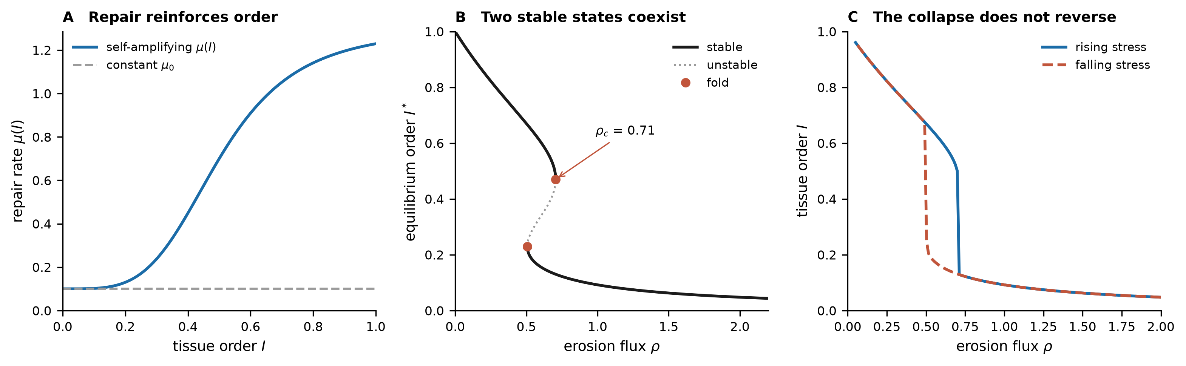
Figure 1. The order–repair model is bistable and hysteretic by construction. (A) Repair that reinforces tissue order compared with a constant baseline rate. (B) The resulting equilibrium curve is S shaped: between ρ = 0.51 and ρ = 0.71, a high-order and a low-order state are simultaneously stable and separated by an unstable branch. The fold at ρ_{c} = 0.71 is the tipping point. (C) Integrating the dynamics under rising and then falling stress traces a hysteresis loop: collapse and recovery occur at different stress levels. These are properties of the assumed feedback, not fitted results.
Bistability here is inherited from the underlying lattice model, not discovered in tissue. The question worth asking is what moves the threshold.
Repair fidelity moves the tipping point exactly and structurally
We represent an organism-wide difference in repair fidelity as a multiplier α on the repair function. The question is how the tipping point ρ_{c} — the erosion flux beyond which no amount of tissue self-repair prevents reversion — depends on α.
When α scales repair uniformly, μ_{α}(I) = αμ(I), the answer is exact. Both μ and μ′ carry the same factor, so it cancels from the fold condition entirely: the fold sits at the same tissue order I_{c} for every α, and ρ_{c} is precisely proportional to α. Computing ρ_{c} independently at 64 values of α between 0.25 and 8 confirms this, with ρ_{c}/α constant to a relative deviation of 3e-16 and the fold position varying by 1e-16—both at machine precision (Fig. 2). Doubling repair fidelity doubles the stress a tissue can absorb before it collapses, and this holds for every value of μ₀, β, K and h.
This is a stronger statement than the model deserves credit for on its own. It is not a fitted result or a simulated cohort; it is an algebraic property of any repair function scaled uniformly. That makes it the most defensible claim in the paper and the most constrained: it says nothing about whether real repair enhancement is uniform.
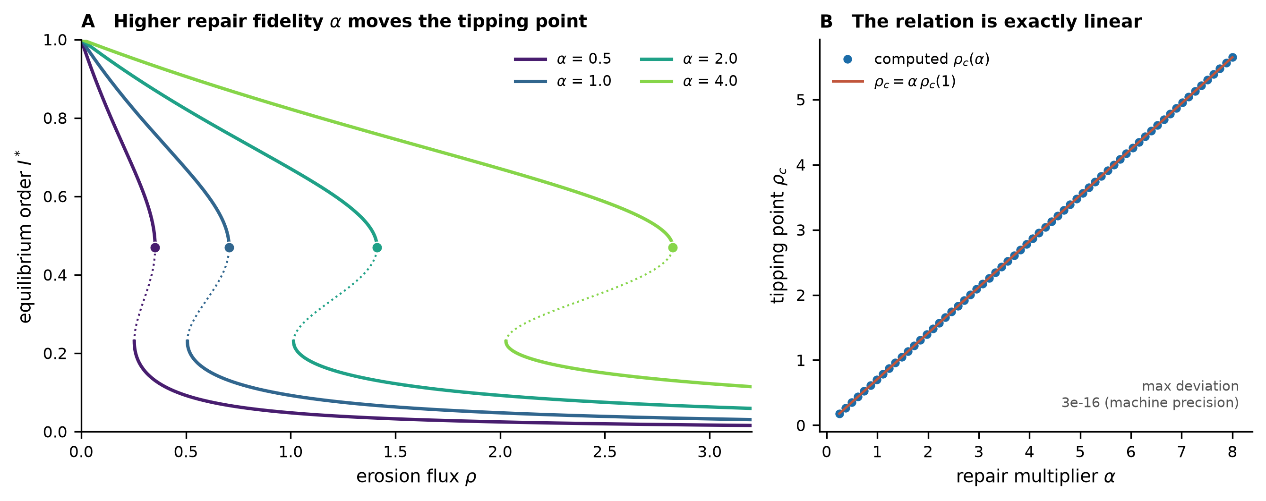
Figure 2. Repair fidelity scales the tipping point. (A) Stable (solid) and unstable (dotted) equilibrium branches for repair multipliers α = 0.5, 1, 2 and 4. Filled circles mark the fold. The folds slide to higher erosion flux while remaining at the same tissue order I_{c} = 0.47. (B) The tipping point computed at 64 values of α lies on the line ρ_{c} = α·ρ_{c}(1) to within 3e-16. The scaling is exact and not fitted.
Under uniform scaling, ρ_{c} = α·ρ_{c}(1) exactly: repair fidelity is a control parameter for the stability of the multicellular state, not an incremental improvement to one defense.
How repair enhancement is implemented changes what it buys
Uniform scaling is an assumption, and a consequential one. Repair enhancement could plausibly act on constitutive repair, the order-dependent feedback term, or both. These are different interventions, and the model distinguishes them as follows:
- A — uniform: αμ₀(1 + βs) — both constitutive and feedback repair scales together.
- B — constitutive only: μ₀(α + βs) — baseline repair increases; the feedback is untouched.
- C — feedback only: μ₀(1 + αβs) — the order-dependent term increases; baseline is untouched.
All three raise the tipping point, and they do so in every one of the 17,583 randomly drawn parameter sets that were bistable at baseline: the fraction with ρ_{c}(α=2) > ρ_{c}(α=1) is 100% in each case. The direction of the effect is therefore robust and does not depend on the particular functional form.
The magnitude is not. Doubling α multiplies ρ_{c} by 2.00 under uniform scaling, 1.89 under feedback-only enhancement, but only 1.10 under constitutive-only enhancement (medians across the same parameter sets). More strikingly, constitutive-only enhancement destroys the bistability above α = 2.60 at the baseline parameters: the two folds annihilate in a cusp, ρ(I) becomes monotone, and the tissue's response to stress changes from an all-or-nothing collapse to a graded decline with no threshold at all (Fig. 3).
This is the model's least expected output, and we believe it is most interesting. It says that sufficiently increasing constitutive repair does not merely move the cliff edge further away; past a point, it removes the cliff. A tissue that would previously have collapsed catastrophically instead degrades smoothly, which is a qualitatively different and more recoverable failure mode. Whether real repair enhancement behaves in this way is an empirical question, and it is one that the framework makes askable.
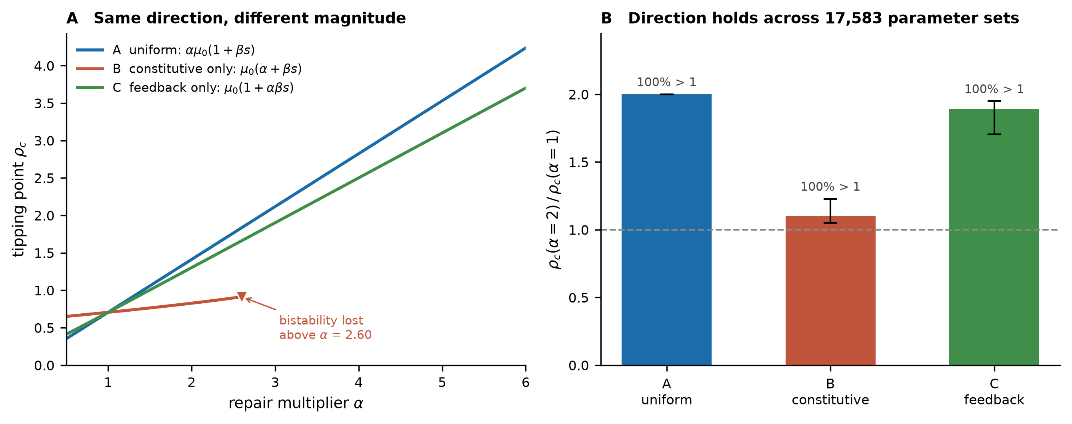
Figure 3. The three implementations agree on direction and disagree on magnitude. (A) Tipping point against the repair multiplier for each implementation. Uniform and feedback-only scaling increase ρ_{c} steadily; constitutive-only scaling increases ρc weakly and then loses bistability entirely above α = 2.60, where the folds annihilate and the stress response becomes graded. (B) ρ_{c}(α=2)/ρ_{c}(α=1) ratios across 17,583 randomly drawn bistable parameter sets; bars are medians; whiskers, the 5th–95th percentiles. The effect is positive in every sampled set under all three implementations.
Every implementation of repair enhancement raises the threshold; they differ by nearly twofold in how much, and one of them abolishes the threshold rather than moving it. This difference is measurable.
CIRBP is a candidate molecular entry point
The model is agnostic about what α corresponds to biologically. The bowhead data supply a concrete candidate: CIRBP-mediated enhancement of double-strand-break repair. The proposed chain runs from high constitutive CIRBP, through enhanced repair and greater genome integrity, to reduced chromosomal instability and mutation accumulation, to a reduced probability of malignant transformation, and — this paper's hypothesis, not an established fact — to slower age-associated tissue decline. Table 1 separates what the bowhead experiments established from what the model adds as interpretation and what remains to be tested.
Published evidence | Model interpretation | What would test it
Bowhead fibroblasts show enhanced double-strand-break repair capacity and fidelity, and lower mutation rates, than human or other mammalian cells (Firsanov et al. 2025). | High constitutive repair fidelity can occur in a long-lived, large-bodied mammal without additional tumor-suppressor barriers. | Raising repair fidelity in other species or cell types should shift the modeled tissue toward a more stable high-order state (P1–P2).
Bowhead CIRBP raises nonhomologous end-joining and homologous-recombination efficiency when expressed in human cells (Firsanov et al. 2025). | CIRBP can act as a transferable repair-fidelity effector rather than a bowhead-specific curiosity. | CIRBP enhancement in other human or mouse cell types should measurably raise genotoxic-stress thresholds (P1–P2).
CIRBP overexpression extends lifespan and radiation resistance in Drosophila (Firsanov et al. 2025). | One repair-fidelity effector can influence both damage resistance and organismal longevity in at least one model organism. | Repair-fidelity enhancement should couple cancer-relevant and aging-relevant readouts in other systems (P5).
The present order–repair model. | Uniform repair scaling raises the erosion threshold ρ_{c} exactly in proportion to α; the implementation determines the magnitude and can abolish the threshold. | Repair-fidelity enhancement should shift measurable tissue-level stress thresholds, and the size of the shift should identify which implementation operates (P3–P4).
Table 1. Evidence, interpretation and test. Only the final row is specific to the present model; the first three summarize Firsanov et al. (2025).
CIRBP gives the abstract parameter α a concrete, transferable, and already partly characterized molecular candidate.
The Bowhead Repair Principle
We propose the following as a named synthesis, offered explicitly as a hypothesis rather than an established law:
The Bowhead Repair Principle: exceptional cancer resistance and longevity may emerge together when an organism maintains genome integrity primarily by increasing the fidelity of repair rather than by relying predominantly on the elimination of damaged cells.
Read through the model, this becomes a specific claim: cancer resistance and longevity are not two independent traits that happen to cooccur in the bowhead but two readouts of the same quantity acting on the same bistable structure from two directions — resistance to acute stress-induced reversion, which is movement along ρ, and resistance to slow baseline-driven erosion, which is the ρ₀ term acting continuously and independently of any tumor challenge.
If the principle holds, an intervention on repair fidelity should not be able to improve one of these phenotypes without improving the other.
Five predictions, from molecules to organisms
The hypothesis generates a ladder of predictions at ascending levels of organization. P1 and P2 extend from published evidence; P3 and P4 are specific to the order–repair model; and P5 is the signature test.
P1—Molecular. Increased repair fidelity—by CIRBP or another effector—should reduce mutation accumulation, chromosomal abnormalities, micronuclei and persistent DNA damage markers under matched genotoxic stress. This prediction is most directly grounded in existing bowhead, human-cell and Drosophila data (Firsanov et al. 2025).
P2—Cellular. The same enhancement should increase the genotoxic-stress threshold for malignant transformation so that fidelity-enhanced cells transform at lower rates than controls under matched mutational load.
P3—Tissue. In organoid or tissue systems with a measurable collective-organization phenotype, the enhancement of repair fidelity should increase the critical stress required to destabilize that organization. The model makes this quantitative: under uniform scaling, the threshold should move in direct proportion to the fidelity gain.
P4—Mechanistic discrimination. The size of the threshold shift should be used to identify how repair is enhanced. A near-proportional shift indicates uniform or feedback-weighted enhancement; a shift of only approximately 10% per doubling indicates enhancement confined to constitutive repair. In the latter case, sufficiently strong enhancement should abolish threshold behavior altogether, replacing catastrophic collapse with graded decline—an unusual and distinctive signature.
P5—Coupling—the signature test. Because P1–P4 all follow from one parameter, an intervention that improves repair fidelity should produce correlated changes in cancer resistance and in age-associated tissue deterioration within the same system. This coupling is not expected if the two outcomes arise from independent mechanisms, and it is what distinguishes this hypothesis from the uncontroversial claim that repair reduces mutations that reduce cancer.
The asymmetry among these matters. If P1 or P2 fails, the bowhead biology is in question. If P3 or P4 fails, the model’s tissue-level structure is wrong, but the underlying biology may stand. If P5 fails — if repair fidelity enhancement improves cancer resistance without any corresponding effect on age-associated decline, or the reverse — then the Bowhead Repair Principle loses most of its distinctive explanatory value, whatever else survives.
P5 is the prediction on which the hypothesis should be judged. Everything else it predicts is either already known or shared with simpler accounts.
Relationship to broader models of cancer
This low-order state is compatible with the atavistic model of cancer, which holds that malignant transformation is a stress-triggered reversion to an ancient unicellular survival program (Davies & Lineweaver 2011; Lineweaver et al. 2021), for which phylostratigraphic evidence has been offered (Trigos et al. 2017; Cisneros et al. 2017; Domazet-Lošo & Tautz 2010; Lineweaver et al. 2014). The present hypothesis does not depend on that interpretation. It requires only that tissue-level order be a meaningful bistable variable maintained by repair, which is a weaker and more general claim than the proposal that the low-order state is phylogenetically ancient. Readers who reject the atavistic account can substitute any other description of the low-order state without affecting anything derived here.
A note on therapeutic implications, which this paper deliberately does not develop. If repair fidelity is a system-level determinant of tissue stability, interventions that raise it would act on ρ_{c}, whereas tumor-directed therapies — including adaptive strategies that manage a tumor population rather than maximizing cell death (Gatenby et al. 2009) — act on ρ. These are different terms of the same equation, which suggests complementarity rather than competition. We state this and stop there: the hypothesis stands or falls as basic biology, and the therapeutic question involves the risks addressed in the next section.
The framework is compatible with the atavistic model but does not rest on it, and its therapeutic reading is deferred rather than argued.
Limitations
More repair is not automatically better. This is the most serious objection to a naive reading of the hypothesis. Enhanced DNA repair is not synonymous with tumor suppression: repair and damage-tolerance pathways can help damaged or premalignant cells survive insults that would otherwise eliminate them, and error-prone end-joining can itself generate the structural variants that drive transformation (Ceccaldi et al. 2016). This hypothesis concerns high-fidelity restoration of genome integrity specifically and makes no claim about indiscriminate enhancement of repair activity or damage tolerance—which the model would represent not as a larger α but as a change in what repair does.
The model is phenomenological as applied to tissue. The form of μ(I) is taken from the lattice model of Sandler (2026), where it follows from an explicitly specified site process; its parameters here were chosen for qualitative consistency with a bistable, hysteretic system and are not fitted to any biological measurement. The exact scaling result above is an algebraic property of uniform multiplication, and the robustness analysis establishes only that the direction of the effect survives across a wide parameter range. Neither is a numerically validated biological prediction.
The bowhead evidence is correlational with respect to longevity. CIRBP is one of several traits that co-occur with the bowhead's body size, metabolic rate, cell number, cold adaptation and immune profile, and existing experiments do not establish its causal weight relative to these. Firsanov et al. (2025) present enhanced repair as an important contributor to the phenotype, not a complete explanation of it.
At least one other solution demonstrably works. The elephant's barrier multiplication achieves a low cancer incidence in a large, long-lived mammal without any repair-based tipping-point mechanism (Abegglen et al. 2015). Repair fidelity is best read as one viable system-level solution among several, not as the general answer to Peto's paradox.
Tissue order is not yet an observable. The order parameter I has no established experimental counterpart. P3 and P4 presuppose that a collective-organization phenotype can be measured in an organoid or tissue system with enough resolution to locate a threshold. The development of such a readout is a prerequisite for testing the model at the level at which it makes its most specific claims.
Outstanding questions
- Does repair fidelity enhancement shift cancer resistance and markers of tissue aging together, or can the two be separated experimentally?
- Can a tissue-level order parameter be measured well enough in organoids to locate a stress threshold and detect its movement?
- Does CIRBP enhancement act uniformly on repair, or only on its constitutive component—and can strong enhancement convert a catastrophic collapse into a graded decline, as the model predicts it should?
- Is repair fidelity, as distinct from repair activity, what differs between long-lived and short-lived mammals of similar size?
- Do species that resolve Peto's paradox by elimination pay a measurable aging cost that repair-based species do not?
A research program
Near term. CIRBP manipulation across additional cell types and species; direct measurement of repair fidelity, not merely efficiency, under controlled genotoxic stress; and quantification of mutation burden, indel spectra and chromosomal stability under the same conditions (P1).
Intermediate term. Organoid or tissue models with a measurable collective-organization phenotype, allowing a tissue-level analog of I to be estimated and a threshold located; transformation assays across a range of repair-fidelity conditions to test P2 and P3 at the tissue level rather than at the single-cell level; measurement of the size of the threshold shift to discriminate implementations (P4).
Long term. Whole-organism aging models testing whether repair fidelity enhancement slows age-associated decline; cancer-prone mouse models testing whether one intervention shifts tumor incidence and independent markers of tissue aging together — the direct test of P5 and of the Bowhead Repair Principle as stated.
Data availability
The model implementation, the parameter set, the random seed and the scripts that generate every figure and number in this paper are openly available at https://github.com/sandlerleon/order-repair-model and are permanently archived at https://doi.org/10.5281/zenodo.22851970. The manuscript is deposited at https://doi.org/10.5281/zenodo.22851972. Both are concept DOIs and resolve to the current version. Running order_repair_model.py followed by make_figures.py reproduces the JSON results file and all three figures. No experimental data were generated or analyzed.
Declarations
Funding. This work received no external funding.
Competing interests. The author declares that there are no competing interests.
Ethics. This study is entirely theoretical and computational and involved no human participants or animal subjects.
Use of generative artificial intelligence. During the preparation of this work, the author used Claude (Anthropic) to assist with literature synthesis, model implementation and drafting. The author subsequently reviewed and edited all the content, verified every cited reference against the primary literature, and takes full responsibility for the content of the publication. No generative AI tool is listed as an author, and none was used to produce or alter any data.
References
Abegglen LM, Caulin AF, Chan A, et al. (2015) Potential mechanisms for cancer resistance in elephants and comparative cellular response to DNA damage in humans. JAMA 314:1850-1860. https://doi.org/10.1001/jama.2015.13134
Caulin AF, Maley CC (2011) Peto's paradox: evolution's prescription for cancer prevention. Trends in Ecology & Evolution 26:175-182. https://doi.org/10.1016/j.tree.2011.01.002
Ceccaldi R, Rondinelli B, D'Andrea AD (2016) Repair pathway choices and consequences at the double-strand break. Trends in Cell Biology 26:52-64. https://doi.org/10.1016/j.tcb.2015.07.009
Cisneros L, Bussey KJ, Orr AJ, et al. (2017) Ancient genes establish stress-induced mutation as a hallmark of cancer. PLoS ONE 12:e0176258. https://doi.org/10.1371/journal.pone.0176258
Davies PCW, Lineweaver CH (2011) Cancer tumors as Metazoa 1.0: tapping genes of ancient ancestors. Physical Biology 8:015001. https://doi.org/10.1088/1478-3975/8/1/015001
Domazet-Lošo T, Tautz D (2010) Phylostratigraphic tracking of cancer genes suggests a link to the emergence of multicellularity in metazoa. BMC Biology 8:66. https://doi.org/10.1186/1741-7007-8-66
Ferrell JE (2002) Self-perpetuating states in signal transduction: positive feedback, double-negative feedback and bistability. Current Opinion in Cell Biology 14:140-148. https://doi.org/10.1016/s0955-0674(02)00314-9
Firsanov D, Zacher M, Tian X, et al. (2025) Evidence for improved DNA repair in the long-lived bowhead whale. Nature. https://doi.org/10.1038/s41586-025-09694-5
Gatenby RA, Silva AS, Gillies RJ, Frieden BR (2009) Adaptive therapy. Cancer Research 69:4894-4903. https://doi.org/10.1158/0008-5472.CAN-08-3658
Lineweaver CH, Davies PCW, Vincent MD (2014) Targeting cancer's weaknesses (not its strengths): therapeutic strategies suggested by the atavistic model. BioEssays 36:827-835. https://doi.org/10.1002/bies.201400070
Lineweaver CH, Bussey KJ, Blackburn AC, Davies PCW (2021) Cancer progression as a sequence of atavistic reversions. BioEssays 43:2000305. https://doi.org/10.1002/bies.202000305
López-Otín C, Blasco MA, Partridge L, Serrano M, Kroemer G (2023) Hallmarks of aging: an expanding universe. Cell 186:243-278. https://doi.org/10.1016/j.cell.2022.11.001
Sandler L (2026) Self-maintained order and hysteretic collapse in a non-equilibrium rotational lattice. Zenodo (preprint; under review). https://doi.org/10.5281/zenodo.21210708
Seluanov A, Gladyshev VN, Vijg J, Gorbunova V (2018) Mechanisms of cancer resistance in long-lived mammals. Nature Reviews Cancer 18:433-441. https://doi.org/10.1038/s41568-018-0004-9
Tian X, Azpurua J, Hine C, et al. (2013) High-molecular-mass hyaluronan mediates the cancer resistance of the naked mole rat. Nature 499:346-349. https://doi.org/10.1038/nature12234
Trigos AS, Pearson RB, Papenfuss AT, Goode DL (2017) Altered interactions between unicellular and multicellular genes drive hallmarks of transformation. Proceedings of the National Academy of Sciences 114:6406-6411. https://doi.org/10.1073/pnas.1617743114
van Deursen JM (2014) The role of senescent cells in ageing. Nature 509:439-446. https://doi.org/10.1038/nature13193
Vijg J, Dong X (2020) Pathogenic mechanisms of somatic mutation and genome mosaicism in aging. Cell 182:12-23. https://doi.org/10.1016/j.cell.2020.06.024

