Manuscript prepared for Construction and Building Materials (Elsevier) – Research article
A Coupled Chemo-Mechanical and Life-Cycle Framework for Oyster-Shell-Derived Cementitious Materials in Aggressive Infrastructure Environments
Leon Sandler¹,*
¹ Independent Researcher, Northbrook, Illinois, United States * Corresponding author: sandler.leon@gmail.com ORCID: 0009-0007-4584-808X

Abstract
Oyster-shell powder is promoted as a low-carbon cement substitute, but joint carbon and durability benefits are usually asserted rather than tested. This paper asks under which processing, substitution and exposure conditions shell-derived concrete delivers a joint advantage over ordinary Portland cement (OPC) concrete, and where that claim fails. Two pathways are separated: uncalcined shell powder replacing cement (P1) and shell calcium carbonate replacing limestone in the kiln feed (P2). A coupled model links hydration, porosity, chloride, acid and leaching transport, damage accumulation and cradle-to-gate carbon and is propagated through paired Monte Carlo analysis of a pavement, a dam and a marine culvert. Published data reject the original model, in which shell is an inert filler. An effective strength-efficiency coefficient k_f was added; calibrated on one scallop-shell dataset it does not transfer to independent oyster-shell data (mean absolute error 0.12 against 0.15 for the inert model and 0.14 for a dilution-only rule), because k_f differs between studies from -0.40 to 1.36. The primary results therefore use a random-effects predictive distribution of k_f pooled across four studies. At r = 25% and constant water-to-binder ratio the median carbon change is −21% with strength 0.88 of OPC; with strength matched it is −15% (P10–P90 −22 to +10%). The probability of a carbon cut of at least 5% with non-inferior life is at most 0.21 for the pavement, 0.14 for the dam and 0.03 for the marine culvert, and zero against a 50% slag blended-cement reference that cuts carbon by about 42% on its own. The P2 pathway raises carbon by about 5.1% unless calcination CO₂ is credited as biogenic. Chloride transport is uncalibrated: coupling k_f to porosity would raise the pavement probability to 0.44. All results are conditional on stated assumptions, and the experiments needed to test them are specified.
Keywords: oyster shell; calcium carbonate filler; service-life prediction; embodied carbon; approximate Bayesian calibration; uncertainty and sensitivity analysis; falsification

1. Introduction
Cement production is a major source of anthropogenic CO₂, with roughly half of the process emissions arising from the calcination of limestone rather than from fuel (Andrew 2019). Strategies to reduce this footprint include clinker substitution by supplementary materials and fillers, alternative binders and carbon capture (Scrivener et al. 2018). Aquaculture waste shells, composed mainly of calcium carbonate, are an attractive candidate because they are a locally available, otherwise problematic waste. Technical communications on “oyster-shell green concrete” frequently claim large carbon reductions, fire resistance to very high temperatures, accelerated hydration, reduced shrinkage and superior chemical resistance. These claims are presented without a mathematical model, uncertainty analysis or experimental evidence, and they conflate materials pathways that are chemically and mechanically different.

1.1 What existing research establishes
Shell-derived calcium carbonate. Ground shells are predominantly calcium carbonate with a small organic matrix and trace salts. Experimental studies of ground seashells (including oyster shell) as partial cement replacement in mortars and masonry blocks report that compressive strength decreases as the replacement fraction increases, that water absorption increases in blocks, that setting is retarded, and that low replacement levels (about 10%) can still meet standards, with higher levels reaching required strength only at later ages (Lertwattanaruk et al. 2012; Jasni et al. 2024). Drying shrinkage of mortars containing some shell types was reported to decrease (Lertwattanaruk et al. 2012). These studies do not provide the kinetic, transport and damage parameters needed for a predictive treatment, and they do not address carbon and life together. A recent constant-binder study of scallop-shell powder reports about 25% lower 28-day strength at 40% binder replacement and a lower carbon footprint (Abbas and Kudukkan 2025); it is the out-of-sample dataset used in Section 4.4.
Hydration and the filler effect. Fine calcium carbonate accelerates early cement hydration through heterogeneous nucleation of C–S–H and, in the presence of aluminates, forms carboaluminates that stabilise ettringite (Lothenbach et al. 2008; Berodier and Scrivener 2014). Dilution, however, raises the effective water-to-cement ratio and removes reactive material, so strength generally decreases with replacement. Organic matter associated with shells may retard hydration.
Transport and durability. Chloride ingress is commonly modelled by Fick’s second law with an age-dependent diffusivity; the Life-365 formulation relates the 28-day diffusivity of OPC concrete to the water-to-cementitious ratio and uses an age exponent of 0.2 (Thomas and Bentz 2002). Acid attack and calcium leaching are classically described by moving-front models in which front depth grows with the square root of time and decreases with the acid-neutralising or calcium capacity of the matrix. Calcite can neutralise acid but also dissolves, so its net effect depends on exposure.
Damage and service life. Fatigue of plain concrete follows stress–life (S–N) relations such as that of Aas-Jakobsen (1970); freeze–thaw damage is governed by the degree of saturation relative to a critical value (Fagerlund 1977); reinforcement corrosion is treated with an initiation plus propagation framework (Tuutti 1982); and continuum damage mechanics treats degradation through an effective stress σ/(1 − D) (Kachanov 1958; Lemaitre 1996).
Life-cycle assessment. Cradle-to-gate embodied carbon is dominated by the cement. Shell powder replaces cement at a small fraction of its footprint, but processing (washing, drying, grinding) and transport are non-zero, and for P2 the calcination CO₂ per unit CaCO₃ is stoichiometrically independent of the carbonate source.
A competing use of shell. Shell is also a restoration resource. It is a widely used substrate for oyster-reef restoration, its supply can limit restoration (Brumbaugh and Coen 2009; Petrolia and Mohrman 2025), and reefs provide habitat, filtration and shoreline services (Beck et al. 2011; Zu Ermgassen et al. 2012; Grabowski et al. 2012). Shell used in concrete is therefore not free of an opportunity cost. That trade-off is the subject of a companion paper on the allocation of recovered shell between reef restoration and construction (Sandler 2026b); here it is labelled pathway P3 and used as context only, and this paper is restricted to the concrete pathways P1 and P2.

1.2 Research gap, claims and hypotheses
A title-level screen of the Crossref index on 1 November 2026 (terms combining oyster or seashell with cement replacement, strength, service life, chloride, life-cycle carbon and uncertainty) returned experimental studies and reviews of shell as a cement replacement but, to the author’s knowledge, no model that couples processing-dependent carbon, hydration, chloride and chemical transport, damage accumulation and infrastructure-specific service life under shared parametric uncertainty. This is a limited screen and not a systematic review, so the gap is stated conditionally. The source technical white paper made seven performance claims. Rather than accept them, each is converted into a testable hypothesis (Table 1).
Table 1. Claims in the source white paper and how each is treated in this manuscript.
Claim | Treatment here
Up to 80% CO₂ reduction | Cradle-to-gate carbon model with explicit processing, transport, calcination and credit terms; carbon change reported at constant w/b and at constant strength
Thermal resistance to 2,400 °F | Not modelled; assessed against calcite thermochemistry only (Section 8)
100% limestone substitution | Separated: P2 (feedstock replacement) vs P1 (cement replacement); never placed on one axis
Accelerated hydration, reduced shrinkage | Hydration kinetics with explicit filler acceleration and organic retardation; shrinkage and early-age cracking indices
Superior acid and chemical resistance | Moving-front acid and leaching models in which calcite both buffers and dilutes
Higher structural durability | Service life from damage accumulation and chloride corrosion limit states, paired with an OPC reference
Inorganic-polymer (alkali-activated) bonding | Excluded (pathway P4); shell calcium carbonate is not an aluminosilicate precursor

Research question. Under which processing, substitution and exposure conditions does oyster-shell-derived concrete provide a simultaneous carbon and durability advantage over conventional concrete, and under which does it fail? Formally, we define a falsification region (Section 3.5) and estimate its probability under parameter uncertainty. The hypotheses are: H1, shell replacement at constant w/b lowers carbon but not service life; H2, at constant strength the carbon benefit shrinks and is lost wherever shell contributes little to strength; H3, the P2 pathway offers no carbon advantage unless calcination CO₂ is credited; H4, shell calcite improves acid resistance only when its particles are fine enough to be accessible.

2. Materials and processing pathways
Oyster shell is approximately 95–98% calcium carbonate (predominantly calcite in the foliated layers) with 1–4 wt% organic matrix (conchiolin) and trace sodium, magnesium, chloride, phosphorus and sulfur; these ranges are generic and should be replaced by measurements for a given supply. Processing for cementitious use comprises collection, weathering or washing to reduce organics and salt, drying, crushing and fine grinding to a target median particle size (10–200 µm is explored). Four pathways are distinguished (Table 2).
Table 2. Pathways considered. They are not interchangeable and are modelled on separate axes.
Pathway | Material route | Principal mechanisms | Status here
P1 | Uncalcined shell powder replaces a mass fraction r of cement in concrete | Dilution, filler nucleation, packing, organic retardation, calcite acid buffering | Modelled; r = 10–100%, median size 10–200 µm
P2 | Shell CaCO₃ replaces a fraction ρ of limestone in clinker raw meal; cement chemistry unchanged | Impurity effects on cement; processing and transport carbon; calcination CO₂ unchanged per kg CaCO₃ | Modelled; ρ = 25–100%, biogenic credit 0–100%
P3 | Recovered, cleaned shell returned to the water as reef substrate (competing use) | Recruitment substrate; habitat, filtration and shoreline services; transport and cleaning energy | Context only; allocation modelled in the companion paper (Sandler 2026b)
P4 | Shell-based alkali-activated binders | Requires an aluminosilicate precursor; not a calcium-carbonate substitution | Out of scope

3. Theoretical framework
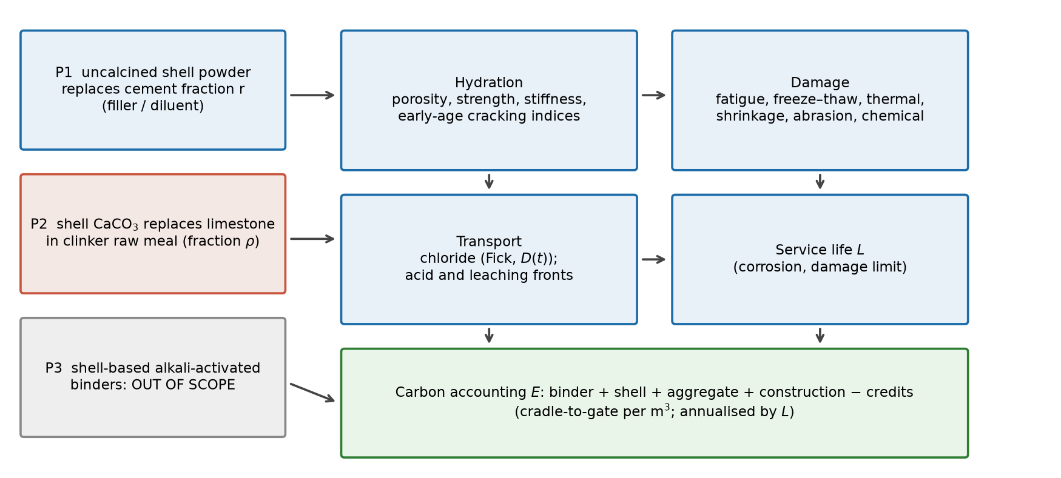
Fig. 1. Coupled model architecture. Pathways P1 and P2 feed hydration, which sets porosity, strength and stiffness; these drive transport and damage, which determine service life; carbon accounting is evaluated per m³ and per year of life.
All quantities are in SI-consistent units; Appendix B lists symbols and units. Damage D, stress ratio S and degree of saturation are dimensionless, and every rate in the damage law has units of inverse time. All parameters are uncertain and are sampled (Section 4). This is a proposed phenomenological framework, not a validated constitutive model; each component is anchored to an established relation where one exists and its limits are stated.

3.1 Hydration, porosity and strength
Hydration degree α evolves with a reaction-progress law that can be accelerated or retarded by shell addition:
dα/dt = k₀ A(T) (1 + ν s(d) r) f_ret (α_max − α)ⁿ (1)
where k₀ is the rate constant at 20 °C, A(T) = exp[E_a/R (1/293.15 − 1/T)] is the Arrhenius factor, ν is the filler nucleation coefficient, s(d) = min[(30 µm/d)^0.5, 2] is a fineness factor, f_ret = 1/(1 + κ_o q) is the retardation factor with q = o(1 − η_w) r/(1 − r) the residual organic dose per unit cement (o is the organic fraction and η_w the washing efficiency), and α_max = min[α_cap, (w/c)/0.42] limits the attainable degree to the water available per unit cement. For α(0) = 0 and n ≠ 1 the closed form is
α(t) = α_max − [α_max^(1−n) + (n − 1) k t]^(1/(1−n)) (2)
Shell addition therefore raises the rate through ν and the ceiling through a larger effective w/c, but lowers the rate through organics, and removes cement. With cement volume v_c, water volume v_w, hydration products of volume 2.06 α v_c, the capillary porosity is φ_cap = v_w − 1.06 α v_c (Powers and Brownyard 1947) and the gel/space ratio X = 2.06 α v_c/(v_w + α v_c). Compressive strength is
f_c = S₀′ X^κ [1 + β_p s r(1 − r)] (1 − k_imp ρ) (3)
where the exponent κ is uncertain (1.8–3.0) and S₀′ = S₀ × 0.742^(2−κ) keeps the nominal OPC strength at w/c = 0.45 fixed for any κ; β_p is a packing bonus and k_imp an impurity penalty that applies only to P2. Stiffness, tensile and flexural strength follow E = 4700√f_c, f_t = 0.33√f_c and f_r = 0.62√f_c (MPa; ACI 318).
Effective strength-efficiency coefficient. In the original model shell powder is an inert diluent in the strength relation. To test this against published data (Section 4.4) an optional coefficient k_f is introduced: the cement volume entering the gel/space ratio is multiplied by [1 + k_f r/(1 − r)], so that a unit mass of shell counts as k_f units of cement for strength, as in the classical k-value concept for fillers and supplementary materials. k_f is an empirical lump of packing, nucleation, organic retardation, particle-size and other unresolved effects; it is not the chemical binding capacity of shell and a value of 0.65 does not mean that shell has 65% of the binding capacity of cement. Hydration, porosity and transport are not changed in the primary formulation; two alternatives (Section 7.4) couple k_f to the porosity or make it depend on particle size. k_f = 0 recovers the original model.

3.2 Transport and chemical degradation
Chloride. One-dimensional diffusion with spatially uniform, age-dependent diffusivity has the solution C(x,t) = C_s erfc[x/(2√τ)] with τ = ∫ D dt (Crank 1975). The diffusivity is
D(t) = D₂₈ f_T (28 d / t_age)^m [1 + κ_c D_mech(t)], m = m₀ + ω r (4)
where f_T is an Arrhenius temperature factor (activation energy 35–50 kJ/mol; Life-365 uses 44.6 kJ/mol), m₀ ≈ 0.2 (Thomas and Bentz 2002), ω an uncertain filler shift and κ_c couples mechanical damage to transport (cracks raise diffusivity). Because the damage trajectory does not depend on chloride, the coupling is exact for constant surface chloride. The 28-day diffusivity is a blend of two mappings with an uncertain weight χ_D ~ U(0,1), which represents model-form uncertainty:
ln D₂₈ = (1 − χ_D) ln D_φ + χ_D ln D_wc (5)
D_φ = λ_D D_ref (φ_p/φ_ref)^(ζ + Δζ) is a porosity mapping, with the paste capillary porosity φ_p and the exponent ζ = 1.73 fitted to the Life-365 relation D₂₈ = 10^(−12.06 + 2.40 w/cm) m²/s for OPC over w/c = 0.30–0.60 (model-to-Life-365 ratio within 1.23); D_wc applies the same Life-365 relation to the cement-only water-to-cement ratio, which treats filler as an inert diluent (pessimistic). Applying a mapping calibrated on OPC to filler-bearing pastes is an extrapolation, which is why both are retained. Corrosion initiates when C(x_cover, t) reaches a critical chloride content and a propagation period follows (Tuutti 1982).
Acid and leaching fronts. For a sharp reaction front, x dx/dt = D_e C_a/N gives x = √(2 ∫ D_e dt C_a/N), where C_a is the aggressive-species concentration and N the capacity of the matrix per unit volume. For acid attack, N = 2[ξ_N · 11.6 α c + χ(d) m_calcite/0.10009] (mol H⁺/m³), where cement supplies 11.6 mol Ca per kg, ξ_N is the accessible share, and calcite supplies 2 mol H⁺ per mole but only when particles are fine enough: χ(d) = 1/[1 + (d/d_c)²]. For soft-water leaching, N = ξ_L · 11.6 α c (calcite does not contribute because of its low solubility), and a pressure-driven term x_a = K i C_sat t/N is added in quadrature to the diffusive front, with hydraulic conductivity K = κ_K D_e. Mass loss from dissolved calcite is not tracked.

3.3 Damage accumulation
Total damage is the sum of a mechanical state D_m integrated in time and chemical and abrasion terms that are explicit functions of time:
dD_m/dt = n_traf / N_f(S_eff) + n_ft d_ft(S_w) (6)
D(t) = D₀ + D_m(t) + D_f x_chem(t)/x_lim + D_f w_abr(t)/w_lim (7)
Fatigue life follows the Aas-Jakobsen relation log₁₀N_f = (1 − S)/[0.0685(1 − R)] with stress ratio R = 0.1, and the effective stress ratio S_eff = (σ_traf + σ_env)/[f_r(t)(1 − D)] includes the continuum-damage amplification 1/(1 − D), so that damage accelerates as the section degrades. The traffic stress σ_traf is a fixed fraction (low, medium, high stress ratio class) of the OPC reference flexural strength, so that shell and OPC mixes carry the same absolute load; σ_env is the restrained shrinkage/curling stress. Freeze–thaw damage per cycle is d_ft = d₁[(S_w − S_crit)/(1 − S_crit)]^q for S_w > S_crit, with S_w = (φ_cap + a_f a_air)/(φ_cap + a_air) the degree of saturation (Fagerlund 1977). The chemical term has the form D_f x/x_lim, i.e. the failure damage D_f is reached exactly when the front reaches its limit, which fixes the coefficient B of a generic chemical driver by dimensional consistency rather than leaving it free. Early-age damage D₀ is switched on by a logistic function of the cracking indices I_sh = max(σ_sh/f_t) for restrained shrinkage (pavement) or I_th for restrained thermal contraction (dam); a mass-concrete temperature drop is ΔT = ψ_T c Q_cem α(5 d)/(ρ c_p).
Service life is the earliest of: chloride initiation plus propagation, and D reaching D_f; it is censored at 100 years. Because OPC reference concrete often survives the horizon, non-inferiority is defined with a tie-break: when the OPC reference survives 100 years, the shell mix must also survive and its damage index at 100 years must not exceed the reference by more than 5% of D_f.

3.4 Carbon accounting
E_total = E_binder + E_shell + E_aggregate + E_water/admix + E_construction − E_credits (8)
The functional unit is 1 m³ of concrete in service; cradle-to-gate embodied carbon E_gate excludes construction, and the annualised value divides E_total by service life. Cement carries a footprint EF_cem (0.75–0.95 kg CO₂e/kg). For P1, shell powder carries EF_sh = [e_dry EF_th + E_g(d) EF_el]/1000 + (distance × EF_truck)/1000 − c_land per kg, where grinding energy scales as E_g = E_ref (45 µm/d)^0.5 and c_land is a small landfill-avoidance credit. For P2 the change in cement footprint per kg is ΔEF = ρ m_CaCO₃ [EF_proc − EF_lq + EF_kiln] − β_bio ρ m_CaCO₃ × 0.4397, where 0.4397 kg CO₂/kg CaCO₃ is the stoichiometric calcination emission and β_bio is the fraction of that emission credited as biogenic. The base case sets β_bio = 0: shell calcium carbonate does not eliminate the CO₂ released on calcination. Organic CO₂ is treated as biogenic.

3.5 Falsification region
For uncertain parameters θ, let E be embodied carbon and L service life. The shell alternative fails to deliver a simultaneous advantage over its OPC reference, on the same draw of θ, in the set
ℱ = { (r, θ) : E_shell ≥ E_OPC ∨ L_shell not non-inferior to L_OPC } (9)
The probability P(ℱ) is estimated by Monte Carlo and its complement P_adv is reported. Because carbon differences of a fraction of a percent are within the noise of the inputs, a second, material version requires E_shell ≤ 0.95 E_OPC and is reported as P_adv,mat. Both are given; the falsification maps use the material version.

4. Numerical methodology

4.1 Cases, parameters and sampling
Three cases are modelled with case-specific mix designs, exposures and mechanisms (Appendix A): (A) highway rigid pavement (fatigue, shrinkage, freeze–thaw, chloride from de-icing salt), (B) dam mass concrete (early-age thermal cracking, soft-water leaching with hydrostatic gradient, freeze–thaw), and (C) marine culvert / riverbed (chloride, acid, abrasion). The parameter study varies shell replacement (r = 10, 25, 50, 75, 100%), median particle size (10, 30, 100, 200 µm), chemical exposure (mild, moderate, severe), mechanical stress ratio (low, medium, high), relative humidity (55–100%), temperature (5–60 °C curing in the hydration study) and horizon (1–100 yr). The P2 pathway is varied over ρ = 25–100% and β_bio = 0, 50, 100%. For P1, two design rules are compared: same w/b (shell replaces cement at constant water and binder content, as in the source white paper) and strength-matched (binder content is increased at constant water until the 28-day strength equals the OPC reference; the search is restricted to the range in which the model strength increases with binder, and draws where matching is infeasible are flagged; 81% of draws are matchable at r = 25%).
Uncertain inputs (65 common and up to 11 case-specific parameters) are drawn by Latin hypercube sampling (McKay et al. 1979) with n = 3000. Every shell configuration is evaluated on the same draws as its OPC reference (common random numbers), so differences are attributable to the material and not to sampling noise. Global sensitivity uses Sobol total-order indices with the Jansen estimator (Saltelli et al. 2010; Sobol 2001), n = 2048 base samples with bootstrap intervals. The cases are time-stepped at 0.125 yr; hydration, chloride and front solutions are closed form or cumulative integrals.

4.2 Baseline anchoring and calibration
Three calibration steps use only the OPC reference. (i) The porosity–diffusivity exponent is fitted to the Life-365 relation (ζ = 1.73; maximum deviation factor 1.23). (ii) The strength model is set so that nominal OPC strength at w/c = 0.45 is about 43 MPa and the strength–w/c slope resembles an Abrams-type curve. (iii) Traffic cycles, curling stress, stress-ratio classes, surface chloride and cover are chosen so that the OPC reference reaches plausible design lives (median 24.9 yr for the pavement, 18.1 yr for the culvert, 98% survival to 100 yr for the dam). The last step anchors the absolute scale of the service life, so results should be read as relative to the reference, not as absolute life predictions. Shell-specific parameters are not calibrated in these three steps; they are tested and calibrated against published data in Section 4.4.

4.3 Verification and validation
Table 3. Numerical verification (python ShellConcreteMC_v2.py --verify).
Test | Result
Baseline recovery: r = 0 (P1) and ρ = 0 (P2) reproduce OPC life and carbon | max difference 0
Closed-form hydration vs fourth-order Runge–Kutta integration | max error 4.5e-6
Time-varying-D chloride solution vs Crank–Nicolson finite differences | max error 2.2e-5 of C_s
Damage time-step convergence (Δt = 0.125 vs 0.0625 yr) | median 0.2%; 95th percentile 3.0% difference in life
Carbon budget closure (sum of parts = total) | residual 0
Calcination stoichiometry | 0.4397 kg CO₂/kg CaCO₃
Strength matching reproduces the OPC 28-day strength (matched draws) | max relative error 1.3e-11; 81% feasible at r = 25%
D₂₈ vs Life-365 relation, OPC, w/c = 0.30–0.60 | within a factor 1.23

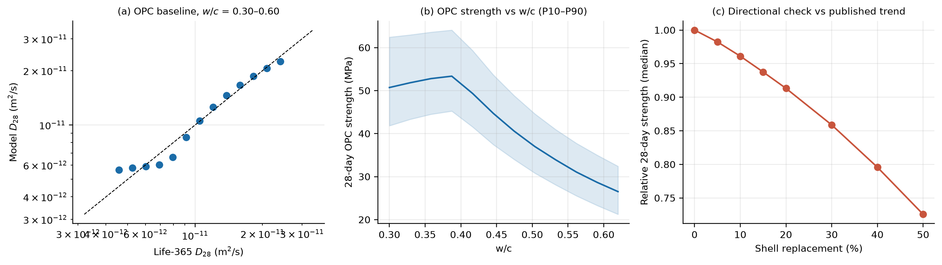
Fig. 2. Baseline checks. (a) Model D₂₈ against the Life-365 relation for OPC. (b) Model OPC 28-day strength against w/c (P10–P90). (c) Median relative 28-day strength against shell replacement (P1, 25 µm).
Verification is not validation. The checks above show that the equations are solved correctly and that the baseline is recovered; they say nothing about whether the model describes shell concrete. The model is compared with published directional behaviour (Table 4) and, in Section 4.4, with the only open quantitative dataset found. Conformity with directional trends is a necessary, not sufficient, condition.
Table 4. Directional checks of the model against published trends for ground shell as cement replacement.
Published trend | Model check | Result
Strength decreases monotonically with replacement (5–50%) | P(strength decreases at every step), r = 0–50% | 60%
Strength relative to OPC at 10 / 20 / 50% replacement | Median relative 28-day strength | 0.96 / 0.91 / 0.73
Porosity / water absorption increases with replacement | P(capillary porosity at 50% > at 0%) | 100%
Drying shrinkage decreases (some shell types) | P(shrinkage proxy at 20% < at 0%) | 100%
Setting / early hydration retarded by shell organics | P(α(1 d) lower; unwashed shell, no filler effect) | 100%

4.4 Out-of-sample tests, calibration and the strength-efficiency coefficient

4.4.1 Calibration on a scallop-shell dataset
Validation needs measured data. The first dataset used is Abbas and Kudukkan (2025), who used scallop shell as filler and partial cement replacement at a binder content of 350 kg/m³ and a water content of 160 kg/m³. The three mixes contain 50, 95 and 140 kg/m³ of shell-derived powder (r = 14%, 27% and 40% of the binder) with the median particle sizes reported there. Observed 28-day strengths relative to the control are read from the text for two mixes (“almost the same”, “nearly 25% reduction”) and derived for the third from the reported moduli of elasticity (E ∝ √f_c); they are approximate, and a tolerance of ±0.07 on the relative strength represents this and specimen scatter.
Table 5. Calibration set: strength model against Abbas and Kudukkan (2025), 28-day compressive strength relative to the control mix, median (P10–P90) of model draws. Observed values: S0F15 and S30F15 from the text of the source, S15F15 derived from the reported moduli. The strength model is shared by all three cases.
Mix | Shell powder, r | Median size (µm) | Observed | Original model (k_f = 0) | With k_f prior | Calibrated (posterior) | Role
S0F15 | 14% | 90 | 1.00 | 0.79 (0.75–0.83) | 0.92 (0.81–1.03) | 0.93 (0.93–0.94) | calibration
S15F15 | 27% | 64 | 0.86 | 0.61 (0.54–0.68) | 0.85 (0.65–1.05) | 0.87 (0.87–0.88) | held out
S30F15 | 40% | 55 | 0.75 | 0.43 (0.36–0.52) | 0.77 (0.49–1.07) | 0.81 (0.79–0.82) | calibration

The original model predicts relative strengths of 0.79, 0.61 and 0.43 against 1.00, 0.86 and 0.75 observed; none of 100,000 prior draws falls within the tolerance for any mix, so the inert-filler strength model is rejected by these data. Adding k_f (prior U(0, 1.2)) and running rejection approximate Bayesian computation on S0F15 and S30F15 (300,000 draws, tolerance 0.07) accepted 10,999 draws (3.7%); S15F15 was held out. The posterior median of k_f is 0.65 (P10–P90 0.54–0.84), and the posterior predictive for the held-out mix is 0.87–0.88 against 0.86 observed (Fig. 3a). This is an interpolation between the calibration mixes, so it is a weak test, and a bias of 0.06–0.07 remains at the calibration mixes (0.93 against 1.00 and 0.81 against 0.75), indicating a residual structural misfit of the strength relation. The carbon accounting was also checked against the same paper: with its emission factors (cement 0.91, shell powder 0.059 kg CO₂e/kg) the model arithmetic gives −24.4% and −36.0%, the same budget the model uses (a consistency check, not an independent test), and the model’s own shell emission factor at 55 µm (0.058 kg CO₂e/kg, P10–P90 0.036–0.084) is of the same order as the laboratory value of 0.059 whose boundary is not stated.
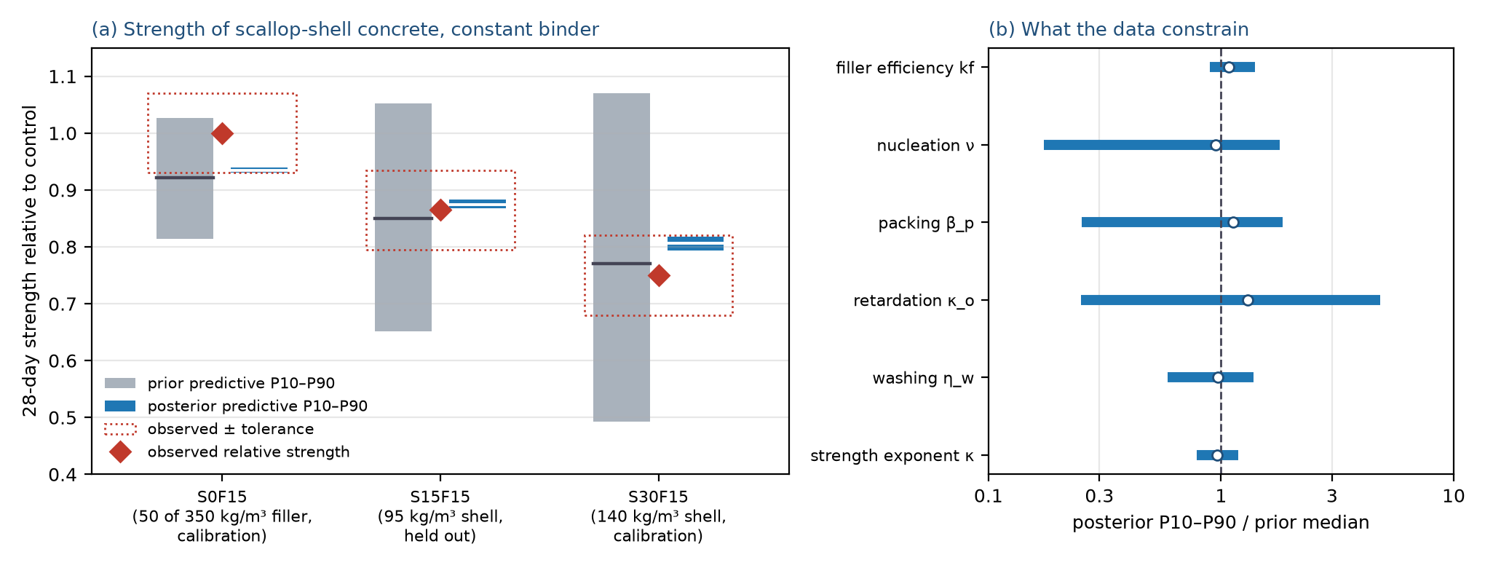
Fig. 3. Calibration against Abbas and Kudukkan (2025). (a) Relative 28-day strength: prior predictive with the k_f prior (grey), calibrated posterior predictive (blue) and observed values with the ±0.07 tolerance (red); S15F15 was not used in the calibration. (b) Posterior 10th–90th percentile range of selected parameters relative to their prior medians (circle: posterior median).

4.4.2 Independent oyster-shell data with frozen parameters
The Abbas-calibrated posterior was then frozen and used to predict three independent sets of oyster-shell data without refitting. (i) Kwon and Wang (2024): oyster-shell powder replacing 15% and 30% of cement in mortar at constant binder (568 kg/m³) and water-to-binder ratio 0.50 (Tables 1 and 3 of the source; observed relative strengths 0.65 and 0.43; particle size not reported, 30 µm assumed). (ii) Abinaya et al. as transcribed in Table A1 of Kim and Lee (2023): oyster shell at 2.5–10% replacement, water-to-binder ratio 0.40, observed relative strengths 1.05, 1.11, 1.05, 1.04; this is a secondary source, binder content (400 kg/m³) and particle size (30 µm) are assumed. (iii) De Dios-Suárez et al. (2026): untreated oyster-shell CaCO₃ at 10 wt% of cement in 1:4 mortar (water-to-cement ratio 0.68) for five sieve fractions of 0.14–0.84 mm (observed relative strengths 1.04, 0.98, 1.00, 1.01, 0.88); the 10 wt% is interpreted as replacement and the sieve apertures as particle sizes, both uncertain. Eleven data points result. The calibrated model is compared with the inert model, a k-value rule with k_f = 0.25 in the same model, and the Bolomey dilution relation f ∝ (c/w − 0.5) without and with a k-value of 0.25; the same errors are reported for all.
Table 6. Prediction of independent oyster-shell strength data (11 points, relative to each study’s control) with frozen parameters: mean absolute error (MAE), root-mean-square error (RMSE), bias (prediction minus observation) and, for the draw-based models, the share of observations inside the 5–95% predictive interval widened by the 0.07 tolerance.
Model | MAE (all) | RMSE (all) | Bias (all) | 90% interval coverage | MAE Kwon & Wang | MAE Abinaya | MAE mortar 2026
Abbas-calibrated, frozen | 0.124 | 0.174 | +0.019 | 64% | 0.368 | 0.080 | 0.063
Inert filler (k_f = 0) | 0.145 | 0.151 | −0.094 | 27% | 0.140 | 0.139 | 0.152
k_f = 0.25 | 0.133 | 0.146 | −0.051 | 18% | 0.225 | 0.116 | 0.110
Bolomey dilution | 0.141 | 0.147 | −0.083 | – | 0.159 | 0.141 | 0.134
Bolomey k-value 0.25 | 0.131 | 0.146 | −0.045 | – | 0.234 | 0.121 | 0.098

The calibrated model has the lowest error but not by a meaningful margin (MAE 0.124 against 0.145 for the inert model and 0.141 for dilution alone), and its errors are not random: it over-predicts the large strength loss of Kwon and Wang by 0.37 (predicted 0.94 and 0.87 against 0.65 and 0.43) and under-predicts the small strength gains of the other two studies. The only open oyster-shell binary dataset with a large replacement therefore loses more strength than pure dilution would, which no filler-efficiency in the range 0–1 can reproduce. The calibrated model does not outperform simple rules on independent data, and this is reported as a result: the calibration of one scallop-shell study is not evidence that the strength of oyster-shell concrete is predicted.

4.4.3 Study-level filler efficiency and the pooled predictive distribution
To describe what the four datasets say about a new study, k_f was estimated separately for each (rejection ABC on the study’s mixes, k_f ~ U(−1.5, 1.5), tolerance 0.07; Table 7). The estimates differ in sign and size: -0.40 for Kwon and Wang (strength loss larger than dilution), 0.65 for Abbas and Kudukkan, 0.76 for the 2026 mortar study and 1.36 for Abinaya et al. (strength gains at low replacement). Treating the study estimates as a random sample, k_f for a new study has a Student-t predictive distribution (reference prior) with location 0.59, scale 0.82 and 3 degrees of freedom, truncated to [−1, 1.5] so that the effective cementing mass is not negative. This distribution, which expresses between-study heterogeneity and not a property of oyster shell, replaces the single posterior in all primary results below. In leave-one-study-out tests it predicts the held-out study with a mean absolute error of 0.038, 0.460, 0.108 and 0.077 for Abbas, Kwon, Abinaya and the 2026 mortar study, and its 90% interval covers every held-out point only because it is very wide.
Table 7. Study-level effective strength-efficiency coefficient k_f (rejection ABC, median and P10–P90) and leave-one-study-out prediction by the pooled distribution.
Study | k_f | Accepted draws | Leave-one-out MAE / bias | Evidence quality
Abbas and Kudukkan 2025 (scallop, concrete) | 0.65 (0.54–0.85) | 4414 | 0.038 / −0.033 | text values and derived moduli; three mixes
Kwon and Wang 2024 (oyster, mortar) | -0.40 (-0.65–-0.17) | 23638 | 0.460 / +0.460 | tabulated values; two mixes; size unknown
Abinaya et al. via Kim and Lee 2023 (oyster) | 1.36 (1.15–1.47) | 17990 | 0.108 / −0.108 | secondary transcription; binder content assumed
De Dios-Suárez et al. 2026 (oyster CaCO₃, mortar) | 0.76 (0.69–1.04) | 31 | 0.077 / −0.064 | tabulated; coarse fractions; addition vs replacement unclear

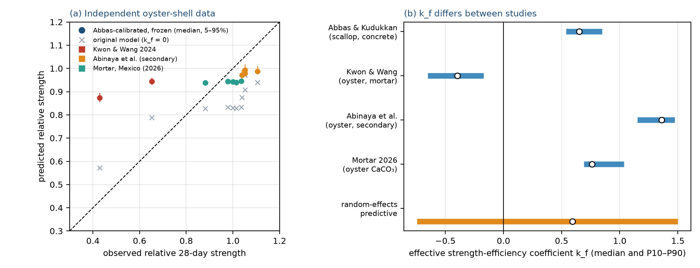
Fig. 4. Independent validation and study-level k_f. (a) Predicted against observed relative strength for 11 independent oyster-shell data points: Abbas-calibrated model with frozen parameters (coloured, median and 5–95% interval) and the original inert model (grey crosses). (b) k_f estimated separately for each study and the pooled random-effects predictive interval used for the primary results.
The calibration constrains strength only. Porosity, and hence chloride diffusivity, count cement only in the primary formulation and k_f is not applied to transport; no open dataset with tabulated chloride, acid or freeze–thaw results for shell-powder concrete was found, so the transport and damage predictions remain uncalibrated and are bracketed in Section 7.4. The study-level estimates condition on the other parameters being at their priors, ignore the weak posterior correlations among them, and the two weakest datasets (Abinaya, 2026 mortar) carry assumptions stated above; leaving them out leaves Abbas and Kwon with estimates of opposite sign and does not narrow the pooled interval.

5. Results
Sections 5–7 report the primary model, in which the strength-efficiency coefficient k_f follows the pooled random-effects predictive distribution of Section 4.4.3 (all other inputs unchanged). The original inert-filler model and the Abbas-only calibration are reported as ablations in Section 7.5.

5.1 Hydration and microstructure
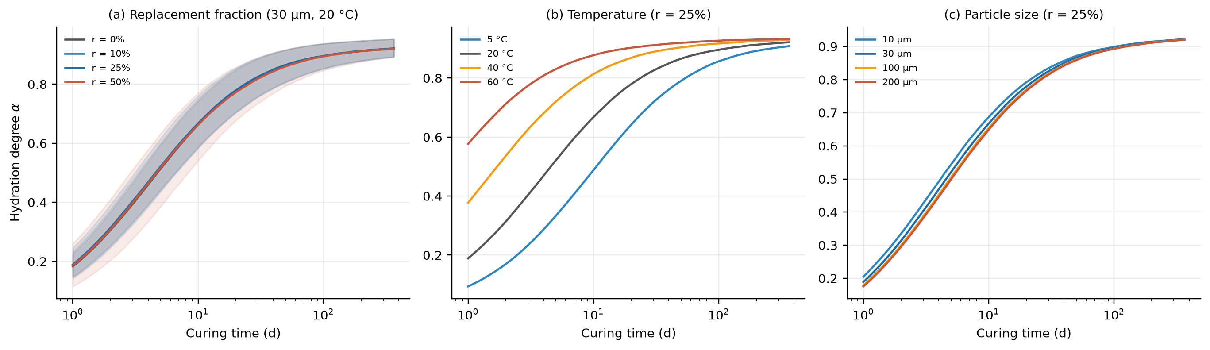
Fig. 5. Hydration degree against curing time (median and P10–P90): (a) shell replacement fraction; (b) curing temperature; (c) median particle size (P1, w/b = 0.42).
The model does not predict a large acceleration. Median hydration degree at 1 day is 0.18 for OPC and 0.19, 0.19 and 0.18 for 10%, 25% and 50% replacement; at 28 days the values are 0.81, 0.82, 0.82 and 0.81. The nucleation effect and the larger effective w/c are largely offset by organic retardation and dilution, so the probability that 1-day hydration is higher than OPC at r = 20% is 70% (the sign depends on the poorly known filler and retardation coefficients). Meanwhile cement is removed: median 28-day strength falls to 88% of OPC at r = 25% and 72% at r = 50%, and capillary porosity per unit paste rises by 46% and 94%. Temperature (Fig. 5b) accelerates hydration through the Arrhenius factor, and finer shell (Fig. 5c) accelerates it moderately.

5.2 Transport
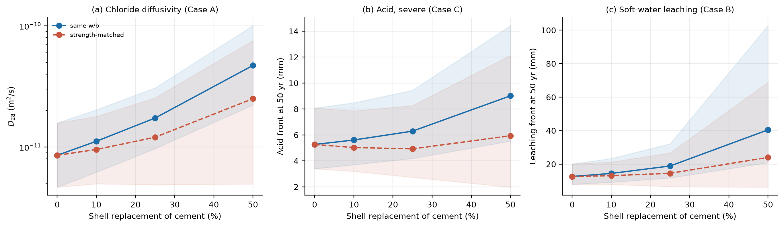
Fig. 6. Transport indicators against shell replacement for same-w/b and strength-matched mixes (median and P10–P90): (a) 28-day chloride diffusivity, pavement; (b) acid front depth at 50 years, severe exposure, culvert; (c) leaching front depth at 50 years, dam.
At constant w/b the median 28-day chloride diffusivity rises by a factor 1.3 at r = 10%, 2.1 at 25% and 5.6 at 50%, because dilution raises porosity and the cement-only mapping amplifies the effect. In the severe acid case the 50-year front is 5.3 mm for OPC and 6.3 mm at r = 25% (same w/b, +20%) but 4.9 mm when strength-matched (−7%): calcite buffering helps only when it is not outweighed by dilution. Particle size matters: at r = 25% the front is 6.2 mm for 10 µm shell and 7.3 mm for 200 µm shell, because coarse particles are less accessible. For soft-water leaching the 50-year front is 12.6 mm for OPC, 18.9 mm at r = 25% (+50%) and 40.6 mm at r = 50%, because calcite adds no leachable calcium and dilutes the cement. The calcite-dissolution mass loss in acid, which could offset the buffering benefit, is not modelled.

5.3 Service-life distributions
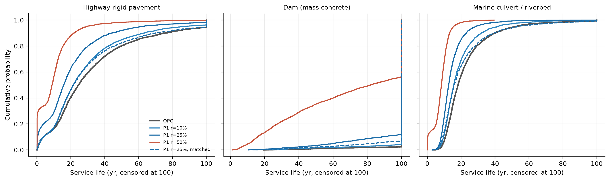
Fig. 7. Empirical cumulative distribution of service life (censored at 100 years) for OPC and selected shell mixes in the three cases (medium load, moderate exposure; 30 µm shell).
The OPC reference has a median life of 24.9 yr (P10–P90 4.5–70.4) in the pavement case, 18.1 yr (10.5–38.6) in the culvert case, and survives 100 years in 97% of dam draws. At constant w/b, shell replacement shifts the distributions to shorter life in the pavement and culvert cases, and strongly so at r ≥ 50% (Fig. 7). Strength-matched mixes recover part of the lost life (median −1.8 yr at r = 25%, pavement) but with a wide spread, because the filler efficiency differs between studies (Section 4.4.3) and the diffusivity mapping is untested (Section 7.3). Details by case are in Section 6.

5.4 Carbon
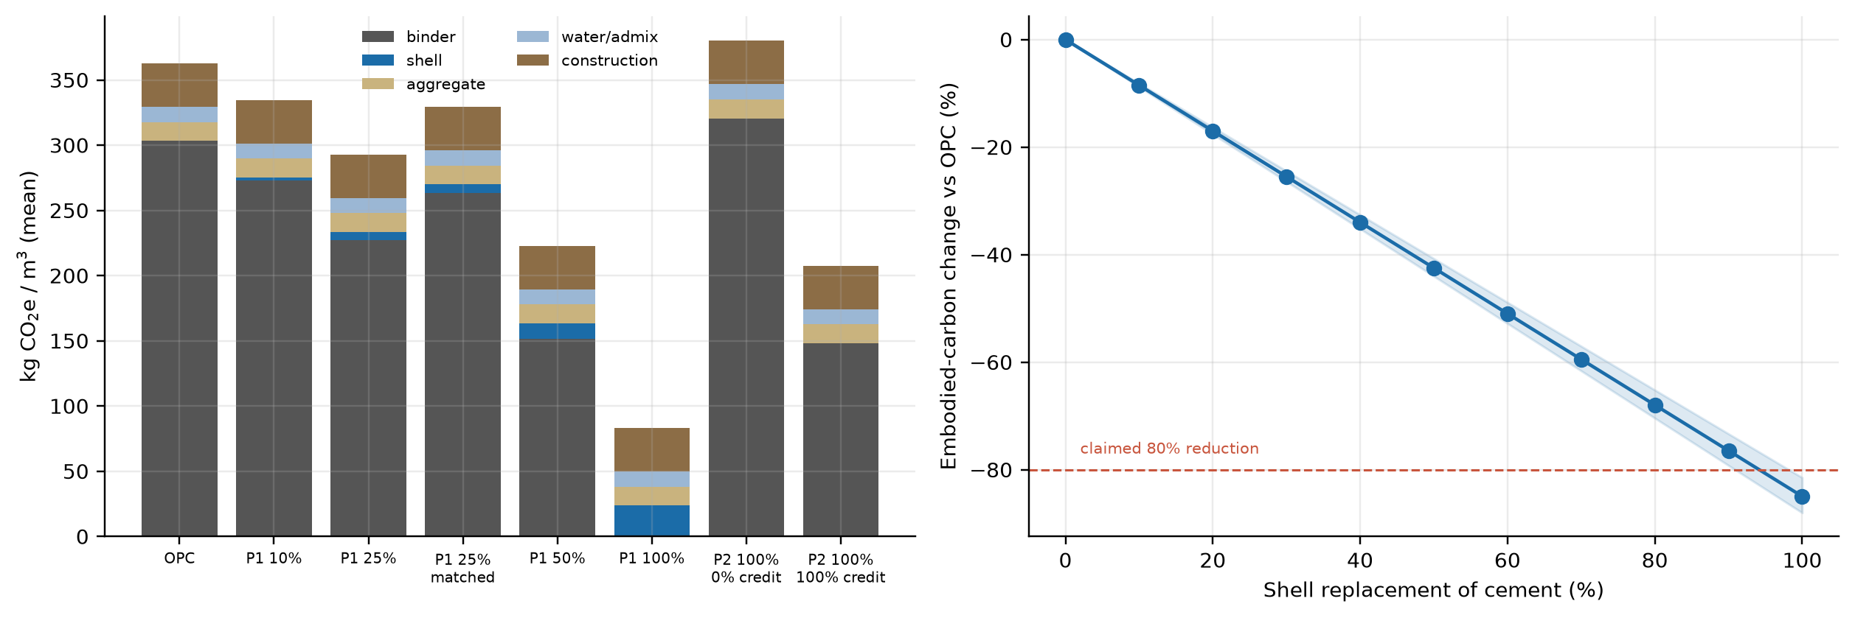
Fig. 8. Left: mean embodied carbon by component (pavement mix). Right: change in embodied carbon against shell replacement at constant w/b (median and P10–P90); the dashed line marks the 80% reduction claimed in the source white paper.
Table 8. Change in cradle-to-gate embodied carbon relative to OPC (median, P10–P90) and relative 28-day strength; pavement mix, 30 µm shell.
Configuration | Carbon change vs OPC (%) | 28-day strength vs OPC
P1, r = 10%, same w/b | −8.5 (−8.8 to −8.1) | 0.95
P1, r = 25%, same w/b | −21.2 (−22.0 to −20.4) | 0.87
P1, r = 50%, same w/b | −42.5 (−44.0 to −40.7) | 0.73
P1, r = 100%, same w/b | −84.9 (−88.1 to −81.5) | 0.00
P1, r = 25%, strength-matched | −15.0 (−21.6 to +9.7) | 1.02
P1, r = 50%, strength-matched | −37.0 (−43.3 to +13.0) | 1.02
P2, ρ = 100%, no biogenic credit | +5.1 (+2.8 to +8.1) | n/a (≈ 1.0)
P2, ρ = 100%, 50% biogenic credit | −21.0 (−24.0 to −17.7) | n/a (≈ 1.0)
P2, ρ = 100%, 100% biogenic credit | −47.1 (−51.7 to −42.7) | n/a (≈ 1.0)

At constant w/b, carbon falls almost proportionally to r (−8.5%, −21.2%, −42.5% at 10, 25 and 50%) because the shell powder footprint is small relative to cement. The claimed 80% reduction is reached only at essentially complete cement replacement (−85.0% at r = 100%), at which the concrete has no strength. When strength is matched by adding binder, the median benefit shrinks to −15.1% at r = 25% and −36.7% at r = 50%, with a wide interval (P10–P90 −21.6 to +9.7% at 25%) that includes net increases where the effective efficiency is low or negative. Pathway P2 increases embodied carbon by 5.1% (P10–P90 2.8 to 8.1) when no biogenic credit is allowed, because processing and transport of shell exceed the footprint of quarrying adjacent limestone while the calcination CO₂ is unchanged; a reduction appears only when 50% or 100% of the calcination CO₂ is credited (-21.0% and -47.1%), which is an accounting choice and not a material property.

5.5 Carbon–durability trade-off
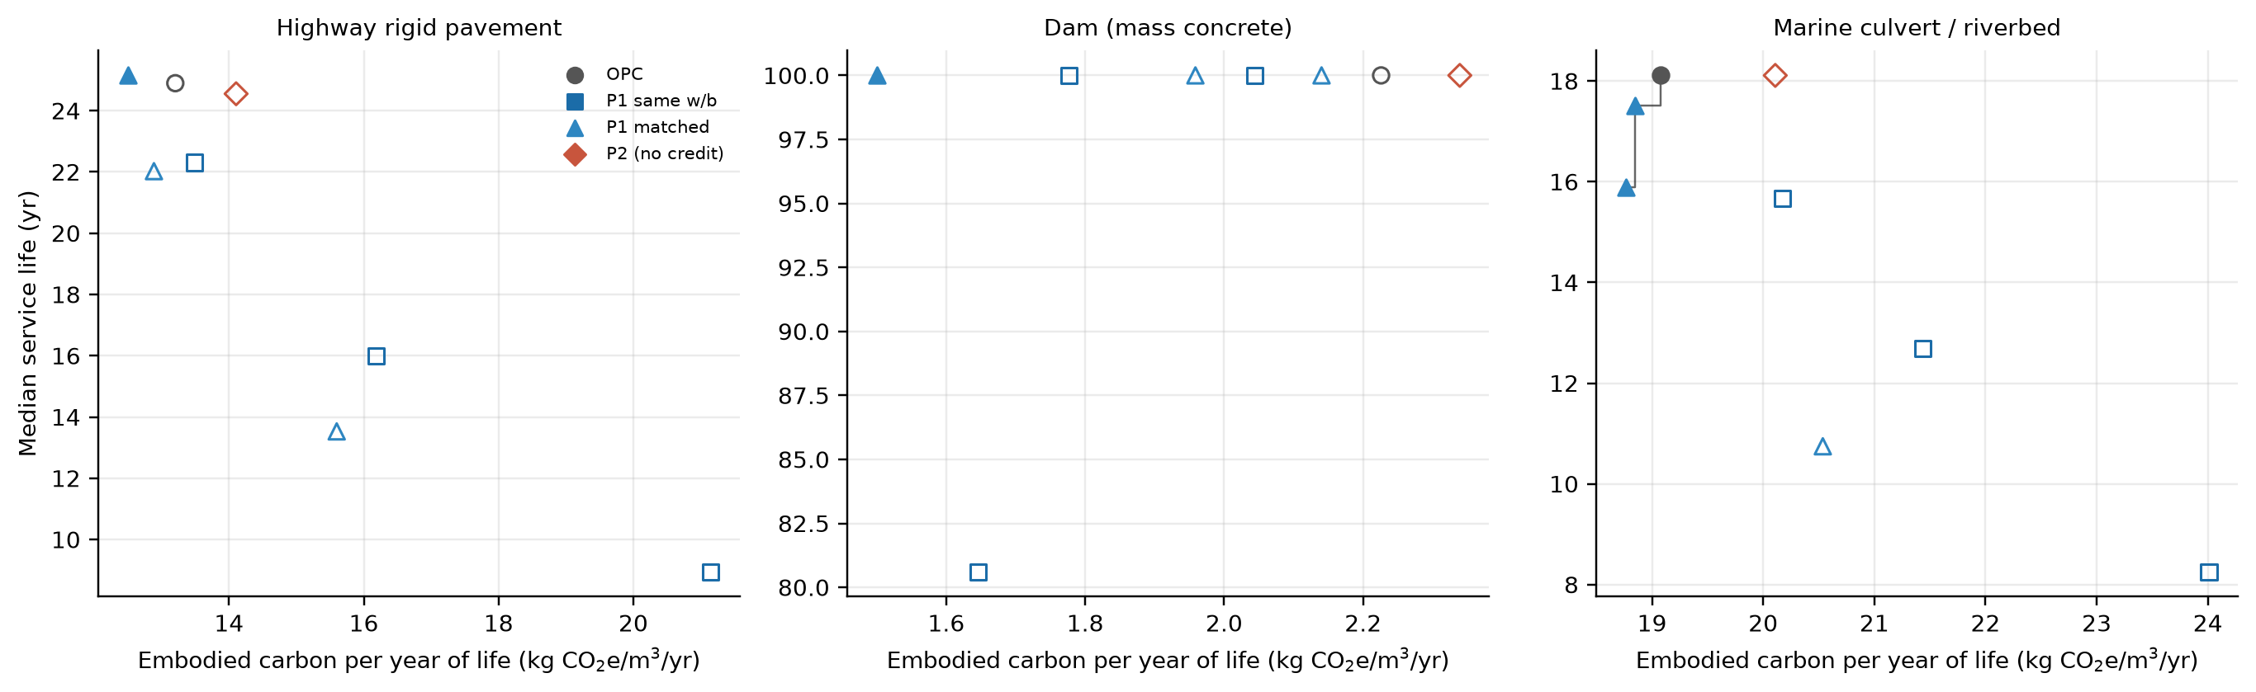
Fig. 9. Embodied carbon per year of life against median service life for OPC, P1 (r ≤ 50%, 30 µm; same w/b and strength-matched) and P2 without credit. Filled symbols are Pareto-optimal, open symbols are dominated.
Over the plausible replacement range (r ≤ 50%), no shell mix dominates OPC in every case. Strength-matched P1 mixes cut carbon by a median −15% at r = 25% but lose a median 1.8 yr (pavement) and 2.3 yr (culvert) of life, whereas same-w/b mixes cut carbon by −21% and lose 8.4 and 5.5 yr; in the dam case life is bounded by the 100-year horizon (Fig. 9). These are median-based statements; the joint-advantage probabilities in Section 7 give the more informative picture.

6. Infrastructure applications

6.1 Case A: highway rigid pavement
The pavement case combines repeated traffic loading, restrained shrinkage and curling, freeze–thaw and chloride ingress from de-icing salt (medium stress ratio, moderate exposure). The OPC failure mode is chloride corrosion initiation plus propagation in 73% of draws and damage in 23% (Table 9).
Table 9. Case A results (30 µm shell; 3,000 paired draws; medium stress ratio, moderate chloride exposure).
Mix | f_c28 (MPa) | Life P10 / P50 / P90 (yr) | ΔL P50 (yr) | P(non-inferior) | ΔE P50 (%) | P(≥5% cut & non-inf.)
OPC reference | 49 | 4.5 / 24.9 / 70.4 | – | – | – | –
P1 10%, same w/b | 46 | 5.2 / 22.3 / 58.5 | −2.7 | 18% | −8.5 | 18%
P1 25%, same w/b | 42 | 0.5 / 16.0 / 41.6 | −8.4 | 14% | −21.2 | 14%
P1 50%, same w/b | 35 | 0.1 / 8.9 / 20.7 | −16.6 | 11% | −42.5 | 11%
P1 10%, matched | 49 | 6.4 / 25.2 / 73.5 | −0.1 | 48% | −6.2 | 15%
P1 25%, matched | 49 | 5.1 / 22.0 / 66.7 | −1.8 | 41% | −15.0 | 21%
P1 50%, matched | 49 | 0.1 / 13.5 / 53.8 | −8.2 | 30% | −37.0 | 19%
P2 100%, no credit | 47 | 4.0 / 24.6 / 69.6 | 0.0 | 4% | +5.1 | 0%
P2 100%, 50% credit | 47 | 4.0 / 24.6 / 69.6 | 0.0 | 4% | −21.0 | 4%

At constant w/b, replacement reduces median life by 2.7 yr (10%), 8.4 yr (25%) and 16.6 yr (50%), since the weaker, more porous paste fatigues and admits chloride faster. The restrained-shrinkage cracking index exceeds 1 in 44% of OPC draws and in 37%, 24% and 5% of draws at 10%, 25% and 50% replacement (same w/b), a shrinkage benefit that arises from dilution; with strength matched it is 35%. Strength-matched mixes change median life by −1.8 yr at r = 25% (P10–P90 −20.6 to +15.8) and carbon by −15.0%. Sensitivity of the life difference is led by strength-efficiency coefficient k_f (0.42), restraint factor (0.23), relative humidity (0.20).

6.2 Case B: dam (mass concrete)
For mass concrete the modelled mechanisms (thermal cracking, leaching with hydrostatic gradient, freeze–thaw on the face) rarely end the life of the OPC reference within 100 years (97% survive), so differences in life are censored and the damage-index tie-break governs (Table 10). Lower cement content reduces the adiabatic temperature rise, but the OPC thermal cracking probability is already 0%, so little is gained. At r = 10% (same w/b) the probability of non-inferior life is 55% and that of a joint 5% carbon cut and non-inferior life is 55%; at 25% it falls to 5% because the leaching front deepens (Section 5.2), and at 50% it is 0%. The apparent success at low replacement is therefore a statement that dam concrete is durable in the model regardless, not evidence of benefit; with strength matched at r = 25% it is 14% (−14.2% carbon). The reference here is OPC although dam concrete usually contains supplementary cementitious materials. Life differences are driven by air-void filling fraction (0.35), permeability factor (0.33), critical degree of saturation (0.30).
Table 10. Case B results (30 µm shell; 3,000 paired draws; moderate exposure). Median life is censored at 100 years for the OPC reference.
Mix | f_c28 (MPa) | Life P10 / P50 / P90 (yr) | ΔL P50 (yr) | P(non-inferior) | ΔE P50 (%) | P(≥5% cut & non-inf.)
OPC reference | 34 | 100.0 / 100.0 / 100.0 | – | – | – | –
P1 10%, same w/b | 32 | 100.0 / 100.0 / 100.0 | 0.0 | 55% | −8.1 | 55%
P1 25%, same w/b | 29 | 94.2 / 100.0 / 100.0 | 0.0 | 5% | −20.2 | 5%
P1 50%, same w/b | 24 | 16.2 / 80.6 / 100.0 | −18.9 | 0% | −40.5 | 0%
P1 10%, matched | 36 | 100.0 / 100.0 / 100.0 | 0.0 | 77% | −5.7 | 33%
P1 25%, matched | 36 | 100.0 / 100.0 / 100.0 | 0.0 | 46% | −14.2 | 14%
P1 50%, matched | 36 | 28.6 / 100.0 / 100.0 | 0.0 | 29% | −34.6 | 6%
P2 100%, no credit | 34 | 100.0 / 100.0 / 100.0 | 0.0 | 100% | +4.9 | 0%
P2 100%, 50% credit | 34 | 100.0 / 100.0 / 100.0 | 0.0 | 100% | −20.0 | 100%

6.3 Case C: marine culvert / riverbed
The culvert case combines chloride ingress, acid from organic matter and abrasion. OPC failure is by chloride corrosion in 96% of draws (Table 11). At constant w/b the median life falls by 2.5 yr at 10%, 5.5 yr at 25% and 10.8 yr at 50%, and the probability of non-inferior life is 0%, 0% and 0%: shell concrete underperforms OPC in essentially every draw when strength is not matched. Strength matching reduces the median loss (−2.3 yr at 25%) and gives non-inferior life in 33% of draws, but the joint-advantage probability is at most 3% because the draws with non-inferior life are mostly those in which the matched mix needs so much added cement that the carbon cut is below 5%. The acid benefit of calcite buffering (Section 5.2) is too small relative to chloride-driven life to alter the failure mode. Life differences are driven by chloride-diffusivity multiplier (0.35), surface chloride (0.17), service temperature (0.17).
Table 11. Case C results (30 µm shell; 3,000 paired draws; moderate exposure).
Mix | f_c28 (MPa) | Life P10 / P50 / P90 (yr) | ΔL P50 (yr) | P(non-inferior) | ΔE P50 (%) | P(≥5% cut & non-inf.)
OPC reference | 49 | 10.5 / 18.1 / 38.6 | – | – | – | –
P1 10%, same w/b | 46 | 9.5 / 15.7 / 31.0 | −2.5 | 0% | −8.5 | 0%
P1 25%, same w/b | 42 | 8.1 / 12.7 / 22.0 | −5.5 | 0% | −21.3 | 0%
P1 50%, same w/b | 35 | 0.3 / 8.3 / 12.8 | −10.8 | 0% | −42.7 | 0%
P1 10%, matched | 49 | 10.1 / 17.5 / 38.0 | −1.0 | 33% | −6.2 | 0%
P1 25%, matched | 49 | 9.0 / 15.9 / 40.2 | −2.3 | 33% | −15.1 | 3%
P1 50%, matched | 49 | 3.3 / 10.7 / 34.5 | −6.2 | 21% | −37.2 | 4%
P2 100%, no credit | 47 | 10.5 / 18.1 / 38.6 | 0.0 | 96% | +5.1 | 0%
P2 100%, 50% credit | 47 | 10.5 / 18.1 / 38.6 | 0.0 | 96% | −21.1 | 96%

6.4 Comparison with a low-clinker blended-cement reference
Plain OPC is not what engineers would choose today for marine or mass concrete. A blended-cement reference was therefore added: 50% of the binder replaced by ground granulated blast-furnace slag, with the Life-365 treatment of slag (age exponent of the diffusivity raised by 0.4 × 0.5/0.7, 28-day diffusivity at equal water-to-binder ratio unchanged), a slag emission factor of 0.07 kg CO₂e/kg (0.12 as a sensitivity), identical 28-day strength and the same acid and leaching treatment as OPC; this is a screening treatment and not a validated slag-concrete model. The blended reference cuts embodied carbon by 42% (P10–P90 41–43%) and raises the median life from 24.4 to 96.2 yr in the pavement case and from 18.2 to 68.2 yr in the culvert case (Table 12).
Table 12. Shell concrete (P1, r = 25%, 30 µm, primary model) against plain OPC and against the 50% slag blended-cement reference: median change in embodied carbon and in service life (P10–P90), and P(≥5% carbon cut and non-inferior life).
Comparison | ΔE median (P10 to P90) % | ΔL median (P10 to P90) yr | P(adv, mat)
Pavement: blended reference vs OPC | −42 | +34.2 | –
Pavement: shell 25%, same w/b vs OPC | −21 (−22 to −20) | −8.0 (−32.2 to +2.0) | 0.15
Pavement: shell 25%, matched vs OPC | −15 (−22 to +10) | −1.8 (−19.6 to +12.9) | 0.21
Pavement: shell 25%, matched vs blended | +47 (+35 to +89) | −40.2 (−79.9 to +4.7) | 0.00
Pavement: shell 50%, matched vs blended | +10 (−2 to +95) | −49.2 (−91.0 to +6.2) | 0.00
Dam: blended reference vs OPC | −40 | 0.0 | –
Dam: shell 25%, same w/b vs OPC | −20 (−21 to −19) | 0.0 (−4.6 to 0.0) | 0.04
Dam: shell 25%, matched vs OPC | −14 (−21 to +23) | 0.0 (0.0 to 0.0) | 0.13
Dam: shell 25%, matched vs blended | +44 (+32 to +106) | 0.0 (0.0 to 0.0) | 0.00
Dam: shell 50%, matched vs blended | +9 (−2 to +111) | 0.0 (−70.8 to 0.0) | 0.00
Culvert: blended reference vs OPC | −42 | +43.1 | –
Culvert: shell 25%, same w/b vs OPC | −21 (−22 to −20) | −5.6 (−17.2 to −2.0) | 0.00
Culvert: shell 25%, matched vs OPC | −15 (−22 to +10) | −2.2 (−12.1 to +9.9) | 0.03
Culvert: shell 25%, matched vs blended | +48 (+36 to +90) | −42.3 (−82.3 to −6.7) | 0.00
Culvert: shell 50%, matched vs blended | +10 (−2 to +95) | −48.2 (−90.2 to −6.8) | 0.00

Against the blended reference, shell concrete at r = 25% has carbon higher by a median 47% in the pavement case (strength matched) and a shorter life, and the joint-advantage probability is 0.00 in all three cases at r = 25% and 50%. A realistic low-clinker concrete already delivers the carbon cut that shell replacement offers, with better chloride durability; in the framework, shell powder at the replacement levels studied here is not a competitor to slag blends but at best a complement, and its value must be sought where slag is not available or in the shell’s other uses (Sandler 2026b).
Table 13. Sensitivity to exposure severity and load class for P1 at r = 25% (30 µm): median life and P(≥5% carbon cut and non-inferior life), same w/b and strength-matched.
Case and condition | OPC life P50 | Same w/b: life P50 | P(adv, mat) | Matched: life P50 | P(adv, mat)
A: moderate exposure, low load | 29.1 | 19.2 | 0.06 | 26.5 | 0.11
A: moderate exposure, medium load | 24.6 | 15.6 | 0.15 | 21.4 | 0.21
A: moderate exposure, high load | 14.2 | 8.4 | 0.29 | 14.0 | 0.39
A: mild exposure, medium load | 48.9 | 28.3 | 0.30 | 44.7 | 0.36
A: severe exposure, medium load | 17.0 | 11.7 | 0.12 | 15.1 | 0.17
B: mild exposure, medium load | 100.0 | 100.0 | 0.14 | 100.0 | 0.21
B: moderate exposure, medium load | 100.0 | 100.0 | 0.04 | 100.0 | 0.14
B: severe exposure, medium load | 100.0 | 100.0 | 0.02 | 100.0 | 0.10
C: mild exposure, medium load | 31.5 | 18.9 | 0.01 | 26.5 | 0.05
C: moderate exposure, medium load | 18.3 | 12.6 | 0.00 | 15.8 | 0.02
C: severe exposure, medium load | 13.8 | 10.4 | 0.00 | 12.4 | 0.02

Across exposure severity and load class the joint-advantage probability for P1 at r = 25% ranges from 0.00 to 0.30 for same-w/b mixes and from 0.02 to 0.39 for strength-matched mixes; no condition gives a high probability, and the highest values occur where the OPC reference is censored at the horizon (dam) or the exposure is mild.

7. Uncertainty and falsification

7.1 Falsification maps
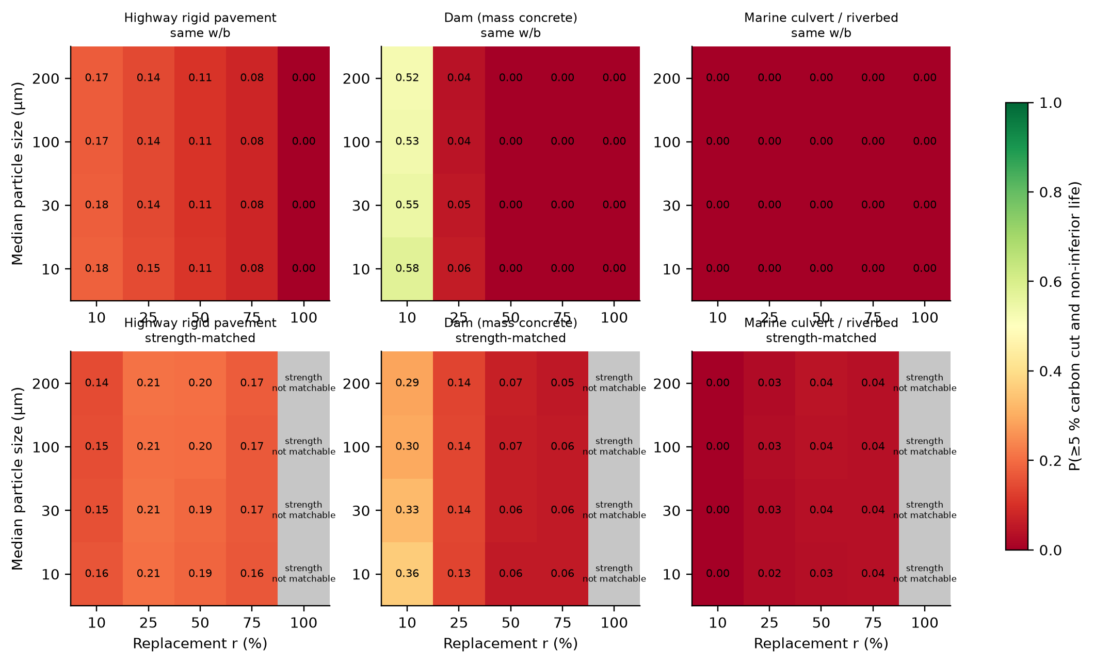
Fig. 10. Probability of a joint advantage (carbon cut of at least 5% and non-inferior service life) for P1 as a function of replacement fraction and median particle size, same-w/b (top) and strength-matched (bottom) designs. Grey cells mark strength-matched designs for which matching is infeasible in more than half of the draws.
The joint-advantage region is small. For the pavement and culvert cases the same-w/b maps reach at most 0.18 and 0.00 for r ≤ 50%, and the strength-matched maps reach up to 0.21 for the pavement and 0.04 for the culvert, wherever matching is possible in at least half of the draws. The dam map is non-empty at r = 10% mainly for the censoring reason explained in Section 6.2. With the strict definition (any carbon reduction), matched mixes appear to succeed in 26% of pavement draws at r = 25%, but the carbon change is −15.0% (P10–P90 −21.6 to +9.7%), so the material threshold of 5% is used.

7.2 Pathway P2
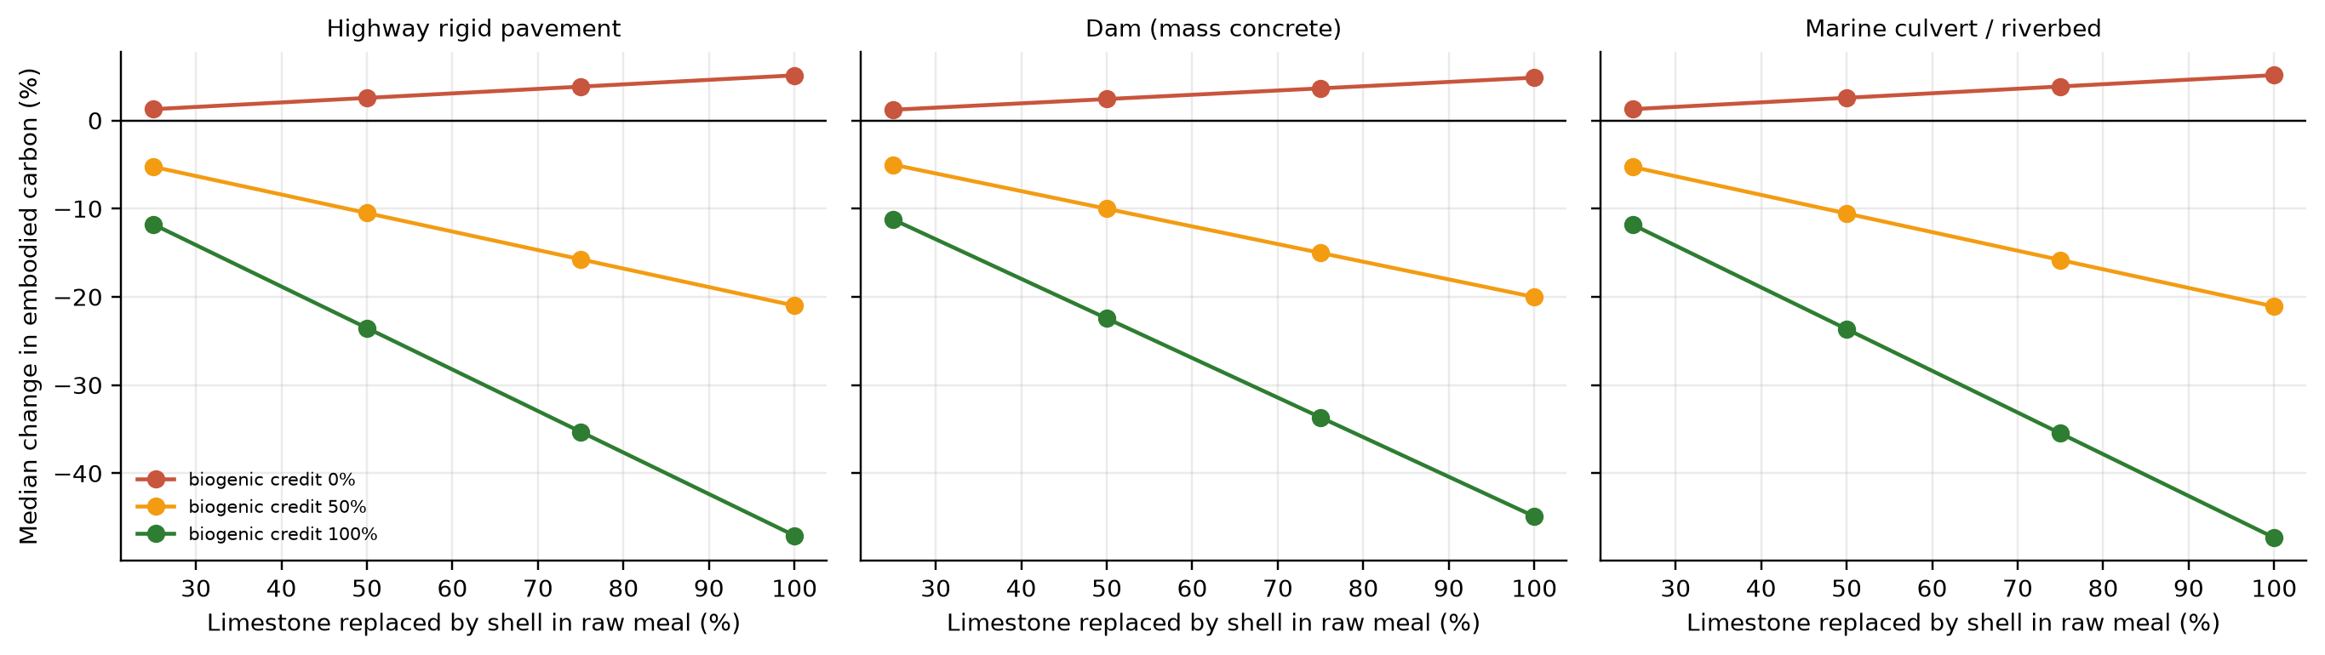
Fig. 11. P2 pathway: median change in embodied carbon against the fraction of limestone replaced by shell in raw meal, for three levels of biogenic credit.
For P2 the durability effect is negligible (median life change −0.04 yr in the pavement case from the impurity penalty, none in the dam and culvert cases), so the outcome is determined by carbon accounting. Without credit P2 is falsified: embodied carbon is higher in 100% of draws. With a 50% or 100% biogenic credit, carbon falls by 21.0% and 47.1% and the joint advantage is reached in 96%–100% of dam and culvert draws (for the pavement, the strict non-inferiority test fails in most draws because of the small strength penalty; with a 5% life tolerance the probability is 81%). Whether shell calcination CO₂ may be treated as biogenic is a methodological and regulatory question that this model cannot resolve; the credit should be reported as a scenario, not a property.

7.3 Model-form uncertainty and sensitivity
Table 14. Dependence of the median life difference (ΔL, years) for P1 at r = 25% on the diffusivity model weight χ_D (0 = porosity mapping, 1 = cement-only w/c mapping).
χ_D range | Pavement: same w/b | Pavement: matched | Culvert: same w/b | Culvert: matched
0.00–0.25 | −6.7 | −0.6 | −5.3 | −1.5
0.25–0.50 | −8.2 | −1.4 | −5.5 | −2.1
0.50–0.75 | −7.8 | −2.1 | −5.7 | −2.5
0.75–1.00 | −9.1 | −3.0 | −5.6 | −2.6

The sign of the same-w/b effect is robust to the diffusivity mapping (negative in all bins), whereas the median life difference of the matched design ranges from −0.6 yr to −3.0 yr in the pavement case as the pessimistic mapping is weighted more heavily. The matched-design result also depends on the assumed filler shift ω of the ageing exponent, which favours filler-bearing mixes and has no experimental support here.
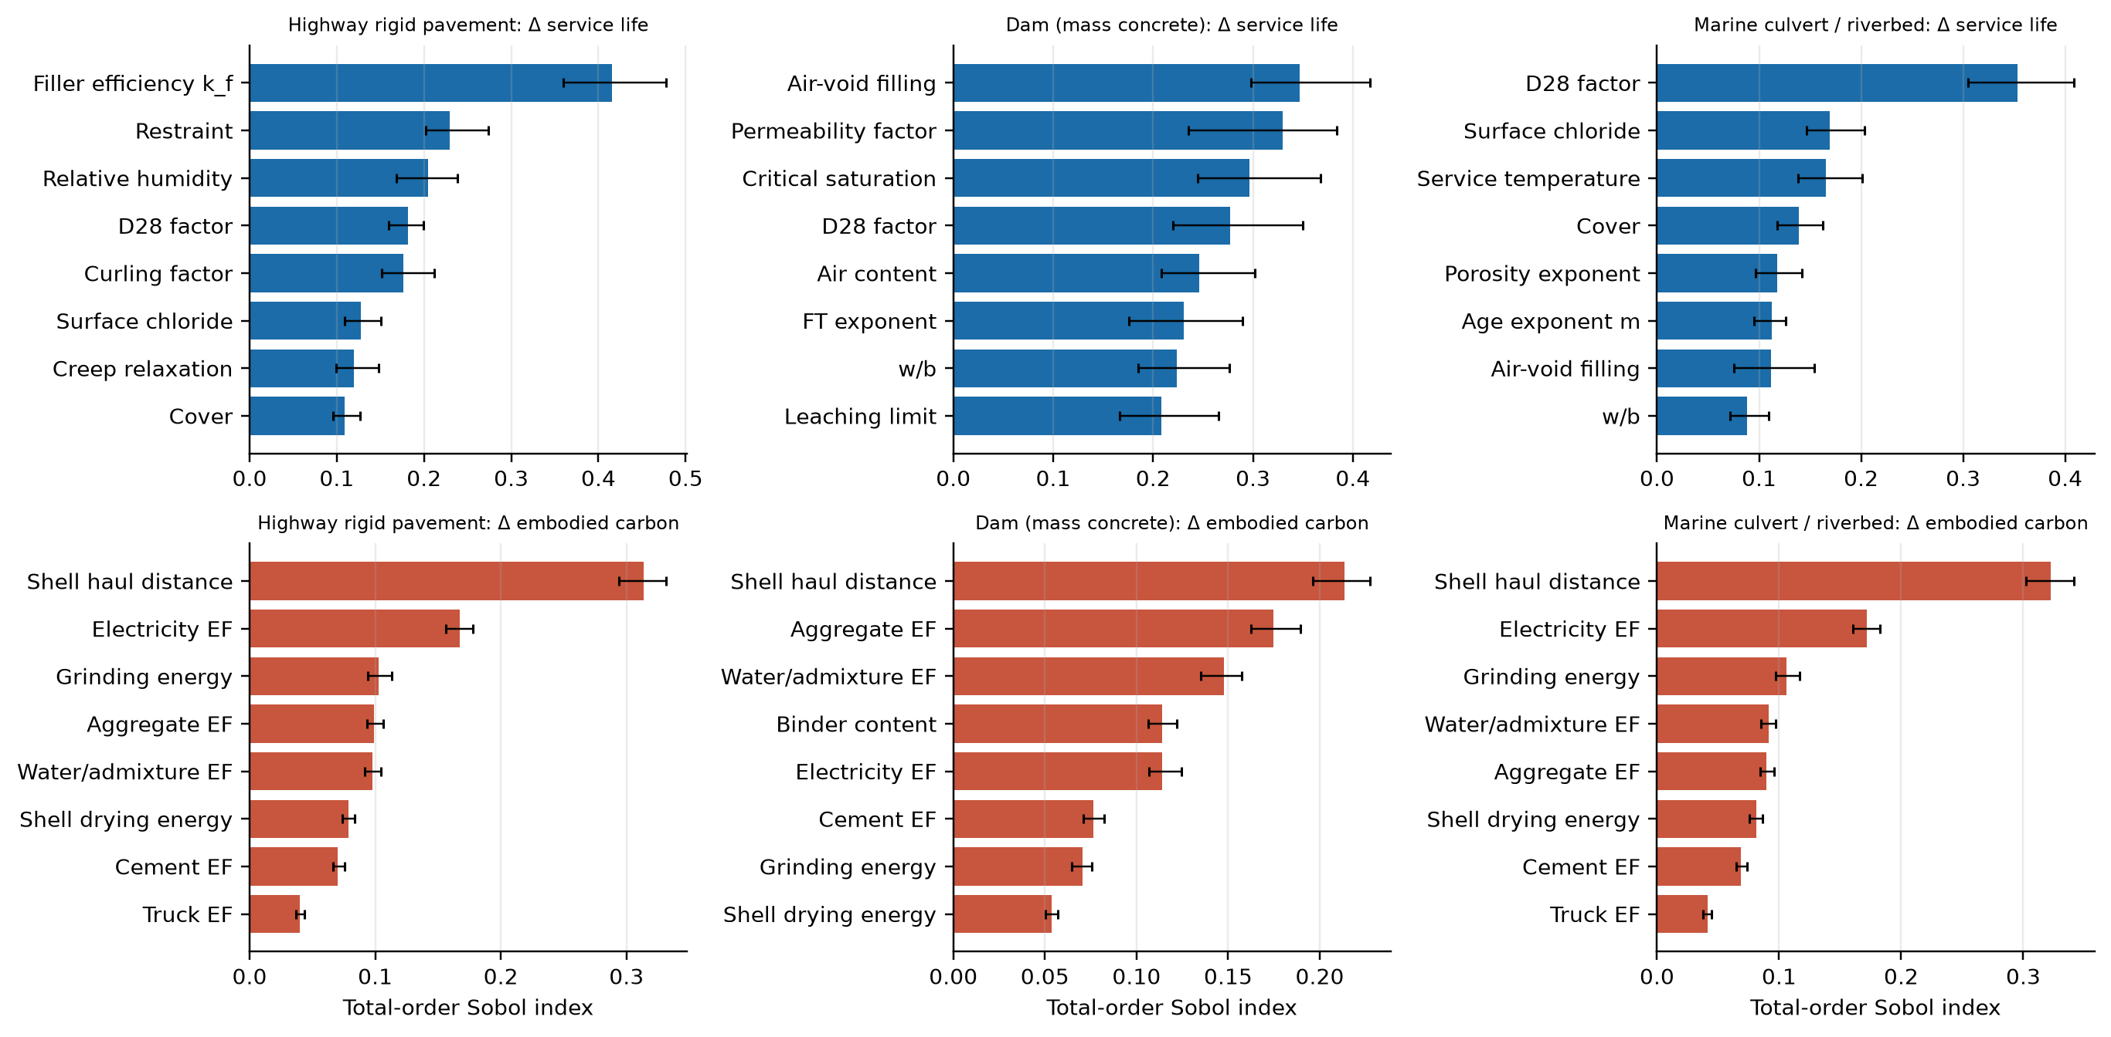
Fig. 12. Total-order Sobol indices (eight largest, with 95% bootstrap intervals) for the difference in service life (top) and in embodied carbon (bottom) between P1 at r = 25% and OPC, in each case.
The life difference is controlled by strength-efficiency coefficient k_f (0.42), restraint factor (0.23), relative humidity (0.20), chloride-diffusivity multiplier (0.18) in the pavement case, by air-void filling fraction (0.35), permeability factor (0.33), critical degree of saturation (0.30), chloride-diffusivity multiplier (0.28) in the dam case, and by chloride-diffusivity multiplier (0.35), surface chloride (0.17), service temperature (0.17), cover depth (0.14) in the culvert case; the sums of the total-order indices exceed one, indicating interactions. The first-order Jansen estimates were noisy (the sums of first-order indices for the three life-difference analyses were 3.19, 0.98 and 0.05, whereas a stable estimate lies between 0 and 1) because of the many parameters and the censored, tie-heavy output, and are not reported. The carbon difference is controlled by logistics and energy inputs: shell haul distance (0.31), electricity emission factor (0.17), grinding energy (0.10). The shell haul distance alone explains 31% of the carbon variance for the pavement, which means that carbon claims for shell concrete cannot be separated from the supply-chain geography.

7.4 Alternative filler–porosity–transport formulations
The primary formulation applies k_f to strength only. Two alternatives were tested with the same pooled distribution: k_f also refines the capillary porosity (and therefore the chloride diffusivity and the freeze–thaw saturation), and k_f scales with particle fineness. The size-dependent formulation fits worse: with it, no prior draw reproduces the Abbas and Kudukkan calibration mixes within the tolerance (best-fit k_f 0.70, near the edge of the prior) or the 2026 mortar data (best-fit 1.50, at the bound), against 4,414 accepted draws for the strength-only form, and it is not carried further. The porosity-coupled form leaves strength unchanged but changes the durability conclusions (Table 15): the pavement joint-advantage probability for the matched design at r = 25% rises from 0.22 to 0.44, the dam value from 0.13 to 0.32 and the culvert value from 0.03 to 0.28. The durability conclusion is therefore as sensitive to the unmeasured coupling between the filler and the pore structure as it is to the strength calibration, and the primary results are the conservative end of a bracket.
Table 15. Strength-only (primary) and porosity-coupled formulations of k_f: P(≥5% carbon cut and non-inferior life), median life difference (yr) and median 28-day chloride diffusivity ratio to OPC (r = 25% same w/b).
Case and design | P(adv, mat): strength-only / coupled | ΔL P50 (yr) | D₂₈ ratio P50
Pavement: 25% same w/b | 0.15 / 0.32 | −8.5 / −3.9 | 2.06 / 1.81
Pavement: 25% matched | 0.22 / 0.44 | −1.8 / +1.5 | –
Pavement: 50% matched | 0.20 / 0.39 | −8.2 / −0.2 | –
Dam: 25% same w/b | 0.05 / 0.19 | 0.0 / 0.0 | 1.96 / 1.83
Dam: 25% matched | 0.13 / 0.32 | 0.0 / 0.0 | –
Dam: 50% matched | 0.07 / 0.16 | 0.0 / 0.0 | –
Culvert: 25% same w/b | 0.00 / 0.17 | −5.5 / −3.6 | 2.06 / 1.81
Culvert: 25% matched | 0.03 / 0.28 | −2.2 / +0.2 | –
Culvert: 50% matched | 0.04 / 0.25 | −6.3 / −2.1 | –

7.5 Ablation: original model, single-study calibration and pooled calibration
The comparison with earlier versions of the model is given in Table 16 and Fig. 13. With shell as an inert filler (the original model) the pavement joint-advantage probability at r = 25% is 0.01 (same w/b) and 0.01 (matched), and strength-matched carbon cuts are −0.3%; calibrated on Abbas and Kudukkan alone they are 0.23, 0.28 and −16.4%; with the pooled distribution 0.14, 0.21 and −15.0%. The conclusion that a joint advantage is rare holds in all three, but its size depends on the filler efficiency, which is the least certain strength parameter and is not a property of the material alone.
Table 16. Ablation of the P1 results across model variants (r = 25%, 30 µm): median carbon change (%), median 28-day strength relative to OPC and P(≥5% carbon cut and non-inferior life): original (k_f = 0) / Abbas-calibrated / pooled (primary).
Case and design | ΔE P50 (%) | f_c28 vs OPC | P(adv, mat)
Pavement: 25% same w/b | −21 / −21 / −21 | 0.67 / 0.91 / 0.87 | 0.01 / 0.23 / 0.14
Pavement: 25% matched | 0 / −16 / −15 | 1.00 / 1.00 / 1.02 | 0.01 / 0.28 / 0.21
Dam: 25% same w/b | −20 / −20 / −20 | 0.64 / 0.90 / 0.85 | 0.04 / 0.04 / 0.05
Dam: 25% matched | 0 / −15 / −14 | 1.00 / 1.00 / 1.04 | 0.00 / 0.19 / 0.14
Culvert: 25% same w/b | −21 / −21 / −21 | 0.67 / 0.91 / 0.87 | 0.00 / 0.00 / 0.00
Culvert: 25% matched | 0 / −16 / −15 | 1.00 / 1.00 / 1.02 | 0.01 / 0.00 / 0.03

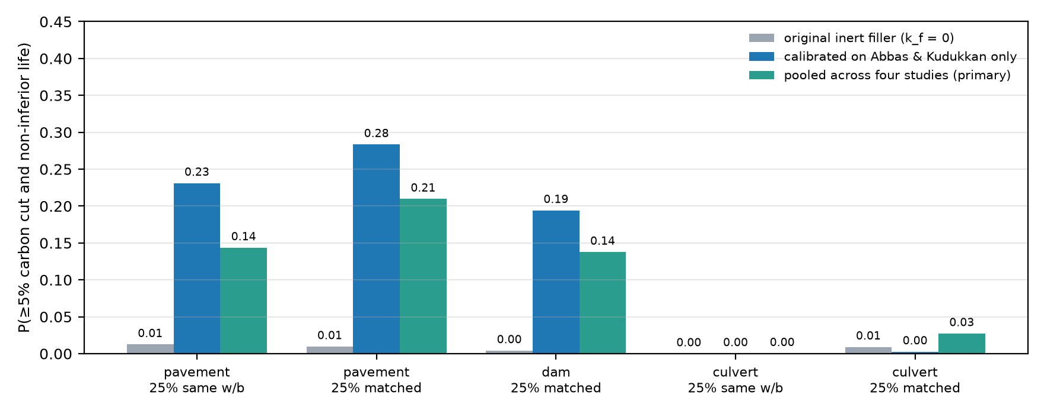
Fig. 13. Probability of a joint advantage (carbon cut of at least 5% and non-inferior life) for P1 at r = 25% (30 µm) under three model variants: original inert filler, calibration on a single scallop-shell study, and the pooled random-effects distribution used for the primary results.

8. Discussion

8.1 Physical interpretation
The main results follow from three mechanisms. First, shell powder is a diluent: removing cement lowers strength and raises porosity almost in proportion, so any benefit must come from a filler effect. The size of that effect is the least certain strength parameter: it is -0.40 to 1.36 across four studies, and it moves the pavement joint-advantage probability from about 0.01 (inert filler) to 0.14–0.21 (pooled) at r = 25% (Section 7.5). Second, embodied carbon is dominated by cement, so replacing cement lowers carbon in proportion to r at constant w/b; at constant strength the added binder re-introduces cement, and the median carbon cut falls from −21% to −15% at r = 25%, with an interval that includes net increases. Third, the carbon benefit of P2 is tied to a convention (biogenic credit), since the calcination CO₂ per kg of CaCO₃ is fixed by stoichiometry. The dam and culvert results show where shell concrete might be advantageous (low replacement in mass concrete) and where it is not (chloride-controlled marine exposure), and the blended-cement comparison (Section 6.4) shows that a conventional low-clinker concrete already delivers a larger carbon cut than shell replacement at the levels modelled.

8.2 Assessment of the white paper’s claims
Table 17. Source claims restated as hypotheses with model outputs and the validation each would need.
Claim | Model output (this study) | Status | Validation needed
Up to 80% CO₂ reduction | −85.0% only at r = 100% (no strength); −21.2% / −42.5% at r = 25 / 50% (same w/b); −15.1% / −36.7% matched; P2 +5.1% without credit | Not supported | Plant-specific cradle-to-gate LCA with defined boundary and functional unit
Thermal resistance to 2,400 °F | Not modelled | Not supported (see text) | Furnace tests with residual strength; thermogravimetry of the shell binder
100% limestone substitution | P2, ρ = 100%: carbon +5.1% (no credit); durability unchanged | Feasible chemically; no carbon benefit without credit | Raw-meal burnability, clinker chemistry, chloride and alkali limits
Accelerated hydration | α(1 d): 0.18 (OPC) vs 0.19 (r = 25%); strength 88% of OPC | Marginal acceleration; strength lower | Isothermal calorimetry; setting time; strength at 1–365 d
Reduced shrinkage | Cracking probability 44% → 24% at r = 25% (same w/b); 35% when matched | Supported only as dilution | Restrained-ring and free-shrinkage tests
Superior acid resistance | 50-yr front +20% (same w/b) vs −7% (matched); particle-size dependent | Conditional | Acid immersion with mass loss and depth of degradation
Higher structural durability | ΔL P50 −8.4 yr (pavement) and −5.5 yr (culvert) at r = 25% same w/b; −1.8 / −2.3 yr matched | Not supported at same w/b; conditional if matched | Chloride migration, freeze–thaw, fatigue and abrasion tests on matched mixes

On the thermal claim. 2,400 °F is about 1,316 °C. Calcite decomposes to CaO and CO₂ at roughly 900 °C (about 1,650 °F) at atmospheric CO₂ pressure (standard thermodynamic data; Chase 1998), so a calcium-carbonate-rich binder is not expected to withstand 2,400 °F; even conventional concrete suffers substantial strength loss and spalling at much lower temperatures. No model of fire behaviour is attempted here and the claim should be removed unless supported by formulation-specific tests.

8.3 Limitations
- No new experiments are reported. Shell-specific parameters (ν, β_p, κ_o, ω, k_imp) are literature-style ranges; only the strength model was calibrated, on one published scallop-shell dataset (three mixes, replacement 14–40% of the binder) whose strengths are partly read from text and derived from moduli, with the held-out mix between the calibration mixes. Independent testing used 11 oyster-shell points from three studies, one of them a secondary transcription and one with coarse particle fractions and an unclear replacement definition; k_f differs in sign and size between studies, so the pooled distribution describes heterogeneity and not a material property, and it ignores correlations with the other parameters.
- Chloride, acid and freeze–thaw transport remain uncalibrated: paste porosity counts cement only, the filler efficiency is not applied to transport, and the claims that depend on life (Section 7.4) are therefore bracketed rather than determined.
- The OPC reference lives are anchored to plausible design lives by adjusting OPC-only parameters; results are relative, and the absolute lives are not predictions.
- The diffusivity mapping for filler-bearing pastes is an extrapolation of a relation calibrated for OPC; the two mappings bracket but do not validate it.
- The reference is plain OPC concrete; dam and marine concretes normally contain supplementary cementitious materials, which would change both carbon and durability baselines.
- Mechanisms are combined additively and one-dimensionally; carbonation, alkali–silica reaction, sulfate attack, reinforcement corrosion kinetics, calcite dissolution mass loss and the interaction of cracking with all transport processes are not modelled; surface chloride is constant.
- Carbon factors are generic screening values; the avoided-landfill credit, shell logistics and biogenic accounting are uncertain and dominate the carbon variance.
- The strength-matching rule (adding binder at constant water) is only one of several ways to achieve equal strength and is not applicable where the model strength saturates with binder.

8.4 Novelty and validation requirements
The contribution is not the finding that fine calcium carbonate acts as a filler, which is established for limestone, but a framework that couples processing-dependent carbon with hydration, transport and damage, evaluates each shell mix against its own OPC reference under shared uncertainty, and reports where the joint advantage fails. To be a validated model, the following would be needed: (i) isothermal calorimetry, porosimetry and strength development on shell-powder pastes and concretes at several replacement levels, particle sizes and organic contents; (ii) chloride migration/diffusion, acid-immersion, freeze–thaw, fatigue and abrasion tests on same-w/b and strength-matched mixes; (iii) further out-of-sample comparisons of predicted and measured properties on oyster shell and on durability indicators, beyond the four strength datasets used in Section 4.4; and (iv) a plant- and supply-chain-specific life-cycle inventory.

9. Conclusions
- A coupled hydration–transport–damage–carbon framework with paired shell/OPC comparison, Latin hypercube Monte Carlo, Sobol sensitivity and a falsification region was developed and verified numerically. Its inert-filler strength model was rejected by published scallop-shell data (predicted 0.43 against 0.75 relative strength at 40% replacement).
- An effective strength-efficiency coefficient calibrated on one scallop-shell dataset does not transfer: on 11 independent oyster-shell points it has a mean absolute error of 0.12, no better than dilution alone (0.14), and the coefficient differs between studies from -0.40 to 1.36. The primary results therefore use a pooled distribution that expresses this heterogeneity.
- At r = 25% and constant w/b, shell replacement lowers embodied carbon by 21% and strength to 88% of OPC and shortens median life by 8.4 yr (pavement) and 5.5 yr (culvert); with strength matched the median carbon cut is −15% (P10–P90 −22 to +10%) and the life change −1.8 yr. The 80% carbon claim is reached only when strength is lost.
- The probability of a carbon cut of at least 5% with non-inferior life is at most 0.21 (pavement), 0.14 (dam, largely censoring) and 0.03 (marine culvert) at r = 25%; it is 0.00 against a 50% slag blended cement, which cuts carbon by about 42% on its own.
- These durability conclusions are conditional on an unmeasured coupling between the filler and the pore structure: if k_f also refines the pores, the pavement probability at r = 25% (matched) rises from 0.22 to 0.44. Chloride, acid and freeze–thaw transport remain uncalibrated.
- Shell calcium carbonate used as limestone feedstock (P2) does not reduce carbon unless calcination CO₂ is credited as biogenic; durability is essentially unchanged.
- Carbon claims for shell concrete are controlled by supply-chain logistics, not by material chemistry, and durability claims by the filler efficiency and the diffusivity of filler-bearing pastes; these are the quantities to measure first.
- Shell used in concrete is not available as reef substrate; the allocation of recovered shell between the two uses is treated in a companion paper (Sandler 2026b).

Declarations
Funding. This research did not receive any specific grant from funding agencies in the public, commercial, or not-for-profit sectors.
Declaration of competing interest. The author declares that he has no known competing financial interests or personal relationships that could have appeared to influence the work reported in this paper.
CRediT authorship contribution statement. Leon Sandler: Conceptualization, Methodology, Software, Validation, Formal analysis, Investigation, Data curation, Writing – original draft, Writing – review & editing, Visualization.
Declaration of generative AI and AI-assisted technologies in the writing process. During the preparation of this work the author used Claude (Anthropic) to help develop and test the simulation code, run the analyses and draft and revise the text and figures. After using this tool, the author reviewed and edited the content as needed and takes full responsibility for the content of the publication.
Data availability. All code, automated checks, result files and manuscript sources are openly available at https://github.com/sandlerleon/oyster-shell-concrete-mc (release v1.1.0; MIT licence) and archived on Zenodo (software, https://doi.org/10.5281/zenodo.23867048; preprint of this manuscript, https://doi.org/10.5281/zenodo.23867044). The published strengths used for calibration and validation are from Abbas and Kudukkan (2025; Table 5), Kwon and Wang (2024), Kim and Lee (2023; transcription of Abinaya et al.) and De Dios-Suárez et al. (2026), and are listed in Section 4.4.2 and in the repository. No new experimental data were collected. The companion allocation study (Sandler 2026b) is archived at https://doi.org/10.5281/zenodo.23867050.

References
Aas-Jakobsen K (1970) Fatigue of concrete beams and columns. Bulletin 70-1, Institutt for Betongkonstruksjoner, NTH, Trondheim.
Abbas A, Kudukkan A (2025) Experimental investigation of low carbon concrete using ground seashell powder as filler and partial cement replacement. Constr Mater 5(4):82. https://doi.org/10.3390/constrmater5040082
ACI Committee 318 (2019) Building code requirements for structural concrete (ACI 318-19). American Concrete Institute, Farmington Hills.
Andrew RM (2019) Global CO₂ emissions from cement production, 1928–2018. Earth Syst Sci Data 11:1675–1710. https://doi.org/10.5194/essd-11-1675-2019
Beck MW, Brumbaugh RD, Airoldi L, Carranza A, Coen LD, Crawford C, et al. (2011) Oyster reefs at risk and recommendations for conservation, restoration, and management. BioScience 61:107–116. https://doi.org/10.1525/bio.2011.61.2.5
Berodier E, Scrivener K (2014) Understanding the filler effect on the nucleation and growth of C-S-H. J Am Ceram Soc 97:3764–3773. https://doi.org/10.1111/jace.13177
Brumbaugh RD, Coen LD (2009) Contemporary approaches for small-scale oyster reef restoration to address substrate versus recruitment limitation: a review and comments relevant for the Olympia oyster, Ostrea lurida Carpenter 1864. J Shellfish Res 28:147–161. https://doi.org/10.2983/035.028.0105
Chase MW (1998) NIST-JANAF thermochemical tables, 4th edn. J Phys Chem Ref Data Monograph 9.
Crank J (1975) The mathematics of diffusion, 2nd edn. Oxford University Press, Oxford.
Fagerlund G (1977) The critical degree of saturation method of assessing the freeze/thaw resistance of concrete. Mater Struct 10:217–229. https://doi.org/10.1007/BF02478693
Grabowski JH, Brumbaugh RD, Conrad RF, Keeler AG, Opaluch JJ, Peterson CH, et al. (2012) Economic valuation of ecosystem services provided by oyster reefs. BioScience 62:900–909. https://doi.org/10.1525/bio.2012.62.10.10
De Dios-Suárez J, Pérez-Escobar B, Pérez-Hernández G, Lizama-Tzec F, Díaz-Flores L, Pérez-Montejo S, et al. (2026) Influence of thermal treatment and particle size on the physicochemical properties and filler performance of oyster shell-derived CaCO₃ in mortar. Materials 19(8):1656. https://doi.org/10.3390/ma19081656
Jasni SA, Muthusamy K, Ruslan HN, Hamada H, Ab Wahab ES (2024) Use of seashell as cement replacement in construction material: a review. Construction 4(1):7–20. https://doi.org/10.15282/construction.v4i1.10001
Kachanov LM (1958) On the time to failure under creep conditions. Izv Akad Nauk SSSR Otd Tekh Nauk 8:26–31.
Lemaitre J (1996) A course on damage mechanics, 2nd edn. Springer, Berlin.
Kim MO, Lee MK (2023) Strength and microstructural changes in cementitious composites containing waste oyster shell powder. Buildings 13:3078. https://doi.org/10.3390/buildings13123078
Kwon SJ, Wang XY (2024) A hydration-based integrated model to evaluate properties development and sustainability of oyster shell powder–cement binary composites. Buildings 14:1578. https://doi.org/10.3390/buildings14061578
Lertwattanaruk P, Makul N, Siripattarapravat C (2012) Utilization of ground waste seashells in cement mortars for masonry and plastering. J Environ Manage 111:133–141. https://doi.org/10.1016/j.jenvman.2012.06.032
Lothenbach B, Le Saout G, Gallucci E, Scrivener K (2008) Influence of limestone on the hydration of Portland cements. Cem Concr Res 38:848–860. https://doi.org/10.1016/j.cemconres.2008.01.002
McKay MD, Beckman RJ, Conover WJ (1979) A comparison of three methods for selecting values of input variables in the analysis of output from a computer code. Technometrics 21:239–245. https://doi.org/10.1080/00401706.1979.10489755
Petrolia DR, Mohrman T (2025) Oyster shell recycling: challenges and opportunities for reef restoration. J Shellfish Res 43:361–370. https://doi.org/10.2983/035.043.0307
Powers TC, Brownyard TL (1947) Studies of the physical properties of hardened Portland cement paste. J Am Concr Inst 43:101–992.
Sandler L (2026b) Reef restoration or low-carbon concrete? A multi-objective life-cycle framework for sustainable oyster-shell allocation in coastal cities. Zenodo. https://doi.org/10.5281/zenodo.23867050
Saltelli A, Annoni P, Azzini I, Campolongo F, Ratto M, Tarantola S (2010) Variance based sensitivity analysis of model output. Design and estimator for the total sensitivity index. Comput Phys Commun 181:259–270. https://doi.org/10.1016/j.cpc.2009.09.018
Scrivener KL, John VM, Gartner EM (2018) Eco-efficient cements: potential economically viable solutions for a low-CO₂ cement-based materials industry. Cem Concr Res 114:2–26. https://doi.org/10.1016/j.cemconres.2018.03.015
Sobol IM (2001) Global sensitivity indices for nonlinear mathematical models and their Monte Carlo estimates. Math Comput Simul 55:271–280. https://doi.org/10.1016/S0378-4754(00)00270-6
Thomas MDA, Bentz EC (2002) Life-365: service life prediction model and computer program for predicting the service life and life-cycle cost of reinforced concrete exposed to chlorides. Life-365 Consortium II.
Tuutti K (1982) Corrosion of steel in concrete. CBI Research Report 4:82, Swedish Cement and Concrete Research Institute, Stockholm.
Zu Ermgassen PSE, Spalding MD, Grizzle RE, Brumbaugh RD (2012) Quantifying the loss of a marine ecosystem service: filtration by the eastern oyster in US estuaries. Estuaries Coasts 36:36–43. https://doi.org/10.1007/s12237-012-9559-y
Classical sources without a DOI (reports, books and the Life-365 documentation) are cited from their bibliographic records; the Life-365 relation D₂₈ = 10^(−12.06 + 2.40 w/cm) with an age exponent of 0.2 for OPC was checked against the public Life-365 documentation and secondary sources.

Appendix A. Model parameters
All ranges are literature-style placeholders. tri(lo, mode, hi); uni(lo, hi); logn(median, σ in ln units); logu(lo, hi) is log-uniform. Parameters in the upper block are common to all cases; case-specific parameters follow.
Parameter | Key | Distribution | Unit
Hydration rate | k0 | logn(0.26, 0.2) | 1/d
Reaction order | nh | uni(1.5, 2.5) | -
Hydration Ea | Ea_h | uni(3.0e+4, 4.5e+4) | J/mol
Max. hydration | acap | uni(0.9, 0.97) | -
Gel strength S0 | S0 | logn(78, 0.1) | MPa
Strength exponent | kap_s | uni(1.8, 3) | -
Filler nucleation | nu | uni(0, 1.5) | -
Packing bonus | bpack | uni(0, 0.3) | -
Shell organics | o_org | tri(5.0e-3, 0.02, 0.04) | kg/kg
Washing efficiency | eta_w | uni(0.3, 0.9) | -
Organic retardation | kap_o | logu(5, 200) | -
Impurity penalty | kimp | uni(0, 0.05) | -
D28 factor | lamD | logn(1, 0.4) | -
D28 model form | chi_D | uni(0, 1) | -
Porosity exponent | dzeta | uni(-0.3, 0.3) | -
Age exponent m | m0 | tri(0.12, 0.2, 0.3) | -
m shift | omega | uni(0, 0.3) | -
Crack–diffusion coupling | kapc | uni(2, 20) | -
Diffusion Ea | UD | uni(3.5e+4, 5.0e+4) | J/mol
Critical chloride | Ccrit | tri(0.6, 1, 1.6) | kg/m3
Propagation period | tprop | tri(3, 6, 12) | yr
Shrinkage strain | eps0 | tri(400, 600, 900) | microstrain
Shrinkage time | tau_sh | tri(20, 35, 60) | d
Restraint | KR | uni(0.2, 0.6) | -
Creep relaxation | psi | uni(0.4, 0.7) | -
Early crack damage | d_cr | uni(0.03, 0.1) | -
Curling factor | f_env | uni(0.05, 0.25) | -
Air content | a_air | tri(0.02, 0.05, 0.07) | m3/m3
Critical saturation | S_crit | uni(0.8, 0.92) | -
FT damage/cycle | d1 | logu(3.0e-4, 3.0e-3) | damage/cycle
FT exponent | q_ft | uni(1, 3) | -
Load variability | var_t | tri(0.85, 1, 1.15) | -
Traffic cycles/yr | n_traf | logu(5.0e+4, 1.0e+6) | cycles/yr
Failure damage | Dfail | tri(0.2, 0.3, 0.4) | -
Heat of hydration | Qcem | uni(350, 480) | kJ/kg
Thermal drop | psiT | uni(0.5, 0.9) | -
Thermal restraint | Rres | uni(0.3, 0.7) | -
Thermal expansion | alphaT | uni(8.0e-6, 1.2e-5) | 1/K
Leaching saturation | Csat | uni(15, 22) | mol/m3
Leachable Ca | xi_L | uni(0.3, 0.7) | -
Permeability factor | kK | logu(0.03, 1) | 1/m
Leaching limit | x_lim_L | tri(30, 50, 100) | mm
Ca diffusivity | Dratio_Ca | uni(0.5, 1.5) | -
Acid-accessible Ca | xiN | uni(0.4, 0.8) | -
Calcite access size | dc | logu(50, 300) | um
H+ diffusivity | DH | uni(3, 8) | -
Acid limit | x_lim_A | tri(10, 20, 30) | mm
Abrasion rate | k_ab | tri(0.05, 0.3, 1) | mm/yr
Abrasion exponent | b_ab | uni(1.5, 2.5) | -
Wear limit | w_lim | tri(15, 25, 40) | mm
Cement EF | EFcem | tri(0.75, 0.85, 0.95) | kgCO2e/kg
Raw-meal CaCO3 | mCaCO3 | tri(1, 1.1, 1.2) | kg/kg
Aggregate EF | EFagg | tri(4.0e-3, 7.0e-3, 0.012) | kgCO2e/kg
Water/admixture EF | EFmisc | tri(5, 10, 20) | kgCO2e/m3
Shell drying energy | e_dry | tri(20, 60, 150) | kWh/t
Grinding energy | E_ref | tri(25, 45, 90) | kWh/t
Crushing energy | E_cr | tri(5, 10, 20) | kWh/t
Electricity EF | EF_el | tri(0.1, 0.4, 0.8) | kgCO2e/kWh
Heat EF | EF_th | tri(0.2, 0.23, 0.3) | kgCO2e/kWh
Shell haul distance | dist_sh | tri(30, 150, 600) | km
Truck EF | EF_tr | tri(0.07, 0.1, 0.15) | kgCO2e/t-km
Landfill credit | c_land | tri(0, 5.0e-3, 0.02) | kgCO2e/kg
Limestone EF | EF_lq | tri(3.0e-3, 6.0e-3, 0.012) | kgCO2e/kg
Kiln penalty | kiln_pen | tri(0, 5.0e-3, 0.02) | kgCO2e/kg
Shell purity | p_sh | uni(0.92, 0.98) | -

Case-specific parameters. Case A (pavement) / Case B (dam) / Case C (culvert):
Parameter | A | B | C | Unit
Binder content | tri(320, 350, 400) | tri(180, 230, 280) | tri(340, 370, 420) | kg/m3
w/b | tri(0.38, 0.42, 0.46) | tri(0.45, 0.5, 0.6) | tri(0.38, 0.42, 0.46) | -
Surface chloride | tri(2, 5, 9) | tri(0, 1.0e-4, 2.0e-4) | tri(3, 6, 12) | kg/m3
Cover | tri(50, 70, 100) | tri(50, 70, 100) | tri(50, 65, 90) | mm
Service temperature | tri(2, 10, 18) | tri(4, 10, 16) | tri(8, 16, 26) | C
Relative humidity | uni(55, 90) | uni(90, 100) | uni(85, 100) | %
Air-void filling | uni(0.1, 0.5) | uni(0.2, 0.7) | uni(0.3, 0.9) | -
Freeze–thaw cycles/yr | tri(10, 40, 90) | tri(0, 15, 50) | tri(0, 20, 60) | cycles/yr
Curing temperature | tri(5, 20, 35) | tri(10, 15, 25) | tri(5, 20, 35) | C
Construction emissions | tri(15, 30, 55) | tri(10, 20, 40) | tri(10, 25, 45) | kgCO2e/m3
Hydraulic gradient | – | tri(5, 20, 60) | – | -

Filler efficiency (extension, Section 4.4). k_f ~ U(0, 1.2); k_f = 0 reproduces the original model; calibrated by rejection ABC on S0F15 and S30F15 (tolerance 0.07).
Scenario variables: stress-ratio classes (low, medium, high) = 0.28, 0.38, 0.46 of the OPC flexural strength; acid concentration (mild, moderate, severe) = 0.03, 0.3, 3 mol H⁺/m³; chloride multiplier = 0.5, 1, 2; leaching-saturation multiplier = 0.5, 1, 1.5. Other fixed values: R = 0.1 in the S–N relation, horizon 100 yr, time step 0.125 yr, D_f ~ tri(0.2, 0.3, 0.4) (a parameter), shell and cement densities 2710 and 3150 kg/m³.

Appendix B. Symbols and units
Symbol | Meaning | Unit
α, α_max | Hydration degree; attainable degree | –
k, k₀ | Hydration rate constant (at 20 °C) | 1/d
r, ρ | Shell replacement of cement (P1); of limestone (P2) | –
v_c, v_f, v_w | Volumes of cement, shell filler and water per m³ of concrete | m³/m³
φ_cap, φ_p | Capillary porosity (per concrete; per paste) | m³/m³
X | Gel/space ratio | –
f_c, f_t, f_r, E | Compressive, tensile, flexural strength; modulus | MPa
D₂₈, D(t) | Chloride diffusivity at 28 d; at age t | m²/s
C_s, C_crit | Surface and critical chloride content | kg/m³
τ | Time integral of diffusivity | m²
x, N, C_a | Front depth; capacity per volume; aggressive concentration | mm; mol/m³; mol/m³
D, D_m, D_f | Damage, mechanical damage, failure damage | –
S, S_eff, S_w | Stress ratio, effective stress ratio, degree of saturation | –
N_f | Cycles to failure | cycles
n_traf, n_ft | Traffic cycles; freeze–thaw cycles per year | 1/yr
d_ft | Freeze–thaw damage per cycle | –
L | Service life (censored at 100 yr) | yr
E_gate, E_total | Cradle-to-gate; total embodied carbon | kg CO₂e/m³
β_bio | Credited fraction of calcination CO₂ | –
ℱ | Falsification region | –

Appendix C. Reproducing the results
pip install numpy scipy matplotlib
python ShellConcreteMC_v2.py --verify
python ShellConcreteMC_v2.py --reproduce --n 3000 --sobol-n 1024 --outdir out
python calibrate_abbas.py # out-of-sample test and ABC calibration (ShellConcreteMC_v3.py)
python kf0_prediction.py # original-model predictions for the published mixes
python make_fig_calibration.py out
python validate_independent.py # independent oyster-shell data, per-study k_f, random-effects distribution
python run_stage1_cal.py && python run_sobol_cal.py A 2048 && python run_sobol_cal.py B 2048 && python run_sobol_cal.py C 2048 && python run_extras_cal.py && python run_figs_cal.py # primary (pooled) results
python run_blend_cal.py && python run_alt_cal.py && python make_fig_validation.py shell_cal # blended-cement benchmark, alternative formulations, figures
Studies use seed 21, severity/load scans seed 31, Sobol seed 11; the figures use fixed seeds in the script. A single full run is long on a single core; the results here were generated in stages (study, Sobol per case, figures), which the script supports through its individual functions.

