Automated bolting and head handling for multi-flange pressure-vessel closures: a simulation-based design evaluation with a delayed-coking case study
Leon Sandler
Independent Researcher, Northbrook, Illinois, USA
E-mail: sandler.leon@gmail.com · ORCID: 0009-0007-4584-808X
Abstract
Large bolted closures on process vessels are still assembled and disassembled largely by hand, often in hazardous areas, following multi-pass tightening sequences whose duration and preload outcome are rarely quantified. This paper evaluates, by simulation rather than by claim, an automated architecture for such closures: orbital pneumatic torque runners on the flange, a bolt-management carousel, a counterbalanced head manipulator and an interlocking sequence controller, applied to a 92-bolt, three-flange delayed-coking drum. A Monte Carlo cycle-time model built on the actual star-pattern rail travel shows that one torque head per flange needs a median 8.0 h to unbolt and re-bolt the drum, and cannot reach a 2.5 h target even with every step at its fastest assumed value; four synchronised heads per flange give 2.3 h, within the target in 70% of samples. With four heads the carousel, not the torque tool, becomes the rate-limiting element. A preload model shows that specifying ±2% torque accuracy has almost no effect on preload scatter, which nut-factor variation dominates, whereas a torque–angle check with re-torque cuts the fraction of bolts outside ±10% of target from 32% to 5%. Exhaustive verification of the interlock logic finds no safety violation, but shows that the interlocks as originally specified deadlock after an emergency stop mid-sequence; an explicit resume rule removes every deadlock. Pneumatic head handling is feasible only with a counterbalance carrying most of the load. The results are predictions from stated assumptions, and a validation programme with acceptance criteria is given.
Keywords: automated bolting; bolted flange joint; torque–angle control; Monte Carlo simulation; interlock verification; hazardous-area automation
1 Introduction
Bolted flange closures are the most frequently disturbed pressure boundaries in process plants, and their assembly is a manufacturing operation in all but name: a sequence of positioning, fastening and verification steps whose quality depends on the order in which fasteners are loaded and on how the applied torque converts to preload. Guidance for pressure-boundary joints prescribes multi-pass tightening sequences for exactly this reason [1], because tightening one bolt changes the load in its neighbours through elastic interaction [2, 3]. Where such joints are opened every few hours, the assembly procedure becomes a recurring production task, and the case for automating it is at once a quality, a throughput and a safety question.
Delayed-coking drums are an extreme instance. Each drum is a large pressure vessel subject to severe thermal cycling and a range of damage mechanisms [4], and its heads are unbolted and re-bolted on every coking cycle unless automatic unheading devices have been fitted. Bottom-head flange leaks are a common problem, the industry trend is to install automatic bottom unheading devices, and the joints that remain require periodic re-tightening and careful assembly practice [5]. Thermal transients can also distort the drum flange until bolt holes no longer align [6]. In the unit considered here, four drums on a 48 h fill cycle give an opening or closing operation every 12 h, and each operation involves 92 bolts across three flanged connections, handled manually at height in a potentially flammable, hot and dusty atmosphere.
An automated architecture for this operation was first proposed by the author in response to an industrial open-innovation challenge, as a pneumatic and automated bolt handling system (PABHS) with four subsystems: orbital torque runners, a bolt carousel, a head manipulator and a sequence controller. That proposal stated performance targets — bolting in 1.5–2.5 h against a reported 4–6 h manually, ±2% torque accuracy and no personnel in the hazard zone — without the models needed to establish whether the architecture could meet them. This paper supplies those models. It treats the proposal as a design hypothesis and asks, for each target, what the architecture would have to achieve and under what conditions it would fail.
The contributions are: (i) a cycle-time model for automated multi-pass flange bolting that computes carriage travel from the actual tightening sequence and propagates step-time uncertainty by Monte Carlo simulation, with a rank-correlation sensitivity analysis; (ii) an admissibility analysis giving the per-bolt-pass time budget implied by a cycle-time target, and the number of synchronised torque heads needed to meet it; (iii) a preload analysis separating the contributions of tool accuracy, nut-factor scatter and torque–angle verification; (iv) exhaustive verification of the sequence and interlock logic, including mutation tests and a liveness check that exposes a deadlock in the logic as first specified; and (v) a force budget for pneumatic head handling, a scored design FMEA and a hazard-exposure comparison. All models are released as open code, and the paper ends with a validation plan whose acceptance criteria can falsify its predictions.
2 Related work
2.1 Flange assembly and tightening sequences
The legacy tightening pattern for pressure-boundary flanges loads bolts in a cross (star) order over several passes at increasing torque, followed by circular check passes until nuts no longer rotate [1]. Alternative patterns that reduce assembly time or improve preload uniformity were added to that guidance with supporting laboratory evidence [7], and experimental comparisons of tightening sequences show that the choice of sequence matters for the uniformity achieved [8]. The underlying mechanism is elastic interaction: bolt loads change as neighbouring bolts are tightened. Experimentally determined interaction coefficients allowed a one-pass, tension-controlled bolt-up to reach ±2% bolt-stress uniformity [2], and analytical models of the interaction have been used to optimise the loads applied in each pass [3, 9]. These studies optimise the sequence for joint quality; none treats the time taken by an automated tool to execute it, which depends on the path the tool must travel between bolts.
2.2 Torque control, preload scatter and torque–angle monitoring
Torque control infers preload from applied torque through the nut factor, and the torque–tension relation is highly sensitive to thread and bearing friction [10]. In gasketed pipe flanges tightened by torque control the scatter of axial bolt force is substantial and affects sealing performance [11], the torque coefficient and bolt preload are closely correlated [12], and finite-element studies find preload scatter due to elastic interaction difficult to eliminate under torque control [13]. The accuracy of the assembly tool and the tightening strategy also affect clamp-force scatter [14]. Monitoring the angle of turn alongside torque provides a second, friction-independent indication of clamp force, and torque–angle formulations of the tightening process have been proposed and evaluated [15].
2.3 Robotic fastening and assembly data
Robotic fastening research has addressed bolt insertion and tightening with tactile in-hand localisation [16], vision-based identification and pose estimation of nuts for a tightening robot [17], an adjustable spanner that engages bolts of different sizes automatically [18], and online vision inspection of screw-fastening quality [19]. Digital records of assembly data and process traceability have been developed for complex products using digital-twin approaches [20]. These works concern small fasteners, structured factory settings or single tightening operations; large multi-pass flange closures in hazardous areas have received little attention.
2.4 Heavy-component handling
Gravity compensation of manipulators may use counterweights, springs or an auxiliary active force [21]. For pneumatic actuation the available force is bounded by supply pressure and by standard cylinder sizes, which for the common ISO series reach a 320 mm bore [22]; whether a multi-tonne head can be handled pneumatically is therefore a question of how much of the load a passive counterbalance carries.
2.5 Automation in hazardous process environments
Reviews of robotics in onshore and offshore oil and gas operations describe systems in which robots act while skilled operators retain cognitive decisions [23, 24]. Equipment in explosive atmospheres must follow the relevant protection concepts and certification requirements [25–27], and interlocks that protect against process hazards fall within functional-safety practice for the process industry [28]. Model checking has been applied to verify PLC software [29], failure mode and effects analysis (FMEA) is the standard means of ranking design risks, with well-known limitations of the risk priority number [30], and discrete-event simulation is widely used to evaluate manufacturing system designs before they are built [31].
2.6 Research gap
The literature optimises flange tightening for joint quality, develops robotic tightening for small fasteners, and verifies PLC logic in general. What has not been done is to evaluate an integrated automated architecture for large multi-pass flange closures quantitatively: how long it takes as a function of its configuration, what preload accuracy its control strategy can actually deliver, whether its interlock logic is both safe and free of deadlock, and whether its head-handling concept is physically feasible. This paper addresses those four questions for one industrial case.
3 Case study, requirements and architecture
3.1 Industrial case
The case is a four-drum delayed-coking unit. Each drum is approximately 28 m tall and 6 m in diameter. Three bolted connections are opened and closed on every cycle: the top head (32 bolts, M48–M64), the bottom head (48 bolts, M48–M64) and the feed inlet (12 bolts, M36–M48). Opening comprises unbolting, bolt storage, head removal and gasket removal; closing comprises face cleaning, gasket installation, head placement, bolt installation, multi-pass tightening, verification and a steam leak test. Hydraulic decoking, which occurs between opening and closing, is outside the scope. Flange drawings and head masses were not available; where the analysis needs them it treats them as swept parameters rather than assumed point values.
3.2 Requirements
Requirement | Target | Source
Bolts per operation | 92 (32 + 48 + 12) | Case data
Bolt sizes | M36–M64 | Case data
Automated operations | Breakout, removal, storage, re-presentation, installation, multi-pass tightening | Design intent
Tightening procedure | Star passes at increasing torque + circular check passes | [1]
Record per bolt | Final torque and angle, pass/fail, time stamp | Design intent
Bolting time (92 bolts) | 1.5–2.5 h (reported manual: 4–6 h) | Source proposal
Personnel in hazard zone | None during routine operation | Design intent
Tool motion | Only with gas clearance confirmed | Design intent
Head motion | Only with no bolt engaged | Design intent
CLOSED status | Only after all bolts verified, leak test passed and operator sign-off | Design intent
Emergency stop | From any state, local and remote | Design intent
Table 1. Functional requirements. 'Source proposal' marks the targets whose achievability this paper tests.
3.3 Architecture
The architecture (Fig. 1) has four subsystems. (A) An orbital bolt runner is a circular rail fixed around each flange carrying a carriage with one or more pneumatic torque multipliers, each with a socket, reaction arm, and torque and angle transducers; with several heads they are spaced equally and act simultaneously. (B) A bolt-management carousel captures each bolt as it is removed, stores it in an indexed slot and presents it for reinstallation in the programmed order. (C) A counterbalanced articulated pneumatic manipulator engages, lifts, swings clear and locks each head. (D) A sequence and interlock controller enforces the tightening protocol, records torque and angle for every bolt, and exchanges start, stop and status signals with the plant control system. Pneumatic actuation is chosen because compressed air is available as plant infrastructure and avoids electrical ignition sources at the tool; the hazardous-area certification of the integrated system is discussed in Section 6.
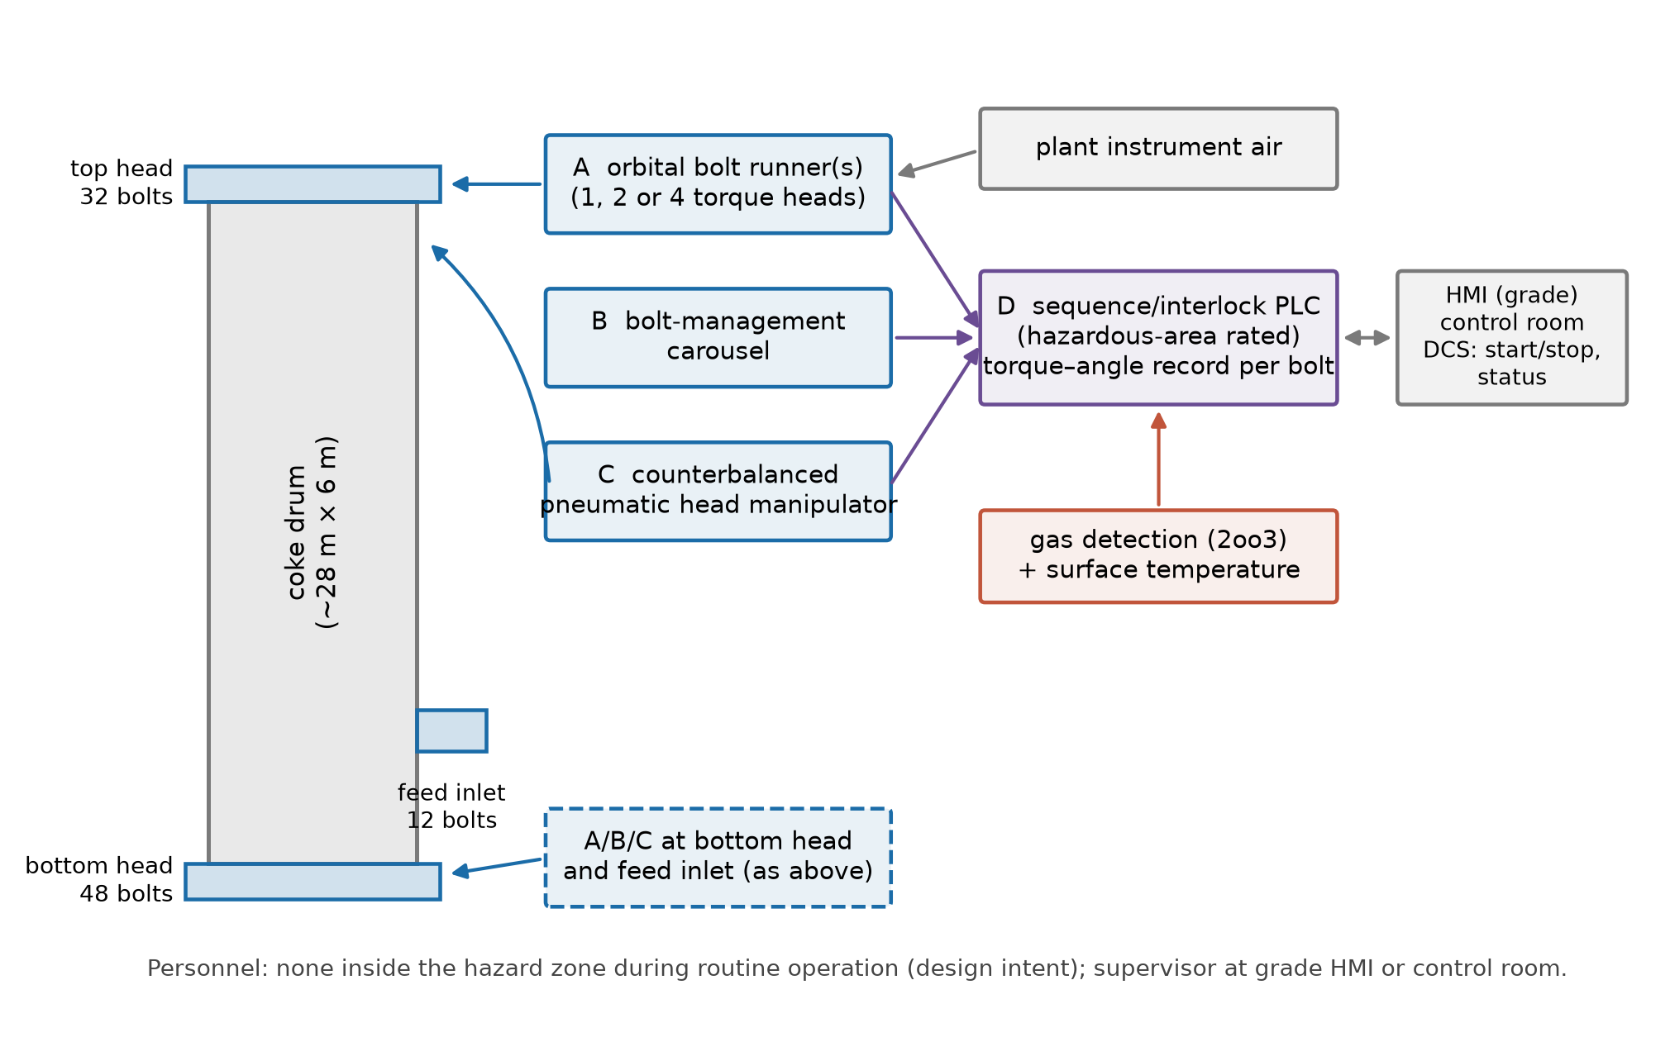
Fig. 1 Architecture of the automated bolting and head-handling system for a three-flange drum. Subsystems A–C are replicated at each flange (C at the two heads only); D is common.
4 Methods
4.1 Geometry
Bolt i of a flange with N bolts sits at angle
θᵢ = 2πi / N, i = 0, 1, …, N − 1 (1)
on a bolt circle of diameter D. Because D was not available, it is bracketed by a circumferential spacing rule s = k·d, with d the nominal bolt diameter and k between 2.5 and 5.0 (wrench clearance sets the lower end, gasket-load uniformity the upper):
D = N k d / π (2)
giving D from 1.83 to 4.89 m for the bottom head, 1.22 to 3.26 m for the top head and 0.34 to 0.92 m for the feed inlet. The spacing factor k is sampled in the Monte Carlo analysis, so its effect appears in the sensitivity results rather than being fixed.
4.2 Tightening sequence and rail travel
The legacy star pattern for N divisible by four is generated as groups of four bolts at 90° spacing, with the groups visited in bit-reversed order, which reproduces the cross-pattern family of the legacy sequence [1]. A circular pass visits bolts in angular order. For a pass visiting stations j₁, j₂, … the carriage travels the shortest way round the rail between consecutive stations,
L = (πD / N) Σₖ min(|jₖ₊₁ − jₖ| mod N, N − |jₖ₊₁ − jₖ| mod N) (3)
With r equally spaced heads acting together, bolts j, j + N/r, … are tightened at one station, so a pass visits N/r stations and the travel is computed over that reduced sequence. Fig. 2 shows the 48-bolt star sequence and the resulting travel per pass: a single head covers 56 bolt-circle diameters per star pass on the bottom head, against 3.1 for a circular pass and 3.5 with four heads.
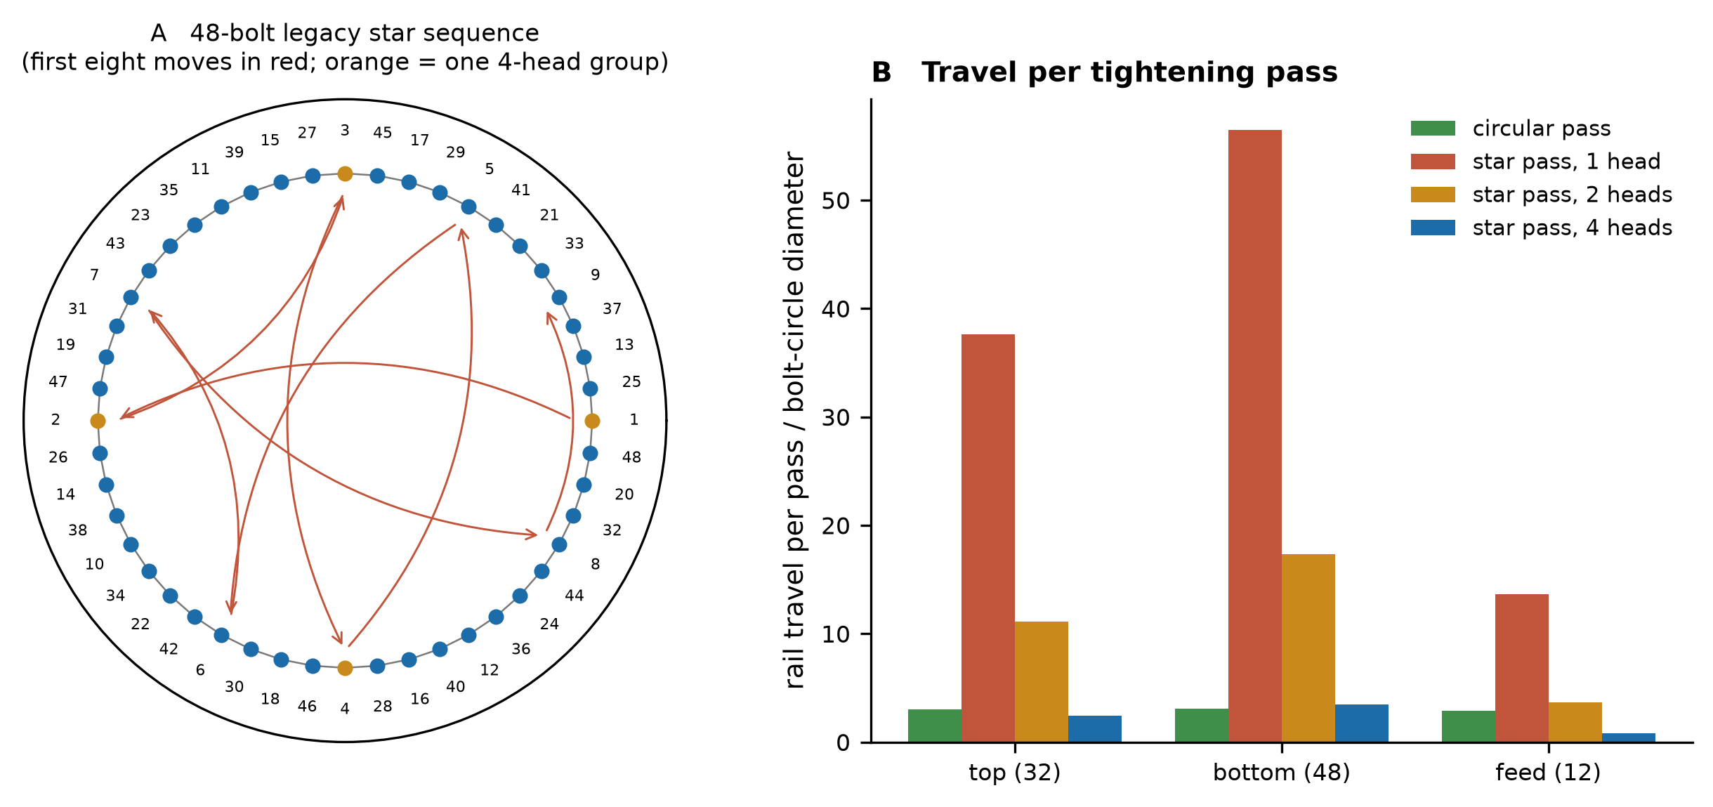
Fig. 2 (a) Legacy star sequence for the 48-bolt bottom head; numbers give the order, red arrows the first eight carriage moves, orange one group of four bolts tightened together by a four-head carriage. (b) Rail travel per pass, in bolt-circle diameters, for each flange and configuration.
4.3 Cycle-time model
One pass over a flange takes
t_pass = (N/r)(t_align + t_engage + t_tool + t_release + t_verify + t_retry + t_review) + L/v + m·t_move (4)
where t_tool is the torque, breakout or run-on/run-off time of the pass, v the carriage speed, m the number of indexing moves and t_move a per-move acceleration and settling overhead. A station is complete only when all r heads are complete, so the expected retry and operator-review delays per station are
t_retry = [1 − (1 − p_retry)ʳ](t_engage + t_tool), t_review = [1 − (1 − p_op)ʳ] t_op (5)
Run-on and run-off take the time to turn the nut through its engagement length, t_spin = 60·(1.5d/P)/n_spin, with P the ISO coarse pitch [32] and n_spin the spin speed in rev/min. Opening is one staged breakout pass in star order, a circular run-off pass and transfer of every bolt to the carousel; closing is transfer from the carousel, a circular run-on pass, three star passes at increasing torque and one to three circular check passes, following the legacy procedure [1]. The carousel serves one bolt at a time, so transfer time is N·t_transfer regardless of r. Flanges are either worked in parallel, each by its own runner, or in series. The full operation adds atmosphere confirmation, head handling, gasket work and the leak test.
Parameter | Range (uniform) | Unit
Carriage speed | 0.05 – 0.2 | m/s
Indexing move overhead | 1 – 4 | s
Alignment to nut | 4 – 15 | s
Socket engagement | 3 – 10 | s
Torque pass, one bolt | 10 – 40 | s
Breakout, one bolt | 10 – 35 | s
Reaction release and retract | 2 – 6 | s
Torque–angle check | 1 – 3 | s
Run-on/run-off speed | 20 – 60 | rev/min
Carousel transfer, one bolt | 10 – 35 | s
P(automatic retry) per bolt-pass | 0.005 – 0.03 | –
P(operator review) per bolt-pass | 0.0005 – 0.005 | –
Operator review duration | 300 – 1200 | s
Circular check passes | 1 – 3 | –
Head handling (each way) | 900 – 1800 | s
Gasket and face work, per flange | 900 – 2400 | s
Atmosphere confirmation | 120 – 600 | s
Steam leak test | 1200 – 2700 | s
Table 2. Assumed step-time ranges. None is a measurement; the ranges are the inputs whose influence the sensitivity analysis ranks, and the validation plan (Section 7) specifies how each is to be measured.
4.4 Monte Carlo simulation and sensitivity
All inputs in Table 2, the spacing factor k and the position of each bolt size within its range are sampled independently 20000 times with a fixed seed (20260925). Six configurations are compared: one head with flanges in parallel, in series, and with circular passes only; two heads; four heads; and four heads with two instead of three star passes, as an example of a reduced-pass procedure of the kind permitted as an alternative to the legacy sequence [7]. Sensitivity is measured by the Spearman rank correlation between each sampled input and the total bolting time. A best case, with every step at the fast end of its range, bounds what each configuration could achieve. Discrete-event simulation of this kind is standard for evaluating manufacturing designs before they are built [31].
4.5 Preload model
The torque needed for a target preload F in a bolt of diameter d is
T = K F d (6)
with K the nut factor. The target is taken as half the specified minimum yield strength of SA-193 B7 bolting, 724 MPa [33], acting on the tensile stress area [34]
A_s = (π/4)(d − 0.9382P)² (7)
The achieved preload under torque control is F = T(1 + ε_tool)/(K d), with tool error ε_tool uniform within the specified accuracy and K normally distributed with coefficient of variation CV_K. To first order
CV_F ≈ (CV_tool² + CV_K²)^½ (8)
so the benefit of a tighter torque specification depends on its size relative to CV_K. Torque–angle monitoring is modelled as an independent estimate of preload from the angle turned after snug, with error CV_θ representing joint and gasket stiffness uncertainty; bolts whose estimate lies outside ±10% of target are re-torqued to the angle-corrected value. Each case uses 200,000 samples.
4.6 Head manipulator force budget
For a head of mass M_h lifted with safety factor SF = 1.5, the pneumatic force needed when a passive counterbalance carries a fraction c of the weight is
F_p = SF(1 − c) M_h g (9)
and the bore of a single cylinder at supply pressure p = 0.6 MPa and force efficiency η = 0.9 is b = [4F_p/(πpη)]^½. The minimum counterbalance fraction for the largest standard bore (320 mm) [22] follows by setting b = 320 mm. Because the head mass is not known, M_h is swept from 1 to 20 t.
4.7 Control logic and its verification
The controller is written as an explicit transition function over 13 modes (Fig. 3) and a state comprising the number of engaged bolts, the number verified, the leak-test result and the phase to resume after an interruption. Nine Boolean inputs (gas clearance, emergency stop, torque pass, angle pass, head aligned, leak pass, start, confirm, reset) are applied in every combination from every reachable state, by breadth-first enumeration, and seven safety invariants are checked on every transition: I1 tool motion begins only with gas clearance; I2 the head moves only with no bolt engaged; I3 the sequence advances by at most one bolt and only on a torque and angle pass; I4 CLOSED follows only a passed leak test with all bolts verified; I5 CLOSED requires operator sign-off; I6 an emergency stop forces the safe state from any state; I7 loss of gas clearance halts tool motion. A liveness check then identifies reachable states from which no input sequence can reach a completed state (OPEN or CLOSED). To test that the invariants have discriminating power, each interlock is removed in turn and the check repeated; a check that no such mutant fails would be testing nothing. This is explicit-state model checking of the logic as specified [29]; it does not verify a PLC implementation.
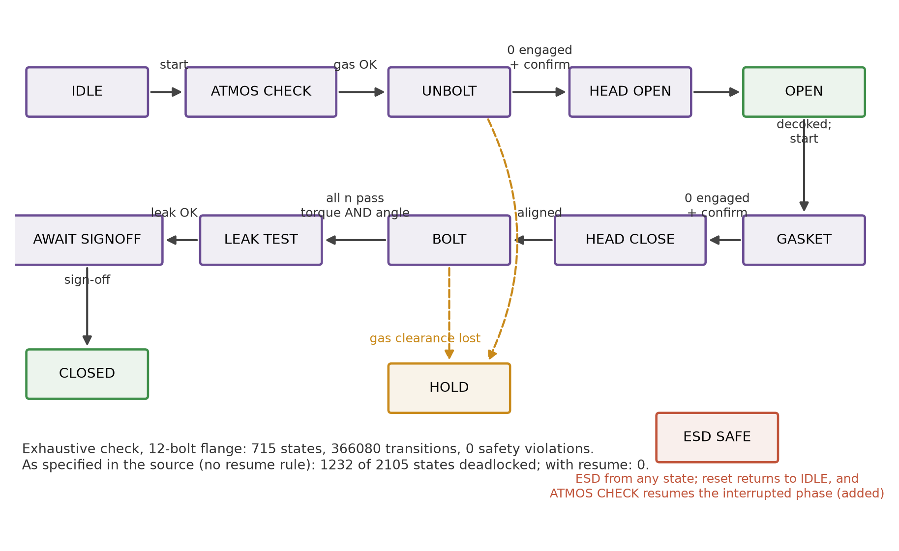
Fig. 3 Sequence and interlock state machine. Dashed transitions are interlock responses; the resume rule on reset (bottom right) was added after the liveness check found deadlocks in the logic as first specified.
4.8 FMEA, automation coverage and exposure
Twelve failure modes are scored for severity S, occurrence O (with the stated control) and detection D on 1–10 scales, and ranked by RPN = S·O·D [30]. The scores are the author's engineering judgement, not field data. Automation coverage is
A = Σ wᵢaᵢ / Σ wᵢ (10)
with aᵢ = 1 for fully automatic, 0.5 for operator-initiated and 0 for manual operations, weighted by modelled task duration wᵢ. Hazard-zone exposure is counted in person-hours per operation.
Implementation note: the models were written in Python with the assistance of a generative AI tool (see Declarations); the author specified, reviewed and checked every model and result.
5 Results
5.1 Torque requirement
Bolt | Aₛ (mm²) | Target preload (kN) | Torque, K = 0.16 (kN·m) | Torque, K = 0.20 (kN·m)
M36 | 817 | 296 | 1.7 | 2.1
M42 | 1121 | 406 | 2.7 | 3.4
M48 | 1473 | 533 | 4.1 | 5.1
M56 | 2030 | 735 | 6.6 | 8.2
M64 | 2676 | 969 | 9.9 | 12.4
Table 3. Target preload at half the specified minimum yield strength of SA-193 B7 and the corresponding torque for two nut factors.
Table 3 gives the torques the runner must deliver: 9.9–12.4 kN·m for the M64 bolts of the heads and 1.7–2.1 kN·m for M36 on the feed inlet. These are within the range of torque multipliers, and they set the reaction load the carriage and rail must resist at every station.
5.2 Cycle time
Configuration | Opening (h) | Closing (h) | Bolting total (h) | P(≤ 2.5 h) | Best case (h)
1 head, parallel flanges | 2.12 | 5.84 | 7.96 [6.09–10.51] | 0.00 | 2.96
1 head, serial flanges | 3.87 | 10.60 | 14.49 [11.12–18.79] | 0.00 | 5.42
1 head, circular passes only | 1.70 | 4.54 | 6.26 [4.79–8.06] | 0.00 | 2.42
2 heads, parallel flanges | 1.16 | 2.91 | 4.08 [3.16–5.20] | 0.00 | 1.51
4 heads, parallel flanges | 0.72 | 1.58 | 2.31 [1.76–2.93] | 0.70 | 0.85
4 heads, 2 star passes | 0.72 | 1.35 | 2.08 [1.57–2.66] | 0.89 | 0.76
Table 4. Modelled bolting time for all 92 bolts (median, with 5th–95th percentiles), probability of meeting the 2.5 h target, and the best case with every step at its fast limit. Opening and closing exclude head handling, gasket work and leak test.
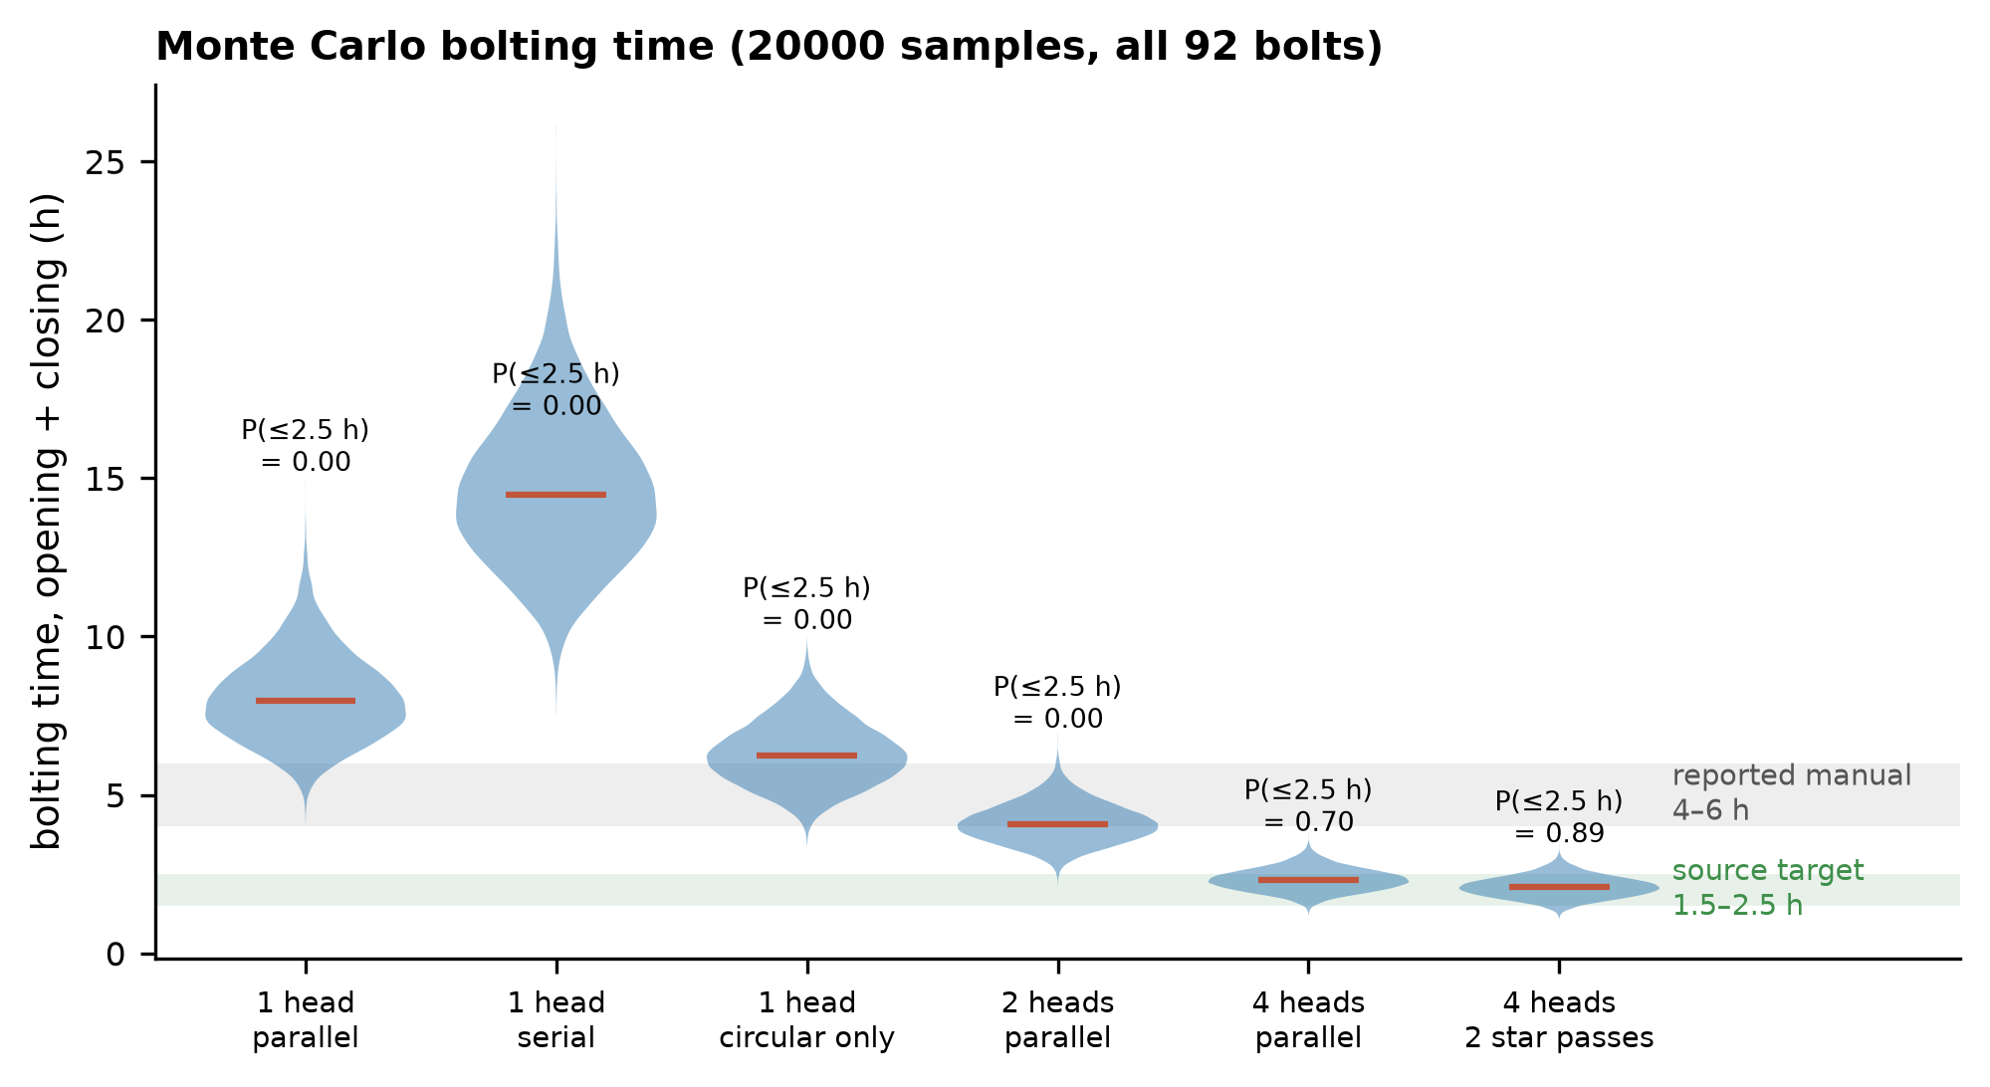
Fig. 4 Distribution of total bolting time by configuration, with the 1.5–2.5 h target of the source proposal and the reported 4–6 h manual duration.
With one head per flange and the flanges worked in parallel, bolting takes 7.96 h (90% interval 6.09–10.51 h), set by the bottom head. Working the flanges in series nearly doubles this to 14.5 h, and using only circular passes, which would not satisfy the legacy procedure, still leaves 6.3 h. Most importantly, the single-head configuration cannot meet the 2.5 h target even in its best case of 2.96 h. A second head per flange halves the time to 4.1 h. Only four synchronised heads bring the median within the target, at 2.31 h (90% interval 1.76–2.93 h), and even then the target is met in 70% of samples; four heads with one fewer star pass raise this to 89%. Including head handling, gasket work and the leak test, the full opening and closing operation takes 9.8 h with one head and 4.2 h with four.
5.3 Admissibility of the cycle-time target
The legacy procedure applies each bolt roughly eight times per open–close operation (one breakout, one run-off, one run-on, three star passes and a median of two check passes), giving 384 bolt-passes on the bottom head and 736 in total. Meeting 2.5 h with flanges in parallel therefore allows 23 s per bolt-pass on the bottom head, and 12 s if the flanges share one runner in series. The modelled median is 75 s per bolt-pass. The target is thus not a matter of faster tools: alignment, engagement, torque, release and verification of a large bolt cannot plausibly fit in about 20 s. It is achievable only by working several bolts at once, which is what a four-head carriage does, and which is also what a manual crew of four to six does.
5.4 Sensitivity
With one head (Fig. 5a) the time is driven by carriage speed (ρ = -0.54), torque time per pass (0.43) and the number of check passes (0.43): the single head spends much of the pass travelling the star pattern. With four heads (Fig. 5b) travel almost disappears and the ranking changes: carousel transfer becomes the strongest driver (ρ = 0.54), followed by check passes (0.46) and torque time (0.42), and the probability of an operator review rises in importance because any one of four heads can stall a station. Carousel transfer accounts for 26% of bottom-head bolting time in the four-head configuration. A design with four heads must therefore also increase carousel throughput, for example with a feed point per head; otherwise the carousel, not the torque tool, sets the pace.
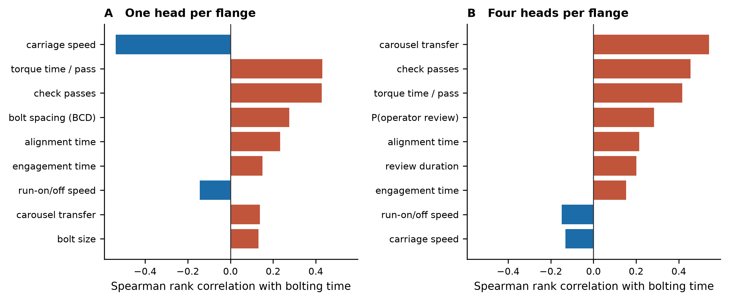
Fig. 5 Spearman rank correlation of each sampled input with total bolting time: (a) one head per flange, (b) four heads per flange. The nine strongest inputs are shown.
5.5 Preload
Fig. 6a shows that the ±2% torque accuracy stated for the system has almost no effect on preload scatter. With CV_K = 10%, preload CV is 10.4% for a ±2% tool, 10.7% for ±5% and 11.8% for ±10%; 32% of bolts fall outside ±10% of target even with the ±2% tool. Preload scatter is set by the nut factor, as the torque–tension literature leads one to expect [10–12]. The angle channel is what changes the outcome (Fig. 6b): with an angle-based preload estimate of 3% uncertainty and re-torque of bolts outside ±10%, the fraction outside falls from 32% to 5% (CV_K = 10%) and from 50% to 5% (CV_K = 15%), at the cost of re-torquing 34% and 51% of bolts respectively. With a 5% angle-estimate uncertainty the residual is about 10%; with 8% the benefit largely disappears. The value of torque–angle monitoring therefore depends on how well joint stiffness is known, which the validation plan measures.
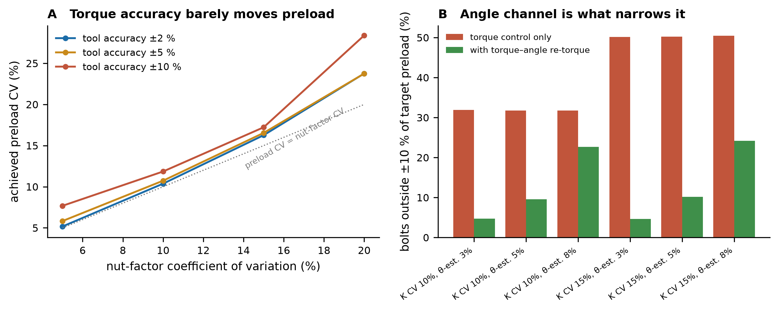
Fig. 6 (a) Achieved preload coefficient of variation against nut-factor variation for three tool accuracies. (b) Fraction of bolts outside ±10% of target under torque control alone and with torque–angle re-torque, for two nut-factor scatters and three angle-estimate uncertainties.
5.6 Head handling
Without counterbalance, lifting a 5 t head at SF 1.5 from 6 bar air needs a 417 mm cylinder and a 10 t head 589 mm, beyond the largest standard bore. The minimum counterbalance fraction that keeps a single cylinder within 320 mm is 41% for 5 t, 70% for 10 t, 80% for 15 t and 85% for 20 t (Fig. 7). A pneumatic manipulator is therefore feasible only as a counterbalanced device in which air supplies the balance correction and motion, not the lift, consistent with passive gravity compensation [21]. Compressibility also makes a pneumatic axis compliant, so the final seating of the head must rely on mechanical guides and alignment pins, and holding must rely on a spring-applied mechanical lock rather than on air pressure.
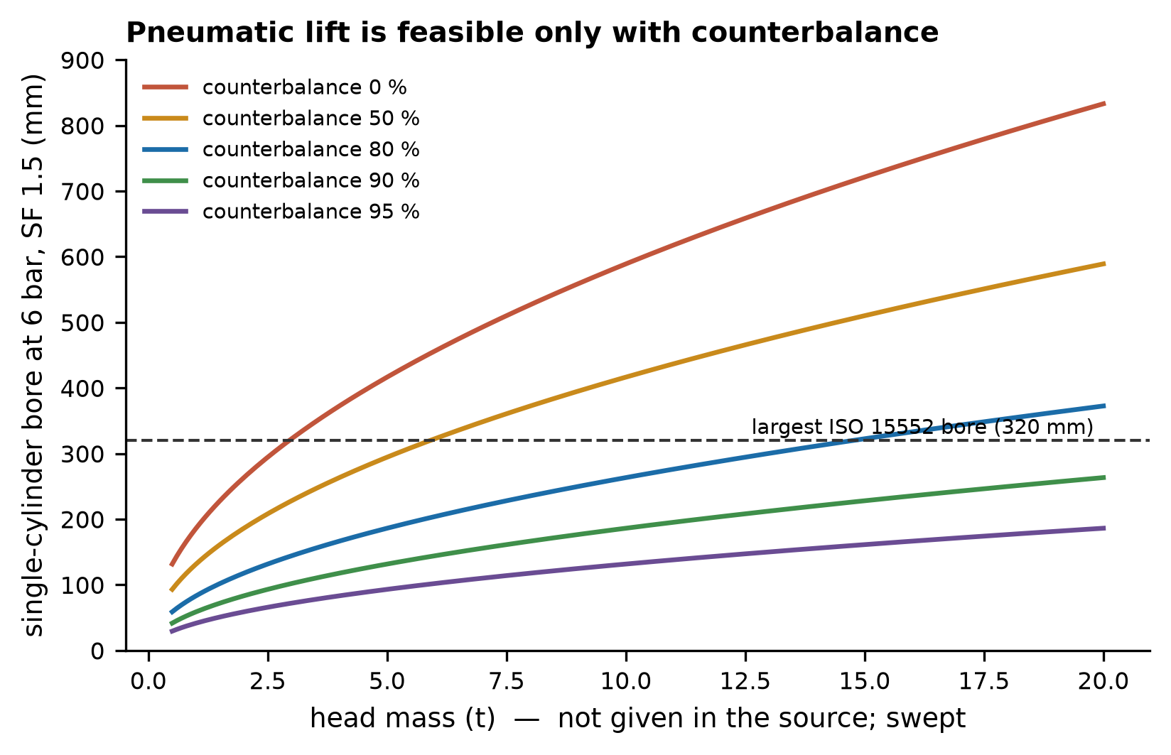
Fig. 7 Single-cylinder bore needed to lift a head against its unbalanced weight, as a function of head mass and counterbalance fraction. Head mass was not available and is swept.
5.7 Control logic
With the full interlock set and the resume rule, exhaustive exploration finds no safety violation: 715 reachable states and 366080 checked transitions for a 12-bolt flange (347 and 177664 for 4 bolts), with all 13 modes reachable and no deadlocked state. Every mutant is detected (Table 5), so each invariant is capable of failing. The liveness check, however, found a defect in the logic as first specified. Without an explicit rule for resuming an interrupted phase, 1232 of 2105 reachable states for a 12-bolt flange (144 of 385 for 4 bolts) can never reach OPEN or CLOSED: an emergency stop part-way through unbolting or tightening leaves a partially bolted joint from which the prose interlocks provide no way forward, so the operator would have to leave the automated system. Adding the rule that atmosphere confirmation routes to the interrupted phase — continue unbolting, resume tightening at the next unverified bolt, repeat the leak test or await sign-off — removes every deadlock while preserving all seven invariants.
Interlock removed | Invariant violated | Shortest counterexample (transitions)
Emergency stop | I6 ESD forces the safe state from any state | 1
Gas clearance before tool motion | I1 unbolting starts only with gas clearance | 2
Hold on loss of gas clearance | I7 loss of gas clearance holds all tool motion | 3
Leak test before CLOSED | I4 CLOSED only after leak test pass | 18
No head motion with bolts engaged | I2 head moves only with no bolt engaged | 3
Sequence advances only on torque AND angle pass | I3 sequence advances only on torque AND angle pass | 13
Operator sign-off before CLOSED | I5 CLOSED only with operator sign-off | 18
Table 5. Mutation test of the interlock logic (4-bolt flange). Each interlock removed in isolation is caught by the invariant it protects.
5.8 Failure modes
The highest-ranked failure mode (Fig. 8, Table 6) is an out-of-window preload that goes undetected (RPN 160), which follows directly from Section 5.5: torque control alone cannot see a nut-factor outlier, and detection depends on the angle channel. Second is failure of gas detection to register residual hydrocarbons (RPN 150, severity 10), which is why the design specifies voted redundant detectors and a pre-cycle functional test. The failure modes with the highest severity but lower RPN — head release with a bolt engaged and loss of air under load — are those the interlocks and the mechanical lock address by design; their low RPN reflects the control, not the absence of the hazard.
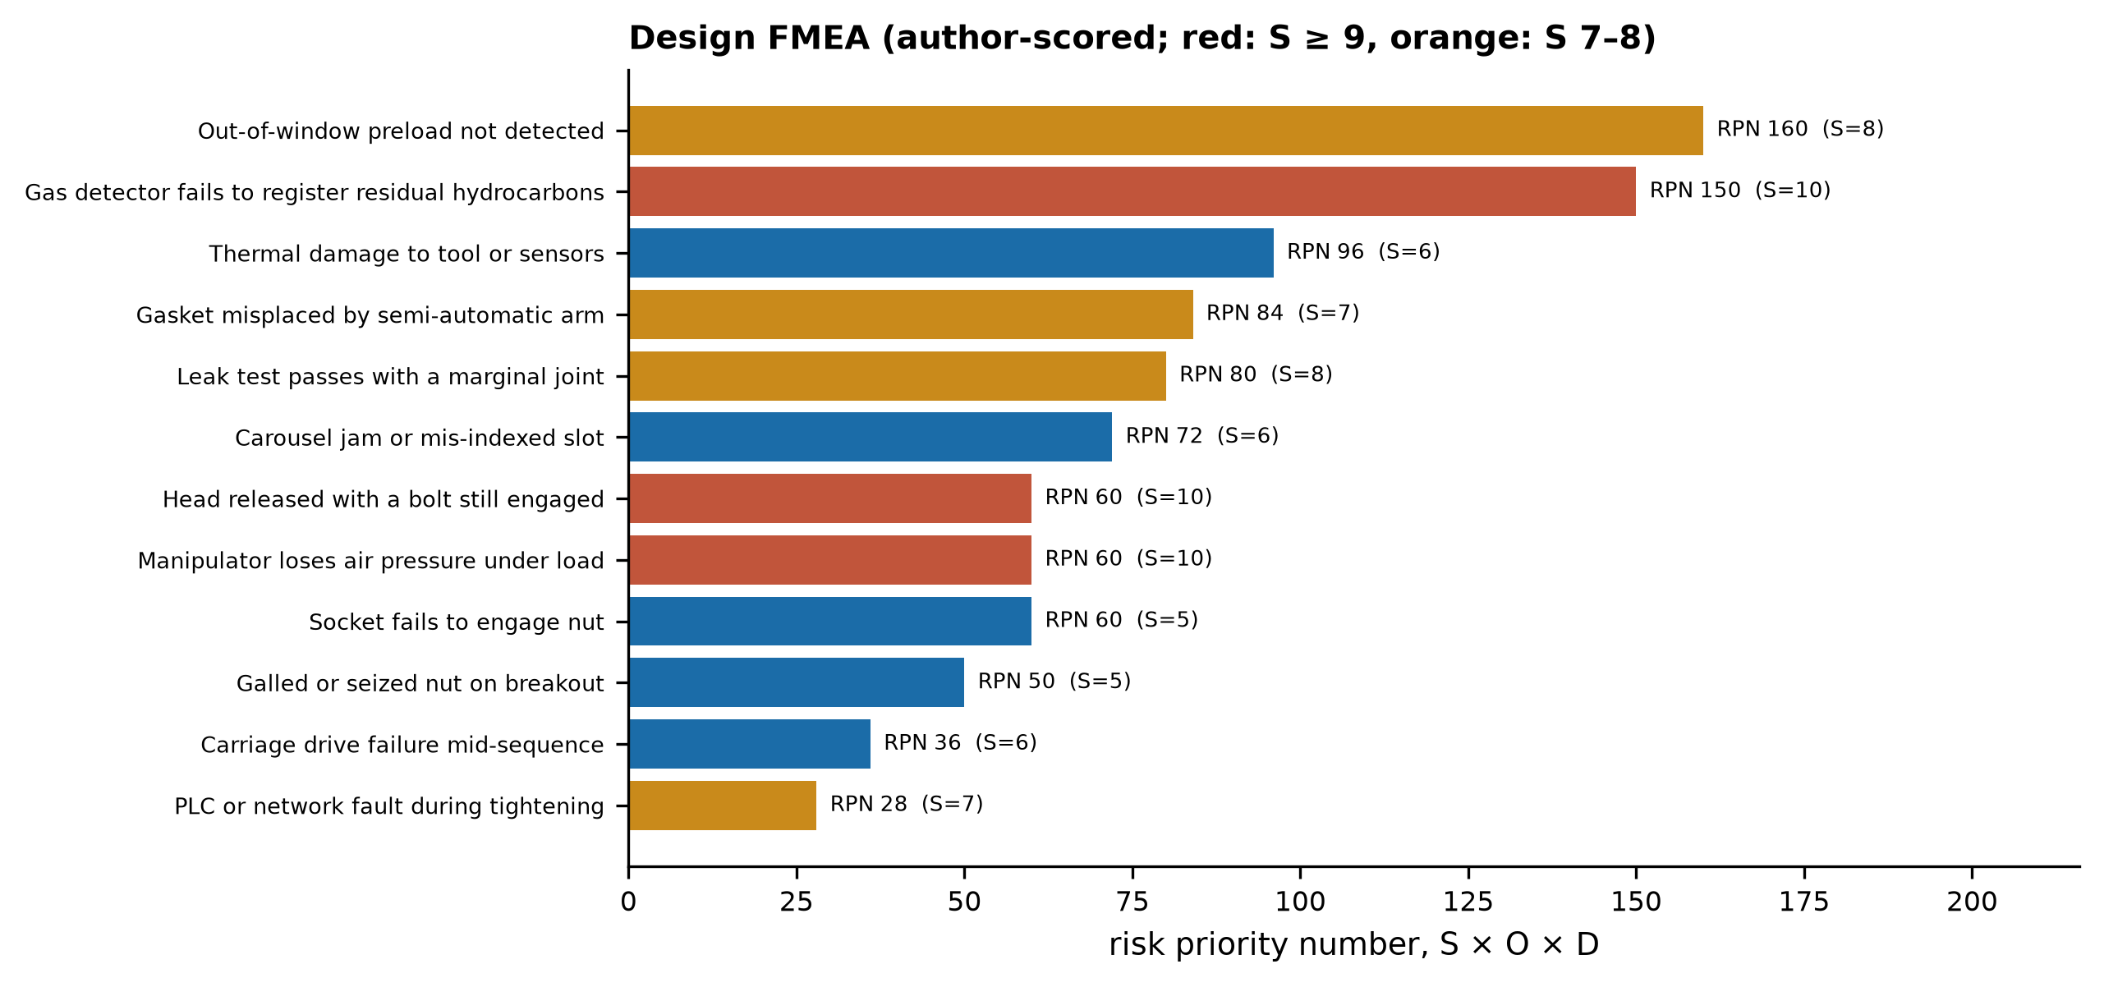
Fig. 8 Design FMEA ranked by risk priority number; colour indicates severity. Scores are the author's judgement and are listed with their controls in Table 6.
Failure mode | Effect | S | O | D | RPN | Control
Out-of-window preload not detected | Gasket leak at restart | 8 | 5 | 4 | 160 | Torque-angle window per bolt; angle-corrected re-torque
Gas detector fails to register residual hydrocarbons | Bolting starts in flammable atmosphere | 10 | 3 | 5 | 150 | Redundant detectors (2oo3 voting), bump test before each cycle
Thermal damage to tool or sensors | Tool failure, sensor drift | 6 | 4 | 4 | 96 | High-temperature rating; surface temperature interlock
Gasket misplaced by semi-automatic arm | Leak at steam test | 7 | 4 | 3 | 84 | Camera confirmation; steam test gate before CLOSED
Leak test passes with a marginal joint | Leak in service | 8 | 2 | 5 | 80 | Defined hold time and decay criterion; torque-angle record review
Carousel jam or mis-indexed slot | Wrong bolt returned or stall | 6 | 4 | 3 | 72 | Slot presence sensing; bolt ID; stop on mismatch
Head released with a bolt still engaged | Head/flange damage, dropped load | 10 | 2 | 3 | 60 | Carousel count must equal n AND per-station sensor; interlock
Manipulator loses air pressure under load | Uncontrolled head motion | 10 | 3 | 2 | 60 | Counterbalance carries static load; spring-applied mechanical lock
Socket fails to engage nut | Bolt skipped, sequence stall | 5 | 6 | 2 | 60 | Laser/contact alignment; engagement proof before torque
Galled or seized nut on breakout | Breakout torque exceeded, stall | 5 | 5 | 2 | 50 | Torque limit with alarm; operator review; spare stud set
Carriage drive failure mid-sequence | Sequence interrupted mid-pass | 6 | 3 | 2 | 36 | Resume-from-bolt state retention; manual procedure retained
PLC or network fault during tightening | Partially tightened joint | 7 | 2 | 2 | 28 | Safe-state on fault; state retention; ESD independent of PLC
Table 6. Design FMEA (1–10 scales; D = 10 is undetectable).
5.9 Automation coverage and exposure
Operation | Modelled duration (h) | Automation level aᵢ
Atmosphere check | 0.10 | 1.0
Bolt loosening and removal | 2.12 | 1.0
Head removal and replacement | 0.75 | 0.5
Gasket removal, cleaning, installation | 0.46 | 0.5
Bolt installation and tightening | 5.84 | 1.0
Leak test | 0.54 | 1.0
Table 7. Operations, modelled durations (one-head configuration, medians) and automation levels used in the coverage metric.
Weighted by modelled duration, automation coverage is A = 0.94 (Table 7). The reported manual procedure places four to six workers in the hazard zone for four to six hours, 16–36 person-hours per operation; with the automated system the routine value is zero, rising to at most 0.46 person-hours if gasket cassette loading has to be done at the flange rather than from outside the zone. The exposure reduction is the least uncertain benefit of the architecture: it does not depend on the step times that dominate the cycle-time uncertainty.
6 Discussion
6.1 What the targets require
The analysis supports two of the three original targets and conditions the third. The exposure target is met by design. The torque-accuracy target is achievable but, on its own, does not deliver the preload quality it appears to promise; what delivers it is the angle channel. The cycle-time target is not met by the architecture as first described, with one runner per flange, under any combination of assumed step times; it requires four synchronised heads per flange and a carousel whose throughput scales with them. That is a substantially larger and more expensive machine than the original proposal implied, and it changes the comparison with manual work: a single automated head is slower than a crew of four to six, and the automated system matches or improves on manual duration only when it too works several bolts at once.
6.2 Sequence choice as a throughput lever
For a single head the star pattern costs far more travel than a circular pass (Fig. 2b), and circular-only tightening shortens the cycle, but the legacy procedure uses the star pattern for good reason: it limits the load redistribution caused by elastic interaction [2, 3]. Multi-head carriages remove most of the travel penalty while keeping cross-pattern loading, because each station tightens bolts at 90° spacing together. Alternative patterns with fewer passes [7], and sequences optimised using interaction coefficients [9], are the natural next step, since the model shows that each pass removed saves roughly a quarter of the closing time with four heads.
6.3 Flange condition and engagement
The engagement and alignment steps assume that nuts are where the rail expects them. Coke-drum bottom flanges can become distorted by thermal transients until bolt holes no longer align [6], and fouling of nuts by coke is likely. Both would raise the retry and operator-review probabilities, which the four-head sensitivity ranks among the stronger drivers. Vision-based nut localisation and pose estimation [17] and self-adjusting engagement tools [18] address part of this; a dimensional survey of the actual flanges before rail fabrication addresses the rest.
6.4 Relation to unheading devices
Where automatic bottom unheading devices are installed, the bottom head is no longer unbolted on every cycle [5], and the per-cycle bolting problem addressed here does not arise at that flange; the drum-to-device joint is then opened only at maintenance intervals, when flange distortion can make reassembly difficult [6]. The architecture evaluated here is relevant to units that retain bolted heads, and its bolting subsystem could serve those maintenance reassemblies. Whether automated bolting or an unheading retrofit is preferable for a given unit is an economic and engineering decision outside the scope of this paper.
6.5 Hazardous-area compliance and functional safety
The source proposal described hazardous-area certification of the integrated system as achievable by selecting certified components. Component certification is necessary but not sufficient: the integrated assembly, including carriage drives, transducers, the carousel and the controller, must satisfy the applicable protection concepts as a whole [25–27]. The gas-clearance and head-motion interlocks are safety functions, and their integrity requirements belong to a functional-safety assessment [28]. The exhaustive check in Section 5.7 shows that the logic is consistent and deadlock-free as specified; it does not establish the hardware fault tolerance or safety integrity level of its implementation.
6.6 Limitations
Every performance figure in this paper is a model prediction. The step-time ranges in Table 2 are assumptions, bounded but not measured; the bolt-circle diameters are bracketed by a spacing rule; head masses are swept. Elastic interaction is represented only through the number of passes, not modelled directly. The preload model treats nut factor and angle-estimate errors as independent and normally distributed. The FMEA scores are judgement. The control-logic verification abstracts the controller to a finite-state model and checks it for flanges of 4, 8 and 12 bolts; its conclusions concern the logic, not an implementation. The manual baseline of 4–6 h is as reported, not measured. Costs are not analysed beyond the preliminary estimates noted in Section 8.
7 Validation plan
The predictions above can be falsified by a staged test programme. Table 8 lists the measurements, the rig on which each is made and the acceptance criterion that would confirm or refute the corresponding result.
Quantity | Rig | Acceptance criterion
Step times: align, engage, torque, release, verify, transfer | Full-size single-station rig with a representative M56–M64 stud and flange segment | Measured medians within the Table 2 ranges; if not, re-run the model with measured values
Carriage speed and indexing overhead | Rail segment, loaded carriage | As above
Per-bolt-pass time, four-head station | Four-head carriage on a full flange mock-up | ≤ 94 s median to meet 2.5 h (Section 5.3)
Nut-factor scatter CV_K | Instrumented studs (ultrasonic elongation) on the mock-up | Measured CV_K; preload prediction of Fig. 6a to be confirmed within ±2 points
Angle-estimate uncertainty CV_θ | As above, with gasket installed | CV_θ ≤ 5% for the torque–angle benefit of Fig. 6b to hold
Engagement success on distorted flange | Mock-up with imposed ovality and cupping | Retry probability within Table 2 range
Interlock logic | Controller hardware-in-the-loop | All seven invariants and the resume rule demonstrated; no deadlock after ESD in any phase
Head handling | Counterbalanced manipulator with dummy head at maximum mass | Lift, swing, lock and reseat without personnel in load path; lock holds on air loss
Table 8. Validation measurements and acceptance criteria. A pilot on one bottom head is proposed only after the single-station and mock-up tests have been passed.
8 Industrial feasibility
Each subsystem uses established technology — pneumatic torque multipliers, rails and carriages, fastener magazines, counterbalanced manipulators and programmable controllers — so the development risk lies in integration and in the hazardous-area environment rather than in any single component. The preliminary cost estimates of the source proposal, about US$0.14–0.20 million for a single-flange pilot and US$0.74–1.1 million for all three flanges on four drums, assumed one runner per flange. The results of Section 5 imply a four-head carriage and a faster carousel on each flange if the cycle-time target is to be met, so those estimates are likely to be low and should be revised after the single-station tests. A staged programme — single-station rig, full-flange mock-up, then a pilot on one bottom head — allows the project to stop cheaply if the measured step times, nut-factor scatter or engagement success fall outside the ranges on which the results depend.
9 Conclusions
An automated architecture for opening and closing a 92-bolt, three-flange pressure vessel was evaluated by simulation against the targets originally claimed for it. With one torque head per flange, bolting takes a median 8.0 h and cannot meet a 2.5 h target under any assumed step times; four synchronised heads per flange bring the median to 2.3 h, and the carousel then becomes the rate-limiting element. Specifying ±2% torque accuracy does little for preload, which nut-factor scatter dominates, whereas torque–angle verification with re-torque substantially narrows it. The interlock logic is safe as specified but deadlocks after an interrupted sequence unless an explicit resume rule is added. Pneumatic head handling requires a counterbalance carrying most of the load. The reduction in hazard-zone exposure, from 16–36 person-hours to essentially none, is the most robust benefit. These are predictions, and the validation plan specifies the measurements that would confirm or overturn them.
Declarations
Funding. This work received no external funding.
Competing interests. The author declares no competing interests.
Ethics approval. Not applicable. No human participants or animals were involved.
Consent to participate / for publication. Not applicable.
Prior dissemination. An earlier, non-quantitative description of the architecture was submitted by the author in response to an industrial open-innovation challenge. That submission was not peer reviewed or published, and contained none of the models or results reported here.
Data availability. No experimental data were generated. All model inputs are stated in the paper.
Code availability. The models, the verification script and the figure generators are openly available at https://github.com/sandlerleon/pabhs-bolting-model. Running pabhs_model.py, plc_verify.py and make_figures.py reproduces every number and figure.
Author contributions. L.S. conceived the study, developed the models, performed the analysis and wrote the manuscript.
Use of generative AI. During the preparation of this work the author used Claude (Anthropic) to assist with literature search, implementation of the models and drafting of the text. The author reviewed and edited all content, verified every cited reference against its source, and takes full responsibility for the content of the article.
References
1. ASME (2022) PCC-1-2022 Guidelines for pressure boundary bolted flange joint assembly. American Society of Mechanical Engineers, New York
2. Bibel GD, Ezell RM (1992) An Improved Flange Bolt-Up Procedure Using Experimentally Determined Elastic Interaction Coefficients. Journal of Pressure Vessel Technology 114(4):439-443. https://doi.org/10.1115/1.2929252
3. Zhu L, Bouzid AH, Hong J, Zhang Z (2018) Elastic Interaction in Bolted Flange Joints: An Analytical Model to Predict and Optimize Bolt Load. Journal of Pressure Vessel Technology 140(4):041202. https://doi.org/10.1115/1.4040421
4. Ma X, Xie Y, Ge Z (2023) Identification of Typical Damage Mechanism of Coke Drum in Delayed Coking Unit. In: Proceedings of the ASME 2023 Pressure Vessels & Piping Conference, Volume 1: Codes & Standards. American Society of Mechanical Engineers. https://doi.org/10.1115/pvp2023-107648
5. Berry A, Brown W, Seijas A, Cook S (2019) Coke Drum Bottom Head Flange Design Optimisation. In: Proceedings of the ASME 2019 Pressure Vessels & Piping Conference, Volume 3: Design and Analysis. American Society of Mechanical Engineers. https://doi.org/10.1115/pvp2019-93136
6. Horstmeyer M, Corcoran A, Seijas A, Berry A, Brown W (2025) Coke Drum Bottom Head Flange Distortion, Root Cause and Solutions. In: Proceedings of the ASME 2025 Pressure Vessels & Piping Conference, Volume 3: Design & Analysis. American Society of Mechanical Engineers. https://doi.org/10.1115/pvp2025-153394
7. Brown W, Waterland J, Lay D (2010) Background on the New ASME PCC-1:2010 Appendix F “Alternatives to Legacy Tightening Sequence/Pattern”. In: ASME 2010 Pressure Vessels and Piping Conference: Volume 3. ASMEDC. https://doi.org/10.1115/pvp2010-25772
8. Kumakura S, Saito K (2003) Tightening Sequence for Bolted Flange Joint Assembly. In: Proceedings of the ASME 2003 Pressure Vessels and Piping Conference, Analysis of Bolted Joints. ASMEDC. https://doi.org/10.1115/pvp2003-1867
9. Zhu L, Bouzid AH, Hong J (2019) A Novel Methodology to Optimize the Tightening Sequence in Bolted Flange Joints. In: Proceedings of the ASME 2019 Pressure Vessels & Piping Conference, Volume 2: Computer Technology and Bolted Joints. American Society of Mechanical Engineers. https://doi.org/10.1115/pvp2019-93062
10. Nassar SA, Ganeshmurthy S, Ranganathan RM, Barber GC (2007) Effect of Tightening Speed on the Torque-Tension and Wear Pattern in Bolted Connections. Journal of Pressure Vessel Technology 129(3):426-440. https://doi.org/10.1115/1.2749290
11. Sawa T, Matsumoto M, Nagata S (2003) Effects of Scatter in Bolt Preload of Pipe Flange Connections With Gaskets on Sealing Performance. In: Proceedings of the ASME 2003 Pressure Vessels and Piping Conference, Analysis of Bolted Joints. ASMEDC. https://doi.org/10.1115/pvp2003-1875
12. Omiya Y, Fujii M (2016) Correlation on Scatter Between Torque Coefficient and Bolt Preload in Pipe Flange Connection. In: Proceedings of the ASME 2016 Pressure Vessels and Piping Conference, Volume 2: Computer Technology and Bolted Joints. American Society of Mechanical Engineers. https://doi.org/10.1115/pvp2016-63720
13. Abid M, Khan YM, Nash DH (2013) Assembly of Gasketed Bolted Flange Joints Using Torque Control of Preload Method: FEA Approach. In: Proceedings of the ASME 2013 Pressure Vessels and Piping Conference, Volume 3: Design and Analysis. American Society of Mechanical Engineers. https://doi.org/10.1115/pvp2013-97863
14. Persson EV, Kumar M, Friberg C, Dressler N (2021) Clamp Force Accuracy in Threaded Fastener Joints Using Different Torque Control Tightening Strategies. SAE Technical Paper 2021-01-5073. SAE International. https://doi.org/10.4271/2021-01-5073
15. Nassar SA, Yang X (2008) Torque-Angle Formulation of Threaded Fastener Tightening. Journal of Mechanical Design 130(2):024501. https://doi.org/10.1115/1.2821388
16. Nozu K, Shimonomura K (2018) Robotic bolt insertion and tightening based on in-hand object localization and force sensing. In: 2018 IEEE/ASME International Conference on Advanced Intelligent Mechatronics (AIM). IEEE. https://doi.org/10.1109/aim.2018.8452338
17. Yibang Z, Xiaoyong W, Lanzhu Z (2023) Visual identification and pose estimation algorithms of nut tightening robot system. The International Journal of Advanced Manufacturing Technology 127(11-12):5307-5326. https://doi.org/10.1007/s00170-023-11597-6
18. Ali MAH, Alshameri MA (2019) An intelligent adjustable spanner for automated engagement with multi-diameter bolts/nuts during tightening/loosening process using vision system and fuzzy logic. The International Journal of Advanced Manufacturing Technology 101(9-12):2795-2813. https://doi.org/10.1007/s00170-018-3133-0
19. Martinez P, Al-Hussein M, Ahmad R (2020) Intelligent vision-based online inspection system of screw-fastening operations in light-gauge steel frame manufacturing. The International Journal of Advanced Manufacturing Technology 109(3-4):645-657. https://doi.org/10.1007/s00170-020-05695-y
20. Zhuang C, Gong J, Liu J (2021) Digital twin-based assembly data management and process traceability for complex products. Journal of Manufacturing Systems 58:118-131. https://doi.org/10.1016/j.jmsy.2020.05.011
21. Arakelian V (2016) Gravity compensation in robotics. Advanced Robotics 30(2):79-96. https://doi.org/10.1080/01691864.2015.1090334
22. ISO (2018) ISO 15552:2018 Pneumatic fluid power. Cylinders with detachable mountings, 1 000 kPa (10 bar) series, bores from 32 mm to 320 mm. Basic, mounting and accessories dimensions. International Organization for Standardization, Geneva
23. Shukla A, Karki H (2016) Application of robotics in onshore oil and gas industry—A review Part I. Robotics and Autonomous Systems 75:490-507. https://doi.org/10.1016/j.robot.2015.09.012
24. Shukla A, Karki H (2016) Application of robotics in offshore oil and gas industry— A review Part II. Robotics and Autonomous Systems 75:508-524. https://doi.org/10.1016/j.robot.2015.09.013
25. Kumar Singh A (2023) Explosion-Proof Equipment in Hazardous Area. Springer Nature Singapore. https://doi.org/10.1007/978-981-99-2516-2
26. IEC (2017) IEC 60079-0:2017 Explosive atmospheres. Part 0: Equipment. General requirements. International Electrotechnical Commission, Geneva
27. European Parliament and Council (2014) Directive 2014/34/EU on the harmonisation of the laws of the Member States relating to equipment and protective systems intended for use in potentially explosive atmospheres. Official Journal of the European Union L 96:309-356
28. IEC (2016) IEC 61511-1:2016 Functional safety. Safety instrumented systems for the process industry sector. Part 1: Framework, definitions, system, hardware and application programming requirements. International Electrotechnical Commission, Geneva
29. Ovatman T, Aral A, Polat D, Ünver AO (2016) An overview of model checking practices on verification of PLC software. Software & Systems Modeling 15(4):937-960. https://doi.org/10.1007/s10270-014-0448-7
30. Liu HC, Liu L, Liu N (2013) Risk evaluation approaches in failure mode and effects analysis: A literature review. Expert Systems with Applications 40(2):828-838. https://doi.org/10.1016/j.eswa.2012.08.010
31. Negahban A, Smith JS (2014) Simulation for manufacturing system design and operation: Literature review and analysis. Journal of Manufacturing Systems 33(2):241-261. https://doi.org/10.1016/j.jmsy.2013.12.007
32. ISO (1998) ISO 261:1998 ISO general purpose metric screw threads. General plan. International Organization for Standardization, Geneva
33. ASTM International (2023) ASTM A193/A193M-23 Standard specification for alloy-steel and stainless steel bolting for high temperature or high pressure service and other special purpose applications. ASTM International, West Conshohocken
34. ISO (2013) ISO 898-1:2013 Mechanical properties of fasteners made of carbon steel and alloy steel. Part 1: Bolts, screws and studs with specified property classes. International Organization for Standardization, Geneva

