A Literature-Based Modular Route-Design Strategy for Scalable Manufacture of PN6047
Leon Sandler
Independent researcher, Northbrook, Illinois, USA
Corresponding author: sandler.leon@gmail.com
ORCID: 0009-0007-4584-808X

Abstract
Purpose: To ask which operations of the only publicly exemplified route to the drug substance of PN6047, a clinical-stage δ-opioid receptor agonist, would limit its manufacture, and what public evidence supports replacing them.
Methods: No synthesis was performed. The operations exemplified in two patent documents were inventoried; each transformation and its conditions were graded A–D by the strength of public evidence for this substrate class; documented regulatory and hazard attributes were flagged; and two process-oriented variants were screened by step count, flags, an evidence-weighted validation burden and a risk register whose ranking was tested under ±1 perturbation of the author's ratings.
Results: The exemplified route (milligram to gram scale; final N-functionalisation isolated in 16 % by preparative HPLC) carries 11 flags, including an ICH Q3C Class 1 solvent, palladium and a benzotriazole-derived coupling reagent. Variant R1 keeps the bond disconnections and carries 3 flags, but its validation burden is higher (11 against 2, linear scale) because its conditions are unvalidated. Two risks dominated: impurity purge when crystallisation replaces chromatography, and the undisclosed route to the vinyl bromide building block (each in the top three in about 87 % of perturbations).
Conclusion: Process-oriented variants reduce documented flags but move the uncertainty to impurity purge and upstream supply. The output is an evidence-graded validation plan, not a validated process.
Keywords: PN6047; pharmaceutical process development; synthetic route design; drug substance manufacturing; evidence grading; risk assessment
Summary (about 100 words). A discovery-scale route to the δ-opioid agonist PN6047 is public only as milligram-to-gram patent examples. We graded each operation of that route, and of two process-oriented variants, by the strength of public evidence, flagged documented regulatory and hazard attributes, and ranked the development risks. Variants remove most flags, including a Class 1 solvent and preparative chromatography, but their conditions are unvalidated, so the burden of proof rises. Impurity purge by crystallisation and the route to one building block are the dominant uncertainties. No experiments were run; the paper is a transparent, reproducible plan for what to test first.
Teaser (25–30 words). Before any process chemistry is run, an evidence-graded screen of a drug substance route shows what the public record supports, what it does not, and which experiments must come first.

1 Introduction

1.1 PN6047 and its development context
PN6047, 4-[(3-carbamoylphenyl)[1-(1,3-thiazol-5-ylmethyl)piperidin-4-ylidene]methyl]-N,N-dimethylbenzamide (C₂₆H₂₈N₄O₂S, relative molecular mass 460.6), is a selective δ-opioid receptor agonist that is G protein-biased in cell-based assays and effective in rodent models of chronic pain [1]. It belongs to the diarylmethylidene-piperidine class that Wei and colleagues described as formally derived from SNC-80 by replacing the piperazine ring with a piperidine ring carrying an exocyclic double bond [2]. The compound was disclosed in a patent application of PharmNovo AB [3], and crystalline forms of its hydrochloride salt were claimed in a later application [4]. A European Innovation Council project coordinated by the same company describes completed phase I trials and a planned phase IIa proof-of-concept study [5]. The author has no affiliation with the company.

1.2 The manufacturing problem
A synthesis that supplies a discovery programme is rarely a manufacturing route. Federsel describes the handover from medicinal chemistry to process research as the point where technical, safety and scalability questions that were invisible at the bench become decisive [6], and surveys of the chemistry used in process research show a different reaction distribution from that of discovery chemistry [7]. In discovery chemistry the most frequently used reactions are amide-bond formation, Suzuki–Miyaura coupling and nucleophilic aromatic substitution, chosen for reagent availability, chemoselectivity and speed of delivery [8]; drug molecules additionally contain amines and nitrogen heterocycles that make synthesis harder [9, 10]. The route that is public for PN6047 is of exactly this kind: the patent examples use a benzotriazole-derived coupling reagent, a palladium-catalysed coupling, trifluoroacetic acid, a chlorinated solvent that is a Class 1 solvent under ICH Q3C, and preparative HPLC [3, 11]. What the public record does not contain is any yield, impurity profile or palladium level at a scale relevant to manufacture.

1.3 Research question and contribution
The research question is: which operations of the publicly exemplified route would limit manufacture of PN6047 drug substance, and how strong is the public evidence for the alternatives that would replace them? The paper contributes (i) an evidence-grading scheme that separates what is shown for PN6047 from what is inferred from the scaffold class, from general pharmaceutical practice, or only hypothesised; (ii) a transparent screening of the exemplified route and two process-oriented variants by step count, documented flags and evidence-weighted validation burden; (iii) a risk register whose ranking is tested for robustness to the author's own uncertainty; and (iv) a stage-gated validation plan. It also corrects a mapping that an earlier form of the idea relied on: pramipexole, a commercial thiazole-containing amine, is a useful benchmark for manufacture and salt formation of a basic API [12], but its tetrahydrobenzothiazole-diamine core is not a substructure of PN6047 and is not used here as a fragment source.
The paper does not claim that any proposed route works. No synthesis was performed, no yield, impurity level, cost or timeline is predicted, and no freedom-to-operate analysis was made. Each claim below is labelled by the strength of its public support.

2 Methods

2.1 Design and scope
The study is a literature- and document-based screening exercise with a small computational layer. It uses no laboratory data of the author. The computation counts and classifies documented operations; it does not simulate chemistry. All inputs are in plain JSON files (route inventories, flags, precedents, risk ratings) and all outputs are regenerated by a single script, so that every number in the text can be traced to an input.

2.2 Sources and how they were used
The primary sources are the two patent documents above [3, 4], whose text as published on Google Patents was searched and read for the passages on synthesis, purification and salt forms, and the ICH guidelines on impurities, residual solvents, elemental impurities and development of drug substances [11, 13–15], whose texts were consulted for the limits quoted. Journal articles were located through Crossref and Europe PMC and chosen for the precedent they provide for a named operation; for most of them the bibliographic record and abstract were examined rather than the full text, and statements about them are limited to what the record supports. The search was purposive, not systematic, and the paper should not be read as a systematic review. All DOIs were resolved through Crossref and the reference list was built from the returned records. The machine-readable text of WO 2016/099393 contains transcription irregularities; in particular, the starting material named for its Example III is not the compound that Example IV requires. The reagent classes of that example are used here, but not its compound names.

2.3 Retrosynthetic decomposition and the five-stage framework
PN6047 was decomposed into five stages (Fig. 1): the thiazol-5-ylmethyl unit (S1), the diarylmethylidene-piperidine core (S2), N-functionalisation joining them (S3), the dimethylamide (S4) and the hydrochloride salt (S5). Three bond disconnections define the framework: (a) the N–CH₂ bond, by reductive amination with thiazole-5-carbaldehyde; (b) the vinylic carbon–aryl bond to the carbamoylphenyl ring, by Suzuki–Miyaura coupling of a vinyl bromide with an arylboronic acid; and (c) the amide C–N bond. The exocyclic double bond joins a carbon bearing two different aryl groups to C-4 of a piperidine ring with identical arms, so no geometric (E/Z) isomerism arises.
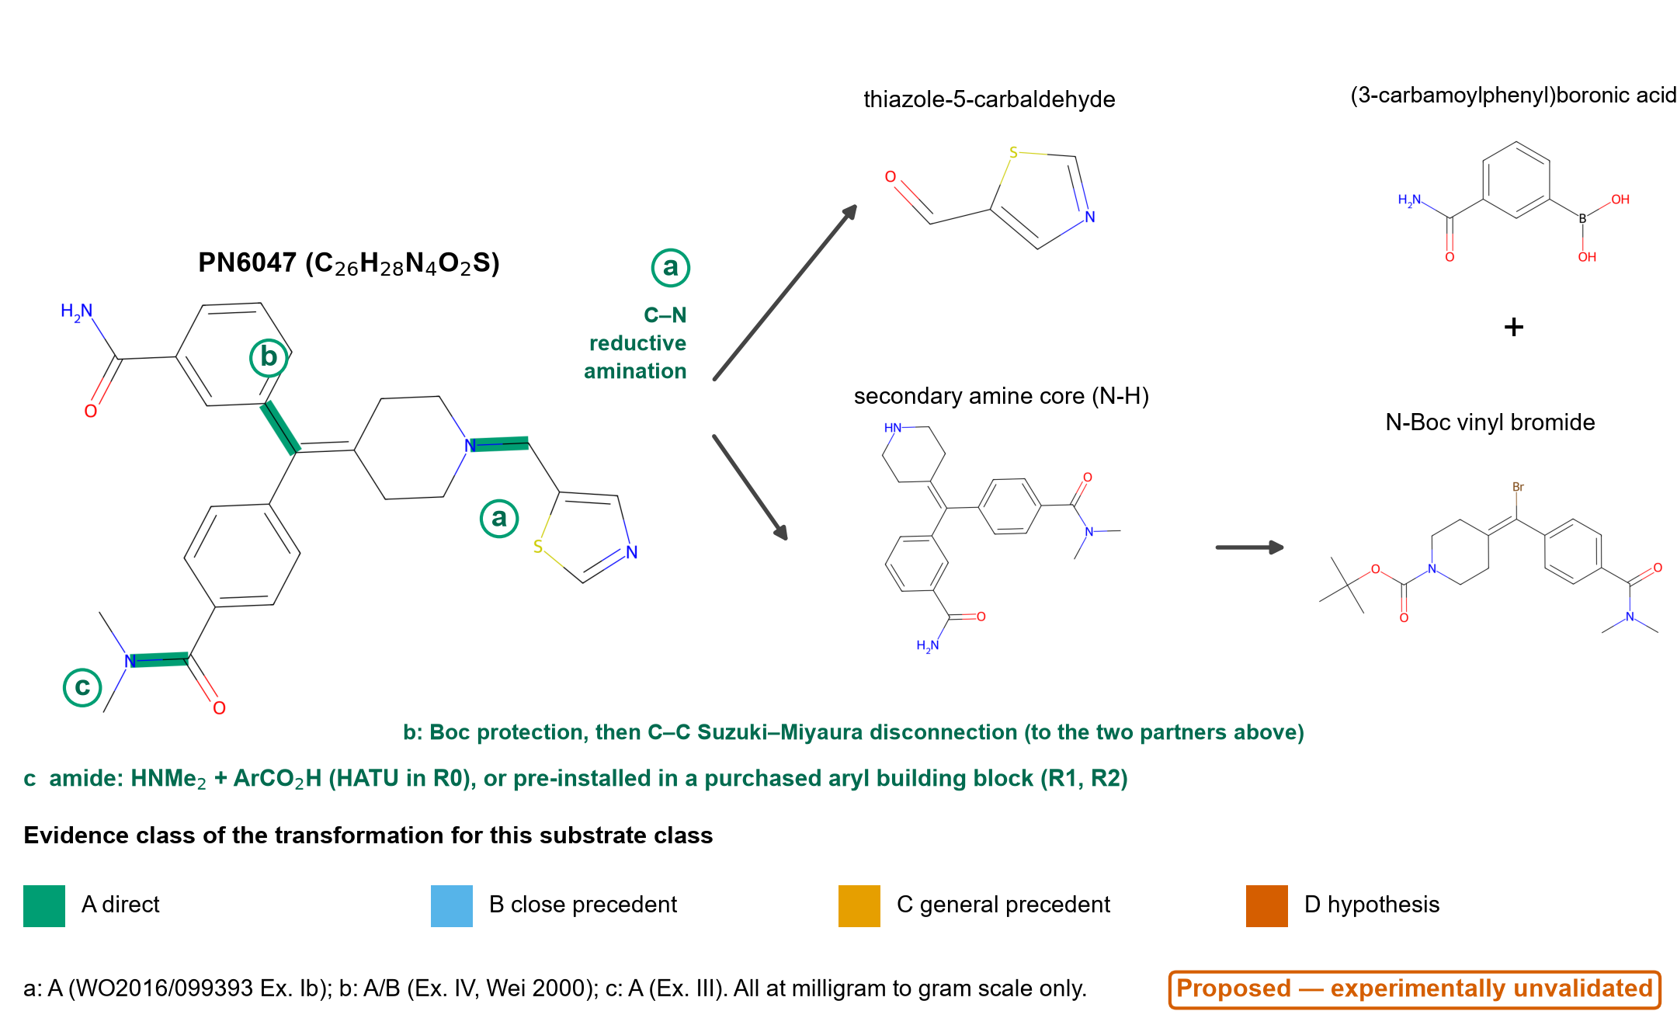
Fig. 1 Retrosynthetic framework for PN6047. Highlighted bonds are the three disconnections: a, N–CH₂ (reductive amination with thiazole-5-carbaldehyde); b, vinylic carbon–aryl (Suzuki–Miyaura coupling of an N-Boc vinyl bromide with an arylboronic acid, after Boc protection of the amine core); c, amide C–N. Structures were drawn from SMILES with RDKit. The scheme is a proposal and is experimentally unvalidated; evidence colours refer to the transformations as exemplified in WO 2016/099393 and by Wei et al. [2].

2.4 Evidence classes
Each operation received two grades (Table 1): one for the transformation itself and one for its conditions as written in the route. A route step that reuses a published transformation under changed conditions can therefore carry class A for the former and class D for the latter. Class A means that the transformation is reported for PN6047 or its immediate precursor in the public record examined; B, a close precedent in the same scaffold class; C, a general pharmaceutical precedent; D, a hypothesis. Classes map to the labels established (A), inferred (B, C) and proposed (D); none of them is a validation at manufacturing scale, which is absent for every step.
Table 1 Evidence classes used to grade the transformation and the conditions of each step. None of the classes implies validation at manufacturing scale.
Class | Label | Definition used | Example in this paper
A | Established (public record) | Reported for PN6047 or its immediate precursor in the public record examined | Reductive amination with thiazole-5-carbaldehyde (WO 2016/099393, Example Ib)
B | Inferred | Reported for the same scaffold class (diarylmethylidene-piperidine δ agonists) | Suzuki coupling of a vinyl bromide in the series [2, 16]
C | Inferred (class level) | Established pharmaceutical practice for the transformation class, not on this scaffold | Boc removal with HCl in a Class 3 solvent [17]
D | Proposed | Adaptation with no direct or close precedent in the sources examined | Crystallisation as the impurity-purging step in place of preparative HPLC

2.5 Route inventories
Route R0 is the sequence exemplified in the patent documents (amide formation, Suzuki–Miyaura coupling, Boc removal, reductive amination, salt formation). Route R1 keeps the same disconnections but pre-installs the amide in a purchased aryl building block, specifies palladium control, removes the Boc group with HCl in a Class 3 solvent, replaces 1,2-dichloroethane in the reductive amination by a solvent that Abdel-Magid and colleagues list as an alternative [18], and uses crystallisation of the hydrochloride [4] as the purification step. Route R2 changes the order: the thiazol-5-ylmethyl group is installed on a piperidone before the alkene is built, which removes the protecting group and the late N-functionalisation but rests entirely on hypotheses. The preparation of the vinyl bromide is not described in the portion of WO 2016/099393 examined, so a number u of undisclosed upstream steps is added to all routes: u = 2 by default and 1–4 in a sensitivity sweep. R0 and R1 grade this upstream block as class B (two general approaches are described for the scaffold [2]); R2 grades it D.

2.6 Screening metrics
For each route the model reports the number of steps N and the longest linear sequence; the number of construction steps (forming a C–C or C–N bond) against concession steps (deprotection, salt formation), whose ratio follows Baran's notion of ideality [19]; the number of steps that are in-house convergent in the sense of Hendrickson [20]; the documented flags of Table 2 (each a screening marker with a cited source, not a hazard or regulatory determination); and a validation burden, the sum over steps of a weight for the evidence class of the conditions. Three weightings are used because no weighting is canonical: linear (A, B, C, D = 0, 1, 2, 3), convex (0, 1, 3, 9) and binary (1 for class D only).
Table 2 Documented flags used in the screening. Flags are markers taken from cited documents; they are not hazard assessments or regulatory conclusions.
Flag | What it marks | Source
Cl1 | Step uses an ICH Q3C Class 1 solvent (1,2-dichloroethane; limit 5 ppm) | [11]
Cl2 | Step uses an ICH Q3C Class 2 solvent (e.g. DMF, DME, dichloromethane, THF, acetonitrile) | [11]
Pd | Palladium catalyst; ICH Q3D Class 2B, oral permitted daily exposure 100 μg/day | [14]
HOAt | Coupling reagent containing a hydroxybenzotriazole-type unit; the class is associated with explosive properties | [21]
HPLC | Preparative HPLC used for purification in the disclosed example | [3]
2 d / 16 % | Reaction time of two days and reported isolated yield of 16 % in the disclosed example | [3]
lyo | Lyophilisation and drying at 80 °C for three days to isolate the amorphous salt (screening scale) | [4]

2.7 Risk register and robustness of its ranking
Twelve development risks of the proposed routes were listed, each with a likelihood (L) and an impact (I) on a 1–5 scale. The ratings are the author's expert judgement; they are not measurements and there is no calibration. To test how much the ranking depends on them, each rating was perturbed by −1, 0 or +1 (probabilities 0.25, 0.50, 0.25, clipped to 1–5) in 20,000 draws with a fixed seed, ties being broken at random, and the probability that each risk ranks in the top three or five was recorded. The approach follows the general principle of quality risk management [22] but is not a formal FMEA.

2.8 Software, checks and reproducibility
Calculations use Python with NumPy and, for structures, RDKit. The structure of PN6047 and of two patent analogues was drawn from SMILES strings and its formula and [M+H]⁺ value recomputed to confirm the mass-spectrometric values printed in the patent. A test suite checks the integrity of the inputs (unique step identifiers, evidence classes, flags defined, every source key resolving to a reference), the order of the exemplified operations, the formula, the agreement with the printed masses and the determinism of the output. Code, inputs, outputs and the manuscript builder are public (Declarations).

2.9 Use of artificial intelligence tools
A large language model (Claude, Anthropic) was used to assist literature retrieval, data-file preparation, code, figures and drafting. The author reviewed and edited the content, checked every quoted value in the patent texts and guidelines against the source, resolved every reference through Crossref, and takes full responsibility for the paper. No such tool is an author, and none was used to generate or alter data.

3 Results

3.1 Consistency of the structural data with the patent
The structure of PN6047 corresponds to C₂₆H₂₈N₄O₂S with a relative molecular mass of 460.6. Recomputed [M+H]⁺ values were 461.201 for PN6047, 523.232 for the 6-(trifluoromethyl)pyridin-3-ylmethyl analogue and 458.255 for the 4-methylimidazol-5-ylmethyl analogue, which agree to the nearest integer with the values 461, 523 and 458 printed in WO 2016/099393 for Examples Ib, Ia and Ic. The framework therefore describes the compounds that the patent actually makes.

3.2 What the public record shows
Table 3 maps each operation to the public evidence. All five operations of the exemplified route reach class A for the transformation, but only at discovery scale: the reductive amination started from 40 mg of amine and delivered 8.2 mg (16 %) after preparative HPLC; the Suzuki–Miyaura step used 0.533 g of the vinyl bromide and the crude product was taken on without purification, so no yield or purity is reported; the Boc removal used 0.630 g; the amide formation used 1.00 g of acid. The amorphous hydrochloride was made from 500.5 mg of free base by lyophilisation, and crystalline hydrochloride forms are described but no scale is reported [4]. The preparation of the vinyl bromide is not described in the portion examined. No published synthesis of PN6047 at a scale relevant to manufacture was found in the sources examined.
Table 3 Precedent map: each operation with the strength of the public evidence, what the sources show and what remains uncertain for PN6047. Stage 0 denotes the general premise (discovery-to-process handover).
Operation (stage) | Evidence | What the public record shows | Remaining uncertainty
Thiazol-5-ylmethyl unit (thiazole-5-carbaldehyde or a 5-(halomethyl)thiazole) as the N-substituent donor (S1) | B | PN6047 carries a thiazol-5-ylmethyl group on the piperidine nitrogen; the same group is installed from 1,3-thiazole-5-carbaldehyde in WO2016/099393 Example Ib. Thiazoles are a recurrent ring in approved drugs, and ritonavir carries a thiazol-5-ylmethyl carbamate. | Supply, quality and registered-starting-material status of the thiazole building block are not documented in the sources examined. The tetrahydrobenzothiazole-2,6-diamine core of pramipexole is not a substructure of PN6047 and is not used as a fragment here.
Construction of the N-Boc diarylmethylidene-piperidine core by Suzuki-Miyaura coupling of a vinyl bromide (S2) | A | WO2016/099393 Example IV couples tert-butyl 4-{bromo[4-(dimethylcarbamoyl)phenyl]methylidene}piperidine-1-carboxylate (0.533 g) with (3-carbamoylphenyl)boronic acid using PdCl2(dppf) in DME/aqueous K2CO3 at 80 C. Wei et al. [2] report two general approaches to this scaffold class: dehydration of benzhydryl alcohols and Suzuki coupling of vinyl bromides. Qian et al. [16] report a continuous-flow synthesis of a close analogue. | No yield, impurity profile or palladium level is reported for the PN6047 coupling in the text examined (crude product taken on). The preparation of the vinyl bromide is not described in the portion examined.
Large-scale palladium-catalysed couplings and removal of residual palladium (S2) | C | Large-scale applications of Pd couplings in pharmaceutical synthesis are reviewed; methods for removing palladium from APIs have been reviewed and silica-based scavengers described; ICH Q3D [14] sets a Class 2B oral PDE of 100 ug/day for Pd. | Whether the PN6047 core (two amides, a basic piperidine) allows effective Pd purge by scavenging or crystallisation is substrate-specific and untested here.
Dimethylamide formation by HATU/DIPEA/dimethylamine hydrochloride (S4) | A | WO2016/099393 Example III uses HATU (1.15 g), DIPEA and dimethylamine hydrochloride in DMF. Amide coupling reagents used at scale are reviewed by Dunetz et al. [23]. The HOAt/HOBt unit in such reagents is associated with explosive properties of 1-hydroxybenzotriazoles (Wehrstedt et al. [21]). | The starting material named in the machine-readable text of Example III is not the compound required by Example IV; only the reagent class is used here. In R1/R2 the amide is pre-installed in a purchased aryl building block, which moves the question to that building block's availability.
Boc removal and isolation of the secondary amine (S2) | A | WO2016/099393 Example V removes the Boc group with trifluoroacetic acid in dichloromethane (0.630 g). Boc removal with acids is a standard protecting-group operation (Isidro-Llobet et al. [17]). | Isolation of the amine as a crystalline hydrochloride from a Class 3 solvent (R1) is a change of conditions for this substrate (condition evidence C).
N-functionalisation by reductive amination with NaBH(OAc)3 (S3) | A | WO2016/099393 Example Ib: 40 mg of the secondary amine and 1,3-thiazole-5-carbaldehyde, AcOH, NaBH(OAc)3, 1,2-dichloroethane, rt, 2 days; preparative HPLC; 8.2 mg (16 %). Abdel-Magid et al. [18] describe the reagent and name DCE as the preferred solvent, with THF and occasionally acetonitrile as alternatives. | 1,2-dichloroethane is an ICH Q3C Class 1 solvent. A change to THF or acetonitrile has general precedent (B/C) but has not been shown for this substrate; an ester solvent would be a hypothesis. Conversion, over-reduction and impurity formation at scale are unknown.
Crystalline hydrochloride salt as the isolated form (S5) | A | WO2022/013153 describes crystalline Forms HCl2 and HCl3 of the PN6047 hydrochloride, Form HCl2 from solvents including 2-propanol, acetone, acetonitrile, ethanol, ethyl acetate or tetrahydrofuran, with improved stability and low hygroscopicity relative to amorphous material; the amorphous salt was made on a 500.5 mg scale by lyophilisation from TFE/water and dried at 80 C for 3 days. Salt-selection practice is reviewed by Bastin et al. [24]. | Crystallisation as the main impurity-purging step (replacing preparative HPLC) is not demonstrated in the sources examined.
Process handover from discovery to development | C | Federsel [6] discusses the transfer of chemistry from medicinal chemistry to process R&D and the technical, safety and scalability questions that arise. Carey et al. [7] survey the chemistries used in process R&D at three companies. Brown and Boström [8] find amide formation and Suzuki-Miyaura coupling among the most frequently used reactions in medicinal chemistry. | None of these sources concerns PN6047; they support the general premise that a discovery-scale route is not by itself a manufacturing route.

3.3 Documented attributes of the exemplified route
Table 4 Inventory of route R0, the operations exemplified in WO 2016/099393 and WO 2022/013153, with documented flags (see the flag table).
Step | Conditions as written | Scale in the example | Flags
Dimethylamide formation | HATU, DIPEA, Me2NH.HCl, DMF, rt, overnight (Example III as printed) | 1.00 g (2.52 mmol) | Cl2, HOAt
Suzuki-Miyaura coupling of the N-Boc vinyl bromide | (3-carbamoylphenyl)boronic acid, PdCl2(dppf) 5 mol %, 2 M K2CO3, DME, 80 C, 3.5 h; crude taken on (Example IV) | 0.533 g (1.26 mmol) | Pd, Cl2
Boc removal | TFA / CH2Cl2, rt, 1 h 15 min; evaporated (Example V) | 0.630 g crude (1.36 mmol) | Cl2
N-functionalisation by reductive amination with thiazole-5-carbaldehyde | 1,3-thiazole-5-carbaldehyde, AcOH, NaBH(OAc)3, 1,2-dichloroethane, rt, 2 days; preparative HPLC (Example Ib) | 40 mg (0.11 mmol); 8.2 mg isolated (16 %) | Cl1, Cl2, HPLC, 2 d, 16 %
Hydrochloride salt formation | amorphous HCl salt by lyophilisation from TFE/water with aqueous HCl, dried at 80 C for 3 days; crystalline Forms HCl2/HCl3 from solvents including 2-propanol, acetone, acetonitrile, ethanol, ethyl acetate, THF (WO2022/013153) | 500.5 mg free base | lyo

Route R0 carries 11 flag instances in 8 distinct flags, distributed over 5 of its five steps (Table 4). The reductive amination alone carries five, including the Class 1 solvent, preparative HPLC, the two-day reaction and the 16 % yield. The Suzuki step carries the palladium flag and the amide formation the benzotriazole-reagent flag. The flags mark where a manufacturing route would have to differ; they do not show that the exemplified route is unsafe or non-compliant at the scale at which it was run.

3.4 Screening of the variants
Table 5 Screening metrics for the three routes at the default number of undisclosed upstream steps. The ordering of the routes by burden and by flags is the same for every weighting and for u = 1–4.
Metric | R0 | R1 | R2
Steps N (u = 2; range for u = 1–4) | 7 (6–9) | 6 (5–8) | 5 (4–7)
Longest linear sequence | 7 | 6 | 5
In-house convergent steps | 0 | 0 | 0
Construction / concession steps (disclosed or proposed) | 3 / 2 | 2 / 2 | 2 / 1
Ideality (construction share) | 0.60 | 0.50 | 0.67
Flag instances (distinct) | 11 (8) | 3 (2) | 3 (2)
Evidence class of conditions (A/B/C/D) | 5/0/0/0 | 0/1/1/2 | 0/0/0/3
Validation burden, linear weights | 2 | 11 | 15
Validation burden, convex weights | 2 | 24 | 45
Validation burden, binary (class D only) | 0 | 2 | 5

Two relations hold in every case tested (Table 5, Fig. 2). First, the exemplified route carries the most flags (11 against 3 for R1 and 3 for R2, for every u from 1 to 4): the Class 1 solvent, the benzotriazole-derived reagent, preparative HPLC and lyophilisation do not appear in R1 or R2. Second, the validation burden runs in the opposite direction, R0 < R1 < R2 under all three weightings and for every u: 2, 11 and 15 on the linear scale (2, 24, 45 convex; 0, 2, 5 binary). R0's low burden reflects that every one of its conditions has been run, once, at a small scale; R1 and R2 have lower flag counts only because their conditions are not yet tested. The step count itself differs by one step between routes (7, 6, 5), and ideality is mixed (0.60, 0.50, 0.67). The gain is not shorter chemistry but the removal of documented flags, at the price of evidence that must still be generated.
None of the routes is convergent in the sense that matters for manufacturing cycle time. The thiazole carbaldehyde and the arylboronic acid enter as purchased building blocks, so, in the accounting of the manufacturer, the counted steps form one linear sequence. A convergent architecture, in which two fragments are made in parallel and joined, exists only if both fragments are prepared in-house, which moves the registered starting-material boundary upstream (Discussion).
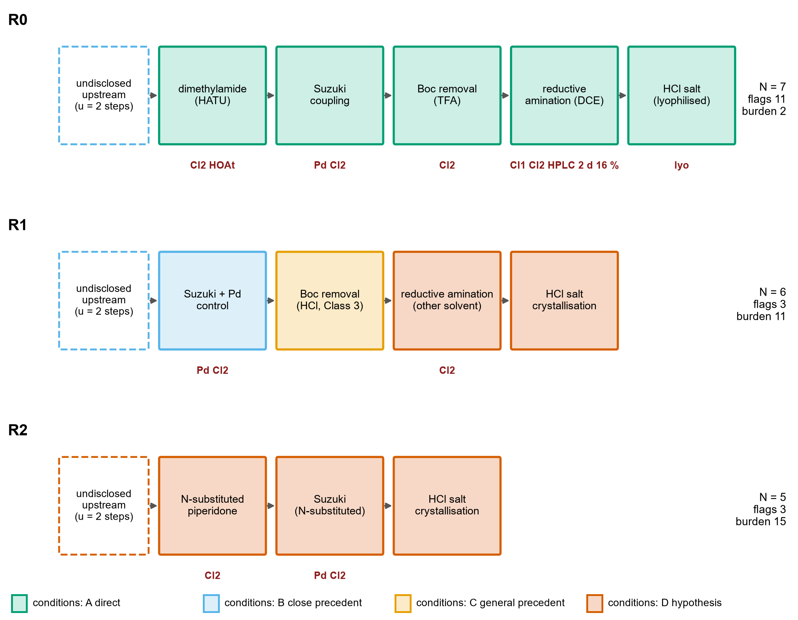
Fig. 2 Routes R0, R1 and R2 as step sequences. Box colour is the evidence class of the conditions as written; dashed boxes are the undisclosed upstream steps (u = 2). Red labels are documented flags (Cl1, Cl2: ICH Q3C Class 1 and 2 solvents; Pd: palladium catalyst; HOAt: hydroxybenzotriazole-type reagent; HPLC: preparative HPLC; 2 d and 16 %: reaction time and yield of the disclosed reductive amination; lyo: lyophilisation). N is the number of steps, flags the number of flag instances and burden the validation burden on the linear scale.

3.5 Risk register and its stability
Table 6 Risk register for the proposed routes with the author's likelihood (L) and impact (I) ratings (1–5) and the probability that each risk ranks in the top three or five when every rating is perturbed by −1, 0 or +1 (20,000 draws). The ratings are judgements, not data.
ID | Risk | L | I | L×I | Top 3 (%) | Top 5 (%)
K1 | Impurity profile and purge when crystallisation replaces preparative HPLC | 4 | 5 | 20 | 87 | 97
K2 | Undisclosed upstream route to the vinyl bromide building block | 5 | 4 | 20 | 87 | 97
K3 | Palladium residue control to the ICH Q3D limit | 3 | 4 | 12 | 23 | 49
K4 | Performance of the Suzuki-Miyaura step on scale (conversion, protodebromination, boronic-acid homocoupling) | 3 | 4 | 12 | 23 | 49
K5 | Reductive amination: conversion, reaction time and solvent change from DCE | 3 | 4 | 12 | 24 | 50
K6 | Regulatory change of route after clinical supply (comparability) and starting-material designation | 3 | 4 | 12 | 24 | 50
K7 | Thermal and gas-evolution hazards (Boc cleavage, borohydride quench, coupling exotherm) | 2 | 5 | 10 | 8 | 25
K10 | Supply and quality of the thiazole and aryl building blocks | 3 | 3 | 9 | 6 | 19
K11 | Compatibility of a thiazole-bearing, basic substrate with Pd coupling (route R2 only) | 3 | 3 | 9 | 6 | 18
K12 | Long-term supply concentration and geopolitical exposure for critical raw materials | 3 | 3 | 9 | 6 | 19
K8 | Control of potentially mutagenic impurities (alkylating agents, residual aldehyde) | 2 | 4 | 8 | 3 | 13
K9 | Polymorph and residual-solvent control of the hydrochloride at scale | 2 | 4 | 8 | 3 | 13

Of the twelve risks, 6 have a baseline score of at least 12 (Table 6). Two stand apart (Fig. 3): the impurity profile and purge when crystallisation replaces preparative HPLC (K1) and the undisclosed upstream route to the vinyl bromide (K2). Each keeps a top-three position in about 87 % of the perturbed rankings, whereas no other risk exceeds 24 %. The other four high-scoring risks (palladium control, performance of the coupling, the reductive amination, and regulatory change of route) are interchangeable within the uncertainty of the ratings, so their order should not be interpreted. The ranking of the two leading risks is a property of the structure of the evidence (the only disclosed purification is chromatography; the upstream route is undisclosed) and not of a fine choice of scores.
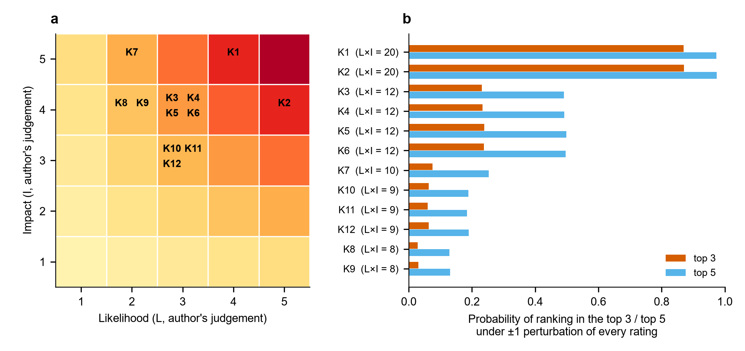
Fig. 3 Risk register. (a) Position of the twelve risks on the likelihood–impact grid (the author's ratings). (b) Probability that each risk ranks in the top three or top five when every rating is perturbed by −1, 0 or +1.

4 Discussion

4.1 Pramipexole as benchmark, not as source of fragments
The idea that prompted this study took pramipexole as a template whose thiazole-amine core would be built on and extended. The structures do not support that mapping. Pramipexole is a 2-amino-4,5,6,7-tetrahydrobenzothiazole bearing a propylamino group [25], whereas the thiazole of PN6047 is an unsubstituted thiazol-5-yl attached through a methylene group to the piperidine nitrogen; the benzothiazole core of pramipexole is not a fragment of PN6047. What pramipexole offers is different: a published scalable synthesis of a thiazole-containing, basic CNS drug [12], and a precedent for salt formation of a basic amine. The thiazol-5-ylmethyl unit itself occurs in other drugs, for example as a carbamate in ritonavir [26], and thiazole chemistry in approved drugs has been reviewed [27]; these are the more relevant precedents for the supply of that unit, but the sources examined do not document its supply, quality or registered-starting-material status (risk K10). Cost figures for pramipexole were not used.

4.2 Convergence is a property of the starting-material boundary
An argument for modular synthesis is that fragments made in parallel shorten the cycle time to the longer of the two branches. That argument applies to steps the manufacturer performs. Where the thiazole carbaldehyde or the arylboronic acid is a purchased material, the branch does not exist in the manufacturer's step count, and the route is linear (Table 5). ICH Q11 states that each branch of a convergent process begins with one or more starting materials, that GMP applies from their first use, that a starting material "should be a substance of defined chemical properties and structure" incorporated "as a significant structural fragment", and that enough of the process must be described for authorities "to understand how impurities are formed in the process" and how they are purged [15]. Whether the thiazole carbaldehyde and the arylboronic acid qualify as registered starting materials is therefore a regulatory judgement that depends on the control strategy. A genuinely convergent design would have to be defined together with a starting-material proposal; it cannot be asserted from the chemistry alone, and the framework treats the boundary as an explicit assumption.

4.3 Flags removed, evidence owed
The trade-off in Table 5 is the central finding. The Class 1 solvent of the exemplified reductive amination has documented alternatives for the reaction class, because the original description of the reagent lists tetrahydrofuran and acetonitrile besides 1,2-dichloroethane [18], but both are Class 2 solvents [11] and the change has not been shown for this substrate. Replacing the benzotriazole-derived coupling reagent by a purchased building block that already carries the amide removes the reagent and its hazard class [21, 23], but moves the question to the availability and quality of that building block. Palladium cannot be removed from a route that uses a cross-coupling for the C–C bond; it can only be controlled, and removal methods are well documented as a class [28, 29] without evidence for this substrate. Finally, crystallisation of the hydrochloride is described in the patent as a way to obtain a stable crystalline form [4]; its use to purge the impurities of the whole sequence, which is what would replace preparative HPLC, is the least supported element of R1 and carries the highest-ranked risk. Thus the variants reduce what can be named, and increase what must be shown.

4.4 Economic considerations without a cost model
No manufacturing cost is estimated. A defensible estimate would need yields and mass balances of each step, from which process mass intensity [30] and the E factor [31] could be computed, a solvent assessment [32, 33], quotations for the building blocks and a model of scale. None of these exists for PN6047 in the sources examined. The screening supports a qualitative statement only: the documented cost drivers of the exemplified route are its reported 16 % isolated yield in the last step, chromatography, the Class 1 solvent and its control, a palladium catalyst and its removal, and an undisclosed upstream sequence; each is addressed in R1 by a proposal, not by a result. Supply concentration of the building blocks (risks K10 and K12) is an assumption of the register, because no supplier or price data were collected.

4.5 Experimental validation requirements
Table 7 Stage-gated experimental programme required before any proposed route could be considered validated. The acceptance criteria other than the cited ICH values are for the development team to set.
Stage | Experiment to be done (not done here) | Decision it informs | Risks addressed
0 Upstream | Define and test a route to the N-Boc vinyl bromide (benzhydryl alcohol dehydration or alternative); propose registered starting materials under ICH Q11 | Whether the building blocks exist at acceptable quality; the starting-material boundary | K2, K6, K10
1 Coupling | Screen catalyst, base, solvent and temperature of the Suzuki–Miyaura step at laboratory scale; quantify palladium by ICP-MS after work-up, scavenging and crystallisation | Whether the coupling gives a purity and palladium level compatible with the ICH Q3D limit | K3, K4
2 Deprotection | Remove the Boc group with HCl in a Class 3 solvent and isolate the amine hydrochloride by crystallisation | Whether an isolated intermediate improves purge of coupling by-products | K1, K7
3 N-functionalisation | Screen solvent (THF, acetonitrile, ester solvents) and reductant for the reductive amination; in-process control of conversion; quench and gas-evolution assessment; compare with alkylation under ICH M7 assessment [34] | Whether the Class 1 solvent can be removed without loss of conversion; which reagent leaves the fewer controlled impurities | K5, K7, K8
4 Salt | Crystallise the hydrochloride (Form HCl2 solvents from the patent); XRPD, residual solvent, hygroscopicity | Whether crystallisation alone purges impurities and delivers the intended polymorph | K1, K9
5 Impurities | Impurity mapping by LC-MS across all stages; spiking and purge studies; working thresholds from ICH Q3A (for doses up to 2 g/day: identification 0.10 %, qualification 0.15 %, or lower daily-intake limits) | Whether the impurity profile of the new route is acceptable or needs further qualification | K1, K6
6 Safety and scale | Reaction calorimetry and thermal-stability screening of each step before any scale-up | Safe operating limits; go/no-go for scale | K7

The programme is ordered so that the two dominant risks are met first (Table 7): the upstream route and the starting-material question, and the purge of impurities in the isolation steps. Calorimetry precedes every scale-up step, and all numerical go/no-go criteria are left to the sponsor, because inventing them without data would give a false precision. The route should be regarded as validated only when the laboratory work above has been completed on PN6047 intermediates.

4.6 What is new, and what is not
No new chemical transformation is proposed. The novelty is in the integration: the published route is analysed as a set of graded operations rather than as a single route; the screening shows that removing documented flags and increasing the validation burden are two sides of one change; and the register shows that the ranking of the leading risks is robust to the author's own uncertainty. The method is general. It needs only an inventory of operations, a grading of their support and a list of documented attributes, and it can be applied before any process chemistry is run to any compound whose discovery route is public.

4.7 Limitations
No synthesis was performed and no yield, impurity profile, scale-up experiment or manufacturing cost was measured or predicted. The regulatory acceptability of the proposed routes has not been assessed, and no freedom-to-operate analysis was made for a compound that is the subject of patent filings. The exemplified route is the discovery route in the patent texts; the clinical-supply route of the developer is not public and may differ. The patent text examined contains an inconsistency (Example III) that could not be resolved from the available text. The evidence grading and the risk ratings are the author's judgement, and the perturbation analysis tests the sensitivity of the ranking to ±1 changes only. The literature search was purposive; for most journal articles only the record and abstract were examined. The number of undisclosed upstream steps is a parameter, not a finding. The screening metrics count documented attributes and do not measure safety, cost or sustainability. The chemical compatibility of the proposed conditions with the PN6047 intermediates, including the coupling in route R2 of a basic, heteroatom-rich substrate, remains untested.

5 Conclusions
The only public route to PN6047 drug substance is a discovery route exemplified at milligram-to-gram scale, and its documented attributes (a Class 1 solvent, a palladium-catalysed coupling, a benzotriazole-derived reagent, preparative HPLC, a 16 % isolated yield in the final N-functionalisation) show where a manufacturing route would have to differ. Process-oriented variants that keep the same disconnections lower the number of such flags, but every one of their conditions is unvalidated, so the burden of proof rises. The impurity purge by crystallisation and the route to the vinyl bromide building block are the dominant uncertainties and should be tested first. The paper offers a reproducible, evidence-graded plan for that work, not a validated route.

Statements and Declarations
Funding. The author received no funding for this work.
Competing interests. The author declares no competing interests. The author has no affiliation with PharmNovo AB or with the project partners named in the cited project description. An earlier, shorter, unpublished outline of the route concept was submitted by the author to an open-innovation challenge (Wazoku challenge idea 141585, 2026); no part of it has been published elsewhere.
Author contributions. Leon Sandler: conceptualisation, methodology, software, formal analysis, investigation, data curation, writing – original draft, writing – review and editing, visualisation.
Data and code availability. The inventories, flags, precedents, risk ratings, model code, tests, figure scripts and the manuscript builder are available at https://github.com/sandlerleon/pn6047-route-design and archived on Zenodo at https://doi.org/10.5281/zenodo.23200174; this manuscript is archived as a preprint at https://doi.org/10.5281/zenodo.23200178. The two patent documents and the ICH guidelines are public.
Ethics. This study uses only published documents; no human participants, animals or personal data were involved.
Use of artificial intelligence. See Section 2.9.

References
[1] Conibear AE, Asghar J, Hill R, Henderson G, Borbely E, Tekus V, et al. A Novel G Protein–Biased Agonist at the δ Opioid Receptor with Analgesic Efficacy in Models of Chronic Pain. The Journal of Pharmacology and Experimental Therapeutics. 2020;372:224–236. https://doi.org/10.1124/jpet.119.258640
[2] Wei ZY, Brown W, Takasaki B, Plobeck N, Delorme D, Zhou F, et al. N,N-Diethyl-4-(phenylpiperidin-4-ylidenemethyl)benzamide: A Novel, Exceptionally Selective, Potent δ Opioid Receptor Agonist with Oral Bioavailability and Its Analogues. J Med Chem. 2000;43:3895–3905. https://doi.org/10.1021/jm000229p
[3] PharmNovo AB (inventors: von Mentzer B, Starke I, Brandt P). Diarylmethylidene piperidine derivatives and their use as delta opioid receptor agonists. Patent application WO 2016/099393 A1; published 23 June 2016. https://patents.google.com/patent/WO2016099393A1/en
[4] PharmNovo AB (inventors: von Mentzer B, Starke I, Nilsson HG). Polymorphs of a hydrochloride salt of PN6047. Patent application WO 2022/013153 A1; published 20 January 2022. https://patents.google.com/patent/WO2022013153A1/en
[5] European Commission. PN6047-DOBRA: PN6047 - a breakthrough treatment of neuropathic pain. CORDIS project 101188409. https://cordis.europa.eu/project/id/101188409. Accessed 6 Oct 2026
[6] Federsel HJ. Chemical Process Research and Development in the 21st Century: Challenges, Strategies, and Solutions from a Pharmaceutical Industry Perspective. Acc Chem Res. 2009;42:671–680. https://doi.org/10.1021/ar800257v
[7] Carey JS, Laffan D, Thomson C, Williams MT. Analysis of the reactions used for the preparation of drug candidate molecules. Org Biomol Chem. 2006;4:2337. https://doi.org/10.1039/b602413k
[8] Brown DG, Boström J. Analysis of Past and Present Synthetic Methodologies on Medicinal Chemistry: Where Have All the New Reactions Gone?. Journal of Medicinal Chemistry. 2015;59:4443–4458. https://doi.org/10.1021/acs.jmedchem.5b01409
[9] Blakemore DC, Castro L, Churcher I, Rees DC, Thomas AW, Wilson DM, et al. Organic synthesis provides opportunities to transform drug discovery. Nature Chem. 2018;10:383–394. https://doi.org/10.1038/s41557-018-0021-z
[10] Vitaku E, Smith DT, Njardarson JT. Analysis of the Structural Diversity, Substitution Patterns, and Frequency of Nitrogen Heterocycles among U.S. FDA Approved Pharmaceuticals. J Med Chem. 2014;57:10257–10274. https://doi.org/10.1021/jm501100b
[11] ICH. Q3C(R8): Impurities: guideline for residual solvents. 2021. https://database.ich.org/sites/default/files/ICH_Q3C-R8_Guideline_Step4_2021_0422_1.pdf
[12] Živec M, Anžič B, Gobec S. A Novel Scalable Synthesis of Pramipexole. Org Process Res Dev. 2010;14:1125–1129. https://doi.org/10.1021/op1000989
[13] ICH. Q3A(R2): Impurities in new drug substances. 2006. https://database.ich.org/sites/default/files/Q3A%28R2%29%20Guideline.pdf
[14] ICH. Q3D(R2): Guideline for elemental impurities. 2022. https://database.ich.org/sites/default/files/Q3D-R2_Guideline_Step4_2022_0308.pdf
[15] ICH. Q11: Development and manufacture of drug substances (chemical entities and biotechnological/biological entities). 2012. https://database.ich.org/sites/default/files/Q11_Guideline.pdf
[16] Qian Z, Baxendale IR, Ley SV. A Continuous Flow Process Using a Sequence of Microreactors with In‐line IR Analysis for the Preparation of N,N‐Diethyl‐4‐(3‐fluorophenylpiperidin‐4‐ylidenemethyl)benzamide as a Potent and Highly Selective δ‐Opioid Receptor Agonist. Chemistry A European J. 2010;16:12342–12348. https://doi.org/10.1002/chem.201002147
[17] Isidro-Llobet A, Álvarez M, Albericio F. Amino Acid-Protecting Groups. Chem Rev. 2009;109:2455–2504. https://doi.org/10.1021/cr800323s
[18] Abdel-Magid AF, Carson KG, Harris BD, Maryanoff CA, Shah RD. Reductive Amination of Aldehydes and Ketones with Sodium Triacetoxyborohydride. Studies on Direct and Indirect Reductive Amination Procedures 1. J Org Chem. 1996;61:3849–3862. https://doi.org/10.1021/jo960057x
[19] Gaich T, Baran PS. Aiming for the Ideal Synthesis. J Org Chem. 2010;75:4657–4673. https://doi.org/10.1021/jo1006812
[20] Hendrickson JB. Systematic synthesis design. 6. Yield analysis and convergency. J Am Chem Soc. 1977;99:5439–5450. https://doi.org/10.1021/ja00458a035
[21] Wehrstedt KD, Wandrey PA, Heitkamp D. Explosive properties of 1-hydroxybenzotriazoles. Journal of Hazardous Materials. 2005;126:1–7. https://doi.org/10.1016/j.jhazmat.2005.05.044
[22] ICH. Q9(R1): Quality risk management. 2022. https://database.ich.org/sites/default/files/ICH_Q9%28R1%29_Guideline_Step4_2022_1219.pdf
[23] Dunetz JR, Magano J, Weisenburger GA. Large-Scale Applications of Amide Coupling Reagents for the Synthesis of Pharmaceuticals. Org Process Res Dev. 2016;20:140–177. https://doi.org/10.1021/op500305s
[24] Bastin RJ, Bowker MJ, Slater BJ. Salt Selection and Optimisation Procedures for Pharmaceutical New Chemical Entities. Org Process Res Dev. 2000;4:427–435. https://doi.org/10.1021/op000018u
[25] Schneider CS, Mierau J. Dopamine autoreceptor agonists: resolution and pharmacological activity of 2,6-diaminotetrahydrobenzothiazole and an aminothiazole analog of apomorphine. J Med Chem. 1987;30:494–498. https://doi.org/10.1021/jm00386a009
[26] Kempf DJ, Sham HL, Marsh KC, Flentge CA, Betebenner D, Green BE, et al. Discovery of Ritonavir, a Potent Inhibitor of HIV Protease with High Oral Bioavailability and Clinical Efficacy. J Med Chem. 1998;41:602–617. https://doi.org/10.1021/jm970636+
[27] Niu ZX, Wang YT, Zhang SN, Li Y, Chen XB, Wang SQ, et al. Application and synthesis of thiazole ring in clinically approved drugs. European Journal of Medicinal Chemistry. 2023;250:115172. https://doi.org/10.1016/j.ejmech.2023.115172
[28] Garrett CE, Prasad K. The Art of Meeting Palladium Specifications in Active Pharmaceutical Ingredients Produced by Pd‐Catalyzed Reactions. Adv Synth Catal. 2004;346:889–900. https://doi.org/10.1002/adsc.200404071
[29] Galaffu N, Man SP, Wilkes RD, Wilson JRH. Highly Functionalised Sulfur-Based Silica Scavengers for the Efficient Removal of Palladium Species from Active Pharmaceutical Ingredients. Org Process Res Dev. 2007;11:406–413. https://doi.org/10.1021/op7000172
[30] Jimenez-Gonzalez C, Ponder CS, Broxterman QB, Manley JB. Using the Right Green Yardstick: Why Process Mass Intensity Is Used in the Pharmaceutical Industry To Drive More Sustainable Processes. Org Process Res Dev. 2011;15:912–917. https://doi.org/10.1021/op200097d
[31] Sheldon RA. The E factor 25 years on: the rise of green chemistry and sustainability. Green Chem. 2017;19:18–43. https://doi.org/10.1039/c6gc02157c
[32] Alfonsi K, Colberg J, Dunn PJ, Fevig T, Jennings S, Johnson TA, et al. Green chemistry tools to influence a medicinal chemistry and research chemistry based organisation. Green Chem. 2008;10:31–36. https://doi.org/10.1039/b711717e
[33] Prat D, Wells A, Hayler J, Sneddon H, McElroy CR, Abou-Shehada S, et al. CHEM21 selection guide of classical- and less classical-solvents. Green Chem. 2016;18:288–296. https://doi.org/10.1039/c5gc01008j
[34] ICH. M7(R2): Assessment and control of DNA reactive (mutagenic) impurities in pharmaceuticals to limit potential carcinogenic risk. 2023. https://database.ich.org/sites/default/files/ICH_M7%28R2%29_Guideline_Step4_2023_0216_0.pdf

