An Evidence-Graded Framework for Pharmaceutical Route Selection and Process-Risk Prioritization: A PN6047 Case Study
Leon Sandler
Independent researcher, Northbrook, Illinois, USA
Corresponding author: sandler.leon@gmail.com
ORCID: 0009-0007-4584-808X

Abstract
Purpose: To develop and demonstrate an evidence-graded framework for screening discovery-scale synthetic routes before experimental process development, using the publicly disclosed route to PN6047, a clinical-stage δ-opioid receptor agonist, as a case study.
Methods: No synthesis was performed. Operations exemplified in two patent documents were inventoried; each transformation and its conditions were graded A–D by the strength of public evidence; documented regulatory and hazard attributes were flagged; two process-oriented variants were screened by step count, flags and an evidence-weighted validation burden; and a twelve-item risk register was ranked, with the sensitivity of the prioritization to the author-assigned ratings tested by perturbation.
Results: The exemplified route (milligram to gram scale; final N-functionalization isolated in 16% by preparative HPLC) carries 11 documented flags, including an ICH Q3C Class 1 solvent, palladium and a benzotriazole-derived coupling reagent. Variants R1 and R2 carry 3 flags each but a higher validation burden (11 and 15 against 2, linear scale): fewer documented flags did not mean lower development uncertainty. Two risks, impurity purge when crystallization replaces chromatography and the undisclosed route to the vinyl bromide, stayed in the top three in about 87% of perturbations, conditional on the initial risk model.
Conclusion: The framework converts public route information into an auditable experimental-prioritization strategy while explicitly separating documented process liabilities from unvalidated alternatives. It does not select a best route; it shows where the evidence is strong or assumed and which experiments carry the highest information value.
Keywords: pharmaceutical process development; synthetic route design; evidence grading; process risk assessment; drug substance manufacturing; PN6047
Summary (approximately 100 words). Discovery-scale synthetic routes are often public only as small-scale examples, yet decisions about process development must be made from them. We present an evidence-graded framework that inventories the operations of a route, grades the public evidence for each, flags documented regulatory and hazard attributes, screens alternative routes, ranks process risks and tests the sensitivity of that ranking. Applied to the δ-opioid agonist PN6047, it showed that variants with fewer documented flags carry a higher burden of proof, and that impurity purge and an undisclosed building-block route dominate. No experiments were run; the output is a stage-gated plan for what to test first.
Teaser (25–30 words). An evidence-graded framework turns a public discovery-scale route into an auditable plan: what the record supports, which documented risks matter, and which experiments to run first.

1 Introduction

1.1 PN6047 and its development context
PN6047, 4-[(3-carbamoylphenyl)[1-(1,3-thiazol-5-ylmethyl)piperidin-4-ylidene]methyl]-N,N-dimethylbenzamide (C₂₆H₂₈N₄O₂S, relative molecular mass 460.6), is a selective δ-opioid receptor agonist that is G protein-biased in cell-based assays and effective in rodent models of chronic pain [1]. It belongs to the diarylmethylidene-piperidine class that Wei and colleagues described as formally derived from SNC-80 by replacing the piperazine ring with a piperidine ring carrying an exocyclic double bond [2]. The compound was disclosed in a patent application of PharmNovo AB [3], and crystalline forms of its hydrochloride salt were claimed in a later application [4]. A European Innovation Council project coordinated by the same company describes completed phase I trials and a planned phase IIa proof-of-concept study [5]. The author has no affiliation with the company.

1.2 The manufacturing problem
A synthesis that supplies a discovery program is rarely a manufacturing route. Federsel describes the handover from medicinal chemistry to process research as the point where technical, safety and scalability questions that were invisible at the bench become decisive [6], and surveys of the chemistry used in process research show a different reaction distribution from that of discovery chemistry [7]. In discovery chemistry, the most frequently used reactions are amide-bond formation, Suzuki–Miyaura coupling and nucleophilic aromatic substitution, chosen for reagent availability, chemoselectivity and speed of delivery [8]; drug molecules additionally contain amines and nitrogen heterocycles that make synthesis harder [9, 10]. The route that is public for PN6047 is of exactly this kind: the patent examples use a benzotriazole-derived coupling reagent, a palladium-catalyzed coupling, trifluoroacetic acid, a chlorinated solvent that is a Class 1 solvent under ICH Q3C, and preparative HPLC [3, 11]. What the public record does not contain is any yield, impurity profile or palladium level at a scale relevant to manufacture.

1.3 Research question and contribution
The general question is how the public information on a discovery-scale route can be converted into an auditable plan for process development: which of its operations carry documented liabilities, how strong is the evidence for the alternatives that would replace them, and which experiment would be most informative to run first. PN6047 is the case study; the contribution is the framework. It consists of (i) an evidence-grading scheme that separates what is shown for the compound from what is inferred from the scaffold class, from general pharmaceutical practice, or only hypothesized; (ii) a screening of the exemplified route and two process-oriented variants by step count, documented flags and an evidence-weighted validation burden, reported as two separate axes; (iii) a risk register whose prioritization is tested for sensitivity to the ratings and to the choice of weighting; and (iv) a stage-gated validation plan that is the principal actionable output (Table 7). The case study also corrects a mapping that an earlier form of the idea relied on: pramipexole, a commercial thiazole-containing amine, is a useful benchmark for manufacture and salt formation of a basic API [12], but its tetrahydrobenzothiazole-diamine core is not a substructure of PN6047 and is not used here as a fragment source.
The paper does not claim that any proposed route works. No synthesis was performed, no yield, impurity level, cost or timeline is predicted, and no freedom-to-operate analysis was made. Each claim below is labeled by the strength of its public support.

2 Methods

2.1 Design and scope
The study is a literature- and document-based screening exercise with a small computational layer. It uses no laboratory data of the author. The computation counts and classifies documented operations; it does not simulate chemistry. All inputs are in plain JSON files (route inventories, flags, precedents, risk ratings), and all outputs are regenerated by a single script so that every number in the text can be traced to an input.

2.2 Sources and how they were used
The primary sources are the two patent documents above [3, 4], whose text as published on Google Patents was searched and read for the passages on synthesis, purification and salt forms, and the ICH guidelines on impurities, residual solvents, elemental impurities and development of drug substances [11, 13–15], whose texts were consulted for the limits quoted. Journal articles were located through Crossref and Europe PMC and chosen for the precedent they provide for a named operation. For the journal precedents, including those that support classes B and C, the bibliographic record and abstract were examined, and the full texts were not accessible to the author; statements about them are therefore limited to what the record supports (for example, that a transformation class is reported for a scaffold or in general practice), not to the specific conditions proposed here. The precedent map (Table 3) is accordingly a screening map, and confirming each journal precedent against its full text is the first item of the experimental program (Table 7, stage 0). The search was purposive, not systematic, and the paper should not be read as a systematic review. All DOIs were resolved through Crossref, and the reference list was built from the returned records. The machine-readable text of WO 2016/099393 contains transcription irregularities; in particular, the starting material named for its Example III is not the compound that Example IV requires. The reagent classes of that example are used here, but not its compound names.

2.3 Retrosynthetic decomposition and the five-stage framework
PN6047 was decomposed into five stages (Fig. 1): the thiazol-5-ylmethyl unit (S1), the diarylmethylidene-piperidine core (S2), N-functionalization joining them (S3), the dimethylamide (S4) and the hydrochloride salt (S5). Three bond disconnections define the framework: (a) the N–CH₂ bond, by reductive amination with thiazole-5-carbaldehyde; (b) the vinylic carbon–aryl bond to the carbamoylphenyl ring, by Suzuki–Miyaura coupling of a vinyl bromide with an arylboronic acid; and (c) the amide C–N bond. The exocyclic double bond joins a carbon bearing two different aryl groups to C-4 of a piperidine ring with identical arms, so no geometric (E/Z) isomerism arises.
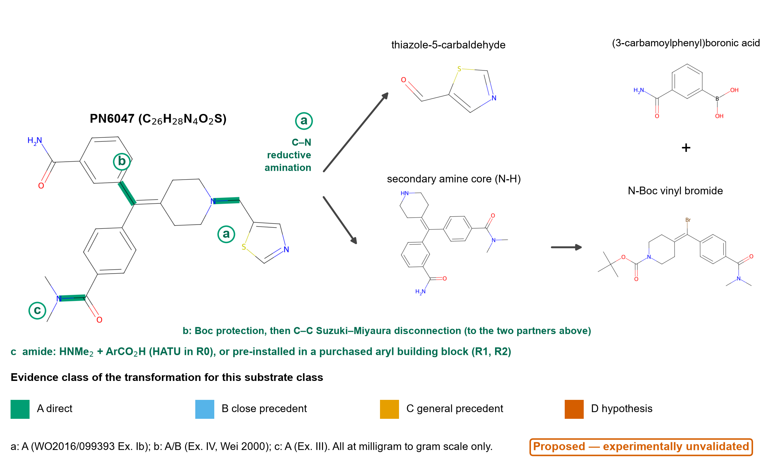
Fig. 1 Retrosynthetic framework for PN6047. Highlighted bonds are the three disconnections: a, N–CH₂ (reductive amination with thiazole-5-carbaldehyde); b, vinylic carbon–aryl (Suzuki–Miyaura coupling of an N-Boc vinyl bromide with an arylboronic acid, after Boc protection of the amine core); c, amide C–N. Structures were drawn from SMILES with RDKit. The scheme is a proposal and is experimentally unvalidated; evidence colors refer to the transformations as exemplified in WO 2016/099393 and by Wei et al. [2].

2.4 Evidence classes
Each operation received two grades (Table 1): one for the transformation itself and one for its conditions as written in the route. A route step that reuses a published transformation under changed conditions can therefore carry class A for the former and class D for the latter. Class A means that the transformation is reported for PN6047 or its immediate precursor in the public record examined; B, a close precedent in the same scaffold class; C, a general pharmaceutical precedent; D, a hypothesis. Classes map to the labels established (A), inferred (B, C) and proposed (D); none of them is a validation at manufacturing scale, which is absent for every step.
Table 1 Evidence classes used to grade the transformation and the conditions of each step. None of the classes implies validation at manufacturing scale.
Class | Label | Definition used | Example in this paper
A | Established (public record) | Reported for PN6047 or its immediate precursor in the public record examined | Reductive amination with thiazole-5-carbaldehyde (WO 2016/099393, Example Ib)
B | Inferred | Reported for the same scaffold class (diarylmethylidene-piperidine δ agonists) | Suzuki coupling of a vinyl bromide in the series [2, 16]
C | Inferred (class level) | Established pharmaceutical practice for the transformation class, not on this scaffold | Boc removal with HCl in a Class 3 solvent [17]
D | Proposed | Adaptation with no direct or close precedent in the sources examined | Crystallization as the impurity-purging step in place of preparative HPLC

2.5 Route inventories
Route R0 is the sequence exemplified in the patent documents (amide formation, Suzuki–Miyaura coupling, Boc removal, reductive amination, salt formation). Route R1 keeps the same disconnections but preinstalls the amide in a purchased aryl building block, specifies palladium control, removes the Boc group with HCl in a Class 3 solvent, replaces 1,2-dichloroethane in the reductive amination by a solvent that Abdel-Magid and colleagues list as an alternative [18], and uses crystallization of the hydrochloride [4] as the purification step. Route R2 changes the order: the thiazol-5-ylmethyl group is installed on a piperidone before the alkene is built, which removes the protecting group and the late N-functionalization but rests entirely on hypotheses. The preparation of the vinyl bromide is not described in the portion of WO 2016/099393 examined, so a number u of undisclosed upstream steps is added to all routes: u = 2 by default and 1–4 in a sensitivity sweep. R0 and R1 grade this upstream block as class B (two general approaches are described for the scaffold [2]); R2 grades it D.

2.6 Screening metrics
For each route, the model reports the number of steps N and the longest linear sequence; the number of construction steps (forming a C–C or C–N bond) against concession steps (deprotection, salt formation), whose ratio follows Baran's notion of ideality [19]; the number of steps that are in-house convergent in the sense of Hendrickson [20]; the documented flags of Table 2 (each a screening marker with a cited source, not a hazard or regulatory determination); and a validation burden, the sum over steps of a weight for the evidence class of the conditions. Three weightings are used because no weighting is canonical: linear (A, B, C, D = 0, 1, 2, 3), convex (0, 1, 3, 9) and binary (1 for class D only).
Table 2 Documented flags used in the screening. Flags are markers taken from cited documents; they are not hazard assessments or regulatory conclusions.
Flag | What it marks | Source
Cl1 | Step uses an ICH Q3C Class 1 solvent (1,2-dichloroethane; limit 5 ppm) | [11]
Cl2 | Step uses an ICH Q3C Class 2 solvent (e.g. DMF, DME, dichloromethane, THF, acetonitrile) | [11]
Pd | Palladium catalyst; ICH Q3D Class 2B, oral permitted daily exposure 100 μg/day | [14]
HOAt | Coupling reagent containing a hydroxybenzotriazole-type unit; the class is associated with explosive properties | [21]
HPLC | Preparative HPLC used for purification in the disclosed example | [3]
2 d / 16% | Reaction time of two days and reported isolated yield of 16% in the disclosed example | [3]
lyo | Lyophilization and drying at 80 °C for three days to isolate the amorphous salt (screening scale) | [4]

2.7 Requirements of the framework
A framework for screening routes before process development has to satisfy four requirements, which also serve as criteria for judging it in the Discussion. Traceability: every statement about a route leads to a source document or is labeled as an assumption; here, each step of each inventory carries its source keys and two evidence grades, and each flag cites the guideline or example it was checked against. Discrimination: it must separate options that differ in a way that matters for a decision; here, routes are described on two axes that are kept apart, documented flags and validation burden, and risks are ranked rather than averaged. Robustness: its conclusions must survive reasonable changes of choices that cannot be justified uniquely; here, three weightings of the evidence classes, one to four undisclosed upstream steps and three distributions of rating uncertainty, are used. Actionability: its output must be a decision, namely, which experiment to run first and what it would decide, not a score; here, the output is the stage-gated program of Table 7.
Three propositions were stated so that the output could contradict them, and the build of this paper stops if they do not hold. P1: the exemplified route has the most documented flags and the lowest validation burden, so that the two axes order the routes in opposite directions. P2: this order is the same under every weighting and for every number of undisclosed steps tested. P3: the two leading risks remain the most frequent members of the top three when the rating uncertainty is widened. P1 and P2 are properties of the inventories, P3 of the register; none is a statement about chemistry that has been run.

2.8 Risk register and sensitivity of risk prioritization to rating uncertainty
Twelve development risks of the proposed routes were listed, each with a likelihood (L) and an impact (I) on a 1–5 scale. The ratings are author-assigned ratings based on the evidence inventory; they are not measurements, and there is no calibration. To test how much the prioritization depends on them, each rating was perturbed by −1, 0 or +1 (probabilities 0.25, 0.50, 0.25, clipped to 1–5) in 20,000 random draws with a fixed seed, ties being broken at random, and the share of draws in which each risk ranks in the top three or five was recorded. This evaluates the stability of the ranking conditional on the initial risk model; the shares are not empirical probabilities that any risk will occur. Two other distributions were used to see whether the conclusion depends on that choice: a narrow one (probabilities 0.1, 0.8, 0.1) and a wide one (−2 to +2, equal probabilities). The smallest change of ratings that would reverse the leading order was also found by enumeration: the least value of |ΔL| + |ΔI| that brings each of the two leading risks down to the score of the next cluster, and each member of that cluster up to the score of the leaders. The approach follows the general principle of quality risk management [22] but is not a formal FMEA.
Because flags and validation burden are different quantities, no single score is reported. To show what a combined score would imply, the exchange rate λ at which two routes score equally on flags + λ × burden was computed for each weighting and each number of undisclosed steps. A sponsor that values one unit of burden at more than λ flags prefers the route with the lower burden; one that values it at less prefers the route with fewer flags. The value of λ* is a statement about preferences, not a result about the chemistry.

2.9 Software, checks and reproducibility
Calculations use Python with NumPy and, for structures, RDKit. The structure of PN6047 and of two patent analogs was drawn from SMILES strings, and its formula and [M+H]⁺ value recomputed to confirm the mass-spectrometric values printed in the patent. A test suite checks the integrity of the inputs (unique step identifiers, evidence classes, flags defined, every source key resolving to a reference), the order of the exemplified operations, the formula, the agreement with the printed masses and the determinism of the output. Code, inputs, outputs and the manuscript builder are public (Declarations).

2.10 Use of artificial intelligence tools
A large language model (Claude, Anthropic) was used to assist literature retrieval, data-file preparation, code, figures and drafting. The author reviewed and edited the content, checked every quoted value in the patent texts and guidelines against the source, resolved every reference through Crossref, and takes full responsibility for the paper. No such tool is an author, and none was used to generate or alter data.

3 Results

3.1 Consistency of the structural data with the patent
The structure of PN6047 corresponds to C₂₆H₂₈N₄O₂S, with a relative molecular mass of 460.6. Recomputed [M+H]⁺ values were 461.201 for PN6047, 523.232 for the 6-(trifluoromethyl)pyridin-3-ylmethyl analog and 458.255 for the 4-methylimidazol-5-ylmethyl analog, which agree to the nearest integer, with the values 461, 523 and 458 printed in WO 2016/099393 for Examples Ib, Ia and Ic. The framework therefore describes the compounds that the patent actually makes.

3.2 What the public record shows
Table 3 maps each operation to the public evidence. All five operations of the exemplified route reach class A for the transformation, but only at discovery scale: the reductive amination started from 40 mg of amine and delivered 8.2 mg (16%) after preparative HPLC; the Suzuki–Miyaura step used 0.533 g of the vinyl bromide, and the crude product was taken on without purification, so no yield or purity is reported; the Boc removal used 0.630 g; the amide formation used 1.00 g of acid. The amorphous hydrochloride was made from 500.5 mg of free base by lyophilization, and crystalline hydrochloride forms are described, but no scale is reported [4]. The preparation of the vinyl bromide is not described in the portion examined. No published synthesis of PN6047 at a scale relevant to manufacture was found in the sources examined.
Table 3 Precedent map: each operation with the strength of the public evidence, what the sources show and what remains uncertain for PN6047. Stage 0 denotes the general premise (discovery-to-process handover). Journal precedents were assessed from the record and abstract, not the full text.
Operation (stage) | Evidence | What the public record shows | Remaining uncertainty
Thiazol-5-ylmethyl unit (thiazole-5-carbaldehyde or a 5-(halomethyl)thiazole) as the N-substituent donor (S1) | B | PN6047 carries a thiazol-5-ylmethyl group on the piperidine nitrogen; the same group is installed from 1,3-thiazole-5-carbaldehyde in WO2016/099393 Example Ib. Thiazoles are a recurrent ring in approved drugs, and ritonavir carries a thiazol-5-ylmethyl carbamate. | Supply, quality and registered-starting-material status of the thiazole building block are not documented in the sources examined. The tetrahydrobenzothiazole-2,6-diamine core of pramipexole is not a substructure of PN6047 and is not used as a fragment here.
Construction of the N-Boc diarylmethylidene-piperidine core by Suzuki-Miyaura coupling of a vinyl bromide (S2) | A | WO2016/099393 Example IV couples tert-butyl 4-{bromo[4-(dimethylcarbamoyl)phenyl]methylidene}piperidine-1-carboxylate (0.533 g) with (3-carbamoylphenyl)boronic acid using PdCl2(dppf) in DME/aqueous K2CO3 at 80 C. Wei et al. [2] report two general approaches to this scaffold class: dehydration of benzhydryl alcohols and Suzuki coupling of vinyl bromides. Qian et al. [16] report a continuous-flow synthesis of a close analog. | No yield, impurity profile or palladium level is reported for the PN6047 coupling in the text examined (crude product taken on). The preparation of the vinyl bromide is not described in the portion examined.
Large-scale palladium-catalyzed couplings and removal of residual palladium (S2) | C | Large-scale applications of Pd couplings in pharmaceutical synthesis are reviewed; methods for removing palladium from APIs have been reviewed and silica-based scavengers described; ICH Q3D [14] sets a Class 2B oral PDE of 100 ug/day for Pd. | Whether the PN6047 core (two amides, a basic piperidine) allows effective Pd purge by scavenging or crystallization is substrate-specific and untested here.
Dimethylamide formation by HATU/DIPEA/dimethylamine hydrochloride (S4) | A | WO2016/099393 Example III uses HATU (1.15 g), DIPEA and dimethylamine hydrochloride in DMF. Amide coupling reagents used at scale are reviewed by Dunetz et al. [23]. The HOAt/HOBt unit in such reagents is associated with explosive properties of 1-hydroxybenzotriazoles (Wehrstedt et al. [21]). | The starting material named in the machine-readable text of Example III is not the compound required by Example IV; only the reagent class is used here. In R1/R2 the amide is pre-installed in a purchased aryl building block, which moves the question to that building block's availability.
Boc removal and isolation of the secondary amine (S2) | A | WO2016/099393 Example V removes the Boc group with trifluoroacetic acid in dichloromethane (0.630 g). Boc removal with acids is a standard protecting-group operation (Isidro-Llobet et al. [17]). | Isolation of the amine as a crystalline hydrochloride from a Class 3 solvent (R1) is a change of conditions for this substrate (condition evidence C).
N-functionalization by reductive amination with NaBH(OAc)3 (S3) | A | WO2016/099393 Example Ib: 40 mg of the secondary amine and 1,3-thiazole-5-carbaldehyde, AcOH, NaBH(OAc)3, 1,2-dichloroethane, rt, 2 days; preparative HPLC; 8.2 mg (16%). Abdel-Magid et al. [18] describe the reagent and name DCE as the preferred solvent, with THF and occasionally acetonitrile as alternatives. | 1,2-dichloroethane is an ICH Q3C Class 1 solvent. A change to THF or acetonitrile has general precedent (B/C) but has not been shown for this substrate; an ester solvent would be a hypothesis. Conversion, over-reduction and impurity formation at scale are unknown.
Crystalline hydrochloride salt as the isolated form (S5) | A | WO2022/013153 describes crystalline Forms HCl2 and HCl3 of the PN6047 hydrochloride, Form HCl2 from solvents including 2-propanol, acetone, acetonitrile, ethanol, ethyl acetate or tetrahydrofuran, with improved stability and low hygroscopicity relative to amorphous material; the amorphous salt was made on a 500.5 mg scale by lyophilization from TFE/water and dried at 80 C for 3 days. Salt-selection practice is reviewed by Bastin et al. [24]. | Crystallization as the main impurity-purging step (replacing preparative HPLC) is not demonstrated in the sources examined.
Process handover from discovery to development | C | Federsel [6] discusses the transfer of chemistry from medicinal chemistry to process R&D and the technical, safety and scalability questions that arise. Carey et al. [7] survey the chemistries used in process R&D at three companies. Brown and Boström [8] find amide formation and Suzuki-Miyaura coupling among the most frequently used reactions in medicinal chemistry. | None of these sources concerns PN6047; they support the general premise that a discovery-scale route is not by itself a manufacturing route.

3.3 Documented attributes of the exemplified route
Table 4 Inventory of route R0, the operations exemplified in WO 2016/099393 and WO 2022/013153, with documented flags (see the flag table).
Step | Conditions as written | Scale in the example | Flags
Dimethylamide formation | HATU, DIPEA, Me2NH.HCl, DMF, rt, overnight (Example III as printed) | 1.00 g (2.52 mmol) | Cl2, HOAt
Suzuki-Miyaura coupling of the N-Boc vinyl bromide | (3-carbamoylphenyl)boronic acid, PdCl2(dppf) 5 mol %, 2 M K2CO3, DME, 80 C, 3.5 h; crude taken on (Example IV) | 0.533 g (1.26 mmol) | Pd, Cl2
Boc removal | TFA / CH2Cl2, rt, 1 h 15 min; evaporated (Example V) | 0.630 g crude (1.36 mmol) | Cl2
N-functionalization by reductive amination with thiazole-5-carbaldehyde | 1,3-thiazole-5-carbaldehyde, AcOH, NaBH(OAc)3, 1,2-dichloroethane, rt, 2 days; preparative HPLC (Example Ib) | 40 mg (0.11 mmol); 8.2 mg isolated (16%) | Cl1, Cl2, HPLC, 2 d, 16%
Hydrochloride salt formation | amorphous HCl salt by lyophilization from TFE/water with aqueous HCl, dried at 80 C for 3 days; crystalline Forms HCl2/HCl3 from solvents including 2-propanol, acetone, acetonitrile, ethanol, ethyl acetate, THF (WO2022/013153) | 500.5 mg free base | lyo

Route R0 carries 11 flag instances in 8 distinct flags, distributed over 5 of its five steps (Table 4). The reductive amination alone carries five, including the Class 1 solvent, preparative HPLC, the two-day reaction and the 16% yield. The Suzuki step carries the palladium flag, and the amide formation the benzotriazole-reagent flag. The flags mark where process development would warrant particular evaluation or modification; they do not show that the exemplified route is unsafe or noncompliant at the scale at which it was run.

3.4 Screening of the variants
Table 5 Screening metrics for the three routes at the default number of undisclosed upstream steps. The ordering of the routes by burden and by flags is the same for every weighting and for u = 1–4.
Metric | R0 | R1 | R2
Steps N (u = 2; range for u = 1–4) | 7 (6–9) | 6 (5–8) | 5 (4–7)
Longest linear sequence | 7 | 6 | 5
In-house convergent steps | 0 | 0 | 0
Construction / concession steps (disclosed or proposed) | 3 / 2 | 2 / 2 | 2 / 1
Ideality (construction share) | 0.60 | 0.50 | 0.67
Flag instances (distinct) | 11 (8) | 3 (2) | 3 (2)
Evidence class of conditions (A/B/C/D) | 5/0/0/0 | 0/1/1/2 | 0/0/0/3
Validation burden, linear weights | 2 | 11 | 15
Validation burden, convex weights | 2 | 24 | 45
Validation burden, binary (class D only) | 0 | 2 | 5

Two relations hold in every case tested (Table 5, Fig. 2). First, the exemplified route carries the most flags (11 against 3 for R1 and 3 for R2, for every u from 1 to 4): the Class 1 solvent, the benzotriazole-derived reagent, preparative HPLC and lyophilization do not appear in R1 or R2. Second, the validation burden runs in the opposite direction, R0 < R1 < R2 under all three weightings and for every u: 2, 11 and 15 on the linear scale (2, 24, 45 convex; 0, 2, 5 binary). R0's low burden reflects that every one of its conditions has been run, once, at a small scale; R1 and R2 have lower flag counts only because their conditions are not yet tested. The step count itself differs by one step between routes (7, 6, 5), and ideality is mixed (0.60, 0.50, 0.67). The gain is not shorter chemistry but the removal of documented flags at the price of evidence that must still be generated.
None of the routes is convergent in the sense that matters for manufacturing cycle time. The thiazole carbaldehyde and the arylboronic acid enter as purchased building blocks, so, in the accounting of the manufacturer, the counted steps form one linear sequence. A convergent architecture, in which two fragments are made in parallel and joined, exists only if both fragments are prepared in-house, which moves the registered starting-material boundary upstream (Discussion).
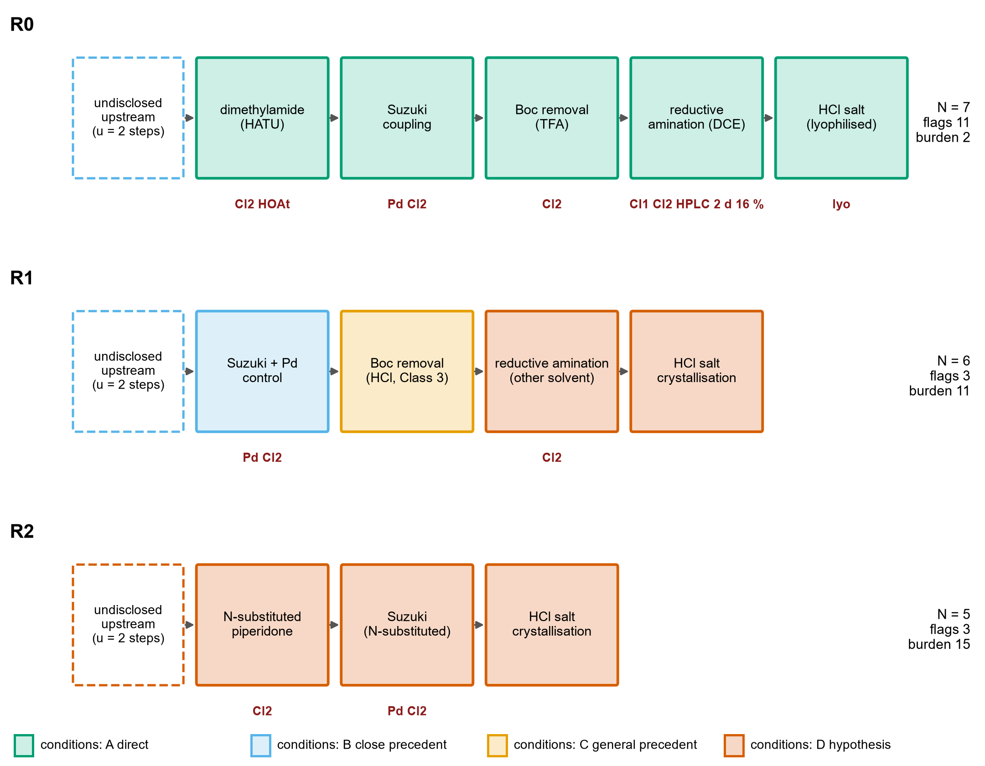
Fig. 2 Routes R0, R1 and R2 as step sequences. Box color is the evidence class of the conditions as written; dashed boxes are the undisclosed upstream steps (u = 2). Red labels are documented flags (Cl1, Cl2: ICH Q3C Class 1 and 2 solvents; Pd: palladium catalyst; HOAt: hydroxybenzotriazole-type reagent; HPLC: preparative HPLC; 2 d and 16%: reaction time and yield of the disclosed reductive amination; lyo: lyophilization). N is the number of steps, flags the number of flag instances and burden the validation burden on the linear scale.

3.5 Risk register and sensitivity of its prioritization
Table 6 Risk register for the proposed routes with the author's likelihood (L) and impact (I) ratings (1–5) and the probability that each risk ranks in the top three or five when every rating is perturbed by −1, 0 or +1 (20,000 random draws; conditional on the initial risk model, not an empirical probability). The ratings are author-assigned on the basis of the evidence inventory, not data.
ID | Risk | L | I | L×I | Top 3 (% of draws) | Top 5 (% of draws)
K1 | Impurity profile and purge when crystallization replaces preparative HPLC | 4 | 5 | 20 | 87 | 97
K2 | Undisclosed upstream route to the vinyl bromide building block | 5 | 4 | 20 | 87 | 97
K3 | Palladium residue control to the ICH Q3D limit | 3 | 4 | 12 | 23 | 49
K4 | Performance of the Suzuki-Miyaura step on scale (conversion, protodebromination, boronic-acid homocoupling) | 3 | 4 | 12 | 23 | 49
K5 | Reductive amination: conversion, reaction time and solvent change from DCE | 3 | 4 | 12 | 24 | 50
K6 | Regulatory change of route after clinical supply (comparability) and starting-material designation | 3 | 4 | 12 | 24 | 50
K7 | Thermal and gas-evolution hazards (Boc cleavage, borohydride quench, coupling exotherm) | 2 | 5 | 10 | 8 | 25
K10 | Supply and quality of the thiazole and aryl building blocks | 3 | 3 | 9 | 6 | 19
K11 | Compatibility of a thiazole-bearing, basic substrate with Pd coupling (route R2 only) | 3 | 3 | 9 | 6 | 18
K12 | Long-term supply concentration and geopolitical exposure for critical raw materials | 3 | 3 | 9 | 6 | 19
K8 | Control of potentially mutagenic impurities (alkylating agents, residual aldehyde) | 2 | 4 | 8 | 3 | 13
K9 | Polymorph and residual-solvent control of the hydrochloride at scale | 2 | 4 | 8 | 3 | 13

Of the twelve risks, 6 have a baseline score of at least 12 (Table 6). Two stand apart (Fig. 3): the impurity profile and purge when crystallization replaces preparative HPLC (K1) and the undisclosed upstream route to the vinyl bromide (K2). Each keeps a top-three position in about 87% of the perturbed rankings, whereas no other risk exceeds 24%. These shares describe the stability of the ranking given the initial ratings; they are not probabilities of the risks themselves. The other four high-scoring risks (palladium control, performance of the coupling, the reductive amination, and regulatory change of route) are interchangeable within the uncertainty of the ratings, so their order should not be interpreted. The ranking of the two leading risks is a property of the structure of the evidence (the only disclosed purification is chromatography; the upstream route is undisclosed) and not of a fine choice of scores.

3.6 What would change the conclusions
Three checks ask what it would take to reverse the findings. First, the exchange rate between the two axes. Between R0 and R1, λ is 0.89 on the linear scale at u = 2 (0.36 to 4.0 across the three weightings and all u): a sponsor that values one unit of linear burden at more than 0.89 documented flag instances would prefer R0 as the route to test with least new evidence, and one that values it at less would prefer R1. Between R0 and R2, λ is 0.47–0.73 over u = 1–4. Between R1 and R2, λ* is zero for every weighting: R2 never has fewer flags or a lower burden than R1, and its only advantage is one step fewer. R2 is therefore dominated on the two axes by R1, and its shorter sequence is bought with hypotheses. Second, the reversal of the leading risks needs a combined change of 2 rating points: moving K1 or K2 (score 20) down to the next cluster (score 12) needs a change of 2 in |ΔL| + |ΔI|, and so does moving one of the four risks in that cluster up to the leaders. The prioritization is therefore stable to a one-point disagreement about a single rating but not to a disagreement of two points about the same risk, which is the kind of challenge the validation program is designed to settle. Third, widening the rating uncertainty does not erase the order but weakens it: under the narrow distribution, the two leading risks stay in the top three in at least 98% of draws (no other risk above 22%), under the wide distribution (−2 to +2) in approximately 54% (no other risk above 26%). That they remain the most frequent members of the top three under every distribution tried supports examining them first, but it remains a conclusion conditional on the initial ratings.
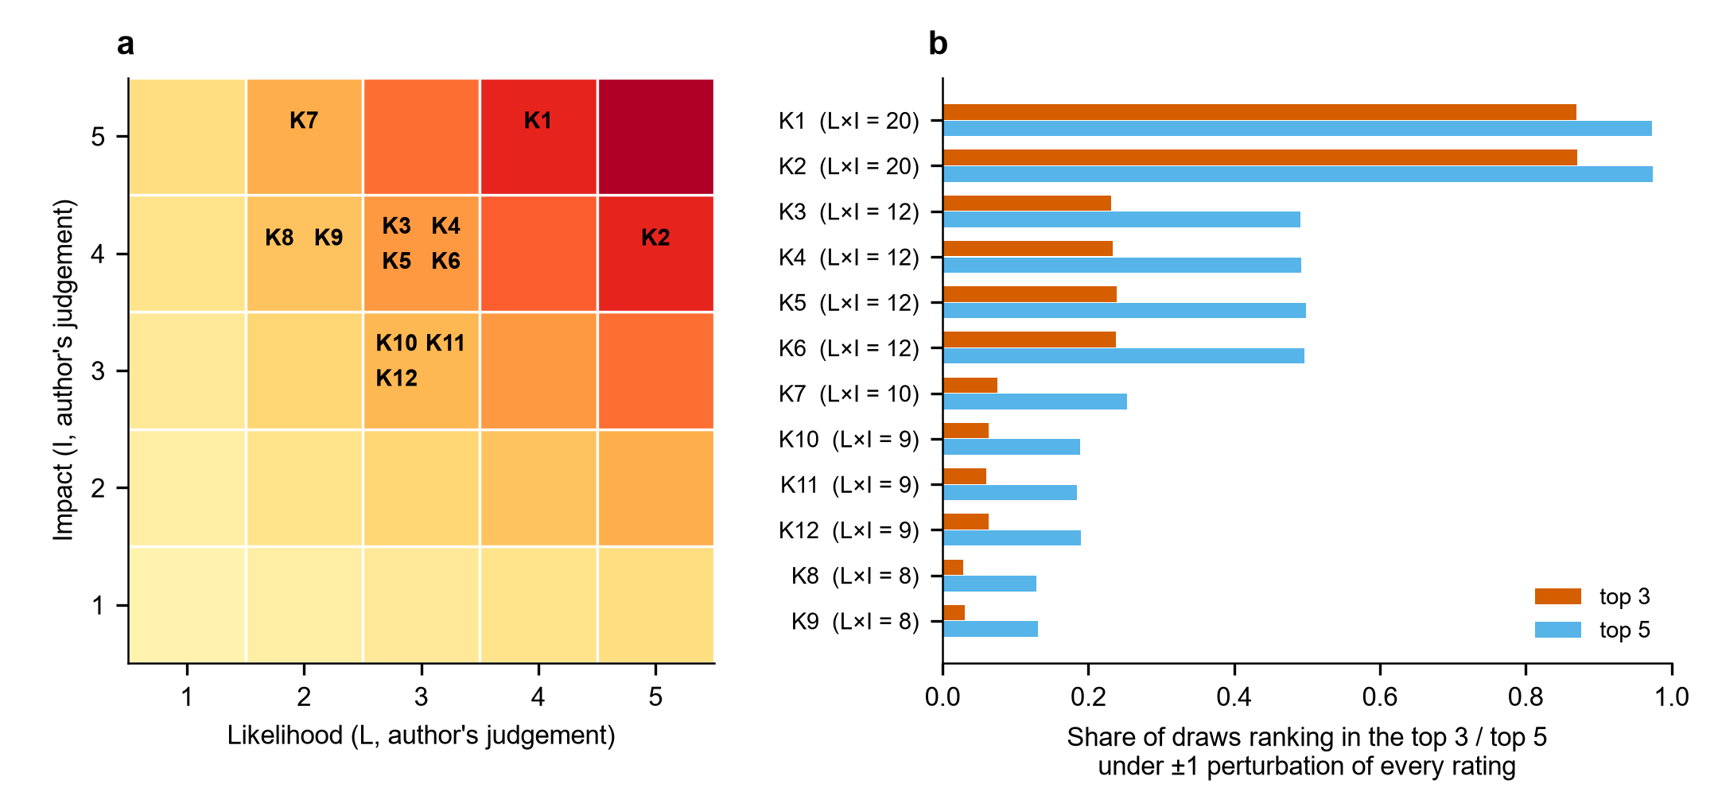
Fig. 3 Risk register. (a) Position of the twelve risks on the likelihood–impact grid (the author's ratings). (b) Share of perturbed draws in which each risk ranks in the top three or top five when every rating is perturbed by −1, 0 or +1 (conditional on the initial risk model; not an empirical probability).

4 Discussion

4.1 Pramipexole as benchmark, not as source of fragments
The idea that prompted this study took pramipexole as a template whose thiazole-amine core would be built on and extended. The structures do not support that mapping. Pramipexole is a 2-amino-4,5,6,7-tetrahydrobenzothiazole bearing a propylamino group [25], whereas the thiazole of PN6047 is an unsubstituted thiazol-5-yl attached through a methylene group to the piperidine nitrogen; the benzothiazole core of pramipexole is not a fragment of PN6047. What pramipexole offers is different: a published scalable synthesis of a thiazole-containing, basic CNS drug [12] and a precedent for salt formation of a basic amine. The thiazol-5-ylmethyl unit itself occurs in other drugs, for example, as a carbamate in ritonavir [26], and thiazole chemistry in approved drugs has been reviewed [27]; these are the more relevant precedents for the supply of that unit, but the sources examined do not document its supply, quality or registered-starting-material status (risk K10). Cost figures for pramipexole were not used.

4.2 Convergence is a property of the starting-material boundary
An argument for modular synthesis is that fragments made in parallel shorten the cycle time to the longer of the two branches. That argument applies to steps the manufacturer performs. Where the thiazole carbaldehyde or the arylboronic acid is a purchased material, the branch does not exist in the manufacturer's step count, and the route is linear (Table 5). ICH Q11 states that each branch of a convergent process begins with one or more starting materials, that GMP applies from their first use, that a starting material "should be a substance of defined chemical properties and structure" incorporated "as a significant structural fragment", and that enough of the process must be described for authorities "to understand how impurities are formed in the process" and how they are purged [15]. Whether the thiazole carbaldehyde and the arylboronic acid qualify as registered starting materials is therefore a regulatory judgment that depends on the control strategy. A genuinely convergent design would have to be defined together with a starting-material proposal; it cannot be asserted from the chemistry alone, and the framework treats the boundary as an explicit assumption.

4.3 Flags removed, evidence owed
The trade-off in Table 5 is the central finding of the case study: fewer documented flags did not mean lower development uncertainty. The exemplified route carries 11 flags and a validation burden of 2; R1 carries 3 flags and a burden of 11, and R2 3 flags and a burden of 15 (linear scale). A reader who counted flags alone would rank the routes in the reverse of the order in which they could be trusted. The Class 1 solvent of the exemplified reductive amination has documented alternatives for the reaction class because the original description of the reagent lists tetrahydrofuran and acetonitrile besides 1,2-dichloroethane [18], but both are Class 2 solvents [11], and the change has not been shown for this substrate. Replacing the benzotriazole-derived coupling reagent by a purchased building block that already carries the amide removes the reagent and its hazard class [21, 23] but moves the question to the availability and quality of that building block. Palladium cannot be removed from a route that uses a cross-coupling for the C–C bond; it can only be controlled, and removal methods are well documented as a class [28, 29] without evidence for this substrate. Finally, crystallization of the hydrochloride is described in the patent as a way to obtain a stable crystalline form [4]; its use to purge the impurities of the whole sequence, which is what would replace preparative HPLC, is the least supported element of R1 and carries the highest-ranked risk. Thus, the variants reduce what can be named and increase what must be shown.

4.4 Economic considerations without a cost model
No manufacturing cost is estimated. A defensible estimate would need yields and mass balances of each step, from which process mass intensity [30] and the E factor [31] could be computed, a solvent assessment [32, 33], quotations for the building blocks and a model of scale. None of these exists for PN6047 in the sources examined. The screening supports a qualitative statement only: the documented cost drivers of the exemplified route are its reported 16% isolated yield in the last step, chromatography, the Class 1 solvent and its control, a palladium catalyst and its removal, and an undisclosed upstream sequence; each is addressed in R1 by a proposal, not by a result. Supply concentration of the building blocks (risks K10 and K12) is an assumption of the register because no supplier or price data were collected.

4.5 Experimental validation requirements
Table 7 Principal actionable output: stage-gated experimental program required before any proposed route could be considered validated. Stage 0 also includes confirming the journal precedents of Table 3 against their full texts. The acceptance criteria other than the cited ICH values are for the development team to set.
Stage | Experiment to be done (not done here) | Decision it informs | Risks addressed
0 Upstream | Confirm the journal precedents of the precedent map against their full texts; define and test a route to the N-Boc vinyl bromide (benzhydryl alcohol dehydration or alternative); propose registered starting materials under ICH Q11 | Whether the grades B and C stand; whether the building blocks exist at acceptable quality; the starting-material boundary | K2, K6, K10
1 Coupling | Screen catalyst, base, solvent and temperature of the Suzuki–Miyaura step at laboratory scale; quantify palladium by ICP-MS after work-up, scavenging and crystallization | Whether the coupling gives a purity and palladium level compatible with the ICH Q3D limit | K3, K4
2 Deprotection | Remove the Boc group with HCl in a Class 3 solvent and isolate the amine hydrochloride by crystallization | Whether an isolated intermediate improves purge of coupling by-products | K1, K7
3 N-functionalization | Screen solvent (THF, acetonitrile, ester solvents) and reductant for the reductive amination; in-process control of conversion; quench and gas-evolution assessment; compare with alkylation under ICH M7 assessment [34] | Whether the Class 1 solvent can be removed without loss of conversion; which reagent leaves the fewer controlled impurities | K5, K7, K8
4 Salt | Crystallize the hydrochloride (Form HCl2 solvents from the patent); XRPD, residual solvent, hygroscopicity | Whether crystallization alone purges impurities and delivers the intended polymorph | K1, K9
5 Impurities | Impurity mapping by LC-MS across all stages; spiking and purge studies; working thresholds from ICH Q3A (for doses up to 2 g/day: identification 0.10%, qualification 0.15%, or lower daily-intake limits) | Whether the impurity profile of the new route is acceptable or needs further qualification | K1, K6
6 Safety and scale | Reaction calorimetry and thermal-stability screening of each step before any scale-up | Safe operating limits; go/no-go for scale | K7

Table 7 is the principal actionable output of the framework. The program is ordered so that the two dominant risks are met first (Table 7): the upstream route and the starting-material question and the purge of impurities in the isolation steps. Calorimetry precedes every scale-up step, and all numerical go/no-go criteria are left to the sponsor because inventing them without data would give a false precision. The route should be regarded as validated only when the laboratory work above has been completed on PN6047 intermediates.

4.6 A reusable workflow and what the method does not do
No new chemical transformation is proposed. The contribution is a workflow that can be applied to any compound whose discovery route is public and that needs no laboratory data to start: (1) reconstruct the public discovery route and its scale; (2) inventory its operations and conditions; (3) classify the evidence for each transformation and each set of conditions; (4) attach documented process flags with their sources; (5) generate alternative routes that change as little as possible; (6) calculate the validation burden of each alternative under more than one weighting; (7) rank the risks and test the ranking against the ratings; (8) test the sensitivity of the conclusions to the choices that cannot be justified uniquely; and (9) convert the result into a stage-gated experimental plan. Steps 1–4 can be done from public documents, steps 5–8 are computed by the code that accompanies the paper, and step 9 is the part that must be done by a development team.
The method does not select the best route. A route is not better because it has fewer flags, nor worse because it carries a higher burden; the two axes answer different questions, the first what has already been identified as a liability in the public record, the second how much of a proposed alternative has still to be shown. What the method gives is a map of where the evidence is strong (the exemplified route has been run once at each step, at a small scale), where it is assumed (all conditions of the proposed variants), and which experiments have the highest information value (those that address the leading risks and move class D conditions to class A). The word selection in the title refers to deciding which route to test first, not to declaring a route chosen.
Return to the four requirements of Section 2.7. Traceability is met by the source keys and the two grades; its weak point is that, for the journal precedents, the grades rest on abstracts. Discrimination is met by the separation of flags and burden, which gave opposite orderings, and by the dominance of R1 over R2, which a single score would have hidden. Robustness is met for the weighting, u and the rating distributions but not for the structure of the register itself, which one author defined. Actionability is met by Table 7, whose acceptance criteria remain to be set by a development team. The framework is therefore a way to organize and challenge a decision, not to make it.

4.7 Limitations
No synthesis was performed, and no yield, impurity profile, scale-up experiment or manufacturing cost was measured or predicted. The regulatory acceptability of the proposed routes has not been assessed, and no freedom-to-operate analysis was made for a compound that is the subject of patent filings. The exemplified route is the discovery route in the patent texts; the clinical-supply route of the developer is not public and may differ. The patent text examined contains an inconsistency (Example III) that could not be resolved from the available text. The evidence grading and the risk ratings are author-assigned on the basis of the evidence inventory; the sensitivity analysis evaluates the stability of the ranking conditional on the initial risk model and is not an empirical probability, and the exchange rates λ* express preferences, not measurements. The literature search was purposive; for the journal precedents, only the record and abstract were examined, so the grades B and C are provisional until the full texts have been checked. The number of undisclosed upstream steps is a parameter, not a finding. The screening metrics count documented attributes and do not measure safety, cost or sustainability. The chemical compatibility of the proposed conditions with the PN6047 intermediates, including the coupling in route R2 of a basic, heteroatom-rich substrate, remains untested.

5 Conclusions
The paper presents a framework that converts public information on a discovery-scale route into evidence grades, documented process flags, a sensitivity-tested ranking of development risks and a stage-gated experimental plan and demonstrates it on PN6047. The only public route to PN6047 drug substance is exemplified at milligram-to-gram scale, and its documented attributes (a Class 1 solvent, a palladium-catalyzed coupling, a benzotriazole-derived reagent, preparative HPLC, a 16% isolated yield in the final N-functionalization) show where process development would warrant particular evaluation or modification. The central result is that fewer documented flags did not mean lower development uncertainty: the variants that remove most flags carry a higher validation burden because every one of their conditions is unvalidated. Impurity purge by crystallization and the route to the vinyl bromide building block are the dominant uncertainties and should be tested first. The framework converts public route information into an auditable experimental-prioritization strategy while explicitly separating documented process liabilities from unvalidated alternatives; it does not identify a best route, and it is not a validated process.

Statements and Declarations
Funding. The author received no funding for this work.
Competing interests. The author declares no competing interests. The author has no affiliation with PharmNovo AB or with the project partners named in the cited project description. An earlier, shorter, unpublished outline of the route concept was submitted by the author to an open-innovation challenge (Wazoku challenge idea 141585, 2026); no part of it has been published elsewhere.
Author contributions. Leon Sandler: conceptualization, methodology, software, formal analysis, investigation, data curation, writing – original draft, writing – review and editing, visualization.
Data and code availability. The inventories, flags, precedents, risk ratings, model code, tests, figure scripts and the manuscript builder are available at https://github.com/sandlerleon/pn6047-route-design and archived on Zenodo at https://doi.org/10.5281/zenodo.23200725; this manuscript is archived as a preprint at https://doi.org/10.5281/zenodo.23201405. The two patent documents and the ICH guidelines are public.
Ethics. This study uses only published documents; no human participants, animals or personal data were involved.
Use of artificial intelligence. See Section 2.10.

References
[1] Conibear AE, Asghar J, Hill R, Henderson G, Borbely E, Tekus V, et al. A Novel G Protein–Biased Agonist at the δ Opioid Receptor with Analgesic Efficacy in Models of Chronic Pain. The Journal of Pharmacology and Experimental Therapeutics. 2020;372:224–236. https://doi.org/10.1124/jpet.119.258640
[2] Wei ZY, Brown W, Takasaki B, Plobeck N, Delorme D, Zhou F, et al. N,N-Diethyl-4-(phenylpiperidin-4-ylidenemethyl)benzamide: A Novel, Exceptionally Selective, Potent δ Opioid Receptor Agonist with Oral Bioavailability and Its Analogues. J Med Chem. 2000;43:3895–3905. https://doi.org/10.1021/jm000229p
[3] PharmNovo AB (inventors: von Mentzer B, Starke I, Brandt P). Diarylmethylidene piperidine derivatives and their use as delta opioid receptor agonists. Patent application WO 2016/099393 A1; published 23 June 2016. https://patents.google.com/patent/WO2016099393A1/en
[4] PharmNovo AB (inventors: von Mentzer B, Starke I, Nilsson HG). Polymorphs of a hydrochloride salt of PN6047. Patent application WO 2022/013153 A1; published 20 January 2022. https://patents.google.com/patent/WO2022013153A1/en
[5] European Commission. PN6047-DOBRA: PN6047 - a breakthrough treatment of neuropathic pain. CORDIS project 101188409. https://cordis.europa.eu/project/id/101188409. Accessed 6 Oct 2026
[6] Federsel HJ. Chemical Process Research and Development in the 21st Century: Challenges, Strategies, and Solutions from a Pharmaceutical Industry Perspective. Acc Chem Res. 2009;42:671–680. https://doi.org/10.1021/ar800257v
[7] Carey JS, Laffan D, Thomson C, Williams MT. Analysis of the reactions used for the preparation of drug candidate molecules. Org Biomol Chem. 2006;4:2337. https://doi.org/10.1039/b602413k
[8] Brown DG, Boström J. Analysis of Past and Present Synthetic Methodologies on Medicinal Chemistry: Where Have All the New Reactions Gone?. Journal of Medicinal Chemistry. 2015;59:4443–4458. https://doi.org/10.1021/acs.jmedchem.5b01409
[9] Blakemore DC, Castro L, Churcher I, Rees DC, Thomas AW, Wilson DM, et al. Organic synthesis provides opportunities to transform drug discovery. Nature Chem. 2018;10:383–394. https://doi.org/10.1038/s41557-018-0021-z
[10] Vitaku E, Smith DT, Njardarson JT. Analysis of the Structural Diversity, Substitution Patterns, and Frequency of Nitrogen Heterocycles among U.S. FDA Approved Pharmaceuticals. J Med Chem. 2014;57:10257–10274. https://doi.org/10.1021/jm501100b
[11] ICH. Q3C(R8): Impurities: guideline for residual solvents. 2021. https://database.ich.org/sites/default/files/ICH_Q3C-R8_Guideline_Step4_2021_0422_1.pdf
[12] Živec M, Anžič B, Gobec S. A Novel Scalable Synthesis of Pramipexole. Org Process Res Dev. 2010;14:1125–1129. https://doi.org/10.1021/op1000989
[13] ICH. Q3A(R2): Impurities in new drug substances. 2006. https://database.ich.org/sites/default/files/Q3A%28R2%29%20Guideline.pdf
[14] ICH. Q3D(R2): Guideline for elemental impurities. 2022. https://database.ich.org/sites/default/files/Q3D-R2_Guideline_Step4_2022_0308.pdf
[15] ICH. Q11: Development and manufacture of drug substances (chemical entities and biotechnological/biological entities). 2012. https://database.ich.org/sites/default/files/Q11_Guideline.pdf
[16] Qian Z, Baxendale IR, Ley SV. A Continuous Flow Process Using a Sequence of Microreactors with In‐line IR Analysis for the Preparation of N,N‐Diethyl‐4‐(3‐fluorophenylpiperidin‐4‐ylidenemethyl)benzamide as a Potent and Highly Selective δ‐Opioid Receptor Agonist. Chemistry A European J. 2010;16:12342–12348. https://doi.org/10.1002/chem.201002147
[17] Isidro-Llobet A, Álvarez M, Albericio F. Amino Acid-Protecting Groups. Chem Rev. 2009;109:2455–2504. https://doi.org/10.1021/cr800323s
[18] Abdel-Magid AF, Carson KG, Harris BD, Maryanoff CA, Shah RD. Reductive Amination of Aldehydes and Ketones with Sodium Triacetoxyborohydride. Studies on Direct and Indirect Reductive Amination Procedures 1. J Org Chem. 1996;61:3849–3862. https://doi.org/10.1021/jo960057x
[19] Gaich T, Baran PS. Aiming for the Ideal Synthesis. J Org Chem. 2010;75:4657–4673. https://doi.org/10.1021/jo1006812
[20] Hendrickson JB. Systematic synthesis design. 6. Yield analysis and convergency. J Am Chem Soc. 1977;99:5439–5450. https://doi.org/10.1021/ja00458a035
[21] Wehrstedt KD, Wandrey PA, Heitkamp D. Explosive properties of 1-hydroxybenzotriazoles. Journal of Hazardous Materials. 2005;126:1–7. https://doi.org/10.1016/j.jhazmat.2005.05.044
[22] ICH. Q9(R1): Quality risk management. 2022. https://database.ich.org/sites/default/files/ICH_Q9%28R1%29_Guideline_Step4_2022_1219.pdf
[23] Dunetz JR, Magano J, Weisenburger GA. Large-Scale Applications of Amide Coupling Reagents for the Synthesis of Pharmaceuticals. Org Process Res Dev. 2016;20:140–177. https://doi.org/10.1021/op500305s
[24] Bastin RJ, Bowker MJ, Slater BJ. Salt Selection and Optimisation Procedures for Pharmaceutical New Chemical Entities. Org Process Res Dev. 2000;4:427–435. https://doi.org/10.1021/op000018u
[25] Schneider CS, Mierau J. Dopamine autoreceptor agonists: resolution and pharmacological activity of 2,6-diaminotetrahydrobenzothiazole and an aminothiazole analog of apomorphine. J Med Chem. 1987;30:494–498. https://doi.org/10.1021/jm00386a009
[26] Kempf DJ, Sham HL, Marsh KC, Flentge CA, Betebenner D, Green BE, et al. Discovery of Ritonavir, a Potent Inhibitor of HIV Protease with High Oral Bioavailability and Clinical Efficacy. J Med Chem. 1998;41:602–617. https://doi.org/10.1021/jm970636+
[27] Niu ZX, Wang YT, Zhang SN, Li Y, Chen XB, Wang SQ, et al. Application and synthesis of thiazole ring in clinically approved drugs. European Journal of Medicinal Chemistry. 2023;250:115172. https://doi.org/10.1016/j.ejmech.2023.115172
[28] Garrett CE, Prasad K. The Art of Meeting Palladium Specifications in Active Pharmaceutical Ingredients Produced by Pd‐Catalyzed Reactions. Adv Synth Catal. 2004;346:889–900. https://doi.org/10.1002/adsc.200404071
[29] Galaffu N, Man SP, Wilkes RD, Wilson JRH. Highly Functionalised Sulfur-Based Silica Scavengers for the Efficient Removal of Palladium Species from Active Pharmaceutical Ingredients. Org Process Res Dev. 2007;11:406–413. https://doi.org/10.1021/op7000172
[30] Jimenez-Gonzalez C, Ponder CS, Broxterman QB, Manley JB. Using the Right Green Yardstick: Why Process Mass Intensity Is Used in the Pharmaceutical Industry To Drive More Sustainable Processes. Org Process Res Dev. 2011;15:912–917. https://doi.org/10.1021/op200097d
[31] Sheldon RA. The E factor 25 years on: the rise of green chemistry and sustainability. Green Chem. 2017;19:18–43. https://doi.org/10.1039/c6gc02157c
[32] Alfonsi K, Colberg J, Dunn PJ, Fevig T, Jennings S, Johnson TA, et al. Green chemistry tools to influence a medicinal chemistry and research chemistry based organisation. Green Chem. 2008;10:31–36. https://doi.org/10.1039/b711717e
[33] Prat D, Wells A, Hayler J, Sneddon H, McElroy CR, Abou-Shehada S, et al. CHEM21 selection guide of classical- and less classical-solvents. Green Chem. 2016;18:288–296. https://doi.org/10.1039/c5gc01008j
[34] ICH. M7(R2): Assessment and control of DNA reactive (mutagenic) impurities in pharmaceuticals to limit potential carcinogenic risk. 2023. https://database.ich.org/sites/default/files/ICH_M7%28R2%29_Guideline_Step4_2023_0216_0.pdf

