Self-Maintained Order and Hysteretic Collapse in a Non-Equilibrium Rotational Lattice
Order-dependent degradation and repair as a source of nonlinear feedback, bistability, and active maintenance
Leon Sandler
Independent Researcher, Northbrook, Illinois, USA
Corresponding author: sandler.leon@gmail.com
ORCID: https://orcid.org/0009-0007-4584-808X

Abstract
We study the maintenance of directional order in a nonequilibrium rotational lattice: a two-dimensional array of interacting rotors whose ordering couplings are removed by an order-dependent flux and restored by repair. Because degradation accelerates with local disorder, the stationary state is a nonequilibrium steady state. In an annealed mean-field reduction controlled by the ratio ρ of repair to shielded degradation, the feedback makes order bistable: for cooperativity h > 1 and gain above a computed threshold, two saddle-node bifurcations bound a hysteresis window, whereas without feedback there is one fixed point, I* = 1/(1 + ρ). In kinetic Monte Carlo, when degradation senses only the nearest neighbors, the lattice shows no bistability at the parameters and sizes tested: the hysteresis loop closes as the sweep slows and ordered and collapsed starts converge, because averaging the steep feedback over a broad distribution of local disorder flattens it. When degradation senses disorder over larger regions, bistability returns: robustly up to L = 96 when the closure itself is imposed on the lattice, and for an 80-site neighborhood with evidence consistent with a discontinuous transition. We also give an exact order–entropy relation for the von Mises law, dS/dU_{χ} = −κ, and use finite-size scaling (L = 16–96) to estimate the field-free loss of stiffness at a diluted fraction f_{KT} ≈ 0.205, far below site percolation (0.407) and consistent with a Berezinskii–Kosterlitz–Thouless mechanism. The measured maintenance current peaks where order is most fragile. Static hysteresis requires degradation that senses order over an extended range.
Keywords: nonlinear dynamics; nonequilibrium statistical mechanics; bistability and hysteresis; Berezinskii–Kosterlitz–Thouless transition; entropy production; kinetic Monte Carlo

1. Introduction
Many physical systems maintain order not as a thermodynamic ground state but as a dynamic balance: a directionally ordered medium is continuously eroded by an external flux, while a maintenance process restores it [1–3]. Order then persists or collapses according to a competition of rates. When erosion depends on the current state of the medium, the balance is governed by feedback, which admits the multistability and dissipation characteristics of nonequilibrium systems [4–6]. Instances include the orientational order of a polymer film under photodegradation with self-healing [7], the alignment of magnetic domains under thermally activated flips [8] with active error-correcting rewrites, and the directional order of a molecular monolayer under chemical attack with turnover [9].
The setting differs from that of best-known orientational nonequilibrium systems. In flocking and active-matter models, driving generates and stabilizes order through self-propulsion and alignment, and long-range order can survive in two dimensions where the equilibrium XY model cannot [10, 11]; in the equilibrium XY model, order is lost through the Berezinskii–Kosterlitz–Thouless (BKT) transition [12]. Here, order is neither generated by the drive nor protected by an equilibrium ground state: it is maintained against state-dependent loss. Keeping information-bearing order away from equilibrium also has a thermodynamic price [13, 14], of which kinetic proofreading is the classic example in which dissipation buys fidelity [15] and in which stochastic thermodynamics makes quantitative [16, 17].
We formulate this as a nonequilibrium interacting particle system [18] in which reversible rotor dynamics is coupled to a nonconservative, order-dependent site process. The coupling produces a nonlinear mean-field reduction that is bistable, with saddle-node bifurcations bounding a hysteresis window in which a maintained and a collapsed nonequilibrium steady state (NESS) coexist (Section 4.2), a behavior absent without the feedback (Section 4.1). We then test the reduction on the lattice by kinetic Monte Carlo designed to separate static from rate-dependent hysteresis (Section 4.3) and find that its bistability survives only when degradation senses order over an extended region; with nearest-neighbor sensing the lattice shows a single NESS at the parameters tested, and we identify why (Section 4.4). Three further contributions support the picture: an exact relation between a directional order parameter and configurational entropy, stated in the form needed here from exponential-family theory (Section 3); a finite-size-scaling analysis locating the field-free transition relative to site percolation and pointing to a BKT mechanism (Section 5); and the measured maintenance current, with the entropy production of an auxiliary cycle as an illustrative thermodynamic reading (Section 6). The order-dependence of the degradation, a site in a disordered neighborhood degrading faster, is what makes the stationary state a genuine NESS rather than a product of an uncoupled two-state chain and an equilibrium rotor gas, and is the source of the nonlinear phenomenology.

2. The model
Let Λ = {1, …, L}² be a square lattice with N = L² sites and periodic boundaries. Each site i has a rotor orientation θ_{i} ∈ [0, 2π) and a binary integrity g_{i} ∈ {1, g₀}, 0 < g₀ ≪ 1. The energy is
$H\left(θ\text{,}g\right)\text{ = }\text{−}J_{\text{0}}\sum_{\text{⟨}ij\text{⟩}}{g_{\text{i}}g_{\text{j}}\text{cos}\left(θ_{\text{i}}\text{ − }θ_{\text{j}}\right)}\text{ − }h_{\text{0}}\sum_{i}{g_{i}\text{cos} θ_{i}}\text{.}$ (1)
The dynamics interleaves a reversible rotor relaxation with a nonconservative, order-dependent site process.
Reversible rotor relaxation. At fixed g, the orientations evolve by a Metropolis kernel reversible with respect to the Gibbs measure ∝ e^{−H/T} (k_{B} T = 1); alone, this equilibrates the rotors in the quenched integrity landscape and satisfies detailed balance.
Order-dependent site process. Each intact site (g_{i} = 1) is diluted (g_{i} → g₀) at a rate that depends on its local orientational disorder,
$λ_{i}\text{ = }λ_{\text{0}}\left[\text{1}\text{ + }β\frac{{δ_{i}}^{h}}{K^{h}\text{ + }{δ_{i}}^{h}}\right]$ (2)
$δ_{i}\text{ = }\text{1}\text{ − }\left|\frac{\text{1}}{\text{4}}\sum_{j\text{∈}\text{∂}i}{e^{iθ_{j}}}\right|$ (3)
$λ_{\text{0}}\text{ = }kG\left(\text{1}\text{ − }su_{\text{s}}\right)\text{.}$ (4)
so an aligned neighborhood shields a site (λ_{i} → λ₀) while a disordered neighborhood accelerates its degradation (λ_{i} → λ₀(1 + β)); degradation is thus autocatalytic in disorder. Each diluted site is repaired (g₀ → 1, θ_{i} reset toward 0) at rate R. The bare susceptibility k, drive G, geometric shielding (1 − s u_{s}), cooperativity h and gain β parameterize the flux. This state dependence couples the site process to the rotor field: the two cannot be treated separately, and detailed balance is broken, driving the joint system to a NESS.
Discrete steps and continuous rates. The simulations advance in discrete steps: the rotors are relaxed, and every site is subsequently updated synchronously, with λ_{i} and R used as per-step probabilities (Appendix A). The rate equations of Section 4 are the continuous-time description of the same process, in which the discrete chain approaches when λ_{i}, R ≪ 1; the control ratio ρ = R/λ₀ is the same in both, and where the discrete update shifts a result (Section 4.1), the shift is stated.
The order parameter and the information variable are
$U_{\text{χ}}\text{ = }\left|N^{\text{−1}}\sum_{i}{e^{iθ_{i}}}\right|\text{,} I\text{ = }\text{1}\text{ − }U_{\text{χ}}\text{.}$ (5)

3. The order–entropy bridge
Fixing the mean resultant length and maximizing differential entropy over circular densities yields the von Mises law vM(κ) [19, 20], with density
$f\left(θ\right)\text{ = }\frac{e^{κ\text{ cos }θ}}{\text{2}πI_{\text{0}}\left(κ\right)}\text{,} A\left(κ\right)\text{ = }\frac{I_{\text{1}}\left(κ\right)}{I_{\text{0}}\left(κ\right)}\text{.}$ (6)
where I₀ and I₁ are modified Bessel functions of the first kind [21].
Theorem 1 (Order–entropy bridge). For the von Mises family, (i) U_{χ} = A(κ) is a smooth, strictly increasing bijection [0, ∞) → [0, 1); (ii) S(κ) = ln(2π I₀(κ)) − κ A(κ) satisfies dS/dκ = −κ A′(κ) < 0 for κ > 0; hence, dS/dU_{χ} = −κ; (iii) S is a strictly decreasing invertible function of U_{χ}, with S = ln 2π at U_{χ} = 0 and S → −∞ as U_{χ} → 1; (iv) H_{χ} = S_{max} − S = −½ ln(1 − U_{χ}) + ½(ln π − 1) + o(1) as U_{χ} → 1.
Proof. (i) The von Mises family is an exponential family in cos θ with log-partition function ln(2π I₀(κ)); thus, A(κ) = d ln I₀(κ)/dκ = E_{κ}[cos θ], and A′(κ) = Var_{κ}(cos θ), which is strictly positive for every κ ≥ 0 because cos θ is not almost surely constant under any von Mises law. The Bessel recurrences give the Riccati identity (see [21] for properties of the ratio A)
$A\text{′}\left(κ\right)\text{ = }\text{1}\text{ − }\frac{A\left(κ\right)}{κ}\text{ − }{A\left(κ\right)}^{\text{2}}\text{,}$ (7)
and 0 < A(κ) < 1 for κ > 0. With A(0) = 0 and the asymptotics A(κ) = 1 − 1/(2κ) + O(κ⁻²) as κ → ∞, A is a strictly increasing bijection [0, ∞) → [0, 1), which proves (i). (ii) Since (d/dκ) ln(2π I₀) = A and (d/dκ)(κA) = A + κA′, dS/dκ = −κA′ < 0; dividing by dU_{χ}/dκ = A′ gives dS/dU_{χ} = −κ. (iii) follows by the inverse-function theorem. (iv) I₀(κ) ∼ e^{κ}/√(2πκ) gives S = ½ + ½ ln 2π − ½ ln κ + o(1), and inverting A(κ) ≈ 1 − 1/(2κ) near U_{χ} → 1 (κ ∼ 1/[2(1 − U_{χ})]) yields the stated tail. ∎
The identity dS/dU_{χ} = −κ is exact: the marginal information gained per unit increase in directional order equals the concentration of the underlying law, so the last increments toward perfect order are logarithmically costly (Figure 1).
Parts (i)–(iii) are instances of standard exponential-family identities: the mean parameter increases because its derivative is a variance, and the derivative of the entropy with respect to the mean parameter is minus the natural parameter [19, 20]. We do not claim the identity as new. Theorem 1 states it in the explicit form needed here for the circular order parameter U_{χ} and with the logarithmic tail (iv) and uses it as an exact tool for translating directional order into configurational information in the remainder of the paper.
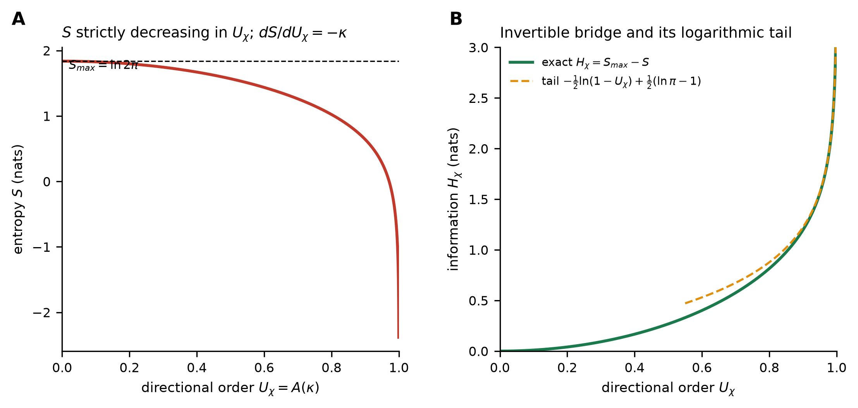
Figure 1. The order–entropy bridge (Theorem 1). (A) S is strictly decreasing in U_{χ}. (B) H_{χ} = S_{max} − S is a strictly increasing invertible image of U_{χ}, with the derived logarithmic tail (dashed).

4. Mean-field reduction, feedback and bistability
4.1 The uncoupled baseline. Setting β = 0 removes the feedback: the integrity of each site is then an exact two-state Markov chain (intact ⇌ diluted at rates λ₀, R), independent of the rotors. The intact fraction obeys ṗ = R(1 − p) − λ₀ p, so with τ = λ₀ t and ρ = R/λ₀,
$\frac{\text{d}I}{\text{d}τ}\text{ = }\left(\text{1}\text{ − }I\right)\text{ − }ρI\text{,} I^{\text{*}}\text{ = }\frac{\text{1}}{\text{1}\text{ + }ρ}\text{.}$ (8)
a globally stable fixed point approached at rate (1 + ρ); the lattice p(t) follows this master equation up to a discrete-time correction: the simulation updates all sites synchronously once per step, so its exact fixed point is R/(λ₀ + R − λ₀R) rather than R/(λ₀ + R), a relative shift below λ₀/(1 − λ₀) ≈ 2% that vanishes as λ₀, R → 0 (it is checked to Monte Carlo accuracy in Appendix A), and U_{χ} is slaved to it (Figure 2). The linear baseline is recovered when β = 0.
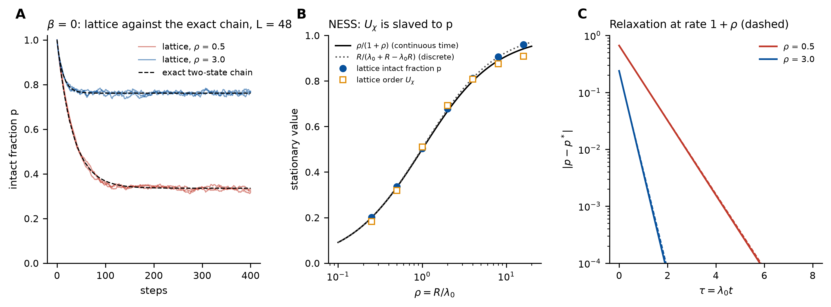
Figure 2. Uncoupled baseline (β = 0, L = 48). (A) Lattice intact fraction from a fully intact start (three runs per ρ) and the exact mean of the synchronous two-state chain (dashed). (B) Stationary intact fraction p and order U_{χ} against ρ, with the continuous-time value ρ/(1 + ρ) and the discrete fixed point R/(λ₀ + R − λ₀R): U_{χ} is slaved to p up to a small boundary-layer correction. (C) Relaxation of the chain to its fixed point against τ = λ₀t, with a continuous-time rate of 1 + ρ (dashed).
4.2 Nonlinear feedback and bistability. With order-dependent degradation, the annealed mean-field identification δ ≐ I closes the feedback loop, and the information variable obeys the nonlinear ODE
$\frac{\text{d}I}{\text{d}τ}\text{ = }μ\left(I\right)\left(\text{1}\text{ − }I\right)\text{ − }ρI\text{,} μ\left(I\right)\text{ = }\text{1}\text{ + }β\frac{I^{h}}{K^{h}\text{ + }I^{h}}\text{.}$ (9)
Proposition 2 (Bistable NESS). Steady states solve
$ρ\text{ = }F\left(I\right)\text{ := }\frac{μ\left(I\right)\left(\text{1}\text{ − }I\right)}{I}\text{.}$ (10)
For cooperative feedback (h > 1 and β > β_{c}(h, K)), F is nonmonotonic, so there is an interval ρ ∈ (ρ₋, ρ₊) on which the ODE has three fixed points: two stable—a maintained (low-I) branch and a collapsed (high-I) branch—separated by an unstable branch. The endpoints ρ± are saddle-node bifurcations, and the system exhibits hysteresis: as ρ decreases from the maintained state, order persists until ρ₋, then it collapses, and as ρ increases from the collapsed state, order is not recovered until ρ₊. For (h, K, β) = (6, 0.5, 20), the bistable window is ρ ∈ (3.9, 11.3).
Proof sketch. F(I) = μ(I)(1 − I)/I → ∞ as I → 0⁺, because μ(0) = 1, and F(I) → 0 as I → 1⁻. For h > 1 and large β the cooperative term contributes a rising factor that makes F nonmonotonic, with a local minimum and a local maximum whose values are ρ₋ (minimum) and ρ₊ (maximum). Between them three real roots exist; linearizing G(I) = μ(I)(1 − I) − ρI gives stability sgn(−G′(I*)), stable on the outer branches and unstable on the middle one. The saddle-node conditions F′(I) = 0 locate ρ±. ∎
Where the feedback is strong enough. Cooperativity is necessary. For h ≤ 1, F(I) = (1 − I)/I + βI^{h−1}(1 − I)/(K^{h} + I^{h}) is a sum of strictly decreasing functions, so the steady state is unique for every β. For h > 1 the threshold β_{c}(h, K), the smallest gain at which F develops its pair of turning points, follows from the saddle-node conditions as in the companion order–repair analysis [22]. At K = 0.5 it is β_{c} = 219, 50.7, 19.1, 7.73 and 2.42 for h = 1.2, 1.5, 2, 3 and 6, diverging as h → 1⁺. The parameters used throughout, (h, K, β) = (6, 0.5, 20), lie at β/β_{c} = 8.3, where the window is ρ ∈ (3.92, 11.30); it shrinks to a point as β → β_{c} and widens to (4.57, 21.8) at β = 40 (mf_threshold.py in the study repository).
The S-shaped steady-state manifold, the bifurcation diagram with its hysteresis window, and two trajectories at a common ρ relaxing to distinct (maintained vs collapsed) NESS are shown in Figure 3. Bistability is the qualitative signature of the feedback: it is absent in the β = 0 baseline and appears only because degradation is coupled to the order it destroys.
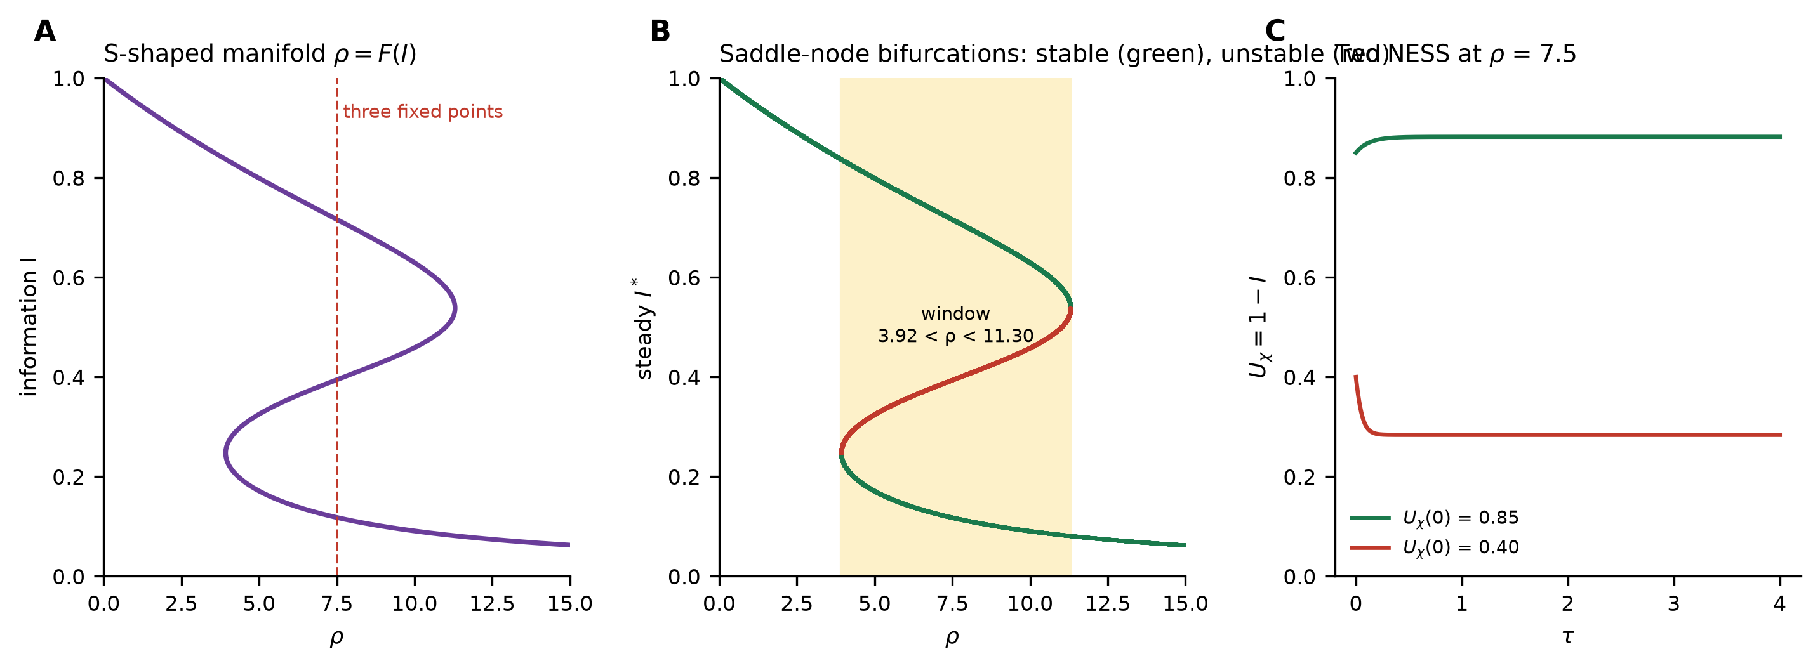
Figure 3. Nonlinear feedback → bistability (Proposition 2). (A) The steady-state manifold ρ = F(I) is S shaped; thus, a range of ρ includes three fixed points. (B) Bifurcation diagram: stable (green) and unstable (red) branches with two saddle node points bounding a hysteresis window (shaded). (C) At ρ = 7.5, inside the window, two initial conditions flow to a maintained and a collapsed NESS.
4.3 Testing the bistability on the lattice. Proposition 2 is a statement about the reduced ODE, obtained under one approximation: the annealed mean-field closure δ ≐ I, which replaces the local neighborhood disorder δ_{i} of each site by the global average I. Whether its central prediction survives on the short-range lattice is a numerical question, and a hysteresis loop recorded at one sweep rate cannot settle it: a loop opens whenever the control parameter moves faster than the system relaxes, whether or not two stable states exist [23]. We therefore use kinetic Monte Carlo [24] to apply two tests that separate dynamic from static hysteresis, at the parameters of Proposition 2 (T = 0.45, h₀ = 0.30) and in a colder, field-free variant (T = 0.30, h₀ = 0) in which thermal fluctuations are weaker. The protocol, run table, engine verification and error analysis are given in Appendix A.
Sweep-rate extrapolation. The ratio ρ is stepped from 16 down to 1 and back on a 31-point grid with a dwell of τ = 1 to 256 steps at each value at L = 16–64 (8 independent runs per size and rate). The signed loop area A = ∫(U_{χ,↓} − U_{χ,↑}) dρ, which, unlike the absolute area, is unbiased under noise, peaks at 2.5 for dwells of two to four steps and decreases steadily as the sweep slows to 0.09 at τ = 32 for L = 64 (Figure 4B). From τ = 64 on, it is consistent with zero: A = -0.007 (95% bootstrap interval -0.020 to 0.005) over the dwells τ = 64–256 at L = 64, |A| ≤ 0.018 at every size in both variants, and every interval contains zero. A bistable system maintains a finite loop as τ → ∞, bounded by its two saddle nodes; for the mean-field reduction, the quasistatic area is 4.30.
Two starts at fixed ρ. Inside the mean-field window (ρ = 4.5, 6, 8 and 10) each run starts either from the ordered state or from a collapsed one (95% of sites diluted, angles random) and is followed for 3000 steps (L = 16–64, 8 runs per start). The stationary order reached from the two starts agrees to within 0.004 in all 40 combinations of ρ, L and variant, with the bootstrap interval of the difference containing zero in 35 of them (Figure 4C). The seed-averaged trajectories meet within 15–115 steps, and the meeting time does not grow with the number of sites from N = 256 to 4096 (Figure A1C), whereas escape from a metastable branch slows exponentially with N. The stationary distribution of U_{χ} is unimodal (bimodality coefficient ≤ 0.37, below the 5/9 of a uniform distribution [25]), and its integrated autocorrelation time is 6–11 steps, again independent of L (Figure A1B).
The five combinations whose interval excludes zero are, with difference and 95% interval: T = 0.30, L = 32, ρ = 6: -0.0021 (-0.00384 to -0.00038); T = 0.30, L = 32, ρ = 8: +0.0014 (+0.00045 to +0.00231); T = 0.30, L = 64, ρ = 6: +0.0008 (+0.00001 to +0.00144); T = 0.45, L = 16, ρ = 10: -0.0015 (-0.00256 to -0.00047); T = 0.45, L = 64, ρ = 10: -0.0005 (-0.00085 to -0.00007). Their differences are at most 0.0021, two orders of magnitude below the 0.63 separation of the mean-field branches at ρ = 6, and they have no common sign (23 of the 40 differences overall are positive). A Welch test per combination, corrected for the 40 comparisons by Holm's procedure, leaves none significant (smallest adjusted p = 0.70). With eight runs per start, percentile bootstrap intervals are known to be somewhat too narrow, so a handful of exclusions among 40 intervals is expected by chance. They do not indicate a residual dependence on the initial state.
Both tests give the same answer. Within the parameters, sizes (L ≤ 64) and run lengths tested, the nearest-neighbor lattice shows a single stationary state at each ρ, and the hysteresis it shows is dynamic: a lag behind a moving control parameter that vanishes in the quasi-static limit. The slow sweeps trace one continuous crossover (Figure 4A) across the range in which the reduction predicts two branches, and at ρ = 6, where the reduction has stable states at U_{χ} = 0.86 and 0.23, both starts settle at U_{χ} = 0.74. We find no evidence that mean-field bistability survives on the lattice at these parameters, including the colder variant. The stationary currents nonetheless balance, J_{kill} = J_{rep} to better than one part in 10³ at every ρ and L (Figure 4D), so the lattice reaches a genuine NESS and the cycle current used in Section 6 is the measured one.
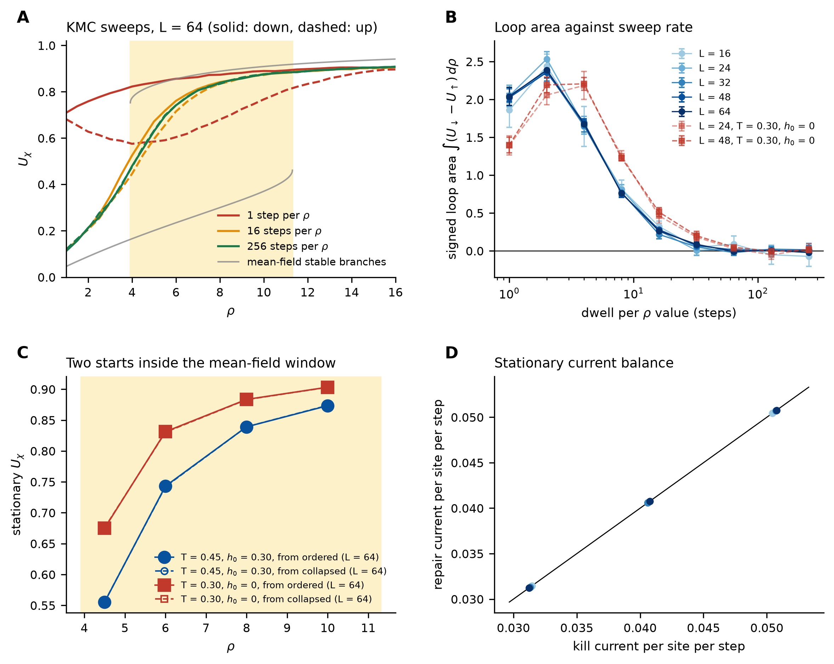
Figure 4. Kinetic Monte Carlo test of Proposition 2 on the nearest-neighbor lattice (T = 0.45, h₀ = 0.30 unless stated). (A) Sweeps of ρ down (solid) and up (dashed) at L = 64, with 1, 16 and 256 steps per ρ value: the loop of fast sweeps closes as the sweep slows; the mean-field window is shaded and its stable branches are grey. (B) Signed loop area against dwell per ρ value for L = 16–64 and for the colder field-free variant (squares); mean ± 95% interval over 8 runs. (C) Stationary order from an ordered and a collapsed start at fixed ρ inside the window (L = 64): the two coincide. (D) Stationary kill and repair currents per site and step at ρ = 4.5, 6 and 8 and L = 16, 32, 64; the line is equality.
4.4 Why the closure fails, and where it holds. The reduction assumes that every intact site is degraded at the rate μ(I) set by the global disorder. The lattice applies instead the average of μ over the local disorders its intact sites actually see, μ̄ = ⟨μ(δ_{i})⟩, and the two differ in both directions (Figure 5A). Where order is low the local disorder of intact sites stays far below the global one: at ρ = 2 the global I is 0.79 while intact sites see δ̄ = 0.45, so the lattice kills at μ̄ = 9.1 against μ(I) = 19.8. Part of this is a ceiling: four rotors pointing in independent random directions give δ = 0.55 on average, barely above K = 0.5, so a nearest-neighbor sensor can never engage the switch fully. Where order is high the lattice kills faster than the closure assumes: at ρ = 6, μ̄ = 2.47 against μ(I) = 1.37, and above even μ(δ̄) = 1.02, the rate at the mean local disorder. That last inequality is the signature of averaging a steep, convex switch over a broad distribution of δ_{i}: the few sites in disordered pockets are killed at nearly the full rate even in an ordered lattice. Together the two effects flatten the effective feedback, and a flattened μ cannot bend F into the S-shape that Proposition 2 requires. Both shrink as the neighborhood that a site senses grows, since the average over n rotors narrows the distribution of δ_{i} and raises its ceiling (to 0.82 for n = 24 and 0.90 for n = 80).
A control experiment tests this directly. Keeping the rotor dynamics, the repair process and every parameter fixed, we let the kill rate respond to the disorder of a larger block of n surrounding sites (n = 8, 24, 80) or to the global disorder 1 − U_{χ}, which imposes mean-field closure on the lattice itself (L = 48, 4 runs per case; Figure 5B–D). With n = 4, the slow-sweep loop disappears (area 0.01 at τ = 256), and with n = 8, it nearly does (0.03); the two starts agree at every ρ. When n = 24, a small loop remains (0.21, still shrinking between τ = 64 and 256), while the starts still agree at the values of ρ tested. With n = 80, the loop has an area of 1.00, and at ρ = 6, the ordered start holds U_{χ} = 0.85, while the collapsed start remains at 0.39 throughout the run. With global sensing, the two starts are separated at ρ = 4.5 (0.82 against 0.28) and 6 (0.85 against 0.37), and the slow sweep collapses at ρ ≈ 3.7, close to the mean-field saddle-node ρ₋ = 3.92, but it recovers already at ρ ≈ 7.5, below ρ₊ = 11.30: at finite N fluctuations, let the collapsed state escape before its own saddle-node, so the loop (area 1.93) is approximately half the quasistatic mean-field value of 4.30.
Because a separation over 2000 steps at one size does not by itself establish bistability, we tested both cases in size and time (Figure A2): L = 32, 48, 64 and 96, 4 runs from each start, 15000 steps each. With global sensing the two starts stay on separate branches at every ρ tested inside the window (4.0, 4.5, 6.0, 7.0) and every size: none of the 128 runs left its branch, and the separation, 0.43–0.54, does not change with L. That is the behavior expected of a genuine mean-field bistability, whose metastable lifetimes grow exponentially with N. With the 80-site neighborhood the results are consistent with a discontinuous transition in a finite-range system. At ρ = 5.5 and 6.0 the separation (0.49 and 0.46) is again independent of L and no run left its branch. At the edges of the window, states do decay: at ρ = 5.0 the ordered state collapsed in 12 of 16 runs, and sooner in larger systems (after 7390–11470 steps at L = 32 but 1200–5070 at L = 96), consistent with a decay rate proportional to the number of sites, as nucleation of the stable phase predicts; at ρ = 6.5 the collapsed state recovered in 13 of 16 runs. With finite-range sensing such nucleation-limited decay is expected to narrow the interval of true coexistence as N → ∞, leaving long-lived metastability and a discontinuous jump near the value of ρ at which an interface between the two phases stalls; our data are consistent with this but do not locate that point. We therefore describe the restored bistability as strong numerical evidence rather than proof: robust in size and time for global sensing, and for the 80-site neighborhood evidence consistent with a discontinuous transition with hysteresis, whose infinite-size, infinite-time limit remains open (problem (b)).
The bistability of Proposition 2 is therefore not an artifact of the reduction: it is realized on the lattice when degradation responds to order averaged over a large enough region, and it is the mean-field limit of that case. It is destroyed when degradation responds only to the nearest neighbors; at the parameters studied, the crossover lies between n = 8 and n = 80 sensed sites. The physical content of Proposition 2 is accordingly conditional on the range over which the degrading flux senses disorder, and that range, not only the gain β and the cooperativity h, is a control parameter of the maintained state.
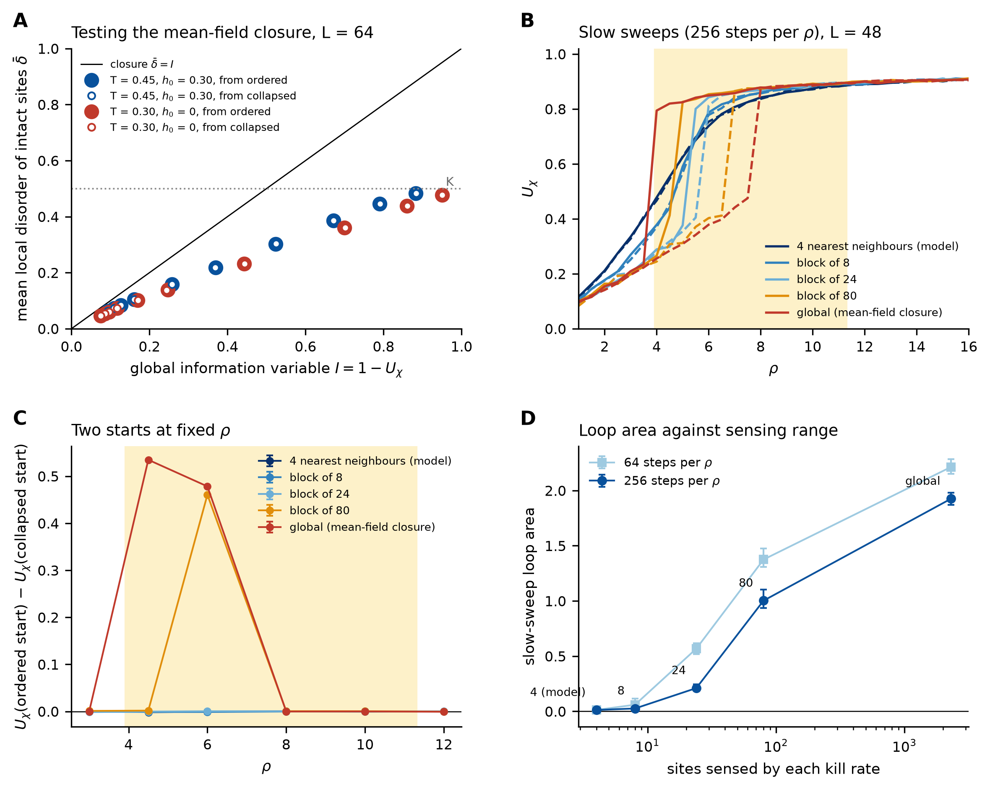
Figure 5. Why nearest-neighbor feedback shows no bistability at the parameters studied, and the sensing range that restores bistability. (A) Mean local disorder of intact sites δ̄ against the global I = 1 − U_{χ} in the stationary lattice (L = 64; filled: ordered start, open: collapsed start; both parameter sets); the line is the closure δ̄ = I and the dotted line marks K. (B) Slow sweeps (256 steps per ρ value) at L = 48 with the kill rate sensing the 4 nearest neighbors (the model), blocks of 8, 24 and 80 sites, or the global disorder; solid down, dashed up; the mean-field window is shaded. (C) Difference in stationary order between the ordered and the collapsed start at fixed ρ, with 95% intervals. (D) Slow-sweep loop area against the number of sites sensed, at 64 and 256 steps per ρ value.

5. Evidence for a BKT-driven field-free transition
At h₀ = 0 the maintained phase requires the intact sublattice to sustain the quasi-long-range order of the two-dimensional XY model [12]. We locate the field-free transition of the quenched problem, in which a fixed fraction f of sites is diluted to g = 0, by finite-size scaling at T = 0.45 with L = 16, 24, 32, 48, 64 and 96 and eight independent disorder realizations per size and dilution (Appendix A), measuring the Binder cumulant U₄ and the helicity modulus (spin stiffness)
$Υ\text{ = }\frac{\text{1}}{L^{\text{2}}}\left\langle \sum_{b}{J\text{cos} Δθ}\right\rangle \text{ − }\frac{\text{1}}{L^{\text{2}}T}\left\langle {\left(\sum_{b}{J\text{sin} Δθ}\right)}^{\text{2}}\right\rangle \text{,}$ (11)
averaged over the two lattice directions. The Nelson–Kosterlitz criterion [26] places the BKT transition where Υ crosses the universal line 2T/π. Dilution lowers the effective coupling and with it the effective transition temperature, and Υ crosses 2T/π at f_{KT}(L) = 0.220 for L = 16, falling slowly to 0.210 at L = 96, with bootstrap intervals over realizations within ±0.005 for L ≥ 48 (Figure 6A, B). The drift is small and of the logarithmic kind expected at a BKT point, and two extrapolations agree: a linear fit in 1/ln²L gives f_{KT}(∞) = 0.205 (95% interval 0.193–0.216), and a Weber–Minnhagen fit [27] of Υ_{L} = (2T/π)[1 + 1/(2 ln L + C)] to the sizes L ≥ 24 gives f_{KT} = 0.205 (0.198–0.213) with χ² = 0.75 for 4 degrees of freedom. The estimate is robust to dropping the smallest lattices: the 1/ln²L extrapolation gives 0.205 (0.194–0.216) for L ≥ 16, 0.209 (0.203–0.282) for L ≥ 24, 0.207 (0.197–0.227) for L ≥ 32, 0.201 (0.181–0.225) for L ≥ 48, and the Weber–Minnhagen fit gives 0.205 (0.196–0.213) for L ≥ 24, 0.205 (0.196–0.213) for L ≥ 32, 0.200 (0.195–0.213) for L ≥ 48. We report f_{KT} ≈ 0.205 as a numerical estimate at L ≤ 96 with eight realizations per point, not as a precisely established critical value. All these estimates lie far below the square-lattice site-percolation value 1 − p_{c} ≈ 0.407 [28]: the intact sublattice still percolates geometrically at f_{KT}, so, within our sizes and numerical resolution, the loss of order is attributable to thermal (BKT) fluctuations rather than to geometric disconnection. The Binder cumulant (Figure 6C) stays at its ordered value up to f ≈ 0.23 and falls between f = 0.26 and 0.35, again well before percolation. The magnitude is plausible: the clean model has T_{BKT} ≈ 0.893 [29], twice the temperature used here, and a linear interpolation of T_{BKT}(f) between that value and zero at percolation, a heuristic only, would bring the transition down to T = 0.45 at f ≈ 0.20.
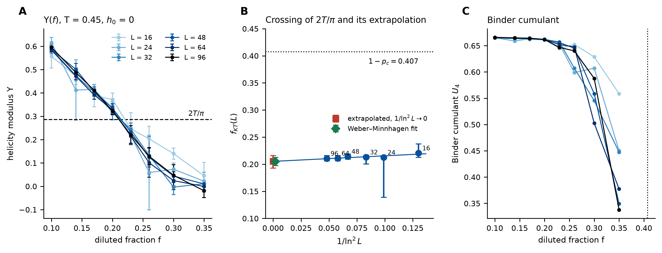
Figure 6. Finite-size scaling of the field-free (h₀ = 0) transition under quenched dilution (T = 0.45; L = 16–96; 8 disorder realizations per point; error bars are 95% intervals). (A) Helicity modulus Υ(f) and the Nelson–Kosterlitz line 2T/π (dashed). (B) Crossing points f_{KT}(L) with bootstrap intervals against 1/ln²L, the linear extrapolation (square) and the Weber–Minnhagen estimate (diamond); the dotted line is the site-percolation value 1 − p_{c} ≈ 0.407. (C) Binder cumulant U₄(f); the dotted line indicates 1 − p_{c}.

6. Entropy production of an auxiliary maintenance cycle
The simulated dynamics are strictly irreversible: a killed site is never unkilled and only repaired, and no transition has a reverse partner. Its Schnakenberg entropy production is therefore formally infinite, and the simulation by itself does not measure a thermodynamic cost. To provide the maintenance cycle with a finite thermodynamic reading, we introduce an auxiliary model, which is not part of the simulated dynamics. A single site has two mesostates, O (intact) and D (diluted), joined by a kill edge O → D with rate k̄, the mean kill rate of an intact site measured in the stationary lattice, and a repair edge D → O with rate R, each given a small reverse rate ε. This is a Schnakenberg network [30] with one cycle of affinity,
$A\text{ = }\text{ln}\left(\frac{k̄R}{ε^{\text{2}}}\right)\text{,}$ (12)
and to the leading order in ε, its stationary current is the measured lattice current J = k̄p = J_{kill} = J_{rep}. Its entropy production rate is
$σ_{\text{aux}}\text{ = }J A\text{ ≥ 0} \text{for} k̄R\text{ ≥ }ε^{\text{2}}\text{.}$ (13)
Figure 7 separates what is measured from what is modeled. The current (Figure 7B) is measured: it is set by the coupled dynamics and differs qualitatively from the uncoupled chain, which it exceeds everywhere. It vanishes as ρ → 0, where little remains to be killed, peaks at J = 0.052 per site and step near ρ = 4, where the feedback is most active, and falls towards λ₀ = 0.02 in the well-maintained regime, where μ̄ → 1. The throughput of the maintenance cycle is therefore largest where order is most fragile, not where most order is held. The entropy production (Figure 7A) is modeled: σ_{aux} inherits from the lattice only the current J and the rates k̄ and R, and depends logarithmically on the unspecified reverse rate ε, diverging in the irreversible limit ε → 0 of the simulation. Two statements survive any choice of small ε: σ_{aux} > 0 throughout, so any thermodynamically consistent completion of the dynamics with weak reverse rates assigns the maintenance cycle a positive dissipation; and its dependence on ρ follows the measured current. Its absolute value does not survive, and we do not claim that the simulation establishes a quantitative thermodynamic cost of maintaining order or information. That would require the microscopic reverse rates of a specific degradation and repair chemistry (open problem (c)).
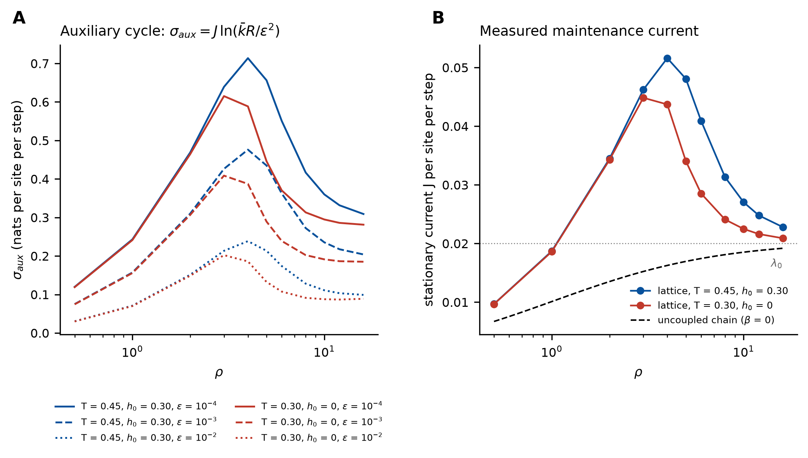
Figure 7. Maintenance current and auxiliary cycle. (A) Entropy production rate σ_{aux} = J ln(k̄R/ε²) of the auxiliary two-state cycle of Section 6 for three reverse rates ε (an illustrative, regularization-dependent quantity, not a property measured in the simulation). (B) Stationary kill current J per site and step measured in the lattice (L = 48, 4 runs per point; the repair current coincides) for both parameter sets, the uncoupled two-state chain (dashed) and λ₀ (dotted).

7. Generality and instances
The construction assumes only three ingredients: a directional order parameter admitting a maximum-entropy law (Theorem 1), an order-dependent flux that removes ordering couplings (the feedback of Section 4), and a repair process that restores them. Systems satisfying these ingredients are expected to exhibit analogous feedback-driven behavior, although the quantitative thresholds and bifurcation structure will depend on their microscopic dynamics — real systems may carry additional degrees of freedom (spatial correlations, memory, non-Markovian repair) that this minimal model does not capture. Instances include the orientational order of a polymer film degraded by ultraviolet chain scission and restored by annealing or self-healing chemistry; magnetic storage domains under thermally activated flips with active error-correcting rewrites (repair); liquid-crystal directors under photochemical damage; and the chiral order of a self-assembled molecular monolayer under non-enzymatic attack with turnover, the applied problem from which this model was abstracted [9]. In each, u_{s} encodes the geometry throttling the flux and ρ measures repair relative to shielded, order-dependent degradation. We emphasize that these are candidate realizations of the same qualitative mechanism, not demonstrated physical instances: the present study is analytic and computational, with no experimental data used (Data and code availability), and the framework should be read as a minimal model that may be applicable to systems with order-dependent degradation and active repair rather than as a validated description of any one of them.

7.1 A falsifiable experimental signature
The mechanism makes a concrete prediction that does not require the rotor language of the model, and Sections 4.3 and 4.4 sharpen it. In any driven, actively maintained, orientationally ordered medium (a magnetic-domain array, a self-healing polymer film, an aligned colloidal or active-particle ensemble), sweep the ratio of repair to degradation down from a well-ordered state and back up at several sweep rates, holding all other conditions fixed. Every such medium shows a loop when the sweep is fast, so the discriminating observable is the loop area extrapolated to zero sweep rate, supported by the dependence of the final state on the initial one at fixed ρ. A finite static loop, with order lost below a threshold ρ₋ and not regained until ρ₊ > ρ₋ however slowly the sweep is made, indicates feedback acting over an extended range, as in Proposition 2. A loop that closes as the sweep slows, as on the nearest-neighbor lattice, indicates feedback that is local, too weak (β < β_{c}) or not cooperative (h ≤ 1); uncoupled two-state degradation shows only the trivial lag of Section 4.1. Where the spatial range over which degradation responds to order can be varied, for example through the diffusion length of a degrading species, the crossover of Section 4.4 is itself testable. This gives Sections 3–6 a shared empirical target across the candidate systems of this section.

8. Status of the claims and approximations
For transparency at the level expected in theoretical statistical physics, we state each principal claim, its logical status, and its support.
Table 1. Status of the principal claims, the logical status of each and its support.
Claim | Status | Support
Order–entropy bijection, dS/dU_{χ} = −κ, tail law (Thm 1) | Proved | Complete analytic proof; Fig. 1
Linear reduction I* = 1/(1 + ρ) at β = 0 | Exact (continuous time) | Two-state master equation; lattice agrees up to the discrete-time correction, Fig. 2, App. A
Bistability and saddle-nodes of the reduction (Prop. 2); threshold β_{c}(h), none for h ≤ 1 | Exact for the mean-field ODE | Analytic; Fig. 3
Bistability on the nearest-neighbor lattice | Not realized at the parameters studied | Zero quasi-static loop area, converging starts, N-independent meeting times; Fig. 4, Fig. A1
Bistability with global sensing | Strong numerical evidence, L ≤ 96 | Finite slow-sweep loop; two branches, no switch in 15 000 steps at any size; Figs. 5, A2
Bistability with 80-site sensing | Consistent with a discontinuous transition with metastability | Split branches mid-window; nucleation-limited decay at the edges, faster at larger L; Figs. 5, A2
Nonequilibrium steady state (J_{kill} = J_{rep}) | Validated numerically | Relative current imbalance below 10⁻³; Fig. 4D
Field-free transition consistent with BKT, f_{KT} ≈ 0.205 < 1 − p_{c} | Numerical estimate (FSS, L = 16–96) | Helicity modulus vs 2T/π, two extrapolations and their sensitivity, Binder cumulant; Fig. 6
Maintenance current J(ρ), nonmonotonic | Measured | Fig. 7B, Fig. 4D
Entropy production σ_{aux} > 0 | Illustrative, auxiliary model | Depends on the added reverse rate ε; Fig. 7A

The framework rests on three explicitly identified approximations. (1) The annealed mean-field closure δ ≐ I underlies Proposition 2. It is now tested directly (Section 4.4): it fails for nearest-neighbor sensing, where it misstates the effective feedback in both directions and becomes accurate as the sensing range increases; whether it becomes exact in a limit in which the range grows with N is an open problem (a). (2) The slaving U_{χ} ≐ p in the β = 0 baseline holds up to a boundary-layer correction controlled by J₀ and h₀. (3) The entropy production of Section 6 belongs to an auxiliary cycle with reverse rates ε that the simulated dynamics do not have; it is illustrative, and the strictly irreversible limit is singular. No other claim relies on an unstated approximation.

9. Open problems
(a) Range of the feedback and the mean-field limit: rigorously establish the scaling limit of the coupled rotor/integrity process and the conditions under which the nonlinear mean-field ODE, including its bistability, is exact, for instance, in a Kac-type limit in which the sensing range increases with N [18]; locate the critical sensing range as a function of (β, h, K, T); and determine whether any region of nearest-neighbor parameters, such as much larger β or smaller K, is bistable.
(b) Metastability and first passage: for finite sensing ranges, determine whether an interval of coexistence survives N → ∞ or shrinks to the single value of ρ at which an interface between the phases stalls, as the nucleation-limited decay at the window edges (Section 4.4) suggests, and characterize the distribution of collapse times and the large-deviation rate for noise-induced transitions, including how the lifetimes scale with N and with the sensing range.
(c) Thermodynamics and the BKT point: a quantitative cost of maintenance requires a thermodynamically consistent model of the degradation and repair steps, with microscopic reverse rates, in place of the auxiliary cycle of Section 6, after which the fluctuation theorems for the entropy production can be tested across the bifurcation; the Nelson–Kosterlitz analysis here (L ≤ 96) gives f_{KT} ≈ 0.205, for which larger sizes, more realizations and temperature scans along the dilution line should be refined.

10. Conclusion
Making degradation depend on the order it destroys turns a passive decay problem into a genuine nonequilibrium one. In mean field the maintained lattice is governed by a single ratio ρ through a nonlinear law that is bistable above a computed feedback threshold. On the lattice the same feedback is bistable only if degradation senses disorder over an extended region, robustly when it senses the global order and, for a finite range, in a form consistent with a discontinuous transition with long-lived metastability. With nearest-neighbor sensing, within the parameters and sizes tested, the broad distribution of local disorder averages the switch away, the steady state appears unique, and the hysteresis seen at finite sweep rates is dynamic and vanishes in the quasi-static limit. The range of the feedback thus joins its gain and cooperativity as a control parameter, and the loop area extrapolated to zero sweep rate is the observable that distinguishes the two regimes. The field-free loss of order is consistent with a BKT mechanism, at an estimated f_{KT} ≈ 0.205, far below percolation. The maintenance current peaks where order is most fragile, and any thermodynamically consistent completion of the dynamics assigns it a positive dissipation, though its size is not fixed by the model; the exact relation dS/dU_{χ} = −κ ties directional order to configurational information. The framework is substrate-free, packaging a family of maintenance-versus-decay problems into one reduced, dissipative law together with a lattice criterion for when that law holds.

Author contributions (CRediT)
Leon Sandler: Conceptualization, Methodology, Software, Formal analysis, Writing – original draft, Writing – review & editing.

Declaration of competing interest
The author declares that he has no known competing financial interests or personal relationships that could have appeared to influence the work reported in this paper.

Funding
This research did not receive any specific grant from funding agencies in the public, commercial or not-for-profit sectors.

Declaration of generative AI and AI-assisted technologies in the writing process
During the preparation of this work the author used Claude (Anthropic) to assist with typesetting the equations in the journal's format, writing and testing the Monte Carlo and analysis code of Sections 4.3–5 and Appendix A to the author's specification, checking the reference list against Crossref records and language editing. After using this tool, the author reviewed and edited the content as needed and takes full responsibility for the content of the publication.

Data and code availability
All Monte Carlo results, the engine, its verification suite, the analysis scripts that turn raw runs into every number of Sections 4–6 and Appendix A, the raw run outputs and the scripts for every figure are openly available at https://github.com/sandlerleon/rotational-lattice-maintenance, archived at https://doi.org/10.5281/zenodo.23131432. Each run is reproducible on its own from its seed code (Appendix A). Every figure, including the analytic Figures 1 and 3, is generated by scripts in that repository (figures_theory.py and analyze_study.py). The engine reproduces exactly the update rules of the open-source MyUncle framework (https://github.com/sandlerleon/MyUncle, https://doi.org/10.5281/zenodo.21223569) used for earlier versions. This manuscript is archived as a preprint at https://doi.org/10.5281/zenodo.21210708. No experimental data were used.

Appendix A. Monte Carlo protocol and error analysis
A.1 Engine and verification. One step consists of two checkerboard Metropolis sweeps of the rotors at fixed integrity, with proposals uniform on (−π, π], followed by one synchronous site update: each intact site is diluted with probability λ_{i}, then each diluted site is repaired with probability R and its rotor reset to θ = 0. One step is the unit of time throughout. The engine restates the update rules of the MyUncle framework used for earlier versions of this work and, before any result was computed, passed the checks of its test suite: it reproduces MyUncle trajectories bit for bit for the same seed at two parameter sets; at β = 0, the intact fraction relaxes to the discrete two-state fixed point R/(λ₀ + R − λ₀R) (0.7606 measured against 0.7614 exact and 0.7500 for the continuous-time value); R = 0 never repairs and λ₀ = 0 never kills; the helicity modulus of the ordered undiluted lattice equals 1; and the block and global sensing options of Section 4.4 average exactly the intended sites.
A.2 Seeding and error estimates. Every run is seeded from a NumPy SeedSequence of a master seed (20261003) and a code naming its study, parameter set, size, control value, replicate and initial state, so runs are statistically independent and each can be repeated alone. Interval estimates are 95% percentile intervals from 2000 bootstrap resamples over independent runs or disorder realizations [31], so that variation between runs, not correlation within a run, sets the error.
A.3 Equilibration and autocorrelation. Integrated autocorrelation times are estimated with an automatic window W ≥ 6τ_{int} [32]. In the stationary coupled lattice τ_{int}(U_{χ}) = 6–11 steps and τ_{int} of the intact fraction 9–16 steps for L = 16–64 and ρ = 4.5–8 (Figure A1A, B), with no growth with L. The 2000-step discard of the stationary runs is therefore more than 150τ_{int}, and the second-half averages of the 3000-step two-start runs begin after 1500 steps, more than 100τ_{int}. In the quenched runs of Section 5, 2000 equilibration sweeps precede 4000 measurement sweeps; the longest τ_{int} of Υ at any size and dilution is 69 sweeps, so each realization contributes at least 29 effectively independent samples, and the error of each point is in any case taken from the spread over the eight disorder realizations.
A.4 Run table. Table A1 lists every study.
Table A1. Monte Carlo runs. Times are in steps (coupled lattice) or sweeps (quenched lattice); “runs” are independent replicates per parameter combination.
Study (section) | Sizes L | Control values | Runs | Length; discard; sampling
Sweep rate (4.3) | 16, 24, 32, 48, 64; colder variant 24, 48 | ρ = 16 → 1 → 16, 31 values; dwell τ = 1–256 (9 values) | 8 | 200-step settle at ρ = 16, then 62τ; U_{χ} at the end of each dwell
Two starts (4.3) | 16, 24, 32, 48, 64 | ρ = 4.5, 6, 8, 10; both parameter sets | 8 per start | 3000; first half; every 5
Stationary (4.3, A.3) | 16, 32, 64 | ρ = 4.5, 6, 8 | 4 | 12 000; 2000; every step
Closure (4.4) | 64 | ρ = 1–16 (10 values); both parameter sets and starts | 4 | 800 + 1200; 800; every 4
Sensing range (4.4) | 48 | block of 8, 24, 80 sites, global; sweeps τ = 64, 256; two starts at ρ = 3–12 | 4 | sweeps as above; two starts 2000, first half, every 5
Quenched dilution (5) | 16, 24, 32, 48, 64, 96 | f = 0.10–0.35 (8 values), T = 0.45, h₀ = 0 | 8 realizations | 2000 + 4000 sweeps; 2000; every 4

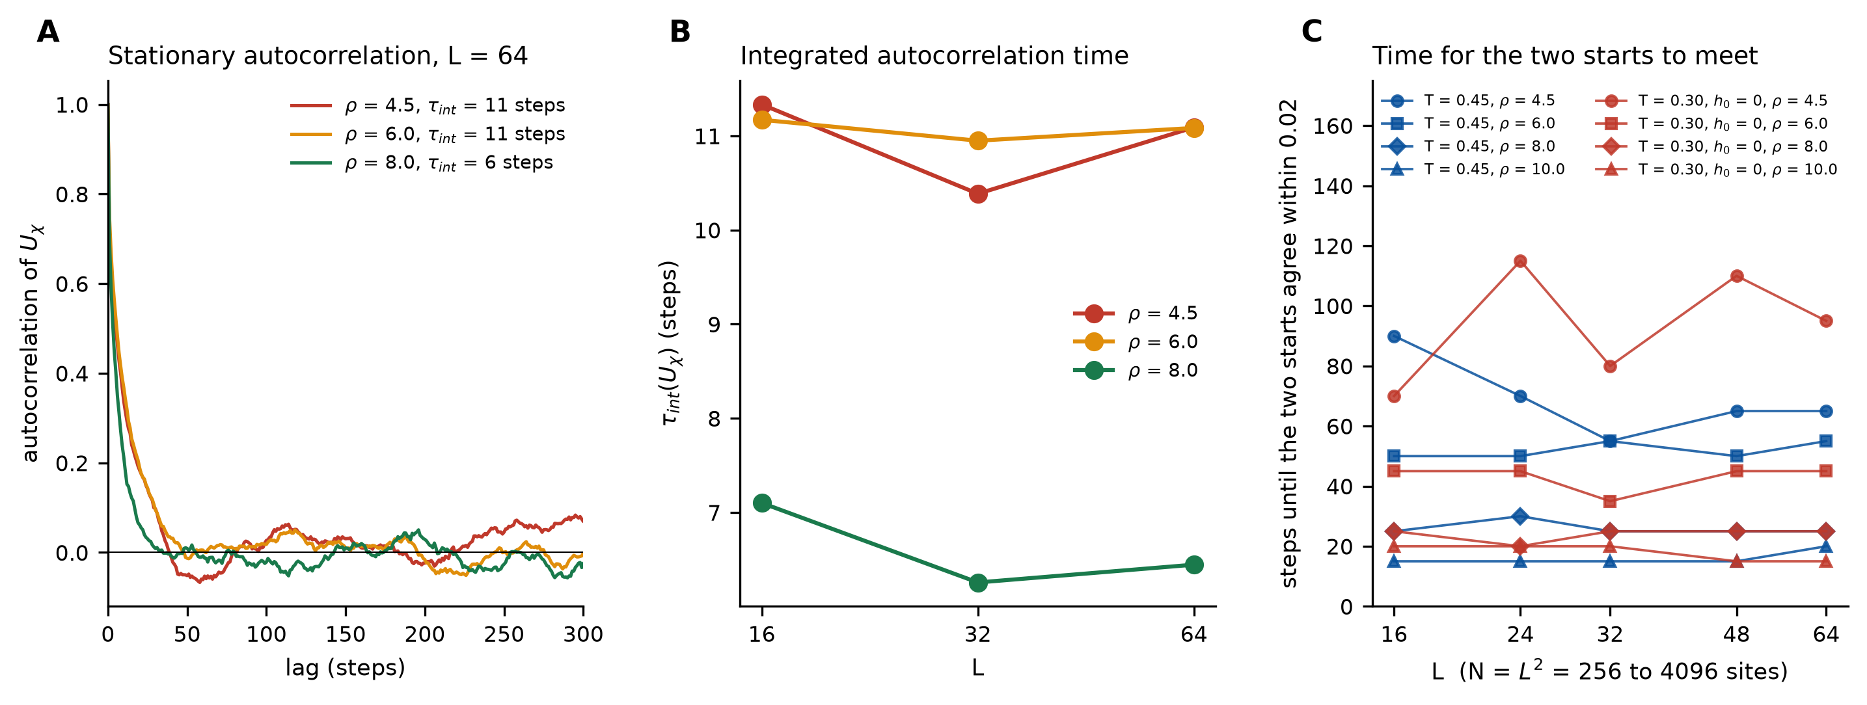
Figure A1. Monte Carlo diagnostics. (A) Stationary autocorrelation of U_{χ} at L = 64 for three values of ρ, with the integrated autocorrelation time. (B) τ_{int}(U_{χ}) against L: no critical slowing down. (C) Time for the seed-averaged trajectories from the ordered and collapsed start to agree within 0.02 (20-step moving average) against the number of sites for both parameter sets and four values of ρ inside the mean-field window; it does not increase with N.
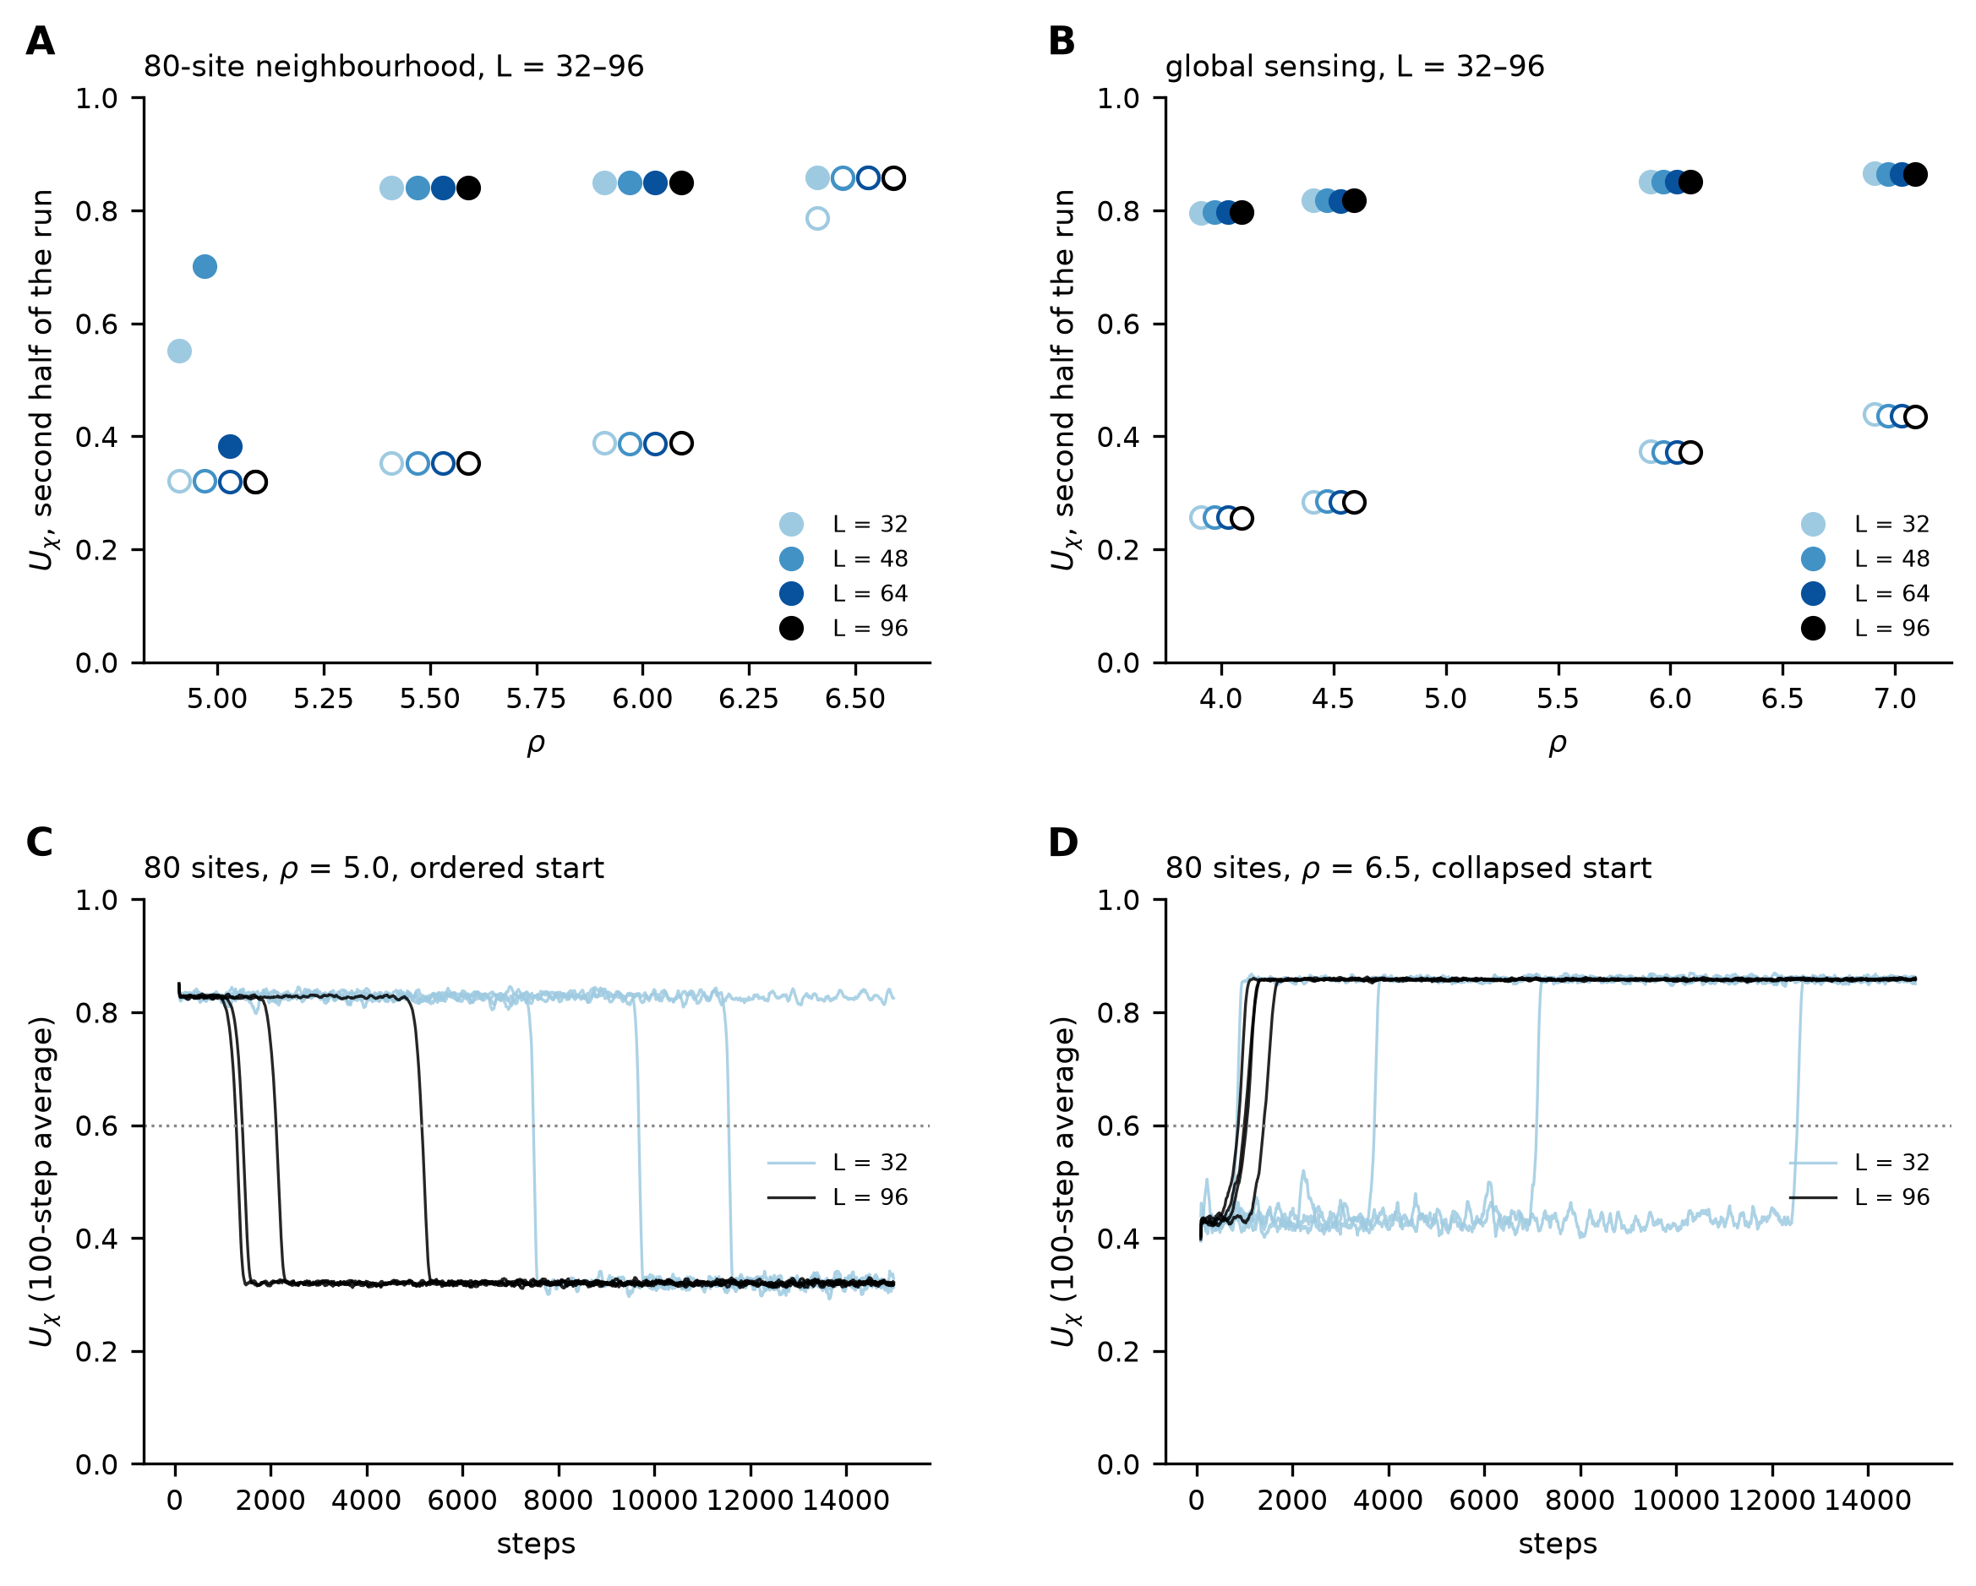
Figure A2. Extended-range bistability in size and time (4 runs per start, 15000 steps). (A, B) Order in the second half of each run from the ordered (filled) and the collapsed (open) start, for the 80-site neighborhood and for global sensing, at L = 32–96 (points offset for visibility). (C) Ordered starts of the 80-site case at ρ = 5.0 decay to the collapsed branch, sooner at L = 96 than at L = 32. (D) Collapsed starts at ρ = 6.5 recover. Dotted: the threshold U_{χ} = 0.6 used to detect a switch.

References
[1] M.C. Cross, P.C. Hohenberg, Pattern formation outside of equilibrium, Rev. Mod. Phys. 65 (1993) 851–1112. https://doi.org/10.1103/RevModPhys.65.851
[2] M.C. Marchetti, J.F. Joanny, S. Ramaswamy, T.B. Liverpool, J. Prost, M. Rao, et al., Hydrodynamics of soft active matter, Rev. Mod. Phys. 85 (2013) 1143–1189. https://doi.org/10.1103/RevModPhys.85.1143
[3] S. Ramaswamy, The mechanics and statistics of active matter, Annu. Rev. Condens. Matter Phys. 1 (2010) 323–345. https://doi.org/10.1146/annurev-conmatphys-070909-104101
[4] F. Schlögl, Chemical reaction models for non-equilibrium phase transitions, Z. Phys. 253 (1972) 147–161. https://doi.org/10.1007/BF01379769
[5] J.E. Ferrell, Self-perpetuating states in signal transduction: positive feedback, double-negative feedback and bistability, Curr. Opin. Cell Biol. 14 (2002) 140–148. https://doi.org/10.1016/S0955-0674(02)00314-9
[6] H. Hinrichsen, Non-equilibrium critical phenomena and phase transitions into absorbing states, Adv. Phys. 49 (2000) 815–958. https://doi.org/10.1080/00018730050198152
[7] B. Blaiszik, S. Kramer, S. Olugebefola, J. Moore, N. Sottos, S. White, Self-healing polymers and composites, Annu. Rev. Mater. Res. 40 (2010) 179–211. https://doi.org/10.1146/annurev-matsci-070909-104532
[8] W.F. Brown, Thermal fluctuations of a single-domain particle, Phys. Rev. 130 (1963) 1677–1686. https://doi.org/10.1103/PhysRev.130.1677
[9] L. Sandler, A chiral-order glycation channel for synthetic cells, companion preprint, Zenodo, 2026.
[10] T. Vicsek, A. Czirók, E. Ben-Jacob, I. Cohen, O. Shochet, Novel type of phase transition in a system of self-driven particles, Phys. Rev. Lett. 75 (1995) 1226–1229. https://doi.org/10.1103/PhysRevLett.75.1226
[11] J. Toner, Y. Tu, Long-range order in a two-dimensional dynamical XY model: how birds fly together, Phys. Rev. Lett. 75 (1995) 4326–4329. https://doi.org/10.1103/PhysRevLett.75.4326
[12] J.M. Kosterlitz, D.J. Thouless, Ordering, metastability and phase transitions in two-dimensional systems, J. Phys. C: Solid State Phys. 6 (1973) 1181–1203. https://doi.org/10.1088/0022-3719/6/7/010
[13] R. Landauer, Irreversibility and heat generation in the computing process, IBM J. Res. Dev. 5 (1961) 183–191. https://doi.org/10.1147/rd.53.0183
[14] J.M.R. Parrondo, J.M. Horowitz, T. Sagawa, Thermodynamics of information, Nat. Phys. 11 (2015) 131–139. https://doi.org/10.1038/nphys3230
[15] J.J. Hopfield, Kinetic proofreading: a new mechanism for reducing errors in biosynthetic processes requiring high specificity, Proc. Natl. Acad. Sci. USA 71 (1974) 4135–4139. https://doi.org/10.1073/pnas.71.10.4135
[16] U. Seifert, Stochastic thermodynamics, fluctuation theorems and molecular machines, Rep. Prog. Phys. 75 (2012) 126001. https://doi.org/10.1088/0034-4885/75/12/126001
[17] F.S. Gnesotto, F. Mura, J. Gladrow, C.P. Broedersz, Broken detailed balance and non-equilibrium dynamics in living systems: a review, Rep. Prog. Phys. 81 (2018) 066601. https://doi.org/10.1088/1361-6633/aab3ed
[18] T.M. Liggett, Interacting Particle Systems, Springer, New York, 1985.
[19] E.T. Jaynes, Information theory and statistical mechanics, Phys. Rev. 106 (1957) 620–630. https://doi.org/10.1103/PhysRev.106.620
[20] K.V. Mardia, P.E. Jupp, Directional Statistics, Wiley, Chichester, 2000.
[21] D.E. Amos, Computation of modified Bessel functions and their ratios, Math. Comput. 28 (1974) 239–251. https://doi.org/10.1090/S0025-5718-1974-0333287-7
[22] L. Sandler, Order–repair model: repair fidelity as a control parameter for tissue stability, software and manuscript, Zenodo, 2026. https://doi.org/10.5281/zenodo.22851970.
[23] M. Rao, H.R. Krishnamurthy, R. Pandit, Magnetic hysteresis in two model spin systems, Phys. Rev. B 42 (1990) 856–884. https://doi.org/10.1103/PhysRevB.42.856
[24] A. Bortz, M. Kalos, J. Lebowitz, A new algorithm for Monte Carlo simulation of Ising spin systems, J. Comput. Phys. 17 (1975) 10–18. https://doi.org/10.1016/0021-9991(75)90060-1
[25] R. Pfister, K.A. Schwarz, M. Janczyk, R. Dale, J.B. Freeman, Good things peak in pairs: a note on the bimodality coefficient, Front. Psychol. 4 (2013) 700. https://doi.org/10.3389/fpsyg.2013.00700
[26] D.R. Nelson, J.M. Kosterlitz, Universal jump in the superfluid density of two-dimensional superfluids, Phys. Rev. Lett. 39 (1977) 1201–1205. https://doi.org/10.1103/PhysRevLett.39.1201
[27] H. Weber, P. Minnhagen, Monte Carlo determination of the critical temperature for the two-dimensional XY model, Phys. Rev. B 37 (1988) 5986–5989. https://doi.org/10.1103/PhysRevB.37.5986
[28] D. Stauffer, A. Aharony, Introduction to Percolation Theory, second ed., Taylor & Francis, London, 1994.
[29] M. Hasenbusch, The two-dimensional XY model at the transition temperature: a high-precision Monte Carlo study, J. Phys. A: Math. Gen. 38 (2005) 5869–5883. https://doi.org/10.1088/0305-4470/38/26/003
[30] J. Schnakenberg, Network theory of microscopic and macroscopic behavior of master equation systems, Rev. Mod. Phys. 48 (1976) 571–585. https://doi.org/10.1103/RevModPhys.48.571
[31] B. Efron, Bootstrap methods: another look at the jackknife, Ann. Stat. 7 (1979) 1–26. https://doi.org/10.1214/aos/1176344552
[32] N. Madras, A.D. Sokal, The pivot algorithm: a highly efficient Monte Carlo method for the self-avoiding walk, J. Stat. Phys. 50 (1988) 109–186. https://doi.org/10.1007/BF01022990

