Change-Aware Reliability-Gated Sensor Fusion: Risk-Bounded Decisions Under Infrastructure Modifications and Model Uncertainty
Leon Sandler
Independent Researcher, Northbrook, Illinois, USA
ORCID: 0009-0007-4584-808X • Corresponding author: sandler.leon@gmail.com
Software: https://github.com/sandlerleon/subsurface-risk-calibrated-mapping (archived at https://doi.org/10.5281/zenodo.23375299). Preprint: https://doi.org/10.5281/zenodo.23375305.

Abstract
Monitoring must support safety decisions while the monitored structure changes between observations, instruments fail, work records are incomplete and models are imperfect. This simulation study proposes change-aware reliability-gated sensor fusion and evaluates it on excavation clearance above buried utilities and on continued use of an industrial scaffold. A hidden-Markov estimator tracks a latent hazard state from asynchronous point sensors, periodic surveys and work records; authorization is contextual evidence, never proof of safety; a decision is released only if the highest hazard probability over the model alternatives that the surveys have not rejected meets a risk criterion, which is conditional on the assumed alternatives and not a guarantee. At matched decision coverage, dynamic estimation lowered the conditional unsafe-decision risk by a factor of 3.7 (utilities) and 2.1 (scaffolds) relative to static-state fusion, and its predicted risk tracked the observed risk as survey age grew. Suppressing permit-matched changes left a hazardous, unflagged state after 22% and 39% of the changes made under a valid permit, against 2% and 5% when permits were used as context. Point sensors added little to periodic surveys, and risk-optimized placement was not consistently better than simple rules. The gate lowered the risk under combined failures by abstaining rather than by better inference, and no method was reliable against every failure mode. The scaffold advantage held under 16 definitions of an unsafe structure. Results are conditional on the simulated environments, are not validated against field data, and the scaffold criterion is synthetic.
Keywords: reliability of monitoring systems; digital twin; model mismatch; change detection; work-permit reconciliation; sensor fusion; reliability-gated decisions; underground utilities; scaffolding

1. Introduction: reliability of decisions under changing infrastructure states
Monitoring systems for infrastructure turn sensor evidence into decisions: release a stretch of ground for mechanical excavation, let people continue to use a scaffold, keep a pipeline in service. The evidence is rarely complete, and the thing being monitored does not stand still. A utility is relocated, repaired or newly installed between two surveys; a brace is removed from a scaffold in the course of authorized work, or without any authorization. The usual remedy is a digital twin or an as-built model that is kept up to date with sensors and work records (Tao et al., 2019; Kritzinger et al., 2018; Jones et al., 2020). A twin, however, is a model, and the decisions that rest on it are only as reliable as the model’s validity at the moment of the decision. It can be stale because the last observation is old, invalid because the change process differs from the one assumed, or misled by an instrument that has failed without announcing it, by a work record that is incomplete or wrong, or by a region that no sensor observes (Zio, 2009; Zio, 2018; Isermann, 2005).
The question that motivates this study is therefore a reliability question: how can a monitoring system distinguish genuine safety-relevant changes from authorized modifications, sensor failures and incomplete observations without becoming overconfident? Three requirements follow. The system has to know what it can observe and when it last observed it, and let the probability of an unobserved change grow in the way the process it monitors dictates, not by an arbitrary confidence-decay factor. It has to use work records as evidence about what is likely to have changed, without treating an authorized change as a safe one, since a permitted activity can still leave the structure hazardous and the record may be wrong. And it has to refuse to support a decision when its model alternatives, taken together, no longer meet the risk criterion, which is a property of the decision and not only of the estimate.
We study these requirements on two structurally different problems. In the first, a utility map and a periodic ground-penetrating radar (GPR) and electromagnetic (EM) survey support the decision whether a segment of corridor may be released for mechanical excavation; the hazard is a utility inside the excavation envelope, and the changes are installations, relocations and repairs. In the second, point sensors on the joints of an industrial scaffold, periodic three-dimensional vision sweeps and work permits support the decision whether the scaffold may continue to be used; the hazard is a missing or disconnected load-bearing member, and the changes are authorized and unauthorized removals. The two problems share a structure (elements with a hidden hazard state, observed asynchronously, with records of work) and differ in sensors, rates, observability and in how element hazards combine into a decision. That is the reason for studying them together: a reliability method that works for one sensor model and one infrastructure type tells little about the method.
The contributions are: (i) a dynamic formulation of the reliability of monitoring decisions, with a safety failure event, three reliability metrics and an explicit treatment of observation age, authorization and sensor coverage (Section 3); (ii) change-aware reliability-gated sensor fusion (CARGSF), which combines a hidden-Markov state estimator with permit reconciliation that keeps authorization separate from hazard, and a gate that releases a decision only if the supremum of the hazard probabilities over the model alternatives that the surveys have not rejected meets a risk criterion (Section 4); (iii) eight experiments that compare it with static, dynamic and domain-specific baselines at matched decision coverage, under single and combined failures, and that vary the monitoring architecture and the allocation of sensors (Sections 5 to 8); (iv) a reliability analysis of the survey evidence layer that feeds the utility case, including sensor-fault and common-cause scenarios, the aleatory and epistemic parts of the unsafe-release risk and a global sensitivity analysis (Section 6.1); and (v) negative results reported alongside the positive ones: continuous point sensors added little to periodic surveys, risk-optimized placement was not consistently better than simple rules, the reliability gate lowered risk mainly by abstaining, and a more elaborate spatial model was less reliable than a simpler one when its geometry assumption failed.
Hypotheses. The experiments were designed to test three hypotheses, stated before they were run.
- H1 (dynamic model validity). Accounting for infrastructure modifications and observation age reduces the conditional unsafe-decision risk relative to static-state probabilistic fusion at matched decision coverage.
- H2 (context-aware change attribution). Incorporating work-event information improves the identification of expected and unexpected changes without increasing the rate of undetected hazardous states.
- H3 (cross-domain reliability). A common reliability-gated architecture gives measurable benefits in two structurally different monitoring problems when compared with calibrated, domain-specific baselines.
Scope. Everything reported here is a simulation under stated assumptions. The sensor models are thresholded signal models whose parameters are assumptions and were not fitted to field data; no published detection dataset was reproduced. The scaffold benchmark uses a synthetic structural criterion (a critical member, or two non-critical members of a bay, hazardous), which is not an engineering model and has not been assessed by a structural engineer. Reliability figures are conditional on the simulated environments and are used to compare methods and to expose failure mechanisms, not to estimate the safety of any real excavation or structure. No claim is made about hardware, hazardous-area certification or deployment.

2. Related work: state estimation, digital twins, change detection, mismatch and risk control

2.1 State estimation and digital twins
Recursive Bayesian estimation of a hidden state from noisy observations is classical, from the linear filter (Kalman, 1960) to hidden Markov models (Rabiner, 1989), and underlies occupancy mapping (Elfes, 1989). Digital twins couple such a model to a physical asset and are reviewed for industry (Tao et al., 2019), manufacturing (Kritzinger et al., 2018) and by systematic literature review (Jones et al., 2020). The twin literature is largely concerned with how the twin is built and kept synchronized. The question taken up here is different: when may a decision rest on the twin, given that its synchronization is never perfect.

2.2 Change detection, concept drift and contextual anomalies
Sequential detection of changes in a process is an old problem (PAGE, 1954; Basseville, 1988), and adaptation to a process whose statistics drift is surveyed as concept drift (Gama et al., 2014). Anomaly detection distinguishes point, collective and contextual anomalies and notes that context decides whether a deviation is an anomaly (Chandola et al., 2009). A work permit is context in this sense. The risk in using it is that context can be mistaken for explanation: a change that matches a permit is not thereby safe. The study evaluates this explicitly.

2.3 Probabilistic safety assessment, model uncertainty and fault diagnosis
Safety is quantified as the likelihood and consequence of failure events (Kaplan and Garrick, 1981). Aleatory variability and epistemic uncertainty have to be kept apart (Apostolakis, 1990; Helton and Burmaster, 1996; Der Kiureghian and Ditlevsen, 2009; Aven and Zio, 2011; Hüllermeier and Waegeman, 2021), and model uncertainty, where the structural form of the model may be wrong, is best treated by scenarios or envelopes when probabilities for the alternatives are not defensible (Droguett and Mosleh, 2008; Flage et al., 2014; Ferson and Ginzburg, 1996; Oberkampf et al., 2004; Paté-Cornell, 1996; Aven, 2016). Fault detection treats a failed or degraded instrument as a hypothesis to be tested against the evidence (Isermann, 2005; Venkatasubramanian et al., 2003), fault trees and Bayesian networks connect component failures to system failure (Bobbio et al., 2001; Langseth and Portinale, 2007; Weber et al., 2012; Ruijters and Stoelinga, 2015; Straub and Der Kiureghian, 2010), and dependent failures invalidate the multiplication of component probabilities (Mosleh, 1991). Life-cycle reliability treats deterioration of structures over time (Frangopol and Maute, 2003); the present study is concerned with the decision, not with the deterioration model.

2.4 Selective decisions, abstention and risk control
A system that declines to decide when the evidence is weak trades error against coverage (Chow, 1970; Hendrickx et al., 2024), and thresholds can be chosen on calibration data to meet a risk target (Bates et al., 2021). Scores are mapped to probabilities by calibration (Zadrozny and Elkan, 2002; Niculescu-Mizil and Caruana, 2005; Naeini et al., 2015). Because a monotone calibration does not change a ranking, an abstention rule can look better than a competitor merely because it abstains more. The study therefore compares methods at matched decision coverage on risk–coverage curves and reports the coverage next to every risk.

2.5 Sensor placement and structural health monitoring
Where to place sensors under a budget is a combinatorial problem, often attacked by greedy maximization of a monotone submodular objective (Nemhauser et al., 1978; Guestrin et al., 2005), and it has a long history in structural identification (Papadimitriou, 2004) and structural health monitoring (Farrar and Worden, 2010). These methods optimize information about a parameter or a mode shape. The objective here is the unsafe-decision risk of the full monitoring and decision policy.

2.6 The two application domains
The capabilities and limits of GPR and EM locators for utility mapping have been reviewed (Metje et al., 2007; Costello et al., 2007; Hao et al., 2012; Lai et al., 2018), positional accuracy depends on survey set-up (Jaw and Hashim, 2013) and depth picking (Xie et al., 2022), and detection and tracking can use hyperbola recognition (Dou et al., 2017), multi-sensor tracking (Dou et al., 2016) or mapping from partial observations (Dou et al., 2020). The quality of utility information is graded from records to exposure (ASCE, 2002). Scaffold accidents are a recurrent cause of construction injuries, and inspection practice and the condition of the structure at the time of use have been evaluated on construction sites (Halperin and McCann, 2004). Work records, permits to work and work orders are standard in both domains, and neither literature, as far as we are aware, treats them as probabilistic evidence about the hazard state while keeping authorization separate from safety.
Table 1. Closest existing approaches and the present framework. Yes = addressed; — = not addressed in the abstract or title read; n/e = not examined in detail. A reading of the cited work, not an audit of it.
Approach | Dynamic state | Work-record context | Asynchronous coverage | Sensor-health modeling | Reliability gate over model alternatives | Two-domain evaluation
Digital twins (Tao et al., 2019; Jones et al., 2020) | Yes (synchronization) | n/e | n/e | n/e | — | —
Kalman and hidden-Markov filtering (Kalman, 1960; Rabiner, 1989) | Yes | — | Yes (by construction) | — | — | —
Change detection and concept drift (Page, 1954; Gama et al., 2014) | Yes | — | — | — | — | —
Contextual anomaly detection (Chandola et al., 2009) | n/e | Yes (context) | n/e | — | — | —
Selective prediction and risk control (Chow, 1970; Bates et al., 2021) | — | — | — | — | Partly (calibrated threshold) | —
Sensor placement (Guestrin et al., 2005; Papadimitriou, 2004) | — | — | — | n/e | — | —
Multi-sensor utility location (Dou et al., 2016) | Partly (tracking) | — | — | — | — | —
This work (simulation) | Yes | Yes (kept separate from hazard) | Yes | Yes (assumed diagnostic) | Yes (supremum, validity selection) | Yes (synthetic scaffold)

The novelty claimed is the combination and its reliability analysis, not a new filtering algorithm: the estimator is a standard hidden-Markov filter, and the gate is a supremum over a set of alternatives with a likelihood-based rejection rule. What is new is the treatment of the decision, not the estimate, as the object of reliability analysis under change, the explicit separation of authorization from hazard, and the comparison with static and domain-specific baselines at matched coverage in two domains.

3. Dynamic reliability problem formulation

3.1 Decision, safety failure event and reliability metrics
A decision unit is the object on which a release decision is taken: a 5 m corridor segment in the utility problem, a whole scaffold in the scaffold problem. At epoch t let A_{t} = 1 if the decision unit is released (a segment is released for mechanical excavation; a scaffold may continue in use), and Q_{t} = 1 if the unit is in a hazardous state (a utility lies inside the excavation envelope; a critical member is missing or disconnected). The safety failure event is
$F_{t}\text{ = \{}A_{t}\text{ = 1, }Q_{t}\text{ = 1\}}$ (1)
Three metrics are reported with explicit denominators: the unsafe-decision probability P(F) = P(A = 1, Q = 1), the conditional risk among released decisions P(Q = 1 | A = 1), and the decision coverage P(A = 1), related by
$P\text{(}F\text{) = }P\text{(}Q\text{ = 1 | }A\text{ = 1) }P\text{(}A\text{ = 1)}$ (2)
The conditional decision reliability in the simulated environment is R_{decision} = 1 − P(Q = 1 | A = 1). It is not the probability that an actual excavation or an actual period of scaffold use is accident-free, which depends on practice, supervision and behavior that are not modeled. Because a method that releases less is safer by construction, every comparison of risk is made at matched coverage on a risk–coverage curve, or the coverage is reported next to the risk.

3.2 Dynamic infrastructure state and observation freshness
The monitored object changes between observations. Let its latent state be
$X_{t}\text{ = (}G_{t}\text{, }Q_{t}\text{, }H_{t}\text{)}$ (3)
with G_{t} the physical geometry or configuration, Q_{t} the safety-relevant condition and H_{t} the health of the sensors, and let it evolve as P(X_{t} | X_{t−1}, W_{t}, M), where W_{t} are recorded work and environmental events and M is the assumed transition model. For underground utilities the transitions are relocation, repair, excavation disturbance and new installation; for scaffolds they are missing braces, altered connections and displacement. In the simulations G enters through modification events only, Q is a binary hazard indicator per element and H the health state of each point sensor (Section 4). The probability that a previously reliable map has become unreliable grows with the time since the last observation of the element at a rate that the transition model, not a universal decay factor, determines. The study asks how fast (Section 6.2).

3.3 Modification, authorization and work records
Let C_{t} = 1 if a physical modification occurred at epoch t, A^{auth}_{t} = 1 if it was authorized, D_{t} the sensor evidence and W_{t} the work-record evidence. The quantity of interest is the joint posterior
$P\text{(}C_{t}\text{, }A_{\text{auth,}t}\text{ | }D_{t}\text{, }W_{t}\text{)}$ (4)
which is kept separate from the probability of a hazardous state, P(Q_{t} = 1 | C_{t}, A^{auth}_{t}, …). An authorized modification may or may not leave a hazard (with probability θ_{A} it does), an unauthorized one usually does (θ_{U} > θ_{A}), and the work records may be missing, delayed, attached to the wrong element or spurious. Table 2 lists the four cases that distinguish a method that uses the records as context from one that does not, and the response that a reliable method should give.
Table 2. Cases of physical change and work-record status, and the expected response.
Physical change | Work-record status | Expected response
No change | No record | Continue monitoring
Change | Valid record | Reassess the physical hazard and update the state; authorization does not suppress the hazard
Change | No valid record | Investigate and escalate
Change | Record missing or incorrect | Mark authorization uncertain and verify

3.4 Asynchronous evidence and coverage
Observations arrive at different frequencies and cover different elements. Write them as
$D_{t}\text{ = \{(}y_{k}\text{, }t_{k}\text{, }s_{k}\text{, }Ω_{k}\text{): }t_{k}\text{ ≤ }t\text{\}}$ (5)
with y_{k} the measurement, t_{k} its time, s_{k} the sensor type and Ω_{k} the set of elements it covers. A measurement updates only the elements in Ω_{k}; an element covered by no sensor, or by a sensor flagged as failed, or hidden from a survey by occlusion or by the physics (a utility beyond the reach of the radar), keeps evolving according to the transition model and is reported as unverified when its probability does not meet the risk criterion.

3.5 Model uncertainty, aleatory variability and the reliability gate
Aleatory variability is the random variation within a specified model (sensor noise, the timing of events); epistemic uncertainty is lack of knowledge about the model or its parameters (the rate of modification, the reliability of the records, the detection probability of a survey). No defensible probabilities are available for the model alternatives, so the study does not average over them. The reliability gate releases a decision only if the highest hazard probability over the alternatives that have not been rejected by the data meets a risk criterion:
$\text{release only if }{\text{sup}}_{m\text{ ∈ }ℳ_{t}} P\text{(}Q_{t}\text{ = 1 | }D_{t}\text{, }W_{t}\text{, }m\text{) ≤ }τ_{\text{safety}}$ (6)
where ℳ_{t} is the retained set of alternatives m (Section 4.4). The threshold τ_{safety} is a design criterion and not a safety standard: it is the highest hazard probability the policy tolerates before it asks for verification, and any other value moves the method along its risk–coverage curve.

3.6 Failure mechanisms
The top event is an unsafe decision. Four conceptual branches lead to it: detection failure (the element could not be observed, or an observation missed), model failure (the change process, the geometry or the sensor parameters differ from those assumed), decision failure (a threshold too permissive for the conditions, visible as a predicted risk below the observed risk among released decisions) and verification failure (a sensor fault or a wrong or missing work record that no diagnostic caught). The decomposition is conceptual and not a Boolean fault tree: the branches are dependent, and the study evaluates failure combinations jointly (Section 8.2) instead of multiplying component probabilities.

4. Change-aware reliability-gated sensor fusion
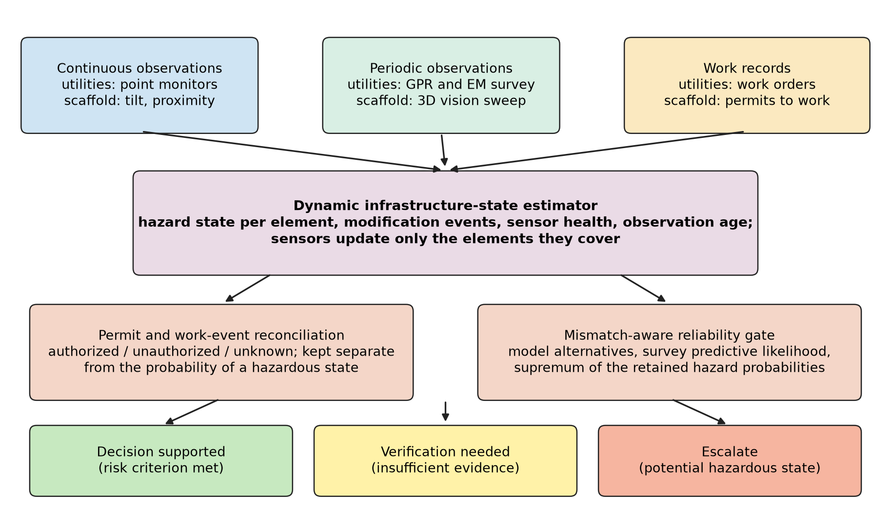
Fig. 1. Architecture of change-aware reliability-gated sensor fusion (CARGSF). Continuous, periodic and work-record evidence feed a dynamic state estimator; reconciliation keeps authorization separate from hazard; the gate releases a decision only if the supremum over the retained model alternatives meets the risk criterion. The architecture is a proposal evaluated in simulation, not a system demonstrated in the field.

4.1 Evidence layers
Point sensors. A point sensor covers one element and reports a modification event with probability d_{e} when one occurs and a false event with probability f_{e} per epoch (0.9 and 0.001 for the utility monitors, 0.95 and 0.0005 for the scaffold tilt and proximity sensors; assumptions). A sensor fails with a per-epoch probability (0.004 and 0.003) and a failure is flagged by a diagnostic with probability 0.8; an unflagged failed sensor is silent, and the estimator, believing it healthy, reads its silence as the absence of an event.
Periodic survey. A survey every 12 epochs (and a baseline survey at the start) reads the hazard state of each element it covers, with detection probability d_{v,i} and false-alarm probability f_{v}. For underground utilities d_{v,i} is the closed-form fused GPR and EM detection probability for the soil, utility class and depth of the segment (the sensor model of the evidence layer analyzed in Section 6.1); 16% of the assumed network lies in cells where it is below 0.3. For the scaffold, vision detects a missing member with probability 0.85 where the structure is visible, and the 25% of members hidden by tarps or netting are not observed and are known to be unobserved.
Work records. An authorized modification is recorded with probability 0.7 (utilities) or 0.8 (scaffold); a record is active from one epoch before to one epoch after the modification, is attached to a wrong element with probability 0.1 or 0.05, and spurious records are generated at a rate of 0.002 or 0.003 per element and epoch. Unauthorized modifications leave no record.

4.2 Dynamic hazard estimator
Each element has a binary hazard state Q. In each epoch a modification event occurs with a probability that depends on whether a work record is active, and is authorized or unauthorized; an event creates a hazard with probability θ_{A} (authorized) or θ_{U} (unauthorized) if the element was safe, and removes it with probability ρ (repair) if it was hazardous. Given the posterior p_{t−1} = P(Q_{t−1} = 1), the joint probability of the new state and the event type follows from these rules, and the point-sensor report y_{e} enters through its likelihood under an event (d_{e} for a report) and under no event (f_{e}):
$p_{t}\text{ = }\frac{\sum_{ε}{L_{ε}\text{(}y_{e}\text{) }P\text{(}ε\text{) }P\text{(}Q_{t}\text{ = 1 | }p_{\text{t−1}}\text{, }ε\text{)}}}{\sum_{ε}{L_{ε}\text{(}y_{e}\text{) }P\text{(}ε\text{)}}}$ (7)
where ε ∈ {none, authorized, unauthorized}. At a survey epoch the posterior is then updated by Bayes’ rule with the survey likelihood of the elements covered, L(y_{v} | Q) = d_{v,i} or 1 − d_{v,i} if Q = 1 and f_{v} or 1 − f_{v} if Q = 0. A sensor flagged as failed contributes a likelihood of one. The event rates, the authorized share and the event probability when a record is active are estimated from separate calibration sites of the nominal world (Section 5.2); θ_{A}, θ_{U} and ρ are taken as known. The estimator treats elements as independent and assumes the calibrated rates, which is wrong in the mismatch scenarios by design.

4.3 Work-event reconciliation and change attribution
Three treatments of the work records are compared on the same dynamic estimator. D0 ignores the records: events occur at the pooled rate. D1 follows a rule found in operational displays: a change that matches an active record is logged and does not raise the hazard probability (permit suppression). D2 uses the record as contextual evidence: the event probability and the authorized share given an active record differ from those without one, and the hazard that an authorized change leaves is estimated, not assumed away. D2 also yields the posterior probability that a reported event was authorized, which classifies it as authorized (above 0.8), unauthorized (below 0.2) or uncertain.

4.4 The reliability gate and model-validity selection
The gate runs D2 under six model alternatives on the same evidence: the nominal model; modification events three times as frequent; work records treated as uninformative; point sensors treated as uninformative (as if every one had failed silently); a survey with 60% of the assumed detection probability; and all four departures combined. For each alternative the survey predictive log-likelihood, accumulated over all surveyed elements of the structure or corridor, measures how well it has explained the surveys so far. An alternative whose log-likelihood falls more than 5 behind the best is rejected; the retained set ℳ_{t} defines the gate of Eq. 6, and the gated hazard probability is the supremum over it. The selection implements model-validity tracking: an alternative that the data contradict stops constraining the decision, and one that they cannot yet distinguish from the nominal model keeps doing so. For the scaffold the hazard probabilities of the members are combined into the probability that the structure is unsafe, P(unsafe) = 1 − ∏_{critical}(1 − p_{i}) ∏_{bays}[P(fewer than two non-critical members of the bay hazardous)], under independence; the structure may continue if P(unsafe) ≤ 0.05.
What the gate bounds and what it does not. The gate is a robust decision rule and not a safety guarantee. The six alternatives are a finite set assumed by the analyst; the rejection threshold of 5 in log-likelihood is a design choice; and the true process may be absent from the retained set, in which case the supremum can understate the hazard (the survey cannot reject an alternative whose consequences it does not reveal). The quantity that the gate holds below the criterion is therefore a modeled hazard probability, conditional on the alternatives, on the evidence and on the independence assumption of Section 4.2; it is not control of the failure probability of a real corridor or structure, and “risk-bounded” in the title is meant in that sense only. The experiments test the property rather than assume it: the observed conditional risk among released decisions is reported next to the criterion and exceeds it where the departure is not visible to the surveys (for example 12.0% in the combined utility scenario against a criterion of 5%, Section 8.2).
Release thresholds are fixed: an element is released if its hazard probability is at most 0.05, escalated if it is at least 0.50, and sent for verification otherwise.

4.5 Baselines
The static twin S0 holds the Bayesian posterior of the surveys (state assumed constant between and across them); S0d relaxes it toward the prior with an ad hoc decay (κ = 0.15 per epoch); S1 is static-state probabilistic fusion: point-sensor reports are treated as hazard indicators with the sensor’s operating characteristics and silence as no evidence, and surveys update the same constant state. In the scaffold domain two domain-specific baselines are added: a point-sensor alarm (the structure is escalated once any healthy sensor has reported a change) and a weighted index between 0 and 100 of importance-weighted event reports and survey detections, with and without suppression of permit-matched changes; its ranking is evaluated as a risk–coverage curve, so that the choice of its thresholds does not decide the comparison. An oracle that knows the true event statistics and the true sensor health is an unattainable reference.

4.6 Risk-constrained sensor allocation
A set S of elements receives point sensors within a budget B. The aim is
$S^{\text{*}}\text{ = }{\text{arg min}}_{S\text{: }C\text{(}S\text{) ≤ }B} R_{\text{unsafe}}\text{(}S\text{)}$ (8)
where R_{unsafe}(S) is the unsafe-decision risk after the full monitoring and decision policy. Four strategies are compared: random, uniform spacing, uncertainty-based (the elements least observable by the survey, weighted by their modification rate) and risk-optimized (the elements with the largest importance-weighted unsafe-decision mass in independent training worlds of the same site, which a greedy selection under a uniform cost maximizes; the greedy rule is the standard approach for monotone submodular objectives (Nemhauser et al., 1978), and the objective here is only approximately of that kind).

5. Experimental design and baselines

5.1 The two domains
Both domains use 48 epochs. A utility epoch is a month and a scaffold epoch a day; the epoch is a unit of simulation and the rates are assumptions. Table 3 lists the parameters. The utility sites are corridors of 200 segments of 5 m whose soils, utility classes and depths are drawn from the assumed network of the evidence layer; the scaffold sites have 240 members in 20 bays, of which 20% are critical (ties and primary diagonals; importance 1) and the others have importance 0.3. A scaffold is unsafe if a critical member, or two non-critical members of one bay, are hazardous. This criterion is a synthetic benchmark chosen to be simple and monotone; it was not derived from a structural analysis, and the importance values are assumptions.
Table 3. Parameters of the two simulated domains. Every value is an assumption; none is a measurement.
Quantity | Utilities | Scaffold
Elements per site | 200 | 240
Authorized / unauthorized events per element and epoch | 0.004 / 0.0015 | 0.00015 / 3e-05
Hazard created by an authorized / unauthorized event (θ_A / θ_U); repair probability ρ | 0.5 / 0.8; 0.3 | 0.4 / 0.95; 0.5
Initial hazard probability | 0.35 | 0.0004
Survey interval; detection probability; false alarm | 12 epochs; 0 to 0.99 by capability; 0.02 | 12 epochs; 0.85 (visible), 0 (occluded 25%); 0.002
Point sensor: event detection; false event per epoch; failure per epoch; failure flagged | 0.9; 0.001; 0.004; 0.8 | 0.95; 0.0005; 0.003; 0.8
Record rate; wrong element; spurious per element and epoch | 0.7; 0.1; 0.002 | 0.8; 0.05; 0.003
Cost of a node; of a survey (node equivalents) | 1; 40 | 1; 10

5.2 Calibration, training and test
The estimators are calibrated on separate calibration sites (10 sites of 40 worlds) of the nominal world, from which the event probability with and without an active record and the authorized share are estimated; the risk-optimized placement uses training worlds (40 independent worlds per site) of the site it allocates; and all results are computed on test sites that share no random numbers with either (24 test sites per experiment, 60 independent worlds each, drawn with seeds derived from the experiment tag and the site index). Intervals are 95% t-intervals over the test sites. In the mismatch scenarios the true world departs from the calibrated assumptions, and the estimators are not recalibrated.

5.3 Experiments
Table 4. Experimental program. E0 is the analysis of the survey evidence layer of the utility problem.
Experiment | Primary comparison | Key outcome | Hypothesis
E0 Survey evidence layer | Release policies, calibrated abstention, robust bounds (utilities) | Unsafe release at matched coverage; epistemic share; drivers | —
E1 Dynamic changes | Static twin and static fusion versus dynamic estimator | Unsafe-decision risk at matched coverage | H1
E2 Observation staleness | Risk against time since the last survey; event rate and survey interval | Risk versus age; predicted versus observed risk | H1
E3 Permit reconciliation | No records, permit suppression, permit as context | Change attribution; hazardous changes not flagged | H2
E4 Hybrid sensing | Point sensors only, surveys only, both | Detection latency, missed changes, cost, risk | H3
E5 Sensor placement | Random, uniform, uncertainty-based, risk-optimized | Unsafe-decision risk at fixed budget | H3
E6 Transfer | Proposed method versus domain-specific baselines in both domains | Risk at matched coverage | H3
E7 Combined failures | Silent sensor failures, erroneous records, mismatched change process, weak survey | Conditional and worst-case risk with coverage | H1–H3
E8 Structural hazard definition | Scaffold conclusions under 16 definitions of an unsafe structure (critical-member share × bay threshold) | Risk ratios at matched coverage; gate coverage and risk | H1, H3

Whether the proposed method outperforms simpler ones is not assumed. Its failures are reported with the same weight as its successes.

5.4 Metrics, matched coverage and the survey evidence-layer study
All risks are conditional risks P(Q = 1 | A = 1) among released decisions, reported with the coverage P(A = 1); unsafe-decision probabilities are P(F). Detection delay is the number of epochs from the onset of a hazard (an element turning hazardous) until the decision is no longer a release; a hazard onset that is never flagged before the hazard ends or the horizon is reached counts as missed. The false-escalation rate is the share of non-hazardous element-epochs that are escalated. Risk–coverage curves release the decisions with the lowest hazard probability first and are evaluated at coverages of 2% to 98% in steps of 2%. At the decision level, the utility curves are at element level and the scaffold curves at structure level.
The utility evidence layer (E0) was analyzed with release policies, scenarios and statistics that are described here briefly and in full in the Supplementary Material: twelve scenarios combining sensor health, geometry and parameter mismatch, each simulated as 10 independent networks of 700 km (1,400 corridors, 140,000 segments); seven release policies and four baselines; a parameter envelope of 40 draws crossed with five structural models of the geometry, 3 independent networks each; an ablation at equal released coverage; and a global sensitivity analysis with a Latin hypercube design of 320 points (McKay et al., 1979) and Sobol indices estimated by Monte Carlo on a gradient-boosting surrogate (Saltelli et al., 2010; Jansen, 1999; Sobol, 2001). Its definitions and results are in Section 6.1 and the Supplementary Material.

5.5 Plausibility and the absence of external validation
No published measurement of GPR or EM detection probability against known utility depth and soil, and no measurement of scaffold-member removal detection, was reproduced in this study. The detection curves and the change processes are outputs of assumed models, and the paper is a methodological demonstration of a reliability analysis, not a predictive model of either domain. For the radar, two plausibility checks are reported, neither of which is a validation: the low-loss relation between conductivity and attenuation reproduces a worked example of the US Environmental Protection Agency (US EPA, n.d.), which gives 36.6 dB/m for 100 mS/m and a relative permittivity of 20 against the 38 dB/m published, and the assumed one-way attenuations at 250 MHz (0.75 dB/m for dry sand, 7.0 dB/m for clay) lie in the tabulated range for clays but above the tabulated value for dry sand, the table stating no frequency and no primary source. For the scaffold there is no external check at all. Because the true parameters may differ from the assumed ones, the mismatch scenarios, the parameter envelope and the sensitivity analysis vary them widely and ask which conclusions survive, not which numbers are right. The most important missing step is a comparison with measured data in both domains (Section 9.4).

6. Case study I: underground utility mapping

6.1 The survey evidence layer (E0)
The decision to release a segment rests first on a survey. Its reliability was analyzed before any change was introduced, in the twelve scenarios of Section 5.4. In the matched model a sensor-quality-adjusted policy (P2: release if the hazard probability is at most 0.10, 0.02 in the marginal capability zone, never in the zone where detection capability is not established or when an on-site reference check fails) releases 28% of the corridor at a conditional risk of 1.3%, a robust policy (P5: the supremum over parameter variants and structural alternatives of the filter) 25% at 0.02%, and standard Bayesian fusion with a 0.5 threshold 44% at 23.4%. The conditional risk is a steep function of the released coverage (Fig. 2); at equal coverage the policies lie close together, and no policy is nowhere worse than another in more than 6 of the twelve scenarios (Supplementary Table S2).
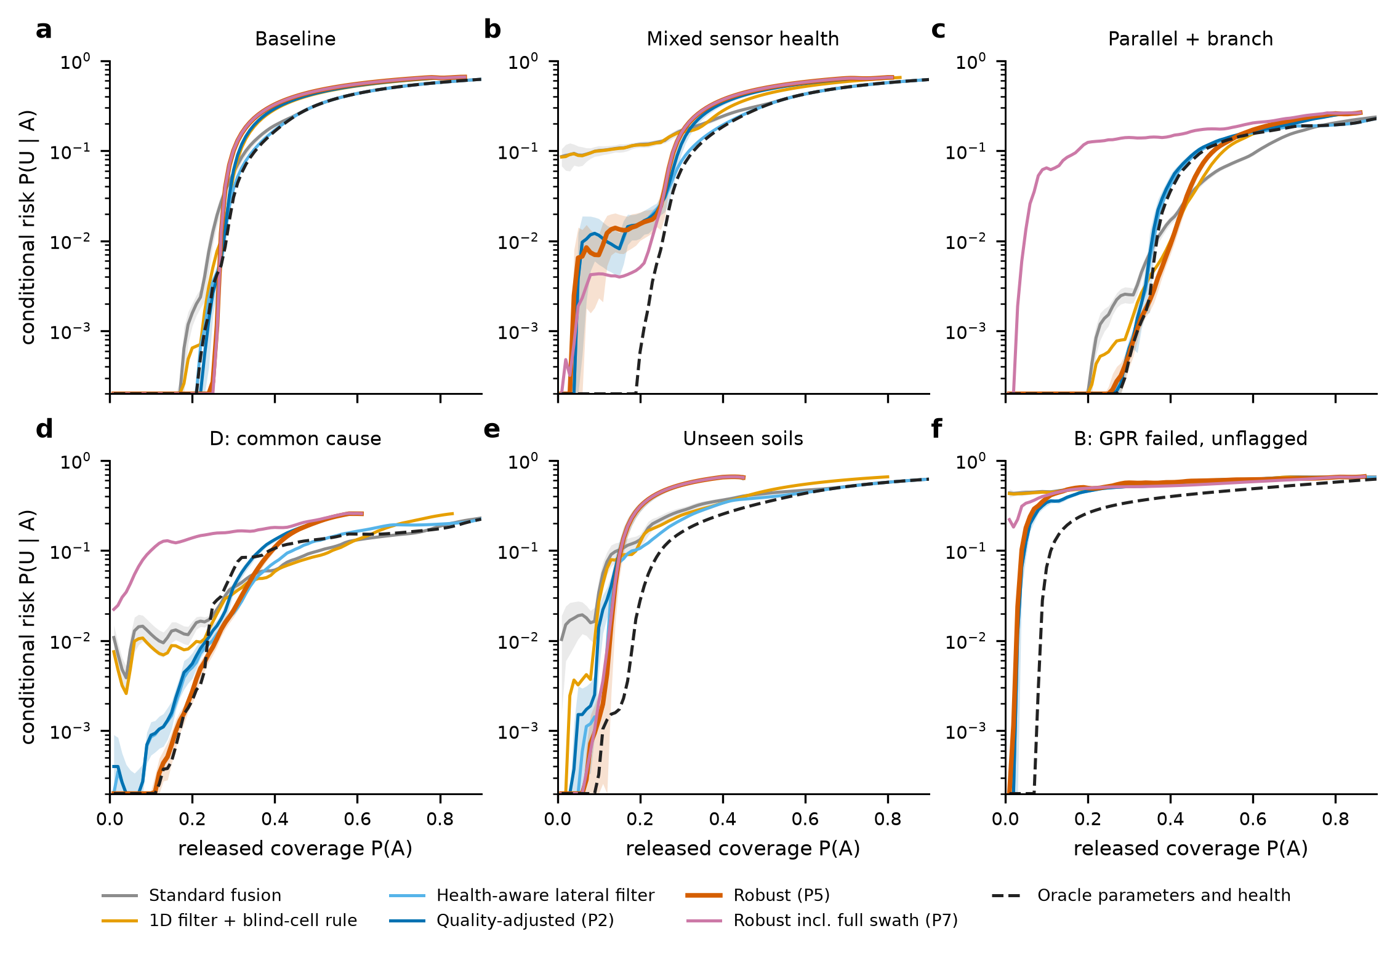
Fig. 2. Risk–coverage curves of the survey evidence layer: conditional false-clearance risk against released coverage in six scenarios (logarithmic axis; means over 10 independent networks of 700 km; bands are 95% t-intervals). The dashed curve is an oracle with the true sensor parameters, soil and health states.
Overconfidence under mismatch. Where the nominal model is wrong the picture changes. With a parallel utility and a branch (G4) P2 releases 65% at a conditional risk of 18% while the probabilities it attaches to those segments predict 0.3%; the robust policy holds 0.3% at 36% coverage, at the price of 29 points of coverage, and calibrated abstention on a plain score is in the same region (0.1% at 30%). An unflagged GPR failure leaves every policy at about 65% conditional risk; only an oracle that knows the sensor health (0.3%) is safe. Combining the failures is neither additive nor independent: a failed unflagged GPR with the wrong geometry gives 25%, below the failure alone, whereas multiplying the marginal risks as independent would give 71%.
When added model complexity reduces reliability. In the matched model a lateral-tracking filter with three parallel passes, which follows a utility that moves sideways, has a false clearance of 1.4% against 4.4% for a one-dimensional continuity filter. Under structural mismatch involving a parallel utility, or a parallel utility and a branch, it has 14.8% and 18.3%, against 1.8% and 2.0% for the simpler filter (Fig. 3). The tracker attributes the returns of the parallel line to the best-fitting offset, takes the line for the target and clears the footprint on which the real utility lies. A model that is more capable when its assumptions hold can therefore be the less reliable one when they do not: it becomes overconfident when its assumed spatial structure does not represent the network. This is the same hazard that the change-aware framework addresses for the process of change, and it motivates the gate.
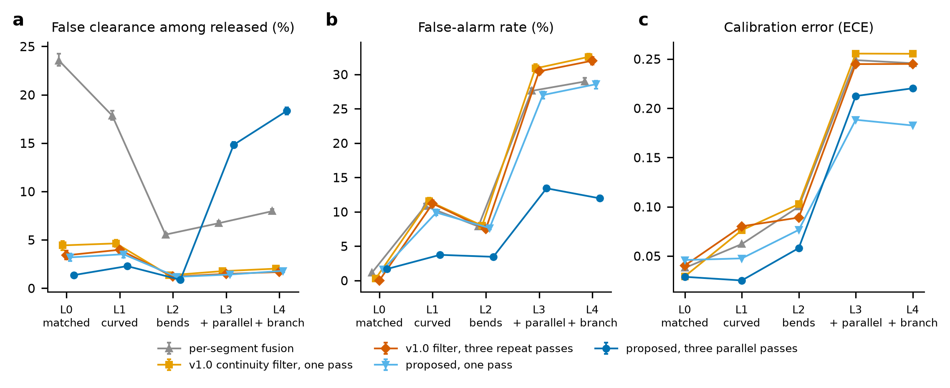
Fig. 3. Deterioration as the true geometry departs from the filters’ model (L0 matched to L4: bends with a parallel utility and a branch): (a) false clearance among released segments, (b) false-alarm rate, (c) calibration error of the probability.
Aleatory and epistemic contributions. Over a parameter envelope of 40 draws crossed with five structural models of the geometry, the epistemic share of the variance of the unsafe-release probability of a simulated network of 490 corridors is 79 to 88% for P2 and 74 to 78% for P5 (Fig. 4): more simulated networks would not reduce it, only knowledge of the sensor parameters would. For P2 the mean unsafe-release probability is 1.1% for the matched geometry and 11.0% for a parallel utility and a branch; for P5 it is 0.26% and 0.33%. A global sensitivity analysis shows that the dominant failure driver depends on the policy: the share of corridors with a parallel utility and a branch for P2, undetected sensor failure for P5. The structural models are scenarios and are not averaged; no single risk figure across them is claimed.
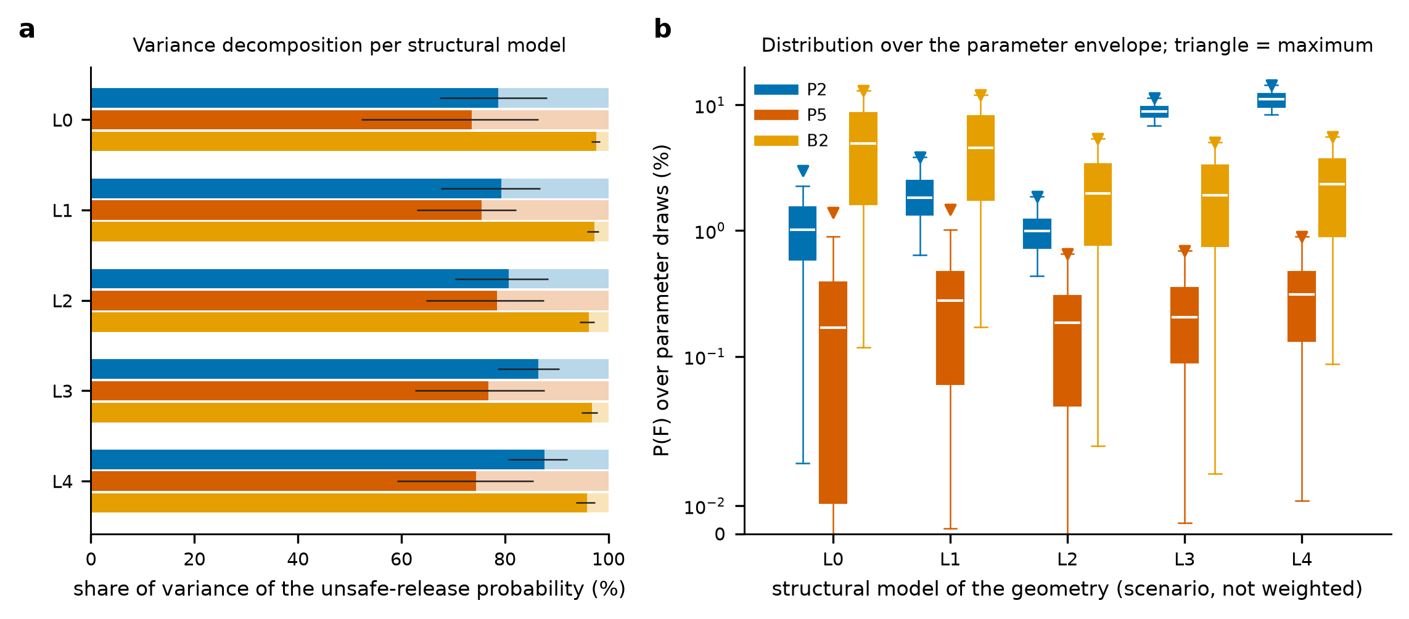
Fig. 4. Aleatory and epistemic contributions to the unsafe-release probability of the survey evidence layer: (a) share of the variance that is epistemic (dark; 95% bootstrap intervals) and aleatory (light) per structural model; (b) distribution over the parameter envelope (boxes: quartiles; whiskers: 5th to 95th percentile; triangles: maxima).
What the survey layer does not contain is time. Everything above treats the true state as fixed while it is observed. The following sections remove that simplification.

6.2 Dynamic changes and observation staleness (E1, E2)
Between surveys the corridor changes: 0.0055 modification events per segment and epoch, 72% of them authorized, and an event creates a hazard with probability 0.5 (authorized) or 0.8 (unauthorized). A static twin of the surveys (S0) releases 51% of the segments at a conditional risk of 3.65% and misses 38% of hazard onsets; the dynamic estimator without work records (D0) releases 49% at 1.90%, and with the work records as context (D2) 48% at 1.26% with a mean detection delay of 2.5 epochs against 7.2. At matched decision coverage (30%) the static twin has 3.5 times the conditional risk of D2, and static-state fusion with continuous sensors 3.7 times (2.63% against 0.71%), which supports H1 for this domain (Fig. 5, Fig. 9). The ad hoc decay (S0d) does not solve the problem: relaxing the twin toward the prior removes the coverage (8% of the segments released) and its risk at that coverage (2.39%) is higher than D2’s (0.20%).
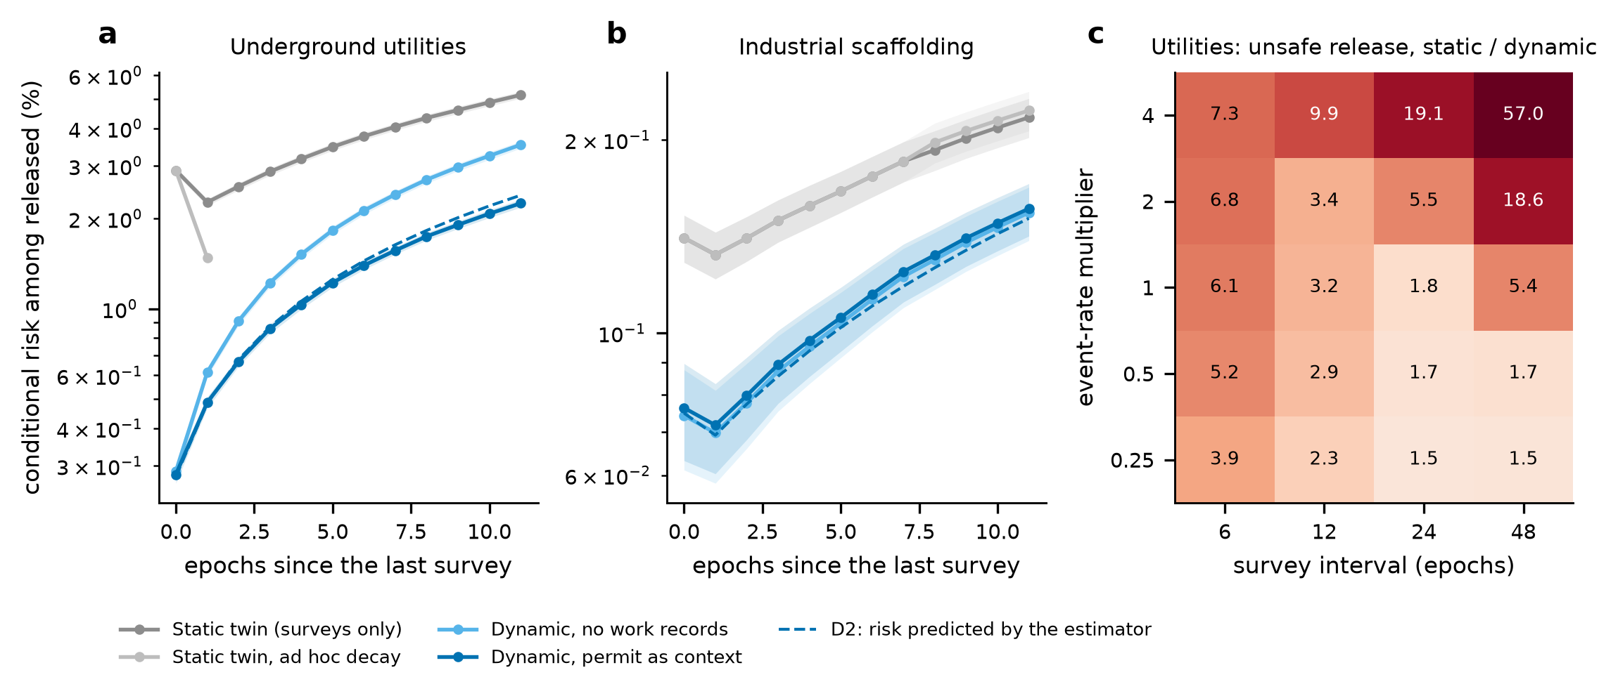
Fig. 5. Observation staleness. Conditional risk among released decisions against the number of epochs since the last survey for (a) utilities and (b) the scaffold (means over test sites with 95% intervals; points with less than 1% of decisions released are omitted); the dashed curve is the risk predicted by the dynamic estimator itself. (c) Utilities: ratio of the unsafe-release probability of the static twin to that of the dynamic estimator over event-rate multipliers and survey intervals (estimators recalibrated for each rate).
The risk of the static twin grows with the age of the last survey, from 2.90% just after a survey to 5.17% eleven epochs later; that of D2 from 0.28% to 2.25%, and the risk the dynamic estimator predicts for its own released segments (2.39% at eleven epochs) follows the observed one. The estimator therefore also answers how fast confidence should fall: at the rate its change model implies, and not at a fixed factor. The benefit depends on the regime (Fig. 5c): the ratio of the unsafe-release probabilities of the static and the dynamic estimator ranges from 1.5 to 57.0 over event-rate multipliers from 0.25 to 4 and survey intervals from 6 to 48 epochs, and is 3.2 at the nominal rate and interval. It is largest where changes are frequent and surveys are rare, which is where a static map is least trustworthy.

6.3 Work-order reconciliation (E3)
With a point sensor on every segment, so that the sensor evidence on each change is the same, the three treatments of the work orders differ only in how they use them. Among changes made under a valid work order, the estimator that suppresses permit-matched changes (D1) flags 53% of the segments, against 87% for the estimator without work records and 90% for the one that uses them as context (Fig. 6), and leaves 22.3% of those segments hazardous and unflagged, against 3.4% and 2.0%. Authorization is not proof of safety: an authorized change creates a hazard in half the cases, and suppressing it removes the warning exactly where the hazard is. Overall, D1 misses 2.2% of the hazard onsets, D0 0.2% and D2 0.1%. The context estimator is not free: it escalates 3.2% of the safe segment-epochs, against 2.8% without work records. For attribution, D2 is right in 99.2% of the reported changes it classifies as authorized or unauthorized but leaves 53% of them uncertain, which is the correct response when the records are missing or wrong; the estimators without records cannot classify any change.
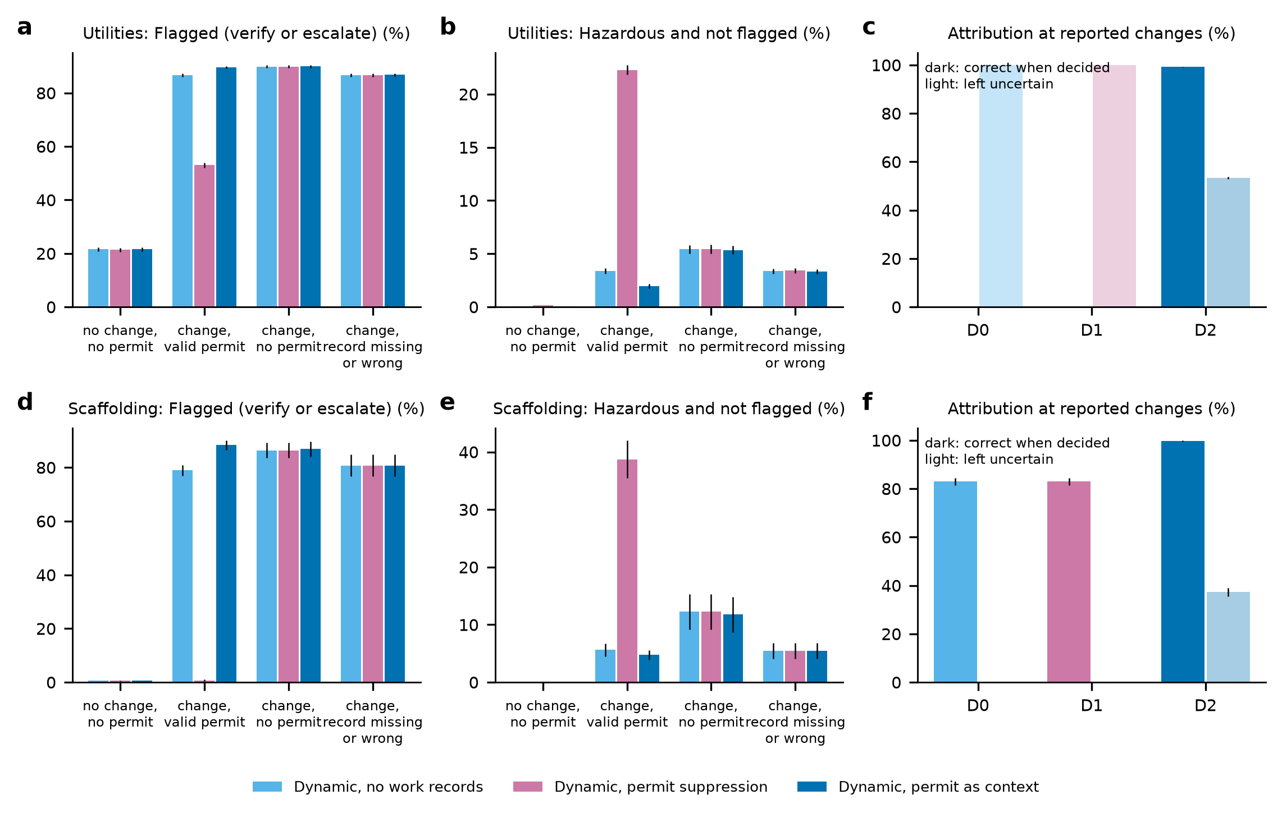
Fig. 6. Work-record reconciliation with a point sensor on every element: (a, d) share of elements flagged (verify or escalate) two epochs after the event, (b, e) share hazardous and not flagged, for the four cases of Table 2, and (c, f) attribution at reported changes (dark: correct when decided; light: left uncertain), for utilities (top) and the scaffold (bottom).
The first row of the cases is a reminder that the survey, not the records, causes most false flags in this domain: 22% of the elements without a change are flagged, because the survey false-alarm probability and the blind cells leave their probability above the release threshold. H2 is therefore supported in the sense that matters for safety: using the records as context did not increase the rate of undetected hazardous states relative to ignoring them (it lowered it slightly), and suppressing matched changes increased it several-fold.

6.4 Hybrid sensing (E4)
Continuous point monitors on 5%, 10% and 20% of the segments were compared with periodic surveys alone and with both, at a cost counted in node equivalents (a node costs 1; a survey 40). With only the baseline survey and monitors on 10% of the segments (cost 60) the corridor can be released over only 25% at a conditional risk of 2.45%; surveys every 12 epochs alone (cost 200) release 48% at 1.25% with a mean delay of 2.5 epochs; adding monitors on 10% or 20% of the segments (costs 220 and 240) gives 1.17% and 1.10% with delays of 2.3 and 2.1 epochs; halving the survey interval to 6 epochs (cost 360) gives 0.64% and 1.2 epochs (Fig. 7). In this domain the cadence of the survey is the dominant lever, and point monitors on a small share of the segments add little, because most hazard onsets occur at segments that no monitor observes. The value of the hybrid architecture is its dependence on where the monitors are, which is the question of the next experiment.
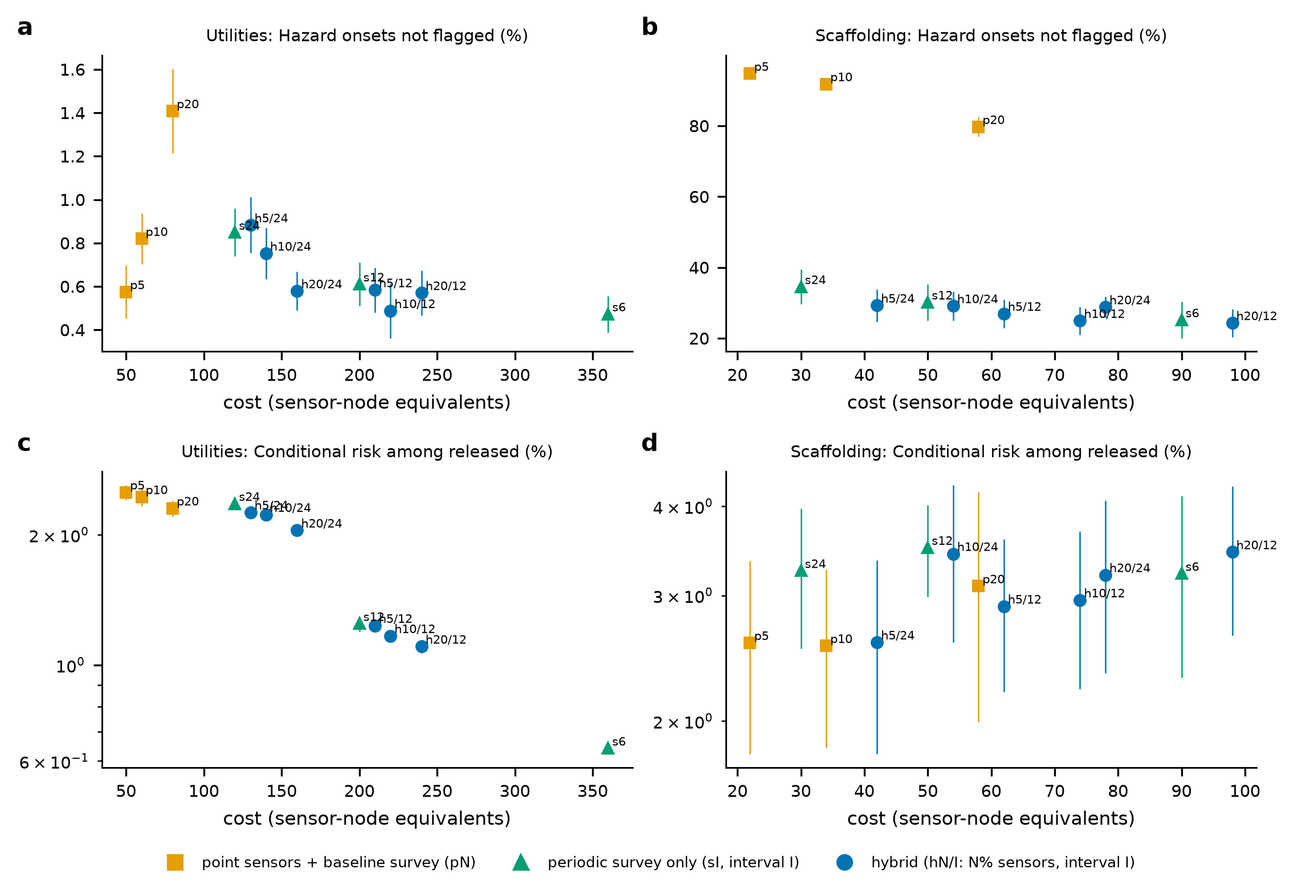
Fig. 7. Hybrid sensing: cost (in sensor-node equivalents) against (a, b) the share of hazard onsets not flagged and (c, d) the conditional risk among released decisions, for configurations of point sensors with a baseline survey only (pN: N% of the elements), periodic surveys only (sI: interval of I epochs) and both (hN/I), for utilities (left) and the scaffold (right); decision-level coverage in the Supplementary Material.

6.5 Sensor placement (E5)
At a budget of 10% of the segments the unsafe-release probability of D2 is 0.57% with random placement, 0.56% with uniform spacing, 0.59% with uncertainty-based placement and 0.53% with risk-optimized placement; at 20% they are 0.52%, 0.52%, 0.59% and 0.47% (intervals in the Supplementary Material; Fig. 8). Risk-optimized placement is the lowest in this domain at 10% and 20%, by about 0.03 and 0.05 percentage points; the half-widths of the intervals are about 0.02, so the difference is within the intervals at 10% and about two half-widths at 20%. Uncertainty-based placement is the worst, probably because the segments least observable by the survey are also those in blind cells, where a point monitor cannot create the missing baseline. The result is a small reduction of risk at the same sensor budget, not an increase in detection accuracy, and it should not be extrapolated to other budgets or domains.
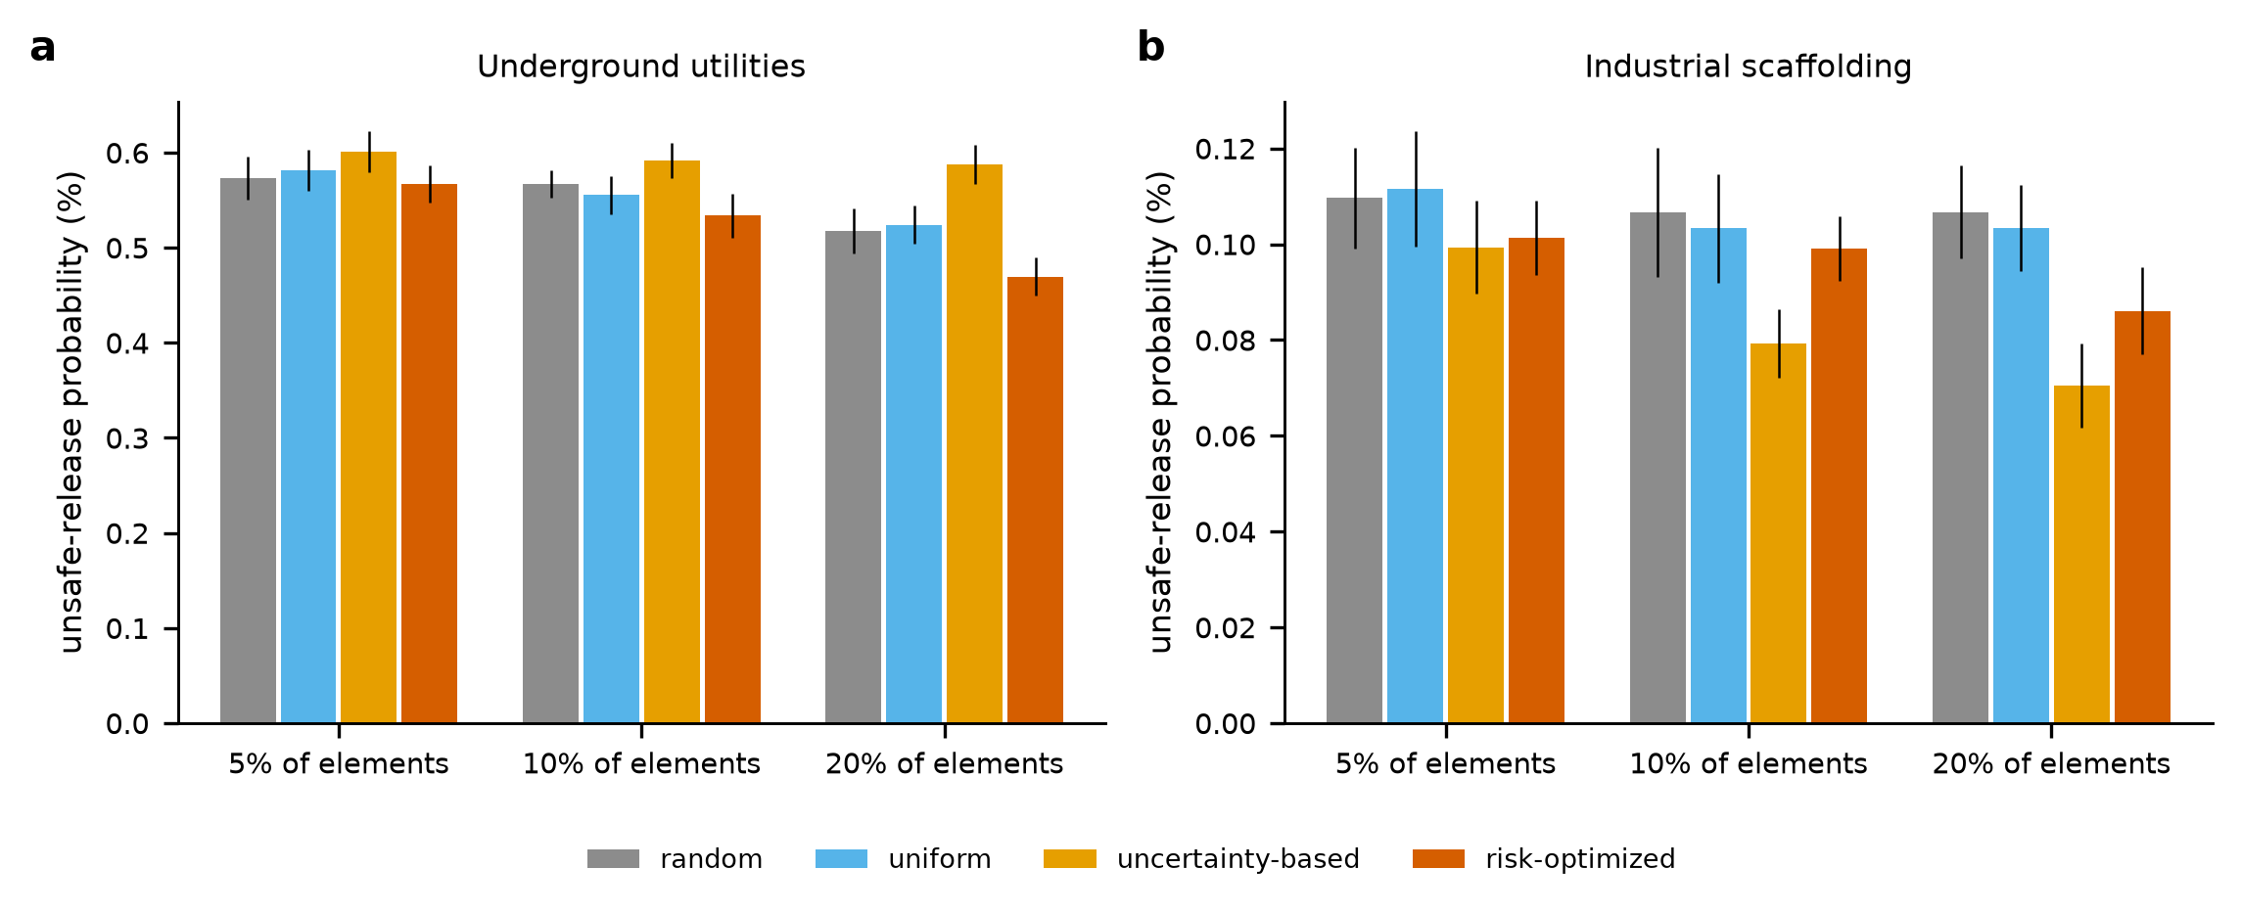
Fig. 8. Sensor placement: unsafe-release probability of the dynamic estimator at three budgets for four allocation strategies (95% intervals over test sites), for utilities (a) and the scaffold (b).

7. Case study II: scaffold structural monitoring

7.1 The synthetic scaffold benchmark
A scaffold of 240 members in 20 bays is monitored for 48 days. Members are removed or disconnected by authorized work (about 1.7 events per scaffold over the horizon, leaving a hazard in 40% of the cases because the work does not always include compensating measures) and by unauthorized removal (0.3 events, a hazard in 95% of the cases). Point sensors (tilt and clamp proximity) report an event with probability 0.95; a vision sweep every 12 days reads each visible member; 25% of the members are occluded by tarps or netting and are unobserved. The structure is unsafe if a critical member, or two non-critical members of one bay, are hazardous; in the assumed rates a scaffold is unsafe in 12% of the scaffold-days of the test worlds. The criterion and the rates are assumptions that make the benchmark simple and monotone; they are not engineering claims, and a defensible analysis would need hazard labels from a structural model or an independent assessment.

7.2 Dynamic changes and observation staleness (E1, E2)
At the structure level the static twin continues 94% of the scaffold-days at a conditional risk of 7.4%; the dynamic estimator with work permits as context continues 46% at 3.0%. The two are not at the same operating point, so the comparison is made at matched coverage: at 30% the static twin has 2.4 times and static-state fusion 2.1 times the conditional risk of D2 (6.0% against 2.8%), and the advantage persists but narrows toward full coverage (at 90%: 7.9% for static-state fusion against 6.3%). The static twin misses 50% of the hazard onsets and the dynamic estimator 29%, with mean delays of 20.0 and 7.1 days. At the element level the risk of the static twin grows from 0.141% just after a sweep to 0.217% eleven days later and that of D2 from 0.076% to 0.156%, and the dynamic estimator again predicts its own risk (0.151% at eleven days; Fig. 5b). H1 is supported in this domain at matched coverage.

7.3 Permit reconciliation (E3)
Among removals made under a valid permit the suppressing rule flags 1% of the elements and leaves 38.7% hazardous and unflagged, against 79% flagged and 5.6% missed without work records and 88% flagged and 4.7% missed with the permit as context (Fig. 6d–f). Over all hazard onsets the suppressing rule misses 27%, no records 5% and context 4%. The context estimator classifies the reported changes it decides on correctly in 99.7% of the cases and leaves 37% uncertain; without records the best available classification is the prior share of authorized events (83%). The false-escalation rate is below 0.1% for all three, because the sensors and the vision have low false-alarm probabilities in this domain. H2 is supported: the records as context improved attribution and did not increase the undetected hazardous states, whereas suppression multiplied them.

7.4 Hybrid sensing and placement (E4, E5)
Point sensors on 5% to 20% of the members, with only the baseline sweep, miss 95% to 80% of the hazard onsets, because most members have no sensor; sweeps every 12 days alone miss 30% (mean delay 6.7 days), and the hybrid with sensors on 10% of the members 25% (5.9 days); sweeps every 6 days miss 25% (3.4 days) at a cost of 90 node equivalents against 74 for the hybrid (Fig. 7b, d). As in the utility problem, the continuous layer helped less than the cadence of the survey, and its benefit is limited by how few elements it observes; the structure-level conditional risks of the configurations differ by less than their intervals (Supplementary Table S9). Allocation matters more here: at a budget of 10% the unsafe-decision probability of D2 is 0.107% with random, 0.103% with uniform, 0.079% with uncertainty-based and 0.099% with risk-optimized placement, and the share of hazard onsets missed is 25%, 25%, 13% and 25% (Fig. 8b). Placing sensors where the vision is blind (the occluded bays) was the best strategy; the risk-optimized rule, which learns the importance-weighted unsafe mass from training worlds, was no better than uniform spacing at 10% and better only at 20% (0.086% against 0.103%). A reduction of modeled risk at a fixed budget is therefore obtainable, but the simple uncertainty-based rule obtained more of it than the more elaborate one; the pilot worlds of 40 realizations per site may be too few to rank the members reliably.

7.5 Domain-specific baselines (E6)
A point-sensor alarm that escalates a structure once any healthy sensor has reported a change continues 71% of the scaffold-days at a conditional risk of 10.4% and escalates 28% of the safe scaffold-days, because sensors have false-event probabilities and the structure has 240 members. A weighted index of importance-weighted event reports and survey detections, of the kind used in operational displays, ranks the scaffold-days at a conditional risk of 4.9% at 30% coverage and 5.7% at 50%, against 2.8% and 3.7% for D2 (Fig. 9b); suppressing permit-matched changes did not change its ranking noticeably (4.9% against 4.7% at 30%), probably because in these worlds the index is dominated by the survey false alarms and the few events; the damage of suppression is in the hazard states it hides (Section 7.3), which a risk–coverage curve of the index does not show. The index is a display, not a probability: its value has no calibrated meaning as a hazard probability, and the comparison is of its ranking only.

8. Cross-domain reliability, combined failures and ablation

8.1 Matched-coverage comparison with domain-specific baselines (E6)
Table 5. Conditional risk (%) at matched decision coverage (10% to 70%) for the static, domain-specific, dynamic and gated methods, with point sensors on 10% of the elements (means over test sites; intervals in the Supplementary Material).
Domain, decision level | Method | Risk at 10% | 20% | 30% | 50% | 70%
Utilities, element | Static twin (surveys only, constant state) | 1.62 | 1.77 | 2.82 | 3.65 | 15.33
Utilities, element | Static-state probabilistic fusion | 1.51 | 1.64 | 2.63 | 3.47 | 21.68
Utilities, element | Dynamic, permit as context | 0.16 | 0.42 | 0.71 | 1.60 | 19.21
Utilities, element | Reliability-gated (change-aware) | 0.25 | 0.57 | 0.82 | 2.02 | 28.75
Utilities, element | Oracle (true rates and sensor health) | 0.17 | 0.43 | 0.70 | 1.59 | 18.14
Scaffold, structure | Static twin (surveys only, constant state) | 6.38 | 6.33 | 6.28 | 6.41 | 6.74
Scaffold, structure | Static-state probabilistic fusion | 5.59 | 5.78 | 5.98 | 6.48 | 6.45
Scaffold, structure | Weighted index (0-100), permit-matched changes suppressed | 4.90 | 4.90 | 4.90 | 5.67 | 5.77
Scaffold, structure | Dynamic, permit as context | 1.70 | 2.34 | 2.81 | 3.68 | 4.47
Scaffold, structure | Reliability-gated (change-aware) | 1.87 | 2.43 | 2.92 | 3.80 | 4.70
Scaffold, structure | Oracle (true rates and sensor health) | 1.73 | 2.30 | 2.71 | 3.65 | 4.49

In both domains the dynamic estimator has a lower conditional risk than the static methods at every matched coverage from 10% to 50% (in utilities the intervals overlap at 70%, where the risk of every method approaches the prevalence) (utilities: 3.9 times lower at 20%; scaffold: 2.5 times at 20%), and than the weighted index at 30% in the scaffold domain (1.7 times). The gated estimator ranks slightly worse than D2 at matched coverage (utilities: 0.82% against 0.71% at 30%; scaffold: 2.92% against 2.81%), so that its value is not a better ranking but a different operating point, as the next section shows. H3 is supported in the narrow sense stated: a common architecture gave a measurable benefit in two structurally different problems against calibrated, domain-specific baselines, in simulation, with simple change processes and independent elements.
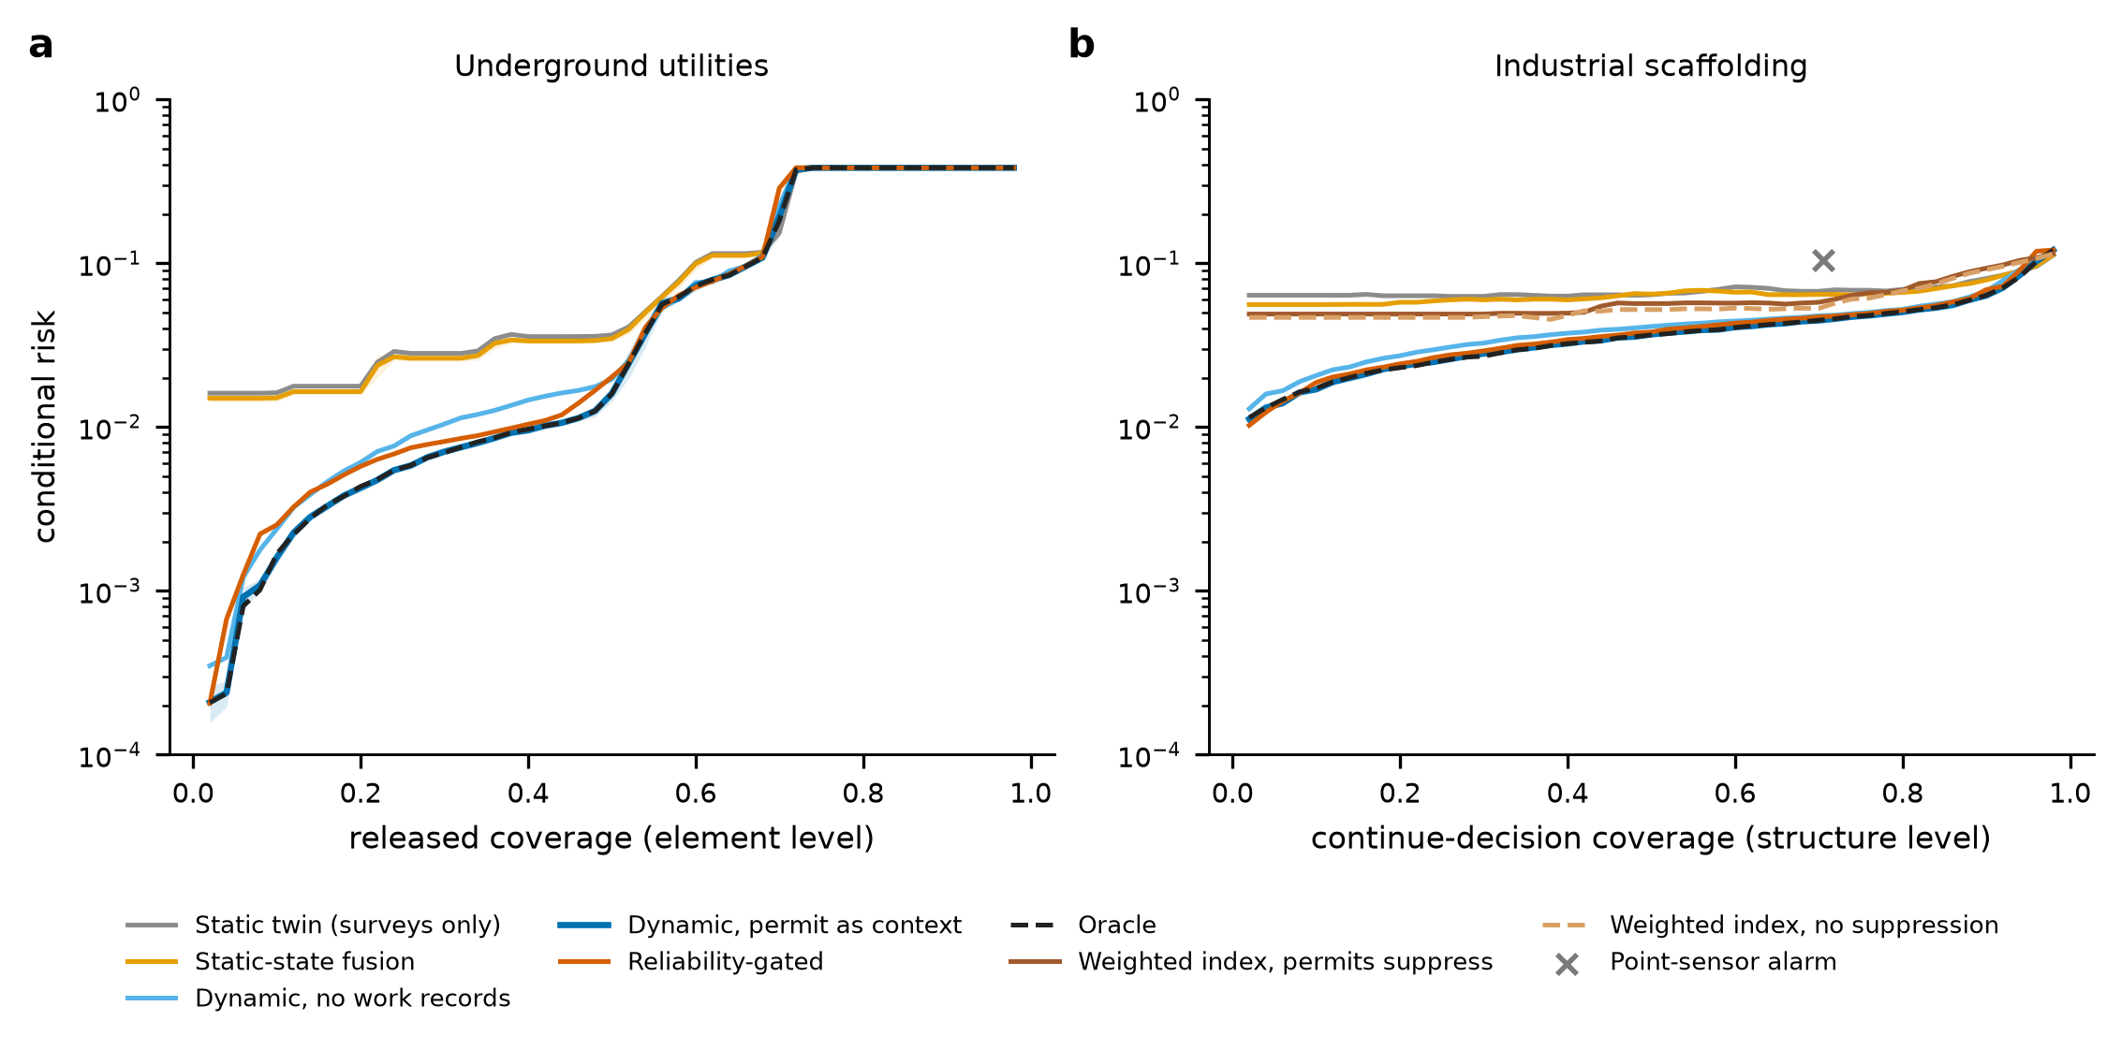
Fig. 9. Cross-domain comparison at matched decision coverage: conditional risk against coverage for the static, dynamic, gated and oracle methods in (a) utilities (element level) and (b) the scaffold (structure level), with the weighted index (ranking) and the point-sensor alarm (single point) in the scaffold domain. Point sensors on 10% of the elements; shaded bands are 95% intervals over test sites.

8.2 Combined failures and the reliability gate (E7)
Table 6. Conditional risk (%) and, in brackets, decision coverage (%) under single and combined failures, with point sensors on 10% of the elements. The estimators are calibrated on the nominal world and are not recalibrated. A coverage below 1% is shown to one decimal; a conditional risk is undefined, and shown as n/a, only where no decision is released.
Domain | Scenario | Static fusion | No records | Context (D2) | Gated | Oracle
Utilities | Nominal | 3.5 (51) | 1.8 (49) | 1.2 (48) | 0.9 (38) | 1.2 (48)
Utilities | Unflagged sensor failures (3x) | 3.5 (51) | 1.8 (49) | 1.2 (48) | 1.0 (38) | 1.2 (48)
Utilities | Erroneous permits | 3.5 (51) | 1.7 (49) | 1.5 (46) | 1.4 (40) | 1.5 (47)
Utilities | 3x event rate with bursts | 12.3 (46) | 6.7 (42) | 4.2 (39) | 2.9 (27) | 2.1 (22)
Utilities | Survey weaker than assumed | 17.3 (60) | 15.1 (57) | 14.7 (56) | 3.2 (2) | 14.7 (56)
Utilities | Combined | 27.9 (57) | 23.6 (53) | 22.7 (48) | 12.0 (0.4) | 18.7 (21)
Scaffold | Nominal | 7.4 (92) | 3.0 (47) | 2.7 (48) | 1.0 (9) | 2.5 (45)
Scaffold | Unflagged sensor failures (3x) | 7.2 (93) | 3.3 (48) | 3.5 (49) | 1.0 (9) | 3.2 (46)
Scaffold | Erroneous permits | 6.7 (92) | 2.7 (47) | 1.6 (16) | 0.7 (5) | 2.6 (44)
Scaffold | 3x event rate with bursts | 36.5 (77) | 16.9 (38) | 15.5 (35) | 4.4 (9) | 3.7 (8)
Scaffold | Survey weaker than assumed | 8.2 (95) | 4.0 (49) | 3.8 (50) | 1.2 (9) | 3.7 (48)
Scaffold | Combined | 42.3 (87) | 21.9 (43) | 11.0 (15) | 3.7 (5) | 4.2 (6)

Table 6 and Fig. 10 give the conditional risk and the coverage under each failure. Unflagged sensor failures, erroneous work records and a weak survey are failure modes of different kinds. Unflagged failures of the point sensors change little (1.2% against 1.2% for D2 in utilities), because the sensors observe few elements. Erroneous records raise the risk of the context estimator toward that of the estimator without records (1.5% against 1.7% in utilities). A change process three times as frequent as calibrated and arriving in bursts raises the risk of D2 from 1.2% to 4.2% (utilities) and from 2.7% to 15.5% (scaffold); a survey weaker than assumed to 14.7% (utilities), because the estimator trusts silence from a survey that is no longer as informative. All the failures together give 22.7% and 11.0%.
The gate lowers the risk under these departures: 3.2% against 14.7% under a weak survey in utilities, 3.7% against 11.0% in the combined scaffold scenario. But it does so by abstaining: its coverage is 2% against 56% under the weak survey, 5% against 15% in the combined scaffold scenario, and 0.4% of the decisions in the combined utility scenario. At the coverage of the gate, D2 has a risk of 2.7% against the gate’s 2.9% under the faster change process in utilities (gate coverage 27%), and 4.3% against 4.4% in the scaffold domain (coverage 9%); in the combined scaffold scenario D2 at the gate’s coverage has 3.2% against the gate’s 3.7%. The oracle, which knows the true event statistics and the sensor health, is not safe either under the combined failure in utilities (18.7%), where the survey is the weak link. The gate thus converts a mismatch it can detect from the surveys into abstention. It cannot protect against a failure the surveys do not reveal, and the abstention has a cost in decisions that cannot be taken.
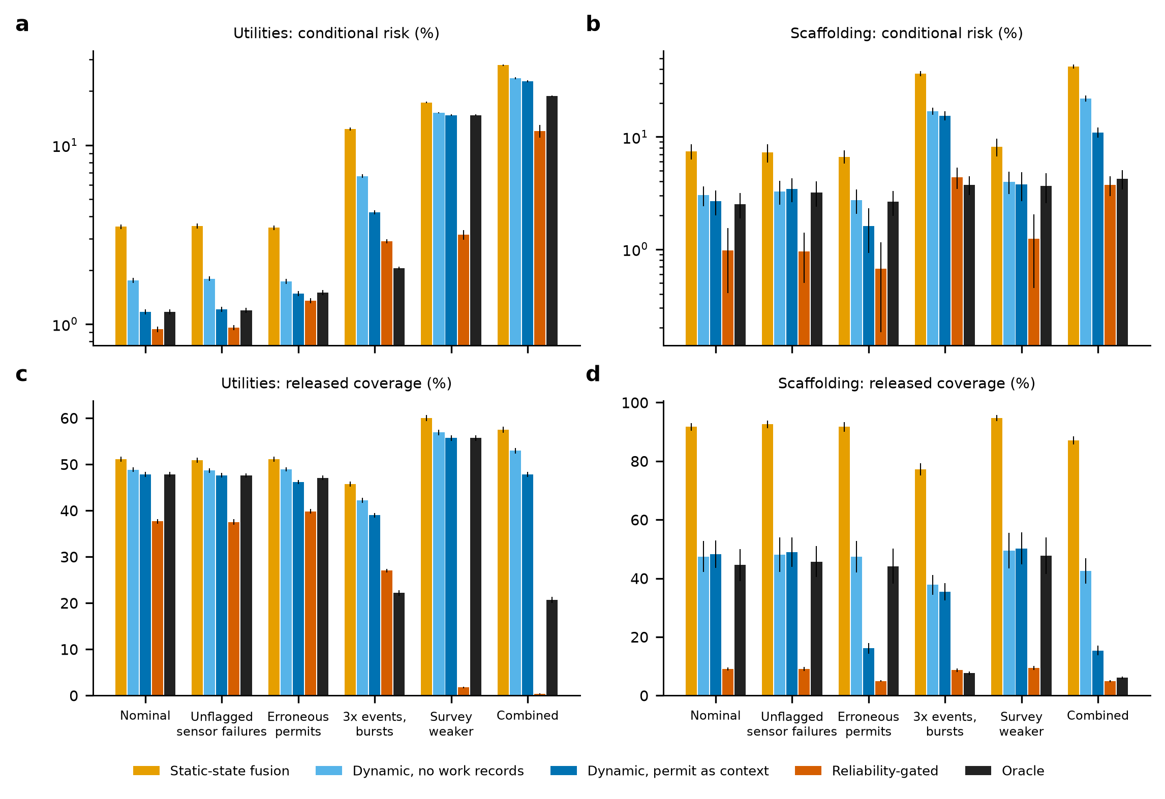
Fig. 10. Combined failures: conditional risk (a, b) and decision coverage (c, d) of static fusion, the dynamic estimators, the reliability gate and the oracle under the six scenarios of Table 6, for utilities (left) and the scaffold (right; structure level). The estimators are not recalibrated.

8.3 Ablation
Removing one component of the gated method at a time (Fig. 11) shows what each does. Without the dynamics (static-state fusion) the nominal risk rises from 0.9% to 3.6% in utilities and from 1.1% to 6.8% in the scaffold (but the coverage rises from 38% to 51% and from 9% to 92%); without the permit context the risk rises to 1.8% and 3.7%; without the survey the scaffold risk rises to 2.2% and the utility corridor cannot be released at all, since the baseline hazard prevalence is unknown without a survey. Without the point sensors the risk is 1.0% and 0.9%, close to the 0.9% and 1.1% with them, and without the health flags 1.0% and 0.7%, which confirms that in these worlds the point sensors and their health matter little. Without the validity selection the gate takes the supremum over all alternatives and releases 0.0% of the utility corridor in the nominal world: the selection is what keeps the gate usable. Under the combined failure, removing the gate raises the conditional risk from 11.7% to 22.5% (utilities) and from 3.3% to 12.9% (scaffold), with coverage rising from 0.3% to 48% and from 5% to 15%. The conditional risk of the full method under the combined failure in utilities (11.7 ± 0.9%, 95% t-interval over test sites) is therefore a statistic of a very small coverage and not of an empty set: it is computed over a mean of 1983 released element-epochs per test site (47596 over the 24 sites, of which 5693 were hazardous; 0.3% of the element-epochs), and it is defined in 100% of the sites. It describes the few decisions that the gate still takes and is not an operating point; where a method releases nothing in a site, its conditional risk in that site is undefined, is reported as n/a and is left out of the mean.
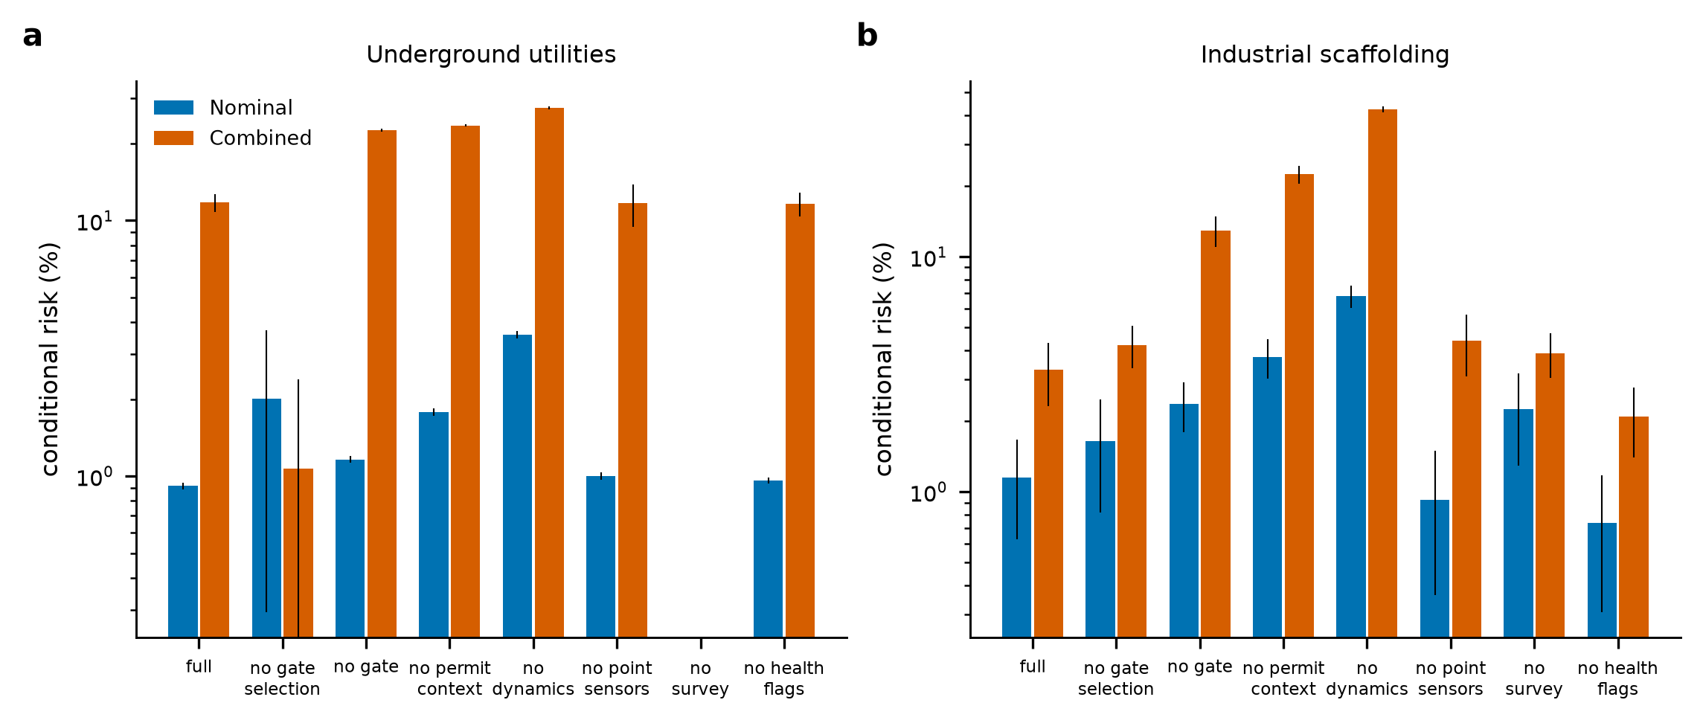
Fig. 11. Ablation: conditional risk of the gated method with one component removed, in the nominal and the combined-failure scenarios, for utilities (a) and the scaffold (b; structure level). The coverage of every variant is in Supplementary Table S10.

8.4 Sensitivity to the structural hazard definition (E8)
The scaffold hazard criterion is synthetic: a structure is unsafe if a critical member is hazardous or if two non-critical members of one bay are. The member-level estimators do not depend on this definition, but the structure-level decisions, the unsafe-state labels and the weighted-index baseline do, and a conclusion that held only for one arbitrary definition would say little. E8 therefore re-evaluates the scaffold experiments under sixteen definitions, crossing the share of critical members (5, 10, 20 and 35%; 20% is the benchmark) with the number of non-critical members of a bay whose hazard makes the structure unsafe (1, 2, 3 and 4; 2 is the benchmark). The simulated worlds and the member hazard probabilities are the same under every definition, the critical members of a smaller share are a subset of those of a larger share, and the release criterion (P(unsafe) ≤ 0.05) is unchanged. The prevalence of unsafe structure-epochs in the nominal world ranges from 2.4% to 43.9% across the definitions (11.3% for the benchmark), so the definitions span benign and demanding benchmarks.
The dynamic estimator had a lower structure-level risk than static-state fusion at every matched coverage from 10% to 50% in 16 of the 16 definitions in the nominal world and in 16 of 16 under the combined failures (Fig. 12a,b). The risk ratio at 30% coverage ranged from 2.1 to 6.7 (median 3.1) in the nominal world and from 1.4 to 3.3 (median 2.0) under the combined failures. It was smallest where one non-critical member made a bay unsafe (ratio 2.1 nominal, 1.4 combined at the benchmark critical share), because the structure is then unsafe so often that the prevalence compresses every method toward it, and it was largest for a small share of critical members, where the decision depends on the bays and so on the evidence about many members at once. The dynamic estimator also had a lower risk than the weighted index at matched coverage in 16 of 16 (nominal) and 16 of 16 (combined) definitions, with ratios at 30% of 1.4 to 4.7 and 1.2 to 1.5 (Fig. 12c). Under the combined failures the reliability gate released fewer structures than D2 in 16 of 16 definitions (at most 38% of the structure-epochs, and none when one non-critical member made a bay unsafe, Fig. 12d), and where it released any its conditional risk was lower than that of D2 in 12 of 12. The benchmark cell is an independent replicate of the worlds of Section 8.1 (the same sites, new simulated worlds): its ratio of 3.1 against 2.1 there has the same direction, but the risk of D2 at 30% coverage is 1.6% there against 2.8% in Section 8.1, which shows how variable a ratio of two small risks is between replicate sets of worlds (Supplementary Table S17); the ratios in this section should be read as orders of magnitude and not as point estimates. The conclusions on H1 and H3 for the scaffold therefore do not depend on the single benchmark definition within the range tested, and the benefit of the gate remains a benefit bought in abstention. The qualification is unchanged and is stated in Section 9.4: all sixteen definitions are monotone criteria of the same kind, none is a structural calculation, and the sensitivity analysis shows that the findings are not an artifact of one definition, not that any definition describes a real scaffold. The full results are in Supplementary Table S17.
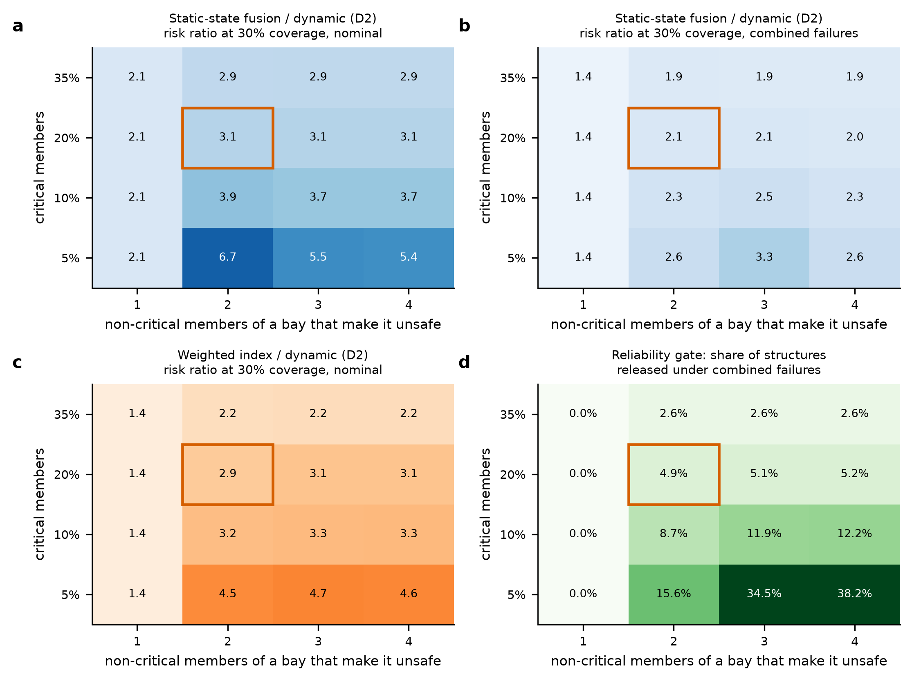
Fig. 12. Sensitivity of the scaffold conclusions to the structural hazard definition (E8): share of critical members (vertical axis) against the number of non-critical members of a bay that make it unsafe (horizontal axis); the outlined cell is the benchmark. (a) Ratio of the conditional risk of static-state fusion to that of the dynamic estimator at 30% matched coverage, nominal world; (b) the same under the combined failures; (c) the same for the weighted index; (d) share of structure-epochs released by the reliability gate under the combined failures. Point sensors on 10% of the members.

8.5 Summary of the hypotheses
Table 7. Outcome of the hypothesis tests (simulation; conditional on the assumed environments).
Hypothesis | Outcome | Evidence | Qualification
H1 dynamic model validity | Supported in both domains | risk 3.7 (utilities) and 2.1 (scaffold) times lower than static-state fusion at 30% matched coverage; predicted risk follows observed risk with age | advantage depends on event rate and survey interval; narrows at high coverage
H2 context-aware attribution | Supported | hazardous unflagged after valid-permit changes: suppression 22% / 39%, context 2% / 5%; attribution accuracy when decided above 99% | 53% and 37% of reported changes left uncertain; small increase in false escalation in utilities
H3 cross-domain reliability | Supported in a narrow sense | dynamic estimator better than static and domain-specific baselines at matched coverage in both domains | simple change processes, independent elements, synthetic scaffold criterion (conclusions held in 16 of 16 alternative definitions of an unsafe structure, Section 8.4); gate benefits come mainly from abstention; point sensors and placement added little

9. Discussion: model validity, failure modes and transferability

9.1 What the simulations show
Demonstrated within the models. (i) A map that is not updated for what can have changed since it was made becomes unreliable at a rate that the change process determines, and a decision layer that tracks the hazard state recursively can predict that rate for its own decisions (Sections 6.2 and 7.2). (ii) Work records are valuable as context and dangerous as explanation: using them to modulate the probability of change and the share of authorized events reduced the undetected hazardous states, and suppressing matched changes multiplied them (Sections 6.3 and 7.3). (iii) Continuous point sensors on a small share of the elements added little to periodic surveys, and where they were placed mattered more than whether the placement was optimized (Sections 6.4, 6.5 and 7.4). (iv) A gate over the model alternatives that the surveys have not rejected lowered risk under departures from the assumed change process and survey, but mainly by releasing fewer decisions; at the gate’s coverage the ungated estimator was close to it where the departure was a faster change process (Section 8.2). (v) In the survey evidence layer, a more elaborate spatial model was less reliable than a simpler one when its geometry assumption failed, the probabilities it attached to released segments could understate the observed risk by two orders of magnitude, and an unflagged sensor failure defeated every policy (Section 6.1). (vi) The scaffold conclusions on dynamic estimation did not depend on one definition of an unsafe structure: the dynamic estimator had the lower matched-coverage risk under all sixteen definitions tested, although the size of the advantage varied by a factor of about three (Section 8.4).
Suggested, conditionally on the models resembling reality. A monitoring system that supports safety decisions should publish with each decision the age and coverage of the evidence behind it, treat work records as probabilistic context and report the hazard probability and the authorization probability separately, and be run beside a model whose disagreement with it is a warning. The architecture should not be judged by the accuracy of its estimate but by the risk of the decisions it supports at the coverage at which they are taken.
Not established. Whether any of the sensor models, change processes or reporting probabilities resembles a real utility corridor or scaffold; whether a real work-permit system has the record, delay and misattribution characteristics assumed; whether the hazard of the synthetic scaffold criterion corresponds to the structural hazard of a real scaffold; whether the change processes of real infrastructure are independent across elements (the bursts of Section 8.2 are one departure, not a model of reality); and any result in a specific plant, country or network. The numbers are properties of the simulators.

9.2 Model validity and the role of abstention
The gate is one answer to the question of when a model has become invalid. Its likelihood-based rejection makes an alternative that the surveys contradict stop constraining the decision, and keeps the others in force. Two features of the results qualify it. First, it can only reject what the surveys reveal: silent failures of sensors that the surveys do not cover, or misattributed work records, leave the surveyed predictive likelihood unchanged. Second, its benefit is bought in abstention, which has a cost that this study does not value: a scaffold that is not released for use, or a segment that must be verified by a trial pit. A policy has to be judged on the risk–coverage curve and on the cost of the decisions it declines to take, and the cost model of the survey evidence layer (a miss, a hold and a pit) is one way to do that.
The result that a more complex spatial model can be less reliable than a simpler one when its assumptions are wrong, and the result that a change-aware estimator is more reliable than a static one when the change process is as assumed, are not in conflict. They are two instances of the same principle: the reliability of a decision is conditional on the validity of the model that supports it, and a method should be evaluated both where its assumptions hold and where they do not.

9.3 Transferability
The framework is stated for elements with a hidden hazard state, observed asynchronously, with records of work. It transfers to other infrastructure whose state changes between observations: a pipeline whose wall thickness is surveyed periodically and monitored at a few points, a temporary works structure, a rail track. What transfers is the method: the decision, not the estimate, as the object of analysis; the observation age and coverage as explicit variables; the work record as context; and the evaluation at matched coverage against static and domain-specific baselines under single and combined failures. What does not transfer is any number.

9.4 Limitations and what field validation would need
- No external validation. The sensor models, the change processes and the work-record model are assumed. For the utility domain no published detection dataset was reproduced; for the scaffold there is no external check. A comparison with measured data in both domains is the necessary next step, and further synthetic experiments cannot replace it.
- Synthetic scaffold criterion. Hazard labels for the scaffold come from a simple, monotone criterion and not from a structural model or an independent assessment. The benchmark tests the reliability of the decision layer given a criterion, not the criterion. Section 8.4 varies the critical-member share and the bay threshold and shows that the conclusions are not an artifact of one definition; it does not make any definition a structural calculation.
- Independence and simple change processes. The estimators treat elements as independent and the events as a memoryless process; real removals are clustered and correlated with schedules. The burst scenario is a departure, not a model.
- Calibration data. The estimators are calibrated on simulated nominal worlds with known event labels; in practice the labels are unknown, and the event rates and record characteristics would have to be learned from the data and from audits.
- Placement and gate parameters. The risk-optimized placement uses 40 training worlds per site and the gate uses six alternatives and a rejection threshold of 5 in log-likelihood; none was tuned, and different choices would give different results. The gate bounds a modeled hazard probability over a finite, assumed set of alternatives (Section 4.4); it is not a guarantee, and the true process may lie outside the set.
- Coverage and cost. The risks are reported with the coverage, but the cost of abstaining is not valued for the change-aware experiments; the costs of nodes and surveys are assumptions in node equivalents.
- Reliability is conditional. All figures are conditional decision reliability in the simulated environments; they do not include human factors, procedures or the consequences of a decision. No claim is made about hardware, certification for hazardous areas or deployment.
A field test would need, for the utility domain, a controlled corridor with known and changing utilities in at least two soils, surveyed repeatedly with GPR and EM and recorded with work orders, with trial pits as ground truth; for the scaffold, instrumented scaffolds with recorded and deliberately unrecorded modifications and an independent structural assessment of the resulting states. In both, the estimator would be calibrated on part of the data and its predicted risk compared with the observed risk on the rest, with a deliberately unflagged sensor fault and a deliberately wrong work record.

10. Conclusions
The reliability of decisions supported by a monitoring system under changing infrastructure states was analyzed in simulation on two structurally different problems. The conclusions apply to the models and not to the field.
- Accounting for modifications and observation age lowered the conditional unsafe-decision risk by a factor of 3.7 (utilities) and 2.1 (scaffold) relative to static-state fusion at matched decision coverage, and the dynamic estimator’s predicted risk followed the observed risk as the time since the last survey grew.
- Work records are context and not explanation: suppressing permit-matched changes left a hazardous, unflagged state after 22% and 39% of the changes made under a valid record, against 2% and 5% when the records were used as evidence.
- Continuous point sensors on a small share of the elements added little to periodic surveys, and risk-optimized placement was not consistently better than simple rules; the cadence of the survey and the placement relative to what the survey cannot see mattered more.
- A reliability gate over the model alternatives that the surveys have not rejected lowered the risk under mismatch, mainly by releasing fewer decisions, and no method was reliable against every failure mode; an unflagged failure that no survey reveals defeats all of them.
- In the survey evidence layer, a more elaborate spatial model was less reliable than a simpler one when its geometry assumption failed, and the probabilities attached to released decisions understated the observed risk by up to two orders of magnitude; the epistemic part of the variance of unsafe release was 58 to 98% across policies and structures.
- The conclusions for the scaffold held under sixteen alternative definitions of an unsafe structure, but the criterion remains synthetic. The simulated performance has not been validated against field data. Validation against measured data, including deliberately wrong work records and unflagged sensor faults, is the necessary next step.
The study fixes definitions and a protocol for assessing the reliability of change-aware monitoring and shows which assumptions its conclusions rest on. It cannot show field performance.

Declarations
CRediT authorship contribution statement. Leon Sandler: Conceptualization, Methodology, Software, Validation, Formal analysis, Investigation, Visualization, Writing – original draft, Writing – review and editing.
Funding. This research received no specific grant from any funding agency in the public, commercial or not-for-profit sectors.
Declaration of competing interests. The author declares that he has no known competing financial interests or personal relationships that could have appeared to influence the work reported in this paper.
Prior dissemination. Two non-peer-reviewed white papers describing applications of the concept, one for underground utility detection and one for scaffold monitoring, were prepared in response to open innovation challenges on the Wazoku (InnoCentive) platform; neither is a publication. The numerical results of the first came from simulation code that was not available when this manuscript was prepared, and the simulation was reimplemented. A preprint of this work is available on Zenodo (https://doi.org/10.5281/zenodo.23375305). The manuscript is not under consideration elsewhere.
Data and code availability. All code, configurations, results (results.json, results_v4.json, results_v5.json, results_v6.json), figure scripts, tests and manuscript builders are available at https://github.com/sandlerleon/subsurface-risk-calibrated-mapping (release v2.1.1) and are archived on Zenodo (software: https://doi.org/10.5281/zenodo.23375299; manuscript preprint: https://doi.org/10.5281/zenodo.23375305). Every table and figure is regenerated by the commands in Appendix A. No field data were used.
Declaration of generative AI and AI-assisted technologies in the writing process. During the preparation of this work the author used Claude (Anthropic; Claude Sonnet 5.5, accessed through Claude Code) to help write and run the simulation code, generate figures and draft and edit the text. The simulation outputs were produced by running the released code with fixed seeds and were not written by the model. After using this tool, the author reviewed and edited the content as needed and takes full responsibility for the content of the publication.
Acknowledgments. None.

Appendix A. Reproducing the results
pip install -r requirements.txt
python SubSurface_MC.py --demo # 27 self-tests
python SubSurface_MC.py --reproduce --out results --n 500 --blocks 10 --seed 42
python SubSurface_v4.py --demo # 14 self-tests
python SubSurface_v4.py --reproduce --out results_v4 --seed 42
python SubSurface_v5.py --demo # 17 self-tests (survey evidence layer)
python SubSurface_v5.py --reproduce --out results_v5 --seed 42 --workers 8
python SubSurface_v6.py --demo # 14 self-tests (change-aware layer)
python SubSurface_v6.py --reproduce --out results_v6 --seed 42
python figure_generation.py --results results/results.json --out results/figures
python figure_generation_v4.py --results results_v4/results_v4.json --out results_v4/figures
python figure_generation_v5.py --results results_v5/results_v5.json --out results_v5/figures
python figure_generation_v6.py --results results_v6/results_v6.json --out results_v6/figures
python tests/test_subsurface.py

SubSurface_v6.py (the change-aware experiments) took 14 minutes on one process (Python 3.11.9, NumPy 2.4.6); SubSurface_v5.py (the survey evidence layer) took 40 minutes with eight processes. Every random stream is derived from the seed, an experiment tag and a site or block index, so that results do not depend on the number of processes. A fresh clone of release v2.1.0, whose code and results are identical to those of v2.1.1 (which changes the manuscript text only), reproduced results_v6.json exactly (apart from the recorded run time and command line) and its self-tests and tests passed; SubSurface_v5.py and results_v5.json are unchanged from release v1.3.0, whose fresh-clone reproduction of results_v5.json was exact. Each results file records the command, the seed, the library versions, the definitions and every table quoted in this paper.

References
The simulations use NumPy (Harris et al., 2020), SciPy (Virtanen et al., 2020) and Matplotlib (Hunter, 2007) and scikit-learn for the surrogate models of the sensitivity analysis.
American Society of Civil Engineers (ASCE) (2002). Standard Guidelines for the Collection and Depiction of Existing Subsurface Utility Data. American Society of Civil Engineers, Reston, VA. https://doi.org/10.1061/9780784406458
Apostolakis, G. (1990). The Concept of Probability in Safety Assessments of Technological Systems. Science 250(4986), 1359-1364. https://doi.org/10.1126/science.2255906
Aven, T., & Zio, E. (2011). Some considerations on the treatment of uncertainties in risk assessment for practical decision making. Reliability Engineering & System Safety 96(1), 64-74. https://doi.org/10.1016/j.ress.2010.06.001
Aven, T. (2016). On the use of conservatism in risk assessments. Reliability Engineering & System Safety 146, 33-38. https://doi.org/10.1016/j.ress.2015.10.011
Basseville, M. (1988). Detecting changes in signals and systems—A survey. Automatica 24(3), 309-326. https://doi.org/10.1016/0005-1098(88)90073-8
Bates, S., Angelopoulos, A., Lei, L., Malik, J., & Jordan, M. (2021). Distribution-free, Risk-controlling Prediction Sets. Journal of the ACM 68(6), 1-34. https://doi.org/10.1145/3478535
Bobbio, A., Portinale, L., Minichino, M., & Ciancamerla, E. (2001). Improving the analysis of dependable systems by mapping fault trees into Bayesian networks. Reliability Engineering & System Safety 71(3), 249-260. https://doi.org/10.1016/s0951-8320(00)00077-6
Borgonovo, E., & Plischke, E. (2016). Sensitivity analysis: A review of recent advances. European Journal of Operational Research 248(3), 869-887. https://doi.org/10.1016/j.ejor.2015.06.032
Brier, G.W. (1950). Verification of forecasts expressed in terms of probability. Monthly Weather Review 78(1), 1-3. https://doi.org/10.1175/1520-0493(1950)078<0001:vofeit>2.0.co;2
Brown, L.D., Cai, T.T., & DasGupta, A. (2001). Interval Estimation for a Binomial Proportion. Statistical Science 16(2), 101-133. https://doi.org/10.1214/ss/1009213286
Chandola, V., Banerjee, A., & Kumar, V. (2009). Anomaly detection. ACM Computing Surveys 41(3), 1-58. https://doi.org/10.1145/1541880.1541882
Chow, C. (1970). On optimum recognition error and reject tradeoff. IEEE Transactions on Information Theory 16(1), 41-46. https://doi.org/10.1109/tit.1970.1054406
Clopper, C.J., & Pearson, E.S. (1934). The use of confidence or fiducial limits illustrated in the case of the binomial. Biometrika 26(4), 404-413. https://doi.org/10.1093/biomet/26.4.404
Costello, S., Chapman, D., Rogers, C., & Metje, N. (2007). Underground asset location and condition assessment technologies. Tunnelling and Underground Space Technology 22(5-6), 524-542. https://doi.org/10.1016/j.tust.2007.06.001
Der Kiureghian, A., & Ditlevsen, O. (2009). Aleatory or epistemic? Does it matter? Structural Safety 31(2), 105-112. https://doi.org/10.1016/j.strusafe.2008.06.020
Dou, Q., Wei, L., Magee, D., Atkins, P., Chapman, D., Curioni, G., Goddard, K., Hayati, F., Jenks, H., Metje, N., Muggleton, J., Pennock, S., Rustighi, E., Swingler, S., Rogers, C., & Cohn, A. (2016). 3D Buried Utility Location Using A Marching-Cross-Section Algorithm for Multi-Sensor Data Fusion. Sensors 16(11), 1827. https://doi.org/10.3390/s16111827
Dou, Q., Wei, L., Magee, D.R., & Cohn, A.G. (2017). Real-Time Hyperbola Recognition and Fitting in GPR Data. IEEE Transactions on Geoscience and Remote Sensing 55(1), 51-62. https://doi.org/10.1109/tgrs.2016.2592679
Dou, Q., Lin, Z., Magee, D.R., & Cohn, A.G. (2020). 3D mapping from partial observations: An application to utility mapping. Automation in Construction 117, 103229. https://doi.org/10.1016/j.autcon.2020.103229
Droguett, E.L., & Mosleh, A. (2008). Bayesian Methodology for Model Uncertainty Using Model Performance Data. Risk Analysis 28(5), 1457-1476. https://doi.org/10.1111/j.1539-6924.2008.01117.x
Efron, B. (1979). Bootstrap Methods: Another Look at the Jackknife. The Annals of Statistics 7(1). https://doi.org/10.1214/aos/1176344552
Elfes, A. (1989). Using occupancy grids for mobile robot perception and navigation. Computer 22(6), 46-57. https://doi.org/10.1109/2.30720
Farrar, C.R., & Worden, K. (2010). An Introduction to Structural Health Monitoring, in: Deraemaeker, A., Worden, K. (Eds.), New Trends in Vibration Based Structural Health Monitoring. CISM Courses and Lectures, vol. 520. Springer, Vienna, pp. 1–17. https://doi.org/10.1007/978-3-7091-0399-9_1
Ferson, S., & Ginzburg, L.R. (1996). Different methods are needed to propagate ignorance and variability. Reliability Engineering & System Safety 54(2-3), 133-144. https://doi.org/10.1016/s0951-8320(96)00071-3
Field, C.A., & Welsh, A.H. (2007). Bootstrapping Clustered Data. Journal of the Royal Statistical Society Series B: Statistical Methodology 69(3), 369-390. https://doi.org/10.1111/j.1467-9868.2007.00593.x
Flage, R., Aven, T., Zio, E., & Baraldi, P. (2014). Concerns, Challenges, and Directions of Development for the Issue of Representing Uncertainty in Risk Assessment. Risk Analysis 34(7), 1196-1207. https://doi.org/10.1111/risa.12247
Frangopol, D.M., & Maute, K. (2003). Life-cycle reliability-based optimization of civil and aerospace structures. Computers & Structures 81(7), 397-410. https://doi.org/10.1016/s0045-7949(03)00020-8
Gama, J., Žliobaitė, I., Bifet, A., Pechenizkiy, M., & Bouchachia, A. (2014). A survey on concept drift adaptation. ACM Computing Surveys 46(4), 1-37. https://doi.org/10.1145/2523813
Gneiting, T., & Raftery, A.E. (2007). Strictly Proper Scoring Rules, Prediction, and Estimation. Journal of the American Statistical Association 102(477), 359-378. https://doi.org/10.1198/016214506000001437
Gneiting, T., Balabdaoui, F., & Raftery, A.E. (2007). Probabilistic Forecasts, Calibration and Sharpness. Journal of the Royal Statistical Society Series B: Statistical Methodology 69(2), 243-268. https://doi.org/10.1111/j.1467-9868.2007.00587.x
Guestrin, C., Krause, A., & Singh, A.P. (2005). Near-optimal sensor placements in Gaussian processes, in: Proceedings of the 22nd International Conference on Machine Learning (ICML '05). ACM. https://doi.org/10.1145/1102351.1102385
Halperin, K.M., & McCann, M. (2004). An evaluation of scaffold safety at construction sites. Journal of Safety Research 35(2), 141-150. https://doi.org/10.1016/j.jsr.2003.11.004
Hao, T., Rogers, C., Metje, N., Chapman, D., Muggleton, J., Foo, K., Wang, P., Pennock, S., Atkins, P., Swingler, S., Parker, J., Costello, S., Burrow, M., Anspach, J., Armitage, R., Cohn, A., Goddard, K., Lewin, P., Orlando, G., Redfern, M., Royal, A., & Saul, A. (2012). Condition assessment of the buried utility service infrastructure. Tunnelling and Underground Space Technology 28, 331-344. https://doi.org/10.1016/j.tust.2011.10.011
Harris, C.R., Millman, K.J., van der Walt, S.J., Gommers, R., Virtanen, P., Cournapeau, D., Wieser, E., Taylor, J., Berg, S., Smith, N.J., Kern, R., Picus, M., Hoyer, S., van Kerkwijk, M.H., Brett, M., Haldane, A., del Río, J.F., Wiebe, M., Peterson, P., Gérard-Marchant, P., Sheppard, K., Reddy, T., Weckesser, W., Abbasi, H., Gohlke, C., & Oliphant, T.E. (2020). Array programming with NumPy. Nature 585(7825), 357-362. https://doi.org/10.1038/s41586-020-2649-2
Helton, J.C., & Burmaster, D.E. (1996). Guest editorial: treatment of aleatory and epistemic uncertainty in performance assessments for complex systems. Reliability Engineering & System Safety 54(2-3), 91-94. https://doi.org/10.1016/s0951-8320(96)00066-x
Hendrickx, K., Perini, L., Van der Plas, D., Meert, W., & Davis, J. (2024). Machine learning with a reject option: a survey. Machine Learning 113(5), 3073-3110. https://doi.org/10.1007/s10994-024-06534-x
Howard, R. (1966). Information Value Theory. IEEE Transactions on Systems Science and Cybernetics 2(1), 22-26. https://doi.org/10.1109/tssc.1966.300074
Hunter, J.D. (2007). Matplotlib: A 2D Graphics Environment. Computing in Science & Engineering 9(3), 90-95. https://doi.org/10.1109/mcse.2007.55
Hüllermeier, E., & Waegeman, W. (2021). Aleatoric and epistemic uncertainty in machine learning: an introduction to concepts and methods. Machine Learning 110(3), 457-506. https://doi.org/10.1007/s10994-021-05946-3
Iooss, B., & Lemaître, P. (2015). A Review on Global Sensitivity Analysis Methods, in: Dellino, G., Meloni, C. (Eds.), Uncertainty Management in Simulation-Optimization of Complex Systems. Operations Research/Computer Science Interfaces Series, vol. 59. Springer, Boston, MA, pp. 101–122. https://doi.org/10.1007/978-1-4899-7547-8_5
Isermann, R. (2005). Model-based fault-detection and diagnosis – status and applications. Annual Reviews in Control 29(1), 71-85. https://doi.org/10.1016/j.arcontrol.2004.12.002
Jansen, M.J. (1999). Analysis of variance designs for model output. Computer Physics Communications 117(1-2), 35-43. https://doi.org/10.1016/s0010-4655(98)00154-4
Jaw, S.W., & Hashim, M. (2013). Locational accuracy of underground utility mapping using ground penetrating radar. Tunnelling and Underground Space Technology 35, 20-29. https://doi.org/10.1016/j.tust.2012.11.007
Jones, D., Snider, C., Nassehi, A., Yon, J., & Hicks, B. (2020). Characterising the Digital Twin: A systematic literature review. CIRP Journal of Manufacturing Science and Technology 29, 36-52. https://doi.org/10.1016/j.cirpj.2020.02.002
Kalman, R.E. (1960). A New Approach to Linear Filtering and Prediction Problems. Journal of Basic Engineering 82(1), 35-45. https://doi.org/10.1115/1.3662552
Kaplan, S., & Garrick, B.J. (1981). On The Quantitative Definition of Risk. Risk Analysis 1(1), 11-27. https://doi.org/10.1111/j.1539-6924.1981.tb01350.x
Kritzinger, W., Karner, M., Traar, G., Henjes, J., & Sihn, W. (2018). Digital Twin in manufacturing: A categorical literature review and classification. IFAC-PapersOnLine 51(11), 1016-1022. https://doi.org/10.1016/j.ifacol.2018.08.474
Lai, W., Dérobert, X., & Annan, P. (2018). A review of Ground Penetrating Radar application in civil engineering: A 30-year journey from Locating and Testing to Imaging and Diagnosis. NDT & E International 96, 58-78. https://doi.org/10.1016/j.ndteint.2017.04.002
Langseth, H., & Portinale, L. (2007). Bayesian networks in reliability. Reliability Engineering & System Safety 92(1), 92-108. https://doi.org/10.1016/j.ress.2005.11.037
McKay, M.D., Beckman, R.J., & Conover, W.J. (1979). Comparison of Three Methods for Selecting Values of Input Variables in the Analysis of Output from a Computer Code. Technometrics 21(2), 239-245. https://doi.org/10.1080/00401706.1979.10489755
Metje, N., Atkins, P., Brennan, M., Chapman, D., Lim, H., Machell, J., Muggleton, J., Pennock, S., Ratcliffe, J., Redfern, M., Rogers, C., Saul, A., Shan, Q., Swingler, S., & Thomas, A. (2007). Mapping the Underworld – State-of-the-art review. Tunnelling and Underground Space Technology 22(5-6), 568-586. https://doi.org/10.1016/j.tust.2007.04.002
Mosleh, A. (1991). Common cause failures: An analysis methodology and examples. Reliability Engineering & System Safety 34(3), 249-292. https://doi.org/10.1016/0951-8320(91)90104-f
Naeini, M., Cooper, G., & Hauskrecht, M. (2015). Obtaining Well Calibrated Probabilities Using Bayesian Binning, in: Proceedings of the AAAI Conference on Artificial Intelligence, 29(1). https://doi.org/10.1609/aaai.v29i1.9602
Nemhauser, G.L., Wolsey, L.A., & Fisher, M.L. (1978). An analysis of approximations for maximizing submodular set functions—I. Mathematical Programming 14(1), 265-294. https://doi.org/10.1007/bf01588971
Niculescu-Mizil, A., & Caruana, R. (2005). Predicting good probabilities with supervised learning, in: Proceedings of the 22nd International Conference on Machine Learning (ICML '05). ACM. https://doi.org/10.1145/1102351.1102430
Oberkampf, W.L., Helton, J.C., Joslyn, C.A., Wojtkiewicz, S.F., & Ferson, S. (2004). Challenge problems: uncertainty in system response given uncertain parameters. Reliability Engineering & System Safety 85(1-3), 11-19. https://doi.org/10.1016/j.ress.2004.03.002
PAGE, E.S. (1954). CONTINUOUS INSPECTION SCHEMES. Biometrika 41(1-2), 100-115. https://doi.org/10.1093/biomet/41.1-2.100
Papadimitriou, C. (2004). Optimal sensor placement methodology for parametric identification of structural systems. Journal of Sound and Vibration 278(4-5), 923-947. https://doi.org/10.1016/j.jsv.2003.10.063
Paté-Cornell, M. (1996). Uncertainties in risk analysis: Six levels of treatment. Reliability Engineering & System Safety 54(2-3), 95-111. https://doi.org/10.1016/s0951-8320(96)00067-1
Pedregosa, F., Varoquaux, G., Gramfort, A., Michel, V., Thirion, B., Grisel, O., Blondel, M., Prettenhofer, P., Weiss, R., Dubourg, V., Vanderplas, J., Passos, A., Cournapeau, D., Brucher, M., Perrot, M., & Duchesnay, É. (2011). Scikit-learn: machine learning in Python. Journal of Machine Learning Research 12, 2825–2830.
Rabiner, L. (1989). A tutorial on hidden Markov models and selected applications in speech recognition. Proceedings of the IEEE 77(2), 257-286. https://doi.org/10.1109/5.18626
Ruijters, E., & Stoelinga, M. (2015). Fault tree analysis: A survey of the state-of-the-art in modeling, analysis and tools. Computer Science Review 15-16, 29-62. https://doi.org/10.1016/j.cosrev.2015.03.001
Saltelli, A., Annoni, P., Azzini, I., Campolongo, F., Ratto, M., & Tarantola, S. (2010). Variance based sensitivity analysis of model output. Design and estimator for the total sensitivity index. Computer Physics Communications 181(2), 259-270. https://doi.org/10.1016/j.cpc.2009.09.018
Sobol, I. (2001). Global sensitivity indices for nonlinear mathematical models and their Monte Carlo estimates. Mathematics and Computers in Simulation 55(1-3), 271-280. https://doi.org/10.1016/s0378-4754(00)00270-6
Straub, D., & Der Kiureghian, A. (2010). Bayesian Network Enhanced with Structural Reliability Methods: Methodology. Journal of Engineering Mechanics 136(10), 1248-1258. https://doi.org/10.1061/(asce)em.1943-7889.0000173
Tao, F., Zhang, H., Liu, A., & Nee, A.Y.C. (2019). Digital Twin in Industry: State-of-the-Art. IEEE Transactions on Industrial Informatics 15(4), 2405-2415. https://doi.org/10.1109/tii.2018.2873186
US EPA (n.d.). Environmental Geophysics: Ground Penetrating Radar (Table 1, electromagnetic properties of earth materials). U.S. Environmental Protection Agency. https://archive.epa.gov/esd/archive-geophysics/web/html/ground-penetrating_radar.html (accessed 11 October 2026).
Venkatasubramanian, V., Rengaswamy, R., Yin, K., & Kavuri, S.N. (2003). A review of process fault detection and diagnosis. Part I: Quantitative model-based methods. Computers & Chemical Engineering 27(3), 293-311. https://doi.org/10.1016/s0098-1354(02)00160-6
Virtanen, P., Gommers, R., Oliphant, T.E., Haberland, M., Reddy, T., Cournapeau, D., Burovski, E., Peterson, P., Weckesser, W., Bright, J., van der Walt, S.J., Brett, M., Wilson, J., Millman, K.J., Mayorov, N., Nelson, A.R.J., Jones, E., Kern, R., Larson, E., Carey, C.J., Polat, İ., Feng, Y., Moore, E.W., VanderPlas, J., Laxalde, D., Perktold, J., Cimrman, R., Henriksen, I., Quintero, E.A., Harris, C.R., Archibald, A.M., Ribeiro, A.H., Pedregosa, F., van Mulbregt, P., SciPy 1.0 Contributors, Vijaykumar, A., Bardelli, A.P., Rothberg, A., Hilboll, A., Kloeckner, A., Scopatz, A., Lee, A., Rokem, A., Woods, C.N., Fulton, C., Masson, C., Häggström, C., Fitzgerald, C., Nicholson, D.A., Hagen, D.R., Pasechnik, D.V., Olivetti, E., Martin, E., Wieser, E., Silva, F., Lenders, F., Wilhelm, F., Young, G., Price, G.A., Ingold, G.L., Allen, G.E., Lee, G.R., Audren, H., Probst, I., Dietrich, J.P., Silterra, J., Webber, J.T., Slavič, J., Nothman, J., Buchner, J., Kulick, J., Schönberger, J.L., de Miranda Cardoso, J.V., Reimer, J., Harrington, J., Rodríguez, J.L.C., Nunez-Iglesias, J., Kuczynski, J., Tritz, K., Thoma, M., Newville, M., Kümmerer, M., Bolingbroke, M., Tartre, M., Pak, M., Smith, N.J., Nowaczyk, N., Shebanov, N., Pavlyk, O., Brodtkorb, P.A., Lee, P., McGibbon, R.T., Feldbauer, R., Lewis, S., Tygier, S., Sievert, S., Vigna, S., Peterson, S., More, S., Pudlik, T., Oshima, T., Pingel, T.J., Robitaille, T.P., Spura, T., Jones, T.R., Cera, T., Leslie, T., Zito, T., Krauss, T., Upadhyay, U., Halchenko, Y.O., & Vázquez-Baeza, Y. (2020). SciPy 1.0: fundamental algorithms for scientific computing in Python. Nature Methods 17(3), 261-272. https://doi.org/10.1038/s41592-019-0686-2
Weber, P., Medina-Oliva, G., Simon, C., & Iung, B. (2012). Overview on Bayesian networks applications for dependability, risk analysis and maintenance areas. Engineering Applications of Artificial Intelligence 25(4), 671-682. https://doi.org/10.1016/j.engappai.2010.06.002
Xie, F., Lai, W.W., & Dérobert, X. (2022). Building simplified uncertainty models of object depth measurement by ground penetrating radar. Tunnelling and Underground Space Technology 123, 104402. https://doi.org/10.1016/j.tust.2022.104402
Zadrozny, B., & Elkan, C. (2002). Transforming classifier scores into accurate multiclass probability estimates, in: Proceedings of the 8th ACM SIGKDD International Conference on Knowledge Discovery and Data Mining. ACM. https://doi.org/10.1145/775047.775151
Zio, E. (2009). Reliability engineering: Old problems and new challenges. Reliability Engineering & System Safety 94(2), 125-141. https://doi.org/10.1016/j.ress.2008.06.002
Zio, E. (2018). The future of risk assessment. Reliability Engineering & System Safety 177, 176-190. https://doi.org/10.1016/j.ress.2018.04.020

