Risk-Calibrated Sensor Fusion Under Model Uncertainty: A Simulation-Based Reliability Framework for Underground Utility Mapping
Leon Sandler
Independent Researcher, Northbrook, Illinois, USA
ORCID: 0009-0007-4584-808X • Corresponding author: sandler.leon@gmail.com
Manuscript prepared for submission to Reliability Engineering & System Safety (research article). Software: https://github.com/sandlerleon/subsurface-risk-calibrated-mapping (archived at https://doi.org/10.5281/zenodo.23328500). Preprint: https://doi.org/10.5281/zenodo.23328501.

Abstract
Safety-critical decisions often rest on incomplete, heterogeneous and possibly faulty sensor evidence, so a decision-support system must itself be assessed as a system that can fail. Underground utility mapping is a representative case: releasing a segment for mechanical excavation while a utility lies within its envelope is a well-defined safety failure. This simulation study, which uses no field data, defines the unsafe-release probability, the conditional false-clearance risk and the release coverage, and compares fixed, sensor-quality-adjusted, expected-loss and robust release policies for ground-penetrating radar and electromagnetic evidence with calibrated-abstention, health-aware and oracle baselines. It separates aleatory variability from epistemic uncertainty over a parameter envelope and five structural models, simulates sensor-fault and common-cause combinations, and ranks failure drivers by global sensitivity analysis. In the matched model the sensor-quality-adjusted policy releases 28% of the corridor at 1.3% conditional risk. With a parallel utility and a branch the same policy reaches 18% risk at 65% coverage, while a robust policy that releases only if an upper bound over a stated uncertainty set is acceptable holds 0.3% at 36% coverage. An unflagged sensor failure defeats every policy (65%), epistemic parameter uncertainty accounts for 79 to 88% of the variance of the unsafe-release probability of the quality-adjusted policy, and at equal coverage no policy dominates. Added spatial-model complexity improves reliability in the matched model and reduces it under structural mismatch, which motivates conservative abstention and independent verification. The results are conditional on the simulated environment and have not been validated against field measurements.
Keywords: reliability of decision support; model uncertainty; aleatory and epistemic uncertainty; sensor fusion; fault detection; selective decision-making; underground utility mapping

1. Introduction
Many safety-critical decisions are taken on incomplete, heterogeneous and sometimes faulty sensor evidence. A decision-support system that turns such evidence into a recommendation is itself a system whose reliability must be assessed: it can fail because the evidence is weak, because an instrument has failed without announcing it, because its internal model of the world is wrong, or because its decision threshold was set on conditions that no longer hold (Zio, 2009; Zio, 2018). The probabilistic safety assessment literature has long insisted that the uncertainty behind such failures be separated into the part that is random within a model and the part that is ignorance about the model (Apostolakis, 1990; Helton and Burmaster, 1996; Der Kiureghian and Ditlevsen, 2009; Aven and Zio, 2011), and the fault-diagnosis literature has treated the detection of faulty sensors as a precondition of trustworthy inference (Isermann, 2005; Venkatasubramanian et al., 2003).
Excavation near buried utilities is a concrete and consequential instance. Before a mechanical excavator is released onto a stretch of ground, someone must decide whether a buried utility could lie within its reach. The evidence comes from ground-penetrating radar (GPR), an electromagnetic (EM) locator, records and an anchor such as a manhole, and its quality depends on soil, depth, utility material and the health of the instruments (Metje et al., 2007; Costello et al., 2007; Doolittle and Collins, 1995; Annan, 2009). Strikes on buried utilities cause injury, service loss and cost (Metje et al., 2015; Makana et al., 2020). A utility map that marks only what was detected invites the reader to treat silence as clearance; whether the map can say that it does not know is a reliability property of the decision-support system, not only an accuracy property of the sensors.
Two features make this setting a useful test of reliability methodology. First, the safety failure event is well defined: a segment is released for mechanical excavation although a utility lies within its excavation envelope. Second, a decision layer can fail in ways that a classification score does not show. It can be accurate on average and still release segments it should not; it can refuse to decide so often that it is useless; and a more elaborate spatial model, which improves accuracy under the conditions it was designed for, can make its output more confidently wrong when its structural assumptions are violated.
This study investigates the reliability of probabilistic sensor-fusion decisions for underground utility mapping under incomplete observations, sensor degradation, and structural model mismatch. Rather than treating classification accuracy as the primary measure of system performance, we examine the probability of unsafe clearance, the relationship between residual risk and operational coverage, and the ability of an abstention policy to prevent unsupported absence decisions. Using a simulation-based case study involving ground-penetrating radar and electromagnetic observations, we compare alternative fusion and decision policies under matched survey conditions. Particular attention is given to the distinction between stochastic variability and uncertainty arising from incorrect model assumptions. The objective is to identify conditions under which increased model complexity improves decision reliability and conditions under which it creates false confidence.
The contributions are: (i) a formal safety failure event and three reliability metrics, with their denominators and their relation to the engineering outcomes of earlier versions of this work (Section 3.1); (ii) a decomposition of unsafe-release risk into aleatory variability and epistemic uncertainty over an explicit set of sensor parameters and five structural models of the geometry, without assigning probabilities to the structural models (Sections 3.3, 5.2 and 6.5); (iii) a conceptual failure decomposition, evaluated by fault scenarios that combine sensor-health states, model mismatch and a common-cause case, with an attribution of simulated unsafe releases to its branches (Sections 3.4 and 6.3); (iv) seven release policies, including an expected-loss policy and robust policies that release only if an upper bound over an uncertainty set is acceptable, compared with calibrated-abstention and oracle baselines on reliability–coverage curves with intervals over independent simulated networks (Sections 3.2, 5.3, 6.1 and 6.2); (v) a component ablation at equal released coverage and a global sensitivity analysis that ranks the drivers of unsafe release (Sections 6.6 and 6.7); and (vi) negative results reported in the main text: a model with lateral tracking that is more reliable in the matched case is much less reliable when a parallel utility is present, and no policy dominates in all conditions (Section 6.4).
Scope. Everything reported here is a simulation under stated assumptions. The sensor model is a thresholded signal-to-noise model whose parameters were chosen to give a plausible range of detectability and were not fitted to field data, and no published detection-versus-depth dataset was reproduced (Section 5.6). The reliability figures are therefore conditional on the simulated environment and are used to compare policies and to expose failure mechanisms; they are not estimates of the safety of any real excavation.

2. Related work

2.1 Probabilistic safety assessment and model uncertainty
Safety is quantified in probabilistic risk assessment as the likelihood and consequence of failure events (Kaplan and Garrick, 1981). Aleatory uncertainty is the variability of a random process inside a model; epistemic uncertainty is lack of knowledge about the model or its parameters (Apostolakis, 1990; Der Kiureghian and Ditlevsen, 2009; Helton and Burmaster, 1996). Treating the two with a single probability can hide the second, and methods that propagate ignorance and variability differently have been argued for (Ferson and Ginzburg, 1996; Oberkampf et al., 2004; Paté-Cornell, 1996). Model uncertainty, the possibility that the structural form of the model is wrong, is harder still, because probabilities for structural alternatives are rarely defensible (Droguett and Mosleh, 2008; Flage et al., 2014). When they are not, a scenario or envelope treatment states results for each alternative and for the worst credible case, and conservative decisions must be justified against an explicit criterion (Aven, 2016). The present study follows this line: parameters are drawn from stated ranges, structural alternatives are scenarios, and no averaged risk across them is reported.

2.2 Fault detection, sensor health and dependent failures
Fault detection and diagnosis treats an instrument that has failed or degraded as a hypothesis to be tested against the evidence, with model-based, process-history and qualitative approaches (Isermann, 2005; Venkatasubramanian et al., 2003). Bayesian networks and fault trees are standard ways to connect component failures to system failure (Bobbio et al., 2001; Langseth and Portinale, 2007; Weber et al., 2012), and the fault tree itself has an extensive literature of modelling and analysis methods (Ruijters and Stoelinga, 2015). A recurrent difficulty is dependence: failures that share a cause, such as a soil that degrades two sensors at once, invalidate the multiplication of component probabilities (Mosleh, 1991). The study therefore evaluates failure combinations, including a common-cause case, by simulation instead of composing independent probabilities (Section 6.3).

2.3 Selective decisions, abstention and calibrated risk control
A classifier with a reject option declines to decide when the evidence is weak, trading error against coverage (Chow, 1970; Hendrickx et al., 2024); the three-state output of the present layer (present, absent, unverified) is of this kind. The trade-off is characterised by a risk–coverage curve, and a threshold can be chosen on calibration data so that a risk target is met (Bates et al., 2021). Calibration methods map scores to probabilities (Zadrozny and Elkan, 2002; Niculescu-Mizil and Caruana, 2005; Naeini et al., 2015) and probabilistic forecasts are scored by proper scoring rules (Gneiting and Raftery, 2007; Gneiting et al., 2007; Brier, 1950). Because a monotone calibration does not change a ranking, an abstention rule can look better than a competitor merely because it abstains more; the study therefore compares policies at equal released coverage on reliability–coverage curves and, separately, at a calibrated risk target. Distinguishing aleatoric from epistemic uncertainty is also central to modern machine learning (Hüllermeier and Waegeman, 2021), which is the same distinction in another vocabulary.

2.4 Underground utility mapping and operator decision support
The capabilities and limits of GPR and EM locators for utility mapping have been reviewed (Metje et al., 2007; Costello et al., 2007; Hao et al., 2012; Lai et al., 2018). Positional accuracy depends on survey set-up (Jaw and Hashim, 2013) and on velocity and depth picking (Xie et al., 2022); detection and tracking can use automatic hyperbola recognition (Dou et al., 2017), multi-sensor tracking with an extended Kalman filter (Dou et al., 2016), or mapping from partial observations (Dou et al., 2020); and the quality of utility information is graded from records to exposure (ASCE, 2002). These works improve detection or location. They do not address when the output should say that it does not know, nor how the decision layer fails when its own model is wrong. Automation that is trusted beyond its reliability is a known source of misuse (Parasuraman and Riley, 1997; Lee and See, 2004), which is why a decision-support output should convey the limits of its evidence. Table 1 positions the present work against the closest existing approaches.
Table 1. Closest existing approaches and the present layer. Yes = addressed; — = not described in the abstract or title read; n/e = not examined in detail. A reading of the cited work, not an audit of it.
Approach | Spatial tracking | Sensor-health modelling | Detection-limit awareness | Calibrated abstention | Robustness to model mismatch
Occupancy grids (Elfes, 1989) | Yes (grid cells) | — | through sensor models | — | —
Reject-option decisions (Chow, 1970) | — | — | — | Yes (posterior threshold) | —
GPR-EMI fusion, landmines (Stanley et al., 2002) | — | n/e | n/e | n/e | n/e
Fusion of correlated decisions, GPR (Tesfamariam et al., 2012) | — | — | n/e | n/e | n/e
Multi-sensor utility location, extended Kalman filter (Dou et al., 2016) | Yes (tracks across scan lines) | — | — | — | —
Utility mapping from partial observations (Dou et al., 2020) | Yes (3D mapping) | n/e | n/e | n/e | n/e
This work (simulation) | Yes (along and across, grid filter) | Yes (assumed diagnostic) | Yes (capability zones) | Yes (three states; risk-controlled baselines) | Evaluated (parameter sets, structural alternatives, supremum rule)

The novelty claimed is the reliability analysis of a decision policy for subsurface utility surveys, not a new filtering algorithm: the lateral filter is a standard grid filter whose tracking function overlaps with that of Dou et al. (2016). What is new is the treatment of the policy as a system with a defined failure event, the separation of aleatory and epistemic contributions to that failure, the evaluation of failure combinations and of structural mismatch, and the comparison of abstention policies at equal coverage.

3. Reliability problem formulation

3.1 Safety failure event and reliability metrics
A corridor is divided into segments of 5 m along a tracked alignment. For segment i let A_{i} = 1 if the segment is released for mechanical excavation under the decision policy, and U_{i} = 1 if an actual utility intersects the modelled excavation envelope (a footprint of ±1 m around the reference alignment). The safety failure event is
$F_{i}\text{ = \{}A_{i}\text{ = 1, }U_{i}\text{ = 1\}}$ (1)
The unsafe-release probability is the joint probability that a segment is released and occupied; it is the product of the conditional false-clearance risk and the release coverage:
$P\text{(}F\text{) = }P\text{(}A\text{ = 1, }U\text{ = 1) = }P\text{(}U\text{ = 1 | }A\text{ = 1) }P\text{(}A\text{ = 1)}$ (2)
The conditional decision reliability in the simulated environment is
$R_{\text{decision}}\text{ = 1 − }P\text{(}U\text{ = 1 | }A\text{ = 1)}$ (3)
This is the share of released segments that are clear in the simulation. It is not the probability that an actual excavation will be accident-free, which depends on excavation practice, locating before digging and operator behaviour, none of which is modelled. Table 2 gives the three metrics, their denominators and their correspondence with the quantities reported in earlier versions of this work; the correspondence is exact because the denominators and event definitions match, and no other earlier quantity is relabelled.
Table 2. Reliability metrics. All are cell-weighted over soil-by-utility cells (the weights are assumptions, Section 5.1) and computed from per-corridor counts, with cluster-bootstrap intervals over corridors.
Metric | Definition | Denominator | Interpretation | Earlier name
Unsafe-release probability | P(A = 1, U = 1) | all segments | joint frequency of unsafe release | modelled intersections per km / 200
Conditional false-clearance risk | P(U = 1 | A = 1) | released segments | risk among released segments | false clearance
Release coverage | P(A = 1) | all segments | fraction released for excavation review | released share
Unverified share | P(call = unverified) | all segments | verification burden | unverified share

3.2 Loss model and release policies
Three actions are available for a segment: release for mechanical excavation, verify (a trial pit or an equivalent independent check) or restrict (hold or reroute). With p_{i} = P(U_{i} = 1 | D_{i}) the posterior probability that a utility lies in the envelope given evidence D_{i}, a simplified loss model is
$L\text{(release) = }p_{i}C_{\text{miss}}\text{, }L\text{(verify) = }C_{\text{verify}}\text{ + }p_{i}C_{\text{hold}}\text{, }L\text{(restrict) = }C_{\text{hold}}$ (4)
where a pit that finds the utility leads to a hold, so that verification costs the pit plus the hold with probability p_{i}. The cost values are scenario assumptions (a miss costs US$5,000 per consequence unit of the utility class, a hold US$1,000 per segment and a pit US$400 plus US$200 per metre of class mid-depth), and the expected-loss policy picks the action of least expected loss. The costs set the break-even probabilities (for a power duct, release is preferred below 0.013), and every cost is an assumption; they are used only to define a decision-theoretic policy and to compare policies, not to claim a real cost.
Seven release policies and four baselines are compared (Table 3). P1 releases when the posterior is at most 0.10. P2 adjusts the threshold to sensor quality: it requires 0.10 in zone A (fused detection capability at least 0.9), 0.02 in zone B (0.3 to 0.9) and never releases in zone C (below 0.3) or when an on-site reference check fails. P3 minimises expected loss. The robust policies release only if an upper bound over an uncertainty set is acceptable:
$\text{release only if }{\text{sup}}_{\text{(}θ\text{, }M\text{) ∈ }Ω} P\text{(}U_{i}\text{ = 1 | }D_{i}\text{, }θ\text{, }M\text{) ≤ }τ_{\text{safety}}$ (5)
where Ω is an explicit set of parameter variants θ and structural alternatives M of the filter (Section 5.2) and τ_{safety} equals the zone-specific threshold of P2. The threshold is a design criterion, not an excavation safety standard: 0.10 is the highest probability of an occupied envelope that the policy tolerates before it asks for verification, chosen so that, in the matched model, the conditional risk of the released set is of the order of one percent; any other value moves the policy along its reliability–coverage curve (Section 6.1). P4 takes the supremum over parameter variants, P5 over parameter variants and structural alternatives, P6 applies the expected-loss rule to the P5 bound, and P7 adds the most conservative structural alternative, the probability that a utility lies anywhere in the ±5 m swath.
Table 3. Policies and baselines. P1 is the sensor-health-aware baseline; B5 is not attainable because it knows the true parameters and health states.
Label | Policy or baseline | Role
B1 | Standard Bayesian fusion, per segment, fixed 0.5 threshold, no abstention | ordinary probability fusion
B2 | Continuity-aware 1D filter with the blind-cell rule (version 1.0 framework) | simpler continuity model with abstention
RC | Calibrated abstention: score isotonic-calibrated on separate networks; release if calibrated probability ≤ 2% (fusion, 1D, health-aware, quality-adjusted and robust scores) | isolates the benefit of abstention itself
P1 | Health-aware lateral filter, fixed threshold 0.10 | sensor-health-aware fusion
P2 | P1 with capability-zone thresholds and reference check | sensor-quality-adjusted policy
P3 | Expected-loss policy on the P1 probability | decision-theoretic policy
P4 | Robust over parameter variants (zone thresholds) | parameter uncertainty only
P5 | Robust over parameter variants and structural alternatives (zone thresholds) | proposed reliability policy
P6 | Expected-loss rule on the P5 bound | robust decision-theoretic policy
P7 | P5 plus the full-swath alternative | most conservative envelope
B5 | Oracle: true sensor parameters, true soil, true health states, fixed threshold | unattainable upper reference

3.3 Uncertainty decomposition
Aleatory uncertainty is random variability within a specified model: measurement noise, depth variability, stochastic degradation and random alignment deviations. Epistemic uncertainty concerns the model itself: soil attenuation, the continuity assumption, unmodelled branching, the likelihoods of sensor health and the transfer of calibration to unfamiliar sites. Let θ denote uncertain parameters and M a structural model. When defensible probabilities for (θ, M) exist, the failure probability given the evidence D is
$P\text{(}F\text{ | }D\text{) = }\sum_{M}{}\int{P\text{(}F\text{ | }D\text{, }θ\text{, }M\text{) }p\text{(}θ\text{, }M\text{ | }D\text{) d}θ}$ (6)
We do not have such probabilities for the structural models, and assigning arbitrary weights merely to obtain a single averaged risk would conceal the result that matters, which is how large the risk is under each structure. The study therefore uses the parameter envelope as a distribution (stated ranges, independent log-uniform or uniform draws) within each structural model, and reports the structural models as scenarios with an explicit worst case,
$P_{\text{F}}{}^{\text{worst}}\text{ = }{\text{sup}}_{\text{(}θ\text{, }M\text{) ∈ }Ω} P\text{(}F\text{ | }θ\text{, }M\text{)}$ (7)
estimated as a high quantile and the maximum over the sampled parameter draws for each structural model. Within a structural model the variance of the unsafe-release probability of a simulated network is decomposed by the law of total variance into the aleatory part (variation between independent networks of the same parameter draw) and the epistemic part (variation of the expected value across parameter draws):
$Var\text{(}Y\text{) = }E{}_{θ}\text{[}Var\text{(}Y\text{ | }θ\text{)] + }Var{}_{θ}\text{(}E\text{[}Y\text{ | }θ\text{])}$ (8)
with Y the unsafe-release probability of one simulated network. The epistemic term is corrected for the sampling variance of its estimate. The aleatory share depends on the size of the simulated network and is reported for the network size used (Section 5.2).

3.4 Failure mechanisms and system-level reliability
The top event is unsafe utility clearance. Figure 1a decomposes it conceptually into four branches. Detection failure: weak signal at depth (the segment lies in capability zone B) or a miss inside the capable zone. Model failure: an unmodelled branch or parallel utility, sensor parameters that differ from those assumed, or an unseen soil. Decision failure: a threshold that is too permissive for the actual conditions, visible as a predicted risk that is below the observed risk among released segments. Verification failure: a sensor fault that the diagnostic does not flag, or an unseen soil that the reference check does not detect. The decomposition is conceptual and not a complete Boolean fault tree: the branches are not independent and share causes such as soil, sensor condition and geometry. The logical conditions are defined operationally for the simulation: a segment is attributed to verification failure if its corridor has a failed or degraded sensor whose state the diagnostic did not report, or lies in an unseen soil that the reference check did not flag; otherwise to model failure if it is intersected by an unmodelled branch; otherwise to detection failure in the marginal capability range or inside the capable zone. The order is a convention and the categories are exclusive by construction (Section 6.3). Decision failure is measured by the calibration gap among released segments. To avoid multiplying component probabilities whose independence is not established, failure combinations are simulated jointly and the conditional risk is evaluated for each combination of sensor-health states and geometry model, P(F | H_{G}, H_{E}, M), where H_{G} and H_{E} are the GPR and EM health states and M the geometry model:
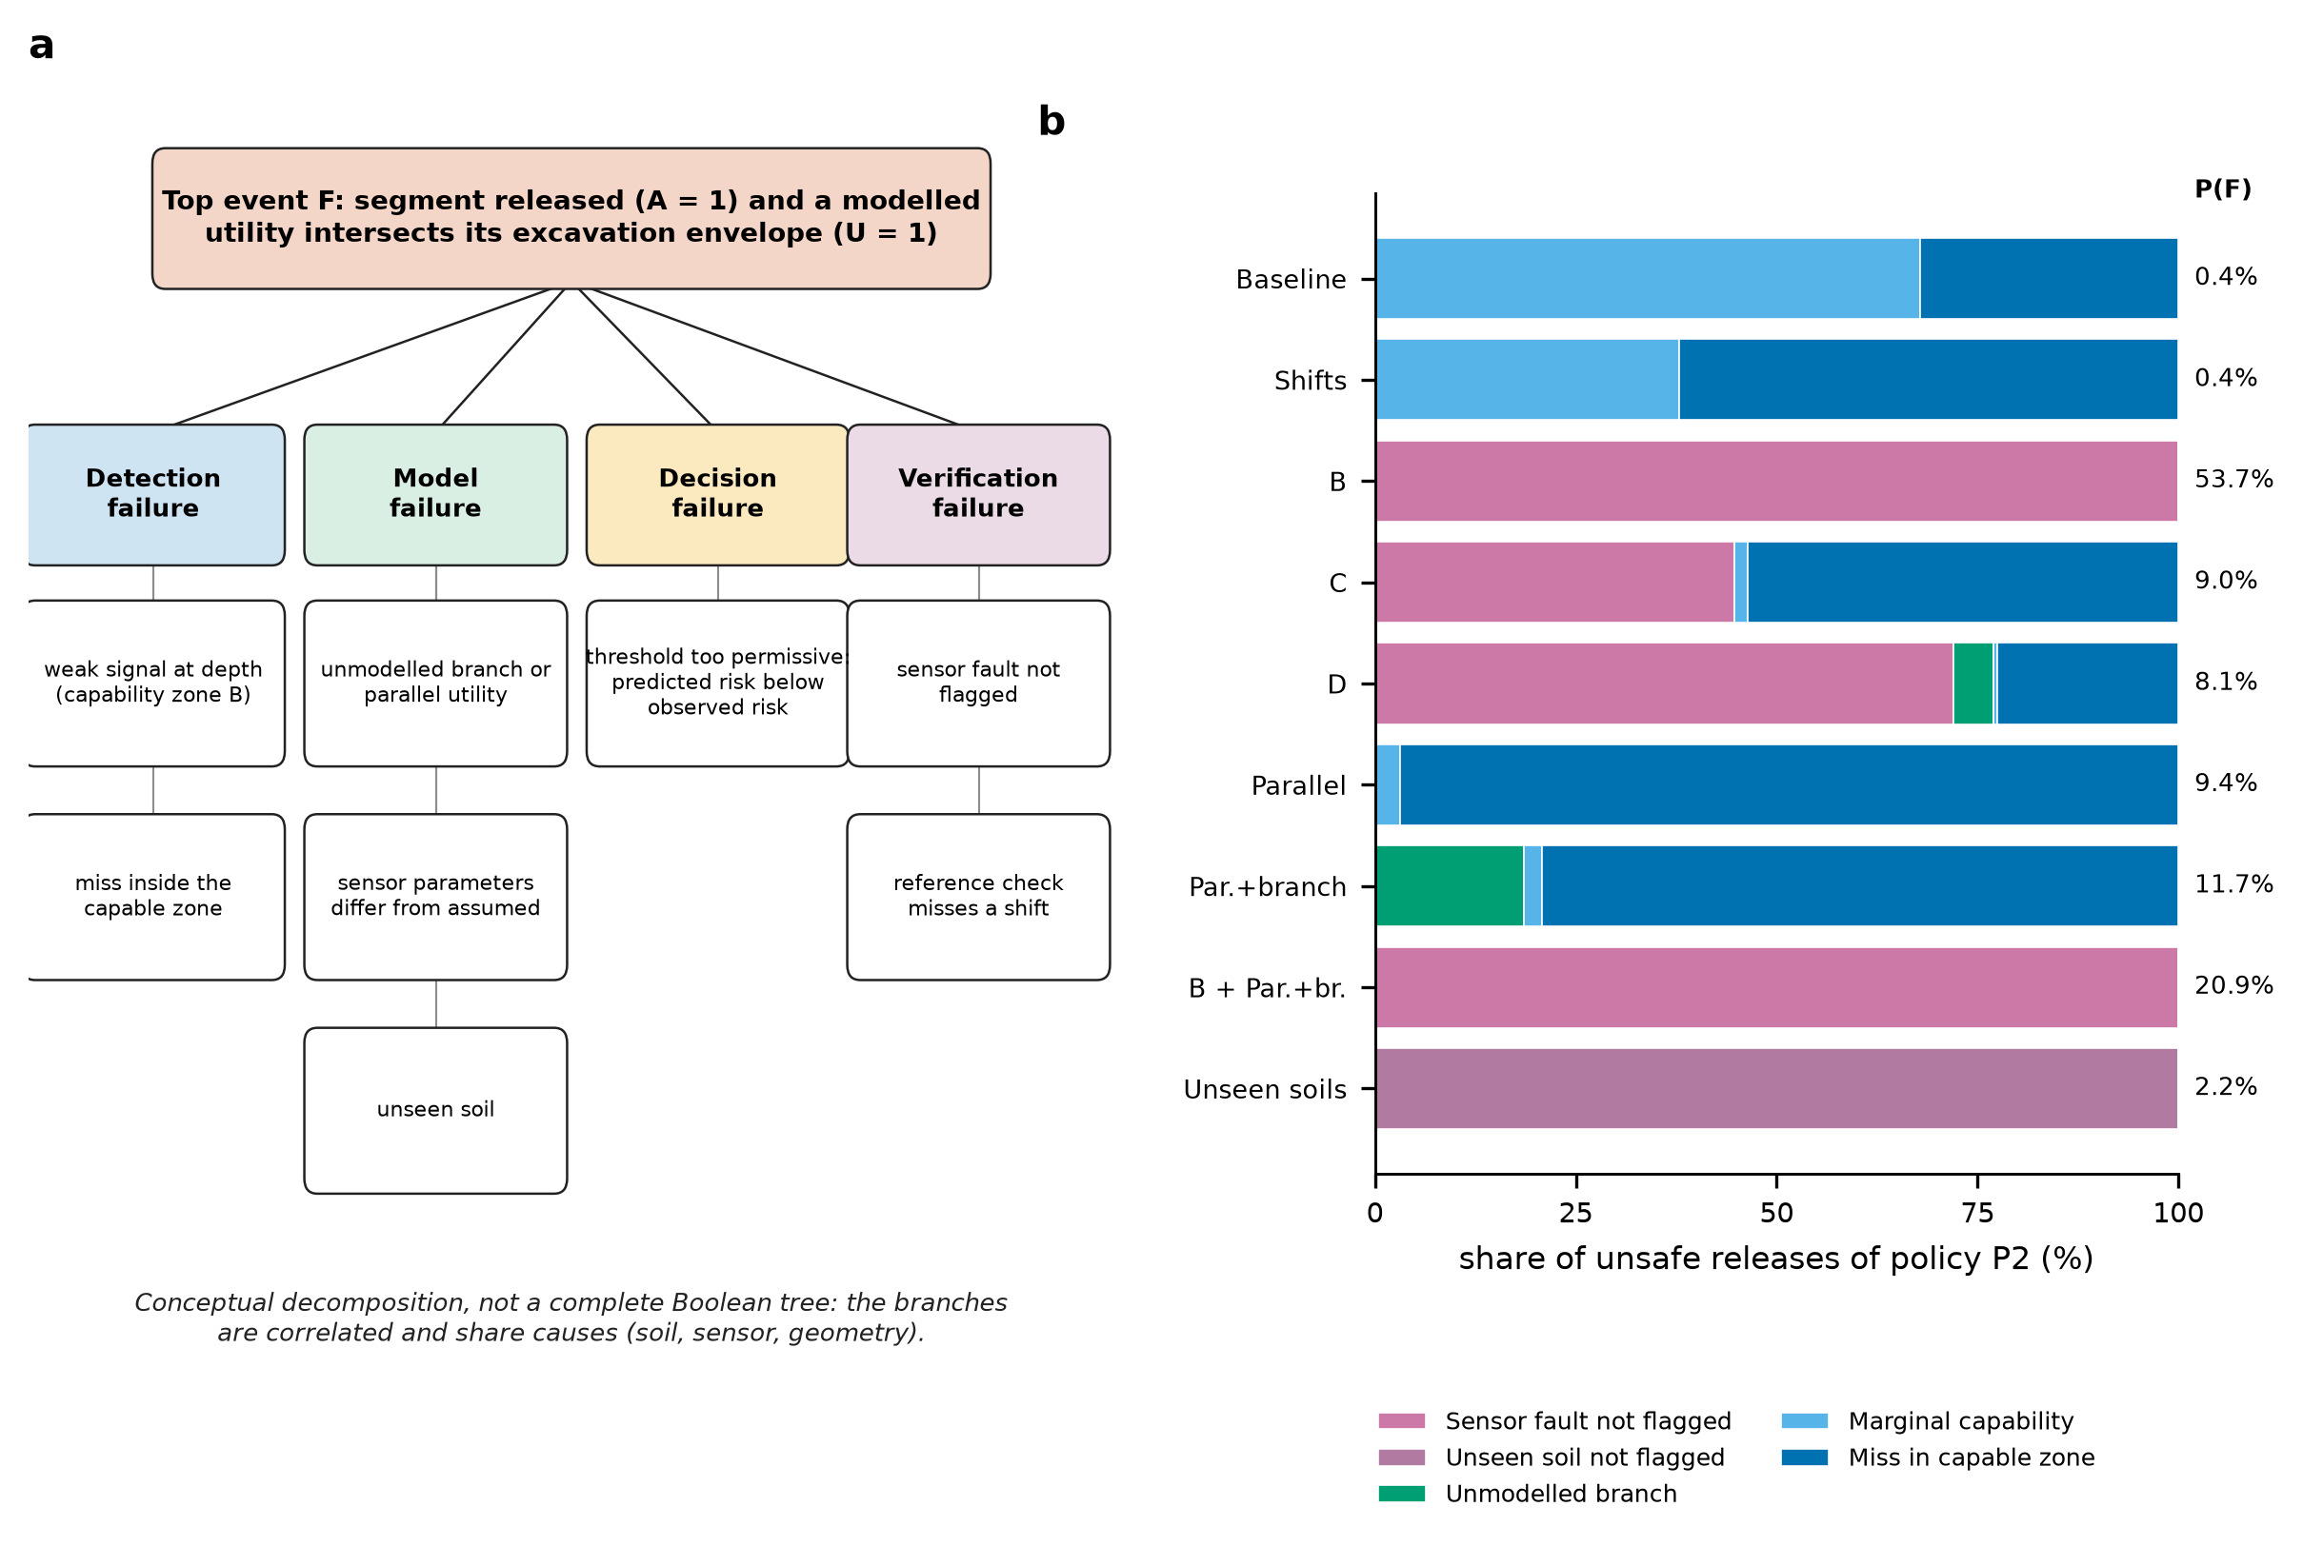
Fig. 1. (a) Conceptual decomposition of the top event, unsafe clearance, into detection, model, decision and verification failure. (b) Attribution of the simulated unsafe releases of the sensor-quality-adjusted policy P2 to mechanisms (exclusive categories assigned by the priority order of Section 3.4); the figure at the end of each bar is the unsafe-release probability P(F) of the scenario.
Table 4. Failure combinations simulated jointly (the other scenarios are listed in Section 5.1).
Scenario | GPR | EM | Geometry | Other
Baseline | healthy | healthy | as assumed | —
Failure A | failed, flagged | healthy | as assumed | —
Failure B | failed, not flagged | healthy | as assumed | —
Failure C | healthy | degraded (6 dB) | incorrect (bends, parallel utility) | —
Common cause D | degraded | degraded | incorrect (bends, parallel utility, branch) | soil twice as lossy as assumed
B with mismatch | failed, not flagged | healthy | incorrect (bends, parallel utility, branch) | —

4. Methods
All results come from three Python files (NumPy, SciPy, scikit-learn, Matplotlib): SubSurface_MC.py (version 1.0 simulation), SubSurface_v4.py (lateral tracking, sensor health, zones, mismatch and envelope experiments) and SubSurface_v5.py (the reliability analyses of this paper), run with a fixed seed (42). Every random stream is derived from the seed, a scenario tag and a block index, so that results do not depend on the number of processes. The built-in self-tests pass (27 + 14 + 17 tests); they check code against its own mathematics, not against reality.

4.1 Simulated corridors, sensors and truth
A corridor holds one utility of one type buried at one depth in one soil, tracked over 100 segments of 5 m. Five seen soils (dry sand, dry loam, moist loam, clay, rubble fill) and seven utility types (PE/PVC water, cast-iron water, plastic sewer, concrete sewer, power duct, telephone duct, dielectric fibre) define 35 cells, weighted by an assumed network share with the soils equally weighted; two unseen soils (wet clay and saline fill) are used only as test conditions. For band b (250 or 600 MHz) the signal-to-noise ratio in segment k is
$S_{b,k}\text{ = }B_{b}\text{ + }ρ_{u}\text{ − }a_{b}\text{(}s\text{) }d\text{ − 40 log}{}_{\text{10}}\text{(max(2}d\text{, 1)) − }L_{\text{lat}}\text{ + }z_{\text{run,}b}\text{ + }z_{\text{seg,}b,k}$ (9)
with system budget B_{b} (70 and 74 dB), utility reflectivity ρ_{u}, two-way soil attenuation a_{b}(s), depth d, a lateral penalty L_{lat} that depends on the offset between the utility and the survey pass, run-level noise z_{run} (3 dB, shared along a corridor) and segment-level noise z_{seg} (4 to 7 dB by soil); the bands are correlated (0.7). A detection occurs when S exceeds 8 dB; clutter adds a soil-dependent false-detection probability. The EM locator couples to a utility with a class-specific probability drawn once per corridor. Every value is an assumption, listed in the assumptions register of the repository and in the Supplementary Material.
The truth process puts the utility on the alignment at the anchor and lets it leave, return, shift sideways or drift. Five structural models of the geometry are used as scenarios: L0, straight (the filter’s assumption); L1, curved with a lateral drift; L2, a piecewise-linear path with abrupt bends (legs of 8 to 25 segments, slopes up to 0.25 m per segment) that is not a Markov chain on the filter’s grid; L3, bends plus a second utility 2 to 5 m away that also returns signals; and L4, bends, a parallel utility and a branch that leaves at a random position and adds to the truth where it lies on the excavation footprint. The filter never knows which geometry a corridor has. The truth label is that a modelled utility lies within 1 m of the reference alignment.

4.2 Fusion filter, sensor health and capability zones
The belief that the utility is absent or at one of 21 lateral offsets (−5 m to +5 m in 0.5 m steps) is propagated along the corridor with small fixed rates for ending, return, shifting and drifting, and updated by each sensor and pass through likelihoods that depend on soil, utility class and offset; the probability that the utility lies on the excavation footprint is the sum of the belief within 1 m. Survey is one centre pass or three parallel passes (−3, 0, +3 m). The EM coupling is a persistent per-corridor state, so that repeated EM non-detections are not counted as independent evidence of absence. Each instrument is healthy, degraded (6 dB loss) or failed (clutter only); an imperfect diagnostic reports the state, and a sensor flagged as failed contributes no evidence, a sensor flagged as degraded uses the degraded likelihood and an unflagged failure is treated as healthy (the assumed diagnostic rates are given in the Supplementary Material). The capability of a segment is the closed-form probability that at least one available sensor produces a true signal detection at the estimated depth (10% velocity error), and defines zones A (at least 0.9), B (0.3 to 0.9) and C (below 0.3). An on-site reference check passes a reference target of the segment’s class 20 times and compares the detection rate with the rate the filter predicts, by an exact binomial test (α = 0.01); in this study it is evaluated against the true sensor parameters of the world, so that it can detect a mismatch of the parameters as well as an unseen soil.

4.3 Uncertainty sets of the robust policies and the oracle
The filter-side set Ω used by P4 to P7 is explicit and is an assumption of the designer. Its parameter variants are the nominal sensor model; soil attenuation doubled; sensor budgets reduced by 3 dB; EM coupling halved; and attenuation doubled together with the 3 dB reduction. Its structural alternatives are a filter with a much less stable geometry model (loss 0.05, shift 0.03 and drift 0.10 per segment); a filter without the anchor; and the one-dimensional on-alignment model of version 1.0. P7 adds the probability that a utility lies anywhere in the ±5 m swath. All members are run on the same observations and the policy uses the pointwise supremum of their probabilities. The set does not contain every condition of the test worlds: the test envelope (Section 5.2) allows attenuation to be a quarter of the assumed value and as much as four times it, thresholds and budgets to vary by ±3 dB, and the geometry to be one of five structures, and the set cannot represent an unflagged sensor failure. The oracle B5 runs the filter with the true parameters, the true soil and the true health states as flags.

5. Experimental design

5.1 Scenarios, replicates and denominators
Twelve scenarios combine sensor health, geometry and parameter mismatch (Table 4 and Table 5). Each is simulated as 10 independent networks (blocks) of 40 corridors per soil-by-utility cell (1,400 corridors, 140,000 segments, 700 km of corridor per network for the seen soils); the conditional risks and coverages are cell-weighted means over the networks, intervals are 95%% percentile intervals of 300 cluster-bootstrap resamples of whole corridors within each cell (Efron, 1979; Field and Welsh, 2007), and curves are averaged over networks with 95%% t-intervals over the 10 independent networks, never over adjacent segments. All policies see the same simulated detections in a scenario (paired comparison).
Table 5. The twelve scenarios.
Scenario | Description
baseline | Baseline: sensors healthy, geometry as assumed
shifted frequent | Frequent lateral shifts (1.5 per 100 m)
A gpr failed flagged | Failure A: GPR failed and flagged; EM healthy
B gpr failed unflagged | Failure B: GPR failed, not flagged; EM healthy
C em degraded wrong geometry | Failure C: GPR healthy, EM degraded, geometry incorrect (parallel utility)
D common cause | Common cause: both sensors degraded, soil twice as lossy as assumed, parallel utility and branch
G3 parallel | Geometry incorrect: bends and a parallel utility
G4 parallel branch | Geometry incorrect: bends, parallel utility and branch
B x G4 | Unflagged GPR failure together with incorrect geometry (bends, parallel, branch)
ood soils check | Unseen soils, on-site reference check active
mixed health | Mixed sensor health, imperfect diagnostic
combined | Shifts, mixed health and 30% dropped observations

5.2 Uncertainty experiment
The epistemic envelope draws the true sensor parameters from the ranges of version 1.1 (40 draws): attenuation of each seen soil multiplied by a log-uniform factor between 0.25 and 4, detection threshold and system budget each varied by ±3 dB, spreading coefficient 30 to 50, EM coupling multiplied by 0.5 to 1.5; the filters keep the nominal parameters, and the reference check sees the true parameters. Each draw is crossed with the five structural models and simulated as 3 independent networks of 14 corridors per cell (490 corridors per network), giving 600 networks. The structural models are scenarios and are never averaged. The envelope is a stated assumption about how far the true parameters might be from the assumed ones, and is wider than the one-at-a-time sensitivity analysis of earlier versions.

5.3 Reliability–coverage curves, dominance and calibrated abstention
For each score the segments are ordered from lowest to highest score and released from the bottom; the conditional risk is evaluated at every released coverage from 1% to 90%. Each curve is computed per independent network and averaged. Two curves are compared at each coverage by the paired difference over networks; A is said to be better where the 95% t-interval of the difference lies below zero, worse where it lies above, and indistinguishable otherwise, and the share of the common coverage range in each state is reported, together with whether A is nowhere worse. The calibrated-abstention baselines are fitted on 8 separate calibration networks of the baseline scenario: the score is isotonic-calibrated against the outcome and a segment is released if its calibrated probability of a utility is at most 2%.

5.4 Ablation and verification prioritisation
Components of the full policy P5 are removed one at a time and the conditional risk is compared at equal released coverage, both on a common grid (10%, 20%, 30%, 40%) and at the released coverage of P5 itself in each scenario: sensor-health information (health-unaware filters and zones), spatial continuity (a near-memoryless filter with a hazard of 0.5 per segment), structural uncertainty (parameter variants only), parameter uncertainty (structural alternatives only), capability thresholds (ranking by the bound without zone-specific scaling or guard) and robustness altogether (the ranking of P2). Verification prioritisation is evaluated separately: segments left unverified by P5 are verified with a budget of pits (2% to 40% of all segments) in random order, lowest probability first, or highest value of information, and the share of the corridor cleared by pits is compared.

5.5 Global sensitivity analysis
Eight parameters are sampled with a Latin hypercube design (McKay et al., 1979; 320 points) over stated ranges: soil attenuation multiplier (log-uniform, 0.25 to 4), sensor sensitivity offset (±4 dB), probability that a failed sensor is flagged (0 to 1), sensor failure prevalence (0 to 0.30; 20% of sensors are degraded), lateral displacements (0 to 3 per 100 m), share of corridors with a parallel utility and branch (0 to 1), share of corridors in unseen soils (0 to 0.5) and the hazard that the utility leaves the alignment (0.05 to 1.0 per 100 m, log-uniform). Each design point is simulated as four sub-worlds (straight or parallel-and-branch, seen or unseen soils) of two independent networks each, mixed by the design weights. A gradient-boosting surrogate is fitted to the unsafe-release probability and the conditional risk of each policy; first-order and total-order Sobol indices are estimated on the surrogate (Saltelli et al., 2010; Jansen, 1999; Sobol, 2001) and their stability is checked by refitting on 60 bootstrap resamples of the design points. The indices are interpretable because the parameters are sampled independently by construction, which is an assumption: in reality soil conditions, sensor performance and model error may be correlated. The surrogate’s hold-out R² is reported, and indices are used only where the surrogate is adequate.

5.6 Physical plausibility and the absence of external validation
No published measurement of GPR or EM detection probability against known utility depth and soil was reproduced in this study. The detection curves are therefore outputs of an assumed model, and the paper is a methodological demonstration of the reliability analysis of a decision policy, not a predictive utility-detection model. Two independent plausibility checks are reported, neither of which is a validation. First, the low-loss relation between conductivity and attenuation reproduces a worked example given by the US Environmental Protection Agency (US EPA, n.d.): for 100 mS/m and a relative permittivity of 20 it gives 36.6 dB/m against the 38 dB/m published. Second, the one-way attenuations implied by the assumed values at 250 MHz (0.75 dB/m for dry sand, 7.0 dB/m for clay, 15.0 dB/m for wet clay) lie within the tabulated range for clays but well above the tabulated value for dry sand; the table states no frequency and no primary source, and the assumed attenuation lumps absorption, scattering and clutter, so this is a check on orders of magnitude only. Because the true parameters may differ from the assumed ones, the parameter envelope and the global sensitivity analysis vary them over wide ranges, and the study asks which conclusions survive, not which numbers are right. The most important missing step is a comparison with a measured detection-versus-depth dataset (Section 7.4). Modelled utility intersections are not strikes: whether an intersection becomes a strike depends on hand-digging and vacuum-excavation procedures, locating before digging and operator behaviour, none of which is modelled.

6. Results

6.1 Reliability–coverage curves
Figure 2 plots the conditional false-clearance risk against the released coverage for the candidate scores. In the matched model every score releases about 20% of the corridor at essentially no risk, the risk rises steeply between 20% and 40% released, and approaches the prevalence of occupied segments beyond. At equal coverage the curves of the policy candidates lie close together: in the baseline the sensor-quality-adjusted score (P2) has a conditional risk of 0.26% at 25% released coverage, standard fusion 1.26%, the health-aware lateral filter without zones 0.35%, the robust score (P5) 0.03% and the oracle 0.32%. The ordering is not consistent along the range: across the twelve scenarios the quality-adjusted score is nowhere worse than standard fusion in 0, the robust score nowhere worse than the quality-adjusted score in 1, and the oracle nowhere worse than the robust score in 6 (Supplementary Table S2). Differences between candidates are small compared with the gap to the oracle where sensor health or the sensor parameters matter: with mixed sensor health the quality-adjusted score has a risk of 1.6% at 20% coverage and the oracle 0.1%; with unseen soils 9.6% and 0.2% at 15% coverage. Where the geometry is wrong the oracle is no better than the other scores: under common-cause conditions (D) the quality-adjusted score and the oracle have 4.0% and 6.1% at 30% coverage.
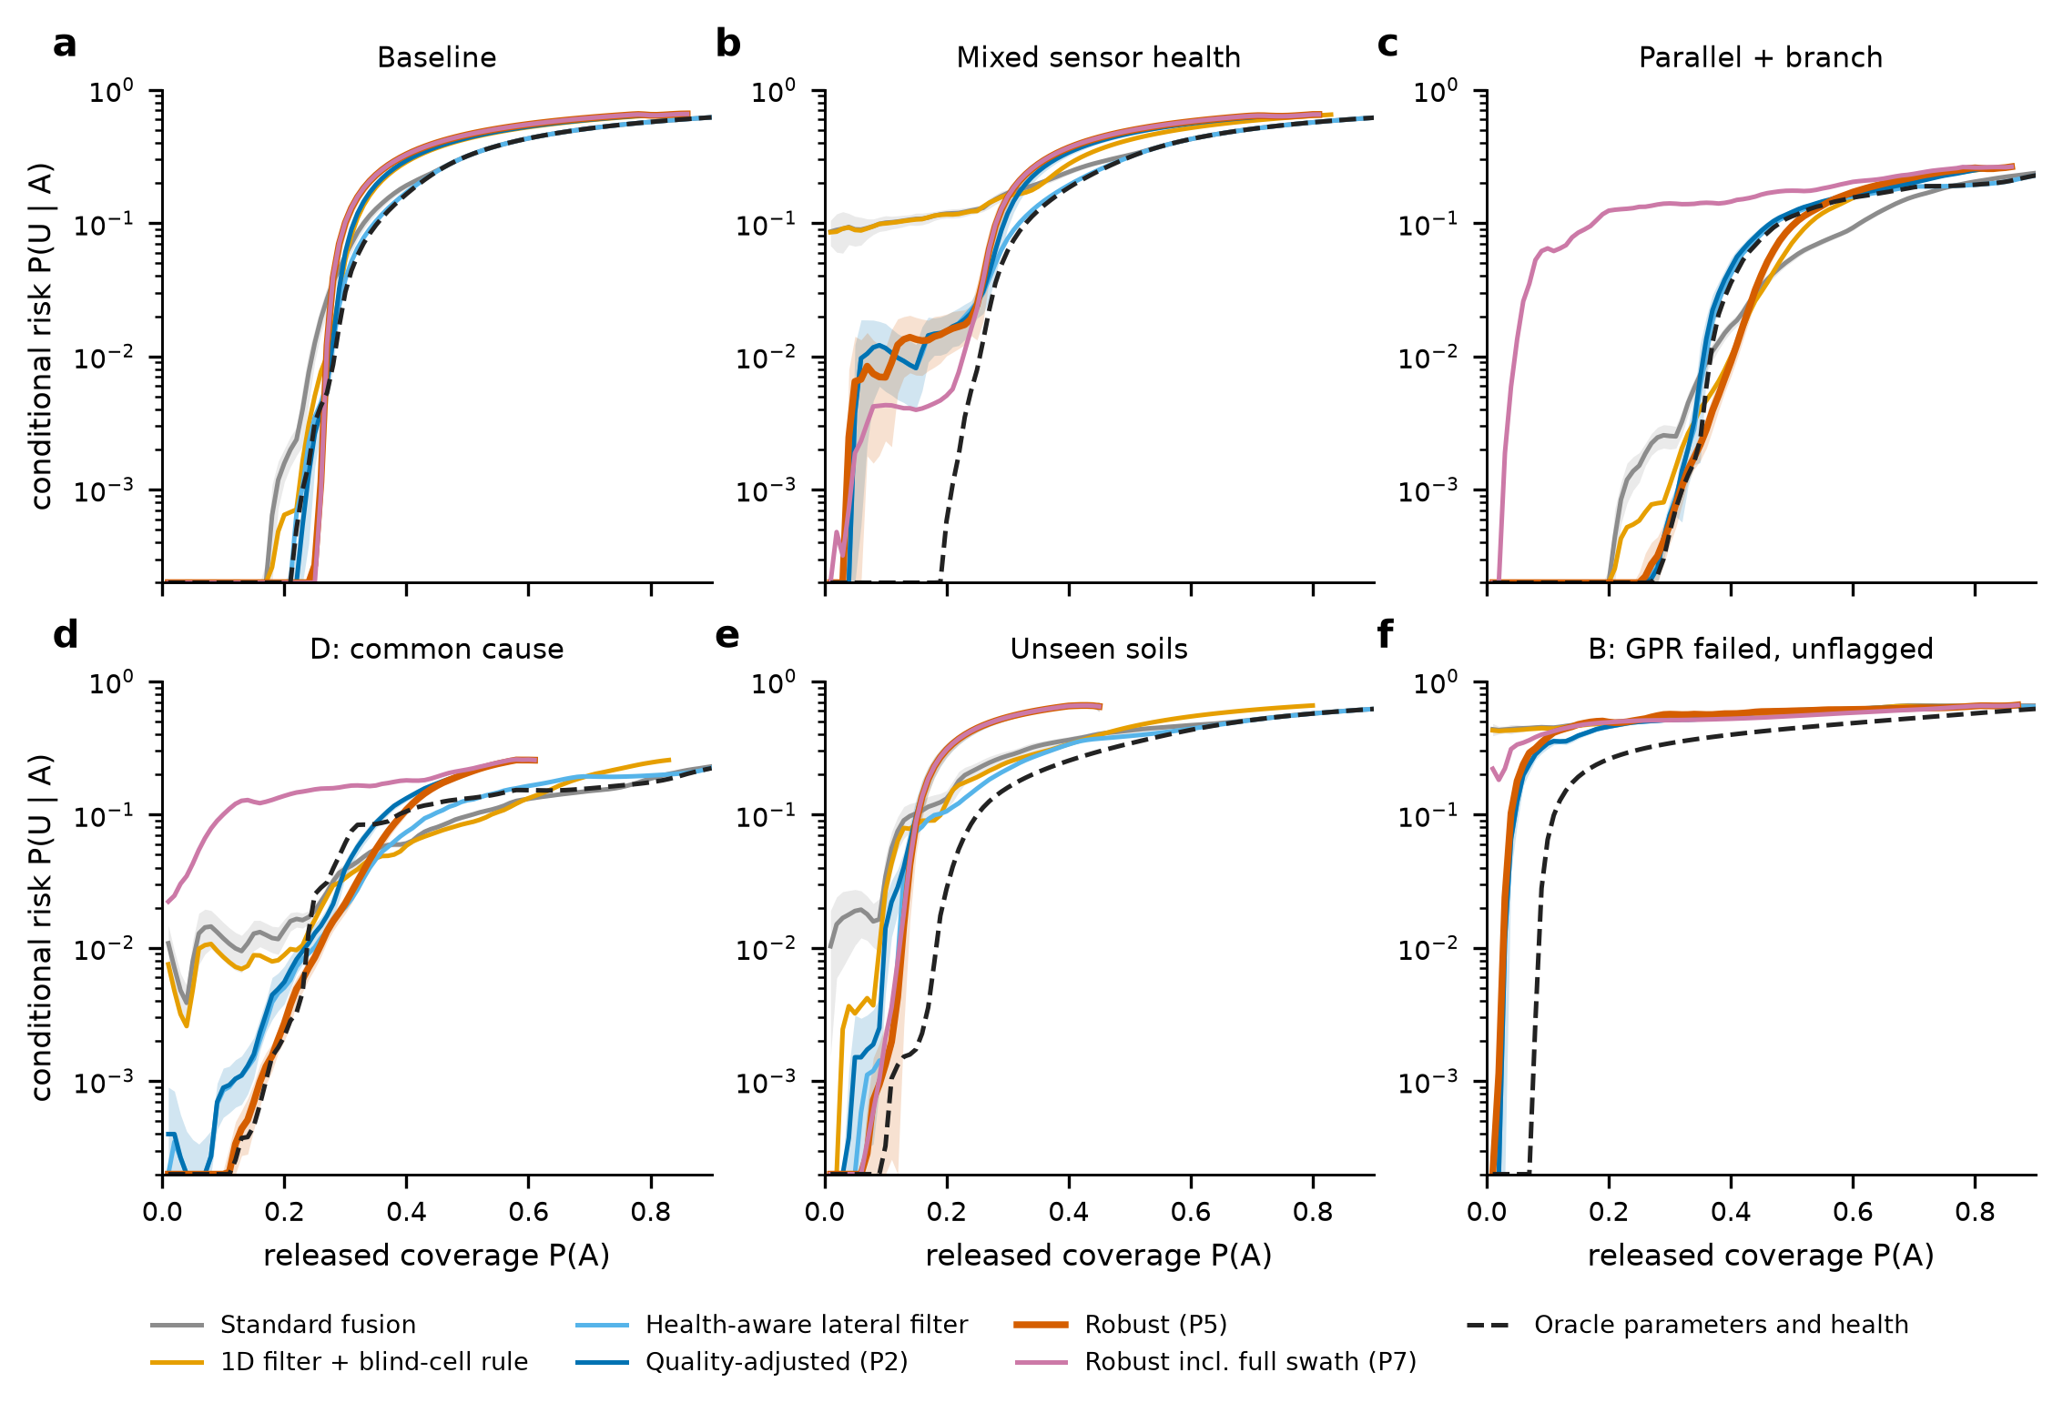
Fig. 2. Reliability–coverage curves: conditional false-clearance risk P(U | A) against released coverage P(A) in six scenarios (logarithmic axis, floor 0.02%). Curves are means over 10 independent simulated networks of 700 km each; shaded bands are 95% t-intervals for the standard-fusion, quality-adjusted and robust scores. The dashed curve is the oracle with the true sensor parameters, soil and health states. The full-swath score (P7) is saturated for most segments when the geometry is wrong, so that its low-coverage values rest on few segments.
The robust score is not uniformly better than the nominal one at equal coverage. In the baseline it is worse than the quality-adjusted score over 61% of the common coverage range (by at most 4.0 percentage points) and better over 9%; it is nowhere worse only under common-cause conditions (D). Its advantage in Section 6.2 therefore comes mainly from the operating point it selects, a lower released coverage in conditions where the nominal model is wrong, and only secondarily from a better ranking of the segments. The same holds for abstention in general: the standard-fusion score and the 1D score with a blind-cell rule have curves that cross those of the lateral scores in several scenarios, and a policy that abstains more simply moves to the left on its own curve.

6.2 Release policies at their operating points
Table 6 and Figure 3 give the conditional risk and the released coverage of every policy at the operating point defined by its own rule. In the matched model standard Bayesian fusion with a fixed 0.5 threshold, the ordinary baseline, releases 44% of the corridor at a conditional risk of 23.4%. The health-aware lateral filter with a fixed threshold (P1) releases 30% at 3.4%, the sensor-quality-adjusted policy (P2) 28% at 1.3%, the expected-loss policy (P3) 29% at 2.9%, and the robust policy (P5) 25% at 0.02% (unsafe-release probability 0.005%). The three-state rule is therefore not a free improvement: it moves the operating point to a lower coverage, and the risk falls with it. The expected-loss policy releases about as much as P1 because, with the assumed costs, a pit costs more than a hold for most segments and the verify action is rarely preferred (0.6% of segments).
Table 6. Conditional false-clearance risk P(U | A) (%) and, in brackets, released coverage P(A) (%) of each policy in each scenario (cell-weighted means over 10 independent networks; cluster-bootstrap intervals are in Supplementary Table S1). RC = calibrated abstention, level fitted on separate baseline networks at a calibrated probability of 2%. B5 knows the true parameters and health states.
Scenario | B1 standard fusion | B2 1D framework | P1 fixed | P2 quality-adj. | P3 exp. loss | P5 robust | P7 robust + swath | RC fusion | RC quality | B5 oracle
baseline | 23.4 (44) | 4.5 (30) | 3.4 (30) | 1.3 (28) | 2.9 (29) | 0.02 (25) | 0.00 (24) | 0.30 (23) | 0.03 (23) | 3.5 (30)
shifted frequent | 5.2 (76) | 1.2 (61) | 1.0 (65) | 0.67 (63) | 0.81 (65) | 0.04 (53) | 0.00 (24) | 0.12 (48) | 0.01 (50) | 1.0 (66)
A gpr failed flagged | 65.7 (98) | 65.4 (83) | 0.23 (8) | 0.05 (6) | 0.18 (8) | 0.00 (6) | 0.00 (6) | 64.6 (67) | 0.00 (6) | 0.23 (8)
B gpr failed unflagged | 65.7 (98) | 65.5 (83) | 64.9 (85) | 65.1 (82) | 64.8 (84) | 63.0 (71) | 51.0 (28) | 64.7 (66) | 63.6 (67) | 0.26 (8)
C em degraded wrong geometry | 6.6 (60) | 1.5 (46) | 14.1 (66) | 14.1 (64) | 13.2 (64) | 0.22 (39) | 0.01 (2) | 0.21 (34) | 0.23 (37) | 14.2 (68)
D common cause | 15.5 (73) | 12.0 (58) | 18.6 (66) | 17.7 (46) | 17.9 (65) | 3.2 (32) | 2.3 (2) | 6.1 (41) | 4.4 (31) | 14.3 (55)
G3 parallel | 6.7 (59) | 1.6 (45) | 14.6 (66) | 14.6 (64) | 13.7 (64) | 0.22 (38) | 0.00 (2) | 0.21 (34) | 0.26 (37) | 14.7 (68)
G4 parallel branch | 7.9 (57) | 1.9 (43) | 18.0 (67) | 18.0 (65) | 16.9 (64) | 0.29 (36) | 0.00 (1) | 0.24 (32) | 0.38 (35) | 18.0 (68)
B x G4 | 26.2 (98) | 25.5 (83) | 25.1 (85) | 25.2 (83) | 25.0 (85) | 24.2 (73) | 18.2 (18) | 25.8 (66) | 24.4 (67) | 2.2 (8)
ood soils check | 48.0 (64) | 39.8 (45) | 34.1 (40) | 13.5 (16) | 32.4 (39) | 1.6 (14) | 0.36 (11) | 13.5 (21) | 3.4 (13) | 5.9 (22)
mixed health | 32.6 (50) | 19.5 (36) | 5.8 (29) | 3.6 (27) | 5.3 (28) | 1.7 (23) | 0.61 (22) | 15.7 (28) | 1.7 (22) | 3.8 (28)
combined | 13.2 (85) | 4.6 (63) | 1.8 (60) | 1.4 (57) | 1.4 (58) | 0.52 (48) | 0.30 (21) | 10.9 (57) | 0.34 (32) | 1.4 (60)

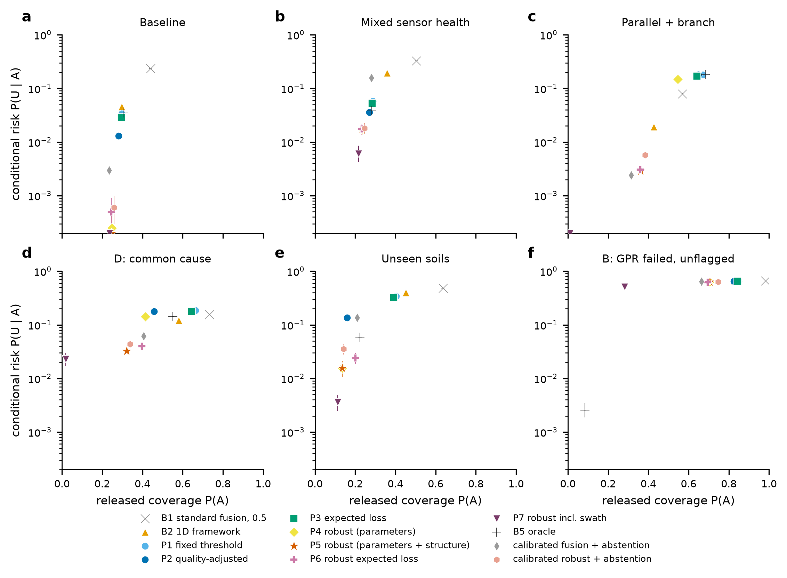
Fig. 3. Safety–coverage trade-offs under alternative abstention policies: conditional risk P(U | A) against released coverage P(A) at each policy’s own operating point in six scenarios (95% cluster-bootstrap intervals; logarithmic axis, floor 0.02%). B5 is the oracle and is not attainable.
Where the nominal model is wrong the picture changes. With a parallel utility and a branch (G4) the fixed and quality-adjusted policies release 67% and 65% of the corridor at conditional risks of 18% and 18%; standard fusion releases 57% at 8% and the 1D framework 43% at 1.9%. The robust policy releases 36% at 0.3% and the robust expected-loss policy 36% at 0.3%; the calibrated-abstention baselines are in the same region (0.1% at 30% for the 1D score with the blind-cell rule, 0.4% at 35% for the quality-adjusted score). The robustness is bought with coverage: P5 releases 29 percentage points less of the corridor than P2 in G4 and 3 in the baseline. The most conservative policy, P7, which also allows the utility to lie anywhere in the swath, releases 1% of the corridor in G4 and is not useful as a working policy; it bounds what an envelope that is wide enough for this mismatch costs. The oracle is as unreliable as P2 in G4 (18%), because it knows the parameters and health states but not the geometry.
Is the benefit just abstention? Partly. A calibrated-abstention baseline on the plain 1D score reaches 0.1% conditional risk at 30% coverage in G4, comparable to the robust policy, and in the baseline the calibrated-abstention baselines release 23% to 26% of the corridor at a risk of 0.30% to 0.06%, against 28% and 1.3% for P2. Their level was fitted on baseline networks to a calibrated probability of 2%, which turned out to be a strict operating point, and it keeps them safe under geometric mismatch simply because they release little. What abstention on a score without health information or a reference check cannot do is show in the scenarios with sensor and soil conditions: with mixed sensor health calibrated fusion plus abstention has a conditional risk of 15.7% against 3.6% for P2 and 1.7% for P5, with unseen soils 13.5% against 13.5% and 1.6%, and in the combined scenario 10.9% against 1.4% and 0.5%. The calibrated baselines that use the health-aware filter (RC quality, RC robust) are close to P5 in these scenarios (for example 1.7% with mixed health). The benefit of the framework in these conditions is therefore the health information and the reference check, which the abstention baselines lack, and not the robust bound on top of them.
Decision failure. The probability that the filter attaches to released segments is a prediction of their risk. In the baseline it predicts 0.05% for P2, where the observed risk is 1.3%; in G4 it predicts 0.30% and 18.0% is observed; with unseen soils 0.19% against 13.5%; with mixed health 0.07% against 3.6%. For P5 the upper bound is predicted at 0.19% in G4 against an observed 0.29%. Overconfidence of this size is a calibration failure of the decision layer: its probabilities are well ordered but not calibrated, the gap grows when the model is wrong, and an operator who read the probabilities as risks would be misled by up to two orders of magnitude (Supplementary Fig. S2).

6.3 Fault scenarios and common-cause failure
Table 4 lists the failure combinations. When the GPR has failed and the failure is flagged (A), the health-aware policies treat the GPR as uninformative and fall back on the EM locator: P2 releases 6% of the corridor at 0.1% conditional risk, whereas standard fusion and the 1D framework read the silence of the dead GPR as absence and release 98% and 83% at risks of 66% and 65%. When the same failure is not flagged (B) every policy fails alike: the conditional risk is 65% for P1, 65% for P2, 63% for P5 and 66% for the 1D framework, against the oracle’s 0.3%. The protection of sensor-health awareness is only as good as the diagnostic; the oracle, which knows the health states, is safe (Fig. 4). The robust policy cannot help here, since none of the members of its uncertainty set represents an unflagged failure.
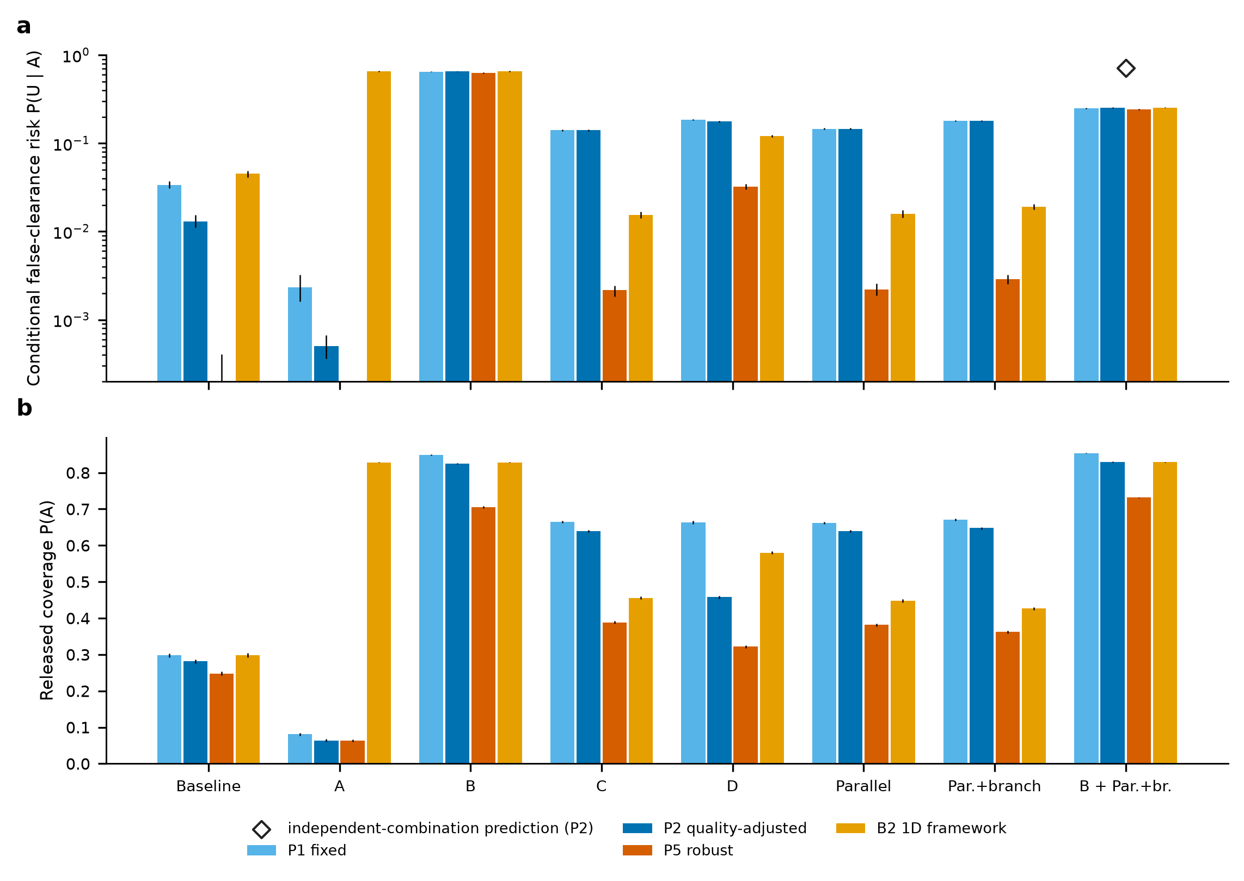
Fig. 4. Fault scenarios: (a) conditional false-clearance risk and (b) released coverage of four policies in the baseline and the failure combinations of Table 4 (95% cluster-bootstrap intervals; logarithmic axis in (a)). The diamond marks the conditional risk obtained by combining the marginal risks of failure B and of the geometry G4 as independent events.
Combinations and dependence. Failure C (a degraded EM locator with a parallel utility) behaves like the geometry alone: the quality-adjusted policy has a conditional risk of 14.1% against 14.6% for the geometry without the EM degradation. The common-cause scenario D, in which both sensors are degraded, the soil is twice as lossy as assumed and the geometry is wrong, gives 17.7% for P2 (releasing 46%), 3.2% for the robust policy (32% released) and 12.0% for the 1D framework; the reference check flags 25% of corridors there. The compound case of an unflagged GPR failure together with the wrong geometry gives 25% for P2. Multiplying the marginal events as independent, 1 − (1 − 0.65)(1 − 0.18) = 71%, would overstate the simulated value by a factor of 2.8, and the simulated value is lower than that of failure B alone (65%), because the bends of the geometry move the utility off the excavation footprint for a share of the segments, so that fewer released segments are occupied. The effects are neither independent nor additive, and no formula that composes component probabilities would have predicted them; they have to be evaluated jointly.
Attribution to the failure tree. Figure 1b assigns the unsafe releases of P2 to mechanisms. In the baseline they are 68% marginal-capability segments (zone B) and 32% misses inside the capable zone, both detection failures. Under failure B all of them are missed diagnostics (verification failure). With unseen soils all are corridors that the reference check did not flag (verification failure; it flags 38% of the corridors). With a parallel utility and a branch, 79% are misses in the capable zone, 18% lie on the unmodelled branch and 2% in marginal capability. The misses in the capable zone are, in this geometry, the tracker’s mistaking of the parallel line for the target, a model failure that segment-level tags cannot isolate; its size is read from the comparison with matched geometry in Section 6.4. The decision-failure branch is measured by the calibration gap above. The attribution is a diagnostic of the simulation with a fixed priority order, not a probability decomposition.

6.4 When increased model complexity reduces reliability
The results demonstrate that increased spatial-model complexity does not necessarily improve safety-critical decision reliability. In the matched model the lateral tracker with three parallel passes has a false clearance of 1.4% against 4.4% for the one-dimensional continuity filter and 23.5% for per-segment fusion (version 1.1 experiment, Table 7), and it keeps false alarms low when utilities shift sideways. Under structural mismatch involving a parallel utility, or a parallel utility and a branch, the continuity-aware model with lateral tracking has a false clearance of 14.8% and 18.3%, against 1.8% and 2.0% for the simpler one-dimensional filter and 6.7% and 8.0% for per-segment fusion. The same reversal is found in the present experiment with the health-aware lateral policies, whose conditional risk rises from 1.3% (P2, matched) to 14.6% (parallel) and 18.0% (parallel and branch), against 1.6% and 1.9% for the 1D framework. A model with abrupt bends alone (L2) does not cause it (0.9% against 1.4% for the matched case). The lateral tracker attributes the returns of the parallel line to the best-fitting offset, takes the line for the target, and clears the excavation footprint on which the real utility lies; the one-pass filters keep calling the footprint occupied whenever they see a return and are safe in this respect only because they cannot tell the lines apart. A model that is more capable when its assumptions hold can therefore be the less reliable model when they do not: it becomes overconfident when its assumed spatial structure does not represent the network, and the calibration gap of Section 6.2 shows the size of that overconfidence. Consequently, reliability assessment must evaluate not only performance under nominal conditions but also the possibility that the model’s own assumptions become a source of unsafe decisions. These findings motivate explicit model-mismatch diagnostics, conservative abstention and independent verification where structural uncertainty cannot be resolved.
Table 7. False clearance among released segments (%, mean and 95% cluster-bootstrap interval; version 1.1 experiment, five soils, 17,500 corridors per geometry) as the truth geometry departs from the filters’ model, and the calibration error of the probability.
Geometry | Fusion | v1.0 1D filter | v1.0, 3 repeats | Lateral, 1 pass | Lateral, 3 passes | ECE (1D / lateral 3)
L0 matched: straight | 23.5 [23.0, 24.3] | 4.4 [3.9, 4.9] | 3.4 [3.0, 3.9] | 3.2 [2.8, 3.6] | 1.4 [1.1, 1.6] | 0.029 / 0.029
L1 curved (drift) | 17.8 [17.4, 18.4] | 4.6 [4.3, 5.0] | 4.0 [3.6, 4.3] | 3.5 [3.2, 3.8] | 2.3 [2.1, 2.5] | 0.076 / 0.025
L2 spline with abrupt bends | 5.5 [5.4, 5.7] | 1.3 [1.2, 1.4] | 1.2 [1.1, 1.3] | 1.2 [1.1, 1.3] | 0.9 [0.8, 0.9] | 0.103 / 0.058
L3 bends + parallel utility | 6.7 [6.5, 6.9] | 1.8 [1.6, 1.9] | 1.5 [1.3, 1.6] | 1.4 [1.3, 1.6] | 14.8 [14.5, 15.1] | 0.255 / 0.212
L4 bends + parallel + branch | 8.0 [7.8, 8.2] | 2.0 [1.8, 2.2] | 1.7 [1.5, 1.9] | 1.8 [1.6, 1.9] | 18.3 [17.9, 18.7] | 0.255 / 0.220

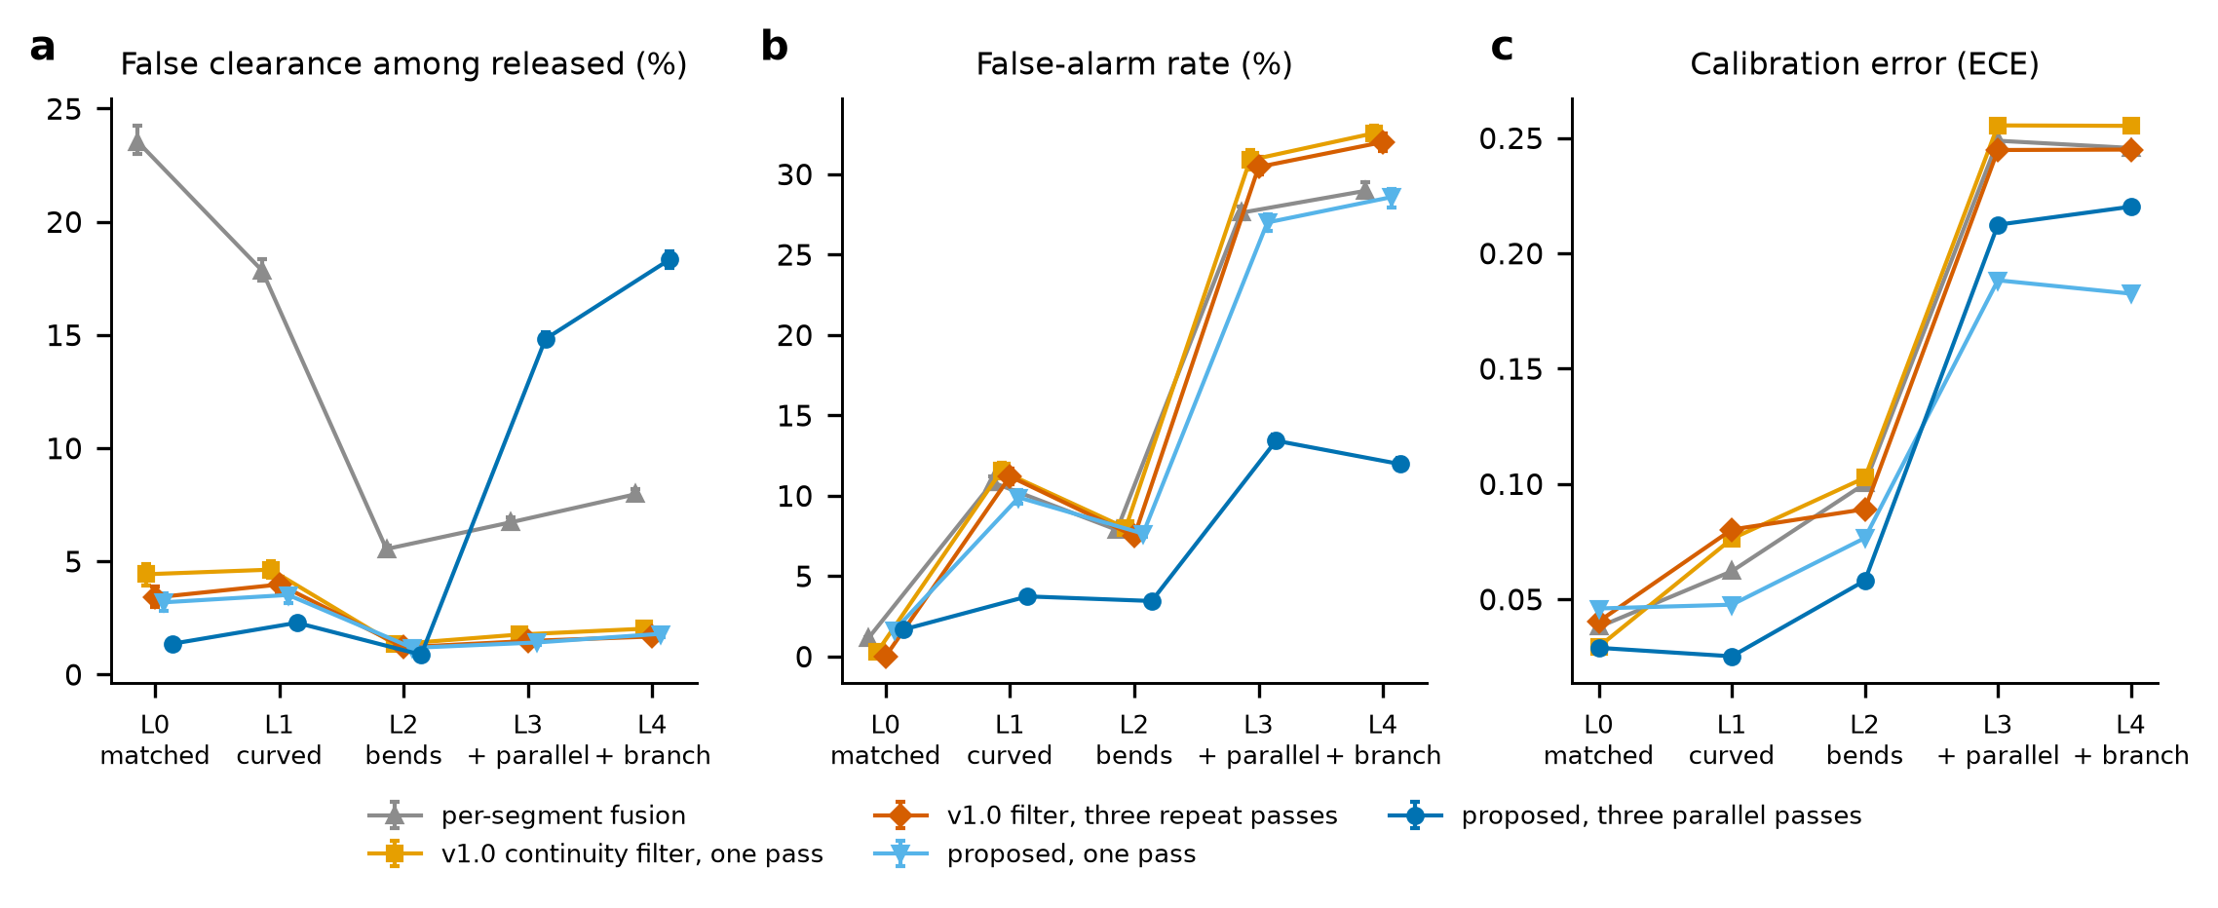
Fig. 5. Deterioration as the truth geometry departs from the filters’ model (L0 matched to L4 bends with a parallel utility and a branch): (a) false clearance among released segments, (b) false-alarm rate, (c) calibration error.
The robust policy is the response considered here. Because its uncertainty set contains the one-dimensional on-alignment model as a structural alternative, P5 keeps the conditional risk at 0.2% (L3) and 0.3% (L4), but at a released coverage of 38% and 36% instead of 64% and 65% for P2. The price is the loss of the lateral tracker’s advantage under shifts; it is not free, and a different set would give a different price. Where the mismatch is not in the set, the bound does not help, as the unflagged failure shows.

6.5 Aleatory and epistemic contributions to unsafe-release risk
Figure 6 and Supplementary Table S4 separate the two kinds of uncertainty for 40 parameter draws crossed with the five structural models (3 networks of 490 corridors, 245 km each, per cell). Within a structural model the unsafe-release probability of the sensor-quality-adjusted policy P2 has a mean between 1.0% (L2) and 11.0% (L4); the between-network (aleatory) standard deviation is 0.16 to 0.58 percentage points, and the standard deviation of the mean across parameter draws (epistemic) is 0.32 to 1.55 percentage points. The epistemic share of the variance is 79 to 88% for P2, 74 to 78% for P5, 96 to 98% for the 1D framework and 58 to 97% for P1. Parameter uncertainty therefore dominates the variability of the unsafe-release probability once a network is large enough for the network-to-network variation to average out; more simulated networks would not reduce it, and only knowledge of the parameters would. The aleatory share is a property of the network size used and would be larger for shorter networks. For P1, the share falls to 58 and 60% for the two geometries with a parallel utility: there the failure is set by the structure and is nearly insensitive to the parameters (the mean is 10.7% and 13.2% across the whole parameter envelope).
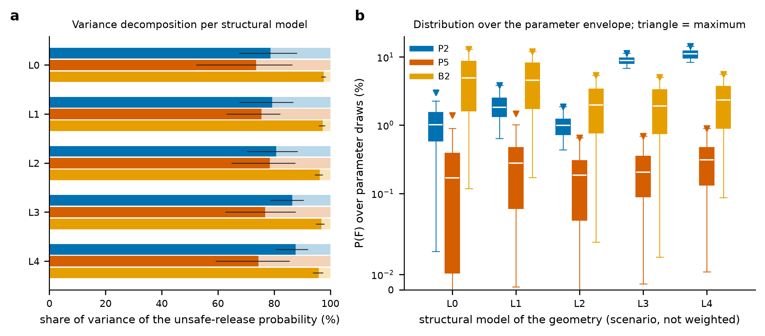
Fig. 6. Aleatory and epistemic contributions to unsafe-release risk. (a) Share of the variance of the unsafe-release probability of a simulated network (490 corridors) that is epistemic (variation of the expected value across 40 parameter draws, dark; 95% bootstrap interval) and aleatory (variation between independent networks of the same draw, light), per structural model and for P2, P5 and the 1D framework. (b) Distribution of the unsafe-release probability over the parameter draws (boxes: quartiles; whiskers: 5th to 95th percentile; triangle: maximum; the structural models are scenarios and are not averaged).
The envelope of results across structural models is the scenario analysis of Eq. 7. For P2 the mean unsafe-release probability across parameter draws is 1.1% for the matched geometry and 11.0% for a parallel utility and a branch, a factor of 10; the 95th percentile and the maximum over the draws in the worst structure are 13.4% and 14.4%, and the maximum conditional risk is 22%. For the robust policy P5 the corresponding means are 0.26% and 0.33%, a factor of 1.3, and the maximum over all 200 parameter-by-structure cells is 1.5% (conditional risk 6.5%). The quantity that the structural models change most is therefore the unsafe-release probability of the nominal policy, and the robust policy narrows the envelope at the price of released coverage (23 to 47% on average against 26 to 58% for P2). No probability has been given to the structural models, so no single risk number is claimed; the ranges are the result.

6.6 Ablation and verification prioritisation
Removing one component of the robust policy at a time and comparing the conditional risk at equal released coverage (Fig. 7; Supplementary Table S3) shows that every component matters in some conditions and none matters everywhere. In the matched baseline all removals change the risk by at most 0.4 percentage points at the released coverage of P5 (25%, where the full policy has a risk of 0.03%). Removing sensor-health information raises the risk by +11.9 points with mixed health, +25.3 points when the GPR has failed and is flagged and +2.1 points in the combined scenario; removing structural uncertainty raises it by +4.5, +4.4 and +4.6 points in the geometries C, G3 and G4 and by +5.4 points in the common-cause scenario; removing spatial continuity raises it by +3.8 points with unseen soils and +3.7 points when the GPR has failed and is flagged; removing parameter uncertainty raises it by +2.4 points with unseen soils; and falling back to the nominal ranking (no robustness, the ranking of P2) raises it by 1.1 to 2.6 points in the mismatch and common-cause scenarios. Two removals have the opposite sign: without sensor-health information the risk falls by 0.8 points in the common-cause scenario and 0.8 points with unseen soils, and without the capability thresholds it falls by 1.3 and 4.0 points, so that, at equal coverage, these components cost reliability in those conditions. We have no tested explanation; the thresholds and the health flags also move segments between the released and unverified sets, and in conditions where the flags and the reference check are themselves wrong they can promote a poor ranking. The result should be read as a limit of the design and not as an argument for removing the components, which are what produce the large gains in Section 6.2.
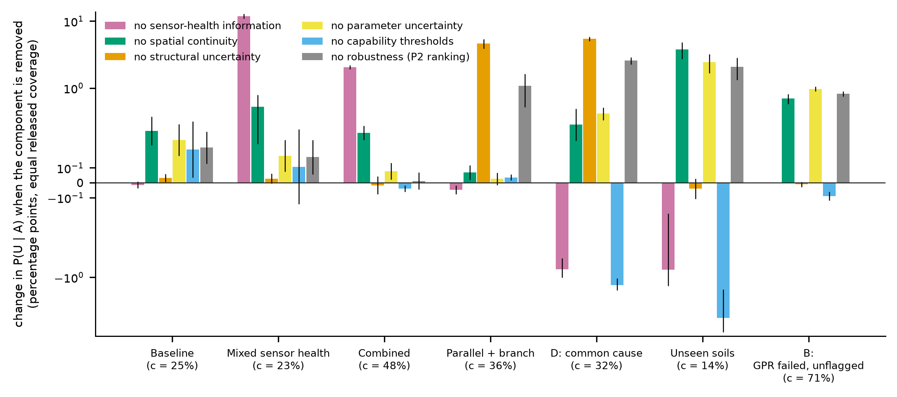
Fig. 7. Ablation at equal released coverage: change in the conditional risk P(U | A), in percentage points (symmetric logarithmic axis), when one component of the robust policy P5 is removed, in seven scenarios. The coverage c is that of the full policy in the scenario; bars are means with 95% t-intervals over 10 networks.
Verification prioritisation. The segments that P5 leaves unverified (16% of the corridor in the baseline, 57% with unseen soils) are the candidates for trial pits. With a budget of pits equal to 5% of all segments, pits placed on the lowest-probability segments first clear 3.5% of the corridor in the baseline, pits ranked by value of information 3.2% and pits placed at random 2.1%; with unseen soils the figures are 4.9%, 3.0% and 1.8% (Supplementary Fig. S1). Verification does not change the risk of the segments already released; it converts unverified segments into released ones at no risk if the pit is reliable. Prioritising by probability clears as many or more segments per pit as ranking by the value of information in almost every case (the exception is the smallest budget in the baseline); the value-of-information ranking is designed to minimise expected cost, not to maximise coverage, and with the assumed costs the two are close. Both are clearly better than random placement.

6.7 Reliability sensitivity and dominant failure drivers
Figure 8 ranks the eight parameters by their total-order Sobol index for the unsafe-release probability and the conditional risk (Latin hypercube design of 320 points; surrogate hold-out R² between 0.85 and 0.93). The ranking depends on the policy, and that is the main result. For the quality-adjusted policy P2 the unsafe-release probability is dominated by the share of corridors with a parallel utility and a branch (total index 0.61; ranked first in 100% of the bootstrap refits), then soil attenuation (0.25) and the utility loss hazard (0.19). For the robust policy P5 the structural share nearly disappears (0.01) and the unsafe-release probability is driven by undetected sensor failure: the failure prevalence (0.51; first in 88% of the refits) and the probability that a failed sensor is flagged (0.41). For its conditional risk the largest contribution is lateral shifting (0.43), then failure prevalence (0.25). The 1D framework and the fixed-threshold policy P1 are driven by soil attenuation (0.69 and 0.35), that is, by the sensor parameters, as is expected of policies with no mechanism that detects a parameter mismatch. The sum of first-order indices is 0.79 to 1.07, so interactions are modest (the sum above one for P1 shows the estimation error of the surrogate). The top-ranked parameter is stable under refitting for P2 and the 1D framework (Kendall τ of the total-order ranking against refits: mean 0.88 to 0.89); the lower ranks are not, and are not interpreted. The caveat of Section 5.5 applies: the parameters were sampled independently, whereas soil, sensor and model error may be correlated.
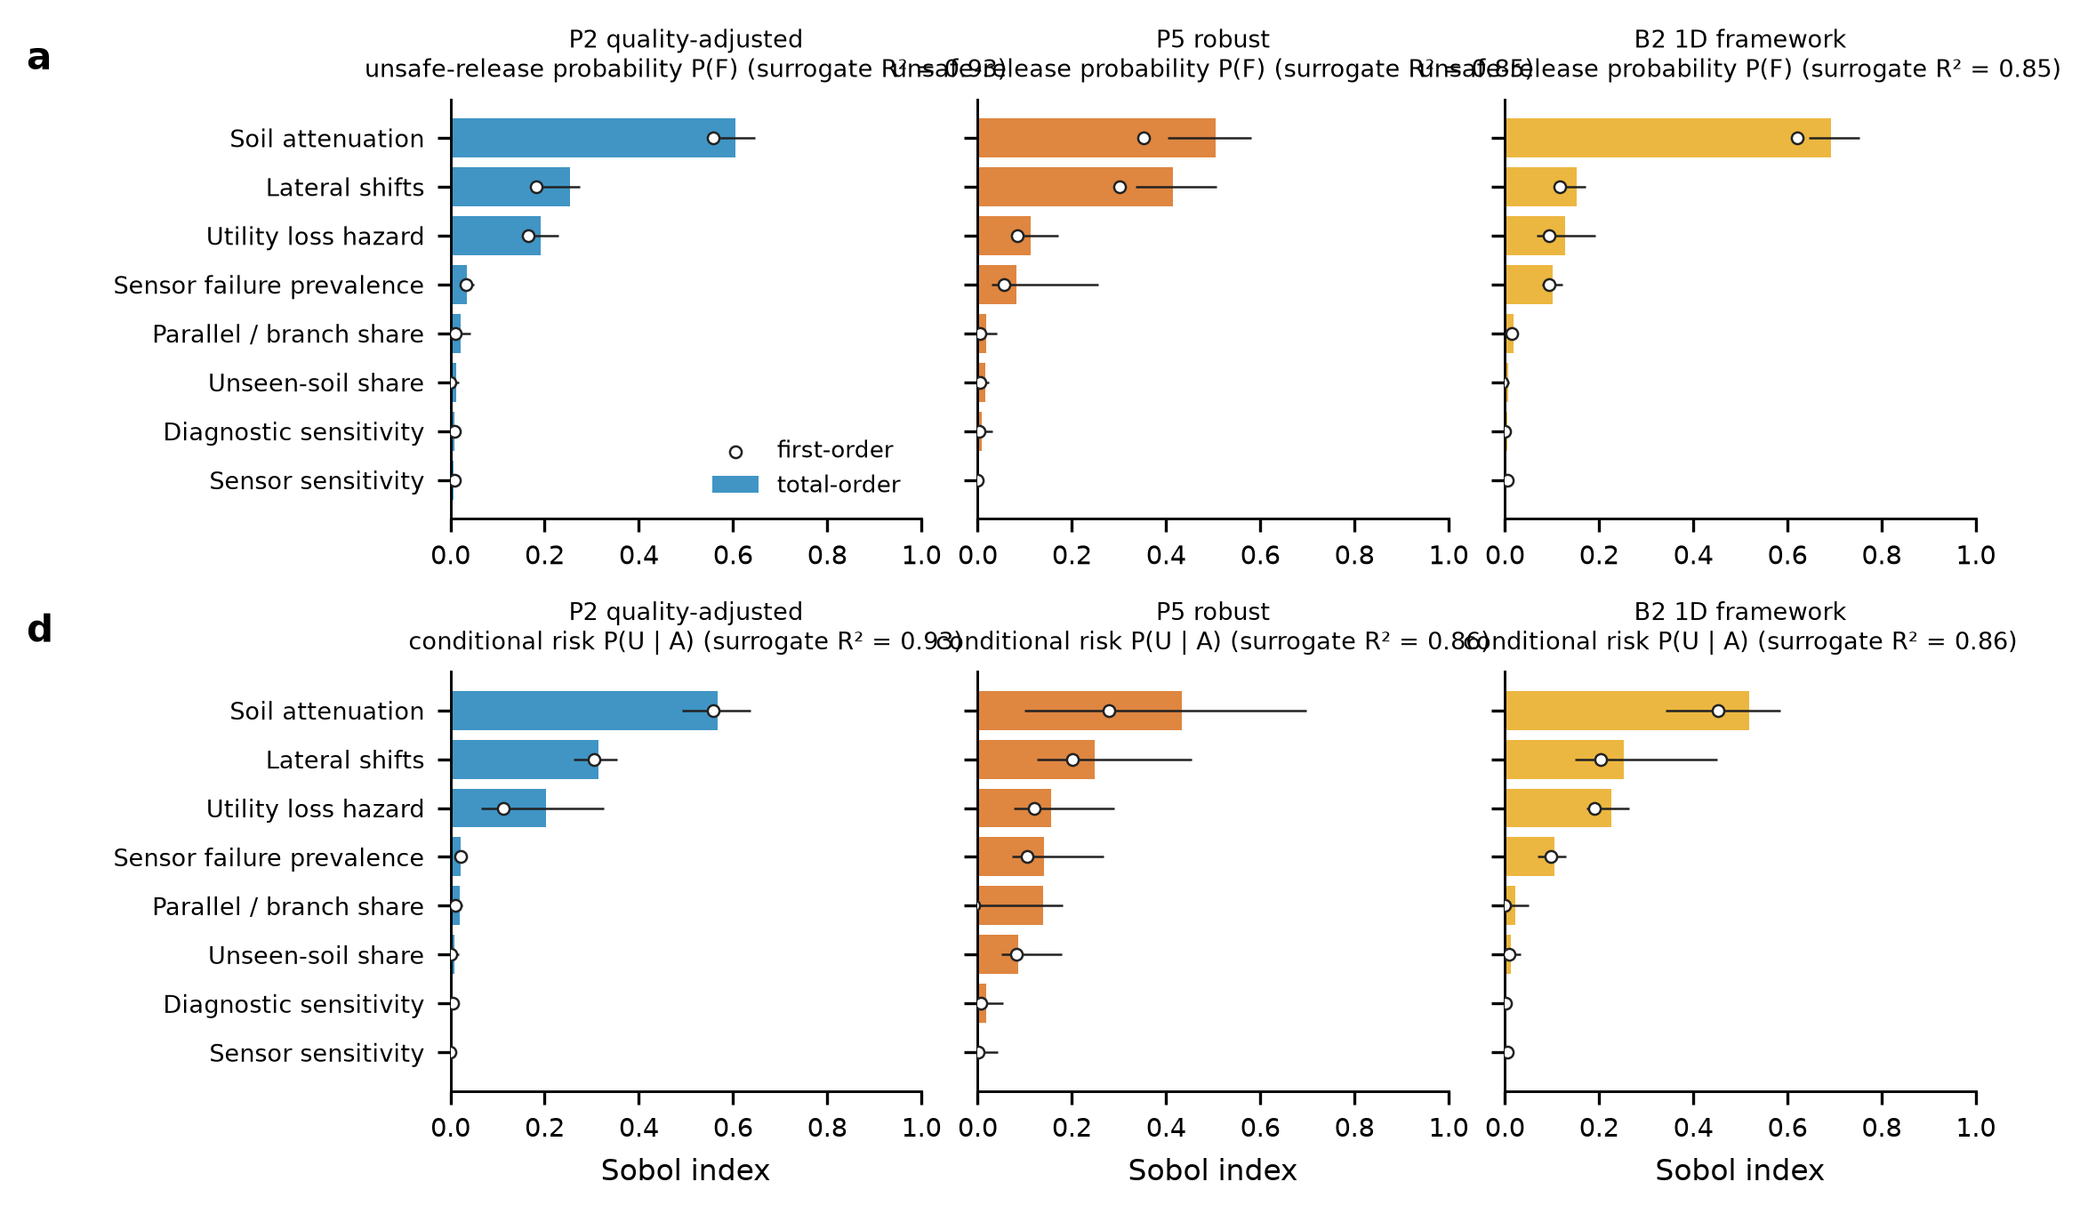
Fig. 8. Global sensitivity of the unsafe-release probability P(F) (a) and of the conditional risk P(U | A) (b) for three policies: total-order Sobol indices (bars; 95% bootstrap intervals over 60 refits of the surrogate) and first-order indices (circles), from a 320-point Latin hypercube design. The hold-out R² of each surrogate is shown above the panel.

6.8 Sensor health and unseen soils in the lateral-tracking model
Two results of the version 1.1 experiments, obtained with the lateral tracker with three passes and used in earlier versions, belong in the reliability argument. With mixed sensor health and the assumed diagnostic (Fig. 9), sensor-health awareness lowers the false clearance of the lateral tracker from 18.9% (version 1.0 filter) to 3.5%, at an unverified share of 21% against 16%; the same conclusion holds in the present policies (P2 3.6% against 19.5% for the 1D framework). With unseen soils (Fig. 10) the lateral tracker has a false clearance of 31.9% without the on-site reference check and 8.7% with it, at an unverified share of 58%; the reference check flags 35% of the corridors in the unseen soils and 0.2% in the seen soils. In both cases the gain depends on a diagnostic or a check whose sensitivity is assumed (0.90 for a failed sensor, a binomial test with α = 0.01), and neither addresses a degradation that the diagnostic cannot see.
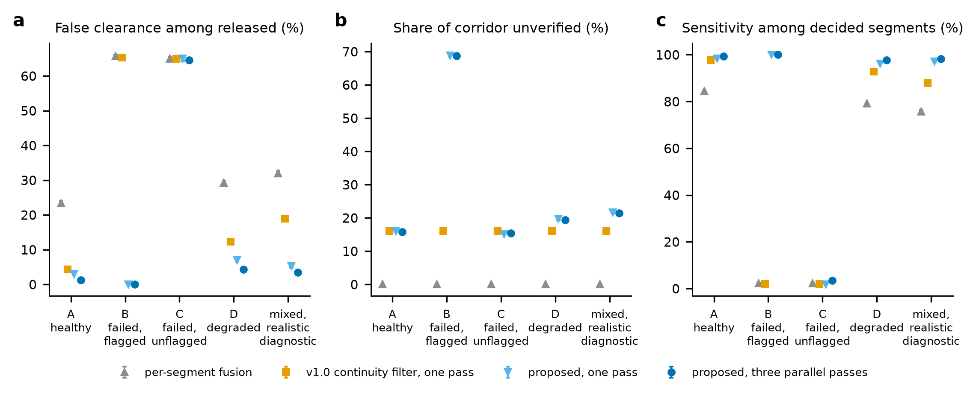
Fig. 9. Classification under sensor degradation and failure (version 1.1 experiment): (a) false clearance among released segments, (b) unverified share, (c) sensitivity among decided segments.
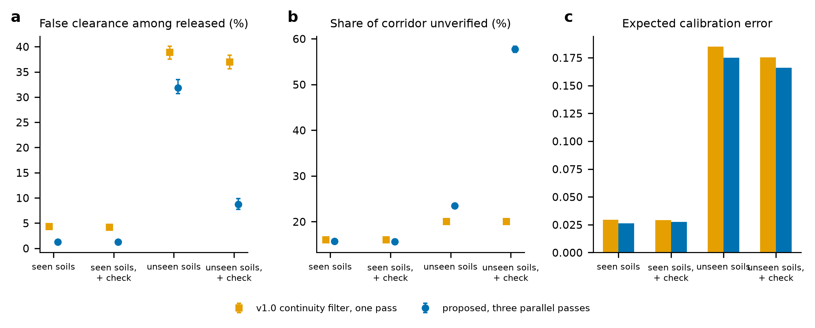
Fig. 10. Seen and unseen soils with and without the on-site reference check (version 1.1 experiment): (a) false clearance, (b) unverified share, (c) calibration error.

7. Discussion

7.1 Reliability limits of probabilistic decision support
What the simulation demonstrates, within the model. (i) The conditional risk of released segments is a steep function of the released coverage, and the policies differ less at equal coverage than at their own operating points: much of what separates them is where on the curve they stop (Sections 6.1 and 6.2). (ii) A policy built on a nominal model is overconfident where the model is wrong; its predicted risk among released segments can be two orders of magnitude below the observed risk (Section 6.2). (iii) A lateral-tracking model that is the most reliable in the matched case is the least reliable under a parallel utility, so that complexity cannot be taken as a proxy for reliability (Section 6.4). (iv) A bound over an explicit set of parameters and structures removes most of that failure at a stated cost in released coverage, but only for what the set contains; an unflagged sensor failure lies outside it and defeats every policy (Section 6.3). (v) Parameter uncertainty accounts for most of the variance of the unsafe-release probability of every policy in the matched geometry, and the dominant failure driver depends on the policy: the geometry for the quality-adjusted policy, undetected sensor failure for the robust one (Sections 6.5 and 6.7). (vi) The benefit of the framework in conditions of sensor and soil mismatch comes from the health information and the reference check, not from the abstention or the robust bound alone (Sections 6.2 and 6.6).
What it suggests, conditionally on the model resembling reality. A decision layer should publish, with its recommendation, an estimate of its risk among released segments under a stated set of alternatives and not only the posterior probability; the gap between the two is the measure of its overconfidence. The health diagnostic and the reference check are the critical components, and their sensitivity should be measured before the rest is trusted. Verification should be directed at the segments in the marginal zone and in conditions flagged as unfamiliar, ranked by probability. Where the geometry cannot be assumed, parallel passes and a swath-wide assessment are needed, and the policy should be run alongside a simpler one whose disagreement is itself a warning.
What it does not establish. Whether the sensor model reproduces real GPR and EM behaviour in any soil; whether any measured detection-versus-depth dataset agrees with the assumed curves (none was reproduced); the real frequency of parallel utilities, branches and unflagged faults; the sensitivity and false-flag rate of real diagnostics; the real cost and consequences of strikes, holds and pits; whether crews would use a three-state output as intended; and any result in a specific country, soil or network. The numerical values of the risks are properties of the simulator. The qualitative findings, that the nominal model is overconfident under mismatch, that a bound costs coverage, that undetected faults dominate, and that no policy dominates at equal coverage, are what the simulation is designed to expose, and they would have to be tested with data.

7.2 Safety implications and operator decision support
A recommendation to release a segment is read by an operator, and misplaced trust is a known failure of automation (Parasuraman and Riley, 1997; Lee and See, 2004). The three-state output addresses it in part: a segment is not released unless it is in a zone where the sensors could have seen a utility and the checks passed, and the unverified share is reported. The results show where that is not enough. With an unflagged sensor failure the output looks the same as with healthy sensors and is wrong for two thirds of the released segments; with a parallel utility the lateral tracker releases the footprint with an apparent confidence that its own probability does not justify. A safety case for such a layer would have to state the conditions under which each branch of the failure tree has been tested, the diagnostic coverage that is assumed, and the independent verification that is required where the structural assumptions cannot be checked. The robust policy is one way to turn the second into a rule; the cost is a lower coverage (Section 6.2), which an operator pays in verification effort, and the explicit trade-off between the two is the decision that the reliability–coverage curve supports. The bound is conservative by construction, and the use of conservatism in risk assessment has its own cautions (Aven, 2016): a bound that is too wide makes the policy unusable (P7), and one that is too narrow gives false assurance.

7.3 Transferability
The case is subsurface utility mapping, but the analysis is not specific to it. Any system that releases an action on sensor evidence, whether an automated vehicle, a process shutdown or an inspection gate, has a failure event of the kind F = {released, hazard present}, a coverage, a set of faults that the diagnostic may or may not see, and a model whose structure may be wrong. What transfers is the method: define the failure event and the metrics with explicit denominators; compare policies on reliability–coverage curves and not at single operating points; decompose the variance of the failure probability into aleatory and epistemic parts without weighting structural alternatives; simulate fault combinations jointly and check dependence; and rank the drivers of failure by global sensitivity analysis for each policy separately. What does not transfer is any number.

7.4 Limitations and what a field test would need
- No external validation. The sensor model is assumed. The first step is external: compare the assumed detection curves with at least one published or newly measured dataset that reports GPR and EM detection across known utility depths and soils, and report the mismatch. This is the most important missing step, and additional synthetic experiments cannot replace it.
- The uncertainty set is the designer’s. The robust policies are robust to what Ω contains. The test envelope overlaps it and goes beyond it in places, and the policy is not robust to an unflagged failure. A different set gives a different cost in coverage; the sets were not optimised.
- Structure and parameters are sampled from stated ranges. The ranges (attenuation from a quarter to four times the assumed value, ±3 dB, geometry from five structures) are assumptions, the five structures are not exhaustive (no crossings, depth changes or buried obstacles), and the independence assumed in the sensitivity analysis is not realistic.
- Network size. The aleatory share depends on the network size, and 490 corridors of 500 m is one choice. The variance decomposition assumes that the parameter draws are independent of the network.
- Costs and diagnostics are assumed. The loss model, the diagnostic rates and the reference check are assumptions; the expected-loss policy is only as good as its costs.
- The ablation shows reversals that are unexplained (Section 6.6), and the attribution to the failure tree uses a fixed priority order; it is a diagnostic, not a probability decomposition.
- Reliability is conditional. All reliability figures are conditional decision reliability in the simulated environment (Section 3.1). They do not include excavation practice, locating before digging or operator behaviour, and modelled intersections are not strikes.
The minimum field test is a controlled corridor with known pipe positions, depths and materials in at least two soils, surveyed with a centre pass and parallel passes; GPR and EM data recorded with surveyed positions; a deliberate sensor fault and a reference-target check; the software run offline; and the conditional risk, coverage, calibration and unverified share reported with the definitions of Section 3.1. A false clearance of at most 1% shown with a 95% upper bound needs about 368 released segments with no failure, or about 555 with one failure (exact binomial intervals; (Clopper and Pearson, 1934; Brown et al., 2001)). A parallel utility, a branch and a deliberately unflagged fault should be included, because these are where the simulation says the risk is.

8. Conclusions
The reliability of a probabilistic decision layer for excavation clearance was analysed in simulation. The conclusions apply to the model and not to the field.
- The unsafe-release probability, the conditional false-clearance risk and the release coverage are linked by P(F) = P(U | A) P(A) and have to be reported together; in the matched model the sensor-quality-adjusted policy releases 28% of the corridor at 1.3% conditional risk, and the policies differ less at equal coverage than at their own operating points.
- A nominal model is overconfident where it is wrong: with a parallel utility and a branch the quality-adjusted policy releases 65% of the corridor at 18.0% conditional risk while its probabilities predict 0.3%, and a more complex spatial model is less reliable than a simpler one there (18% against 2% for the one-dimensional framework).
- A policy that releases only if an upper bound over an explicit set of parameters and structures is acceptable reduces that risk to 0.3% at 36% coverage, at the price of 29 percentage points of released coverage; it does not protect against what the set does not contain, and an unflagged sensor failure leaves every policy at 65% conditional risk.
- Epistemic parameter uncertainty accounts for 79 to 88% of the variance of the unsafe-release probability of the quality-adjusted policy, and the dominant failure driver depends on the policy: the share of parallel utilities and branches for the quality-adjusted policy, and undetected sensor failure for the robust one.
- Sensor-health information and a reference check, not abstention alone, are what separate the framework from calibrated-abstention baselines when sensors or soils depart from the assumed ones; no policy dominates at equal released coverage.
- The simulated performance has not been validated against field measurements. Physical validation against measured detection data, with parallel utilities, branches and deliberately unflagged faults, is the necessary next step.
The study fixes definitions and a protocol for assessing the reliability of a decision-support layer, and shows which assumptions its conclusions rest on. It cannot show field performance.

Declarations
CRediT authorship contribution statement. Leon Sandler: Conceptualization, Methodology, Software, Validation, Formal analysis, Investigation, Visualization, Writing – original draft, Writing – review and editing.
Funding. This research received no specific grant from any funding agency in the public, commercial or not-for-profit sectors.
Declaration of competing interests. The author declares that he has no known competing financial interests or personal relationships that could have appeared to influence the work reported in this paper.
Prior dissemination. An earlier, non-peer-reviewed white paper describing the concept was prepared in response to an open innovation challenge on detecting underground utilities issued through the Wazoku (InnoCentive) platform. Its numerical results came from an earlier version of the simulation whose code was not available when this manuscript was prepared; the simulation was reimplemented from the method description and all numbers in this paper come from the released code. The challenge submission is not a publication and the present manuscript is not under consideration elsewhere. Earlier versions of the preprint were prepared for a different journal and have not been submitted to it.
Version history of the preprint. Version 1 (https://doi.org/10.5281/zenodo.23306883) compared a binary map and a three-state rule at different released coverages and reported about four times fewer strikes for the three-state rule; that comparison is withdrawn. Version 2 (https://doi.org/10.5281/zenodo.23307526) compared policies at equal coverage and added lateral tracking, sensor-health awareness, capability zones, unseen soils and a value-of-information analysis. Version 3 (https://doi.org/10.5281/zenodo.23308159) added a structural-mismatch experiment and a parameter envelope. Version 4 (this version) reframes the study as a reliability analysis: it defines the safety failure event and the reliability metrics, adds the aleatory–epistemic decomposition, the fault and common-cause scenarios, the release policies and calibrated-abstention baselines, the reliability–coverage curves, the ablation and the global sensitivity analysis. Numbers of earlier versions that are quoted here are unchanged.
Data and code availability. All code, configurations, results (results.json, results_v4.json, results_v5.json), figure scripts, tests and manuscript builders are available at https://github.com/sandlerleon/subsurface-risk-calibrated-mapping (release v1.3.0) and archived on Zenodo (software: https://doi.org/10.5281/zenodo.23328500, all versions https://doi.org/10.5281/zenodo.23306880; manuscript preprint: https://doi.org/10.5281/zenodo.23328501, all versions https://doi.org/10.5281/zenodo.23306882). Every table and figure is regenerated by the commands in Appendix A. No field data were used.
Declaration of generative AI and AI-assisted technologies in the writing process. During the preparation of this work the author used Claude (Anthropic; Claude Sonnet 5.5, accessed through Claude Code) to help write and run the simulation code, generate figures and draft and edit the text. The simulation outputs were produced by running the released code with a fixed seed and were not written by the model. After using this tool, the author reviewed and edited the content as needed and takes full responsibility for the content of the publication.
Acknowledgements. None.

Appendix A. Reproducing the results
pip install -r requirements.txt
python SubSurface_MC.py --demo # 27 self-tests of the version 1.0 code
python SubSurface_MC.py --reproduce --out results --n 500 --blocks 10 --seed 42
python figure_generation.py --results results/results.json --out results/figures
python SubSurface_v4.py --demo # 14 self-tests of the version 1.1 code
python SubSurface_v4.py --reproduce --out results_v4 --seed 42
python figure_generation_v4.py --results results_v4/results_v4.json --out results_v4/figures
python SubSurface_v5.py --demo # 17 self-tests of the reliability analyses
python SubSurface_v5.py --reproduce --out results_v5 --seed 42 --workers 8
python figure_generation_v5.py --results results_v5/results_v5.json --out results_v5/figures
python tests/test_subsurface.py

The version 1.0 and 1.1 commands take a few minutes and about twelve minutes; SubSurface_v5.py took 40 minutes with eight worker processes (Python 3.11.9, NumPy 2.4.6). Every random stream is derived from the seed, a scenario tag and a block index, so that the results do not depend on the number of processes. A fresh clone of the release was run and its results files compared with the archived ones (see the repository README). results_v5.json records the command, the seed, the library versions, the definitions, the uncertainty sets and every table quoted in this paper.

Appendix B. Assumptions of the reliability experiments
Costs (scenario assumptions): miss US$5,000 per consequence unit of the utility class (PE/PVC water 4, cast-iron water 6, plastic and concrete sewer 3, power 10, telephone and fibre 2), hold US$1,000 per segment, pit US$400 plus US$200 per metre of class mid-depth. Decision thresholds: present at 0.5; absent at 0.10 in zone A and 0.02 in zone B; calibrated-abstention target 2%. Uncertainty set of the robust policies: attenuation doubled; sensors 3 dB weaker; EM coupling halved; both of the first two; a filter with loss 0.05, shift 0.03 and drift 0.10 per segment; no anchor; the one-dimensional on-alignment model; and, for P7, the probability that a utility lies anywhere in the ±5 m swath. All other assumptions are in the assumptions registers of the repository (Supplementary Material).

References
The simulation uses NumPy (Harris et al., 2020), SciPy (Virtanen et al., 2020) and Matplotlib (Hunter, 2007) and scikit-learn for the surrogate models.
American Society of Civil Engineers (ASCE) (2002). Standard Guidelines for the Collection and Depiction of Existing Subsurface Utility Data. American Society of Civil Engineers, Reston, VA. https://doi.org/10.1061/9780784406458
Annan, A. (2009). Electromagnetic Principles of Ground Penetrating Radar, in: Jol, H.M. (Ed.), Ground Penetrating Radar: Theory and Applications. Elsevier, Amsterdam. https://doi.org/10.1016/b978-0-444-53348-7.00001-6
Apostolakis, G. (1990). The Concept of Probability in Safety Assessments of Technological Systems. Science 250(4986), 1359-1364. https://doi.org/10.1126/science.2255906
Aven, T., & Zio, E. (2011). Some considerations on the treatment of uncertainties in risk assessment for practical decision making. Reliability Engineering & System Safety 96(1), 64-74. https://doi.org/10.1016/j.ress.2010.06.001
Aven, T. (2016). On the use of conservatism in risk assessments. Reliability Engineering & System Safety 146, 33-38. https://doi.org/10.1016/j.ress.2015.10.011
Bates, S., Angelopoulos, A., Lei, L., Malik, J., & Jordan, M. (2021). Distribution-free, Risk-controlling Prediction Sets. Journal of the ACM 68(6), 1-34. https://doi.org/10.1145/3478535
Bobbio, A., Portinale, L., Minichino, M., & Ciancamerla, E. (2001). Improving the analysis of dependable systems by mapping fault trees into Bayesian networks. Reliability Engineering & System Safety 71(3), 249-260. https://doi.org/10.1016/s0951-8320(00)00077-6
Borgonovo, E., & Plischke, E. (2016). Sensitivity analysis: A review of recent advances. European Journal of Operational Research 248(3), 869-887. https://doi.org/10.1016/j.ejor.2015.06.032
Brier, G.W. (1950). Verification of forecasts expressed in terms of probability. Monthly Weather Review 78(1), 1-3. https://doi.org/10.1175/1520-0493(1950)078<0001:vofeit>2.0.co;2
Brown, L.D., Cai, T.T., & DasGupta, A. (2001). Interval Estimation for a Binomial Proportion. Statistical Science 16(2), 101-133. https://doi.org/10.1214/ss/1009213286
Chow, C. (1970). On optimum recognition error and reject tradeoff. IEEE Transactions on Information Theory 16(1), 41-46. https://doi.org/10.1109/tit.1970.1054406
Clopper, C.J., & Pearson, E.S. (1934). The use of confidence or fiducial limits illustrated in the case of the binomial. Biometrika 26(4), 404-413. https://doi.org/10.1093/biomet/26.4.404
Costello, S., Chapman, D., Rogers, C., & Metje, N. (2007). Underground asset location and condition assessment technologies. Tunnelling and Underground Space Technology 22(5-6), 524-542. https://doi.org/10.1016/j.tust.2007.06.001
Der Kiureghian, A., & Ditlevsen, O. (2009). Aleatory or epistemic? Does it matter? Structural Safety 31(2), 105-112. https://doi.org/10.1016/j.strusafe.2008.06.020
Doolittle, J.A., & Collins, M.E. (1995). Use of soil information to determine application of ground penetrating radar. Journal of Applied Geophysics 33(1-3), 101-108. https://doi.org/10.1016/0926-9851(95)90033-0
Dou, Q., Wei, L., Magee, D., Atkins, P., Chapman, D., Curioni, G., Goddard, K., Hayati, F., Jenks, H., Metje, N., Muggleton, J., Pennock, S., Rustighi, E., Swingler, S., Rogers, C., & Cohn, A. (2016). 3D Buried Utility Location Using A Marching-Cross-Section Algorithm for Multi-Sensor Data Fusion. Sensors 16(11), 1827. https://doi.org/10.3390/s16111827
Dou, Q., Wei, L., Magee, D.R., & Cohn, A.G. (2017). Real-Time Hyperbola Recognition and Fitting in GPR Data. IEEE Transactions on Geoscience and Remote Sensing 55(1), 51-62. https://doi.org/10.1109/tgrs.2016.2592679
Dou, Q., Lin, Z., Magee, D.R., & Cohn, A.G. (2020). 3D mapping from partial observations: An application to utility mapping. Automation in Construction 117, 103229. https://doi.org/10.1016/j.autcon.2020.103229
Droguett, E.L., & Mosleh, A. (2008). Bayesian Methodology for Model Uncertainty Using Model Performance Data. Risk Analysis 28(5), 1457-1476. https://doi.org/10.1111/j.1539-6924.2008.01117.x
Ferson, S., & Ginzburg, L.R. (1996). Different methods are needed to propagate ignorance and variability. Reliability Engineering & System Safety 54(2-3), 133-144. https://doi.org/10.1016/s0951-8320(96)00071-3
Flage, R., Aven, T., Zio, E., & Baraldi, P. (2014). Concerns, Challenges, and Directions of Development for the Issue of Representing Uncertainty in Risk Assessment. Risk Analysis 34(7), 1196-1207. https://doi.org/10.1111/risa.12247
Gneiting, T., & Raftery, A.E. (2007). Strictly Proper Scoring Rules, Prediction, and Estimation. Journal of the American Statistical Association 102(477), 359-378. https://doi.org/10.1198/016214506000001437
Gneiting, T., Balabdaoui, F., & Raftery, A.E. (2007). Probabilistic Forecasts, Calibration and Sharpness. Journal of the Royal Statistical Society Series B: Statistical Methodology 69(2), 243-268. https://doi.org/10.1111/j.1467-9868.2007.00587.x
Hao, T., Rogers, C., Metje, N., Chapman, D., Muggleton, J., Foo, K., Wang, P., Pennock, S., Atkins, P., Swingler, S., Parker, J., Costello, S., Burrow, M., Anspach, J., Armitage, R., Cohn, A., Goddard, K., Lewin, P., Orlando, G., Redfern, M., Royal, A., & Saul, A. (2012). Condition assessment of the buried utility service infrastructure. Tunnelling and Underground Space Technology 28, 331-344. https://doi.org/10.1016/j.tust.2011.10.011
Harris, C.R., Millman, K.J., van der Walt, S.J., Gommers, R., Virtanen, P., Cournapeau, D., Wieser, E., Taylor, J., Berg, S., Smith, N.J., Kern, R., Picus, M., Hoyer, S., van Kerkwijk, M.H., Brett, M., Haldane, A., del Río, J.F., Wiebe, M., Peterson, P., Gérard-Marchant, P., Sheppard, K., Reddy, T., Weckesser, W., Abbasi, H., Gohlke, C., & Oliphant, T.E. (2020). Array programming with NumPy. Nature 585(7825), 357-362. https://doi.org/10.1038/s41586-020-2649-2
Helton, J.C., & Burmaster, D.E. (1996). Guest editorial: treatment of aleatory and epistemic uncertainty in performance assessments for complex systems. Reliability Engineering & System Safety 54(2-3), 91-94. https://doi.org/10.1016/s0951-8320(96)00066-x
Hendrickx, K., Perini, L., Van der Plas, D., Meert, W., & Davis, J. (2024). Machine learning with a reject option: a survey. Machine Learning 113(5), 3073-3110. https://doi.org/10.1007/s10994-024-06534-x
Hunter, J.D. (2007). Matplotlib: A 2D Graphics Environment. Computing in Science & Engineering 9(3), 90-95. https://doi.org/10.1109/mcse.2007.55
Hüllermeier, E., & Waegeman, W. (2021). Aleatoric and epistemic uncertainty in machine learning: an introduction to concepts and methods. Machine Learning 110(3), 457-506. https://doi.org/10.1007/s10994-021-05946-3
Iooss, B., & Lemaître, P. (2015). A Review on Global Sensitivity Analysis Methods, in: Dellino, G., Meloni, C. (Eds.), Uncertainty Management in Simulation-Optimization of Complex Systems. Operations Research/Computer Science Interfaces Series, vol. 59. Springer, Boston, MA, pp. 101–122. https://doi.org/10.1007/978-1-4899-7547-8_5
Isermann, R. (2005). Model-based fault-detection and diagnosis – status and applications. Annual Reviews in Control 29(1), 71-85. https://doi.org/10.1016/j.arcontrol.2004.12.002
Jansen, M.J. (1999). Analysis of variance designs for model output. Computer Physics Communications 117(1-2), 35-43. https://doi.org/10.1016/s0010-4655(98)00154-4
Jaw, S.W., & Hashim, M. (2013). Locational accuracy of underground utility mapping using ground penetrating radar. Tunnelling and Underground Space Technology 35, 20-29. https://doi.org/10.1016/j.tust.2012.11.007
Kaplan, S., & Garrick, B.J. (1981). On The Quantitative Definition of Risk. Risk Analysis 1(1), 11-27. https://doi.org/10.1111/j.1539-6924.1981.tb01350.x
Lai, W., Dérobert, X., & Annan, P. (2018). A review of Ground Penetrating Radar application in civil engineering: A 30-year journey from Locating and Testing to Imaging and Diagnosis. NDT & E International 96, 58-78. https://doi.org/10.1016/j.ndteint.2017.04.002
Langseth, H., & Portinale, L. (2007). Bayesian networks in reliability. Reliability Engineering & System Safety 92(1), 92-108. https://doi.org/10.1016/j.ress.2005.11.037
Lee, J.D., & See, K.A. (2004). Trust in Automation: Designing for Appropriate Reliance. Human Factors: The Journal of the Human Factors and Ergonomics Society 46(1), 50-80. https://doi.org/10.1518/hfes.46.1.50.30392
Makana, L.O., Metje, N., Jefferson, I., Sackey, M., & Rogers, C.D.F. (2020). Cost estimation of utility strikes: towards proactive management of street works. Infrastructure Asset Management 7(2), 64-76. https://doi.org/10.1680/jinam.17.00033
McKay, M.D., Beckman, R.J., & Conover, W.J. (1979). Comparison of Three Methods for Selecting Values of Input Variables in the Analysis of Output from a Computer Code. Technometrics 21(2), 239-245. https://doi.org/10.1080/00401706.1979.10489755
Metje, N., Atkins, P., Brennan, M., Chapman, D., Lim, H., Machell, J., Muggleton, J., Pennock, S., Ratcliffe, J., Redfern, M., Rogers, C., Saul, A., Shan, Q., Swingler, S., & Thomas, A. (2007). Mapping the Underworld – State-of-the-art review. Tunnelling and Underground Space Technology 22(5-6), 568-586. https://doi.org/10.1016/j.tust.2007.04.002
Metje, N., Crossland, S.M., & Ahmad, B. (2015). Causes, impacts and costs of strikes on buried utility assets. Proceedings of the ICE - Municipal Engineer 168(3), 165-174. https://doi.org/10.1680/muen.14.00035
Mosleh, A. (1991). Common cause failures: An analysis methodology and examples. Reliability Engineering & System Safety 34(3), 249-292. https://doi.org/10.1016/0951-8320(91)90104-f
Naeini, M., Cooper, G., & Hauskrecht, M. (2015). Obtaining Well Calibrated Probabilities Using Bayesian Binning, in: Proceedings of the AAAI Conference on Artificial Intelligence, 29(1). https://doi.org/10.1609/aaai.v29i1.9602
Niculescu-Mizil, A., & Caruana, R. (2005). Predicting good probabilities with supervised learning, in: Proceedings of the 22nd International Conference on Machine Learning (ICML '05). ACM. https://doi.org/10.1145/1102351.1102430
Oberkampf, W.L., Helton, J.C., Joslyn, C.A., Wojtkiewicz, S.F., & Ferson, S. (2004). Challenge problems: uncertainty in system response given uncertain parameters. Reliability Engineering & System Safety 85(1-3), 11-19. https://doi.org/10.1016/j.ress.2004.03.002
Parasuraman, R., & Riley, V. (1997). Humans and Automation: Use, Misuse, Disuse, Abuse. Human Factors: The Journal of the Human Factors and Ergonomics Society 39(2), 230-253. https://doi.org/10.1518/001872097778543886
Paté-Cornell, M. (1996). Uncertainties in risk analysis: Six levels of treatment. Reliability Engineering & System Safety 54(2-3), 95-111. https://doi.org/10.1016/s0951-8320(96)00067-1
Pedregosa, F., Varoquaux, G., Gramfort, A., Michel, V., Thirion, B., Grisel, O., Blondel, M., Prettenhofer, P., Weiss, R., Dubourg, V., Vanderplas, J., Passos, A., Cournapeau, D., Brucher, M., Perrot, M., & Duchesnay, É. (2011). Scikit-learn: machine learning in Python. Journal of Machine Learning Research 12, 2825–2830.
Ruijters, E., & Stoelinga, M. (2015). Fault tree analysis: A survey of the state-of-the-art in modeling, analysis and tools. Computer Science Review 15-16, 29-62. https://doi.org/10.1016/j.cosrev.2015.03.001
Saltelli, A., Annoni, P., Azzini, I., Campolongo, F., Ratto, M., & Tarantola, S. (2010). Variance based sensitivity analysis of model output. Design and estimator for the total sensitivity index. Computer Physics Communications 181(2), 259-270. https://doi.org/10.1016/j.cpc.2009.09.018
Sobol, I. (2001). Global sensitivity indices for nonlinear mathematical models and their Monte Carlo estimates. Mathematics and Computers in Simulation 55(1-3), 271-280. https://doi.org/10.1016/s0378-4754(00)00270-6
US EPA (n.d.). Environmental Geophysics: Ground Penetrating Radar (Table 1, electromagnetic properties of earth materials). U.S. Environmental Protection Agency. https://archive.epa.gov/esd/archive-geophysics/web/html/ground-penetrating_radar.html (accessed 11 October 2026).
Venkatasubramanian, V., Rengaswamy, R., Yin, K., & Kavuri, S.N. (2003). A review of process fault detection and diagnosis. Part I: Quantitative model-based methods. Computers & Chemical Engineering 27(3), 293-311. https://doi.org/10.1016/s0098-1354(02)00160-6
Virtanen, P., Gommers, R., Oliphant, T.E., Haberland, M., Reddy, T., Cournapeau, D., Burovski, E., Peterson, P., Weckesser, W., Bright, J., van der Walt, S.J., Brett, M., Wilson, J., Millman, K.J., Mayorov, N., Nelson, A.R.J., Jones, E., Kern, R., Larson, E., Carey, C.J., Polat, İ., Feng, Y., Moore, E.W., VanderPlas, J., Laxalde, D., Perktold, J., Cimrman, R., Henriksen, I., Quintero, E.A., Harris, C.R., Archibald, A.M., Ribeiro, A.H., Pedregosa, F., van Mulbregt, P., SciPy 1.0 Contributors, Vijaykumar, A., Bardelli, A.P., Rothberg, A., Hilboll, A., Kloeckner, A., Scopatz, A., Lee, A., Rokem, A., Woods, C.N., Fulton, C., Masson, C., Häggström, C., Fitzgerald, C., Nicholson, D.A., Hagen, D.R., Pasechnik, D.V., Olivetti, E., Martin, E., Wieser, E., Silva, F., Lenders, F., Wilhelm, F., Young, G., Price, G.A., Ingold, G.L., Allen, G.E., Lee, G.R., Audren, H., Probst, I., Dietrich, J.P., Silterra, J., Webber, J.T., Slavič, J., Nothman, J., Buchner, J., Kulick, J., Schönberger, J.L., de Miranda Cardoso, J.V., Reimer, J., Harrington, J., Rodríguez, J.L.C., Nunez-Iglesias, J., Kuczynski, J., Tritz, K., Thoma, M., Newville, M., Kümmerer, M., Bolingbroke, M., Tartre, M., Pak, M., Smith, N.J., Nowaczyk, N., Shebanov, N., Pavlyk, O., Brodtkorb, P.A., Lee, P., McGibbon, R.T., Feldbauer, R., Lewis, S., Tygier, S., Sievert, S., Vigna, S., Peterson, S., More, S., Pudlik, T., Oshima, T., Pingel, T.J., Robitaille, T.P., Spura, T., Jones, T.R., Cera, T., Leslie, T., Zito, T., Krauss, T., Upadhyay, U., Halchenko, Y.O., & Vázquez-Baeza, Y. (2020). SciPy 1.0: fundamental algorithms for scientific computing in Python. Nature Methods 17(3), 261-272. https://doi.org/10.1038/s41592-019-0686-2
Weber, P., Medina-Oliva, G., Simon, C., & Iung, B. (2012). Overview on Bayesian networks applications for dependability, risk analysis and maintenance areas. Engineering Applications of Artificial Intelligence 25(4), 671-682. https://doi.org/10.1016/j.engappai.2010.06.002
Xie, F., Lai, W.W., & Dérobert, X. (2022). Building simplified uncertainty models of object depth measurement by ground penetrating radar. Tunnelling and Underground Space Technology 123, 104402. https://doi.org/10.1016/j.tust.2022.104402
Zadrozny, B., & Elkan, C. (2002). Transforming classifier scores into accurate multiclass probability estimates, in: Proceedings of the 8th ACM SIGKDD International Conference on Knowledge Discovery and Data Mining. ACM. https://doi.org/10.1145/775047.775151
Zio, E. (2009). Reliability engineering: Old problems and new challenges. Reliability Engineering & System Safety 94(2), 125-141. https://doi.org/10.1016/j.ress.2008.06.002
Zio, E. (2018). The future of risk assessment. Reliability Engineering & System Safety 177, 176-190. https://doi.org/10.1016/j.ress.2018.04.020

