Supplementary Material
Risk-Calibrated Sensor Fusion Under Model Uncertainty: A Simulation-Based Reliability Framework for Underground Utility Mapping
Software https://doi.org/10.5281/zenodo.23328500; preprint https://doi.org/10.5281/zenodo.23328501. All values are simulation results under stated assumptions; intervals are 95% cluster-bootstrap percentile intervals over corridors (stratified by soil-by-utility cell) unless stated; curve statistics use 95% t-intervals over independent simulated networks.

S1. Policies and baselines in every scenario
Percentages. P(F) = unsafe-release probability, P(U|A) = conditional false-clearance risk, P(A) = release coverage, unverified = share of all segments, cost = expected loss per km under the scenario cost assumptions (US$ thousand, per km of corridor). Policy definitions are in Table 3 of the manuscript. The calibrated-abstention levels were fitted on separate baseline networks (isotonic calibration, calibrated probability of a utility at most 2%).

baseline: Baseline: sensors healthy, geometry as assumed
Policy | P(F) | P(U|A) | P(A) | Unverified | Cost (k$/km)
Standard Bayesian fusion, fixed 0.5 threshold, no abstention | 10.31 (10.08 to 10.53) | 23.45 (22.90 to 24.05) | 44.0 (43.4 to 44.6) | 0.0 (0.0 to 0.0) | 434 (426 to 442)
Continuity-aware 1D filter with blind-cell rule (v1.0 framework) | 1.35 (1.22 to 1.47) | 4.53 (4.09 to 4.89) | 29.8 (29.3 to 30.4) | 16.0 (16.0 to 16.0) | 226 (220 to 232)
Health-aware lateral filter, fixed threshold | 1.01 (0.91 to 1.10) | 3.39 (3.08 to 3.70) | 29.8 (29.2 to 30.3) | 7.3 (7.2 to 7.5) | 188 (185 to 193)
Sensor-quality-adjusted thresholds | 0.37 (0.32 to 0.43) | 1.30 (1.11 to 1.53) | 28.1 (27.5 to 28.7) | 16.0 (15.8 to 16.3) | 191 (187 to 194)
Expected-loss policy (nominal probability) | 0.85 (0.77 to 0.93) | 2.88 (2.60 to 3.17) | 29.5 (28.9 to 30.0) | 0.6 (0.6 to 0.7) | 169 (166 to 172)
Robust over parameter set | 0.01 (0.00 to 0.01) | 0.02 (0.01 to 0.05) | 24.8 (24.3 to 25.4) | 16.6 (16.3 to 16.9) | 180 (178 to 181)
Robust over parameter set and structural alternatives | 0.00 (0.00 to 0.01) | 0.02 (0.00 to 0.04) | 24.8 (24.2 to 25.3) | 16.4 (16.2 to 16.7) | 180 (178 to 181)
Robust expected-loss policy | 0.01 (0.00 to 0.02) | 0.05 (0.02 to 0.09) | 24.6 (24.1 to 25.1) | 0.8 (0.8 to 0.9) | 151 (150 to 152)
Robust, with the full-swath alternative (most conservative) | 0.00 (0.00 to 0.00) | 0.00 (0.00 to 0.00) | 23.6 (23.0 to 24.1) | 16.6 (16.4 to 16.9) | 181 (180 to 182)
Oracle parameters and health (unattainable reference) | 1.07 (0.97 to 1.17) | 3.51 (3.20 to 3.85) | 30.4 (29.9 to 31.0) | 6.5 (6.5 to 6.6) | 189 (185 to 193)
Calibrated fusion + abstention (risk-controlled) | 0.07 (0.06 to 0.08) | 0.30 (0.24 to 0.35) | 23.5 (23.0 to 23.9) | 76.5 (76.1 to 77.0) | 265 (263 to 267)
Calibrated 1D filter + abstention (risk-controlled) | 0.02 (0.01 to 0.03) | 0.08 (0.06 to 0.13) | 22.9 (22.4 to 23.3) | 77.1 (76.7 to 77.6) | 264 (263 to 266)
1D filter with blind-cell rule + abstention (risk-controlled) | 0.02 (0.01 to 0.03) | 0.08 (0.05 to 0.13) | 22.9 (22.4 to 23.4) | 77.1 (76.6 to 77.6) | 264 (262 to 266)
Health-aware lateral filter + abstention (risk-controlled) | 0.03 (0.02 to 0.04) | 0.12 (0.08 to 0.17) | 23.6 (23.1 to 24.2) | 76.4 (75.8 to 76.9) | 262 (260 to 264)
Quality-adjusted score + abstention (risk-controlled) | 0.01 (0.00 to 0.01) | 0.03 (0.01 to 0.04) | 23.4 (22.9 to 24.0) | 76.6 (76.0 to 77.1) | 262 (260 to 264)
Robust score + abstention (risk-controlled) | 0.02 (0.01 to 0.03) | 0.06 (0.03 to 0.10) | 25.9 (25.3 to 26.5) | 74.1 (73.5 to 74.7) | 257 (255 to 260)

Capability zones A/B/C: 0.78 / 0.08 / 0.14; reference check flagged 0.3% of corridors; mean upper bound minus nominal probability 0.047; unsafe mass attributed (P2): detection marginal capability 68%, detection miss in capable zone 32%.

shifted frequent: Frequent lateral shifts (1.5 per 100 m)
Policy | P(F) | P(U|A) | P(A) | Unverified | Cost (k$/km)
Standard Bayesian fusion, fixed 0.5 threshold, no abstention | 3.91 (3.80 to 4.01) | 5.17 (5.02 to 5.32) | 75.5 (75.2 to 75.9) | 0.0 (0.0 to 0.0) | 170 (166 to 174)
Continuity-aware 1D filter with blind-cell rule (v1.0 framework) | 0.74 (0.69 to 0.80) | 1.21 (1.12 to 1.31) | 61.0 (60.7 to 61.3) | 16.0 (16.0 to 16.0) | 126 (123 to 129)
Health-aware lateral filter, fixed threshold | 0.68 (0.63 to 0.73) | 1.03 (0.96 to 1.12) | 65.4 (65.1 to 65.8) | 8.1 (8.0 to 8.3) | 104 (102 to 107)
Sensor-quality-adjusted thresholds | 0.42 (0.39 to 0.46) | 0.67 (0.61 to 0.74) | 63.1 (62.7 to 63.4) | 16.8 (16.5 to 17.1) | 112 (110 to 115)
Expected-loss policy (nominal probability) | 0.53 (0.49 to 0.57) | 0.81 (0.75 to 0.87) | 64.6 (64.3 to 65.0) | 1.5 (1.5 to 1.6) | 89 (87 to 91)
Robust over parameter set | 0.14 (0.12 to 0.16) | 0.25 (0.22 to 0.29) | 56.0 (55.6 to 56.4) | 19.3 (19.0 to 19.5) | 113 (111 to 115)
Robust over parameter set and structural alternatives | 0.02 (0.02 to 0.03) | 0.04 (0.03 to 0.05) | 52.9 (52.6 to 53.3) | 18.6 (18.3 to 18.9) | 111 (110 to 112)
Robust expected-loss policy | 0.03 (0.02 to 0.03) | 0.05 (0.04 to 0.06) | 52.6 (52.2 to 53.0) | 2.1 (2.0 to 2.2) | 94 (94 to 95)
Robust, with the full-swath alternative (most conservative) | 0.00 (0.00 to 0.00) | 0.00 (0.00 to 0.01) | 23.8 (23.3 to 24.3) | 20.2 (19.9 to 20.5) | 166 (165 to 167)
Oracle parameters and health (unattainable reference) | 0.68 (0.64 to 0.74) | 1.03 (0.95 to 1.11) | 66.4 (66.1 to 66.8) | 7.5 (7.4 to 7.6) | 102 (100 to 105)
Calibrated fusion + abstention (risk-controlled) | 0.06 (0.05 to 0.07) | 0.12 (0.10 to 0.14) | 48.2 (47.9 to 48.6) | 51.8 (51.4 to 52.1) | 147 (146 to 148)
Calibrated 1D filter + abstention (risk-controlled) | 0.02 (0.01 to 0.03) | 0.04 (0.03 to 0.06) | 46.8 (46.5 to 47.2) | 53.2 (52.8 to 53.5) | 147 (146 to 149)
1D filter with blind-cell rule + abstention (risk-controlled) | 0.02 (0.01 to 0.03) | 0.04 (0.03 to 0.05) | 46.8 (46.5 to 47.2) | 53.2 (52.8 to 53.5) | 147 (146 to 149)
Health-aware lateral filter + abstention (risk-controlled) | 0.02 (0.01 to 0.02) | 0.03 (0.02 to 0.05) | 50.0 (49.6 to 50.4) | 50.0 (49.6 to 50.4) | 141 (140 to 142)
Quality-adjusted score + abstention (risk-controlled) | 0.01 (0.00 to 0.01) | 0.01 (0.01 to 0.02) | 50.1 (49.7 to 50.5) | 49.9 (49.5 to 50.3) | 141 (140 to 142)
Robust score + abstention (risk-controlled) | 0.07 (0.06 to 0.08) | 0.13 (0.11 to 0.15) | 55.7 (55.3 to 56.1) | 44.3 (43.9 to 44.7) | 133 (132 to 134)

Capability zones A/B/C: 0.78 / 0.08 / 0.14; reference check flagged 0.2% of corridors; mean upper bound minus nominal probability 0.101; unsafe mass attributed (P2): detection marginal capability 38%, detection miss in capable zone 62%.

A gpr failed flagged: Failure A: GPR failed and flagged; EM healthy
Policy | P(F) | P(U|A) | P(A) | Unverified | Cost (k$/km)
Standard Bayesian fusion, fixed 0.5 threshold, no abstention | 64.51 (63.93 to 65.13) | 65.72 (65.14 to 66.33) | 98.2 (98.1 to 98.2) | 0.0 (0.0 to 0.0) | 2770 (2737 to 2803)
Continuity-aware 1D filter with blind-cell rule (v1.0 framework) | 54.20 (53.56 to 54.76) | 65.41 (64.67 to 66.09) | 82.9 (82.8 to 82.9) | 16.0 (16.0 to 16.0) | 2528 (2493 to 2560)
Health-aware lateral filter, fixed threshold | 0.02 (0.01 to 0.03) | 0.23 (0.16 to 0.32) | 8.1 (7.7 to 8.5) | 38.2 (37.9 to 38.5) | 213 (211 to 214)
Sensor-quality-adjusted thresholds | 0.00 (0.00 to 0.00) | 0.05 (0.04 to 0.07) | 6.4 (6.1 to 6.8) | 69.0 (68.6 to 69.3) | 259 (258 to 260)
Expected-loss policy (nominal probability) | 0.01 (0.01 to 0.02) | 0.18 (0.11 to 0.25) | 7.9 (7.5 to 8.3) | 11.8 (11.6 to 12.0) | 187 (186 to 187)
Robust over parameter set | 0.00 (0.00 to 0.00) | 0.00 (0.00 to 0.00) | 6.3 (6.0 to 6.6) | 69.0 (68.7 to 69.3) | 259 (258 to 260)
Robust over parameter set and structural alternatives | 0.00 (0.00 to 0.00) | 0.00 (0.00 to 0.00) | 6.3 (6.0 to 6.6) | 69.0 (68.7 to 69.3) | 259 (257 to 260)
Robust expected-loss policy | 0.00 (0.00 to 0.00) | 0.01 (0.00 to 0.01) | 7.7 (7.3 to 8.1) | 11.7 (11.6 to 12.0) | 187 (186 to 187)
Robust, with the full-swath alternative (most conservative) | 0.00 (0.00 to 0.00) | 0.00 (0.00 to 0.00) | 6.2 (5.8 to 6.5) | 62.6 (62.4 to 62.8) | 257 (256 to 258)
Oracle parameters and health (unattainable reference) | 0.02 (0.01 to 0.03) | 0.23 (0.16 to 0.32) | 8.2 (7.8 to 8.6) | 38.0 (37.6 to 38.3) | 212 (211 to 213)
Calibrated fusion + abstention (risk-controlled) | 42.97 (42.48 to 43.48) | 64.61 (63.85 to 65.36) | 66.5 (66.3 to 66.7) | 33.5 (33.3 to 33.7) | 2118 (2087 to 2151)
Calibrated 1D filter + abstention (risk-controlled) | 42.70 (42.20 to 43.24) | 64.47 (63.82 to 65.26) | 66.2 (66.1 to 66.4) | 33.8 (33.6 to 33.9) | 2157 (2129 to 2186)
1D filter with blind-cell rule + abstention (risk-controlled) | 42.70 (42.17 to 43.21) | 64.47 (63.67 to 65.23) | 66.2 (66.1 to 66.3) | 33.8 (33.7 to 33.9) | 2157 (2125 to 2190)
Health-aware lateral filter + abstention (risk-controlled) | 0.00 (0.00 to 0.00) | 0.00 (0.00 to 0.00) | 7.1 (6.7 to 7.4) | 92.9 (92.6 to 93.3) | 283 (282 to 285)
Quality-adjusted score + abstention (risk-controlled) | 0.00 (0.00 to 0.00) | 0.00 (0.00 to 0.00) | 5.8 (5.5 to 6.1) | 94.2 (93.9 to 94.5) | 285 (284 to 286)
Robust score + abstention (risk-controlled) | 0.00 (0.00 to 0.00) | 0.03 (0.02 to 0.04) | 6.5 (6.2 to 6.8) | 93.5 (93.2 to 93.8) | 284 (283 to 286)

Capability zones A/B/C: 0.00 / 0.43 / 0.57; reference check flagged 0.2% of corridors; mean upper bound minus nominal probability 0.009; unsafe mass attributed (P2): detection marginal capability 100%.

B gpr failed unflagged: Failure B: GPR failed, not flagged; EM healthy
Policy | P(F) | P(U|A) | P(A) | Unverified | Cost (k$/km)
Standard Bayesian fusion, fixed 0.5 threshold, no abstention | 64.49 (63.92 to 65.13) | 65.69 (65.13 to 66.35) | 98.2 (98.1 to 98.2) | 0.0 (0.0 to 0.0) | 2756 (2720 to 2784)
Continuity-aware 1D filter with blind-cell rule (v1.0 framework) | 54.31 (53.71 to 54.77) | 65.54 (64.82 to 66.09) | 82.9 (82.8 to 82.9) | 16.0 (16.0 to 16.0) | 2518 (2486 to 2548)
Health-aware lateral filter, fixed threshold | 55.09 (54.49 to 55.65) | 64.90 (64.23 to 65.56) | 84.9 (84.8 to 85.0) | 7.3 (7.2 to 7.3) | 2509 (2475 to 2539)
Sensor-quality-adjusted thresholds | 53.70 (53.07 to 54.26) | 65.12 (64.38 to 65.77) | 82.5 (82.3 to 82.7) | 15.5 (15.3 to 15.6) | 2491 (2453 to 2520)
Expected-loss policy (nominal probability) | 54.74 (54.12 to 55.32) | 64.81 (64.10 to 65.55) | 84.5 (84.3 to 84.6) | 0.7 (0.7 to 0.8) | 2478 (2448 to 2511)
Robust over parameter set | 44.50 (43.93 to 45.05) | 63.03 (62.33 to 63.76) | 70.6 (70.3 to 70.8) | 19.8 (19.6 to 20.0) | 2130 (2095 to 2158)
Robust over parameter set and structural alternatives | 44.44 (43.89 to 45.06) | 63.03 (62.30 to 63.77) | 70.5 (70.3 to 70.8) | 19.5 (19.3 to 19.7) | 2126 (2094 to 2159)
Robust expected-loss policy | 43.55 (43.00 to 44.13) | 62.67 (61.89 to 63.40) | 69.5 (69.3 to 69.7) | 3.0 (2.9 to 3.1) | 2023 (1993 to 2053)
Robust, with the full-swath alternative (most conservative) | 14.35 (14.00 to 14.66) | 51.02 (50.00 to 52.04) | 28.1 (27.8 to 28.5) | 50.3 (49.9 to 50.6) | 1007 (989 to 1029)
Oracle parameters and health (unattainable reference) | 0.02 (0.02 to 0.03) | 0.26 (0.19 to 0.35) | 8.5 (8.1 to 8.9) | 37.7 (37.4 to 38.1) | 212 (211 to 213)
Calibrated fusion + abstention (risk-controlled) | 42.92 (42.34 to 43.46) | 64.65 (63.86 to 65.46) | 66.4 (66.2 to 66.6) | 33.6 (33.4 to 33.8) | 2096 (2059 to 2128)
Calibrated 1D filter + abstention (risk-controlled) | 42.78 (42.26 to 43.36) | 64.59 (63.83 to 65.45) | 66.2 (66.1 to 66.4) | 33.8 (33.6 to 33.9) | 2148 (2118 to 2179)
1D filter with blind-cell rule + abstention (risk-controlled) | 42.78 (42.37 to 43.30) | 64.59 (63.93 to 65.36) | 66.2 (66.1 to 66.4) | 33.8 (33.6 to 33.9) | 2148 (2122 to 2178)
Health-aware lateral filter + abstention (risk-controlled) | 42.22 (41.67 to 42.73) | 63.35 (62.60 to 64.12) | 66.6 (66.5 to 66.8) | 33.4 (33.2 to 33.5) | 2064 (2034 to 2093)
Quality-adjusted score + abstention (risk-controlled) | 42.57 (42.08 to 43.06) | 63.61 (62.88 to 64.34) | 66.9 (66.7 to 67.1) | 33.1 (32.9 to 33.3) | 2081 (2054 to 2108)
Robust score + abstention (risk-controlled) | 47.38 (46.86 to 47.98) | 63.35 (62.65 to 64.07) | 74.8 (74.5 to 75.1) | 25.2 (24.9 to 25.5) | 2233 (2201 to 2267)

Capability zones A/B/C: 0.80 / 0.07 / 0.13; reference check flagged 0.2% of corridors; mean upper bound minus nominal probability 0.100; unsafe mass attributed (P2): verification missed sensor diagnostic 100%.

C em degraded wrong geometry: Failure C: GPR healthy, EM degraded, geometry incorrect (parallel utility)
Policy | P(F) | P(U|A) | P(A) | Unverified | Cost (k$/km)
Standard Bayesian fusion, fixed 0.5 threshold, no abstention | 3.95 (3.85 to 4.06) | 6.57 (6.39 to 6.76) | 60.1 (59.7 to 60.4) | 0.0 (0.0 to 0.0) | 202 (199 to 206)
Continuity-aware 1D filter with blind-cell rule (v1.0 framework) | 0.70 (0.64 to 0.76) | 1.54 (1.41 to 1.67) | 45.6 (45.2 to 46.0) | 16.0 (16.0 to 16.0) | 154 (152 to 157)
Health-aware lateral filter, fixed threshold | 9.37 (9.18 to 9.57) | 14.10 (13.80 to 14.38) | 66.5 (66.2 to 66.8) | 9.9 (9.7 to 10.0) | 505 (493 to 516)
Sensor-quality-adjusted thresholds | 9.02 (8.84 to 9.19) | 14.10 (13.81 to 14.37) | 64.0 (63.6 to 64.3) | 18.8 (18.5 to 19.1) | 510 (502 to 520)
Expected-loss policy (nominal probability) | 8.45 (8.24 to 8.63) | 13.19 (12.87 to 13.46) | 64.0 (63.7 to 64.4) | 4.4 (4.3 to 4.5) | 429 (419 to 438)
Robust over parameter set | 6.04 (5.90 to 6.20) | 11.12 (10.85 to 11.40) | 54.4 (54.0 to 54.8) | 20.0 (19.7 to 20.3) | 402 (393 to 411)
Robust over parameter set and structural alternatives | 0.08 (0.07 to 0.09) | 0.22 (0.18 to 0.24) | 38.9 (38.4 to 39.2) | 18.0 (17.7 to 18.3) | 142 (141 to 143)
Robust expected-loss policy | 0.10 (0.08 to 0.11) | 0.25 (0.21 to 0.29) | 38.7 (38.3 to 39.1) | 1.8 (1.7 to 1.9) | 125 (124 to 126)
Robust, with the full-swath alternative (most conservative) | 0.00 (0.00 to 0.00) | 0.01 (0.00 to 0.03) | 1.7 (1.5 to 1.8) | 16.7 (16.5 to 17.0) | 212 (211 to 212)
Oracle parameters and health (unattainable reference) | 9.65 (9.47 to 9.83) | 14.23 (13.97 to 14.51) | 67.8 (67.5 to 68.1) | 9.1 (9.0 to 9.2) | 517 (506 to 528)
Calibrated fusion + abstention (risk-controlled) | 0.07 (0.06 to 0.08) | 0.21 (0.18 to 0.24) | 34.2 (33.8 to 34.6) | 65.8 (65.4 to 66.2) | 164 (163 to 165)
Calibrated 1D filter + abstention (risk-controlled) | 0.02 (0.02 to 0.03) | 0.08 (0.05 to 0.10) | 32.7 (32.4 to 33.1) | 67.3 (66.9 to 67.6) | 165 (164 to 166)
1D filter with blind-cell rule + abstention (risk-controlled) | 0.02 (0.02 to 0.03) | 0.08 (0.06 to 0.10) | 32.7 (32.3 to 33.1) | 67.3 (66.9 to 67.7) | 165 (164 to 166)
Health-aware lateral filter + abstention (risk-controlled) | 0.06 (0.05 to 0.07) | 0.17 (0.14 to 0.20) | 36.6 (36.2 to 37.0) | 63.4 (63.0 to 63.8) | 160 (159 to 161)
Quality-adjusted score + abstention (risk-controlled) | 0.09 (0.07 to 0.10) | 0.23 (0.19 to 0.27) | 37.3 (36.9 to 37.7) | 62.7 (62.3 to 63.1) | 160 (159 to 161)
Robust score + abstention (risk-controlled) | 0.17 (0.14 to 0.18) | 0.41 (0.35 to 0.45) | 41.1 (40.6 to 41.5) | 58.9 (58.5 to 59.4) | 156 (155 to 158)

Capability zones A/B/C: 0.77 / 0.08 / 0.14; reference check flagged 0.2% of corridors; mean upper bound minus nominal probability 0.276; unsafe mass attributed (P2): verification missed sensor diagnostic 45%, detection marginal capability 2%, detection miss in capable zone 54%.

D common cause: Common cause: both sensors degraded, soil twice as lossy as assumed, parallel utility and branch
Policy | P(F) | P(U|A) | P(A) | Unverified | Cost (k$/km)
Standard Bayesian fusion, fixed 0.5 threshold, no abstention | 11.39 (11.21 to 11.58) | 15.53 (15.31 to 15.80) | 73.3 (73.0 to 73.7) | 0.0 (0.0 to 0.0) | 467 (457 to 476)
Continuity-aware 1D filter with blind-cell rule (v1.0 framework) | 6.99 (6.82 to 7.16) | 12.05 (11.76 to 12.37) | 58.0 (57.6 to 58.4) | 16.0 (16.0 to 16.0) | 390 (381 to 400)
Health-aware lateral filter, fixed threshold | 12.36 (12.13 to 12.57) | 18.64 (18.29 to 18.90) | 66.3 (65.9 to 66.8) | 12.0 (11.8 to 12.2) | 621 (608 to 633)
Sensor-quality-adjusted thresholds | 8.09 (7.89 to 8.29) | 17.67 (17.29 to 18.07) | 45.8 (45.3 to 46.2) | 42.3 (41.9 to 42.7) | 507 (497 to 518)
Expected-loss policy (nominal probability) | 11.53 (11.33 to 11.79) | 17.87 (17.56 to 18.22) | 64.5 (64.2 to 64.9) | 4.3 (4.1 to 4.4) | 554 (544 to 567)
Robust over parameter set | 5.89 (5.72 to 6.04) | 14.19 (13.83 to 14.54) | 41.5 (41.1 to 41.8) | 42.7 (42.4 to 43.1) | 426 (417 to 435)
Robust over parameter set and structural alternatives | 1.04 (0.96 to 1.11) | 3.22 (3.00 to 3.44) | 32.2 (31.7 to 32.6) | 41.5 (41.1 to 41.9) | 212 (207 to 218)
Robust expected-loss policy | 1.59 (1.50 to 1.67) | 4.01 (3.77 to 4.21) | 39.7 (39.2 to 40.0) | 4.7 (4.6 to 4.8) | 188 (183 to 193)
Robust, with the full-swath alternative (most conservative) | 0.04 (0.03 to 0.05) | 2.30 (1.70 to 3.02) | 1.8 (1.7 to 1.9) | 42.6 (42.2 to 43.0) | 219 (218 to 220)
Oracle parameters and health (unattainable reference) | 7.86 (7.71 to 8.02) | 14.27 (14.01 to 14.58) | 55.1 (54.7 to 55.4) | 15.5 (15.4 to 15.6) | 487 (478 to 499)
Calibrated fusion + abstention (risk-controlled) | 2.49 (2.39 to 2.60) | 6.14 (5.90 to 6.41) | 40.5 (40.2 to 40.9) | 59.5 (59.1 to 59.8) | 262 (256 to 269)
Calibrated 1D filter + abstention (risk-controlled) | 2.13 (2.03 to 2.23) | 5.45 (5.21 to 5.69) | 39.1 (38.7 to 39.4) | 60.9 (60.6 to 61.3) | 260 (254 to 267)
1D filter with blind-cell rule + abstention (risk-controlled) | 2.13 (2.03 to 2.25) | 5.45 (5.19 to 5.73) | 39.1 (38.8 to 39.4) | 60.9 (60.6 to 61.2) | 260 (254 to 267)
Health-aware lateral filter + abstention (risk-controlled) | 1.49 (1.41 to 1.59) | 4.31 (4.08 to 4.56) | 34.7 (34.4 to 35.1) | 65.3 (64.9 to 65.6) | 227 (222 to 232)
Quality-adjusted score + abstention (risk-controlled) | 1.36 (1.29 to 1.44) | 4.44 (4.20 to 4.68) | 30.7 (30.4 to 31.1) | 69.3 (68.9 to 69.6) | 221 (217 to 224)
Robust score + abstention (risk-controlled) | 1.47 (1.39 to 1.56) | 4.35 (4.11 to 4.62) | 33.8 (33.4 to 34.3) | 66.2 (65.7 to 66.6) | 239 (234 to 245)

Capability zones A/B/C: 0.73 / 0.10 / 0.17; reference check flagged 24.7% of corridors; mean upper bound minus nominal probability 0.223; unsafe mass attributed (P2): verification missed sensor diagnostic 72%, model unmodelled branch 5%, detection miss in capable zone 23%.

G3 parallel: Geometry incorrect: bends and a parallel utility
Policy | P(F) | P(U|A) | P(A) | Unverified | Cost (k$/km)
Standard Bayesian fusion, fixed 0.5 threshold, no abstention | 3.96 (3.86 to 4.09) | 6.70 (6.54 to 6.93) | 59.1 (58.7 to 59.5) | 0.0 (0.0 to 0.0) | 206 (202 to 211)
Continuity-aware 1D filter with blind-cell rule (v1.0 framework) | 0.71 (0.64 to 0.79) | 1.59 (1.43 to 1.75) | 44.8 (44.4 to 45.3) | 16.0 (16.0 to 16.0) | 158 (155 to 161)
Health-aware lateral filter, fixed threshold | 9.67 (9.48 to 9.84) | 14.61 (14.33 to 14.87) | 66.2 (65.8 to 66.5) | 9.9 (9.8 to 10.0) | 521 (509 to 532)
Sensor-quality-adjusted thresholds | 9.36 (9.18 to 9.56) | 14.63 (14.33 to 14.95) | 63.9 (63.6 to 64.3) | 18.6 (18.4 to 18.9) | 526 (515 to 538)
Expected-loss policy (nominal probability) | 8.73 (8.57 to 8.91) | 13.69 (13.45 to 13.96) | 63.7 (63.4 to 64.1) | 4.4 (4.3 to 4.5) | 443 (434 to 453)
Robust over parameter set | 6.18 (6.03 to 6.35) | 11.47 (11.18 to 11.75) | 53.9 (53.6 to 54.3) | 19.8 (19.5 to 20.0) | 410 (401 to 420)
Robust over parameter set and structural alternatives | 0.08 (0.07 to 0.10) | 0.22 (0.19 to 0.26) | 38.1 (37.8 to 38.5) | 17.8 (17.5 to 18.0) | 144 (142 to 145)
Robust expected-loss policy | 0.08 (0.07 to 0.10) | 0.22 (0.18 to 0.25) | 37.9 (37.4 to 38.3) | 1.9 (1.8 to 2.0) | 127 (125 to 128)
Robust, with the full-swath alternative (most conservative) | 0.00 (0.00 to 0.00) | 0.00 (0.00 to 0.00) | 1.5 (1.4 to 1.6) | 16.5 (16.2 to 16.7) | 212 (212 to 212)
Oracle parameters and health (unattainable reference) | 9.92 (9.72 to 10.11) | 14.68 (14.35 to 14.95) | 67.6 (67.3 to 67.8) | 9.1 (9.1 to 9.2) | 528 (518 to 539)
Calibrated fusion + abstention (risk-controlled) | 0.07 (0.06 to 0.08) | 0.21 (0.18 to 0.25) | 33.5 (33.1 to 33.9) | 66.5 (66.1 to 66.9) | 166 (165 to 168)
Calibrated 1D filter + abstention (risk-controlled) | 0.03 (0.02 to 0.04) | 0.09 (0.06 to 0.11) | 32.0 (31.7 to 32.4) | 68.0 (67.6 to 68.3) | 167 (166 to 168)
1D filter with blind-cell rule + abstention (risk-controlled) | 0.03 (0.02 to 0.04) | 0.09 (0.07 to 0.11) | 32.0 (31.7 to 32.4) | 68.0 (67.6 to 68.3) | 167 (166 to 168)
Health-aware lateral filter + abstention (risk-controlled) | 0.06 (0.05 to 0.07) | 0.17 (0.13 to 0.21) | 36.0 (35.7 to 36.4) | 64.0 (63.6 to 64.3) | 162 (160 to 163)
Quality-adjusted score + abstention (risk-controlled) | 0.10 (0.08 to 0.11) | 0.26 (0.21 to 0.31) | 36.7 (36.3 to 37.1) | 63.3 (62.9 to 63.7) | 162 (161 to 163)
Robust score + abstention (risk-controlled) | 0.17 (0.15 to 0.19) | 0.42 (0.37 to 0.47) | 40.3 (39.9 to 40.8) | 59.7 (59.2 to 60.1) | 159 (157 to 160)

Capability zones A/B/C: 0.78 / 0.08 / 0.14; reference check flagged 0.2% of corridors; mean upper bound minus nominal probability 0.282; unsafe mass attributed (P2): detection marginal capability 3%, detection miss in capable zone 97%.

G4 parallel branch: Geometry incorrect: bends, parallel utility and branch
Policy | P(F) | P(U|A) | P(A) | Unverified | Cost (k$/km)
Standard Bayesian fusion, fixed 0.5 threshold, no abstention | 4.51 (4.40 to 4.63) | 7.92 (7.72 to 8.12) | 56.9 (56.6 to 57.3) | 0.0 (0.0 to 0.0) | 228 (224 to 232)
Continuity-aware 1D filter with blind-cell rule (v1.0 framework) | 0.81 (0.76 to 0.87) | 1.91 (1.78 to 2.04) | 42.6 (42.2 to 43.0) | 16.0 (16.0 to 16.0) | 167 (164 to 171)
Health-aware lateral filter, fixed threshold | 12.05 (11.87 to 12.25) | 17.96 (17.67 to 18.25) | 67.1 (66.8 to 67.4) | 10.2 (10.0 to 10.3) | 638 (626 to 650)
Sensor-quality-adjusted thresholds | 11.66 (11.45 to 11.83) | 18.00 (17.68 to 18.26) | 64.8 (64.4 to 65.0) | 18.9 (18.7 to 19.2) | 642 (629 to 652)
Expected-loss policy (nominal probability) | 10.88 (10.68 to 11.08) | 16.95 (16.62 to 17.25) | 64.2 (63.9 to 64.6) | 5.1 (4.9 to 5.2) | 541 (529 to 551)
Robust over parameter set | 8.13 (7.96 to 8.33) | 14.88 (14.57 to 15.23) | 54.7 (54.3 to 55.0) | 19.9 (19.6 to 20.2) | 512 (500 to 523)
Robust over parameter set and structural alternatives | 0.10 (0.09 to 0.12) | 0.29 (0.25 to 0.32) | 36.2 (35.8 to 36.6) | 17.5 (17.2 to 17.7) | 149 (148 to 151)
Robust expected-loss policy | 0.11 (0.10 to 0.12) | 0.31 (0.26 to 0.35) | 36.0 (35.5 to 36.4) | 1.8 (1.7 to 1.9) | 131 (130 to 132)
Robust, with the full-swath alternative (most conservative) | 0.00 (0.00 to 0.00) | 0.00 (0.00 to 0.00) | 1.0 (1.0 to 1.1) | 16.0 (15.7 to 16.3) | 214 (214 to 215)
Oracle parameters and health (unattainable reference) | 12.32 (12.12 to 12.50) | 18.02 (17.72 to 18.30) | 68.4 (68.1 to 68.6) | 9.5 (9.4 to 9.5) | 646 (633 to 657)
Calibrated fusion + abstention (risk-controlled) | 0.08 (0.07 to 0.09) | 0.24 (0.21 to 0.29) | 31.5 (31.2 to 31.9) | 68.5 (68.1 to 68.8) | 176 (175 to 177)
Calibrated 1D filter + abstention (risk-controlled) | 0.03 (0.02 to 0.04) | 0.10 (0.07 to 0.12) | 29.9 (29.5 to 30.3) | 70.1 (69.7 to 70.5) | 177 (175 to 178)
1D filter with blind-cell rule + abstention (risk-controlled) | 0.03 (0.02 to 0.04) | 0.10 (0.07 to 0.12) | 29.9 (29.5 to 30.3) | 70.1 (69.7 to 70.5) | 177 (175 to 178)
Health-aware lateral filter + abstention (risk-controlled) | 0.09 (0.08 to 0.10) | 0.26 (0.22 to 0.31) | 34.1 (33.8 to 34.5) | 65.9 (65.5 to 66.2) | 172 (170 to 173)
Quality-adjusted score + abstention (risk-controlled) | 0.13 (0.11 to 0.15) | 0.38 (0.31 to 0.44) | 34.9 (34.6 to 35.3) | 65.1 (64.7 to 65.4) | 172 (171 to 173)
Robust score + abstention (risk-controlled) | 0.22 (0.20 to 0.24) | 0.57 (0.52 to 0.63) | 38.4 (38.0 to 38.7) | 61.6 (61.3 to 62.0) | 170 (168 to 171)

Capability zones A/B/C: 0.78 / 0.08 / 0.14; reference check flagged 0.2% of corridors; mean upper bound minus nominal probability 0.314; unsafe mass attributed (P2): model unmodelled branch 18%, detection marginal capability 2%, detection miss in capable zone 79%.

B x G4: Unflagged GPR failure together with incorrect geometry (bends, parallel, branch)
Policy | P(F) | P(U|A) | P(A) | Unverified | Cost (k$/km)
Standard Bayesian fusion, fixed 0.5 threshold, no abstention | 25.70 (25.42 to 25.99) | 26.19 (25.91 to 26.48) | 98.1 (98.1 to 98.2) | 0.0 (0.0 to 0.0) | 1100 (1086 to 1114)
Continuity-aware 1D filter with blind-cell rule (v1.0 framework) | 21.11 (20.85 to 21.39) | 25.47 (25.15 to 25.81) | 82.9 (82.8 to 82.9) | 16.0 (16.0 to 16.0) | 1006 (990 to 1022)
Health-aware lateral filter, fixed threshold | 21.40 (21.05 to 21.66) | 25.07 (24.65 to 25.37) | 85.4 (85.3 to 85.4) | 7.3 (7.2 to 7.3) | 993 (975 to 1005)
Sensor-quality-adjusted thresholds | 20.91 (20.61 to 21.17) | 25.21 (24.86 to 25.53) | 82.9 (82.8 to 83.1) | 15.4 (15.2 to 15.6) | 994 (978 to 1010)
Expected-loss policy (nominal probability) | 21.24 (20.93 to 21.56) | 25.00 (24.63 to 25.37) | 85.0 (84.9 to 85.1) | 0.7 (0.6 to 0.7) | 978 (961 to 994)
Robust over parameter set | 17.74 (17.46 to 17.99) | 24.22 (23.84 to 24.55) | 73.3 (73.1 to 73.4) | 20.2 (20.1 to 20.4) | 896 (880 to 911)
Robust over parameter set and structural alternatives | 17.71 (17.46 to 18.02) | 24.20 (23.88 to 24.62) | 73.2 (73.1 to 73.3) | 19.8 (19.7 to 20.0) | 894 (879 to 910)
Robust expected-loss policy | 16.99 (16.72 to 17.26) | 23.88 (23.48 to 24.26) | 71.2 (71.0 to 71.3) | 4.4 (4.3 to 4.6) | 819 (805 to 834)
Robust, with the full-swath alternative (most conservative) | 3.33 (3.18 to 3.48) | 18.20 (17.54 to 18.84) | 18.3 (17.9 to 18.6) | 44.2 (43.7 to 44.7) | 345 (335 to 354)
Oracle parameters and health (unattainable reference) | 0.18 (0.16 to 0.21) | 2.18 (1.87 to 2.49) | 8.4 (8.0 to 8.8) | 42.3 (42.0 to 42.6) | 189 (188 to 191)
Calibrated fusion + abstention (risk-controlled) | 17.09 (16.84 to 17.35) | 25.80 (25.45 to 26.19) | 66.2 (66.1 to 66.4) | 33.8 (33.6 to 33.9) | 878 (862 to 893)
Calibrated 1D filter + abstention (risk-controlled) | 16.17 (15.93 to 16.44) | 24.43 (24.05 to 24.86) | 66.2 (66.0 to 66.3) | 33.8 (33.7 to 34.0) | 857 (842 to 870)
1D filter with blind-cell rule + abstention (risk-controlled) | 16.17 (15.92 to 16.45) | 24.43 (24.04 to 24.85) | 66.2 (66.0 to 66.3) | 33.8 (33.7 to 34.0) | 857 (843 to 874)
Health-aware lateral filter + abstention (risk-controlled) | 15.75 (15.52 to 16.01) | 23.94 (23.57 to 24.31) | 65.8 (65.5 to 66.0) | 34.2 (34.0 to 34.5) | 817 (804 to 832)
Quality-adjusted score + abstention (risk-controlled) | 16.22 (15.93 to 16.47) | 24.36 (23.93 to 24.73) | 66.6 (66.4 to 66.8) | 33.4 (33.2 to 33.6) | 830 (813 to 846)
Robust score + abstention (risk-controlled) | 19.00 (18.71 to 19.32) | 24.44 (24.08 to 24.82) | 77.7 (77.6 to 77.9) | 22.3 (22.1 to 22.4) | 949 (933 to 966)

Capability zones A/B/C: 0.80 / 0.07 / 0.13; reference check flagged 0.2% of corridors; mean upper bound minus nominal probability 0.076; unsafe mass attributed (P2): verification missed sensor diagnostic 100%.

ood soils check: Unseen soils, on-site reference check active
Policy | P(F) | P(U|A) | P(A) | Unverified | Cost (k$/km)
Standard Bayesian fusion, fixed 0.5 threshold, no abstention | 30.53 (29.78 to 31.21) | 47.98 (46.82 to 48.99) | 63.6 (62.9 to 64.5) | 0.0 (0.0 to 0.0) | 1258 (1214 to 1296)
Continuity-aware 1D filter with blind-cell rule (v1.0 framework) | 18.00 (17.21 to 18.73) | 39.82 (38.23 to 41.18) | 45.2 (44.4 to 46.0) | 20.0 (20.0 to 20.0) | 977 (931 to 1021)
Health-aware lateral filter, fixed threshold | 13.76 (13.07 to 14.42) | 34.07 (32.48 to 35.50) | 40.4 (39.4 to 41.3) | 12.9 (12.7 to 13.2) | 801 (764 to 850)
Sensor-quality-adjusted thresholds | 2.15 (1.91 to 2.41) | 13.52 (12.03 to 15.25) | 15.9 (15.2 to 16.6) | 58.1 (57.4 to 58.8) | 330 (311 to 346)
Expected-loss policy (nominal probability) | 12.67 (12.05 to 13.33) | 32.36 (30.99 to 33.95) | 39.1 (38.2 to 40.0) | 3.5 (3.3 to 3.7) | 722 (681 to 765)
Robust over parameter set | 0.21 (0.14 to 0.29) | 1.55 (1.08 to 2.11) | 13.6 (13.0 to 14.3) | 57.5 (56.8 to 58.3) | 255 (248 to 263)
Robust over parameter set and structural alternatives | 0.21 (0.14 to 0.29) | 1.55 (1.05 to 2.12) | 13.6 (12.9 to 14.3) | 57.1 (56.4 to 58.0) | 254 (247 to 262)
Robust expected-loss policy | 0.48 (0.37 to 0.61) | 2.40 (1.85 to 3.00) | 20.1 (19.3 to 20.8) | 2.8 (2.7 to 3.0) | 201 (190 to 213)
Robust, with the full-swath alternative (most conservative) | 0.04 (0.03 to 0.06) | 0.36 (0.25 to 0.50) | 11.3 (10.7 to 11.9) | 58.0 (57.2 to 58.7) | 243 (241 to 245)
Oracle parameters and health (unattainable reference) | 1.32 (1.09 to 1.54) | 5.88 (4.86 to 6.94) | 22.4 (21.6 to 23.2) | 17.0 (16.6 to 17.3) | 280 (257 to 300)
Calibrated fusion + abstention (risk-controlled) | 2.84 (2.57 to 3.10) | 13.54 (12.36 to 14.76) | 21.0 (20.3 to 21.7) | 79.0 (78.3 to 79.7) | 437 (415 to 458)
Calibrated 1D filter + abstention (risk-controlled) | 3.04 (2.73 to 3.40) | 14.59 (13.26 to 16.07) | 20.8 (20.2 to 21.5) | 79.2 (78.5 to 79.8) | 509 (481 to 542)
1D filter with blind-cell rule + abstention (risk-controlled) | 3.04 (2.75 to 3.38) | 14.59 (13.19 to 16.16) | 20.8 (20.2 to 21.5) | 79.2 (78.5 to 79.8) | 509 (481 to 540)
Health-aware lateral filter + abstention (risk-controlled) | 2.30 (2.03 to 2.57) | 10.93 (9.77 to 12.38) | 21.0 (20.2 to 21.8) | 79.0 (78.2 to 79.8) | 458 (433 to 485)
Quality-adjusted score + abstention (risk-controlled) | 0.43 (0.33 to 0.54) | 3.41 (2.63 to 4.35) | 12.6 (11.9 to 13.2) | 87.4 (86.8 to 88.1) | 304 (294 to 314)
Robust score + abstention (risk-controlled) | 0.50 (0.40 to 0.62) | 3.53 (2.81 to 4.34) | 14.2 (13.6 to 14.8) | 85.8 (85.2 to 86.4) | 304 (295 to 316)

Capability zones A/B/C: 0.69 / 0.12 / 0.19; reference check flagged 38.2% of corridors; mean upper bound minus nominal probability 0.170; unsafe mass attributed (P2): verification missed reference check unseen soil 100%.

mixed health: Mixed sensor health, imperfect diagnostic
Policy | P(F) | P(U|A) | P(A) | Unverified | Cost (k$/km)
Standard Bayesian fusion, fixed 0.5 threshold, no abstention | 16.43 (15.99 to 16.86) | 32.57 (31.70 to 33.45) | 50.4 (49.8 to 51.1) | 0.0 (0.0 to 0.0) | 686 (663 to 708)
Continuity-aware 1D filter with blind-cell rule (v1.0 framework) | 7.01 (6.65 to 7.43) | 19.55 (18.60 to 20.53) | 35.9 (35.2 to 36.5) | 16.0 (16.0 to 16.0) | 465 (444 to 488)
Health-aware lateral filter, fixed threshold | 1.67 (1.51 to 1.83) | 5.81 (5.25 to 6.37) | 28.7 (28.1 to 29.2) | 10.6 (10.3 to 10.9) | 222 (213 to 232)
Sensor-quality-adjusted thresholds | 0.96 (0.84 to 1.11) | 3.57 (3.13 to 4.09) | 27.0 (26.4 to 27.6) | 21.9 (21.4 to 22.4) | 225 (218 to 233)
Expected-loss policy (nominal probability) | 1.49 (1.35 to 1.65) | 5.26 (4.72 to 5.81) | 28.4 (27.8 to 28.9) | 1.9 (1.7 to 2.0) | 200 (193 to 207)
Robust over parameter set | 0.41 (0.31 to 0.52) | 1.77 (1.33 to 2.18) | 23.4 (22.9 to 24.0) | 22.7 (22.3 to 23.1) | 208 (202 to 214)
Robust over parameter set and structural alternatives | 0.41 (0.32 to 0.52) | 1.75 (1.35 to 2.21) | 23.4 (22.9 to 23.9) | 22.4 (22.0 to 22.9) | 207 (202 to 214)
Robust expected-loss policy | 0.41 (0.32 to 0.50) | 1.75 (1.38 to 2.19) | 23.2 (22.6 to 23.7) | 2.1 (2.0 to 2.2) | 173 (166 to 179)
Robust, with the full-swath alternative (most conservative) | 0.13 (0.09 to 0.19) | 0.61 (0.43 to 0.85) | 21.7 (21.1 to 22.3) | 22.5 (22.0 to 22.9) | 198 (194 to 202)
Oracle parameters and health (unattainable reference) | 1.08 (0.98 to 1.18) | 3.82 (3.43 to 4.14) | 28.3 (27.7 to 28.9) | 10.1 (9.9 to 10.4) | 196 (191 to 200)
Calibrated fusion + abstention (risk-controlled) | 4.43 (4.11 to 4.79) | 15.73 (14.69 to 16.94) | 28.2 (27.6 to 28.8) | 71.8 (71.2 to 72.4) | 453 (436 to 473)
Calibrated 1D filter + abstention (risk-controlled) | 4.27 (3.95 to 4.63) | 15.50 (14.33 to 16.72) | 27.6 (27.0 to 28.1) | 72.4 (71.9 to 73.0) | 451 (433 to 471)
1D filter with blind-cell rule + abstention (risk-controlled) | 4.27 (3.95 to 4.59) | 15.50 (14.42 to 16.62) | 27.6 (27.1 to 28.1) | 72.4 (71.9 to 72.9) | 451 (433 to 469)
Health-aware lateral filter + abstention (risk-controlled) | 0.39 (0.30 to 0.48) | 1.75 (1.35 to 2.16) | 22.1 (21.6 to 22.6) | 77.9 (77.4 to 78.4) | 281 (275 to 287)
Quality-adjusted score + abstention (risk-controlled) | 0.38 (0.28 to 0.48) | 1.75 (1.30 to 2.21) | 21.8 (21.3 to 22.3) | 78.2 (77.7 to 78.7) | 281 (275 to 288)
Robust score + abstention (risk-controlled) | 0.45 (0.35 to 0.56) | 1.82 (1.43 to 2.25) | 24.7 (24.2 to 25.2) | 75.3 (74.8 to 75.8) | 279 (272 to 286)

Capability zones A/B/C: 0.70 / 0.11 / 0.19; reference check flagged 0.2% of corridors; mean upper bound minus nominal probability 0.048; unsafe mass attributed (P2): verification missed sensor diagnostic 67%, detection marginal capability 22%, detection miss in capable zone 10%.

combined: Shifts, mixed health and 30% dropped observations
Policy | P(F) | P(U|A) | P(A) | Unverified | Cost (k$/km)
Standard Bayesian fusion, fixed 0.5 threshold, no abstention | 11.17 (10.98 to 11.37) | 13.17 (12.92 to 13.40) | 84.9 (84.6 to 85.1) | 0.0 (0.0 to 0.0) | 482 (471 to 491)
Continuity-aware 1D filter with blind-cell rule (v1.0 framework) | 2.88 (2.73 to 3.02) | 4.55 (4.32 to 4.77) | 63.3 (62.9 to 63.6) | 16.0 (16.0 to 16.0) | 220 (211 to 228)
Health-aware lateral filter, fixed threshold | 1.04 (0.97 to 1.13) | 1.75 (1.63 to 1.89) | 59.5 (59.1 to 60.0) | 12.2 (12.0 to 12.5) | 131 (127 to 136)
Sensor-quality-adjusted thresholds | 0.78 (0.71 to 0.84) | 1.37 (1.25 to 1.48) | 57.1 (56.6 to 57.6) | 23.5 (23.0 to 23.9) | 139 (135 to 143)
Expected-loss policy (nominal probability) | 0.84 (0.77 to 0.92) | 1.44 (1.32 to 1.57) | 58.3 (57.9 to 58.8) | 3.5 (3.3 to 3.6) | 114 (111 to 117)
Robust over parameter set | 0.36 (0.32 to 0.41) | 0.72 (0.64 to 0.81) | 50.1 (49.6 to 50.6) | 26.0 (25.5 to 26.4) | 135 (132 to 138)
Robust over parameter set and structural alternatives | 0.25 (0.21 to 0.28) | 0.52 (0.44 to 0.60) | 47.6 (47.1 to 48.1) | 25.3 (24.8 to 25.8) | 132 (129 to 135)
Robust expected-loss policy | 0.22 (0.18 to 0.27) | 0.48 (0.40 to 0.58) | 46.6 (46.2 to 47.0) | 4.7 (4.6 to 4.9) | 114 (111 to 117)
Robust, with the full-swath alternative (most conservative) | 0.06 (0.04 to 0.09) | 0.30 (0.20 to 0.42) | 20.9 (20.5 to 21.4) | 26.9 (26.5 to 27.3) | 174 (173 to 176)
Oracle parameters and health (unattainable reference) | 0.83 (0.77 to 0.89) | 1.39 (1.29 to 1.49) | 59.6 (59.2 to 60.1) | 12.0 (11.8 to 12.3) | 122 (119 to 125)
Calibrated fusion + abstention (risk-controlled) | 6.20 (6.07 to 6.36) | 10.85 (10.60 to 11.12) | 57.2 (56.9 to 57.4) | 42.8 (42.6 to 43.1) | 417 (406 to 427)
Calibrated 1D filter + abstention (risk-controlled) | 1.00 (0.91 to 1.09) | 2.93 (2.68 to 3.18) | 34.0 (33.7 to 34.2) | 66.0 (65.8 to 66.3) | 209 (204 to 215)
1D filter with blind-cell rule + abstention (risk-controlled) | 1.00 (0.91 to 1.09) | 2.93 (2.68 to 3.19) | 34.0 (33.7 to 34.2) | 66.0 (65.8 to 66.3) | 209 (204 to 214)
Health-aware lateral filter + abstention (risk-controlled) | 0.11 (0.08 to 0.13) | 0.34 (0.25 to 0.42) | 31.9 (31.5 to 32.2) | 68.1 (67.8 to 68.5) | 171 (168 to 173)
Quality-adjusted score + abstention (risk-controlled) | 0.11 (0.08 to 0.14) | 0.34 (0.26 to 0.43) | 32.2 (31.9 to 32.5) | 67.8 (67.5 to 68.1) | 170 (168 to 172)
Robust score + abstention (risk-controlled) | 0.42 (0.38 to 0.48) | 0.83 (0.75 to 0.94) | 51.1 (50.6 to 51.6) | 48.9 (48.4 to 49.4) | 155 (153 to 159)

Capability zones A/B/C: 0.70 / 0.11 / 0.19; reference check flagged 0.2% of corridors; mean upper bound minus nominal probability 0.095; unsafe mass attributed (P2): verification missed sensor diagnostic 44%, detection marginal capability 16%, detection miss in capable zone 40%.

S2. Dominance of reliability–coverage curves
For each pair, the share of the common released-coverage range in which the first score has a significantly lower conditional risk (95% t-interval of the paired difference over 10 networks below zero), a significantly higher risk, or no significant difference; 'nowhere worse' states that the first score is never significantly worse over the range. Coverage range: the coverages both scores can reach.
Scenario | Pair (A vs B) | A better | B better | Indistinguishable | Nowhere worse | Range
baseline | robust vs quality | 9% | 61% | 29% | no | 1%–85%
baseline | quality vs fusion | 14% | 65% | 21% | no | 1%–85%
baseline | robust vs fusion | 12% | 67% | 21% | no | 1%–85%
baseline | nominal vs fusion | 70% | 0% | 30% | yes | 1%–90%
baseline | quality vs 1d_blind | 14% | 60% | 25% | no | 1%–83%
baseline | robust vs 1d_blind | 13% | 63% | 24% | no | 1%–83%
baseline | robust vs robust_theta | 7% | 56% | 36% | no | 1%–85%
baseline | robust_theta vs quality | 6% | 62% | 32% | no | 1%–85%
baseline | oracle vs robust | 68% | 5% | 27% | no | 1%–85%
shifted frequent | robust vs quality | 4% | 35% | 61% | no | 1%–85%
shifted frequent | quality vs fusion | 36% | 22% | 41% | no | 1%–85%
shifted frequent | robust vs fusion | 28% | 31% | 41% | no | 1%–85%
shifted frequent | nominal vs fusion | 62% | 0% | 38% | yes | 1%–90%
shifted frequent | quality vs 1d_blind | 55% | 0% | 45% | yes | 1%–83%
shifted frequent | robust vs 1d_blind | 27% | 29% | 45% | no | 1%–83%
shifted frequent | robust vs robust_theta | 18% | 27% | 55% | no | 1%–85%
shifted frequent | robust_theta vs quality | 1% | 45% | 54% | no | 1%–85%
shifted frequent | oracle vs robust | 39% | 6% | 55% | no | 1%–85%
A gpr failed flagged | robust vs quality | 2% | 5% | 93% | no | 1%–43%
A gpr failed flagged | quality vs fusion | 70% | 26% | 5% | no | 1%–43%
A gpr failed flagged | robust vs fusion | 70% | 26% | 5% | no | 1%–43%
A gpr failed flagged | nominal vs fusion | 100% | 0% | 0% | yes | 1%–90%
A gpr failed flagged | quality vs 1d_blind | 70% | 26% | 5% | no | 1%–43%
A gpr failed flagged | robust vs 1d_blind | 70% | 26% | 5% | no | 1%–43%
A gpr failed flagged | robust vs robust_theta | 0% | 19% | 81% | no | 1%–43%
A gpr failed flagged | robust_theta vs quality | 2% | 5% | 93% | no | 1%–43%
A gpr failed flagged | oracle vs robust | 86% | 0% | 14% | yes | 1%–43%
B gpr failed unflagged | robust vs quality | 37% | 53% | 9% | no | 1%–86%
B gpr failed unflagged | quality vs fusion | 70% | 26% | 5% | no | 1%–86%
B gpr failed unflagged | robust vs fusion | 41% | 45% | 14% | no | 1%–86%
B gpr failed unflagged | nominal vs fusion | 73% | 23% | 3% | no | 1%–90%
B gpr failed unflagged | quality vs 1d_blind | 61% | 28% | 11% | no | 1%–83%
B gpr failed unflagged | robust vs 1d_blind | 35% | 54% | 11% | no | 1%–83%
B gpr failed unflagged | robust vs robust_theta | 58% | 15% | 27% | no | 1%–86%
B gpr failed unflagged | robust_theta vs quality | 38% | 53% | 8% | no | 1%–86%
B gpr failed unflagged | oracle vs robust | 98% | 0% | 2% | yes | 1%–86%
C em degraded wrong geometry | robust vs quality | 31% | 28% | 41% | no | 1%–85%
C em degraded wrong geometry | quality vs fusion | 38% | 55% | 7% | no | 1%–85%
C em degraded wrong geometry | robust vs fusion | 47% | 46% | 7% | no | 1%–85%
C em degraded wrong geometry | nominal vs fusion | 50% | 41% | 9% | no | 1%–90%
C em degraded wrong geometry | quality vs 1d_blind | 14% | 42% | 43% | no | 1%–83%
C em degraded wrong geometry | robust vs 1d_blind | 25% | 43% | 31% | no | 1%–83%
C em degraded wrong geometry | robust vs robust_theta | 45% | 8% | 47% | no | 1%–85%
C em degraded wrong geometry | robust_theta vs quality | 1% | 58% | 41% | no | 1%–85%
C em degraded wrong geometry | oracle vs robust | 39% | 21% | 40% | no | 1%–85%
D common cause | robust vs quality | 67% | 0% | 33% | yes | 1%–61%
D common cause | quality vs fusion | 48% | 51% | 2% | no | 1%–61%
D common cause | robust vs fusion | 56% | 43% | 2% | no | 1%–61%
D common cause | nominal vs fusion | 48% | 50% | 2% | no | 1%–90%
D common cause | quality vs 1d_blind | 46% | 52% | 2% | no | 1%–61%
D common cause | robust vs 1d_blind | 54% | 44% | 2% | no | 1%–61%
D common cause | robust vs robust_theta | 44% | 2% | 54% | no | 1%–61%
D common cause | robust_theta vs quality | 36% | 38% | 26% | no | 1%–61%
D common cause | oracle vs robust | 38% | 25% | 38% | no | 1%–61%
G3 parallel | robust vs quality | 33% | 31% | 36% | no | 1%–85%
G3 parallel | quality vs fusion | 28% | 56% | 15% | no | 1%–85%
G3 parallel | robust vs fusion | 39% | 46% | 15% | no | 1%–85%
G3 parallel | nominal vs fusion | 42% | 41% | 17% | no | 1%–90%
G3 parallel | quality vs 1d_blind | 20% | 41% | 39% | no | 1%–83%
G3 parallel | robust vs 1d_blind | 24% | 45% | 31% | no | 1%–83%
G3 parallel | robust vs robust_theta | 46% | 14% | 40% | no | 1%–85%
G3 parallel | robust_theta vs quality | 6% | 58% | 36% | no | 1%–85%
G3 parallel | oracle vs robust | 38% | 21% | 41% | no | 1%–85%
G4 parallel branch | robust vs quality | 32% | 28% | 40% | no | 1%–85%
G4 parallel branch | quality vs fusion | 24% | 58% | 19% | no | 1%–85%
G4 parallel branch | robust vs fusion | 33% | 48% | 19% | no | 1%–85%
G4 parallel branch | nominal vs fusion | 37% | 43% | 20% | no | 1%–90%
G4 parallel branch | quality vs 1d_blind | 30% | 34% | 36% | no | 1%–83%
G4 parallel branch | robust vs 1d_blind | 22% | 46% | 33% | no | 1%–83%
G4 parallel branch | robust vs robust_theta | 44% | 24% | 33% | no | 1%–85%
G4 parallel branch | robust_theta vs quality | 5% | 59% | 36% | no | 1%–85%
G4 parallel branch | oracle vs robust | 36% | 21% | 42% | no | 1%–85%
B x G4 | robust vs quality | 34% | 47% | 20% | no | 1%–86%
B x G4 | quality vs fusion | 86% | 5% | 9% | no | 1%–86%
B x G4 | robust vs fusion | 73% | 0% | 27% | yes | 1%–86%
B x G4 | nominal vs fusion | 87% | 3% | 10% | no | 1%–90%
B x G4 | quality vs 1d_blind | 49% | 31% | 19% | no | 1%–83%
B x G4 | robust vs 1d_blind | 34% | 54% | 12% | no | 1%–83%
B x G4 | robust vs robust_theta | 64% | 7% | 29% | no | 1%–86%
B x G4 | robust_theta vs quality | 31% | 49% | 20% | no | 1%–86%
B x G4 | oracle vs robust | 97% | 0% | 3% | yes | 1%–86%
ood soils check | robust vs quality | 25% | 50% | 25% | no | 1%–44%
ood soils check | quality vs fusion | 32% | 64% | 5% | no | 1%–44%
ood soils check | robust vs fusion | 32% | 64% | 5% | no | 1%–44%
ood soils check | nominal vs fusion | 99% | 0% | 1% | yes | 1%–90%
ood soils check | quality vs 1d_blind | 23% | 66% | 11% | no | 1%–44%
ood soils check | robust vs 1d_blind | 25% | 66% | 9% | no | 1%–44%
ood soils check | robust vs robust_theta | 2% | 0% | 98% | yes | 1%–44%
ood soils check | robust_theta vs quality | 27% | 50% | 23% | no | 1%–44%
ood soils check | oracle vs robust | 77% | 0% | 23% | yes | 1%–44%
mixed health | robust vs quality | 8% | 61% | 31% | no | 1%–80%
mixed health | quality vs fusion | 39% | 59% | 2% | no | 1%–80%
mixed health | robust vs fusion | 36% | 61% | 2% | no | 1%–80%
mixed health | nominal vs fusion | 96% | 0% | 4% | yes | 1%–90%
mixed health | quality vs 1d_blind | 38% | 60% | 2% | no | 1%–80%
mixed health | robust vs 1d_blind | 36% | 61% | 2% | no | 1%–80%
mixed health | robust vs robust_theta | 14% | 54% | 32% | no | 1%–80%
mixed health | robust_theta vs quality | 4% | 62% | 34% | no | 1%–80%
mixed health | oracle vs robust | 94% | 0% | 6% | yes | 1%–80%
combined | robust vs quality | 28% | 36% | 36% | no | 1%–80%
combined | quality vs fusion | 81% | 18% | 1% | no | 1%–80%
combined | robust vs fusion | 76% | 24% | 0% | no | 1%–80%
combined | nominal vs fusion | 100% | 0% | 0% | yes | 1%–90%
combined | quality vs 1d_blind | 75% | 24% | 1% | no | 1%–80%
combined | robust vs 1d_blind | 69% | 31% | 0% | no | 1%–80%
combined | robust vs robust_theta | 11% | 40% | 49% | no | 1%–80%
combined | robust_theta vs quality | 34% | 32% | 34% | no | 1%–80%
combined | oracle vs robust | 86% | 0% | 14% | yes | 1%–80%

S3. Ablation at equal released coverage
Conditional risk P(U|A) in percent (mean and 95% half-width over 10 networks) for the full policy P5 and with one component removed, at 10%, 20%, 30% and 40% released coverage and at the released coverage of P5 in the scenario (op). n/a: the variant cannot release that coverage.

baseline (operating point: 25% released)
Variant | 10% | 20% | 30% | 40% | op | op: difference to full (points)
full | 0.00 (0.00) | 0.00 (0.00) | 10.06 (1.80) | 32.54 (1.35) | 0.03 (0.02) | +0.00 (0.00)
no sensor health | 0.00 (0.00) | 0.00 (0.00) | 8.26 (1.85) | 31.20 (1.39) | 0.01 (0.01) | -0.02 (0.02)
no spatial continuity | 0.00 (0.00) | 0.05 (0.02) | 10.01 (1.80) | 32.51 (1.35) | 0.38 (0.09) | +0.35 (0.10)
no structural uncertainty | 0.00 (0.00) | 0.00 (0.00) | 10.01 (1.79) | 32.50 (1.34) | 0.06 (0.03) | +0.03 (0.03)
no parameter uncertainty | 0.00 (0.00) | 0.02 (0.01) | 6.21 (1.47) | 29.59 (1.22) | 0.31 (0.11) | +0.29 (0.11)
no capability thresholds | 0.00 (0.00) | 0.00 (0.00) | 5.48 (0.79) | 16.97 (1.02) | 0.25 (0.18) | +0.22 (0.19)
no robustness | 0.00 (0.00) | 0.01 (0.01) | 6.06 (1.42) | 29.46 (1.20) | 0.26 (0.12) | +0.24 (0.11)

shifted frequent (operating point: 53% released)
Variant | 10% | 20% | 30% | 40% | op | op: difference to full (points)
full | 0.00 (0.00) | 0.00 (0.00) | 0.00 (0.00) | 0.00 (0.00) | 0.05 (0.02) | +0.00 (0.00)
no sensor health | 0.00 (0.00) | 0.00 (0.00) | 0.00 (0.00) | 0.00 (0.00) | 0.03 (0.01) | -0.02 (0.01)
no spatial continuity | 0.00 (0.00) | 0.00 (0.00) | 0.00 (0.00) | 0.01 (0.00) | 0.12 (0.02) | +0.07 (0.02)
no structural uncertainty | 0.00 (0.00) | 0.00 (0.00) | 0.00 (0.00) | 0.00 (0.00) | 0.09 (0.02) | +0.04 (0.02)
no parameter uncertainty | 0.00 (0.00) | 0.00 (0.00) | 0.00 (0.00) | 0.00 (0.00) | 0.09 (0.03) | +0.04 (0.02)
no capability thresholds | 0.00 (0.00) | 0.00 (0.00) | 0.00 (0.00) | 0.00 (0.00) | 0.05 (0.02) | +0.00 (0.00)
no robustness | 0.00 (0.00) | 0.00 (0.00) | 0.00 (0.00) | 0.00 (0.00) | 0.06 (0.02) | +0.01 (0.01)

A gpr failed flagged (operating point: 6% released)
Variant | 10% | 20% | 30% | 40% | op | op: difference to full (points)
full | 15.23 (1.64) | 35.67 (2.06) | 51.37 (1.88) | 63.50 (1.41) | 0.07 (0.15) | +0.00 (0.00)
no sensor health | 40.25 (2.86) | 49.56 (2.14) | 57.11 (1.52) | 57.98 (1.27) | 25.36 (4.35) | +25.30 (4.35)
no spatial continuity | 23.78 (2.18) | 39.96 (2.08) | 51.47 (1.88) | 63.50 (1.41) | 3.77 (1.96) | +3.70 (1.85)
no structural uncertainty | 15.22 (1.64) | 35.66 (2.06) | 51.37 (1.88) | 63.50 (1.41) | 0.06 (0.13) | -0.01 (0.02)
no parameter uncertainty | 15.14 (1.55) | 35.63 (2.05) | 51.37 (1.88) | 63.50 (1.41) | 0.03 (0.07) | -0.04 (0.08)
no capability thresholds | 8.98 (1.85) | 27.33 (1.36) | 35.10 (1.35) | 40.37 (1.34) | 0.00 (0.00) | -0.07 (0.15)
no robustness | 15.13 (1.56) | 35.62 (2.05) | 51.37 (1.88) | 63.50 (1.41) | 0.03 (0.06) | -0.04 (0.09)

B gpr failed unflagged (operating point: 71% released)
Variant | 10% | 20% | 30% | 40% | op | op: difference to full (points)
full | 38.09 (2.31) | 49.46 (1.45) | 56.66 (1.50) | 57.24 (1.27) | 63.17 (0.60) | +0.00 (0.00)
no sensor health | 38.09 (2.31) | 49.46 (1.45) | 56.66 (1.50) | 57.24 (1.27) | 63.17 (0.60) | +0.00 (0.00)
no spatial continuity | 35.81 (2.47) | 49.43 (1.62) | 57.70 (1.43) | 60.05 (1.27) | 63.87 (0.60) | +0.70 (0.12)
no structural uncertainty | 41.87 (2.32) | 51.94 (1.58) | 58.10 (1.61) | 57.94 (1.39) | 63.16 (0.61) | -0.01 (0.02)
no parameter uncertainty | 28.25 (1.72) | 46.22 (1.53) | 51.64 (1.23) | 54.50 (1.14) | 64.14 (0.63) | +0.97 (0.08)
no capability thresholds | 38.09 (2.31) | 49.46 (1.45) | 56.65 (1.50) | 57.24 (1.27) | 63.08 (0.62) | -0.09 (0.03)
no robustness | 34.20 (2.99) | 45.76 (1.64) | 51.29 (1.41) | 54.38 (1.12) | 63.99 (0.63) | +0.82 (0.08)

C em degraded wrong geometry (operating point: 39% released)
Variant | 10% | 20% | 30% | 40% | op | op: difference to full (points)
full | 0.00 (0.00) | 0.00 (0.00) | 0.02 (0.01) | 0.31 (0.05) | 0.23 (0.04) | +0.00 (0.00)
no sensor health | 0.00 (0.00) | 0.00 (0.00) | 0.02 (0.01) | 0.26 (0.05) | 0.19 (0.04) | -0.04 (0.02)
no spatial continuity | 0.00 (0.00) | 0.00 (0.00) | 0.05 (0.02) | 0.35 (0.04) | 0.31 (0.05) | +0.08 (0.04)
no structural uncertainty | 0.00 (0.00) | 0.00 (0.00) | 0.06 (0.03) | 5.38 (0.59) | 4.77 (0.59) | +4.54 (0.56)
no parameter uncertainty | 0.00 (0.00) | 0.00 (0.00) | 0.03 (0.01) | 0.30 (0.05) | 0.25 (0.05) | +0.03 (0.03)
no capability thresholds | 0.00 (0.00) | 0.00 (0.00) | 0.03 (0.01) | 0.36 (0.07) | 0.26 (0.05) | +0.04 (0.02)
no robustness | 0.00 (0.00) | 0.00 (0.00) | 0.02 (0.01) | 2.18 (0.46) | 1.56 (0.47) | +1.33 (0.43)

D common cause (operating point: 32% released)
Variant | 10% | 20% | 30% | 40% | op | op: difference to full (points)
full | 0.01 (0.01) | 0.27 (0.07) | 2.16 (0.34) | 10.87 (0.95) | 3.16 (0.53) | +0.00 (0.00)
no sensor health | 0.02 (0.01) | 0.16 (0.04) | 1.78 (0.27) | 8.82 (0.79) | 2.40 (0.31) | -0.76 (0.24)
no spatial continuity | 0.01 (0.01) | 0.38 (0.06) | 2.72 (0.37) | 10.95 (0.98) | 3.55 (0.47) | +0.39 (0.11)
no structural uncertainty | 0.01 (0.00) | 0.27 (0.05) | 6.94 (0.68) | 13.31 (0.59) | 8.58 (0.53) | +5.42 (0.42)
no parameter uncertainty | 0.06 (0.03) | 0.75 (0.18) | 2.66 (0.38) | 10.52 (0.97) | 3.63 (0.52) | +0.47 (0.05)
no capability thresholds | 0.01 (0.01) | 0.24 (0.06) | 1.39 (0.21) | 4.20 (0.44) | 1.86 (0.28) | -1.30 (0.27)
no robustness | 0.09 (0.04) | 0.55 (0.17) | 3.96 (0.58) | 13.25 (0.69) | 5.73 (0.72) | +2.57 (0.31)

G3 parallel (operating point: 38% released)
Variant | 10% | 20% | 30% | 40% | op | op: difference to full (points)
full | 0.00 (0.00) | 0.00 (0.00) | 0.03 (0.01) | 0.38 (0.05) | 0.21 (0.05) | +0.00 (0.00)
no sensor health | 0.00 (0.00) | 0.00 (0.00) | 0.02 (0.01) | 0.31 (0.04) | 0.17 (0.03) | -0.04 (0.02)
no spatial continuity | 0.00 (0.00) | 0.00 (0.00) | 0.05 (0.01) | 0.41 (0.07) | 0.30 (0.03) | +0.08 (0.04)
no structural uncertainty | 0.00 (0.00) | 0.00 (0.00) | 0.08 (0.03) | 5.78 (0.49) | 4.57 (0.62) | +4.36 (0.59)
no parameter uncertainty | 0.00 (0.00) | 0.00 (0.00) | 0.04 (0.01) | 0.37 (0.06) | 0.24 (0.06) | +0.03 (0.03)
no capability thresholds | 0.00 (0.00) | 0.00 (0.00) | 0.03 (0.01) | 0.43 (0.08) | 0.22 (0.05) | +0.01 (0.01)
no robustness | 0.00 (0.00) | 0.00 (0.00) | 0.02 (0.01) | 2.65 (0.36) | 1.29 (0.37) | +1.08 (0.34)

G4 parallel branch (operating point: 36% released)
Variant | 10% | 20% | 30% | 40% | op | op: difference to full (points)
full | 0.00 (0.00) | 0.00 (0.00) | 0.05 (0.02) | 0.90 (0.20) | 0.28 (0.08) | +0.00 (0.00)
no sensor health | 0.00 (0.00) | 0.00 (0.00) | 0.05 (0.01) | 0.74 (0.13) | 0.24 (0.05) | -0.05 (0.03)
no spatial continuity | 0.00 (0.00) | 0.00 (0.00) | 0.08 (0.04) | 1.13 (0.25) | 0.35 (0.07) | +0.07 (0.05)
no structural uncertainty | 0.00 (0.00) | 0.00 (0.00) | 0.78 (0.61) | 8.03 (0.57) | 4.90 (0.83) | +4.62 (0.77)
no parameter uncertainty | 0.00 (0.00) | 0.00 (0.00) | 0.07 (0.01) | 0.92 (0.22) | 0.31 (0.08) | +0.03 (0.04)
no capability thresholds | 0.00 (0.00) | 0.00 (0.00) | 0.06 (0.01) | 0.95 (0.15) | 0.32 (0.08) | +0.04 (0.02)
no robustness | 0.00 (0.00) | 0.00 (0.00) | 0.06 (0.02) | 4.61 (0.83) | 1.36 (0.63) | +1.08 (0.56)

B x G4 (operating point: 73% released)
Variant | 10% | 20% | 30% | 40% | op | op: difference to full (points)
full | 17.26 (0.95) | 19.26 (0.88) | 21.25 (0.66) | 22.15 (0.61) | 24.18 (0.46) | +0.00 (0.00)
no sensor health | 17.26 (0.95) | 19.26 (0.88) | 21.25 (0.66) | 22.15 (0.61) | 24.18 (0.46) | +0.00 (0.00)
no spatial continuity | 18.04 (1.15) | 19.58 (0.88) | 21.11 (0.68) | 22.74 (0.55) | 24.83 (0.43) | +0.65 (0.16)
no structural uncertainty | 19.61 (1.20) | 19.49 (0.90) | 21.94 (0.67) | 22.59 (0.56) | 24.18 (0.46) | -0.00 (0.01)
no parameter uncertainty | 11.47 (1.22) | 19.48 (0.93) | 20.15 (0.69) | 21.14 (0.52) | 24.75 (0.44) | +0.57 (0.10)
no capability thresholds | 17.26 (0.95) | 19.26 (0.88) | 21.24 (0.66) | 22.15 (0.61) | 24.13 (0.47) | -0.05 (0.03)
no robustness | 11.65 (1.18) | 19.09 (0.96) | 20.15 (0.73) | 20.98 (0.53) | 24.64 (0.47) | +0.46 (0.09)

ood soils check (operating point: 14% released)
Variant | 10% | 20% | 30% | 40% | op | op: difference to full (points)
full | 0.13 (0.13) | 30.65 (3.64) | 53.76 (2.42) | 65.32 (1.82) | 4.16 (2.58) | +0.00 (0.00)
no sensor health | 0.12 (0.13) | 29.63 (3.69) | 53.08 (2.46) | 64.81 (1.84) | 3.39 (2.45) | -0.77 (0.57)
no spatial continuity | 2.07 (0.59) | 30.77 (3.66) | 53.84 (2.44) | 65.38 (1.83) | 7.94 (1.98) | +3.78 (1.06)
no structural uncertainty | 0.13 (0.13) | 30.55 (3.68) | 53.70 (2.45) | 65.27 (1.84) | 4.12 (2.61) | -0.04 (0.07)
no parameter uncertainty | 2.36 (1.21) | 30.56 (3.68) | 53.70 (2.45) | 65.28 (1.84) | 6.60 (2.17) | +2.44 (0.77)
no capability thresholds | 0.04 (0.06) | 3.17 (1.37) | 16.05 (1.76) | 25.55 (1.57) | 0.12 (0.11) | -4.04 (2.53)
no robustness | 1.40 (0.95) | 30.44 (3.71) | 53.61 (2.48) | 65.21 (1.86) | 6.25 (2.19) | +2.09 (0.76)

mixed health (operating point: 23% released)
Variant | 10% | 20% | 30% | 40% | op | op: difference to full (points)
full | 0.70 (0.46) | 1.54 (0.53) | 15.55 (2.46) | 36.67 (1.84) | 1.73 (0.50) | +0.00 (0.00)
no sensor health | 9.70 (1.58) | 12.86 (1.10) | 14.86 (0.93) | 30.03 (1.90) | 13.58 (0.97) | +11.85 (0.90)
no spatial continuity | 0.98 (0.63) | 1.90 (0.58) | 16.16 (2.43) | 37.12 (1.82) | 2.26 (0.53) | +0.53 (0.27)
no structural uncertainty | 0.96 (0.61) | 1.57 (0.56) | 15.51 (2.47) | 36.63 (1.85) | 1.76 (0.50) | +0.03 (0.03)
no parameter uncertainty | 1.13 (0.62) | 1.68 (0.54) | 11.94 (2.66) | 33.96 (2.00) | 1.91 (0.57) | +0.18 (0.11)
no capability thresholds | 0.70 (0.46) | 1.51 (0.54) | 9.34 (0.97) | 20.08 (1.03) | 1.84 (0.48) | +0.11 (0.25)
no robustness | 1.15 (0.61) | 1.56 (0.50) | 11.76 (2.65) | 33.82 (1.99) | 1.90 (0.56) | +0.17 (0.12)

combined (operating point: 48% released)
Variant | 10% | 20% | 30% | 40% | op | op: difference to full (points)
full | 0.06 (0.06) | 0.21 (0.09) | 0.26 (0.09) | 0.34 (0.07) | 0.56 (0.08) | +0.00 (0.00)
no sensor health | 1.41 (0.36) | 1.72 (0.26) | 2.28 (0.19) | 2.44 (0.14) | 2.62 (0.15) | +2.05 (0.14)
no spatial continuity | 0.07 (0.07) | 0.22 (0.12) | 0.28 (0.10) | 0.65 (0.09) | 0.90 (0.10) | +0.33 (0.05)
no structural uncertainty | 0.08 (0.09) | 0.20 (0.11) | 0.23 (0.09) | 0.36 (0.07) | 0.55 (0.06) | -0.02 (0.06)
no parameter uncertainty | 0.14 (0.10) | 0.21 (0.08) | 0.37 (0.09) | 0.51 (0.09) | 0.64 (0.09) | +0.08 (0.06)
no capability thresholds | 0.06 (0.06) | 0.20 (0.09) | 0.26 (0.09) | 0.34 (0.07) | 0.52 (0.07) | -0.04 (0.02)
no robustness | 0.06 (0.08) | 0.20 (0.08) | 0.31 (0.08) | 0.47 (0.08) | 0.58 (0.09) | +0.01 (0.06)

S4. Aleatory and epistemic decomposition
Per policy and structural model (scenario, not weighted): mean unsafe-release probability P(F); standard deviation within a (parameter draw, structural model) cell across independent networks of 490 corridors (aleatory) and across parameter draws (epistemic, corrected for sampling variance); epistemic share of variance with its 95% bootstrap interval over parameter draws; 5th, 50th and 95th percentile and maximum of P(F) over the 40 parameter draws; mean coverage.

Standard Bayesian fusion, fixed 0.5 threshold, no abstention
Structural model | mean P(F) % | SD aleatory | SD epistemic | Epistemic share | P(F) q05 / q50 / q95 / max % | P(U|A) max % | Coverage %
L0 matched: straight | 14.06 | 0.72 | 4.63 | 98% (96–98) | 7.69 / 13.96 / 21.47 / 22.31 | 40.0 | 47
L1 curved (drift) | 12.10 | 0.72 | 4.12 | 97% (96–98) | 6.19 / 12.49 / 18.50 / 19.89 | 32.1 | 54
L2 spline with abrupt bends | 5.40 | 0.42 | 1.86 | 95% (93–97) | 2.96 / 5.28 / 8.45 / 8.75 | 10.7 | 76
L3 bends + parallel utility | 5.30 | 0.36 | 1.79 | 96% (94–98) | 2.72 / 5.33 / 8.18 / 8.39 | 12.3 | 61
L4 bends + parallel + branch | 5.94 | 0.39 | 1.99 | 96% (94–98) | 3.25 / 5.88 / 8.99 / 9.32 | 13.8 | 59

Continuity-aware 1D filter with blind-cell rule (v1.0 framework)
Structural model | mean P(F) % | SD aleatory | SD epistemic | Epistemic share | P(F) q05 / q50 / q95 / max % | P(U|A) max % | Coverage %
L0 matched: straight | 5.46 | 0.61 | 3.95 | 98% (97–98) | 0.47 / 4.95 / 12.57 / 13.09 | 31.9 | 34
L1 curved (drift) | 5.04 | 0.59 | 3.54 | 97% (96–98) | 0.60 / 4.57 / 11.47 / 12.02 | 25.2 | 40
L2 spline with abrupt bends | 2.24 | 0.31 | 1.56 | 96% (94–97) | 0.32 / 1.97 / 5.25 / 5.41 | 8.2 | 62
L3 bends + parallel utility | 2.17 | 0.28 | 1.53 | 97% (95–98) | 0.27 / 1.91 / 4.90 / 5.05 | 9.3 | 48
L4 bends + parallel + branch | 2.45 | 0.34 | 1.63 | 96% (94–97) | 0.29 / 2.34 / 5.28 / 5.57 | 10.4 | 45

Health-aware lateral filter, fixed threshold
Structural model | mean P(F) % | SD aleatory | SD epistemic | Epistemic share | P(F) q05 / q50 / q95 / max % | P(U|A) max % | Coverage %
L0 matched: straight | 5.14 | 0.61 | 3.52 | 97% (96–98) | 0.57 / 4.75 / 10.45 / 13.30 | 30.8 | 34
L1 curved (drift) | 5.43 | 0.57 | 2.78 | 96% (94–98) | 1.86 / 5.28 / 10.81 / 11.38 | 22.8 | 44
L2 spline with abrupt bends | 2.50 | 0.27 | 1.20 | 95% (93–96) | 0.99 / 2.40 / 4.86 / 5.10 | 7.3 | 66
L3 bends + parallel utility | 10.68 | 0.55 | 0.65 | 58% (39–71) | 9.59 / 10.65 / 11.64 / 12.65 | 17.6 | 69
L4 bends + parallel + branch | 13.17 | 0.61 | 0.75 | 60% (36–74) | 11.97 / 13.12 / 14.54 / 15.56 | 20.9 | 70

Sensor-quality-adjusted thresholds
Structural model | mean P(F) % | SD aleatory | SD epistemic | Epistemic share | P(F) q05 / q50 / q95 / max % | P(U|A) max % | Coverage %
L0 matched: straight | 1.08 | 0.34 | 0.65 | 79% (67–88) | 0.11 / 1.02 / 2.25 / 3.00 | 11.2 | 26
L1 curved (drift) | 1.91 | 0.37 | 0.73 | 79% (68–87) | 0.70 / 1.83 / 3.07 / 3.84 | 10.8 | 35
L2 spline with abrupt bends | 1.00 | 0.16 | 0.32 | 81% (70–88) | 0.49 / 0.99 / 1.46 / 1.87 | 3.4 | 55
L3 bends + parallel utility | 8.85 | 0.46 | 1.17 | 87% (79–90) | 7.07 / 8.83 / 10.52 / 11.35 | 18.3 | 58
L4 bends + parallel + branch | 11.04 | 0.58 | 1.55 | 88% (81–92) | 8.47 / 11.16 / 13.45 / 14.44 | 21.6 | 58

Expected-loss policy (nominal probability)
Structural model | mean P(F) % | SD aleatory | SD epistemic | Epistemic share | P(F) q05 / q50 / q95 / max % | P(U|A) max % | Coverage %
L0 matched: straight | 4.87 | 0.61 | 3.40 | 97% (96–98) | 0.53 / 4.53 / 10.00 / 12.83 | 30.1 | 33
L1 curved (drift) | 5.01 | 0.54 | 2.73 | 96% (94–98) | 1.49 / 4.95 / 10.39 / 10.84 | 22.1 | 43
L2 spline with abrupt bends | 2.26 | 0.27 | 1.18 | 95% (93–96) | 0.80 / 2.20 / 4.62 / 4.79 | 7.0 | 66
L3 bends + parallel utility | 9.73 | 0.52 | 0.60 | 57% (38–69) | 8.70 / 9.68 / 10.67 / 11.40 | 16.5 | 66
L4 bends + parallel + branch | 12.02 | 0.62 | 0.65 | 52% (28–68) | 10.99 / 11.99 / 13.29 / 14.25 | 20.0 | 67

Robust over parameter set
Structural model | mean P(F) % | SD aleatory | SD epistemic | Epistemic share | P(F) q05 / q50 / q95 / max % | P(U|A) max % | Coverage %
L0 matched: straight | 0.31 | 0.18 | 0.27 | 69% (44–83) | 0.00 / 0.25 / 0.90 / 1.39 | 6.5 | 23
L1 curved (drift) | 0.81 | 0.22 | 0.42 | 78% (65–85) | 0.16 / 0.80 / 1.69 / 1.79 | 6.0 | 30
L2 spline with abrupt bends | 0.50 | 0.10 | 0.21 | 82% (71–89) | 0.14 / 0.47 / 0.85 / 0.99 | 1.9 | 50
L3 bends + parallel utility | 6.15 | 0.39 | 0.65 | 73% (56–82) | 5.24 / 6.03 / 7.25 / 7.91 | 14.4 | 50
L4 bends + parallel + branch | 7.91 | 0.50 | 0.85 | 74% (61–84) | 6.66 / 7.93 / 9.26 / 9.96 | 17.7 | 50

Robust over parameter set and structural alternatives
Structural model | mean P(F) % | SD aleatory | SD epistemic | Epistemic share | P(F) q05 / q50 / q95 / max % | P(U|A) max % | Coverage %
L0 matched: straight | 0.26 | 0.18 | 0.29 | 74% (52–86) | 0.00 / 0.17 / 0.84 / 1.39 | 6.5 | 23
L1 curved (drift) | 0.34 | 0.18 | 0.32 | 76% (63–82) | 0.01 / 0.28 / 0.90 / 1.47 | 5.7 | 27
L2 spline with abrupt bends | 0.19 | 0.09 | 0.16 | 78% (65–88) | 0.01 / 0.18 / 0.46 / 0.66 | 1.5 | 47
L3 bends + parallel utility | 0.24 | 0.10 | 0.17 | 77% (63–88) | 0.03 / 0.21 / 0.64 / 0.69 | 2.0 | 35
L4 bends + parallel + branch | 0.33 | 0.13 | 0.22 | 74% (59–86) | 0.04 / 0.31 / 0.74 / 0.90 | 2.6 | 33

Robust expected-loss policy
Structural model | mean P(F) % | SD aleatory | SD epistemic | Epistemic share | P(F) q05 / q50 / q95 / max % | P(U|A) max % | Coverage %
L0 matched: straight | 1.09 | 0.28 | 1.25 | 95% (91–97) | 0.00 / 0.72 / 3.48 / 4.67 | 16.1 | 25
L1 curved (drift) | 1.15 | 0.29 | 1.23 | 95% (90–97) | 0.01 / 0.84 / 3.95 / 4.07 | 12.0 | 31
L2 spline with abrupt bends | 0.52 | 0.18 | 0.53 | 90% (85–94) | 0.01 / 0.32 / 1.68 / 1.81 | 3.4 | 52
L3 bends + parallel utility | 0.66 | 0.17 | 0.62 | 93% (89–95) | 0.07 / 0.45 / 1.95 / 2.10 | 4.9 | 39
L4 bends + parallel + branch | 0.79 | 0.17 | 0.65 | 93% (89–96) | 0.09 / 0.60 / 2.08 / 2.26 | 5.3 | 37

S5. Global sensitivity analysis
Parameter | Range | Scale
Soil attenuation multiplier (log-uniform) | 0.25 to 4 | log
Sensor sensitivity offset (dB) | -4 to 4 | lin
Probability a failed sensor is flagged | 0 to 1 | lin
Sensor failure prevalence | 0 to 0.3 | lin
Lateral displacements per 100 m | 0 to 3 | lin
Share of corridors with parallel utility and branch | 0 to 1 | lin
Share of corridors in unseen soils | 0 to 0.5 | lin
Utility leaves alignment per 100 m | 0.05 to 1 | log

320 Latin hypercube points; each point mixes four sub-worlds (straight or parallel-and-branch geometry, seen or unseen soils) of 2 independent networks of 10 corridors per cell. each design point mixes four simulated sub-worlds (straight/branch x seen/unseen soils) with weights from the design; health states: degraded 20%, failed = prevalence

Health-aware lateral filter, fixed threshold, response unsafe-release probability (surrogate hold-out R² = 0.89; sum of first-order indices 1.07; Kendall τ of the total-order ranking against 60 bootstrap refits: mean 0.92, 5th percentile 0.85)
Parameter | First order | Total order | 95% interval (total) | Ranked first (share of refits) | Spearman rank correlation
Soil attenuation multiplier (log-uniform) | 0.32 | 0.35 | 0.26 to 0.37 | 25% | +0.45
Sensor sensitivity offset (dB) | 0.00 | 0.00 | 0.00 to 0.00 | 0% | +0.01
Probability a failed sensor is flagged | 0.03 | 0.03 | 0.02 to 0.04 | 0% | -0.17
Sensor failure prevalence | 0.00 | 0.00 | 0.00 to 0.01 | 0% | +0.06
Lateral displacements per 100 m | 0.08 | 0.12 | 0.04 to 0.20 | 0% | -0.17
Share of corridors with parallel utility and branch | 0.37 | 0.34 | 0.29 to 0.41 | 73% | +0.59
Share of corridors in unseen soils | 0.01 | 0.01 | 0.00 to 0.03 | 0% | +0.01
Utility leaves alignment per 100 m | 0.25 | 0.26 | 0.23 to 0.32 | 2% | -0.49

Health-aware lateral filter, fixed threshold, response conditional risk (surrogate hold-out R² = 0.90; sum of first-order indices 1.05; Kendall τ of the total-order ranking against 60 bootstrap refits: mean 0.77, 5th percentile 0.57)
Parameter | First order | Total order | 95% interval (total) | Ranked first (share of refits) | Spearman rank correlation
Soil attenuation multiplier (log-uniform) | 0.20 | 0.20 | 0.12 to 0.23 | 0% | +0.38
Sensor sensitivity offset (dB) | 0.00 | 0.00 | 0.00 to 0.00 | 0% | -0.01
Probability a failed sensor is flagged | 0.01 | 0.01 | 0.00 to 0.03 | 0% | -0.07
Sensor failure prevalence | 0.01 | 0.01 | 0.00 to 0.01 | 0% | +0.11
Lateral displacements per 100 m | 0.21 | 0.26 | 0.11 to 0.44 | 22% | -0.22
Share of corridors with parallel utility and branch | 0.33 | 0.32 | 0.24 to 0.38 | 23% | +0.58
Share of corridors in unseen soils | 0.00 | 0.01 | 0.00 to 0.04 | 0% | +0.02
Utility leaves alignment per 100 m | 0.30 | 0.32 | 0.24 to 0.41 | 55% | -0.57

Sensor-quality-adjusted thresholds, response unsafe-release probability (surrogate hold-out R² = 0.93; sum of first-order indices 0.96; Kendall τ of the total-order ranking against 60 bootstrap refits: mean 0.89, 5th percentile 0.78)
Parameter | First order | Total order | 95% interval (total) | Ranked first (share of refits) | Spearman rank correlation
Soil attenuation multiplier (log-uniform) | 0.18 | 0.25 | 0.19 to 0.27 | 0% | -0.33
Sensor sensitivity offset (dB) | 0.01 | 0.01 | 0.00 to 0.01 | 0% | +0.05
Probability a failed sensor is flagged | 0.03 | 0.03 | 0.02 to 0.05 | 0% | -0.17
Sensor failure prevalence | -0.00 | 0.01 | 0.00 to 0.02 | 0% | +0.13
Lateral displacements per 100 m | 0.01 | 0.02 | 0.01 to 0.04 | 0% | -0.02
Share of corridors with parallel utility and branch | 0.56 | 0.61 | 0.55 to 0.65 | 100% | +0.73
Share of corridors in unseen soils | 0.01 | 0.01 | 0.00 to 0.01 | 0% | -0.09
Utility leaves alignment per 100 m | 0.17 | 0.19 | 0.16 to 0.23 | 0% | -0.42

Sensor-quality-adjusted thresholds, response conditional risk (surrogate hold-out R² = 0.93; sum of first-order indices 1.01; Kendall τ of the total-order ranking against 60 bootstrap refits: mean 0.90, 5th percentile 0.79)
Parameter | First order | Total order | 95% interval (total) | Ranked first (share of refits) | Spearman rank correlation
Soil attenuation multiplier (log-uniform) | 0.00 | 0.00 | 0.00 to 0.01 | 0% | +0.09
Sensor sensitivity offset (dB) | 0.00 | 0.01 | 0.00 to 0.02 | 0% | +0.00
Probability a failed sensor is flagged | 0.02 | 0.02 | 0.01 to 0.03 | 0% | -0.12
Sensor failure prevalence | 0.01 | 0.02 | 0.01 to 0.02 | 0% | +0.16
Lateral displacements per 100 m | 0.11 | 0.20 | 0.06 to 0.33 | 0% | -0.15
Share of corridors with parallel utility and branch | 0.56 | 0.57 | 0.49 to 0.64 | 100% | +0.74
Share of corridors in unseen soils | -0.00 | 0.00 | 0.00 to 0.01 | 0% | -0.01
Utility leaves alignment per 100 m | 0.31 | 0.31 | 0.26 to 0.35 | 0% | -0.55

Robust over parameter set and structural alternatives, response unsafe-release probability (surrogate hold-out R² = 0.85; sum of first-order indices 0.81; Kendall τ of the total-order ranking against 60 bootstrap refits: mean 0.80, 5th percentile 0.71)
Parameter | First order | Total order | 95% interval (total) | Ranked first (share of refits) | Spearman rank correlation
Soil attenuation multiplier (log-uniform) | 0.01 | 0.02 | 0.01 to 0.02 | 0% | +0.19
Sensor sensitivity offset (dB) | 0.01 | 0.02 | 0.00 to 0.04 | 0% | -0.02
Probability a failed sensor is flagged | 0.30 | 0.41 | 0.34 to 0.51 | 12% | -0.58
Sensor failure prevalence | 0.35 | 0.51 | 0.40 to 0.58 | 88% | +0.59
Lateral displacements per 100 m | 0.06 | 0.08 | 0.03 to 0.26 | 0% | -0.15
Share of corridors with parallel utility and branch | 0.00 | 0.01 | 0.00 to 0.03 | 0% | +0.14
Share of corridors in unseen soils | -0.00 | 0.00 | 0.00 to 0.01 | 0% | -0.07
Utility leaves alignment per 100 m | 0.08 | 0.11 | 0.07 to 0.17 | 0% | -0.19

Robust over parameter set and structural alternatives, response conditional risk (surrogate hold-out R² = 0.86; sum of first-order indices 0.79; Kendall τ of the total-order ranking against 60 bootstrap refits: mean 0.73, 5th percentile 0.50)
Parameter | First order | Total order | 95% interval (total) | Ranked first (share of refits) | Spearman rank correlation
Soil attenuation multiplier (log-uniform) | 0.08 | 0.09 | 0.05 to 0.18 | 0% | +0.39
Sensor sensitivity offset (dB) | -0.01 | 0.14 | 0.00 to 0.18 | 0% | -0.03
Probability a failed sensor is flagged | 0.12 | 0.16 | 0.08 to 0.29 | 2% | -0.46
Sensor failure prevalence | 0.20 | 0.25 | 0.12 to 0.45 | 40% | +0.53
Lateral displacements per 100 m | 0.28 | 0.43 | 0.10 to 0.70 | 58% | -0.20
Share of corridors with parallel utility and branch | 0.01 | 0.02 | 0.01 to 0.05 | 0% | +0.21
Share of corridors in unseen soils | 0.00 | 0.00 | 0.00 to 0.04 | 0% | +0.00
Utility leaves alignment per 100 m | 0.11 | 0.14 | 0.07 to 0.27 | 0% | -0.28

Continuity-aware 1D filter with blind-cell rule (v1.0 framework), response unsafe-release probability (surrogate hold-out R² = 0.85; sum of first-order indices 0.94; Kendall τ of the total-order ranking against 60 bootstrap refits: mean 0.88, 5th percentile 0.79)
Parameter | First order | Total order | 95% interval (total) | Ranked first (share of refits) | Spearman rank correlation
Soil attenuation multiplier (log-uniform) | 0.62 | 0.69 | 0.64 to 0.75 | 100% | +0.76
Sensor sensitivity offset (dB) | 0.01 | 0.00 | 0.00 to 0.01 | 0% | -0.04
Probability a failed sensor is flagged | -0.00 | 0.00 | 0.00 to 0.01 | 0% | -0.03
Sensor failure prevalence | 0.09 | 0.10 | 0.08 to 0.12 | 0% | +0.35
Lateral displacements per 100 m | 0.09 | 0.13 | 0.07 to 0.19 | 0% | -0.23
Share of corridors with parallel utility and branch | -0.01 | 0.01 | 0.00 to 0.01 | 0% | +0.05
Share of corridors in unseen soils | 0.01 | 0.02 | 0.01 to 0.03 | 0% | +0.04
Utility leaves alignment per 100 m | 0.12 | 0.15 | 0.12 to 0.17 | 0% | -0.31

Continuity-aware 1D filter with blind-cell rule (v1.0 framework), response conditional risk (surrogate hold-out R² = 0.86; sum of first-order indices 0.96; Kendall τ of the total-order ranking against 60 bootstrap refits: mean 0.89, 5th percentile 0.79)
Parameter | First order | Total order | 95% interval (total) | Ranked first (share of refits) | Spearman rank correlation
Soil attenuation multiplier (log-uniform) | 0.45 | 0.52 | 0.34 to 0.59 | 87% | +0.66
Sensor sensitivity offset (dB) | 0.00 | 0.00 | 0.00 to 0.01 | 0% | -0.04
Probability a failed sensor is flagged | 0.00 | 0.00 | 0.00 to 0.01 | 0% | -0.01
Sensor failure prevalence | 0.10 | 0.10 | 0.07 to 0.13 | 0% | +0.34
Lateral displacements per 100 m | 0.20 | 0.25 | 0.15 to 0.45 | 13% | -0.27
Share of corridors with parallel utility and branch | -0.00 | 0.02 | 0.01 to 0.05 | 0% | +0.14
Share of corridors in unseen soils | 0.01 | 0.01 | 0.00 to 0.03 | 0% | +0.04
Utility leaves alignment per 100 m | 0.19 | 0.23 | 0.17 to 0.26 | 0% | -0.43

S6. Verification prioritisation
Share of the corridor cleared by trial pits (percent of all segments) for a pit budget of 2%, 5%, 10%, 20% and 40% of all segments, spent on the segments left unverified by P5.
Scenario | Unverified by P5 | Order | 2% | 5% | 10% | 20% | 40%
baseline | 16.4% | random | 0.8 | 2.1 | 4.2 | 6.9 | 6.9
baseline | 16.4% | lowest probability | 1.5 | 3.5 | 5.9 | 6.9 | 6.9
baseline | 16.4% | highest voi | 1.8 | 3.2 | 5.6 | 6.9 | 6.9
shifted frequent | 18.6% | random | 1.6 | 4.1 | 8.1 | 15.1 | 15.1
shifted frequent | 18.6% | lowest probability | 1.9 | 4.7 | 9.3 | 15.1 | 15.1
shifted frequent | 18.6% | highest voi | 2.0 | 4.7 | 9.2 | 15.1 | 15.1
A gpr failed flagged | 69.0% | random | 0.7 | 1.8 | 3.7 | 7.4 | 14.7
A gpr failed flagged | 69.0% | lowest probability | 1.8 | 3.5 | 6.3 | 11.4 | 20.0
A gpr failed flagged | 69.0% | highest voi | 1.2 | 2.8 | 5.4 | 10.3 | 17.0
B gpr failed unflagged | 19.5% | random | 0.7 | 1.8 | 3.5 | 6.9 | 6.9
B gpr failed unflagged | 19.5% | lowest probability | 0.7 | 2.2 | 4.4 | 6.9 | 6.9
B gpr failed unflagged | 19.5% | highest voi | 0.7 | 1.8 | 4.3 | 6.9 | 6.9
C em degraded wrong geometry | 18.0% | random | 1.6 | 4.0 | 8.1 | 14.5 | 14.5
C em degraded wrong geometry | 18.0% | lowest probability | 1.9 | 4.7 | 9.2 | 14.5 | 14.5
C em degraded wrong geometry | 18.0% | highest voi | 1.9 | 4.5 | 9.0 | 14.5 | 14.5
D common cause | 41.5% | random | 1.5 | 3.7 | 7.4 | 14.8 | 29.5
D common cause | 41.5% | lowest probability | 2.0 | 4.7 | 8.9 | 17.4 | 30.2
D common cause | 41.5% | highest voi | 1.6 | 4.1 | 8.1 | 15.3 | 30.0
G3 parallel | 17.8% | random | 1.6 | 4.0 | 8.0 | 14.3 | 14.3
G3 parallel | 17.8% | lowest probability | 1.9 | 4.7 | 9.2 | 14.3 | 14.3
G3 parallel | 17.8% | highest voi | 1.9 | 4.5 | 9.0 | 14.3 | 14.3
G4 parallel branch | 17.5% | random | 1.5 | 3.9 | 7.7 | 13.5 | 13.5
G4 parallel branch | 17.5% | lowest probability | 1.9 | 4.6 | 8.8 | 13.5 | 13.5
G4 parallel branch | 17.5% | highest voi | 1.9 | 4.5 | 8.7 | 13.5 | 13.5
B x G4 | 19.8% | random | 1.5 | 3.7 | 7.5 | 14.8 | 14.8
B x G4 | 19.8% | lowest probability | 1.3 | 4.0 | 8.1 | 14.8 | 14.8
B x G4 | 19.8% | highest voi | 1.4 | 3.7 | 8.0 | 14.8 | 14.8
ood soils check | 57.1% | random | 0.7 | 1.8 | 3.5 | 7.0 | 14.0
ood soils check | 57.1% | lowest probability | 2.0 | 4.9 | 8.3 | 13.6 | 19.9
ood soils check | 57.1% | highest voi | 1.2 | 3.0 | 5.5 | 8.9 | 14.4
mixed health | 22.4% | random | 0.8 | 2.0 | 3.9 | 7.9 | 8.8
mixed health | 22.4% | lowest probability | 1.5 | 3.3 | 6.0 | 8.8 | 8.8
mixed health | 22.4% | highest voi | 1.3 | 3.0 | 4.9 | 8.7 | 8.8
combined | 25.3% | random | 1.6 | 4.0 | 8.1 | 16.2 | 20.5
combined | 25.3% | lowest probability | 1.9 | 4.7 | 9.2 | 17.9 | 20.5
combined | 25.3% | highest voi | 1.8 | 4.6 | 8.7 | 17.3 | 20.5

S7. Version 1.1 scenario tables (six models in sixteen scenarios)
Percentages. Sensitivity is among decided segments; false clearance is the share of released (called absent) segments that are truly occupied; unverified and released are shares of all segments; strikes per km are released occupied segments per km of corridor (modelled intersections). ECE is the expected calibration error of the probability (mean over blocks, 95% interval over blocks).

baseline (defaults; 17500 corridors; truth label: footprint)
Model | Sensitivity | False clearance | False alarm | Unverified | Released | Intersections/km | ECE
EM only | 25.4 (24.7 to 26.1) | 59.3 (58.7 to 60.0) | 1.0 (1.0 to 1.0) | 0.0 (0.0 to 0.0) | 82.9 (82.5 to 83.4) | 98.3 (97.1 to 99.7) | n/a
GPR only (dual band) | 83.9 (83.6 to 84.2) | 23.9 (23.4 to 24.4) | 1.1 (1.1 to 1.2) | 0.0 (0.0 to 0.0) | 44.3 (43.8 to 44.8) | 21.2 (20.8 to 21.6) | n/a
Per-segment GPR + EM fusion | 84.4 (84.1 to 84.7) | 23.4 (22.9 to 23.9) | 1.1 (1.1 to 1.1) | 0.0 (0.0 to 0.0) | 44.0 (43.5 to 44.6) | 20.6 (20.2 to 21.0) | 0.036
v1.0 continuity filter, one pass | 97.7 (97.4 to 97.8) | 4.3 (4.0 to 4.7) | 0.3 (0.2 to 0.3) | 16.0 (16.0 to 16.0) | 29.8 (29.4 to 30.3) | 2.6 (2.4 to 2.8) | 0.030
v1.0 filter, three repeat passes | 98.2 (98.0 to 98.4) | 3.4 (3.1 to 3.8) | 0.0 (0.0 to 0.0) | 16.0 (16.0 to 16.0) | 29.6 (29.1 to 30.2) | 2.0 (1.8 to 2.3) | 0.039
Proposed, one pass | 98.4 (98.2 to 98.6) | 3.0 (2.7 to 3.4) | 1.7 (1.6 to 1.9) | 16.0 (15.8 to 16.3) | 28.9 (28.4 to 29.4) | 1.7 (1.6 to 1.9) | 0.044
Proposed, three parallel passes | 99.3 (99.3 to 99.4) | 1.3 (1.1 to 1.5) | 1.8 (1.6 to 1.9) | 15.7 (15.5 to 16.0) | 28.4 (27.8 to 28.9) | 0.7 (0.6 to 0.8) | 0.026

curved (geom=curved; 17500 corridors; truth label: footprint)
Model | Sensitivity | False clearance | False alarm | Unverified | Released | Intersections/km | ECE
EM only | 25.5 (24.8 to 26.2) | 48.2 (47.7 to 48.7) | 7.0 (6.6 to 7.3) | 0.0 (0.0 to 0.0) | 83.1 (82.6 to 83.5) | 80.0 (79.1 to 81.0) | n/a
GPR only (dual band) | 82.2 (81.9 to 82.6) | 18.7 (18.3 to 19.0) | 10.4 (10.1 to 10.7) | 0.0 (0.0 to 0.0) | 51.0 (50.6 to 51.6) | 19.1 (18.7 to 19.4) | n/a
Per-segment GPR + EM fusion | 82.8 (82.5 to 83.1) | 18.3 (17.9 to 18.7) | 10.9 (10.6 to 11.3) | 0.0 (0.0 to 0.0) | 50.4 (50.0 to 50.9) | 18.5 (18.1 to 18.8) | 0.064
v1.0 continuity filter, one pass | 96.3 (96.0 to 96.6) | 4.6 (4.3 to 4.9) | 11.8 (11.4 to 12.2) | 16.0 (16.0 to 16.0) | 36.0 (35.6 to 36.5) | 3.3 (3.1 to 3.6) | 0.076
v1.0 filter, three repeat passes | 96.9 (96.6 to 97.1) | 3.9 (3.6 to 4.2) | 11.4 (11.0 to 11.8) | 16.0 (16.0 to 16.0) | 35.9 (35.4 to 36.4) | 2.8 (2.6 to 3.0) | 0.081
Proposed, one pass | 97.3 (97.1 to 97.5) | 3.4 (3.2 to 3.7) | 10.0 (9.7 to 10.3) | 17.5 (17.3 to 17.7) | 35.4 (34.8 to 35.8) | 2.4 (2.3 to 2.6) | 0.046
Proposed, three parallel passes | 98.1 (98.0 to 98.3) | 2.2 (2.1 to 2.4) | 3.7 (3.5 to 3.9) | 17.0 (16.7 to 17.2) | 37.6 (37.1 to 38.1) | 1.7 (1.6 to 1.8) | 0.023

shifted (geom=shifted; 17500 corridors; truth label: footprint)
Model | Sensitivity | False clearance | False alarm | Unverified | Released | Intersections/km | ECE
EM only | 25.7 (24.9 to 26.6) | 30.8 (30.4 to 31.3) | 5.8 (5.6 to 6.2) | 0.0 (0.0 to 0.0) | 87.0 (86.6 to 87.4) | 53.7 (52.8 to 54.5) | n/a
GPR only (dual band) | 83.1 (82.7 to 83.5) | 9.2 (9.0 to 9.4) | 6.0 (5.7 to 6.2) | 0.0 (0.0 to 0.0) | 66.2 (65.7 to 66.6) | 12.2 (11.9 to 12.5) | n/a
Per-segment GPR + EM fusion | 83.6 (83.2 to 84.0) | 9.0 (8.7 to 9.2) | 6.4 (6.2 to 6.7) | 0.0 (0.0 to 0.0) | 65.7 (65.3 to 66.1) | 11.8 (11.5 to 12.1) | 0.065
v1.0 continuity filter, one pass | 96.9 (96.6 to 97.2) | 1.8 (1.7 to 2.0) | 6.2 (6.0 to 6.5) | 16.0 (16.0 to 16.0) | 51.2 (50.9 to 51.7) | 1.9 (1.7 to 2.1) | 0.072
v1.0 filter, three repeat passes | 97.5 (97.3 to 97.8) | 1.5 (1.3 to 1.6) | 5.8 (5.5 to 6.1) | 16.0 (16.0 to 16.0) | 51.3 (50.9 to 51.7) | 1.5 (1.3 to 1.7) | 0.064
Proposed, one pass | 97.7 (97.5 to 97.9) | 1.4 (1.2 to 1.5) | 5.7 (5.4 to 6.0) | 17.1 (16.9 to 17.4) | 50.5 (50.1 to 50.9) | 1.4 (1.2 to 1.5) | 0.050
Proposed, three parallel passes | 98.4 (98.2 to 98.6) | 0.9 (0.8 to 1.0) | 1.8 (1.7 to 1.9) | 16.6 (16.3 to 16.8) | 52.6 (52.2 to 53.1) | 1.0 (0.8 to 1.1) | 0.034

shifted frequent (geom=shifted_frequent; 17500 corridors; truth label: footprint)
Model | Sensitivity | False clearance | False alarm | Unverified | Released | Intersections/km | ECE
EM only | 25.9 (25.0 to 26.7) | 19.1 (18.8 to 19.4) | 5.8 (5.6 to 6.1) | 0.0 (0.0 to 0.0) | 89.5 (89.2 to 89.8) | 34.3 (33.7 to 34.8) | n/a
GPR only (dual band) | 82.3 (81.8 to 82.7) | 5.4 (5.3 to 5.5) | 6.2 (6.0 to 6.4) | 0.0 (0.0 to 0.0) | 76.2 (75.9 to 76.5) | 8.2 (8.0 to 8.4) | n/a
Per-segment GPR + EM fusion | 82.8 (82.4 to 83.2) | 5.3 (5.1 to 5.4) | 6.6 (6.4 to 6.7) | 0.0 (0.0 to 0.0) | 75.8 (75.5 to 76.1) | 8.0 (7.8 to 8.2) | 0.089
v1.0 continuity filter, one pass | 96.0 (95.6 to 96.2) | 1.3 (1.2 to 1.4) | 6.5 (6.2 to 6.7) | 16.0 (16.0 to 16.0) | 61.2 (60.9 to 61.5) | 1.6 (1.5 to 1.7) | 0.093
v1.0 filter, three repeat passes | 96.8 (96.5 to 97.1) | 1.0 (0.9 to 1.1) | 6.0 (5.8 to 6.2) | 16.0 (16.0 to 16.0) | 61.4 (61.1 to 61.7) | 1.2 (1.1 to 1.4) | 0.080
Proposed, one pass | 96.7 (96.5 to 97.0) | 1.0 (0.9 to 1.1) | 5.9 (5.7 to 6.1) | 18.0 (17.7 to 18.2) | 60.3 (60.0 to 60.7) | 1.2 (1.1 to 1.3) | 0.065
Proposed, three parallel passes | 97.8 (97.6 to 97.9) | 0.7 (0.6 to 0.7) | 2.0 (1.9 to 2.1) | 17.1 (16.8 to 17.3) | 63.0 (62.7 to 63.4) | 0.9 (0.8 to 0.9) | 0.051

interrupted (geom=interrupted; 17500 corridors; truth label: footprint)
Model | Sensitivity | False clearance | False alarm | Unverified | Released | Intersections/km | ECE
EM only | 25.7 (24.9 to 26.5) | 40.8 (40.3 to 41.3) | 1.0 (1.0 to 1.0) | 0.0 (0.0 to 0.0) | 87.2 (86.8 to 87.6) | 71.2 (70.2 to 72.1) | n/a
GPR only (dual band) | 83.6 (83.3 to 83.9) | 13.2 (13.0 to 13.5) | 1.1 (1.1 to 1.1) | 0.0 (0.0 to 0.0) | 59.4 (59.0 to 59.7) | 15.7 (15.4 to 16.0) | n/a
Per-segment GPR + EM fusion | 84.0 (83.7 to 84.3) | 12.9 (12.7 to 13.2) | 1.1 (1.1 to 1.1) | 0.0 (0.0 to 0.0) | 59.2 (58.8 to 59.6) | 15.3 (15.0 to 15.6) | 0.016
v1.0 continuity filter, one pass | 97.2 (97.0 to 97.4) | 2.5 (2.3 to 2.7) | 0.4 (0.3 to 0.4) | 16.0 (16.0 to 16.0) | 44.8 (44.4 to 45.1) | 2.2 (2.1 to 2.4) | 0.034
v1.0 filter, three repeat passes | 98.1 (98.0 to 98.3) | 1.7 (1.5 to 1.9) | 0.0 (0.0 to 0.0) | 16.0 (16.0 to 16.0) | 44.5 (44.2 to 45.0) | 1.5 (1.4 to 1.6) | 0.034
Proposed, one pass | 98.2 (98.1 to 98.4) | 1.6 (1.5 to 1.8) | 1.9 (1.8 to 2.0) | 16.3 (16.0 to 16.5) | 43.6 (43.1 to 44.0) | 1.4 (1.3 to 1.6) | 0.028
Proposed, three parallel passes | 99.1 (99.0 to 99.2) | 0.8 (0.7 to 0.9) | 2.0 (1.9 to 2.1) | 15.9 (15.7 to 16.2) | 43.2 (42.7 to 43.6) | 0.7 (0.6 to 0.8) | 0.023

B gpr failed flagged (gpr_state=failed, flag=all; 17500 corridors; truth label: footprint)
Model | Sensitivity | False clearance | False alarm | Unverified | Released | Intersections/km | ECE
EM only | 25.7 (25.0 to 26.3) | 59.2 (58.5 to 59.8) | 1.0 (1.0 to 1.0) | 0.0 (0.0 to 0.0) | 82.7 (82.2 to 83.2) | 97.9 (96.7 to 99.1) | n/a
GPR only (dual band) | 1.1 (1.1 to 1.2) | 65.9 (65.4 to 66.4) | 1.1 (1.1 to 1.2) | 0.0 (0.0 to 0.0) | 98.9 (98.8 to 98.9) | 130.2 (129.2 to 131.3) | n/a
Per-segment GPR + EM fusion | 2.3 (2.2 to 2.4) | 65.6 (65.1 to 66.1) | 1.1 (1.1 to 1.1) | 0.0 (0.0 to 0.0) | 98.1 (98.1 to 98.2) | 128.8 (127.8 to 129.7) | 0.567
v1.0 continuity filter, one pass | 2.0 (1.9 to 2.1) | 65.2 (64.7 to 65.9) | 0.0 (0.0 to 0.1) | 16.0 (16.0 to 16.0) | 82.9 (82.9 to 82.9) | 108.1 (107.2 to 109.2) | 0.572
v1.0 filter, three repeat passes | 0.5 (0.4 to 0.5) | 65.6 (64.9 to 66.2) | 0.0 (0.0 to 0.0) | 16.0 (16.0 to 16.0) | 83.7 (83.7 to 83.8) | 109.8 (108.7 to 110.9) | 0.598
Proposed, one pass | 100.0 (100.0 to 100.0) | 0.0 (0.0 to 0.0) | 25.8 (24.4 to 27.3) | 68.8 (68.5 to 69.1) | 6.5 (6.2 to 6.7) | 0.0 (0.0 to 0.0) | 0.100
Proposed, three parallel passes | 100.0 (100.0 to 100.0) | 0.1 (0.1 to 0.1) | 25.7 (24.0 to 27.1) | 68.7 (68.4 to 68.9) | 6.5 (6.2 to 6.8) | 0.0 (0.0 to 0.0) | 0.088

C gpr failed unflagged (gpr_state=failed, flag=none; 17500 corridors; truth label: footprint)
Model | Sensitivity | False clearance | False alarm | Unverified | Released | Intersections/km | ECE
EM only | 25.2 (24.6 to 26.0) | 58.6 (58.0 to 59.2) | 1.0 (1.0 to 1.0) | 0.0 (0.0 to 0.0) | 83.2 (82.7 to 83.7) | 97.5 (96.3 to 98.5) | n/a
GPR only (dual band) | 1.1 (1.1 to 1.2) | 65.2 (64.7 to 65.7) | 1.2 (1.1 to 1.2) | 0.0 (0.0 to 0.0) | 98.9 (98.8 to 98.9) | 128.9 (127.9 to 130.0) | n/a
Per-segment GPR + EM fusion | 2.2 (2.1 to 2.3) | 65.0 (64.4 to 65.5) | 1.1 (1.1 to 1.1) | 0.0 (0.0 to 0.0) | 98.2 (98.1 to 98.2) | 127.5 (126.5 to 128.6) | 0.561
v1.0 continuity filter, one pass | 2.0 (2.0 to 2.1) | 64.9 (64.4 to 65.6) | 0.0 (0.0 to 0.0) | 16.0 (16.0 to 16.0) | 82.9 (82.8 to 82.9) | 107.6 (106.7 to 108.8) | 0.567
v1.0 filter, three repeat passes | 0.5 (0.4 to 0.6) | 65.3 (64.7 to 65.9) | 0.0 (0.0 to 0.0) | 16.0 (16.0 to 16.0) | 83.7 (83.7 to 83.8) | 109.3 (108.4 to 110.3) | 0.593
Proposed, one pass | 1.9 (1.8 to 2.0) | 65.0 (64.3 to 65.6) | 0.6 (0.5 to 0.7) | 15.1 (15.0 to 15.3) | 83.7 (83.5 to 83.8) | 108.7 (107.6 to 109.8) | 0.576
Proposed, three parallel passes | 3.4 (3.2 to 3.6) | 64.5 (63.9 to 65.1) | 0.6 (0.5 to 0.7) | 15.3 (15.2 to 15.5) | 82.6 (82.4 to 82.7) | 106.6 (105.5 to 107.5) | 0.567

D both degraded (gpr_state=degraded, em_state=degraded; 17500 corridors; truth label: footprint)
Model | Sensitivity | False clearance | False alarm | Unverified | Released | Intersections/km | ECE
EM only | 25.9 (25.2 to 26.5) | 59.3 (58.7 to 60.0) | 1.0 (1.0 to 1.0) | 0.0 (0.0 to 0.0) | 82.6 (82.1 to 83.0) | 98.0 (96.9 to 99.3) | n/a
GPR only (dual band) | 78.2 (77.9 to 78.6) | 30.0 (29.4 to 30.6) | 1.1 (1.1 to 1.2) | 0.0 (0.0 to 0.0) | 47.9 (47.4 to 48.4) | 28.8 (28.2 to 29.3) | n/a
Per-segment GPR + EM fusion | 79.1 (78.7 to 79.5) | 29.2 (28.6 to 29.7) | 1.1 (1.1 to 1.2) | 0.0 (0.0 to 0.0) | 47.4 (46.9 to 47.8) | 27.7 (27.1 to 28.1) | 0.067
v1.0 continuity filter, one pass | 92.8 (92.5 to 93.2) | 12.2 (11.6 to 12.8) | 0.2 (0.2 to 0.2) | 16.0 (16.0 to 16.0) | 32.5 (31.9 to 33.0) | 7.9 (7.6 to 8.3) | 0.060
v1.0 filter, three repeat passes | 93.3 (93.0 to 93.7) | 11.4 (10.8 to 12.1) | 0.0 (0.0 to 0.0) | 16.0 (16.0 to 16.0) | 32.2 (31.7 to 32.7) | 7.4 (7.0 to 7.8) | 0.072
Proposed, one pass | 96.2 (95.9 to 96.5) | 7.0 (6.5 to 7.6) | 1.9 (1.7 to 2.1) | 19.7 (19.4 to 20.1) | 28.8 (28.3 to 29.3) | 4.1 (3.7 to 4.4) | 0.067
Proposed, three parallel passes | 97.7 (97.5 to 97.9) | 4.3 (3.9 to 4.7) | 2.0 (1.8 to 2.2) | 19.3 (19.0 to 19.6) | 28.0 (27.4 to 28.5) | 2.4 (2.2 to 2.6) | 0.047

mixed health realistic diagnostic (gpr_state=mixed, em_state=mixed; 17500 corridors; truth label: footprint)
Model | Sensitivity | False clearance | False alarm | Unverified | Released | Intersections/km | ECE
EM only | 22.4 (21.7 to 23.1) | 59.9 (59.4 to 60.6) | 1.0 (1.0 to 1.0) | 0.0 (0.0 to 0.0) | 84.9 (84.5 to 85.5) | 101.8 (100.6 to 103.1) | n/a
GPR only (dual band) | 75.2 (74.6 to 75.7) | 32.4 (31.7 to 33.1) | 1.1 (1.1 to 1.2) | 0.0 (0.0 to 0.0) | 50.3 (49.7 to 50.9) | 32.6 (31.9 to 33.4) | n/a
Per-segment GPR + EM fusion | 75.7 (75.1 to 76.3) | 31.9 (31.3 to 32.6) | 1.1 (1.1 to 1.2) | 0.0 (0.0 to 0.0) | 50.0 (49.4 to 50.6) | 31.9 (31.1 to 32.6) | 0.091
v1.0 continuity filter, one pass | 87.8 (87.2 to 88.4) | 18.9 (18.1 to 19.8) | 0.2 (0.2 to 0.2) | 16.0 (16.0 to 16.0) | 35.5 (34.9 to 36.1) | 13.5 (12.8 to 14.2) | 0.085
v1.0 filter, three repeat passes | 88.1 (87.4 to 88.8) | 18.5 (17.5 to 19.4) | 0.0 (0.0 to 0.0) | 16.0 (16.0 to 16.0) | 35.4 (34.9 to 36.0) | 13.1 (12.4 to 13.8) | 0.097
Proposed, one pass | 97.2 (96.9 to 97.5) | 5.3 (4.8 to 5.8) | 2.4 (2.2 to 2.6) | 21.7 (21.3 to 22.1) | 27.4 (26.9 to 27.9) | 2.9 (2.6 to 3.2) | 0.057
Proposed, three parallel passes | 98.2 (97.9 to 98.4) | 3.5 (3.1 to 3.9) | 2.5 (2.2 to 2.7) | 21.4 (21.0 to 21.7) | 26.9 (26.4 to 27.4) | 1.9 (1.7 to 2.1) | 0.040

map offset (map_quality=offset, truth_mode=swath; 17500 corridors; truth label: swath)
Model | Sensitivity | False clearance | False alarm | Unverified | Released | Intersections/km | ECE
EM only | 19.9 (19.3 to 20.6) | 61.1 (60.5 to 61.7) | 1.0 (1.0 to 1.0) | 0.0 (0.0 to 0.0) | 86.5 (86.1 to 86.9) | 105.7 (104.5 to 106.9) | n/a
GPR only (dual band) | 20.0 (19.4 to 20.6) | 61.1 (60.4 to 61.8) | 1.1 (1.1 to 1.2) | 0.0 (0.0 to 0.0) | 86.4 (86.0 to 86.8) | 105.6 (104.4 to 106.9) | n/a
Per-segment GPR + EM fusion | 21.6 (21.0 to 22.2) | 60.6 (60.0 to 61.3) | 1.1 (1.1 to 1.2) | 0.0 (0.0 to 0.0) | 85.4 (85.0 to 85.8) | 103.5 (102.3 to 104.7) | 0.441
v1.0 continuity filter, one pass | 24.7 (23.9 to 25.5) | 59.5 (58.8 to 60.3) | 0.1 (0.1 to 0.1) | 16.0 (16.0 to 16.0) | 70.3 (69.8 to 70.7) | 83.6 (82.4 to 84.9) | 0.442
v1.0 filter, three repeat passes | 22.9 (22.1 to 23.7) | 60.0 (59.4 to 60.7) | 0.0 (0.0 to 0.0) | 16.0 (16.0 to 16.0) | 71.3 (70.8 to 71.8) | 85.6 (84.6 to 86.7) | 0.469
Proposed, one pass | 99.9 (99.8 to 99.9) | 2.2 (1.2 to 3.2) | 73.9 (72.4 to 75.3) | 48.0 (47.6 to 48.5) | 2.2 (2.1 to 2.4) | 0.1 (0.1 to 0.1) | 0.052
Proposed, three parallel passes | 99.2 (99.1 to 99.3) | 1.6 (1.4 to 1.9) | 3.5 (3.3 to 3.8) | 17.7 (17.5 to 17.9) | 26.2 (25.8 to 26.8) | 0.9 (0.7 to 1.0) | 0.013

map incomplete (map_quality=incomplete; 17500 corridors; truth label: footprint)
Model | Sensitivity | False clearance | False alarm | Unverified | Released | Intersections/km | ECE
EM only | 26.0 (25.3 to 26.8) | 58.8 (58.1 to 59.3) | 1.0 (1.0 to 1.1) | 0.0 (0.0 to 0.0) | 82.6 (82.1 to 83.0) | 97.0 (95.7 to 98.1) | n/a
GPR only (dual band) | 83.4 (83.2 to 83.7) | 24.2 (23.7 to 24.7) | 1.2 (1.1 to 1.2) | 0.0 (0.0 to 0.0) | 44.9 (44.4 to 45.3) | 21.7 (21.3 to 22.1) | n/a
Per-segment GPR + EM fusion | 84.0 (83.7 to 84.3) | 23.6 (23.1 to 24.1) | 1.1 (1.1 to 1.2) | 0.0 (0.0 to 0.0) | 44.5 (44.0 to 45.1) | 21.0 (20.6 to 21.3) | 0.038
v1.0 continuity filter, one pass | 97.4 (97.2 to 97.6) | 4.8 (4.4 to 5.2) | 0.3 (0.2 to 0.3) | 16.0 (16.0 to 16.0) | 30.3 (29.8 to 30.8) | 2.9 (2.7 to 3.1) | 0.062
v1.0 filter, three repeat passes | 98.0 (97.8 to 98.2) | 3.7 (3.3 to 4.1) | 0.0 (0.0 to 0.0) | 16.0 (16.0 to 16.0) | 30.0 (29.5 to 30.7) | 2.2 (2.0 to 2.5) | 0.066
Proposed, one pass | 98.2 (98.1 to 98.4) | 3.3 (2.9 to 3.6) | 1.1 (1.0 to 1.2) | 17.0 (16.7 to 17.3) | 29.3 (28.6 to 29.7) | 1.9 (1.7 to 2.1) | 0.130
Proposed, three parallel passes | 99.2 (99.1 to 99.3) | 1.5 (1.3 to 1.7) | 1.2 (1.1 to 1.3) | 16.6 (16.4 to 16.9) | 28.7 (28.2 to 29.2) | 0.9 (0.8 to 1.0) | 0.080

map misleading (map_quality=misleading; 17500 corridors; truth label: footprint)
Model | Sensitivity | False clearance | False alarm | Unverified | Released | Intersections/km | ECE
EM only | 25.1 (24.1 to 26.0) | 31.0 (30.5 to 31.7) | 1.0 (1.0 to 1.0) | 0.0 (0.0 to 0.0) | 90.0 (89.6 to 90.4) | 55.9 (54.8 to 57.1) | n/a
GPR only (dual band) | 83.7 (83.1 to 84.2) | 8.9 (8.6 to 9.2) | 1.1 (1.1 to 1.2) | 0.0 (0.0 to 0.0) | 68.0 (67.5 to 68.7) | 12.1 (11.8 to 12.5) | n/a
Per-segment GPR + EM fusion | 84.2 (83.7 to 84.7) | 8.7 (8.4 to 9.0) | 1.1 (1.1 to 1.1) | 0.0 (0.0 to 0.0) | 67.9 (67.3 to 68.5) | 11.8 (11.4 to 12.2) | 0.028
v1.0 continuity filter, one pass | 97.5 (97.2 to 97.7) | 1.5 (1.3 to 1.7) | 1.0 (1.0 to 1.0) | 16.0 (16.0 to 16.0) | 53.0 (52.3 to 53.6) | 1.6 (1.4 to 1.8) | 0.045
v1.0 filter, three repeat passes | 98.1 (97.8 to 98.4) | 1.1 (1.0 to 1.3) | 0.1 (0.1 to 0.1) | 16.0 (16.0 to 16.0) | 53.2 (52.5 to 53.8) | 1.2 (1.0 to 1.3) | 0.039
Proposed, one pass | 98.4 (98.1 to 98.6) | 1.0 (0.9 to 1.1) | 1.9 (1.8 to 2.1) | 16.2 (15.9 to 16.4) | 52.0 (51.4 to 52.7) | 1.0 (0.9 to 1.2) | 0.031
Proposed, three parallel passes | 99.2 (99.1 to 99.4) | 0.5 (0.4 to 0.5) | 2.0 (1.9 to 2.2) | 16.2 (15.9 to 16.5) | 51.5 (50.9 to 52.1) | 0.5 (0.4 to 0.6) | 0.035

sparse coverage (dropout=0.5; 17500 corridors; truth label: footprint)
Model | Sensitivity | False clearance | False alarm | Unverified | Released | Intersections/km | ECE
EM only | 12.6 (12.2 to 12.9) | 62.0 (61.4 to 62.6) | 0.5 (0.5 to 0.5) | 0.0 (0.0 to 0.0) | 91.7 (91.4 to 92.0) | 113.6 (112.6 to 114.8) | n/a
GPR only (dual band) | 41.8 (41.6 to 42.0) | 52.1 (51.4 to 52.6) | 0.6 (0.5 to 0.6) | 0.0 (0.0 to 0.0) | 72.7 (72.4 to 73.0) | 75.6 (74.9 to 76.3) | n/a
Per-segment GPR + EM fusion | 42.0 (41.8 to 42.2) | 52.0 (51.4 to 52.5) | 0.6 (0.5 to 0.6) | 0.0 (0.0 to 0.0) | 72.5 (72.3 to 72.8) | 75.3 (74.7 to 76.0) | 0.304
v1.0 continuity filter, one pass | 97.4 (97.1 to 97.6) | 4.7 (4.3 to 5.1) | 2.2 (2.1 to 2.3) | 16.0 (16.0 to 16.0) | 30.4 (29.9 to 30.9) | 2.9 (2.6 to 3.1) | 0.024
v1.0 filter, three repeat passes | 97.7 (97.5 to 97.9) | 4.0 (3.7 to 4.4) | 0.4 (0.4 to 0.4) | 16.0 (16.0 to 16.0) | 30.7 (30.2 to 31.3) | 2.5 (2.2 to 2.7) | 0.032
Proposed, one pass | 98.5 (98.4 to 98.7) | 2.7 (2.5 to 3.1) | 3.6 (3.5 to 3.8) | 16.5 (16.3 to 16.7) | 28.9 (28.4 to 29.4) | 1.6 (1.4 to 1.8) | 0.047
Proposed, three parallel passes | 99.2 (99.1 to 99.3) | 1.6 (1.4 to 1.8) | 3.7 (3.6 to 3.9) | 16.2 (16.0 to 16.5) | 28.5 (28.0 to 29.0) | 0.9 (0.8 to 1.0) | 0.030

ood soils (soils=[5, 6], guard=True; 7000 corridors; truth label: footprint)
Model | Sensitivity | False clearance | False alarm | Unverified | Released | Intersections/km | ECE
EM only | 25.7 (24.7 to 26.9) | 57.5 (56.3 to 58.5) | 1.0 (1.0 to 1.1) | 0.0 (0.0 to 0.0) | 83.1 (82.4 to 83.9) | 95.5 (93.3 to 97.4) | n/a
GPR only (dual band) | 52.5 (51.7 to 53.3) | 47.0 (45.9 to 48.1) | 3.4 (3.3 to 3.5) | 0.0 (0.0 to 0.0) | 65.1 (64.3 to 65.7) | 61.1 (59.8 to 62.4) | n/a
Per-segment GPR + EM fusion | 55.1 (54.2 to 56.0) | 45.5 (44.5 to 46.4) | 3.1 (3.0 to 3.2) | 0.0 (0.0 to 0.0) | 63.5 (62.8 to 64.2) | 57.8 (56.6 to 59.0) | 0.189
v1.0 continuity filter, one pass | 67.7 (66.8 to 68.6) | 37.0 (35.6 to 38.3) | 0.3 (0.3 to 0.4) | 20.0 (20.0 to 20.0) | 45.0 (44.3 to 45.7) | 33.3 (32.2 to 34.5) | 0.175
v1.0 filter, three repeat passes | 68.0 (66.9 to 69.1) | 36.7 (35.4 to 38.0) | 0.0 (0.0 to 0.0) | 20.0 (20.0 to 20.0) | 45.0 (44.1 to 45.7) | 33.0 (31.7 to 34.2) | 0.194
Proposed, one pass | 82.6 (81.2 to 84.1) | 22.7 (21.2 to 24.5) | 2.1 (1.7 to 2.6) | 58.6 (58.0 to 59.2) | 19.8 (19.0 to 20.4) | 9.0 (8.2 to 9.8) | 0.237
Proposed, three parallel passes | 94.5 (93.8 to 95.3) | 8.7 (7.7 to 9.9) | 2.1 (1.7 to 2.6) | 57.7 (57.0 to 58.4) | 16.7 (16.0 to 17.4) | 2.9 (2.5 to 3.3) | 0.166

ood soils no guard (soils=[5, 6], guard=False; 7000 corridors; truth label: footprint)
Model | Sensitivity | False clearance | False alarm | Unverified | Released | Intersections/km | ECE
EM only | 24.1 (22.9 to 25.3) | 59.1 (58.2 to 60.0) | 1.0 (1.0 to 1.1) | 0.0 (0.0 to 0.0) | 83.9 (83.0 to 84.7) | 99.1 (97.4 to 101.1) | n/a
GPR only (dual band) | 52.3 (51.6 to 53.2) | 48.2 (47.2 to 49.2) | 3.4 (3.3 to 3.5) | 0.0 (0.0 to 0.0) | 64.7 (63.9 to 65.3) | 62.3 (60.9 to 63.6) | n/a
Per-segment GPR + EM fusion | 54.6 (53.8 to 55.4) | 46.9 (45.9 to 47.8) | 3.1 (3.0 to 3.2) | 0.0 (0.0 to 0.0) | 63.2 (62.5 to 64.1) | 59.3 (58.1 to 60.4) | 0.197
v1.0 continuity filter, one pass | 66.7 (65.6 to 67.7) | 38.8 (37.5 to 40.1) | 0.3 (0.3 to 0.4) | 20.0 (20.0 to 20.0) | 45.0 (44.2 to 45.6) | 34.9 (33.7 to 36.2) | 0.185
v1.0 filter, three repeat passes | 66.7 (65.5 to 67.8) | 38.7 (37.5 to 40.0) | 0.0 (0.0 to 0.0) | 20.0 (20.0 to 20.0) | 45.0 (44.3 to 45.9) | 34.9 (33.7 to 36.3) | 0.205
Proposed, one pass | 62.5 (61.2 to 63.8) | 40.8 (39.3 to 42.2) | 1.7 (1.4 to 2.0) | 24.5 (24.1 to 24.9) | 44.7 (43.8 to 45.4) | 36.5 (34.8 to 37.8) | 0.245
Proposed, three parallel passes | 75.2 (74.1 to 76.1) | 31.9 (30.7 to 33.5) | 1.7 (1.4 to 1.9) | 23.4 (23.1 to 23.9) | 38.7 (37.9 to 39.5) | 24.7 (23.7 to 25.9) | 0.175

combined stress (geom=shifted, gpr_state=mixed, em_state=mixed, map_quality=offset, dropout=0.3, truth_mode=swath; 17500 corridors; truth label: swath)
Model | Sensitivity | False clearance | False alarm | Unverified | Released | Intersections/km | ECE
EM only | 9.7 (9.3 to 10.0) | 63.5 (62.9 to 64.1) | 0.7 (0.7 to 0.7) | 0.0 (0.0 to 0.0) | 93.4 (93.2 to 93.6) | 118.6 (117.6 to 119.8) | n/a
GPR only (dual band) | 15.2 (14.8 to 15.6) | 62.0 (61.4 to 62.6) | 0.8 (0.8 to 0.8) | 0.0 (0.0 to 0.0) | 89.8 (89.5 to 90.0) | 111.4 (110.1 to 112.4) | n/a
Per-segment GPR + EM fusion | 15.8 (15.4 to 16.1) | 61.9 (61.3 to 62.4) | 0.8 (0.8 to 0.8) | 0.0 (0.0 to 0.0) | 89.4 (89.1 to 89.6) | 110.6 (109.6 to 111.4) | 0.476
v1.0 continuity filter, one pass | 26.9 (26.3 to 27.5) | 58.4 (57.7 to 59.1) | 0.3 (0.3 to 0.3) | 16.0 (16.0 to 16.0) | 69.1 (68.7 to 69.4) | 80.6 (79.7 to 81.7) | 0.423
v1.0 filter, three repeat passes | 25.2 (24.6 to 25.9) | 58.8 (58.1 to 59.5) | 0.0 (0.0 to 0.0) | 16.0 (16.0 to 16.0) | 70.1 (69.7 to 70.5) | 82.5 (81.4 to 83.6) | 0.448
Proposed, one pass | 97.3 (97.1 to 97.6) | 28.0 (25.7 to 30.5) | 65.5 (63.6 to 67.5) | 59.8 (59.3 to 60.3) | 3.2 (3.0 to 3.4) | 1.8 (1.6 to 2.0) | 0.119
Proposed, three parallel passes | 93.0 (92.6 to 93.4) | 13.4 (12.6 to 14.0) | 6.7 (6.3 to 7.2) | 24.8 (24.4 to 25.2) | 26.5 (26.0 to 27.0) | 7.1 (6.7 to 7.5) | 0.052

baseline with reference check (guard=True; 17500 corridors; truth label: footprint)
Model | Sensitivity | False clearance | False alarm | Unverified | Released | Intersections/km | ECE
EM only | 25.4 (24.7 to 26.2) | 59.0 (58.4 to 59.7) | 1.0 (1.0 to 1.0) | 0.0 (0.0 to 0.0) | 82.9 (82.4 to 83.4) | 97.9 (96.6 to 99.2) | n/a
GPR only (dual band) | 83.9 (83.6 to 84.2) | 23.7 (23.2 to 24.2) | 1.1 (1.1 to 1.2) | 0.0 (0.0 to 0.0) | 44.5 (44.0 to 45.0) | 21.1 (20.7 to 21.5) | n/a
Per-segment GPR + EM fusion | 84.3 (84.1 to 84.6) | 23.2 (22.7 to 23.8) | 1.1 (1.1 to 1.1) | 0.0 (0.0 to 0.0) | 44.2 (43.7 to 44.7) | 20.6 (20.2 to 20.9) | 0.036
v1.0 continuity filter, one pass | 97.7 (97.5 to 97.9) | 4.2 (3.8 to 4.6) | 0.3 (0.2 to 0.3) | 16.0 (16.0 to 16.0) | 30.1 (29.6 to 30.6) | 2.5 (2.3 to 2.7) | 0.029
v1.0 filter, three repeat passes | 98.3 (98.0 to 98.4) | 3.2 (2.8 to 3.6) | 0.0 (0.0 to 0.0) | 16.0 (16.0 to 16.0) | 29.8 (29.3 to 30.3) | 1.9 (1.7 to 2.1) | 0.039
Proposed, one pass | 98.5 (98.4 to 98.7) | 2.8 (2.5 to 3.1) | 1.6 (1.5 to 1.7) | 15.9 (15.7 to 16.2) | 29.1 (28.5 to 29.6) | 1.6 (1.4 to 1.8) | 0.044
Proposed, three parallel passes | 99.3 (99.2 to 99.4) | 1.3 (1.1 to 1.5) | 1.7 (1.5 to 1.8) | 15.6 (15.4 to 15.9) | 28.7 (28.2 to 29.2) | 0.7 (0.6 to 0.8) | 0.027

S8. Equal-coverage clearance (version 1.1, both worlds)

Matched model
Policy | 5% | 10% | 20% | 30% | 40% | 50% | 60% | 70% | max release | cov. at <=1% | <=2% | <=5%
EM locator only | 5.9 | 11.9 | 23.8 | 35.6 | 47.5 | 59.4 | 71.2 | 83.1 | 100% | 0.0% | 0.0% | 0.0%
GPR dual-band, per segment | 0.0 | 0.0 | 0.1 | 3.3 | 15.5 | 31.8 | 51.7 | 71.7 | 100% | 24.5% | 26.1% | 29.7%
GPR + EM fusion, per segment | 0.0 | 0.0 | 0.1 | 3.1 | 15.3 | 31.8 | 51.7 | 71.7 | 100% | 24.7% | 26.4% | 30.0%
Anchored filter, binary map | 0.0 | 0.0 | 0.0 | 2.1 | 13.4 | 31.7 | 51.7 | 71.7 | 100% | 27.1% | 28.9% | 31.0%
Anchored filter, three-state (unverified never released) | 0.0 | 0.0 | 0.0 | 2.8 | 22.6 | 42.6 | 62.6 | 82.6 | 84% | 27.1% | 28.9% | 30.2%
Random release (reference) | 6.6 | 13.2 | 26.3 | 39.5 | 52.7 | 65.8 | 79.0 | 92.2 | 100% | 0.0% | 0.0% | 0.0%

Half of utility losses are lateral shifts
Policy | 5% | 10% | 20% | 30% | 40% | 50% | 60% | 70% | max release | cov. at <=1% | <=2% | <=5%
EM locator only | 6.2 | 12.5 | 24.9 | 37.4 | 49.9 | 62.4 | 74.9 | 87.4 | 100% | 0.0% | 0.0% | 0.0%
GPR dual-band, per segment | 0.0 | 0.1 | 6.9 | 19.7 | 35.4 | 51.4 | 67.8 | 83.8 | 100% | 12.1% | 12.7% | 14.5%
GPR + EM fusion, per segment | 0.0 | 0.1 | 6.8 | 19.7 | 35.2 | 51.7 | 67.7 | 83.8 | 100% | 12.1% | 12.8% | 14.5%
Anchored filter, binary map | 0.0 | 0.0 | 5.7 | 18.7 | 34.8 | 51.4 | 67.4 | 83.5 | 100% | 13.1% | 14.3% | 15.8%
Anchored filter, three-state (unverified never released) | 0.0 | 0.0 | 7.7 | 23.7 | 39.9 | 56.1 | 72.3 | 88.2 | 84% | 13.1% | 14.3% | 15.7%
Random release (reference) | 6.6 | 13.2 | 26.4 | 39.6 | 52.8 | 66.0 | 79.2 | 92.3 | 100% | 0.0% | 0.0% | 0.0%

Modelled intersections per km of corridor. Policies rank segments by probability (EM only and GPR only by detection).

S9. Capability zones and attenuation consistency
Soil | pe water | ci water | plastic sewer | concrete sewer | power | telephone | fibre
dry sand | 4.5 / 6.0 | 7.0 / 7.0 | 5.0 / 7.0 | 5.5 / 7.0 | 6.5 / 7.0 | 5.0 / 7.0 | 4.0 / 6.0
dry loam | 3.0 / 4.0 | 4.5 / 7.0 | 3.5 / 4.5 | 3.5 / 4.5 | 4.0 / 7.0 | 3.0 / 6.5 | 2.5 / 4.0
moist loam | 2.0 / 2.5 | 3.0 / 6.0 | 2.0 / 3.0 | 2.5 / 3.0 | 2.5 / 6.0 | 2.0 / 5.0 | 2.0 / 2.5
clay | 1.5 / 2.0 | 2.0 / 4.5 | 1.5 / 2.0 | 1.5 / 2.0 | 2.0 / 4.5 | 1.5 / 3.5 | 1.5 / 2.0
rubble fill | 2.0 / 3.5 | 3.5 / 7.0 | 2.5 / 3.5 | 2.5 / 4.0 | 3.0 / 6.5 | 2.5 / 5.5 | 2.0 / 3.0
wet clay | 0.5 / 1.0 | 1.0 / 3.5 | 1.0 / 1.0 | 1.0 / 1.0 | 1.0 / 3.5 | 1.0 / 3.0 | 0.5 / 1.0
saline fill | 1.5 / 2.0 | 2.0 / 5.0 | 1.5 / 2.5 | 1.5 / 2.5 | 2.0 / 5.0 | 1.5 / 4.0 | 1.5 / 2.0

Entries are A / B: the deepest depth (m) with fused signal detection probability at least 0.9 (zone A) and at least 0.3 (zone A or B), on a 0.5 m grid up to 7 m.
Soil | Two-way attenuation at 250 MHz (dB/m) | Assumed relative permittivity | Implied conductivity (mS/m)
dry sand | 1.5 | 4 | 0.9
dry loam | 4.0 | 8 | 3.5
moist loam | 8.0 | 15 | 9.5
clay | 14.0 | 25 | 21.4
rubble fill | 6.0 | 8 | 5.2
wet clay | 30.0 | 25 | 45.8
saline fill | 12.0 | 12 | 12.7

S10. Value of information (version 1.1): change in total cost against no pits (US$ thousand per km)

Holding cost US$1,000 per segment
Strategy | 0% | 1% | 2% | 5% | 10% | 20% | 40%
random | 0.0 (+-0.0) | 0.5 (+-0.1) | 1.0 (+-0.2) | 2.6 (+-0.5) | 5.2 (+-0.9) | 10.3 (+-1.8) | 20.5 (+-3.5)
probability | 0.0 (+-0.0) | 0.9 (+-0.0) | 1.7 (+-0.0) | 4.3 (+-0.0) | 8.6 (+-0.1) | 16.8 (+-0.5) | 32.5 (+-1.7)
value of information | 0.0 (+-0.0) | -0.1 (+-0.1) | -0.1 (+-0.1) | -0.1 (+-0.1) | -0.1 (+-0.1) | -0.1 (+-0.1) | -0.1 (+-0.1)

Holding cost US$3,000 per segment
Strategy | 0% | 1% | 2% | 5% | 10% | 20% | 40%
random | 0.0 (+-0.0) | 0.4 (+-0.2) | 0.7 (+-0.3) | 1.9 (+-0.7) | 3.7 (+-1.3) | 7.5 (+-2.6) | 14.8 (+-5.2)
probability | 0.0 (+-0.0) | 0.9 (+-0.0) | 1.7 (+-0.0) | 4.3 (+-0.0) | 8.4 (+-0.2) | 15.7 (+-1.3) | 28.3 (+-4.9)
value of information | 0.0 (+-0.0) | -0.5 (+-0.6) | -0.6 (+-0.7) | -0.9 (+-1.2) | -1.2 (+-1.7) | -1.5 (+-2.4) | -1.5 (+-2.4)

Holding cost US$10,000 per segment
Strategy | 0% | 1% | 2% | 5% | 10% | 20% | 40%
random | 0.0 (+-0.0) | 0.3 (+-0.2) | 0.5 (+-0.3) | 1.4 (+-0.7) | 2.8 (+-1.5) | 5.5 (+-3.0) | 10.8 (+-6.0)
probability | 0.0 (+-0.0) | 0.9 (+-0.0) | 1.7 (+-0.0) | 4.3 (+-0.1) | 8.0 (+-0.7) | 13.5 (+-4.0) | 21.4 (+-12.0)
value of information | 0.0 (+-0.0) | -1.0 (+-1.0) | -1.4 (+-1.4) | -2.2 (+-2.5) | -3.3 (+-3.8) | -4.9 (+-6.3) | -5.5 (+-7.3)

S11. Pilot sample sizes (exact binomial, two-sided 95% interval)
Target upper bound for a failure rate | Observed failures | Segments required
1% | 0 | 368
1% | 1 | 555
1% | 2 | 720
1% | 5 | 1164
2% | 0 | 183
2% | 1 | 277
2% | 2 | 359
2% | 5 | 581
5% | 0 | 72
5% | 1 | 110
5% | 2 | 142
5% | 5 | 230

Target lower bound for sensitivity | Observed misses | Occupied segments required
90% | 0 | 36
90% | 1 | 54
90% | 2 | 70
90% | 5 | 114
95% | 0 | 72
95% | 1 | 110
95% | 2 | 142
95% | 5 | 230

S12. Supplementary figures
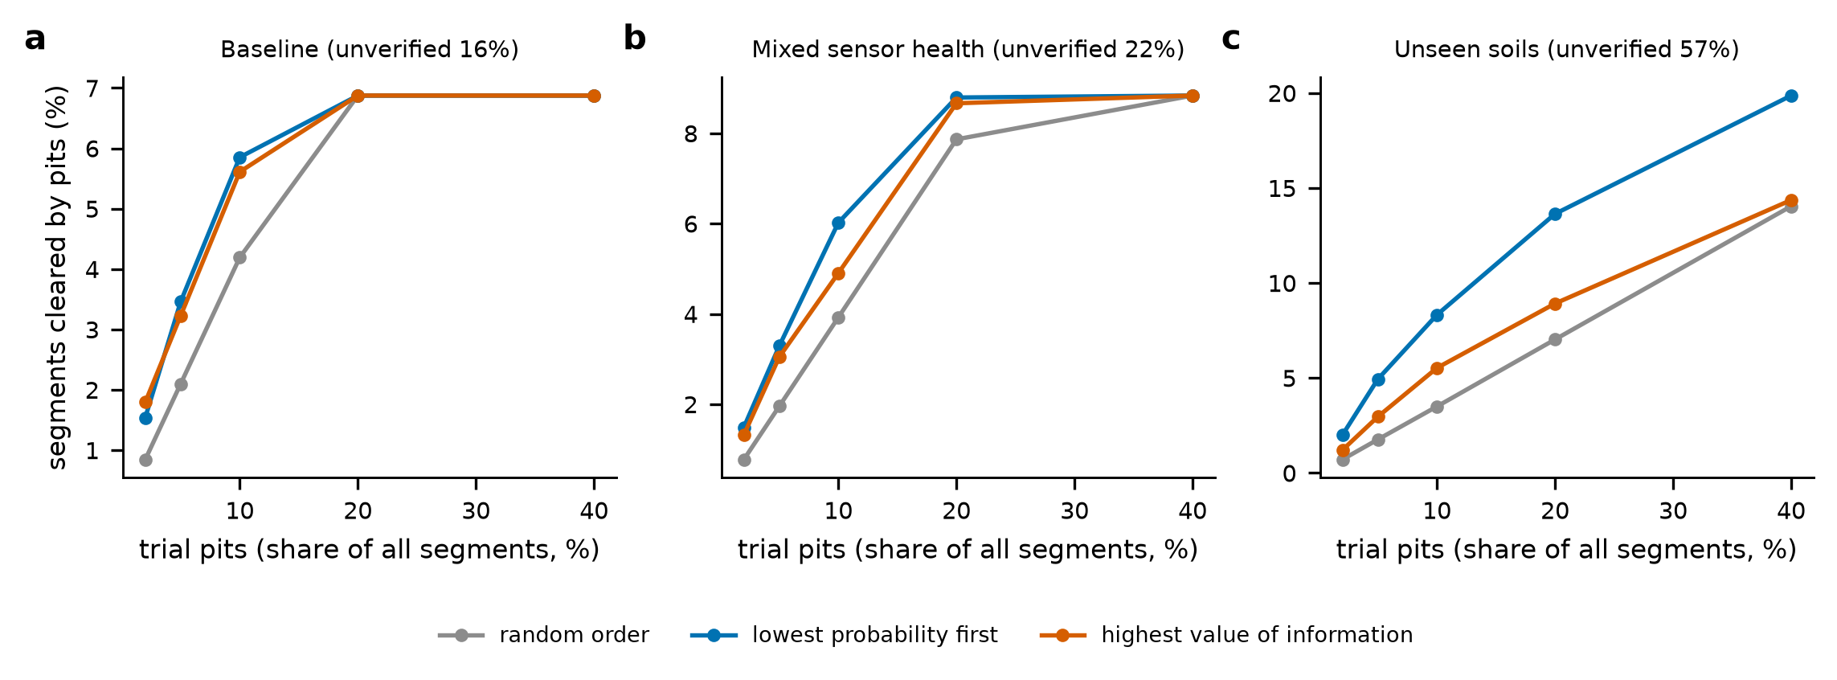
Fig. S1. Share of the corridor cleared by trial pits against the pit budget (share of all segments) for three allocation orders, among the segments left unverified by P5.
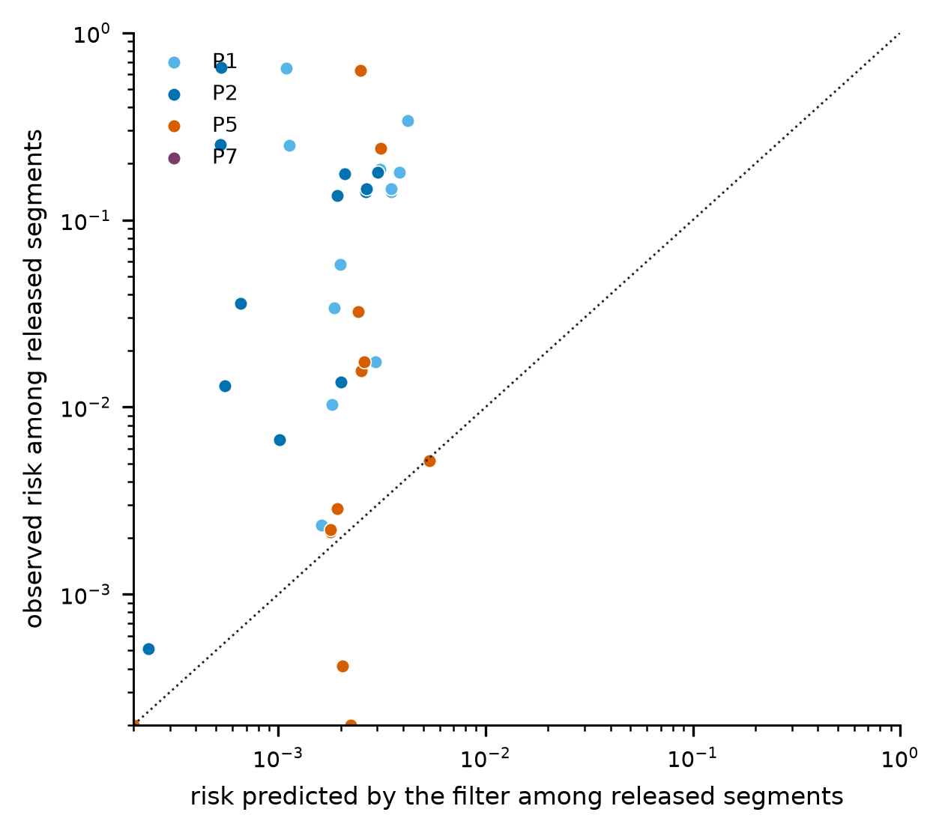
Fig. S2. Risk predicted by the filter among released segments against the risk observed, for four policies in the twelve scenarios (logarithmic axes; the dotted line is perfect calibration).
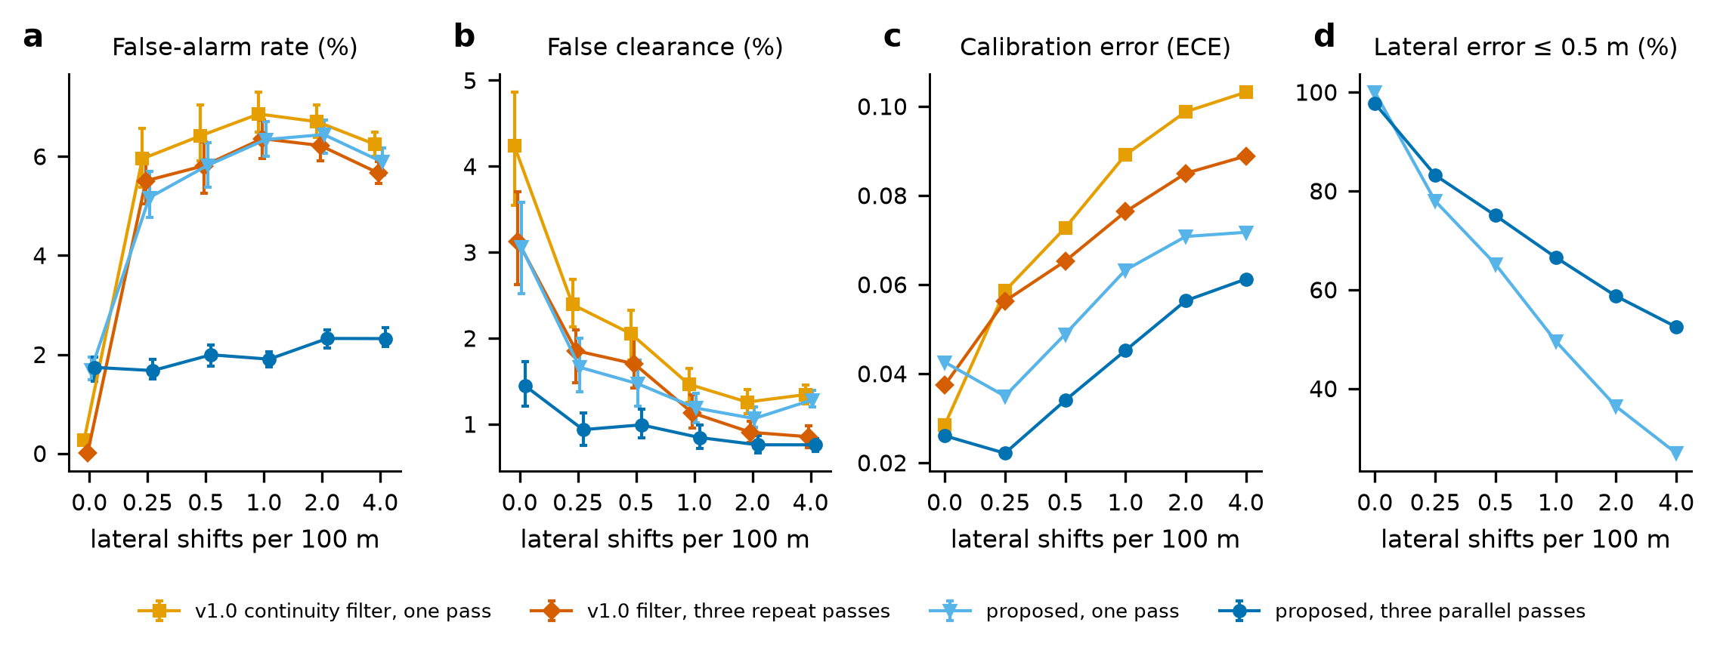
Fig. S3. Robustness to lateral displacement of the utility: false-alarm rate, false clearance, calibration error and lateral accuracy against the number of lateral shifts per 100 m (version 1.1 experiment).
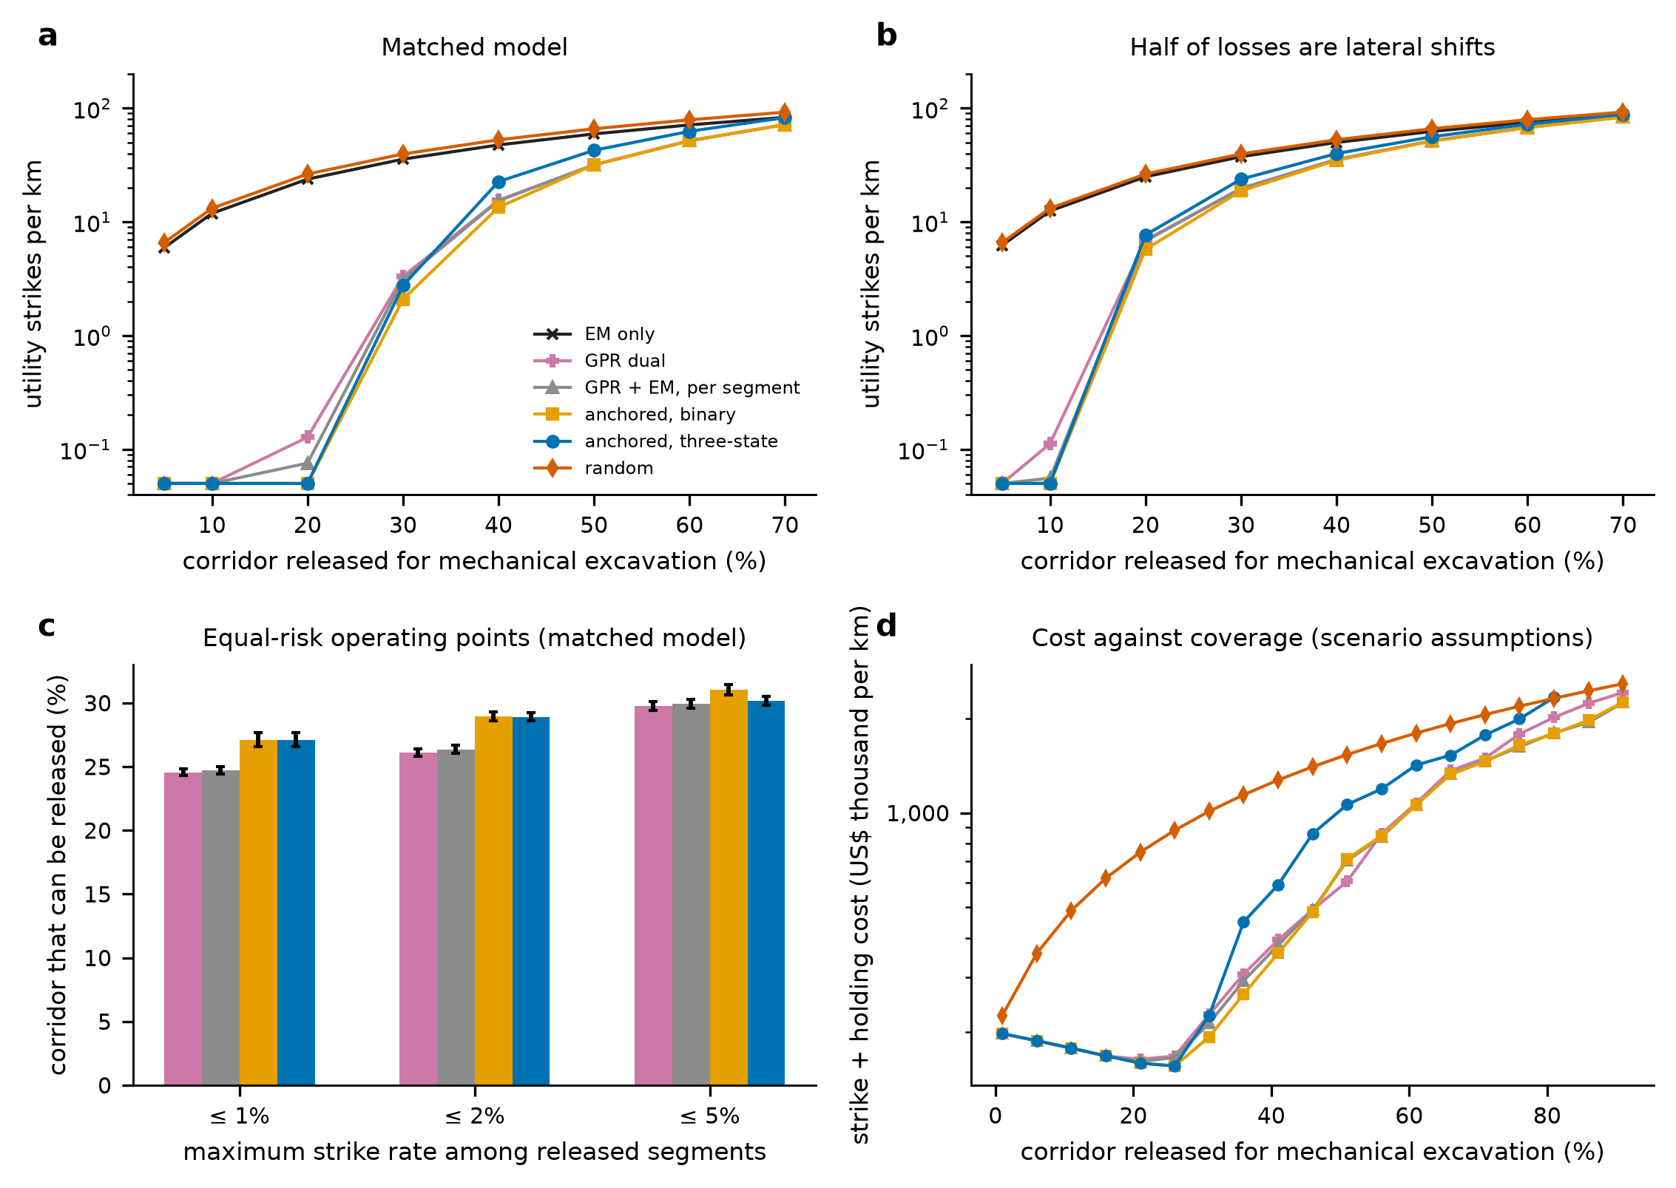
Fig. S4. Clearance at equal coverage in the version 1.1 experiment: modelled intersections per km against released coverage, in the matched model and with half of the losses as lateral shifts, equal-risk coverage and cost.
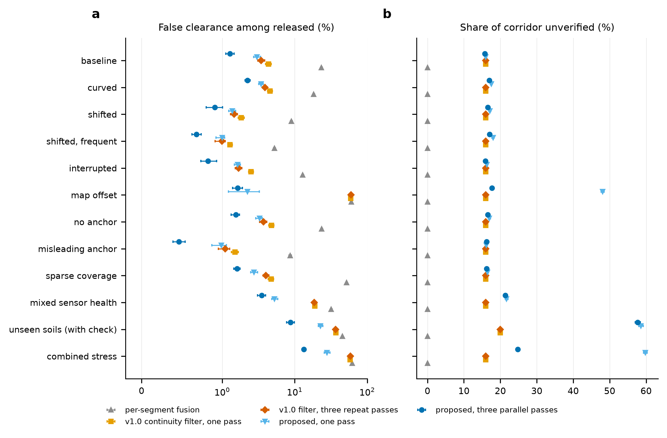
Fig. S5. False clearance and unverified share for five models in twelve scenarios (version 1.1 experiment).
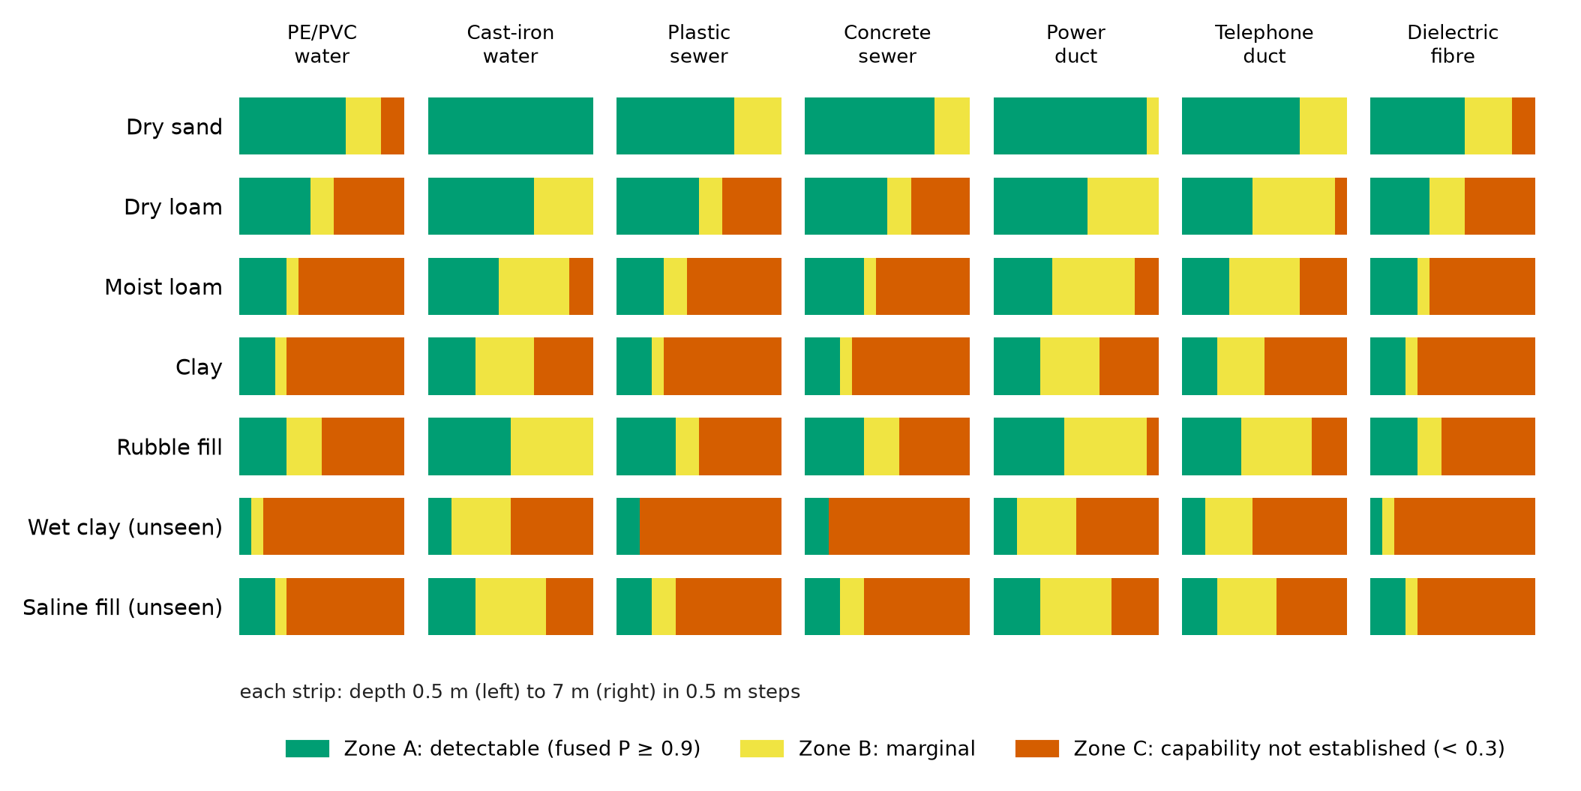
Fig. S6. Capability zones by soil, utility and depth (closed form).
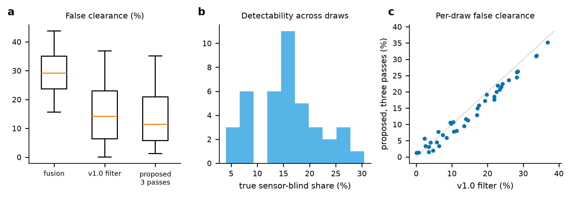
Fig. S7. Parameter-uncertainty envelope of version 1.2: false clearance of three methods over parameter draws, true sensor-blind share and the proposed layer against the version 1.0 filter.
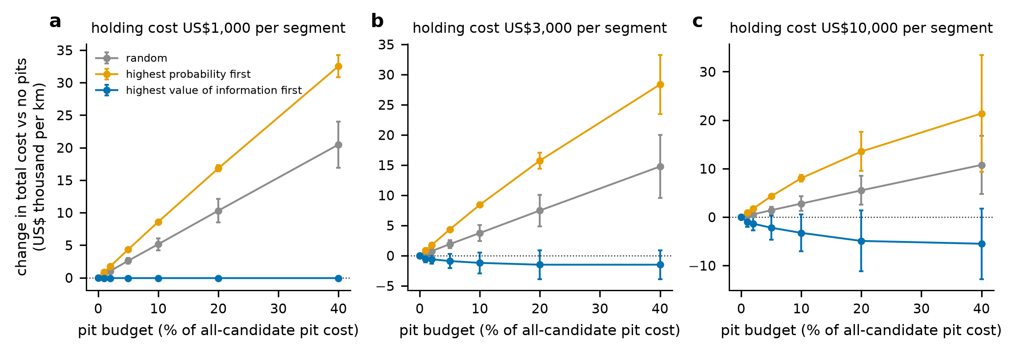
Fig. S8. Value of information (version 1.1): change in total cost against the pit budget for three allocation rules and three holding costs.
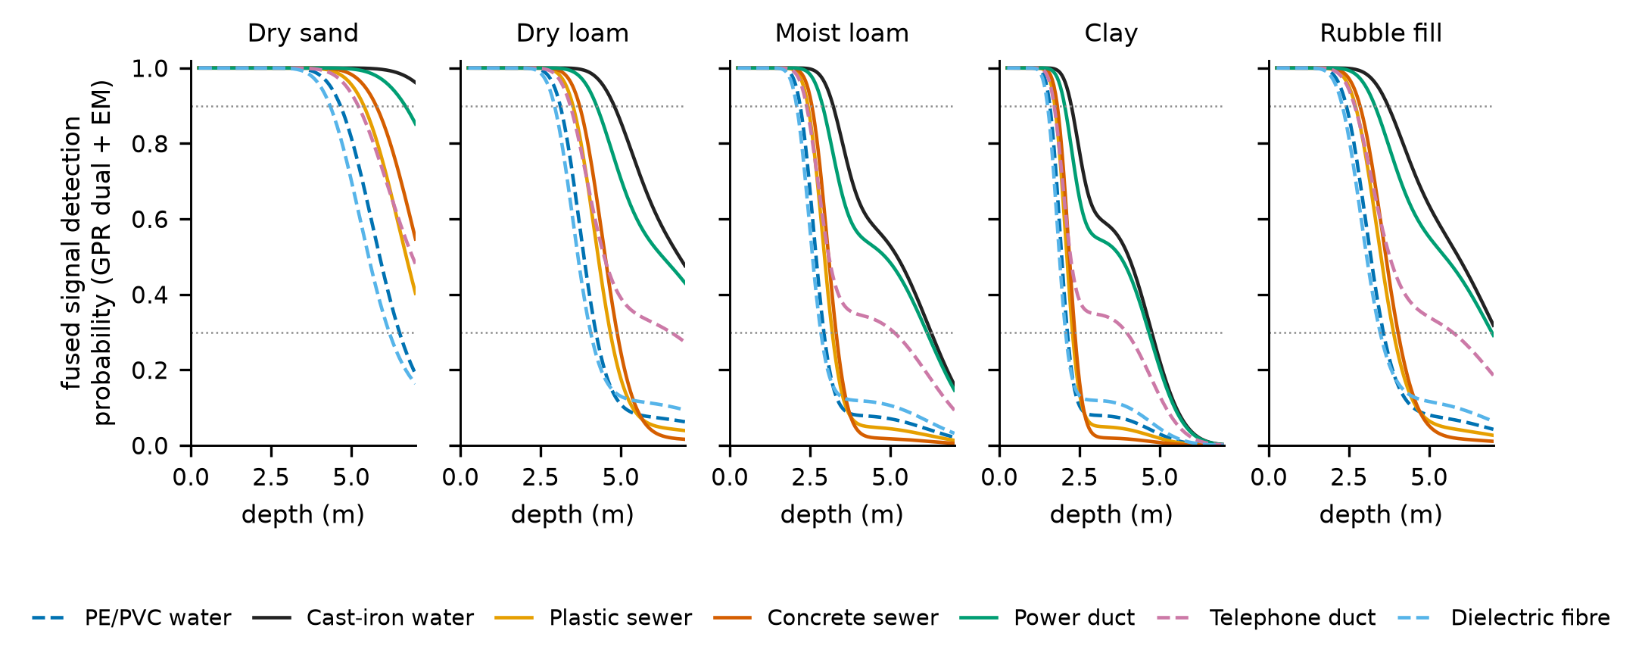
Fig. S9. Fused signal detection probability (dual-band GPR and EM) against depth for each soil and utility type (closed form).
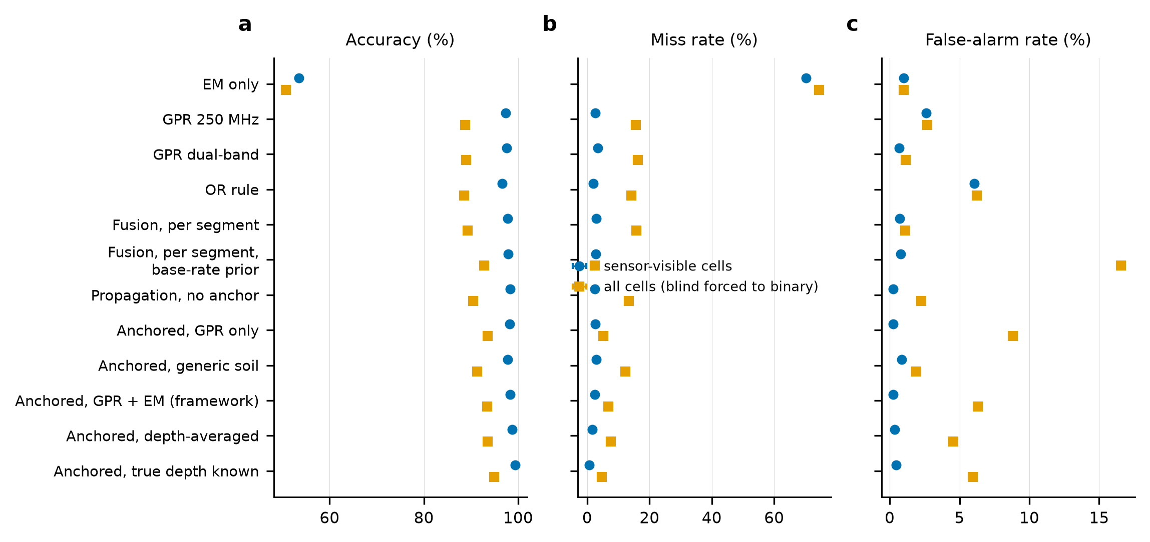
Fig. S10. Detection and classification performance of the compared methods of version 1.0 in sensor-visible cells and in all cells.
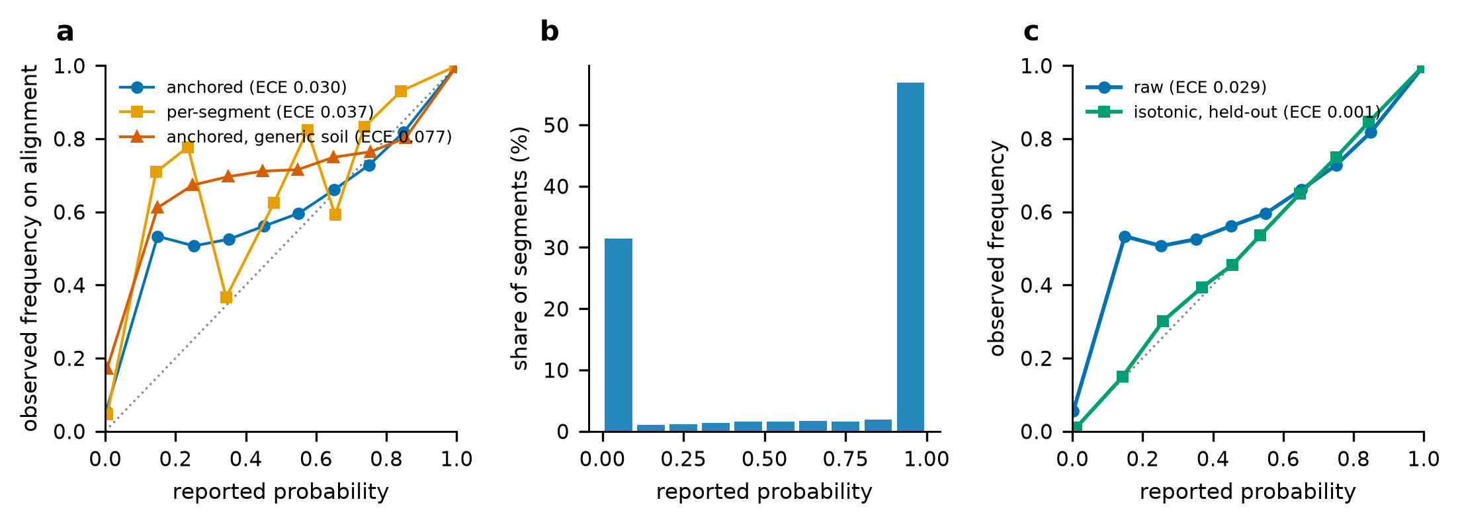
Fig. S11. Calibration of the version 1.0 framework: reliability curves, distribution of probabilities and an isotonic recalibration.

