Supplementary Information
Thermal Shielding, Melt Kinetics and Surge Control of a Steam-Assisted Pipeline Cleaning Crawler: A Monte Carlo Study and Its Deployment Limits
Leon Sandler
Independent Researcher, Northbrook, Illinois, USA. sandler.leon@gmail.com

S1. Thermal sweep (first suite, 3,000 draws per case; 800 per thickness)
Aerogel (mm) | Atmospheric, 45 min | Atmospheric, 90 min | Evacuated, 45 min | Evacuated, 90 min
5 | 0.1% (0.0–0.7%) | 0% | 51.9% (48.4–55.3%) | 0%
10 | 19.1% (16.5–22.0%) | 0% | 92.4% (90.3–94.0%) | 12%
15 | 62.4% (59.0–65.7%) | 0% | 97.1% (95.7–98.1%) | 35%
20 | 86.5% (84.0–88.7%) | 1% | 98.6% (97.6–99.2%) | 50%
30 | 96.2% (94.7–97.4%) | 16% | 98.9% (97.9–99.4%) | 69%
40 | 99.1% (98.2–99.6%) | 40% | 99.6% (98.9–99.9%) | 80%
50 | 99.2% (98.4–99.7%) | 60% | 99.6% (98.9–99.9%) | 80%
60 | 100.0% (99.5–100.0%) | 72% | 98.9% (97.9–99.4%) | 79%
Table S1. P(pack ≤ 55 °C) against aerogel thickness, 45 min (Wilson 95% interval) and 90 min.
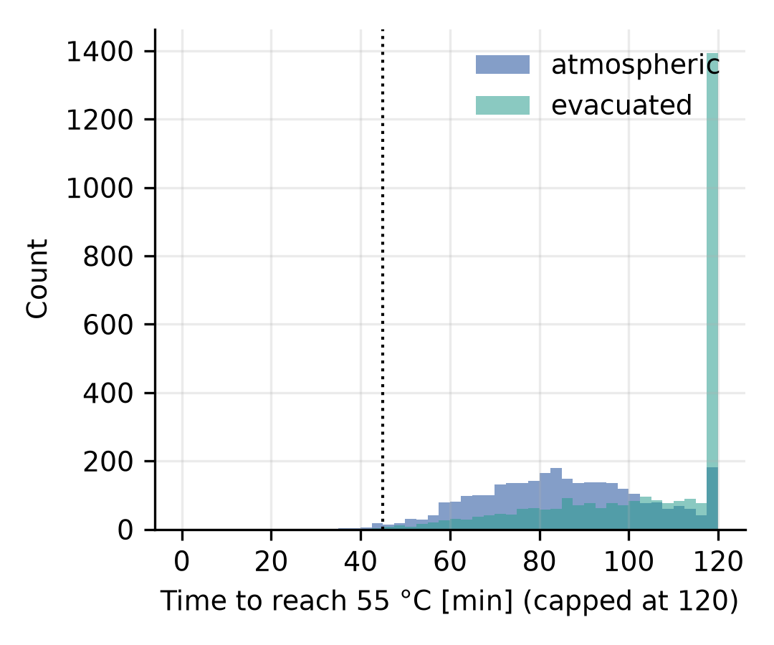
Fig. S1. Time to reach 55 °C for atmospheric and evacuated aerogel, 40 mm (capped at 120 min).
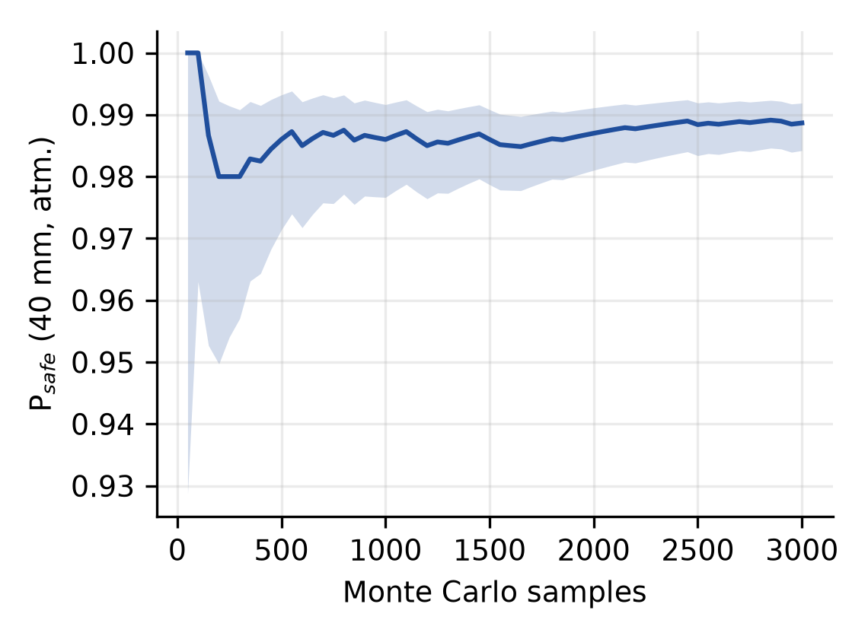
Fig. S2. Convergence of the Monte Carlo estimate of P(pack ≤ 55 °C) with the number of draws (40 mm, atmospheric); band: Wilson 95% interval.
S2. Pipe length and logistics (all cases)
Mission | Melt removal | L (m) | P(one) | Dep. median | Dep. p95 | Active (h) | Total (h) | Range (m)
45 min atmospheric | ablation | 0.3 | 100% | 1 | 1 | 0.00 | 11.5 (8.3–14.7) | 133.6
45 min atmospheric | ablation | 10 | 100% | 1 | 1 | 0.06 | 11.6 (8.4–14.8) | 133.6
45 min atmospheric | ablation | 100 | 65% | 1 | 3 | 0.56 | 12.9 (9.1–18.4) | 133.6
45 min atmospheric | ablation | 300 | 0% | 3 | 8 | 1.68 | 17.1 (12.0–31.5) | 133.6
45 min atmospheric | ablation | 600 | 0% | 5 | 16 | 3.36 | 22.6 (14.9–51.9) | 133.6
45 min atmospheric | ablation | 1,000 | 0% | 8 | 26 | 5.61 | 30.6 (18.2–79.6) | 133.6
45 min atmospheric | retained 0.5 mm | 0.3 | 100% | 1 | 1 | 0.02 | 11.5 (8.3–14.7) | 12.5
45 min atmospheric | retained 0.5 mm | 10 | 62% | 1 | 3 | 0.60 | 13.1 (9.1–18.5) | 12.5
45 min atmospheric | retained 0.5 mm | 100 | 0% | 9 | 27 | 6.00 | 32.1 (16.8–81.2) | 12.5
45 min atmospheric | retained 0.5 mm | 300 | 0% | 25 | 79 | 18.01 | 75.3 (30.6–224.9) | 12.5
45 min atmospheric | retained 0.5 mm | 600 | 0% | 49 | 158 | 36.02 | 140.0 (50.0–438.8) | 12.5
45 min atmospheric | retained 0.5 mm | 1,000 | 0% | 81 | 263 | 60.03 | 227.1 (76.3–723.3) | 12.5
45 min atmospheric | no drainage | 0.3 | 97% | 1 | 1 | 0.10 | 11.7 (8.5–15.1) | 2.3
45 min atmospheric | no drainage | 10 | 9% | 5 | 28 | 3.30 | 22.7 (11.6–82.2) | 2.3
45 min atmospheric | no drainage | 100 | 0% | 45 | 274 | 32.99 | 130.5 (29.2–725.2) | 2.3
45 min atmospheric | no drainage | 300 | 0% | 133 | 822 | 98.96 | 369.0 (66.2–2,154.9) | 2.3
45 min atmospheric | no drainage | 600 | 0% | 265 | 1,643 | 197.92 | 727.6 (121.5–4,301.2) | 2.3
45 min atmospheric | no drainage | 1,000 | 0% | 442 | 2,738 | 329.86 | 1,206.4 (195.9–7,162.3) | 2.3
90 min evacuated | ablation | 0.3 | 100% | 1 | 1 | 0.00 | 11.5 (8.3–14.7) | 255.2
90 min evacuated | ablation | 10 | 100% | 1 | 1 | 0.06 | 11.6 (8.4–14.8) | 255.2
90 min evacuated | ablation | 100 | 89% | 1 | 2 | 0.56 | 12.4 (9.0–16.2) | 255.2
90 min evacuated | ablation | 300 | 41% | 2 | 5 | 1.68 | 14.9 (10.1–24.5) | 255.2
90 min evacuated | ablation | 600 | 0% | 3 | 9 | 3.37 | 18.8 (13.0–38.2) | 255.2
90 min evacuated | ablation | 1,000 | 0% | 4 | 14 | 5.61 | 23.9 (15.0–57.0) | 255.2
90 min evacuated | retained 0.5 mm | 0.3 | 100% | 1 | 1 | 0.02 | 11.5 (8.3–14.7) | 23.8
90 min evacuated | retained 0.5 mm | 10 | 89% | 1 | 2 | 0.60 | 12.4 (9.0–16.3) | 23.8
90 min evacuated | retained 0.5 mm | 100 | 2% | 5 | 14 | 6.02 | 24.9 (14.4–57.8) | 23.8
90 min evacuated | retained 0.5 mm | 300 | 0% | 13 | 42 | 18.05 | 53.4 (23.9–151.6) | 23.8
90 min evacuated | retained 0.5 mm | 600 | 0% | 26 | 84 | 36.10 | 95.9 (37.1–292.9) | 23.8
90 min evacuated | retained 0.5 mm | 1,000 | 0% | 43 | 140 | 60.17 | 152.5 (54.9–480.9) | 23.8
90 min evacuated | no drainage | 0.3 | 99% | 1 | 1 | 0.10 | 11.7 (8.4–14.9) | 4.3
90 min evacuated | no drainage | 10 | 23% | 3 | 15 | 3.29 | 18.6 (10.6–58.7) | 4.3
90 min evacuated | no drainage | 100 | 0% | 24 | 146 | 32.89 | 88.6 (23.2–498.1) | 4.3
90 min evacuated | no drainage | 300 | 0% | 70 | 438 | 98.66 | 245.1 (47.9–1,473.8) | 4.3
90 min evacuated | no drainage | 600 | 0% | 138 | 875 | 197.31 | 479.7 (84.6–2,936.8) | 4.3
90 min evacuated | no drainage | 1,000 | 0% | 230 | 1,458 | 328.86 | 792.3 (134.8–4,891.9) | 4.3
Table S2. Deployments, active time and total intervention time by mission, melt-removal case and pipe length (median; total with 5th–95th percentile).
S3. Pipe size and temperature (detail)
NPS (in) | Bore (mm) | Hull OD (mm) | Pack radius (mm) | Aerogel (mm) | P atm. | P evac. | h scale | Steam scale
4 | 102.3 | – | 25 | does not fit | – | – | 1.31 | 0.34
6 | 154.1 | 65 | 25 | does not fit | – | – | 1.19 | 0.51
8 | 202.7 | 114 | 25 | 24 | 0.0% (0.0–0.5%) | 5.1% (3.8–6.9%) | 1.11 | 0.67
10 | 254.5 | 166 | 35 | 40 | 42.2% (38.9–45.7%) | 50.0% (46.5–53.5%) | 1.05 | 0.83
12 | 304.8 | 216 | 60 | 40 | 99.2% (98.4–99.7%) | 99.4% (98.5–99.7%) | 1.00 | 1.00
14 | 336.5 | 248 | 60 | 40 | 99.2% (98.4–99.7%) | 99.4% (98.5–99.7%) | 0.98 | 1.10
16 | 387.3 | 298 | 60 | 40 | 99.2% (98.4–99.7%) | 99.4% (98.5–99.7%) | 0.94 | 1.27
Table S3. Fit and thermal margin by nominal pipe size (800 draws; Wilson interval). h scale: condensation coefficient relative to 12 in; steam scale: melting steam per metre relative to 12 in.
Temperature (°C) | P atm. (95% interval) | P evac. (95% interval) | Median pack T at 45 min (°C) | Melt time (s) | Range (m)
0 | 100.0% (99.5–100.0%) | 100.0% (99.5–100.0%) | 14.3 | 13.1 | 111
10 | 100.0% (99.5–100.0%) | 100.0% (99.5–100.0%) | 24.2 | 12.3 | 119
25 | 98.8% (97.7–99.3%) | 99.9% (99.3–100.0%) | 39.1 | 10.9 | 133
35 | 84.5% (81.8–86.8%) | 89.8% (87.5–91.7%) | 49.0 | 10.1 | 139
45 | 21.9% (19.1–24.9%) | 35.9% (32.6–39.3%) | 58.9 | 9.3 | 102
55 | 0.4% (0.1–1.1%) | 0.1% (0.0–0.7%) | 68.7 | 8.4 | 0
Table S4. Pipe / fluid temperature (12 in design, 40 mm aerogel; 800 draws): probability, median pack temperature at 45 min (atmospheric), median melt time and range.
S4. Bypass: peak speed by pocket volume
V_g (m³) | 0 | 5 | 10 | 20 | 40 | 80 | 160 | 320
0.3 | 97% | 97% | 96% | 95% | 92% | 88% | 82% | 72%
1.0 | 98% | 98% | 98% | 98% | 97% | 95% | 92% | 87%
3.0 | 99% | 99% | 99% | 98% | 98% | 98% | 96% | 94%
10.0 | 99% | 99% | 99% | 99% | 99% | 99% | 98% | 98%
Table S5. P(peak speed > 1 m/s) against bypass area (cm²; columns) for four gas-pocket volumes (rows, m³); other inputs sampled.
V_g (m³) | 20 cm² | 80 cm² | 320 cm²
0.3 | 76 | 19 | 5
1.0 | 254 | 64 | 16
3.0 | 762 | 190 | 48
10.0 | 2,538 | 635 | 159
Table S6. Median time for a fully open bypass to halve the break-through differential (ms), tool held at rest, against pocket volume and bypass area.
Q_s (m³/s at upstream conditions) | Bypass area (cm²)
0.01 | 1.6
0.03 | 4.7
0.10 | 15.6
0.30 | 46.9
1.00 | 156.3
Table S7. Bypass flow area that holds a 0.5 bar differential at 18 bar upstream (assumed methane-like gas, C_d = 0.7) for a supply flow Q_s.
S5. Automated checks
tests/test_all.py runs 27 checks: the first suite is unchanged (sha256) and reproduces its published results; the maintenance-lattice formula; the extended thermal, melt and surge functions equal the first suite when the added mechanisms are off (pack temperature histories, speed, range, steam per metre and melt time, peak speeds for the passive and controller-only crawlers, and the zero-area orifice); monotonic range with retained film; the no-drainage limit; the series-resistance flux; the D^{−1/4} scaling of the condensation coefficient; zero and choked orifice flow; the gas fraction bounds; monotonic bypass benefit; venting-time scaling with volume; proportionality of the holding area to the supply flow; the 12 in hull; the fit in 4, 6 and 8 in pipes; the wall-heating energy balance; the standard-wall pipe mass; the baseline probability against the first suite's interval; monotonic temperature dependence; mesh convergence; and the 270 m and 540 m range caps implied by the speed set-point.
References
[1] A. Aiyejina, D.P. Chakrabarti, A. Pilgrim, M. Sastry, Wax formation in oil pipelines: A critical review, International Journal of Multiphase Flow 37 (2011) 671–694. https://doi.org/10.1016/j.ijmultiphaseflow.2011.02.007
[2] Z. Huang, S. Zheng, H.S. Fogler, Wax Deposition: Experimental Characterizations, Theoretical Modeling, and Field Practices, CRC Press, Boca Raton (2016). https://doi.org/10.1201/b18482
[3] S. Kim, J. Jeong, K. Yoo, H. Yoo, Y. Seo, Experimental investigation on speed excursion of PIG due to friction variation in natural gas pipeline, Journal of Natural Gas Science and Engineering 104 (2022) 104659. https://doi.org/10.1016/j.jngse.2022.104659
[4] T.T. Nguyen, S.B. Kim, H.R. Yoo, Y.W. Rho, Modeling and simulation for PIG with bypass flow control in natural gas pipeline, KSME International Journal 15 (2001) 1302–1310. https://doi.org/10.1007/bf03185671
[5] X. Zhu, S. Zhang, G. Tan, D. Wang, W. Wang, Experimental study on dynamics of rotatable bypass-valve in speed control pig in gas pipeline, Measurement 47 (2014) 686–692. https://doi.org/10.1016/j.measurement.2013.08.060
[6] J. Quarini, Ice-pigging to reduce and remove fouling and to achieve clean-in-place, Applied Thermal Engineering 22 (2002) 747–753. https://doi.org/10.1016/s1359-4311(02)00019-4
[7] G. Quarini, E. Ainslie, M. Herbert, T. Deans, D. Ash, D. Rhys, N. Haskins, G. Norton, S. Andrews, M. Smith, Investigation and development of an innovative pigging technique for the water-supply industry, Proceedings of the Institution of Mechanical Engineers, Part E: Journal of Process Mechanical Engineering 224 (2010) 79–89. https://doi.org/10.1243/09544089jpme312
[8] Wazoku (InnoCentive), Innovative Pipeline Cleaning Solutions (scouting challenge for YPF), https://www.innocentive.com/challenges/innovative-pipeline-cleaning-solutions/ (accessed 7 November 2026).
[9] L. Sandler, MyUncle: maintenance-lattice simulation framework (software repository), https://github.com/sandlerleon/MyUncle (accessed 7 November 2026).
[10] N. Metropolis, S. Ulam, The Monte Carlo method, Journal of the American Statistical Association 44 (1949) 335–341. https://doi.org/10.1080/01621459.1949.10483310
[11] M. Koebel, A. Rigacci, P. Achard, Aerogel-based thermal superinsulation: an overview, Journal of Sol-Gel Science and Technology 63 (2012) 315–339. https://doi.org/10.1007/s10971-012-2792-9
[12] IEC 60079-0, Explosive atmospheres — Part 0: Equipment — General requirements, International Electrotechnical Commission, Geneva (current edition).
[13] ASME B16.5, Pipe Flanges and Flanged Fittings: NPS 1/2 through NPS 24 Metric/Inch Standard, American Society of Mechanical Engineers, New York (current edition).
[14] X. Feng, M. Ouyang, X. Liu, L. Lu, Y. Xia, X. He, Thermal runaway mechanism of lithium ion battery for electric vehicles: A review, Energy Storage Materials 10 (2018) 246–267. https://doi.org/10.1016/j.ensm.2017.05.013
[15] W. Nusselt, Die Oberflächenkondensation des Wasserdampfes, Zeitschrift des Vereines Deutscher Ingenieure 60 (1916) 541–546, 569–575.
[16] F.P. Incropera, D.P. DeWitt, T.L. Bergman, A.S. Lavine, Fundamentals of Heat and Mass Transfer, 6th ed., Wiley, Hoboken (2007).
[17] E.B. Wilson, Probable inference, the law of succession, and statistical inference, Journal of the American Statistical Association 22 (1927) 209–212. https://doi.org/10.1080/01621459.1927.10502953
[18] A. Saltelli, M. Ratto, T. Andres, F. Campolongo, J. Cariboni, D. Gatelli, M. Saisana, S. Tarantola, Global Sensitivity Analysis: The Primer, Wiley, Chichester (2008). https://doi.org/10.1002/9780470725184

