Coupled Condensation–Melting Heat Transfer and Thermal Design Limits of a Steam-Assisted Pipeline Cleaning Crawler: A Probabilistic Modeling Study
Leon Sandler
Independent Researcher, Northbrook, Illinois, USA
ORCID: https://orcid.org/0009-0007-4584-808X
Corresponding author: sandler.leon@gmail.com

Highlights
• Retained melt-film resistance, not insulation, limits steam pipeline cleaning
• A dynamic film model predicts a 0.35 mm film and 18 m median range per deployment
• Melt-time formulas are benchmarked against an enthalpy solver and Neumann
• A 1 km line needs 57 deployments with the dynamic film, 8 with instant removal
• Class 150 steam limit (195 °C) costs only 3% of the range
Abstract
Steam-assisted pipeline cleaning couples condensation heat transfer, melting of a deposit and a thermally protected tool, and the coupling, not any single component, sets its limits. We study a motorized steam-assisted crawler with a probabilistic model: transient conduction through an aluminum–aerogel–titanium wall into a lumped battery pack, film condensation, a melt model with a retained liquid film whose resistance is the dimensionless group Pi_{f}=hs/k_{l}, a dynamic film balancing melt production and gravity drainage, an orifice model of the bypass relief, and a steam budget. The conduction and melt formulas are benchmarked against an independent solver and the Neumann solution; no experiment was available for the coupled model. Under assumed input distributions, with 40 mm of aerogel the pack stays at or below 55 °C for 45 min in 98.9% of draws at 25 °C but 22% at 45 °C. The median range per deployment is 138 m if molten deposit leaves at once, 18 m with the dynamic film (0.35 mm) and 2 m with none removed; Sobol indices attribute 55% of the range variance to the film. The condensation correlation changes the instant-removal range by 25%, a Class 150 steam limit of 195 °C by 3%. A 1 km line needs a median of 57 deployments with the dynamic film (8 with instant removal), and the hull does not fit pipes below 8 in. These are model probabilities, not field reliabilities.
Keywords
Condensation heat transfer; Melting with drainage; Paraffin deposition; Silica aerogel; Pipeline pigging; Global sensitivity analysis
1. Introduction
Wax, asphaltene, scale and sediment deposits narrow the bore of upstream hydrocarbon pipelines, raise the pressure loss and degrade the product. Wax deposition has been studied extensively [1,2], and the usual remedies are high-volume flushing, chemical treatment and mechanical pigging. Each has a known cost: abrasive or mechanical cleaning can wear the wall and generates solid waste, and a passive pig can stall behind a heavy deposit and then surge, because the gas stored behind it expands when the blockage lets go [3]; bypass valves that vent the gas are used to control the speed of pigs in gas lines [4,5]. Ice-slurry pigging has been developed for water mains and process plant [6,7]. A scouting challenge published by an energy company has recently asked for cleaning solutions for pipelines of 4 to 16 inches and up to 1 km that have no dedicated launcher or receiver and can be reached only through a connection aligned with the flow [8].
Thermal mobilization with steam is an obvious alternative to abrasion, because condensation delivers a large heat flux at a modest temperature difference. A tool that carries steam into a line and melts the deposit ahead of itself is a coupled heat-transfer system: steam condenses on a cold, wax-covered wall; the heat is conducted through the condensate film and through any molten deposit that stays on the surface before it melts the solid; the melt either leaves the surface or does not; and the same steam attacks the insulation that protects the tool's battery. This paper studies that coupling for one concept, a tracked, self-propelled crawler with an elastomeric sealing skirt (the Thermally Assisted Motorized Pipeline Remediation Crawler, TAMPRC), and asks which of its limits are set by heat transfer and which by the tool and the line.
The first suite of the study (thermal shield, melt kinetics, surge, maintenance lattice) was written as a design-screening model and is retained unchanged in the repository. This paper re-examines its assumptions in the order that matters for a thermal-engineering reader. (i) The melt model assumed that molten deposit leaves the surface at once. Allowing a retained liquid film adds a conduction resistance, which we express as a dimensionless group Pi_{f}=hs/k_{l}, and we predict the film with a dynamic balance of melt production and gravity drainage instead of prescribing it. (ii) The condensation correlation was derived for the outside of a horizontal tube; we compare it with an internal-flow correlation and a noncondensable-gas limit. (iii) The melt-time formulas and the conduction solver are benchmarked against an independent enthalpy-method solver, the exact Neumann solution and an independent stiff-ODE integration. (iv) Sensitivity is analyzed globally (Sobol indices) and for correlated inputs, and the spread caused by the choice of model form is separated from the spread caused by parameter uncertainty. (v) The design variables are searched under constraints and the Pareto set is reported. (vi) The steam pressure is checked against flange ratings and a revised operating envelope is derived. Deployment limits (pipe length, size, temperature), the surge on blockage release and the steam budget complete the study. With every added mechanism switched off the extended model reproduces the first suite draw for draw (Section 5). All input distributions are assumed, and no measurement of these deposits, steam conditions or tool was available; the paper therefore reports model probabilities under assumed inputs, not field reliabilities, and ranks the measurements that would matter.
2. Concept and operating envelope
The tool (Fig. 1) is a crawler of about 120 kg with cleated tracks and an elastomeric sealing skirt. Steam condenses on the deposit face ahead of the skirt, delivers latent heat and melts the deposit in place, and the skirt sweeps the liquefied residue forward. The battery pack, motors and electronics sit in a sealed vessel inside a concentric stack of aluminum shell, silica aerogel [9] and titanium hull; an evacuated (vacuum-jacketed) variant is also evaluated. Brushless motors drive the tracks and act as regenerative brakes against a speed setpoint of 0.10 m/s, and a seal-differential bypass valve is added to relieve the pressure when a blockage releases.
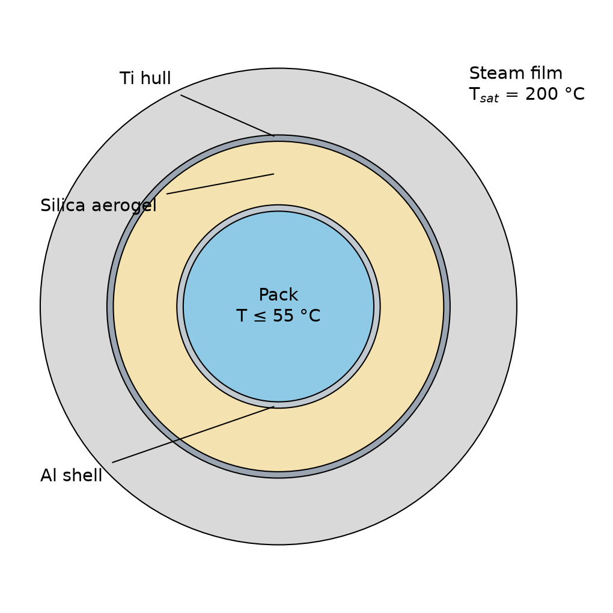
Fig. 1. Cross-section of the crawler hull (not to scale): pack, aluminum shell, silica aerogel, titanium hull and the steam film.
Table 1 lists the operating envelope that the brief states [8] next to what the modeled tool assumes. The tool modeled here is at concept stage (technology readiness level 2 to 3), below the 4 to 6 that the brief requires, and this paper does not claim otherwise.
Item | Brief [8] | Modeled tool
Pipe diameter | 4 to 16 in | 12 in (0.30 m bore) baseline; 4 to 16 in studied in Section 6.7
Pipe length | about 0.3 m to 1 km | one 45 min deployment; 0.3 m to 1 km studied in Section 6.6
Material | carbon steel | carbon steel, standard wall
Deposits | paraffin, sediment, scale, sludge, residue | meltable paraffin only (melt point 58 ± 8 °C); solids not modeled
Access | connection aligned with the flow; no fixed launcher or receiver | not modeled; tool recovery and steam path are open design items
Stages | preparation, isolation, cleaning, residue collection, verification, return to service | active cleaning and assumed logistics durations (Section 6.6)
Readiness | technology readiness level 4 to 6 | level 2 to 3 (simulation only)
Table 1. Operating envelope in the published brief and in the model.
Steam delivery. Fig. 2 shows the three ways in which steam can reach the deposit face. The model assumes arrangement (a): steam is fed through a line that passes through the tool and discharges ahead of the sealing skirt into a steam zone of length L_{z} (0.3 to 0.8 m) between the skirt and the deposit face. The skirt closes the zone, so the steam condenses on the deposit face and on the pipe wall inside the zone, the melt drains along the wall and collects as a pool at the invert, and the hull is exposed to saturated steam only in that zone. In arrangement (b) steam travels through the pipe behind the tool and reaches the zone through ports in the skirt, and it heats the whole pipe wall on the way (Section 6.11); in (c) a hose carried inside the pipe feeds the lance, which avoids the wall heating at the price of tether drag over up to 1 km and a second line at the steam temperature. In all three, steam must enter the line through the connection by which the tool enters, which needs a pressure-sealed gland or hose and is not designed here. The choice changes the steam budget and the hull exposure, not the melt model of Section 3, which depends only on the steam temperature and contact length at the deposit face.
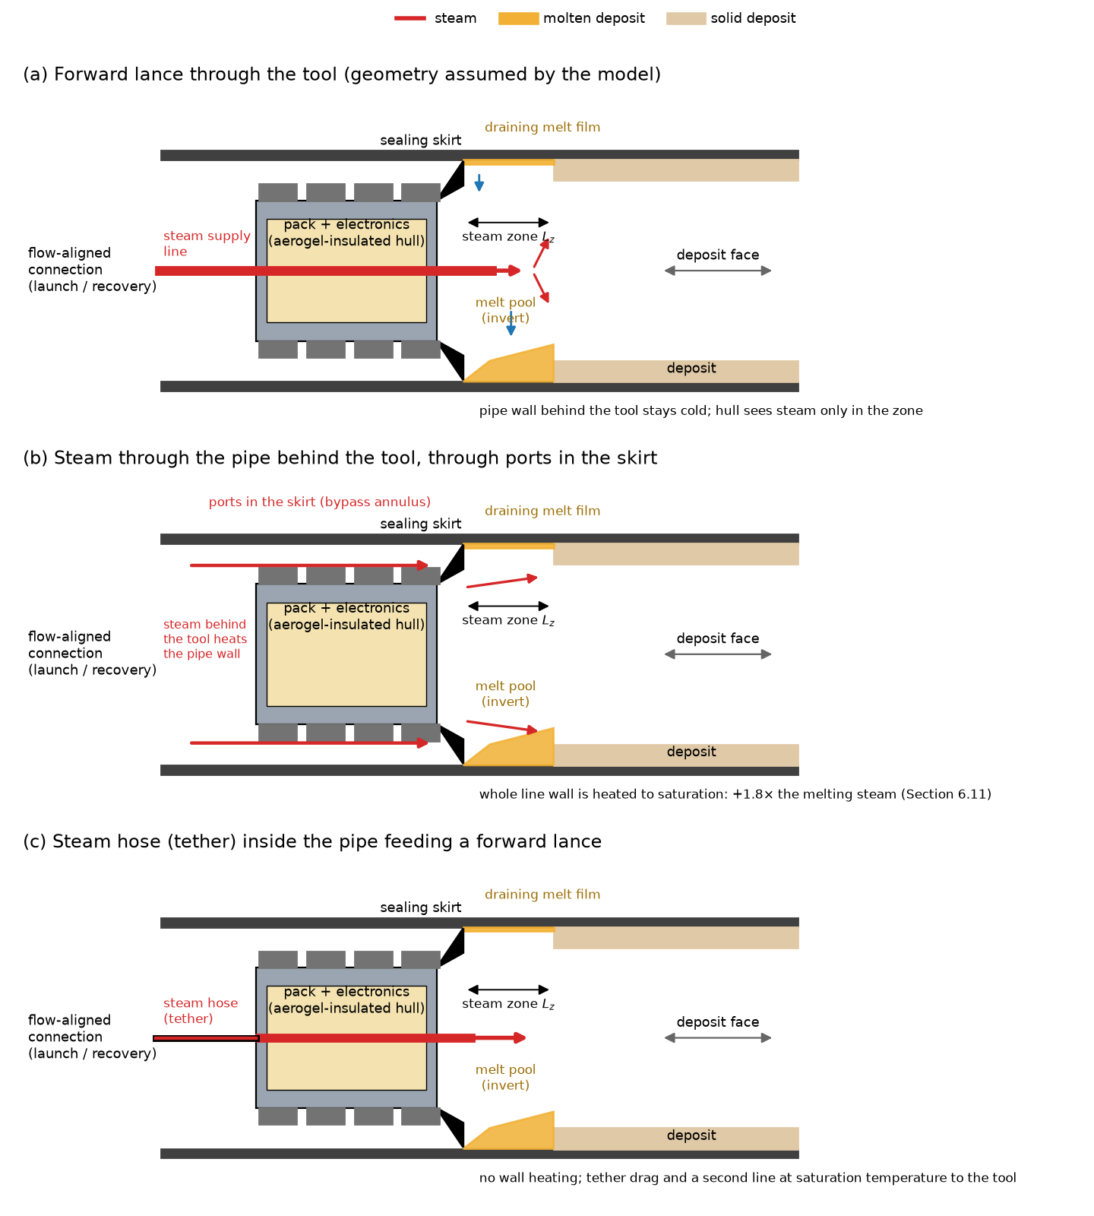
Fig. 2. Steam delivery to the deposit face: (a) forward lance through the tool (assumed by the model), (b) steam through the pipe behind the tool and ports in the skirt, (c) hose inside the pipe feeding a lance. Not to scale.
The saturation temperature must be compatible with the pressure rating of the line: the first design used steam at 198 °C, which is 1.49 MPa, and Section 6.8 shows that this exceeds the rating of a Class 150 carbon-steel flange at that temperature and derives a revised envelope. Equipment protection for explosive atmospheres [10] and the recovery of a stalled tool are discussed in Section 7.3.
3. Mathematical model
3.1 Transient conduction in the composite wall
The radial temperature T(r,t) in the composite wall (aluminum shell, silica aerogel, titanium hull) obeys one-dimensional cylindrical conduction,
$ρ c_{p}(T) \frac{∂T}{∂t}=\frac{1}{r}\frac{∂}{∂r}\left[r k(T) \frac{∂T}{∂r}\right]$ (1)
with density ρ, specific heat c_{p} and conductivity k. For atmospheric-pressure aerogel k=k₀[1+α(T−25)] with k₀=0.018 W/m·K and a slope of 8×10⁻⁵ W/m·K²; for the evacuated jacket k=0.0040+2.5×10⁻⁵(T−25) W/m·K. Both are multiplied by a lognormal factor for compaction, moisture and lot variation. The outer boundary exchanges heat with saturated steam through a film coefficient capped at 12 kW/m²·K, the inner boundary with a lumped battery pack (heat capacity m_{pack}c_{p}/L per unit length, source P_{gen}/L), and a parallel bridge conductance (tracks, end caps) equal to a fraction φ∼U(0.05,0.30) of the nominal aerogel conductance joins hull and pack. The pack limit is T_{crit}=55 °C; this is an assumed design limit, conservative relative to the onset of self-heating reported for lithium-ion cells [11], and no cell-level analysis is made. Eq. (1) is discretized by finite volumes (2 shell, 16 aerogel and 2 hull cells) and integrated with backward Euler at 10 s, with the conductivity lagged one step.
3.2 Film condensation: three representations
The first suite used the Nusselt film correlation [12,13], derived for the outside of a horizontal tube, with a conduit diameter D,
$h=0.728{\left[\frac{g ρ_{l}(ρ_{l}−ρ_{v}) k_{l}^{3} h'_{fg}}{μ_{l} D (T_{sat}−T_{w})}\right]}^{1/4}, h'_{fg}=h_{fg}+0.68 c_{p,l}(T_{sat}−T_{w})$ (2)
with saturated-water properties near 1.55 MPa, a lognormal multiplier (σ=0.15) and a noncondensable-gas factor U(0.5,1). Inside a horizontal tube at low vapor velocity the condensate drains to the invert and the film is stratified; the correlation of Chato [14,15] has the same form with the coefficient 0.555 and h'_{fg}=h_{fg}+tfrac38c_{p,l}(T_{sat}−T_{w}). A third, conservative representation for the range fixes the noncondensable factor at its lower bound 0.5. All three scale as D^{−1/4}. They are compared in Sections 5 and 6.3. An impingement model is not applied, because the steam path (a forward lance or annulus) is not defined; the steam-side coefficient on the hull is capped at 12 kW/m²·K in every case.
3.3 Deposit melting and the retained-film resistance
A deposit of thickness δ and melt point T_{m} needs the energy per unit area e=ρ_{d}δ[L_{f}+c_{d}(T_{m}−T₀)]. The first suite assumed that molten deposit leaves the surface at once (ablation), so that the heat flux is that of the condensate film at the melt temperature, q=h(T_{sat}−T_{m}). A liquid layer of thickness s that stays on the surface adds a conduction resistance in series with the condensate film. With the liquid conductivity k_{l} and a fraction η∼U(0.15,0.50) of the flux reaching the deposit,
$q_{eff}=η \frac{T_{sat}−T_{m}}{1/h+s/k_{l}}=\frac{q_{0}}{1+{Pi}_{f}}, {Pi}_{f}=\frac{h s}{k_{l}}, t_{m}=\frac{e}{q_{eff}}, v=\text{min}\left(v_{set},\frac{L_{z}}{t_{m}}\right)$ (3)
where q₀ is the flux without a film, L_{z}∼U(0.3,0.8) m is the steam contact length and v_{set}=0.10 m/s. The dimensionless group Pi_{f} is the ratio of the film's conduction resistance to the condensate film's: for Pi_{f}=1 the retained film halves the heat flux. Setting s=0 recovers the first suite exactly. The opposite limit, in which no melt drains and the layer grows from 0 to δ, gives
$t_{nd}=\frac{ρ_{d}[L_{f}+c_{d}(T_{m}−T_{0})] (δ/h+δ^{2}/2k_{l})}{η (T_{sat}−T_{m})}$ (4)
The liquid conductivity is assumed (k_{l}=0.15 W/m·K). The cleaned range of a deployment is v min (t_{crit},t_{run}), where t_{crit} is the first time the pack reaches 55 °C and t_{run} the mission length (45 min). Both the instant-removal and no-drainage formulas are quasi-steady and are benchmarked in Section 5.
3.4 Dynamic retained film
Instead of prescribing s, a surface element in the steam zone is advanced in time. The melted thickness x grows at the rate set by the flux through the film, and the film thickness is the difference between the volume of melt produced and the volume that drains under gravity as a Nusselt film along the wall between the crown and the invert (path ℓ=πD/4, mean sinθ=0.7),
$\frac{dx}{dt}=\frac{q_{eff}(s)}{ρ_{d}[L_{f}+c_{d}(T_{m}−T_{0})]}, \frac{ds}{dt}=\frac{ρ_{d}}{ρ_{l}}\frac{dx}{dt}−\frac{ρ_{l} g\text{sin}θ (s−s_{res})^{3}}{3 μ_{l} ℓ}$ (5)
with the molten-paraffin density ρ_{l}=770 kg/m³ and viscosity μ_{l} lognormal with median 4 mPa·s and σ=0.3 (assumed), and a residual wetting film s_{res} (zero in the baseline, 0.02 and 0.05 mm in the sensitivity study). The element is melted through when x=δ, which gives t_{m} and v_{th}=L_{z}/t_{m}. The model is a quasi-steady conduction film with gravity drainage; it ignores the molten pool at the invert, which the skirt pushes ahead, the shear of the steam on the film, and the temperature dependence of the viscosity. Its two limits are exact: for instant drainage it reproduces the ablation time, and for no drainage it approaches Eq. (4) (Section 5). Wall orientation (through sinθ), an interfacial steam shear τ (adding a film flux τs²/2μ_{l} to the gravity term) and the molten pool are examined in Section 6.4.
3.5 Blockage release with an orifice bypass
From breakthrough the tool of mass m obeys
$m \frac{dv}{dt}=A ΔP (1−β)−F_{f}−c_{d}v^{2}−F_{c}$ (6)
with pipe area A, seal friction F_{f}, downstream drag c_{d} and controller force F_{c} (PI on speed, limited to the braking and traction authority). The first suite represented the bypass relief by a factor β→β_{max}[1−0.5 bar/ΔP] (0.85 to 0.97) with a 5 to 30 ms lag, that is, as a force reduction without a flow. Here the upstream gas pocket (initial volume V₀, pressure P₀=P_{d}+ΔP_{b}) expands adiabatically as the tool advances a distance x and loses its gas through the bypass,
$P_{u}=P_{0}{\left(\frac{φV_{0}}{V_{0}+A x}\right)}^{γ}, \frac{dφ}{dt}=−\frac{{\dot{m}}_{b}}{m_{0}}, {\dot{m}}_{b}=C_{d}A_{b} u P_{u}\sqrt{\frac{2γ}{(γ−1)RT}}\sqrt{r^{2/γ}−r^{(γ+1)/γ}}$ (7)
where φ is the remaining gas fraction, m₀=P₀V₀/RT, r=max (P_{d}/P_{u},r_{c}) with r_{c} the critical ratio (choked flow), A_{b} the bypass flow area, C_{d}=0.7 and uin[0,1] the valve opening, which follows the demand (ΔP−0.5 bar)/(0.5 bar) with the same 5 to 30 ms lag. The gas is methane-like (R=518 J/kg·K, T=300 K, γ=1.3, assumed) and the downstream pressure is held constant. With A_{b}=0 the model reduces to the first suite's crawler without relief.
3.6 Pipe length, logistics and steam budget
For a line of length L and a deployment range R_{dep}=v t_{run}, the number of deployments is the smallest integer not below L/R_{dep}, the active cleaning time is L/v, and the total intervention time adds preparation and isolation, turnaround between deployments, verification and return to service, whose durations are assumed (Table 2). If steam reaches the tool through the pipe, it must also heat the steel wall of the whole line behind it,
$\dot{m}'_{s}=\frac{ρ_{s}A_{s}c_{s} (T_{sat}−T_{p})}{h_{fg}}+\dot{m}'_{melt}$ (8)
per meter of line, with the steel cross-section A_{s} of standard-wall pipe (ρ_{s}=7,850 kg/m³, c_{s}=490 J/kg·K), the pipe temperature T_{p} and the melting steam ṁ'_{melt} of Section 3.3. The radial clearance (tracks, cleats, skirt) is that of the first design in a 12 in pipe, 44 mm; the hull is scaled for other sizes by reducing the pack radius, and then the aerogel, down to a 25 mm pack. The saturation pressure is computed from the IAPWS-IF97 saturation line [16]. The maintenance lattice of the first suite (a periodic 48×24 lattice of wall cells fouled at a rate r_{f}(1+γn_{f}/4) and cleared with probability p per pass, checked against its exact solution for γ=0 [17]) is retained and reported in the Supplementary Information; it is not calibrated to any deposit.
3.7 Global sensitivity and constrained design
For a scalar output Y=f(mathbfX) of independent inputs, the first-order and total Sobol indices are S_{i}=Var[E(Y|X_{i})]/Var(Y) and S_{Ti}=E[Var(Y|mathbfX_{∼i})]/Var(Y) [18,19]. They are estimated with the Jansen estimators [20,21] on scrambled Sobol sequences, with bootstrap intervals. The design search is the constrained problem
${\text{max}}_{mathbfx} \text{median}(R_{dep}) \text{subject} \text{to} P(T_{pack}≤55 ^{circ}\text{C} \text{through} t_{run})≥0.95, D_{hull}≤D_{fit}, v_{set}≤0.20 \text{m/s}, t_{run}≤90 \text{min}$ (9)
over the aerogel thickness (10 to 60 mm), the jacket (atmospheric or evacuated), the mission length and the speed setpoint, for each melt-removal assumption. The Pareto set is taken over the median range (maximize), the melting steam per meter (minimize), the hull diameter (minimize) and the thermal probability (maximize). A surge-speed constraint v_{peak}≤v_{safe} is not imposed on this search, because the surge depends on the blockage and the bypass, not on these variables (Section 6.10), and a safe speed has not been justified for any line.
4. Monte Carlo methodology
Input uncertainty is propagated by Monte Carlo sampling [22]. All inputs are sampled independently from the distributions in Table 2 with fixed seeds, except where correlation is studied (Section 6.5, Gaussian copula). The thermal studies use 3,000 draws per scenario (800 for the sweeps), the surge study 10,000, and probabilities carry Wilson 95% intervals [23]. Common random numbers are used across the retained-film, coverage, condensation-model and steam studies, so differences between cases are not sampling noise. The distributions are assumed design-stage values, not measurements; no published distribution of these quantities for the deposits, steam conditions or tool was found. Two kinds of uncertainty are kept apart: the spread within a model caused by uncertain parameters (the 5th to 95th percentile of a case) and the spread between models caused by the choice of model form (condensation correlation, melt-removal model). The success percentages are model probabilities under the assumed distributions; without calibration they are not field reliabilities.
Input | Distribution or value
Aerogel thickness; k multiplier | 40 mm × (1 + N(0, 0.03)) (swept 5–60 mm); lognormal σ = 0.15 (× lognormal σ = 0.30 and 5% vacuum loss when evacuated)
Pack mass; heat generation; initial temperature | N(16, 1.2) kg; lognormal, median 70 W, σ = 0.35; N(25, 4) °C (shifted 0–55 °C in Section 6.7)
Thermal-bridge fraction; condensation multiplier; noncondensable factor | U(0.05, 0.30); lognormal σ = 0.15; U(0.5, 1.0)
Steam saturation temperature | N(198, 3) °C truncated to 185–204 °C (revised envelope: Section 6.8)
Deposit thickness; melt point; density; latent heat | lognormal, median 6 mm, σ = 0.5 (1–40 mm); N(58, 8) °C; N(850, 40) kg/m³; N(200, 30) kJ/kg
Pipe temperature; heat-coupling fraction η; contact length | N(25, 5) °C; U(0.15, 0.50); U(0.3, 0.8) m
Retained melt film s; liquid conductivity | swept 0–5 mm, or lognormal (median 0.2 mm, σ = 1.0) in the Sobol study; dynamic in Section 6.4; 0.15 W/m·K
Molten-paraffin viscosity; density; drain path | lognormal, median 4 mPa·s, σ = 0.3; 770 kg/m³; πD/4 (sensitivity ×0.25 and ×4)
Breakthrough ΔP; gas-pocket volume; downstream pressure | lognormal, median 3 bar, σ = 0.6 (0.5–25 bar); lognormal, median 1 m³, σ = 0.7 (0.2–10 m³); U(5, 30) bar
Seal friction; downstream drag; masses | lognormal, median 400 N; lognormal, median 2,000 N s²/m²; N(80, 8) kg pig, N(120, 10) kg crawler
Braking limit; traction limit; relief lag | N(2.5, 0.4) kN; N(1.5, 0.2) kN; U(5, 30) ms
Bypass area; discharge coefficient; crack differential | swept 0–320 cm² (pipe 707 cm²); 0.7; 0.5 bar
Assumed logistics durations (h) | preparation and isolation U(3, 8); turnaround between deployments U(1, 3); verification U(1, 3); return to service U(2, 6)
Table 2. Principal sampled or assumed inputs.
5. Verification, benchmarks and applicability
5.1 Code verification
62 automated checks run on the committed code and results (tests/test_all.py). They confirm that the first suite is intact (the file is byte-identical to the one submitted, and rerunning it reproduces its published results to the last digit); that every added mechanism reduces to the first suite when switched off (the extended thermal, melt and surge functions equal the originals draw for draw, and the orifice model with zero area equals the controller-only crawler; the dynamic film with instant drainage reproduces the ablation melt time); and the limiting and conservation properties of the added mechanisms. A deterministic nominal case refined from 20 to 160 cells and from 10 s to 1.25 s changes the pack temperature at 45 min from 38.65 °C to 38.68 °C, a difference of 0.03 K, and the differences to the finest grid fall monotonically. The exact mean-field solution of the maintenance lattice agrees with the lattice Monte Carlo within 0.26 percentage points for γ=0. Numerical verification is not physical validation, which Section 5.2 addresses as far as the available references allow.
5.2 Benchmarks against independent solutions
The melt formulas are quasi-steady and the steam correlation is borrowed from another geometry, so each was checked against an independent reference (Table 3, Fig. 3). An enthalpy-method finite-volume solver of one-dimensional melting, written independently of the melt formulas, reproduces the exact Neumann solution for a liquid layer growing into a solid at its melting temperature, at a Stefan number St=cΔT/L_{f}=1.47, to 0.007% in the front position at 60 s [24]. The solver is then run with the convective steam boundary and with the median parameters. For instant removal of the melt (cells removed as soon as they are liquid) the ablation formula agrees with the solver within 4.6% for h=1–10 kW/m²·K and deposit thicknesses of 3–12 mm, once the cell size resolves the ablation layer (4 µm; the melt time changes by 0.05% between 4 and 2 µm). The no-drainage formula (Eq. 4), which neglects the sensible heat of the liquid, gives melt times shorter than the solver by 18%, the same in every case; the quasi-steady front of the Neumann problem is 19% ahead of the exact one at this Stefan number. The no-drainage limit is therefore optimistic by about a fifth, and the true no-drainage range is smaller than reported, which strengthens the conclusion that the range can collapse. The conduction solver, integrated with backward Euler at 10 s, differs from an independent stiff-ODE integration (BDF, relative tolerance 10⁻¹⁰) of the same equations by 0.013 K at 45 min, and by 0.001 K at 0.625 s.
Component | Reference | Result
Enthalpy-method Stefan solver | Exact Neumann solution, St = 1.47 | front position error −0.007%
Instant-removal (ablation) melt time | enthalpy solver, 4 µm cells, h 1–10 kW/m²·K, 3–12 mm | formula shorter by 0.2 to 4.6%
No-drainage melt time, Eq. (4) | enthalpy solver | formula shorter by 18% in every case
Quasi-steady melt front | Neumann solution, St = 1.47 | front ahead by 19%
Conduction solver, pack at 45 min | independent BDF integration, same equations | −0.013 K (10 s step); −0.001 K (0.625 s)
Condensation coefficient | Chato internal stratified correlation | Chato is 0.75 of Nusselt at 40–140 K
Saturation pressure | IAPWS-IF97 saturation line | 1.554 MPa at 200 °C; 1.49 MPa at 198 °C
Coupled model (all components) | experiments with steam melting a deposit in a pipe | none identified; not validated
Table 3. Benchmarks of the model components.
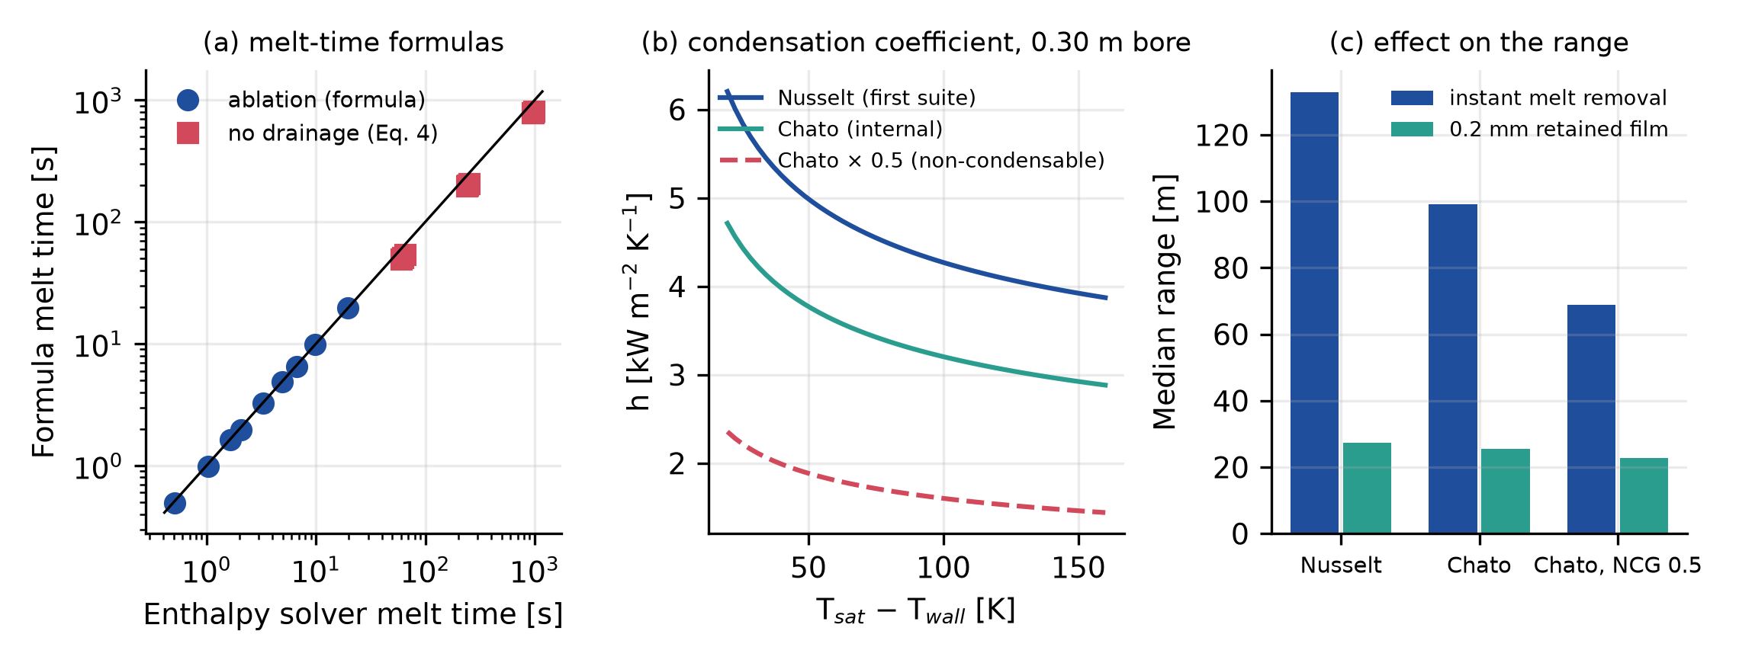
Fig. 3. (a) Melt-time formulas against the enthalpy solver (the line is equality). (b) Nusselt, Chato and noncondensable-limited condensation coefficients in a 0.30 m bore. (c) Median range for the three coefficients, instant melt removal and a 0.2 mm retained film.
No published experiment that measures steam melting a paraffin deposit in a pipe, or the coupled system, was identified in the literature consulted for this study, and the coupled model is therefore not validated. The paraffin-melting experiments that were located are enclosure experiments, for example paraffin RT58 in a horizontal cylinder, in which conduction governs at first and natural convection later, and whose results are reported as phase-front contours [25]; they do not test a conduction-limited layer heated through a condensate film, and no front-position data suitable for a quantitative comparison with Eq. (4) were found. Reviews of paraffin phase-change materials [26] are the source for the kind of property (latent heat, liquid conductivity) that the model assumes; the assumed values were not fitted to a specific wax. The benchmarks above establish that the numerical solutions are correct for the stated equations and quantify the error of the quasi-steady formulas; they do not show that the stated equations describe a real deposit, a real steam path or a real tool. The model applies as a design-screening tool for a meltable paraffin deposit of millimeter thickness on a steel wall at melt-front Stefan numbers of order one, with the steam taken at rest. Wax solids that do not melt, gel structure, the thermal inertia of the pipe steel, steam velocity and shear, and two-phase flow of the melt are outside it.
6. Results
6.1 Thermal shield
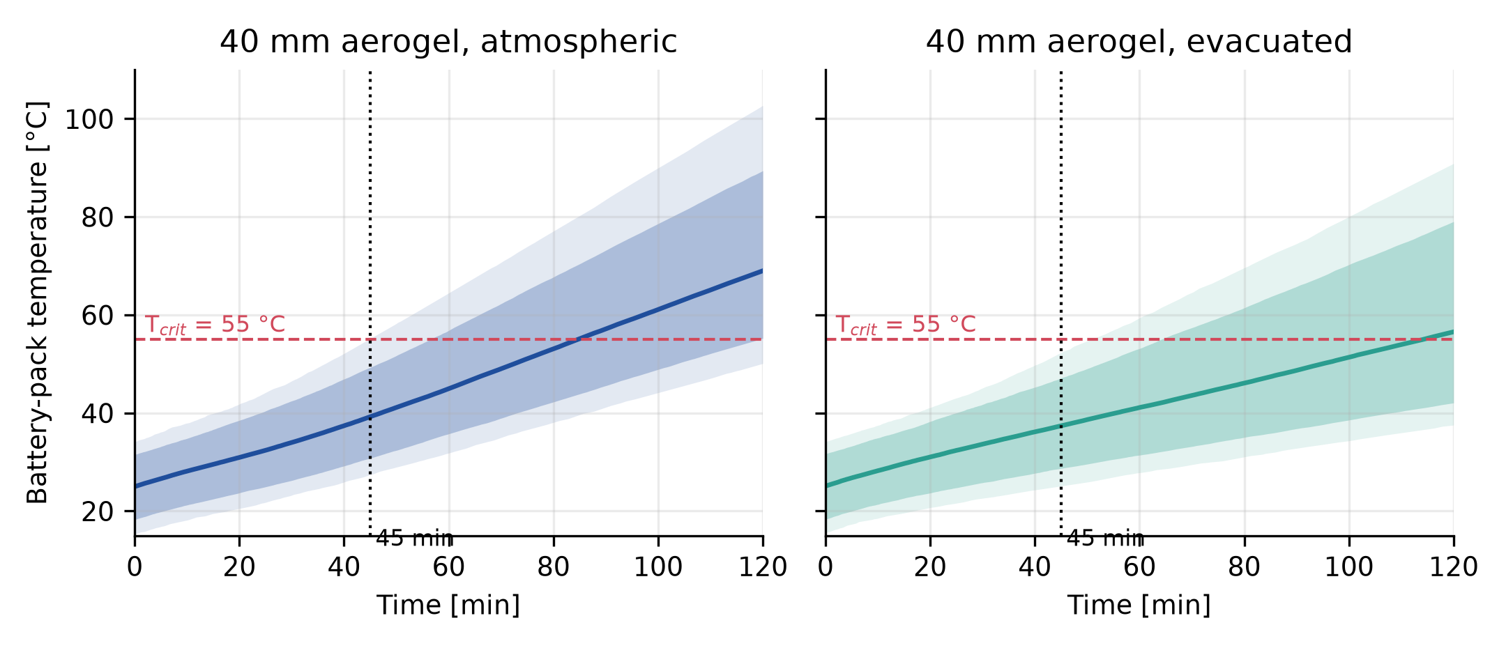
Fig. 4. Pack temperature against time for 40 mm of aerogel, atmospheric (left) and evacuated (right): median, 5–95% and 1–99% bands.
At 45 min the pack median is 39.2 °C (95th percentile 49.3 °C) with atmospheric aerogel and 37.4 °C (47.1 °C) with the evacuated jacket (Fig. 4). The probability of staying at or below 55 °C is 98.9% (95% interval 98.4–99.2%) and 99.7% (99.5–99.9%) respectively. The median time to reach 55 °C is 85 min (5th percentile 56 min) and 114 min (64 min), and 44% of the evacuated draws never reached it within the 120 min horizon. The first suite's 3,000 draws and the redrawn 3,000 of the extended suite agree (98.8% against 98.9%). The diffusion time of aerogel across 40 mm is of the order of hours, so the wall has not reached steady state within the mission and the margin belongs to the thermal mass of the pack and to the starting temperature, not to the insulation alone (Section 6.5).
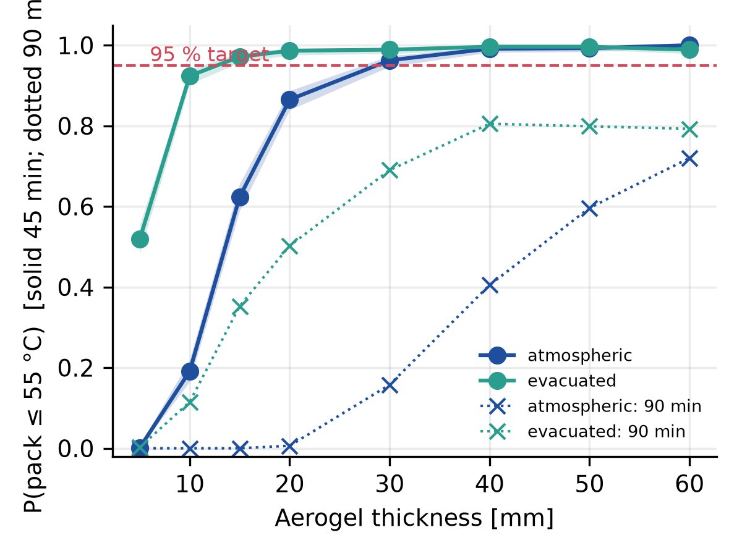
Fig. 5. Probability of meeting the 55 °C limit against aerogel thickness (solid: 45 min; dotted: 90 min).
A 95% target at 45 min requires roughly 30 mm of atmospheric aerogel (96.2%) or 15 mm of evacuated aerogel (97.1%) (Fig. 5). The evacuated curve plateaus near 99% because of the assumed 5% vacuum loss probability and the tails of initial temperature and heat generation. For a 90 min mission the probability at 40 mm falls to 40% (atmospheric) and 80% (evacuated).
6.2 Melt kinetics with instant removal of the melt, and the speed cap
With the first suite's assumption that molten deposit leaves the surface at once, the median condensation coefficient is 3.0 kW/m²·K and the film flux 413 kW/m². The melt time of a deposit has a median of 10.8 s (95th percentile 32 s). The thermally limited speed v_{th} has a median of 5.1 cm/s (5th percentile 1.5 cm/s) and is below the 10 cm/s setpoint in 83% of the draws. The median cleaned range per 45 min deployment is 138 m (5th to 95th percentile 39 to 270 m). The upper value, and every range above it, is the speed setpoint and not a thermal limit: the cap of 0.1 m/s × 2,700 s = 270 m binds in 17% of the draws, those with v_{th}≥0.10 m/s. Without the cap the thermally limited range v_{th}t_{run} has a median of 134 m, a 95th percentile of 436 m, and reaches 300 m in 13% and 1 km in 0.2% of the draws. The 270 m of the first suite is therefore an input, and the thermal result is the distribution of v_{th} (Fig. 6). The median steam use is 1.75 kg per meter (95th percentile 4.8 kg/m), about 0.18 m³ of condensate per 100 m.
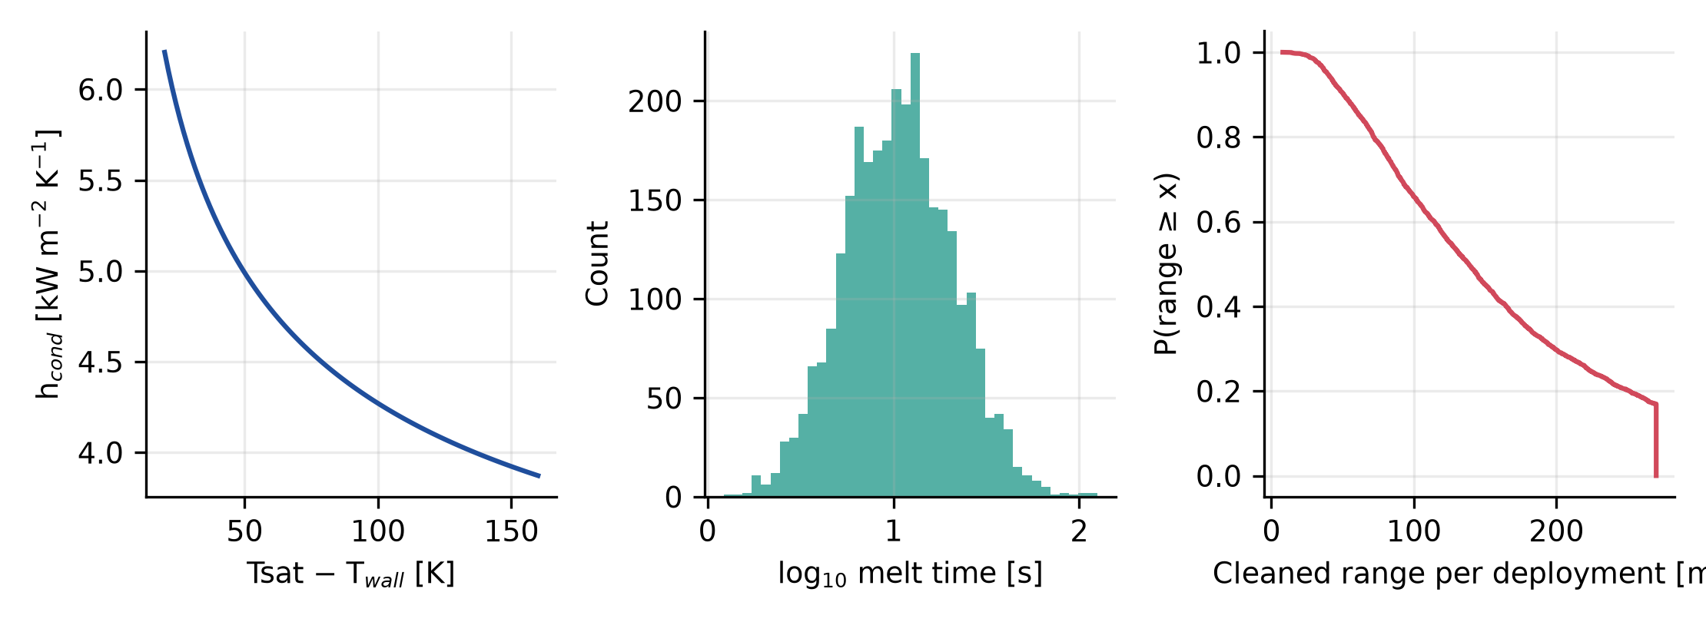
Fig. 6. Condensation coefficient against temperature difference, melt-time distribution and exceedance of the cleaned range per deployment (instant removal of the melt; the vertical step at 270 m is the speed cap).
6.3 Condensation representation
The Chato correlation gives a coefficient 0.75 of the Nusselt value (Fig. 3b), and the noncondensable limit half of that. With instant removal of the melt the median range falls from 133 m to 99 m and 69 m (Table 4), changes of 25% and 48%. With a 0.2 mm retained film the three representations give 27, 26 and 23 m: the film, with Pi_{f}=hs/k_{l}≈4.0 at the median coefficient, dominates the resistance, and the condensation model matters little. The pack probability does not change (98.9%) because the steam-side coefficient on the hull is capped at 12 kW/m²·K and the aerogel dominates the resistance by two orders of magnitude, so the hull is insensitive to the condensation model; the case that is conservative for the pack, no condensate-film resistance at all, is covered by that cap.
Representation | Median range, instant removal (m) | 5th to 95th percentile (m) | Median range, 0.2 mm film (m) | P(pack ≤ 55 °C)
Nusselt (first suite) | 133 | 39 to 270 | 27.4 | 98.9%
Chato, internal stratified | 99 | 29 to 270 | 25.6 | 98.9%
Chato, noncondensable factor 0.5 | 69 | 21 to 214 | 22.8 | 98.9%
Table 4. Effect of the condensation representation (3,000 draws, same random numbers; 45 min; 40 mm atmospheric aerogel).
6.4 The retained film: dimensionless resistance, constant film and dynamic film
Eq. (3) gives the generalization: the heat flux through a retained film is q₀/(1+Pi_{f}) with Pi_{f}=hs/k_{l}, so a film of s=k_{l}/h, 51 µm at the median coefficient, halves the flux. Because the median melt-limited speed of the first suite is only 1.4 times the 3.7 cm/s that a 100 m range needs, the median range falls below 100 m at Pi_{f}=0.34, a film of 18 µm (Table 5, Fig. 7). A range of 100 m therefore needs Pi_{f}≲0.3, and a film resistance a third of the condensate film's is enough to lose it. For a constant film the median range falls to 68 m at 0.05 mm, 27 m at 0.2 mm and 6.6 m at 1 mm. If none of the melt drains (Eq. 4), the median melt time is 629 s instead of 10.6 s, a factor 59, and the median range is 2.3 m; with the benchmark bias of Section 5.2 the true value is lower still.
s (mm) | Π_f | Median v_th (cm/s) | Median range (m) | 5th to 95th percentile (m) | P(range ≥ 100 m)
0 (instant removal) | 0.00 | 5.0 | 134 | 40 to 270 | 65%
0.05 | 0.99 | 2.5 | 67.8 | 21 to 213 | 29%
0.10 | 1.98 | 1.7 | 45.5 | 14 to 140 | 12%
0.20 | 3.95 | 1.0 | 27.4 | 8.4 to 83 | 3%
0.50 | 9.89 | 0.46 | 12.5 | 3.8 to 38 | 0%
1.00 | 19.77 | 0.24 | 6.6 | 2.0 to 20 | 0%
2.00 | 39.55 | 0.12 | 3.4 | 1.0 to 10 | 0%
5.00 | 98.86 | 0.05 | 1.4 | 0.4 to 4 | 0%
dynamic film (Eq. 5) | 6.9 | 0.66 | 17.7 | 5.8 to 52 | 0%
no drainage (limit) | – | 0.08 | 2.3 | – | 0%
Table 5. Median speed and cleaned range per 45 min deployment against the retained film (atmospheric aerogel, 40 mm; same draws in every row). Pi_{f}=hs/k_{l} at the median coefficient (for the dynamic film, at the median steady film).
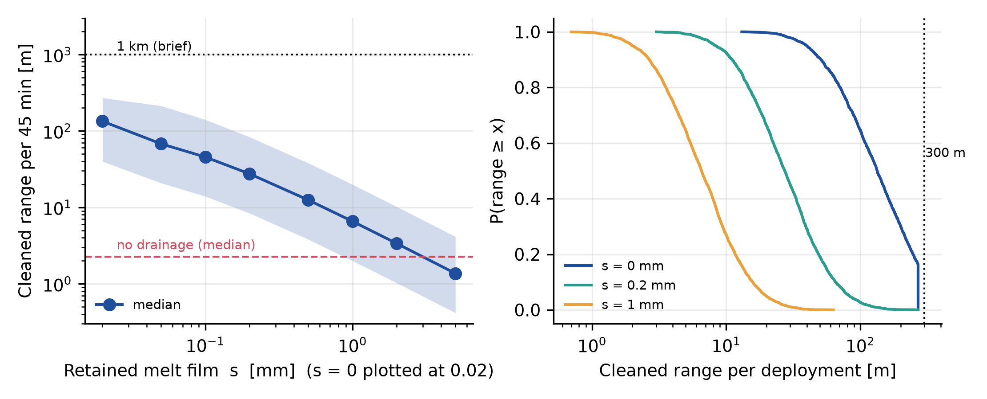
Fig. 7. (a) Cleaned range per 45 min deployment against the retained film (median and 5–95% band; dashed: no-drainage limit; dotted: 1 km). (b) Exceedance of the range for three film thicknesses.
The dynamic film (Eq. 5) predicts instead of prescribing the film. Melt production raises the film to its quasi-steady value within seconds (Fig. 8a), after which the front advances at the rate that film allows. For the median parameters the film settles at 0.35 mm (Pi_{f}=6.9, a flux reduced to 13% of the film-free value); over the draws it has a median of 0.35 mm (5th to 95th percentile 0.28 to 0.42 mm), the melt time has a median of 81 s (7.6 times the instant-removal value), and the median range is 18 m (6 to 52 m), with 0.3% of draws reaching 100 m. The prediction is the middle of the constant-film curve, close to the 0.5 mm case, and far from both limits (Fig. 8b). It depends on the drainage assumptions through the group μ_{l}ℓ: a four times lower viscosity or drain path raises the median range to 24 m, a four times higher one lowers it to 13 m, and a residual wetting film of 0.02 or 0.05 mm gives 17 and 16 m (Fig. 8c). The film is a few tenths of a millimeter because gravity drains a Nusselt film slowly at these viscosities: the cubic law makes the steady film scale as (μ_{l}ℓ ẋ)^{1/3}, so even large changes of the drainage parameters move it by tens of percent. The drainage model is assumed, not measured, and a molten pool at the invert is outside it; the result that the range is of order 10 m and not 100 m holds across this sensitivity.
Three idealizations of the drainage model were examined. Wall orientation: the film drains by gravity along the wall between the crown and the invert, and the mean sinθ of 0.7 stands for that path; for a wall near the invert (sinθ=0.2) the median range is 13 m and for the spring line (sinθ=1) 19 m, so orientation moves the result by a quarter. Steam shear: an interfacial shear τ adds a film flux τs²/2μ_{l}. Gravity exerts a stress of about 1.9 Pa on the median film, whereas the steam that condensation alone feeds into the zone moves at about 0.19 m/s and produces a shear of order 10⁻³ Pa, negligible; shears of 0.1, 1 and 10 Pa need steam velocities of about 1.6, 5 and 16 m/s (friction factor 0.01, assumed) and raise the median range to 18, 21 and 33 m. A forced steam flow through the zone could therefore help, but only at velocities far above those that condensation induces, and the interfacial shear on a viscous film is uncertain. Molten pool: the melt collects as a pool at the invert, ahead of the skirt. Where the pool covers the deposit it behaves as a layer that does not drain, and the range of that sector approaches the no-drainage limit (2.3 m) unless the skirt moves the pool ahead of the tool; since the whole circumference has to be cleaned, the dynamic-film value (18 m) is an upper bound for a tool whose pool covers part of the circumference, and the true median lies between it and the no-drainage limit. The pool and the shear are not modeled explicitly, and the range of 18 m is therefore a screening value with the sensitivity shown, not a prediction.
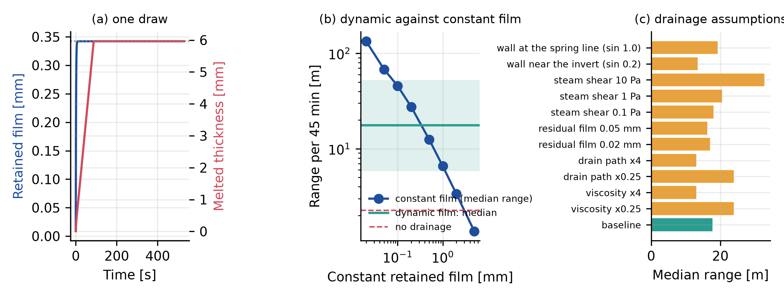
Fig. 8. Dynamic retained film. (a) Film thickness and melted thickness for one draw. (b) Median range of the dynamic model (band: 5–95%) against the constant-film curve and the no-drainage limit. (c) Median range for the drainage sensitivity cases.
6.5 Global sensitivity, correlated inputs and model-form uncertainty
Sobol indices (Fig. 9; 2⁹ base samples for the pack, 2¹³ for the melt model; bootstrap intervals in the Supplementary Information) show that the pack temperature at 45 min is governed by two inputs, the total indices being initial temperature (0.49), internal heat generation (0.48); the first-order indices sum to 1.00, so the response is nearly additive. The range, with the retained film as an assumed lognormal input (median 0.2 mm, σ=1), is governed by retained film (0.55), deposit thickness (0.24), heat-coupling fraction (0.11); the film alone carries 55% of the variance. With instant removal the ranking is deposit thickness (0.48), heat-coupling fraction (0.23), contact length (0.16). The melting steam per meter depends on the deposit and the heat-coupling fraction (deposit thickness (0.65), heat-coupling fraction (0.29)) and not on the film, because the film changes the speed and not the energy. The indices depend on the assumed input distributions, in particular on the film prior, and are conditional on them. Sampling adequacy was checked by halving the base sample: the total indices of the melt model change by at most 0.001 and those of the pack by at most 0.016, the half-widths of the 95% bootstrap intervals are at most 0.018 (melt model) and 0.062 (pack), and the ranking of the leading inputs does not change.
Physically plausible correlations were imposed through a Gaussian copula. A positive correlation of 0.6 between the starting temperature and the heat generation (a hot, heavily loaded tool) lowers the thermal probability from 99.1% to 97.4%, and a negative one raises it to 99.8%; a correlation of ±0.6 between the deposit thickness and its melt point changes the median range by less than 0.5%. The thermal conclusion is therefore sensitive to the correlation of the two dominant inputs, not to the others. The two kinds of uncertainty differ greatly in size. Within the instant-removal model the 5th to 95th percentile of the range spans a factor of 7 (39 to 270 m) from parameter uncertainty alone. Across the model forms studied, the median range spans 2.3 to 133 m, a factor of 59, from the condensation correlation, the melt-removal model and the film treatment. The choice of model form is a larger source of uncertainty than the parameters within a model, which is why the claims below are stated against the model form.
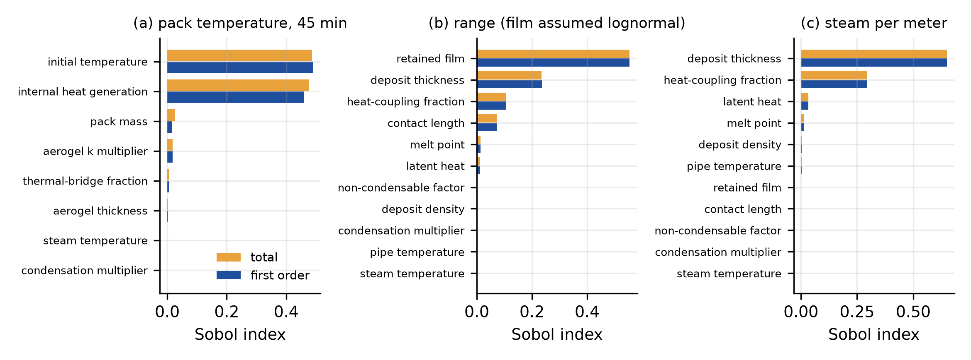
Fig. 9. Sobol indices (total and first order) of (a) the pack temperature at 45 min, (b) the cleaned range with the retained film as an assumed lognormal input, and (c) the melting steam per meter.
6.6 Pipe length, deployments and intervention time
The brief names pipes from about 0.3 m to 1 km. The number of deployments depends decisively on the melt-removal assumption, and the two cases must not be mixed (Table 6, Fig. 10). With instant removal of the melt the median range is 138 m per deployment, and a 1 km line needs a median of 8 deployments (95th percentile 26); with the dynamic film, the baseline of this paper, the median range is 18 m and a 1 km line needs a median of 57 deployments (5th to 95th percentile 20 to 172), in agreement with the simple estimate of 1,000 m divided by the median range, 56. With a 0.5 mm constant film it needs 81 and if no melt drains 442. Under the assumed logistics durations (Table 2) the total intervention time for 1 km has a median of 31 h with instant removal (5.6 h of active cleaning, 18%) and 164 h with the dynamic film (5th to 95th percentile 58 to 480 h; 42 h active, 25%). A 90 min evacuated mission needs 30 deployments with the dynamic film. No draw cleans a 300 m line in one deployment (the 270 m of a 45 min mission is the setpoint cap, Section 6.2; with a higher setpoint the thermally limited speed with instant removal would allow 300 m in 13% of the draws), and with the dynamic film the largest range in any draw is 163 m. The absolute hours depend on assumed durations, but the ratio does not: most of the intervention is not cleaning. Every extra deployment also requires that the tool is recovered through the same flow-aligned connection by which it entered, which the brief states as the only access; the model does not include recovery or the passage of the tool through bends, valves and diameter changes.
Mission | Melt removal | L (m) | P(one deployment) | Deployments | Active (h) | Total (h) | Active share
45 min, atmospheric | instant removal | 100 | 65% | 1 (3) | 0.6 | 13 | 5%
45 min, atmospheric | instant removal | 300 | 0% | 3 (8) | 1.7 | 17 | 10%
45 min, atmospheric | instant removal | 1,000 | 0% | 8 (26) | 5.6 | 31 | 18%
45 min, atmospheric | 0.5 mm film | 100 | 0% | 9 (27) | 6.0 | 32 | 18%
45 min, atmospheric | 0.5 mm film | 300 | 0% | 25 (79) | 18.0 | 75 | 23%
45 min, atmospheric | 0.5 mm film | 1,000 | 0% | 81 (263) | 60.0 | 227 | 26%
90 min, evacuated | instant removal | 100 | 89% | 1 (2) | 0.6 | 12 | 5%
90 min, evacuated | instant removal | 300 | 41% | 2 (5) | 1.7 | 15 | 12%
90 min, evacuated | instant removal | 1,000 | 0% | 4 (14) | 5.6 | 24 | 23%
90 min, evacuated | 0.5 mm film | 100 | 2% | 5 (14) | 6.0 | 25 | 24%
90 min, evacuated | 0.5 mm film | 300 | 0% | 13 (42) | 18.1 | 53 | 33%
90 min, evacuated | 0.5 mm film | 1,000 | 0% | 43 (140) | 60.2 | 153 | 38%
45 min, atmospheric | dynamic film | 100 | 0% | 6 (18) | 4.2 | 26 | 16%
45 min, atmospheric | dynamic film | 300 | 0% | 17 (52) | 12.7 | 57 | 22%
45 min, atmospheric | dynamic film | 1,000 | 0% | 57 (172) | 42.2 | 164 | 25%
90 min, evacuated | dynamic film | 100 | 5% | 3 (10) | 4.2 | 21 | 20%
90 min, evacuated | dynamic film | 300 | 0% | 9 (28) | 12.7 | 41 | 31%
90 min, evacuated | dynamic film | 1,000 | 0% | 30 (93) | 42.2 | 112 | 37%
Table 6. Deployments and time to clean a line of length L (median; 95th percentile of the deployment count in parentheses). Durations of the noncleaning stages are assumed (Table 2).
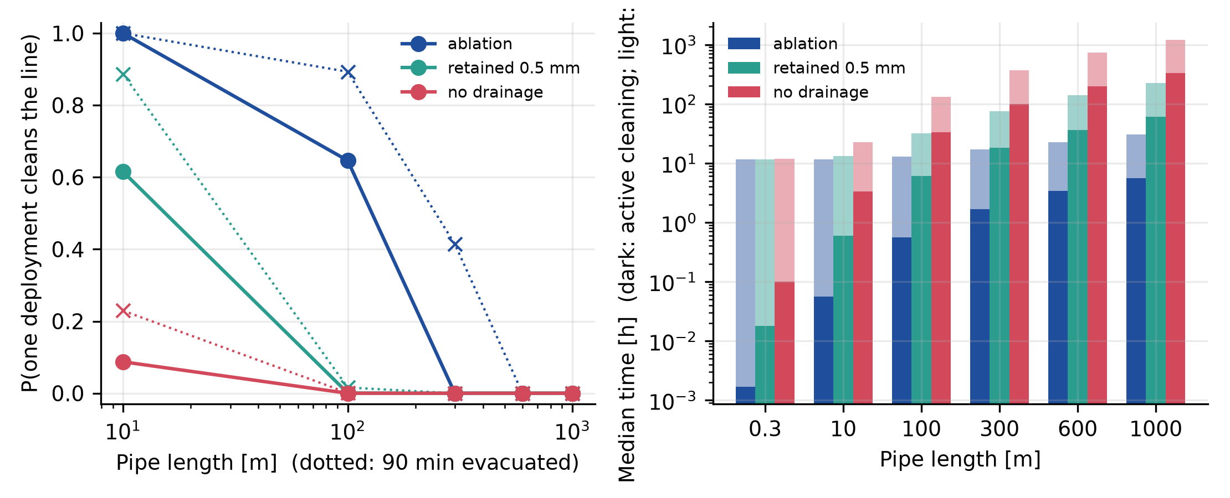
Fig. 10. (a) Probability that one deployment cleans a line against its length for three melt-removal cases (solid: 45 min atmospheric; dotted: 90 min evacuated). (b) Median active cleaning time (dark) and total intervention time (light), 45 min atmospheric.
6.7 Pipe size, pipe temperature and the feasible envelope
The brief covers 4 to 16 inches; the first design was sized for 12 in. Keeping the radial clearance of the first design (44 mm), the hull does not fit in a 4 or 6 in pipe, even with the aerogel removed down to a 25 mm pack. In an 8 in pipe the aerogel shrinks to 24 mm and the pack to 2.8 kg, and the probability of keeping the pack at or below 55 °C for 45 min is 0% (5% evacuated); in a 10 in pipe it is 42% (50% evacuated); from 12 in upward it is 99% (Table 7). The thermal margin therefore scales with the thermal mass of the pack, and the architecture as modeled covers about the upper third of the brief's diameter range. The surge force of a 3 bar breakthrough grows with the bore, from 10 kN (8 in) to 35 kN (16 in), against the same 2.5 kN of braking authority.
NPS (in) | Bore (mm) | Hull OD fitted (mm) | Aerogel (mm) | Pack (kg) | P(≤ 55 °C) atm. | P(≤ 55 °C) evac. | Force at 3 bar (kN) | Force / braking
4 | 102 | – | does not fit | – | – | – | 2.5 | 1.0
6 | 154 | 65 | does not fit | – | – | – | 5.6 | 2.2
8 | 203 | 114 | 24 | 2.8 | 0% | 5% | 9.7 | 3.9
10 | 254 | 166 | 40 | 5.4 | 42% | 50% | 15.3 | 6.1
12 | 305 | 216 | 40 | 16.0 | 99% | 99% | 21.9 | 8.8
16 | 387 | 298 | 40 | 16.0 | 99% | 99% | 35.4 | 14.1
Table 7. Fit and thermal margin against nominal pipe size (standard wall; 45 min; 40 mm aerogel where it fits).
The pack starts at the pipe temperature, which is the dominant input (Section 6.5). Shifting the initial pack and pipe temperature with the same draws, the probability for the 12 in design falls from 99% at 25 °C to 84% at 35 °C, 22% at 45 °C and 0% at 55 °C (atmospheric; evacuated 100%, 90%, 36% and 0%), while the median range changes little (133 m at 25 °C, 102 m at 45 °C) until the pack limit is reached early (Fig. 11). Fig. 12 combines the two: a probability of at least 95% requires a pipe of 12 in or larger and a pipe temperature of about 30 °C or below, and no size in the brief's range is reliable at 40 °C. A line that still carries warm produced fluid, for example at 40 to 60 °C, must therefore be cooled and flushed before the tool enters, which is a preparation step that the intervention time of Table 6 only partly includes.
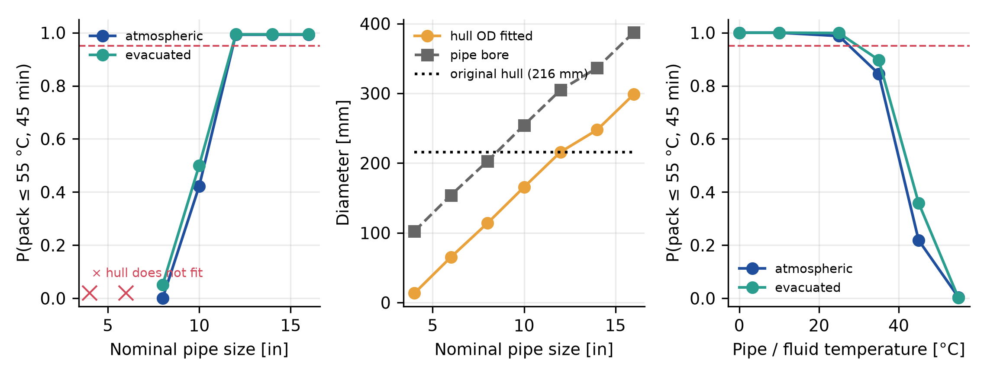
Fig. 11. (a) Probability of keeping the pack at or below 55 °C for 45 min against nominal pipe size (crosses: the hull does not fit). (b) Fitted hull diameter, pipe bore and the first design's hull. (c) The same probability against pipe temperature, 12 in design.
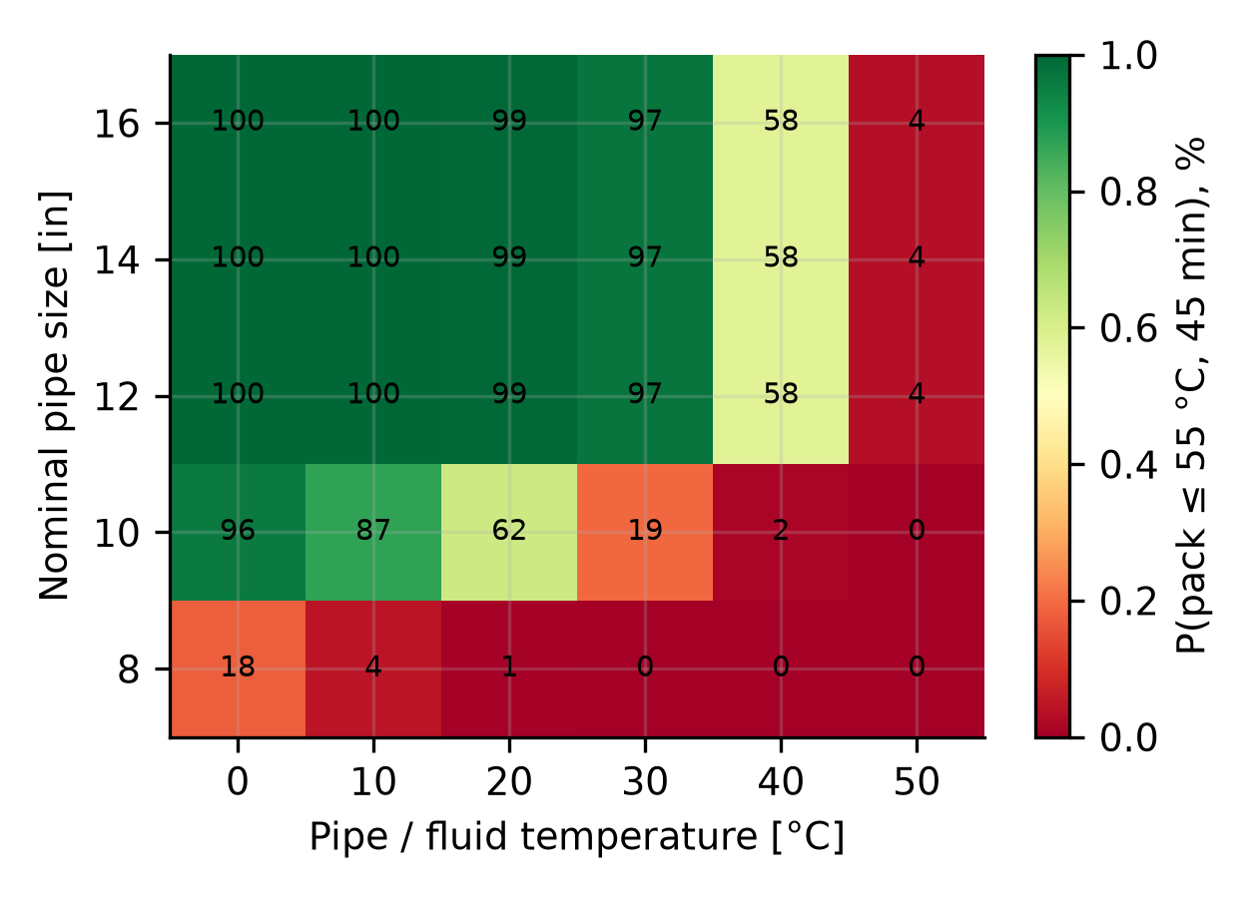
Fig. 12. Feasible envelope: probability (%) of keeping the pack at or below 55 °C for 45 min against nominal pipe size and pipe temperature (atmospheric aerogel, 40 mm where it fits; 400 draws per cell).
6.8 Pressure–temperature compatibility and the revised envelope
The first design used saturated steam at 198 °C, whose pressure is 14.9 bar. The rated working pressure of a Group 1.1 carbon-steel flange of Class 150 falls with temperature to about 13.8 bar at 200 °C [27], so the model's operating point exceeds it (Table 8, Fig. 13). The highest saturation temperature whose pressure is within the Class 150 rating is 195 °C (14.0 bar); Class 300 would admit the whole range studied. The rated values used are rounded approximations of the standard's tables; the governing ratings must be taken from the current edition and the actual line specification. A revised operating envelope for a Class 150 line is saturated steam at 192 °C, 3 °C below the limit. The check covers the whole sampled steam-temperature distribution, not its mean: in the first design 83% of the sampled temperatures (maximum 204 °C) exceed the limit. With the steam temperature redrawn as N(192, 2) °C truncated at the limit (maximum sampled value 194.7 °C, none above it) the median melt time rises from 10.8 to 11.2 s, the median range falls from 132 to 128 m (3%) and the pack probability is unchanged (99.0%), because the aerogel, not the steam film, controls the heat reaching the pack. The pressure limit is therefore a constraint on the design, not a reason to reject it, provided the line is Class 150 or better at the temperature and the seals and elastomers are rated for it; a line of lower rating would need a lower steam temperature and a rerun of the study.
Temperature (°C) | Saturation pressure (bar) | Class 150 rating (bar) | Class 300 rating (bar)
150 | 4.8 | 15.8 | 45.1
170 | 7.9 | 15.0 | 44.6
180 | 10.0 | 14.6 | 44.3
190 | 12.6 | 14.2 | 44.1
195 | 14.0 | 14.0 | 43.9
200 | 15.5 | 13.8 | 43.8
205 | 17.2 | 13.6 | 43.6
Table 8. Saturation pressure of steam against approximate rated working pressure of Group 1.1 carbon-steel flanges (bar; rounded; verify against the current edition).
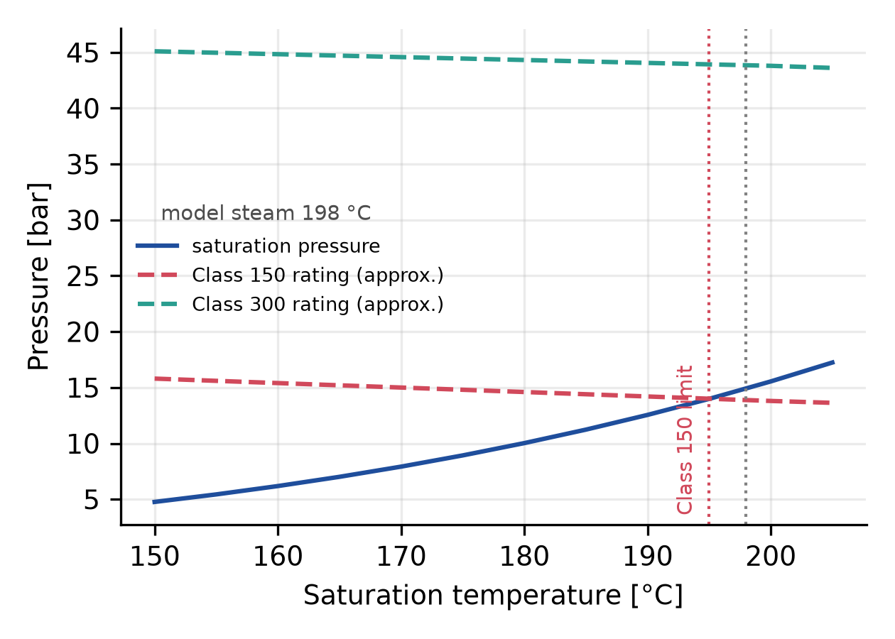
Fig. 13. Saturation pressure of steam (IAPWS-IF97) against the approximate pressure ratings of Class 150 and Class 300 flanges; dotted lines: the model's 198 °C and the Class 150 limit.
6.9 Constrained design search and Pareto set
The constrained problem of Eq. (9) was evaluated on a grid of 240 designs for each melt-removal assumption (aerogel 10–60 mm, two jackets, missions of 30, 45, 60 and 90 min, setpoints of 0.05, 0.10 and 0.20 m/s). The hull constraint removes the thicknesses above 40 mm in a 12 in bore and the thermal constraint removes the thinner and the longer-mission designs; 75 designs are feasible with instant removal and 75 with the dynamic film. With instant removal the best feasible design is a 40 mm evacuated jacket on a 60 min mission at 0.10 m/s, with a median range of 178 m (Table 9). With the dynamic film the feasible designs span only 12 to 24 m, the best is 24 m, and the setpoint does not matter because the thermally limited speed is below it. The Pareto set (16 and 36 designs; Fig. 14) is a trade between the range, the thermal probability and the hull size; the melting steam per meter is a property of the deposit and varies by only a few percent across the designs, so it does not trade off against them. The conclusion is that no choice of the thermal-protection variables restores the range lost to the film: the range is bounded by the melt model, not by the design variables.
Melt removal | Mission (min) | Jacket | Aerogel (mm) | Setpoint (m/s) | Hull OD (mm) | P(≤ 55 °C) | Median range (m) | Steam (kg/m) | Energy (Wh)
instant removal | 30 | atmospheric | 25 | 0.10 | 186 | 99.9% | 89.2 | 1.77 | 35
instant removal | 45 | atmospheric | 40 | 0.10 | 216 | 99.1% | 133.7 | 1.77 | 53
instant removal | 60 | evacuated | 40 | 0.10 | 216 | 97.0% | 177.7 | 1.77 | 69
dynamic film | 30 | atmospheric | 20 | 0.05 | 176 | 99.8% | 11.8 | 1.73 | 35
dynamic film | 45 | evacuated | 35 | 0.05 | 206 | 99.5% | 17.8 | 1.73 | 52
dynamic film | 60 | evacuated | 40 | 0.05 | 216 | 97.0% | 23.6 | 1.73 | 69
Table 9. Best feasible design for each mission length (constraints of Eq. 9; median range, melting steam per meter and battery energy at the median heat generation).
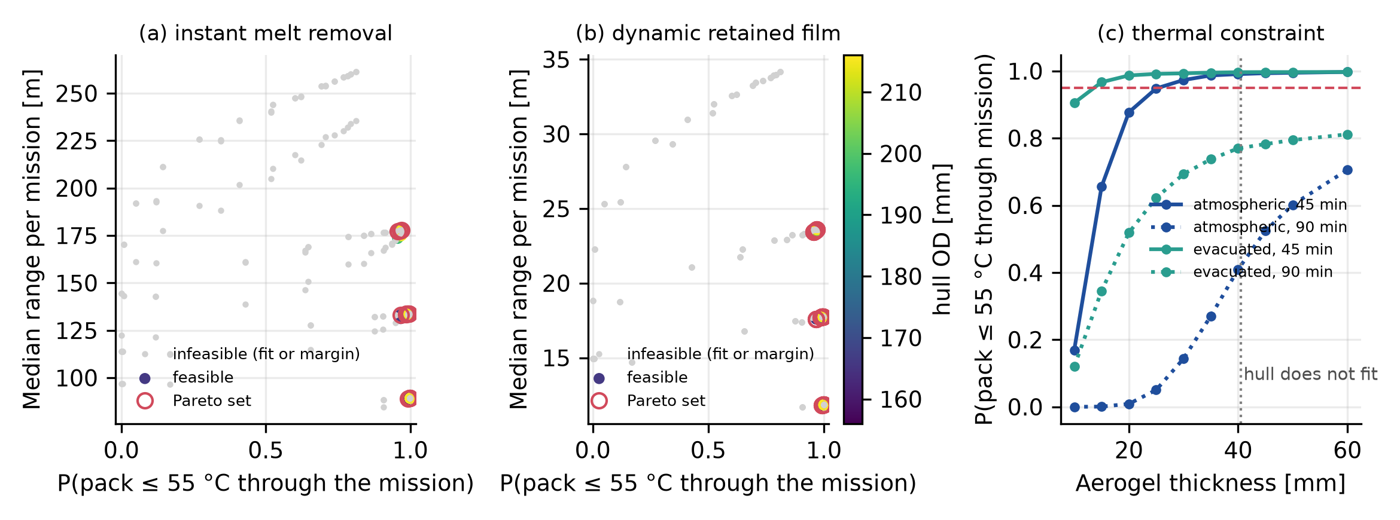
Fig. 14. Design search: median range against the thermal probability for (a) instant melt removal and (b) the dynamic film (color: hull diameter; circles: Pareto set; gray: infeasible). (c) The thermal constraint against aerogel thickness.
6.10 Surge on blockage release
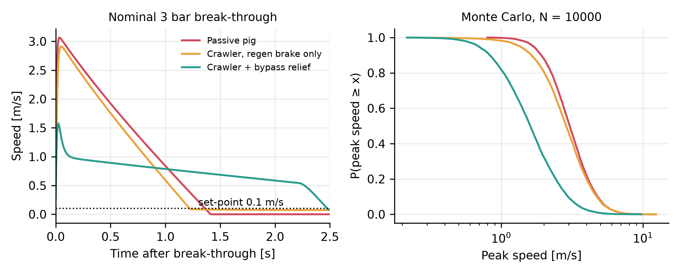
Fig. 15. Speed transient for a nominal 3 bar breakthrough (left) and Monte Carlo exceedance of the peak speed (right), first suite.
In the first suite the pressure force of a 3 bar breakthrough on a 12 in bore, A ΔP ≈ 21 kN, exceeds the 2.5 kN braking authority by about a factor of nine, so braking alone changes the median peak speed only from 3.0 to 2.9 m/s (Table 10, Fig. 15). Treating the bypass relief as a force factor β, the median peak falls to 1.6 m/s. Venting the gas pocket through an orifice (Eq. 7) gives a smaller benefit: with 80 cm² of bypass area, 11% of the bore, the median peak is 2.5 m/s, and even with 320 cm², 45% of the bore, it is 2.1 m/s with 53% of the releases above 2 m/s, against 32% in the force-factor model. The reason is a mismatch of time scales. The tool reaches 1 m/s in 6 ms (5th percentile 2 ms), whereas a fully open bypass of 80 cm² needs 64 ms to halve the differential across a 1 m³ pocket (19 ms for 0.3 m³, 635 ms for 10 m³), and a valve lag of 5 to 30 ms adds to that. The relief therefore limits the duration of the surge, bringing the speed back to the setpoint within about 0.3 s for 80 cm² (Fig. 16b), but not its first peak. A bypass that is closed until the differential reaches the breakthrough value cannot arrest the impulse. The design alternative is a bypass that is already open during the stall, so that the pocket never charges: it holds a differential of 0.5 bar at 18 bar upstream if its area passes the supply flow, which requires 5 cm² for 0.03 m³/s, 16 cm² for 0.1 m³/s and 47 cm² for 0.3 m³/s (assumed methane-like gas; Fig. 16a). The price is that the differential that melts or breaks the deposit is then limited as well, so the deposit must be freed thermally rather than by pressure.
Configuration | Median peak (m/s) | P(> 1 m/s) | P(> 2 m/s) | Model
Passive pig | 3.04 | 100% | 88% | first suite
Crawler, braking only | 2.87 | 98% | 81% | first suite
Crawler + relief as force factor β | 1.60 | 82% | 32% | first suite
Crawler + orifice bypass 10 cm² | 2.80 | 98% | 78% | this paper
Crawler + orifice bypass 20 cm² | 2.75 | 97% | 77% | this paper
Crawler + orifice bypass 40 cm² | 2.67 | 96% | 73% | this paper
Crawler + orifice bypass 80 cm² | 2.54 | 94% | 69% | this paper
Crawler + orifice bypass 160 cm² | 2.34 | 91% | 62% | this paper
Crawler + orifice bypass 320 cm² | 2.08 | 86% | 53% | this paper
Table 10. Peak speed after breakthrough (12 in bore; same draws; N = 10,000).
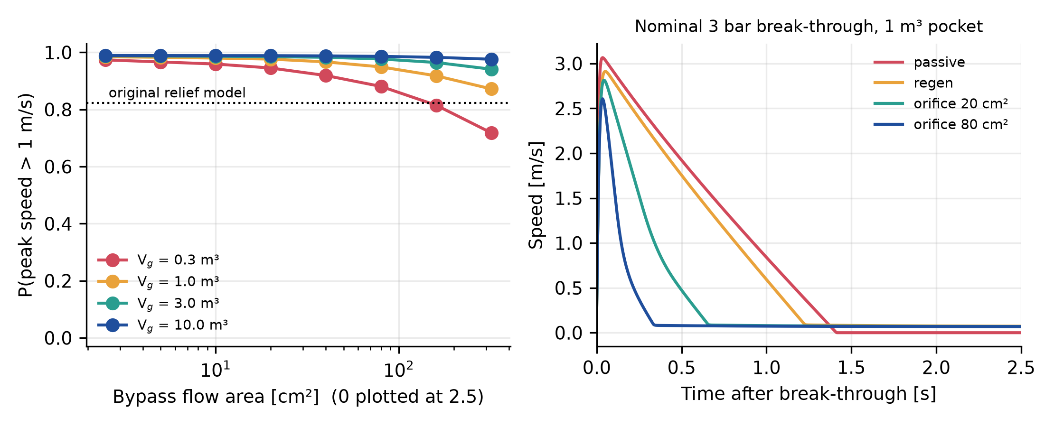
Fig. 16. (a) Probability of a peak speed above 1 m/s against the bypass area for four gas-pocket volumes (dotted: the first suite's force-factor model). (b) Speed after a nominal 3 bar breakthrough with a 1 m³ pocket.
6.11 Steam budget
Melting the deposit uses a median of 1.79 kg of steam per meter in a 12 in pipe (first suite). If the steam reaches the tool through the pipe behind it, the steel wall of the whole line must also be heated from 25 °C to the saturation temperature: for standard-wall 12 in pipe of 74 kg/m this takes 3.2 kg of steam per meter, 1.8 times the melting steam, and the total is 5.0 kg/m, or about 5.0 t of steam (and of condensate) for a 1 km line, against the 1.8 t that the melting alone would suggest (Table 11, Fig. 17). A pipe at 0 °C needs 3.7 kg/m for the wall. The wall-heating term is a lower bound, because it ignores heat lost from the pipe to its surroundings during the intervention. A steam hose carried inside the pipe avoids heating the wall but adds tether drag over up to 1 km and a second line at the steam temperature to the tool. Either way the water use is larger than the melting alone suggests, which matters because reduced water use is one of the brief's nice-to-have criteria.
NPS (in) | Steel (kg/m) | Melting (kg/m) | Wall heating (kg/m) | Total (kg/m) | Wall heating from 0 °C (kg/m)
4 | 16 | 0.64 | 0.70 | 1.34 | 0.80
6 | 28 | 0.93 | 1.23 | 2.17 | 1.41
8 | 43 | 1.21 | 1.86 | 3.07 | 2.13
10 | 60 | 1.51 | 2.63 | 4.14 | 3.01
12 | 74 | 1.79 | 3.23 | 5.02 | 3.69
14 | 81 | 1.97 | 3.55 | 5.52 | 4.07
16 | 93 | 2.25 | 4.07 | 6.33 | 4.66
Table 11. Steam per meter of line: melting (median) and heating the pipe wall (standard wall, 25 °C start; last column 0 °C start).
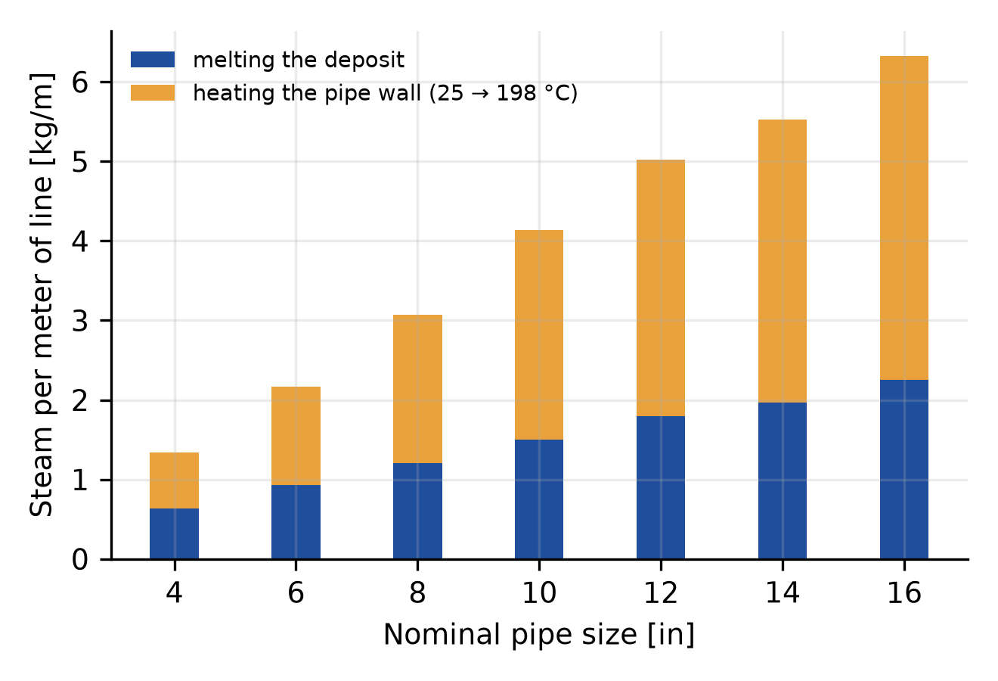
Fig. 17. Steam per meter of line against nominal pipe size: melting the deposit and heating the pipe wall.
7. Discussion
7.1 A regime map for thermal cleaning with a retained melt film
The crawler is the application; the transferable result is the role of the dimensionless group Pi_{f}=hs/k_{l}. For Pi_{f}≪1 the melt leaves the surface, the heat flux is that of the condensate film, and the speed is set by the energy needed to melt the deposit (here 138 m per 45 min, capped by the setpoint in 17% of draws). For Pi_{f}≳1 the liquid layer controls the flux, the speed falls as 1/(1+Pi_{f}), and the condensation correlation becomes irrelevant (Section 6.3). The dynamic balance of Eq. (5) places the median draw at Pi_{f}≈6.9, well inside the second regime, because gravity drains a viscous film slowly; a range of 100 m needs Pi_{f}≲0.3. Any thermal cleaning concept in which molten deposit must leave a surface that the heat reaches through that deposit is in this situation, and the retained film, not the heat source, is what a test should measure. The group can be reduced only by removing the melt as it forms: by mechanical scraping at the melt front, by a flow that shears the film, or by orienting the heating so that the melt falls away. These are design features the present model does not contain and the proposed bench test (Section 7.2) would evaluate.
7.2 What the concept has to demonstrate
The brief states six must-have requirements [8]. Table 12 sets what this study can and cannot say about each. The strongest statement is negative and quantitative: with the assumptions of the first design, the concept does not by itself meet the length, diameter, temperature and access conditions of the brief, and its reach is governed by a quantity, the retained melt film, that nobody has measured. The strongest positive statement is narrower: for a 12 in pipe at 25 °C, 40 mm of aerogel keeps the pack below 55 °C for 45 min in 99% of the draws under the assumed distributions, so the thermal shield is not the first obstacle, provided the pipe is cool. The measurements that would change the conclusion most, in order, are: the retained film and the heat flux when condensing steam melts paraffin of known melting point on a steel wall (it decides whether the range is of order 10 m or 100 m); the thermal soak of a sealed aerogel module with a dissipating pack in saturated steam at several starting temperatures (it replaces the assumed heat generation and bridge conductance); a steam-delivery test in a short pipe loop (condensate and wall-heating mass per meter); a bypass and seal rig for the stall and release, with the valve open before the stall; and the characterization of the deposits that a line actually contains, in particular the fraction that does not melt.
Requirement | What the simulation shows | What is missing
Effective removal, with evidence and limits | Range per 45 min deployment: 138 m (instant melt removal), 18 m (dynamic film), 2.3 m (no drainage); the film decides | Measured melt removal on steel; deposit composition (solid fraction); scale and sediment are not melted
Compatibility with operating conditions, connections and recovery | No single 45 min deployment reaches 300 m at the setpoint; a 1 km line needs a median of 57 deployments with the dynamic film (8 with instant removal); hull does not fit below 8 in | A tool-recovery route through a flow-aligned connection; steam path; bends, valves and diameter changes
Operational safety and integrity | Surge peak not arrested by a bypass closed at the stall (tool at 1 m/s in 6 ms); pack margin falls above 35 °C; steam at 198 °C exceeds the Class 150 rating, revised envelope 192 °C | Explosive-atmosphere protection, seal elastomers in hydrocarbon and steam, cell-level battery analysis, stalled-tool recovery
Limited disruption, with a full timeline | Active cleaning is 10% to 18% of the intervention (assumed logistics); steam is 5.0 kg/m including the wall | Real preparation, isolation and return-to-service durations
Detailed proof-of-concept plan | Section 7.2 lists the tests, in order of how much each one changes the answer | Costs and schedule are not estimated here
Credibility of the solver | Computational study only; the author is an independent researcher with no hardware or field experience in pipeline cleaning | A partner with pipeline-intervention experience
Table 12. Requirements of the published brief [8] and the evidence of this study.
7.3 Safety, condensate and recovery
Three engineering conditions that the thermal model does not contain are part of the feasibility envelope. (i) Pressure: the steam temperature must be compatible with the pressure rating of the line, flanges, seals and elastomers; at Class 150 the limit is about 195 °C (Section 6.8), and a lower-rated line, a vacuum-jacket seal or a hydrocarbon-swollen elastomer would lower it further. (ii) Explosive atmosphere: electrical equipment in a hydrocarbon line needs a protection concept suitable for the zone [10], which for a sealed pressure vessel means certified enclosures, cable entries and battery, and a purge of the line before steam is admitted so that the steam does not meet an explosive mixture. (iii) Condensate and residue: melting and wall heating produce about 5.0 m³ of condensate per kilometer in a 12 in line, mixed with molten deposit and hydrocarbon, which must be collected and separated at the connection through which the tool is recovered, and treated as contaminated material. A stalled tool is the principal recovery case: at a residual differential of 0.5 bar on a 12 in bore the force to pull it back is about 3.9 kN including seal friction, which needs a tether or a reverse differential across the skirt, and a bypass that is open during the stall (Section 6.10) both reduces that force and prevents the surge on release.
7.4 Comparison with ice-slurry pigging
The brief names ice-slurry pigging as of particular interest [8]. Table 13 compares it, concisely, with the steam crawler. In ice pigging a slurry of ice crystals in a carrier liquid is pumped through the line and removes deposit by scouring [6,7]; the slurry leaves at the downstream end and melts, so no tool has to be launched or recovered and the access can be the flow-aligned connection. The steam crawler melts the deposit but has to be inserted and recovered through that connection, and its range per deployment is limited (Section 6.6). For the energy demand, a first-order bound for a 12 in line (0.073 m³ per meter) is that making the slurry takes the latent heat of the ice (334 kJ/kg) and cooling of the carrier water from 15 °C: for a slurry volume of 10%, 30% and 100% of the line volume at an ice fraction of 10% or 30%, 0.6 to 9.9 MJ of cooling per meter of line, or 0.3 to 4.0 MJ of electricity at a refrigeration coefficient of performance of 2.5 (assumed). The steam route of this paper needs, from 15 °C feed water, 4.9 MJ per meter for melting alone and 14 MJ per meter including the pipe wall. The ice route is thus comparable to or lower in energy even if a full line volume of slurry is used, and far lower for a partial volume; but the slurry volume needed to clean a given deposit is not known here, and the energy ranking says nothing about effectiveness. The comparison is qualitative apart from this arithmetic; ice pigging is not modeled, and no ranking is claimed.
Aspect | Steam-assisted crawler (this study) | Ice-slurry pigging
Access and recovery | inserted and recovered through the flow-aligned connection; steam line or hose through it; launch and recovery not designed | slurry pumped through the connection and leaves at the downstream end; no tool to recover
Mechanism on paraffin | melts the deposit; range set by the retained melt film (about 18 m per 45 min, dynamic film) | scouring by the slurry; a cold carrier does not melt wax, and its effect on hard or waxy deposit has to be established
Energy per meter of 12 in line | 4.9 MJ melting alone; 14 MJ with pipe-wall heating (thermal, from 15 °C feed water) | 0.6 to 9.9 MJ cooling (0.3 to 4.0 MJ electric) for 10% to 100% of the line volume as slurry
Water use and waste | condensate 1.8 to 5.0 kg per meter, contaminated | water-based slurry volume set by the fraction of the line filled; contaminated residue at the outlet
Operating constraints | steam pressure against the line rating (Class 150: about 195 °C); pipe temperature below about 30 °C; explosive-atmosphere equipment; hull does not fit below 8 in | cold water in gas or hydrocarbon lines (hydrate and water-handling risk, not assessed here); outlet handling of slurry and residue
Readiness | concept, technology readiness level 2 to 3 | established in water-supply and process applications [7]; suitability for the lines of the brief to be shown
Table 13. Concise comparison of the steam crawler with ice-slurry pigging (ice-slurry entries are general characteristics from the cited literature and the arithmetic above, not results of this study).
7.5 Limitations
(i) All inputs are assumed, and the retained-film drainage parameters, the liquid conductivity, the heat-coupling fraction and the logistics durations are the least constrained. (ii) The coupled model is not validated against experiment; the benchmarks of Section 5.2 verify the numerical solutions and quantify the error of the quasi-steady formulas. (iii) The conduction model is radial; axial conduction, end caps and track mounts enter through a bridge fraction. (iv) The condensation correlations are used outside their derivation ranges and the steam is taken at rest; the effect of steam shear and of a defined steam path is not modeled. (v) The surge model is reduced-order: a gas pocket vented to a constant downstream pressure, with a quadratic drag standing for the compressibility downstream; liquid-filled lines, which would surge differently, are not modeled, and no safe speed is justified. (vi) The pack is lumped, with no cell-level thermal runaway analysis. (vii) The steam delivery path, the recovery of the tool, bends, valves and diameter changes are not modeled. (viii) Deposits are meltable paraffin only. (ix) Ice-slurry pigging is compared only qualitatively and by first-order energy arithmetic (Section 7.4). (x) The drainage idealizations (orientation, steam shear, molten pool) are bounded by sensitivity runs, not modeled in detail (Section 6.4). The results are a design-screening tool and not a validated prediction.
8. Conclusions
1. Heat transfer through a retained melt film governs the reach. The film adds the dimensionless resistance Pi_{f}=hs/k_{l} to the condensate film; a range of 100 m needs Pi_{f}≲0.3. A dynamic balance of melt production and gravity drainage predicts a film of 0.35 mm and a median range of 18 m per 45 min deployment, against 138 m if the melt leaves at once and 2.3 m if none drains; the prediction rests on assumed drainage parameters (median range 13 to 24 m across a factor-of-four change of the drainage group).
2. The numerical solutions are correct for their equations, and the formulas have known errors. The enthalpy solver reproduces the Neumann solution to 0.007%, the instant-removal formula agrees with it within 4.6%, and the no-drainage formula is 18% too fast; the coupled model has no experimental validation. The condensation correlation changes the instant-removal range by 25% (Chato) or 48% (noncondensable limit) and matters little once a film is present.
3. The thermal shield works in a cool pipe and fails in a warm one. With 40 mm of atmospheric aerogel the pack stays at or below 55 °C for 45 min in 98.9% of the draws at 25 °C, 84% at 35 °C and 22% at 45 °C. Sobol indices attribute the pack temperature almost entirely to the starting temperature and the heat generation, and a positive correlation between them lowers the probability. These are model probabilities, not field reliabilities.
4. Against the brief the concept as designed fails on length, diameter and temperature, and the length result depends on the melt-removal assumption. A 1 km line needs a median of 57 deployments with the dynamic film (5th to 95th percentile 20 to 172; about 164 h in total under assumed logistics), against 8 if the melt leaves at once; no 45 min deployment reaches 300 m in either case at the 0.10 m/s setpoint (a cap, not a thermal limit). The hull does not fit pipes below 8 in, and heating the pipe wall makes the steam budget 1.8 times the melting steam. A constrained design search shows that no thermal-protection choice restores the range lost to the film (best feasible 178 m with instant removal, 24 m with the dynamic film).
5. The steam pressure is a constraint, not a reason to reject the concept. Steam at 198 °C (14.9 bar) exceeds the Class 150 rating, whose limit is about 195 °C; a revised envelope at 192 °C costs 3% of the range and leaves the pack probability unchanged.
6. A bypass that is closed at the stall cannot arrest the first surge peak, because the tool reaches 1 m/s in about 6 ms while a fully open 80 cm² bypass needs about 64 ms to halve the differential over a 1 m³ gas pocket; a bypass that is open during the stall, sized to the supply flow, is the design alternative.
7. These are the results of assumed inputs, and the largest uncertainty is the model form, not the parameters within a model. Their value is to identify what to measure first: melt removal on steel, a thermal soak in steam, steam delivery and a bypass rig, then deposit characterization.
Declarations
Author contributions (CRediT): Leon Sandler, sole author: conceptualization, methodology, software, formal analysis, writing – original draft, writing – review and editing.
Funding: This work received no external funding.
Competing interests: The author declares no competing interests. The concept was prepared as a response to a public scouting challenge [8]; the author has no financial relationship with its seeker or platform.
Data and code availability: The code, the data of every figure and table and the manuscript are archived at https://doi.org/10.5281/zenodo.24045599 (software, all versions) and https://doi.org/10.5281/zenodo.24045595 (manuscript, all versions), and are available at https://github.com/sandlerleon/tamprc-pipeline-crawler-mc. One command per script regenerates every number and figure; the results quoted in the text are read from the JSON files that the scripts write.
Use of generative AI: a generative AI tool (Claude, Anthropic) assisted with code development, numerical experiments, drafting and editing. The author checked all of it and takes full responsibility for the content.
References
[1] A. Aiyejina, D.P. Chakrabarti, A. Pilgrim, M. Sastry, Wax formation in oil pipelines: A critical review, International Journal of Multiphase Flow 37 (2011) 671–694. https://doi.org/10.1016/j.ijmultiphaseflow.2011.02.007
[2] Z. Huang, S. Zheng, H.S. Fogler, Wax Deposition: Experimental Characterizations, Theoretical Modeling, and Field Practices, CRC Press, Boca Raton (2016). https://doi.org/10.1201/b18482
[3] S. Kim, J. Jeong, K. Yoo, H. Yoo, Y. Seo, Experimental investigation on speed excursion of PIG due to friction variation in natural gas pipeline, Journal of Natural Gas Science and Engineering 104 (2022) 104659. https://doi.org/10.1016/j.jngse.2022.104659
[4] T.T. Nguyen, S.B. Kim, H.R. Yoo, Y.W. Rho, Modeling and simulation for PIG with bypass flow control in natural gas pipeline, KSME International Journal 15 (2001) 1302–1310. https://doi.org/10.1007/bf03185671
[5] X. Zhu, S. Zhang, G. Tan, D. Wang, W. Wang, Experimental study on dynamics of rotatable bypass-valve in speed control pig in gas pipeline, Measurement 47 (2014) 686–692. https://doi.org/10.1016/j.measurement.2013.08.060
[6] J. Quarini, Ice-pigging to reduce and remove fouling and to achieve clean-in-place, Applied Thermal Engineering 22 (2002) 747–753. https://doi.org/10.1016/s1359-4311(02)00019-4
[7] G. Quarini, E. Ainslie, M. Herbert, T. Deans, D. Ash, D. Rhys, N. Haskins, G. Norton, S. Andrews, M. Smith, Investigation and development of an innovative pigging technique for the water-supply industry, Proceedings of the Institution of Mechanical Engineers, Part E: Journal of Process Mechanical Engineering 224 (2010) 79–89. https://doi.org/10.1243/09544089jpme312
[8] Wazoku (InnoCentive), Innovative Pipeline Cleaning Solutions (scouting challenge for YPF), https://www.innocentive.com/challenges/innovative-pipeline-cleaning-solutions/ (accessed 7 November 2026).
[9] M. Koebel, A. Rigacci, P. Achard, Aerogel-based thermal superinsulation: an overview, Journal of Sol-Gel Science and Technology 63 (2012) 315–339. https://doi.org/10.1007/s10971-012-2792-9
[10] IEC 60079-0, Explosive atmospheres — Part 0: Equipment — General requirements, International Electrotechnical Commission, Geneva (current edition).
[11] X. Feng, M. Ouyang, X. Liu, L. Lu, Y. Xia, X. He, Thermal runaway mechanism of lithium ion battery for electric vehicles: A review, Energy Storage Materials 10 (2018) 246–267. https://doi.org/10.1016/j.ensm.2017.05.013
[12] W. Nusselt, Die Oberflächenkondensation des Wasserdampfes, Zeitschrift des Vereines Deutscher Ingenieure 60 (1916) 541–546, 569–575.
[13] F.P. Incropera, D.P. DeWitt, T.L. Bergman, A.S. Lavine, Fundamentals of Heat and Mass Transfer, 6th ed., Wiley, Hoboken (2007).
[14] J.C. Chato, Laminar condensation inside horizontal and inclined tubes, ASHRAE Journal 4 (1962) 52–60.
[15] M.K. Dobson, J.C. Chato, Condensation in smooth horizontal tubes, Journal of Heat Transfer 120 (1998) 193–213. https://doi.org/10.1115/1.2830043
[16] W. Wagner, A. Kruse, IAPWS Industrial Formulation 1997 for the Thermodynamic Properties of Water and Steam, in: Properties of Water and Steam, Springer, Berlin (1998) 7–37. https://doi.org/10.1007/978-3-662-03529-0_3
[17] L. Sandler, MyUncle: maintenance-lattice simulation framework (software repository), https://github.com/sandlerleon/MyUncle (accessed 7 November 2026).
[18] I.M. Sobol', Global sensitivity indices for nonlinear mathematical models and their Monte Carlo estimates, Mathematics and Computers in Simulation 55 (2001) 271–280. https://doi.org/10.1016/s0378-4754(00)00270-6
[19] A. Saltelli, M. Ratto, T. Andres, F. Campolongo, J. Cariboni, D. Gatelli, M. Saisana, S. Tarantola, Global Sensitivity Analysis: The Primer, Wiley, Chichester (2008). https://doi.org/10.1002/9780470725184
[20] M.J.W. Jansen, Analysis of variance designs for model output, Computer Physics Communications 117 (1999) 35–43. https://doi.org/10.1016/s0010-4655(98)00154-4
[21] A. Saltelli, P. Annoni, I. Azzini, F. Campolongo, M. Ratto, S. Tarantola, Variance based sensitivity analysis of model output. Design and estimator for the total sensitivity index, Computer Physics Communications 181 (2010) 259–270. https://doi.org/10.1016/j.cpc.2009.09.018
[22] N. Metropolis, S. Ulam, The Monte Carlo method, Journal of the American Statistical Association 44 (1949) 335–341. https://doi.org/10.1080/01621459.1949.10483310
[23] E.B. Wilson, Probable inference, the law of succession, and statistical inference, Journal of the American Statistical Association 22 (1927) 209–212. https://doi.org/10.1080/01621459.1927.10502953
[24] V. Alexiades, A.D. Solomon, Mathematical Modeling of Melting and Freezing Processes, CRC Press, Boca Raton (2018; first published by Hemisphere, 1993). https://doi.org/10.1201/9780203749449
[25] A. Yadav, B. Donepudi, S. Siddani, Numerical and experimental investigation of melting characteristics of phase change material-RT58, Thermal Science and Engineering Progress 17 (2020) 100378. https://doi.org/10.1016/j.tsep.2019.100378
[26] A. Sharma, V.V. Tyagi, C.R. Chen, D. Buddhi, Review on thermal energy storage with phase change materials and applications, Renewable and Sustainable Energy Reviews 13 (2009) 318–345. https://doi.org/10.1016/j.rser.2007.10.005
[27] ASME B16.5, Pipe Flanges and Flanged Fittings: NPS 1/2 through NPS 24 Metric/Inch Standard, American Society of Mechanical Engineers, New York (current edition).

