Numerical Admissibility and Regularization of Shear-Suppression Closures for Reduced Tokamak Transport
Leon Sandler
Independent researcher, Northbrook, IL 60062 USA (e-mail: sandler.leon@gmail.com; ORCID: 0009-0007-4584-808X)

Abstract—Closures in which turbulent heat transport is suppressed by sheared plasma flow make the transport coefficient depend on the evolving profile, yet the conditions under which they define a solvable problem are rarely examined. This paper studies such closures in a reduced model of a reactor-scale tokamak, with a one-dimensional radial energy balance, fusion heating, and a toroidal-rotation equation, so that only the closure changes between runs. The local closure, whose shearing rate contains the second derivative of the temperature, is found numerically to be ill posed: its steady state depends on how the edge is treated, and a grid-scale instability appears at a threshold that grows as the square root of the number of cells. A closure that smooths the shearing rate over a fixed length is stable and grid converged over the tested conditions; its fusion gain converges at second order and is fitted by an inverse-square relation in the suppression threshold. For momentum transport, a steady flux relation gives closed-form conditions under which a shear-dependent viscosity admits a steady rotation profile and predicts its saturation, fold, and hysteresis, which direct solutions reproduce to ten digits. The baseline, with its edge temperature imposed, is consistent with an L-mode scaling (a check, not a validation), the smoothed closure raises the fusion gain by 0.6% at a threshold of 0.3 and by 6% at 0.1, and neutral-beam torque of reactor size adds about 1.5%. Parameter uncertainty is quantified. No experimental data are used.
Index Terms—Bifurcation, fusion reactors, numerical stability, plasma confinement, plasma transport processes, tokamaks.

I. INTRODUCTION
Predicting energy confinement in a tokamak requires a model of the transport driven by micro-turbulence. The transport is stiff: above a critical normalized temperature gradient a small increase of the gradient produces a large increase of the heat flux, so profiles are pinned near marginal stability [1], [2]. Sheared E×B flow decorrelates the turbulence and reduces the transport; this underlies the edge transport barrier and many improved-confinement regimes [3]–[6], and quench rules that suppress the turbulence when the shearing rate exceeds a growth-rate scale are used in transport models [7]. A closure that encodes this is state dependent: the shearing rate is a function of the evolving profile, and the feedback it creates is the standard route to bistability and hysteresis in models of the L–H transition [8], [9].
Whether such a closure defines a well-behaved steady problem, and how much it changes the fusion gain under controlled conditions, are separate questions that are seldom answered together. This paper makes four contributions.
1) Closed-form admissibility conditions for shear-dependent flux closures, from a steady flux relation, with the saturation, fold, and hysteresis predicted when they fail (Section III), tested against direct solutions (Section V-C).
2) A diagnosis of the local heat closure: because the shearing rate contains the second derivative of the temperature, the steady problem is numerically ill posed, and a smoothed (adaptive-field) closure with a fixed length restores numerical stability and convergence over the tested conditions (Sections III-B and V-A).
3) A controlled, verified comparison in which only the closure differs, with grid-converged results, a fitted gain relation, a torque-driven extension, and a parameter-uncertainty study (Sections V-B to V-E).
4) A physical calibration: the baseline is benchmarked against recognized confinement scalings, operating limits, and neutral-beam torque, and the conclusions are stated as conditional on the unknown suppression threshold (Section VI).
Nothing is fitted to experiment, no new fluid equation is proposed, and the model describes no specific device; the results are statements about closures in a reduced model. “Well posed” is used here in a numerical sense: the admissibility conditions of Section III are proved, but for the nonlinear heat problem existence, uniqueness, and continuous dependence are not, and the evidence is numerical (eigenvalues, convergence orders, edge-condition variants).
II. MODEL
A. Energy Balance and Baseline Closure
One temperature T(r) (electrons and ions equal) is solved on a circular torus with flux-surface radius r ∈ [0, a], major radius R₀, and fixed density n(r) and safety factor q(r). The thermal energy density is 3nT, so a diffusivity χ acting on the energy per particle gives the heat flux −3nχ ∂_{r}T (T in energy units):
$\text{3}n∂_{t}T\text{ = }\frac{\text{1}}{r}∂_{r}\left[\text{3}r n χ∂_{r}T\right]\text{ + }S_{\text{aux}}\text{ + }S_{\text{α}}\text{ − }S_{\text{rad}}\text{.}$ (1)
The sources are a Gaussian auxiliary heating of power P_{aux}, alpha heating S_{α} = (n²/4)⟨σv⟩E_{α} for a 50:50 deuterium–tritium plasma with the Bosch–Hale reactivity [10], and bremsstrahlung S_{rad} = 5.35×10⁻³⁷ n²T^{1/2} W m⁻³ (T in keV). The fusion power is P_{fus} = 5P_{α}, the gain Q = P_{fus}/P_{aux}, and τ_{E} = W/(P_{aux} + P_{α} − P_{rad}). The edge temperature is fixed at T_{a} = 4 keV. The model reduces the single-fluid magnetohydrodynamic description [11], [12] to a thermal-transport coefficient; no fluid equation is modified. Table I lists the parameters, which are generic reactor-scale values, not a model of a specific device. The baseline diffusivity is a smoothed critical-gradient form [1], [2],
$χ_{\text{base}}\text{ = }χ_{\text{n}}\text{ + }χ_{\text{s}}w\text{ ln}\left[\text{1}\text{ + }\text{exp}\left(\frac{κ\text{ − }κ_{\text{c}}}{w}\right)\right]\text{, }κ\text{ = }\frac{R_{\text{0}}\text{|}∂_{r}T\text{|}}{T}\text{.}$ (2)
B. State-Dependent Closure and the Adaptive Field
The closure divides the baseline by a shear-suppression factor,
$χ\text{ = }\frac{χ_{\text{base}}}{\text{1}\text{ + }\frac{A}{{s_{\text{c}}}^{\text{2}}}}\text{, }A\text{ − }ℓ^{\text{2}}\frac{\text{1}}{r}∂_{r}\left(r∂_{r}A\right)\text{ = }{\left(\frac{ω_{\text{E}}}{γ_{\text{0}}}\right)}^{\text{2}}\text{,}$ (3)
where γ₀ = c_{s}/R₀ is a decorrelation-rate proxy (c_{s} = (T/m_{i})^{1/2}, m_{i} = 2.5 amu), ω_{E} is the Hahm–Burrell shearing rate [4], ω_{E} = |(r/q) ∂_{r}(qE_{r}/rB)| with E_{r} = (en)⁻¹∂_{r}(nT), and A is a dimensionless adaptive field that relaxes to (ω_{E}/γ₀)² and diffuses over the length ℓ (zero-flux ends); it is the steady limit of ∂_{t}A = D_{A}∇²A + [(ω_{E}/γ₀)² − A]/τ_{A} with ℓ² = D_{A}τ_{A}. The threshold s_{c} is the only other parameter, and s_{c} → ∞ recovers the baseline. The limit ℓ → 0 is the local closure, A = (ω_{E}/γ₀)². The reference length ℓ = 0.05 m is about 16 ion gyroradii at 10 keV; it is a new parameter, varied in Section V-E.
C. Rotation, Viscosity Closures, and Coupling
Toroidal rotation Ω(r, t) obeys
$ρ_{\text{m}}{R_{\text{0}}}^{\text{2}}∂_{t}Ω\text{ = }\frac{\text{1}}{r}∂_{r}\left[rμ_{\text{eff}}{R_{\text{0}}}^{\text{2}}∂_{r}Ω\right]\text{ + }τ_{\text{in}}\text{, }μ_{\text{eff}}\text{ = }μ_{\text{0}}F\left(Λ\right)\text{, }Λ\text{ = }\frac{r}{qγ_{\text{0}}}\text{|}∂_{r}Ω\text{|}\text{,}$ (4)
with ρ_{m} = nm_{i}, regularity on the axis, and Ω(a) = 0. The torque density τ_{in} has a Gaussian profile of width 0.4a and total ∫τ_{in}dV = T_{tot}; μ₀ = Pr ρ̄ χ_{s} with Pr = 1 unless stated (μ₀ = 3.11×10⁻⁷ kg m⁻¹ s⁻¹). Λ = ω_{rot}/γ₀ is the rotation shearing rate in units of γ₀. Four viscosity closures F(Λ) are used: F = 1; 1/(1 + Λ^{m}); the floor form f + (1 − f)/(1 + Λ²); and f + (1 − f)exp(−αΛ²). Rotation adds to the diamagnetic shear in the heat closure because qE_{r}/rB contains −Ω: ω_{E} → |ω_{dia} + σω_{rot}| with σ = +1 when the shears add and σ = −1 when they oppose, and the coupling is one way (T sets γ₀; Ω adds shear).
TABLE I
Model parameters held identical in every run
Quantity | Value
R₀, a, B | 6.2 m, 2.0 m, 5.3 T
n(r), q(r) | 10²⁰(1 − 0.75(r/a)²) m⁻³; 1 + 2(r/a)²
T_{a}; P_{aux} | 4 keV (fixed); 40 MW Gaussian, width 0.4a
χ_{n}, χ_{s}, κ_{c}, w | 0.3, 1.0 m² s⁻¹, 4, 0.5
m_{i}; E_{α} | 2.5 amu; 3.5 MeV
ℓ (reference) | 0.05 m
μ₀ (Pr = 1) | 3.11×10⁻⁷ kg m⁻¹ s⁻¹
Torque profile | Gaussian, width 0.4a, 0–250 N m

III. ADMISSIBILITY AND REGULARIZATION
A. Shear-Dependent Viscosity: Steady Flux Relation
Proposition 1 (steady flux relation). In steady state, with regularity on the axis, the shearing rate satisfies at each radius
$F\left(Λ\right)Λ\text{ = }Θ\left(r\right)\text{, }Θ\text{ = }\frac{I\left(r\right)}{qγ_{\text{0}}μ_{\text{0}}{R_{\text{0}}}^{\text{2}}}\text{, }I\left(r\right)\text{ = }{\text{∫}}_{\text{0}}τ\text{(r′) r′ dr′}\text{.}$ (5)
The closure enters only through Ψ(Λ) = ΛF(Λ), the normalized momentum flux; Θ is the torque number, proportional to the torque (Θ_{max} = 2.017×10⁻³ per N m here).
Proposition 2 (admissibility). (a) Ψ′ = F(1 + d ln F/d ln Λ), so Ψ increases if and only if d ln F/d ln Λ > −1. (b) If Ψ is increasing with supremum Ψ∞, the relation has exactly one solution at each radius if and only if Θ < Ψ∞: a steady state exists for every torque when Ψ∞ = ∞ and only for Θ_{max} < Ψ∞ otherwise (saturation). (c) If Ψ has a local maximum Ψ_{M} then a local minimum Ψ_{m} < Ψ_{M}, three solutions exist for Ψ_{m} < Θ < Ψ_{M}; the branch started at Λ = 0 ends in a fold at Θ = Ψ_{M}, and on decreasing torque the upper branch persists to Ψ_{m}: a hysteresis window [Ψ_{m}, Ψ_{M}] in Θ.
Proposition 3 (families). F = 1/(1 + Λ^{m}) is admissible iff m ≤ 1 (m = 1 saturates at Ψ∞ = 1; for m > 1 the fold is at Λ* = (m − 1)^{−1/m}, Ψ = Λ*/m, i.e. Θ = 1/2 for m = 2). F = f + (1 − f)/(1 + Λ²) is admissible iff f > 1/9. F = f + (1 − f)exp(−αΛ²) is admissible iff f > 2e^{−3/2}/(1 + 2e^{−3/2}) = 0.3086, for any α. Proofs are in the supplement. This is the condition under which a nonlinear diffusion problem with a drive-dependent flux is well posed [13], and part (c) is the rotation analogue of the S-curve of L–H models [8], [9].
Proof sketch. Integrating the steady rotation equation from the axis, where rG vanishes by regularity, gives rG = −I(r), hence μ₀R₀²F(Λ)|∂_{r}Ω| = I/r and, with Λ = r|∂_{r}Ω|/qγ₀, Eq. (5). Proposition 2 follows from Ψ′ = F + ΛF′ and the monotonicity of Ψ. For F = 1/(1 + Λ^{m}), d ln F/d ln Λ = −mΛ^{m}/(1 + Λ^{m}) ∈ (−m, 0], which stays above −1 iff m ≤ 1; for the floor forms Ψ′ = f + (1 − f)g with min g = −1/8 (algebraic) or −2e^{−3/2} (exponential), giving f > 1/9 and f > 0.3086. Full proofs are in the supplement.
TABLE II
Admissibility of the viscosity closures
Closure F(Λ) | Steady state for all Θ? | Threshold
1; 1/(1 + Λ^{m}), m < 1 | yes | –
1/(1 + Λ) | no: saturates | Θ < 1
1/(1 + Λ²) | no: fold | Θ < 1/2
f + (1 − f)/(1 + Λ²) | yes if f > 1/9 | 1/9 = 0.1111
f + (1 − f)exp(−αΛ²) | yes if f > 0.3086 | 0.3086, any α

B. Heat Closure: Branching and the Need for Regularization
The heat flux of the local closure is Φ(T′, T″) = 3nχ_{base}T′/(1 + ω_{E}²/s_{c}²γ₀²) with ω_{E} = ω₀(r, T, T′) + cT″, c = 10³/B V per keV (T in keV). Because Φ depends on ω_{E} only through ω_{E}², the integrated balance rΦ(T′, T″) = −I_{h}(r) (with I_{h} the net source inside r) determines T″ only up to the choice of branch ω_{E} = ±ω*: the steady local problem is a branching second-order equation, and a solution may switch branch in a thin layer. Nothing in the Dirichlet edge value or in regularity on the axis selects the branch, so the choice is made by the discretization of the edge cell. This is not a loss of ellipticity: the principal part, D_{eff} = [∂Φ/∂T′ + ∂_{r}(∂Φ/∂T″)]/3n, stays at least 0.30 m² s⁻¹ at every radius for all s_{c} tested (Table S4 of the supplement). The smoothed closure of Eq. (3) removes the branching: Φ is a smooth functional of the profile through A, and (T, A) obey a closed system of two second-order equations with the conditions T(a) = T_{a}, T′(0) = 0, and A′(0) = A′(a) = 0. Sections V-A and V-B test this diagnosis; it is supported by the evidence there but not proved.
IV. NUMERICAL METHOD AND VERIFICATION
The energy equation is discretized conservatively on N uniform cells (finite volume, face conductivities from the arithmetic mean of the cell values). All edge and axis derivatives are second order: the cell gradient at the edge cell and the edge-face derivative use the quadratic through the edge value and the last two cells, the axis cell uses T = A + Br², and E_{r}/r is extrapolated evenly to the axis. Steady states are obtained by damped Newton iteration with a banded (local) or dense (smoothed) central-difference Jacobian, started from a backward-Euler march of the baseline and followed in s_{c} by continuation; linear stability is read from the eigenvalues of the Jacobian of dT/dt. The rotation equation is solved by scaled Newton iteration with torque continuation, and torque ramps by backward-Euler marching so that the dynamics select the branch. Details are in the supplement.
TABLE III
Verification (all checks are reproduced by the code archive)
Check | Result
Bosch–Hale at 10, 20 keV | 1.136, 4.33 ×10⁻²² m³ s⁻¹
Power balance residual | max 2×10⁻¹⁰ of heating (s_{c} = ∞ to 0.03)
s_{c} = 10⁹ vs baseline | difference 0 keV
Radau integration vs Newton | max 1×10⁻¹⁰ keV (4 values of s_{c})
Order of convergence of Q | 1.7–2.0 (baseline and s_{c} ≥ 0.05)
λ₁(s_{c} = 2), N = 100, 400 | -2.675, -2.675 s⁻¹
Flux relation vs direct solution | max relative error 5×10⁻¹¹ (17 cases)

V. RESULTS
A. The Local Closure Is Numerically Ill Posed
With the second-order edge treatment and no smoothing, the steady state exists but its linear stability depends on the resolution: at every s_{c} below a threshold s_{c}^{lin}(N) a grid-scale mode localized in the last cells has a positive growth rate (Table IV, Fig. 1a,b). The growth rate rises by roughly an order of magnitude per doubling of N, and the threshold grows as N^{0.52}, so for any finite s_{c} an unstable resolution is reached. In time integration at N = 100 a cold start of the local closure settles for s_{c} ≥ 0.3 and runs away below it (Fig. 1).
TABLE IV
Local closure: onset of the grid-scale instability against resolution
N | s_{c}^{lin} | λ₁(s_{c} = 0.4) (s⁻¹) | λ₁(s_{c} = 0.2) (s⁻¹)
50 | 0.124 | -2.67 | -2.64
100 | 0.181 | -2.67 | -2.63
200 | 0.261 | -2.67 | 1.49e+05
400 | 0.372 | -2.67 | 2.45e+06

The converged value depends on how the edge is treated (Table V, Fig. 1c). A first-order half-cell edge treatment, which damps the grid-scale mode, appears stable and even produces a fold at s_{c} = 0.047; this disappears when the edge is treated consistently, so it is an artifact. Imposing an explicit extra edge condition (the last cell takes its neighbour's shearing rate, or no suppression in the last cell) makes the local closure stable and convergent, but the two answers differ by 10% at s_{c} = 0.05. The smoothed closure agrees with the edge-held condition to 0.3% at s_{c} = 0.1 and varies by only 0.8% over a tenfold range of ℓ.
TABLE V
Gain Q at s_{c} = 0.1 for different edge treatments and smoothing lengths (baseline Q = 3.702)
Closure (edge condition) | Q, N = 200 | Q, N = 400 | λ₁, N = 400
local, first-order edge | 4.142 | 4.134 | -2.18
local, second-order edge | 4.051 | 4.056 | 7.48e+06
local, edge value held | 3.924 | 3.930 | -2.53
local, none in last cell | 3.856 | 3.862 | -2.6
smoothed, ℓ = 0.02 m | 3.935 | 3.932 | -2.53
smoothed, ℓ = 0.05 m | 3.920 | 3.919 | -2.54
smoothed, ℓ = 0.10 m | 3.908 | 3.907 | -2.55
smoothed, ℓ = 0.20 m | 3.899 | 3.899 | -2.57

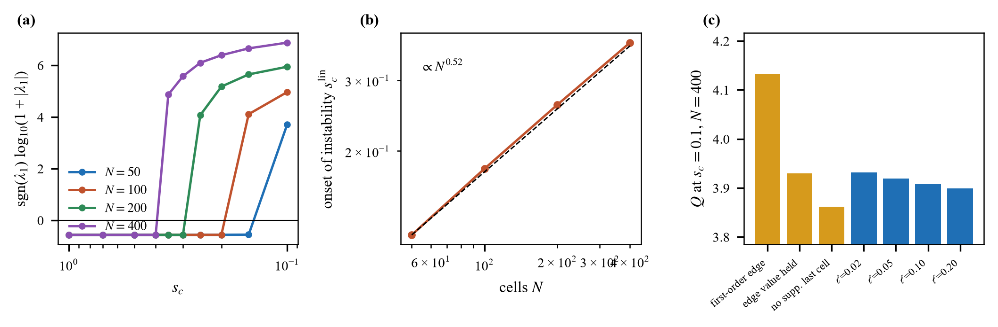
Fig. 1. Local closure. (a) Leading eigenvalue λ₁ against s_{c} for four resolutions (signed logarithm). (b) Threshold s_{c}^{lin} against N. (c) Q at s_{c} = 0.1 for different edge conditions (orange: local; blue: smoothed).

B. Smoothed Closure: Convergence and Controlled Comparison
The smoothed closure is linearly stable at every s_{c} tested (λ₁ ≤ -0.91 s⁻¹, down to s_{c} = 0.02) and converges at second order: the observed order is 1.73–2.05 over s_{c} = 0.5 to 0.05 (Fig. 3b), and Q changes by 0.04% between N = 400 and N = 800 at s_{c} = 0.05. A cold start settles on the steady state for every s_{c} tested. Table VI gives the comparison. The gain is described by a fitted inverse-square relation, ΔQ = C/s_{c}² with C = 0.00206 (range 0.00204–0.00209 for s_{c} ≥ 0.2), i.e. ΔQ/Q = 0.056%/s_{c}²; the fit is within 12% over 0.02 ≤ s_{c} ≤ 1 for this parameter set. It is an empirical relation for the tested range, not a derived or universal scaling law. The confinement time barely changes (τ_{E} = 1.816 s at s_{c} = 0.05 against 1.836 s), so the gain acts through the power balance and the core temperature (T₀ rises from 15.2 to 16.9 keV). Like any discretization, the smoothed closure is resolution limited at very strong coupling: a grid-scale mode turns unstable below s_{c} = 0.034, 0.025, and 0.015 at N = 100, 200, and 400, and is absent down to s_{c} = 0.015 at N = 800. In contrast with the local closure, this threshold falls as the grid is refined, so it is a resolution requirement (ℓ must be resolved), not a property of the model.
TABLE VI
Smoothed closure (ℓ = 0.05 m, N = 400) at 40 MW: gain, core temperature, and benchmark quantities
s_{c} | Q | ΔQ/Q | T₀ (keV) | H₉₈ | β_{N}
∞ | 3.702 | – | 15.2 | 0.48 | 1.05
1 | 3.704 | 0.06% | 15.3 | 0.48 | 1.05
0.5 | 3.710 | 0.22% | 15.3 | 0.48 | 1.05
0.3 | 3.725 | 0.62% | 15.3 | 0.48 | 1.05
0.2 | 3.754 | 1.4% | 15.3 | 0.48 | 1.05
0.1 | 3.919 | 5.9% | 15.7 | 0.48 | 1.07
0.07 | 4.153 | 12.2% | 16.1 | 0.49 | 1.10
0.05 | 4.577 | 23.6% | 16.9 | 0.50 | 1.14
0.03 | 5.909 | 59.6% | 19.7 | 0.54 | 1.28
0.02 | 8.222 | 122.1% | 24.7 | 0.59 | 1.49

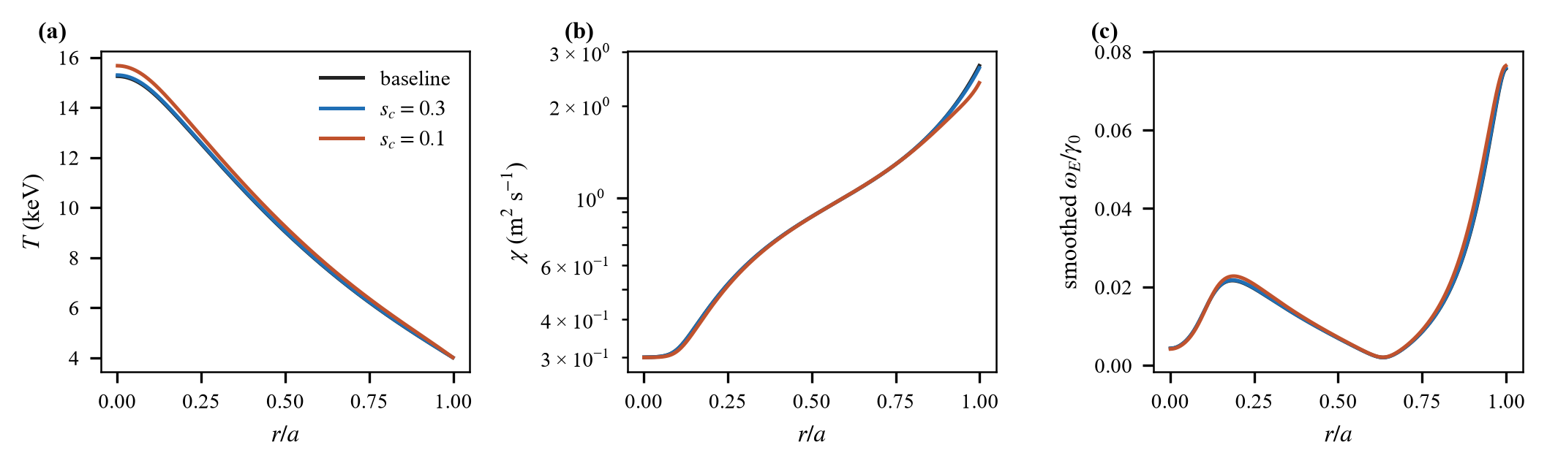
Fig. 2. Smoothed closure at 40 MW (N = 400, ℓ = 0.05 m): (a) temperature, (b) diffusivity, and (c) smoothed shearing rate against r/a for the baseline and s_{c} = 0.3 and 0.1. The suppression is confined to the edge.

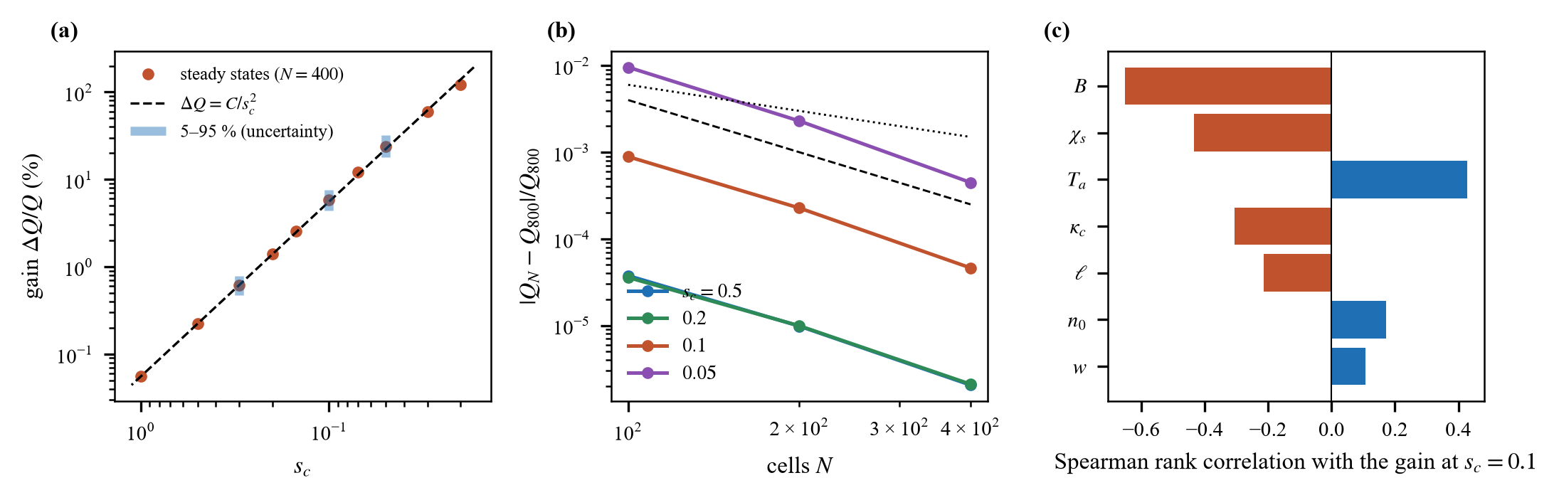
Fig. 3. Smoothed closure. (a) Relative gain against s_{c} with the fitted inverse-square relation (dashed) and the 5–95 % interval from the parameter-uncertainty study (bars). (b) Convergence of Q with N (dotted: N⁻¹; dashed: N⁻²). (c) Rank correlation of the gain at s_{c} = 0.1 with each sampled parameter.

C. Tests of the Admissibility Theory
The rotation equation was solved directly (finite volume, N = 200, baseline temperature profile, torques 25–250 N m) and compared with Proposition 1 (Fig. 4b): the simulated Λ_{max} agrees with the solution of F(Λ)Λ = Θ(r) to a relative error of at most 4.8×10⁻¹¹ over 17 cases, and a steady state exists exactly when Θ_{max} < Ψ∞. The last torque with a steady state is 247.8 N m for m = 2 (Θ_{max} = 0.49995; predicted fold at 1/2) and 495.7 N m for m = 1 (Θ_{max} = 0.99999; predicted saturation at 1). For the floor closure with f = 0.05 < 1/9 the theory gives Ψ_{M} = 0.5280 and Ψ_{m} = 0.4235, a hysteresis window of 210–262 N m; torque ramps show the jump between 260 and 280 N m and a return at or below 210 N m, while f = 0.20 shows no hysteresis (Fig. 4c).

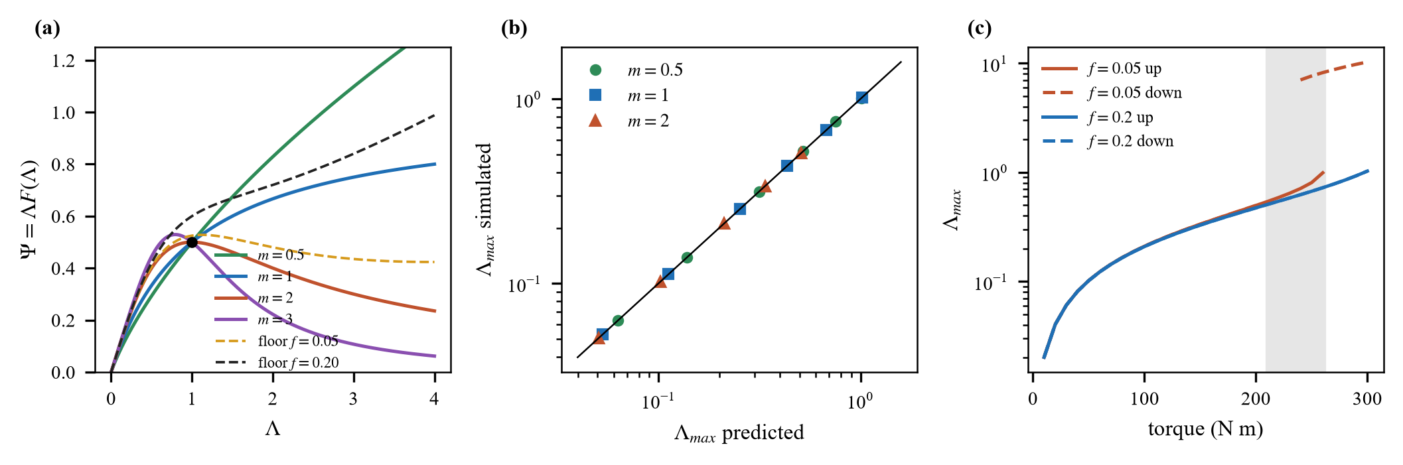
Fig. 4. Admissibility theory. (a) Normalized flux Ψ = ΛF(Λ); the fold for m = 2 is marked. (b) Λ_{max} from direct solutions against the flux relation. (c) Torque ramps for the floor closure (f = 0.05: hysteresis; shaded: predicted window; f = 0.20: none).

D. Torque-Driven Shear
TABLE VII
Gain with torque-driven shear (s_{c} = 0.5, N = 100, 40 MW, shears adding unless noted)
Torque (N m) | Θ_{max} | Q const. | Q, m = 1 | Q, m = 2, f = 0.2 | Q const., σ = −1
0 | 0 | 3.71 | 3.71 | 3.71 | 3.71
50 | 0.100 | 3.81 | 3.83 | 3.81 | 3.76
100 | 0.199 | 4.06 | 4.22 | 4.08 | 3.97
200 | 0.384 | 4.95 | 6.44 | 5.26 | 4.80
250 | 0.470 | 5.57 | 8.67 | 6.39 | 5.41

With the shears adding, the gain rises monotonically with torque (Table VII, Fig. 5): for a constant viscosity Q goes from 3.71 to 4.06 at 100 N m and 4.95 at 200 N m (34% above the baseline); a viscosity that falls with shear amplifies the effect (m = 1: Q = 6.44 at 200 N m). The inadmissible closure m = 2 has no steady rotation profile above Θ = 1/2 (250 N m), as Proposition 3 predicts, whereas the admissible floor closure does. When the shears oppose, the gain is smaller but still increases. At the neutral-beam torque of Section VI-C (about 36 N m) the gain is 1.5% at s_{c} = 0.5 and 9.3% at s_{c} = 0.2.
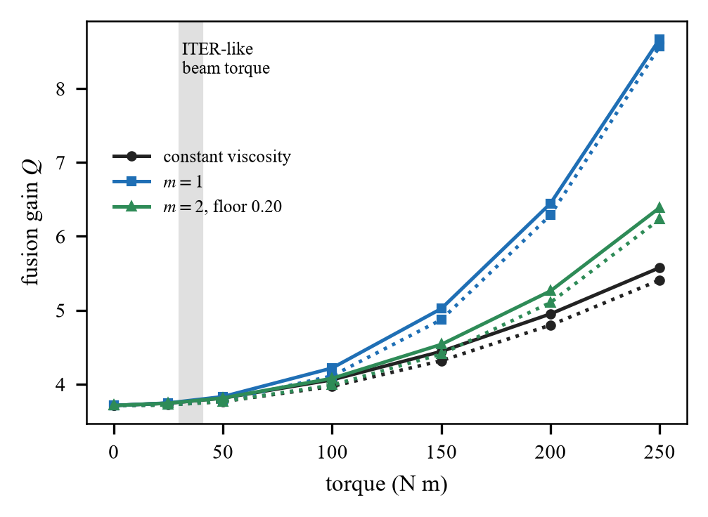
Fig. 5. Gain against torque for three viscosity closures (solid: shears adding; dotted: opposing). The shaded band is the full-energy neutral-beam torque estimate for a reactor-scale device (Section VI-C).
E. Parameter Uncertainty and Sensitivity
A scrambled Sobol sequence (fixed seed, 128 points) samples χ_{s} ∈ [0.7, 1.4] m² s⁻¹, κ_{c} ∈ [3.6, 4.4], w ∈ [0.3, 0.7], T_{a} ∈ [3, 5] keV, n₀ ∈ [0.8, 1.2]×10²⁰ m⁻³, B ∈ [4.8, 5.8] T, and ℓ ∈ [0.02, 0.10] m (128 converged). The baseline gain Q varies from 1.6 to 7.1 (5–95 %), but the relative gain is far more stable: 0.5–0.8% at s_{c} = 0.3, 4–8% at 0.1, and 18–32% at 0.05 (Fig. 3a). The rank correlations (Fig. 3c) identify the parameters that control the gain at s_{c} = 0.1. A second sequence over the torque study (torque 25–200 N m, profile width 0.2–0.6a, Pr 1–4, s_{c} 0.2–1, both signs, ℓ) gives a gain of 0–37% (median 4%) over 64 converged samples.
VI. PHYSICAL CALIBRATION AND ENGINEERING APPLICABILITY
The parameters of the model are illustrative; this section places them against recognized scalings and limits, using an ITER-like reference device (R₀ = 6.2 m, a = 2.0 m, B = 5.3 T, plasma current 15 MA, elongation 1.7, 2.5 amu). The plasma current is not an input of the one-dimensional model, so it is taken from the reference device; all formulas are given in the code archive.
A. Confinement Scalings
With the net heating P_{net} = 66.2 MW and the line-average density 7.5×10¹⁹ m⁻³, the baseline confinement time 1.84 s is 1.01 times the ITER89-P L-mode scaling [14] (1.81 s) and 0.48 times the IPB98(y,2) H-mode scaling [15] (3.85 s). The stiff baseline with a fixed 4 keV edge is therefore an L-mode-like plasma. The agreement with ITER89-P is a consistency check, not an independent validation: the edge temperature is imposed, the critical-gradient parameters are generic, and the density and heating profiles are prescribed, so other parameter choices would also bring H₈₉ near unity. The smoothed closure acts only on the edge shear, and even at s_{c} = 0.02 it raises the H₉₈ factor from 0.48 to 0.59 (Table VI): it produces a partial edge barrier, not an H-mode pedestal, and must not be read as predicting H-mode performance.
B. Operating Limits
The Greenwald fraction n̄/n_{G} = 0.63 [16], with n_{G} = I_{p}/πa² = 1.19×10²⁰ m⁻³, is fixed by the density profile. The normalized beta β_{N} = 1.05 for the baseline rises to 1.07 at s_{c} = 0.1 and 1.49 at s_{c} = 0.02, below the Troyon-type limit of order 3 [17]; the magnetohydrodynamic limit therefore does not bound the closure in the range studied, although the model contains no stability physics, so this is a consistency check only.
C. Neutral-Beam Torque
The heating neutral beams of a reactor-scale device deliver 33 MW at 1 MeV (deuterium) [18]. A beam of power P and speed v injects a torque T = 2PR_{t}/v, since each particle of energy mv²/2 carries angular momentum mvR_{t}; with v = 9.79×10⁶ m s⁻¹ and a tangency radius R_{t} = 4.5–6 m this gives 30–40 N m (full-energy component only, no losses), consistent with the statement that the torque scales as P/E^{1/2} and is small in a large device [18]. The torque scan to 250 N m is therefore a sensitivity range up to 7 times the estimate, not a prediction; at the estimated torque the gain is 1.5% (s_{c} = 0.5) to 9.3% (s_{c} = 0.2), and the Mach number at 250 N m is 0.75.
D. The Suppression Threshold
The threshold plays the role of the maximum linear growth rate in units of γ₀ in a quench rule [7], s_{c} = γ_{max}/γ₀. The largest smoothed diamagnetic shear in the model is ω_{E}/γ₀ ≈ 0.08, so for s_{c} ≳ 0.3, i.e. growth rates above 0.3c_{s}/R₀, the closure changes Q by less than 1%, and it changes it by more than 10% only for s_{c} ≲ 0.07. Which regime applies cannot be decided without gyrokinetic growth rates for the profiles in question, and that calibration, together with ℓ, is the main open step. Meanwhile the fitted relation ΔQ/Q = 0.056%/s_{c}² (valid only for the tested range and parameters) and its uncertainty band give the sensitivity of the result to the choice.
TABLE VIII
Calibration summary
Quantity | Value | Reference
H₈₉, H₉₈ (baseline) | 1.01, 0.48 | [14], [15]
n̄/n_{G}; β_{N} | 0.63; 1.05–1.49 | [16], [17]
Beam torque estimate | 30–40 N m | 33 MW, 1 MeV [18]
Gain at that torque | 1.5% (s_{c} = 0.5) | this work
ℓ / ρ_{i} (10 keV) | 16 | this work

VII. DISCUSSION AND LIMITATIONS
A. Principal Findings
Three findings stand out. First, whether a shear-suppression closure is well behaved is not a numerical detail: for the local closure the converged answer is set by an edge condition that the physics does not supply, and a consistent discretization is unstable at fine resolution. A local-closure result should therefore be reported with its edge treatment, resolution, and eigenvalues; the smoothed closure removes the issue at the price of one new length, to which the gain is insensitive (Table V). Second, the admissibility conditions are a priori checks that cost nothing and are reproduced to ten digits. Third, in this model the diamagnetic shear changes the gain by well under one per cent at moderate threshold, and the sensitivity to the threshold, not the form of the closure, dominates the uncertainty.
B. Limitations
The limitations are those of a reduced model: no existence, uniqueness, or continuous-dependence theorem is proved for the nonlinear heat problem, so “ill posed” and “well behaved” rest on numerical evidence over the tested conditions; one-dimensional energy transport with fixed density, equal temperatures, and local alpha deposition; one-way coupling to rotation; no pedestal, edge-localized-mode, or magnetohydrodynamic physics; generic critical-gradient parameters (benchmarked only at the level of Section VI); an uncalibrated threshold and length; and no experimental data. The plasma current, elongation, and the Troyon limit enter only the calibration. A predictive claim would require gyrokinetic calibration of s_{c} and ℓ, a self-consistent density and pedestal, and validation against experiment.
C. Implications for Compact, Cost-Constrained Tokamak Design
Compact devices have tight margins among confinement, field strength, auxiliary heating, and actuator capability, so a reduced transport model used to screen their operating regimes must not turn numerical artifacts into confinement gains. The present results bear on this only as a methodological prerequisite. The local closure is sensitive to the edge treatment and the resolution, whereas the regularized closure gave convergent solutions over the tested conditions; a predicted confinement improvement should therefore be accepted only after the flux admissibility, the grid convergence, and the sensitivity to the regularization length have been checked.
Auxiliary rotation drive is the clearest case. At the reactor-scale beam torque of Section VI-C the modelled gain is only 1.5% (s_{c} = 0.5) to 9.3% (s_{c} = 0.2), and larger gains need either stronger suppression or a torque far above that estimate. This says nothing about the torque a compact device requires, because size, field, beam energy, geometry, and momentum transport change the accessible regime.
A natural extension would apply the verified closure to a family of compact configurations that differ in major radius, minor radius, field, plasma current, and auxiliary power, and compare confinement time, fusion gain, actuator requirements, and operating margins under the same admissibility and convergence criteria; the one-dimensional model would first need geometric rescaling and equilibrium constraints. The relevant objective is not the largest modelled gain but an operating point that reaches adequate confinement with little auxiliary power and little sensitivity to the uncertain closure parameters. Weighing fusion output against auxiliary power, other power demands, and a normalized engineering cost would require a cost model, which is not part of this study.
The model is not sufficient to establish compact-device feasibility: it omits self-consistent equilibrium and stability, pedestal physics, current drive, magnet engineering, neutron shielding, and balance of plant, and the threshold and the length are uncalibrated against gyrokinetic calculations or experiment. The contribution is therefore a verified method for assessing closure sensitivity, not a prediction that a compact or low-cost tokamak can reach a given gain; neither plant-level net electric power nor cost is computed.
VIII. CONCLUSION
State-dependent shear-suppression closures need two things that are easy to overlook: an admissibility condition on the flux and a length that regularizes the shearing rate. With them the reduced model is verified, converges at second order, and gives a gain described over the tested range by the fitted relation ΔQ/Q = 0.056%/s_{c}² with a documented uncertainty, while the local closure is numerically ill posed and its answers depend on the edge treatment. The admissibility conditions are exact and tested to ten digits. The baseline is L-mode-like (H₈₉ = 1.01, a consistency check because the edge temperature is imposed), and neutral-beam torque of reactor size adds about 1.5%. The suppression threshold and the smoothing length are the quantities that a gyrokinetic calibration must supply before the gain can be used for design.
ACKNOWLEDGMENT
The author used Claude Sonnet 5.5 (Anthropic; model identifier claude-sonnet-5-5), accessed through the Claude Code environment of the Claude desktop application between 7 and 9 October 2026, to write and test the code, derive and check the closed-form results, run the numerical experiments, produce the figures, and draft the text. The author reviewed and edited all content, checked every reference against Crossref, and takes full responsibility for the paper. No funding was received.
CODE AND DATA AVAILABILITY
All code, tests, raw results (results.json), figure scripts, and the manuscript builders are at https://github.com/sandlerleon/tokamak-statedependent-closure (release v1.1.1) and archived at https://doi.org/10.5281/zenodo.23267847 (software, MIT licence); this manuscript is archived as a preprint at https://doi.org/10.5281/zenodo.23267849. No experimental data were used. A supplementary file contains the proofs, the numerical protocol, and extended tables.
REFERENCES
[1] A. M. Dimits et al., "Comparisons and physics basis of tokamak transport models and turbulence simulations," Phys. Plasmas, vol. 7, no. 3, pp. 969–983, 2000, doi: 10.1063/1.873896.
[2] M. Kotschenreuther, W. Dorland, M. A. Beer, and G. W. Hammett, "Quantitative predictions of tokamak energy confinement from first-principles simulations with kinetic effects," Phys. Plasmas, vol. 2, no. 6, pp. 2381–2389, 1995, doi: 10.1063/1.871261.
[3] H. Biglari, P. H. Diamond, and P. W. Terry, "Influence of sheared poloidal rotation on edge turbulence," Phys. Fluids B, vol. 2, no. 1, pp. 1–4, 1990, doi: 10.1063/1.859529.
[4] T. S. Hahm and K. H. Burrell, "Flow shear induced fluctuation suppression in finite aspect ratio shaped tokamak plasma," Phys. Plasmas, vol. 2, no. 5, pp. 1648–1651, 1995, doi: 10.1063/1.871313.
[5] K. H. Burrell, "Effects of E×B velocity shear and magnetic shear on turbulence and transport in magnetic confinement devices," Phys. Plasmas, vol. 4, no. 5, pp. 1499–1518, 1997, doi: 10.1063/1.872367.
[6] P. W. Terry, "Suppression of turbulence and transport by sheared flow," Rev. Mod. Phys., vol. 72, no. 1, pp. 109–165, 2000, doi: 10.1103/revmodphys.72.109.
[7] R. E. Waltz, G. D. Kerbel, and J. Milovich, "Toroidal gyro-Landau fluid model turbulence simulations in a nonlinear ballooning mode representation with radial modes," Phys. Plasmas, vol. 1, no. 7, pp. 2229–2244, 1994, doi: 10.1063/1.870934.
[8] S.-I. Itoh and K. Itoh, "Model of L to H-mode transition in tokamak," Phys. Rev. Lett., vol. 60, no. 22, pp. 2276–2279, 1988, doi: 10.1103/physrevlett.60.2276.
[9] F. L. Hinton, "Thermal confinement bifurcation and the L- to H-mode transition in tokamaks," Phys. Fluids B, vol. 3, no. 3, pp. 696–704, 1991, doi: 10.1063/1.859866.
[10] H.-S. Bosch and G. M. Hale, "Improved formulas for fusion cross-sections and thermal reactivities," Nucl. Fusion, vol. 32, no. 4, pp. 611–631, 1992, doi: 10.1088/0029-5515/32/4/i07.
[11] J. P. Freidberg, Ideal MHD. Cambridge, U.K.: Cambridge Univ. Press, 2014.
[12] J. Wesson, Tokamaks, 4th ed. Oxford, U.K.: Oxford Univ. Press, 2011.
[13] P. Perona and J. Malik, "Scale-space and edge detection using anisotropic diffusion," IEEE Trans. Pattern Anal. Mach. Intell., vol. 12, no. 7, pp. 629–639, 1990, doi: 10.1109/34.56205.
[14] P. N. Yushmanov et al., "Scalings for tokamak energy confinement," Nucl. Fusion, vol. 30, no. 10, pp. 1999–2006, 1990, doi: 10.1088/0029-5515/30/10/001.
[15] ITER Physics Expert Group on Confinement and Transport et al., "Chapter 2: Plasma confinement and transport," Nucl. Fusion, vol. 39, no. 12, pp. 2175–2249, 1999, doi: 10.1088/0029-5515/39/12/302.
[16] M. Greenwald, "Density limits in toroidal plasmas," Plasma Phys. Control. Fusion, vol. 44, no. 8, pp. R27–R53, 2002, doi: 10.1088/0741-3335/44/8/201.
[17] F. Troyon, R. Gruber, H. Saurenmann, S. Semenzato, and S. Succi, "MHD-Limits to Plasma Confinement," Plasma Phys. Control. Fusion, vol. 26, no. 1A, pp. 209–215, 1984, doi: 10.1088/0741-3335/26/1a/319.
[18] E. J. Paul, M. Landreman, F. M. Poli, D. A. Spong, H. M. Smith, and W. Dorland, "Rotation and neoclassical ripple transport in ITER," Nucl. Fusion, vol. 57, no. 11, Art. no. 116044, 2017, doi: 10.1088/1741-4326/aa7fa4.

