Wormhole Formation in Matter-Coupled Vacuum Transitions: Gravitational Collapse, Horizon Constraints, and the Limits of Cosmological Rebirth
Leon Sandler
Independent Researcher, Northbrook, Illinois, USA
ORCID: https://orcid.org/0009-0007-4584-808X
Corresponding author: sandler.leon@gmail.com

Abstract
Rebirth scenarios invoke a wormhole carrying matter into a new expanding region. We ask whether a density-triggered vacuum transition can form one in a scalar-only gravitational benchmark: a canonical scalar whose false vacuum has the observed dark-energy density, motivated by a dark-matter coupling that the numerical experiments do not evolve. In this classical model the null energy condition holds, so no ordinary traversable throat can form; nontraversable bridges and quantum or baby-universe continuations are not excluded. For a thin spherical wall and regular initial data the Israel junction conditions give a finite-tension critical exterior mass parameter, equal to (1+q)R_{dS} up to corrections of order σ̂², below which the configurations on the branch analyzed collapse; an independent derivation confirms it. A spherical Einstein–scalar code checked against exact solutions found trapped surfaces in 65 of 72 runs and in 6 more after refinement. An expanding (anti-trapped) false-vacuum core appears only when the initial data already contain a core larger than its own de Sitter radius; none develops in the 42 runs that start smaller: persistence, not creation. At the observed dark-energy scale the core radius is 5.3 Gpc and the exterior mass parameter 1.1 × 10²³ solar masses (for q=1 half of it is quasilocal at the wall), dominated by the vacuum-energy difference. In the computed double-null domain no causal curve carries exterior matter into the core; the global structure is not computed. The evidence is complete only for anti-de Sitter exteriors and walls much thicker than the physical one.
Keywords
Wormholes; Vacuum decay; Gravitational collapse; Black hole physics; Cosmology: theory; Methods: numerical
1. Introduction
In a universe that dilutes its matter and approaches a cold, dark-energy-dominated state, any mechanism that returns the cosmos to a hot, dense phase has to do two things: change the vacuum, and supply a geometry through which a new expanding region can be reached. Cyclic models [1] and cosmological natural selection [2] place that geometry in a bounce or in a black-hole interior. A more literal proposal is a wormhole: a spacetime throat that forms near the end of the universe and carries matter back to a new beginning. General relativity does not establish that a wormhole behaves as a gravitational vacuum cleaner, and ordinary traversable wormholes need stress-energy that violates the null energy condition [3–5]. A defensible version of the idea must therefore be stated as a set of mathematical questions that can fail.
This paper states and answers such questions for one model. The model is a scalar field φ with a double-well potential whose false vacuum is held in place by dark matter through a symmetron-type coupling [6], so that the observed dark-energy density is carried by the false vacuum while the matter density is above a critical value, and released once the expansion has diluted the matter (Section 2). The release can start locally, by the nucleation of a bubble of the lower vacuum, and the reverse process, the return of a region to the false vacuum when its matter density rises above the critical value, can also be local. The question is what the gravitational collapse of such a region can produce. The hypothesis, stated so that it can fail, is that a density-triggered vacuum transition may create a localized gravitational configuration that, under explicit conditions, develops a spacetime throat connecting a contracting region to a new expanding daughter region.
Three outcomes are distinguished throughout and are not allowed to blur. In outcome A the collapse is ordinary: a trapped region forms and no regular expanding region does. In outcome B a bridge-like geometry exists but nothing can cross it. In outcome C an expanding region exists behind a horizon. A collapsing region can produce a trapped surface without producing either a traversable wormhole or a new universe, and the distinction is the content of the paper. A second distinction is made as sharply: an expanding region that is present in the initial data and persists beside a collapse is not a daughter universe that the collapse has created. Even a created daughter would establish cosmological reproduction, not a cyclic return of the same universe, which additionally needs a daughter that reconnects with or replaces its parent; no part of this work provides that. Section 9.1 discusses the alternative that the bridge is primordial rather than formed by the collapse.
Four terms are used with fixed meanings. An anti-trapped (expanding) region is a region in which both null expansions are positive, r_{u}>0 and r_{v}>0: a local property that the numerical solutions can test. The expanding core is the false-vacuum interior of the wall when it contains such a region. A bridge is the nontraversable two-ended geometry of the thin-wall solution (Section 4); no bridge is constructed numerically. A daughter universe is reserved for a global expanding region that the collapse has created and that has a causal continuation; no run produces one. Persistence is the survival of an anti-trapped region that is present in the initial data, and creation is its appearance from initial data that have none.
The mechanism is not new in its geometry. Thin false-vacuum bubbles in general relativity were analyzed in detail in the 1980s [7,8], the possibility of a baby universe attached to a black hole by a throat was explored in classical and quantum form [9–11], and the obstacle that regular initial data do not lead to one was identified at the time [12]. Known from that literature are the Israel junction analysis of a false-vacuum bubble, the existence of a critical mass below which regular data collapse, and the obstruction to reaching the baby-universe branch from regular initial data. What this paper adds is quantitative and specific to the model: a null-energy proposition for the scalar-plus-dust model; a finite-tension critical mass with its small-tension limit and a coincidence of horizon areas there, rederived independently (Supplement S8); a regular-center Einstein–scalar experiment that separates persistence from creation, with its dependence on wall thickness quantified (Section 5.6); and dimensioned numbers at the observed dark-energy scale, with the exterior mass parameter distinguished from the quasilocal mass (Section 4). The vacuum energy is the observed dark-energy density, so the critical sizes and masses are numbers rather than free parameters, and they can be compared with the matter that the universe actually contains. The paper does not add a new bubble solution, a traversable throat or a global spacetime for the numerical solutions. It makes five contributions.
• A null-energy argument for the whole model (Section 3): no traversable throat can form, and no null ray has a minimum of the areal radius.
• A finite-tension thin-wall criterion (Section 4): a critical exterior mass m_{c}(σ̂) below which a false-vacuum region is confined and collapses, with its small-tension limit (1+q)R_{dS} and a coincidence of horizon areas at that limit (Section 6).
• A numerical Einstein–scalar experiment with a regular center (Section 5), validated against exact solutions and by the convergence of its constraints, that tests the criterion with thick walls, separates expanding regions that persist from those that could be created, and compares exteriors of different vacuum depths.
• An accounting of the size, mass and energy budget that the criterion requires at the observed dark-energy scale, showing that the critical mass is dominated by the vacuum-energy difference and not by matter (Section 7), and falsification criteria (Section 8).
• Audits of the evidence: an independent derivation of the junction branches, horizons and masses (Supplement S8), a quantitative wall-thickness extrapolation (Section 5.6) and a causal-classification diagnostic that separates the evolved domain from conjecture (Section 5.4).
2. Model, inputs and scales
Units are 8πG = 1 (M_{Pl} is the reduced Planck mass) and c = ℏ= 1 unless stated. The action is
$S=\text{∫}d^{4}x\sqrt{−g}\left[\frac{M_{\text{Pl}}^{2}}{2}R−\frac{1}{2}(∇ϕ)^{2}−V_{0}(ϕ)\right]+S_{\text{dm}}\left[A^{2}(ϕ)g_{μν},ψ_{\text{dm}}\right]$ (1)
with A(φ)=1+φ²/2M² the coupling to dark matter alone. For pressureless dark matter of conserved density ρ*∝a⁻³ the scalar moves in V_{eff}=V₀(φ)+ρ*A(φ). While ρ* exceeds a critical value ρ_{crit}=μ²M² the symmetric point of V₀=V_{c}−μ²φ²/2+λφ⁴/4 is a minimum and holds the field in a false vacuum of density V_{f}. When the expansion has diluted the matter below ρ_{crit} the point becomes a maximum and the field can roll to a lower vacuum. Two numbers fix the gravitational problem, and nothing else of the particle physics enters it: the false-vacuum density V_{f}, which is set equal to the observed dark-energy density, and the depth of the true vacuum, V_{t}=−qV_{f}. The baseline is q=1; q>0 is an anti-de Sitter true vacuum, q=0 a Minkowski one and −1<q<0 a lower de Sitter vacuum. The relevant length is the de Sitter radius of the false vacuum,
$R_{dS}=\sqrt{3/V_{f}}=H_{Λ}^{−1}$ (2)
which for the Planck 2018 values [13] H₀=67.66 km s⁻¹ Mpc⁻¹ and Ω_{Λ}=0.6889 is 5.34 Gpc (H_{Λ}=56.2 km s⁻¹ Mpc⁻¹). The gravitational effect of a wall between the vacua is set by its tension σ. A scalar whose potential scale is the dark-energy scale, V_{f}^{1/4}≈2.2 meV, has a wall tension of the order of V_{f}^{3/4}, that is of order 10 meV³; a bounce calculation for a potential of this kind gives 19 meV³ and a thickness of 0.24 mm, and the conclusions depend only on the wall being a probe, not on these values. In units of the de Sitter radius this is σ̂=σR_{dS}/M_{Pl}² = 2.7 × 10⁻³⁰ and δ/R_{dS} = 1.5 × 10⁻³⁰, so that the wall's own gravity, measured by 3σ̂²/4 for q=1, is 5.5 × 10⁻⁶⁰. The wall is a probe, and its thickness is invisible to any gravitational observable of the size of the de Sitter radius. That fact organizes the paper: the thin-wall treatment of Section 4 is controlled by these two numbers, and the numerical experiments of Section 5 can only reach thick, heavy walls and therefore test the structure of the solution, not the physical values.
2.1 Inputs and what is derived here
The inputs taken from the benchmark dilution-triggered model are the false-vacuum density V_{f} (the observed dark energy), the depth q of the true vacuum (baseline 1, varied from −0.5 to 2 in Section 5.5) and the order of magnitude of the wall tension. Everything else is derived or computed in this paper: the energy-condition argument (Section 3), the junction analysis (Section 4), the numerical solver and its experiments (Section 5), and the size, mass and entropy accounting (Sections 6 and 7); none of it relies on a result of the benchmark model's cosmology. One limit of scope is stated at once, because it is the largest gap between the motivating model and the computed one: the numerical experiments are a scalar-only gravitational benchmark. They evolve the scalar field alone in a prescribed double-well potential, with the false vacuum held by the potential and not by dark matter, so they study the gravitational problem of a false-vacuum region bounded by a wall and not the matter-triggered process. What depends on the dark matter and what does not is as follows. The null-energy proposition (Section 3) is proved for the scalar together with nonnegative-density dust and does not use the numerical solutions. The thin-wall criterion (Section 4) depends on the matter only through the exterior mass parameter, to which dust contributes its conserved mass, and through the vacuum energies. The numerical persistence and creation results (Section 5) are results for the scalar-only system: whether positive-energy dust inside the core or the wall can change the classification of any run was not tested, and a controlled subset with dust, which needs a coupled solver, is the most consequential extension. The claim that the whole process has been simulated is not made.
2.2 The exterior vacuum
The thin-wall model of Section 4 and the experiments of Section 5 place a false-vacuum region (positive density V_{f}) inside an exterior of lower vacuum energy. That exterior is not the late-time de Sitter state of the parent universe: the parent's heat-death state is the false vacuum itself. The exterior is the region in which the field has rolled to the true vacuum, which for q>0 is anti-de Sitter and recollapsing and for q≤0 is not. A false-vacuum region inside it arises when a region returns to the false vacuum, as when its matter density rises above ρ_{crit} and pins the field, while its surroundings have already made the transition; the nucleation of a bubble of the true vacuum inside the false vacuum [14] is the opposite configuration, whose interior is anti-de Sitter and ends in a crunch [15], so that it settles outcome A for that direction without further work. How such a region is reached, and whether a negative exterior is cosmologically viable, are not decided by this paper. What it can do is test how much the conclusions depend on the sign of the exterior vacuum energy: the thin-wall criterion holds for any q>−1 (Section 4), and the numerical experiments are repeated for a Minkowski exterior and a de Sitter exterior of lower energy in Section 5.5.
Table 1 lists the scales.
Quantity | Symbol | Value
de Sitter radius of the false vacuum | R_{dS}=H_{Λ}⁻¹ | 5.34 Gpc (1.65 × 10²⁶ m)
Hubble rate of the false vacuum | H_{Λ} | 56.2 km s⁻¹ Mpc⁻¹
Wall tension in units of M_{Pl}²/R_{dS} | σ̂ | 2.7 × 10⁻³⁰
Wall thickness over R_{dS} | δ/R_{dS} | 1.5 × 10⁻³⁰
Gravitational parameter of the wall | 3σ̂²/4 | 5.5 × 10⁻⁶⁰
de Sitter entropy of the false vacuum | πR_{dS}²/ℓ_{P}² | 3.3 × 10¹²²
Matter within one Hubble radius today | M_{H} | 1.4 × 10²² M_{odot}
Table 1. Scales of the benchmark model (q=1, Planck 2018 cosmology).
3. What the energy conditions allow
A spherically symmetric spacetime is written ds²=−f(u,v) du dv+r(u,v)²dΩ² with null coordinates u (outgoing rays are u= const) and v (ingoing rays are v= const) and areal radius r. The null expansions of the two families are proportional to r_{u} and r_{v}. A sphere is normal if r_{v}>0>r_{u}, trapped if r_{v}<0 and r_{u}<0, and anti-trapped (expanding) if r_{v}>0 and r_{u}>0; the fourth quadrant, r_{u}>0>r_{v}, is the second exterior region of a bridge (a Kruskal-type extension). The Misner–Sharp mass [16] is
$m=r\left(1+\frac{4r_{u}r_{v}}{f}\right)$ (3)
in units where it includes the vacuum energy, m=ρr³/3 for a vacuum of density ρ, and a Schwarzschild–(anti-)de Sitter exterior of mass parameter m_{ext}=2GM has m=m_{ext}+ρ_{out}r³/3. Einstein's equations for the model reduce to (derived symbolically in the repository)
$r_{vv}−{\left(\text{ln}f\right)}_{v}r_{v}=−\frac{r}{2}T_{vv}^{\text{dust}}−\frac{r}{2}{\left(ϕ_{v}\right)}^{2}$ (4)
$r_{uv}=−\frac{r_{u}r_{v}}{r}−\frac{f}{4r}+\frac{Ufr}{4}$ (5)
where U is the total potential (the dust term is omitted in the numerical experiments, Section 5, where the field alone is evolved) and Eq. (4) is the constraint along v (and the analog along u). The sign of the right-hand side of Eq. (4) is the whole story about throats. For every term of the model the null energy condition holds. For a null vector k, T_{μν}k^{μ} k^{ν}=(k^{μ}∂_{μ}φ)²+ρ_{dm}(k·u)²≥0: the potential terms −g_{μν}V drop out because k is null, whatever the sign of V (including a negative true-vacuum density), and the dark matter is dust of nonnegative density in the Einstein frame.
Proposition 1. In spherical symmetry with T_{μν}k^{μ} k^{ν}≥0, no null geodesic has a strict local minimum of the areal radius. Proof. A minimum along an outgoing ray requires r_{v}=0 and r_{vv}≥0 there. Eq. (4) at r_{v}=0 gives r_{vv}=−(r/2)T_{vv}≤0, so r_{vv}≥0 forces T_{vv}=0 and the minimum is not strict; the same argument with u and v exchanged applies to ingoing rays. □ This is the local content of the focusing theorem. It means that a throat in the sense of Morris and Thorne, a minimal sphere that a traveler can cross, or a timelike marginal surface of Hayward's dynamic definition, needs matter that violates the null energy condition [4,5,17]. The model has none, so an ordinary traversable throat cannot form in it for any parameter values or any wall profile. The statement is limited to this classical model of a canonical scalar and nonnegative-density dust: it does not exclude nontraversable bridges, quantum or semiclassical continuations that violate the null energy condition locally, or baby-universe scenarios that rest on them. Outcome B survives only as a nontraversable bridge: a minimal sphere on a spacelike slice (as in the Einstein–Rosen bridge, where the null energy condition holds trivially) that is hidden behind horizons, and outcome C only as an expanding region attached to such a bridge.
That settles the central obstacle identified at the outset, and it narrows the question to what such a bridge needs. Because the question does not involve exotic matter, it can be put to the ordinary Einstein–scalar system within a thin-wall treatment and numerically with a thick wall.
4. Thin-wall criterion
A thin shell of tension σ at areal radius R(τ), with U=dR/dτ, separates an interior de Sitter region of density ρ_{in}=V_{f} from an exterior Schwarzschild–(anti-)de Sitter region of mass parameter m and density ρ_{out}=−qρ_{in} [7,18]. With Δ=ρ_{in}−ρ_{out}=(1+q)V_{f} the Israel junction condition takes the form
$Γ_{in}−Γ_{out}=\frac{σR}{2}, Γ_{in}^{2}=1+U^{2}−\frac{R^{2}}{R_{dS}^{2}}, Γ_{out}^{2}=1+U^{2}−\frac{m}{R}−\frac{ρ_{out}R^{2}}{3}$ (6)
where Γ=dR/dn is the derivative of the areal radius along the unit normal, which points from the interior to the exterior, so that a negative Γ_{in} means that the interior region extends beyond the equator of its de Sitter 3-sphere. Eliminating Γ_{out} gives
$Γ_{in}=\frac{σR}{4}+\frac{m}{σR^{2}}−\frac{ΔR}{3σ}$ (7)
Motion is possible only where U²≥0. For R<R_{dS} this reads m≥m₊(R) or m≤m₋(R) with
$m_{±}(R)=\left(\frac{Δ}{3}−\frac{σ^{2}}{4}\right)R^{3}±σR^{2}\sqrt{1−R^{2}/R_{dS}^{2}}$ (8)
and for R≥R_{dS} it is always satisfied. The curves m± bound a band of forbidden radii (Fig. 1). The band reaches up to the finite-tension critical mass
$m_{c}(\hat{σ})={\text{max}}_{R≤R_{dS}}m_{+}(R)=(1+q)R_{dS}−{\hat{σ}}^{2}\left[\frac{1}{4}−\frac{1}{6(1+q)}\right]R_{dS}+O({\hat{σ}}^{4})$ (9)
which is exact within the junction equations (the maximum is found numerically; the expansion is that of the maximum of Eq. (8) near R=R_{dS} and is checked against it in Table 2). The simple form m_{c}=(1+q)R_{dS} is the limit of vanishing tension, not an additional result: its relative error is of order σ̂² (6.1 × 10⁻⁶¹ for q=1 and the model's tension), and the two are indistinguishable there. For m<m_{c} every wall lies either at R≤R₁(m) or at R≥R₂(m), with a forbidden window R₁<R<R₂ around R_{M}=(3m/Δ)^{1/3} that no trajectory crosses. For m>m_{c} there is no window. A numerical scan of R confirms this at nine combinations of tension and depth: a window exists at m=m_{c}(1−10⁻³) and none at m=m_{c}(1+10⁻³) in every case (Table S0 of the supplementary information).
σ̂ | m_{c}(σ̂) | Expansion, Eq. (9) | r_{h}(m_{c}) | S_{dS}/S_{BH}
0.01 | 1.99998 | 1.99998 | 1.00000 | 1.00001
0.10 | 1.99833 | 1.99833 | 0.99958 | 1.00083
0.30 | 1.98505 | 1.98500 | 0.99625 | 1.00754
0.90 | 1.86927 | 1.86500 | 0.96648 | 1.07056
2.7 × 10⁻³⁰ (model) | 2 − 1.2 × 10⁻⁶⁰ | 2 − 1.2 × 10⁻⁶⁰ | 1 − 3.1 × 10⁻⁶¹ | 1 + 6.1 × 10⁻⁶¹
Table 2. Finite-tension critical mass for q=1 (units of R_{dS}): the numerically maximized m_{c}(σ̂), its small-tension expansion of Eq. (9), the radius of the exterior horizon at m_{c} and the ratio of the de Sitter and black-hole horizon entropies, (R_{dS}/r_{h})², which equals 1 only in the limit.
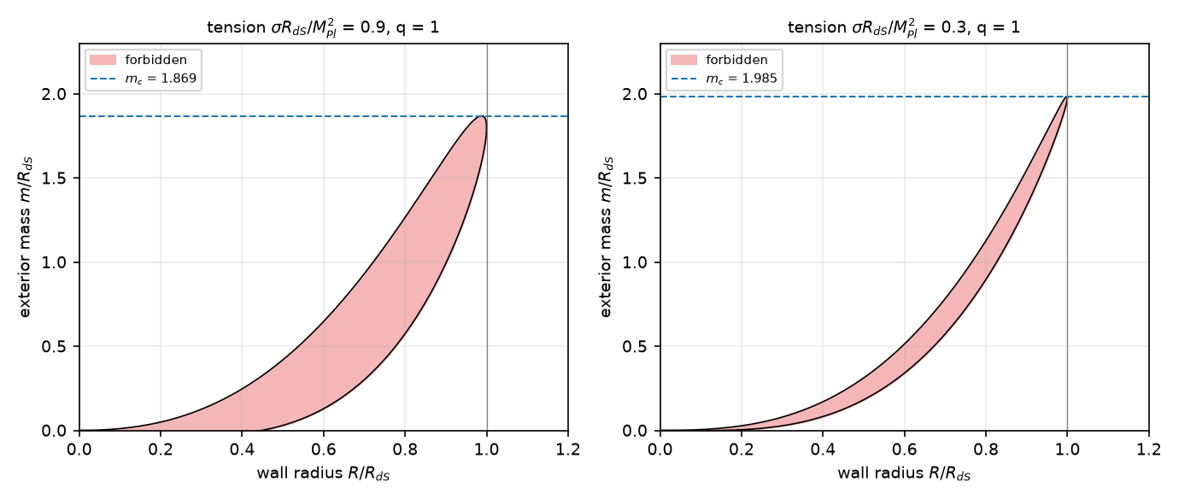
Fig. 1. Allowed and forbidden wall radii for q=1 and two values of the wall tension. The shaded band is forbidden; the dashed line is the finite-tension critical mass m_{c}(σ̂). For m<m_{c} a horizontal line crosses the band, which a wall cannot cross; for m>m_{c} it does not.
The consequences follow from which side of the window a wall can be on and what a regular initial slice looks like. A slice that is regular, in the sense that the interior is a de Sitter ball less than half of its 3-sphere (Γ_{in}>0) and the exterior is an asymptotic region (Γ_{out}>0), has R<R_{M}(1−O(σ̂)). If m<m_{c} it therefore lies at R≤R₁, can never reach R₂, and collapses to R=0, where the singularity theorem applies [19]: outcome A for every configuration of subcritical mass on the branch analyzed here (spherical, thin wall, vacuum exterior of the stated form, regular initial slice), with no assumption on the initial velocity. The branch R≥R₂ needs Γ_{in}<0, an interior beyond the equator of its own de Sitter space, which is not a regular ball; that is the configuration of the baby-universe solutions of Refs. [7,10], and it cannot be reached from regular data, which is the obstacle of Ref. [12]. For m>m_{c} the window is absent, so a wall that starts regular can move out through R_{M}, where Γ_{in} changes sign.
The bridge in these solutions needs to be stated precisely, because the wall is not where the minimal sphere is. On the time-symmetric slice through a turning point with Γ_{in}<0 and Γ_{out}<0, the areal radius is zero at the pole of the de Sitter cap, rises to R_{dS} at its equator (a maximal sphere), decreases across the wall, and continues to decrease through the exterior to its minimum at the bifurcation sphere of the exterior solution, r=r_{h}, beyond which it increases again to the second asymptotic region. The minimal sphere is therefore the bifurcation sphere of the exterior's horizons, which is a marginal surface and not a throat that can be crossed; the bridge is nontraversable, as Proposition 1 requires. This construction rests on the thin-wall solution and its literature: the numerical evolution of Section 5 starts on a null cone and ends at the singularity, and does not construct such a slice, so no throat is claimed for it.
Which mass is meant needs a statement. The m of Eqs. (6)–(9) is the parameter m=2GM/c² of the exterior metric function f=1−m/r−ρ_{out}r²/3: for q>0 the Schwarzschild–anti-de Sitter mass, for q=0 the ADM mass, and for q<0 the Schwarzschild–de Sitter parameter, which is not an asymptotic mass because there is no asymptotically flat region. The quasilocal Misner–Sharp mass at the wall is m_{MS}(R)=m+ρ_{out}R³/3, so the two differ by the exterior vacuum energy. At R=R_{dS} and vanishing tension the interior and exterior quasilocal masses coincide and equal R_{dS} in these units for every q, whereas the parameter is (1+q)R_{dS} (Supplementary Table S6). For q=1 the critical mass quoted in this paper, 1.12 × 10²³ M_{odot}, is therefore the exterior parameter, twice the quasilocal mass at the wall (5.58 × 10²² M_{odot}); statements about the mass of the region mean the parameter unless ‘quasilocal’ is written. An independent derivation (Supplement S8) reproduces Eqs. (7)–(9) from the extrinsic curvatures, the critical mass with 120-digit arithmetic (for the model's tension m_{c}−2= -1.22 × 10⁻⁶⁰), the horizon roots at m_{c} and the conversion to solar masses to 10⁻¹⁶.
Two statements follow. First, m>m_{c}(σ̂) is necessary for any regular configuration to reach Γ_{in}<0. Second, because m_{c} is fixed by the vacuum energy through R_{dS}, the necessary mass is a property of the observed dark-energy scale, not of the particle physics. Whether the condition is also sufficient, and what thick walls do, is a question for the numerical evolution of the next section.
5. Numerical experiment: collapse of a false-vacuum core with a regular center
5.1 Formulation
The thin-wall result assumes an infinitely thin, infinitely light wall. To test its structure with a wall of finite thickness and tension, the coupled Einstein–scalar equations are evolved in double-null gauge with a regular center, the standard formulation of spherical scalar-field collapse [20,21], which resolves trapped surfaces and expanding regions and requires no choice of slicing near horizons. The equations are Eqs. (4) and (5) with the scalar equation and the equation for f,
$ϕ_{uv}=−\frac{ϕ_{u}r_{v}+ϕ_{v}r_{u}}{r}−\frac{f}{4}U'(ϕ), (\text{ln}f)_{uv}=\frac{f+4r_{u}r_{v}}{2r^{2}}−ϕ_{u}ϕ_{v}$ (10)
with U(φ)=(κ/4)(φ²/A²−1)²+sφ/A+d, tuned so that the false minimum has density ρ_{in}=3 (so that R_{dS}=1) and the true minimum has density −qρ_{in}, with κ=24 and, in the baseline, q=1. The field amplitude A is the only free scale of the wall: its thickness is ℓ=A√2/κ and its tension is of the order of A√κ/2, so that A→0 is the thin, light wall limit. Only the scalar field is evolved: this is a scalar-only gravitational benchmark, and the dark matter of the full model is not included (Section 2.1). The scheme is the second-order diamond predictor–corrector on a uniform lattice [22,23]: r and φ are updated cell by cell, the metric function σ=ln f is integrated from the constraint within six points of the center, where the evolution equation divides by a small radius, and from its evolution equation beyond; the center value of σ follows from elementary flatness, r_{v}=√f/2, solved by the secant method because the plain iteration has a gain of modulus greater than one, and the center value of φ from regularity, φ_{t}=2φ_{v}, by an implicit trapezoid. Data are given on the outgoing null cone from the center in the gauge r=v/2: φ(0,v) is false vacuum for v<V_{w} and true vacuum beyond, with a tanh transition of width w, and σ(0,v) follows from the constraint. The wall is then an ingoing wall of radius R_{w}=V_{w}/2, with the false-vacuum core inside it and no matter outside. The code is dnull.py; the equations were derived symbolically (derive_equations.py).
Three limits of the method should be stated at once. The scheme does not follow the evolution beyond the formation of a singularity, where f diverges: a run ends when σ exceeds 12 or a value becomes nonfinite, and the classification below uses only features that cannot be undone by the evolution that follows, a trapped surface and an anti-trapped region. The wall is far thicker and heavier than the physical wall by thirty and sixty orders of magnitude (Table 1), so the experiments test structure, not the values of the physical model. And the evolution is spherically symmetric and classical.
5.2 Verification
The solver was checked against the two exact vacuum solutions with a regular center. For de Sitter space (ρ=3) and anti-de Sitter space (ρ=−3) the Misner–Sharp mass of Eq. (3) must equal ρr³/3 at every point. Table 3 gives the largest relative error for three grid steps; the errors fall at second order. The radius of the first trapped point of a collapsing run (R_{w}=1, w=0.1, A=0.1) converges at the same order, 1.0859, 1.0837 and 1.0831 at h=0.02, 0.01 and 0.005, with a Richardson extrapolation of 1.0829.
Vacuum | h=0.04 | h=0.02 | h=0.01 | Orders
de Sitter | 1.9 × 10⁻⁴ | 5.1 × 10⁻⁵ | 1.3 × 10⁻⁵ | 1.9, 2.0
anti-de Sitter | 1.8 × 10⁻⁴ | 4.8 × 10⁻⁵ | 4.8 × 10⁻⁶ | 1.9, 3.3
Table 3. Verification against exact vacuum solutions: largest relative error of the Misner–Sharp mass with a regular center (u≤0.6, v≤3).
Exact vacuum solutions do not test the dynamics of a scalar wall, so the constraints were evaluated on the dynamical solutions. The constraint of Eq. (4) along v and its analog along u are imposed only within six points of the center, and elsewhere the evolved fields are free to violate them. Their root-mean-square residuals over the region 0.05≤u≤0.28, u+0.4≤v≤3 of the run with a core inside its de Sitter radius (R_{w}=1) fall with the grid step at orders 1.4 and 1.8 for C_{vv} and 2.3 and 2.1 for C_{uu} between h=0.02, 0.01 and 0.005, and for the run with a core outside it (R_{w}=2) at orders 1.7 and 1.9 for C_{vv} and 3.3 and 2.1 for C_{uu} (Fig. S1). The residuals are absolute (units R_{dS}=1); for scale each is also given relative to the RMS of the largest of the three terms of that constraint over the same region. For the core inside its de Sitter radius C_{vv} has RMS 5.0 × 10⁻¹ (34% of its terms) at h=0.02, 1.8 × 10⁻¹ (12% of its terms) at h=0.01 and 5.4 × 10⁻² (3.3% of its terms) at h=0.005 and C_{uu} 1.2 × 10⁻² (1.9% of its terms), 2.4 × 10⁻³ (0.36% of its terms) and 5.6 × 10⁻⁴ (0.08% of its terms); the largest values lie at the wall, whose width of 0.1 is resolved by about 5, 10 and 20 points. For the core outside it C_{vv} is 3.8 × 10⁻³ (2.7% of its terms), 1.2 × 10⁻³ (0.77% of its terms) and 3.2 × 10⁻⁴ (0.20% of its terms) and C_{uu} 1.3 × 10⁻³ (0.09% of its terms), 1.3 × 10⁻⁴ (0.01% of its terms) and 3.1 × 10⁻⁵ (0.00% of its terms). The base-resolution scans use h=min (0.01,w/8), so that the middle values apply to the thinner walls: at that resolution the constraint along v is satisfied near the wall to about 12% of its terms, and quantities that depend on the detail of the wall, such as the exact radius of a first trapped point inside a wall that is still passing, carry that uncertainty, whereas the exterior mass and the horizon structure are less sensitive (Section 5.3). The null expansions converge as well: the maximum difference of r, r_{u} and r_{v} at u=0.2 between successive resolutions falls with Cauchy ratios 4.1, 4.0 and 2.4 for the core inside its de Sitter radius (the ratio of r_{v} is lower, about order 1.3, because of the sharp wall) and 3.3, 3.0 and 3.2 for the core outside it, at u=0.12 and with the same signs of r_{u} and r_{v} at all points.
5.3 Horizon formation
A scan of 72 runs varies the field amplitude (A=0.05, 0.1 and 0.2), the wall width (w=0.05, 0.1 and 0.2) and the core radius R_{w}/R_{dS} from 0.4 to 3 (Supplementary Table S1). Each run measures the exterior mass m_{ext} on the initial cone beyond the wall, from the Misner–Sharp mass (constant across the exterior to within 2% in 70 of the 72 runs, at most 9.5%), and the radius of the first trapped point. At the base resolution a trapped surface forms before the code breaks down in 65 runs, and 7 runs ended without one. These seven were examined individually (Table S2): the code stopped on nonfinite values with σ still between 1.5 and 2.8, far from the divergence that marks a singularity, so that the stops are numerical. Refinement by factors of 2 and 4 gave a trapped surface in 6 of them, so that trapped surfaces form in 71 of the 72 runs; the remaining run (A=0.1, w=0.1, R_{w}=0.4R_{dS}, a mass whose horizon radius, 0.2, is about two wall widths) stays unresolved at the finest step and is reported as such. The radius of the first trapped point agrees with the horizon radius of the Schwarzschild–anti-de Sitter solution of the measured mass, r_{h}³+r_{h}=m_{ext} for q=1, to a median of 0.2%, a 95th percentile of 3.1% and a maximum of 6.2% over the 65 base-resolution runs (Fig. 2). The agreement is best at A=0.1 (median 0.1%) and is not monotonic in A, which is expected because the apparent horizon forms in a region where the wall has not yet fully passed; for the wide high-mass walls resolved only after refinement, the first trapped point lies 19% to 29% inside the final horizon radius for the same reason. This agreement checks the identification of the horizon against the expected exterior solution. It does not validate the interpretation of the expanding core as a separate region, which rests on the quadrant structure and on the persistence of the expanding core discussed next.
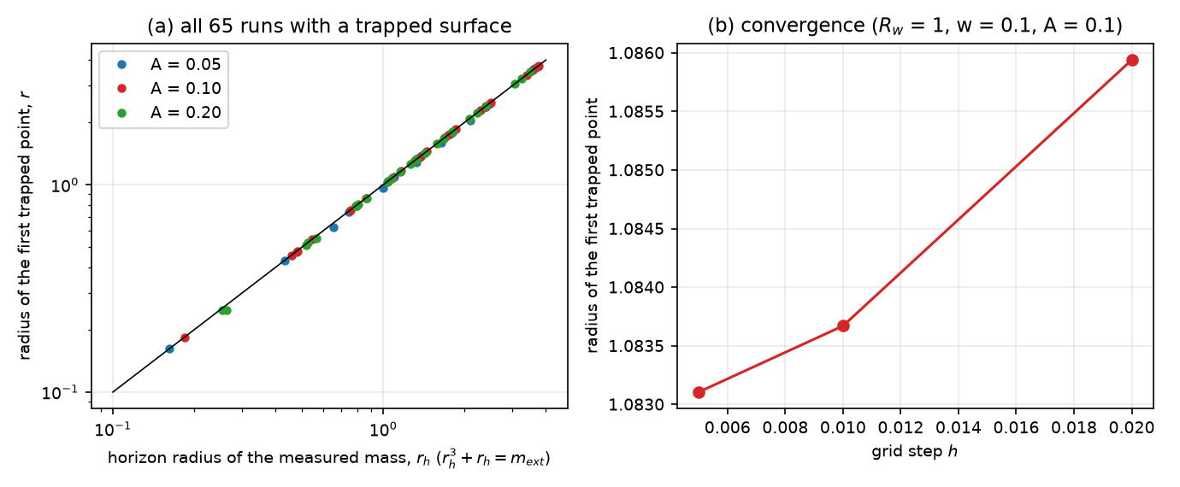
Fig. 2. (a) Radius of the first trapped point against the horizon radius of the Schwarzschild–anti-de Sitter solution of the mass measured outside the wall, for all runs with a trapped surface at the base resolution; the line is equality. (b) Convergence of the first trapped point with the grid step.
5.4 Expanding core: persistence or creation
The question that decides between outcomes A and C is whether an anti-trapped region survives next to the trapped surface, and the question that decides between persistence and creation is whether it can appear where the initial data have none. Fig. 3 classifies the runs by core radius and exterior mass. A core that stays inside its own de Sitter radius (R_{w}≤1.0 R_{dS} for the thin walls, w=0.05, and R_{w}≤1.2 R_{dS} for the thicker ones, the offset being of the order of the wall width) is normal everywhere inside the wall in the initial data, and the collapse is outcome A with a trapped region and a shrinking regular core (37 runs with a trapped surface at the base resolution). A core that extends beyond its own de Sitter radius (R_{w}≥1.2 R_{dS} for thin walls, ≥1.5 R_{dS} for thick walls) contains a region with r_{u}>0 and r_{v}>0 in the initial data, which persists to the end of every such run, next to a trapped region: 28 runs. The thin-wall criterion is a necessary condition in every run: all of the runs with an expanding core have m_{ext}>m_{c}. Mass alone does not decide the outcome, however: several runs with m_{ext} up to 3.0 times m_{c} and a core inside the de Sitter radius have no expanding region.
The distinction between persistence and creation can be tested directly, and it is the main limitation of the evidence. Of the 72 runs, 42 start with a core that is normal everywhere in the initial data and 30 start with an expanding core. In none of the 42 runs that start normal does an anti-trapped point appear at any later row. The simulations therefore show the persistence of an expanding false-vacuum core that the initial data already contain, beside a trapped region that forms around it; they do not show the dynamical creation of an expanding region, let alone a daughter universe, from initially nonexpanding, localized data, and for such data the evidence is the opposite. Because the evolution stops before the global causal structure is established, ‘daughter universe’ is reserved in this paper for a hypothetical global interpretation of the persistent core.
A related question is whether the expanding core could receive matter from the exterior at all. In the chart used here a future-directed causal curve has nondecreasing u and v, because ds²=−f du dv≤0 requires du dv≥0. The false-vacuum core is the region at smaller v than the ingoing wall and the exterior is the region at larger v, so no point of the core lies in the causal future of a point of the exterior: matter or signals of the exterior cannot enter the core, and only signals of the core can reach the exterior. This follows from the geometry of the ingoing wall in the region the chart covers, the domain of dependence of the initial cone, and not from a numerical result; it is the precise sense in which these solutions carry no matter into the core, and it holds within the computed double-null domain and for these initial-data families. It is not a global causal statement: the continuation beyond the last evolved row is unknown. It does not settle the case of a preexisting bridge, whose causal structure has to be computed for the whole spacetime (Section 9.1).
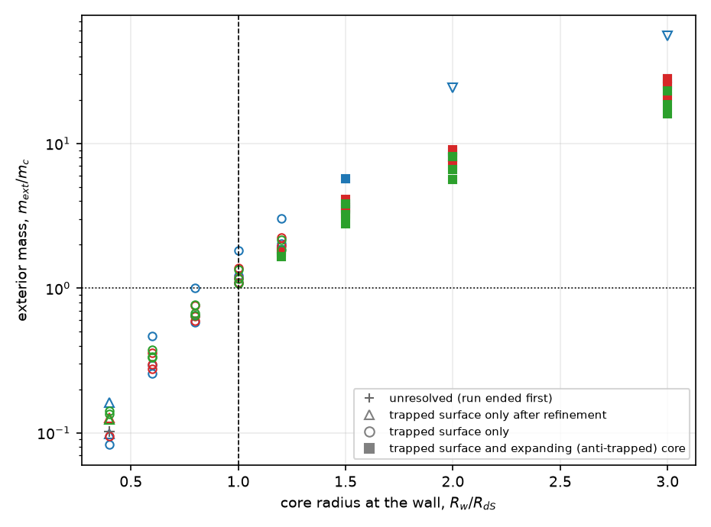
Fig. 3. Outcome of each run against core radius and exterior mass in units of the thin-wall critical mass. Open circles: a trapped surface forms and the core is normal (outcome A); filled squares: a trapped surface forms and an expanding core, present in the initial data, persists; open triangles: a trapped surface forms only after refinement; the cross: unresolved. The dashed line is the core radius equal to R_{dS} and the dotted line is m=m_{c}. Colors distinguish A=0.05 (blue), 0.1 (red) and 0.2 (green).
Fig. 4 shows the causal structure of two runs in terms of the signs of the null expansions. For R_{w}=0.8R_{dS} (panel a) the region inside the ingoing wall stays normal and the region outside it becomes trapped behind the apparent horizon at r≈0.79. For R_{w}=2R_{dS} (panel b) a region of positive expansions in both directions fills the core between the de Sitter horizon and the wall and, in the earliest rows only, extends a little beyond it (Fig. 5); beyond the wall there is first a region with r_{u}>0>r_{v}, the second-exterior quadrant of a bridge, and then a trapped region. No null ray has a minimum of the areal radius, as Proposition 1 requires: over all 3297 rows of all 72 runs, no outgoing ray has a point at which r_{v} changes from negative to positive. The runs do not construct a spacelike slice through the bridge, so no throat is claimed from them; the interpretation of the thin-wall bridge given in Section 4 rests on the exact solution.
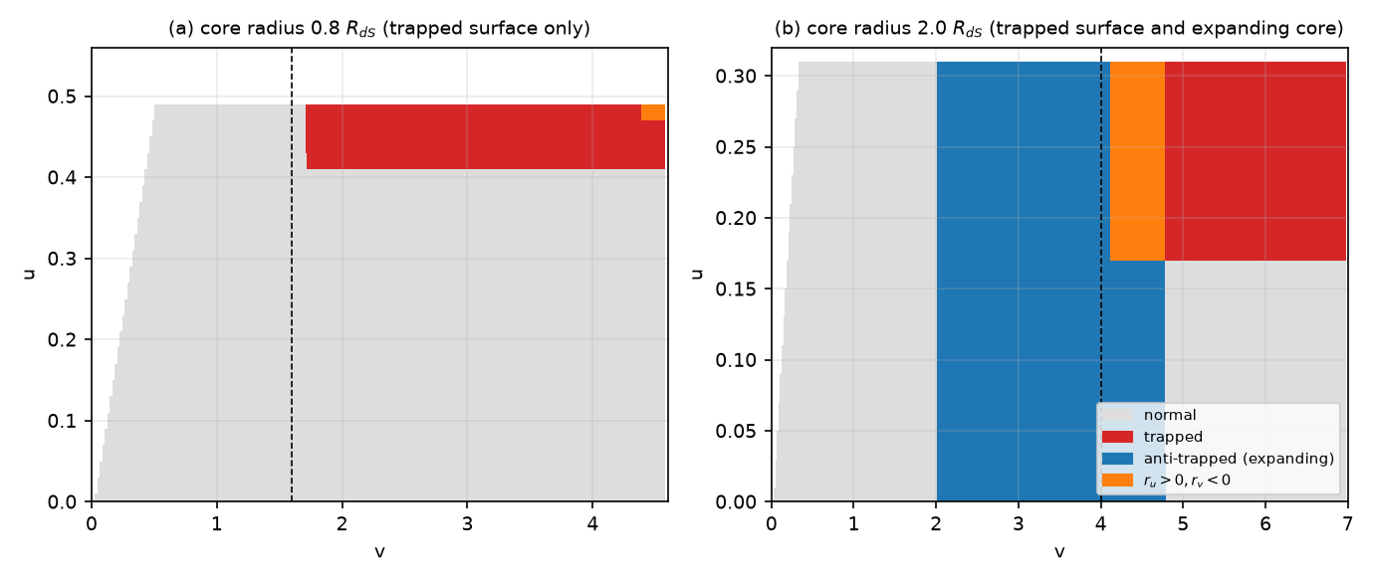
Fig. 4. Quadrants of the null expansions in the (u,v) plane for two runs (A=0.1, w=0.1): (a) a core inside its de Sitter radius, (b) a core outside it. The dashed line is the wall. Gray: normal (r_{u}<0<r_{v}); red: trapped; blue: anti-trapped (expanding); orange: r_{u}>0>r_{v}. The runs stop when the code can no longer follow the trapped region.
To separate what the numerical solutions establish from what is conjecture, a causal-classification diagnostic was run on the two runs of Fig. 4 (causal_diagnostic.py). In the evolved domain of the expanding-core run (16 rows, u≤0.30) the fractions of the lattice in the four sign quadrants are 45% normal, 14% trapped, 37% anti-trapped and 4% with r_{u}>0>r_{v}. The wall, located by the half-way value of φ on every row, stays within 0.12 of v=V_{w}, so that the core and the exterior are the same regions of the chart at all u. One statement follows from the chart and one from the numbers. From the chart: a future-directed causal curve has nondecreasing u and v, so no exterior point lies in the causal past of a core point; a lattice test, which checks this statement on the evolved cells and is not a global causal proof, finds no exterior cell in the causal past of any of the 2,981 anti-trapped cells inside the core, and 100% of the core cells have an exterior cell in their causal future, so signals can leave the core and cannot enter it. From the numbers: the anti-trapped quadrant is not confined to the core. In the earliest rows, up to u=0.16, 479 of the 3,972 anti-trapped cells (12%) lie beyond the wall, in the initial data of the exterior, before that region becomes trapped, and those cells do have exterior cells in their causal past. The statement that the exterior cannot send matter into the expanding region is therefore a statement about the false-vacuum core, and in these runs the exterior contains no matter. Fig. 5 marks what is established (the evolved domain, panel a) and what is not (panel b): the continuation beyond the last row, whether the anti-trapped region reaches a second asymptotic region or closes on itself, and any spacelike slice through a throat. None of these is computed, and the solutions are not labeled wormholes or bridges.
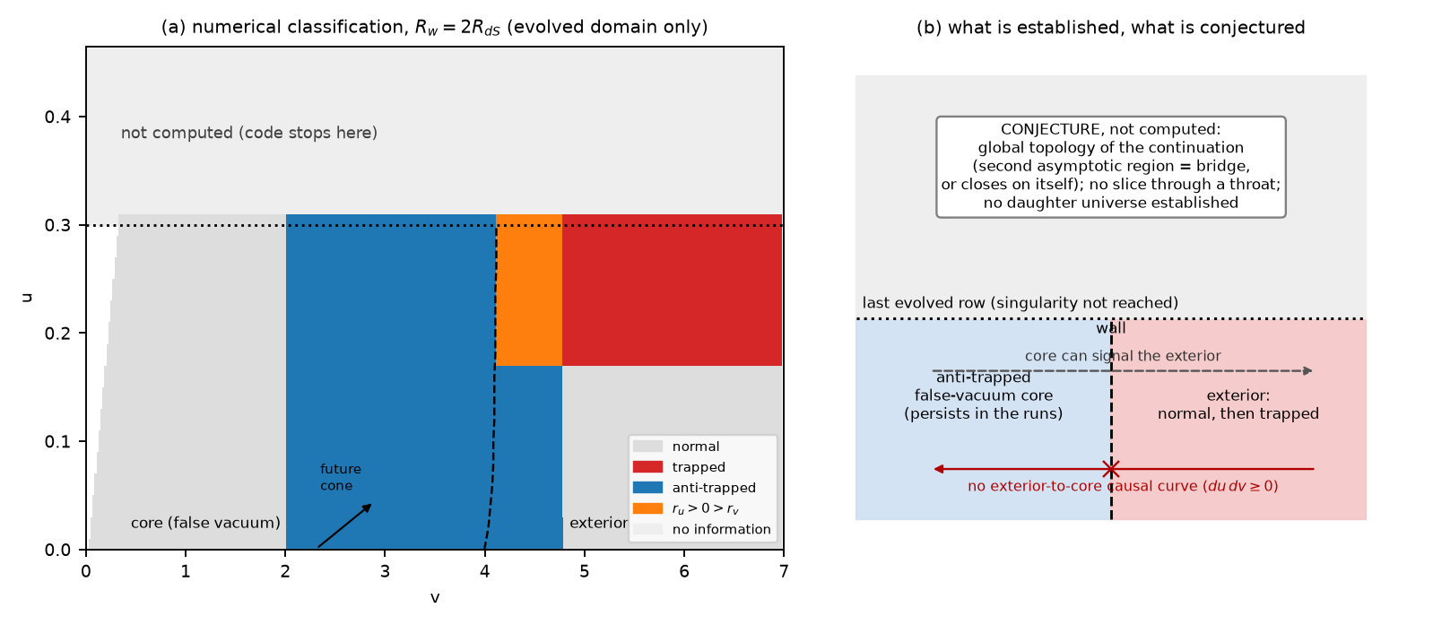
Fig. 5. Causal classification for R_{w}=2R_{dS}, computed domain only. (a) Sign quadrants of the null expansions on the evolved domain, with the wall (dashed), the last evolved row (dotted) and the region that is not computed. (b) What is established (core and exterior fixed regions of the chart; no exterior-to-core causal curve) and what is conjecture and not computed (the global continuation).
Two limits of this evidence should be explicit. First, it establishes that the structure predicted by the thin-wall theory is present at finite thickness and tension; it does not establish what lies beyond the horizon after the code ends, so the statement that an expanding core persists rests on the anti-trapped region, which the dynamics cannot undo, and not on a global evolution. Second, within the scan the thin-wall limit is approached but not reached; the thickness scale of the wall ranges from 1.4% to 5.8% of R_{dS} (Table 1 gives 10⁻³⁰ for the physical wall), so that the match of the apparent-horizon radius to the analytic value to a fraction of a percent is a test of the code and of the exterior solution, not of the thin-wall limit itself; Section 5.6 quantifies the dependence on thickness.
5.5 Exteriors of other vacuum depths
The baseline exterior is anti-de Sitter (q=1). To test how much of the picture depends on that choice, the scan was repeated with A=0.1, two wall widths and seven core radii for q=2 (a deeper anti-de Sitter exterior), q=0 (a Minkowski exterior) and q=−0.5 (a de Sitter exterior of energy 0.5V_{f}), with the thin-wall threshold m_{c}=(1+q)R_{dS} in each case (Fig. 6, Supplementary Table S3). For q=2 the picture of the baseline is reproduced: a trapped surface forms in 14 of the 14 runs, with a radius within a median of 0.2% (maximum 1.3%) of the horizon radius of the exterior, and an expanding core is present in the 7 runs whose core extends beyond its de Sitter radius, none of them with a mass below m_{c}. For q=0 trapped surfaces were found in 5 of the 14 runs (the others ended on nonfinite values before one formed), within a median of 0.5% of the Schwarzschild radius r_{h}=m_{ext}, and again an expanding core in the 7 runs with a core beyond R_{dS} and none below m_{c}. For q=−0.5 the exterior has a black-hole horizon only for masses below the Nariai value m=0.544 R_{dS}, and 10 of the 14 runs have a larger mass; no trapped surface was found in any of them, and an expanding core is present in the 7 runs with a core beyond R_{dS}, again with m_{ext}>m_{c} in all.
Two conclusions follow, and a third limits them. The necessary condition m>m_{c} and the dependence of the expanding core on a core larger than its de Sitter radius do not depend on the sign of the exterior vacuum energy in these runs. What does depend on it is the horizon structure: for q≥0 the false-vacuum region is hidden behind a black-hole horizon, whereas for q<0 and large mass the exterior has no black-hole horizon at all, so that the configuration is not a daughter behind a horizon but an expanding region bounded by the exterior's cosmological horizon, and outcome C in the sense of this paper does not apply. The third is the limit: the q=0 and q=−0.5 scans are largely unresolved with respect to trapped surfaces, so that they support the statement about the expanding core and the threshold, not a full classification. The distinction is the following. The thin-wall criterion of Section 4 holds for every q>−1 and so covers all of the vacuum depths modeled. The numerical evidence is strongest for the anti-de Sitter exteriors (q=1 and 2), where trapped surfaces are found in nearly all runs; the Minkowski and lower-energy de Sitter exteriors do not yet provide equally complete numerical confirmation.
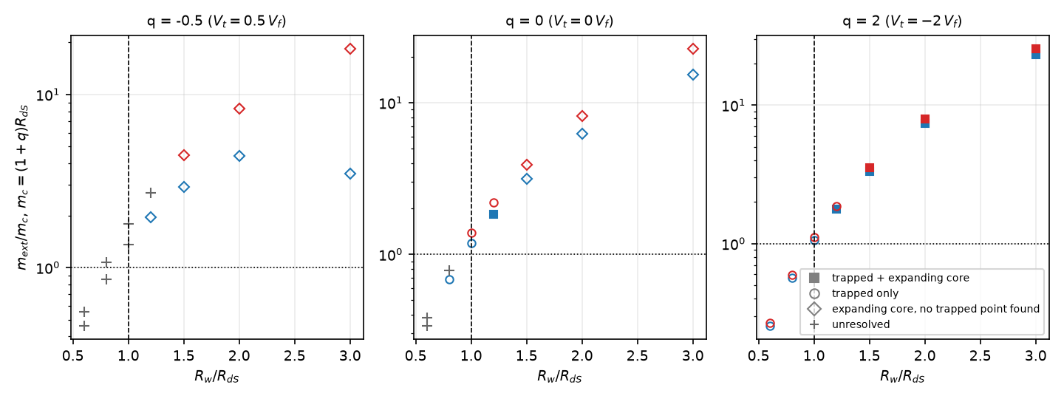
Fig. 6. Outcomes for exteriors of other vacuum depths (A=0.1; blue w=0.05, red w=0.1): core radius against exterior mass in units of m_{c}=(1+q)R_{dS}. The dashed line is R_{w}=R_{dS} and the dotted line is m=m_{c}. Trapped surfaces are found in nearly all runs for q=2 (and for q=1, Fig. 3), in 5 of 14 for q=0 and in none of 14 for q=−0.5, where many masses exceed the Nariai value; ‘unresolved’ marks runs that ended before classification. The thin-wall criterion covers all three exteriors; the numerical confirmation is complete only for the anti-de Sitter case.
5.6 Extrapolation to the physical wall
The experiments use walls that are thicker than the physical wall by a factor 9.9 × 10²⁷ and heavier by 8.5 × 10²⁸ (Table 1); resolving the physical wall on the grid used here would take about 6.9 × 10²⁹ points per de Sitter radius. Which conclusions can be carried to the physical wall? Three classes can be separated, and the third cannot be answered by this paper.
First, conclusions fixed for any thickness by argument. Proposition 1 uses only the null energy condition. The existence of anti-trapped points in the initial core depends on whether the core radius exceeds R_{dS}, with an offset of the order of the wall width (Section 5.4). The thin-wall mass depends on the tension only through σ̂²: at the simulated tensions (σ̂=0.23–0.92) the critical mass is 0.4% to 6.9% below its limit, and at the physical tension the shift is 6×10⁻⁶¹ (Fig. 7b; Supplement S8). Evaluating the criterion at the finite simulated tension instead of the limit does not change the classification of any run: the smallest m_{ext}/m_{c} among the expanding cores is 1.76 with the finite-tension mass and 1.64 with the limit.
Second, conclusions that are insensitive within the resolution. The formation of a trapped surface at subcritical mass holds in every run. The radius of the first trapped point agrees with the horizon radius of the measured mass to a median of 0.20%–0.75% in the normal-core runs (over all trapped runs Section 5.3 gives 0.1%–0.3%), against a resolution floor h/r_{h} of about 1.0%. The deviation shows no trend with the amplitude A, which scales thickness and tension together (95% interval of the slope −0.09 to 0.14 per unit A, consistent with zero), but it does depend on the wall width: the median signed deviation is −0.29%, −0.35% and −0.92% for w=0.05, 0.1 and 0.2, a slope of −0.096 per unit w/R_{dS} (95% interval −0.178 to −0.022). A linear extrapolation to w→0 gives 0.15% (95% interval −0.51% to 0.86%), consistent with the thin-wall value within the resolution floor (Fig. 7a). The result supports consistency with the thin-wall prediction at the one percent resolution of the grid, and no better. The interval is conditional on a linear model in w fitted over 0.05≤w≤0.2 and on a bootstrap over the runs; it is not a systematic-error bound, and the extrapolation does not establish convergence to the physical wall thickness, which lies some 28 orders of magnitude below the smallest width.
Third, what cannot be extrapolated: the dynamics of a wall 10⁻³⁰R_{dS} thick, which is neither resolved nor tested; any quantity at the level of one percent or finer in the horizon radius; the stability of the wall and its energy exchange with the exterior; the fate of matter after the code stops at the singularity; and nonspherical or quantum wall dynamics. The simulations therefore do not validate the physical wall regime. They support the necessary-condition statement m>m_{c}, the null-energy result and the dependence of the expanding core on a core larger than its own de Sitter radius, and they show that the thin-wall structure is present at finite thickness to the stated accuracy.
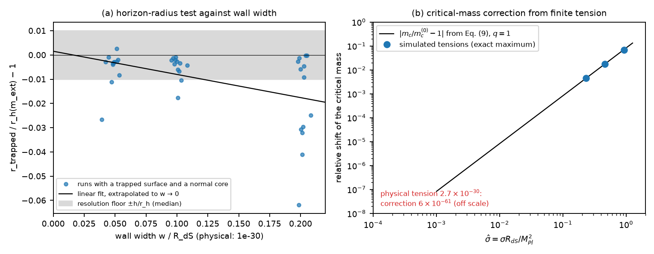
Fig. 7. (a) Radius of the first trapped point relative to the horizon radius of the measured exterior mass against the wall width, with a linear fit extrapolated to zero width and the resolution floor. The fit is linear in w and its interval is conditional on that model. (b) Relative shift of the critical mass with the wall tension (line: Eq. (9); points: the exact maximum at the three simulated tensions); the physical tension lies far to the left and its correction is 6×10⁻⁶¹.
6. Matter transfer and a horizon-area coincidence
The plan to carry all of a universe's matter through a throat to a new beginning needs an accounting that the geometry can check. In a dynamical spacetime a flux of energy through a surface is not a conserved mass unless a time-flow vector and a hypersurface are specified. The unambiguous quantity in spherical symmetry is the Misner–Sharp mass of Eq. (3), which is conserved in vacuum and changes only by the flux of matter, and the exterior mass parameter m_{ext}=2GM that it defines. In the small-tension limit the critical mass m_{c}→(1+q)R_{dS} has a simple meaning: it is ΔR_{dS}³/3, the vacuum-energy difference Δ=(1+q)V_{f} integrated over a de Sitter volume of radius R_{dS}, M_{c}=(4π/3)ΔR_{dS}³. A false-vacuum region of radius R_{w} has an exterior mass of at least ΔR_{w}³/3 because of its vacuum energy alone, so that m>m_{c} is automatic for R_{w}>R_{dS} and no matter is needed to supply it. In the configurations analyzed the expanding core is vacuum energy and nothing else: none of the parent's matter enters it, and none has to. Matter is transferred in no sense, and the exterior black hole is what is left of the parent's vacuum-energy deficit.
The horizon of the exterior at the critical mass has a property that deserves a precise statement. The exterior has f(r)=1−m/r+q r²/R_{dS}² (for ρ_{out}=−qρ_{in} the anti-de Sitter radius satisfies L²=R_{dS}²/q), and its horizons obey r−m+q r³/R_{dS}²=0. At m=(1+q)R_{dS} one root is exactly
$r=R_{dS} ⇒ \frac{A_{dS}}{A_{h}}={\left(\frac{R_{dS}}{r}\right)}^{2}=1$ (11)
for every q>−1: the exterior horizon has the area of the interior de Sitter horizon. For q≥0 this root is the black-hole horizon. For −1<q<0 it is the exterior's cosmological horizon and the black-hole horizon is smaller (for q=−0.5 at m=0.5R_{dS} the roots are 0.618R_{dS} and R_{dS}), so the coincidence is then with the cosmological horizon. At finite tension the critical mass is slightly smaller (Eq. (9)) and the horizon radius at m_{c} is R_{dS}{1−σ̂²[1/4−1/6(1+q)]/(1+3q)}, so that the equality of Eq. (11) holds only in the limit σ̂→0 (Table 2); for the model's tension the departure is 3.1 × 10⁻⁶¹.
Equal horizon areas correspond to equal Bekenstein–Hawking and Gibbons–Hawking entropies A/4G of the two horizons [24,25]. That is a geometric coincidence at the limiting threshold, and it is stated as one. It is not a derivation of the threshold from the generalized second law. Such a statement would need an entropy accounting for the global spacetime, a definition of the horizons that bound the two regions, and the entropy of the matter, none of which is attempted here, and the entropy bound [26] is cited only as context. The coincidence suggests an entropic reading of the threshold; it does not show that thermodynamics independently requires it. The entropy of the observed dark-energy horizon is S_{dS} = 3.3 × 10¹²² in units of k_{B}.
7. How large must the region be, and where can it come from?
In the benchmark model with q=1 the exterior mass must exceed m_{c}=2 R_{dS} (to the accuracy of the limit), that is an exterior mass parameter M_{c} = 1.1 × 10²³ M_{odot} (the quasilocal mass at the wall is half of it for q=1, Section 4), for a region of radius R_{dS} = 5.3 Gpc. This mass is 7.7 times the matter within one Hubble radius today (1.4 × 10²² M_{odot}) and 4.4 times the matter within a sphere of radius R_{dS} (2.5 × 10²² M_{odot}), so that today's matter provides only 23% of it. The present-day matter content of that region is insufficient to reproduce the critical mass through matter alone; the critical gravitational mass is instead dominated by the vacuum-energy difference, which the false vacuum itself supplies, so the criterion does not require matter to be gathered. In the past the matter in such a sphere was larger, and equalled M_{c} at a=0.61 (Fig. 8b); but then the interior was dominated by matter and not by the false-vacuum energy, which is not the vacuum-dominated expanding core studied here, and with dust inside the threshold radius becomes the Hubble radius of the denser interior, a case that the thin-wall and numerical analyses of this paper did not treat. Table 4 gives the requirement for other depths of the true vacuum; deeper vacua need more.
q | m_{c}/R_{dS} | M_{c} (M_{odot}) | M_{c}/M_{H} | M_{c}/M_{R} | Horizon radius r_{h}/R_{dS} at m_{c}
0.25 | 1.25 | 6.97 × 10²² | 4.8 | 2.77 | 1.000
0.50 | 1.50 | 8.37 × 10²² | 5.8 | 3.32 | 1.000
1.00 | 2.00 | 1.12 × 10²³ | 7.7 | 4.43 | 1.000
2.00 | 3.00 | 1.67 × 10²³ | 11.6 | 6.65 | 1.000
4.00 | 5.00 | 2.79 × 10²³ | 19.4 | 11.08 | 1.000
Table 4. Critical region for an expanding core, as a function of the depth of the true vacuum (V_{t}=−qV_{f}), with Planck 2018 parameters and the small-tension limit of the critical mass. M_{H} is the matter within one Hubble radius today and M_{R} the matter within a sphere of radius R_{dS}.
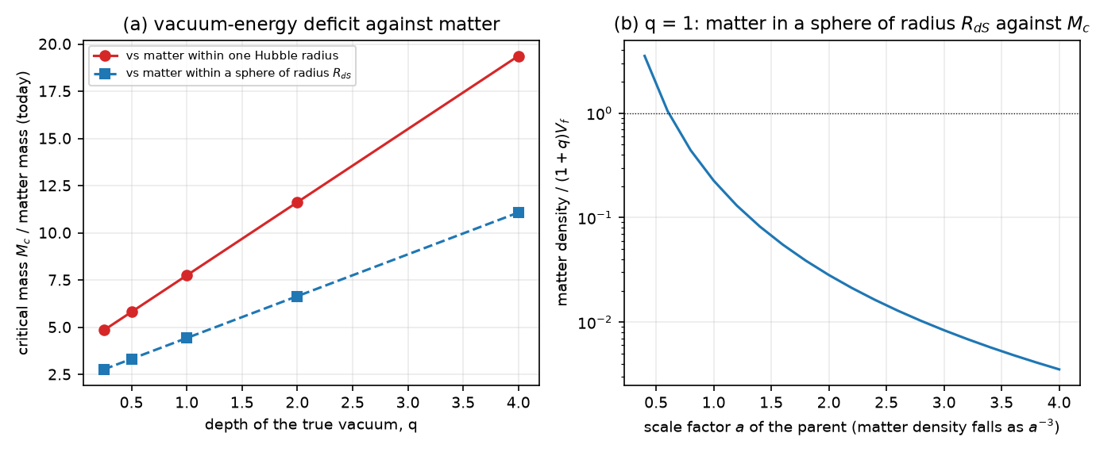
Fig. 8. (a) Critical mass of the false-vacuum region, in units of the matter within one Hubble radius today (red) and within a sphere of radius R_{dS} (blue), against the depth q of the true vacuum. (b) Matter density of the parent, relative to the vacuum-energy difference (1+q)V_{f} for q=1, against its scale factor.
Three conclusions follow, and each can be wrong in a specific way. First, the size: the region has the radius of the de Sitter horizon of the observed dark-energy density, 5.3 Gpc, 1.21 times the Hubble radius today; no lump, void or halo is of that size. In the scanned initial data a false-vacuum region smaller than R_{dS} is outcome A whatever its mass, and for m<m_{c} on the thin-wall branch of Section 4 this is what the analysis proves. Second, the origin: what is left is a region of undecayed false vacuum that is itself larger than R_{dS}, which in this model is a patch of the parent universe that has not made the transition. In the runs studied such a patch is not created by the collapse; the numerical runs show an expanding region only where the initial data already contain it, and what the collapse of its lower-energy surroundings does is trap it behind a horizon. That does not produce a reset of the parent: it separates a piece of the parent's own vacuum. Third, causality: while the parent accelerates, its event horizon is of order R_{dS}, and a region of radius R_{dS} cannot be assembled by classical dynamics inside it, because matter beyond the horizon is out of reach; the requirement can be met only by an acausal initial condition or by a patch that survives. The special case in which the whole parent returns to the false vacuum in a contracting phase is not a localized collapse: it is the homogeneous restoration that the model assumes elsewhere, and it needs no throat.
8. Phase diagram and falsification criteria
Collecting the results, the model has three regimes for a false-vacuum region of core radius R_{w} and exterior mass m, in units of R_{dS} and with q=1. They are limited to the thin-wall branch of Section 4 and to the initial data that were scanned (72 runs for q=1 and 14 for each other q); they are not theorems about all configurations:
• m<m_{c} (thin-wall result): for regular initial data on the spherical thin-wall branch, the wall is confined and collapses; a trapped surface forms (outcome A). In the scan this holds for every run with R_{w}≲R_{dS} and m<m_{c}; no theorem extends it beyond the branch and the data studied.
• m>m_{c} and R_{w}≲R_{dS}: the numerical runs show a trapped surface and a normal core (outcome A), and no expanding region ever appears; extra mass by itself does not keep the core from collapsing.
• R_{w}≳R_{dS} (which implies m>m_{c}): the initial data already contain an expanding core, which persists next to a trapped surface (outcome C in the sense of persistence). It requires the horizon-sized region of Section 7, it is not created by the collapse in any run, and it does not transfer matter.
Each statement of the paper can be falsified, and the falsification criteria are:
1. A violation of the null energy condition by the matter that the model contains. This would remove Proposition 1 and reopen outcome B. For the canonical scalar and dust of the model it is excluded; for a model with a noncanonical kinetic term or a ghost it must be checked afresh.
2. A numerical solution, with a thick or thin wall, in which a trapped region and an expanding core coexist at m_{ext}<m_{c} with regular initial data. The thin-wall result says that none exists; a counterexample would show that the junction analysis misses a configuration.
3. A run in which an anti-trapped region appears at a later time from initial data that have none. None of the 42 runs with a normal initial core does so; a single instance would turn persistence into creation.
4. A mechanism that forms a vacuum-dominated false region of radius ≳R_{dS} by the collapse of smaller regions. None is known, and the numerical runs with R_{w}≲R_{dS} give none.
5. A thick-wall or global evolution whose threshold differs from the finite-tension m_{c}(σ̂) by more than the corrections of finite wall thickness. The experiments of Section 5 show the threshold pattern, but do not measure m_{c} to a stated accuracy.
6. A regular, global evolution through the horizon that shows the expanding core is not a separate region, for example by closing the anti-trapped region. The anti-trapped region cannot be undone by the dynamics in the numerical runs, but a global argument has not been given.
9. Discussion
The result is a conditional negative, and the paper has tried to state exactly what is and is not shown. Shown: the null energy condition removes traversable throats from this model; on the thin-wall branch analyzed, below a finite-tension critical mass every regular configuration collapses; at the limit of vanishing tension the critical mass is (1+q)R_{dS}, at which the horizon areas coincide; trapped surfaces were identified in 65 of the 72 numerical runs at the base resolution and in 6 more after refinement, and the constraints and null expansions converge; and a persistent expanding false-vacuum core coexists with the trapped region when the core is larger than its own de Sitter radius. Not shown: that collapse creates a daughter universe. The expanding core is in the initial data of every run in which it is found, and none of the 42 runs with a smaller core develops one; the simulations show persistence beside a collapse, not creation by it.
Four caveats limit even the persistence result. The exterior vacuum of the baseline is anti-de Sitter, which is not the late-time state of a universe that approaches heat death; the experiments with a Minkowski and a lower de Sitter exterior (Section 5.5) support the threshold and the dependence of the expanding core on its size, but are largely unresolved with respect to trapped surfaces, and for a de Sitter exterior of large mass there is no black-hole horizon to hide behind. The dark matter that motivates the transition is not simulated: the experiments are a scalar-only gravitational benchmark, with the scalar field in a prescribed double-well potential, so the complete matter-triggered process has not been simulated and the effect of dust on the classification of the runs is untested. The expanding core is a cold de Sitter region with the vacuum energy V_{f}. If it were interpreted globally as a daughter universe, producing a hot big bang inside it would need a reheating process, and none is included; and it would not reconnect with the parent: to call the process a cycle one would have to show that the daughter replaces or re-enters the parent, which the geometry does not suggest, because the core is behind the horizon of an exterior black hole whose mass is at least M_{c}.
The work also leaves things undone. The numerical solution is spherically symmetric and classical, the walls are not as thin as the physical wall, the evolution ends at the singularity, and the bridge of Section 4 is a thin-wall construction: no spacelike slice through it is built from the numerical solutions. The tunnelling route to a baby universe [10,11] is outside the classical treatment, and a quantum or semiclassical stress-energy that violates the null energy condition locally could in principle allow a throat; the present model has neither. Perturbations of the exterior and of the wall are not studied, and a nonspherical collapse could form different horizons. A global numerical evolution through the horizon, with excision of the singularity, would settle whether the core is a separate region and would test the bridge directly; it is the most useful extension.
9.1 Primordial bridges and observationally hidden continuations
The results leave a different hypothesis untouched. The expanding cores that persist in the runs are in the initial data, so the experiments say nothing about their origin. The bridge, if there is one, might be primordial, formed in an earlier epoch or part of the global spacetime, and a late-time vacuum transition might then act on an existing bridge instead of creating one. Stated so that it can fail, the hypothesis is that a preexisting, nontraversable bridge connects a late-time vacuum-transition region to an expanding region, with the connection hidden from observers in the parent universe. It does not require matter that violates the null energy condition, and it does not require a throat to form spontaneously at the end of the cosmic evolution. It is not tested here.
Three reasons why such a bridge could be unobservable should be kept apart. It may lie behind an event horizon: a nontraversable Einstein–Rosen-type bridge can be part of the global geometry without letting signals reach distant observers. It may lie beyond our cosmological horizon, where no signal will ever reach us. Or its exterior may mimic an ordinary black hole while its interior topology stays hidden. None of these makes the bridge usable: a bridge behind a horizon is not a passage, and an object beyond our horizon is not an observable mechanism without additional causal assumptions.
A preexisting bridge is also not sufficient by itself. A geometric connection between spatial slices is not a causal path, and matter can be transferred only if some future-directed causal curve joins the parent to the expanding region. In the numerical solutions of Section 5 none does (Section 5.4). That is a property of those solutions and does not settle the primordial case, for which the causal structure of the whole spacetime has to be computed, for example from radial null geodesics. For a traversable throat the energy-condition obstruction of Section 3 applies however the throat arose.
The natural test is a comparison of three kinds of initial data: (A) regular, localized data, as in this paper; (B) data that already contain an Einstein–Rosen-type bridge, followed by the vacuum transition, to ask whether the bridge stays regular, pinches off or develops trapped surfaces; and (C) a bridge with an explicitly defined quantum or modified-gravity correction, to ask whether anything can cross it and whether the geometry is stable. Table 5 sets out the levels of success and what this paper does and does not provide at each. The decisive question is whether a preexisting nontraversable bridge can support an expanding region without matter traversing it; if it can, it could support cosmological reproduction even though it cannot recycle matter. A prediction worth testing must be one that can fail, such as a stability boundary, a causal-accessibility criterion or a quantitative distinction from ordinary black-hole collapse; being undetectable is not one.
Level | Achievement | Status here
1 | A mathematically consistent hidden bridge exists | Thin-wall solution (Section 4, with its literature); not constructed numerically
2 | The bridge survives a density-triggered vacuum transition | Not tested
3 | A causal path carries energy or matter into the expanding region | Absent in the present solutions (Section 5.4); open for a primordial bridge
4 | The expanding region develops a hot cosmology | Not addressed (the core is a cold de Sitter region)
5 | The process repeats under the same laws | Not addressed
Table 5. Levels of success for a preexisting bridge and the status of each in this paper.
9.2 Externally seeded vacuum transitions and critical growth
A further speculative extension is whether an externally prepared, localized high-energy configuration could initiate a vacuum transition whose subsequent evolution is driven by the vacuum-energy difference rather than by continued external energy input. This is analogous, at the level of threshold dynamics, to a self-propagating phase transition, but not to a nuclear chain reaction in its microscopic mechanism. The initiating configuration could in principle arise through an engineered intervention by a sufficiently advanced technological civilization; no such intervention is assumed or modeled here.
In the nongravitating thin-wall approximation a bubble separating two vacuum phases has the energy
$E(R)=4πσR^{2}−\frac{4π}{3}ΔV R^{3}, R_{c}=\frac{2σ}{ΔV}$ (12)
where ΔV>0 is the energy-density advantage of the interior phase. Above R_{c} expansion is energetically favorable within the approximation. In the units of this paper ΔV=(1+q)V_{f}=3(1+q)/R_{dS}², so that R_{c}/R_{dS}=2σ̂/[3(1+q)], which for the model's tension and q=1 is 9.0 × 10⁻³¹, about 0.15 mm: of the order of the wall's own thickness (0.24 mm), so the estimate sits at the edge of the validity of the thin-wall picture. Gravity can change the conclusion substantially, and the junction conditions, the causal structure, the null energy condition and the stability of the wall decide whether such growth is physically possible. A growing vacuum bubble is not necessarily a wormhole, a nonsingular daughter universe or a mechanism for restarting the parent cosmology.
The present results impose an important constraint on this proposal: localized collapse did not create an expanding daughter region in the numerical experiments, and the expanding cores that persisted were already present in the initial data. The gravitational threshold of Section 4 is also not lowered by the energy of a seed, because m_{c} is fixed by the vacuum-energy difference at the scale R_{dS}. Consequently, an engineered seed would require a physically justified mechanism that overcomes the identified formation obstruction rather than merely increasing the initial energy.
A future investigation could compare localized perturbations, externally prepared supercritical bubbles and initial data containing a preexisting bridge. The decisive tests would be whether regular initial data evolve into a newly formed expanding region, whether the solution remains stable, and whether a future-directed causal continuation exists. Such a study would distinguish vacuum-transition propagation from genuine cosmological reproduction.
10. Conclusions
The question was whether a matter-dilution-triggered vacuum transition can form a wormhole, a nonsingular gravitational bridge to an expanding daughter universe, or whether the energy conditions and causal structure of the model forbid it. For this model the answer has three parts. Ordinary traversable throats are forbidden in this classical canonical-scalar and nonnegative-density dust model: the null energy condition holds, and no null ray has a minimum of the areal radius. This does not exclude nontraversable bridges, quantum or semiclassical continuations, or baby-universe scenarios that rest on them. A nontraversable bridge with an expanding region requires an exterior mass above the finite-tension critical value, which is (1+q)R_{dS} in the limit of a probe wall, where the exterior and interior horizon areas coincide; and in the numerical runs the expanding region is present only where the initial data already contain a false-vacuum core larger than its own de Sitter radius, so that the runs show persistence and not creation. At the observed dark-energy scale that core has a radius of 5.3 Gpc and an exterior mass parameter, equal to the vacuum-energy deficit, of 1.1 × 10²³ M_{odot}, 4.4 times the matter within a sphere of that radius today. The critical mass is dominated by the vacuum-energy difference and not by matter; in the tested model and initial-data families a localized collapse does not supply a region of that size, and no mechanism that would is known, and in the computed domain the matter of the parent does not pass into the core. The threshold itself is established for the thin-wall junction branches with regular initial data; for thick walls the experiments show its pattern but do not measure m_{c}, the physical wall is thinner than any numerically resolved wall by thirty orders of magnitude, and for other exterior cosmologies only the thin-wall statement and the incomplete experiments of Section 5.5 apply. The mechanism is therefore best described as the isolation of a horizon-sized false-vacuum patch, not as a cyclic reset, and it is not supported as an end-of-universe process of the model. A preexisting, nontraversable bridge is not excluded; it is the natural next step, and it would need a causal path to carry matter (Section 9.1).
Declarations
Funding: this work received no external funding.
Competing interests: the author declares no competing interests.
Author contributions (CRediT): Leon Sandler, sole author: conceptualization, methodology, software, formal analysis, writing, review and editing.
Data and code availability: the code, the data of every figure and table and the manuscript are archived at https://doi.org/10.5281/zenodo.23995982 (software, all versions) and https://doi.org/10.5281/zenodo.23995978 (manuscript, all versions), and are available at https://github.com/sandlerleon/vacuum-transition-throats. One command per script regenerates every number and figure; the results quoted in the text are read from the JSON files that the scripts write.
Use of generative AI: a generative AI tool (Claude, Anthropic) assisted with code development, numerical experiments, drafting and editing. The author checked all of it and takes full responsibility for the content.
References
[1] P.J. Steinhardt, N. Turok, A cyclic model of the universe, Science 296 (2002) 1436–1439. https://doi.org/10.1126/science.1070462
[2] L. Smolin, Did the universe evolve?, Classical and Quantum Gravity 9 (1992) 173–191. https://doi.org/10.1088/0264-9381/9/1/016
[3] M.S. Morris, K.S. Thorne, Wormholes in spacetime and their use for interstellar travel: A tool for teaching general relativity, American Journal of Physics 56 (1988) 395–412. https://doi.org/10.1119/1.15620
[4] D. Hochberg, M. Visser, Geometric structure of the generic static traversable wormhole throat, Physical Review D 56 (1997) 4745–4755. https://doi.org/10.1103/PhysRevD.56.4745
[5] S.A. Hayward, Dynamic wormholes, International Journal of Modern Physics D 8 (1999) 373–382. https://doi.org/10.1142/S0218271899000286
[6] K. Hinterbichler, J. Khoury, Screening long-range forces through local symmetry restoration, Physical Review Letters 104 (2010) 231301. https://doi.org/10.1103/PhysRevLett.104.231301
[7] S.K. Blau, E.I. Guendelman, A.H. Guth, Dynamics of false-vacuum bubbles, Physical Review D 35 (1987) 1747–1766. https://doi.org/10.1103/PhysRevD.35.1747
[8] V.A. Berezin, V.A. Kuzmin, I.I. Tkachev, Dynamics of bubbles in general relativity, Physical Review D 36 (1987) 2919–2944. https://doi.org/10.1103/PhysRevD.36.2919
[9] V.P. Frolov, M.A. Markov, V.F. Mukhanov, Through a black hole into a new universe?, Physics Letters B 216 (1989) 272–276. https://doi.org/10.1016/0370-2693(89)91114-3
[10] E. Farhi, A.H. Guth, J. Guven, Is it possible to create a universe in the laboratory by quantum tunneling?, Nuclear Physics B 339 (1990) 417–490. https://doi.org/10.1016/0550-3213(90)90357-J
[11] W. Fischler, D. Morgan, J. Polchinski, Quantum nucleation of false-vacuum bubbles, Physical Review D 41 (1990) 2638–2641. https://doi.org/10.1103/PhysRevD.41.2638
[12] E. Farhi, A.H. Guth, An obstacle to creating a universe in the laboratory, Physics Letters B 183 (1987) 149–155. https://doi.org/10.1016/0370-2693(87)90429-1
[13] Planck Collaboration, N. Aghanim et al., Planck 2018 results. VI. Cosmological parameters, Astronomy & Astrophysics 641 (2020) A6. https://doi.org/10.1051/0004-6361/201833910
[14] S. Coleman, F. De Luccia, Gravitational effects on and of vacuum decay, Physical Review D 21 (1980) 3305–3315. https://doi.org/10.1103/PhysRevD.21.3305
[15] L.F. Abbott, S. Coleman, The collapse of an anti-de Sitter bubble, Nuclear Physics B 259 (1985) 170–174. https://doi.org/10.1016/0550-3213(85)90305-0
[16] C.W. Misner, D.H. Sharp, Relativistic equations for adiabatic, spherically symmetric gravitational collapse, Physical Review 136 (1964) B571–B576. https://doi.org/10.1103/PhysRev.136.B571
[17] S.A. Hayward, General laws of black-hole dynamics, Physical Review D 49 (1994) 6467–6474. https://doi.org/10.1103/PhysRevD.49.6467
[18] W. Israel, Singular hypersurfaces and thin shells in general relativity, Il Nuovo Cimento B 44 (1966) 1–14. https://doi.org/10.1007/BF02710419
[19] R. Penrose, Gravitational collapse and space-time singularities, Physical Review Letters 14 (1965) 57–59. https://doi.org/10.1103/PhysRevLett.14.57
[20] D. Christodoulou, The problem of a self-gravitating scalar field, Communications in Mathematical Physics 105 (1986) 337–361. https://doi.org/10.1007/BF01205930
[21] M.W. Choptuik, Universality and scaling in gravitational collapse of a massless scalar field, Physical Review Letters 70 (1993) 9–12. https://doi.org/10.1103/PhysRevLett.70.9
[22] D. Garfinkle, Choptuik scaling in null coordinates, Physical Review D 51 (1995) 5558–5561. https://doi.org/10.1103/PhysRevD.51.5558
[23] C. Gundlach, J.M. Martín-García, Critical phenomena in gravitational collapse, Living Reviews in Relativity 10 (2007) 5. https://doi.org/10.12942/lrr-2007-5
[24] J.D. Bekenstein, Black holes and entropy, Physical Review D 7 (1973) 2333–2346. https://doi.org/10.1103/PhysRevD.7.2333
[25] G.W. Gibbons, S.W. Hawking, Cosmological event horizons, thermodynamics, and particle creation, Physical Review D 15 (1977) 2738–2751. https://doi.org/10.1103/PhysRevD.15.2738
[26] R. Bousso, The holographic principle, Reviews of Modern Physics 74 (2002) 825–874. https://doi.org/10.1103/RevModPhys.74.825

