Vacuum-Transition-Induced Spacetime Throats: Gravitational Collapse, Matter Transfer, and Conditional Cosmological Rebirth
Leon Sandler
Independent Researcher, Northbrook, Illinois, USA
ORCID: https://orcid.org/0009-0007-4584-808X
Corresponding author: leon.sandler@alumni.swinburne.edu

Abstract
Rebirth scenarios invoke a spacetime throat carrying matter from a collapsing region into a new expanding one. We ask whether this can occur when the only matter is a canonical scalar field coupled to dark matter, whose false vacuum has the observed dark-energy density and whose true vacuum lies below it. The null energy condition holds, so no traversable throat can form: no null ray has a minimum of the areal radius. The closest allowed structure is a non-traversable bridge to a black-hole exterior. For a thin wall the Israel junction conditions give an exact critical exterior mass m_{c}=(1+q)R_{dS}, below which every regular configuration collapses; at that mass the exterior horizon and the interior de Sitter horizon have equal area, so the threshold is the equality of their entropies. A spherically symmetric Einstein–scalar code, checked against exact solutions, forms a trapped surface in 65 of 72 runs, within 0.2% (median) of the analytic horizon radius. An expanding core survives beside the trapped region only when the false-vacuum region extends beyond its own de Sitter radius. At the observed dark-energy scale that is 5.3 Gpc, and the vacuum-energy deficit of such a region, 1.1 × 10²³ solar masses, is 4.4 times the matter inside a sphere of that radius today. Localized collapse therefore cannot produce a daughter, and matter is not transferred to it: the daughter is a pre-existing, horizon-sized false-vacuum region that its collapsing surroundings isolate. The mechanism is not supported as a cosmological reset.
Keywords
Spacetime throats; Vacuum decay; False-vacuum bubbles; Baby universes; Null energy condition; Gravitational collapse
1. Introduction
In a universe that dilutes its matter and approaches a cold, dark-energy-dominated state, any mechanism that returns the cosmos to a hot, dense phase has to do two things: change the vacuum, and supply a geometry through which a new expanding region can be reached. Cyclic models [1] and cosmological natural selection [2] place that geometry in a bounce or in a black-hole interior. A more literal proposal is a wormhole: a spacetime throat that forms near the end of the universe and carries matter back to a new beginning. General relativity does not establish that a wormhole behaves as a gravitational vacuum cleaner, and ordinary traversable wormholes need stress-energy that violates the null energy condition [3–5]. A defensible version of the idea must therefore be stated as a set of mathematical questions that can fail.
This paper states and answers such questions for one model. The model is a scalar field φ with a double-well potential whose false vacuum is held in place by dark matter through a symmetron-type coupling [6], so that the observed dark-energy density is carried by the false vacuum while the matter density is above a critical value, and released once the expansion has diluted the matter (Section 2). The release can start locally, by the nucleation of a bubble of the lower vacuum, and the reverse process, the return of a region to the false vacuum when its matter density rises above the critical value, can also be local. The question is what the gravitational collapse of such a region can produce. The hypothesis, stated so that it can fail, is that a density-triggered vacuum transition may create a localized gravitational configuration that, under explicit conditions, develops a spacetime throat connecting a contracting region to a new expanding daughter region.
Three outcomes are distinguished throughout and are not allowed to blur. In outcome A the collapse is ordinary: a trapped region forms and no regular expanding region does. In outcome B a bridge-like geometry exists but nothing can cross it. In outcome C an expanding region exists behind a horizon. A collapsing region can produce a trapped surface without producing either a traversable wormhole or a new universe, and the distinction is the content of the paper. Even outcome C would establish cosmological reproduction, not a cyclic return of the same universe: that additionally needs a daughter that reconnects with or replaces its parent, which no part of this work provides.
The mechanism is not new in its geometry. Thin false-vacuum bubbles in general relativity were analysed in detail in the 1980s [7,8], the possibility of a baby universe attached to a black hole by a throat was explored in classical and quantum form [9–11], and the obstacle that regular initial data do not lead to one was identified at the time [12]. What is new here is the application to a specific density-triggered model with a fixed vacuum scale. The vacuum energy is the observed dark-energy density, so the critical sizes and masses are numbers rather than free parameters, and they can be compared with the matter that the universe actually contains. The paper makes four contributions.
• A null-energy argument for the whole model (Section 3): no traversable throat can form, and no null ray has a minimum of the areal radius.
• An exact thin-wall criterion (Section 4): a critical exterior mass m_{c} below which a false-vacuum region is confined and collapses, with a threshold that coincides with the equality of the horizon entropies of the interior and the exterior (Section 6).
• A numerical Einstein–scalar experiment with a regular centre (Section 5), validated against exact solutions, that tests the criterion with thick walls and maps the outcomes.
• An accounting of the size, mass and entropy that the criterion requires at the observed dark-energy scale, with the conclusion that matter cannot supply them (Sections 6 and 7), and falsification criteria (Section 8).
2. Model and scales
Units are 8πG = 1 (M_{Pl} is the reduced Planck mass) and c = ℏ= 1 unless stated. The action is
$S=\text{∫}d^{4}x\sqrt{−g}\left[\frac{M_{\text{Pl}}^{2}}{2}R−\frac{1}{2}(∇ϕ)^{2}−V_{0}(ϕ)\right]+S_{\text{dm}}\left[A^{2}(ϕ)g_{μν},ψ_{\text{dm}}\right]$ (1)
with A(φ)=1+φ²/2M² the coupling to dark matter alone. For pressureless dark matter of conserved density ρ*∝a⁻³ the scalar moves in V_{eff}=V₀(φ)+ρ*A(φ). While ρ* exceeds a critical value ρ_{crit}=μ²M² the symmetric point of V₀=V_{c}−μ²φ²/2+λφ⁴/4 is a minimum and holds the field in a false vacuum of density V_{f}. When the expansion has diluted the matter below ρ_{crit} the point becomes a maximum and the field can roll to a lower vacuum. Two numbers fix the gravitational problem, and nothing else of the particle physics enters it: the false-vacuum density V_{f}, which is set equal to the observed dark-energy density, and the depth of the true vacuum, V_{t}=−qV_{f} with q>0 (the baseline has q=1). The relevant length is the de Sitter radius of the false vacuum,
$R_{dS}=\sqrt{3/V_{f}}=H_{Λ}^{−1}$ (2)
which for the Planck 2018 values [13] H₀=67.66 km s⁻¹ Mpc⁻¹ and Ω_{Λ}=0.6889 is 5.34 Gpc (H_{Λ}=56.2 km s⁻¹ Mpc⁻¹). The gravitational effect of a wall between the vacua is set by its tension σ. A scalar whose potential scale is the dark-energy scale, V_{f}^{1/4}≈2.2 meV, has a wall tension of the order of V_{f}^{3/4}, that is of order 10 meV³; a bounce calculation for a potential of this kind gives 19 meV³ and a thickness of 0.24 mm, and the conclusions depend only on the wall being a probe, not on these values. In units of the de Sitter radius this is σ̂=σR_{dS}/M_{Pl}² = 2.7 × 10⁻³⁰ and δ/R_{dS} = 1.5 × 10⁻³⁰, so that the wall's own gravity, measured by 3σ̂²/4 for q=1, is 5.5 × 10⁻⁶⁰. The wall is a probe, and its thickness is invisible to any gravitational observable of the size of the de Sitter radius. That fact organizes the paper: the exact thin-wall treatment of Section 4 is controlled by these two numbers, and the numerical experiments of Section 5 can only reach thick, heavy walls and therefore test the structure of the solution, not the physical values.
Table 1 lists the scales. Two processes are of interest. The forward process is the nucleation of a bubble of true vacuum (lower density) inside the false vacuum [14]; its interior is anti-de Sitter and ends in a crunch [15], which settles outcome A for that direction without further work. The reverse process is a region of false vacuum (higher density) inside a true-vacuum exterior, as arises when a region's matter density returns above ρ_{crit} and the field is pinned in its false minimum. The false-vacuum region is then a de Sitter ball in an exterior of lower vacuum energy and positive mass m, which is the configuration of the false-vacuum bubbles of Refs. [7,10]. The rest of the paper concerns this direction.
Quantity | Symbol | Value
de Sitter radius of the false vacuum | R_{dS}=H_{Λ}⁻¹ | 5.34 Gpc (1.65 × 10²⁶ m)
Hubble rate of the false vacuum | H_{Λ} | 56.2 km s⁻¹ Mpc⁻¹
Wall tension in units of M_{Pl}²/R_{dS} | σ̂ | 2.7 × 10⁻³⁰
Wall thickness over R_{dS} | δ/R_{dS} | 1.5 × 10⁻³⁰
Gravitational parameter of the wall | 3σ̂²/4 | 5.5 × 10⁻⁶⁰
de Sitter entropy of the false vacuum | πR_{dS}²/ℓ_{P}² | 3.3 × 10¹²²
Matter within one Hubble radius today | M_{H} | 1.4 × 10²² M_{odot}
Table 1. Scales of the benchmark model (q=1, Planck 2018 cosmology).
3. What the energy conditions allow
A spherically symmetric spacetime is written ds²=−f(u,v) du dv+r(u,v)²dΩ² with null coordinates u (outgoing rays are u= const) and v (ingoing rays are v= const) and areal radius r. The null expansions of the two families are proportional to r_{u} and r_{v}. A sphere is normal if r_{v}>0>r_{u}, trapped if r_{v}<0 and r_{u}<0, and anti-trapped (expanding) if r_{v}>0 and r_{u}>0; the fourth quadrant, r_{u}>0>r_{v}, is the second exterior region of a bridge (a Kruskal-type extension). The Misner–Sharp mass [16] is
$m=r\left(1+\frac{4r_{u}r_{v}}{f}\right)$ (3)
in units where it includes the vacuum energy, m=ρr³/3 for a vacuum of density ρ, and a Schwarzschild–(anti-)de Sitter exterior of mass parameter m_{ext}=2GM has m=m_{ext}+ρ_{out}r³/3. Einstein's equations for the model reduce to (derived symbolically in the repository)
$r_{vv}−{\left(\text{ln}f\right)}_{v}r_{v}=−\frac{r}{2}T_{vv}^{\text{dust}}−\frac{r}{2}{\left(ϕ_{v}\right)}^{2}$ (4)
$r_{uv}=−\frac{r_{u}r_{v}}{r}−\frac{f}{4r}+\frac{Ufr}{4}$ (5)
where U is the total potential (the dust term is omitted in the numerical experiments, Section 5, where the field alone is evolved) and Eq. (4) is the constraint along v (and the analogue along u). The sign of the right-hand side of Eq. (4) is the whole story about throats. For every term of the model the null energy condition holds. For a null vector k, T_{μν}k^{μ} k^{ν}=(k^{μ}∂_{μ}φ)²+ρ_{dm}(k·u)²≥0: the potential terms −g_{μν}V drop out because k is null, whatever the sign of V (including the negative true-vacuum density), and the dark matter is dust of non-negative density in the Einstein frame.
Proposition 1. In spherical symmetry with T_{μν}k^{μ} k^{ν}≥0, no null geodesic has a strict local minimum of the areal radius. Proof. A minimum along an outgoing ray requires r_{v}=0 and r_{vv}≥0 there. Eq. (4) at r_{v}=0 gives r_{vv}=−(r/2)T_{vv}≤0, so r_{vv}≥0 forces T_{vv}=0 and the minimum is not strict; the same argument with u and v exchanged applies to ingoing rays. square This is the local content of the focusing theorem. It means that a throat in the sense of Morris and Thorne, a minimal sphere that a traveller can cross, or a timelike marginal surface of Hayward's dynamic definition, needs matter that violates the null energy condition [4,5,17]. The model has none, so a traversable throat cannot form in it for any parameter values or any wall profile. Outcome B survives only as a non-traversable bridge: a minimal sphere on a spacelike slice (as in the Einstein–Rosen bridge, where the null energy condition holds trivially) that is hidden behind horizons, and outcome C only as an expanding region attached to such a bridge.
That settles the central obstacle identified at the outset, and it narrows the question to what such a bridge needs. Because the question does not involve exotic matter, it can be put to the ordinary Einstein–scalar system exactly (thin wall) and numerically (thick wall).
4. Exact thin-wall criterion
A thin shell of tension σ at areal radius R(τ), with U=dR/dτ, separates an interior de Sitter region of density ρ_{in}=V_{f} from an exterior Schwarzschild–(anti-)de Sitter region of mass parameter m and density ρ_{out}=−qρ_{in} [7,18]. With Δ=ρ_{in}−ρ_{out}=(1+q)V_{f} the Israel junction condition takes the form
$Γ_{in}−Γ_{out}=\frac{σR}{2}, Γ_{in}^{2}=1+U^{2}−\frac{R^{2}}{R_{dS}^{2}}, Γ_{out}^{2}=1+U^{2}−\frac{m}{R}−\frac{ρ_{out}R^{2}}{3}$ (6)
where Γ=dR/dn is the derivative of the areal radius along the unit normal, which points from the interior to the exterior, so that a negative Γ_{in} means that the interior region extends beyond the equator of its de Sitter 3-sphere. Eliminating Γ_{out} gives
$Γ_{in}=\frac{σR}{4}+\frac{m}{σR^{2}}−\frac{ΔR}{3σ}$ (7)
Motion is possible only where U²≥0. For R<R_{dS} this reads m≥m₊(R) or m≤m₋(R) with
$m_{±}(R)=\left(\frac{Δ}{3}−\frac{σ^{2}}{4}\right)R^{3}±σR^{2}\sqrt{1−R^{2}/R_{dS}^{2}}$ (8)
and for R≥R_{dS} it is always satisfied. The curves m± bound a band of forbidden radii (Fig. 1). The band reaches up to the exact critical mass m_{c}=max _{R≤RdS}m₊(R), which equals (1+q)R_{dS} [1+O(σ̂²)]. For m<m_{c} every wall lies either at R≤R₁(m) or at R≥R₂(m), with a forbidden window R₁<R<R₂ around R_{M}=(3m/Δ)^{1/3} that no trajectory crosses. For m>m_{c} there is no window. A numerical scan of R confirms this at nine combinations of tension and depth: a window exists at m=m_{c}(1−10⁻³) and none at m=m_{c}(1+10⁻³) in every case (Table S0 of the supplementary information). For the model's tension the correction is of order 10⁻⁶⁰, so
$m_{c}=(1+q) R_{dS}$ (9)
to all practical purposes: m_{c}=2 R_{dS} for q=1.
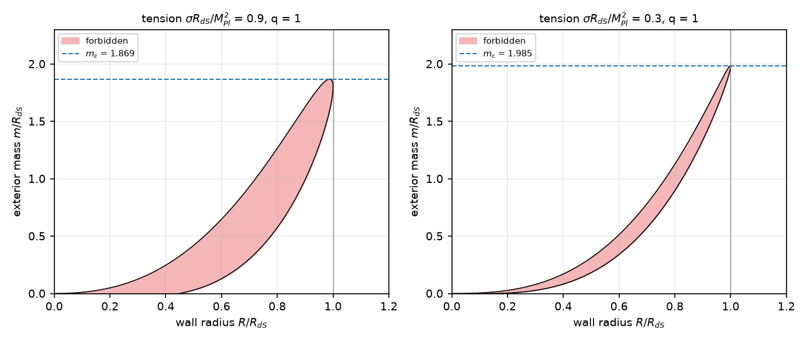
Fig. 1. Allowed and forbidden wall radii for q=1 and two values of the wall tension. The shaded band is forbidden; the dashed line is the exact critical mass m_{c}. For m<m_{c} a horizontal line crosses the band, which a wall cannot cross; for m>m_{c} it does not.
The consequences follow from which side of the window a wall can be on and what a regular initial slice looks like. A slice that is regular, in the sense that the interior is a de Sitter ball less than half of its 3-sphere (Γ_{in}>0) and the exterior is an asymptotic region (Γ_{out}>0), has R<R_{M}(1−O(σ̂)). If m<m_{c} it therefore lies at R≤R₁, can never reach R₂, and collapses to R=0, where the singularity theorem applies [19]: outcome A for every regular configuration of subcritical mass, with no assumption on the initial velocity. The branch R≥R₂ needs Γ_{in}<0, an interior beyond the equator of its own de Sitter space, which has a neck on every slice that crosses it. That is the configuration of the baby-universe solutions of Refs. [7,10], and it cannot be reached from regular data; this is the obstacle of Ref. [12]. For m>m_{c} the window is absent, so a wall that starts regular can move out through R_{M}, where Γ_{in} changes sign. The solution then develops a neck at the wall: a minimal sphere on a spacelike slice, not forbidden by Proposition 1, whose two sides are the expanding interior and the far side of the exterior bridge.
Two statements are therefore exact in the thin-wall model. First, m>m_{c} is necessary for any regular configuration to develop a neck. Second, because m_{c}=(1+q)R_{dS} is fixed by the vacuum energy, the necessary mass is a property of the observed dark-energy scale, not of the particle physics. Whether the condition is also sufficient, and what thick walls do, is a question for the numerical evolution of the next section.
5. Numerical experiment: collapse of a false-vacuum core with a regular centre
5.1 Formulation
The thin-wall result is exact but assumes an infinitely thin, infinitely light wall. To test its structure with a wall of finite thickness and tension, the coupled Einstein–scalar equations are evolved in double-null gauge with a regular centre, the standard formulation of spherical scalar-field collapse [20,21], which resolves trapped surfaces and expanding regions and requires no choice of slicing near horizons. The equations are Eqs. (4) and (5) with the scalar equation and the equation for f,
$ϕ_{uv}=−\frac{ϕ_{u}r_{v}+ϕ_{v}r_{u}}{r}−\frac{f}{4}U'(ϕ), (\text{ln}f)_{uv}=\frac{f+4r_{u}r_{v}}{2r^{2}}−ϕ_{u}ϕ_{v}$ (10)
with U(φ)=(κ/4)(φ²/A²−1)²+sφ/A+d, tuned so that the false minimum has density ρ_{in}=3 (so that R_{dS}=1) and the true minimum has density −qρ_{in}, with q=1 and κ=24. The field amplitude A is the only free scale of the wall: its thickness is ℓ=A√2/κ and its tension is of the order of A√κ/2, so that A→0 is the thin, light wall limit. The scheme is the second-order diamond predictor–corrector on a uniform lattice [22,23]: r and φ are updated cell by cell, the metric function σ=ln f is integrated from the constraint within six points of the centre, where the evolution equation divides by a small radius, and from its evolution equation beyond; the centre value of σ follows from elementary flatness, r_{v}=√f/2, solved by the secant method because the plain iteration has a gain of modulus greater than one, and the centre value of φ from regularity, φ_{t}=2φ_{v}, by an implicit trapezoid. Data are given on the outgoing null cone from the centre in the gauge r=v/2: φ(0,v) is false vacuum for v<V_{w} and true vacuum beyond, with a tanh transition of width w, and σ(0,v) follows from the constraint. The wall is then an ingoing wall of radius R_{w}=V_{w}/2, with the false-vacuum core inside it and no matter outside. The code is dnull.py; the equations were derived symbolically (derive_equations.py).
Three limits of the method should be stated at once. The scheme does not follow the evolution beyond the formation of a singularity, where f diverges: a run ends when σ exceeds 12 or a value becomes non-finite, and the classification below uses only features that cannot be undone by the evolution that follows, a trapped surface and an anti-trapped region. The wall is far thicker and heavier than the physical wall by thirty and sixty orders of magnitude (Table 1), so the experiments test structure, not the values of the physical model. And the evolution is spherically symmetric and classical.
5.2 Verification
The solver was checked against the two exact vacuum solutions with a regular centre. For de Sitter space (ρ=3) and anti-de Sitter space (ρ=−3) the Misner–Sharp mass of Eq. (3) must equal ρr³/3 at every point. Table 2 gives the largest relative error for three grid steps; the errors fall at second order. The radius of the first trapped point of a collapsing run (R_{w}=1, w=0.1, A=0.1) converges at the same order, 1.0859, 1.0837 and 1.0831 at h=0.02, 0.01 and 0.005, with a Richardson extrapolation of 1.0829.
Vacuum | h=0.04 | h=0.02 | h=0.01 | Orders
de Sitter | 1.9 × 10⁻⁴ | 5.1 × 10⁻⁵ | 1.3 × 10⁻⁵ | 1.9, 2.0
anti-de Sitter | 1.8 × 10⁻⁴ | 4.8 × 10⁻⁵ | 4.8 × 10⁻⁶ | 1.9, 3.3
Table 2. Verification against exact vacuum solutions: largest relative error of the Misner–Sharp mass with a regular centre (u≤0.6, v≤3).
5.3 Horizon formation
A scan of 72 runs varies the field amplitude (A=0.05, 0.1 and 0.2), the wall width (w=0.05, 0.1 and 0.2) and the core radius R_{w}/R_{dS} from 0.4 to 3 (Supplementary Table S1). Each run measures the exterior mass m_{ext} on the initial cone beyond the wall, from the Misner–Sharp mass (constant across the exterior to within 2% in 70 of the 72 runs, at most 9.5%), and the radius of the first trapped point. In 65 runs a trapped surface forms before the code breaks down, and in 7 runs (low-mass wide walls and two high-mass wide walls) the run ended before it could be classified; none of the runs reached the end of its domain without a trapped surface. The radius of the first trapped point agrees with the horizon radius of the Schwarzschild–anti-de Sitter solution of the measured mass, r_{h}³+r_{h}=m_{ext} for q=1, to a median of 0.2%, a 95th percentile of 3.1% and a maximum of 6.2% (Fig. 2); the agreement is best at A=0.1 (median 0.1%) and is not monotonic in A, which is expected because the apparent horizon forms in a region where the wall has not yet fully passed.
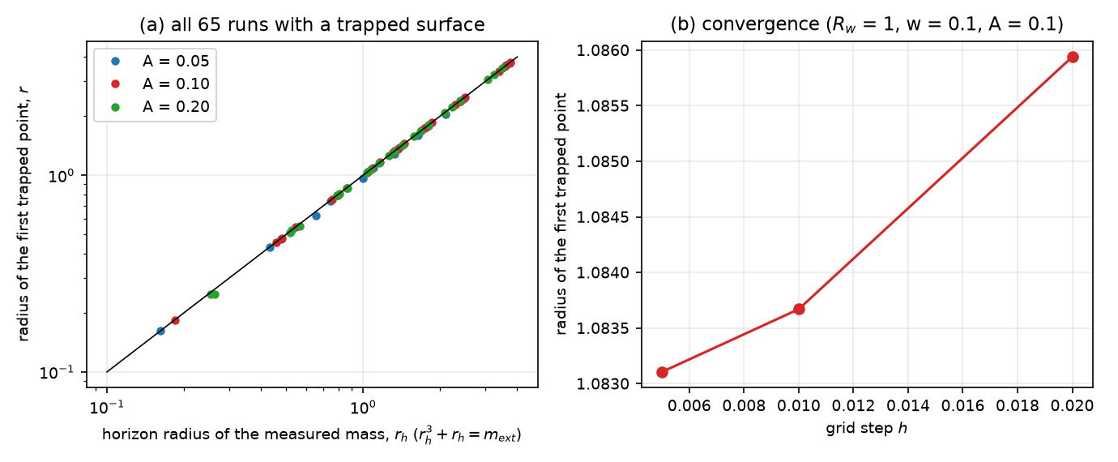
Fig. 2. (a) Radius of the first trapped point against the horizon radius of the Schwarzschild–anti-de Sitter solution of the mass measured outside the wall, for all runs with a trapped surface; the line is equality. (b) Convergence of the first trapped point with the grid step.
5.4 Expanding core
The question that decides between outcomes A and C is whether an anti-trapped region survives next to the trapped surface. Fig. 3 classifies the runs by core radius and exterior mass. A core that stays inside its own de Sitter radius (R_{w}≤1.0 R_{dS} for the thin walls, w=0.05, and R_{w}≤1.2 R_{dS} for the thicker ones, the offset being of the order of the wall width) is normal everywhere inside the wall (37 runs), and the collapse is outcome A with a trapped region and a shrinking regular core. A core that extends beyond its own de Sitter radius (R_{w}≥1.2 R_{dS} for thin walls, ≥1.5 R_{dS} for thick walls; the offset is of order the wall width) contains a region with r_{u}>0 and r_{v}>0 from the start, which persists to the end of every such run, next to a trapped region: 28 runs. The thin-wall criterion is a necessary condition in every run: all of the runs with an expanding core have m_{ext}>m_{c} (Fig. 3, filled squares above the dotted line). Mass alone does not decide the outcome, however: several runs with m_{ext} up to 3.0 times m_{c} and a core inside the de Sitter radius have no expanding region.
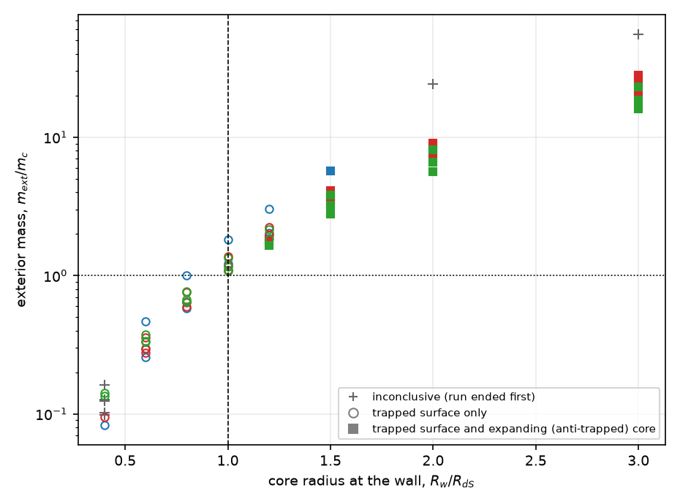
Fig. 3. Outcome of each run against core radius and exterior mass in units of the thin-wall critical mass. Open circles: a trapped surface forms and the core is normal (outcome A); filled squares: a trapped surface forms and an expanding core persists; crosses: the run ended before classification. The dashed line is the core radius equal to R_{dS} and the dotted line is m=m_{c}. Colours distinguish A=0.05 (blue), 0.1 (red) and 0.2 (green).
Fig. 4 shows the causal structure of two runs in terms of the signs of the null expansions. For R_{w}=0.8R_{dS} (panel a) the region inside the ingoing wall stays normal and the region outside it becomes trapped behind the apparent horizon at r≈0.79. For R_{w}=2R_{dS} (panel b) a region of positive expansions in both directions fills the core between the dS horizon and the wall; beyond the wall there is first a region with r_{u}>0>r_{v}, the second-exterior quadrant of a bridge, and then a trapped region. The geometry on the two sides of the wall is that of the neck of Section 4: the areal radius has a minimum on a slice that crosses the wall, between an expanding interior and an exterior that is trapped. No null ray has a minimum of the areal radius, as Proposition 1 requires: over all 3297 rows of all 72 runs, no outgoing ray has a point at which r_{v} changes from negative to positive.
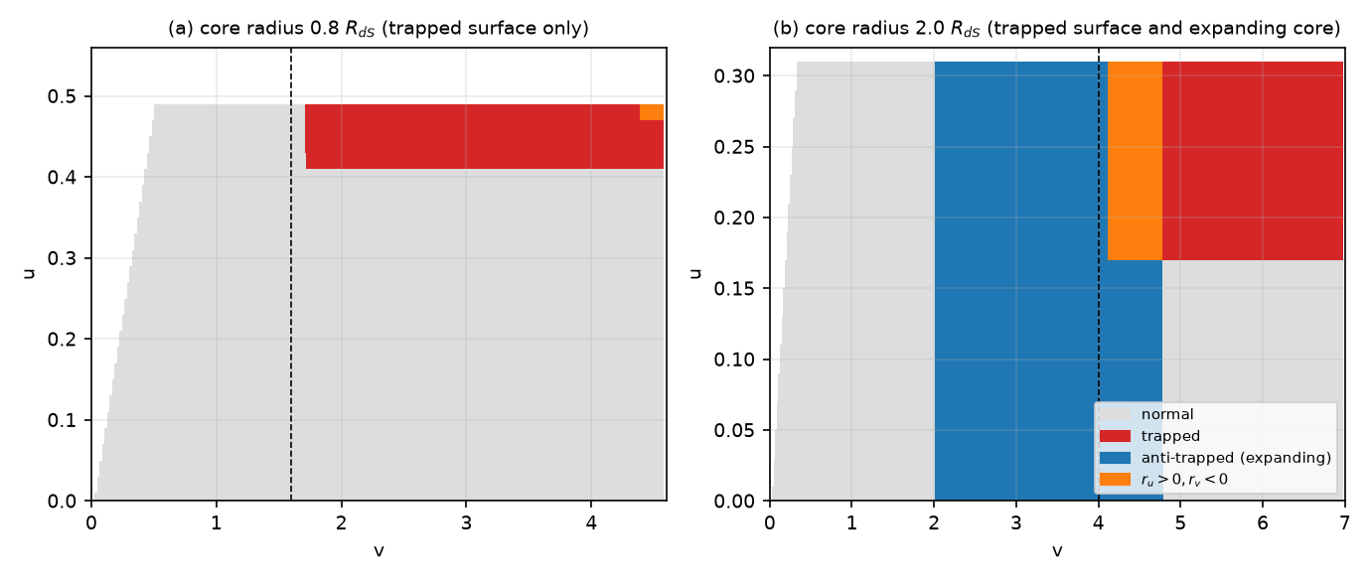
Fig. 4. Quadrants of the null expansions in the (u,v) plane for two runs (A=0.1, w=0.1): (a) a core inside its de Sitter radius, (b) a core outside it. The dashed line is the wall. Grey: normal (r_{u}<0<r_{v}); red: trapped; blue: anti-trapped (expanding); orange: r_{u}>0>r_{v}. The runs stop when the code can no longer follow the trapped region.
Two limits of this evidence should be explicit. First, it establishes that the structure predicted by the thin-wall theory is present at finite thickness and tension; it does not establish what lies beyond the horizon after the code ends, so the statement that an expanding core is a daughter region rests on the persistence of the anti-trapped region, which the dynamics cannot undo, and not on a global evolution. Second, within the scan the thin-wall limit is approached but not reached; the thickness of the wall ranges from 1.4% to 5.8% of R_{dS} (Table 1 gives 10⁻³⁰ for the physical wall), so that the match of the apparent-horizon radius to the analytic value to a fraction of a percent is a test of the code and of the exterior solution, not of the thin-wall limit itself.
6. Matter transfer and entropy
The plan to carry all of a universe's matter through a throat to a new beginning needs an accounting that the geometry can check. In a dynamical spacetime a flux of energy through a surface is not a conserved mass unless a time-flow vector and a hypersurface are specified. The unambiguous quantity in spherical symmetry is the Misner–Sharp mass of Eq. (3), which is conserved in vacuum and changes only by the flux of matter, and the exterior mass parameter m_{ext}=2GM that it defines. The critical mass m_{c}=(1+q)R_{dS} has a simple meaning: it is m_{c}=ΔR_{dS}³/3, that is the vacuum-energy difference Δ=(1+q)V_{f} integrated over a de Sitter volume of radius R_{dS}, M_{c}=(4π/3)ΔR_{dS}³. A false-vacuum region of radius R_{w} has an exterior mass of at least ΔR_{w}³/3 because of its vacuum energy alone, so that m>m_{c} is automatic for R_{w}>R_{dS} and no matter is needed to supply it. In the configurations analysed the daughter is vacuum energy and nothing else: none of the parent's matter enters it, and none has to. Matter is transferred in no sense, and the exterior black hole is what is left of the parent's vacuum-energy deficit.
The horizon of the exterior at the critical mass has a remarkable property. The exterior has f(r)=1−m/r+q r²/R_{dS}² (for ρ_{out}=−qρ_{in} the anti-de Sitter radius satisfies L²=R_{dS}²/q), and its horizon obeys r_{h}−m+q r_{h}³/R_{dS}²=0. At m=(1+q)R_{dS} the root is exactly
$r_{h}=R_{dS} ⇒ \frac{S_{dS}}{S_{BH}}={\left(\frac{R_{dS}}{r_{h}}\right)}^{2}=1$ (11)
for every q (the left side of Eq. (11) uses the Gibbons–Hawking entropy of the de Sitter horizon and the Bekenstein–Hawking entropy of the black hole, each A/4G [24,25]; the thin-wall correction is of order σ̂²). At the critical mass the horizon entropies of the interior and of the exterior black hole are equal, and for m>m_{c} the black hole has the larger entropy. Below m_{c} the de Sitter horizon of a daughter would carry more entropy than the black hole that contains it, and that is the regime in which the wall is confined. The geometry therefore agrees with the generalized second law at the threshold, and the entropy bound [26] gives a reason for the criterion that does not depend on the details of the wall. The daughter's entropy is S_{dS} = 3.3 × 10¹²² in units of k_{B}, the entropy of the observed dark-energy horizon.
7. How large must the region be, and where can it come from?
In the benchmark model with q=1 the exterior mass must exceed m_{c}=2 R_{dS}, that is a mass M_{c} = 1.1 × 10²³ M_{odot}, for a region of radius R_{dS} = 5.3 Gpc. This mass is 7.7 times the matter within one Hubble radius today (1.4 × 10²² M_{odot}) and 4.4 times the matter within a sphere of radius R_{dS} (2.5 × 10²² M_{odot}), so that today's matter provides only 23% of it. The remainder is the vacuum-energy deficit, and no collection of matter within that sphere can make up the difference. In the past the matter in such a sphere was larger, and equalled M_{c} at a=0.61 (Fig. 5b); but then the interior was dominated by matter and contracting, which has no expanding core, and with dust inside the threshold radius becomes the Hubble radius of the denser interior, a case that the thin-wall and numerical analyses of this paper did not treat. Table 3 gives the requirement for other depths of the true vacuum; deeper vacua need more.
q | m_{c}/R_{dS} | M_{c} (M_{odot}) | M_{c}/M_{H} | M_{c}/M_{R} | Horizon radius r_{h}/R_{dS} at m_{c}
0.25 | 1.25 | 6.97 × 10²² | 4.8 | 2.77 | 1.000
0.50 | 1.50 | 8.37 × 10²² | 5.8 | 3.32 | 1.000
1.00 | 2.00 | 1.12 × 10²³ | 7.7 | 4.43 | 1.000
2.00 | 3.00 | 1.67 × 10²³ | 11.6 | 6.65 | 1.000
4.00 | 5.00 | 2.79 × 10²³ | 19.4 | 11.08 | 1.000
Table 3. Critical region for a daughter, as a function of the depth of the true vacuum (V_{t}=−qV_{f}), with Planck 2018 parameters. M_{H} is the matter within one Hubble radius today and M_{R} the matter within a sphere of radius R_{dS}.
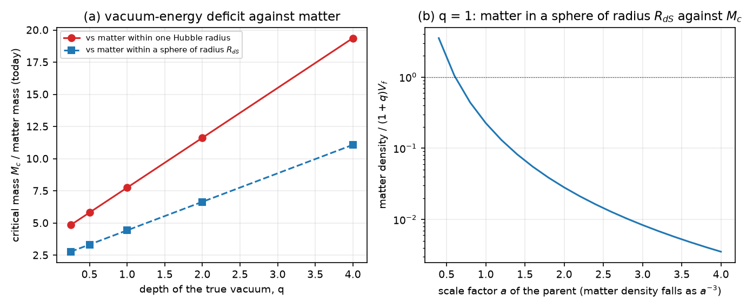
Fig. 5. (a) Critical mass of the false-vacuum region, in units of the matter within one Hubble radius today (red) and within a sphere of radius R_{dS} (blue), against the depth q of the true vacuum. (b) Matter density of the parent, relative to the vacuum-energy difference (1+q)V_{f} for q=1, against its scale factor.
Three conclusions follow, and each can be wrong in a specific way. First, the size: the region has the radius of the de Sitter horizon of the observed dark-energy density, 5.3 Gpc, 1.21 times the Hubble radius today; no lump, void or halo is of that size. A false-vacuum region smaller than R_{dS}, whatever its mass, is outcome A: this is what the numerical runs with R_{w}≲R_{dS} show and, for m<m_{c}, what the thin-wall analysis proves. Second, the origin: what is left is a region of undecayed false vacuum that is itself larger than R_{dS}, which in this model is a patch of the parent universe that has not made the transition. Such a patch is not created by the collapse; it exists beforehand, and what the collapse of its lower-energy surroundings does is trap it behind a horizon. That does not produce a reset of the parent: it separates a piece of the parent's own vacuum. Third, causality: while the parent accelerates, its event horizon is of order R_{dS}, and a region of radius R_{dS} cannot be assembled by dynamics inside it, because matter beyond the horizon is out of reach; the requirement can be met only by an acausal initial condition or by a patch that survives. The special case in which the whole parent returns to the false vacuum in a contracting phase is not a localized collapse: it is the homogeneous restoration that the model assumes elsewhere, and it needs no throat.
8. Phase diagram and falsification criteria
Collecting the results, the model has three regimes for a false-vacuum region of core radius R_{w} and exterior mass m, in units of R_{dS} and with q=1:
• m<m_{c} (exact): the wall is confined and collapses; a trapped surface forms (outcome A). This includes every region that is smaller than R_{dS} and has no more than its own vacuum energy.
• m>m_{c} and R_{w}≲R_{dS}: the numerical runs show a trapped surface and a normal core (outcome A): extra mass by itself does not keep the core from collapsing.
• R_{w}≳R_{dS} (which implies m>m_{c}): a trapped surface forms next to a persisting expanding core, with a neck-like minimum of the areal radius on a spacelike slice; this is outcome C, a daughter behind a horizon. It requires the horizon-sized region of Section 7, and it does not transfer matter.
Each statement of the paper can be falsified, and the falsification criteria are:
1. A violation of the null energy condition by the matter that the model contains. This would remove Proposition 1 and reopen outcome B. For the canonical scalar and dust of the model it is excluded; for a model with a non-canonical kinetic term or a ghost it must be checked afresh.
2. A numerical solution, with a thick or thin wall, in which a trapped region and an expanding core coexist at m_{ext}<m_{c} with regular initial data. The thin-wall result says that none exists; a counterexample would show that the junction analysis misses a configuration.
3. A mechanism that forms a vacuum-dominated false region of radius ≳R_{dS} by the collapse of smaller regions. None is known, and the numerical runs with R_{w}≲R_{dS} give none.
4. A daughter whose horizon entropy exceeds that of the exterior black hole. This would conflict with the generalized second law at the threshold of Eq. (11), and either the law or the classical solution would have to give way.
5. A regular, global evolution of the thick-wall problem through the horizon that shows the core is not a separate daughter, for example by closing the anti-trapped region. The anti-trapped region cannot be undone by the dynamics in the numerical runs, but a global argument has not been given.
9. Discussion
The result is a conditional negative with one specific positive. The negative: localized collapse in this model does not create a new universe, matter is not carried through a throat, and the null energy condition removes traversable throats outright. The positive: a regular expanding de Sitter core next to a trapped region does exist when the false-vacuum region extends beyond its own de Sitter radius, and its existence is sharply characterized by m>m_{c}=(1+q)R_{dS} together with R_{w}≳R_{dS}, a condition that equates the horizon entropies of the interior and the exterior black hole. What the positive result describes is the isolation of an existing region, not a rebirth.
Three caveats limit even that. The daughter obtained here is a cold de Sitter region with the vacuum energy V_{f}. Producing a hot big bang inside it needs a reheating process, and none is included. The daughter also does not reconnect with the parent: to call the process a cycle one would have to show that the daughter replaces or re-enters the parent, which the geometry does not suggest, because the daughter is behind the horizon of an exterior black hole. And the daughter exists together with an exterior black hole whose mass is at least M_{c}, so that a parent which isolated such a region would be left with an object of that mass and would differ from the universe observed.
The work also leaves things undone. The numerical solution is spherically symmetric and classical, the walls are not as thin as the physical wall, the evolution ends at the singularity, and the dark matter is omitted from the numerical experiments (it is present in the null-energy argument and the thin-wall criterion, which do not depend on it). The tunnelling route to a baby universe [10,11] is outside the classical treatment, and a quantum or semiclassical stress-energy that violates the null energy condition locally could in principle allow a throat; the present model has neither. Perturbations of the exterior and of the wall are not studied, and a nonspherical collapse could form different horizons. A global numerical evolution through the horizon, with excision of the singularity, would settle whether the core is a separate region, and is the most useful extension.
10. Conclusions
The question was whether a matter-dilution-triggered vacuum transition can produce a non-singular gravitational bridge to an expanding daughter universe, or whether the energy conditions and causal structure of the model forbid it. For this model the answer has three parts. A traversable throat is forbidden: the null energy condition holds, and no null ray has a minimum of the areal radius. A non-traversable bridge with an expanding daughter is allowed exactly when the exterior mass exceeds the critical value m_{c}=(1+q)R_{dS}, where the horizon entropies of the interior and exterior coincide, and in the numerical runs when the false-vacuum core extends beyond its own de Sitter radius. At the observed dark-energy scale that is a region of 5.3 Gpc whose vacuum-energy deficit, 1.1 × 10²³ M_{odot}, is 4.4 times the matter within a sphere of that radius today. A localized collapse cannot supply it, and the matter of the parent does not pass to the daughter. The mechanism is therefore best described as the isolation of a horizon-sized false-vacuum patch, not as a cyclic reset, and it is not supported as an end-of-universe process of the model.
Declarations
Funding: this work received no external funding.
Competing interests: the author declares no competing interests.
Author contributions (CRediT): Leon Sandler, sole author: conceptualization, methodology, software, formal analysis, writing, review and editing.
Data and code availability: the code, the data of every figure and table and the manuscript are archived at https://doi.org/10.5281/zenodo.23995982 (software, all versions) and https://doi.org/10.5281/zenodo.23995978 (manuscript, all versions), and are available at https://github.com/sandlerleon/vacuum-transition-throats. One command per script regenerates every number and figure; the results quoted in the text are read from the JSON files that the scripts write.
Use of generative AI: a generative AI tool (Claude, Anthropic) assisted with code development, numerical experiments, drafting and editing. The author checked all of it and takes full responsibility for the content.
References
[1] P.J. Steinhardt, N. Turok, A cyclic model of the universe, Science 296 (2002) 1436–1439. https://doi.org/10.1126/science.1070462
[2] L. Smolin, Did the universe evolve?, Classical and Quantum Gravity 9 (1992) 173–191. https://doi.org/10.1088/0264-9381/9/1/016
[3] M.S. Morris, K.S. Thorne, Wormholes in spacetime and their use for interstellar travel: A tool for teaching general relativity, American Journal of Physics 56 (1988) 395–412. https://doi.org/10.1119/1.15620
[4] D. Hochberg, M. Visser, Geometric structure of the generic static traversable wormhole throat, Physical Review D 56 (1997) 4745–4755. https://doi.org/10.1103/PhysRevD.56.4745
[5] S.A. Hayward, Dynamic wormholes, International Journal of Modern Physics D 8 (1999) 373–382. https://doi.org/10.1142/S0218271899000286
[6] K. Hinterbichler, J. Khoury, Screening long-range forces through local symmetry restoration, Physical Review Letters 104 (2010) 231301. https://doi.org/10.1103/PhysRevLett.104.231301
[7] S.K. Blau, E.I. Guendelman, A.H. Guth, Dynamics of false-vacuum bubbles, Physical Review D 35 (1987) 1747–1766. https://doi.org/10.1103/PhysRevD.35.1747
[8] V.A. Berezin, V.A. Kuzmin, I.I. Tkachev, Dynamics of bubbles in general relativity, Physical Review D 36 (1987) 2919–2944. https://doi.org/10.1103/PhysRevD.36.2919
[9] V.P. Frolov, M.A. Markov, V.F. Mukhanov, Through a black hole into a new universe?, Physics Letters B 216 (1989) 272–276. https://doi.org/10.1016/0370-2693(89)91114-3
[10] E. Farhi, A.H. Guth, J. Guven, Is it possible to create a universe in the laboratory by quantum tunneling?, Nuclear Physics B 339 (1990) 417–490. https://doi.org/10.1016/0550-3213(90)90357-J
[11] W. Fischler, D. Morgan, J. Polchinski, Quantum nucleation of false-vacuum bubbles, Physical Review D 41 (1990) 2638–2641. https://doi.org/10.1103/PhysRevD.41.2638
[12] E. Farhi, A.H. Guth, An obstacle to creating a universe in the laboratory, Physics Letters B 183 (1987) 149–155. https://doi.org/10.1016/0370-2693(87)90429-1
[13] Planck Collaboration, N. Aghanim et al., Planck 2018 results. VI. Cosmological parameters, Astronomy & Astrophysics 641 (2020) A6. https://doi.org/10.1051/0004-6361/201833910
[14] S. Coleman, F. De Luccia, Gravitational effects on and of vacuum decay, Physical Review D 21 (1980) 3305–3315. https://doi.org/10.1103/PhysRevD.21.3305
[15] L.F. Abbott, S. Coleman, The collapse of an anti-de Sitter bubble, Nuclear Physics B 259 (1985) 170–174. https://doi.org/10.1016/0550-3213(85)90305-0
[16] C.W. Misner, D.H. Sharp, Relativistic equations for adiabatic, spherically symmetric gravitational collapse, Physical Review 136 (1964) B571–B576. https://doi.org/10.1103/PhysRev.136.B571
[17] S.A. Hayward, General laws of black-hole dynamics, Physical Review D 49 (1994) 6467–6474. https://doi.org/10.1103/PhysRevD.49.6467
[18] W. Israel, Singular hypersurfaces and thin shells in general relativity, Il Nuovo Cimento B 44 (1966) 1–14. https://doi.org/10.1007/BF02710419
[19] R. Penrose, Gravitational collapse and space-time singularities, Physical Review Letters 14 (1965) 57–59. https://doi.org/10.1103/PhysRevLett.14.57
[20] D. Christodoulou, The problem of a self-gravitating scalar field, Communications in Mathematical Physics 105 (1986) 337–361. https://doi.org/10.1007/BF01205930
[21] M.W. Choptuik, Universality and scaling in gravitational collapse of a massless scalar field, Physical Review Letters 70 (1993) 9–12. https://doi.org/10.1103/PhysRevLett.70.9
[22] D. Garfinkle, Choptuik scaling in null coordinates, Physical Review D 51 (1995) 5558–5561. https://doi.org/10.1103/PhysRevD.51.5558
[23] C. Gundlach, J.M. Martín-García, Critical phenomena in gravitational collapse, Living Reviews in Relativity 10 (2007) 5. https://doi.org/10.12942/lrr-2007-5
[24] J.D. Bekenstein, Black holes and entropy, Physical Review D 7 (1973) 2333–2346. https://doi.org/10.1103/PhysRevD.7.2333
[25] G.W. Gibbons, S.W. Hawking, Cosmological event horizons, thermodynamics, and particle creation, Physical Review D 15 (1977) 2738–2751. https://doi.org/10.1103/PhysRevD.15.2738
[26] R. Bousso, The holographic principle, Reviews of Modern Physics 74 (2002) 825–874. https://doi.org/10.1103/RevModPhys.74.825

