TRUE:

**Did Crocodile Bile Really Kill 75 People In Mozambique?**

Over the weekend, the Associated Press picked up on a tragic story from Mozambique where dozens of people apparently died after drinking a traditional beer that had been laced, allegedly, with "crocodile bile."

Radio Mozambique (Rádio Moçambique) updated the story Monday morning, confirming that 69 people have died and 196 are hospitalized after attending a funeral on Friday in the village of Chitima in the western part of the country. The mourners had gathered later in the day in a neighborhood to drink Pombe (or Phombe), a fermented mix of sorghum, bran, corn, and sugar. (Note: The Latin name for a yeast, not usually used in brewing, is Schizosaccharomyces pombe.)

(Update, Thursday, January 28: The final update from Mozambique health authorities is that 75 people died and another 177 were treated for poisoning. As of this date, the identity of the poison has not been determined.)

The owner of the drink stand, her daughter, nephew, and four members of neighboring families were among the first seven fatalities received at the local hospital morgue on Saturday morning.

Paula Bernardo, district director of [Health](http://www.forbes.com/health/), Women and Social Action in Cahora Bassa, told Radio Mozambique that as authorities attempted to determine the cause of these deaths, local hospitals became inundated with people suffering from diarrhea and muscle aches (roughly translated from Portuguese) and more people already dead. The patients came both from Chitima and the nearby village of Songo.

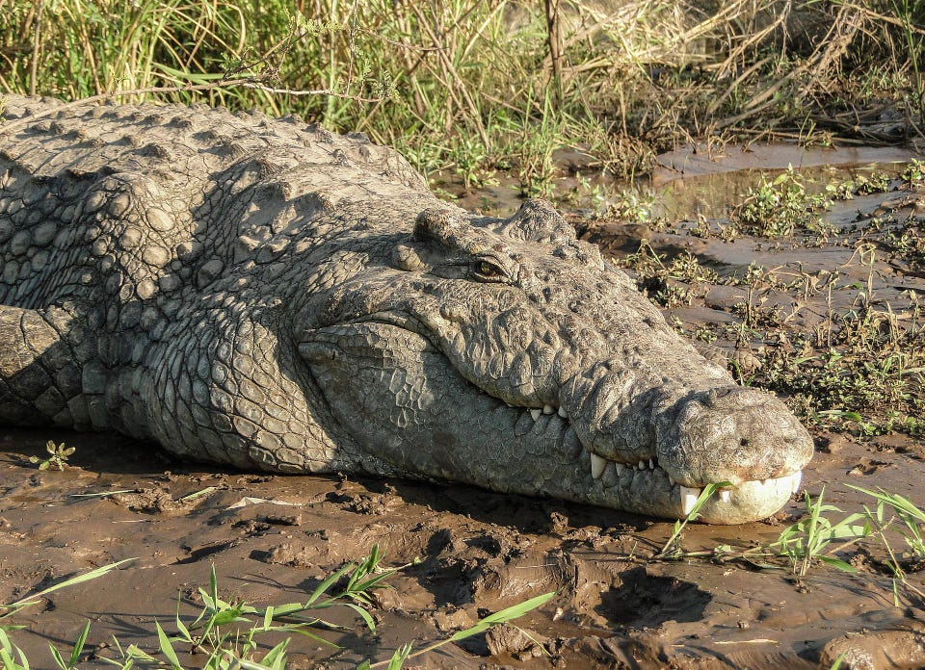

The provincial health director for Tete, Carla Mosse Lazarus, said that samples had already been sent to a national analytical laboratory to determine what poison or poisons had contaminated the 210-liter drum of the brewed beverage. It is widely believed that the bile from the gall bladder of a crocodile is very poisonous. The bile nduru is used as poison which is added to beer or stiff porridge, sadza, of an unsuspecting victim. It is not easy to buy this poison neither is it easy for anyone to kill a crocodile solely for the purpose of obtaining the bile. But with a good fee one can obtain some of the poison from a special nanga [a traditional healer of the Zimbabwean Shona tribe]. At times the nanga may undertake to poison the victim thus adding mystery to the ingredients of the poison. It is reported that the poisoning occurs at special occasions like beer drinking: The nduru is said to be introduced into the beer by dipping the finger or nail where a small amount is placed: This will suffice for the purpose. The unfortunate victim is supposed to die within 24 hours. The poison is supposed to manifest itself when the patient develops pains mainly in the abdomen.