Article

Effect of Multiple Factors on the Wettability of Leaf Surface

Yong He 1, Shupei Xiao 1, Jianjian Wu 1 and Hui Fang 1,*

1 College of Biosystems Engineering and Food Science, Zhejiang University, Hangzhou 310058, China;

yhe@zju.edu.cn (Y.H.); 180312@zju.edu.cn (S.X.); 11713011@zju.edu.cn (J.W.);

**\*** Correspondence: hfang@zju.edu.cn; Tel.: +86-135-8843-3933

Received: date; Accepted: date; Published: date

**Abstract:** The wettability of plant leaves reflects the leaf hydrophilicity directly, which is the key factor to improve the adhesion of liquid pesticide as well as affect farm chemical efficacy. Generally, the wettability of leaf surface is quantified by the contact angle, which was affected by multiple factors during the spray process. Therefore, the aim of this paper was to investigate the effect and influence of droplet falling height, solid surface and farm chemical concentration on the wettability. The whole process of droplet falling was recorded by high speed camera, and the contact angle at different falling height, different solid surface and different concentration was measured by the contact angle measuring device. The results showed that: (1) the increase of droplet falling height had a significant effect on improving wettability between wax surface and adjuvant solution, while it had little improving effect on the wettability between wax surface and water; (2) the wettability of different solid surface varied greatly, and the order of wettability from good to bad is water, sensitive paper, wax, rape leaf and rice leaf; (3) the effect of farm chemical concentration on the leaf surface wettability is significant, the contact angle decreased with the increase of farm chemical concentration, and the wettability of microemulsion is better than that of suspending agent and wettable powder in general. In conclusion, studying the influence of multiple factors on leaf surface wettability can provide a reliable reference for providing scientific guidance as well as improving the effective utilization of farm chemicals.

**Keywords:** wettability; contact angle; droplet falling height; farm chemical

1. Introduction

Farm chemicals spraying is an important measurement in crop pest and disease control. The ultimate purpose of using different spraying methods is to deposit sufficient active components of farm chemicals on target crops [1]. The farm chemical is sprayed on the surface of the crop through water or oil solution when sprayed, thus, the wettability of leaf surface, adhesion force and the spreading and retention behavior of farm chemical solution on leaf surface are the key factors affecting the exertion of farm chemical efficacy [2]. Generally, leaf surface wettability refers to the process of liquid replacing air on the leaf surface, as well as the result of the interaction between the surface tension of liquid and the properties of leaf surface. The wettability reflects the hydrophilicity of the leaf surface [3], which affects the water absorption, gas exchange, pathogen infection and other functions of the plant leaf [4].

During the process of droplets falling on the surface of plant leaves, some droplets will adhere to the leaf surface, while some other droplets will rupture, rebound and slip off the leaf surface [5]. The wettability of droplet on leaf surface is closely related to the properties of the farm chemical and leaf surface properties according to whether the droplets are able to wet the leaf surface or not. Some researchers have indicated that the wettability of plant leaf surface is closely related to the content and morphological distribution of wax on leaf surface [6], density, texture and distribution of leaf villus [7] and the number of stomata [8]. The leaf of different plant species shows different wettability. The results of scanning electron microscopy (SEM) observation of soybean leaves on early growth stage by Puente et al. [9] showed that the dense layer of waxy crystals is the main reason causing low wettability. Boyce et al. [10] found that the wettability of hydrophobic plant leaf surface increased after removing the waxy substance of leaf surface by organic solvent, while the wettability became worse when hydrophilic plant was treated in the same way. Similarly, Takamatsu et al. [11] found that some hydrophobic plant leaves tend to have high-density wax distribution, while the wettability of the leaves with more wax content is relatively small. On this basis, Burton et al. [12] found that the microstructures and waxes on leaf surface were the key factors to determine the hydrophobic properties of the leaves. Sun et al. [13] observed the wettability of lotus leaves in fresh, old, diseased and withered state respectively. The results showed that the compound structure of mastoid and waxy layer was the fundamental reason affecting the wettability of lotus leaf, and the wettability was also influenced by the water state of leaf. Moreover, Brewer et al. [14] found that there was a significant positive correlation between the villi density and contact angle, and the structure of villi had a certain influence on the wettability of leaf surface. Kumar et al. [15] found that the leaves with high villous density had strong hydrophobicity while the leaves with low villous density had good wettability. Besides, the wettability of the front and back sides of plant leaves is obviously different as well. In general, the wettability of the front side of leaf is better than that of the back side, which is consistent with the stomatal distribution of leaf. The results of Brewer et al. [8] showed that the hydrophobicity of plant leaves was stronger when stomatal density was higher. Pandey et al. [16] tested the wettability of 30 species plant leaves, the results suggested that the leaf with the highest stomatal density had the worst wettability.

In addition to the internal factors of plant leaves mentioned above, leaf surface wettability is the result of the interaction between the surface tension of liquid and the surface properties of leaves. Thus the wettability of plant leaves is also affected by the plant growth stage, the properties of farm chemical and adjuvant as well as some external factors such as spraying mode and parameters. Guo et al. [17] supposed that the wettability of plant leaves varied with leaf ages, and the leaf wettability increases with the increase of leaf age. Xu et al. [18] tested the wettability of 52 types of farm chemicals on rice leaves. The wettability of most farm chemicals in rice leaves was poor when sprayed with large capacity mode (spray 750 kg per hectare) and mist mode (spray 225 kg per hectare). Beyond that, Zyl et al. [19] found that adding different adjuvants in spraying solution could increase the deposition of both front and back side of grape leaves, some adjuvants could improve the quality of deposition distribution as well. And the optimum effect of droplet deposition can be achieved by matching the concentration of adjuvants with the dosage of spraying amount. Xu et al. [20] suggested that the use of reasonable concentration of adjuvants could change the behavior of droplets on the leaf surface, which improve the uniformity of droplet coverage and increase the utilization of farm chemicals. At present, there are few studies concentrate on the factors directly affecting wettability by external spraying, while the amount of spray deposition can reflect the wettability of plant leaves to a great extent. Dorr et al. [21] constructed a virtual leaf model for chenopodium, wheat and cotton as well as simulated the behavior of droplet impact on the blade and the subsequent behavior of the droplet. The results showed that the droplet characteristics, spray formulation and leaf surface properties all affected the amount of droplet retained on the horizontal blade.

Therefore, the main purpose of this study is to investigate the effect of multiple factors on wettability using contact angle as an evaluation index. That is, (1) investigate the effect of droplet falling height as well as the instantaneous velocity of droplet contacting solid surface on the variation of wettability; (2) investigate the variation of wettability between different solid surfaces (rice leaves, rape leaves, water-sensitive paper and wax; (3) investigate the influence of farm chemical solution concentration on wettability based on rape leaf surface.

2. Materials and Methods

2.1. Experimental materials

Four kinds of surfaces chosen in this experiment were water-sensitive paper, wax, rape leaf and rice leaf, where water-sensitive paper represents hydrophilic surface and wax represents hydrophobic surface. The varieties of rape and rice are Zhejiang University No.619 and japonica rice Huke No.3, respectively. In general, the farm chemical concentration applied with UAV spraying is 30-50 times as much as the conventional ground-machinery spraying [22]. According to the instructive dosage of farm chemical, the concentration prepared is shown in Table 1.

**Table 1**. Reagent name, formulations and concentrations of farm chemicals.

|  |  |  |
| --- | --- | --- |
| **Reagent name** | **Formulation** | **Concentration** |
| organosilicone | adjuvant | 0.33 g/L |
| prochloraz | 30% microemulsion | 2.67 g/L |
| pymetrozine | 25% suspending agent | 2 g/L |
| tricyclazole | 20% wettable powder | 3.33 g/L, 10 g/L~100 g/L, 10 g/L per gradient 1 |
| dimethachlon | 40% wettable powder | 1 g/L, 5 g/L, 10 g/L~50 g/L, 10 g/L per gradient |
| iprodione | 25% suspending agent | 2 g/L, 10 g/L~100 g/L, 10 g/L per gradient |

2.2. Experimental instrument

The experimental instrument was as follows: dataphysics OCA 50AF (Data physics Corp., Germany) was used to measure the contact angle between liquid and solid surfaces, which was capable of auto focusing with 6 times zoom lens and the measuring accuracy is ±0.1°. The halogen lamp can be continuously adjusted with matching control software and the sample table can be adjusted in *XYZ* three directions. Besides, the scanning electron microscope (SEM) photos of rape and rice were obtained by ultra-high resolution scanning electron microscope HITACHI SU8010 (Hitachi Ltd., Japan). This instrument has high resolution with the highest resolution of 1.1 nm in 1 kV deceleration mode and 0.8 nm in 15 kV mode. In addition, in order to investigate the effect of droplet falling height (instantaneous velocity of droplet contacting solid surface) on contact angle, a high-speed camera pco.dimax HD (PCO.Imaging, Germany) was used to record the complete process of droplet falling. This camera has 2.8 million pixels and ultra-high sensitivity, the maximum camera shooting speed is 1603 fps at full resolution (1920 × 1440 pixels) and 3822 fps at 1008 × 1000 pixels, the shortest shutter time is 1.5 μs.

2.3. Experimental methods

2.3.1. Contact angle determination

The contact angle is an important index to quantitatively measure the wettability of solid surface. Specifically, when take a point at the boundary of liquid-solid interface and draw a tangent to the liquid surface and the solid surface respectively, the angel between the two tangent lines through the inside of the liquid is called the contact angle [23]. When the contact angle is 0°, the liquid completely infiltrates the solid surface; when the contact angle is 180°, the liquid is spherical on the solid surface and the liquid completely un-infiltrated the solid surface; when the contact angle is between 0° and 90°, it is considered to be hydrophilic; when the contact angle is between 90° and 180°, it is considered not to be hydrophobic. However, different scholars have different boundaries of contact angle and wetting range according to the study purpose [24].

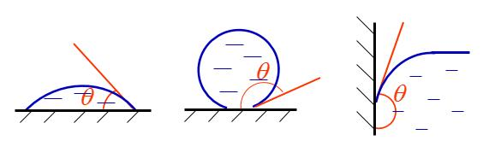

**Figure 1.** The diagram of contact angel (θ).

2.3.2. Experimental Process

In this paper, the experiments mainly includes three parts.

Experiment I：The effects of droplet falling height as well as the instantaneous velocity of droplet contacting solid surface on the wettability were investigated. The specific experimental process is as follows. First, a wax with smooth surface was place on the sample stage of contact angle measuring device and the height of the sample stage was adjust to a suitable visual field. Second, the dividing ruler was fixed to the side of the sample stage. Third, the droplet was released from 1 cm height and the contact angle was measured with the matching software of the contact angle measuring device after droplet stabilization. Forth, the contact angle measurement was repeated three times at each height with the gradient of 1 cm each time. In addition, since the droplet is easily adsorbed on the head of the pipettor, disposable syringe of 1 mL range was used for releasing the droplet in this experiment. Meanwhile, the whole process of droplet falling was recorded by high speed camera at the rate of 2000 fps to calculate the instantaneous velocity of droplet contacting solid surface. In order to avoid the influence of surface morphology and leaf moisture, the wax with stable composition was chosen as the solid surface, and the liquid was decided as water and organosilicon adjuvant solution respectively. The experimental platform is shown in Figure 1.

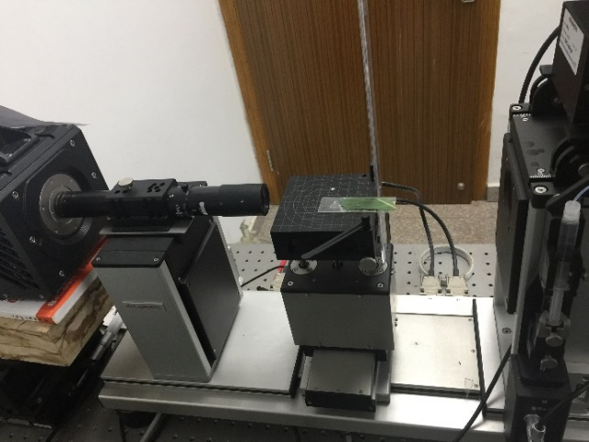

**Figure 2.** Contact angle measuring device: high speed camera (left), sample stage (center) and contact angle measuring device (right).

Experiment II: The difference of wettability between different solid surfaces was explored. In this experiment, four kinds of solid media chosen were water-sensitive paper, wax, rape leaf and rice leaf. The leaves were cut off from rape and rice plant and then fixed on the glass slide to ensure the relative smoothness surface during the contact surface measurement. Besides, the pipettor (set scale to 1 μL) was used to pipet and release the droplet to the solid surface and the contact angle is measured after the droplet stabilization. Each contact angle between liquid and solid surface was measured for 5 times.

Experiment III: The effect of the farm chemical concentration on the wettability of rape leaves was investigared. In this experiment, three kinds of farm chemicals (20% wettable powder tricyclazole, 40% wettable powder dimethachlon, 25% suspending agent iprodione) were used and the concentration gradient was divided according to the guidance concentration of UAV spraying (Table 1). Additionally, the rape leaves were chosen as solid surface and the droplet was released by 1 μL pipettor. The contact angle at different concentration of farm chemicals was determined five times respectively on the surface of rape leaves.

2.3.3. SEM Images Acquisition

According to the SEM sample preparation method, the SEM samples of rice and rape leaves were prepared respectively. The preparation steps were mainly as follows. First, the samples were fixed with 2.5% glutaraldehyde overnight at 4°C. Second, the samples were rinsed with phosphoric buffer (0.1 M, pH 7.0) for three times, 15 min each time. Third, the samples were fixed with 1% osmic acid in the ventilated cabinet with for 1.5 hours. Forth, the samples were rinsed with phosphoric buffer (0.1 M, pH 7.0) for three times, 15 min each time. Fifth, the samples were dehydrated with 30%, 50%, 70%, 80%, 90% and 95% ethanol orderly for 15 min each time and dehydrated with absolute ethyl alcohol for 20 min. Finally, the samples were dried by CO2 critical point dryer and coated, then trimmed to the appropriate size and then observed under ultra-high resolution scanning electron microscope. In this experiment, the SEM images of rape and rice leaves were obtained at the magnification times of 100 times, 300 times, 1000 times and 5000 times respectively.

3. Results and Discussion

3.1. The Influence of Droplet Falling Height on Wettability

In order to investigate the influence of droplet falling height as well as the instantaneous velocity of droplet contacting solid surface on the wettability, the wax was used as the solid surface in this experiment. The variation of contact angle with the droplet falling height were measured using water and organosilicon adjuvant respectively, and a high-speed camera was used to record the complete falling process of the droplet.

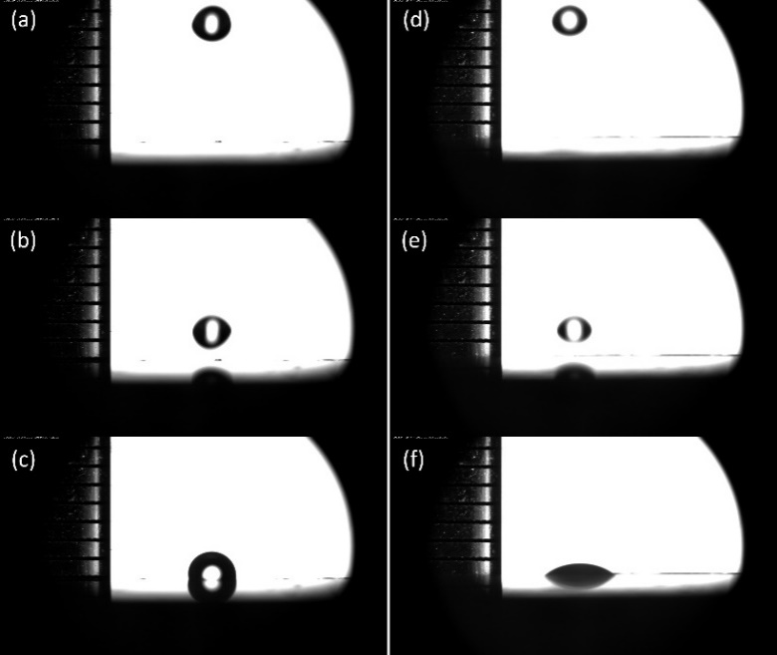

**Figure 3.** Partial screenshots of droplets falling from 1 cm altitude: water droplet (abc) and organosilicon adjuvant droplet (def).

Figure 3 shows some partial screenshots when droplets falling from 1 cm altitude. Among them, (a) and (d) refers to the first frame that the droplet (water and organosilicon adjuvant) appears in the lens field of vision; (b) and (e) refers to the moment immediately before the droplet touches the solid surface; (c) and (f) refer to stable status of droplets on the solid surface. Based on the number of shooting frames of the high-speed camera and the corresponding time difference, it is possible to calculate the instantaneous velocity of the droplet touching the wax surface. Comparing the velocity calculated by high-speed camera with that calculated by formula ($v=\sqrt{2gh}$, local g=9.79362 m/s2), the error between them is less than 0.04 m/s2, which indicated that the motion of droplets could be considered as the motion of a free falling body.

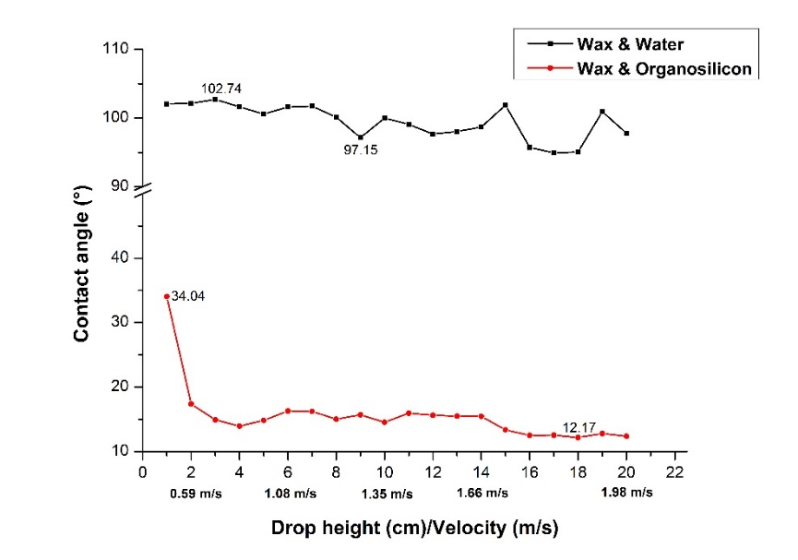

**Figure 4.** The variation of wettability with the increase of droplet falling height.

Figure 4 shows the variation of contact angle of droplet on the wax surface with the increase of droplet falling height. When the falling droplets were water, the contact angle fluctuates between 97° and 103° with the increase of droplet falling height. It is indicated that there is an obvious hydrophobic relationship between the wax and water droplet, and the increase of the droplet falling height as well as the instantons velocity of the droplet contacting wax surface does not change the hydrophilicity between the droplet and the wax surface. However, when the droplets were organosilicon, the contact angle between droplet and wax surface was only 34.04° at 1 cm droplet falling height. The contact angle between organosilicon droplet and wax was obviously better than that of the water droplet, which indicated that the organosilicon adjuvant could improve the wettability to a large extent. Besides, the contact angle was only 17.38° when the droplet falling height increased to 2 cm. It was tended to be stable with the increase of droplet falling height, and finally fluctuated between 12° and 13°. Therefore, it can be seen that the use of organosilicon adjuvant can greatly increase the surface tension of droplets. Since the organosilicon droplets were already extremely hydrophilic at low falling altitudes, the variation of contact angle was small as the falling height rose continuously, where the contact angle tended to be stable gradually.

3.2. The Influence of Solid Surface on Wettability

In order to investigate the effect of solid surface on wettability, water-sensitive paper, wax, rice leaf and rape leaf were selected as solid surface, water, 20% wettable powder tricyclazole, 30% microemulsion prochloraz and 25% suspending agent pymetrozine were used as test solution. Rice and rape are two common crops which represent typical monocotyledonous crops and dicotyledonous crops respectively, and the surface properties of those two crops differ greatly, while water-sensitive and wax represent hydrophilic and hydrophobic solid surface respectively. Figure 5 shows the SEM images of rice and rape leaves at 1000 and 5000 magnification times respectively.

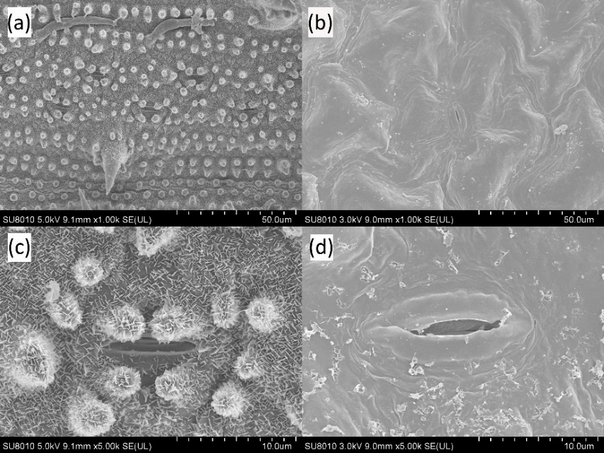

**Figure 5.** High magnification SEM of rape and rice leaves：(a) rice of 1000 times；(b) rape of 1000 times；(c) rice of 5000 times；(d) rape of 5000 times.

The non-smooth surface structure of most plant leaves, such as furs, spines, protrusions and other appendages, is a direct factor affecting the hydrophobicity of leaves [25]. From the view of the microstructure of leaves, the surface of rice leaves is rough with a regular arrangement of beaded microprotrusions (Figure 5a), whose average diameter is around 5-8 μm [26]. Some studies showed that those microprotrusions are the mixture of wax on the leaf surface and silicon oxide with strong hydrophobicity [22], while the leaf surface is covered with dense acerose arrangement at the magnification of 5000 times (Figure 5c). In addition, the surface of rape leaves is relatively smooth and the waxy morphology of the leaves is irregularly arranged with the shape of blocks. The wax around the stomata is in the form of small rods [27], and there are filamentous appendages around the stomata (Figure 5d). In general, some results in current research indicated that the wettability of leaf surface with less waxiness and sparse villus distribution is better.

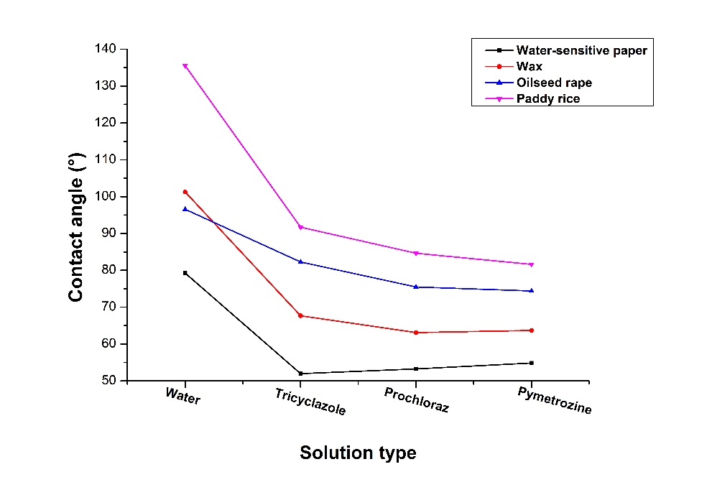

**Figure 6.** The variation of contact angle with the variation of solid surfaces and farm chemicals.

Figure 6 compares the wettability of four solid surfaces with different farm chemicals. It can be seen that the hydrophilicity of four solid surface from high to low is water-sensitive paper, wax, rape leaf and rice leaf. Specifically, when using water for experiment, only the contact angle with water-sensitive paper was less than 90° and appeared as hydrophilic, while the water droplet with rice leave, rape leave and wax were appeared as hydrophobic. Besides, the wettability of rice leaves changed from hydrophobic to hydrophilic while using three farm chemicals to replace water droplet, among which the wettability of rice leaves was greatly improved by using pymetrozine and the contact angle decreased to about 80°.

For the influence of farm chemical types on the wettability of solid surface, the contact angle between water-sensitive paper and three kinds of farm chemicals was from 50° to 60°. And the results of wettability between rice, rape and wax on the three farm chemicals showed that the contact angle of 25% suspending agent pymetrozine was slightly lower than that of 30% microemulsion prochloraz, and both of them were obviously superior to 20% wettable powder tricyclazole. It is concluded that the solubility of tricyclazole as a wettable powder is poor, whose solution is a mixture of powder and water and there is sediment in the solution after resting. Thus the effect of improving wettability is not as good as that of suspending agent and microemulsion.

3.3. The Influence of Farm Chemical Concentration on Wettability

In order to investigate the effect of the farm chemicals concentration on the wettability of rape leaves, 20% wettable powder tricyclazole, 40% wettable powder dimethachlon and 25% suspending agent iprodione were divided in different concentration gradient according to the quantity of the UAV spray application. The contact angle varies with the concentration of three farm chemicals was shown in Figure 7.

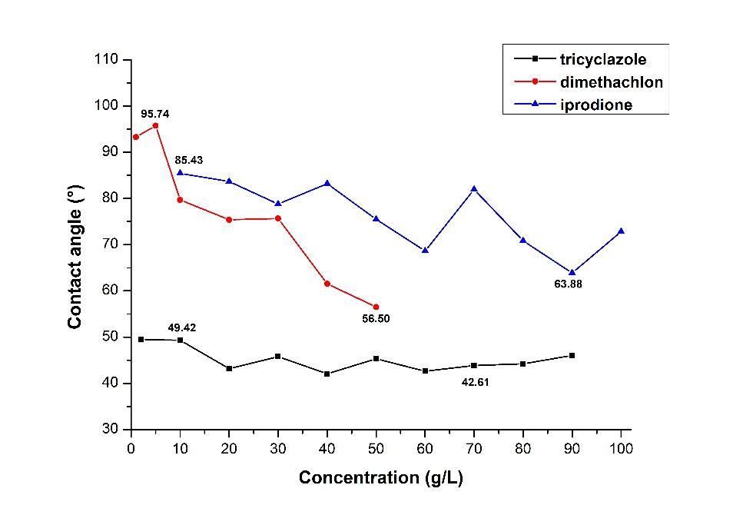

**Figure 7.** The variation of contact angle with the variation of farm chemical concentration.

Wettable powder is one of the earliest and most common-used farm chemical reagents, while the biggest problem is that the poor solubility of the wettable powder results in the precipitate of the particles. Thus the wettable powder solution needs to be stirred frequently during the spraying process to ensure its uniformity. Comparing to wettable powder, the particle size of suspending agent is smaller and the suspension rate is higher, thus it is not easy to precipitate and the stability of suspending agent is better as well. In this experiment, three kinds of farm chemicals with different formulation were used.

According to Figure 7, tricyclazole is a kind of protective fungicide with strong internal absorption, whose contact angle fluctuates between 42° and 50° along with a slow decreasing trend as the concentration increased. In general, the change of contact angle with tricyclazole concentration is almost negligible and the reason might be that the solubility of 20% wettable powder tricyclazole is poor, a lot of sediments were found in the bottom of test tube. Although the shaking treatment was done before the test, the effective components of tricyclazole in the solution may have reached the saturation degree. In addition, dimethachlon is a potent fungicide, which is the most commonly-used towards rape among three farm chemicals. Dimethachlon showed the largest decrease in contact angle with the increase of dimethachlon concentration, and the wettability of rape leaves was almost not improved when the concentration was at a low level, which was closely to the contact angle between water and rape leaves (96.56°). With the continuous increase of dimethachlon concentration, the wettability of rape leaves increased significantly and the contact angle decreased to about 80° when the concentration reached 10 g/L. Besides, iprodione is a kind of contact fungicide with broad range and high efficiency, whose contact angle decreases gradually with the increase of iprodione concentration and it also fluctuates in a wide range between 63°and 86°. The reason might be that the solution has reached saturation state when the concentration is high, and the bubble and sediment in the solution might also affect the measurement of contact angle to some extent. In general, with the increase of farm chemical concentration, the wettability increased differently depending on the formulation of farm chemicals, and the wettability of microemulsion is better than that of suspending agent and wettable powder.

4. Conclusions

In this paper, the effects of droplet falling height, solid surface and farm chemical concentration were studied. The main conclusions are as follows: 1）With the increase of droplet falling height, the wettability between organosilicon adjuvant and wax was improved greatly and then tended to be stable while the wettability between water and wax was not influenced within 2 m/s droplet falling velocity; 2）The hydrophilicity of the four solid surface from high to low is water-sensitive paper, wax, rape leaves, rice leaves, in which water-sensitive paper is hydrophilic, wax, rice and rape leaves are hydrophobic. And the wettability was significantly improved when the farm chemicals were used instead of water; 3）With the increase of concentration, the contact angle decreased in different degrees depending on farm chemical formulations. Generally, the wettability of microemulsion is better than that of suspending agent and wettable powder. In conclusion, studying the influence of multiple factors on leaf surface wettability can help to provide scientific spraying guidance and improve the effective utilization of farm chemicals.

**Author Contributions:** Y.H. and S.X. conceived and designed the experiments; S.X. and J.W. performed the experiments; Y.H., S.X. and H.F. analyzed the data; Y.H. wrote the drift manuscript; S.X., J.W. and H.F. revised the manuscript.

**Funding:** This research was funded by The National Key Research and Development Program of China, grant number 2016YFD0200701.

**Conflicts of Interest:** The authors declare no conflict of interest.

References

1. Xiang, D.; Zhu, H.P.; Yang, X.J. Characterization of droplet impact and deposit formation on leaf surfaces. *Pest Manag. Sci.* **2015**, *71(2)*, 302-308.

2. Yue, G.; Guo, R.F.; Fan, R.J.; Liu, Z.F.; Kong, W.N.; Zhang, P.J.; Du, F.P. Wettability of pear leaves from three regions characterized at different stages after flowering using the OWRK method. *Pest Manag. Sci.* **2018**, *74(8)*, 1804-1809.

3. Shi, H.; Wang, H.X.; Li, Y.Y. Wettability on plant leaf surfaces and its ecological significance. *Acta Ecologica Sinica* **2011**, *31(15)*, 4287-4298.

4. Aryal, B.; Neuner, G. Leaf wettability decreases along an extreme altitudinal gradient. *Oecologia* **2010**, *162(1)*, 1-9.

5. Dorr, G.J.; Wang, S.S.; Mayo, L.C.; Mccue, S.W.; Forster, W.A.; Hanan, J.; He, X.K. Impaction of spray droplets on leaves: influence of formulation and leaf character on shatter, bounce and adhesion. *Experiments in Fluids* **2015**, *56(7)*, 1-17.

6. Taylor, P. The wetting of leaf surfaces. *Curr. Opin. Colloid Interface Sci.* **2011**, *16(4)*, 326-334.

7. Neinhuis, C.; Barthlott, W. Characterization and Distribution of Water-repellent, Self-cleaning Plant Surfaces. *Annals of Botany* **1997**, *79(6)*, 667-677.

8. Brewer, C.; Nunez, C. Patterns of leaf wettability along an extreme moisture gradient in western Patagonia, Argentina. *Int. J. Plant Sci.* **2007**, *168(5)*, 555-562.

9. Puente, D.W.; Baur, P. Wettability of soybean (Glycine max L.) leaves by foliar sprays with respect to developmental changes. *Pest Manag. Sci.* **2011**, *67(7)*, 798–806.

10. Boyce, R.L.; Mccune, D.C.; Berlyn, G.P. A comparison of foliar wettability of red spruce and balsam fir growing at high elevation. *New Phytol.* **1991**, *117(4)*, 543-555.

11. Takamatsu, T.; Sase, H.; Takada, J.; Matsushita, R. Annual Changes in Some Physiological Properties of Cryptomeria Japonica Leaves from Kanto, Japan. *Water Air Soil Pollut.* **2001**, *130(1-4)*, 941-946.

12. Burton, Z.; Bhushan, B. Surface characterization and adhesion and friction properties of hydrophobic leaf surfaces. *Ultramicroscopy* **2006**, *106(8-9)*, 709.

13. Sun, Y.H.; Yang, X.D.; Yang, Z.J.; Wang, Q.C.; Men, Y.Z. Difference in wettability of lotus leaves in typical states and its mechanism analysis. *Transactions of the Chinese Society of Agricultural Engineering* **2014**, *30(13)*, 263-267.

14. Brewer, C.A.; Smith, W.K. Patterns of leaf surface wetness for montane and subalpine plants. *Plant Cell Environ.* **1997**, *20(1)*, 1-11.

15. Kumar, N.; Pandey, S., A; Ahuja, P. Do leaf surface characteristics affect Agrobacterium infection in tea [Camellia sinensis(L.) O Kuntze? *J. Biosci.* **2004**, *29(3)*, 309-317.

16. Pandey, S.; Nagar, P.K. Patterns of leaf surface wetness in some important medicinal and aromatic plants of Western Himalaya. *Flora* **2003**, *198(5)*, 349-357.

17. Guo, Y.L. Reasearch on leaf wettability and water retention capability of plants in loess hilly-gully region. Northwest A&F University, 2015.

18. Xu, G.C.; Gu, Z.Y.; Xu, D.J.; Xu, X.L.; Dong, Y.X. Wettability Analysis of Pesticides on Rice Leaf. *Scientia Agricultura Sinica* **2012**, *45(9)*, 1731-1740.

19. Zyl, S.A.V.; Brink, J.C.; Calitz, F.J.; Fourie, P.H. Effects of adjuvants on deposition efficiency of fenhexamid sprays applied to Chardonnay grapevine foliage. *Crop Prot.* **2010**, *29(8)*, 843-852.

20. Xu, L.; Zhu, H.; Ozkan, H.E.; Bagley, W.E.; Krause, C.R. Droplet evaporation and spread on waxy and hairy leaves associated with type and concentration of adjuvants. *Pest Manag. Sci.* **2011**, *67(7)*, 842-851.

21. Dorr, G.J.; Kempthorne, D.M.; Mayo, L.C.; Forster, W.A.; Zabkiewicz, J.A.; McCue, S.W.; Belward, J.A.; Turner, I.W.; Hanan, J. Towards a model of spray–canopy interactions: Interception, shatter, bounce and retention of droplets on horizontal leaves. *Ecol. Model.* **2014**, *290(C)*, 94-101.

22. Xue, X.Y. Application of modern pesticide aerial application technology and the impact on rice quality. Nanjing Agricultural University, 2013.

23. Ramos, G.Q.; Ferreira, J.L.P.; Cotta, E.A.; Filho, H.D.D.F. Wettability and morphology of the leaf surface in cashew tree from the Amazon, Northern Brazil. *Acta Sci. Biol. Sci.* **2016**, *38(2)*, 215.

24. Bhushan, B.; Yong, C.J. Natural and biomimetic artificial surfaces for superhydrophobicity, self-cleaning, low adhesion, and drag reduction. *Progress in Materials Science* **2011**, *56(1)*, 1-108.

25. Ren, L.Q.; Wang, S.J.; Tian, X.M.; Han, Z.W.; Yan, L.N.; Qiu, Z.M. Non-Smooth Morphologies of Typical Plant Leaf Surfaces and Their Anti-Adhesion Effects. *Journal of Bionic Engineering* **2007**, *4(1)*, 33-40.

26. Guo, Z.; Liu, W. Biomimic from the superhydrophobic plant leaves in nature: Binary structure and unitary structure. *Plant Sci. (Amsterdam, Neth.)* **2007**, *172(6)*, 1103-1112.

27. Wang, X.Q. Study on the mechanisms of ethylene in regulating Brassica napus leaf cuticular waxes. Southwest University, 2015.

H:\documents\layout\new template June 2014\figures\CC-BY logo original v1.wmf© 2018 by the authors. Submitted for possible open access publication under the terms and conditions of the Creative Commons Attribution (CC BY) license (http://creativecommons.org/licenses/by/4.0/).