codeBeamer

SCMLoop Installation manual

|  |  |
| --- | --- |
| Release | 7.7.1 |
| Date | 28-th July 2015 |

**Content**

1 Introduction 3

2 Installing SCMLoop 4

2.1 Installation for Mercurial 4

3 Instrumenting SCM repositories 5

3.1 Instrumenting a CVS repository 5

3.2 Instrumenting a Subversion repository 6

3.3 Instrumenting a Mercurial repository 7

3.4 Instrumenting a Git repository 8

# Introduction

This document describes how to install the Intland codeBeamer SCMLoop component.

SCMLoop is a notification mechanism, which allows associating commits to a Source Code Management (SCM) repository with Work Items in codeBeamer.

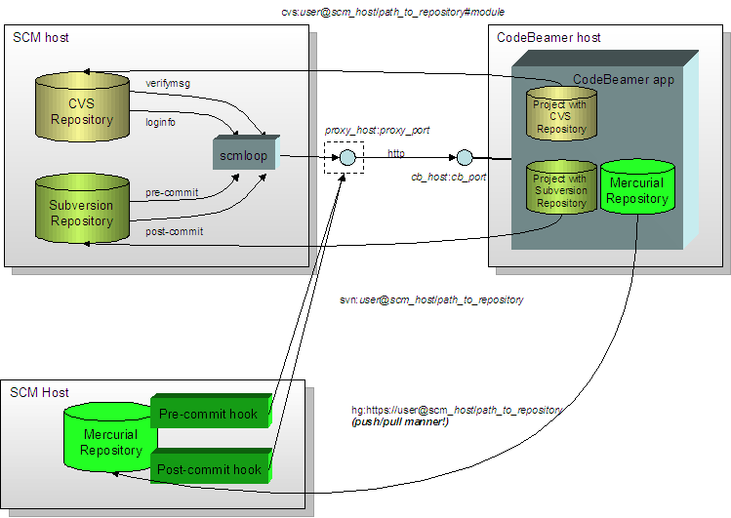

Currently, SCMLoop is available for the following SCM systems:

* **Git (only on Unix)**
* **Subversion**
* **Mercurial (Hg)**
* **CVS**

CodeBeamer has built in support for so called “Managed Repositories”. Managed repositories are SCM repositories created and maintained by codeBeamer itself.

An exclusive feature of Managed (Git, Mercurial and Subversion) Repositories is the seamless integration to create and administrate (including access control) of repository with codeBeamer.

You only need to setup the extra SCMLoop component manually if you want to connect already existing (external) Subversion, Git, Mercurial and CVS repositories to codeBeamer to for example associate SCM changesets (commits) to codeBeamer Work Items.

# Installing SCMLoop

You need to install the SCMLoop component on every server that hosts SCM repositories you want to connect.

Unpack the SCMLoop distribution archive scmloop.zip to a publicly accessible directory/folder. Either on each server that hosts SCM repositories, or on a network folder that is accessible from each SCM host.

Please note, that also a Java Runtime Environment (JRE 1.6 or 1.7) is required.

In order for SCMLoop to work, its configuration must be adjusted to the current environment.

On Windows systems you have to edit the script scmloop/scmloop.bat, on Unix systems scmloop/scmloop, and modify the values of the following variables:

* SCM_DIR is the path to the scmloop[.bat] script itself
* CB_BASE_URL the base URL of the codeBeamer webapplication. For example: *http://localhost:8080/cb*
* JAVA must point to the java executable of the JRE to use.

Make sure, that all SCM users are allowed to access and execute the scmloop[.bat] script. On Linux/Unix systems it must be ensured (eg. using command *chmod*) that the script scmloop is executable.

After you have successfully installed and configured SCMLoop, you can now start to instrument your SCM repositories.

## Installation for Mercurial

Install Mercurial 1.8 or later (<http://mercurial.selenic.com/wiki/Download>) and add hg to the PATH. On Windows use:

setx PATH “%PATH%;MERCURIAL_HOME”

on linux use

export PATH=$PATH:MERCURIAL_HOME

where MERCURIAL_HOME is the directory where you installed Mercurial.

# Instrumenting SCM repositories

Instrumenting a SCM repository means to add appropriate SCMLoop callbacks/hooks to every SCM repository you want to connect to Codebeamer (or configuration file for Mercurial).

The SCMLoop distribution contains pre-instrumented examples for all files named in this chapter.

When copying the example files, please take care to adjust the path to the scmloop directory accordingly.

## Instrumenting a CVS repository

Setting up a CVS repository and access to it, is not part of this document. For more information about CVS see [http://www.cvshome.org](http://www.cvshome.org/).

We assume that the repository already exists and is accessible.

1. Check out the CVS repository administrative files (CVSROOT) to some working directory.
2. Edit the file **verifymsg** in the **CVSROOT** folder in the working directory and add the following line:  
     
   **ALL** [**cmd /c**][1]*<path_to_scmloop>****[2]*scmloop -mode verifymsg**
3. Edit the file **loginfo** in the **CVSROOT** folder in the working directory and add the following line:  
     
   **ALL** [**cmd /c**]1*<path_to_scmloop>*2**scmloop -mode loginfo %{sVv}**
4. On some CVS servers you might have to add "LogHistory=all" to **CVSROOT/config**
5. Commit your changes to the repository.

## Instrumenting a Subversion repository

We assume that the repository already exists and is accessible. The templates of the Subversion hook scripts can be found under *svn/<operating_system>* directory in scmloop.zip (where *<operating_system>* is either *windows* or *unix*).

1. Check out the **hooks** directory of the Subversion repository to some working directory.
2. Copy the files from *svn/<operating_system>* to the hooks folder of the working directory.
3. Edit the scripts: replace the string ${scmloop} with the actual path of the scmloop script.
4. On Linux/Unix systems it must be ensured (eg. using command *chmod*) that the scripts are executable.

Create a file codebeamer.properties under conf in your repository and add the following line to it:

repositoryId= *repository-ID*

where *repository-ID* is the id of the codeBeamer repository that you want to associate the repository with.

1. Commit your changes to the repository.

## Instrumenting a Mercurial repository

We assume that the repository already exists and is accessible. The mercurial example configuration files can be found under the hg directory in scmloop.zip.

1. Check hgrc file under **.hg** directory (hidden directory at the root of repository) of the Mercurial repository. If there is an already existing one, append content of the provided **hgrc** file to the original one (with a preferred editor), otherwise copy it to **.hg** dir. Also copy hgrc-codebeamer to the .hg dir.
2. Copy the commit-hook(.bat) and the changegroup-hook(.bat) scripts from hg/<operating_system> (in scmloop.zip) to a directory of your choice.
3. (**Required**) Set your repositoryId property for the project where this repository used:  
     
   [codebeamer]  
   repositoryId = 266 # (number!)  
   ...
4. **(Required)** In hgrc-codebeamer replace the string ${scmloop} with the actual path of the scmloop script.
5. **(Required)** In hgrc-codebeamer replace all occurrences of the string ${hookDirectory} with the absolute path of the directory where you copied the scripts to (step 2).
6. (**Optional**) In hgrc-codebeamer set your host name as it was registered in codebeamer. This value will be the hostname of the machine where the Mercurial run by default.  
     
   [codebeamer]  
   host = myscmhost  
   ...
7. (**Optional**) In hgrc-codebeamer set cburl property in the hgrc file according to the settings of your codebeamer commit url (this will be set to <http://localhost:8080/cb/sccCommitInfo> if missing):

[codebeamer]  
cburl = http://mycbhost  
...

1. (**Optional**) Check and set proxyhost, proxyport, proxyuser, password properties in the hgrc file according to the settings of your network like:

[codebeamer]  
proxyhost = myproxy  
proxyport = 81  
proxyuser = myproxyuser  
password = v3ght # put password here in a base64 encoded form  
...  
  
Online tool can be used for base64 encoding   
 (like: <http://www.motobit.com/util/base64-decoder-encoder.asp>)

1. (**Optional**) If you would like to ignore codebeamer accessibility errors set the ignore flag (false by default):  
     
   [codebeamer]  
   ...  
   ignore = true

## Instrumenting a Git repository

We assume that the repository already exists and is accessible. The templates of the Git hook scripts can be found under *git/<operating_system>* directory in scmloop.zip (where *<operating_system>* is either *windows* or *unix*).

1. Copy the files from *git/<operating_system>* to the hooks folder of the git repository.
2. Edit the scripts: replace the string ${scmloop} with the actual path of the scmloop script.
3. On Linux/Unix systems it must be ensured (eg. using command *chmod*) that the scripts are executable.
4. Create a file called codebeamer.properties under the .git directory of your repository or under the top directory in case of bare repository and add the following line to it:

repositoryId= *repository-ID*

where *repository-ID* is the id of the codeBeamer repository that you want to associate the repository with.

1. Only on Windows systems.
2. Replace with the absolute path to the directory, where the scmloop[.bat] script resides (see chapter 2).