In-Class Exercise #2 - MySQL on Class Server

Database Design & Data Warehousing

Task #1 – Login to the class server and into MySQL to view some data:

1. Open the Putty terminal emulator on your lab PC.

2. Enter itins3.madisoncollege.edu in the Host Name or IP Address box. Make sure the Connection Type is set to SSH (Secure Socket Layer Shell), then click the Open button

3. Enter your username and password when prompted. Your username will be your first initial and last name. Your password will be 's' followed by your 7-digit student ID.

4. Use a command line similar to the following to log in to MySQL. Use your user name (first initial and last name) rather than the one used here.

mysql -u mweishan -p

5. Again you will be prompted for a password. Your password will again be 's' followed by your 7-digit student ID.

6. Enter the following series of commands in MySQL, and answer the questions below:

USE winestore;
SHOW TABLES;
SELECT * FROM region;

7. How many tables are there in the winestore database? __14____

8. What is the name of region number 7? ___Barossa Valley____________
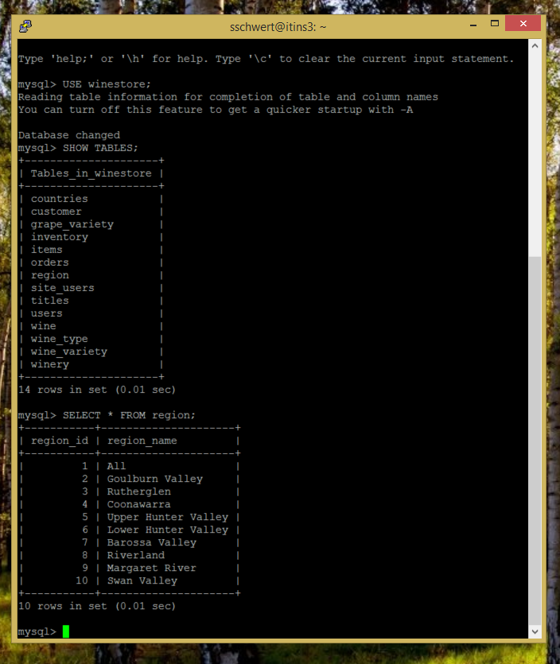
- 2 -

Task #2 - Create a table in your own database schema:

1. Change to your personal database (called a schema in Oracle) by entering a command similar to the following. Your database name will be your first initial and last name:

use mweishan;

2. Create a table named customer_list using the following statement:

CREATE TABLE customer_list (
customer_id int unsigned NOT NULL auto_increment PRIMARY KEY,
last_name varchar(30) NOT NULL,
first_name varchar(30),
address varchar(100),
city varchar(30) NOT NULL,
state char(2) NOT NULL,
zip varchar(9)
);

3. Add 3 rows of data to the table customer_list by issuing INSERT statements. (The statement syntax is exactly the same as for Oracle.)

Here is some sample syntax:

INSERT into customer_list (last_name,first_name,address,city,state,zip) VALUES ('Smith','James','123 any street','Madison', 'WI', '53527');

4. Run a SELECT statement on the table and show your instructor the results.

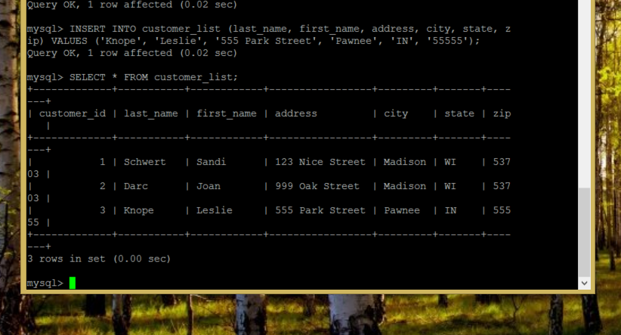

6. Enter the MySQL command:

exit;

to quit MySQL and the Linux command:

exit

(no semi-colon) to sign off from the class server.

