Cost of Retracted Articles to the NIH: a Living Analysis
Alejandro Sandoval-Lentisco¹, John P.A. Ioannidis¹²³⁴
¹ Meta-Research Innovation Center at Stanford (METRICS), Stanford University, Stanford, CA, USA ² Stanford Prevention Research Center, Department of Medicine, Stanford University, Stanford, CA, USA ³ Department of Epidemiology and Population Health, Stanford University, Stanford, CA, USA ⁴ Department of Biomedical Data Science, Stanford University, Stanford, CA, USA
Correspondence: John P.A. Ioannidis, MD, DSc, 3180 Porter Drive, Stanford Research Park, Palo Alto, CA 94304, USA. E-mail: jioannid@stanford.edu

ABSTRACT
Retractions attract substantial attention (1) and have become more frequent over time (2, 3). Retractions reflect the self-correcting nature of science but also wasted resources (4). The Retraction Watch Database (RWD) includes over 60,000 records (5, 6). We integrated RWD with NIH funding metadata (RePORTER system). As of July 2026, of the 6,081 U.S. affiliated retracted articles, 1,725 (28.4%) were linked to at least one NIH grant. With a mean attributed cost per retracted NIH-funded article of $255,087 in 2026 dollars, the attributed total cost of NIH-funded retracted research is $440 million in 2026 dollars. Grants associated with retracted papers for which the first or last author of the paper was the principal investigator were awarded $4.03 billion in 2026 dollars. NIH-funded articles take longer to be retracted (mean = 6.3 years) than other US-based articles, which may entail greater downstream implications. NIH funding of retracted authors decreased over the 3 years following retraction, particularly among authors with multiple retractions. We have developed a continuously updated dynamic dashboard (https://sandovallentisco.shinyapps.io/nih-retractions/) for the cost of retractions reflecting NIH-funded work.

Retracted publications are a visible manifestation of how science self-corrects, but they may also signal serious weaknesses in research practices and peer review (1). Retracted work, especially when it is due to serious fraudulent practices or major flaws and not just publisher or journal technical errors, may undermine trust in science, distort scientific evidence, and represent a waste of scarce research resources. Although retractions remain rare relative to overall publication volume, their frequency has been climbing for two decades (2, 3). One would wish to estimate the cost of the research work that has been retracted. Previous estimates of the cost of retracted research for the U.S. National Institutes of Health (NIH), the world’s largest public funder of biomedical research, examined 149 retracted NIH-funded papers between 1992 and 2012 and reported a direct cost of about $58 million (4), but this figure is now outdated. Far more comprehensive accounting is possible today using the Retraction Watch Database (RWD), a curated, regularly updated catalogue of more than 60,000 retraction records across all disciplines (5, 6), and NIH funding metadata, accessible through the agency’s RePORTER system. We integrated the two systems via an automated weekly pipeline and developed a dynamic dashboard that updates continuously as new retractions are cataloged (https://sandovallentisco.shinyapps.io/nih-retractions/). We present here the data for the cost of retracted NIH-funded research as of July 2026 and discuss some implications of these findings.

Direct cost to the NIH
We retrieved the latest version of the Retraction Watch Database (RWD) from the Crossref repository (https://gitlab.com/crossref/retraction-watch-data) and selected entries marked as retractions, excluding expressions of concern or corrections. We also excluded entries classified as ‘Retract and Replace’, and retractions that did not represent a high likelihood of serious error and/or misconduct by the authors (e.g., administrative or publisher errors). For those eligible retracted articles for which RWD identified an institutional affiliation within the U.S., we queried PubMed using the National Center for Biotechnology Information (NCBI) Entrez API to get supplementary funding metadata (grant IDs and number of publications linked to each grant). Finally, to retrieve the funding amount associated with each grant, we used the NIH Research Portfolio Online Reporting Tools Expenditure and Results (RePORTER) tool. Databases from all available fiscal years were downloaded using the ExPORTER tool (see more details about the method in Supplementary Materials). Data and scripts are available at https://github.com/sandovallentisco/nih-retractions-cost.
As of July 2026, the RWD listed 6,081 retracted articles with at least one U.S. affiliated author. Of these, 1,725 (28.4%) were linked to at least one NIH grant. To calculate the attributed cost per retracted publication, we divided the total grant award by the total number of publications produced under that grant (i.e., attributing a proportional cost to the specific retracted article rather than the entire grant value). The mean attributed cost per retracted NIH-funded article was $155,567 in nominal dollars, $255,087 in 2026 dollars. Summed across all papers, the attributed total direct cost is $268 million in nominal dollars, $440 million in 2026 dollars, about 1% of a single year of NIH budget, but a 7.6-fold increase over the previously published benchmark that covered retractions during 1992-2012 (4). The retracted publications were associated with a total of 2,796 distinct NIH grants, i.e., a total of $94.66B in nominal dollars. However, the vast majority of this sum is institutional center and infrastructure funding (e.g., P30 center core grants) rather than money awarded to individual investigators. Considering only investigator-held research, career and fellowship awards (R/K/F-series; see Supplementary materials for the exact activity-code rule) for which the retracted author was the principal investigator, a total amount of $2.63B in nominal dollars or $4.03B in 2026 dollars from 976 grants was associated with retracted papers.
Retracted articles only reflect the work the literature has managed to identify and withdraw, but not the much larger body of flawed or fraudulent work that has yet to be exposed or has been exposed but not yet retracted (7–9). Therefore, the $440 million is clearly an underestimate of the wasted resources. The $4.03B can be either an overestimate or an underestimate of the wasted resources. Much of these researchers’ other work may have been without serious flaws; conversely, other work by other researchers who have no retraction yet may have been seriously flawed or even fraudulent.

Consequences to retracted authors
We tracked the funding trajectories of 1,509 first/last authors for the 3 pre- and post-retraction years. We selected cases in which the first retraction occurred by 2022, so that a full 3-year post-retraction window of funding data was observable for every author in the cohort given the most recent RePORTER fiscal year (2025). Because common author names can match several different NIH investigators, for the 440 authors whose name maps to more than one investigator we kept only the grants of the one whose institution matches their retracted paper (see Supplementary materials for details). We observed some potential decrease in NIH funding for retracted authors. The per-author cohort-wide median annual NIH funding fell from $133,293 in the 3 years pre-retraction to $55,973 in the 3 years post-retraction, a -58.0% change (paired Wilcoxon $V$ = 280,530, p = 0.021). This decrease in the median is due to a higher proportion of authors receiving no funding after retraction; the average annual fraction of the cohort holding an active NIH grant fell from 46.7% to 42.3% (McNemar’s test $χ^{2}$(1) = 16.3, p < 0.001). However, the mean remained very similar ($745,851 pre vs $723,275 post; the full per-author funding distribution before and after retraction is shown in the Supplementary Results). The number of unique active grants dropped by 9.9% (paired Wilcoxon $V$ = 184,570, p < 0.001). 26.7% of previously funded authors lost all NIH funding in the 3 years after their first retraction.
Changes were more pronounced for authors with more than one retracted paper (n = 332). Their median annual funding fell from $321,648 to $110,200 (-65.7%; paired Wilcoxon $V$ = 17,177, p < 0.001), and the mean annual fraction of the cohort holding an active NIH grant fell from 52.5% to 43.5% (McNemar’s test $χ^{2}$(1) = 12.0, p < 0.001). In contrast to the full cohort, here the mean also decreased substantially ($868,142 pre vs $679,177 post) (See Fig. 1). The number of unique active grants dropped by 19.9% (paired Wilcoxon $V$ = 11,520, p < 0.001), and 28.6% of previously funded authors in this subgroup lost all NIH funding in the 3 years after their first retraction.
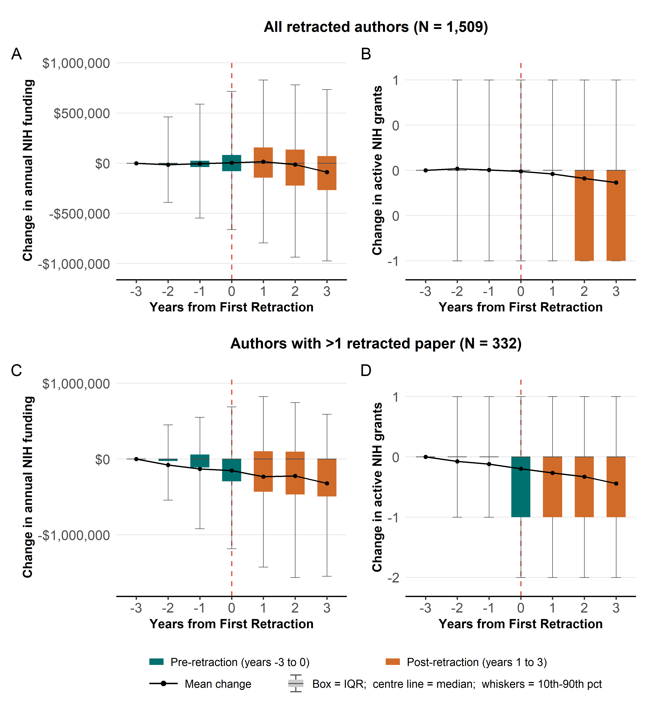
Figure 1. Change in funding for retracted authors compared to year -3 Top row (A, B): the full cohort of 1,509 retracted first/last authors; bottom row (C, D): the 332 authors with more than one retracted paper. (A, C) inflation-adjusted NIH funding; (B, D) count of distinct active NIH grants. Every panel shows the within-author change relative to the baseline year −3 as a boxplot.

Time to retract NIH-funded articles
Time-to-retraction (see Fig. 2) is markedly longer for NIH-funded papers than for U.S. retractions without NIH funding (6.3 versus 3.13 years on average; Mann-Whitney rank-sum, $W$ = 5,388,742, p < 0.001). This gap is largely explained by the different mix of retraction reasons: NIH-funded papers are retracted more often for image-integrity and formal misconduct issues (e.g., data fabrication), which take longer to surface and resolve, whereas non-NIH papers are retracted more often for plagiarism, paper mills, or compromised peer review which may be faster and more definitive to document and retract (see more details in Supplementary Table 1 in Supplementary Materials). The practical implication is that NIH-funded results spend longer in the literature before being retracted, with more time to seed downstream studies, clinical practice, and subsequent funding decisions.
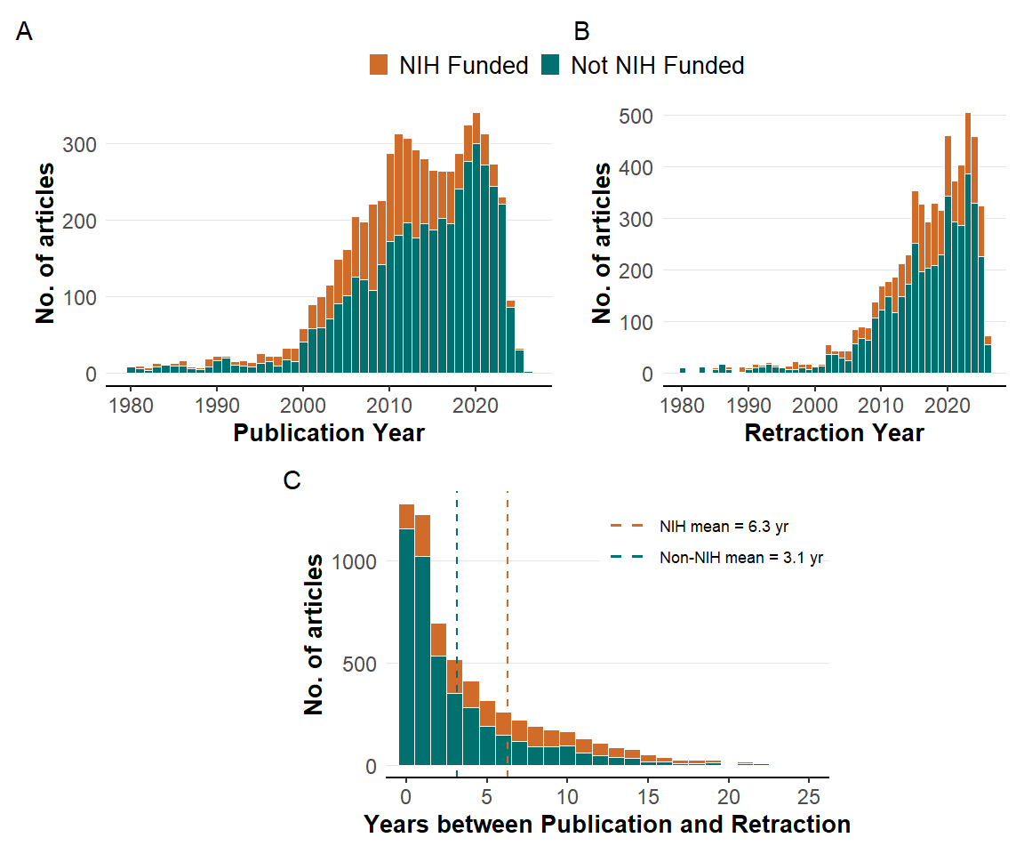
Figure 2. Publication and Retraction Trends. (A) Distribution of publication years. (B) Distribution of retraction years. (C) Lag between publication and retraction; dashed lines mark the mean lag for NIH-funded (orange) and non-NIH (green) papers. Note: For readability, Panels A and B exclude 32 papers published and 12 papers retracted before 1980. Likewise, the X axis of Panel C is capped at 25 years; 15 papers with a lag greater than 25 years are excluded from the plot but included in the means.

Additional considerations and implications
According to our estimates, the direct financial costs of NIH-funded retracted only represent a very small portion of the NIH budget. However, far more papers are seriously flawed, misleading, or even fraudulent and never get retracted. Therefore, the wasted resources may be much larger. We also found that investigator-held grants for which the retracted author was the principal investigator were awarded $4.03B in 2026 dollars. Therefore, the footprint of flawed and fraudulent work may relate to a much larger space of research efforts. Furthermore, retraction mechanisms remain slow and inefficient as of today, and they only reflect the visible part of a problem that might be much bigger (7–9). Besides, direct cost is also an underestimate of damage since downstream research that built on flawed conclusions or clinical decisions informed by them also entail cost. Evidence synthesis may also be affected (10).
Enhancing detection of papers that warrant retraction is not a simple process. Mass-detection tools (image forensics, “tortured-phrase” scanners, statistical anomaly detectors, or emerging AI-content classifiers) may be funded and developed as research infrastructure and applied as pre- and post-publication surveillance. Efficiency and yield of different tools require careful study. Accurate and robust methods to detect fraudulent papers might prevent their publication if applied at the peer review stage or, at least, should enable shorter retraction times, which is especially relevant considering the longer time-to-retraction for NIH-funded studies. Moreover, it should be acknowledged that many retractions reflect honest errors and their authors who detect them and withdraw their flawed work from the published corpus should be congratulated for their diligence and honesty. Creating a culture where honest correction or error is rewarded rather than leading to reputational damage is warranted (11–13). Currently, most retractions probably reflect poor research practices and misconduct (14), but the balance may change if more honest error retractions are incentivized.
Another important point is that retracted authors experienced a short-term decrease in NIH funding, with the most pronounced declines among authors with more than one retracted article, although a big proportion of previously funded authors still retained at least some funding. One may debate whether and how the NIH might consider enforcing faster and stricter consequences for retracted authors, especially when the reasons for retractions are not due to honest errors, but to serious fraudulent practices such as data fabrication. “Super-retractor” authors with a large number of retractions may account for a sizeable share of total retractions (15) and may be a particular group warranting more aggressive measures. Some of these authors may be highly cited and may have a major negative impact in their fields (16).
Lastly, considering the fast pace with which the published scientific literature is evolving, static reports quickly become obsolete. The dashboard accompanying this analysis (https://sandovallentisco.shinyapps.io/nih-retractions/) is automatically recomputed weekly from openly available data, so the estimates in this article will continue to refresh after publication. We encourage meta-scientists and policy researchers to also include living, automated analyses of research practices and research outcomes when possible.

Supplementary materials
Detailed methods and additional analyses can be found at: https://github.com/sandovallentisco/nih-retractions-cost/blob/main/supplementary_materials.pdf

Disclosures and data availability statement
This study was preregistered on March 23, 2026, on OSF (https://osf.io/guq59/). Deviations from preregistration can be found at https://osf.io/kd8bf/. All data and scripts can be found at https://github.com/sandovallentisco/nih-retractions-cost.

References
1. I. Oransky, A. Marcus, Why write a blog about retractions? (2010). https://retractionwatch.com/2010/08/03/why-write-a-blog-about-retractions/.
2. P. Sebo, M. Sebo, Geographical Disparities in Research Misconduct: Analyzing Retraction Patterns by Country. Journal of Medical Internet Research 27, e65775 (2025).
3. R. G. Steen, A. Casadevall, F. C. Fang, Why Has the Number of Scientific Retractions Increased? (American Psychological Association, Washington, DC, US, 2016)Methodological issues and strategies in clinical research, 4th ed.
4. A. M. Stern, A. Casadevall, R. G. Steen, F. C. Fang, Financial costs and personal consequences of research misconduct resulting in retracted publications. eLife 3, e02956 (2014).
5. I. Oransky, The retraction watch database becomes completely open and RW becomes far more sustainable (2023). https://retractionwatch.com/2023/09/12/the-retraction-watch-database-becomes-completely-open-and-rw-becomes-far-more-sustainable/.
6. P. Sebo, M. Sebo, Comparing the performance of retraction watch database, PubMed, and web of science in identifying retracted publications in medicine. Accountability in Research 0, 1–25 (2025).
7. M. Naddaf, E. Quill, Hallucinated citations are polluting the scientific literature. What can be done? Nature 652, 26–29 (2026).
8. B. Scancar, J. A. Byrne, D. Causeur, A. G. Barnett, Machine learning based screening of potential paper mill publications in cancer research: methodological and cross sectional study. BMJ 392, e087581 (2026).
9. M. Topaz, N. Roguin, P. Gupta, Z. Zhang, L.-M. Peltonen, Fabricated citations: An audit across 2·5 million biomedical papers. The Lancet 407, 1779–1781 (2026).
10. C. Bakker, S. Boughton, C. M. Faggion, D. Fanelli, K. Kaiser, J. Schneider, Reducing the residue of retractions in evidence synthesis: Ways to minimise inappropriate citation and use of retracted data. BMJ Evidence-Based Medicine 29, 121–126 (2024).
11. D. Fanelli, J. P. A. Ioannidis, S. Goodman, Improving the integrity of published science: An expanded taxonomy of retractions and corrections. European Journal of Clinical Investigation 48, e12898 (2018).
12. M. Hosseini, M. Hilhorst, I. de Beaufort, D. Fanelli, Doing the right thing: A qualitative investigation of retractions due to unintentional error. Science and Engineering Ethics 24, 189–206 (2018).
13. D. Fanelli, Set up a ’self-retraction’ system for honest errors. Nature 531, 415 (2016).
14. S. Y. Hwang, D. K. Yon, S. W. Lee, M. S. Kim, J. Y. Kim, L. Smith, A. Koyanagi, M. Solmi, A. F. Carvalho, E. Kim, J. I. Shin, J. P. A. Ioannidis, Causes for retraction in the biomedical literature: A systematic review of studies of retraction notices. Journal of Korean Medical Science 38, e333 (2023).
15. C. Lyu, M. Matbouriahi, F. Naudet, J. P. A. Ioannidis, I. A. Cristea, Retracted randomized clinical trials from superretractors and top-cited scientists with multiple retractions. JAMA Network Open 9, e267424 (2026).
16. J. P. A. Ioannidis, A. M. Pezzullo, A. Cristiano, S. Boccia, J. Baas, Linking citation and retraction data reveals the demographics of scientific retractions among highly cited authors. PLOS Biology 23, e3002999 (2025).

