Supplementary Materials to Cost of Retracted Articles to the NIH: a Living Analysis

Supplementary methods

Data extraction and preparation
First, we retrieved the latest version of the Retraction Watch Database (RWD) from the Crossref repository (https://gitlab.com/crossref/retraction-watch-data). We only considered entries marked as retractions and not expressions of concern or corrections. We also excluded entries classified as ‘Retract and Replace’, which indicates that a paper was retracted but subsequently replaced by a corrected version, as this implies the work only contained remediable errors and remains valid in the literature. Additionally, we omitted retractions that did not represent a high likelihood of serious error and/or misconduct by the authors (e.g., administrative or publisher errors), filtering out entries classified as ‘Error by Journal/Publisher’, ‘Duplicate Publication through Error by Journal/Publisher’, or ‘Withdrawn (out of date)’ provided these were not accompanied by additional reasons suggesting author fault.
For those eligible retracted articles for which RWD identified an institutional affiliation within the U.S., we used a custom Python script to automate the retrieval of supplementary funding metadata. This script queried PubMed using the National Center for Biotechnology Information (NCBI) Entrez API to get funding information (grant IDs and and the total number of publications under each grant). We judged the accuracy of PubMed NIH funding information to be good, with very few missing grants (see more details in the next section). In fact, PubMed sometimes captured more grants than were explicitly reported in the article text, which reflects the fact that PubMed also incorporates grant–publication associations from sources beyond the manuscript itself. For example, through the NIH’s My NCBI / My Bibliography system, where investigators link their accounts to eRA Commons and associate their publications with active grants for routine bibliography management and when preparing annual progress reports (RPPRs). Additional grant information might come from publisher deposits, the NIH Manuscript Submission System (NIHMS), and NLM’s own text mining and indexing processes. Together, these mechanisms can capture official funding support even when authors inadvertently omitted the grant numbers from the manuscript’s acknowledgments section. Finally, to retrieve the funding amount associated with a grant, we used the NIH Research Portfolio Online Reporting Tools Expenditure and Results (RePORTER) tool. Databases from all available fiscal years were downloaded using the ExPORTER tool. Grant IDs were searched within these databases, extracting the funding amount associated with each one.

Examining the accuracy of PubMed NIH funding information
To assess the accuracy of the retrieved NIH funding data, we qualitatively compared the funding and acknowledgement sections of the first entries (i.e., the most recent entries) from the Retraction Watch Database (RWD) (version retrieved in December 2025) with the information from PubMed. This way, we inspected a total of 123 entries for which there was an associated PubMed ID. Using this sample, we detected that while reported grants from non-NIH funding bodies were frequently missing from the PubMed metadata, NIH grants reported in the articles were correctly included in PubMed in all but two cases (i.e., 2 out of the 45 entries for which some NIH funding was reported). In the first case, all four grants reported in the full text were missing because they were incorrectly disclosed within the Conflict of Interest (COI) section rather than the funding/acknowledgment sections. In the second case, one out of three reported grants was not retrieved, likely missed by the PubMed indexing algorithm due to non-standard reporting formats (it was reported as R 56-139561 instead of R56 HL139561). To mitigate problems arising from misplaced disclosures like in the first case, we also retrieved information about COIs to identify potential grant IDs. In the remaining 78 cases, PubMed did not retrieve any NIH grants because, correctly, no NIH funding had been reported. Nonetheless, because PubMed began indexing COI statements systematically only in 2017 (U.S. National Library of Medicine, 2017), earlier articles may still be subject to missing data.
However, importantly, we also observed in this sample that, in 9 out of the 44 entries for which PubMed identified some NIH grant, the PubMed metadata yielded more NIH grant IDs than those explicitly reported in the article funding/acknowledgement sections. This discrepancy likely happened because PubMed/RePORTER also considers information from authors reported internally, e.g., information submitted to the My NCBI tool to fill in the NIH Research Performance Progress Report (RPPR). Therefore, even if authors failed to disclose funding in the article but submitted this information to other platforms, this information becomes available in PubMed/RePORTER. For this reason, we believe that funding data provided by PubMed is more comprehensive than what is reported in the article. Additionally, we observed minor issues regarding duplicate entries, where the same grant appeared several times with varying formats—e.g., ‘NCI NIH HHS (R01 CA138409)’ and ‘NCI NIH HHS (CA138409)’, or ‘P20RR 15635’ and ‘P20 RR015635’. To prevent double-counting, we implemented an automated cleaning of duplicates based on numeric suffix matching.
After examining this sample, we wanted to determine if PubMed might have poorer retrieval of NIH grants for older cases (although it is also important to note that the number of retractions is much higher in recent publications). Nonetheless, for this reason, but also to further examine the possible issues mentioned above, we randomly selected another 200 entries from the entire sample, ensuring that 100 entries corresponded to articles published before 2005 and the other 100 corresponded to articles published after 2005. After removing the records that lacked an associated PubMed ID, we were finally able to examine 73 and 65 entries from each publication period.
In all cases within this new sample (both before and after 2005), whenever PubMed did not retrieve a grant ID it was because, correctly, no grant ID had been reported in the article either. For the subset of articles published before 2005, PubMed identified at least one NIH grant in 37 entries. Upon inspecting these grants, out of a total of 77 NIH grants IDs that were retrieved by PubMed/74 NIH grants IDs that were explicitly reported in the articles, a total of 6 grants could not be found in RePORTER. Two of these cases not found in RePORTER were published before 1985, which could explain this omission, as RePORTER data only goes back to 1985. In the remaining entries with funding, discrepancies between the number of NIH grant IDs retrieved by PubMed and those reported in the articles were found in only two cases; one because a grant ID was duplicated and in the other cases 2 grant IDs not reported in the text were present in PubMed. After inspecting these cases, we believe it may be a PubMed error since the Fiscal Year was later than the publication of the article. To control these types of potential errors, we excluded grant IDs with fiscal years that post-date the article’s publication.
For the subset of articles published after 2005, PubMed retrieved some NIH funding for 21 entries. For these entries, PubMed retrieved a total of 90 NIH grant IDs, while only 43 were reported in the articles. 24 of these discrepancies were due to duplicate grant IDs, an issue easily resolved by deduplicating as previously mentioned. Most of the remaining 23 discrepancies stem from a case where the article only reports ‘This work was supported by National Institutes of Health grants’ yet PubMed retrieves 14 NIH grant IDs, all of which are linked to one of the authors; we therefore consider this a case where PubMed was more comprehensive than the article itself. Of the remaining 9 discrepant NIH grant IDs, 7 of the grant IDs were also linked to one of the authors, and the other appears to be a PubMed error assigning two placeholder grant IDs (NIA NIH HHS (R99 AG999999); Intramural NIH HHS (Z99 AG999999)), not found in RePORTER. In sum, most discrepancies are due to duplicates that can be resolved or NIH grant IDs that were not reported in the article but are linked to the authors. Spreadsheets with the selected and inspected samples can be found in the ‘Supplementary Materials’ folder of the OSF registration as ‘sample_1.xlsx’ and ‘sample_2.xlsx’ at (https://osf.io/guq59/).

Automated “Living” Analysis Pipeline
To ensure the findings remain current (“living analysis”), the entire data retrieval, processing, and deployment pipeline was automated using GitHub Actions. A scheduled workflow is triggered weekly (every Sunday at 06:00 UTC) on a cloud-based environment. The automated pipeline executes the following sequential steps: the workflow initializes a Python 3.11 environment to download the latest raw datasets from the Retraction Watch Database and the NIH ExPORTER. It then executes the core data processing scripts (main.py), interacting with the NCBI Entrez API to fetch updated publication metadata. Once the raw data is cleaned, merged, and analyzed, the workflow automatically commits the newly processed CSV files back to the GitHub repository. This ensures transparent data versioning and maintains a historical record of the dataset over time. In the final stage, the workflow provisions an R 4.3 environment, installs the required dashboard dependencies (e.g., shiny, tidyverse, plotly) directly from the Comprehensive R Archive Network (CRAN), and automatically redeploys the updated Shiny web application to shinyapps.io. The project does not need for manual data updates, guaranteeing that the dashboard consistently reflects the most recent retraction and funding information. The online dashboard is accessible at: https://sandovallentisco.shinyapps.io/nih-retractions/.

Estimating the direct cost of NIH-funded retracted articles
We quantify the direct cost in different ways. First, we calculate the attributed cost dividing each grant total award by the number of publications produced under that grant and assigns the corresponding share to the retracted paper. This represents the fraction of the grant money that produced a specific retracted paper. We also calculated the money associated with retracted papers directly awarded to researchers in personal grants (i.e., excluding institutional center and infrastructure grants). For this, we first calculate the total award of unique grants (de-duplicating repeated grants to prevent double-counting). Then, to separate grants awarded to an investigator from those awarded to an institution, we use the NIH activity code (e.g., R01, P30, U01). This code is present in the raw ‘Funding_Info’ text (e.g., NCI NIH HHS (R01 CA203737)) in FINAL_Retractions_Costs_and_Pubs.csv. We extract it with a regular expression that captures the three components of a grant number (i.e., activity code, Institute/Center abbreviation, and serial number) allowing the activity code to be either separated from or concatenated with the ID (e.g., U19AI057229, 5P50CA101942). For grants whose code is not recoverable from ‘Funding_Info’, we fall back to the full grant numbers stored in the author–funding file (field ‘Grant_ID’, e.g., K08HL086671, in Author_Funding_Matches.csv). Together these sources assign an activity code to approximately 95% of the unique-grant dollars.
We label a grant as directly awarded to the investigator (“personal”) if its activity code is a research, career-development, or fellowship grant (i.e., codes beginning with R, K or F) or one of the NIH Director’s high-risk personal awards (DP1 Pioneer, DP2 New Innovator, DP5 Early Independence). Within the R-, K- and F-series we exclude mechanisms that are not awarded to fund an individual investigator’s own research, namely institutional career/training mechanisms (K12, KL2), SBIR/STTR awards to companies (R41–R44), and institutional R-series mechanisms; resource grants (R24), education grants (R25), and linked research project awards (RL1). All remaining mechanisms are treated as institutional: center grants (P30, P50, P20, P60, P40, P51, P41), clinical-research centers (M01, UL1), institutional training grants (T-series), shared instrumentation and construction (S10, G-, C06), cooperative agreements (U01, U54, U2C, U19, …; we exclude U01 because, although some fund a single investigator, others are large multi-site consortia that behave more like program or institutional grants), and resource grants from the former National Center for Research Resources (Institute/Center code “RR”). Program-project grants (P01) span several sub-projects and cores across multiple investigators and are treated as institutional here. Grants whose activity code could not be recovered are conservatively not counted as personal.

Inflation adjustment
To account for inflation, the attributed cost of each retracted article was adjusted to current-year dollars using the Consumer Price Index (CPI). We matched each article’s publication year to the corresponding historical CPI and calculated an inflation multiplier relative to the most recent available fiscal year. This multiplier was then applied to the raw attributed cost of the publication.
Because a grant award spans several years, there is no single base year to which it can be deflated. For this reason, we assign each grant a representative inflation multiplier equal to the mean of the multipliers of the papers that cite it (each paper’s multiplier is taken from its publication year).

Same name correction in the author-consequences analysis
The consequences analysis (Figure 1 of the main text) follows individual authors’ NIH funding across the retraction event. Authors are linked to their NIH grant histories by name, which is reliable for distinctive names but ambiguous for common ones. When a name matches the grant records of several different investigators who happen to share that name, the funding attributed to a retracted author is partly, or entirely, another person’s, which inflates the per-author funding trajectories and can bias the pre/post change.
To address this, we used the NIH ExPORTER project files, in which every project lists the unique person identifiers (PI_IDS) and awardee institution (ORG_NAME) of its principal investigator(s). For each retracted author we collected the distinct PI_IDS that their name maps to across all of their attributed grants. When the name maps to a single PI_ID, every attributed grant belongs to the same person and the link is unambiguous. However, when it maps to more than one PI_ID, the attributed grant history pools two or more different investigators who happen to share that name, a situation we call a “collision”.
To identify whether any of the attributed funding can be tied to the real retracted researcher, we used institutional affiliation. For each attributed grant we compared its awardee institution (ORG_NAME) against the institution listed on the author’s retracted paper. Institutions were matched leniently: each string was upper-cased and reduced to its distinctive tokens (words longer than three characters, excluding generic terms such as “university”, “hospital” or “center”), and a grant was deemed to match the paper when the two shared at least one such token (e.g. the paper affiliation “Dana-Farber Cancer Institute, Harvard Medical School” matches the grant awardee “DANA-FARBER CANCER INSTITUTE”).
We then used this match to clean the attribution at the level of individual grants rather than whole authors. For each collision author we identified the real person’s PI_ID(s) as those holding at least one institution-matching grant, and retained only the grants belonging to that PI_ID, discarding the grants of the same-named others. Because a PI_ID is stable when a researcher changes institution, this keeps the real author’s entire funding trajectory, including grants they later held at other institutions; matching grants by institution alone would instead penalise legitimate institution moves. Authors whose name does not collide keep all of their grants. A collision author with no institution-matching grant has no identifiable real PI_ID, contributes no attributable funding, and therefore leaves the cohort. This grant-level correction is the one used in the main text.
Sensitivity of the author-consequences result to name-collision handling. ‘Change’ is the percentage change in the cohort-wide median per-author annual NIH funding from the three pre-retraction to the three post-retraction years; the Wilcoxon p-value is from the paired signed-rank test; ‘Lost all funding’ is the share of previously funded authors with no NIH funding in the post window. The grant-level PI_ID rule is used in the main text.
Specification | Authors (N) | Median pre | Median post | Change | Wilcoxon p | Lost all funding
Full cohort (no correction) | 1,628 | $145,164 | $110,200 | -24.1% | 0.219 | 24.7%
Grant-level by PI_ID (main analysis) | 1,509 | $133,293 | $55,973 | -58.0% | 0.021 | 26.7%
The two rows contrast the uncorrected cohort with the grant-level PI_ID correction used in the main analysis. Without correction, the attributed funding still pools same-named investigators, whose large, persistent portfolios dilute the decline to about 24%. The grant-level PI_ID rule isolates each real author’s own grants—for an author whose name matches several investigators, keeping only the grants of the one whose awardee institution matches their retracted paper—after which the cohort-wide median annual funding falls by about 58% (paired Wilcoxon p = 0.021), a decline that, unlike the uncorrected cohort, reaches statistical significance. The magnitude of the decline is thus sensitive to how name collisions are handled, and the headline figure should be read with that caveat; the direction, i.e., a substantial post-retraction decline in the funding genuinely attributable to retracted authors, holds once the attribution is cleaned.

Supplementary Results

Distribution of per-author funding
The corrected cohort-wide median falls by about 58%, but this reflects mainly an increase in the share of authors with no NIH funding rather than a uniform reduction across the cohort. The figure below shows the per-author annual funding before and after retraction. For the full cohort the two distributions, and their means, are very similar; the change is concentrated in the median. For authors with more than one retracted paper, the whole distribution, including the mean, shifts downward.
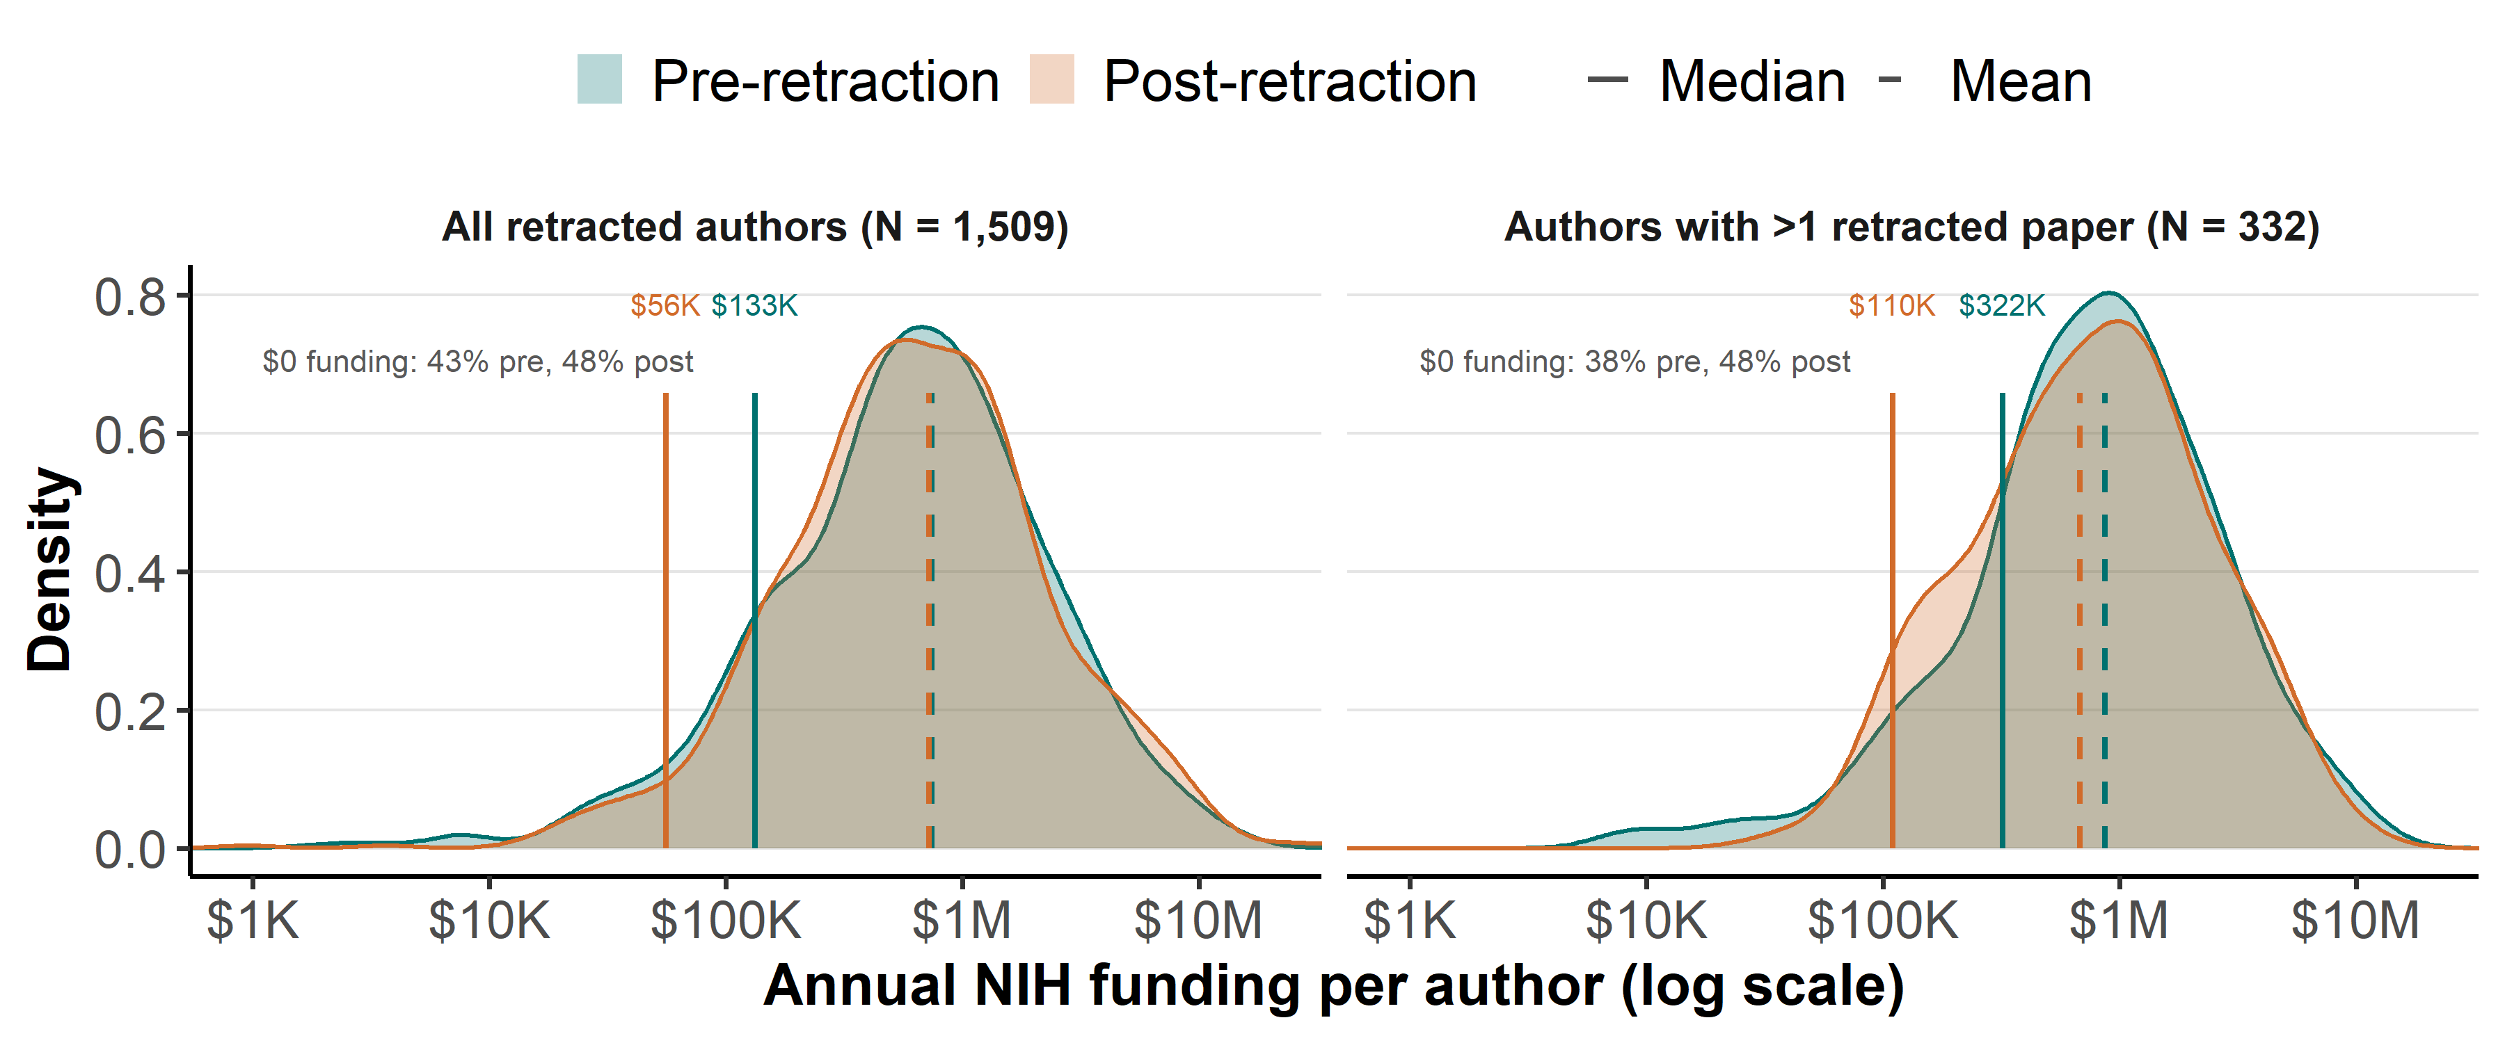
Distribution of per-author annual NIH funding in the three years before (green) and after (orange) retraction, after the grant-level collision correction, for authors with non-zero funding (kernel density on a log scale; zero-funding authors are omitted from the curve but their share is annotated in each panel).

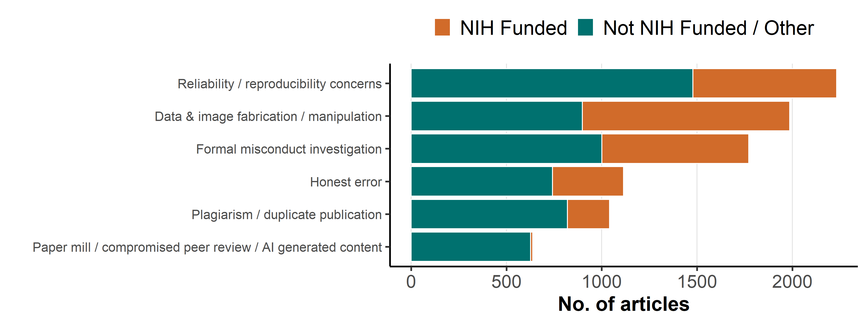
Retraction reasons by funding source, grouped into broad categories.

Top retraction reasons by funding source and time-to-retraction
NIH-funded and non-NIH-funded retracted papers differ systematically in why they are retracted, and these reasons differ in how quickly they are acted on, which accounts for much of the longer time-to-retraction of NIH-funded papers reported in the main analysis. NIH-funded papers are concentrated in data- and image-fabrication/manipulation and in formal misconduct investigations, which surface late (through image forensics and institutional or ORI investigations) and take years to resolve; non-NIH papers are more often retracted for plagiarism and paper mills, which are acted on much faster. The table below shows, for each broad reason category, the share of papers in each funding group whose retraction notice lists such a reason, together with the median time-to-retraction for papers with that reason.
Retraction reasons by funding source and their median time-to-retraction.
Retraction reason | % of NIH-funded | % of non-NIH-funded | Median lag (years)
Data & image fabrication / manipulation | 63.1% | 20.6% | 6
Formal misconduct investigation | 44.7% | 23.0% | 5
Reliability / reproducibility concerns | 43.8% | 33.9% | 3
Plagiarism / duplicate publication | 12.8% | 18.8% | 2
Honest error | 21.6% | 17.0% | 2
Paper mill / compromised peer review / AI generated content | 0.7% | 14.4% | 1
The categories are our own aggregations of the raw Retraction Watch Database reason labels, grouping the most frequent substantive reasons into six broad mechanisms. Because a single retraction notice can list several labels, the categories are not mutually exclusive; and because the database uses many fine-grained labels, the categories do not capture every label; some substantive labels (e.g., research-ethics and consent, authorship, or referencing/attribution issues) fall outside the six categories. Procedural and administrative reasons (e.g., Investigation by Journal/Publisher) and notice-status labels (Notice – Limited or No Information; Date of Article and/or Notice Unknown; Upgrade/Update of Prior Notice(s); Removed; Notice – Unable to Access via current resources) are not included, as they describe the retraction process or notice status rather than a substantive cause.
Each category groups the following raw labels — Data & image fabrication / manipulation: Duplication of/in Image; Manipulation of Images; Falsification/Fabrication of Image; Concerns/Issues about Image; Plagiarism of Image; Unreliable Image; Falsification/Fabrication of Data; Falsification/Fabrication of Results. Formal misconduct investigation: Investigation by Company/Institution; Investigation by ORI; Investigation by Third Party; Misconduct - Official Investigation(s) and/or Finding(s); Misconduct by Author. Reliability / reproducibility concerns: Unreliable Results and/or Conclusions; Unreliable Data; Concerns/Issues about Data; Concerns/Issues about Results and/or Conclusions; Results Not Reproducible; Original Data and/or Images not Provided and/or not Available. Plagiarism / duplicate publication: Plagiarism of/in Article; Plagiarism of Text; Plagiarism of Data; Duplication of/in Article; Duplication of Text; Euphemisms for Plagiarism; Euphemisms for Duplication; Duplication of Data. Honest error: Error in Data; Error in Analyses; Error in Results and/or Conclusions; Error in Methods; Error in Image. Paper mill / compromised peer review / AI generated content: Compromised Peer Review; Concerns/Issues about Peer Review; Paper Mill; False/Forged Authorship; False/Forged Affiliation; Computer-Aided Content or Computer-Generated Content.
Unlike the other categories, “Formal misconduct investigation” does not describe a specific defect of the paper but rather the procedural pathway through which the retraction was reached (i.e., a formal investigation by an institution, the ORI, or a third party). Accordingly, 95% of papers in this category also carry a label from at least one other category (most often data/image fabrication or manipulation, or reliability/reproducibility concerns). Because NIH-funded papers are routed through these formal investigations far more often than non-NIH papers, this slow institutional/ORI pathway accounts for a substantial part of their longer time-to-retraction.

Scientific domains and publishers of U.S. retracted articles
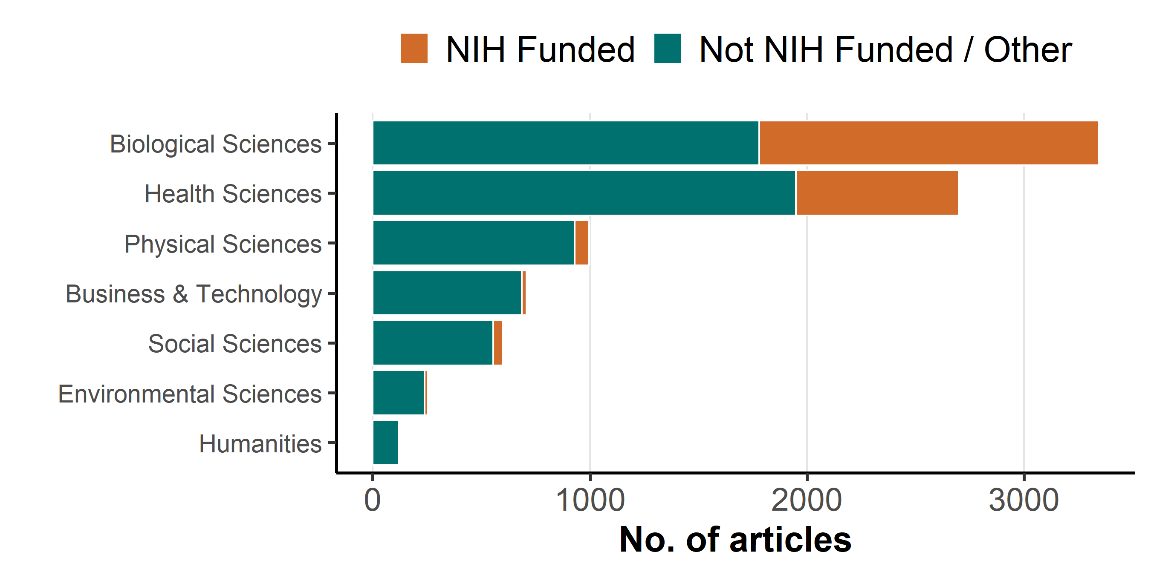
Scientific Domains. Note: A single paper can have multiple subjects, but each broad category is counted at most once per paper.

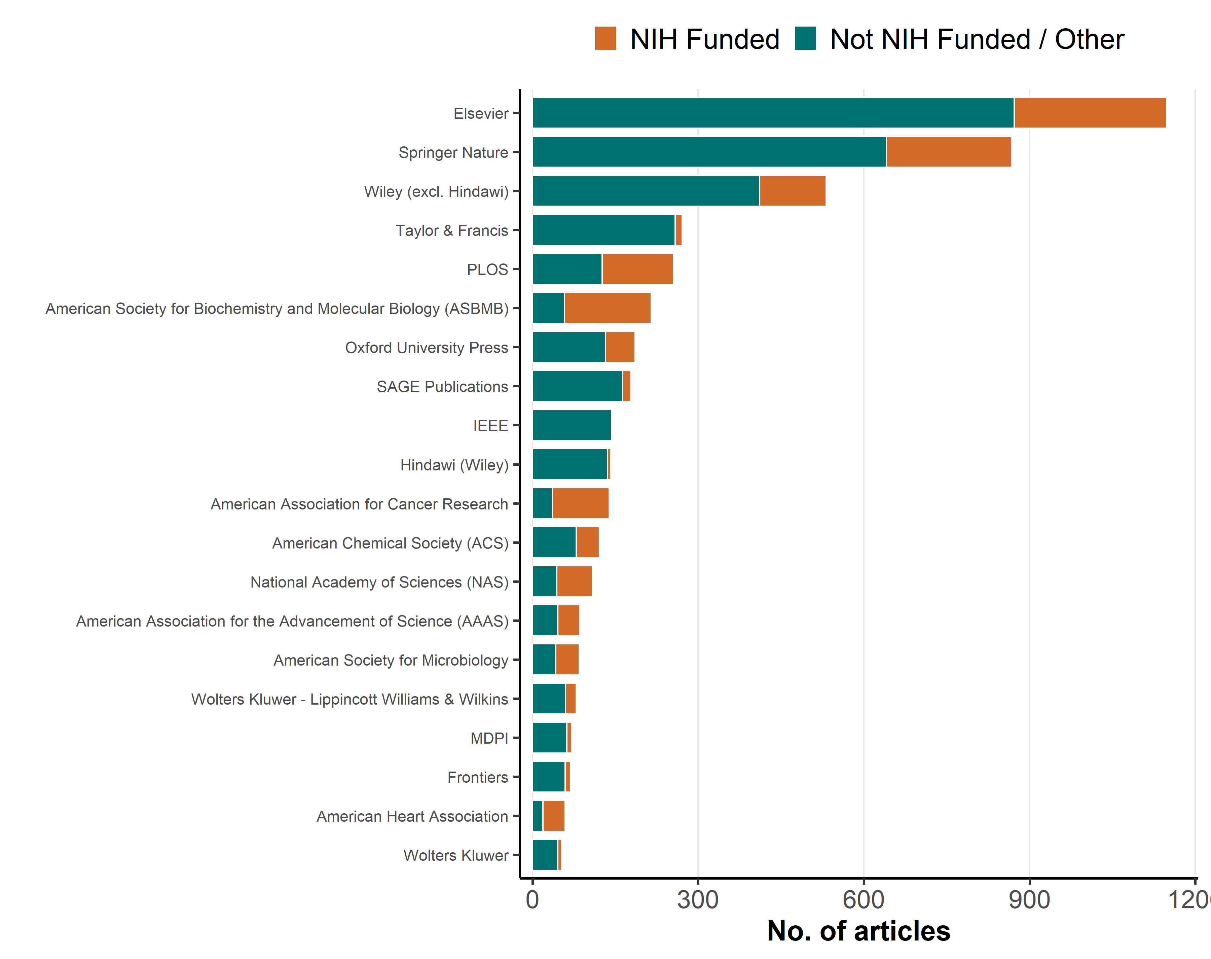
Top Retracted Publishers. Note: Publishers were grouped by parent companies where possible. ‘Springer Nature’ includes Springer, Nature, BMC, Palgrave. ‘Elsevier’ includes Cell Press, Lancet. ‘Hindawi’ has been separated from ‘Wiley’ to show its specific impact. ‘Taylor & Francis’ includes Routledge, Dove Medical Press..

