Title Goes Here

Jane Doe1,2,✉, John Q. Doe1, Peder Ås1, Juan Pérez3, and Max Mustermann

May 16, 2025

Abstract

Text of abstract

1 Formatting Open Science Group  
2 Federation of Planets  
3 Acme Corporation

✉ Correspondence: [Jane Doe <[email]>](mailto:[email])

Keywords: keyword 1; keyword 2; keyword 3

Highlights: These are the highlights.

# Introduction

Here is a citation (Marwick, 2017)

https://annakrystalli.me/rrresearch/10_compendium.html

# Background

Natural language processing, text analytics

https://github.com/datasciencedojo/IntroToTextAnalyticsWithR/tree/master

How To Fix Support For Password Authentication Was Removed On GitHub : https://www.youtube.com/watch?v=ePCBuIQJAUc

Aqui escriurem mes.

# Install all required packages.  
# install.packages(c("ggplot2",  
# "e1071",  
# "caret",  
# "quanteda",  
# "irlba",  
# "randomForest"))

# Load up the .CSV data and explore in RStudio.  
spam.raw <- read.csv("../data/raw_data/spam.csv",   
 stringsAsFactors = FALSE,   
 fileEncoding = "UTF-16")  
  
# Clean up the data frame and view our handiwork.  
spam.raw <- spam.raw[, 1:2]  
names(spam.raw) <- c("Label", "Text")  
View(spam.raw)  
  
# Check data to see if there are missing values.  
length(which(!complete.cases(spam.raw)))

[1] 0

# Convert our class label into a factor.  
spam.raw$Label <- as.factor(spam.raw$Label)  
  
# The first step, as always, is to explore the data.  
# First, let's take a look at distibution of the class labels (i.e., ham vs. spam).  
prop.table(table(spam.raw$Label))

ham spam   
0.8659368 0.1340632

# Next up, let's get a feel for the distribution of text lengths of the SMS   
# messages by adding a new feature for the length of each message.  
spam.raw$TextLength <- nchar(spam.raw$Text)  
summary(spam.raw$TextLength)

Min. 1st Qu. Median Mean 3rd Qu. Max.   
 2.00 36.00 61.00 80.12 121.00 910.00

# Visualize distribution with ggplot2, adding segmentation for ham/spam.  
library(ggplot2)  
  
ggplot(spam.raw, aes(x = TextLength, fill = Label)) +  
 theme_bw() +  
 geom_histogram(binwidth = 5) +  
 labs(y = "Text Count", x = "Length of Text",  
 title = "Distribution of Text Lengths with Class Labels")

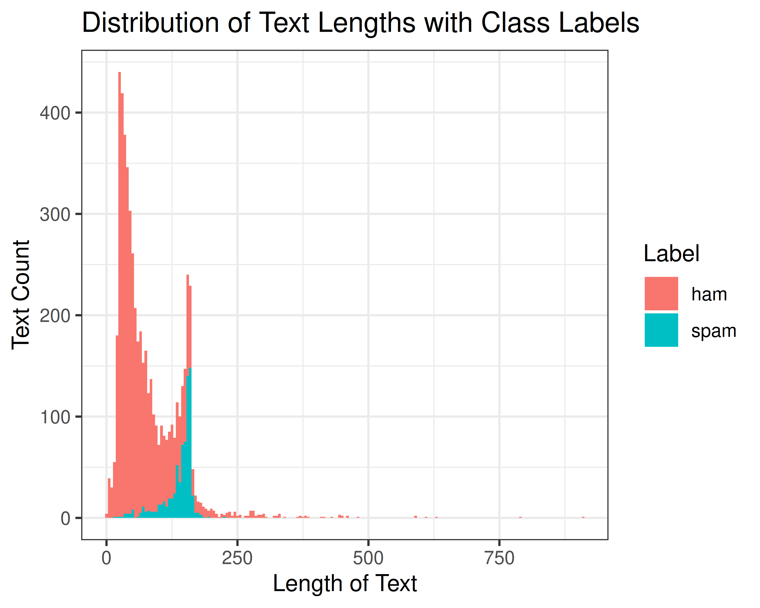

https://m-clark.github.io/text-analysis-with-R/

# Methods

bla

# Results

bla

# Note the path that we need to use to access our data files when rendering this document  
my_data <- read.csv(here::here('analysis/data/raw_data/my_csv_file.csv'))

plot(rnorm(10))

|  |
| --- |
| Figure 1: A plot of random numbers |

Figure 1 shows how we can have a caption and cross-reference for a plot. Note that figure label and cross-references must both be prefixed with fig-

Here is an example of inline code 3.14 in the middle of a sentence.

# Discussion

# Conclusion

# Acknowledgements

# References

Marwick, B., 2017. Computational reproducibility in archaeological research: Basic principles and a case study of their implementation. Journal of Archaeological Method and Theory 24, 424–450. <https://doi.org/10.1007/s10816-015-9272-9>

### Colophon

This report was generated on 2025-05-16 13:47:03.355628 using the following computational environment and dependencies:

# which R packages and versions?  
if ("devtools" %in% installed.packages()) devtools::session_info()

─ Session info ───────────────────────────────────────────────────────────────  
 setting value  
 version R version 4.5.0 (2025-04-11)  
 os Ubuntu 24.04.2 LTS  
 system x86_64, linux-gnu  
 ui X11  
 language (EN)  
 collate en_US.UTF-8  
 ctype en_US.UTF-8  
 tz Europe/Madrid  
 date 2025-05-16  
 pandoc 3.4 @ /usr/lib/rstudio/resources/app/bin/quarto/bin/tools/x86_64/ (via rmarkdown)  
 quarto 1.4.554 @ /usr/local/bin/quarto  
  
─ Packages ───────────────────────────────────────────────────────────────────  
 package * version date (UTC) lib source  
 cachem 1.1.0 2024-05-16 [1] CRAN (R 4.5.0)  
 cli 3.6.5 2025-04-23 [1] CRAN (R 4.5.0)  
 devtools 2.4.5 2022-10-11 [1] CRAN (R 4.5.0)  
 digest 0.6.37 2024-08-19 [1] CRAN (R 4.5.0)  
 dplyr 1.1.4 2023-11-17 [1] CRAN (R 4.5.0)  
 ellipsis 0.3.2 2021-04-29 [1] CRAN (R 4.5.0)  
 evaluate 1.0.3 2025-01-10 [1] CRAN (R 4.5.0)  
 farver 2.1.2 2024-05-13 [1] CRAN (R 4.5.0)  
 fastmap 1.2.0 2024-05-15 [1] CRAN (R 4.5.0)  
 fs 1.6.6 2025-04-12 [1] CRAN (R 4.5.0)  
 generics 0.1.4 2025-05-09 [1] CRAN (R 4.5.0)  
 ggplot2 * 3.5.2 2025-04-09 [1] CRAN (R 4.5.0)  
 glue 1.8.0 2024-09-30 [1] CRAN (R 4.5.0)  
 gtable 0.3.6 2024-10-25 [1] CRAN (R 4.5.0)  
 htmltools 0.5.8.1 2024-04-04 [1] CRAN (R 4.5.0)  
 htmlwidgets 1.6.4 2023-12-06 [1] CRAN (R 4.5.0)  
 httpuv 1.6.16 2025-04-16 [1] CRAN (R 4.5.0)  
 jsonlite 2.0.0 2025-03-27 [1] CRAN (R 4.5.0)  
 knitr 1.50 2025-03-16 [1] CRAN (R 4.5.0)  
 labeling 0.4.3 2023-08-29 [1] CRAN (R 4.5.0)  
 later 1.4.2 2025-04-08 [1] CRAN (R 4.5.0)  
 lifecycle 1.0.4 2023-11-07 [1] CRAN (R 4.5.0)  
 magrittr 2.0.3 2022-03-30 [1] CRAN (R 4.5.0)  
 memoise 2.0.1 2021-11-26 [1] CRAN (R 4.5.0)  
 mime 0.13 2025-03-17 [1] CRAN (R 4.5.0)  
 miniUI 0.1.2 2025-04-17 [1] CRAN (R 4.5.0)  
 pillar 1.10.2 2025-04-05 [1] CRAN (R 4.5.0)  
 pkgbuild 1.4.7 2025-03-24 [1] CRAN (R 4.5.0)  
 pkgconfig 2.0.3 2019-09-22 [1] CRAN (R 4.5.0)  
 pkgload 1.4.0 2024-06-28 [1] CRAN (R 4.5.0)  
 profvis 0.4.0 2024-09-20 [1] CRAN (R 4.5.0)  
 promises 1.3.2 2024-11-28 [1] CRAN (R 4.5.0)  
 purrr 1.0.4 2025-02-05 [1] CRAN (R 4.5.0)  
 R6 2.6.1 2025-02-15 [1] CRAN (R 4.5.0)  
 RColorBrewer 1.1-3 2022-04-03 [1] CRAN (R 4.5.0)  
 Rcpp 1.0.14 2025-01-12 [1] CRAN (R 4.5.0)  
 remotes 2.5.0 2024-03-17 [1] CRAN (R 4.5.0)  
 rlang 1.1.6 2025-04-11 [1] CRAN (R 4.5.0)  
 rmarkdown 2.29 2024-11-04 [1] CRAN (R 4.5.0)  
 rstudioapi 0.17.1 2024-10-22 [1] CRAN (R 4.5.0)  
 scales 1.4.0 2025-04-24 [1] CRAN (R 4.5.0)  
 sessioninfo 1.2.3 2025-02-05 [1] CRAN (R 4.5.0)  
 shiny 1.10.0 2024-12-14 [1] CRAN (R 4.5.0)  
 tibble 3.2.1 2023-03-20 [1] CRAN (R 4.5.0)  
 tidyselect 1.2.1 2024-03-11 [1] CRAN (R 4.5.0)  
 urlchecker 1.0.1 2021-11-30 [1] CRAN (R 4.5.0)  
 usethis 3.1.0 2024-11-26 [1] CRAN (R 4.5.0)  
 vctrs 0.6.5 2023-12-01 [1] CRAN (R 4.5.0)  
 withr 3.0.2 2024-10-28 [1] CRAN (R 4.5.0)  
 xfun 0.52 2025-04-02 [1] CRAN (R 4.5.0)  
 xtable 1.8-4 2019-04-21 [1] CRAN (R 4.5.0)  
 yaml 2.3.10 2024-07-26 [1] CRAN (R 4.5.0)  
  
 [1] /home/jordi/R/x86_64-pc-linux-gnu-library/4.5  
 [2] /usr/local/lib/R/site-library  
 [3] /usr/lib/R/site-library  
 [4] /usr/lib/R/library  
 * ── Packages attached to the search path.  
  
──────────────────────────────────────────────────────────────────────────────

The current Git commit details are:

# what commit is this file at?   
if ("git2r" %in% installed.packages() & git2r::in_repository(path = ".")) git2r::repository(here::here())

Local: master /home/jordi/Documents/nlprrcompendium  
Remote: master @ origin (https://ghp\[email]/sandpiles/nlprrcompendium)  
Head: [cb28908] 2025-05-16: small changes