**Jenkins**

* Take a java class
* Convert it to testng :- Right click it -> Go to testNG -> And convert to testNG
* Go to the location of testNG in my pc.
* Create a folder called lib.
* Add all the jars of selenium in it.
* also https://repo1.maven.org/maven2/org/webjars/jquery/3.5.1/jquery-3.5.1.jar -> Click the link -> Get it downloaded and paste it in lib.
* Also

->users->ustjava->.p2->search for testng in the left->right click any one of the 4 you see and check its path (It would be in pools/pluggins)(The rest of the 3 will be there)org.testng -4 jar files are there->copy these four to lib

* In the TestNG folder create a new text document called new text document
* java -cp bin;lib/* org.testng.TestNG testNG.xml (Check the name of the xml file)->paste this in the text document
* save it as "filecommand.bat" with double quotes
* run the filecommand.bat (It will open a command prompt)
* Go to jenkins->New item (testng name)
* Advanced button at the side
* Click the use custom workplace
* Copy path of the testng folder paste it there
* Apply
* In build button->The dropdown->Execute windows batch command->In the command box write filecommand.bat

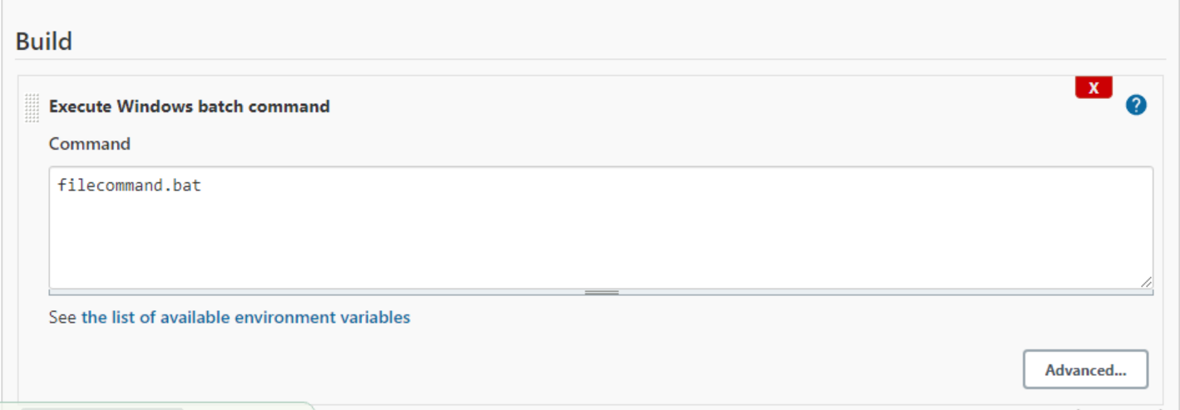

* Apply Again->Save
* In the build now (a bar will load in the left )->Click the files in the left->Console output.

**Cucumber_Jenkins**

Install the necessary pluggins

**Dashboard->Manage Jenkins->Mange Plugins->Available**

Install the below without restarting

**1.Maven Integration**

**2.Cucumber**

**3.Cucumber Trend Report**

**4.Cucumber Report**

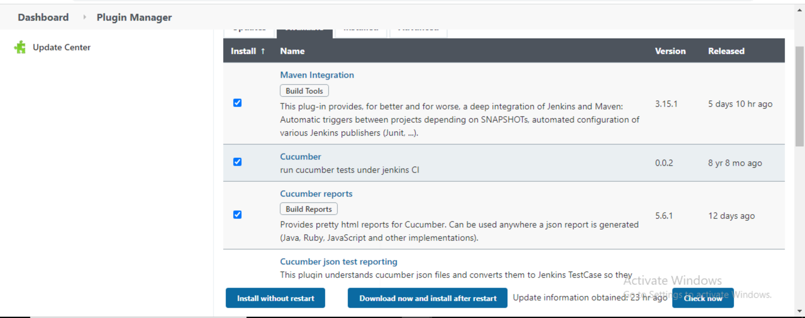

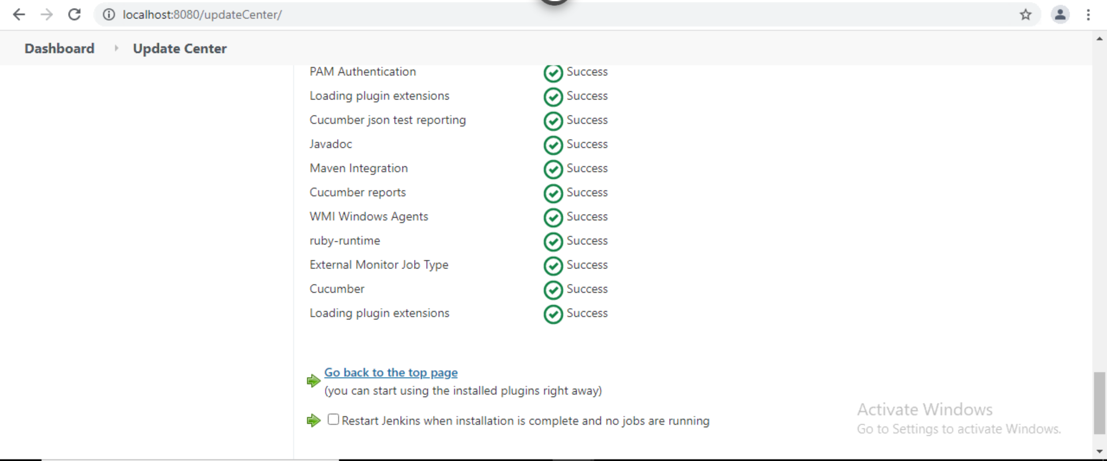

Go back to dashboard and create a New Item

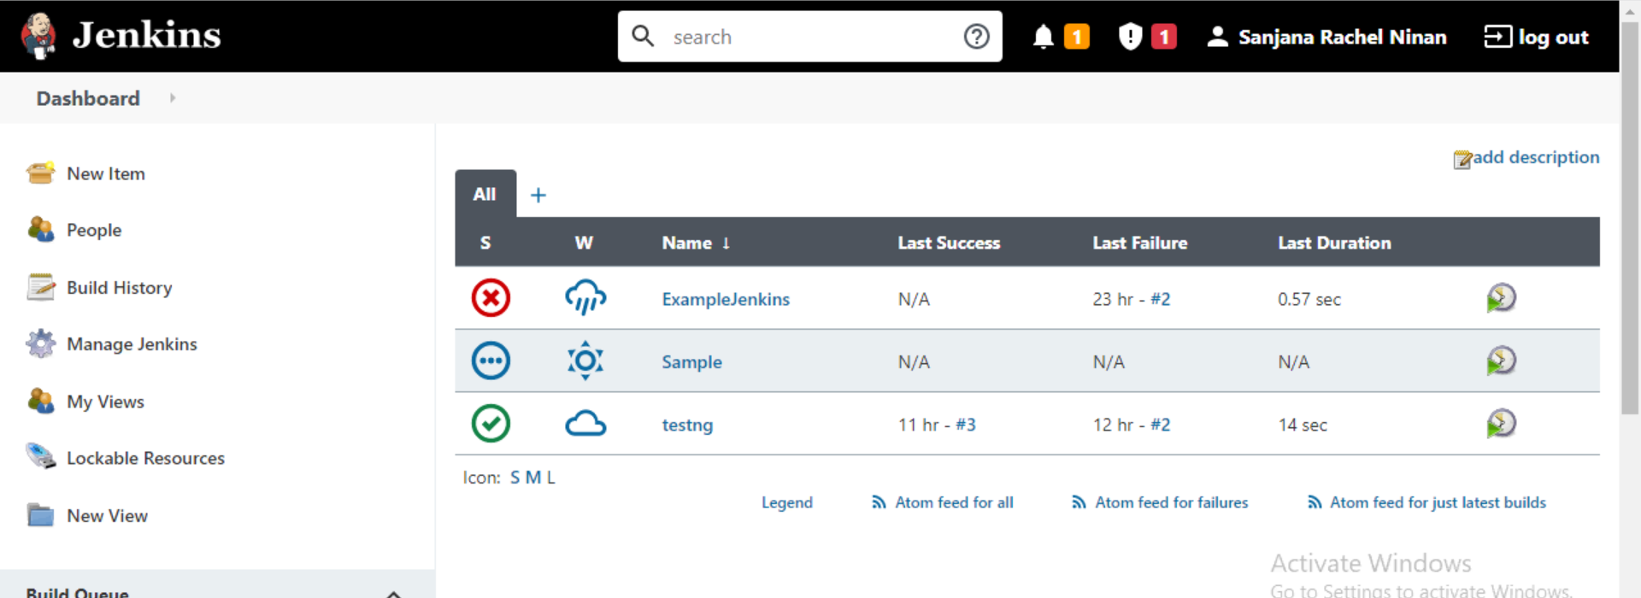

Enter the name of the item

**Maven project -> OK**

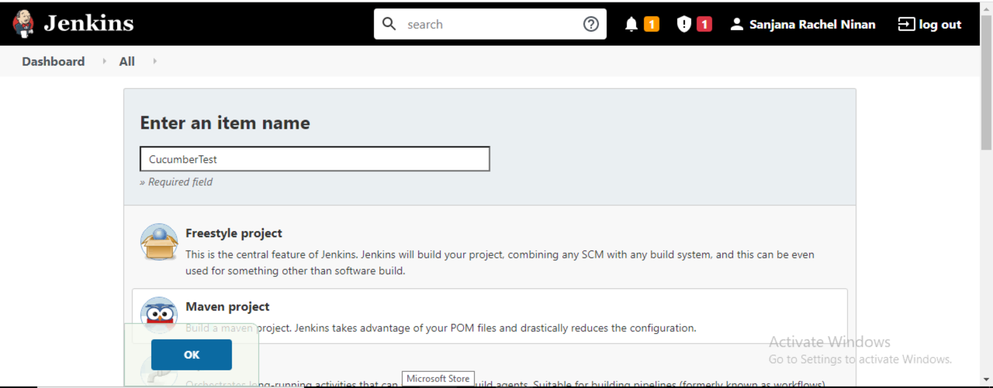

**Go back to Dashboard->Manage Jenkins->Global tool Configuration**

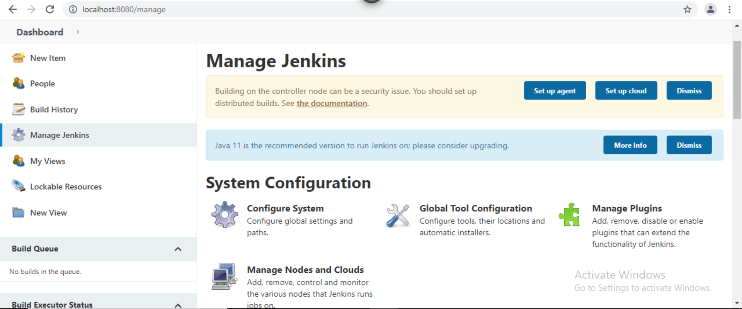

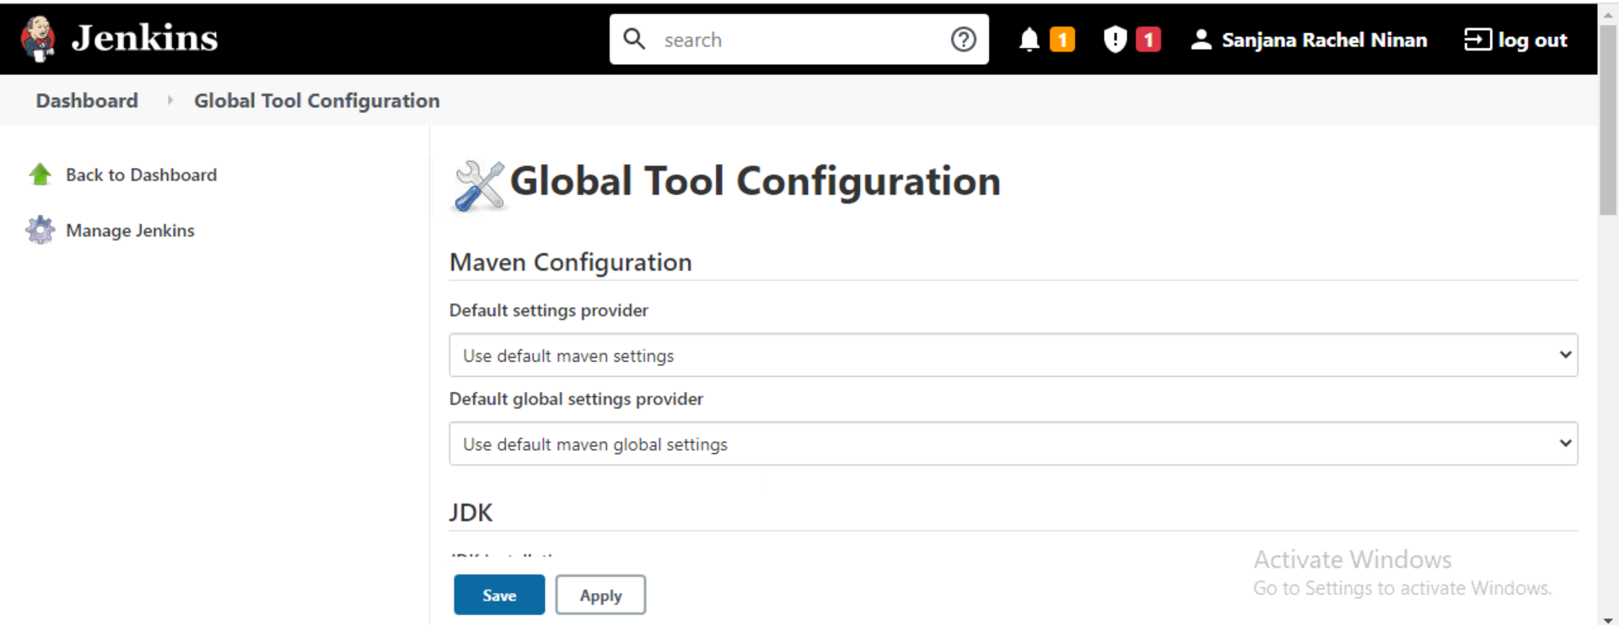

Go to JDK

**Enter the name(JAVA_HOME) -> Under the specified name(JAVA_HOME) enter the path of the jdk file**

If not installed

[**https://www.oracle.com/in/java/technologies/javase/javase8-archive-downloads.html**](https://www.oracle.com/in/java/technologies/javase/javase8-archive-downloads.html)



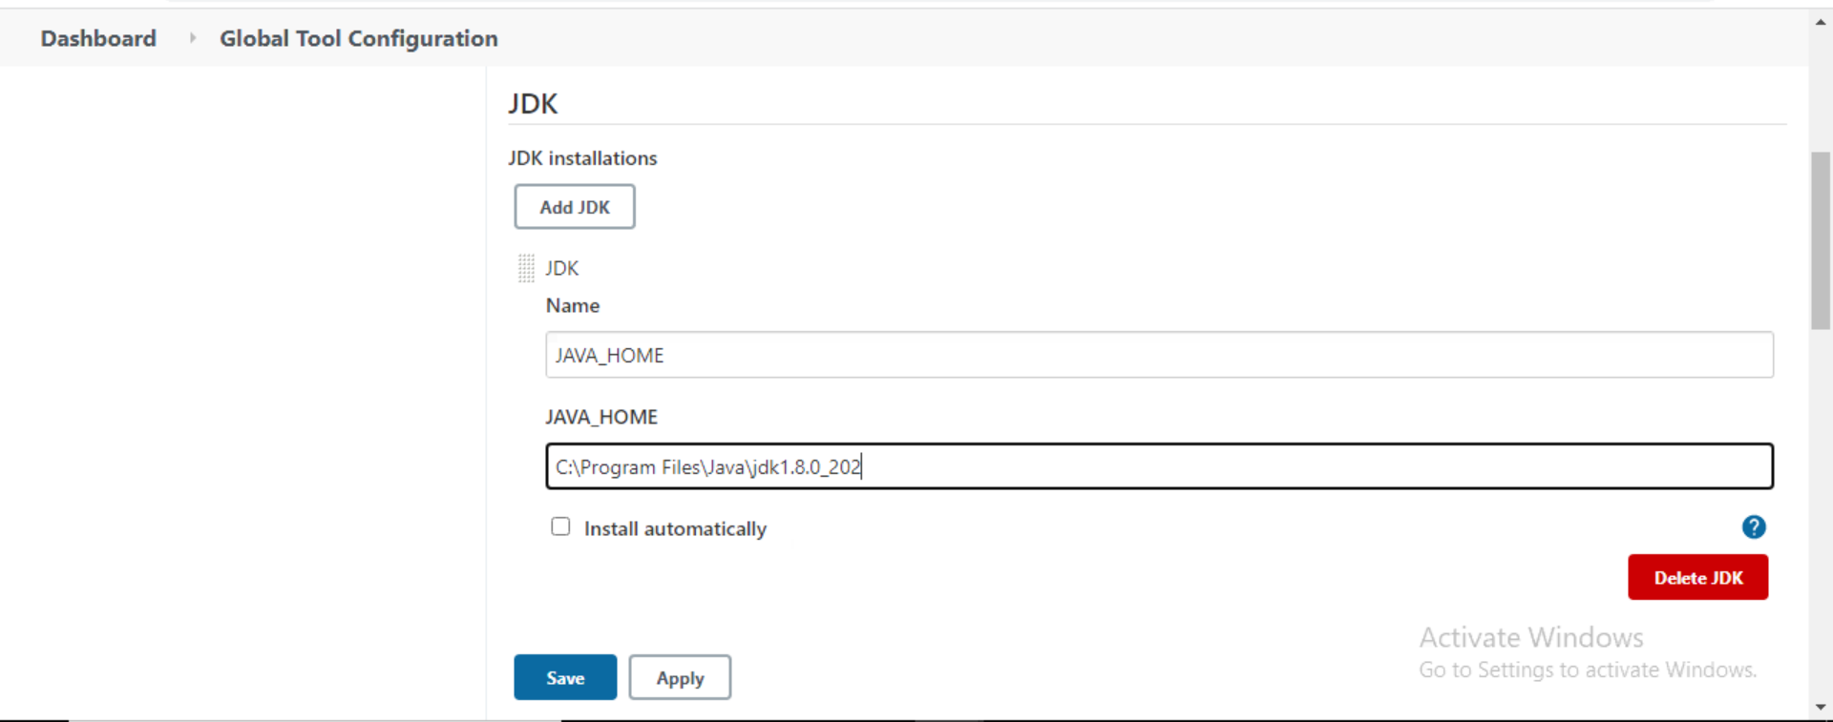

Apply

Go to Maven(Below JDK)

**Add Maven Name(MAVEN_HOME)->Under the specified name(MAVEN_HOME) enter the path of Apache Maven**

If not downloaded

**https://drive.google.com/drive/folders/1RNYWuQ2sFbgf2KsfH_dAk_c2_n-qLE2G?usp=sharing**

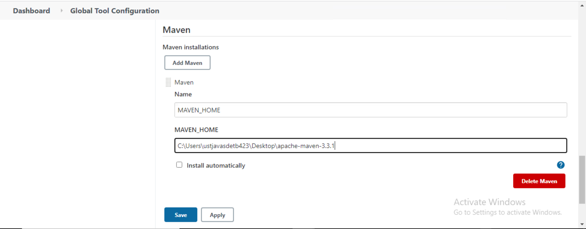

Apply

**Go back to Dashboard->CucumberTest->Configure->**

**Under Build->**

**In Root Pom->Enter the path of the pom file**

**In Goals and Options->clean install(small case)**

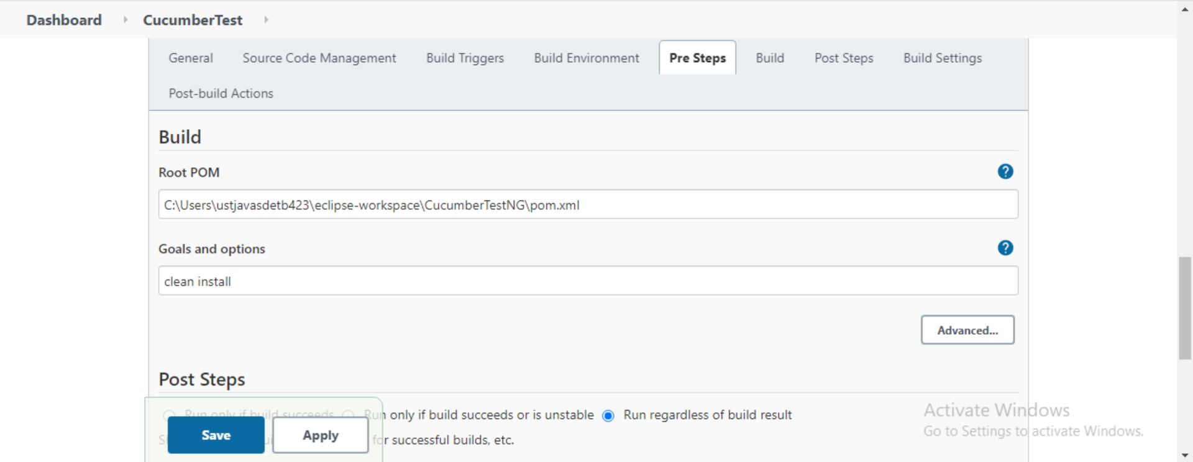

**Go back to Cucumber Test->Build Now->Console Output**

