**Jmeter-TIMERS**

Requirements : create thread group ,http request and add view results in table listener.

**Constant timer:**

Step1: Add timer to the thread group.

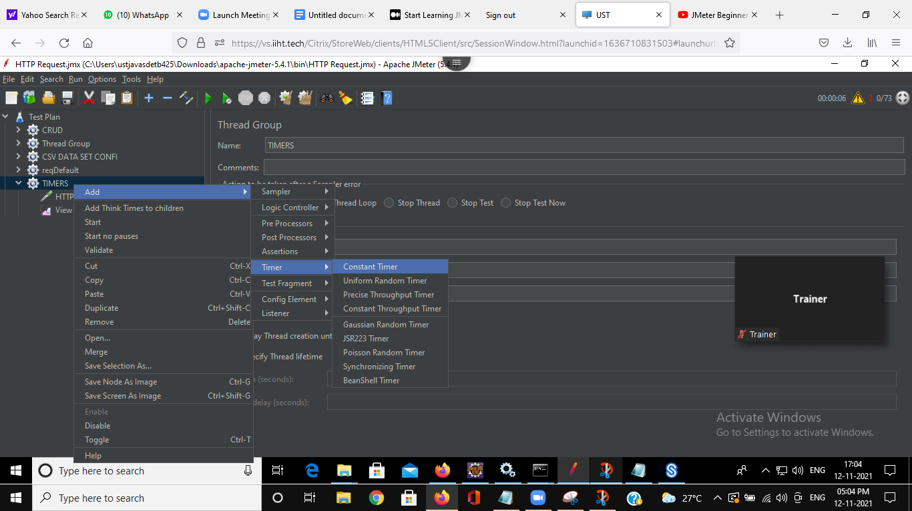

Step2: Add thread delay in milli second

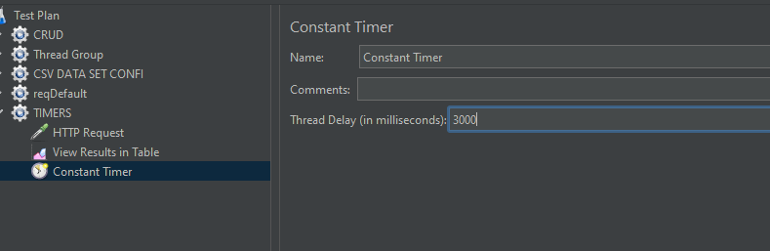

Step3 : Run test

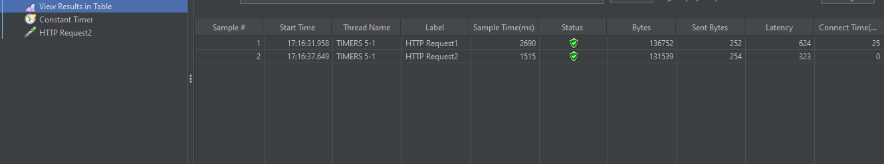

There will be delay before executing each request.

We can add constant timers to the whole thread group as well as each http request.

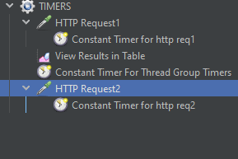

On running the test we get delay in each execution

