**Karma**

**Installation of Karma requires Nodejs**

**Install Karma**

**npm install karma --save-dev**

**Install plugins that your project needs.**

**npm install karma-jasmine karma-chrome-launcher jasmine-core --save-dev**

**To run Karma on Windows from the command line.**

**npm install -g karma-cli**

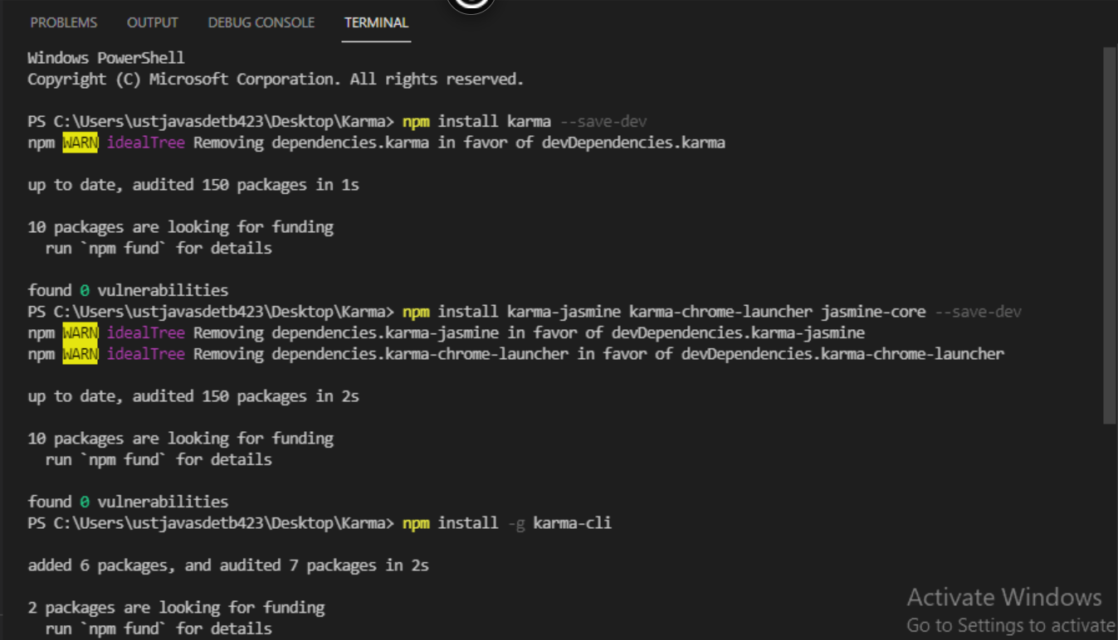



**karma init**

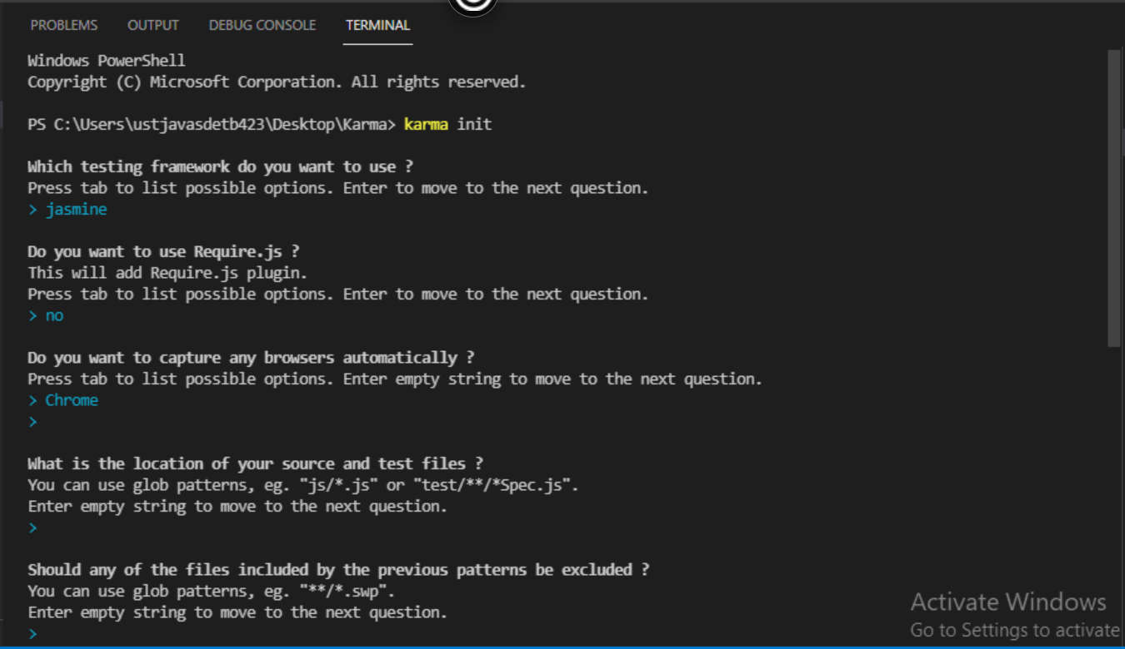

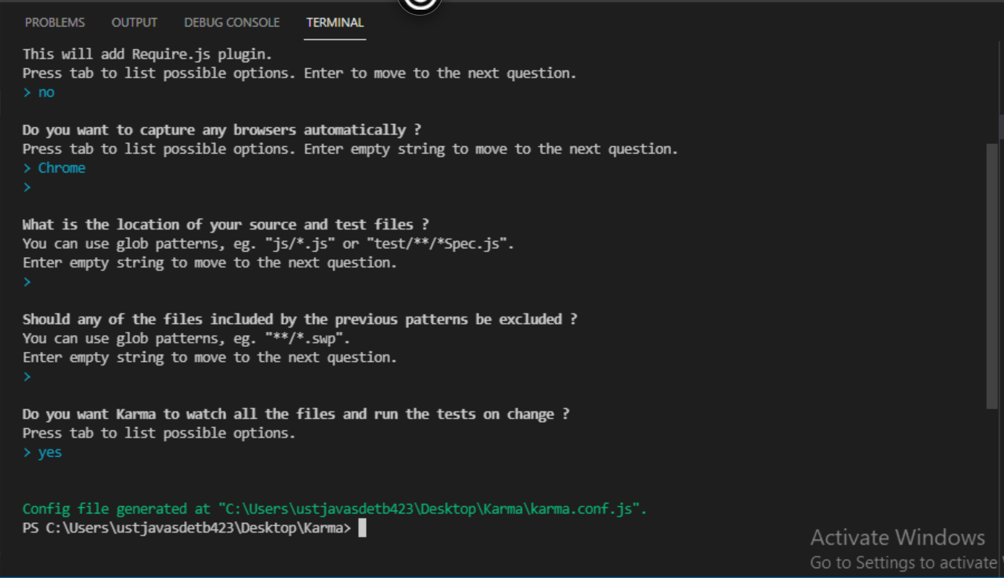

**karma start**

