**Python**

**Python Example 1 :-**

**Code :-**

#Finding Sum of Two Numbers

# Store input numbers

num1 = input('Enter first number : ')

num2 = input('Enter second number 1: ')

# Add two numbers

sum = float(num1) + float(num2)

# Display the sum

print('\nThe sum of {0} and {1} is {2}'.format(num1, num2, sum))

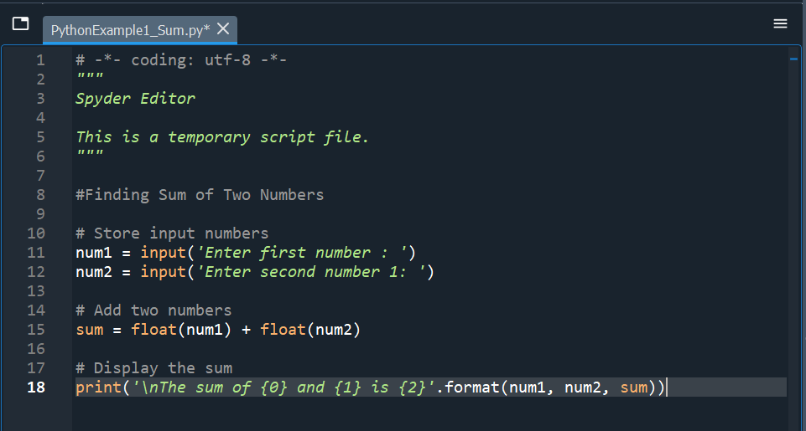

**Output :-**

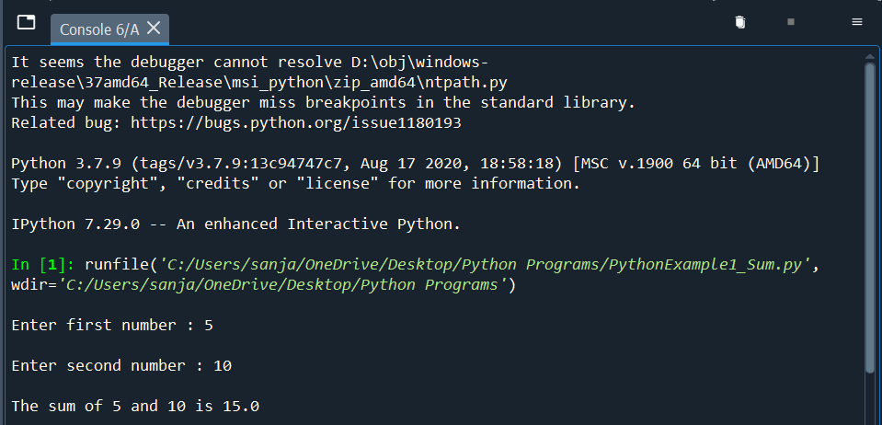

**Python Example 2:-**

**Code :-**

# Python program to swap two variables

#To take inputs from the user

x = input('Enter value of x : ')

y = input('Enter value of y : ')

print('\n The value of x before swapping : {}'.format(x))

print('\n The value of y before swapping : {}'.format(y))

# create a temporary variable and swap the values

temp = x

x = y

y = temp

print('\n The value of x after swapping : {}'.format(x))

print('\n The value of y after swapping : {}'.format(y))

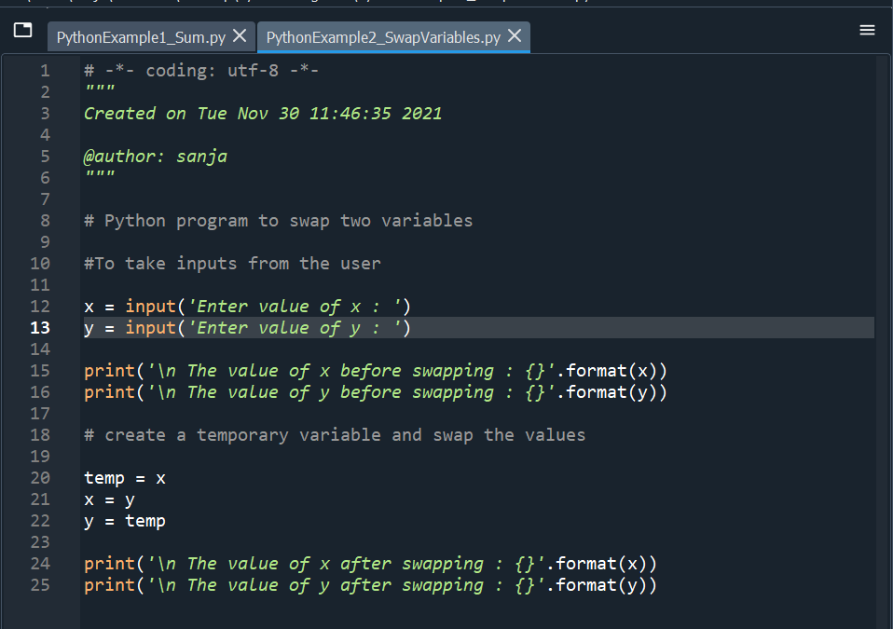

**Output :-**

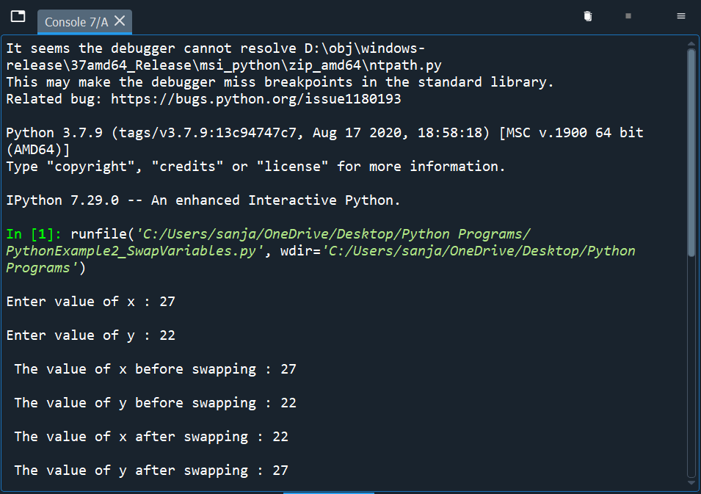

**Python Example 3:-**

**Code :-**

# Python program to Replace a letter with another.

a = "Hello, World!"

print(a.replace("H", "J"))

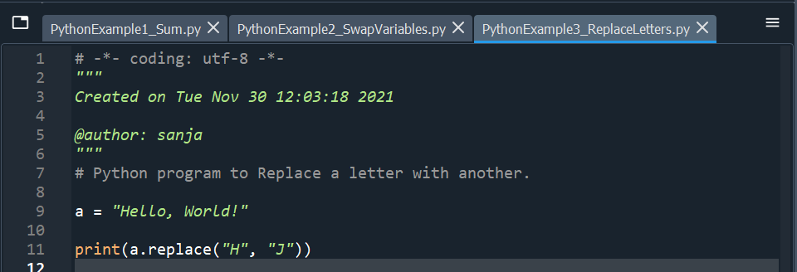

**Output :-**

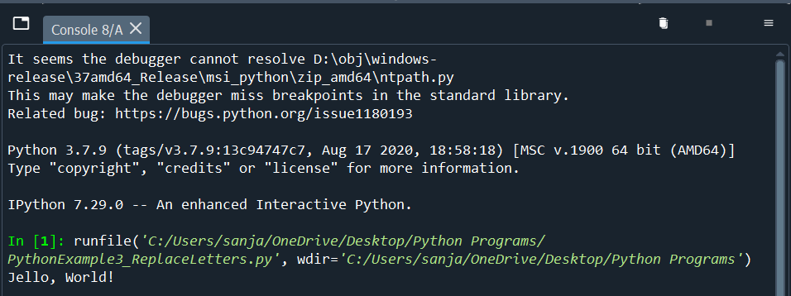

**Python Example 4:-**

**Code :-**

# Python program to remove an element from a list.

thislist = ["apple", "banana", "cherry"]

print("\n")

print(thislist)

print("\n")

thislist.remove("banana")

print(thislist)

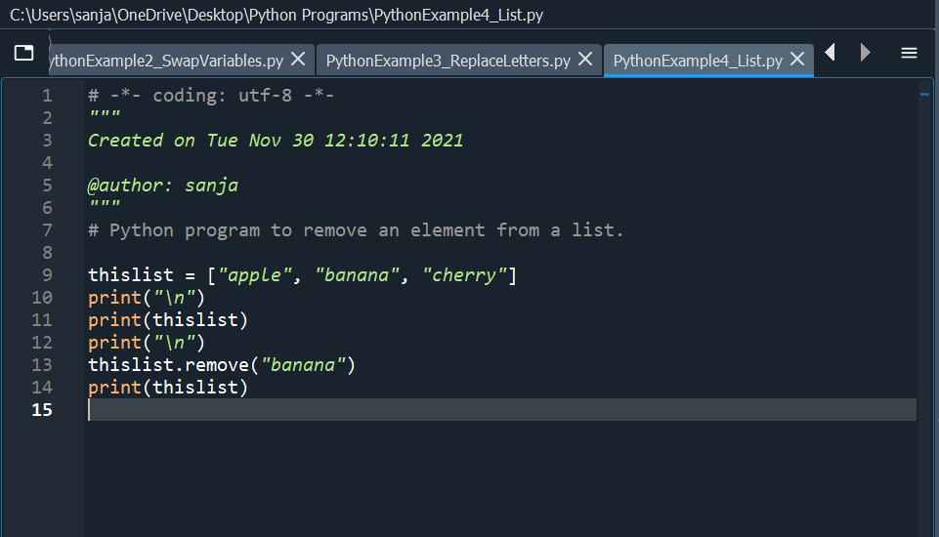

**Output :-**

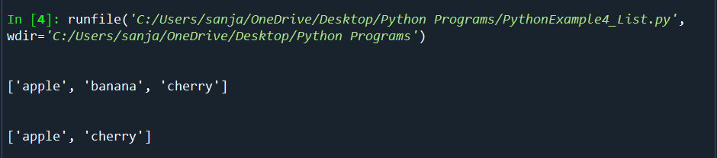

**Python Example 5:-**

**Code :-**

# Python program to display a tuple.

thistuple = ("apple", "banana", "cherry")

print("\n")

print(thistuple)

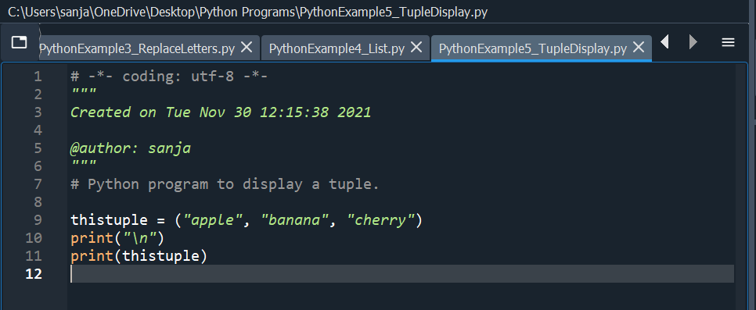

**Output :-**

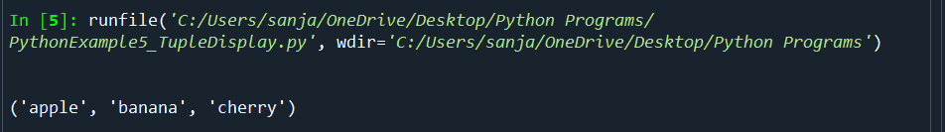

**Python Example 6:-**

**Code :-**

# Python program to display a tuple.

thistuple = ("apple", "banana", "cherry")

print("\n")

print(thistuple)

thistuple[1] = "blackcurrant"

# The value is still the same :

print("\n")

print(thistuple)

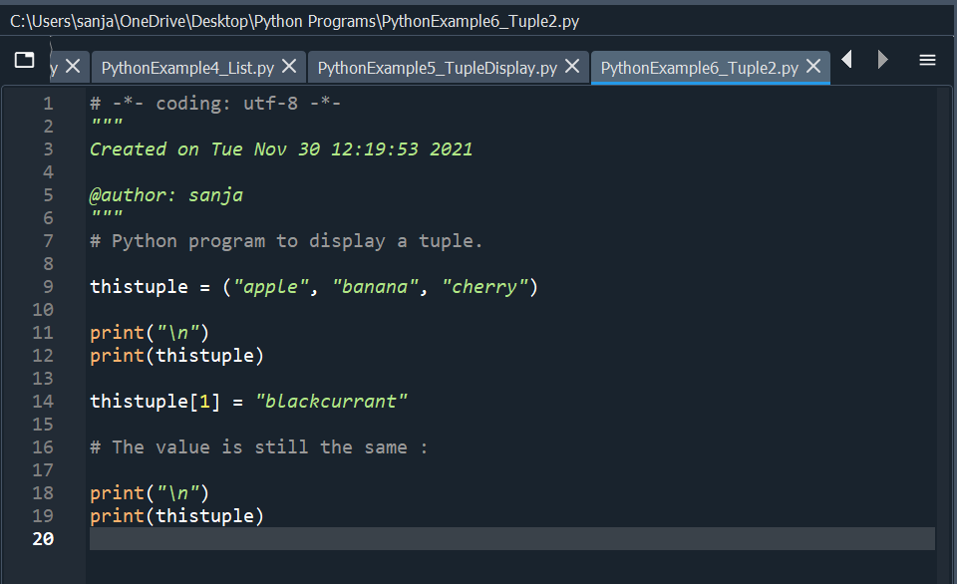

**Output :-**

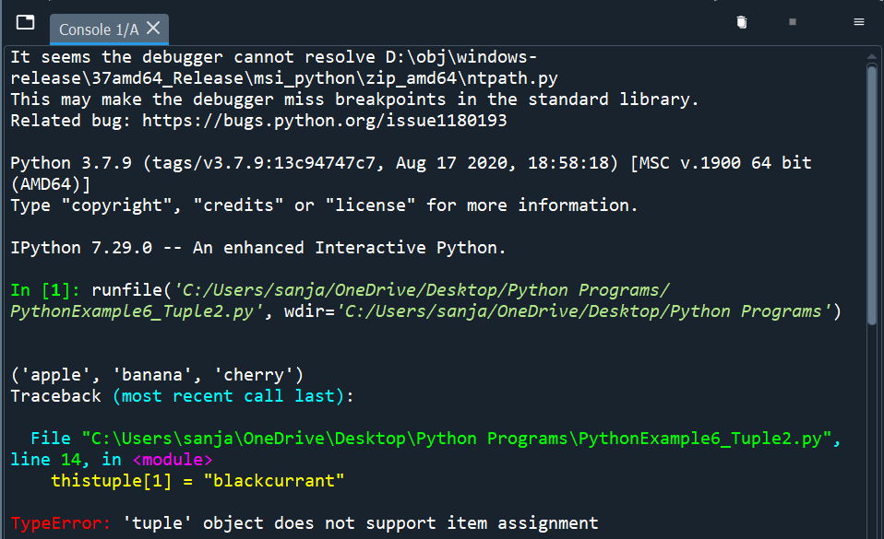

**Python Example 7:-**

**Code :-**

#Python program to display a Set.

thisset = {"apple", "banana", "cherry"}

#Printing the Set before updation

print(thisset)

thisset.update(["orange", "mango", "grapes"])

#Printing the Set after updation

print(thisset)

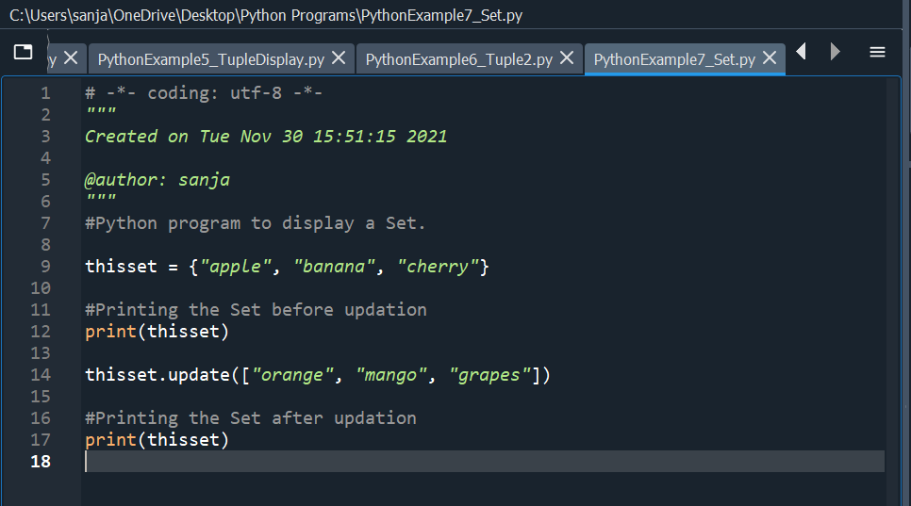

**Output :-**

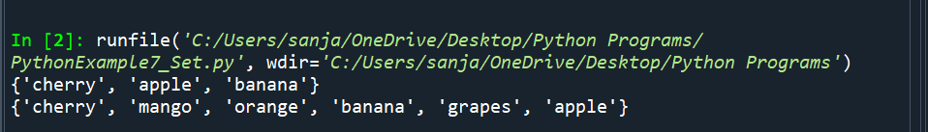

**Python Example 8:-**

**Code :-**

#Python program to display a Dictionary.

thisdict = {

"brand": "Ford",

"model": "Mustang",

"year": 1964

}

print('\n')

print(thisdict)

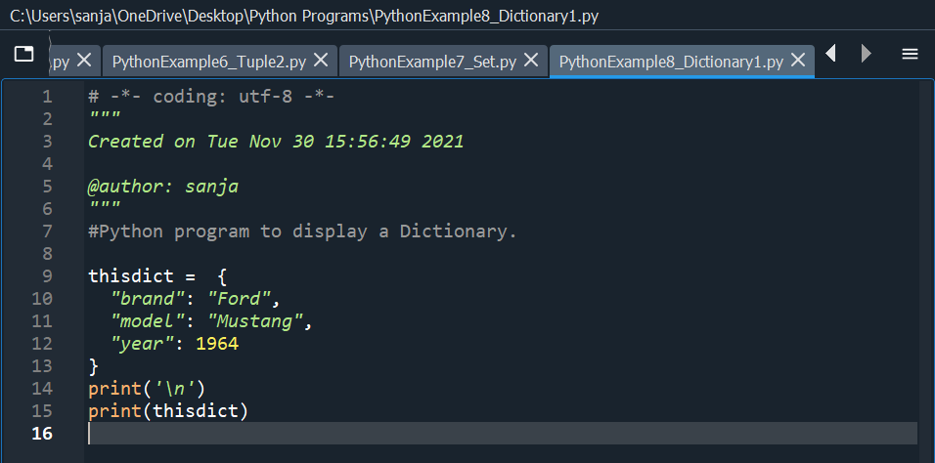

**Output :-**

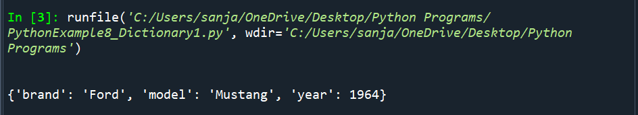

**Python Example 9:-**

**Code :-**

#Python program to display a Dictionary - Part 2.

thisdict = {

"brand": "Ford",

"model": "Mustang",

"year": 1964

}

for x, y in thisdict.items():

print('\n')

print(x, y) 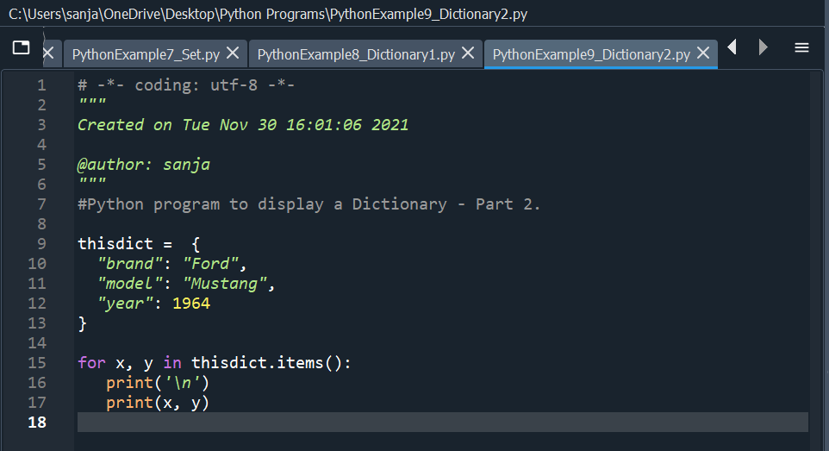**Output :-**

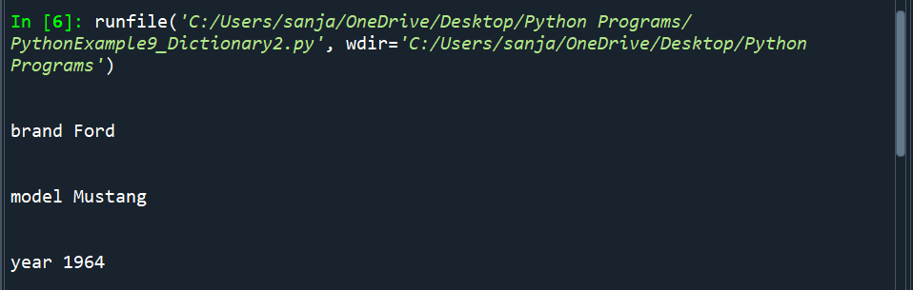

**Python Example 10:-**

**Code :-**

# Python program to check is a number is greater ,lesser or equal to the other number

# Store input numbers

num1 = input('Enter first number (Num1) : ')

num2 = input('Enter second number (Num2) : ')

print('\n')

if num1 > num2:

print("Num1 : {} is greater than Num2 : {} ".format(num1,num2))

elif num1 < num2:

print("Num1 : {} is lesser than Num2 : {} ".format(num1,num2))

elif num1 == num2:

print("Num1 : {} and Num2 : {} are equal ".format(num1,num2))

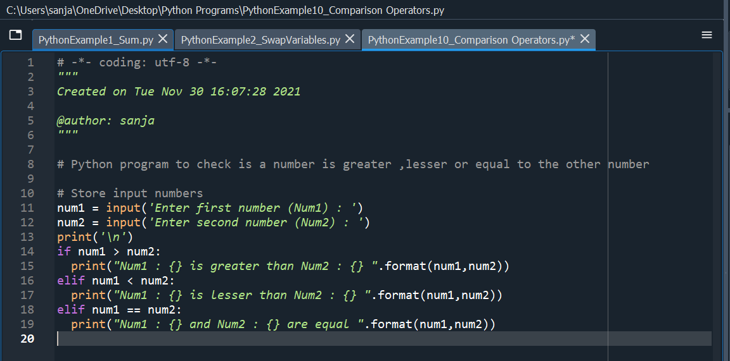

**Output :-**

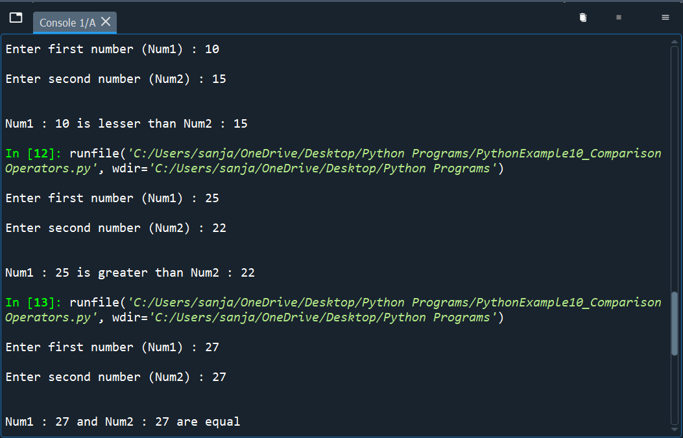

**Python Example 11:-**

**Code :-**

#Python program - For Loop

fruits = ["apple", "banana", "cherry"]

for x in fruits:

if x == "banana":

continue

print('\n')

print(x)

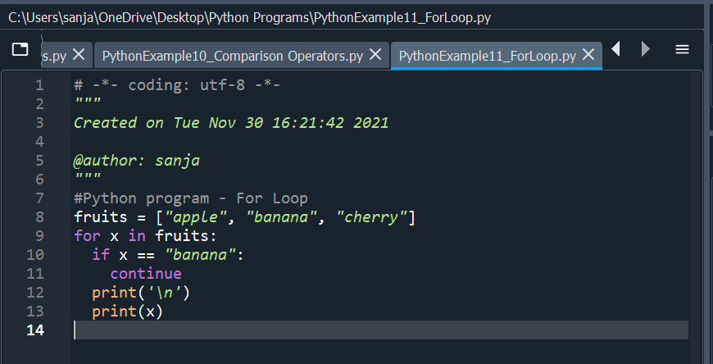

**Output :-**

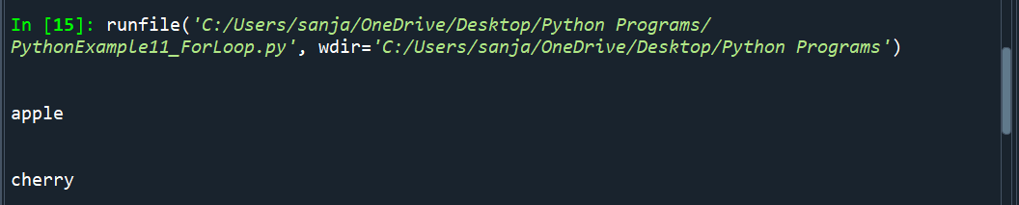

**Python Example 12:-**

**Code :-**

#Python Program - Functions

def my_function(country = "Norway"):

print("\n I am from " + country)

my_function("Sweden")

my_function("India")

my_function()

my_function("Brazil")

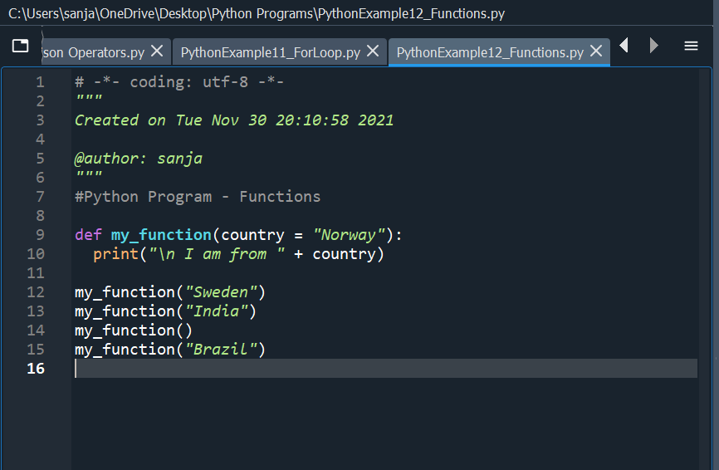

**Output :-**

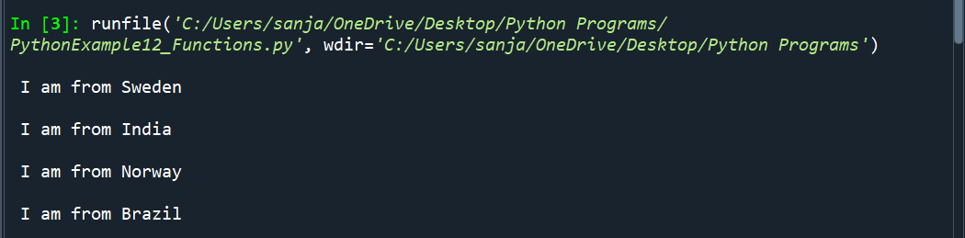

**Python Example 13:-**

**Code :-**

#Python Program - Lambda

x = lambda a, b, c: a + b + c

print('\n')

print(x(5, 6, 2))

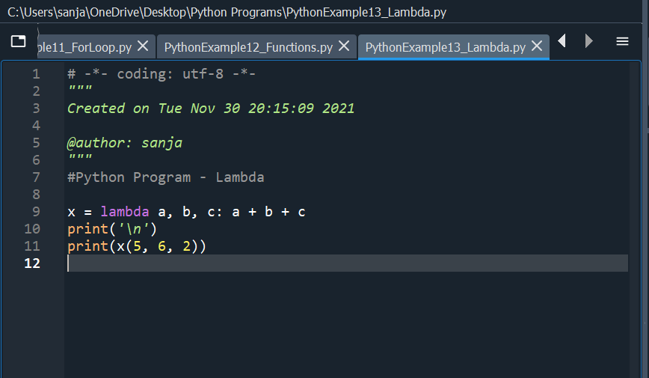

**Output :-**

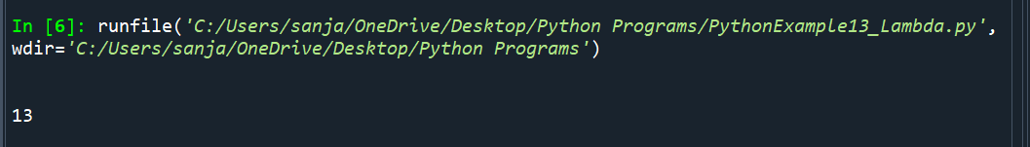

**Python Example 14:-**

**Code :-**

#Python Program - List with For loop

cars = ["Ford", "Volvo", "BMW"]

for x in cars:

print('\n')

print(x)

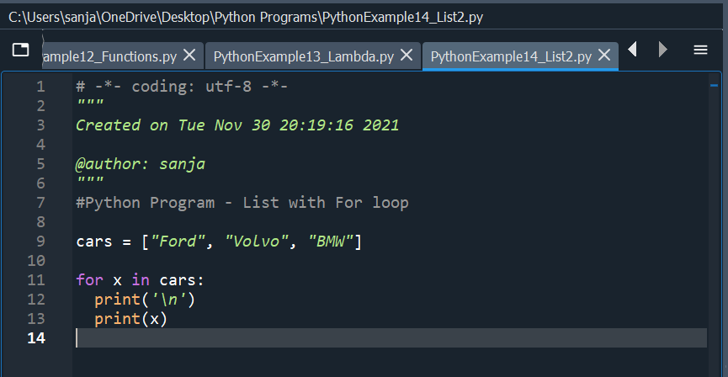

**Output :-**

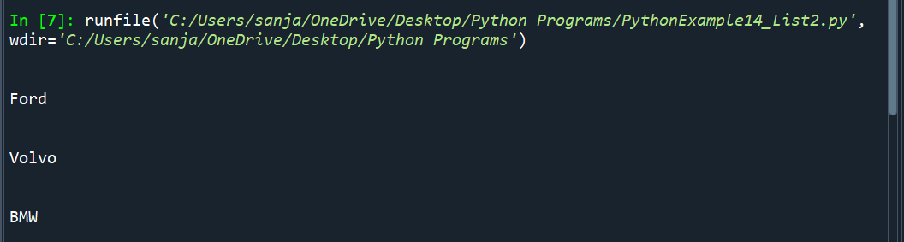

**Python Example 15:-**

**Code :-**

#Python Program – Class

class Person:

def __init__(self, name, age):

self.name = name

self.age = age

def myfunc(self):

print("\nHello my name is " + self.name)

p1 = Person("John", 36)

p1.myfunc()

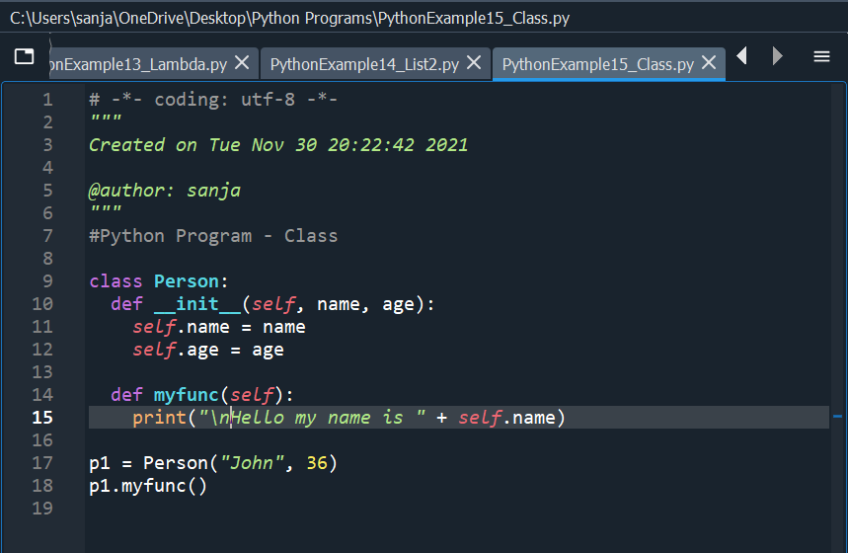

**Output :-**

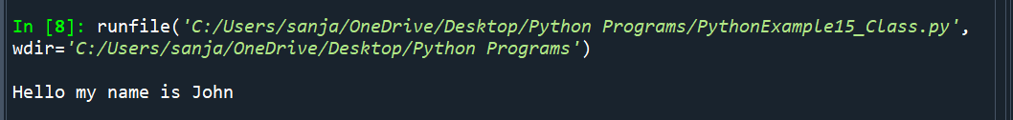

**Python Example 16:-**

**Code :-**

#Python Program - ClassObject

class MyNumbers:

def __iter__(self):

self.a = 1

return self

def __next__(self):

x = self.a

self.a += 1

return x

myclass = MyNumbers()

myiter = iter(myclass)

print('\n')

print(next(myiter))

print(next(myiter))

print(next(myiter))

print(next(myiter))

print(next(myiter))

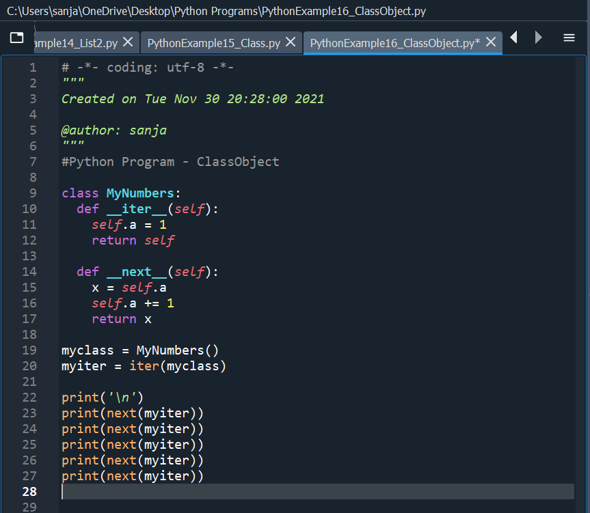

**Outputs :-**

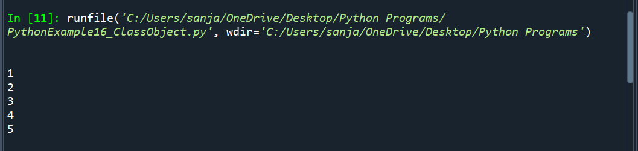

**Python Example 17:-**

**Code :-**

#Python Program - Module

"""mymodule is a py file containing

person1 = {

"name": "John",

"age": 36,

"country": "Norway"

}"""

import mymodule as mx

a = mx.person1["age"]

print('\n')

print(a)

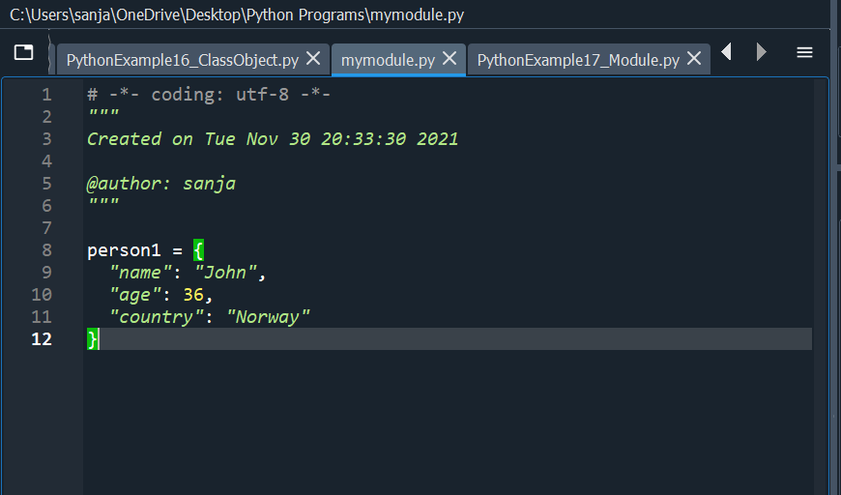

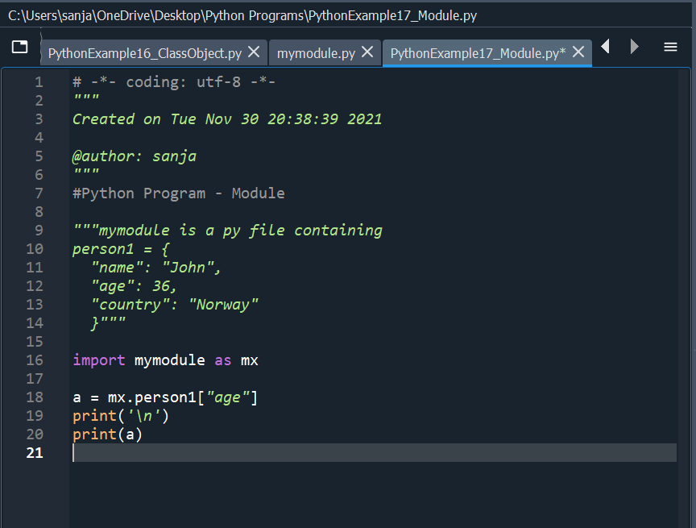

**Outputs :-**

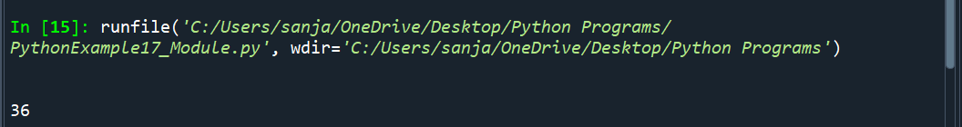

**Python Example 18:-**

**Code :-**

#Python Program - JSON 1

import json

# some JSON:

x = '{ "Name":"John", "Age":30, "City":"New York"}'

# parse x:

y = json.loads(x)

# the result is a Python dictionary:

print('\n')

print(y["Age"])

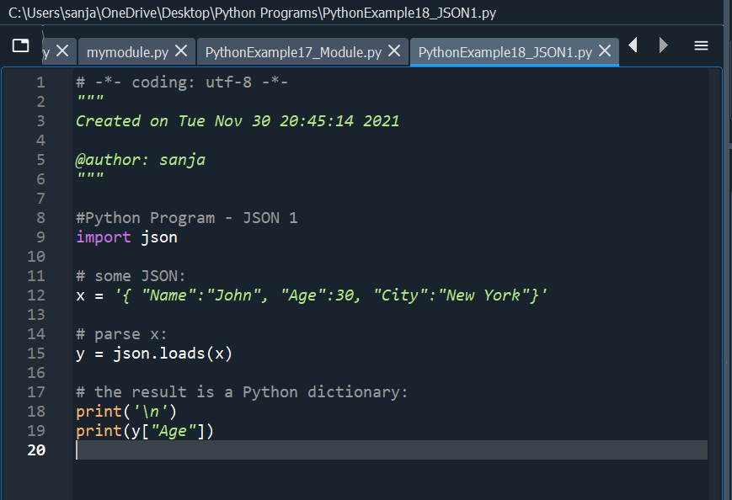

**Outputs :-**

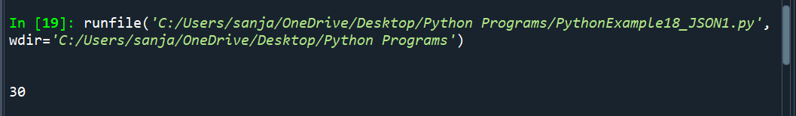

**Python Example 19:-**

**Code :-**

#Python Program - JSON 2

import json

x = {

"name": "John",

"age": 30,

"married": True,

"divorced": False,

"children": ("Ann","Billy"),

"pets": None,

"cars": [

{"model": "BMW 230", "mpg": 27.5},

{"model": "Ford Edge", "mpg": 24.1}

]

}

# convert into JSON:

y = json.dumps(x)

# the result is a JSON string:

print('\n')

print(y)

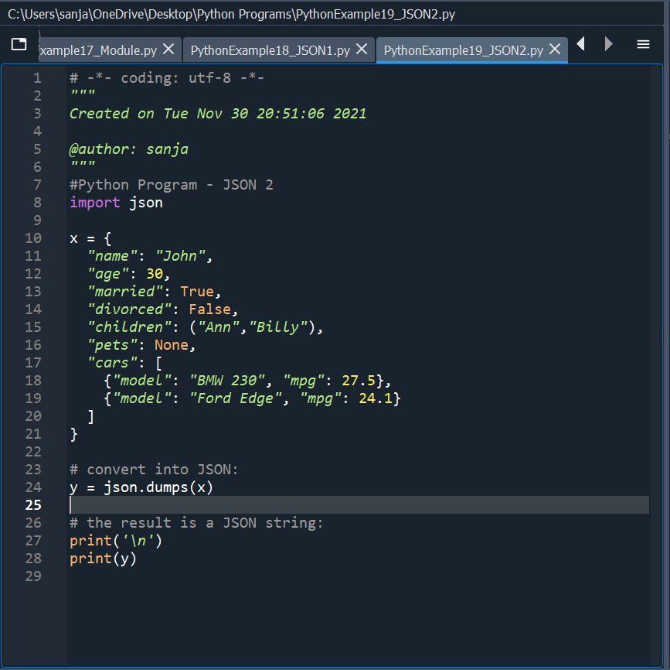

**Outputs :-**

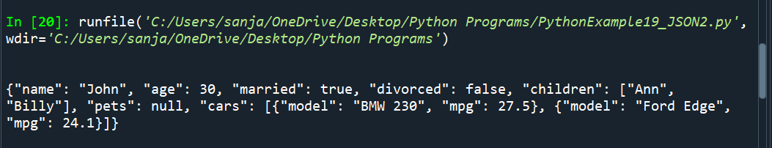

**Python Example 20:-**

**Code :-**

#Python Program - RegEx

import re

#Split the string at every white-space character:

txt = "The rain in Spain"

x = re.split("\s", txt)

print('\n')

print(x)

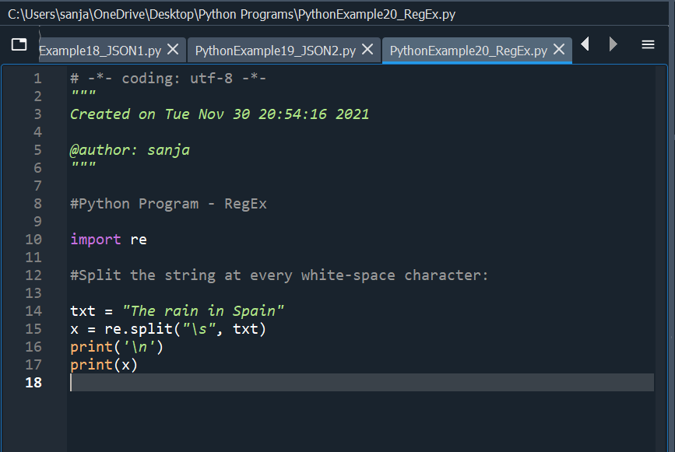

**Outputs :-**

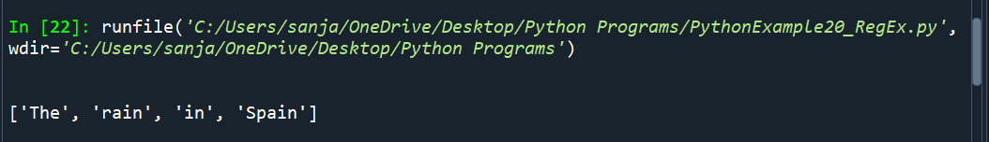

**Python Example 21:-**

**Code :-**

# Python Program - Files

""""demofile is a text document containing

. . . . . . . . . . . . . . .

Name : Sanjana Rachel Ninan

Age : 22

. . . . . . . . . . . . . . .

"""

f = open("demofile.txt", "r")

print('\n')

for x in f:

print(x)

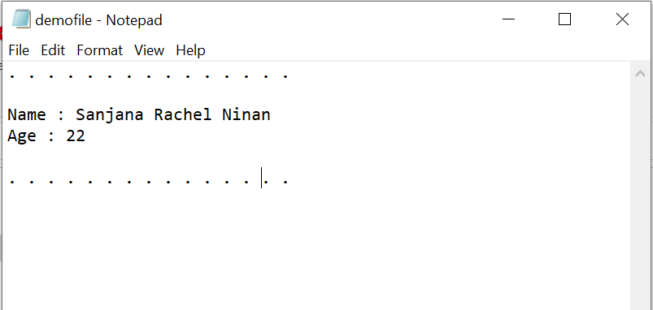

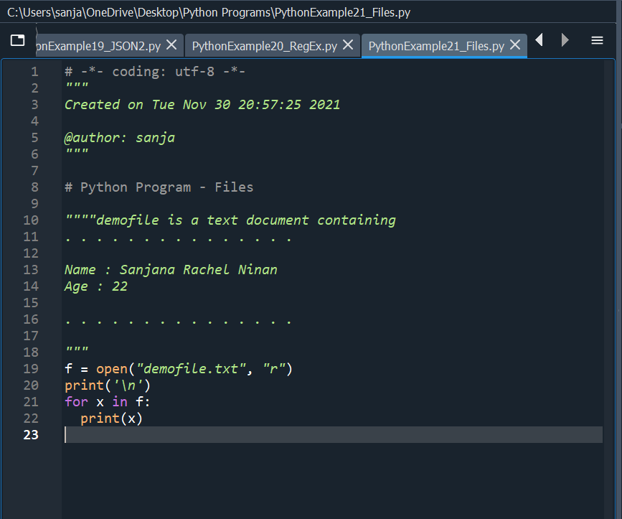

**Outputs :-**

