**TestNG**

**Example 1 :-**

**package** TestNGpractice;

//import java.util.concurrent.TimeUnit;

**import** org.openqa.selenium.By;

**import** org.openqa.selenium.WebDriver;

**import** org.openqa.selenium.chrome.ChromeDriver;

**import** org.testng.annotations.AfterTest;

**import** org.testng.annotations.BeforeTest;

**import** org.testng.annotations.Test;

**public** **class** CalculatorTestNG {

WebDriver ob;

@BeforeTest

**public** **void** launchapp() {

// Puts an Implicit wait, Will wait for 10 seconds before throwing exception

//ob.manage().timeouts().implicitlyWait(10, TimeUnit.SECONDS);

// Launch website

System.*setProperty*("webdriver.chrome.driver","C:\\Users\\ustjavasdetb423\\Desktop\\chromedriver_win32\\chromedriver.exe");

ob= **new** ChromeDriver();

ob.navigate().to("http://www.calculator.net");

ob.manage().window().maximize();

}

@Test

**public** **void** calculatepercent() {

// Click on Math Calculators

ob.findElement(By.xpath("//*[@id=\"contentout\"]/table/tbody/tr/td[3]/div[2]/a")).click();

System.***out***.println("***Click on Math calculator is working***");

// Click on Percent Calculators

ob.findElement(By.xpath("//*[@id=\"content\"]/table[2]/tbody/tr/td/div[3]/a")).click();

System.***out***.println("***Click on Percent calculator is working***");

// Enter value 10 in the first number of the percent Calculator

ob.findElement(By.id("cpar1")).sendKeys("10");

System.***out***.println("***Entered value 10 in the first number of the percent Calculator***");

// Enter value 50 in the second number of the percent Calculator

ob.findElement(By.id("cpar2")).sendKeys("50");

System.***out***.println("***Entered value 50 in the second number of the percent Calculator***");

// Click Calculate Button

ob.findElement(By.xpath("//*[@id=\"content\"]/table[1]/tbody/tr[2]/td/input[2]")).click();

System.***out***.println("***Click on Calculate Button is working***");

// Get the Result Text based on its xpath

String result =

ob.findElement(By.xpath("//*[@id=\"content\"]/p[2]/font/b")).getText();

System.***out***.println("***Got the Result Text based on its xpath***");

// Print a Log In message to the screen

System.***out***.println(" The Result is " + result);

**if**(result.equals("5")) {

System.***out***.println("The Result is Pass");

} **else** {

System.***out***.println("The Result is Fail");

}

System.***out***.println("***Printed a Log In message to the screen***");

}

@AfterTest

**public** **void** terminatetest() {

ob.close();

}

}

**Outputs :-**

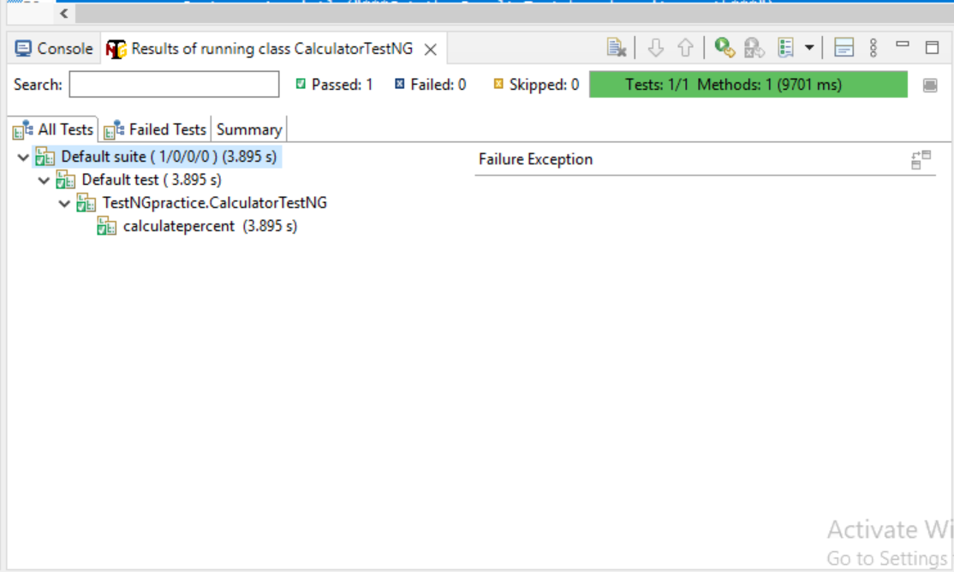

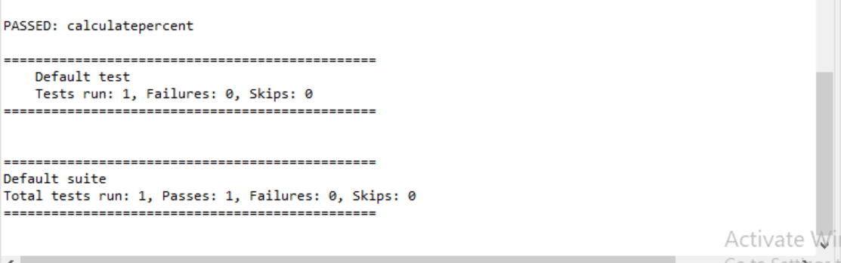

**Example 2 :-**

**package** TestNGpractice;

**import** org.openqa.selenium.By;

**import** org.openqa.selenium.WebDriver;

**import** org.openqa.selenium.chrome.ChromeDriver;

**import** org.testng.Assert;

**import** org.testng.annotations.AfterMethod;

**import** org.testng.annotations.AfterTest;

**import** org.testng.annotations.BeforeMethod;

**import** org.testng.annotations.BeforeTest;

**import** org.testng.annotations.Test;

**public** **class** PriorityTestNG {

**public** String baseUrl = "http://demo.guru99.com/test/newtours/";

String driverPath = "C:\\geckodriver.exe";

**public** WebDriver driver;

**public** String expected = **null**;

**public** String actual = **null**;

@BeforeTest

**public** **void** launchBrowser() {

System.***out***.println("Launching Chrome browser");

System.*setProperty*("webdriver.chrome.driver","C:\\Users\\ustjavasdetb423\\Desktop\\chromedriver_win32\\chromedriver.exe");

driver= **new** ChromeDriver();

driver.navigate().to(baseUrl);

driver.manage().window().maximize();

}

@BeforeMethod

**public** **void** verifyHomepageTitle() {

String expectedTitle = "Welcome: Mercury Tours";

String actualTitle = driver.getTitle();

Assert.assertEquals(actualTitle, expectedTitle);

}

@Test(priority = 0)

**public** **void** register(){

driver.findElement(By.linkText("REGISTER")).click() ;

expected = "Register: Mercury Tours";

actual = driver.getTitle();

Assert.assertEquals(actual, expected);

}

@Test(priority = 1)

**public** **void** support() {

driver.findElement(By.linkText("SUPPORT")).click() ;

expected = "Under Construction: Mercury Tours";

actual = driver.getTitle();

Assert.assertEquals(actual, expected);

}

@AfterMethod

**public** **void** goBackToHomepage ( ) {

driver.findElement(By.linkText("Home")).click() ;

}

@AfterTest

**public** **void** terminateBrowser(){

driver.close();

}

}

**Outputs :-**

