LINUX:
Installation Of WSL (Windows Subsystem For Linux) In Windows :-

Install ubuntu18.0 LTS

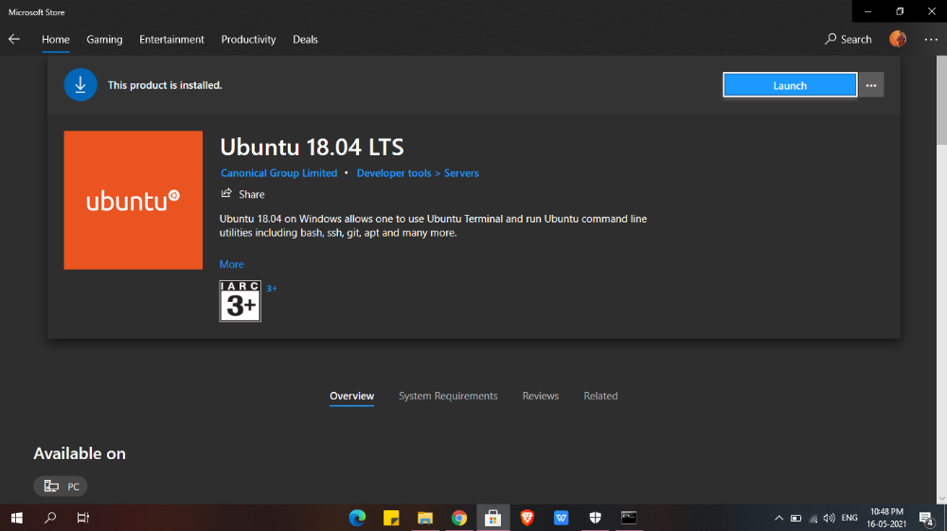

After installing enabling the WSL from turn ON and OFF
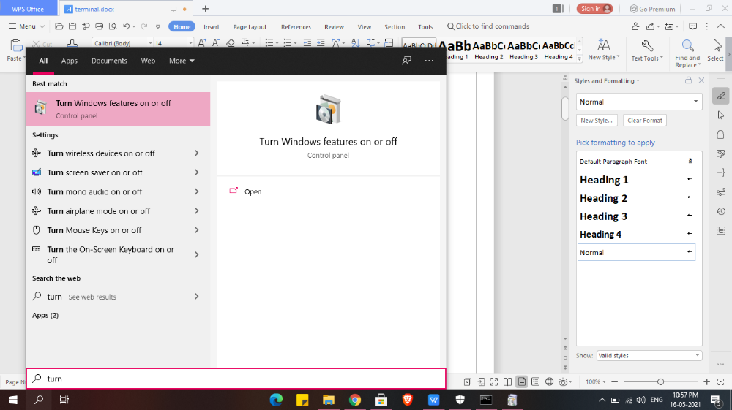
Enable windows subsystem for Linux

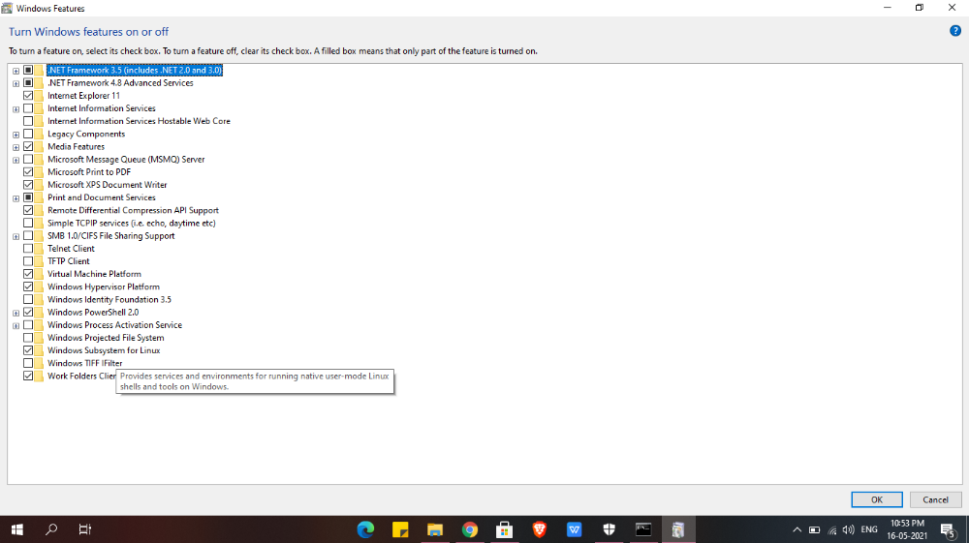

Search ubuntu 18.0 LTS and use it

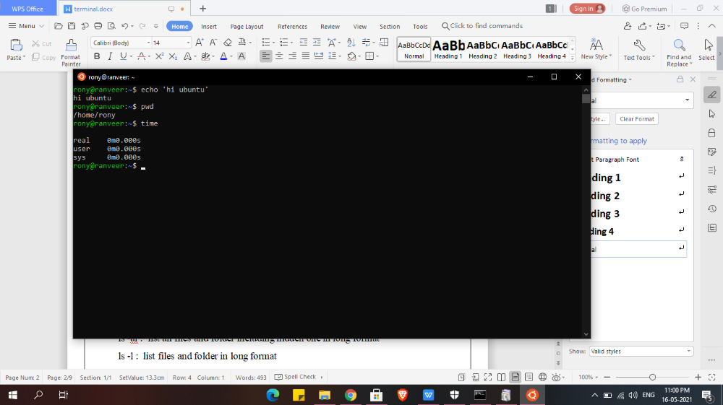

- ls

ls ~: gives/jump all file present in system or all home directory
ls .. : give content or file present in parent directory
ls . : List files and folder in current directory
ls ~ : show u all content in home directory
ls -a : list all files and folder including hidden one
ls -al : list all files and folder including hidden one in long format
ls -l : list files and folder in long format
ls -p :give all files in current directory
ls -p | grep pdf :gives if any pdf file is present (you can write whatever type of file in place of pdf like txt n all)

- mkdir

mkdir directory_name : create directory
rmdir dire_name : removes that particular directory
mkdir -p directory_name1/directory_name2 : create nested directory
(2 is inside 1)

- cd

cd directory_name/ : take u to that directory
cd .. : take u to one directory before
cd - : take u to previous working directory

- touch

touch file_name : create empty file
cd /etc/ :take u to home directory directly
ls -t : gives highlight on last modified directory
ls -lt :give complete details about recent modified file plus other file present
touch file_name : create file name of file_name

- rm
rm -r file_name : deletes that perticular file_name
rm -i file_name : ask user permission before deletion
rm -I file_name : dosnt ask user before deletion
rm -r directory_name: remove the directory recursively
rm -ir directory_name : removes the file or dir with asking permission

ls -s file_name : gives all file presnt inside in tabular format
ls -l file_name : gives all file presnt inside in long vertical format
pwd : present working directory

- cp and mv
cp file_parent file_child : copy content of parent on child
mv file_parent file_child : move content of parent on child

- ln

ln -s test temp/ : symbolic link test file into temp dir // ln command is used to link files with dir
~ : This symbol takes you home

- man

man command_name : gives complete details about that particular command_name

- chmod

This command is used for changing the permission ..what read write and execution feature can be given to user group and owner
+1 for read
+2 for write
+4 for execute

More Examples at :-

The 40 Simple Yet Effective Linux Shell Script Examples (ubuntupit.com)

