

***Graduation project (comp 411)***

***Department of computer science***

***Project Progress Report 2018***

**Student No: 1130603, 1130862, 1131585**

**Student Name: Sandra Fawadleh, Bara Abu Sharbak , Aya Owda**

**Course: Graduation Project.**

**Email:**[**sandrafawadleh@gmail.com**](mailto:sandrafawadleh@gmail.com)

[**Bara0abusharbak@gmail.com**](mailto:Bara0abusharbak@gmail.com)

**ayah.od95@gmail.com**

**Title of Project:Nutrition Mobile Application (Android App)**

**Project No:**

**Supervisor: Dr. SamerAl\_zain**

**Key Areas:**

**Student Signature:** \_\_\_\_\_\_\_\_\_\_\_\_\_\_\_\_\_\_\_\_\_\_\_\_\_\_\_ **Date Submitted:**

**First Supervisor Name: Dr. Samer**

**First Supervisor Signature: Date Approved: \_\_\_\_ / \_\_\_\_ / \_\_**

# Abstract

The aim of this project is to develop a nutrition mobile app using Android. Nutrition apps are an important aspect to promote healthy life style by maintaining a perfect weight and to avoid diseases resulting from overweight. The general idea is to develop an app that uses a calorie counter and diet tracker for lose weight, gain or maintain.

The features in our app will developed to be as the user want, in other words we mapped to make a simple app that can be understandable by human with different ages. Develop a friendly user interface that can be used any time and in any condition even if you don’t have time, the app interface and features will help you to reach what you want fast. Finally the app will work even in offline condition.

A calorie counter mapped to work on equations depends on the data entry, so data entry on this app must be specific and real which makes the app works efficiently. After data had been entered, the equations will find your budget calories counter for a day; then the users will enter them daily meals and snacks until they reach the specific calories required .This means that you take your calorie range in that day and calorie counter will track your food and your exercise to create a balance between your burned calories and your gained calories .Finally by using this app which tracks your food you can manage your daily meals until you reach your weight goal.

***Table of content***

[Abstract i](#_Toc502432183)

[Chapter 1: Introduction 5](#_Toc502432184)

[Chapter 2: Background 10](#_Toc502432185)

[Chapter 3: Literature Review. 14](#_Toc502432186)

[Chapter 4:System Analysis 22](#_Toc502432187)

[Chapter5: Experiment 33](#_Toc502432188)

[Chapter 7: References: 40](#_Toc502432189)

# 

Contents

[Abstract i](#_Toc502432201)

[Chapter 1: Introduction 4](#_Toc502432202)

[1.1 Brief Introduction 4](#_Toc502432203)

[1.2 The Aim of the project 5](#_Toc502432204)

[1.3) Objectives 6](#_Toc502432205)

[1.4 Features: 7](#_Toc502432206)

[1.5 Technologies: 7](#_Toc502432207)

[1.5.1) Android 7.0 Nougat 7](#_Toc502432208)

[1.5.2) SQL light 8](#_Toc502432209)

[1.5.3) PHP 8](#_Toc502432210)

[1.5.4) Android Studio 2.3 8](#_Toc502432211)

[1.5.5) Restful Web Services 8](#_Toc502432212)

[1.5.6)AxureRP: 8](#_Toc502432213)

[1.5.7) java 9](#_Toc502432214)

[Chapter 2: Background 9](#_Toc502432215)

[2.1) What is Android?! 9](#_Toc502432216)

[2.1.1) The Android Architecture: 10](#_Toc502432217)

[2.1.2) Google Play: 10](#_Toc502432218)

[2.1.3) Android features and usability: 11](#_Toc502432219)

[2.1.4) Main components of Android: 11](#_Toc502432220)

[2.2) what is restful web services: 12](#_Toc502432221)

[2.2.1)how to expose URIs in our rest web service: 12](#_Toc502432222)

[Chapter 3: Literature Review. 13](#_Toc502432223)

[3.1) summarize Article 13](#_Toc502432224)

[3.1.1) nutrition mobile application 13](#_Toc502432225)

[3.1.2) the privacy policies in android nutrition mobile application 14](#_Toc502432226)

[3.1.3) self monitoring 15](#_Toc502432227)

[3.2) The main point of Articles: 16](#_Toc502432228)

[3.3) Apps 17](#_Toc502432229)

[3.4) Challenges of our App: 21](#_Toc502432230)

[Chapter 4:System Analysis 22](#_Toc502432231)

[4.1) System Requirements 22](#_Toc502432232)

[4.1.1) Functional Requirements 22](#_Toc502432233)

[4.1.2) Non-Functional Requirements 22](#_Toc502432234)

[4.2) Functional Decomposition (use case diagram) 23](#_Toc502432235)

[4.2.1) Actor 23](#_Toc502432236)

[4.2.2) use case specification 23](#_Toc502432237)

[4.2.3) use case diagram 25](#_Toc502432238)

[4.3) System Models 26](#_Toc502432239)

[4.3.1) ER Diagram 26](#_Toc502432240)

[4.3.2) Class Diagram 27](#_Toc502432241)

[4.4) System Analysis : 28](#_Toc502432242)

[4.4.1) Framework Steps: 28](#_Toc502432243)

[Chapter5: Experiment 32](#_Toc502432244)

[5.1) Experiment: 32](#_Toc502432245)

[5.1.1) Survey Items 35](#_Toc502432246)

[5.1.2) Data analysis 35](#_Toc502432247)

[5.2) result of analysis 35](#_Toc502432248)

[Chapter 7: References: 39](#_Toc502432249)

Figure table:

[Figure 1:picture of my net Diary app 18](#_Toc502404924)

[Figure 2:picture of fatsecret App . 20](#_Toc502404925)

[Figure 3:picture of lose it APP. 21](#_Toc502404926)

[Figure 4: Use Case Diagram . 26](#_Toc502404927)

[Figure 5:ER Diagram . 27](#_Toc502404928)

[Figure 6:class diagram 28](#_Toc502404929)

[Figure 7:the registration interface after instillation 33](#_Toc502404930)

[Figure 8:login form interface 34](#_Toc502404931)

[Figure 9: the start interface of required data 34](#_Toc502404932)

[Figure 10: Main interface of our App 35](#_Toc502404933)

[Figure 11: User Plan interface 35](#_Toc502404934)

[Figure 12:chart of using app in one hand. 37](#_Toc502404935)

[Figure 13:chart of simple and easy to use 37](#_Toc502404936)

[Figure 14:chart of understandable feature. 37](file:///C:\Users\Aya\Desktop\Graduation%20project-v5.docx#_Toc502404937)

[Figure 15:chart of consistent of view. 38](#_Toc502404938)

[Figure 16:chart of color consistent 39](#_Toc502404939)

[Figure 17:char define if the distribution of content is good 39](#_Toc502404940)

# Chapter 1: Introduction

## 1.1 Brief Introduction

Recently, nowadays smart phones are the most spread technological devices all over the world which is used by 44% of the world population (Linda Sui, 2016). A huge number of apps which are software applications designed to run in these smart phones or other devices, and there is a variety categories of these apps one of them is healthcare and nutrition apps.

Due to the variety of apps relating to diet, nutrition and weight control, common techniques like weigh tracking, goal-setting for health eating are required because it helps people regulate their health behavior, which is really hard to do. So 1 of 5 persons uses nutrition and health apps, so that's the reason why it’s necessary to develop an application which is effective in promoting healthy diet and nutrition (healthcare apps).

Based on the features provided in some health apps as (Fat Secret, Lose IT and MyNetDiary) there are several services provided by those apps. Such as “activity tracking service” which is track uses physical activity- everything the user does during the day. “Diet and nutrition service” help users to monitor their food habits, count the number of calories taken/burned, control water balance, and body weight) .“Workout or exercise tracking service” provides a user with a set of exercises.

After we explain the services that provided by other apps, we plan to distinguish in our app by:

1)develop app provide the above services together which are (activity tracking service , Diet and nutrition service , Workout or exercise tracking service) however the other apps don’t provide these three types of services together

2)The app algorithm will be build by equation from nutrition specialist so the result will be precise.

3) Some other app has unfriendly user interface, so this point make us study how to make our app friendly as possible, and we will support this point by statistic depend on our app interface.

Collecting data with apps for health can help individuals work with health professionals to set safe and reasonable goals, and can increase individuals’ confidence when making lifestyle changes to achieve health-related goals. As well, individuals can share their personal results with loved ones and friends, thereby obtaining encouragement and support while working toward wellness.

## 1.2 The Aim of the project

The main idea behind this project is to make a calorie counter tracker uses food and exercise to manage user weight. The aim is to make a nutrition app help user maintain a good diet and exercise routines through tracking your weight, by selecting the main goals from the user why he/she uses the app depends on the current weight (lose, maintain or gain weight).

In the first phase of the app is to track what you eat for a while by manual data entry from the user for all meals and snacks that he/she eats all the day, and in specific quantity with specific number of calories for each meal.

Later on, the app will start providing guidance based on specific designed algorithms for users on what to eat; in order to decrease consumed calories and maintain the main goal of using the application .Also it has an exercise feature which help to put all the activity done by the user with its specific calories burned by this exercise, then make a calculations of the target calorie of the day from the calories gained and burned.

## 1.3) Objectives

1.3.1) We start studying about the health techniques which we will be used in our app, reading about android app nutrition in general and the usability of it. Reading about the algorithms and equations and how it works in the health application, then we start using some of the most spread nutrition apps and it’s features.

1.3.2) Build an algorithm that can calculate the total energy requirements “total calories” (TER) by using the physical activity level (PAL) factor, which is an assessment tool that it used to express a person’s daily physical activity as a number from (1.2-1.9 or higher ).

By entering the physical activity status (extremely inactive, sedentary , moderately active , very active, extremely active ) which is entered by the user in the registration form ,also by using the resting metabolic rate (RMR) which will calculated by Mifflin equation .

So, (TER) is ready, then by using body mass index (BMI) which decide if the user weight status (underweight, normal, overweight, obese class 1, obese class 2, obese class 3), if the user categorized underweight range, the daily TER will be increased by 600 calories, if the user categorized normal, it will give the user diet according to the TER, if the user categorized overweight or obese ranges the app will decrease 600 calories from TER.

1.3.3) Build an algorithm that can calculate the percentage of each nutrient the body need such as (carbohydrates, fat, protein) which can plan your daily diet.

1.3.4) Develop a prototype for UI in specific standards we will use it to develop a friendly UI and to be easy to use.

1.3.5) Test this prototype by the audience and check if we need to make any changes later on.

1.3.6) Develop server side web application.

1.3.7) Develop the nutrition health app.

## 1.4 Features:

* Our application works online and offline.
* It can make weekly calorie analysis based on the specific algorithms which developed based on the user current weight.
* The application contains timer used while exercising, and it must be turned on 5 times a week for 30 minutes for each time.
* The application contain a calorie counting, calculating IBW, find BMI.
* The application help the user lose, gain or maintain weight.
* The application has reminders to drink water, and reminders to enter every meal on time.
* The application provide social site to connect with Facebook, contacts and email.
* The application contains a photo album and it will ask you to update it every six month.

## 1.5 Technologies:

### 1.5.1) Android 7.0 Nougat

It introduces a notable change to the operating system and its development platform; including the ability to display multiple app on-screen at once in a split screen view and it has many features (user experience, platform, security).

### 1.5.2) SQL light

It is a local storages works like a data base program, it is the most widely deployed database engine, as it is used today by several widespread browsers, operating systems, and embedded systems (such as mobile phones), among others, and it is a part of local/client storage in application software such as web browsers, and it is embedded into the end program.

### 1.5.3) PHP

It is one of the most popular programming language used in web sites, the web server interprets and executes its code, and sends the result to be displayed in the user browser, and it is used to create dynamic web pages (variable content pages) this content changes as a result of interaction with the user.

PHP is an open source language and is constantly being developed by a group of volunteers under the PHP license and this is one of the main reasons for its popularity.

### 1.5.4) Android Studio 2.3

It’s the official integrated development environment (IDE) for Google’s android operating system, based on IntelliJ IDEA software. Android Studio offers even more features that enhance the productivity when building Android apps such as: Extensive testing tools and frameworks, a fast and feature-rich emulator, a flexible Gradle-based build system.

### 1.5.5) Restful Web Services

It’s “Representational state transfer” It is called this name because it mainly depends on what happens from the source (program) to the user (client) through the HTTP protocol ,and introduces all the operations , transactions and understanding between (client) and (server),As well as guidance on pages (Request and respond).

1.5.6)AxureRP: Pro is a [wire framing](https://en.wikipedia.org/wiki/Website_wireframe), [rapid prototyping](https://en.wikipedia.org/wiki/Software_prototyping#Throwaway_prototyping), [documentation and specification](https://en.wikipedia.org/wiki/Functional_specification) software tool aimed at web and desktop applications. It offers drag and drop placement, resizing, and formatting of widgets, and it supports prototyping [Rich Internet Applications](https://en.wikipedia.org/wiki/Rich_Internet_Applications) by mapping desired interface behaviors (such as displaying or hiding an element) in response to actions like mouse clicks or touch.

### 1.5.7) java

“java is a powerful and versatile programming language for developing software running on mobile devices, desktop computers ,and servers”.(liang,2013) ,general characteristic in this programming language that it can be used to develop robust mission-critical application , program created in java offer portability in a network and java is object-oriented , on other word java is a full-featured language.

# 

# Chapter 2: Background

## 2.1) What is Android?!

Android is a [mobile operating system](https://en.wikipedia.org/wiki/Mobile_operating_system) developed by [Google](https://en.wikipedia.org/wiki/Google) , based on the [Linux kernel](https://en.wikipedia.org/wiki/Linux_kernel) .it’s designed primarily for [touch screen](https://en.wikipedia.org/wiki/Touchscreen) mobile devices such as smart phones and [tablets](https://en.wikipedia.org/wiki/Tablet_computer) .It’s developed in many sides also such as (Android TV, Android Auto, and Android Wear). And now it’s an official platform uses by public in different sides and around the world, (Rubin) described the Android project as “tremendous potential in developing smarter mobile devices that are more aware of its owner's location and preferences”(J.F DiMarzio).Since 2008, Android has seen [numerous updates](https://en.wikipedia.org/wiki/Android_version_history) which have incrementally improved the operating system, adding new features and fixing [bugs](https://en.wikipedia.org/wiki/Software_bug) in previous releases (Wikipedia).

### 2.1.1) The Android Architecture:

There are 4 layers that makeup the Android OS:

1. Applications
2. Application framework
3. Libraries
4. Linux kernel

The android OS is roughly divided into five sections in four main layers:

1. Linux kernel: this layer contains all the low-level device drivers.
2. Libraries: these contain the code that provides the main features of an Android OS.
3. Android runtime: it’s located in the same layer with the libraries and provides a set of core libraries that enable developers to write Android apps using the Java programming language.
4. Application framework: The application framework exposes the various capabilities of the Android OS to application developers so that they can make use of them in their applications.
5. Application: at this top layer are the applications that ship with the Android device (such as browser). (J.F Dimarzio )

### 2.1.2) Google Play:

Google play is an application that is pre-installed on user Android devices to directly download third-party applications to their devices. Both paid and free applications are available in the Google Play Store, although paid applications are available only to users in certain countries because of legal issues.

### 2.1.3) Android features and usability:

Powerful and usability appears furthermore in the Android OS which supports many features, including:

* Connectivity.
* Messaging—Both SMS and MMS.
* Hardware support.
* Multi-touch—Multi-touch screens
* Multi-tasking—Multi-tasking applications.
* Tethering—Sharing of Internet connections as a wired/wireless hotspot.

We chose the Android Os to develop our app because its powerful, free and open operating system, we inference those feature from those points , Android is the world popular mobile platform, it’s the largest installed base of any mobile platform, and android give you a world-class platform for creating apps and games for Android users everywhere , those in general from user side , moreover in developer side Android innovation lets you build powerful, differentiated application that use the latest mobile technology .In other wise Android is the default operating system for most of the phones that manufacturers offer.

### 2.1.4) Main components of Android:

* **Activities**: applications have one or more activities. The main purpose of an activity is to interact with the user. From the moment an activity appears on the screen to the moment it is hidden, it goes through a number of stages. These stages are known as an activity’s life cycle. Each activity class loads its user interface (UI) component using the XML file.

So, the Activity base class defines a series of events that govern the life cycle of an activity.

* **Fragments**: when an activity is displayed in a large-screen device, such as on a tablet, it is some what out of place. Because the screen is much bigger, all the views in an activity must be arranged to make full use of the increased space, resulting in complex changes to the view hierarchy. A better approach is to have “mini-activities,” each containing its own set of views. During runtime, an activity can contain one or more of these mini-activities, depending on the screen orientation in which the device is held. In Android 3.0 and later, these mini-activities are known as fragments.
* **Intents**: an Android application can contain zero or more activities .when your application has more than one activity; you often need to navigate from one to another. In Android, you navigate between activities through what is known as intent.

## 2.2) what is restful web services:

Our work will include a restful web services with plain PHP. Rest(representational state transfer) define architectural principle by design web services, including how  resource states are addressed and transferred over HTTP by clients .In restful services ,URIS are used to access the resource via services, resource are data and function .

In general we need client side and server side ,client side which contain client ,is connected with server side which contain restful web services ,the process done between those two side by http request from client then server respond by http respond.

a restful web server use explicitly http protocol to return the data format and used to extend the functionality of the web site ,this mean that web server use http data producing ,that created to be used by client side to get data from web server.

In server side which is coded to be hidden from client, the main purpose of it to access resources on the web server, so how this server work the server , server contain different technology for creating web applications and the technology ,we depended in server-side PHP script, so server will have extinction PHP interpreter , so server will extend http request in PHP and then resend it as http to client side .

### 2.2.1)how to expose URIs in our rest web service:

REST Web service URIs should be intuitive to the point where they are easy to guess. Think of a URI as a kind of self-documenting interface that requires little, if any, explanation or reference for a developer to understand what it points to and to derive related resources. To this end, the structure of a URI should be straightforward, predictable, and easily understood. (Alex Rodriguez)

URIs should also be static so that when the resource changes or the implementation of the service changes, the link stays the same. This allows bookmarking. It's also important that the relationship between resources that's encoded in the URIs remains independent of the way the relationships are represented where they are stored.(Alex Rodriguez)

# 

# Chapter 3: Literature Review.

## 3.1) summarize Article

Depends on the related article that we read and summarize, we specify the contents that support our main goal and support our information on Android and nutrition dietary mobile app.

### 3.1.1) nutrition mobile application

Now a day operating system for android have global platforms for mobile health apps, there is a huge number of people impact on health mobile apps, “A little over half (934/1604, 58.23%) of mobile phone users had downloaded a health-related mobile app”.( Krebs & Duncan,2015) , and this huge number of mobile user the most of them download application that categorized on diet and nutrition domain , this improve that user require this type of application so as we see that nutrition mobile application needed and this attention us to be sure that this domain is needed, and to be sure this feature of health app which is Weight Loss, Calorie Tracking, Nutrition, and Physical Activity is one of most needed in health app.

A major participants wants app to provide personal recommendation and tracking user daily exercise and food , after this needed has been shown the paper specify that participants need something to track their daily diet attribute in other word need something to keep them in a the range of allow daily calorie to keep your health good ,need something to keep them with a good diet and help them to reach them goal, so participants need app to do the following :” Remind me what food I have to eat every single day, Tell me when I am eating the wrong food, and Suggest exercises, customize workouts to fit my goals and needs.”( Krebs & Duncan,2015), so this app not specified just for lose weight tracking will be consider easy way for user to know how many calories user consume and burn per day, to keep them motivate and encourage them .

health app has been apply in the diverse sample of society who use health app from mobile users. and by using above method the study find that over half of mobile phone users had downloaded a health mobile app, and the result show that Fitness and nutrition are the most app customer download and use in health app domain , with range of daily use for user , even though there a large proportion of respondents not used health apps ,for Common reasons as lack of interest, cost, and concern about apps collecting their data.

### 3.1.2) the privacy policies in android nutrition mobile application

Because of the mobile health privacy policies limited and not available for all these apps and only 10% had a privacy policies, this study show that the mobile health developers fail to provide app privacy policies.

Both operating system for android and apple have global platforms for mobile health apps, although sensors of users devices and those mobile health it can collect all data for the user and storing it. The user also likes to be privacy policies for his/her data so little attention has been paid to the information security and privacy policies and practices of mobile health app vendors.

IOS and Android both app store uses dynamically generated HTML pages so that the HTML texts displayed in the browser do not contain much useful information, which is dynamically loaded from an underlying database ,so  Hence, we used a third-party open-source interface, the android-market-api, for retrieving app information.

-discovery and evaluation of privacy policies

They used 3 steps for privacy policies discovery, first, they checked for a privacy policy on the app store web site for the particular app. Then they checked the web page maintained by the developer to advertise and introduce the company and its products. Finally, they reviewed the first 30 results of a Google search for the query ‘$APPNAME “privacy” “policy”’.

They surveyed the 300 most frequently rated apps in our sample; they instead selected apps for privacy policy assessment based on their rating count. For Android apps, rating count and download count are strongly positively correlated (Spearman r=0.89, p<0.001), indicating that rating count is a good proxy for download count.

### 3.1.3) self monitoring

Self-monitoring of physical activity (PA) and dietary intake are key components of behavioral weight loss programs.

Self-monitoring of PA, which includes recording frequency, intensity, time, and type of activity, is an important component of a weight loss program but can add to participant burden. Self-monitoring of diet requires daily recording of each food consumed and its energy content. This can also be onerous for participants who often must use a book listing the caloric values of common foods to assess the caloric value of their daily diets. Self-monitoring is important, however, as it is associated with improved weight loss.

Generally, studies requiring self-monitoring by participants have utilized paper journal methods. With advances in mobile technologies, studies have started to employ electronic devices for self-monitoring, for dietary intake. As paper recording methods can be time consuming and tedious for participants, using mobile devices for self-monitoring holds promise for making self-monitoring easier (through automatic calculation of energy intake and expenditure) and presents an opportunity for real-time self-monitoring. The assess was if the method of PA (app vs. no app) and diet (app, website, or paper journal).

This study discovered an important relationship between the diet and self-monitoring method of the PA but we will need to explore whether mobile surveillance methods give advantages over the Internet or paper journal methods. In addition, research is needed to explore ways to provide people with a self-monitoring method that works best for them. In general, this study refers to some of the advantages of self-monitoring methods for both the diet and the PA. However, adherence to any form of monitoring in this self-study was low, so future studies should examine ways to make self-monitoring technology more attractive or less burdensome to increase commitment. Ways are also needed to predict the self-monitoring method that best results in individual performance.

This study support sour idea to do it as an application for diet and PA as the user prefer to use (Availability to the user اis demands).

## 3.2) The main point of Articles:

\* From the articles summarizing we find that:

1. A huge number of people prefer self monitoring method for diet and PA, and this point improves why our app idea is effective and satisfied user Requirements.
2. We find that health app more efficient in smart phones then other device.
3. Health app in general suffers of privacy policies so we have to success in providing app privacy policies that protect user data entry.
4. As a crowded life we live user prefer efficient mobile app for diet rather than go to nutrition center or doctor.

\*Finally after we find those points from articles our job is:

1. Create nutrition mobile app that make self monitoring for diet and PA.
2. Make android mobile app simple to use.
3. Make mobile app provide privacy policies as possible as we can.

## 

## 3.3) Apps

**MyNetDiaryApp**

This app allow the user to set his/her main goal of using it by choose what they want from the app (lose, maintain or gain weight) and by choosing the gender ,current weight target weight of the user it will give them the target daily calories exactly the weekly rate kg’s of lose or gain and target date .s  
This app allow the user to input all the meals with its calories budget (breakfast, lunch, dinner, snacks) by search for these meals or scan it or add custom food with the specific quantity for this item , After you complete all these steps it will also give the user the quantity.

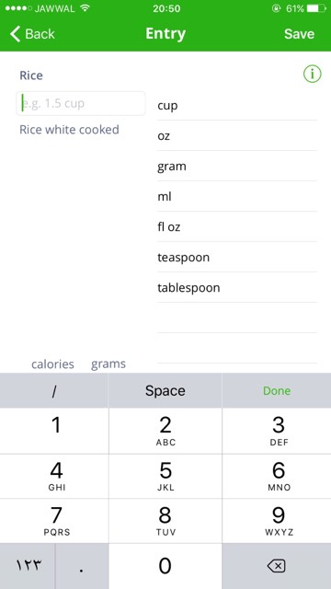 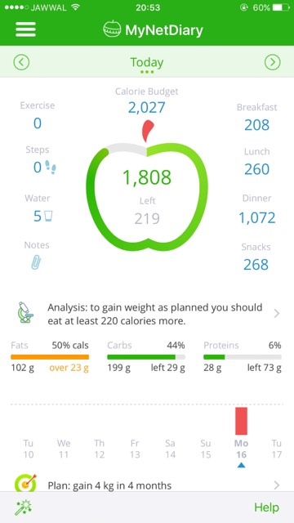

Figure 1:picture of my net Diary app

Quantity for this item,after you complete all these steps it will also give the user the quantity of fats, carbs and proteins.

-This app has a friendly UI and easy to use.

-Allow the user to connect with friends and family.

-Allow the user make healthy food choices and get more active

**FatSecret app**

About fat Secret:

Fat secret is a health app that can be specify as a nutrition app,that use calorie counter and diet tracker for weight loss, and because it has a good feature we use it to support our project idea and it support our idea by give us how we can to improve nutrition app in fitness and diet domain and how we can Distinguished.

To specify how it work:

Firstly after install app you have to answer question that arranged sequentially And to go from question to another you can move forward and backward so if u need to change any entered information its seem for us easy ,therefore , the way it move we find that the questions content are relate to the aim of app and they were clear , and those question are : my goal ,weight, gender, activity level and every think were specified about this question ,height and my birthday, then we sign up so from these steps we find that app have a friendly user interface and have a simplicity feature , so I wish we could start in a same way with interface encourage user to answer the hole questions without filing back using our app.

After sign up in the bottom of screen you will find home which is a place to share people your status so you  Connect with a global community of people looking to make a change for the better and start losing weight the healthy way so I think it’s a good feature support you to Achieve your goals, you will find beside first choice a diary choice which is the place that you enter your daily meal and it supported with ready choice you can choice it by search feature in the top of screen and after you enter your daily the app will track your meal to count the calories then you will find the report which contains your daily report , finally you will find weight choice which contain weight changes in every month.

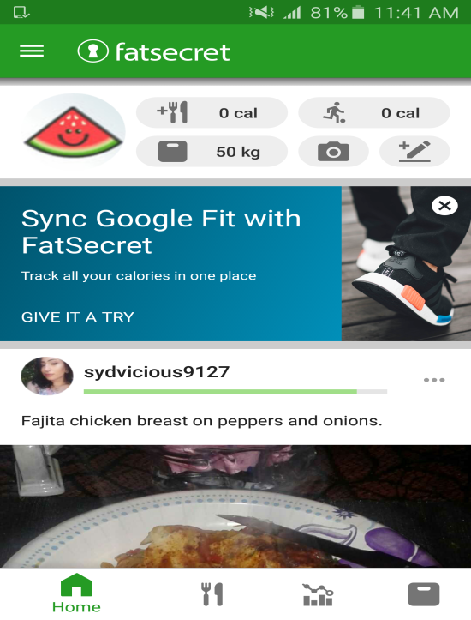 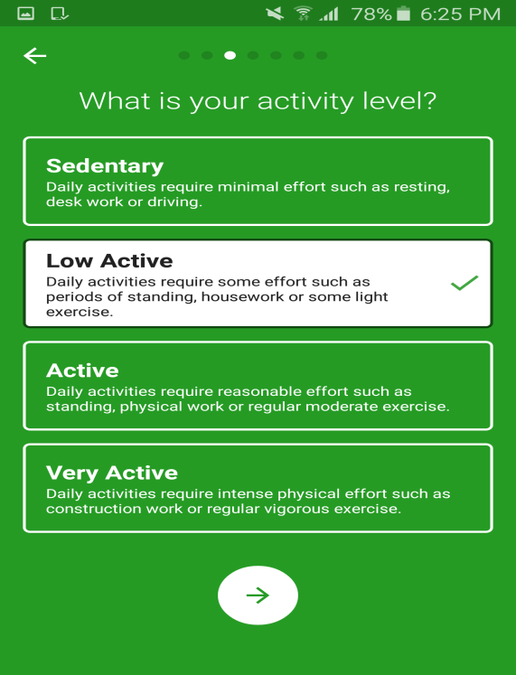

Figure 2:picture of fatsecret App .

The app also support exercise tracker to count your burned calories to give be shore that calorie tracker is a real tracker give you overall burned calorie and gained calories.

After we gain how fatSecret work we find this app contain feature as:

-This app has a friendly UI and easy to use.

-Allow the user to connect with friends and family.

-Allow the user make healthy food choices and get more active.

**Lose It**

This app works online and some features works offline, it allow the user to set his/her to just lose their weight, and by adding the height, current weight, gender, goal weight and then choose how quickly you’d like to reach your goal (slower – faster) of the user it will give them the date to reach this weight, daily calories budget, total weight loss and weekly weight loss.

This app allow the user to input if he/she do any exercises by searching and all the meals with its calories budget (breakfast, lunch, dinner, snacks) by search for these meals or scan it. After all steps you can find your body fat, hydration, sleep, body measurements, exercise calories, blood glucose, top food, daily calories chart, daily email report, meal planning, fats, sugar, sodium, fiber, protein, and carbohydrates and all that related to health.

It has a friendly UI easy to use, and he/she can add friends and share their friends that can be a challenge and access the diet.

This application is about how to lose weight as you read up and our application is a Nutrition App, we sure want to use losingweightIn addition to raise your wright or to be normal.

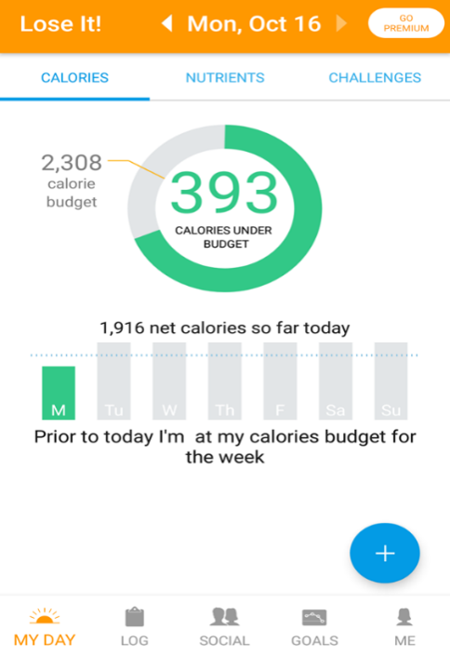 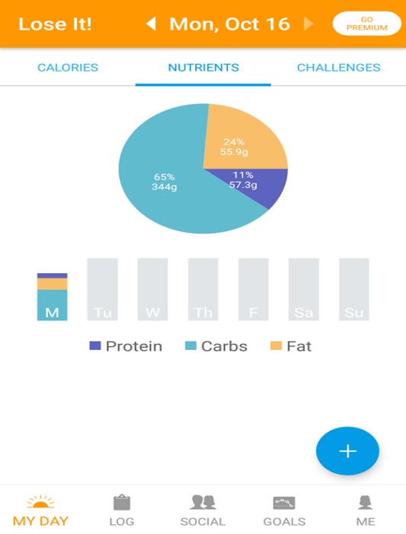

Figure 3:picture of lose it APP.

## 

## 3.4) Challenges of our App:

1) Develop app that distinguish in user interface side by make it friendly as possible ,simple to use in any time and any condition.

2) Develop app contains ability to manage lose weight, gain or maintain by depending on your goal and your idol wait, so this app will manage your weight in any condition.

3) Develop app help user to select the best goal of their weight, and this feature not supported in other apps.

4) Develop app to provide activity tracking service, Diet and nutrition service and Workout or exercise tracking service together.

# Chapter 4:System Analysis

## 4.1) System Requirements

### 4.1.1) Functional Requirements

* The system should be able to provide user to login and signup.
* The system allows the user to edit or update data.
* The system will show the total daily calorie depends on the data the user entered (height, weight, PA, gender, age).
* The system allows the user to enter all the meals, snacks, exercise, and water for a day.
* The system allows adding or searching for meals in specific quantities and calories.
* The system should notify the user to add meals during the day.
* The system will show the calorie counter that consumed after the user enters meals or snacks and will calculate the left calories.
* The system allows the user to add the type of exercise with its calories, the timer will count 30 minutes each time.
* The system will notify the user if they don’t play exercise 5 days in a week.
* The system will notify the user to drink the water.

### 4.1.2) Non-Functional Requirements

* Usability: the system should be easy, familiar to use and have a friendly interface.
* Reliability: the application should run the system in accepted time, and if the system down all information will be safe.
* Security: The system should be secure and this will be accomplished by saving the user data on secure server.
* Availability: the system should be available 24 hours for 7 days.

## 4.2) Functional Decomposition (use case diagram)

### 4.2.1) Actor

Users that connected with the system

* Member: this actor represents a person how uses the system, how fill data entry, determine his/her goal, add meals, add drinks, add snacks, add water and add exercises.
* Timer: how notify water, exercise and meals as we mapped before.
* Face book: this actor how share his/her post with friends.

### 4.2.2) use case specification

* **Registration or login in the system**:
* The System prompts the user for a username and password or register new account.
* The user selects registration option.
* The System prompts user for registration information, weight, PA, gender, height and age.
* The user enters in their information.
* System verifies information and creates account.
* **Set the user goal:**
* The system prompts the user for the main goals of using the system (gain, lose, maintain).
* The user will select his/her goal option.
* **View notification:**
* The system will show notification to drink water after a specific time.
* The system will show notification to add the daily meals.
* The system will show notification to do exercise.
* **Post information:**
* The system will allow the user to post and share his/her motivation messages, how it reacts with the system, status posts, and food items pictures.
* **Insert food items:**
* The user will add the meals and snacks with its specific quantity for a day.
* The system allows the user to add new food items with its calorie count.
* **Insert exercise:**
* The system allow the user to search for the exercise that user will do, with specific time for this type and how much calories it burn.
* The system allow user to add new types of exercises with its calorie count.

### 4.2.3) use case diagram

## 25564690_10215037033576163_1640729769_n

Figure 4: Use Case Diagram .

## 4.3) System Models

### 4.3.1) ER Diagram

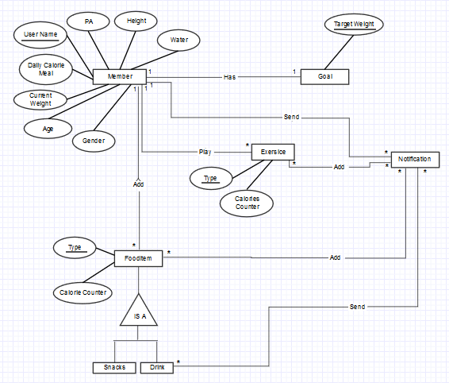

Figure 5:ER Diagram .

### 4.3.2) Class Diagram

## C:\Users\Aya\Downloads\26174678_10215118160404283_1511013428_n.png

Figure 6:class diagram

## 4.4) System Analysis :

Because of the usability of the nutrition health apps which help the users to have a good diet and hit their goals. Food tracking apps are particularly helpful .Tracking your food can not only give you an eye-opening picture of what you’re really eating each day, but it can also improve you to lose ,gain or maintain weight. These apps effective in promoting healthy eating and exercising. Our objective to achieve as a part of these apps which affected the user’s actions, health awareness, and self-education about nutrition and PA. This will be done by the framework of our application which follows specified steps.

### 4.4.1) Framework Steps:

**Step#1**: Install the application in the user device which support Android platform.

**Step#2**: Registration in the application   
 when the user download the application then he/she must sign up in the application by filling the personal information which appears in the registration form which include the user name , password , age, height, current weight, gender and physical activity level.

*The physical activity is divided into 5 levels with specified by factor:*

* Extremely inactive (this includes patients who are sitting in chairs, or who suffers from Cerebral Palsy), with 1.2 level factor.
* Sedentary (this includes office workers getting little or no exercise), with 1.375 level factor.
* Moderately active (this includes office workers with moderate exercise or sports 3-5 days/week), with 1.55 level factor.
* Very active (this includes construction workers, person swimming two hours daily or person running one hour daily), with 1.75 level factor.
* Extremely active (this includes competitive athletes who train for hours every day), with 1.9 level factor.

After filling the required data in the form, the system will allow user to submit data, after that the data will be upload in server under the unique user id.

**Step#3**: Calculate the Resting Metabolic Rate (RMR):

RMR is calculated by many equations, our application will use Mifflin equation which uses the personal data information (current weight in kilograms, height in cm, and age in years).

* RMR for women = (10\*weight) + (6.25\*height)-(5\*Age)-161
* RMR for men= (10\*weight) + (6.25\*height)-(5\*Age) +5

**Step#4**: Calculate the Total Energy Requirements (TER):

TER (total calorie) is calculated by multiplying the resting metabolic rate and physical activity factor.

* TER= RMR\*PAL factor

**Step#5:**Calculate the Body Mass Index (BMI):

After the TER is calculated, then the BMI must be decided by calculating the equation which uses the height in meters and weight kilograms, which decide if the user’s weight status is in the normal or abnormal.

* BMI = weight/height\*height

Then, the user will be categorized the result by this scale:

|  |  |
| --- | --- |
| **BMI** | **Weight Status** |
| less than 18.5 | Underweight |
| 18.5-24.9 | Normal |
| 25-29.9 | Overweight |
| 30-34.9 | Obese class 1 |
| 35-39.9 | Obese class 2 |
| More than 40 | Obese class 3 |

After that:

* If the user categorized in the underweight range, the system will increase the daily TER by 600 calories /day this help user to increase his/her weight.
* If the user categorized in the normal weight, the system will give the user diet according to the TER.
* If the user categorized in the overweight or obese ranges, the system will decrease the TER by 600 calories/day.

**Step#6**: Calculate the Ideal Body Weight (IBW):

The application will calculate the IBW which is suitable with the user height and gender by these equations:

* Women = allow 45 kg for the first 152.4 cm + 0.9 kg for each additional cm.
* Men= allow 50 kg for the first 152.4 cm + 1.1 kg for each additional cm.

**Step#7**: Calculate the percentage of each nutrient body needs:

* Carbohydrates: 45-65% of TER.
* Fat: 20-35% of TER.
* Protein: 10-35% of TER.

**step#8**: Calculate the consumed calories:

After that, the application will show the daily total calories for the user, to be awareness to be in the limit of this total. Our application will contain the progress bar for calculate the total of gain calories from the meals and snacks which will be added from the user all the day in specific times. After that, it wills subtraction the consumed calories from the total to show the user the left calories.

**Step#9:** show notification:

The system will send daily notification for user depend on specific time by using timer, those notification are the meal notification this will be send for user to add his/her daily meals, water notification and exercises notification that will be send at least 5 times per week.

# Chapter5: Experiment

## 5.1) Experiment:

According a huge number of existing mobile Application in nutrition domain, we decide to distinguish in user interface of our Application, so we think seriously how to make this application usable as possible, in other description how to make a user friendly interface, after that we create the interfaces of application, then our work improved by questioner relate to the main concept of usability(user friendly interface).

* The test has been done in this interfaces:
* After App instillation this will be shown in screen

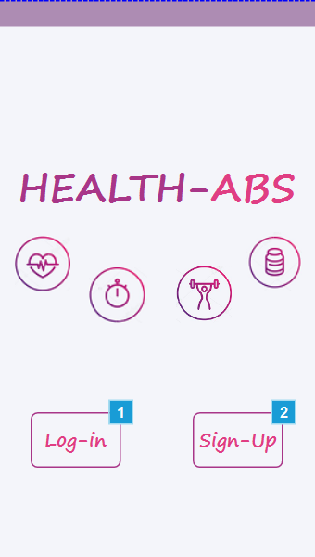

Figure 7:the registration interface after instillation

* If user select login this will be shown

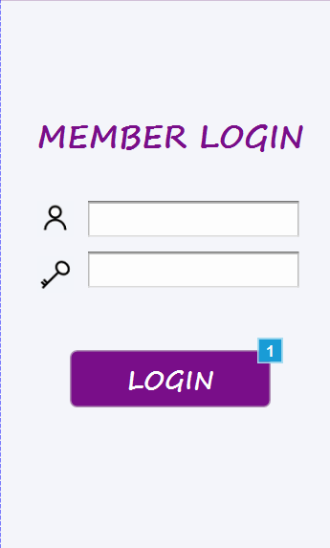

Figure 8:login form interface

* If user select sign up

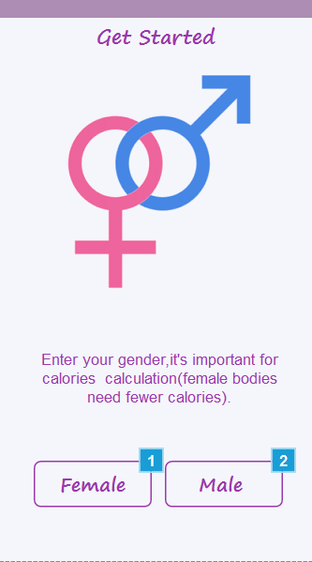

Figure 9: the start interface of required data

* The main page interface after login or sign up

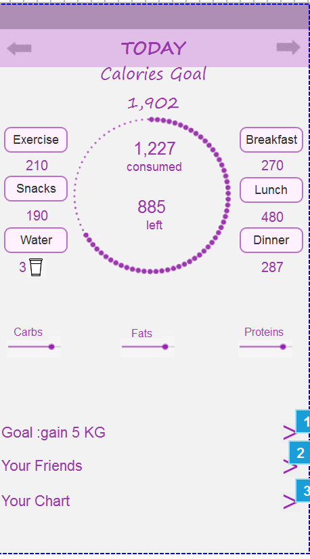

Figure 10: Main interface of our App

* Other internal interfaces

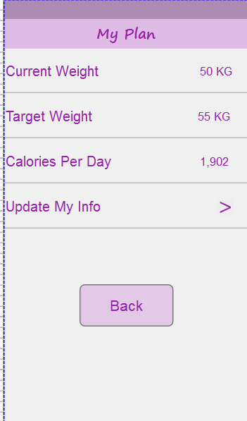

Figure 11: User Plan interface

### 5.1.1) Survey Items

The survey consisted of 6 questions encompassing the following domains: (1) use by one hand, (2) easy to use, (3) easy to understand, (4) consistent of view in form, (5) consistent of colours in form, and (6) and distribution of content increase the speed of reach ability. Those questions have been chosen to improve that our application is usable and friendly to use.

### 5.1.2) Data analysis

The dataset used in this experiment is consist of 40 questioner , this questioner has been distributed randomly for the student in Birzeit university ,after we collect data we start the analysis of those questioner we use excel to enter each questioner data and then we enter those table on the SPSS to analysis the data and make chart of it .

### 5.2) result of analysis

**As a result of analysis data in Survey we find:**

* 97.5% of sample agrees that application can be used by one hand and 2.5% neutral.
* 95% of sample agrees that interface is simple and easy to use and there is 5% of sample disagrees.
* 100% of sample agrees that content of main interface understandable.
* 90% of sample agrees that view of interface is consistent and 10% of sample disagree.
* 77% of sample agree with color consistent and 23% of sample disagree
* 95% of sample agrees that a distribution of content increase the speed of reach ability and there is 5% of sample disagrees.

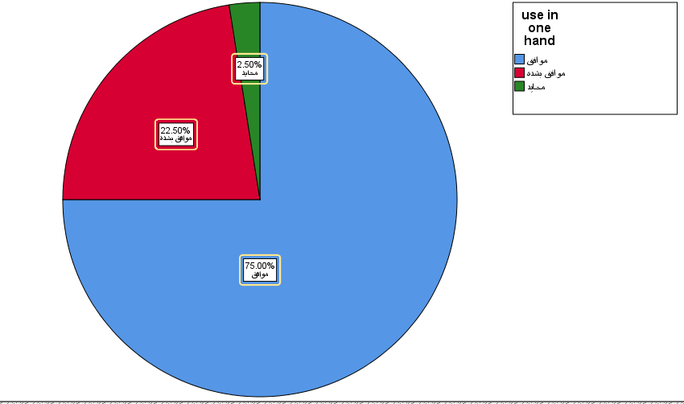

Figure 12:chart of using app in one hand.

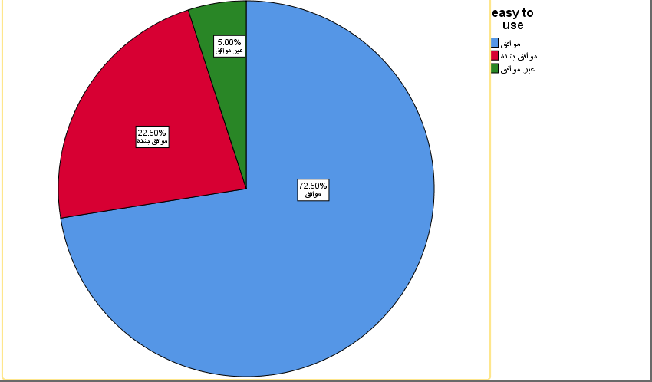

Figure 13:chart of simple and easy to use

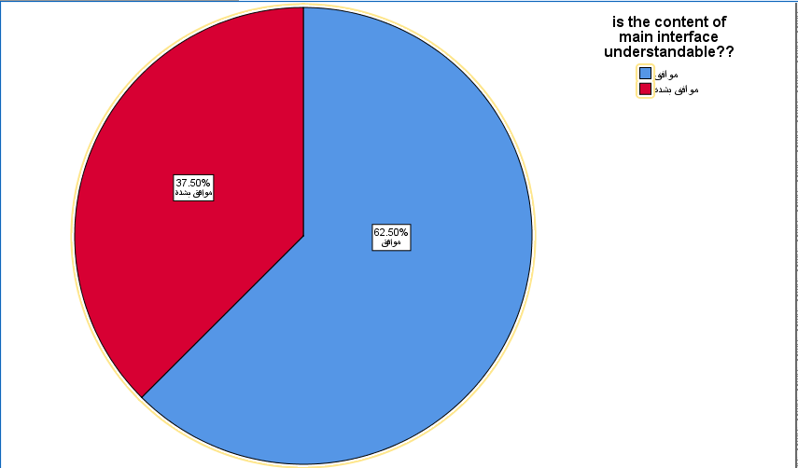

Figure 14:chart of understandable feature.

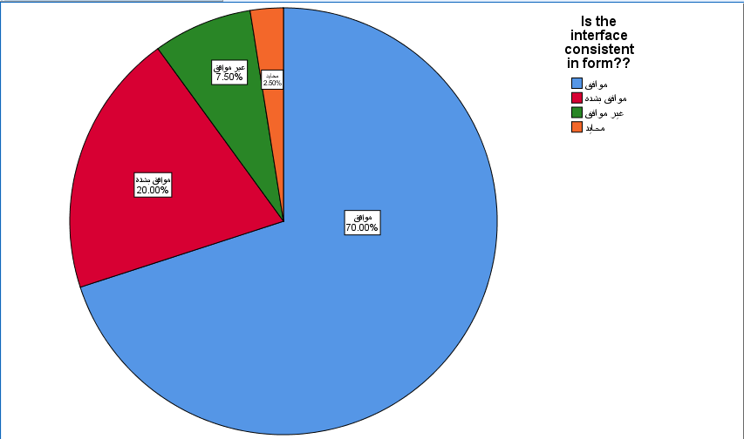

Figure 15:chart of consistent of view.

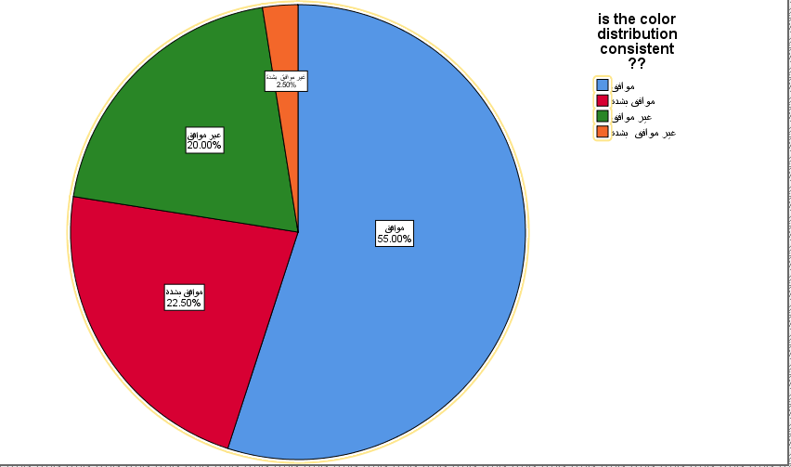

Figure 16:chart of color consistent

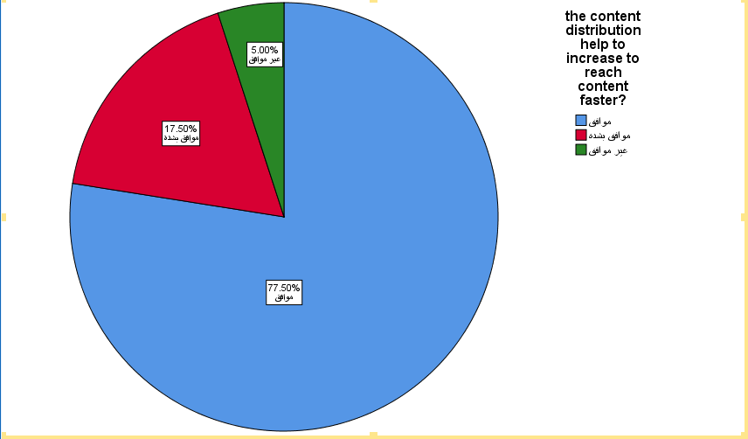

Figure 17:char define if the distribution of content is good

# Chapter 6: Discussion

## 6.1) challenges of our App :

Our challenges in this semester:

1. Because we aren’t specialist in the health side, and we don’t know very much information about nutrition care. We had read much information and articles to be flexible with this ways.
2. New definition about the nutrition which we will use them in our app, such as PA,IBM, and so on, which must be very clear to help us.
3. We take a very much time to create the prototype of UI, which will be friendly, usable and contain the main idea of the app.
4. Searching then downloading many nutrition apps and learn how it used, its features, its rating and how we will be different.
5. Weak English language .

## 6.2) Conclusion :

## In this semester we made study about nutrition mobile Apps, this study include the aim of this project which is to make a nutrition app help user maintain a good diet and exercise routines through tracking your weight, the main feature in developing this app, the technology that will be use in development and specification about related topic ideas and system requirements , then as a demo we build a simple user interface using Axure mobile prototype then the demo has been used to test user interface and the result was positive.

## Providing by nutrition specialist from nutrition department we take the equation that will be use in the algorithm to build our app, and the data base which contain a ready tables of food type and excise mapped to build in SQL data base technology ether the customer information will be included in this data base.

6.3)

For the next semester, we are making improvements on the portal; first of all, we will build the database for the users of the portal, which will handle the sign-up and login functions. and the mentioned above features will be applied. So the user will be able to add meals with the Occasion calorie counter and to achieve him/his goal (maintaining weight, raising weight, or losing weight).

# Chapter 7: References:

1) service Alex Rodriguez,URI Restful published on November 06, 2008 /Updated: February 09,2015.From

www.ibm.com/developerworks/library/ws-restful/index.html.

2) J.FDimarzio , What is android: from Android ® Programming with Android Studio book.

3) Krebs, P., & Duncan, D. T, Health app use among US mobile phone owners: a national survey. JMIR mHealth and uHealth, 3(4) (2015).‏

4) Liang.L.D. Introduction to Java Programming (2013).

5) Journal of the American Medical Informatics Association, Volume 20, Issue 3, 1 May 2013, Pages 513–518, Published in 2013.

[doi.org/10.1136/amiajnl-2012-001510](https://doi.org/10.1136/amiajnl-2012-001510).

6) Design interface, [www.axure.com/downloadthanks?dl=80pc](http://www.axure.com/downloadthanks?dl=80pc).

7) the free encyclopedia, 1November2017, From Wikipedia.

8) G.F.DiMardidio. Beginning Android programming with android stiduo.4th edition .

9) Android studio,[developer.android.com/studio/index.html](https://developer.android.com/studio/index.html).

10) Design interface, [www.axure.com/downloadthanks?dl=80pc](http://www.axure.com/downloadthanks?dl=80pc),

11) Sunyaev,A..Dehling, T.,Taylor ,P.L.,&Mandl,K.D.(2014). Availability & quality of mobile health app privacy policies. Journal of the American Medical Information,22(e1),e28-e33.ISO690.

12) a new-icon that use in user interface by , icons8.com.

13) material.io/guidelines/style/color.html#color-color-palette

[14) material.io/color/#!/?view.left=0&view.right=0](https://material.io/color/#!/?view.left=0&view.right=0)

15)www.helloerik.com/ux-is-not-ui

16)en.wikipedia.org/wiki/System\_model

17) en.wikipedia.org/wiki/Android\_Nougat

18)www.google.ps/search?hl=ar&biw=1422&bih=658&tbm=isch&sa=1&ei=mTQyWtFTxfiTBYWQqMAK&q=calorie+counter+applications++forms&oq=calorie+counter+applications++forms&gs\_l=psy-ab.3...54531.58176.0.58593.14.12.0.0.0.0.433.2147.2-3j3j1.7.0....0...1c.1.64.psy-ab..10.0.0....0.csD-tk\_K8Kg#imgdii=QYoYQb29DR7oaM:&imgrc=oyhBcUi8-YZSYM:

19)reqtest.com/requirements-blog/functional-vs-non-functional-requirements/

20)www.elegantthemes.com/blog/resources/10-rules-of-good-ui-design-to-follow-on-every-web-design-project

|  |
| --- |
|  |