Salinity controls rocky intertidal community structure via suppression of herbivory

T.A. Coyle*, S.M. Emry*, R.L. Kordas, & C.D.G. Harley

08/02/2022

**keywords** environmental stress; herbivory; indirect effects; intertidal zone; salinity; Strait of Georgia

**Abstract**  
The direct effects of climate change are mediated by species interactions and shape the abundance and distribution of species. In order to predict how species will be impacted by ongoing environmental change, we need to better understand the relative roles of direct vs indirect effects. Here, we conducted monthly surveys in regions of either high or seasonally low salinity in the Strait of Georgia, British Columbia to understand how the rocky intertidal communities compare. We then manipulated the presence of grazers in the same regions, to determine whether direct effects of hyposalinity or indirect effects mediated by suppression of herbivory, controls community structure. Lastly, we paired these surveys with a series of laboratory experiments to quantify the salinity tolerance of the dominant grazer, Lottia pelta, and the green algae Ulva sp. We show that rocky intertidal shores from two regions of disparate salinity regimes are distinct in their intertidal communities: low salinity sites were composed primarily of Mytilus trossulus, Fucus distichus and Ulva sp., whereas high salinity site were dominated by barnacles, red algae and grazers. Our laboratory trials confirmed that salinity conditions experienced in the low salinity region exceeded the tolerance of *Lottia* spp, but not that of *Ulva* sp. Further, we show that by manipulating grazer presence in high salinity sites, these communities more closely resemble that of the low salinity sites, than they do of other high salinity sites with grazers present. Together, these results demonstrate that the pattern of distinct estuarine intertidal communities in low vs. high salinity regions in the Strait of Georgia may be largely driven by the indirect effects of freshwater inputs, mediated by salinity-driven differences in herbivore population size and thus grazing pressure.

**Introduction**

          Understanding organisms’ direct responses to abiotic stress in terms of growth, reproduction, and survival is an important first step in explaining the distribution of species across environmental gradients in time and space (Miller et al. 2011; Levy et al. 2015; Bernhardt et al. 2018). A given species’ tolerance to environmental stressors is frequently used to predict the likelihood that it will persist in the face of climate change (Van der Putten et al. 2010; Louthan et al. 2021). However, predictions made solely on tolerance limits to stress and without reference to the influence of interacting species can often lead to misleading results, and fail to explain the observed distribution and abundance of species (Brooker et al. 2017; Davis et al. 1998; Hein et al. 2012; Hof et al. 2012; Wallingford and Sorte 2019; Zacher et al. 2019; but see Thierry et al. 2021). A growing body of evidence suggests that environmental stressors impact community development and structure not only via direct effects on the physiology and survival of organisms, but also through indirect effects mediated by the interactions among species (Underwood 1999; Dahlhoff et al. 2002; Longtin et al. 2009; Kordas et al. 2011; Diamond et al. 2017; Barton and Ives 2014). To better understand patterns of community composition and diversity, and forecast how these patterns will shift due to ongoing environmental change, we need to better integrate the direct effects of the environment on any given species with the indirect forcing that arises through environmentally-driven shifts in trophic interactions, competition, and facilitation.  
          Environmental forcing is often mediated, or amplified, by changes in the strength of interspecific interactions (Kroeker and Sanford 2022). Interactions, such as predation, herbivory, facilitation and competition, are altered by both changes in the abundance of one or more interacting species, as well as changes in per capita interaction strength (Kordas et al. 2011; Low and Micheli 2018; Aguera et al. 2015). Stressors that alter key ecological rates such as feeding, through either of the aforementioned pathways, will therefore also have an indirect impact on prey species, which can have further cascading impacts on tertiary species (Paine 1974; Rogers-Bennett and Catton 2019). For example, tropical herbivorous fish have migrated into new habitats while tracking thermoclines, triggering a phase shift from a kelp-dominated system to a rocky barren, with a coinciding loss of kelp-associated diversity (Vergés et al. 2014). Further, environmental drivers can disproportionately affect some species over others; when ‘leverage species’ (sensu Power et al. 1996) are particularly sensitive to changes in the environment, small alterations in the abiotic world can drive considerable change to community structure (Sanford et al. 1999; Harley et al. 2006; Kordas et al. 2011; Kroeker and Sandford 2022).  
          Response to environmental forcing may manifest among populations within a species in different ways, reflecting variation in abiotic histories resulting in divergent selection or plasticity (Sanford and Kelly 2011). For example, despite gene flow among populations, an alpine grass species showed clear differentiation in fitness-related traits along an elevation gradient (Gonzalo-Turpin and Hazard 2009). Likewise, juveniles of *Nucella lamellosa* originating from an area of high salinity experienced higher mortality under hyposaline stress, compared to juveniles originating from a region of low salinity (Covernton and Harley 2020). Ultimately, the interplay between direct and indirect effects of abiotic factors at both a species and a population level will determine aggregate community level properties such as diversity and community structure.  
          We investigated the importance of direct and indirect environmental controls on estuarine rocky shores. Rocky intertidal shores are a unique system to study such ecological processes as they are highly dynamic in their physical environment, being at the interface of land and sea and exposed to the conditions of both with the rise and fall of the tides (Kunze et al. 2021). Fluctuations in abiotic conditions occur daily, seasonally and in the long term in response to large scale geographical and climatological processes, further influencing the dynamic nature of intertidal communities (Helmuth et al. 2002; Hsieh et al. 2005; Menge et al. 2011). Along with the natural variability in abiotic conditions, rocky shores are highly tractable, making these systems ideal for testing questions related to how species interactions mediate the impacts of abiotic stress on species composition.  
          In estuarine rocky intertidal ecosystems, salinity is one of the most important drivers of performance of organisms at multiple scales of biological organization, and thus has cascading impacts on population and community structure (Ritter et al. 2005; Schoch et al. 2006: Covernton and Harley 2020). Exposure to fresh water can induce physiological stress responses in marine animals, including decreased heart rate, reduced haemolymph osmolality and mortality (De Pirro et al. 1999; Chelazzi et al. 2001; Firth and Williams 2009; Marshall and McQuaid 1993), as well as disrupt ecological processes such as feeding, activity, reproduction and larval development rate (Cheung 1997; Zimmerman and Pechenik 1991). Similarly, decreased salinity levels have been found to reduce the survival, development and settlement of marine larvae, and subsequently influence adult distribution (Qiu and Qian 1999; Dineen and Hines 1994; Starczak et al. 2011). Further, hyposaline conditions inhibit the growth and photosynthetic rate of many marine algal species (Luo and Liu 2011; Connan and Stengel 2011; Karsten 2007), although several algal species have demonstrated a wide salinity tolerance range (Chang et al. 1999; Rath and Adhikary 2005), as well as a capacity for local adaptation to low salinities (Nygard and Ekelund 2006; Nygard and Dring 2008). As species and populations can have individualistic responses to salinity across a food web, salinity variation can result in changes in community structure and ecological processes that influence biodiversity (Witman and Grange 1998; Zacharias and Roff 2001; Hampel et al. 2009; Nielsen and Gosselin 2011; Rubal et al. 2012).  
          Here, we sought to understand the direct and indirect effects of spatial variation in salinity in the Strait of Georgia for intertidal algal-herbivore interactions and resulting community structure. We hypothesized that limpets are disproportionately vulnerable to hyposalinity stress relative to other species like *Ulva* sp. We further hypothesized that differences in community structure between high and low salinity areas would be related to differences in grazing pressure due to variation in limpet abundance, and therefore indirectly driven by salinity. To test these hypotheses, we combined laboratory salinity tolerance trials on limpets, specifically *Lottia pelta*, and the green macroalgae *Ulva* sp., with observational surveys and a manipulative herbivore exclusion experiment at six sites, three each within an area of consistently high salinity, the Southern Gulf Islands, Canada, and in an area of seasonally low salinity, West Vancouver, Canada. First, we predicted a lower abundance of limpets in the periodically low salinity environments than in the consistently high salinity areas. Second, we predicted that any local adaptation to salinity in limpet populations, if present, would not be enough to overcome the minimum salinity level in WV and maintain a population level comparable to the rocky shores of the SGIs. Third, we predicted that a reduction in grazing pressure would result in an increase in algal cover in low salinity sites. Lastly, as increased algal abundance has been shown to negatively impact barnacle species (Farrell 1991), we therefore predicted lower barnacle abundance in low salinity sites.

**Materials and Methods**

*Study system*  
| This research took place in the Strait of Georgia, British Columbia. The 220 km Strait is located between Vancouver Island and mainland British Columbia, and is partially isolated from the Pacific Ocean by restricted flow through narrow channels around the northern and southern tips of the island (Fig. 1). Freshwater inputs are dominated by the Fraser River, which regularly exceeds a mean outflow rate of more than 7000 m³/s in summer months during the freshet (Environment Canada 2012). The late spring peak in river discharge causes a corresponding reduction in sea surface salinity in the southern Strait of Georgia, with an annual drop from approximately 25 psu to less than 10 psu at coastal sites near the river mouth during peak discharge (Ianson et al. 2016; Moore-Maley et al. 2018). This effect, however, declines with increasing distance from the Fraser River, with waters southwest of the Southern Gulf Islands maintaining salinities of 23 psu to 32 psu year round (Halverson and Pawlowicz 2011; MacCready et al. 2021; Tully and Dodimead 1957). The contrasting salinity regimes on either side of the Strait make this system a unique and ideal environment for disentangling the direct and indirect effects of this environmental stressor on coastal marine communities.  
| The field studies described here took place on the traditional, ancestral, and unceded territory of the Sḵwx̱wú7mesh (Squamish), xʷməθkʷəy̓əm (Musqueam), səlil̓ilw̓ətaʔɬ (Tsleil-Waututh), Stz’uminus, Quw’utsun (Cowichan), Semiahmoo, scəw̓aθən məsteyəxʷ (Tsawwassen), SȾÁUTW̱ (Tsawout), Penelakut and Hwlitsum nations. We conducted field studies at three sites within each of two regions with contrasting salinity regimes: West Vancouver (LS1, LS2, LS3) and the Southern Gulf Islands (HS1, HS2, and HS3; Fig. 1). The Southern Gulf Island (SGIs) sites are located on the southwest side of the island chain, and are not directly exposed to the Fraser River plume. Because of this, the SGI sites remain at consistently high salinities year-round, while the West Vancouver (WV) sites experience reduced salinities during the summer (Fig. 2). Salinity measurements were collected and analyzed with a handheld refractometer, approximately once a month throughout the summers of 2010 and 2011, as well as once for each site in the following winters. Sea surface temperature in the two regions is comparable, ranging from 5.0 to 18.5°C in WV and 6.0 to 18.5°C in the SGIs (Fisheries and Oceans Canada 2009). The tidal range is greater in WV, with extreme high tides reaching 4.7 m above Canadian chart datum (approximated as the lowest astronomical tide), compared to 3.4 m in the SGIs. All sites used in this study were composed of granitic rock except for HS1, which was sandstone. Areas selected for surveys and experiments were gently sloping (<40°) bedrock, with varying aspect (see Table S1).

*Transect Surveys*  
| We conducted monthly surveys during low tide at each of the six study sites from May to August, 2011. Because the tidal range differs between the two areas, we carried out surveys at the vertical height corresponding to approximately 30% submersion time. This occurs at 2.1 m in the SGIs and 3.0 m in WV. Ten meters of transect tape were laid across the rock face and eight randomly selected points were surveyed using a 25x25 cm quadrat. We counted all motile invertebrates and quantified sessile invertebrate percent cover.

*Salinity Tolerance Experiments*  
i). Salinity tolerance and local adaptation of *L. pelta*  
| To determine the salinity tolerance of a common grazer, the limpet *Lottia pelta*, and whether or not the salinity tolerance was contingent on source population, we conducted an experiment with two populations: one from a high salinity site and one from a low salinity site. We collected *L. pelta*, 20±5 mm in length, from HS1 (salinity of 27 psu) on June 2, 2011, and from LS3 (salinity of 10 psu) on June 6, 2011. Limpets from HS1 were randomly divided into eighteen 1 L Ziploc® containers with mesh walls, for a total of six limpets in each. We placed each container inside of an aquarium containing seawater at 30 psu; the salinity of the water within these aquaria was lowered by 2.5 psu per day until a salinity of 20 psu was reached. Limpets were allowed to acclimate to this salinity for ten days. We also randomly divided limpets from LS3 into an additional eighteen containers (six limpets per container), and placed all containers into aquaria containing seawater at 10 psu, increasing the salinity at increments of 2.5 psu per day to 20 psu. These limpets were allowed to acclimate to the final salinity of 20 psu for six days. After the acclimation period was complete, we randomly arranged containers into eighteen aquaria, all containing seawater at 20 psu, so that each aquarium contained one container of limpets from the high salinity site and one from the low salinity site. Aquaria were randomly assigned salinity treatments of 5, 8, 11, 14, 17 and 20 psu, with three aquaria for each salinity. Aquaria were covered, provided with compressed air and placed in a recirculating sea water system to maintain a water temperature of 12°C. We lowered salinities at a rate of 3 psu every 30 minutes until the desired salinity was reached, and limpets remained submerged for twenty-eight days. Each day, we examined limpets for signs of mortality, including tissue damage, discolouration and rigidity; any dead limpets were removed. The experiment continued for twenty-eight days, and limpets were not fed during this time.

ii). Salinity tolerance of *Lottia spp.* with tidal emersion  
| To determine whether or not the salinity tolerance of limpets is influenced by the periodic emersion from hyposaline conditions experienced during low tides, we conducted a salinity tolerance experiment with *L. pelta* and *L. digitalis*, which incorporated a mimic of tidal exposure. See additional methods for this experiment in the Supplementary Material.

iii). Salinity Tolerance of *Ulva* sp.  
| We collected *Ulva* sp. from LS2 in WV, from a salinity of 28 psu on December 7, 2011. Approximately 5-6 g of blot dried *Ulva* sp. was placed into each of sixty-four 1 L plastic bottles. Each bottle was randomly assigned a salinity treatment between 0 and 30 psu at intervals of 2.5 psu and provided with compressed air. The 0 psu treatment contained only distilled water, while all other treatments contained combinations of filtered seawater at 31 psu and dechlorinated freshwater at 0 psu. Bottles were placed inside of a flow-through sea water system to maintain a water temperature of 12°C and provided 25±5 µmol*m^-2* s^-1 of continuous light. After three weeks, we blot dried and weighed all samples, and one sample from each treatment was randomly selected to be assessed for photosynthetic efficiency using a pulse amplitude modulation (PAM) fluorometer (Jr PAM, Heinz Walz GmbH). Light intensities were altered using a 240W Fiber Optic Illuminator (6000-1, Intralux®) and screening filters. Samples were dark acclimated for one hour before quantum yields were measured by applying a saturating light pulse after reaching a steady state. We used photosynthesis vs. irradiance curves to determine maximum photosynthetic electron transport rate (ETRmax).

*Herbivore Exclusion Experiment*  
| We manually cleared all organisms at seven subsites within each of the six study sites. Similar to the transect surveys, these plots were placed at a tide height corresponding to approximately 30% emersion time. Each subsite included a limpet inclusion, exclusion and control plot. Inclusions and exclusions were formed by securing two copper fences, 2.5 cm high and 28.5 cm in diameter, to the rock face using Quickcrete® quick drying cement. Copper enclosures/exclosures of this type are effective barriers to limpets (Harley 2002) and partial barriers to periwinkles (Harley 2006). We marked one circular plot within each area, also 28.5 cm in diameter, with steel bolts to serve as a control. The position of control and treatments was randomized within each subsite. We did not include copper controls in this study, as previous work has shown that partial copper treatments lead to partial effects which are difficult to interpret (Johnson 1992). Ultimately, local salinity levels exceeded the lower tolerance limit of limpets in the low salinity sites, and the inclusion plots were not effective at retaining *L. pelta*. Because of this, we only analyzed exclusion and control plots. We maintained the exclusion treatments by removing limpets, along with any other grazers found inside the rings, every two weeks. We censused plots once per month during low tide, from May to August. We used a 10x10 cm quadrat to count motile invertebrates and barnacles and estimate percent cover of algae and mussels within each treatment. Salinity samples were taken at each sampling event and measured using a refractometer (S/Mill-E, Atago Inc.).

*Statistical Analyses*  
| All analyses were completed using R version 4.1.2 (R Core Team 2020). To test whether salinity regimes between our study areas were different, we performed a student’s two sample t-test on the 10th percentile of salinities measured across two years at each of the six sites.

*Transect surveys*  
| We analyzed community data from the transect surveys using the *vegan* package, version 2.5-7. Species abundances were first relativized with a double Wisconsin transformation. This standardized species to equal maxima, then sites to equal totals, putting equal emphasis among sample units and among species. We ordinated the data with non-metric multidimensional scaling (nMDS). We then performed a permutational multivariate analysis of variance (PERMANOVA) to test the null hypothesis that the centroids of the groups are equivalent. In order to respect the dependence of sampling blocks within a site, we restricted the permutation scheme such that all quadrats along a transect were always permuted together. In doing so, 199 permutations were run on a matrix of Bray-Curtis dissimilarities. Because PERMANOVA cannot distinguish between differences in centroid location or levels of dispersion, we also used a PERMDISP test with 999 permutations, to test if the variances of the groups are different. We then conducted a Similarity of Percentages (SIMPER) analysis to investigate which species contributed most to the observed differences in salinity regions.

*Lab experiments*  
| To test whether survival of *L. pelta* populations originating from a low and high salinity region differ along a gradient of salinity levels, we conducted a survival analysis with the *survival* package, version 3.3-1 in R. We modeled the probability of survival with the Kaplan-Meier method, which is a non-parametric method to estimate survival probability from observed survival events. We then used these model fits to calculate the restricted mean survival time (RMST), for each site by population combination. To determine differences in net productivity of *Ulva* sp., we used a least-squares regression to analyze the change in biomass before and after the treatments, as well as ETRmax at the end of the experiment.

*Field exclusion experiment*  
| Due to a lack of recruitment in Spring months, and a late Summer heat wave in August 2011 that resulted in the die-off of many species, we analyzed community data in the penultimate sampling point of July only. We used the same methods as described above in the transect surveys subsection. We restricted permutations similarly, keeping treatment plots within a subsite together. We then conducted a SIMPER analysis to investigate which species contribute the most to observed differences among salinity regions, grazer treatments and the interaction between the two. Prior to running the SIMPER analysis, we removed grazers from the site-species matrix, to ensure that our analysis does not identify a species that differed among treatments due to experimental manipulation. Finally, we fit generalized linear models, using the glmmTMB package - version 1.1.2.3., to the abundance of two species which were consistently identified as the most influential taxa in the SIMPER analysis, as well as had abundance patterns that were markedly altered by our experimental design: *Ulva* sp., and the barnacle *Chthamalus dalli*. Both of these models included an interaction between the two fixed effects, region and treatment, and site as a random effect nested within salinity region. To model percent cover of *Ulva* sp., we first attempted to fit a model with a beta error distribution, but this model failed to converge, therefore we used a tweedie error distribution with variance among regions modeled independently. We modeled abundance of *C. dalli* with a negative binomial error distribution, with a zero-inflation parameter. Both models were fitted with a type III sums of squares. We checked model diagnostics with the DHARMa package, version 0.4.5, by running K-S tests, Levene’s test and plotting scaled residuals against each predictor variable.

**Results**  
*Abiotic conditions*  
| Salinity decreased as a result of increasing Fraser River discharge in the Spring and Summer at all sites, but was much more pronounced at the three low salinity sites (Fig. 2). The tenth percentile of salinity measured from 2010 to 2012 in WV was 9.6 psu (+ 0.9 SE), over 15 psu lower than the tenth percentile of 26 psu (+ 0.9 SE) measured in the SGIs (t_4 = -13.35, *P* < 0.001).

*Transect surveys*  
| Communities belonging to low or high salinity regions had definite and substantial differences in community composition from one another (PERMANOVA, F = 81.18, *P* = 0.005; Fig. 3). Low salinity sites changed through time whereas the high salinity sites remained fairly similar (region x month, PERMANOVA, F = 1.70, *P* = 0.005; Fig. 3). Different months of the summer also had significantly different communities across salinity regions (PERMANOVA, F = 4.48, *P* = 0.005; Fig. 3), however May and June had less variance than September (PERMDISP, F = 6.52, *P* = 0.001; Table S2, Fig. S1b). As groups with different dispersions may result in misleadingly low p values, PERMANOVA results must be interpreted cautiously. Dispersion among salinity groups was equal (PERMDISP, pseudo-F = 0.23, *P* > 0.05; Table S2, Fig. S1a). The following species contributed the most to differences between salinity groups: *Mytilus trossulus*, *Balanus glandula*, *Fucus distichus*, *Chthamalus dalli*, and the *Petrocelis* phase of *Mastocarpus sp*. Low salinity sites were composed of more *M. trossulus* and *F. distichus*, while high salinity sites were composed of more *B. glandula*, *C. dalli*, *Mastocarpus* sp, and *Lottia paradigitalis* (SIMPER; Table S3). Species-specific responses are shown graphically in Fig. S2a-h.

*Tolerance Experiments*  
i). Salinity tolerance and local adaptation of *Lottia pelta*  
| The survival of *L. pelta* was strongly reduced by low salinity, although the impacts of salinity differed between high and low salinity populations (Fig. 4). Limpets could only survive for a few days at the two lowest salinities tested (5 and 8 psu), although the low salinity population had a higher restricted mean survival time (5.6 + 0.4 at 5 psu and 6.4 + 0.4 days at 8 psu) than the high salinity population (4.4 + 0.2 at 5 psu and 4.9 + 0.3 days at 8 psu). The difference in survival among populations was amplified at 11psu, where the majority of low salinity limpets survived for the duration of the experiment with survival time estimated as 21.4 + 2.5 days, as compared to 11.7 + 1.5 days for the high salinity population. Limpet survival was uniformly high at salinities of 14, 17, and 20 psu, and populations did not differ in their restricted mean survival time at these salinities. Survival of *L. pelta* was not impacted by tidal emersion (see the supplementary material for detailed results).

ii). Salinity tolerance of *Ulva* sp.  
| The net productivity of *Ulva* sp. was significantly and unimodally related to salinity (Figure 5a; R^2 = 0.48, P < 0.001), with the greatest gain in mass at 15 psu and net losses at both 0 psu and 30 psu. ETRmax showed a similarly significant unimodal relationship (Fig. 5b; R^2 = 0.71, *P* = 0.002), with a maximum value at 20 psu and minimum at 0 psu.

*Herbivore exclusion experiment*  
| Herbivore exclusion had little influence on community structure in the low salinity region, but had a large effect in the high salinity region (Fig. 6). Notably, the communities in the high salinity herbivore exclusion plots were more similar to low salinity communities (with or without herbivore exclusion fences) than to high salinity plots with herbivores. Salinity region did not have a significant effect on community structure (PERMANOVA, F = 0.375, *P* = 0.375; Fig. 6), but treatment (PERMANOVA, F = 3.41, *P* = 0.005), as well as the interaction between salinity region and treatment (PERMANOVA, F = 1.52, *P* = 0.025) did have a significant effect. Dispersion among salinity groups was unequal (PERMDISP, F = 17.3, *P* = 0.001; Fig. S3a), as well as dispersion among treatment groups (PERMDISP, F = 7.5, *P* = 0.007; Fig. S3b). *Ulva* sp., along with the barnacles *B. glandula* and *C. dalli*, contributed the most to differences in community composition among the high salinity with grazers and the high salinity without grazer plots (SIMPER, Table S5). Similarly, the same three species also had the highest contribution to between group differences in the high salinity and low salinity plots with grazers. Excluding grazers differentially affected the abundance of *C. dalli* and *Ulva* sp. across salinity regions. Grazer-excluded plots in the high salinity region had an order of magnitude less *C. dalli* than the control plots in the same region (grazer x salinity, x2 = 17.1, df = 1, *P*<0.001; Fig. 7a). There was a consistent pattern of more *Ulva* sp in the low salinity sites ( x_2 = 20.06, df = 1, *P* < 0.001). Excluding grazers had a strong effect in the high salinity sites, such that the herbivore exclusion plots in the SGIs had similar Ulva cover to all of the plots in WV (grazer x salinity, x2 = 14.99, df = 1, *P* < 0.001; Fig. 7b). Results for the other species are shown graphically in Fig. S4a-f.

**Discussion**  
| As climate change continues to alter the biophysical world and place increasing pressure on ecosystems, understanding the mechanistic link between the abiotic environment and the resultant patterns on community composition is imperative. A multitude of environmental drivers, which include salinity amongst others, are shifting in space and time due to anthropogenic effects (IPCC 2022). The combination of gradients in abiotic drivers and resultant shifts in community interaction webs can create complex changes in community structure and ecosystem function (drought: Amundrud and Srivastava 2016; Chase and Knight 2003, warming: Barton and Ives 2014; Robinson et al. 2017, snowpack: Brodie et al. 2012). Although the correlation between the abiotic environment and species abundance and distribution is well studied (Hastings et al. 2020; Sunday et al. 2012; Walther et al. 2002), the extent to which this pattern is driven directly by changes to performance and survival or indirectly by changes to species interactions is not fully known (Bertness et al. 1999; Blois et al. 2013; Brown et al. 2001; Kordas et al. 2011; Stenseth et al. 2002). Empirical studies that disentangle the impacts of direct environmental stress and the indirect effects of modified species interactions in natural communities are rare.  
| There were distinct differences in both salinity regime and intertidal community structure in our two study regions. As freshwater discharge from the Fraser River increased in the Spring, salinity decreased in both WV and SGIs, but was much more pronounced at WV, as these sites were in closer proximity to the estuary. In WV, the average tenth percentile of salinity was 9.5 psu, which is in stark contrast to the 10th percentile of 26 psu experienced in the SGIs. In addition, there was very little overlap in the composition of communities inhabiting low and high salinity regions. Species driving the differences in the community composition among salinity regions consisted of a greater abundance of *M. trossulus* and *F. distichus*, and in some places *Ulva* sp. (e.g., the control plots in our experimental manipulations) in WV, and barnacles, red algae and grazers like the limpet species *L. paradigitalis* and *L. pelta* in the SGIs. Interestingly, community composition changed as the summer progressed in the low salinity region but not the high salinity region. This context-dependent shift in community structure may correspond with differences in the seasonal variation in salinity in the two regions, i.e., strong seasonal swings in WV salinity and only weak seasonal changes in SGI salinity, that are driving shifts in species presence or abundance.  
| Our results align with other studies that found similar patterns of distinct communities associated with distance from freshwater sources such as riverine input or glacial melt (Giménez et al. 2010; Hossain et al. 2019; McCabe and Konar 2021). This pattern of disparate communities among habitats that lay along a gradient of abiotic stress is not unique to salinity alone; documented differences in species composition have also been shown for freshwater phytoplankton communities along a thermal gradient (Vinson and Rushforth 1989; Ikram et al. 2022), plant communities along an elevation gradient, and butterfly species species in areas of low and high rainfall (Beirão et al. 2017), to name a few. Despite the importance of identifying differences in species composition among regions of varying environmental conditions, teasing apart the relative importance of whether indirect or direct impacts of abiotic stress in driving these patterns is very difficult in observational research alone.  
| The divergent pattern in limpet abundance between regions over the summer likely reflects the influence of the low salinity riverine output. Limpets are osmoconformers, and thus are unable to regulate their extracellular osmolality in response to changes in their environment, leading to deleterious effects on both physiological and behavioral responses, and ultimately survival (Chaparro et al. 2008; Denny and Gaines 2007; Firth and Williams 2009; Marshall and McQuaid 1993; Morritt et al. 2007). In the SGIs, limpets were able to survive a small seasonal decrease in salinity and maintain a fairly constant abundance throughout the summer. In contrast, limpets in WV nearly disappeared as surface salinity approached freshwater levels, likely as a result of osmotic stress related mortality.  
| Our experimental lab results on the limits of salinity tolerance in limpets provide additional support to our hypothesis that differences in the regional abundance of limpets are driven by salinity tolerance. Here, we show that limpet survival is strongly compromised below 11 psu in populations originating from both regions, but to a greater degree for limpets from the SGIs. While limpets are broadcast spawners with moderate dispersal ability and are thus likely to possess a certain degree of population connectivity, even species with dispersive planktonic larval stages can show signatures of local adaptation when faced with strong enough selective pressures (Sandford and Kelly 2011). Despite a propensity for local adaptation or acclimatization, limpets were not able to survive exposure to the full range of salinities potentially encountered in WV. In general, this intolerance to low salinity is in accordance with previous research on intertidal gastropods (e.g. Covernton and Harley 2020; Wilson et al. 2009).  
| Based on our results, limpet populations are expected to experience substantial mortality after less than a week of exposure to salinities less than 11 psu. Interestingly, while limpet abundance was exceedingly low in WV over the summer, some individuals were able to persist in this hyposaline environment, at levels as low as 7 psu. Our lab experiment shows that this likely isn’t a result of daily emersion during low tides, but there are other potential, non-mutually exclusive explanations as to why limpets were consistently found in WV. First, there may be enough intraspecific variation in the salinity tolerance of individuals that make up the population to allow the hardiest individuals to persist. Second, the amount of time limpets had to acclimate to salinity treatments in the lab differed from what they would experience in the field. The surviving limpets in WV may have persisted by inhabiting areas where high salinity intrusions occurred at a finer scale than our measurements. Third, there are likely periods of elevated salinity due to tidal dynamics or wind-driven mixing that were not captured by our salinity sampling. Lastly, populations may be replaced annually through recruitment from high salinity source populations.  
| Salinity-driven differences in limpet abundance had cascading consequences for community structure across the salinity gradient. When grazers had been excluded from plots in the SGIs, communities resembled WV to a remarkable degree, with more *Ulva* sp. and fewer barnacles, particularly *C. dalli*. The role of herbivory in structuring communities has been documented in several other systems besides rocky shores, but seem to be especially strong in marine systems (Poore et al. 2012; Shurin et al. 2005) where their gain or loss can result in striking shifts (Bellwood et al. 2004; Filbee-Dexter and Scheibling 2014; Hughes 1994; Ledlie et al. 2007). Herbivores can thus impact successional trajectories, habitat complexity, and alter the strength of competition in communities.  
| *Ulva* sp. is very effective at colonizing empty space made available by disturbance , has fast growth rates, and inhibits the settlement and growth of other algal species as well as invertebrates, thus often has a strong role in the successional trajectories of rocky shores (Sousa 1979). While we did not capture strong differences in *Ulva* sp. among regions in our transect surveys, our experimental plots showed that in the absence of grazer manipulations (i.e. the control plots), *Ulva* sp. was approximately 10 times more abundant in WV compared to the SGIs. Unlike limpets, several species belonging to the genus *Ulva* have demonstrated a wide tolerance for salinities as low as 5 psu (Ichihara et al. 2013), and are therefore widespread in marine and brackish habitats (Rybak 2018). Our hypothesis that differences in grazing pressures, not salinity tolerance, was driving the asymmetry in regional abundance of *Ulva* was supported by our results. Our lab experiment showed positive net gains in mass and high levels of ETR at a range of salinity levels from 5 to 25 psu, which encompasses the full range of salinities experienced at both the SGIs and WV during the summer. In the SGIs, the absence of limpets in the exclusion experiment allowed *Ulva* sp. to proliferate to abundances that matched that of the low salinity sites. Grazing by gastropods is known to have a direct negative impact on both the abundance and vertical zonation of intertidal foliose algae (Underwood 1981; Harley et al. 2006; Hesketh et al. 2021), which is what we documented during our field manipulation. The effect of excluding limpets on algal cover is often strongest in the absence of barnacles, as barnacles increase the habitat structural complexity, impeding the movement of larger grazers (Geller et al. 1991; Harley 2006). As our plots were completely cleared at the outset of the experiment, the lack of barnacles may have strengthened the ability of grazers to reduce *Ulva* cover so effectively.  
| Excluding grazers in the SGIs had the opposite effect on *C. dalli*, whereby abundance decreased to match that of the abundance seen in WV control plots. Limpets can have positive indirect effects on the abundance of the barnacles either by freeing up space for settlement of cyprid larvae that would otherwise be occupied by macroalgae, or by ‘bull-dozing’ *B. glandula* and reducing interspecific competition among the two barnacle species (Dayton 1971; Harley 2006). Because the presence of grazers did not have a negative effect on *B. glandula* abundance in the control plots in comparison to the exclusion plots, the facilitatory role limpets played in the recruitment of *C. dalli* was likely a result of grazing on algae, and not due to changes in interspecific competition. The former pathway is supported by experimental manipulations of limpet exclusions on the rocky shores of California and the Mediterranean, where algal cover increased and the congeneric species *Chthamalus montagui* and *Chthamalus stellatus* subsequently decreased (Dungan 1986, Benedetti-Cecchi 2000, Arrontes et al. 2004). Herbivore presence may also serve as a settlement cue through chemical signals that indicate a suitable habitat for *C. dalli*. For instance, *Chthamalus anispoma* had higher settlement in response to the chemical cues of species whose suitable habitat overlapped with its own (Raimondi 1988).  
| Taken together, our results show that indirect effects of abiotic drivers such as salinity can propagate through levels of biological organization, having profound impacts on community structure. The estuarine rocky intertidal system of the Strait of Georgia is driven by osmotic-related suppression of a key grazing species, and cascading effects on trophic interactions that ultimately restructure the entire community. Unfortunately, we were unable to determine the effects of grazing in WV, as the poor salinity tolerance of limpets meant that they were unable to survive in the inclusion plots. Had these inclusion plots been effective at retaining limpets, we would predict a decrease in *Ulva* cover, which would facilitate an increase in *C. dalli* and red algae in WV, as these species were already present and therefore have a salinity tolerance that allows at least some population persistence here. Ultimately, we need a better understanding of the salinity tolerance of these other species to understand the full effects of limpet grazing in this system. Nonetheless, abiotic conditions that vary in both space and time can lead to dynamic patterns in species distribution and abundance along these spatiotemporal gradients. Climate change is expected to impact salinity regimes in coastal regions both by intensification of the hydrological cycle that impacts precipitation patterns, as well as shifting the timing and strength of the Spring freshet (Held and Soden 2006; Douville et al. 2021). While intertidal populations have demonstrated a capacity for local adaptation, the expected changes to the global hydrological cycle are likely to alter the structure and composition of coastal communities. Understanding the effects of indirect effects on community dynamics may therefore prove essential to predicting the direction of such change in coastal ecosystems.

**Acknowledgements**  
We would like to thank those who helped in the field; Daniel Hepler, Jocelyn Nelson, Kat Anderson, Joshua Elzam, Andres Cisneros, Kyle Demes, Rebecca Gooding, Jonathan Coyle, Steve Fuchs, Manon Picard, Gerald Singh, Jacob Uber and Darah Gibson. We would also like to thank Kyle Demes for his assistance with the PAM fluorometry experiments. This project was supported by a Canadian Natural Sciences and Engineering Research Council (NSERC) Discovery Grant to CDGH, and by an NSERC Undergraduate Summer Research Assistantship and a UBC Dean of Science Summer Research Award to TC.

**Author Contributions**  
CDGH initially conceived the idea for the study; CDGH, RLK and TC developed the methodology; TC performed the experiments; TC and RLK conducted the field work; TC analyzed the Ulva lab experiment, SE analyzed the field survey data, limpet lab experiments, and the field experiment; TC wrote the initial version of the manuscript; SE wrote the final version of the manuscript. All authors contributed editorial advice.

**Conflicts of interest**  
The authors declare that they have no conflict of interest.

**Open research**  
The data sets generated and analysed, and the code used to analyse the data during this study are available in the [] repository.

## References

## Figure captions

## Figures

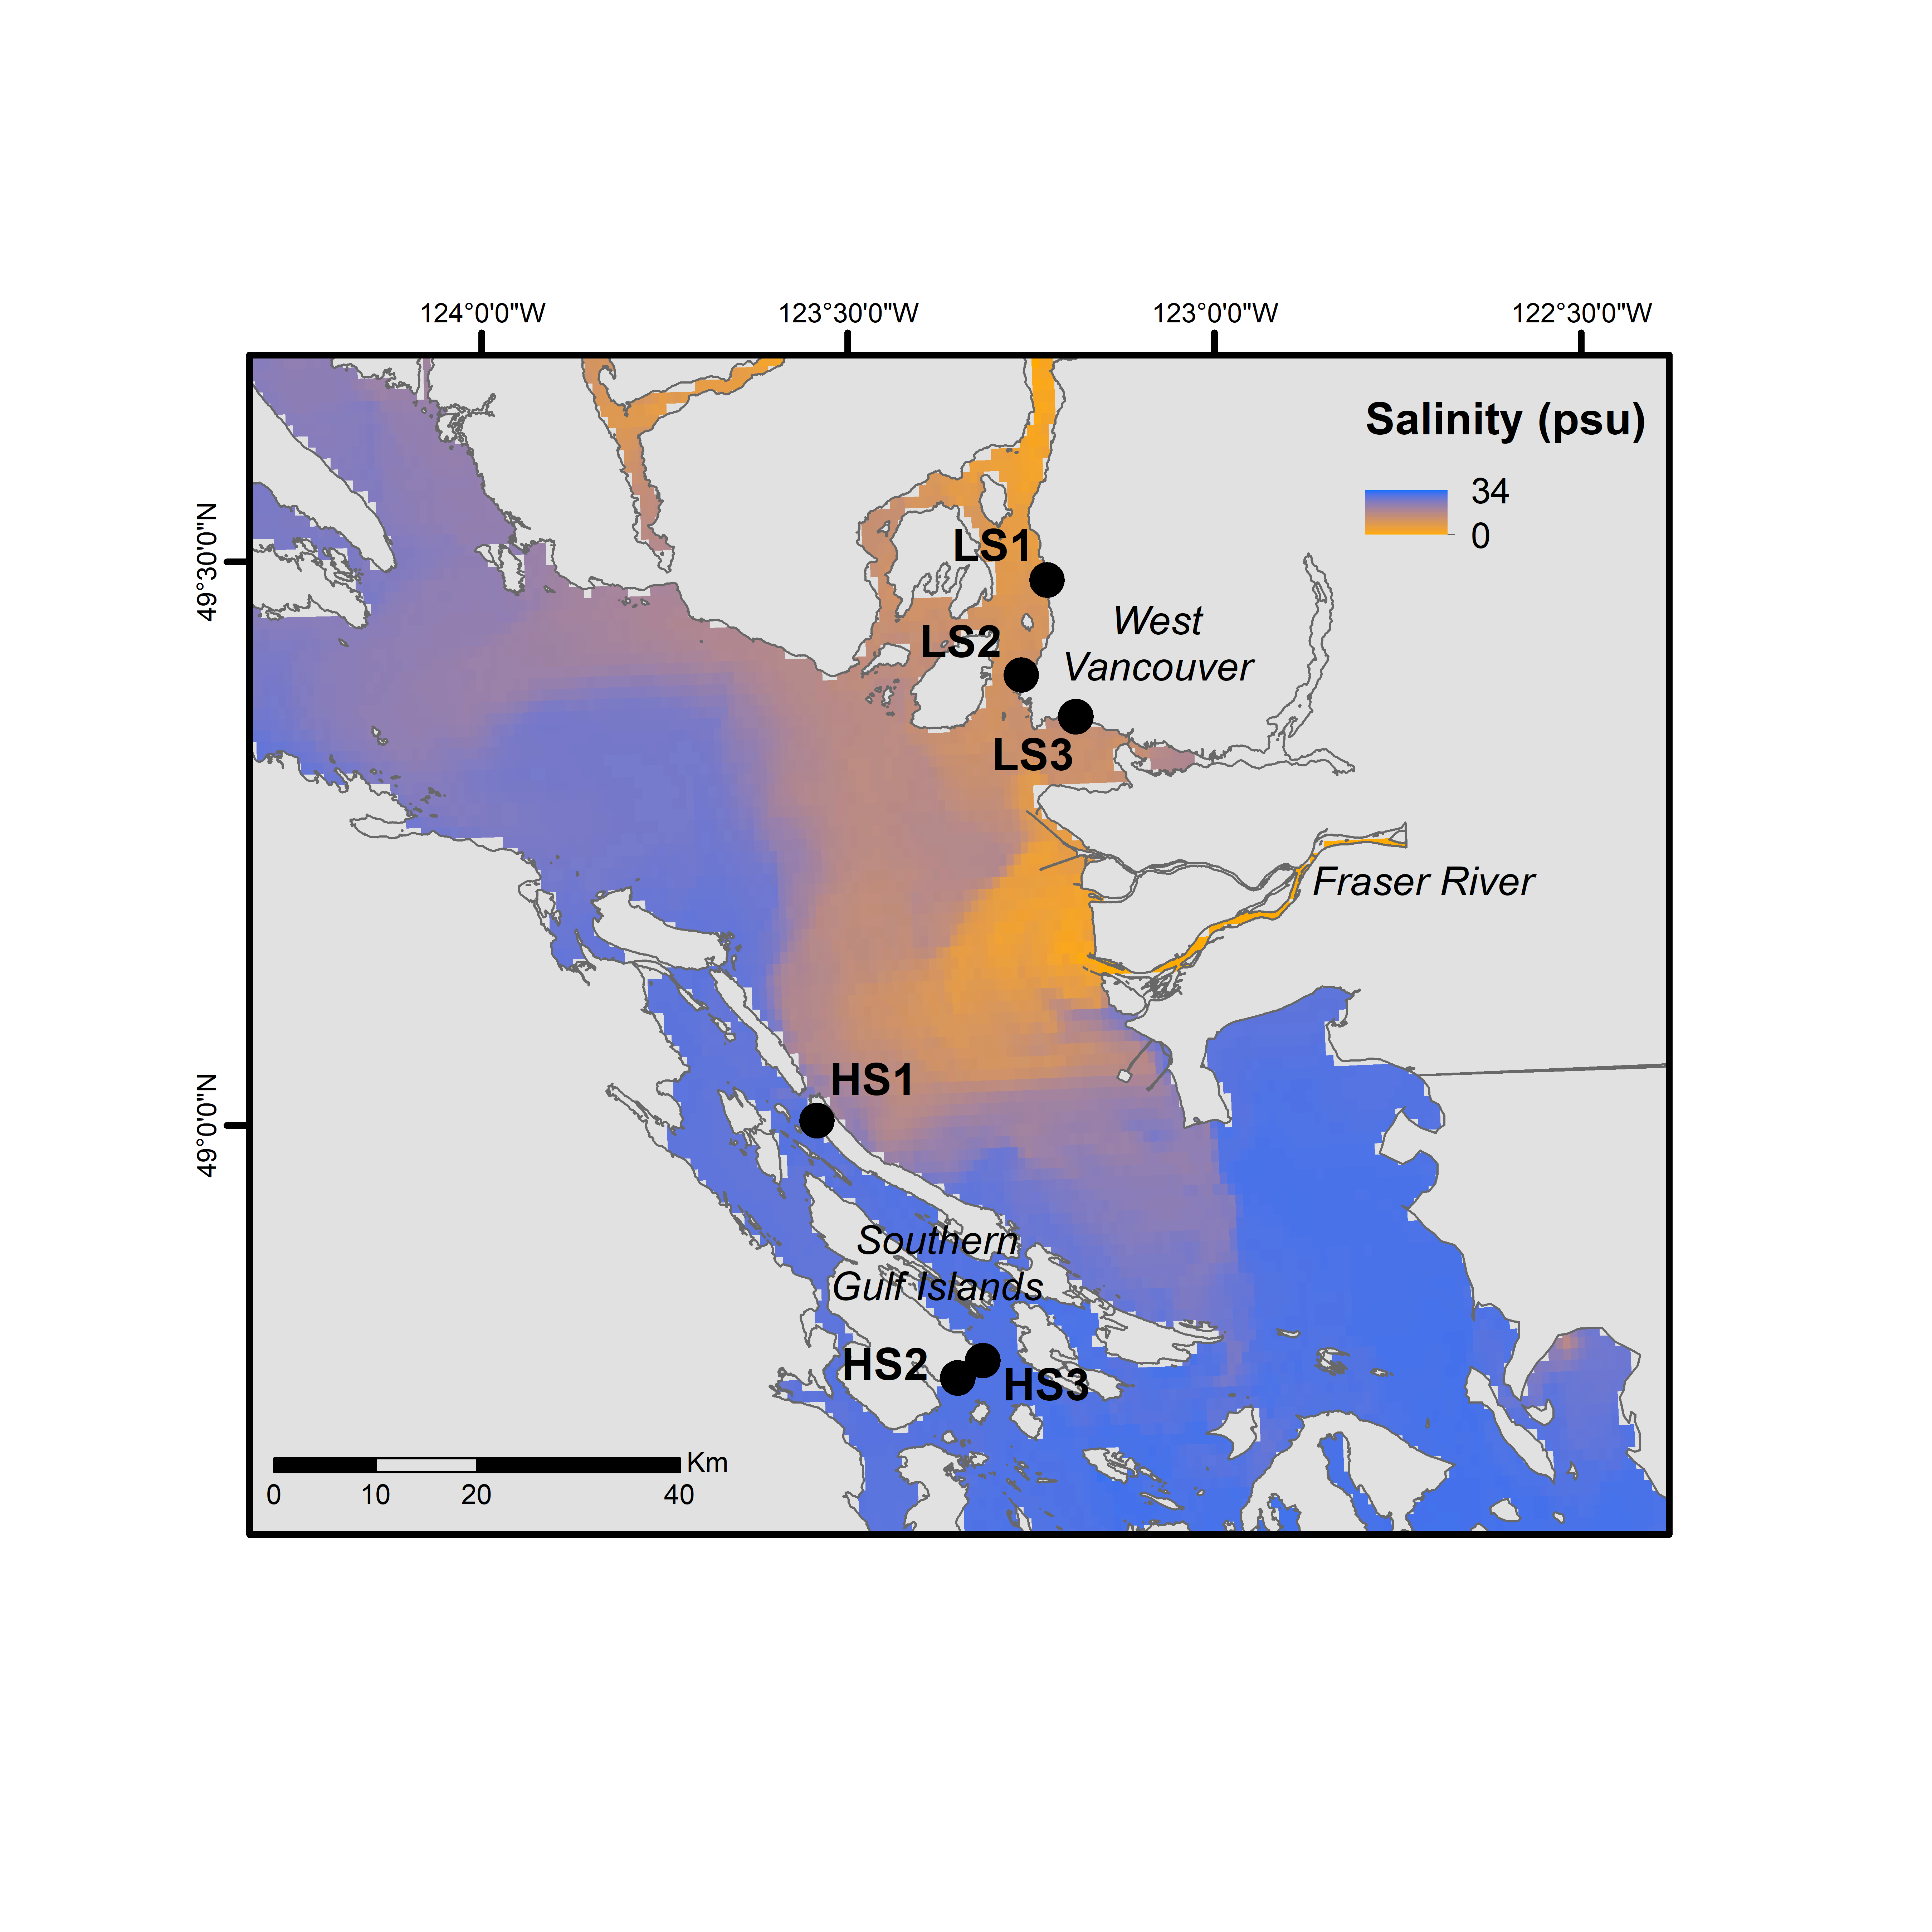 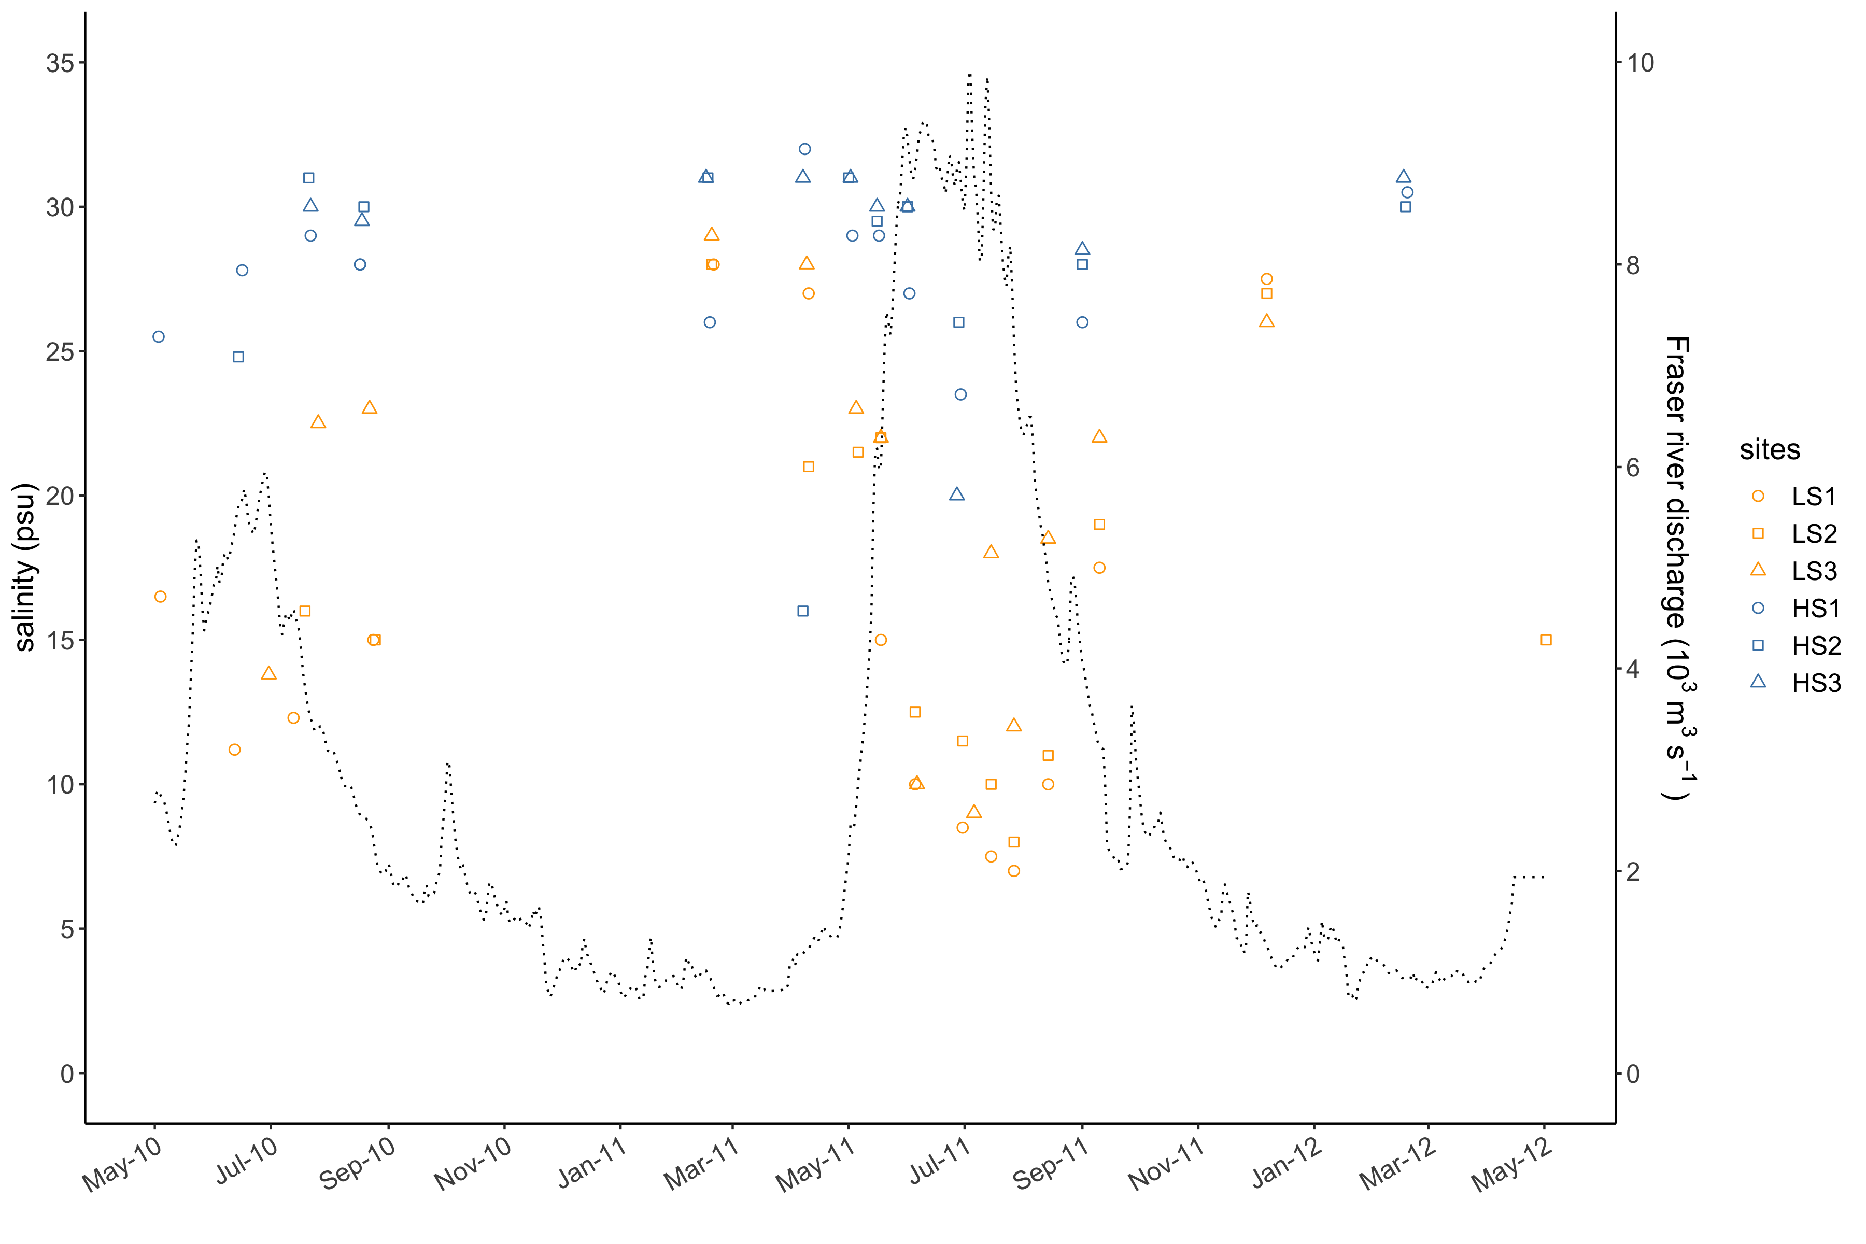

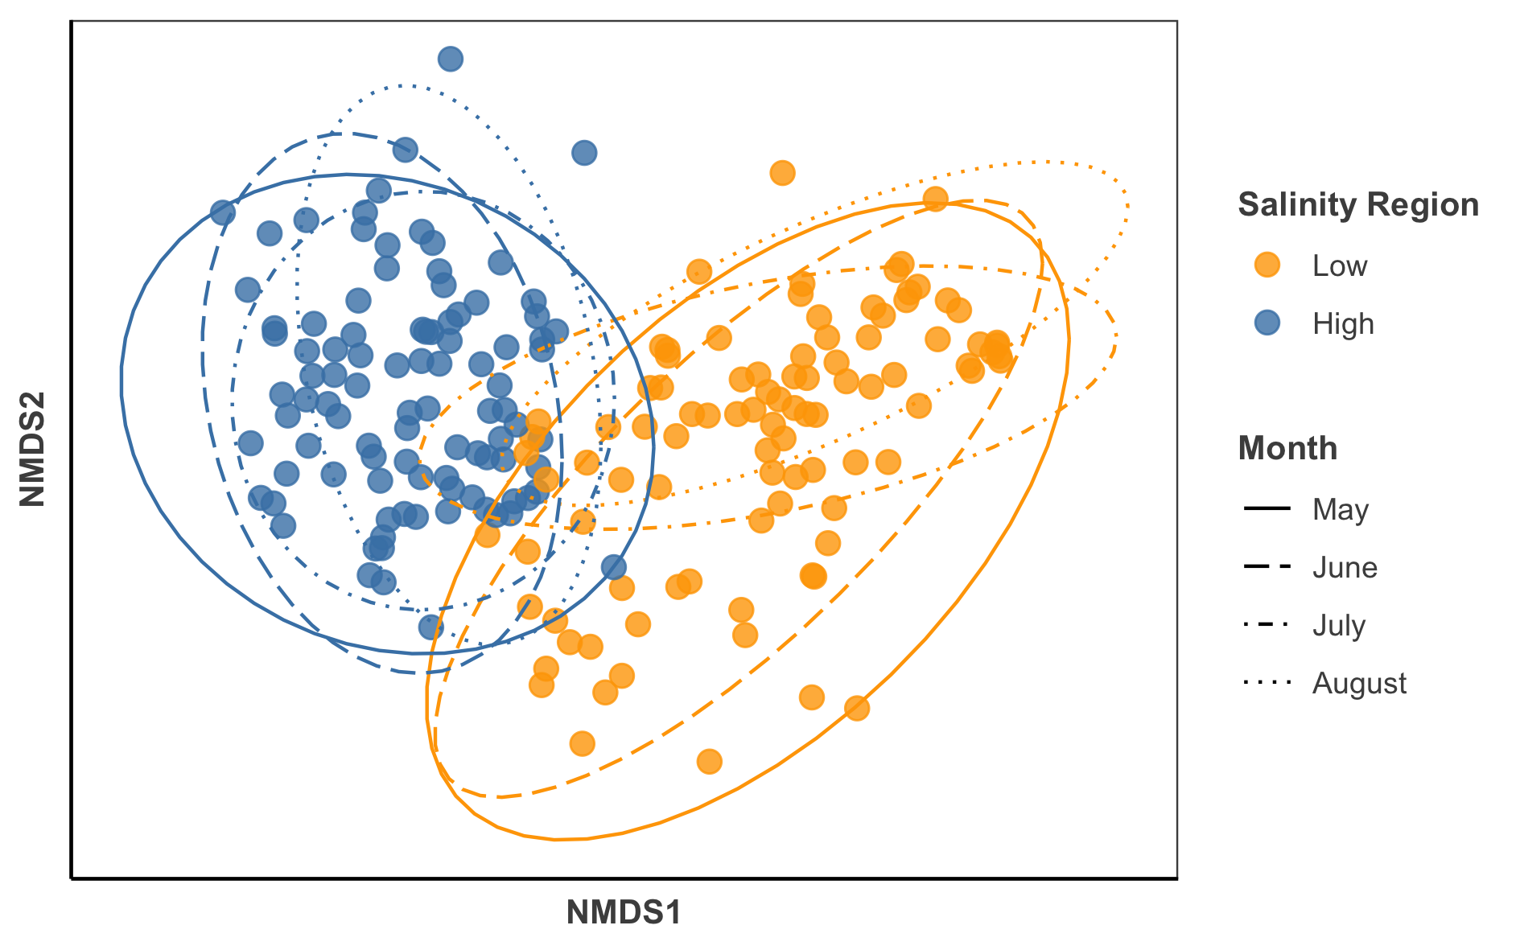

figure 3

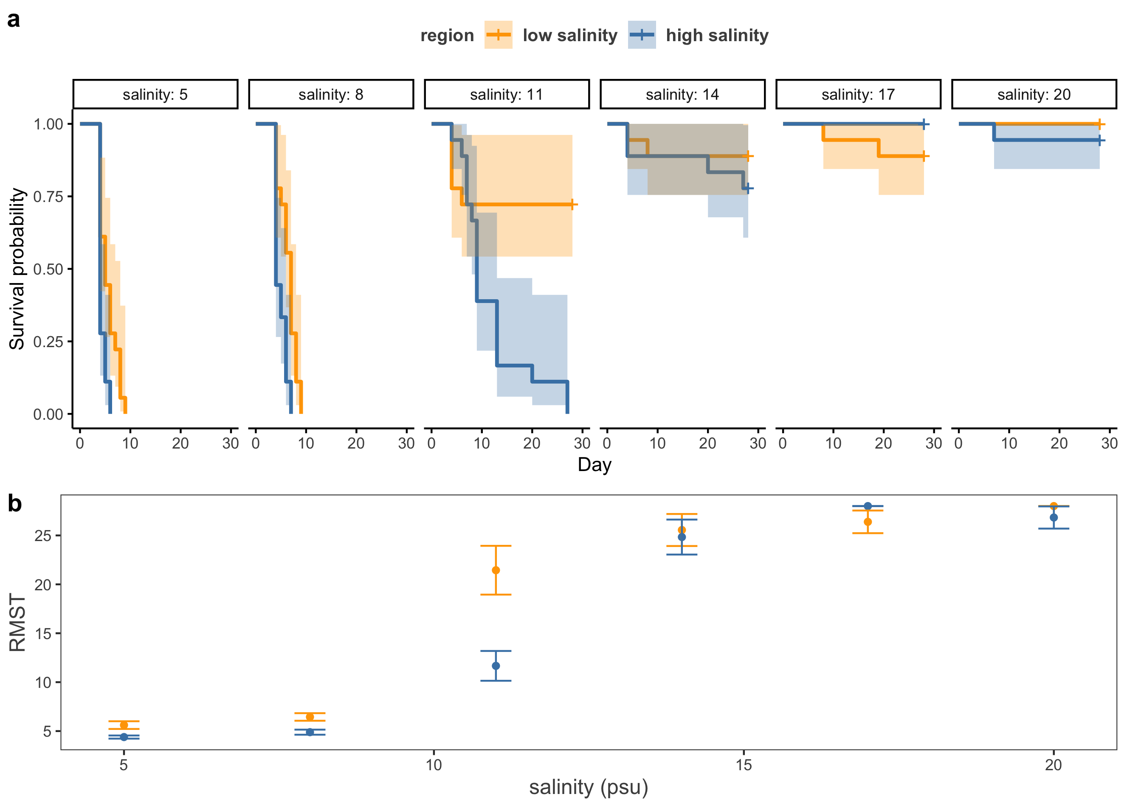

figure 4

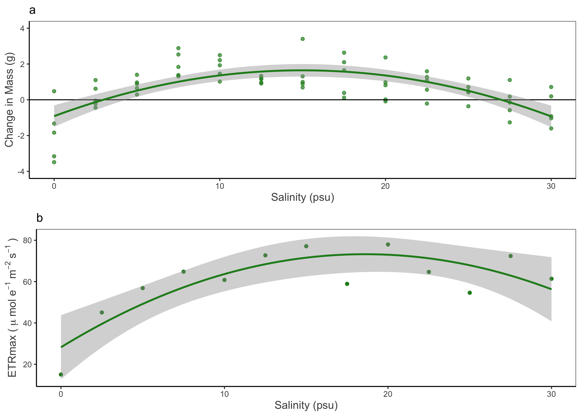

figure 5

