Biol 501 Graphics Homework

Sandra Emry

2016-09-30

## original graph

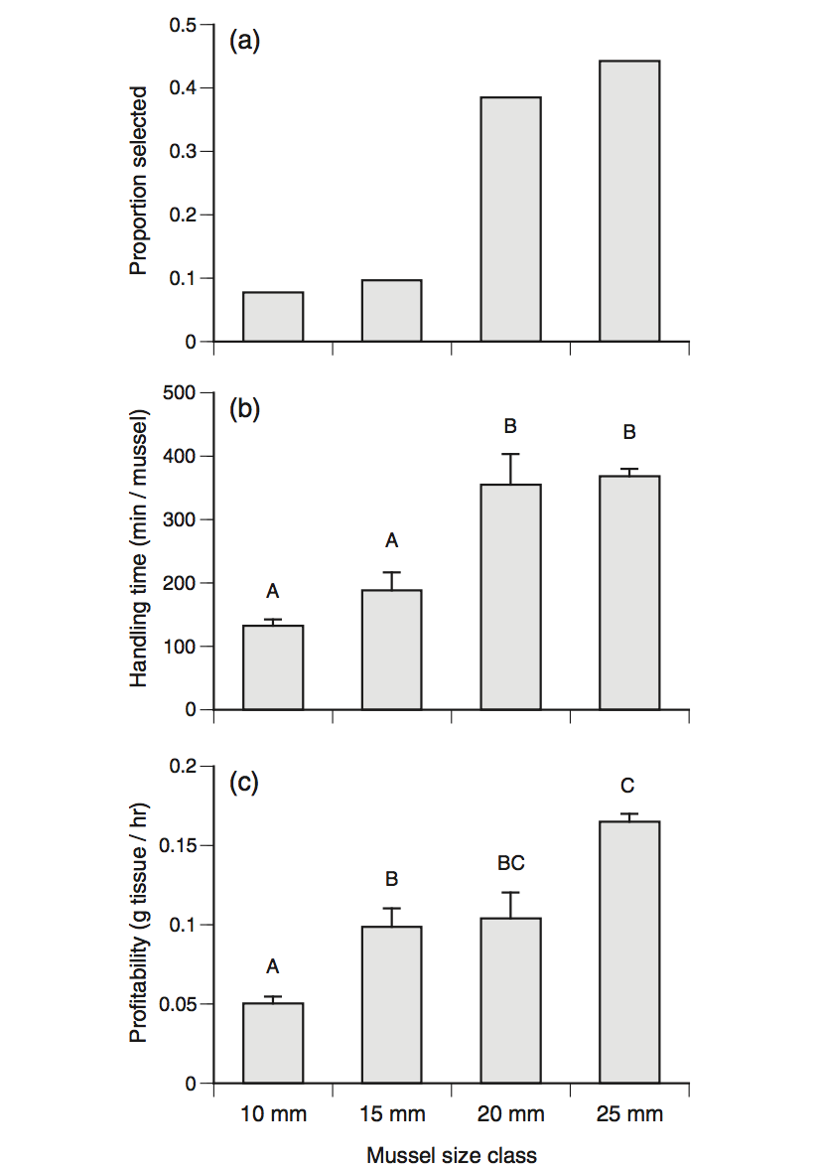

Gooding RA, Harley CDG (2015) Quantifying the Effects of Predator and Prey Body Size on Sea Star Feeding Behaviors. Biol. Bull. 228: 192–200

This study looked at how the size of Pisaster ochraceus, and its prey, Mytilus trossulus, affect predatory behaviour. This was done by feeding trials involving different sized prey and predator, and quantifying preference for size, handling time, and tissue consumption. Broadly, the study found that Pisaster is very responsive to changes in prey size, thus changes to the distribution of either species may have implications for the predator-prey dynamics of this pair.

The graph shows three feeding criteria of seastars for different sizes of mussels. The data shows that seastars profit more from eating larger mussels and select larger mussels more often. However, handling time is the longest for larger mussels.

## data manipulation

# read in data  
feeding <- read.csv(file = "./data/hw01_data_2.csv")  
  
# load packages  
suppressMessages(library(tidyverse))  
  
# examine data  
str(feeding)

## 'data.frame': 13 obs. of 8 variables:  
## $ Trial : Factor w/ 2 levels "08-11-20","08-11-21": 1 1 1 2 1 1 1 2 1 1 ...  
## $ Seastar : int 11 18 20 34 2 9 15 29 3 5 ...  
## $ Prey_size : int 10 10 10 10 15 15 15 15 20 20 ...  
## $ Wet_weight : num 11.9 17.6 11.8 14.4 17.6 ...  
## $ Handling_time_min : int 146 104 146 133 150 160 169 273 389 259 ...  
## $ Profitability_g_per_min: num 0.000745 0.001046 0.000745 0.000818 0.001946 ...  
## $ feeding_time_1_hr_d : num 10.79 7.68 10.79 9.83 5.27 ...  
## $ X : logi NA NA NA NA NA NA ...

# rename variables  
feeding <- feeding %>%   
 rename(prey_size = Prey_size,   
 prof = Profitability_g_per_min,  
 feed_time = feeding_time_1_hr_d,   
 hand_time = Handling_time_min,  
 seastar = Seastar)

## updated plots

# data for figure a) was not provided, so only figure b and c are recreated

Box plot of handling time vs mussel size class

# handling time vs mussel size   
ggplot(feeding, aes(x = as.factor(prey_size), y = hand_time)) +   
 geom_boxplot(outlier.colour = "green") +  
 geom_jitter(position = position_jitter(width = 0, height = 0), alpha = 1/2) +   
 ylab("handling time (min/mussel)") +  
 xlab("mussel size class") +  
 scale_x_discrete(labels = c("10" = "10 mm", "15" = "15 mm",  
 "20" = "20 mm", "25" = "25 mm")) +  
 theme_bw() +  
 expand_limits(y = c(0, 500))

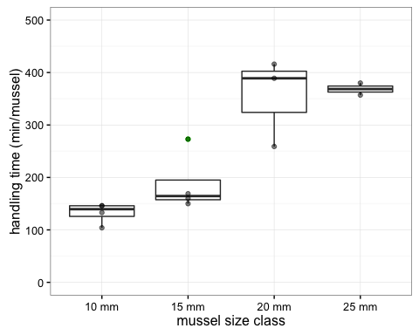

Box plot of profitability vs mussel size

ggplot(feeding, aes(x = as.factor(prey_size), y = prof)) +   
 geom_boxplot(outlier.colour = "green") +   
 geom_jitter(position = position_jitter(width = 0, height = 0), alpha = 1/2) +   
 ylab("profitability (g tissue/hr)") +   
 xlab("mussel size class") +   
 scale_x_discrete(labels = c("10" = "10 mm", "15" = "15 mm",  
 "20" = "20 mm", "25" = "25 mm")) +  
 theme_bw()

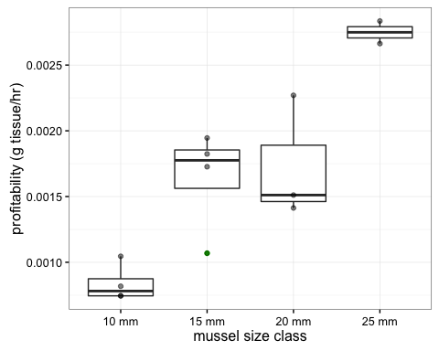

## explanation of new plots

The new graphs use boxplots instead of bar graphs. This makes it easier for readers to see the distribution of data by including each data point. It also makes the sample size clearer, which is not shown in the original graphs. Any outliers in the data are shown in green.