Reading the Signs: How Clinical Markers Relate to Heart Disease

Course
Data 601 Working with Data and Visualization
Group Members
Ahmed Muhammad — 30292476
Joy Umejiego — 30334187
Sandra Igboanugo — 30337403
Final Project Report
University of Calgary | Fall 2026

Table of Contents
Reading the Signs: How Clinical Markers Relate to Heart Disease 1
Table of Contents 2
1. Ask a question 3
Our question and ideal outcome 3
Data source and its quality 3
What kind of machine-learning problem is this? 3
2. Data understanding, exploration, and visualization 4
2.1 What the measurements mean 4
2.2 Missing data is not random 4
2.3 Key numbers: sick vs healthy patients 5
2.4 Charts 5
2.5 How strongly is each marker linked to heart disease? 6
3. Data wrangling and preprocessing 7
4. Build and test a model 8
Q4. How well does the model perform, and does it generalize to new data? 10
5. Interpret your model 11
Q5. Which markers are related to heart disease, in which direction, and how strongly? 11
6. Answer your question 12
Q6. What is the relationship between the markers and heart disease? 12

1. Ask a question

1.1 Our question and ideal outcome
What is the relationship between each patient marker (age, sex, chest-pain type, resting blood pressure, blood sugar, resting heart tracing, and exercise-test results) and whether a patient has heart disease or not?

Ideal outcome: For every marker, a clear plain-language answer to three things:
(1) Is it linked to heart disease at all?
(2) In which direction? (more or less of it goes with more disease)
(3) How strongly compared with the other markers?

1.2 Data source and its quality
The UCI Heart Disease dataset, downloaded from Kaggle (redwankarimsony/heart-disease-data). It has 920 patients from four hospitals: Cleveland and VA Long Beach (USA), Hungary and Switzerland. Each row is one patient. For each patient we have about a dozen measurements and a label, num, that says whether heart disease was found (0 = none, 1 to 4 = increasing severity).

Quality issue we focus on: sample selection (and consistency between hospitals).

- Every patient was referred for heart testing, so they are not a picture of the general population. Our results only apply to "patients like these".
- About three quarters are men.
- The hospitals recorded different things. Some tests were almost never recorded outside Cleveland, and cholesterol was never recorded in Switzerland (the dataset uses 0 as a placeholder). The share of sick patients also differs a lot by hospital (98% in Switzerland vs 36% in Hungary). If we are careless, a model could learn which hospital a patient came from instead of anything about their heart. We guard against this in Section 3.

1.3 What kind of machine-learning problem is this?
- Supervised learning: because every patient comes with a known answer (disease or not) and we want to see how the markers relate to it.

- Classification: because the answer is a category (yes / no), not a number.

- Model: Decision Tree. A decision tree is a flowchart of yes/no questions ("Is the patient's chest pain asymptomatic?", "Is ST depression above 0.7?") that sorts patients into groups. We chose it because it is a set of yes/no questions that keeps splitting patients into smaller groups, and each final group (a leaf) predicts whichever class most of its patients belong to. We chose it because we can draw the whole model and follow how it reaches a decision, which matters when the predictions are about heart disease. Its weakness is that it can memorize the training patients, so we limit how deep it can go. We use its predictions on unseen patients as a reality check on the relationships it finds.

2. Data understanding, exploration, and visualization

2.1 What the measurements mean
Column | Meaning
age, sex | Age in years; sex (male/female)
cp | Chest-pain type; typical angina, atypical angina, non-anginal, or asymptomatic (no typical chest-pain symptoms)
trestbps | Blood pressure at rest (mm Hg)
fbs | Is fasting blood sugar above 120 mg/dl? (True/False)
restecg | Result of a resting heart tracing (normal, ST-T abnormality, LV hypertrophy)
thalch | The highest heart rate reaches during the exercise test (beats per minute)
exang | Did exercise trigger chest pain? (True/False)
oldpeak | How much the heart tracing dips during exercise (“ST depression”). Higher means more strain on the heart
num | The answer we want predict: 0 = no heart disease, 1 to 4 = disease of increasing severity
ca, thal, slope, chol | Vessel count, a thallium stress-test result, ST slope, cholesterol. We drop these in Section 3 because they are mostly missing

We first load the data and make two small fixes:
(1) Cholesterol and blood pressure of exactly 0 are impossible, so we mark them as missing. (2) We rename the dataset column to origin (which hospital) so its meaning is clear.

We also create a simple yes/no label, diseased (0 = no disease, 1 = any disease), which is what we will predict. Section 2.3 explains why.

2.2 Missing data is not random
Four columns are mostly empty: ca (66% missing), thal (53%), slope (34%) and chol (22%). The table below shows why this matters: the gaps are tied to the hospital, not to chance.
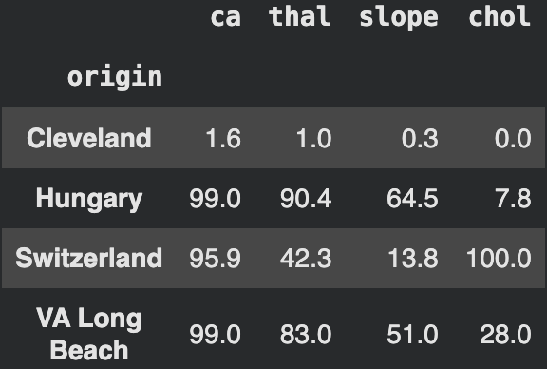
Cleveland recorded almost everything, but ca is missing for 96 to 99% of patients at the other three hospitals, and cholesterol was never recorded in Switzerland. Why a reader should care: a missing value here mostly says "this hospital didn't run that test". We handle this carefully in Section 3 so the model learns about hearts, not about hospital record-keeping.

2.3 Key numbers: sick vs healthy patients
For the charts and statistics below we use the 766 patients (83% of 920) who have a recorded value for every measurement we plan to use.
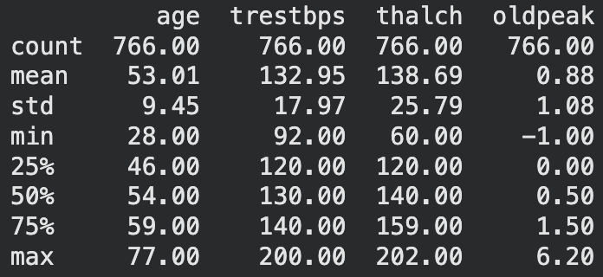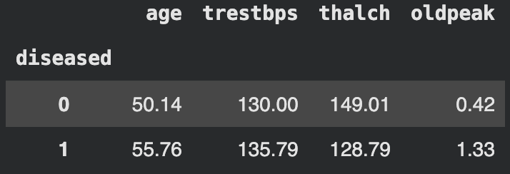
The average patient is about 53 years old. Compared with healthy patients, sick patients are about 6 years older (55.8 vs 50.1), reach a max heart rate about 20 beats per minute lower (128.8 vs 149.0), and show about three times the ST depression (1.33 vs 0.42). Resting blood pressure is only slightly higher (135.8 vs 130.0), so on its own it will not help much.

2.4 Charts
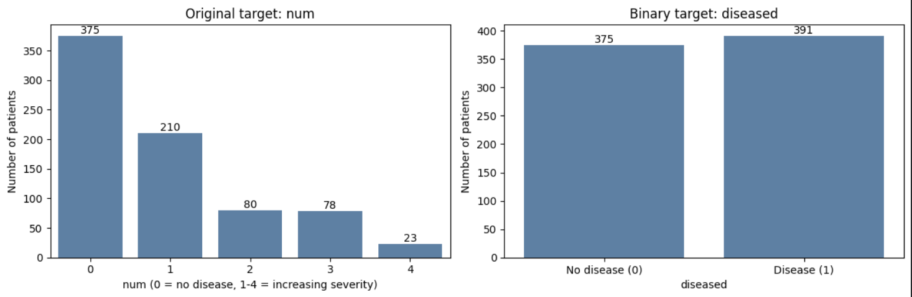
Why do we predict yes/no instead of severity? The left chart shows the five severity levels are very uneven: 375 patients have no disease, but only 80, 78 and 23 patients are at levels 2, 3 and 4. A model has too few examples of the severe levels to learn from. Grouping everything into "disease or not" (right chart) gives two groups of nearly equal size (391 vs 375), which is also the question we care about. We test this choice in Section 4.

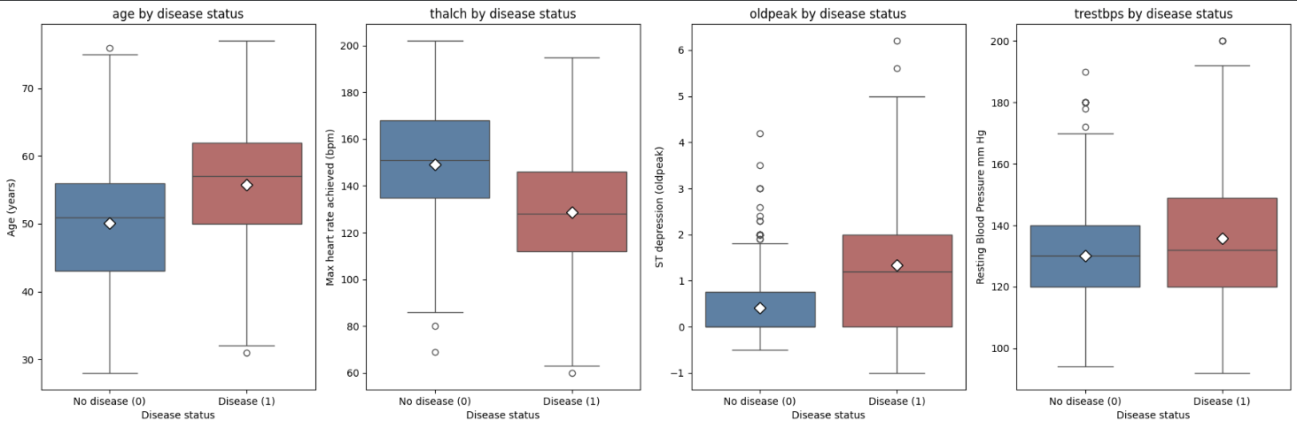
How to read a boxplot: the box holds the middle half of patients, the line inside is the median, and the diamond is the average. If the two boxes sit at different heights, the measurement differs between healthy and sick patients.

- Max heart rate and ST depression show the clearest gap: sick patients' boxes sit lower (heart rate, median 128 vs 151 bpm) and higher (ST depression, median 1.2 vs 0).
- Age is shifted up by about 6 years for sick patients, but some of this may reflect who gets referred for testing.
- Blood pressure: the boxes almost sit on top of each other (median 130 vs 132), so it is a weak signal.

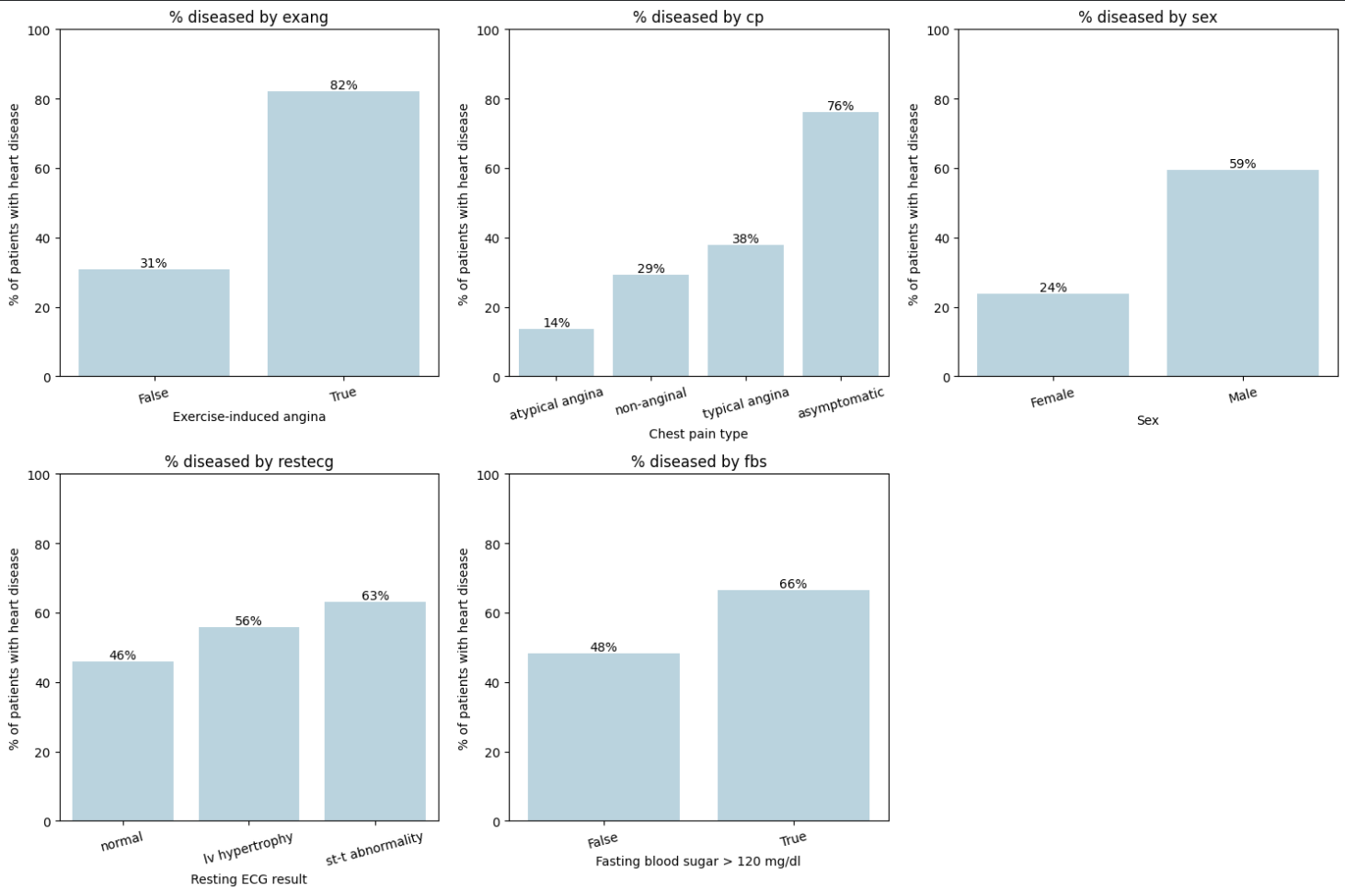
Each bar is the percentage of patients in that group who have heart disease.

- Exercise-triggered chest pain (exang): 82% of patients who get chest pain during exercise are sick, vs 31% of those who don't.
- Chest-pain type (cp) is a surprise: patients with asymptomatic chest pain are the most likely to be sick (76%). This is probably because these patients were referred for testing despite having no typical symptoms, which suggests other warning signs.
- Sex: 59% of men are sick vs 24% of women (and the sample is about three-quarters male).
- Resting heart tracing and blood sugar: smaller differences (and only 113 patients had high blood sugar).

Takeaway: no single measurement cleanly separates the two groups (there is a lot of overlap), but several each carry a bit of information. This is why we try a model that combines them.

2.5 How strongly is each marker linked to heart disease?
A correlation is a number between -1 and +1. Positive means "more of this goes with more disease", negative means "more of this goes with less disease", and the closer to 1 or -1, the stronger the link. Zero means no link. (We use a version called Spearman that is safe for yes/no columns and skewed numbers.)
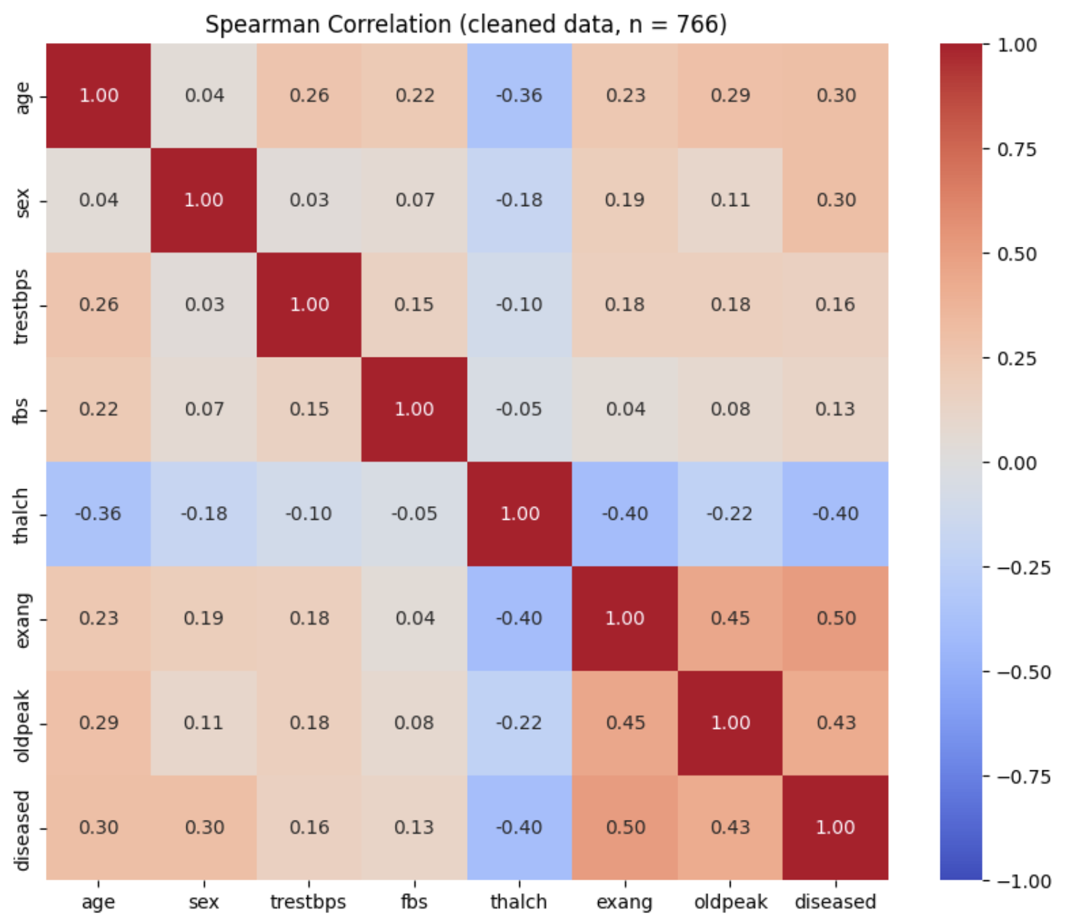

Marker | Link with Disease | Meaning
Exercise-triggered chest pain | +0.50 (moderate) | Strongest. Patients who get chest pain when exercising are more likely to have disease
ST depression (oldpeak) | +0.43 (moderate) | More dip in the tracing goes with more disease
Max heart rate (thalch) | -0.40 (moderate) | Sick patients can't push their heart rate as high
Age, male sex | +0.30 (weak) | Older patients and men are somewhat more likely to be sick
Resting blood pressure, high blood sugar | +0.16, +0.13 (very weak) | Barely linked
Chest-pain type is not in the heatmap (it has four categories), but the bar chart above shows a strong link. Note that exercise pain, ST depression and max heart rate are also linked **to each other** (about 0.2 to 0.45) because they come from the same exercise test, so they partly overlap.

3. Data wrangling and preprocessing
Every step below is needed to reproduce our results. Steps 1 and 2 were already applied in Section 2.
 | Step | Reason
1 | Mark 0 cholesterol / 0 blood pressure as missing | These are impossible values, they stand for “not measured”
2 | create yes/no label diseased | Too few patients at higher severity levels
3 | Drop the columns ca, thal, slope, chol, then drop the few rows that still have gaps | Too much is missing, and not at random
4 | Convert yes/no and make/female columns to 1/0 | The model only understands numbers
5 | One-hot encode cp and restecg | Give each category its own 0/1 column, so the model doesn’t think “asymptomatic” is bigger than “typical angina”
6 | Leave out id, num and origin from the predictors | id is just a number; num would give away the answer; origin would let the model learn the hospital instead of the heart
7 | Split patients 80% training / 20% testing | We need patients the model has never seen to test it honestly

Why do we drop columns instead of filling gaps? We could fill missing values with an average, but over 200 patients would then share the exact same made-up cholesterol, and most of them were sick. A tree would learn "this value means sick", which only reflects which hospital skipped the test. We could instead drop every patient with a gap, but keeping ca this way left only 302 of 920 patients, almost all from Cleveland. Dropping four mostly-empty columns instead keeps 766 patients (83%) from all four hospitals. The cost is losing ca, a strong marker.
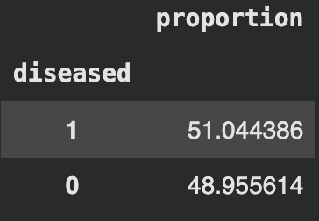
We keep 766 patients with no gaps, and the mix is balanced (51% sick, 49% healthy).

Every column is now a number. (Steps 4 and 5 are in the cell above.) Now we choose the predictors, set aside the testing patients and split.

Scaling: we did not rescale the numbers. A decision tree only asks "is this value above a cutoff?", so rescaling would not change its questions, and leaving the numbers in real units (beats per minute, mm Hg, years) keeps the flowchart readable.

4. Build and test a model
Summary: the tree is our tool for finding which markers matter and in which direction. We first make sure it learns real patterns rather than memorizing: we let the tree grow without limits and found it memorized the training patients. We then limited how many levels of questions it may ask, picked the depth that did best on unseen patients, and tested it.

Step 1: an unlimited tree.
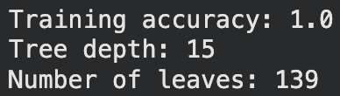
It scores a perfect 100% on the training patients, but it did that by asking 15 levels of questions and ending with 139 tiny groups, many holding only one or two patients. That is memorizing, not learning, and it usually fails on new patients.

Step 2: find the right depth. We tried trees that allowed 1 to 10 levels of questions (max_depth) and compared accuracy on training patients vs unseen patients.

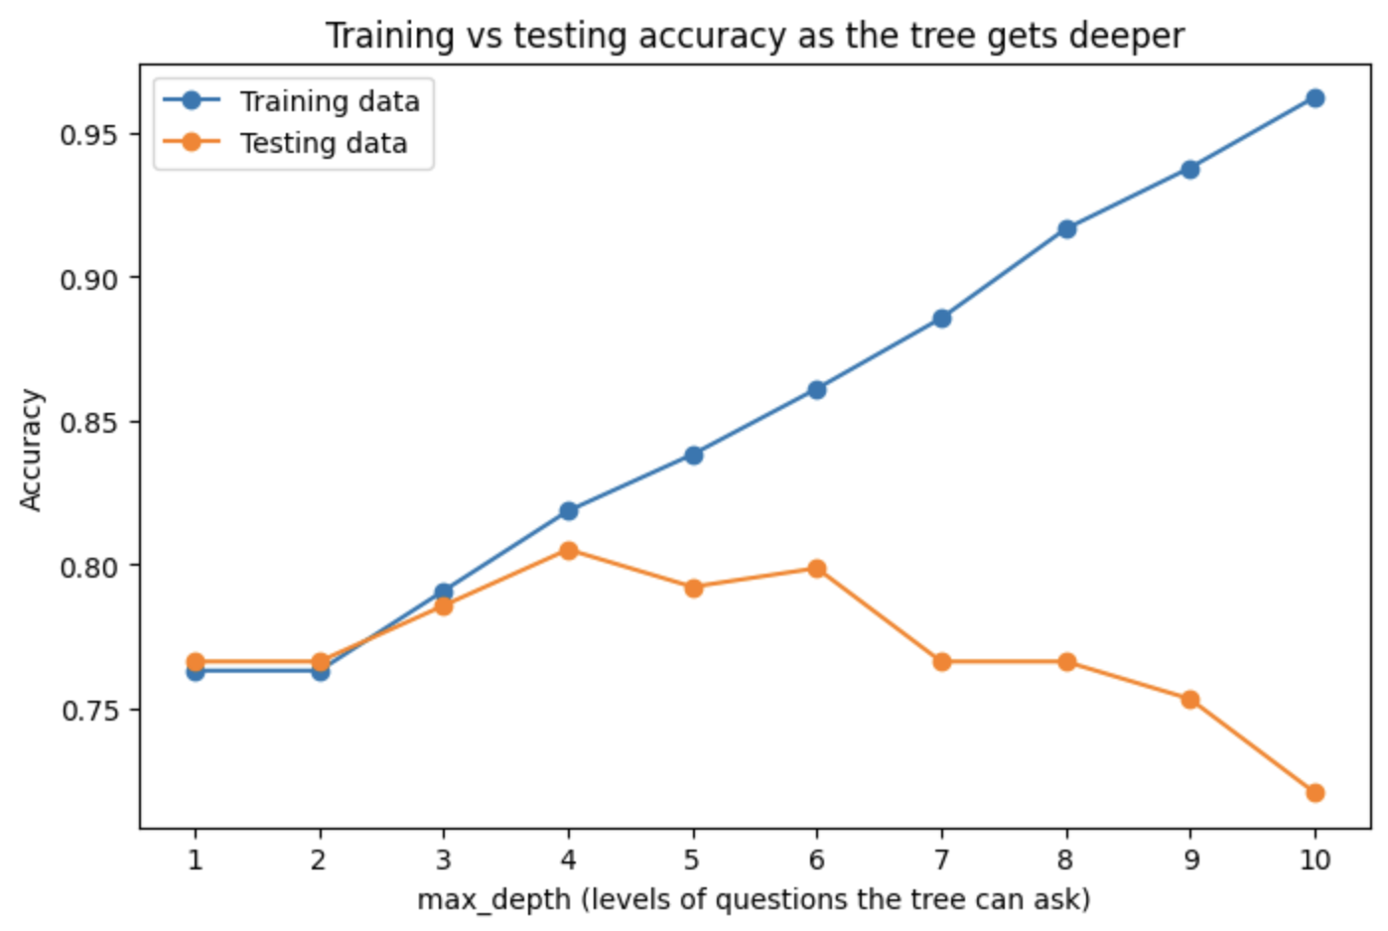
Training accuracy keeps rising as the tree gets deeper (76% to 96%), but accuracy on unseen patients peaks at depth 4 (80.5%) and then falls to 72%. The extra questions only fit quirks of the training patients. We chose depth 4: it has the best test score and its training and test scores are close (81.9% vs 80.5%), so it is not memorizing.

Step 3: the final tree. Each box shows the question, how many training patients reach it, and how many are healthy vs sick. Orange leans "no disease", blue leans "disease". "True" goes left.

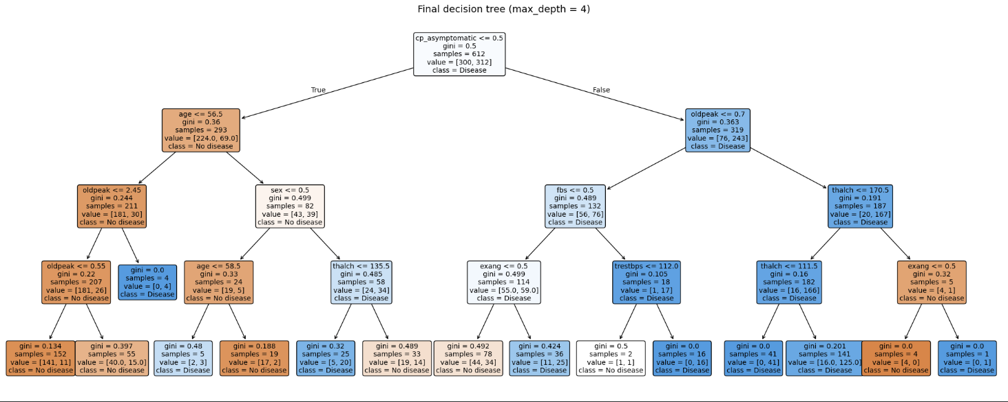
Reading the flowchart The first question is "Is chest pain asymptomatic?"

- No (left side, 293 patients): only 24% are sick. The tree then asks about age: patients 56 or younger are mostly healthy (30 of 211 sick). Among older patients, men with a low max heart rate are mostly sick (20 of 25), while older women are mostly healthy.
- Yes (right side, 319 patients): 76% are sick. If ST depression is above 0.7, 89% are sick (167 of 187). If it is lower, the result is close to a coin flip (76 of 132), so the tree also checks blood sugar and exercise-triggered chest pain.
A few of the smallest groups contain only 1 to 5 patients, so we would not trust those branches much on their own.

Check on our yes/no choice We also trained the same tree to predict all five severity levels:
It gets 57% right, which is only about 8 points better than guessing "no disease" for everyone (49%). With yes/no it gets 80.5% against a 51% baseline. So predicting yes/no was the right call.

Q4. How well does the model perform, and does it generalize to new data?
Relationships found in one group of patients are only useful if they also hold in new patients. So we test on the 154 patients the model has never seen. Three measures, in plain words:

Accuracy: out of all patients, how many did it get right?
Precision: when it says "sick", how often is it right?
Recall: out of the patients who really are sick, how many did it catch? This matters most here, because a missed sick patient could be sent home untreated.

We compare with a baseline that always guesses the most common answer ("disease"), to check if the model adds something real.

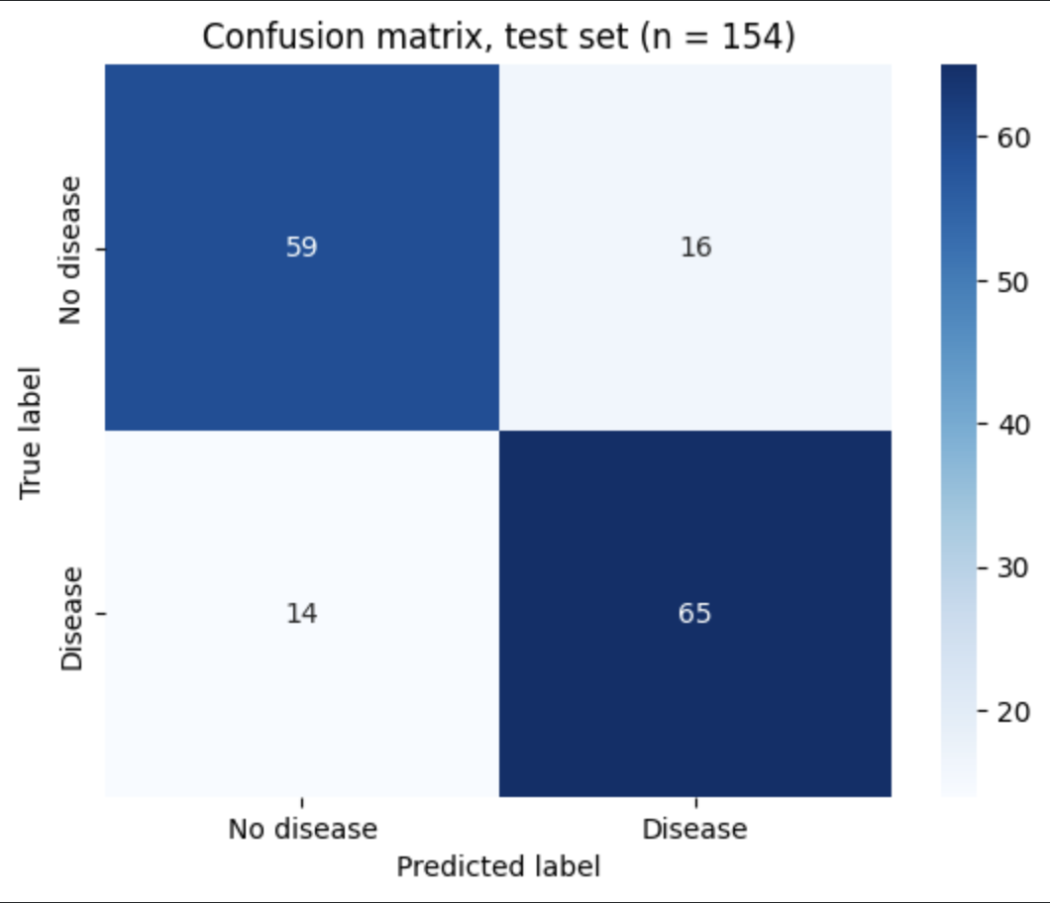
Results
- The tree is right for 81% (Accuracy) of unseen patients, vs 51% for the baseline, so it has learned something real.
- Recall 0.82: it catches 65 of the 79 sick patients and misses 14 (about 1 in 6).
- Precision 0.80: of the 81 patients it flags as sick, 65 are truly sick and 16 are healthy patients who would get extra tests they didn't need. In medical testing, an unneeded extra test is the more acceptable mistake.

Does it generalize? Compare the unlimited tree with our final tree:
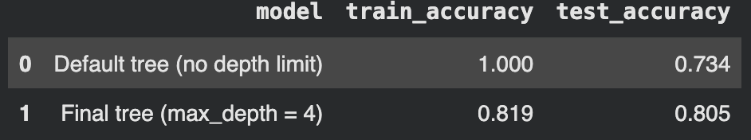

The unlimited tree falls from 100% to 73% on new patients (a 27-point drop), the classic sign of memorizing. Our final tree scores 82% on training and 80.5% on testing, a gap of under 2 points, so it works about as well on new patients as on the ones it learned from. In Project 2 we also checked accuracy hospital by hospital: Cleveland 83%, VA Long Beach 81%, Hungary 76% (Switzerland 89%, but with only 9 test patients), so it is not just a Cleveland model.

5. Interpret the model

Q5. Which markers are related to heart disease, in which direction, and how strongly?
Section 2.5 looked at each marker on its own. The tree adds a second view: how much it relies on each marker when all of them are used together. We measure that with permutation importance: shuffle one marker at random across the test patients (breaking its link to the outcome) and see how much accuracy drops. A big drop means the model really depends on that marker.
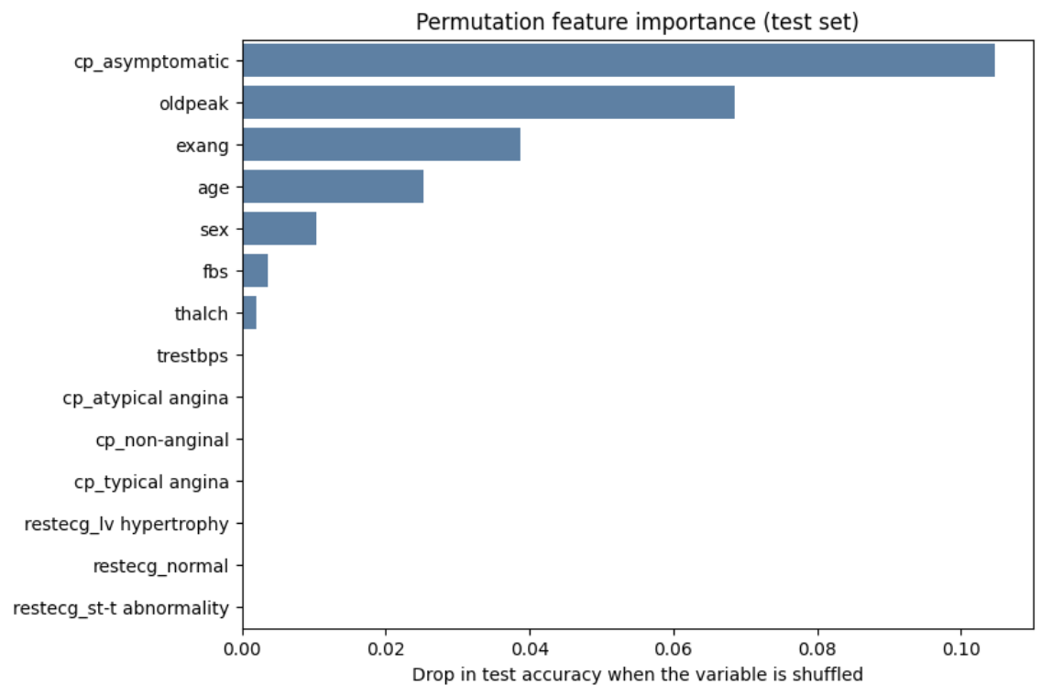
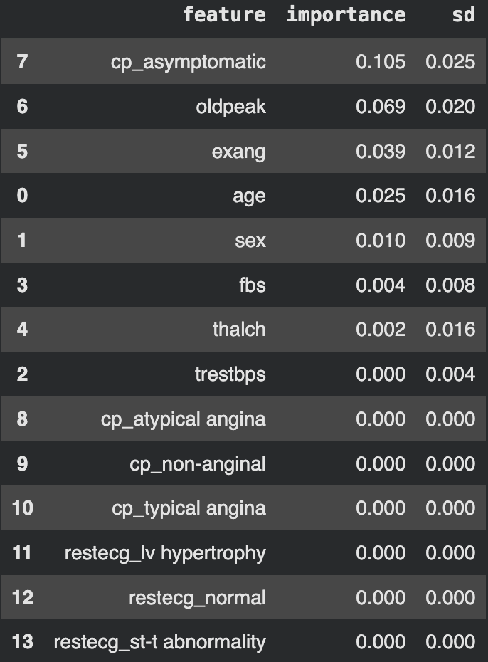

What this means:

- The strongest relationships are with chest-pain type, ST depression, exercise-triggered pain and max heart rate. Age and sex matter, but less.
- A marker can be linked to disease and still rank low in the model. Max heart rate has a clear link on its own (-0.40) but little model reliance, because it comes from the same exercise test as ST depression and exercise pain. Once the tree has used those, heart rate adds little extra. So a low rank means "adds little beyond the others", not "unrelated".
- The "sd" column in the output shows the importance numbers can wobble by up to 2.5 points, so the order of the lower-ranked items should not be over-read.
- These are associations, not causes. They describe what goes together with disease in this group of referred patients. They do not show that any marker causes heart disease.

6. Answer the question

Q6. What is the relationship between the markers and heart disease?
Answer: several markers are clearly related to heart disease, a few are barely related, and the relationships held up on new patients.

Did these relationships generalize? Yes. A tree built from these markers classified 81% of 154 unseen patients correctly (guessing: 51%), and its training and test scores were within 2 points (82% vs 80.5%). That shows the patterns are real and not just memorized quirks of the training patients. We judge our goal achieved: we identify which markers matter, in which direction and how strongly.

What we learned for the team

- Chest-pain type and the exercise-test markers do most of the work. One surprise: no typical chest pain goes with more disease. This is probably because these patients were referred for testing because of other warning signs.
- A marker's link on its own is not the same as its added value. Max heart rate is strongly linked but adds little once ST depression and exercise pain are known.
- Missing data shaped the answer. We had to drop ca (vessel count), our strongest marker, because it was recorded almost only in Cleveland. Its relationship to disease could not be tested here.
- Simpler was better. A deeper tree memorized the training patients and did worse on new ones.

Limits to keep in mind

- Association, not cause. We cannot say any marker causes heart disease.
- All patients were already referred for heart testing, mostly men (181 women), from four hospitals. The relationships may differ in the general population, in women, or at other hospitals.
- We chose the tree depth using the test patients, and the test set is small (154), so the 80.5% could be a few points lower or higher.
- The tree still misses about 1 in 6 sick patients (14 of 79), so it is not a diagnostic tool, only evidence the relationships are real.

Next steps

- Choose the depth without peeking at the test set (cross-validation) for a more trustworthy check.
- Try other models (e.g. logistic regression, which gives a number for each marker's effect) to confirm the same markers and directions appear.
- Test on a hospital the model has never seen (train on three, test on the fourth) to see whether the relationships hold across hospitals.
- Study women and the dropped markers (ca, thal, cholesterol) with better, consistent data.
- Ask clinicians whether the surprising chest-pain finding matches how patients are referred.

