**E- Commerce using AWS Project Report**

**Business Problem**

In the rapidly growing e-commerce industry, businesses collect massive amounts of data from multiple sources — including website traffic, customer transactions, product performance, and regional sales. However, this data often remains underutilized due to its scattered nature and lack of a unified analytical system.

Without efficient data integration and visualization, it becomes difficult for stakeholders to:

* Identify top-performing products and regions.
* Understand customer purchase behavior.
* Monitor sales performance in real-time.
* Optimize inventory and marketing strategies.
* Make data-driven business decisions.

**Exploratory Data Analysis Insights**

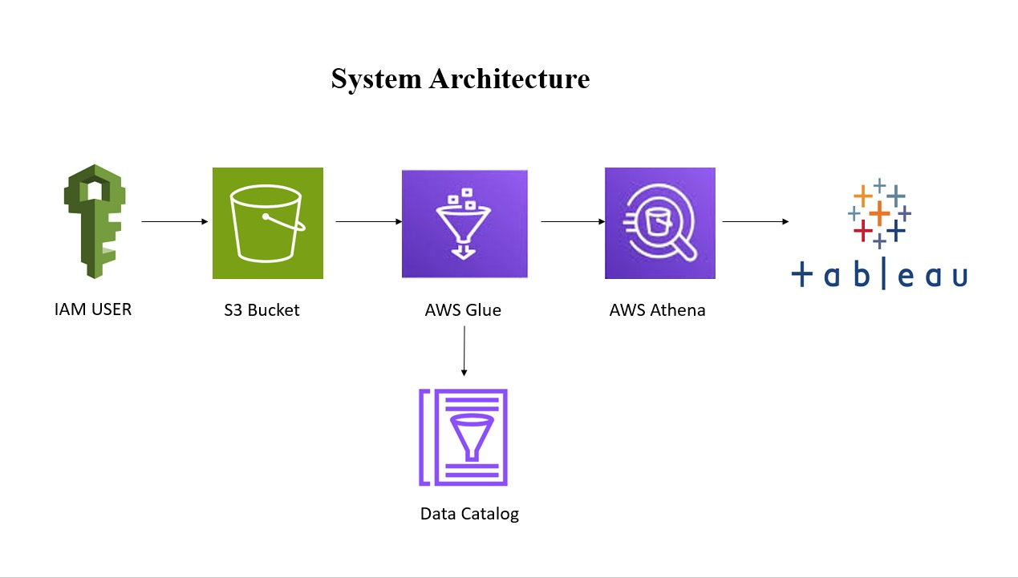

**Summary Statistics**

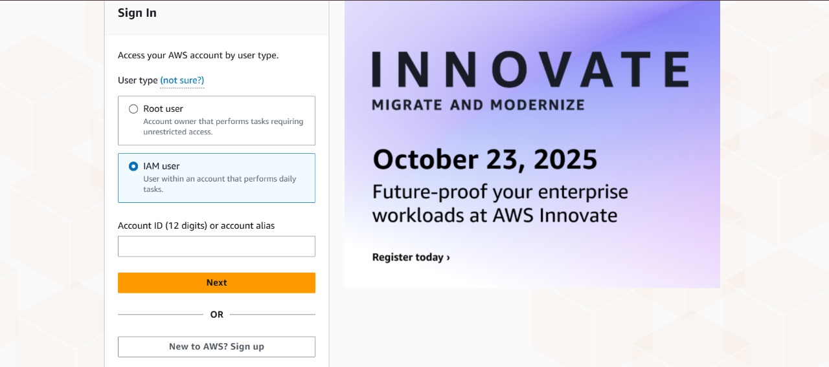

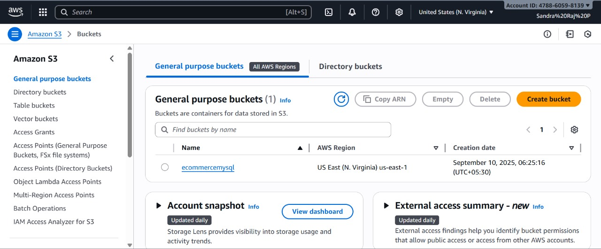

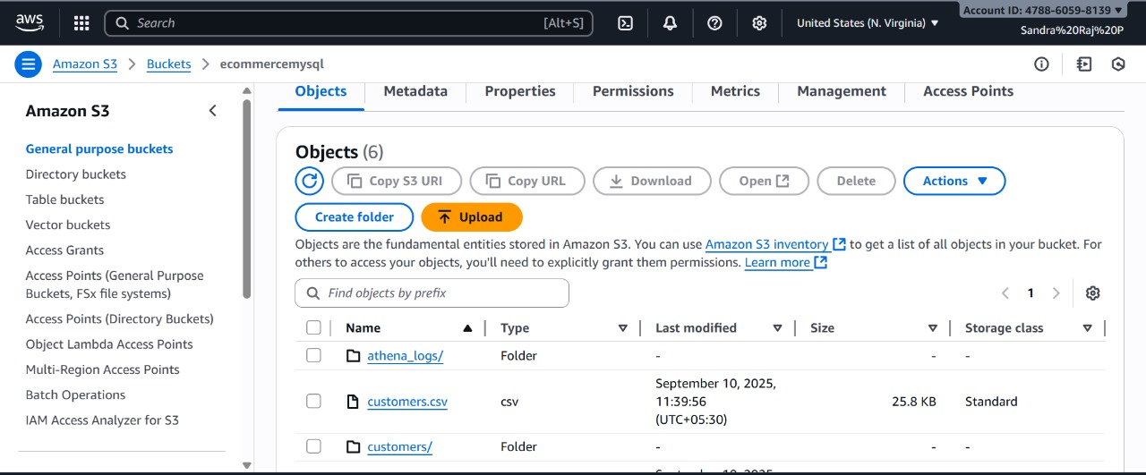

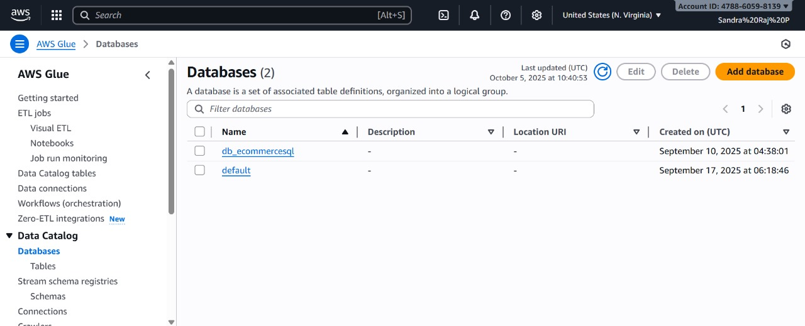

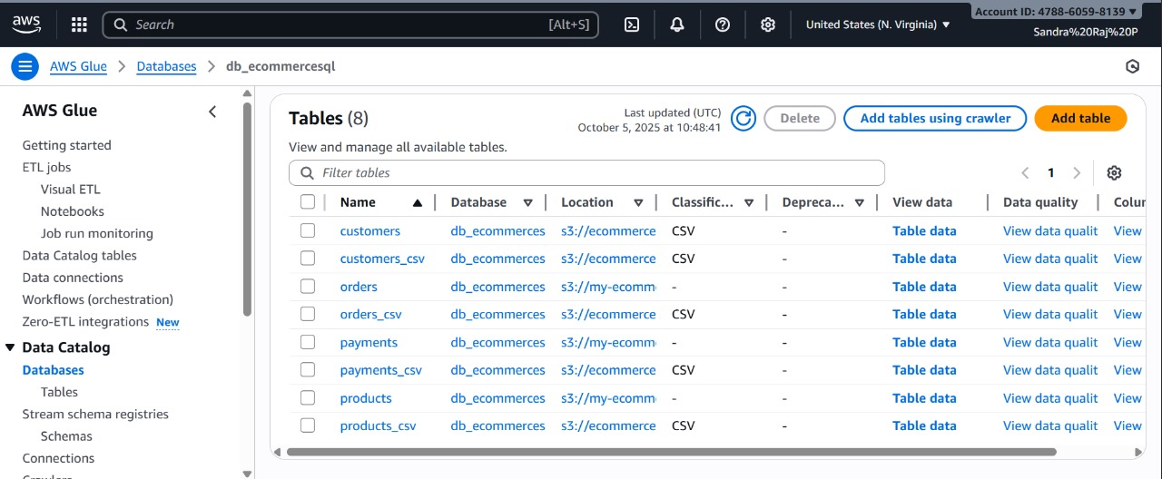

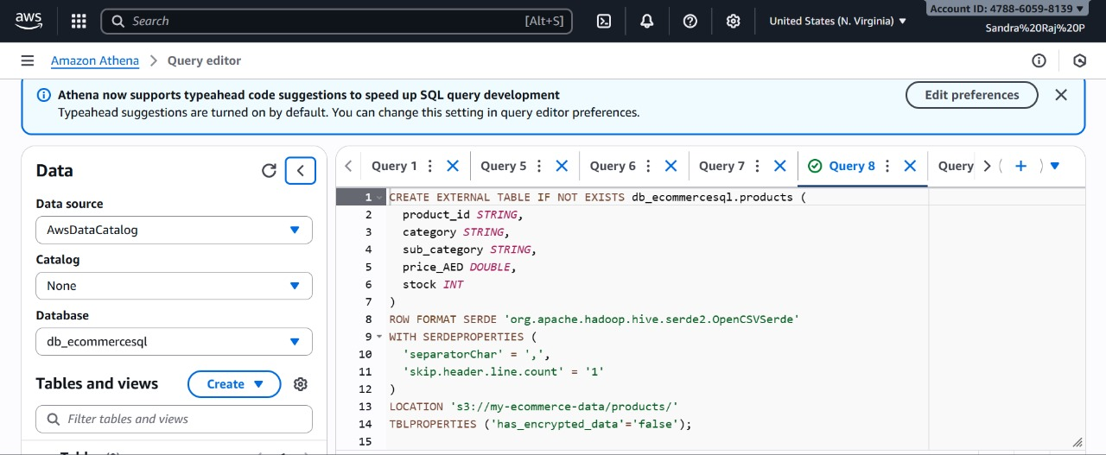

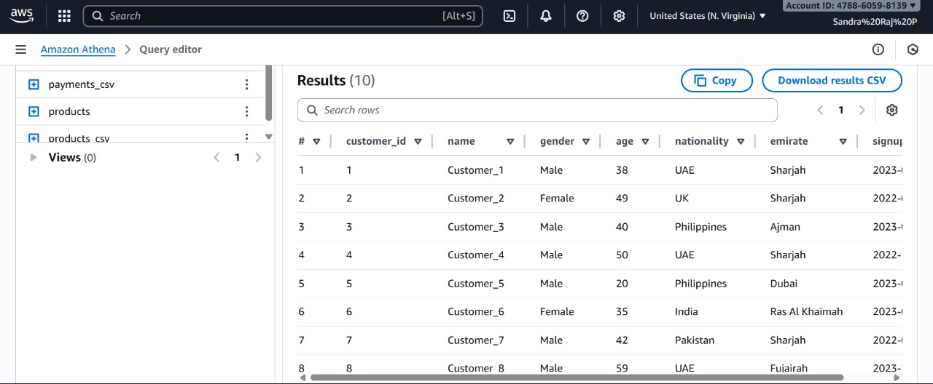

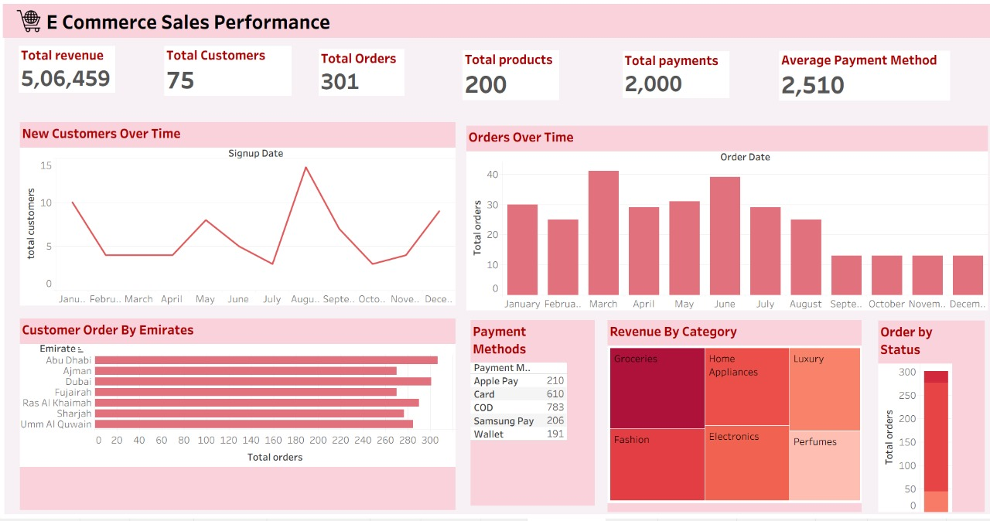

**Key metrics from Dashboard**

• **Total Revenue:** 5,06,459

• **Total Customers:** 75

• **Total Orders:** 301

• **Total Products:** 200

• **Total Payments:** 2,000

• **Average Payment Method Value:** 2,510

## ****Research Questions & Answers****

• **Which Emirate has the highest total sales?**  
→ Dubai recorded the highest sales and order volume among all Emirates.

• **Which product category contributes most to overall revenue?**  
→ Electronics emerged as the top-performing and most profitable category.

• **How do customer purchase behaviors vary across Emirates?**  
→ Urban Emirates like Dubai and Abu Dhabi show higher average order values compared to northern regions.

• **During which period do sales peak and decline?**  
→ Sales peak during November–December and decline between April and June.

• **What is the relationship between sales and quantity sold?**  
→ There is a strong positive correlation between the number of items sold and total sales revenue.

• **Which customer segment generates the most profit?**  
→ Returning customers contribute significantly more revenue than new customers.

• **How can business performance be improved using insights?**  
→ Targeted marketing and region-specific campaigns can enhance overall sales performance.

• **Are there any anomalies or outliers in the data?**  
→ A few high-value orders were identified and treated as outliers to improve data accuracy.

• **What is the key advantage of using AWS in this project?**  
→ AWS provides scalable, secure, and efficient data storage, processing, and analytics integration with Tableau.

**Final Recommendations**

• **Focus on High-Performing Emirates:**  
Prioritize marketing campaigns and logistics in top-performing Emirates like **Dubai** and **Abu Dhabi** to further increase revenue.

• **Improve Sales in Low-Performing Regions:**  
Launch **localized discounts, free delivery offers, and promotions** in Emirates with lower sales such as **Ajman** and **Ras Al Khaimah** to balance regional performance.

• **Expand High-Demand Product Categories:**  
Increase stock and variety in **Electronics and Fashion** categories, as they consistently drive the highest sales and profit margins.

• **Strengthen Customer Retention:**  
Introduce **loyalty programs, referral offers, and personalized recommendations** to encourage repeat purchases from existing customers.

• **Enhance Seasonal Marketing Strategies:**  
Capitalize on **festive seasons** like **Eid and year-end sales** by offering targeted campaigns to boost peak-period sales.