UGANDA CHRISTIAN UNIVERSITY

BISHOP BARHAM UNIVERSITY COLLEGE

WEB AND MOBILE APPLICATION DEVELOPMENT

PROJECT BASED EXAM REPORT

TUHAIRWE SANDRA S25/BBUC/BSIT/023

AHUMUZA SETH S25/BBUC/BSIT/001

1. The Problem Statement
Currently, students at Uganda Christian University (UCU) rely on informal social media groups to organize study sessions. This often excludes students who are not in specific social circles and makes it difficult to find academic help for specific course units. There is a need for a centralized, web-based platform where students can openly discover, join, and organize study groups based on their academic programs and schedules.

2. Project Objectives
Primary Objective: To develop a responsive web application that facilitates the discovery and organization of study groups at UCU.
Specific Objectives:
  - To design a secure user authentication system for student registration.
  - To create a searchable database of study groups categorized by course units.
  - To implement a scheduling feature for organizing upcoming study sessions.

3. Technology Stack
Backend: PHP (Laravel) for its robust security and ease of database management.
Frontend: HTML, CSS, and JavaScript (or React) to create a user-friendly interface.
Database: MySQL/MariaDB for structured data storage of users and groups.
System Architecture

The 3-Tier Architecture for your Study Group Finder
- Presentation Tier (The Frontend):
This is what the UCU BBUC student sees.
Built with HTML, CSS, and JavaScript.
It sends requests (like "Search for Law Groups") to the server.
- Logic Tier (The Backend):
This is the "brain" of your app, built with PHP (Laravel).
It receives data from the frontend, checks if the user is logged in, and asks the database for information.
- Data Tier (The Database):
This is MySQL/MariaDB.
It stores the actual tables: users, study_groupsS, and sessions.
ER Diagram
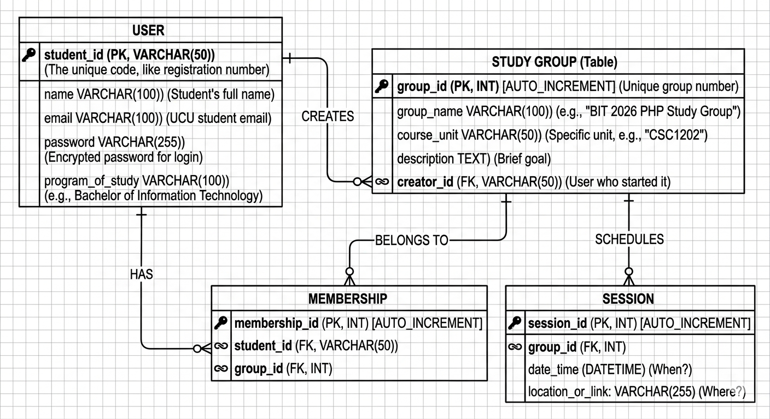

Interface Mockup
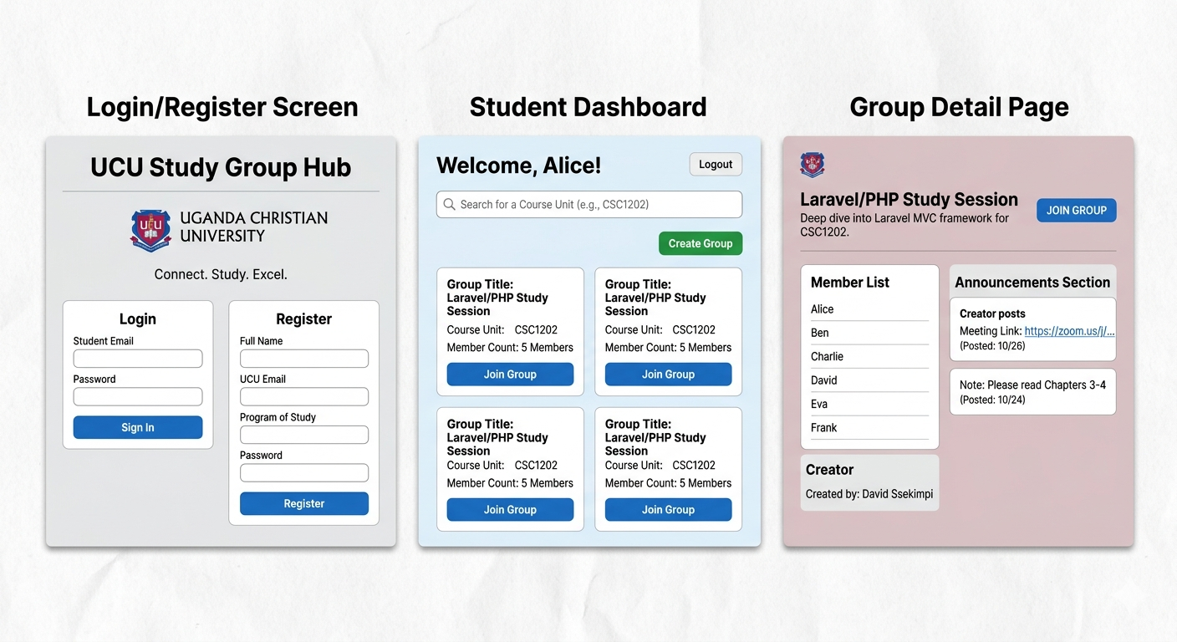

Components:
Main Header: The group's name and description.
Member List: A simple list of everyone who has joined.
Creator: The name of the student who created the group.
Announcements Section: A feed for the creator to post meeting links or notes.
The Big Action Button: A clear blue "JOIN GROUP" button (or "LEAVE GROUP" if they are already a member).

Technology Choices
To develop the Student Study Group Finder, the following technologies were selected based on their reliability, ease of integration, and suitability for the UCU academic environment.

Backend: PHP (Hypertext Preprocessor)
We chose PHP as our server-side language for several reasons:
Database Connectivity: PHP has native support for MySQL, making it easy to fetch and store study group data.
Open Source: It is free to use and has a massive community for troubleshooting.
Laravel Framework (Optional): If we use Laravel, it provides built-in security features like protection against SQL injection and Cross-Site Request Forgery (CSRF), which is essential for protecting student data.

Database: MySQL / MariaDB
For data storage, we chose a Relational Database Management System (RDBMS):
Structured Data: Since our data (Users, Groups, Sessions) is highly structured and related, a relational database is more efficient than a non-relational one.
ACID Compliance: This ensures that every transaction (like joining a group) is processed reliably without data loss.

Frontend: HTML5, CSS3, and JavaScript
To build the user interface:
HTML5: Used for the structural layout of the web pages.
CSS3: Used for styling to ensure the application looks professional and is responsive on both mobile and laptop screens.
JavaScript: Used for client-side validation (e.g., ensuring the password is long enough) without needing to refresh the page.

Version Control: Git & GitHub
Collaboration: Since this is a team project, GitHub allows us to work on the code simultaneously without overwriting each other's work.
Accountability: Every "Commit" provides a timestamped history of who added what, which serves as evidence for our Milestone assessments.

Feasibility Study
A feasibility study was conducted to determine the viability of the Student Study Group Finder project at Bishop Barham University College. The study focused on three main pillars: Technical, Economic, and Operational feasibility.

Technical Feasibility
This section assesses whether the current technical resources are sufficient to build the system.
Hardware: The development team possesses laptops with sufficient RAM and processing power to run a local server (XAMPP/WAMP).
Software: The choice of PHP and MySQL is ideal because they are open-source and compatible with most web hosting platforms.
Skills: The team has a foundational understanding of database management and web development, which will be supplemented by documentation and peer learning during the implementation phase.

Economic Feasibility
This assesses the costs versus the benefits of the project.
Development Cost: Since the project uses open-source tools (VS Code, Git, PHP, MySQL), the financial cost of development is zero.
Operational Cost: Hosting the application on the university’s local network or a free tier cloud service involves minimal to no cost.
Benefit: The primary "profit" is the academic success of the students and the improved efficiency in organizing study sessions, which far outweighs the zero financial investment.

Operational Feasibility
This assesses how well the system will be accepted by the users (UCU Students).
Usability: The interface mockups ensure a simple, user-friendly experience that requires no special training for students.
Support: By automating the group-finding process, the system reduces the administrative burden on class representatives who currently manage group lists manually.
Compliance: The system will operate within the academic guidelines of the university, ensuring data privacy and student accountability.

