***Ex1:***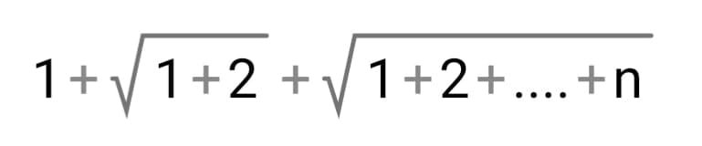

***Ex2:*** 0.1+0.2+…1.8

***Ex3:*** Fibonacci: 0 1 1 2 3 5 8 13 …

**import** java.util.Scanner;

**public** **class** Forloop {

**public** **static** **void** main(String[] args) {

Scanner t= **new** Scanner(System.***in***);

**int** n=t.nextInt();

**int** m=t.nextInt();

Tema l= **new** Tema();

l.Ex1(n);

l.Ex2();

l.Ex3(m);

t.close();

}

}

**public** **class** Tema {

**int** i;

**double** j;

**void** Ex1(**int** n) {

**double** s=0;

**double** s1=0;

**for**(i=1; i<=n; i++) {

s1+=i;

s=s+Math.*sqrt*(s1);

}

System.***out***.println("Suma 1 este "+s);

}

**void** Ex2() {

**double** s=0;

**for**(j=0.1; j <=1.8; j+=0.1) {

s+=j;

}

System.***out***.println("Suma 2 este "+s);

}

**int** y,n1=0,n2=1,n3;

**void** Ex3(**int** m) {

System.***out***.print(n1+" "+n2);

**for**(y=2; y<=m; ++y) {

n3=n1+n2;

System.***out***.print(" "+n3);

n1=n2;

n2=n3;

}

}

}