RAM Generic Mega-Wizard

# Scope

RAM Generic Mega-Wizard creates a template file, which can be used as a template to write any entity, which uses Generic RAM.

# GUI

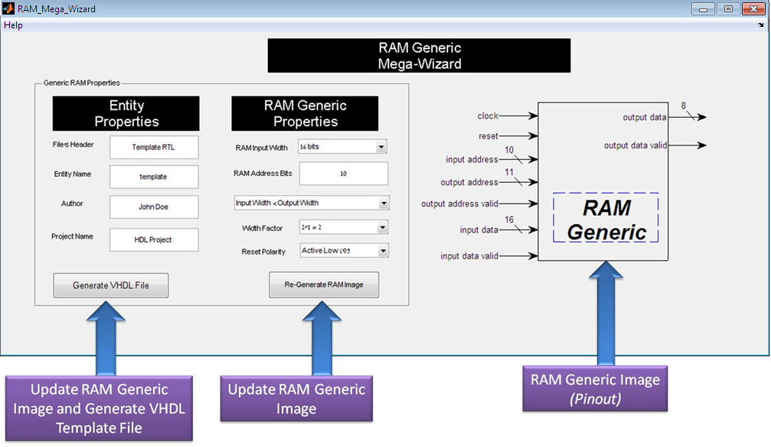

Figure 1 - RAM Generic GUI

## Components

The GUI is composed of the following:

1. **Entity Properties** – Relevant for the VHDL header and entity name.
2. **RAM Generic Properties** – RAM Constants, signals and instantiations will be generated in the VHDL file according to these parameters.
3. **RAM Generic Pinout** – A template of the RAM Generic Pinout, with its bus sizes.

## Buttons

1. **Generate VHDL File** – Opens a Windows Save dialog:  
   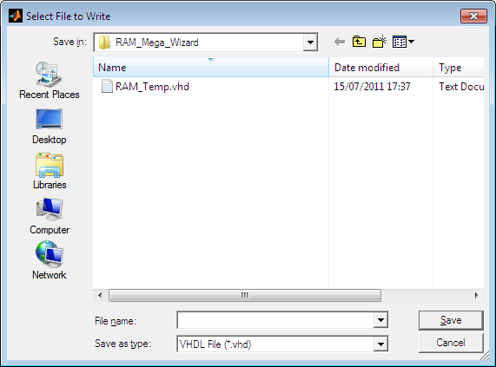

Figure 2 - Save dialog

1. **Re-generate RAM Image** – Re-generates RAM pinout, according to the new parameters.

## Error Validation

In case of error, such as input address is negative or output address is a fraction, and error message will be displayed, and the corrupted values will be set to their default values.

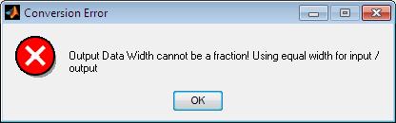

Figure 3 - Output Data Width Error

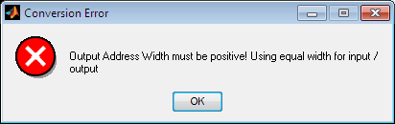

Figure 4 - Output Address Width Error

# Version

Use *Help/About* to see current version.

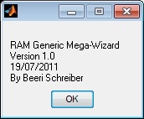

Figure 5 - Version Number

# VHDL Output File

VHDL Output File is attached here.

For best view, use Notepad++.

