Technical Design Document (TDD)
Around the World!

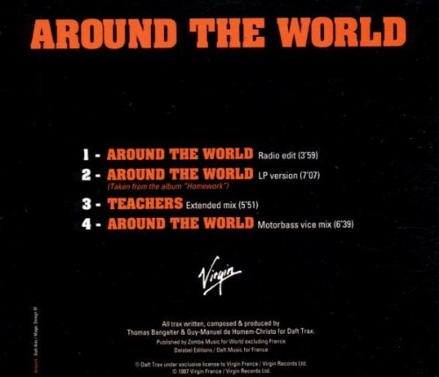

Version: 1.0.0
Created: 8/18/15
Last Updated: 8/18/15
Table of Contents

Executive Summary
Project
Technical
Hardware and Software
2D Software
3D Software
Sound Software
Programming Software
Development Plan
Itinerary
Milestones
Project Goals
File Formats
2D
3D
Audio
Scripts
Scenes
Other
Level Layouts
Asset List
Common Type
2D Art
3D Models
Audio
Level 1 (Replace with name)
2D Art
3D Models
Audio

Executive Summary

Project

Around the World! is a space flying game where the player tries to survive in space for as long as they can. Around the World! has the player avoid the planets of the solar system while staying inside the solar system and increasing their flight speed the longer they survive. This seemingly simple game becomes truly challenging as the score increases! The game will be developed around a joystick, primarily being built for PC but also being portable to most modern consoles. Players will be able to compete for high scores via a local leaderboard depicting their high score and max speed.

Technical
Programs
Programs required to build Around the World!:
Program | Purpose | Cost
Unity3D | Game Development Environment | $1,500.00
Microsoft Visual Studio | Debugging Environment | $299.00
BFXR | Sound Effect creation | Free

Market Release
Around the World! will be released for PC through IndieDB, for Xbox 360 and Xbox One through Xbox Live Arcade, and for Playstation 3 and Playstation 4 through the Playstation Store.

Estimated Cost of Completion
Unity 3D $ 1,500.00
Visual Studio $ 299.00
40 hours salary, 3 programmers $ 3,240.00
Total: $ 5,039.00

Hardware and Software

Sound Software
- BFXR: BFXR will be used to create sound effects.

Programming Software
- Microsoft Visual Studio: Microsoft Visual Studio will be used to debug and create the code for the project. $299.00

Development Plan

Milestones

Date | Milestone
8/21/15 | TDD Complete
8/24/15 | Prototyping and asset generation complete
8/25/15 | Content created
8/28/15 | Level and Interface created bug-free
8/31/15 | Complete, submitted for grading

Project Goals
There is only one screen for the game. The gameworld contains the player ship and the solar system, all viewable on-screen. When the player either collides with a planet or exits the solar system, the game is over and the player is prompted to reset or quit.

The player will always start the game next to Earth. They will be constantly moving forward, with input being to rotate left or right.

The planets will be spherical colliders with their own scripts for moving. Designers will be able to edit the speed the planets rotate around the sun and the moon’s rotation speed around Earth.
There is a game controller object that will track the player’s score and speed along with positions of the player and all planets in the solar system. The director will also handle game over conditions.

File Formats

2D

Naming Convention | Description | Format
PlanetName | 2D Texture for planets | .png

3D

Naming Convention | Description | Format
Ship | A finished 3D model | .obj
Object_Filename | An unfinished 3D model | .obj

Audio

Naming Convention | Description | Format
Explosion | Ship explosion sound effect | .wav
Music | Background music | .mp3

Scripts

Naming Convention | Description | Format
Script_Filename | A script for an object | .cs

Scenes
Naming Convention | Description | Format
Scene_Filename | A scene in Unity3D used in the build | .scene
SceneName | A scene not used in the final build; mainly for testing purposes | .scene

Other
Naming Convention | Description | Format
TDD_Finished | The completed Technical Design Document | .pdf
GDD_Finished | The completed Game Design Document | .pdf

Asset List

Common Type

2D Art
Background
Planet Textures
Ship Textures

3D Models
Planets
Ship

Audio
Explosion Sound
Music

