**CSA Exam – January 2017 exam duration: 120 minutes**

Introduction

In this exam, you are going to implement a client-service system for real estate agency.

The core of the system is the Agency Service, which buyers use to make their offers on houses. This service has a list of selling houses. Each house has:

1. an address (string, e.g., “Grasdreef 2”),
2. a capacity (integer indicating the maximal allowed number of buyer’s offers, e.g., 5),
3. an asking price (integer, indicating the desired price for the given house, e.g., € 239.000),
4. a seller name (string, e.g., “Thijs van Leer”),
5. offers (a list of offers indicating the offers, e.g., {“204.000”, “195.000”, “235.000”}).

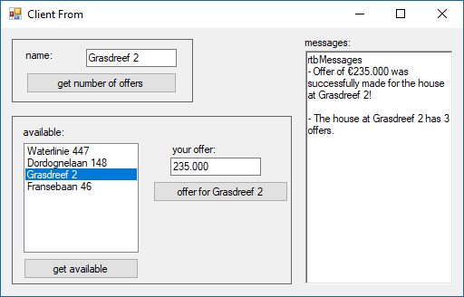

Agency

Service

Client

Download the startup project from the SharePoint/CSA and unzip the start Visual Studio solution. This solution already contains two Client projects, each with one Form. The Client project is used by the buyers to make offers for houses. The Admin Client is used by the real estate agents to see the offers for each house. You should either add one new service project to this solution, or you can make a new solution for the service project. In this exam you are free to decide which type of endpoint configuration you will use (programmatic or administrational).

|  |  |  |  |  |  |  |  |  |
| --- | --- | --- | --- | --- | --- | --- | --- | --- |
| Exam points: | Exercise | 1 | 2 | 3 | 4 | 5 | Total |  |
| Points | 20 | 20 | 20 | 20 | 20 | 100 |  |
| For each exercise, exam points will be awarded if and only if the required functionality described in the exercise works (runs)! | | | | | | | | |

**Exercise 1 [20 points]**

Create several ‘hard coded’ houses in the Service.

By filling in a house address in **tbName** and then clicking on the “**get asking price**” button, the Client should retrieve the asking price of the given house and show it (or appropriate error message) in **rtbMessages**.

**Exercise 2 [20 points]**

By clicking on the **“get a**v**ailable”** button, the Client should retrieve a list of all ‘available’ houses from the Service and show addresses of these houses in **lbAvailable**. A house is ‘available’ if buyers may still make an offer for it, i.e., if its capacity is higher than the number of current offers (e.g., a house with capacity 5 and number of interested-in buyers 3 is ‘available’).

Note that for each house only address and asking price should be given to the Clients. The seller and list of offers are hidden from the Clients.

**Exercise 3 [20 points]**

By selecting a house address in **lbName**, entering an offer price in **tbOffer** and clicking **“make offer …”** button the client asks the service to make an offer for the selected house. The Client should:

* show the notification whether this action succeeded or not in **rtbMessages** and
* if it is the case that this house becomes ‘unavailable’ after successful offer, the Client should remove this house from the **lbAvailable** list box.

Before accepting an offer from a buyer, the Service must check the following:

* The house address exists; and
* The house is ‘available’ (i.e., capacity is higher than the number of current offers).

If any of the three conditions above is not fulfilled, then offer fails.

**Exercise 4 [20 points]**

The service should work with multiple Clients at the same time. Whenever a house becomes ‘unavailable’, the Service should automatically notify all other connected Clients about this event.

Upon such a notification, all notified Clients should remove this house from the **lbAvailable** list box. At the startup, each Client application should automatically register for receiving these automatic notifications. Similarly, each Client should automatically unregister for automatic notifications at shutdown of the Client application.

**Exercise 5 [20 points]**

Add a new business endpoint to the service: the Administrator endpoint will be used by the real estate agency office to connect to the service in order to retrieve offers of buyers who are interested-in to houses.

By entering a house address in **tbName** and clicking on the “**get offers**” button, the Administration Client should retrieve all offers of all buyers who are interested-in to the given house from service’s new endpoint Administrator and show it on its Form as shown below:

|  |  |  |
| --- | --- | --- |
| Client | Agency Service | Administrator Client |