OfertaeDites ADMIN

Functional Specification

Document history:

Version | Date | Author | Comments
1.0 | 15/08/11 | Ermal Aliraj | First Release

Table of Contents

1 Introduction 5
1.1 Overwiew 5
1.2 Purpose 5
1.3 Out of scope 5
2 System Specifications 5
2.1 Login 5
2.2 HomePage / Site's structure 5
2.2.1 Menu 6
2.3 Users Management 6
2.4 Clients 7
2.5 Client's Credit 7
2.6 City 7
2.7 Partners 7
2.8 Deals 7
2.9 Publications 8
2.9.1 Publications Calendar 8
2.9.2 Search Publications 8
2.10 Purchases 8
2.11 Payments 9
2.12 Discount Cards 9
2.13 Invites 9
2.14 System Configurations 9
2.15 Audit Trial 10
2.16 Statistics 10
3 Automatic Modules Specifications 10
3.1 Newsletter service 10
3.2 Publication Expires Time 10
3.3 Credit Card payment 10
4 Data Model 11
4.1 Database schema 11
4.2 Database tables 11
5 Authorization Concept 12
6 Infrastructure Specifications 12
7 FS estimation time 12
8 References / Glossary 13

Introduction

Overwiew
OFERTAEDITES SH.P.K is a “One deal a day” web-based business, in which a single type of product is offered for sale for a period of 24 hours. OfertaeDites is the system used for handling the business activities. The system will publish each day a different deal. Registered clients will receive a daily newsletter through the email with the day's deal. If the user is interested for the published good, he can login and purchase the good. At the publishing expires time, the system will count if the number of purchases has reached the minimum asked from the partner in order that the deal can be considered done. In this case the deal is considered done, so the coupons will be sent through email to the users. In case the minimum numbers of purchases is not been reached, the system will send a notification message to all users (that purchased the good) confirming that the money used in the purchased time will be recharged in the same credit card used for the purchase. To permit this goal OfertaeDites will be composed by two modules:
- OfertaeDites, the portal www.ofertaedites.com
- OfertaeDitesAdmin, Back-end tool for administrators.

Purpose
This document is the Functional Specification for project OfertaeDitesAdmin. In this document will be explained all specifications that the back end system OfertaeDitesAdmin should support.

Out of scope
Front-end functional specifications are described in the appropriate document OFERTAEDITES_Functional_Specification_FE.doc

System Specifications

OfertaeDitesAdmin module is the tool used from administrators to handle the data of the system (FE and Back-End). This module will allow the administrators to add new partners, publish daily deals, add credit to the clients and all the necessary needed from the portal.

Login
Here a user can insert his credentials to access the system. After the authentication the user must select the role from a pop-up, in case he has more than one role, and after the system must shows only pages authorized by the chosen role. In case a user mistakes the password for 3 consecutively times the user will be locked. Only an administrator can unlock a locked user.

HomePage / Site's structure
The structure of the web application will be composed by:
- Header
- Menu
- Content
- Footer

In the header section will be present the logo, information related to the logged user, and a logout link.

Menu will be always present during the navigation between different pages.

Footer will be always present with a static write regards the copyright.

Content will be the area in which each single page will be rendered during the navigation.

Most of the pages will be composed by two areas.
- Search Area, filters to apply for the research.
- Result Area, often will be a table with all records found by the search. The click in each row will open row detail.

As default page will be shown real time information regards the day of the deal, number of registered clients and other information relevant for the day activity.

Menu
The menu structure will be as the follow:

- User Management
  - Users
- Registries
  - Partners
  - Deals
  - Clients
  - Cities
- Publications
  - Publication Calendar
  - Search Publication
- Purchases
- Payments
- Bonuses
  - Credits
  - Discount Cards
- Invites
- System Configurations
- Audit Trial
- Statistics

Users Management
This functionality allows the insert, update and delete users in the application. Users are categorized by roles and a user can have more than one role associated.

Clients
This section will manage the clients registered in the system using the portal (front end module). Clients must not be confused with Users which are back-end application users. From this section, choosing a single client the system will allow the consultation of:
- user's purchases
- user's bonuses
- user's credit
- user's invitations

Search form can filter the user's list using the fields:
- name
- surname
- email
- sex
- registered after date

Client's Credit
Section for managing the client's credit. The credit can be added to a client in case of reimbursement. Example when, the client didn't used the coupon, OFERTAEDITES already charged from the partner, and the client asked for reimbursement. OFERTAEDITES can also donate credit to his clients for benefit reasons. All credit addition will be traced by the audit trial specifying the reason of the addition. The system automatically adds credit to a client in case an invited person from the client, will register in the portal.

Search filters will be the following:
- Client username/email
- Benefit/Reimbursement

City
The functionality allows to insert update and delete cities in the system. A deal can be published for a different city but in the first version the default city will be Tirana.

Partners
This functionality allows the management of the partners. For each partner can be shown all his deals.

Partners can be filtered using:
- Partner Name

Deals
Management of the deals accorded with partners. A partner in a long time period can accord many deals with OfertaeDites. For each deal can be checked all his past publications.

Deals can be filtered by the fields:
- Partner name
- Deal name
- Range registration date

Publications
A deal can be published choosing a day, minimum purchases and maximum purchases. After the deal publication it will be inserted in the Publications Calendar. Future publishes can be updated and deleted, instead closed publishing can be access in read only mode. For the same deal can be more than one publishing. The system will allow from this section to check the payments and the list of the clients purchased the published deal.

This section may be subdivided in two functionalities:
- Publications Calendar
- Search Publications

Publications Calendar
From this section a publication can be inserted, consulted, updated or deleted. Here the user can have an idea regards the “busy” days, so days in which has been already published a deal. The “online timing” (example 1, 3 or 7 days) can be configured from System Configuration section (2.2.11)

Search Publications
Functionality for searching and consulting all publications present in the system. From this section a user can find and open the publication details, allowing the user to update/delete the publication ONLY if the publication is not closed.
Search filters will be the following:
- Partner name
- Deal name
- Publication date
- Deal Confirmed
- Client username/email
- Publication range date

Same page Publishing details will be used in the following cases:
- Insert a new Publishing
- Update a future publishing
- Consult a closed publishing (read-only mode)
- Clicking in a single publication, from the result area of the Search Publishing functionality. In case the chosen publishing is not yet closed, it can be updated or deleted.

Purchases
All purchases present in the system. In this section the user can consult the publication to which belongs this purchase and the client who made this purchase. If a bonus or discount card has been used they can be consulted from this section.

Search filters will be the following:
- Publication id
- Partner name
- Deal name
- Range date

Payments
Registry for all payments made by the clients. From this section the user can be able to check the purchase and the publication to which a single payment belongs to.

Search filters will be the following:
- Publication id
- Client username/email
- Client name
- Client Surname
- Range date

Discount Cards
Management of Discount Cards. From this section the user can be able to check the client who used a single discount card.

Search filters will be the following:
- Client username/email
- Used
- Card Value

Invites
Functionality for invites management. When a client send an invitation to another person, it will be traced in the system for future references in case the invited person will register. In this case the system will automatically add credit to the client who sent the invitation.

Invitation will be in two mode:
- Through email, client send invitation to a single email, so the system trace the invited email. In case this email will register in the future, the system will add credit to the client.
- Through a link, or publishing a link in a social network. In this case the system will find a way to trace the “object” used by the client (a cookie or a sequential string) for future references. In case a user click the sent link to register, the system must be able to recognize the “object “ used by the user, so will add the credit to the client.

Search filters will be the following:
- Client username/email
- Invitation confirmed (used by the invited person)

System Configurations
In this section are configurable the parameters needed for the system, front end and back end.
Example:
- Frequency of the newsletters
- Range online time for the publications(24 hours, 48, 70 etc)
- Maximum wrong password inserted by the user

Audit Trial
This section will make possible to show the Audit trial for each system user.

Statistics
Statistics section related Deals, Number of clients registered in the system, purchases for each publications etc.

- Actual publication
  - Deal name
  - Actual purchases
  - Concluded
- Clients
  - How many clients registered in OFERTAEDITES. How many has one, two, three, five or more than 10 purchases.
- Frequency Statistics
  - Weekly
    - Deals, deals accorded with partners in the actual week, how many already published?
    - Publications, How many publications made this week, how many purchases for single publication, concluded?
  - Monthly
    - Same as Weekly
  - Yearly
    - same as Yearly

Automatic Modules Specifications

Newsletter service
At a specific time, configurable from System Configuration, the system will send an email to all users registered in the system with the deal of the day.

Publication Expires Time
When the publication time expires, the system calculates if the minimum number of purchases has been reached. In this case the deal will be considered done and the coupons will be sent to each user through the email. Another email will be sent to the partner for notification. If the minimum number of purchases has not been reached, so the deal will not be considered done, the system must use an appropriate system to give back the money to the users.

Credit Card payment
OfertaeDites will interact in two phases with the credit card payment system:
- Every time a user purchase a deal (portal functionality)
- In case of a not concluded deal, the system (admin module) will send a notification to the credit card system with the list of Credit Cards and the value to reverse.

Data Model

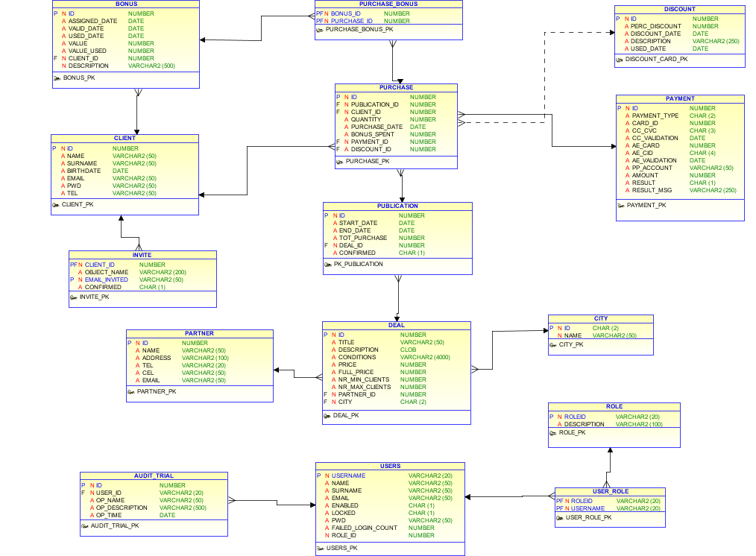
Database schema

Database tables

Table Name | Description
AUDIT_TRIAL
BONUS
CITY
CLIENT
DEAL
DISCOUNT
INVITE
PARTNER
PAYMENT
PUBLICATION
PURCHASE
PURCHASE_BONUS
ROLE
USER_ROLE
USERS

Authorization Concept

# | Role | Name | Description
1 | READ_USER | Simple User | Privileges for read-only pages. Ex. Statistics.
2 | WRITE_USER | Write Privilege User | Data entry privileges. (Ex. DEAL and PARTNER tables)
3 | PUBLISH_USER | Publication User | Privileges for publishing deals
4 | ADMIN | Administrator | Full access read/write in the system

Infrastructure Specifications

Admin module will be a Java web application based on JSF technology.
Other technologies used
- JSF, for web app development
- iBatis, layout between BD and Java objects
- Spring, IoC for DAO and Manager management and all needed for web application
- Spring Security 3
- AOP & AspectJ for transaction management
- Sitemesh as decorator tool for application layout

Web app will be deployed in application Server
- Tomcat 6

Database used
- MySql

FS estimation time

In the table below are traced all functionalities followed by an approximated estimation time needed for implementation using technologies described in section 6.

FS-ID | Interface / Feature | Estimated days | Description
FS-2.1 | Login
FS-2.2 | HomePage
FS-2.3 | User management
FS-2.4 | Client
FS-2.5 | Client's credit
FS-2.6 | City
FS-2.7 | Partners
FS-2.8 | Deals
FS-2.9.1 | Publications Calendar
FS-2.9.2 | Publications Search
FS-2.10 | Purchases
FS-2.11 | Payments
FS-2.12 | Discount Cards
FS-2.13 | Invites
FS-2.14 | System Configurations
FS-2.15 | Audit Trials
FS-2.16 | Statistics
Project Set-up
Test
Design document

References / Glossary
References and terms used in the document.
FE | Front-End

