OZone

Design Specification

Document history:

Version | Date | Author | Comments
1.0 | 15/08/11 | Ermal Aliraj | First Release

Table of Contents

1 Introduction 4
1.1 Overview 4
1.2 Scope 4
1.3 Definitions, Acronyms, and Abbreviations 4
2 System Overview 5
3 System Architectural Design 6
3.1 Data Layer 6
3.2 Business Layer 6
3.3 Presentation Layer 7
3.4 Packages interactions in three layers 7
3.5 Flow example - Partner 7
4 Detailed modules structure 8
4.1 OEDitesBL 8
4.1.1 Project Structure 8
4.1.2 Project Configuration 9
4.2 OZoneAdmin 12
4.2.1 Project Structure 12
4.2.2 Project Configuration 12
4.3 OZoneFE 14
4.3.1 Project Structure 14
4.3.2 Project Configuration 14

Introduction

Overview

ZONE SH.P.K is a “One deal a day” web-based business, in which a single type of product is offered for sale for a period of 24 hours. OZone is the system used for handling the business activities. The system will publish each day a different deal. Registered clients will receive a daily newsletter through the email with the day's deal. If the user is interested for the published good, he can login and purchase the good. At the publishing expires time, the system will count if the number of purchases has reached the minimum asked from the partner in order that the deal can be considered done. In this case the deal is considered done, so the coupons will be sent through email to the users. In case the minimum numbers of purchases is not been reached, the system will send a notification message to all users (that purchased the good) confirming that the money used in the purchased time will be recharged in the same credit card used for the purchase. To permit this goal OZone will be composed by two modules:
- OZone, the portal www.ozone.al
- OZoneAdmin, Back-end tool for administrators.

Scope
The purpose of these Design Specifications (DS) for the OZone system is to specify how the requirements as documented in the Functional Specifications (FS) will be implemented.

Definitions, Acronyms, and Abbreviations
Design Specification (DS) – A specification that documents how a system is to be built. It typically includes system or component structure, algorithms, control logic, data structures, data set (file) use information, input/output formats, interface descriptions, etc.
Functional Specification (FS) – A specification that documents the functional requirements for a system or system component. It describes what the system or component is to do rather than how it is to be built.
Requirement – 1) A condition or capability needed by a user to solve a problem or achieve an objective. 2) A condition or capability that must be met or possessed by a system or system component to satisfy a contract, standard, specification, or other formally imposed documents.

System Overview

Three tier/layer architecture.
- Data Tier
- Business Tier
- Presentation Tier

Both modules will use the same DB. For this is optimal to choose a 3 tier architecture to permit localize the business logic in a single layer for later be used both from Admin tool or the portal (Front-End)

The project OZone is composed by three modules:

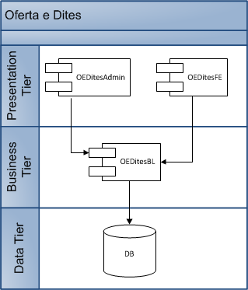
Fig 3.1 Three layer architecture level

System Architectural Design

Data Layer

As database management system will be used MySql.
As Data mapper to map the relational database into java objects will be used MyBatis.

MyBatis is not an ORM (Objet Relational Mapper) but is a Data Mapper framework and as so, it handles the interaction between Relational Database and Object model.

For each table, or relation, will be a DAO(Data Access Object) interface which exposes the access methods and another class implementing the interface. This choice is to separate the implementation from the specific. In case we need to change the Data Mapper in the future will be necessary to change only the implementation classes and let immutable all the system.

Each DAO implementation class use its xxx_SqlMap.xml file, in which are defined all the SQL statements for database interaction. This file is responsible for mapping the SQL statements into Java Objects. Example, all table columns of the result query getPartner will be mapped as fields of the java Object Partner.

Packages related to DL are
- DAO
- DAO.impl

Business Layer

Business Layer will be composed by 2 principal packages:
- Manager
- Manager.Impl

DAO and DAO.imp are the data access packages. All DAOs operates in a single table and do not handle the transactions.

Manager and Manager.imp are business logic packages. Each Manager class is responsible for a specific business part. Example, PartnerManager define all activities done for a partner.
A manager can use more than one DAO, but a DAO must not use another DAO.
Transaction manager, handled by AOP and AspectJ, is configured to handle all methods of all Manager classes. This means that each Manager method handles the transaction, and the commit is done only if the method ends successfully with no Exceptions. This is helpfull in case when a manager method use different DAO method calls.

Example:
- public void deleteExpense(id){
2. ExpenseItemDAO.deleteItemsByExpId(id);
3. ExpenseDAO.deleteExpenseById(id);
4. }
The transactions guaranties a rollback, for deleteItemsByExpId(), in case the execution of the line 3 go in exception and a commit for all DAO calls in case of success.

Presentation Layer

Web side will use Business Layer to interact with DB.
In this Layer will be present two components
- OZoneAdmin
- OZone

Packages interactions in three layers

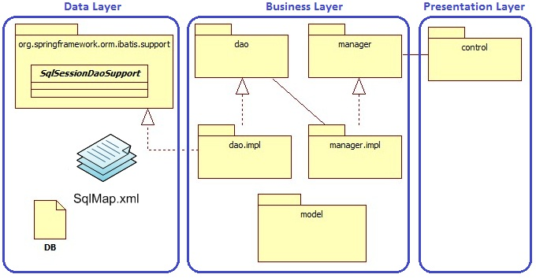 Fig 2. Packages interaction between three levels

Flow example - Partner
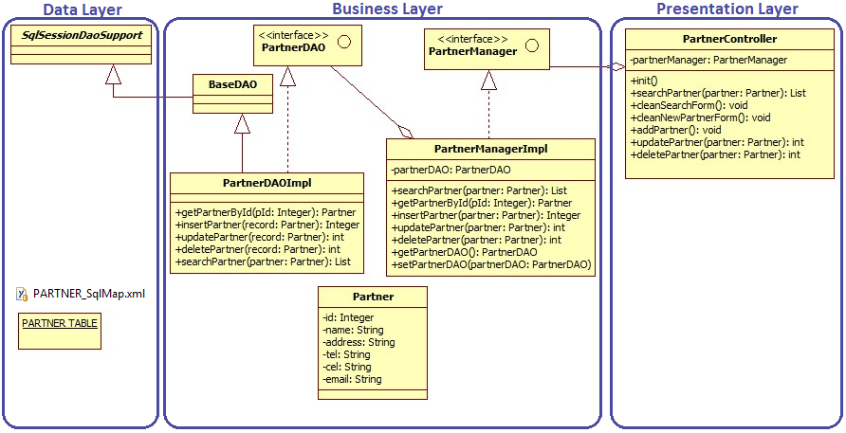
Fig 3. Partner example – interaction between three levels

Detailed modules structure

This chapter will describe the structure of three modules and their configuration in Eclipse.

OEDitesBL
OEDitesBL is a Simple Java Project complied with environment Java 1.6.

Project Structure

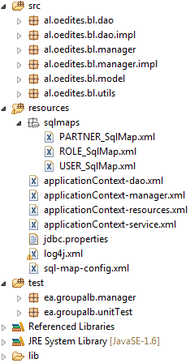 | 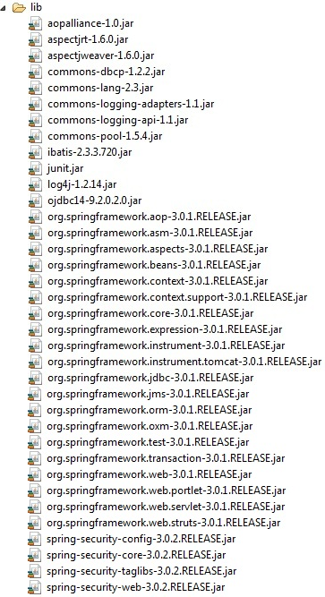
Fig. 4.1-1 OEDitesBL Structure

Project Configuration

Java Build Path

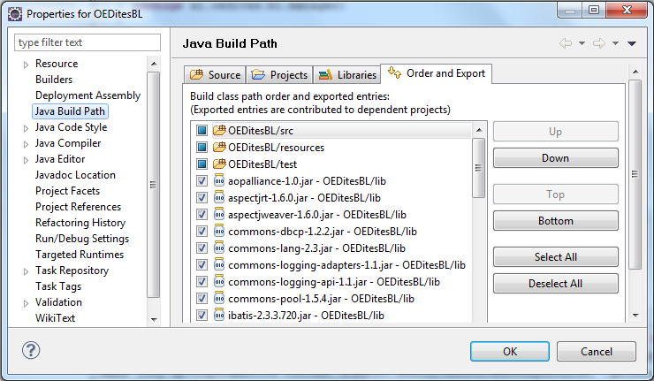
Fig. 4.1-2 OEDitesBL Java Bild Path

All libraries must be included to the project using Libraries tab.
Order and Export tab permits to choose the jars needed for other projects referencing to the BL
Export all jars expect junit.jar.

Project Facets
Java 1.6
Utility Module checked - Enables the project to be referenced by Java EE modules

Deployment Assembly
Add all jars to the output OEDitesBL.jar deployment file, using Java Build Path Entries.
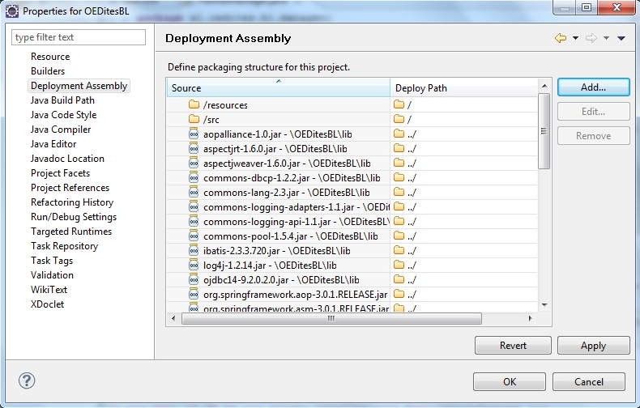
Fig. 4.1-3 OEDitesBL Deployment Assembly

DRAFT resumption:

OZoneBL
Libraries: All-BL-libs
Order and Export: All-BL-libs
Deployment Assembly: All-BL-libs

OZoneEngine
Libraries: All-Engine-libs (2 files)
Order and Export: All-Engine-libs
Deployment Assembly: All-Engine-libs

OZoneAdmin
WEB-INF/libs: All-Admin-libs
Deployment Assembly: 2 projects OZoneBL and OZoneEngine as jar in WEB-INF/libs

OZoneAdmin

OZoneAdmin is a Dynamic Web Application

Dynamic Web Module 2.5
Java 1.6

Project Structure
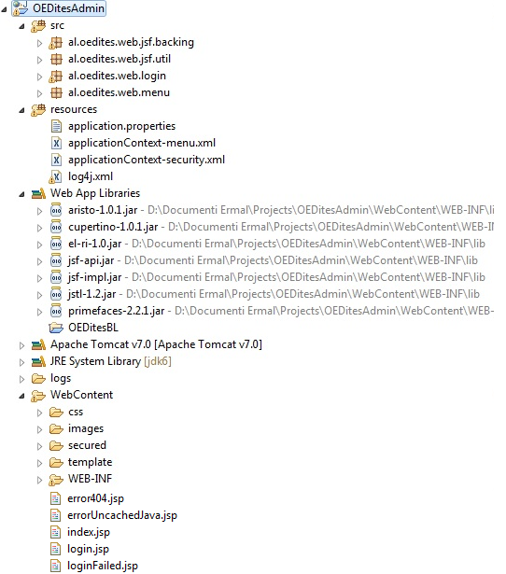
Fig. 4.2-1 OEDitesAdmin Structure

Project Configuration
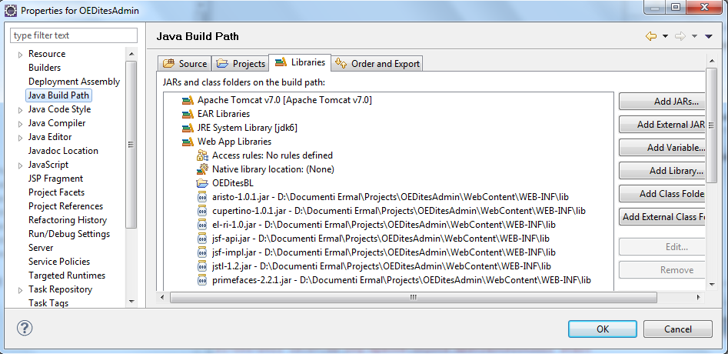
Fig. 4.2-2 OEDitesAdmin Java Build Path

Project Facets
Dynamic Web Module 2.5
Java 1.6
JavaScript 1.0

Runtimes(tab) Apache Tomcat v.7.0

Java Build Path
- Projects tab – Add the project OEDitesBL
- Libraries tab – Copying the libs in the folder /OEDites/WebContent/WEB-INF/lib must be enaugh to been recognized automaticely by Eclipse as Web App Libraries

Deployment Assembly
Add the project OEDites as a jar file for the final deplyments package (.war)
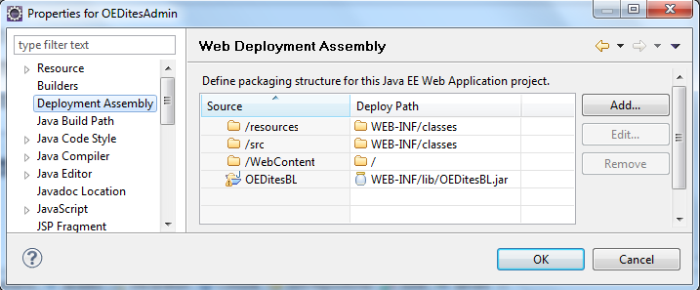
Fig. 4.2-3 OEDitesAdmin Deployment Assembly

OZoneFE

Complete me!

Project Structure

Complete me!

Project Configuration

Complete me!

